

Ship synthetic aperture radar based on deep learning
Study on the image detection methods
by
Jian He

Supervisor: DrDivya Chidambaram

Project submitted as part of the requirements for the award of
MSc Software Engineering

September 2023

Declaration and Form of Consent

DECLARATION

I, ............................................Jian He………………………………… declare that I am the sole author of this Project; that all references cited have been consulted; that I have conducted all work of which this is a record, and that the finished work lies within the prescribed word limits.

This work has not previously been accepted as part of any other degree submission.

Signed : .....................Jian He.........................

Date : .............September 2023...............

FORM OF CONSENT

I ___________Jian He.__________ hereby consent that my Project, submitted in candidature for the M.Sc. Software Engineering , if successful, may be made available for inter-library loan or photocopying (subject to the law of copyright), and that the title and abstract may be made available to outside organisations.

Signed ________Jian He.__________________

Date __________September 2023___________

Where necessary replace M.Sc. Applied Computing with your named award.

ABSTRACT

Synthetic Aperture Radar (SAR) has been applied to the field of ship target recognition because of its advantages of being able to work all-weather and all-day. With the gradual improvement of SAR image resolution and the vigorous development of deep learning algorithms, deep learning methods based on Convolutional Neural Networks (CNN)have gradually replaced traditional methods with cumbersome processing and complex computation. However, there are problems in directly migrating deep learning methods from optical image recognition to SAR image recognition, such as lack of dedicated network models, scarce training samples, and unbalanced distribution between classes. These problems make deep learning methods perform poorly.
Therefore, this paper aims to solve the problems of lack of dedicated lightweight CNNs and class imbalance. These problems widely exist in ship SAR image target recognition tasks. The main work of this paper is as follows:
For medium-resolution SAR images and high-resolution SAR images, lightweight network models are designed respectively. Compared with the previous models, the lightweight network models greatly reduces the amount of model parameters, computation and training time while ensuring a higher recognition rate. It also has the advantages of stable training and faster convergence.

catalogue
Chapter 1 Introduction 1
1.1Research background and significance 1
1.2 Research status, both at home and abroad 3
1.2.1 Traditional SAR Ship Detection Methods 3
1.2.2 SAR Ship Detection Methods Based on Deep Learning 5
1.3. Introduction of the data set 7
1.3.1. OpenSARShip dataset 7
1.3.2. FUSAR-Ship dataset 9
1.4. Content arrangement of this article 10
Chapter 2: Basic Theory 12
2.1. SAR image overview 12
2.2 Neural network principle 12
2.2.1 Convolutional layer 12
2.2.2 pooling layer 14
2.2.3 activation function 16
2.3 The Main Neural Network 18
2.3.1ResNet network 18
2.3.2 ShuffleNetv2 Lightweight network 21
2.4 Typical deep learning detection algorithm 23
2.4.1 Dual-stage detection algorithm 24
2.4.2 Single-stage detection algorithm 25
2.4.3 Non-maximum suppression 26
2.5 Summary of this chapter 27
Chapter 3, SAR ship target detection for the improved YOLOv3 28
3.1 Introduction 28
3.2 Enhanced YOLOv3 test design 28
3.2.1 ResNet50-d skeleton network 29
3.2.2, deformable convolution 31
3.2.3 Multi-scale decoding structure 33
3.3 Test results and comparison 35
3.3.1 Detection results and comparison of the SSDD dataset 36
3.3.2 Detection results and comparison of the SAR-Ship-Dataset dataset 39
3.4 Summary of this chapter 41
Chapter 4 the integration of lightweight SAR ship target detection and segmentation is realized 43
4.1 Introduction 43
4.2 LRSNet lightweight detection segmentation model 43
4.3 Experimental results and analysis 45
4.4 Summary of this chapter 47
Chapter 5 Summary and outlook 48
5.1 Summary 48
5.2 Outlook 49
Appendix 1: logbook 51
References 53

Chapter 1 Introduction

1.1Research background and significance
In recent years, the development of marine resources and economic trade has been rapid, with a sharp increase in the number of ships and more frequent ship traffic, posing great challenges to the safety and rapid and accurate detection of ships. Therefore, the significance of research on ship detection and control technology is becoming increasingly important. With the increasing economic and military cooperation among countries, countries around the world have[1] increased their supervision and regulation efforts within their own maritime territories to maintain their economic interests and ensure the security of their maritime territories, especially in areas near large ports and important straits. Therefore, ship target detection is becoming increasingly important in civil, commercial, and military aspects, as the rapid and accurate detection of ships can not only affect the success of a country's military operations at sea, but also relate to its security and economic development.
With the rapid development of our country's economy and the increasing frequency of commercial exchanges[2] with countries around the world, the throughput of maritime goods has continued to increase, and the number of ships within our country's maritime territory has sharply increased, posing severe challenges to the traffic safety of our nearshore waters. However, existing ship monitoring systems, such as patrol systems and video surveillance systems, are still unable to meet the needs of large-scale maritime ship monitoring and emergency management. So far, our country's grasp of maritime traffic data (such as the types and quantities of ships in a certain maritime area) and monitoring of marine environments (such as red tide occurrences) are far from enough and cannot meet the urgent needs of our country's shipping transformation and upgrading. Therefore, it is extremely urgent and necessary to implement rapid and detailed maritime ship monitoring in our country's waters.
Specifically speaking: In civil use, government agencies can ensure the safety of maritime traffic in a particular port or near-sea area by monitoring the passing of ships. For example, ship detection can be used to quickly locate a sunken vessel in the event of a maritime accident, thereby speeding up the rescue process. At the same time, ship monitoring technology can also be used to combat illegal fishing, illegal dumping of waste, smuggling, and piracy. In the military field, we can use ship detection to monitor the dynamic deployment of enemy navies in important ports and specific sea areas, and to obtain information about the enemy's numbers and military strength in real-time. The use of fast ship monitoring to obtain intelligence from the enemy will become one of the important ways to acquire intelligence. With the increasing awareness of national maritime security and the rapid development of human ocean development, research on rapid[3] and accurate detection of ship targets is urgent. In recent years, deep learning represented by convolutional neural networks has made great progress and has attracted more and more researchers. It occupies an important position in artificial intelligence research. With the improvement of computer GPU development technology, GPUs have more and more cores and performance has also been greatly improved.
Thanks to the massive computing power of GPUs, deep learning methods have achieved great success in many fields such as computer vision, natural language processing, intelligent customer service, smart healthcare, and smart homes, quickly becoming a hot research direction in both academia and industry, attracting more and more researchers to participate. Among them, deep learning methods represented by convolutional neural networks (CNNs) have made breakthrough progress in tasks such as image classification, object detection, image segmentation, and object tracking. Compared with traditional machine learning methods such as support vector machines and random forests, CNNs, especially deep CNNs, can use a large amount of data for training and learning, extract high-level semantic features contained in the target, and accurately describe the differences between different targets. Moreover, CNNs are a typical end-to-end network model, where users only need to focus on the network input and output, without perceiving the results of intermediate layers. When a large number of training images of the same size are input into the network, the result can be obtained after intermediate layer calculations such as convolutional layers and pooling layers, greatly reducing the previous laborious work of manual feature extraction. Therefore, the successful application of deep CNNs in ship detection is very valuable.
England is a maritime power with a vast territorial sea, covering about 4.7 million square kilometers of ocean area and a coastline stretching 18,000 kilometers long. Ships, as the main transportation tool on the sea, are active in human daily life, and their regulation involves many aspects, playing an extremely important role in both military and civilian fields. In military affairs, foreign warships frequently approach China's territorial waters. Effective warning and monitoring can be of tremendous help to tactical deployment and mobilization. In the civilian sector, it can assist in the navigation planning of fishing boats and the detection and management of maritime transport. Unlike natural images and hyperspectral images, Synthetic Aperture Radar (SAR) is an active microwave remote sensing imaging sensor widely used in airborne and satellite fields. SAR uses the relative motion between the radar and the target to synthesize a larger equivalent aperture of the true antenna aperture through data processing. SAR has very good penetration characteristics, can effectively penetrate coverings, is not affected by cloud cover, and can work around the clock. In addition, it can display the scattering characteristics of targets and identify camouflage. These advantages [4]make SAR irreplaceable in military affairs, maritime monitoring, disaster warning, and other fields.
Currently, deep learning (DL) methods relying on prior knowledge of data itself have achieved rapid development, making it possible to detect ship targets from massive high-resolution SAR data. Among them, the convolutional neural network (CNN) with strong processing capabilities for 2D data is widely used in image processing. The local receptive field and weight sharing characteristics of CNN also make it quite advantageous in SAR image processing. Based on existing SAR data, the successful application of deep learning in the field of computer vision (CV) has also driven the intelligent interpretation of SAR images. The detection method based on deep learning is widely used in SAR ship detection tasks, which has made huge progress compared to traditional methods, and has achieved considerable detection performance.
However, there are still many limitations, such as detection accuracy, execution efficiency, and practical application[5] possibilities. How to more effectively integrate deep learning methods with SAR image ship detection has become a current research hotspot, driving the development of the field. This has extremely important reference significance for SAR remote sensing and other remote sensing methods.

1.2 Research status, both at home and abroad
1.2.1 Traditional SAR Ship Detection Methods
The traditional Automatic Target Recognition (ATR) process for SAR image mainly consists of the following aspects: image preprocessing, region of interest (ROI) extraction, target detection, and target recognition. Preprocessing mainly includes geometric correction, coherent speckle suppression, multi-view processing, and image fusion to obtain higher quality SAR images for subsequent processing. ROI extraction aims to obtain target regions from large-scale SAR images and remove some interfering targets. Target detection and recognition use traditional methods to detect the obtained target regions and input them into the next level for recognition.
Traditional ship target detection in SAR images mainly includes the following aspects: CFAR detection and its variant algorithms, ship target detection based on wake detection, and detection based on saliency. For many years, CFAR detection has been widely used in SAR ship detection tasks and is still the mainstream SAR detection method. In 1968, Finn et al. first proposed the Cell Averaging CFAR[6] detector (CA-CFAR), which uses the data of adjacent cells around the detected cell to obtain the background clutter power estimation and detection threshold, and can achieve good performance when the clutter background is homogeneous. The Two Parameter CFAR (TP-CFAR) detection proposed by EIDarymli et al. is widely used in SAR ship target detection. It is an adaptive threshold detection method that can adapt to the changes of background clutter and usually consists of three windows: target window, guard window, and background window. Other excellent CFAR detectors include those based on normal distribution proposed by Ai et al., those based on generalized gamma distribution proposed by Qin et al., those based on K distribution proposed by OLIVER et al., and those based on alpha-stable distribution proposed by LIAO et al.
In addition, other excellent CFAR detection algorithms continue to emerge. However, most of them are still based on the intensity information of the image for ship target detection. In contrast to these approaches, LENG et al. proposed a bilateral CFAR detection algorithm that incorporates spatial distribution information in addition to considering the intensity information of the image, which can effectively improve the detection performance. AI Jiaqiu et al. improved this method and proposed an improved bilateral CFAR detector under complex backgrounds, which was experimentally verified to achieve good detection results in dense small target SAR images.
The detection method based on ship wakes detects the difference in energy between the wake and the background caused by the sea wave generated during the ship's navigation process. It can not only detect ship targets, but also estimate the ship's heading and speed based on the wake. Currently, it has a wide range of applications and high value. Kuo et al. and Courmontagne et al. both consider [7]wake detection as line feature detection and propose using Radon transform to implement wake detection. The difference between the two is that the former uses the method of wavelet correlator, while the latter uses random matching filtering. Xing et al. enhanced dark wakes through filtering preprocessing and introduced the length-normalized Radon transform method. Yang Guozheng et al. proposed a new wake detection method that combines morphological component analysis with multi-dictionary learning. By constructing a rich dictionary of sea surface textures, the ship wake structure is analyzed and iteratively updated, and the image is decomposed into ship wake structure components and sea surface background texture components for detection, which is suitable for complex backgrounds.[8] In addition, some scholars have applied saliency detection methods to ship detection in SAR images. Yan Chengzhang et al. proposed to use saliency detection in SAR image ship detection. By decomposing the original image into multiple scales and detecting saliency in each layer, saliency subgraphs are obtained and fused to obtain the final saliency map, and then post-processing is performed to obtain the detection results. This method has strong robustness and low dependence on prior knowledge.
1.2.2 SAR Ship Detection Methods Based on Deep Learning
The widespread use of deep learning methods in optical image processing has also driven the process of intelligent interpretation of SAR images. In 2012, Krizhevsky et al. proposed the AlexNet convolutional neural network, which won the ImageNet ILSVRC-2012 recognition competition and triggered extensive research on neural networks. This research can be roughly divided into two aspects: on the [9]one hand, research on convolutional neural networks in a vertical direction; on the other hand, research on the application of convolutional neural networks in other fields or tasks in a horizontal direction.
Simonyan et al. proposed the VGG network architecture, which first explained the impact of depth on performance in convolutional neural networks, and verified that small cascading convolution kernels can be used to replace large convolution kernels while keeping the receptive field size consistent and performance unchanged, thereby reducing the number of parameters. He et al. proposed a convolutional neural network design with residual structures, which was another important milestone in this field. The ResNet network unit they proposed uses the idea of learning residual with convolutional neural networks, which can preserve information at different levels and effectively avoid gradient disappearance, enabling the neural network to go deeper, currently reaching up to 150 layers. Others, such as Szegedy et al. proposed the GoogLeNet network, which adopts the design of Inception unit structure; Zhang et al. proposed ResNest, a variant network of ResNet that incorporates the attention mechanism. In order to use deep learning methods on mobile and embedded platforms, lightweight model design has become the main research content of current network design. Howard and Sandler et al. proposed the MobileNetv1 to MobileNetv3 series of network structures for mobile use, mainly proposing the idea of depth-wise separable convolution (DWS), which extracts the features of a single feature layer through grouped convolution and then fuses the results using point convolution, effectively reducing the number of parameters. Zhang and Ma et al. proposed the ShuffleNet series of lightweight model structures, which introduced channel shuffling (CS) based on depth-wise separable convolution, so that the learned features come from multi-channel results rather than single-channel results.
In terms of other tasks, convolutional neural networks are also widely used for detection and segmentation tasks. The biggest difference between tasks lies in the different decoding structures. The feature extraction network, also known as the backbone network, uses classic feature extraction structures such as VGG, ResNet, and MobileNet. However, the decoding structure corresponding to different tasks is changed. Classification involves categories and confidence, detection involves object box location and classification, and semantic segmentation involves pixel-wise classification tasks.

Current deep learning detection algorithms can be mainly divided into two categories: two-stage detection and one-stage detection algorithms. In 2013, Girshick et al. first proposed the two-stage detection R-CNN algorithm, which opened up the application [10]of convolutional neural networks in the field of object detection. R-CNN is a region-based detection method, which is called a two-stage method because the detection process is divided into two parts. The first part is responsible for generating candidate boxes, and a large number of candidate boxes are obtained for adjustment. The second part refines the results by filtering and fine-tuning candidate boxes to obtain more refined bounding boxes and target categories as well as confidence. In 2015, Girshick proposed the Fast R-CNN detection network based on R-CNN. Fast R-CNN optimized the candidate box generation, using the selective search algorithm to generate candidate boxes and proposing the ROI pooling operation to optimize the problem of different candidate box sizes. It achieved end-to-end training from candidate boxes to detection results, greatly reducing inference time. Faster R-CNN, which came as an improvement, further improved performance and reduced time consumption. Faster R-CNN proposed the Region Proposal Network (RPN) to obtain candidate boxes through convolutional neural networks and shared features with the detection part, greatly speeding up detection.[11] It is the first end-to-end object detection task achieved in a strict sense.
Unlike the fine-tuning structure adjustment of two-stage detection algorithms, one-stage detection algorithms pursue an all-in-one effect. They directly predict the position and category of targets through convolutional neural networks and give the confidence of targets. Compared with two-stage detection algorithms, they have extremely high execution speed, but the accuracy is relatively reduced. Redmon et al. first proposed the one-stage detection algorithm YOLOv1, which divides the input image into grids and predicts the target category, multiple positions, and confidence for each grid. YOLOv1 belongs to the method without anchor boxes, with a simple design method and serious position deviation, resulting in relatively poor performance. The grid division method makes it unfriendly to small targets, resulting in serious omissions. Liu et al. proposed the SSD fully convolutional one-stage algorithm, which can achieve end-to-end detection better. Its main contribution is the multi-scale feature prediction and the setting of prior boxes. Multi-scale feature prediction refers to the prediction results of large-scale feature maps corresponding to small targets and small-scale feature maps corresponding to large targets. This idea is also a promotion idea borrowed by Redmon's subsequent YOLO upgraded version. YOLOv3 integrates the Feature Pyramid Network (FPN) structure on the basis of the above and proposes a new detection backbone network DarkNet53 while continuing to use multi-scale detection, which has made one-stage detection methods widely used. Subsequently, the culmination of YOLOv4 and YOLOx algorithms made one-stage detection methods reach their peak.

1.3. Introduction of the data set
1.3.1. OpenSARShip dataset
The dataset of medium resolution SAR image target recognition used in this paper is from OpenSARShip, which is established by Huang et al., the first publicly available dataset for the recognition of SAR. This dataset was derived from the Sentinel-1 satelThe dataset of medium resolution SAR image target recognition used in this paper is from OpenSARShip, which is established by Huang et al., the first publicly available dataset for the recognition of SAR. This dataset was derived from the Sentinel-1 satellite, The Sentinel-1 satellite works in the C-band, Using the VV-VH bipolarization mode, To interferometry the wide bands (Interferometric Wide Swath, IW) mode for earth observation and provide single visual plural image (Single Look Complex, SLC) and horizon horizon (Ground Range Detected, GRD), and both products, Of the SLC, with a resolution of 2.722 to 3.522 m, With a GRD resolution [12]of 2,022 m, Specific information is shown in Table 1.2.lite, The Sentinel-1 satellite works in the C-band, Using the VV-VH bipolarization mode, To interferometry the wide bands (Interferometric Wide Swath, IW) mode for earth observation and provide single visual plural image (Single Look Complex, SLC) and horizon horizon (Ground Range Detected, GRD), and both products, Of the SLC, with a resolution of 2.722 to 3.522 m, With a GRD resolution of 2,022 m, Specific information is shown in Table 1.1
Sample target slices in OpenSARShip are shown in Figure 1.1.
The number of different ships in the OpenSARShip dataset was counted as shown in Figure 1.3.

Table 1.1 OpenSARShip Dataset-specific information

satellite | Sentinel- 1
Work band | C wave band
Polarization mode | VV-VH
Imaging mode | SLC GRD
resolution ratio | 2.7×22 to 3.5×22m 20×22m
SAR images | 41
Number of target sections | 5673
Category number | 14 major categories , and 68 subcategories
Collection site | Shanghai,Shenzhen,Tianjin,Yokohama, Singapore
.

(a)VH-polarized Cargo slices in the SLC mode

(b) The SLC mode of VV-polarized Cargo slices
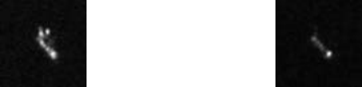
(c) GRD mode VH polarized Cargo slice (d) GRD mode VV polarized Cargo slice
Figure 1.1 Example plots of the target slices of the OpenSARShip dataset
1.3.2. FUSAR-Ship dataset
The FUSAR-Ship data set was established by Hou et al. of Fudan University. The data comes from Gaofen-3 satellite. Gaofen-3 satellite is the first C-band dual-channel multi-polarization high-resolution SAR satellite in China. It has the characteristics of high resolution, large imaging width, high radiation accuracy, [13]multi-imaging mode and long-time working
It can be well used in the inspection of sea targets (such as ships, artificial facilities, offshore oil platforms, etc.)
Test and identify the task]. The FUSAR-Ship dataset contains 126 high score 3 images, polarized in DH or DV (Double Aperture HH / VV), azimuth resolution of 1.124m, distance resolution of 1.700 to 1.754 m, imaging mode (Ultrafine Strip-map, UFS) mode , the specific information is shown in Table 1.2.

Table 1.2 FUSAR-Ship data set details
satellite | Gaofen-3
Work band | C wave band
Polarization mode | DH/DV
Imaging mode | UFS
resolution ratio | Azimuth direction: 1.124m, distance direction: 1.700m to 1.754m
SAR, and the number of images | 126
Number of target sections | 5243
Target slice size | 512*512
Category number | 15 major categories, and 99 subcategories
Category number | The middle and lower reaches of the Yangtze River and the estuary, the Yellow Sea and the East China Sea

FUSAR-Ship, the sample target slices in are shown in Figure 1.2
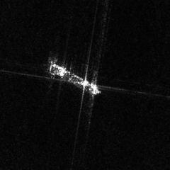
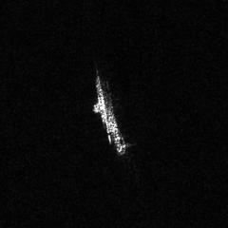.
- DH polarized Cargo Ship slice (b) DV polarized Cargo Ship slice
Figure 1.2 Example plot of the FUSAR-Ship dataset
It can be seen that the FUSAR-Ship data set is similar to the OpenSARShip data set. Despite the large number of ship samples, the number of samples is rare, and the distribution imbalance is still extremely serious.

1.4. Content arrangement of this article
This paper uses the deep learning method to explore the lightweight CNN network structure suitable for ship SAR image target recognition, so as to solve the defects of CNN model parameters, heavy calculation and low accuracy in ship SAR image target recognition, and solve the problem of target recognition of the ship based on convolutional neural network.
The first chapter is the introduction, which[14] introduces the research background and research status of ship SAR image target recognition, and briefly introduces the traditional method and deep learning method respectively, and focuses on the main problems facing the use of deep learning method. Finally, the data set used by the experiments in this paper is introduced.
The second chapter introduces the relevant theoretical basis of this paper, including the imaging principle and characteristics of SAR images and the basic theory of deep learning. In it, it mainly introduces the principle of convolutional neural network, including convolutional layer, pooling layer, activation function and so on. Finally, the common data augmentation methods are introduced.
The third chapter designs a special lightweight convolutional neural network for medium resolution and high resolution SAR images. The lightweight model in this paper, inspired by the lightweight model ShuffleNet V2 in the field of optical image, effectively reduces the calculation amount through channel dimension splicing, channel shuffling and other operations. For high resolution image, in order to further reduce the operational burden, put forward the preprocessing module, preprocessing module, the original image center cutting, maximum pooling and average pooling operation, and on the results of the processing volume, product and channel dimension[15] splicing operation input subsequent convolution neural network, implements the retention image effective information and elimination.
The fourth chapter puts forward the lightweight model LRSNet network, and on the basis of the fourth chapter, introduces the idea of lightweight model design, so that the generalization ability of the model, namely the model effect, can realize the use of mobile terminal
Reality use increases feasibility.
The fifth chapter summarizes and prospects the work content of this paper, and analyzes the questions existing in the current research process
Problem and deficiency, and put forward the next possible research ideas and solutions.

Chapter 2: Basic Theory

This chapter first briefly introduces the principles and characteristics of SAR image imaging, as well as the basic theories of deep learning.

2.1. SAR image overview
Synthetic aperture radar (Synthetic Aperture Radar, SAR) originates from the solid aperture technology. Solid aperture radar uss the beam to form the distinction point target in the azimuth direction[16]
The azimuth resolution of the aperture radar is shown in formula:
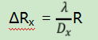
Where λ is the radar operating wavelength, Dx is the antenna aperture, and R is the distance from the target to the antenna. It can be seen that the azimuth resolution is inversely proportional to the aperture of the antenna, and to obtain a high resolution, you can only use a longer antenna, which is not only expensive and difficult to achieve on the flight platform. Synthetic aperture is to install a radar on an aircraft or a satellite, forming a huge effective antenna aperture in the process of movement, to transmit and receive a fixed scene on the ground
Signal, and the signal does a synthetic array processing to break through the azimuth resolution limit of .

2.2 Neural network principle
2.2.1 Convolutional layer
Traditional neural networks usually use a fully connected layer structure, resulting in a large number of parameters, not suitable for image processing, while the emergence of the convolution layer changes this situation. Convolutional layer has the characteristics of parameter sharing, which can effectively reduce the amount of parameter operation, and has the ability of efficient feature extraction. The shallow network can extract the underlying features such as texture and color, while the deep network can capture more complex semantic information.
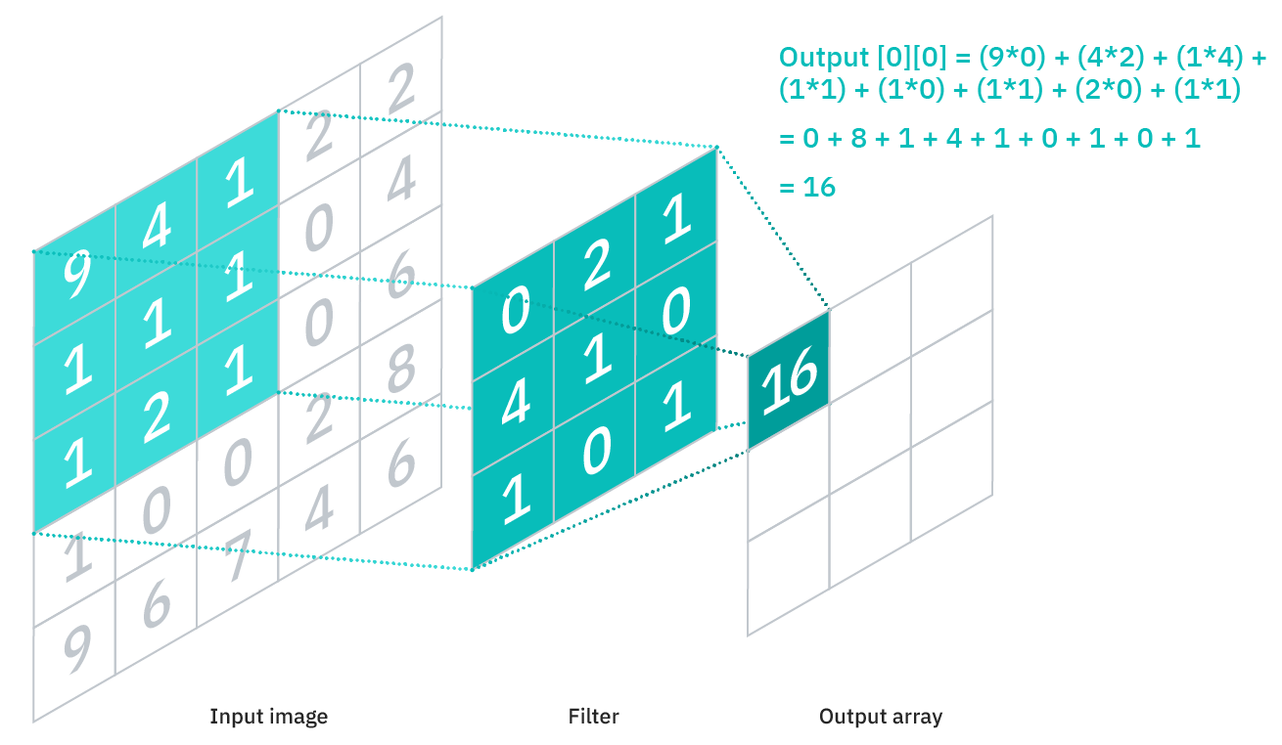
Figure 2.1 Schematic diagram of the convolution operation implementation

The convolution operation in deep learning are shown in the figure above. The left represents the input features or input images, the middle is the convolution kernel, and the right is the convolution output results on the right. Here, for the feature map with the input 33, the output feature is output 22 with the convolution kernel size 22. It can be seen that the overall process of convolution operation is to slide the convolution core with a fixed window size on the input features to find the weighted sum of all the elements in the window, and usually the step is set to 1. The value of the convolution kernel is fixed, and the output results obtained by sliding are all collected
With the same convolution kernel. In order to obtain different features, multiple convolution kernel is often used, as shown in the figure below:
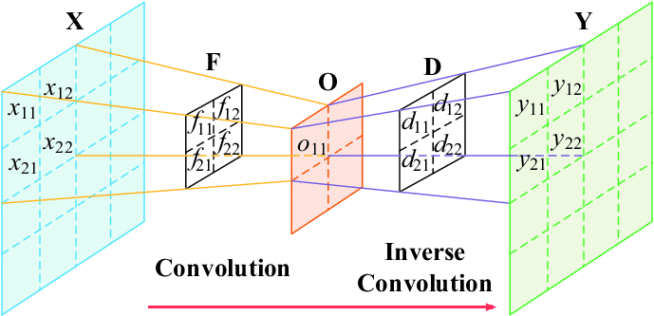
Figure 2.2 Schematic diagram of multi-convolution kernel operation

With multiple different convolution kernels, multiple different convolution results can be obtained, namely, different feature graphs,
For the latter layer of connection or for discrimination.
Strictly speaking, the convolution operations in many current neural network algorithms libraries are actually correlation functions
Number, as defined as follows:
S(i,j) = I(i + m,j + m)k(m, n)
Specifically, S represents the output result, I represents the input feature or image, and k represents the convolution kernel of size MN. It can be seen that it is a flip different from the convolution operation, but because in machine learning, the learning algorithm will learn the right value at the appropriate position of the kernel, the impact is small, so it is basically considered consistent.[17]
Figure 2.2 shows the results of multiple convolution kernel convolution for single-channel data, while in general, the input is often many
Characteristic plots of the channel. Therefore, the more generalized convolution operation is represented as follows:
S(i, j) = I(l, i + m,j + m)k(l, m, n)
Where C indicates is the number of channels. Compared with the former formula , the input feature and the convolution kernel are increased by one
Dimension, where the l represents the l-th channel.
The composition and implementation of convolutional neural networks are usually data-driven and obtained by intrinsic learning. Manual manipulation often can only obtain simple convolution kernel designs, such as edge extraction operators. But it is very difficult to design the convolution kernels with more complex patterns. Data-driven learning is now the mainstream approach to solve pattern recognition. In addition, the cascade structure of the convolutional neural network, a single convolution kernel extracts features in a certain aspect, and obtains a more comprehensive and complex feature representation through the cascade structure, which provides support for tasks such as detection and recognition. As for the design of this cascade mode, which is some of the main skeleton networks, the method is flexible considering how to extract and combine the features efficiently. The simple convolutional neural network is realized in this way, which has strong expression ability and is contained in the convolution kernel. However, in order to introduce nonlinear information and increase the perception to obtain stronger semantic information expression, it is often pooled and activated after the convolution. This section details the pooling operation and activation functions in later sections.
2.2.2 pooling layer
In the convolutional neural network, the pooling layer often appears after the convolutional layer, which has many advantages and functions. The pooling operation can also be called a downsampling or downsampling operation, and the overall statistical characteristics of adjacent outputs at a certain position are used to replace the output of the network at that position. Common pooling operations are: maximum pooling (Max Pooling) and average pooling (Average Pooling). The maximum pooling operation is shown in Figure 2.3
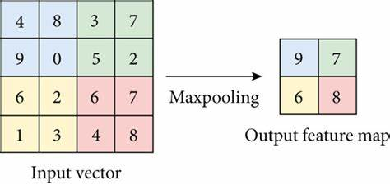
Figure 2.3 Schematic diagram of the maximum pooling

Pooling often requires the selection of the step size and the pooling method. As shown above, the figure is the maximum pooling operation with a step size of 2, that is, the maximum value in a given window is found as the overall feature description in the window and output. The average pooling diagram is shown in Figure 2.4:
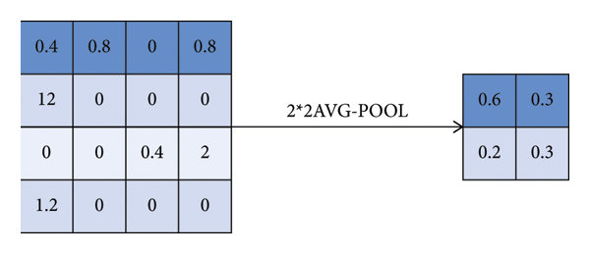
Figure 2.4 Schematic representation of the average pooling

The average pooling operation coincides with maximum pooling, averaging all elements in the selected window and output. In contrast, maximum pooling is more widely used, which often enables to save feature texture information, while
Average pooling retains more background information or features of the overall data.
Pooling operation is a parameter-free implementation, whose main function is to downsample, remove redundant information, compress the features, reduce the amount of operation, and prevent overfitting. Pooling also brings a benefit that doubles the receptive field and facilitates the acquisition of high-level semantic information. In addition, it also has an extremely important invariance, which is able to
The representation of the help input is approximately invariant.
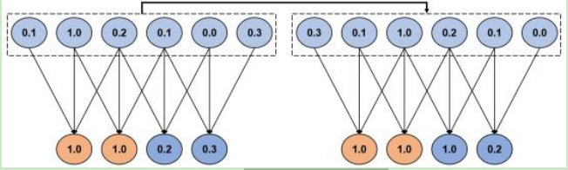
Figure 2.5 Maximum pooling translation invariance

The schematic diagram of maximum pooling translation invariance is shown in Figure 2.5 above. Overlap maximum pooling is used on the left and right, but the sampling point on the right is the offset result of the left sampling point deviation. It can be seen that the output result indicates that the input microoffsets has little effect on the maximum pooling and can maintain the local translation invariance.this
It also strengthens the generalization ability of deep convolutional neural network, so that the network has stronger semantic expression ability.

2.2.3 activation function
Activation function (Activation Function, AF), also known as nonlinear mapping (Non-Linearity Mapping, NLM), is widely used in convolution and pooling operation, the main purpose is to introduce the nonlinear expression ability of the model. Using only neural networks for modeling often only linear expression ability, the increase of hidden layers is equivalent to the single-layer network, finding no suitable solution for complex problems. However, after adding the activation function, the network has the layered nonlinear expression ability, and more appropriate results can be sought for more complex problems.
Activation functions typically require the following features:
1. Nonlinearity, namely, the derivative is not a constant. This is the essential problem of introducing the activation function, adding a nonlinear capability to the model and ensuring that the multilayer network does not degenerate into a single-layer network.[18]
2. Variability to ensure the propagability of the gradient in the optimization process. During the gradient backpropagation,
The differentiable activation function does not affect the process.
3. Simple enough to calculate. Complex activation functions can affect the computational speed, while simple activation functions are designed
More efficient.
4. Unsaturation. Saturation refers to the gradient being close to zero in some intervals, where the gradient vanishes, making the parameters inaccessible during backpropagation.
5. Monotonicity, that is, the derivative sign does not change. When the activation function is monotone
The single-layer network is a convex function.
Moreover, the output range of the activation function can be either finite or infinite. When the output value is finite, the gradient-based optimization method is more stable because the representation of features is more significantly influenced by the finite weight; when the output value is infinite, the training of the model is more efficient, but often requires a smaller learning rate.
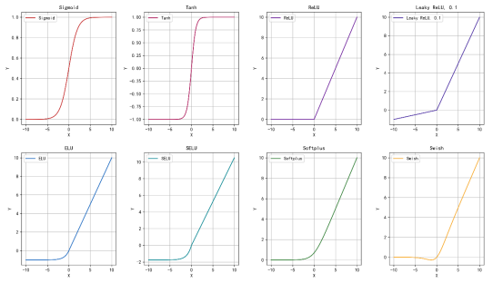
Figure 2.6 Common activation functions

The activation functions commonly used in deep learning are shown in the figure above, while the Sigmoid is frequently used frequently
Live functions are defined as follows:
sigmoid(x) = 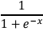
Tanℎ(x) = 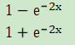

ReLU(x) = max(0, x)
fLR (x) = {, ixx 00
Where, fLR (x) represents the Leaky ReLU activation function.
In the history of neural network development, Sigmoid and Tanh activation functions were mainly used in the early stage, while ReLU activation functions were mostly used in the later stage. Sigmoid The activation function output has a finite interval value range, has an exponential shape, and is closer to the neuronal concept in a physical sense. Its value range is from 0 to 1, which is often used as the output probability or normalize the input, but it has saturation, which is not conducive to the gradient update in the process of back propagation and the output mean is not 0, resulting in offset phenomenon. The Tanh activation function takes values ranging between-1 and 1, but it has an output mean of 0 and has a relatively fast convergence rate. In terms of saturation, it coincides with Sigmoid. Currently, the ReLU series activation function is used, which is proposed for the saturation of the Sigmoid and Tanh series activation functions. The ReLU activation function involves the complex operation such as exponential, and introduces the nonlinear relationship. During the gradient back-propagation process, the gradient is 1, which does not reduce the derivative due to the activation function, and can alleviate the gradient disappearance problem to a certain extent. But it exists very much
Large problem, with the range of input value less than 0, the weight can not be updated.[19]
Part of the neuron,eventually, it is not activated. In order to alleviate this situation, when the input value is less than 0, the coefficient is used to compress the output range, allowing the neuronal output to activate the neurons during back propagation.

2.3 The Main Neural Network
2.3.1ResNet network
Deep learning has evolved from LeNet to AlexNet to VGG and GoogLeNet networks. Experience shows that the depth and width of the convolutional neural network have a great influence on the results of detection and identification, while the depth of the neural network occupies the most dominant position. Deep neural network can extract the underlying features of the image well and combine them to obtain high-level semantic information, but it also brings many problems. The first problem is gradient explosion or gradient disappearance; the second problem is degradation problem, network deepening is too saturated and difficult to optimize the training error and prediction error. The first problem can be solved by batch orthogonalization (Batch Normalization, BN) and better network initialization.
In view of the second problem, He Kaiming et al. proposed the ResNet residual structure to solve and optimize the first problem at the same time. In 2015, he won the CVPR best paper award, and his idea is still widely used in the current research. ResNet Is proposed by thinking about the optimization process. In the optimization process, it is much easier to learn the residuals through the network than to establish the mapping relationship directly. It calls several superimposed layers "blocks", assuming that for some
For "block", the function to be fitted is F (x), and the desired potential map is H (x), so the following relationship exists:[20]
F(x) = H(x) − x
In this way, compared with directly learning the latent map H (x), F (x) learns the difference function between input and output, which is more conducive to optimization. When the network is deep and there are many redundant convolution layers, this design idea can make F (x) learn the constant mapping F (x) 0 without affecting the performance of the whole network, that is, there is a self-adjustment mechanism, so that the deeper network can choose the appropriate mapping relationship and get the mapping more in line with the situation.
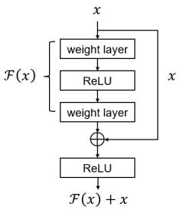
Figure 2.7 Schematic diagram of the residual block

Figure 2.7 shows the specific implementation diagram of the residual block, which consists of the residual path ℱ (x) and the identity map x (or the jump connection). In the implementation process, the end is fused through the element addition operation, which requires the output of the two paths to keep the same dimension and the same size. In order to reduce the practical problem of computational complexity, the realization of residual blocks can be divided into two categories. One is the base residual block (Basic Block) of the low-dimensional feature graph, and the other is the bottleneck residual block (Bottleneck Block) of the high-dimensional feature graph.in compliance with
As shown in Figure 2.8:
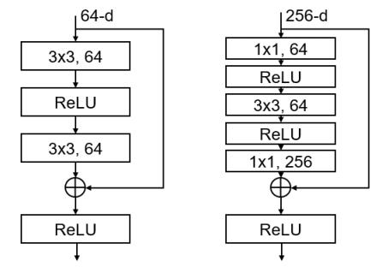
Figure2.8 Residual block concrete implementation

In Figure 2.8, the base residue block is shown on the left and the bottleneck residue block on the right. It can be seen that the base residual block is composed of two layers of 33 convolution, and the output is fused by element addition. And the bottleneck residual block first uses 11 convolution to reduce the dimension of the input data, reduce the amount of subsequent operations, and then recovers it to the original dimension through 11 convolution for feature fusion.
For the residual block itself, the jump connection (Shortcut) can also be divided into two forms, mainly depending on whether the mapping relationship established by the residual path changes the dimension of the input and output. As shown in Figure 2.9 below:
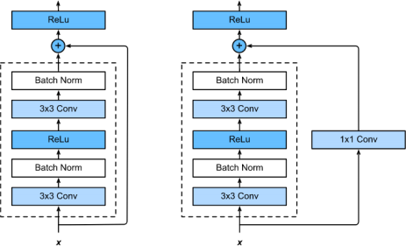
Figure 2.9 Jump connects the different forms

On the left side of the figure is the form of using the input directly as the identity mapping and merging with the residual path, while on the right is the input by 11 convolution and matches the transformation result with the dimension of the residual path result. The main purpose of this transformation operation is to ensure that the residual path has the same dimension as the input degree, you can perform the element plus operation.
2.3.2 ShuffleNetv2 Lightweight network
ResNet, Inception and other designs make the neural network can achieve quite good results in different tasks, but the network itself has a very large number of parameters and a very large amount of operation, so there are great limitations in practical application. At present, there are many ideas to try to design the lightweight network to facilitate the use of mobile terminals. The most typical ones are such as:MobileNet Series, ShuffleNet series, etc. This chapter will cover those involved in the subsequent experimentsShuffleNetv2 Network introduction, discuss the reasons and the problems solved.
The lightweight model is inseparable from the concept of deep separable convolution (DepthWise Separable convolution (DWS). The concept of deep separable convolution was proposed in MobileNet lightweight real-time network, and was improved and applied by the current mainstream ideas. The idea of grouping convolution can be traced back to 2012. The global AlexNet network was used to solve the problem of insufficient computing power of graphics cards at that time, but this idea was created starting from the current lightweight end-end model.
Conventional convolution obtains multiple output features by convoluting multiple multichannel convolution kernels with multichannel inputs. The depth separable convolution is composed of packet convolution . The intermediate results are obtained by convolution of channel convolution to obtain the intermediate results, and then the intermediate results are adjusted through point convolution and information fusion to obtain the output features. Depth separable convolution has the characteristics of reducing the number of parameters, but the corresponding result loss, and the point convolution operation becomes the bottleneck of performance improvement. ShuffleNetv1 Channel cleaning (Channel Shuffle, CS) is proposed to improve these problems and enhance the information after channel convolution interactions between.
The channel cleaning is on the left and the refinement is on the right. It can be seen that the idea is to divide the input, and then through the group convolution operation, the resulting feature graph is separated and reorganized according to a certain rule to ensure the mutual communication of information between each group, and then the results are stitched through the group convolution to obtain the output feature graph.
On this basis, the ShuffleNetv2 network is proposed, reaching the peak stage of lightweight model design. It puts forward four design principles for the practical application of lightweight and proposes a new architecture based on these principles. The evaluation index commonly used in lightweight neural network is floating-point operation quantity (Floating-Point Calculation, FLOPs), which is an indirect evaluation index. In many cases, it cannot reflect the real operation situation. On different platforms, the running speed of the model with the same FLOPs may be very different. There are two main reasons for this problem. First, the running speed of different mobile platforms is different. Second, affecting the running speed in addition to FLOPs, the memory access cost (Memory Access Cost, MAC) and parallelism should be considered. The thinking of these problems has led ShuffleNetv2 to propose four currently commonly used lightweight model design principles:[21]
1. Keep the number of channels constant to minimize the memory access cost.
2. Avoid overuse of grouping convolution.
3. Use fragmented networks carefully.
4. The negative effects of element-level operations cannot be ignored.
Under the guidance of these four basic principles, ShuffleNetv2 designed a new network structure as shown in Figure 2.10:
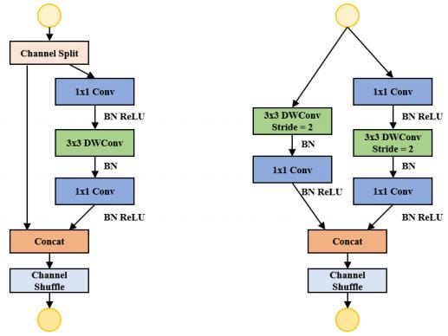
Figure 2.10 Schematic diagram of the ShuffleNetv2 structure

In Figure 2.10, the left side is the normal form, and the right side is the form of data dimension reduction. In the left, the input features are segmented first, usually evenly divided into two branches. To avoid fragmentation, one branch remains unchanged and the other branch follows principle one and contains three convolution layers, and the number of input-output channels remains consistent. In order to meet principle 2, the 11 convolution in this branch will no longer use grouping convolution, and then the characteristics of the two branches will be stitched and channel cleaned. However, the network design form involving downsampling is slightly different. In the implementation process, the channel segmentation operation is removed, the input features are allocated to two branches at the same time, and the output feature channel dimension is doubled.

2.4 Typical deep learning detection algorithm
In order to facilitate the introduction of the subsequent detection methods in this paper, this section combines the above basic knowledge to introduce the detection of deep learning. Start with the typical dual-stage detection algorithm Faster R-CNN and the single-stage detection algorithm SSD and YOLO, and describe the specific implementation process and the more important non-maximum suppression (Non-
Maximum Suppression, for short, NMS) concept.
2.4.1 Dual-stage detection algorithm
The two-stage detection method is represented by R-CNN series, and Faster R-CNN reaches its peak, which is suitable for scenarios with high accuracy requirements and low real-time requirements. Some concepts proposed by Faster R-CNN are still used even today, and will be introduced in this section.
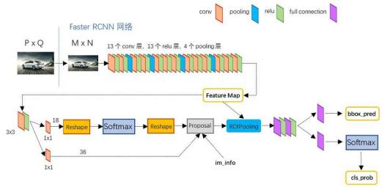
Figure 2.11 The Faster R-CNN detection network

Faster R-CNN solves many problems such as time-consuming in the detection process, and further improves the detection accuracy. In the previous dual-stage detection, selective search (Selective Search, SS) is often used to obtain a large number of candidate boxes (about 2000). This selective search algorithm takes up a lot of time, which is not conducive to the improvement of detection performance. The Faster R-CNN has proposed a regional recommendation network (Region Proposal
Network, RPN) structure and other solutions have changed the status quo, its framework is shown in Figure 2.11.
For images of any size, they are first scaled to the MN size, and then the scaled image is input into the network. The common skeleton network is used to generate a series of feature maps, while the simplest network composition is shown in Figure 2.11, consisting of 13 convolutional layers, 13 ReLU activation layers and 4 pooling layers. The resulting feature map was then divided into two branches, one branch input into the RPN network and used to generate candidate boxes. The RPN network generates a number of anchor boxes (usually 9) for each pixel on the feature map, then determines whether each anchor box belongs to the foreground or the background through the softmax activation function, and then corrects the anchor box through the boundary box regression to obtain the exact candidate box position. Another branch and the resulting candidate box position information are input into the ROI pooling layer. By extracting the candidate region of the position information of the candidate box on the feature map, then a fixed length feature is generated by pooling, which is sent to the subsequent fully connected layer for target discrimination and fine adjustment of the candidate box position.[22]
2.4.2 Single-stage detection algorithm
Different from the two-stage detection, which has fine adjustment, the single-stage detection algorithm pursues the one-step detection effect, and directly obtains the category, position and confidence of the target through the convolutional neural network at one time. Typical representatives have YOLO series and SSD algorithm, and this subsection will give a detailed introduction of YOLOv1 and SSD. The main idea of both is to sample evenly at different locations in the image, and then use the convolutional neural network. The detection framework of YOLOv1 is shown in Figure 2.12:
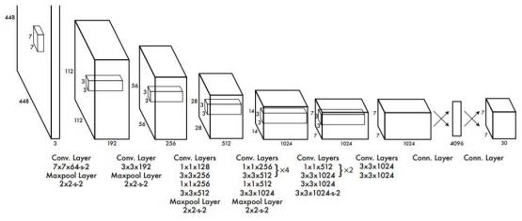
Figure 2.12The YOLOv1 detection frame

YOLOv1 Anchorless frame detection algorithm, which divides the input image into SS grids, and each cell is responsible for predicting the center point falling into the target within the cell. Moreover, to improve the detection accuracy, each cell predicts the B bounding boxes and the confidence and C category probability values corresponding to the bounding box. Figure 2.12shows the YOLOv1, the schematic diagram is divided into 77 grids, each grid predicts 2 bounding boxes and 20 categories, then the final prediction result is 7730. The network thus outputs the bounding box, confidence, and category, and then the overlapping targets can be removed by non-maximum suppression to obtain the final detection results. YOLOv1 Has extremely fast detection ability, which is one third that of Faster R-CNN, but it also has obvious disadvantages. Each grid corresponds to one category where multiple different targets miss in one grid and also cause small target miss; moreover, each grid predicts 2 bounding boxes,
For multi-scale and diverse targets, they have poor adaptability.The proposal of SSD algorithm alleviates the detection problem of YOLOv1. The full convolution structure can be detected more quickly, and the anchor frame idea of Faster R-CNN has achieved quite good detection effect.As shown in the figure below:
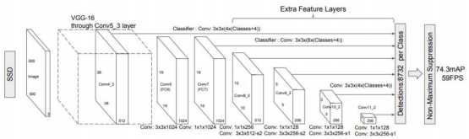
Figure 2.13 SSD framework for detection algorithm

For the input image, the image feature extraction is performed through the VGG network, and on this basis, a new convolution layer is added to obtain more feature maps for detection. It first tries multi-scale prediction, that is, prediction through feature maps of different sizes. In the convolutional neural network, the feature graph of the shallow neural network is often relatively large and can correspond to it small target; and the deep feature map is often relatively small, and can correspond to the large target. This allows for the use of a larger special size
Eigengrams to predict small targets and smaller feature maps to predict large targets. Secondly, in order to adapt to the multi-scale and multi-type target detection problem, SSD adopts the idea of preset anchor box in Faster R-CNN. Each unit will set multiple a priori boxes with different scales and aspect ratio to make predictions at multiple scales, and each prior box will predict a set of complete and independent detection results. Then all the overlapping test results were subjected to non-maximum suppression to obtain the final result. Compared with YOLOv1, the detection accuracy and detection speed are improved.The YOLO series algorithm proposed later also holds these advantages existing in SSD.
2.4.3 Non-maximum suppression
Both single-stage and two-stage detection algorithms involve a very important concept: non maximum suppression. This subsection will give a preliminary introduction and specific implementation of the algorithm.
Non-maximum suppression of , as the name implies, is a way to find the maxima in the local range and suppress other values in the neighborhood. It is widely used in the field of one-dimensional to multidimensional signal processing, especially suitable for target detection problems. In the field of object detection based on deep learning, the specific schematic diagram is shown as follows:[23]
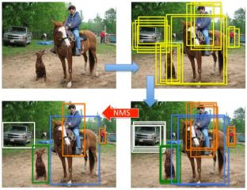
Figure 2.18 Schematic diagram of non-maximum inhibition
The non-maximum suppression algorithm takes as input the output of various detection methods, all candidate boxes generated by an image. First, all detection boxes are divided by category and deleted if background classes exist. Secondly, for each category to rank the bounding boxes from high to low by confidence, choose the bounding box with the highest confidence as the standard, compare the other bounding boxes with them, and calculate the intersection and ratio. If the intersection ratio is greater than the preset threshold, the rear bounding box is deleted and the process is repeated until the bounding box of a category is completed.last,Non-maximum suppression was applied for all categories, and the detection results after processing were output.

2.5 Summary of this chapter
This chapter summarizes and summarizes the basic knowledge of deep learning, common skeleton networks and non-maximum suppression. First, the basic principles of convolutional neural network, including convolution, pooling and activation function are introduced, the main neural network ResNet and ShuffleNetv2 Introduction; Finally, for the detection algorithm itself, we introduce the classical dual-stage detection algorithms Faster R-CNN and the single-stage detection algorithms YOLOv1 and SSD. In order to help in the subsequent understanding and detection.This chapter also introduces the concept of non-maximum suppression.

Chapter 3, SAR ship target detection for the improved YOLOv3
3.1 Introduction
With the support of many existing SAR ship detection data sets, the detection method of deep learning is directly applied to SAR image ship detection tasks, which can often achieve acceptable results. However, the current detection methods are mostly designed for optical images, and there are essential differences between the optical image imaging mode and the SAR imaging principle. The former depends on the light source, while the latter belongs to active imaging. In addition, there are great differences in resolution and view Angle between the two. Direct transferring detection methods from optical images to SAR images will lead to problems such as inaccurate detection, low recall rate, poor accuracy and large offset of the target frame.
This chapter improves on the YOLOv3 model using conventional convolution, proposing an enhanced YOLOv3 with the detection model for SAR image ship target detection tasks. However, the average accuracy increases from 93.21% to 96.94% compared with the original algorithm. In addition, by using the lightweight ShuffleNetv2 model as the lightweight skeleton network, the number of parameters was one-eighth of the original YOLOv3, but the detection performance was not available[24]
The large decrease, while maintaining high speed prediction, can realize the use of embedded.

3.2 Enhanced YOLOv3 test design
In this section, the enhanced YOLOv3 model is introduced first introduced, and then the specific parts of the implementation, such as feature extraction network, multiscale decoding structure and loss function, are introduced. The framework of the enhanced YOLOv3 model is shown in Figure 3.1:
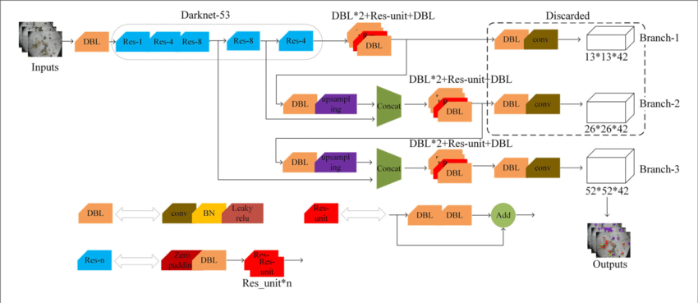
Figure 3.1, Enhanced YOLOv3 network structure
The framework of the improved YOLOv3 model proposed in this chapter can be composed of two parts: automatic feature extraction networks and the multiscale decoding structures. The final results are obtained by non-maximum suppression of all the detection box.The improvement scheme of this chapter retains the excellent structure of the network detection effect of YOLOv3: first, the multi-scale prediction of YOLOv3 is continued, and the large-scale feature map corresponds to the prediction of small targets, and the small-scale feature map corresponds to the prediction of large ship targets. In this way, the network's ability to detect targets of different scales can be effectively improved. Secondly, the idea of using the loss function and focusing on the small target is continued. Most SAR image ship target detection are small scale targets. Usually, in the case of small target prediction error, namely missed detection and false alarm, there is no too much impact on the overall loss function, and the trained network often does not pay attention to the small ship target. By changing the weight to tilt the loss function to the small ship target, the network model can be improved.
The following content will be on the feature extraction part and improvement, multi-scale decoding structure and loss function
Line introduction.
3.2.1 ResNet50-d skeleton network
Generally speaking, for the neural network used in optical images, the deeper the neural network, the stronger the ability to extract features, the larger the receptive field range acquired, and the richer the semantic information it contains. However, too deep convolutional neural network will make the gradient too small in the process of back propagation, so that it is difficult to update the shallow parameters of the network and the redundant features are not very obvious help for the detection and identification, so it cannot simply deepen and stack the neural network. The ResNet network structure design proposed by He Kaiming et al. cleverly solves this problem, while deepening the convolutional neural network and solving the problem of gradient disappearance, making it possible to train hundreds of layers of convolutional neural network. Moreover, the form of residual structure can establish constant mapping, without worrying too much about the network is too deep
The resulting overfitting problem.[25]
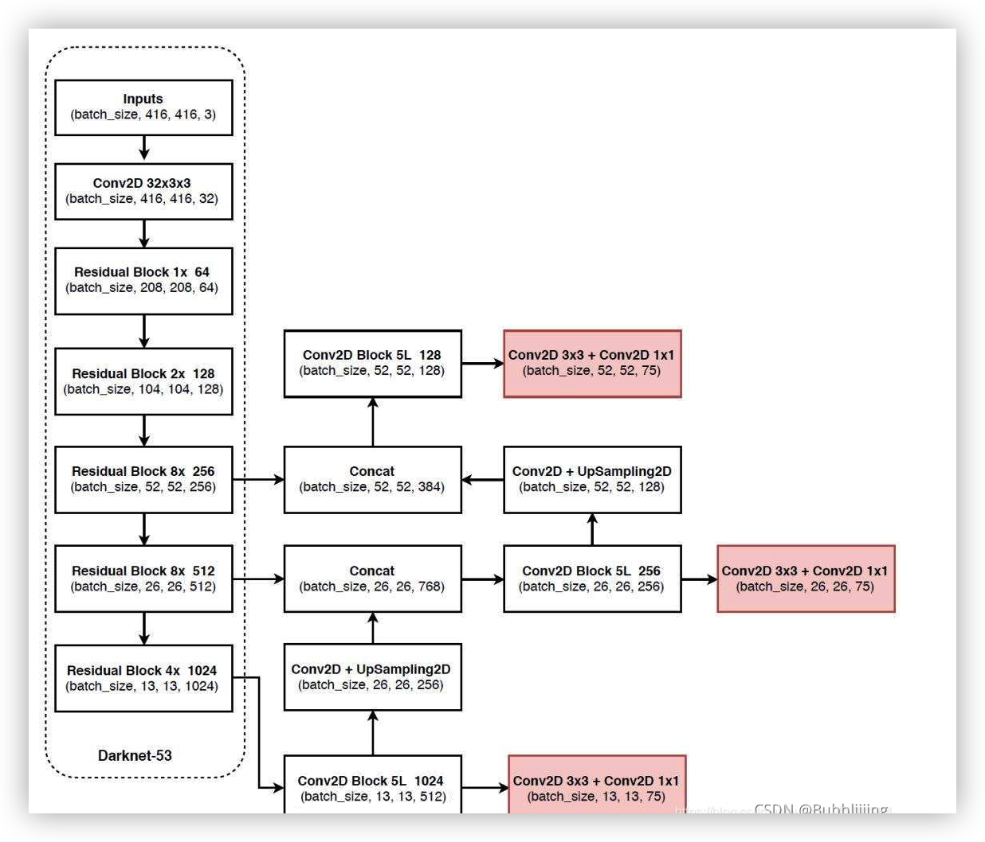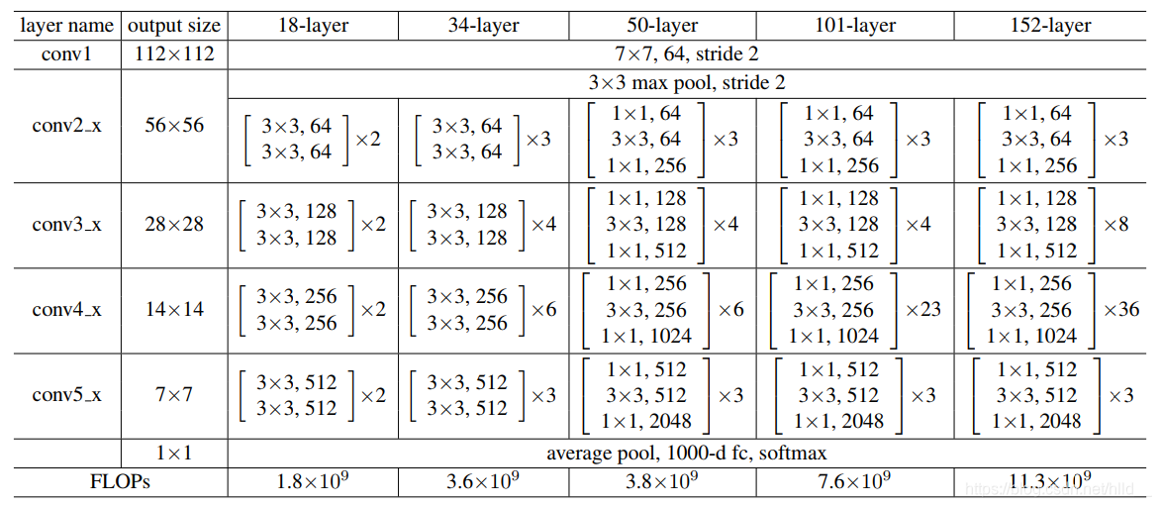
Figure 3.2 Feature extraction network. And DarkNet53 on the above and ResNet50 on the bottom.

The original YOLOv3 network designed a feature extraction network with DarkNet53 (see the above of Figure 3.2) to extract preliminary features for subsequent network decoding operation. It drew on the design mode of ResNet and network residual, and deepened the feature extraction network from the previously designed DarkNet19 to 53 layers. Considering two considerations, this chapter does not use DarkNet53 as a feature extraction network to improve the algorithm. On the one hand, different from the imaging mode of optical images, active microwave remote sensing SAR imaging does not contain the rich feature information in optical images, such as color, delicate texture, etc., and the use of too deep DarkNet53 does not benefit too much. On the other hand, the number of DarkNet53 parameters is larger than ResNet50, and the number of convolution layers is more, which is less flexible than ResNet50. This chapter finally uses the ResNet50 (see the bottom of Figure 3.2) instead of the DarkNet53 junction structure, to reduce the number of parameters and the number of repeat features.
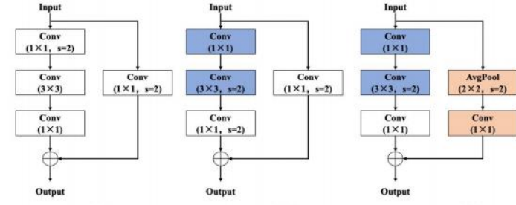
Figure 3.3 ResNet Comparison of dimension reduction of different structures

ResNet50 The improvement of the bottleneck structure is shown in the figure above. According to the content involved in the literature [84], only the change of the local structure can have a great impact on the effect of the classification. On the basis of the original bottleneck structure, ResNet50-b downsampling is implemented in the process of 33 convolution. However, the ResNet50-d structure used in this paper optimizes the jump connection branches, and the input features are first averaged pooling, and then the channel is adjusted by convolution with size 11 and step size 1. The classification effect of different bottleneck structures on the ImageNet dataset is shown in Table 3.1:[26]

Table 3.1 Comparison of the results of the different ResNet50 structures
model | #Params | FLOPs | Top-1 | Top-5
ResNet50 | 25M | 3.8G | 76.21 | 92.97
ResNet50-b | 25M | 4.1G | 76.66 | 93.28
ResNet50-d | 25M | 4.3G | 77.16 | 93.52

It can be seen that the improved ResNet50-d structure can effectively improve the recognition accuracy, and the amount of floating point operation increases when the number of parameters is consistent. However, relative to the original DarkNet53 structure,it is still down. In summary, the structure of ResNet50-d was adopted in the feature extraction stage.In order to further enhance the ability of network feature extraction and help detect ship targets, this chapter introduces deformable convolution in this structure.
3.2.2, deformable convolution
In the SAR image ship detection task, the target scale is not uniform and the shape is changeable. If the conventional convolutional neural network is used, there are inherent detection defects for large scale and unknown shape ship targets, resulting [27]in the detection effect performance is not excellent. This defect mainly comes from the inherent geometry of the conventional convolutional neural network: the convolution kernel
The fixed position of the input feature graph is sampled; the pooling layer pools the input feature graph with a fixed step size.The deformable idea can be well applied in SAR image ship detection tasks, with conventional convolution pairs as shown in Figure 3.4 below. The basic idea of deformable convolution is to learn an offset and weight on the sampling point,The convolution kernel focuses on sampling the region of interest or the target rather than a fixed location.
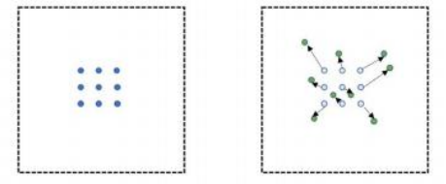
Figure 3.4 Comparison of conventional and deformable convolution

Definine conventional 33 convolution with expansion rate 1, the sampling point interval R = {(1,1), (1,0),..., (1,0), (1,1)}. For the input feature figure x, the output y of the corresponding feature figure position p0 is:
y(p0) = W(pn ) ∙ x(p0 + pn )
Where W represents is the weight for each sampled value. For the deformable convolution, an additional one is added deviant:
y(p0) = W(pn ) ∙ x(p0 + pn + ∆pn )
In practice, the resulting irregular sampling location is limited to keep it within the characteristics. Since the offset value pn is usually a decimal, it can be implemented by bilinear interpolation. The original version of deformable convolution has the problem that the position offset value is uncontrollable, leading to the local introduction of excessive context information and packets context information with much background does not improve the performance of the network and may damage the detection effect.
The deformable convolution improvement version introduces the method of weight value, which not only learns the offset value of the sampling points,
Also learning the weight value of each sampling point, the calculation formula is as follows:
y(p0) = W(pn ) ∙ x(p0 + pn + ∆pn ) ∙ ∆mn
The value of control weight can effectively reduce the influence of excessive context information, increase the greater degrees of freedom, and the unneeded sampling point weight can be learned as 0.
Assuming that the size of the convolution kernel used in the input feature map is k k, then N is:
N = k × k
Then the offset value of the parallel convolution network corresponds to the offset of the two dimensions of 2N, while the weight network is the weight value of each sampling point, and the number of channels corresponds to N. Although the deformable convolution is well adapted to the shape of the ship target, the introduction of the parallel convolutional neural network adds a lot of additional computation and parameters. If the deformable convolution, it will lead to a large number of parameters and the network is difficult to train. In addition, a slight disturbance of the shallow network has little impact on the subsequent deep network, while adding deformable convolution in the deep network, corresponding to the shallow network, which can capture the shape of the ship target and change the location of sampling points. Taken together, this chapter adds deformability to the feature extraction network for the improved ResNet50-d structure in the last downsampling stage convolution to achieve a good balance between the effect and the number of parameters.[28]
3.2.3 Multi-scale decoding structure
In the process of network realization, target detection can be divided into three parts: category decoding, confidence decoding and coordinate frame decoding. Due to constraints, SAR image ship target detection task is only ship target class
Category decoding is not considered. Confidence decoding can occupy a fixed position in the output dimension and is activated using Sigmoid Function, limited to the interval of 0~1. In order to adapt to the task of multi-scale ship target detection, the current inspection the test and decoding structure mostly adopts the multi-scale decoding scheme, as shown in Figure 3.5 below:
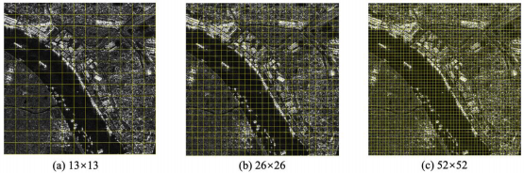
Figure 3.5Multi-scale decoding structure

Assuming that the input is 416 416 size image, 8,16, and 32 fold down sampled feature maps whose outputs are 52 52,26 26, and 13 13 size output, respectively. Multi-scale decoding structure detects ship targets on three different sizes: high-fold sampling corresponds to small feature maps, which can be used to predict larger scale ship targets; while low-fold sampling corresponds to large feature maps, which can be used to predict small rulerDegree ship target.[29]
The key to detection lies in the decoding of the coordinate frame, and the decoding at a certain scale is shown in Figure 3.6:
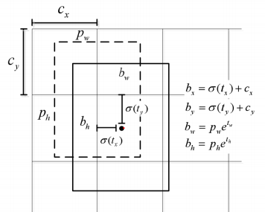
Figure 3.6 Schematic representation of single-scale decoding

The thin line frame is the mesh division form, the dashed line box is the preset anchor frame, and the solid line frame is the predicted bounding box. The coordinate value (tx, ty, tw, t ℎ) obtained through the convolutional neural network is not the final prediction result, but in the form of network encoding, which needs to be decoded. The decoding formula is as follows:
bx = σ(tx ) + cx
by = σ(ty ) + cy
bw = pw ℯ tw
bℎ = pℎ ℯ tℎ

Where cx and cyrepresents the upper left coordinate of the grid area of the detection center, pw and pℎ represent the width and height of the anchor box, while the σ function represents Sigmoid, σ (tx) and σ (ty) represent the offset of the detection center point relative to the upper left corner of the grid, which is restricted to the current grid by the Sigmoid activation function. In addition, ℯ tw and ℯ t ℎ represent the predicted broad offset, the resulting bw and b ℎ are the width and height of the final frame, and multiply the decoding bx and by by the adopted downsampling rate 8,16,32 to obtain the central coordinates of the predicted bounding box.
The above is the decoding process of a single scale. In general, the number of anchor boxes on each scale is set to 3, that is, three coordinate boxes and confidence degrees are separately predicted for each grid. After completing the prediction on the three scales, the non-maximum suppression of the result is the final boundary box of all the detected targets.

3.3 Test results and comparison
.In order to obtain the experimental results better, this chapter is conducted in Baidu's AI Studio cloud laboratory, and the domestic deep learning framework PaddlePaddle provided by Baidu is adopted. During the experiment, the hardware configuration 8 core CPU, 32GB memory, Tesla V100 graphics card and memory size of 16G.
The experimental dataset of this chapter uses the relatively common SSDD data set, which is published by Professor Jianwei Li of Naval Aviation University and contains 1160 images and 2358 ship targets. A single image in this dataset contains the number of ship targets ranging from 1 to 29, with an average of 2.03 ship targets per image. In addition, the ship target scale in the SSDD data set varies from 77 pixels to 211 298 large scale targets, with a variety of polarization methods, different resolutions, different offshore and offshore scenarios. To further verify the effect of the model, this section is also conducted on the SAR-Ship-Dataset dataset provided by the Chinese Academy of Sciences Test the effect test.
Since the SSDD data set is not divided in a unified way, in order to verify the comparison effect of each model, this paper is divided into a unified training set, 7:2:1 and test set according to the ratio. The test set contains 267 ship targets, which has fewer training samples and more test samples compared with most of the partition strategies in the literature.
The training process uses the RMSProp optimizer[30] and sets an initial learning rate of 0.001. The advantage of this optimizer is that it can adjust the learning rate adaptively. In addition, all models adopted the pre-training mode in transfer learning, 200 epochs were set for training, and batch size was set to 32. When training and epoch was a multiple of 4 or over 150, the model was verified, and the model parameters with the best validation set were saved. In order to further improve the performance of the model and enhance the generalization ability of the model, the method of data enhancement was also adopted in the experiment, mainly using random rotation, zoom, flip, translation, noise, contrast change and other schemes. Next, this section will be a detail of the experimental results
A detailed introduction was validated on two datasets, SSDD and SAR-Ship-Dataset.
3.3.1 Detection results and comparison of the SSDD dataset
This section will compare and explain the test results from two aspects: the test indicators, namely the table statistical form and the display of the test results, namely the test results diagram. Suppose the number of correctly detected (True Positives, TP) is TP, the number of ships missed (False Negatives, FN) is FN, the number of ships with false alarm (False Positives, FP) is FP, and the number of ships actually true (Ground Truth, GT) is GT.
The statistical results of the detection effect of each model are shown in Table 3.2:

Table 3.2 Statistics of the test results of each model
model | GT | TP | FN | FP
DarkNet53 | 267 | 255 | 12 | 32
ShuffleNetv2 | 267 | 257 | 10 | 29
ResNet50 | 267 | 259 | 8 | 38
ResNet50-d | 267 | 258 | 9 | 31
ResNet50-d-DCN | 267 | 261 | 6 | 29

The models in the table refer to the YOLOv3 series using different skeleton networks, where DarkNet53 refers to the original YOLOv3 model, while ShuffleNetv2 refers to the modified model of the lightweight design, ResNet50 andResNet50-d, is the intermediate model for the final improvement method ResNet50-d-DCN in this section.
It can be seen that on the unified divided data set, the improved enhanced YOLOv3 detected the largest number of ship targets, with the lowest false alarm and missed targets. In the test set of 125 images and 267 ship targets, the improved algorithm in this chapter correctly detected 261 targets, missed 6 targets and missed 29 targets. The original YOLOv3 detection algorithm correctly detected 255 targets, 12 missed targets, and 32 targets for false alarm. In addition, the lightweight model design and the improvement method give the intermediate process model good results.
In order to further reflect the detection performance of each model, the above preliminary results are analyzed in this section. Pd is assumed to be the detection probability, PMA is the missed probability, PFA is the false alarm probability, and PTed is the accuracy
Then:
Pd = = TP FN
PMA = = TPFN = 1 − Pd
PTed = 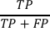
PFA = 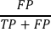 = 1 − PTed
Further analysis of the test results are shown in Table 3.3 below:

Table 3.3 Evaluation indexes of SSDD dataset
model | Pd (%) | PMA (%) | PFA (%) | PTed(%) | mAP(%) | #Params
DarkNet53 | 95.51 | 4.49 | 11.15 | 88.85 | 93.21 | 234M
ShuffleNetv2 | 96.25 | 3.75 | 10.14 | 89.86 | 92.84 | 27M
ResNet50 | 97.00 | 3.00 | 12.79 | 87.21 | 95.02 | 172M
ResNet50-d | 96.63 | 3.37 | 10.73 | 89.27 | 95.23 | 172M
ResNet50-d-DCN | 97.75 | 2.25 | 10.00 | 90.00 | 96.64 | 173M
The mAP in the table refers to the average accuracy (mean Average Precision, mAP), calculated public.
The formula is as follows:
mAP = AP = 1P(R)d(R)
The mAP used here is in the integral form, and P (R) refers to the precision-recall (Precision-Recall) curve. Because in the SAR image ship detection mission, only one category is included, it is not required for each category.Category AP is averaged, so mAP = AP.[31]
It can be clearly seen from Table 3.3 that compared with the original YOLOv3 model using DarkNet53, the algorithm ResNet50-d-DCN increases the mAP in the SSDD test set to 96.64%, 3.43% over the original model; while the false alarm rate and omission rate decrease, decreasing by 2.24% and 1.15% respectively. In addition, considering the size of the number of parameters of the model itself, the number of improved model parameters is 173M, which makes the number of model parameters reduced by 61M compared to the original YOLOv3 model. This fully shows that the method of improvement in this chapter is quite feasible. On the other hand, it is also clear that the detection model with lightweight design through ShuffleNetv2 achieves the minimum number of parameters, only 27M, but relative to the improved method in this paper.The measurement accuracy has been decreased.
Moreover, the comparison of different networks, such as the detection results of DarkNet53 with ShuffleNetv2 and ResNet50, can reflect some existing deficiencies. Using Darknet53, the model is not as effective as ResNet50 or even ShuffleNetv2 lightweight skeleton network, which is quite different from the phenomenon existing in optical images. There are two reasons: on the one hand, the SSDD data set is small, making is difficult to train the desired effect; on the other hand, considering the characteristics of the SAR image itself and the information it contains is not as rich as the optical image, the too deep and too complex network is available in SAR images.That's not so true.
In order to intuitively see the quality of the detection effect, this section, in addition to the above table and statistical results,The detection results of the algorithm in different scenarios in this chapter are presented, as shown in Figure 3.7:
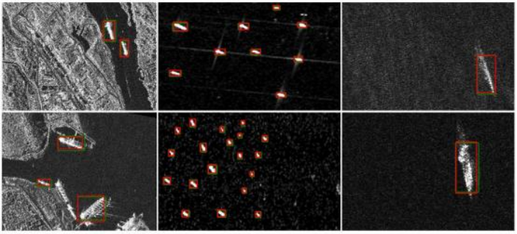
Figure 3.7 Test results of the improvement protocol in this chapter
In the figure, the left side shows the multi-scale detection of the near coast, the middle column shows the detection of dense small targets in the far sea, and the right column shows the large-scale target detection of the far sea. The green box is the actual real box, while the red box is the detection result of the algorithm. On the one hand, the detection results in different backgrounds and situations reflect the strong generalization ability of the improved model. The introduction of deformable convolution and other concepts improves the model performance and adaptability. On the other hand, the detection results are compared with the real annotation box, and the position offset is small, reflecting the strong positioning ability of the model. In the single-stage detection algorithm, the position offset is large, that is, the coincidence degree of the detection box and the real box is often relatively low, cross and relatively small, and the improved method in this chapter is very good for this problem adaptability.[32]
3.3.2 Detection results and comparison of the SAR-Ship-Dataset dataset
To further validate the improved model effects, in addition to the experiments on the SSDD dataset, the test effect was also verified on the SAR-Ship-Dataset dataset. The SAR-Ship-Dataset data set was published for the first time by the team of Digital Earth Key Laboratory of Space Information, Chinese Academy of Sciences. It is from multi-source and multi-mode SAR images. The data set is mainly based on the SAR data of Gaofen-3 and Sentinel-1 SAR data as the main data sources. The high-resolution SAR ship detection deep learning sample library constructed with 102 Gaofen-3 and 108 Sentinel-1 SAR images, including 43819.
Sections of 11 ships.Compared with the SSDD dataset, the SAR-Ship-Dataset dataset is unified in size of 256 256, with larger data volume, including scenarios and more complex background is a very good dataset for the current study. The above content in this chapter already well describes the improvement of algorithms and the specific process of training and verification on SSDD datasets. This section will focus on applying the proposed enhanced YOLOv3 detection algorithm to the SAR-Ship-Dataset data set, and analyze and discuss different scenarios and situations as well as the problem of detection errors,ensure that the content of this section is different from the aforementioned SSDD test results, and can reflect the effectiveness of the improved algorithm from differentangles. 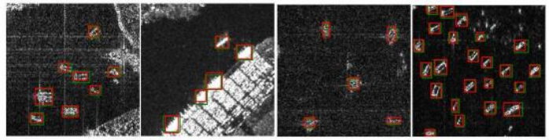 a b
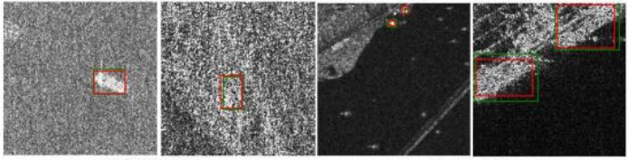
c d
Figure 3.8 Results of SAR-Ship-Dataset detection based on the modified YOLOv3
In Figure 3.8, (a) reflects the detection of dense targets near the coast; (b) reflects the detection of dense small targets on the original coast; (c) reflects the detection of the ship under strong noise interference; and (d) reflects the detection of multi-scale targets. The test results can be analyzed from four aspects: First, it can be seen from the figure that the red detection box and the real marked green box are relatively large, and the offset is small. This again shows that the improved single-stage detection algorithm enhanced YOLOv3 has a strong ability to capture range and localization. Secondly, in different backgrounds such as near coast or far sea, the improved algorithm has a strong adaptability and can distinguish the background and the ship target. Thirdly, under the strong noise interference, the improved algorithm can also achieve relatively good detection performance, which fully shows that the algorithm has relatively good anti-interference ability. Finally, in the detection situation at different scales, whether the proportion of the target is too large or far above the background or far below the background, the improved algorithm can detect the ship target. On the experimental results of the SSDD dataset, this can again show that the algorithm is extremely adaptable to multi-scale targets and is suitable for different ruler detection of ship targets under degrees.[33]
Figure 3.9 reflects the false alarm and omission situation of the improved enhanced YOLOv3 detection algorithm. False alarm and missing detection in the SSDD dataset are shown on the left, and false alarm and missing detection in the SAR-Ship-Dataset dataset are shown on the right. It can be seen that the false alarm and missed detection are mainly the identification of ship targets and islands and the distinction between ships and background noise.
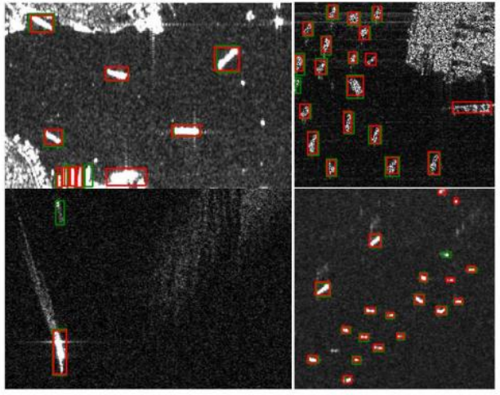
a b
Figure 3.10 False alarm and missed detection of enhanced YOLOv3
For the above problems, the following analysis: on the one hand, the near coast ship detection is too complex, the target and background are not clear, and the ship distance is easy to produce missed detection, the ship target is easy to drown in the noise interference, missed detection. On the other hand, some islands show similar characteristics with the coast and ship targets, and the convolutional neural network cannot ignore whether the similar islands or the coast are ship targets and cause false alarm. In addition, the setting of the confidence threshold during the experiment will also lead to the different final detection results, too high the threshold will lead to excessive missed detection, and pass low false alarm is easy to produce false alarm situation.

3.4 Summary of this chapter

This chapter optimizes and improves the YOLOv3 model commonly used for real-time detection in natural image scenes, and proposes an enhanced single-stage detection algorithm. On the basis of multi-scale decoding structure, the algorithm can realize the detection of ship targets at different scales and have strong adaptability. By integrating the idea of deformable convolution, the improvement algorithm can better adapt to the shape adaptive selection of the ship target for convolution operation and give considerable weight. In addition, in order to achieve more efficient ship detection, this chapter believes that the too-deep feature extraction network may be redundant in the SAR images. Through the optimization of the skeleton network, such as ResNet50-d, ShuffleNetv2, etc., it can obtain a good detection result, which can be verified in the SAR ship detection task that in the deep network is not as good as the efficient network design.
To verify the effectiveness of the improved algorithm, this chapter is unified, divided and tested on two datasets, SSDD and SAR-Ship-Dataset, and makes a considerable comparison with the original YOLOv3 detection algorithm. The experimental results of the SSDD data set show that the improved detection algorithm can effectively improve the detection performance, reduce the false alarm and missed detection cases, and the model size is much smaller than the original YOLOv3 model. Further lightweight detection model can reach one-eighth of the original model, which can realize the use of mobile terminals. In addition, the algorithm still has some deficiencies to some extent. For example, although the ship target in complex background has been improved, it has still not been completely solved, and the ship target close to it is still easy to miss detection, which is also what needs to be improved later. And questions about the model generalization ability, the current detection algorithm are basically training on a single data set and, testing, data set makes the training on a single data set model is difficult to directly applied to it, his data set or scenario, the robustness of the current algorithm puts forward a big challenge, this part is the part of this article.

Chapter 4 the integration of lightweight SAR ship target detection and segmentation is realized
4.1 Introduction
This chapter aims to make lightweight design of the model while realizing detection through semantic segmentation, so as to add some possibilities for practical application. Under this consideration, this chapter proposes a lightweight real-time detection segmentation network LRSNet network, and the number of parameters is only 8.4M, which is one thirtieth of the YOLOv4 model, but the effect achieves the detection effect of YOLOv4.[34]

4.2 LRSNet lightweight detection segmentation model
In this chapter, the characteristics of the UNet-S model are extracted, and the lightweight model ShuffleNetv2 is integrated as the skeleton network, and a simple integrated detection and segmentation network LRSNet is designed. See Section 2 for the ShuffleNetv2, and the references in this chapter will be analyzed in other ways. The UNet-S detection segmentation model improves the typical UNet network structure. The most important feature of the latter is the multi-scale fusion of spatial location information and semantic information. In the decoding process, the position information of shallow network is combined with the semantic information of deep network. The design idea can be shown in Figure 4.1 below:
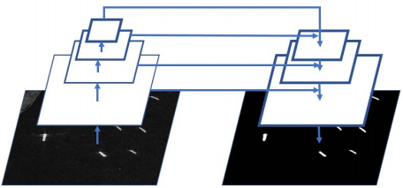
Figure 4.1 Design Idea

The overall design idea is very similar to the structure of the characteristic pyramid. The difference is that the feature processing method here is the splicing form, while the feature pyramid is the way of element addition. The advantages of this design are that: on the one hand, it captures rich semantic information and location information at the same time, and combines the two through layer by layer fusion. On the other hand, similar to multi-scale prediction recovery structure, deep networks can be used to represent large scale targets and recover layer by layer, while shallow networks represent small scale targets, directly fusion to obtain the final result. In this idea, this chapter puts forwardLRSNet, as shown in Figure 4.2:
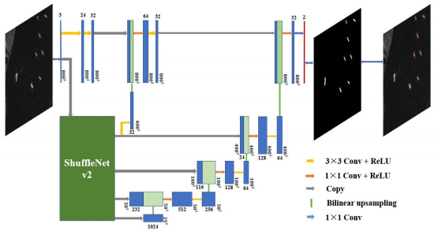
Figure 4.2, lightweight LRSNet detection and segmentation integration model
LRSNet Using ShuffleNetv2 as the skeleton network can greatly reduce the number of parameters, and the multiscale features of the backbone network ShuffleNetv2 are used for fusion in the decoding stage. Considering that the maximum scale feature map output by the lightweight model ShuffleNetv2 is 400 400 and the final result scale is 800 800, the LRSNet model additionally added the convolution module to extract features of small targets and accurate location information for subsequent feature fusion and result generation. To further compress the number of parameters,convolution in decoding .This chapter also tries to use depth separable convolution instead of implementation.[35]
Conventional convolution is convolution through multiple multichannel convolution kernels with multi-channel input. The depth separable convolution is composed of packet convolution (channel convolution) and point convolution (11 convolution). First, the convolution of the channel convolution to obtain the intermediate result, and then the output feature is adjusted through the point convolution and the information fusion. Assuming that the input feature graph channels are M, the size is DFDF, using N standard convolution, step size of 1 and fill, the output feature graph is DFDFN. If the standard convolution kernel size is DkDkMN, the conventional convolution calculation quantity CG is:
CG = Dk ⋅ Dk ⋅ M ⋅ N ⋅ DF ⋅ DF
Using the deep separable convolution scheme, the input feature map of M channels are convolved to obtain the intermediate output feature map of DFDFM, and then the final output feature map of DFDFN is fused through 11 MN convolution to adjust the channel.The calculated amount of the CD is as follows:
CD = Dk ⋅ Dk ⋅ M ⋅ DF ⋅ DF + M ⋅ N ⋅ DF ⋅ DF
Then the ratio of the two calculations Rc is:
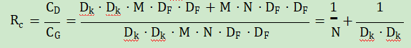
Since the number of channels N tends to be set up very large, its inverse can be ignored. Assuming 33 convolution, depth separable convolution can reduce the number of parameters to one ninth compared to conventional convolution.

4.3 Experimental results and analysis
In this chapter, HRSID dataset is also used for algorithm verification. Since HRSID dataset provides instance labels, the instance labels can be transformed to obtain the required semantic labels for the training of the model.
The LRSNet network in this chapter realizes the integration of detection and segmentation through semantic segmentation, and can obtain the segmentation results and the detection box of ship targets simultaneously. Therefore, LRSNet can also analyze the experimental results from the perspective of segmentation and detection, respectively. The results of the experiment are shown as follows:[36]

Table 4.1 LRSNet, the semantic segmentation results
classification | DWS | MIoU(%) | MPA(%)
 | x | 99.82 | 99.91
background |  | 99.81 | 99.96
warships | x | 63.37  54.75 | 77.57  59.87
amount | x | 81.60  77.28 | 88.74  79.92

Table 4.2 LRSNet, mean accuracy index
model | DWS | AP | AP0.5 | AP0.75 | APs | APm | APl
YOLOv4 | — | 0.376 | 0.788 | 0.324 | 0.390 | 0.367 | 0.088
LRSNet | x | 0.423 | 0.635 | 0.472 | 0.426 | 0.455 | 0.145
LRSNet |  | 0.426 | 0.617 | 0.484 | 0.435 | 0.423 | 0.093

Table 4.3 LRSNet Mean recall index
model | DWS | The number of parameters | AR | ARs | ARm | ARl
YOLOv4 |  | 244.4M | 0.438 | 0.434 | 0.495 | 0.233
LRSNet | x | 12.9M | 0.601 | 0.597 | 0.657 | 0.370
LRSNet |  | 8.4M | 0.595 | 0.600 | 0.604 | 0.178
Where, DWS refers to whether a depth-separable convolution is used. According to the detection results in the above table, the LRSNet with depth separable convolution and the model without depth separable convolution have similar performance in the detection results, which are better than the YOLOv4 detection model in all aspects, and the number of parameters in the former is respectively 8.4M and 12.9M are much less than the number of YOLOv4. For the more refined segmentation index, Table 4.1 shows.In order to see, the performance of the LRSNet model using deeply separable convolution has decreased compared with the unused model, but it still has a good feature in the detection level, which is reduced at the expense of fine results, which is acceptable within a certain range. Specific detection and segmentation.
The results are shown Figure below. 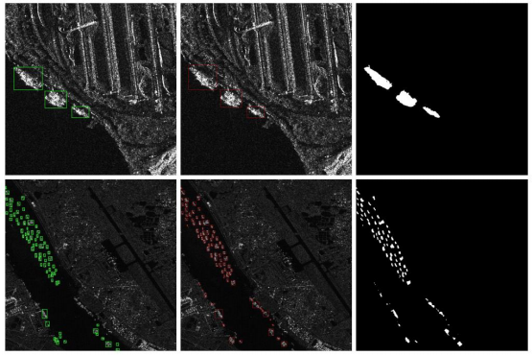
Figure 4.3 Detection and segmentation results of the LRSNet model

The green box in the left column of the figure represents the actual marked detection box, the red box in the middle column is the result of the algorithm implemented in this chapter, and the black and white image in the right column is the segmentation result of the algorithm in this chapter. As you can see, under the background of complex, multi-scale and dense small target detection problem, the algorithm of this chapter can achieve a good result, there are still the characteristics of the proposed features: position small offset frame, accurate segmentation and less false alarm and detection, then considering the parameters of this chapter algorithm number is only 8.4M, to use reality has certain reference act on.[37]
4.4 Summary of this chapter
Based on the theory and analysis of the previous chapter, we have designed a LRSNet model of lightweight detection and segmentation network. This model has good characteristics. While achieving the detection effect of single-stage excellent YOLOv4, it can segment the results and obtain a more refined outline. In addition, the number of LRSNet model parameters is only 8.4M, one-30 of YOLOv4 model and one-eleven of UNet-S, which provides a feasible scheme for practical application from the perspective of parameters. Further considering the practical feasibility, we can combine the realization ideas of this chapter and the previous chapter with the traditional CFAR detection, and integrate different methods to distinguish from the discriminant layer.
Chapter 5 Summary and outlook
5.1 Summary
Data-driven deep learning detection algorithm has also been widely tried and used in the field of SAR image detection, but there are still many other limitations and deficiencies. In terms of detection results, the effect needs to be further improved; in terms of the idea of implementation, the decoding results based on computer vision are too complex to understand; and in terms of practical application, the number of detection model parameters is often too large, reducing the possibility of practical application. This paper fully studies and discusses the use of the deep learning-based detection methods for SAR image detection tasks, puts forward several problems of these methods for SAR image ship detection, and divides the work into two.
In different periods, namely two different solutions to solve the proposed problems, the main contents are as follows:[38]
(1) The main problems of deep learning in SAR image ship detection include: poor multi-scale ship target detection effect, serious leakage of small ship target, and serious false alarm under coherent spot noise and complex background interference. In this paper, an improved YOLOv3 detection model is proposed by the deep learning detection algorithm to solve the above problems, and the good experimental results are obtained on multiple data sets. Based on the decoding idea of YOLOv3 model, the clustering anchor frame as the benchmark, the multi-scale decoding structure, the idea of variable and type convolution, it obtains a performance improvement model, which is suitable for multi-scale ship target, small ship target detection and other problems. In addition, supplemented by the lightweight model design and the network structure of ShuffleNetv2, the model can be used in the mobile terminal platform to realize the detection of SAR image ship targets.
(2) The detection method of deep learning has an extremely complex decoding structure, which is difficult to understand intuitively. Instead, the regression of position information weakens the expression of semantic information, which leads to the poor generalization ability of the model in the SAR image ship detection task. Considering that the detection method of deep learning is not completely equivalent to SAR image ship target detection, this paper proposes the integration method of ship target detection and segmentation through the full convolutional neural network, which can obtain more refined contour and segmentation results while obtaining the detection results. In this paper, we use the simplest full convolutional UNet to experiment as the basic network, and integrate empty convolution and the optimization of loss function, which achieve extremely good detection performance. The experimental results show that the simplest full convolutional structure has the performance of a typical two-stage detection algorithm and the model is easy to understand. In a single data set, it is also good for other detection.
Methods do not have the characteristics of the method.
- On the basis of the above realization of SAR image ship target detection based on semantic segmentation, this paper adds a lightweight model design. On the basis of maintaining a good model generalization ability, the model parameters are greatly reduced to make the possibility of practical application higher. In this paper, the LRSNet is an integrated model of lightweight detection and segmentation based on ShuffleNetv2. Its detection effect exceeds the current excellent single-stage detection algorithm YOLOv4, while the model size is only 8.4M, 1 / 30 of YOLOv4.

5.2 Outlook
The preliminary work idea of this paper has analyzed and verified the SAR images from the perspective of deep learning[39] detection. The improved YOLOv3 model has good detection performance, but it also causes further thinking in this paper. In the process of practical application, the generalization ability of the model and the feasibility of practical application need great attention. However, the current common detection model can only be trained on a single data set and test set separated from the same distribution. When applied in other data sets, the model generalization ability is extremely poor due to the ship target scale. The later thinking is a further thinking of this problem, and tries to obtain the detection and segmentation results from the perspective of semantic segmentation. Because the implementation idea is not directly regression to the position coordinate of the detection box, but using the way of semantic information discrimination, it can retain the generalization ability of the model as much as possible. The experimental results also show that the model trained in a single data set can be directly used in other SAR ship detection data sets to achieve quite good detection effect.
The later realization of the detection idea in this paper is only a preliminary realization, and there are still many areas to be improved.did not
The study aspect can be conducted from two aspects:
(1) Lightweight detection and segmentation model optimization. The LRSNet network involved in this paper is only a preliminary integrated idea of lightweight detection and segmentation, and there are still many ways to improve the effect of detection and segmentation
Is the next main concern.
(2), and combined with conventional CFAR detection methods. CFAR detection method is a practical detection method with good performance, which should not be abandoned for the current development trend. Thanks to the experimental ideas in the later stage of this paper, the results can be combined with CFAR test results can be used for discrimination, which is also the research problem that will be tried in the future.

Appendix 1: logbook
Ship Image Object Detection Study Log

July 2023

July 1, 2023
Today marks the start of my journey into ship image object detection. I've set my goals for the next three months: become proficient in computer vision, learn about object detection algorithms, and develop practical skills in implementing these techniques. I began by researching the basics of computer vision and familiarizing myself with the relevant libraries, such as OpenCV and TensorFlow.

July 13, 2023
I completed several online courses on computer vision fundamentals and deep learning. This week, I focused on understanding Convolutional Neural Networks (CNNs), which are essential for object detection tasks. I also started experimenting with simple image classification models using TensorFlow and Keras.

July 21, 2023
I delved deeper into object detection algorithms, specifically the two-stage detectors like Faster R-CNN and single-stage detectors like YOLO (You Only Look Once). I set up a development environment with GPU support for faster model training and testing.

July 29, 2023
I began working with image datasets that contain ship images. Data preprocessing has been a significant task, involving data augmentation, resizing, and labeling. I've collected a substantial dataset, which I will use for training and validation.

August 2023

August 10, 2023
I started implementing a simple object detection model using TensorFlow's Object Detection API. I used a pre-trained model (SSD) and fine-tuned it on my ship image dataset. Initial results are promising, but there's still much room for improvement.

August 26, 2023
I continued fine-tuning my model, experimenting with hyperparameters, and optimizing the training process. I also explored transfer learning with different backbone architectures like ResNet and MobileNet. Model evaluation and metric tracking are crucial to measure progress accurately.

August 30, 2023
I spent the past week optimizing model performance and efficiency. I implemented non-maximum suppression (NMS) to remove redundant bounding boxes and achieved better results. I also explored techniques like anchor box tuning and focal loss to handle imbalanced classes in the dataset.

References
[1] Hadji I, Wildes R P. What do we understand about convolutional networks? [J]. arXiv preprint arXiv:1803.08834, 2018.
[2] Aloysius N, Geetha M. A review on deep convolutional neural networks[C]. 2017 International Conference on Communication and Signal Processing (ICCSP). IEEE, 2017: 0588-0592.
[3] 陈冬,句彦伟.基于语义分割实现的 SAR 图像舰船目标检测[J/OL].系统工程与 电 子 技 术 : 1-10[2021-10-29]. http://kns.cnki.net/kcms/detail/11.2422.TN.20210910.1450.008.html
[4] 艾加秋, 曹振翔, 毛宇翔, 等. 一种复杂环境下改进的 SAR 图像双边 CFAR 舰船检测算法[J]. 雷达学报, 2021, 10(4): 499 –515.
[5] 赵明波, 何峻, 付强. SAR 图像 CFAR 检测的快速算法综述[J].自动化学报2012, 38(12): 1885-1885.
[6] Cozzolino D, Verdoliva L, Scarpa G, et al. Nonlocal CNN SAR image despeckling[J]. Remote Sensing, 2020, 12(6): 1006.
[7] Wang P, Zhang H, Patel V M. SAR image despeckling using a convolutional neural network[J]. IEEE Signal Processing Letters, 2017, 24(12): 1763-1767.
[8] Kahraman S, Bacher R. A comprehensive review of hyperspectral data
fusion with LiDAR and SAR data[J]. Annual Reviews in Control, 2021.
[9] Hu J, Mou L, Schmitt A, et al. FusioNet: A two-stream convolutional neural network for urban scene classification using PolSAR and hyperspectral data[C]. 2017 Joint Urban Remote Sensing Event (JURSE).
IEEE, 2017: 1-4.
[10] 邹成晓 , 张海霞 , 程 玉 堃 . 雷 达 恒 虚 警 率 检 测 算 法 综 述 [J].雷达与对抗,2021,41(02):29-35.
[11] CRISP D J. The state-of-the-art in ship detection in synthetic
aperture radar imagery[R]. DSTO-RR-0272, 2004: 2 –30.
[12] Ai J, Cao Z, Xing M. An adaptive-trimming-depth based CFAR detector of heterogeneous environment in SAR imagery[J]. Remote Sensing
Letters, 2020, 11(8): 730-738.
[13] Qin X, Zhou S, Zou H, et al. A CFAR Detection Algorithm for Generalized Gamma Distributed Background in High-Resolution SAR Images[J]. IEEE Geoscience and Remote Sensing Letters, 2013,
10(4):806-810.
[14] Krizhevsky A, Sutskever I, Hinton G E. ImageNet classification with deep convolutional neural networks[J]. Communications of the ACM,
2017, 60(6): 84-90.
[15] Simonyan K, Zisserman A. Very deep convolutional networks for large- scale image recognition. arXiv[J]. arXiv preprint arXiv:1409.1556,
2018.
[16] He K, Zhang X, Ren S, et al. Deep Residual Learning for Image Recognition[J]. IEEE, 2016.
[41] Szegedy C, Liu W, Jia Y, et al. Going Deeper with Convolutions[J].
IEEE Computer Society, 2014.
[17] Zhang H, Wu C, Zhang Z, et al. Resnest: Split-attention networks[J].
arXiv preprint arXiv:2004.08955, 2020.
[18] Howard A G, Zhu M, Chen B, et al. Mobilenets: Efficient convolutional neural networks for mobile vision applications[J]. arXiv preprint
arXiv:1704.04861, 2017.
[19] Sandler M, Howard A, Zhu M, et al. Mobilenetv2: Inverted residuals and linear bottlenecks[C]. Proceedings of the IEEE conference on
computer vision and pattern recognition. 2018: 4510-4520.
[20] Howard A, Sandler M, Chu G, et al. Searching for mobilenetv3[C]. Proceedings of the IEEE/CVF International Conference on Computer
Vision. 2019: 1314-1324.
[21] Zhang X, Zhou X, Lin M, et al. Shufflenet: An extremely efficient convolutional neural network for mobile devices[C]. Proceedings of the IEEE conference on computer vision and pattern recognition. 2018:
6848-6856.
[22] Ma N, Zhang X, Zheng H T, et al. Shufflenet v2: Practical guidelines for efficient cnn architecture design[C]. Proceedings of the
European conference on computer vision (ECCV). 2018: 116-131.
[23] Jiao L, Zhang F, Liu F, et al. A survey of deep learning-based object
detection[J]. IEEE access, 2019, 7: 128837-128868.
[24] Minaee S, Boykov Y Y, Porikli F, et al. Image segmentation using deep learning: A survey[J]. IEEE Transactions on Pattern Analysis
and Machine Intelligence, 2021.
[25] He T, Zhang Z, Zhang H, et al. Bag of tricks for image classification with convolutional neural networks[C]. Proceedings of the IEEE/CVF Conference on Computer Vision and Pattern Recognition. 2019: 558-
567.
[26] McMahan B, Streeter M. Delay-tolerant algorithms for asynchronous distributed online learning[J]. Advances in Neural Information
Processing Systems, 2014, 27: 2915-2923.
[27] Tan C, Sun F, Kong T, et al. A survey on deep transfer learning[C]. International conference on artificial neural networks. Springer,
Cham, 2018: 270-279.
[28] Minaee S, Boykov Y Y, Porikli F, et al. Image segmentation using deep learning: A survey[J]. IEEE Transactions on Pattern Analysis
and Machine Intelligence, 2021.
[29] SHELHAMER E, LONG J, DARRELL T. Fully Convolutional Networks for Semantic Segmentation[J]. IEEE Transactions on Pattern Analysis and
Machine Intelligence, 2017, 39(4): 640-651.
[30] RONNEBERGER O, FISCHER P, BROX T. U-Net: Convolutional Networks for Biomedical Image Segmentation[C]. Proc. of the Medical Image Computing and Computer-Assisted Intervention – MICCAI 2015. 2015:
234-241.
[31] BADRINARAYANAN V, KENDALL A, CIPOLLA R. SegNet: A Deep Convolutional Encoder-Decoder Architecture for Image Segmentation[J]. IEEE Transactions on Pattern Analysis and Machine Intelligence, 2017,
39(12): 2481-2495.
[32] CHEN L, PAPANDREOU G, KOKKINOS I, et al. DeepLab: Semantic Image Segmentation with Deep Convolutional Nets, Atrous Convolution, and Fully Connected CRFs[J]. IEEE Transactions on Pattern Analysis and
Machine Intelligence, 2018, 40(4): 834-848.
[33] Shen L, Lin Z, Huang Q. Relay Backpropagation for Effective Learning of Deep Convolutional Neural Networks[C]//Lecture Notes in Computer Science (Including Subseries Lecture Notes in Artificial Intelligence and Lecture Notes in Bioinformatics). . DOI:10.1007/978-3-319-46478-7_29.
[34] Richard M D, Lippmann R P. Neural Network Classifiers Estimate Bayesian a Posteriori Probabilities [J]. Neural Computation, 1991. DOI:10.1162/neco.1991.3.4.461.
[35] Musgrave K, Belongie S, Lim S N. A Metric Learning Reality Check[C]//Lecture Notes in Computer Science (Including Subseries Lecture Notes in Artificial Intelligence and Lecture Notes in Bioinformatics). . DOI:10.1007/978-3-030-58595-2_41.
[36] Hadsell R, Chopra S, LeCun Y. Dimensionality Reduction by Learning an Invariant Mapping[C]//Proceedings of the IEEE Computer Society Conference on Computer Vision and Pattern Recognition. . DOI:10.1109/CVPR.2006.100.
[37] Weinberger K Q, Saul L K. Distance Metric Learning for Large Margin Nearest Neighbor Classification[J]. Journal of Machine Learning Research, 2009. DOI:10.1145/1577069.1577078.
[38] Pouyanfar S, Tao Y, Mohan A, et al. Dynamic Sampling in Convolutional Neural Networks for Imbalanced Data Classification[C]//Proceedings - IEEE 1st Conference on Multimedia Information Processing and Retrieval, MIPR 2018. . DOI:10.1109/MIPR.2018.00027.
[39] Lawrence S, Burns I, Back A, et al. Neural Network Classification and Prior Class Probabilities[J]. Lecture Notes in Computer Science (Including Subseries Lecture Notes in Artificial Intelligence and Lecture Notes in Bioinformatics), 2012. DOI:10.1007/978-3-642-35289-8- 19.

