

LCLM 4006 - Enterprise & Entrepreneurship
Component 1: Business Plan

Student Name: Mark Tunnicliffe
Student Number: 2512864
Lecturer Name: Doreen Amundam
Module Lead: Chung Lai Johnny Wan



Executive Overview
This business plan will outlay in depth the research, strategies and findings of future enterprise of Trinium Limited which plans to bring a new contender to the console gaming space. The subjects of presentation for this enterprise are as follows;
- A business overview including its unique selling point.
- A justification for the type of legal classification for the enterprise.
- A justification for the starting management team of the enterprise.
- A SWOT analysis of the relevant industry/market.
- A PESTEL analysis based on the findings of the SWOT analysis.
- Conducting efficient and relevant marketing research.
- Conclusion of the data’s finding and which demographic to target.
- A brief description of the enterprise’s competitors in the industry.
- A rundown of the first month’s expenditure and funding estimates.
All of the findings in this business plan will help Trinium Limited to be structured and enter the UK market as proactively as possible. Trinium will look to expand into more global markets after establishing itself as a viable rival to the industry juggernauts.
This will have a double effect on desirability as starting only in the UK will give Trinium’s product region exclusivity, a common trait of some of the bestselling products across the world.
Pokémon is a notable example as collectors no longer just collect cards from their own regions but also from sets exclusive to countries such as China and Japan. Some of the more niche collectors even going as far as European language sets.
Finally, Trinium Limited plans to expand into multi-channel sales including; in house game development studios, first party game franchises, integration into the PC gaming markets and branded merchandising.

Table of Contents

Executive Overview 2
Business Overview 4
Starting Management Team 5
SWOT Analysis of the Gaming Industry 6
PESTEL Analysis 7
Market Research & Competition 8
Age Demographics 8
Gender Demographics 9
Spending Habits 10
Competition 11
Funding & Expenditure 11
Reference List 12
Image Links 13

Business Overview
The enterprise I intend to register with companies house and establish in 2026 is named Trinium Limited this enterprise will be a technology company that operates within the videogame market and will be positioned as a UK contender against the likes of Microsoft (Xbox), Sony (PlayStation) and Nintendo.
Initially, the company will only trade and operate in the UK, established in Leicester, England, which will also be the location for the office address registered with Companies House.
Trinium Limited will use its initial funding and resources concentrating on three main objectives;
- Designing and manufacturing a console prototype/developer kit.
- Designing a professional website and companion mobile app.
- Creating brand awareness and opening social media channels.
Trinium Limited will also deliver the unique selling point that separates its product from its competitors; lifetime backwards compatibility for first party games, by having built in software to natively run/emulate older generation titles.
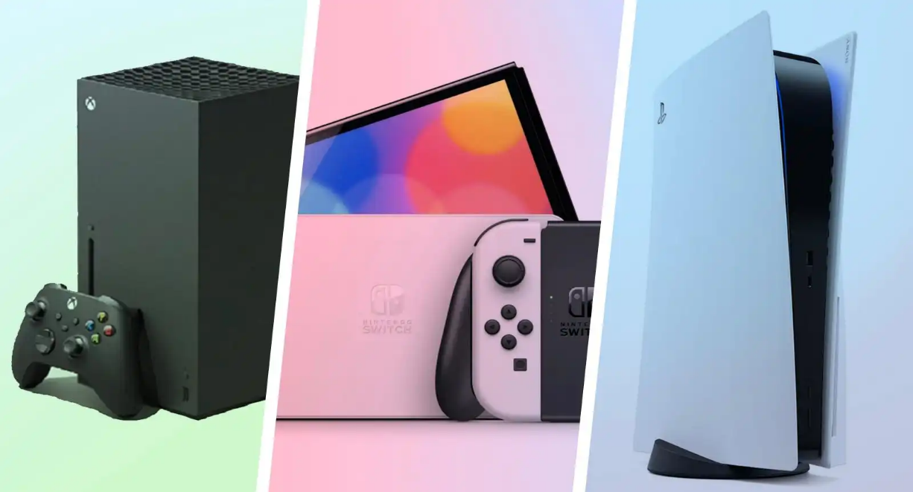
This is especially important to the wider gaming community as recent events like the “Stop killing games” movement has made appearances in the European parliament after Ubisoft made their live service open world racing game ‘The Crew’ unplayable and unpurchaseable through complete server shutdowns and marketplace delisting.
Enterprise Legal Format
I intend to setup this enterprise legally as Trinium Limited and have checked if this name is available on the government name checker website.
Despite being more expensive to start up initially, objectively, there are several advantages to this over an enterprise startup as a sole trader. Some of these advantages include;
- Some businesses will only interact with other limited companies.
- Other businesses consider limited companies to be more “professional”.
- No two limited companies can share names, ensuring a unique brand.
- Limited companies are tax efficient and offer company pensions and benefits.
- Limited companies are registered as separate legal entities from the owner(s).
- Limited company owners are typically not liable for the debts of the company.
- Limited companies can use shares to onboard new directors.

Starting Management Team
It is critical for small business leaders to understand that each stage of an organisation’s lifecycle brings with it different opportunities and challenges that should be dealt with by adopting different leadership techniques. A ‘one-size-fits-all’ approach will not work and could even become detrimental in the long term. (G. Pillai, 2022)
To minimise costs and onboard talent quickly, Trinium Limited will focus on hiring a small pool of multi-skilled managers. This will aim not only to create a tight knit group of decision makers, but also to avoid unnecessary points of conflict from too many sources of influence.
Directors
Chief Executive Officer
Chief Technology Officer
Chief Operations Officer
Strengths | Weaknesses
- Long history of innovation and resiliency.  - Widely popular digital properties.  - Strong partnerships with global brands.  - Differentiated customer segmentation.  - Brand loyalty & reputation.  - Easy to use software.  - Strong distribution channels.  - Robust financial performance. | - Lagging supply chain management.  - Ineffective pricing strategies.  - Over reliance on developed markets.  - Skewed revenue streams.  - Dependence on hardware manufacturers.  - Security flaws.  - Mature PC markets.  - Slow to innovate.  - Meeting consumer standards & expectations.
Opportunities | Threats
- Expansion into emerging markets.  - Exploration of disruptive technologies.  - Becoming a more open gaming ecosystem.  - Growing E-sports popularity.  - Cloud based services.  - Augmented gaming experiences.  - Mobile device industry.  - Growth through acquisitions. | - Intensifying competition in the gaming console space.  - Continued popularity of mobile games.  - Supply chain disruptions.  - Intellectual property infringement.  - Open-source projects.  - Potential lawsuits.  - Net zero policies.  - Consumer data hijacking

SWOT Analysis of the Gaming Industry
Adapted from: SWOT Analysis in Handbook of Improving Performance in the Workplace: Volumes 1-3. (2009)

PESTEL Analysis
The SWOT analysis (See p.6) examines the gaming industry by its strengths, weaknesses, opportunities, and threats. Furthermore, it assesses the internal and external factors affecting the business environment while looking at its current and future potential. Those factors are sorted into the six analytical categories in the table below to enable how to identify and best take advantage of or mitigate those factors.
Political
- Regulations
- Licences
- Responsible gambling
- Taxation/revenue
Economical
- Market growth
- Operational costs
- Profitability
- Investment
Social
- Consumer habits
- Consumer preferences
- User engagement
- Demographic shifts
Technology
- Cybersecurity
- Development
- Immersion
- Mobile technology
Environmental
- Waste management
- Energy consumption
- Sustainable practices
- Carbon offsetting
Legal
- Regional compliance
- Gambling regulations
- IP protection
- Regional licencing
Adapted from: The international business environment: challenges and changes. (2011, pp.1-6)​

Market Research & Competition
Before any research programme can be undertaken, its scope and objectives must be defined. Too often, research surveys are undertaken with insufficient clarification of their objectives, with the result that the findings are found to be too vague, too narrow or entirely inappropriate. (S. Crouch, 2003)
To ensure Trinium Limited can not only reach an audience that is invested and familiar with the product(s) Trinium Limited brings to market, but also, to create a loyal customer base and community for the brand as a whole. This involves identifying the groups of potential customers and how to target them specifically.

Age Demographics
Firstly, an investigation of which age groups in the UK own the same type of product Trinium Limited aims to put to market. An online panel of 3,658 respondents in the UK shows that the optimal age demographic is 16-44 as at least one in three own a console within all of those age groups.
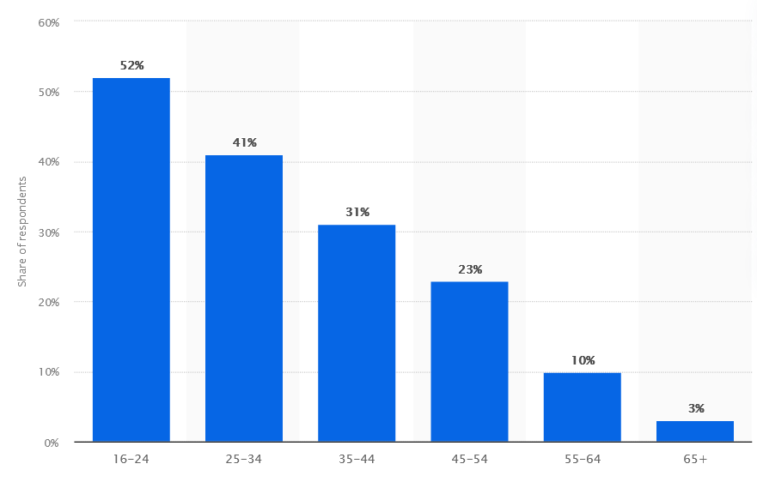
Console gaming penetration in the United Kingdom (UK) as of November 2024, by age group. (Critical Research, 2025)

Gender Demographics
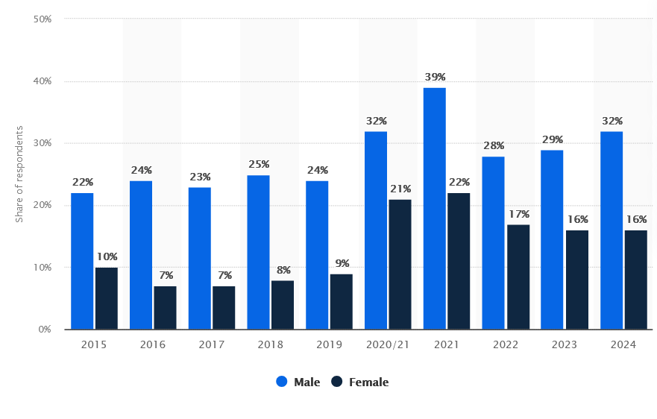
Secondly, an investigation of which gender groups engage with the type of products Trinium Limited aim to bring to market and what trends those gender groups are showing over time. This is important to show how the market is skewed in terms of popularity and likelihood of retention within those groups.
Console gaming penetration in the United Kingdom (UK) from 2015 to 2024, by gender. (Critical Research, 2025)

A September to November 2024 survey of UK adults aged 16 years and older found that almost three in ten male respondents had ever played games on a gaming console. In the United Kingdom, men were more likely to play console games than women, but female console gaming audiences grew significantly since 2019. Console gaming is the second-most popular type of video gaming in the UK, ranking only behind mobile gaming in terms of audience reach. (Statista, 2025)
This data also shows during COVID/lockdown the market for the product Trinium Limited intends to bring to market not only grew as a whole but retained the majority of its growth. It also shows that in terms of gender, on average, males purchase these products at or above a ratio of two to one compared to females.

Spending Habits
Thirdly, an investigation of which channels consumers spend their money when using a product in the same market as Trinium Limited. These habits will influence how Trinium Limited will focus its digital marketplace offerings.
In 2024, it was found that consumers in the United Kingdom spent over 3.09 billion British pounds on digital console and PC games, down from 3.1 billion GBP in the previous year. Digital is by far the most popular gaming format in the UK, beating out boxed and second-hand sales. (Statista 2025)
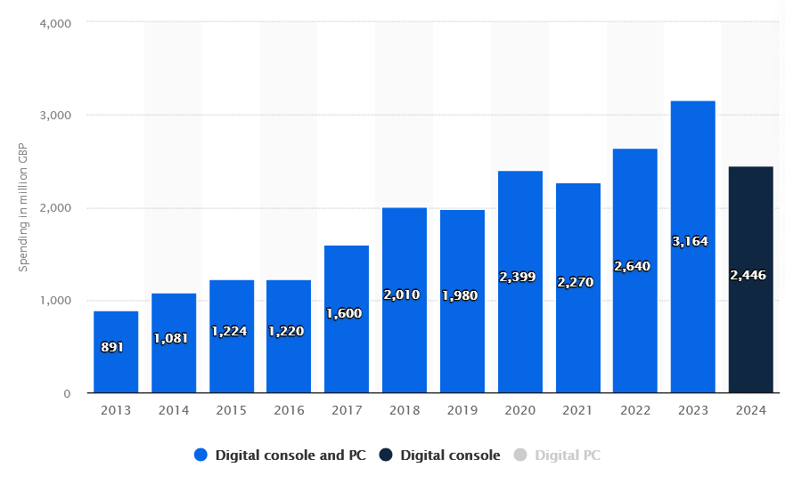
Consumer spending on digital console and PC games in the United Kingdom (UK) from 2013 to 2024 in million GBP. (Omdia, 2025)
Finally, this market research concludes that in the UK the highest impact to gaining and maintaining custom will be to target males between the ages of sixteen and forty-four, utilizing a digital sales platform.
A second subsidiary market is also within this data set, females between the ages of sixteen and forty-four also using a digital sales strategy. These markets will be both taken as performance metrics for a measure of how well Trinium Limited’s product penetrates the UK market.

Competition
To understand how Trinium Limited can operate best in the console video gaming space it is important to identify direct and indirect competitors. In this market the main competitors run an oligopoly: few competitors producing identical services.
Direct Competition
- XBOX (Microsoft)
- PlayStation (Sony)
- Nintendo
Indirect Competition
- PC Gaming
- Mobile Gaming
- Handheld devices (Steam Deck etc.)
Future Competition
- Cloud based delivery
- Virtual Reality
- Augmented Reality

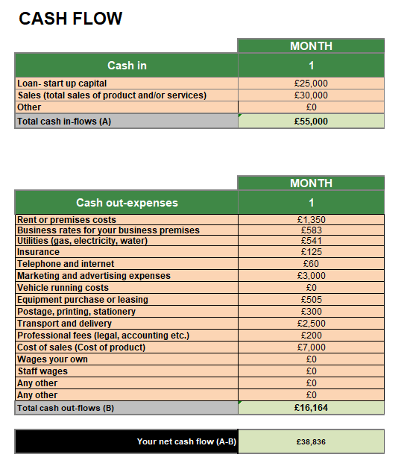
Funding & Expenditure
Trinium Limited plans to take a government startup loan of £25,000 we also plan to raise £30,000 in sales based on a retail unit sale price of £650 each and 50 units sold in that first month.
Whilst this means selling at slight loss, more costs are recovered through the eventual digital sales on the platform Trinium creates.
Other costs are calculated based on 3 directors sharing an office space with loaned equipment and outsourcing other critical operations when necessary.

Reference List

- Brooks, I. (2011) The international business environment, in I. Brooks, J. Weatherston, G. Wilkinson, (eds) The international business environment: challenges and changes, Second edition, Pearson Prentice Hall, pp.1-6

- Critical Research (2025) Adults’ Media Literacy Tracker 2024, Ofcom, Available at: https://www.statista.com/statistics/273284/uk-console-gaming-reach-by-age/?srsltid=AfmBOoq8PidYYbefvOqlm0QIReSUupobx74507FAijAUIr7BEbWMP4yB (Last accessed: 24/06/2026)

- Critical Research (2025) Adults’ Media Literacy Tracker 2024, Ofcom, Available at: https://www.statista.com/statistics/273269/uk-console-gaming-reach-gender/ (Last accessed: 27/06/2026)

- Crouch, S. Sunny, H. (2003) Marketing research for managers, Third edition, Butterworth-Heinemann, p. 112

- J. J. David Pillai, G. (2022) Small business management and control of the uncertain external environment, Emerald publishing limited, Available at DOI: https://doi-org.uwtsd.idm.oclc.org/10.1108/978-1-83909-624-220211006 (Accessed: 24/06/2026)

- Leigh, D. (2009) SWOT Analysis in K.H. Silber, W.R. Foshay, R. Watkins, D. Leigh, J.L. Moseley, J.C. Dessinger, (eds) Handbook of Improving Performance in the Workplace: Volumes 1-3, Pfeiffer & Co, Available at DOI: https://doi.org/10.1002/9780470592663.ch24 (Accessed: 27/06/2026)

- Omdia (2025) Ukie 2024 Video Games Consumer Market Valuation, Ukie, Available at: https://www.statista.com/statistics/513273/consumer-spending-on-digital-console-and-pc-games-united-kingdom-uk/?srsltid=AfmBOooGQY3QFYB4sFBmm5R8vaCjkyBh0yfsIC4ohtMe9Oa1xDCUS0yN (Accessed: 27/06/2026)

- Statista Research Department (2025) UK digital console and online games consumer spending 2013-2024, https://www.statista.com/statistics/513273/consumer-spending-on-digital-console-and-pc-games-united-kingdom-uk/?srsltid=AfmBOooGQY3QFYB4sFBmm5R8vaCjkyBh0yfsIC4ohtMe9Oa1xDCUS0yN (Last accessed: 28/06/2026)

- Statista Research Department (2025) UK console gaming reach 2015-2024 by gender, https://www.statista.com/statistics/273269/uk-console-gaming-reach-gender/ (Last accessed: 27/06/2026)

Image Links

- UWTSD Birmingham logo: https://encrypted-tbn0.gstatic.com/images?q=tbn:ANd9GcQf7gibGjkNEmLFn-03GwzHsGEoZBn5TcTXbSgVE3fZJKZv6wHzGyndhPQ&s=10

- UWTSD White logo: https://admin.sagarconsultants.co.uk/storage/university_logo/1754288436.jpg

- Triple console image: https://www.techadvisor.com/wp-content/uploads/2023/11/best_game_console_2022.jpg?quality=50&strip=all

- All tables in this business plan have been created by Mark John Tunnicliffe (Student #2512864)

- All graphs in this business plan are screenshots from Statista’s website taken from the reference links above.

