

Welsh Contemporary Architecture – The Senedd

School of Architecture, Built and Natural Environment

Course: BSc Architecture

Name: Wiktoria Dolecka
Student Number: 2318298
Module code: ACAA5003
Word count: 1379
Date: 13/12/2024

Contents
Welsh Contemporary Architecture – The Senedd 1
School of Architecture, Built and Natural Environment 1
Course: BSc Architecture 1
Introduction 4
Chapter 1: History of Cardiff Bay 5
Chapter 2: Construction of the Senedd. 6
Site and Architect selection process. 6
Design and Construction process. 6
Materiality. 7
Chapter 3: The Senedd in the present. 8
Sustainability. 8
Function and Aesthetic. 8
Conclusion 9
Reference List 10

List of Figures
Figure 1: Dolecka, Wiktoria: (2023) The Senedd. | 7
Figure 2: Dolecka, Wiktoria: (2023) The Senedd, timber interior. | 7
Figure 3: Dolecka, Wiktoria: (2023) The Senedd, view from the Debating Chamber onto the upper floor. | 9

Introduction
The Senedd building, located in Cardiff Bay, is an incredible example of Welsh contemporary architecture designed by architects Richard Rogers and Ivan Harbour (The Senedd - a landmark building, no date). It is the official Welsh government building, and instantly became a landmark building when Queen Elizabeth II opened the doors on St David’s day in 2006 (Design at its Heart, no date). This essay will cover the history of Cardiff Bay and its contents. Additionally, the construction and architecture of the Senedd will also be discussed, along with the context of the design, aesthetic views and sustainability factors.

Chapter 1: History of Cardiff Bay
In the 19th century, iron and coal trade became prominent in Cardiff, which lead to the construction of the docks to make exporting goods easier (Webmaster, no date). The docklands quickly grew into a diverse community, with at least 50 different nationalities settling in the area, it established the name of “Tiger Bay” (Webmaster, no date). However, the Second World War caused the coal demand to drop, and lead to the neglect of Tiger Bay which eventually became a derelict area, suffering mass unemployment and a social exclusion from the rest of the country (Webmaster, no date). Now, the area is well known as Cardiff Bay and is “Wales’ oldest multi-ethnic community” (Webmaster, no date), while also being a major tourism destination for people visiting Cardiff. Cardiff Bay offers a range of attractions, restaurants and bars to visitors, but it also allows people to learn the history of the docklands, with the historical boat tours and the Pierhead building. As of 2006, Cardiff Bay is now also home to the Senedd, official Welsh assembly building, which is an honoured landmark in the city of Cardiff, offering an insight to the Welsh government and an exhibition space.

Chapter 2: Construction of the Senedd.

Site and Architect selection process.
Before any official construction of the Senedd had begun, there was a long site selection process in progress, with there being 20 sites in the first selection process and a further 24 sites in the second. However, former Welsh Secretary Ron Davies concluded that the new Welsh Assembly building should be located in Cardiff as he stated that “Wales has invested 40 years in promoting Cardiff as our capital city” (BBC News | The Welsh Assembly | Building a new assembly, 6 April 1999). In March of 1998, Ron Davies officially announced that the site of the new building would be in Cardiff Bay, which was a great decision as it included the capital city of Wales and its people, both with the location and design. Furthermore, to determine the design itself, a competition was held by the RIBA and totalled 55 interests from architects all over the world, with the selected winner being Richard Rogers Partnership (RRP) (BBC News | The Welsh Assembly | Building a new assembly, 6 April 1999).

Design and Construction process.
Regarding the design, Ron Davies wanted the building “to capture the imagination of the Welsh people" (BBC News | The Welsh Assembly | Building a new assembly, 6 April 1999), so Richard Rogers and Ivan Harbour did exactly that. The concept of the Senedd was to create a transparent building so that the public could see into and engage with. The architects ensured that the Senedd would highlight transparency and the outlook onto Cardiff Bay and beyond, therefore encouraging the public to participate and feel included in democratic processes (Rshp, no date). While the roof, shown in Figure 1, which overhangs past the building, symbolises shelter and further inclusivity, allowing people both on the outside and the inside to feel safe and welcome (Rshp, no date). At the centre of the building, the roof falls into a wind coil, which sits directly above the debating chamber, symbolising where the most important room of the building is located (Rshp, no date). Construction of the Senedd officially began on the 1^{st of} March 2001 and unfortunately saw some legal issues throughout the process, as well as being majorly over budget with the construction costs reaching almost £50 million and a major delay in completion.

Materiality.
The Senedd’s exterior is almost entirely constructed from glass, symbolising the transparency of the government to the people of Wales and allowing plenty of natural light in (The Senedd - a landmark building, no date b). Some windows are automatic and open to allow ventilation and moderate the interior temperature as needed (The Senedd - a landmark building, no date b). Additionally, traditional Welsh sourced materials were used in the construction, including Welsh slate from North Wales and steel from Port Talbot which are both durable and sustainable (Senedd | VisitWales, no date). However, people have argued that these materials have not been sourced sustainably, as Port Talbot steelworks contributed a lot of damage and pollution to the environment. Also, materials including stone and timber were used due to their durability and 100-year life in the surrounding environment (Rshp, no date). In conclusion, the Senedd overall represents Wales and sustainability, as well as inclusivity for the people of Wales. Timber was a great material choice for the interior of the Senedd, as it adds warmth and texture, while also clearly identifying the centre leading into the main chamber, as highlighted in Figure 2.
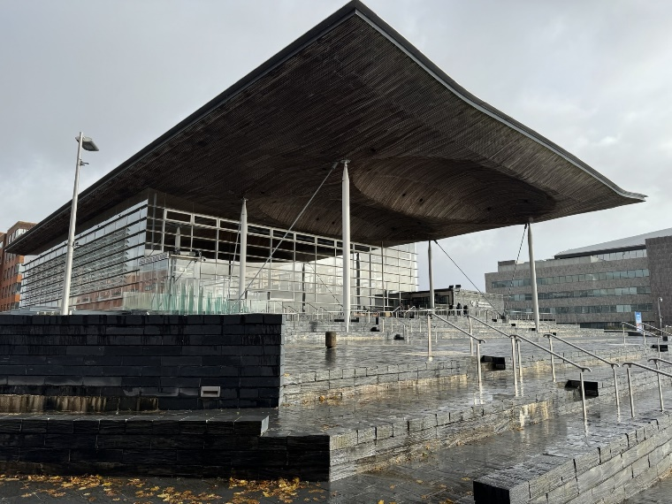 | 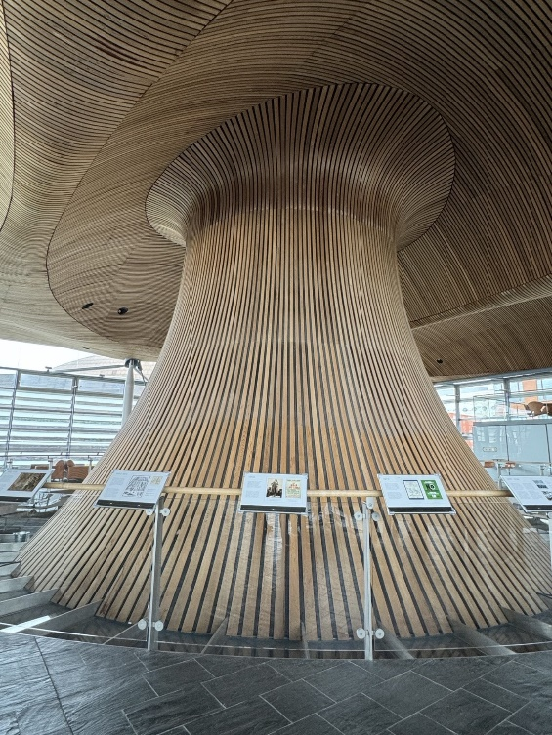
Figure 1. Dolecka, Wiktoria: (2023) The Senedd. | Figure 2. Dolecka, Wiktoria: (2023) The Senedd, timber interior.

Chapter 3: The Senedd in the present.

Sustainability.
Sustainability was an important topic when developing the design and functionality of the Senedd, as previously mentioned, sustainable materials were used in the construction. A major sustainability feature in the Senedd is the cowl at the top of the centre funnel, which is a ventilation system which works by “producing negative pressure inside the funnel; drawing warm air out of the chamber and replenishing it with cooler, fresh air from below” (The Senedd - a landmark building, no date b). A ground source heat pump is in place and ensures the heating and cooling of the building by utilising the temperature of the Earth (The Senedd - a landmark building, no date b). Additionally, the roof’s design collects rainwater which is utilised for maintenance and flush water for toilets in the building, stored in two 75m3 tanks (The Senedd - a landmark building, no date b). Rainwater collection and the use of waterless urinals and automatic taps keeps the demand for mains water very low, which promotes sustainability greatly (The Senedd - a landmark building, no date b). Overall, the sustainability of the Senedd has been designed very carefully and is effective.

Function and Aesthetic.
The Senedd’s main hall is divided into two levels, the lower level being the entry and reception area with information facilities (Rshp, no date). A large staircase to the left side of the building leads to the upper floor, where a café and exhibition area are both situated, as well as the beautiful timber centre funnel which reflects into the Debating Chamber below, as shown in figure 3. The glass is used to view into the chamber by allowing natural light to penetrate the space, but it also allows the public to have a glimpse into the chamber to feel included in Welsh democracy, which is the physical and metaphorical centre of the Senedd (Rshp, no date). Aesthetically, the Senedd is a beautiful example of contemporary architecture, with the bright timbers contrasting with the dark slate, concrete and stone, while being divided by the glazing all around the building. The fading of the timber on the outside underside of the roof also provides a unique contrast between the interior and the exterior, as well as showing how the environment and weather has affected the material.
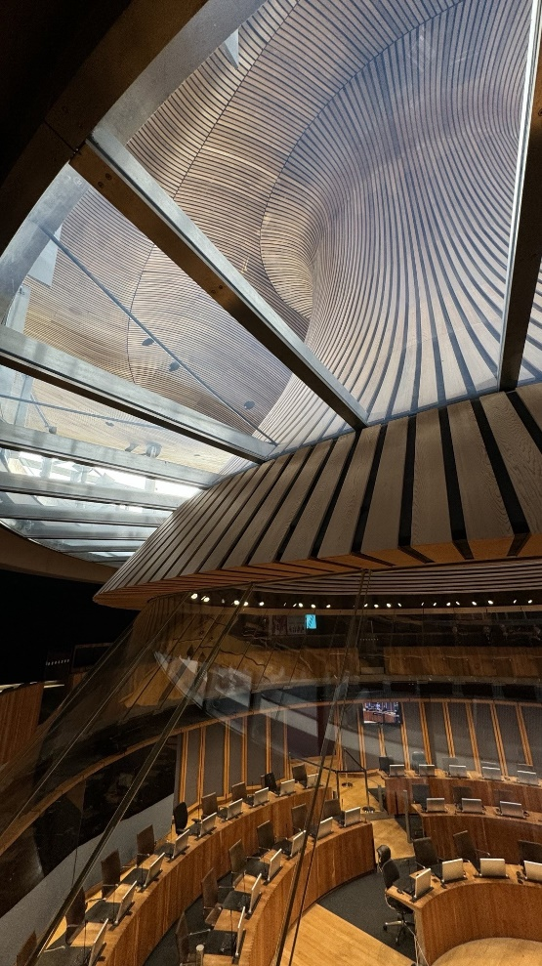
Figure 3. Dolecka, Wiktoria: (2023) The Senedd, view from the Debating Chamber onto the upper floor.

Conclusion
To conclude, the Senedd’s design beautifully represents contemporary, modern and sustainable architecture all in one, whilst also perfectly slotting into the surrounding built environment. The architects did an amazing job at ensuring that the Senedd stands out in its environment, but in the best way possible, by taking on board the needs of the client and ensuring that the building feels inviting to the people of Wales and represents transparency of the Welsh government. Overall, the Senedd is loved by Wales and all visitors, and has become a focal point in the city, a symbol of contemporary and modern architecture in Wales with great functionality.

Reference List
BBC News | The Welsh Assembly | Building a new assembly (6 April, 1999. http://news.bbc.co.uk/1/hi/events/wales_99/the_welsh_assembly/310031.stm. Accessed 3 December 2024.
Design at its Heart (no date). https://senedd.wales/visit/exhibitions/design-at-its-heart/. Accessed 2 December 2024.
Rshp (no date) Senedd Cymru, Welsh Parliament – Civic – Projects – RSHP. https://rshp.com/projects/civic/senedd-cymru-welsh-parliament/. Accessed 3 December 2024.
Senedd | VisitWales (no date). https://www.visitwales.com/attraction/visitor-centre/senedd-1702982. Accessed 3 December 2024.
The Senedd - a landmark building (no date). https://senedd.wales/visit/our-estate/the-senedd-a-landmark-building/. Accessed 2 December 2024.
Webmaster, C.B. (no date) Cardiff Bay. https://www.cardiffbay.co.uk/history/. Accessed 2 December 2024.

