

University of Wales – Trinity Saint David

MSc. Industry 4.0 Advanced Manufacturing

The use of Virtual Reality in promoting Industry 4.0 in Manufacturing SMEs.

By
Fredrick Emeka Okwute

Supervisor
Alan Mumby

A dissertation submitted in partial fulfilment of the requirements for the award of Master of Science Degree in Advanced Manufacturing.

March, 2024

ABSTRACT
This dissertation delves into a comprehensive exploration of the transformative potential of Virtual Reality (VR) in facilitating the adoption of Industry 4.0 knowledge within Manufacturing Small and Medium-sized Enterprises (SMEs). The literature review underscores the pivotal role of Industry 4.0 technologies, encompassing Artificial Intelligence (AI), Internet of Things (IoT), Robotics, Additive Manufacturing, and Digital Twins, in enhancing the productivity, efficiency, and profitability of manufacturing businesses, particularly SMEs. Despite these advantages, the literature also highlights challenges and barriers hindering the seamless integration of Industry 4.0 in SMEs, with workforce skills and knowledge gaps constituting nearly 30% of the identified barriers. Recognising the importance of addressing these skills and knowledge gaps, the literature introduces Virtual Reality as an emerging and effective tool for knowledge transfer within the manufacturing industry. The subsequent development of a test VR platform, featuring three industrial automation courses, presented to manufacturing stakeholders, validates the efficacy of VR in mitigating the knowledge and skills gap. Participants exhibited significant improvement in Industry 4.0 knowledge, confidence, and overall engagement, confirming the potential of VR as a transformative tool for SMEs. This research contributes by shedding light on the unique challenges faced by manufacturing SMEs in adopting Industry 4.0, emphasising the workforce skills and knowledge gap as a significant barrier. The study introduces VR as a viable solution, presenting empirical evidence of its effectiveness in enhancing knowledge, confidence, and engagement among manufacturing stakeholders. The collaborative effort with industry partners unveils the complexities and challenges associated with the development and implementation of VR platforms in the manufacturing sector. Future research recommendations include an in-depth sector analysis, a larger participant pool for more comprehensive evaluations, a focus on long-term impact assessment, and a comparative analysis between traditional training methods and VR-based training. In conclusion, this dissertation provides valuable insights into the transformative potential of Virtual Reality in addressing Industry 4.0 adoption challenges in manufacturing SMEs, laying the groundwork for continued exploration in this dynamic and evolving field.

POSTER
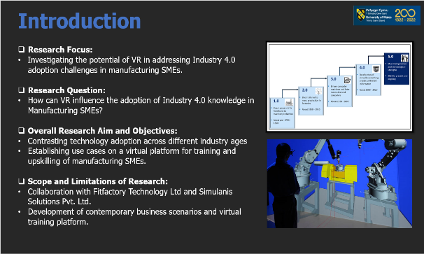
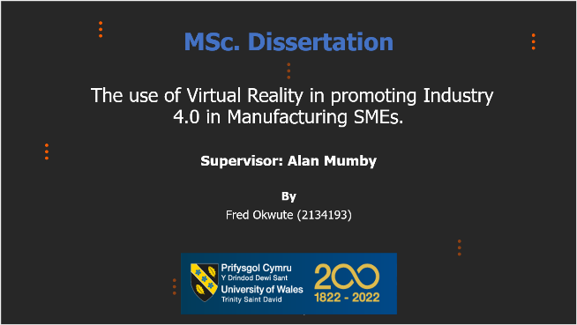

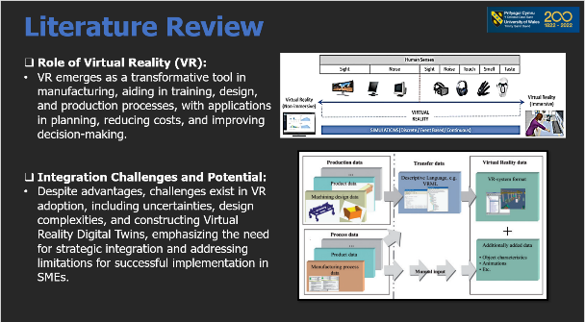
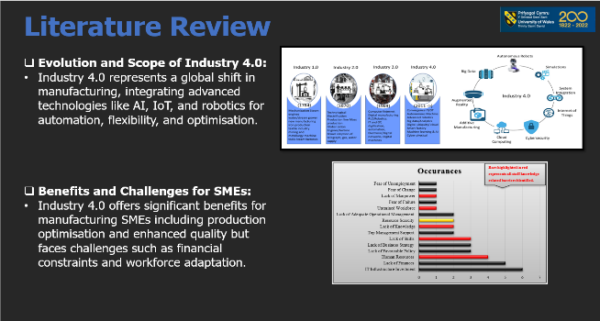

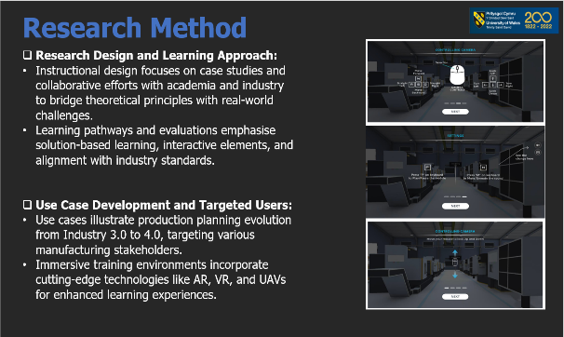
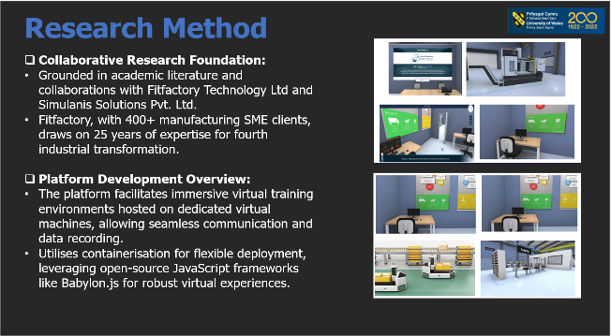

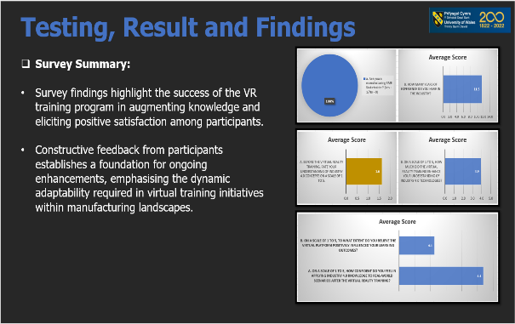
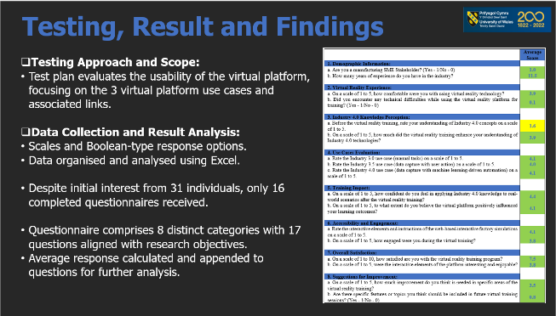

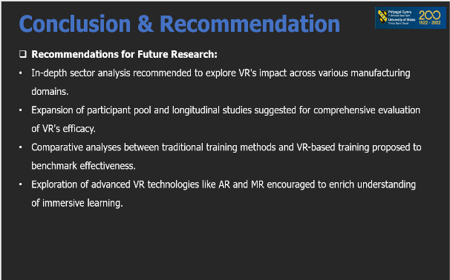
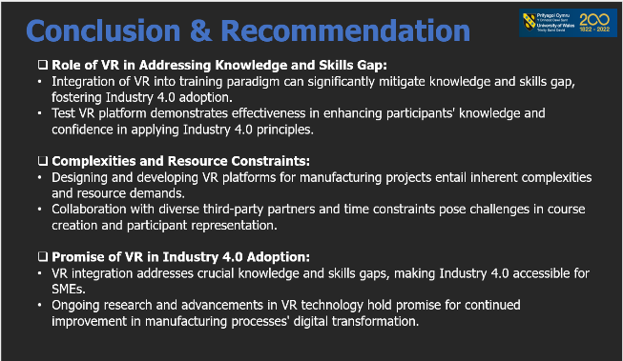

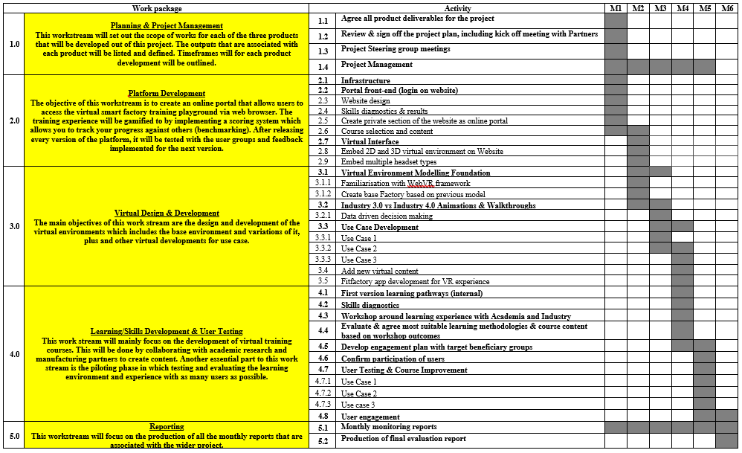
GANTT CHART PLAN LAYOUT

ACKNOWLEDGEMENT
I am profoundly grateful to God and to the remarkable individuals and organisations who played instrumental roles in the successful completion of my MSc dissertation. Foremost, my heartfelt appreciation goes to my supervisor, Alan Mumby, whose unwavering guidance, encouragement, and support were indispensable throughout the entire dissertation process. Without his expertise and supervision, this achievement would have been an insurmountable challenge.
I extend my sincere gratitude to all my module leaders and teachers who generously shared their knowledge and assistance whenever additional information was needed. Special thanks are also due to Fitfactory Technology, my employer, for their consistent support in terms of resources and time, enabling me to fully engage in this research endeavour.
I owe a debt of gratitude to my beloved wife, Mrs. Oliveth Chioma Okwute, and our children, Jessica and Elena, whose unwavering support provided the foundation for my focused dissertation work. I am also deeply thankful to the managements of Simulanis Solutions Pvt. Ltd and Fitfactory’s loyal customers for granting me the necessary permissions for the development and testing phases of this research.
To my friends and colleagues, particularly Jason Pritchard and Paul Oyani, I express my profound appreciation for their assistance and encouragement at various stages of the dissertation process. Your support was invaluable, and I am truly grateful for the collaborative spirit that defined this journey.
In conclusion, I acknowledge with gratitude the collective contributions of everyone mentioned, as well as those who may not be explicitly named but have played vital roles in shaping the successful outcome of this dissertation.

LIST OF FIGURES
Figure 1: Industrial Revolution 3
Figure 2: The immersive 3D model of a virtual factory 4
Figure 3: Elements of Industry 4.0 Technologies 9
Figure 4: Industry 4.0 Business Models 10
Figure 5: Industrial Revolution and Industry 4.0 Technologies 12
Figure 6: Summary of Key Benefits of Industry 4.0 13
Figure 7: Recurring Barriers in the Adoption of Industry 4.0 in a Manufacturing SMEs 17
Figure 8: Virtual Reality Immersion Spectrum 18
Figure 9: Types of VR System 19
Figure 10: Manufacturing process integration with VR 20
Figure 11: Implementation approach for VR 21
Figure 12: Contrasting Traditional to Virtual Manufacturing Planning 22
Figure 13: Virtual Platform IT Architectural Layout Design 28
Figure 14: Use Case Overview Mapping 31
Figure 15: Virtual Environment Layout 31
Figure 16: User/leaner control options on the Virtual Platform 33
Figure 17: Images of Virtual Platform of Use Case 1 36
Figure 18: Images of Virtual Platform of Use Case 2 38
Figure 19: Images of Virtual Platform of Use Case 3 41
Figure 20: Demographic Information Result Analysis 53
Figure 21: Virtual Reality Experience Result Analysis 54
Figure 22: Industry 4.0 Knowledge Perception Result Analysis 55
Figure 23: Use Case Evaluation Result Analysis 55
Figure 24: Training Impact Result Analysis 56
Figure 25: Accessibility and Engagement Result Analysis 57
Figure 26: Overall Satisfaction Result Analysis 58
Figure 27: Suggestion for Improvement Result Analysis 59

LIST OF TABLES
Table 1: Problem Statement and Proposal Summary 6
Table 2: List of Industry 4.0 Adoption Barriers in a Manufacturing SME 17
Table 3: Key deliverables and formats for Use Cases 33
Table 4: Test survey result indicating average scaling. 52

LIST OF ABBREVIATIONS
Terms | Meaning
3D | Three Dimension
4IR | Fourth Industrial Revolution
AI | Artificial Intelligence
AM | Additive Manufacturing
AR | Augmented Reality
AUT | Application Under Test
CM | Condition Monitoring
DM | Digital Manufacturing
I4.0 | Industry 4.0
ICT | Information Communication Technology
IoT | Internet of Things
MBOM | Manufacturing Bill of Material
ML | Machine Learning
MR | Mixed Reality
MRP/ERP | Material Requirement Planning / Enterprise Resource Planning
OEM | Original Equipment Manufacturer
RFID | Radio Frequency Identification
SFDC | Shop Floor Data Capture
SM | Smart Manufacturing
SME | Small and Medium Enterprises
UAV | Unmanned Aerial Vehicles
UTM | User Testing Methodology
VM | Virtual Machine
VR | Virtual Reality
XR | Extended Reality

TABLE OF CONTENTS
ABSTRACT------------------------------------------------------------------------------ii
POSTER---------------------------------------------------------------------------------iii
GANTT CHART-----------------------------------------------------------------------iv
ACKNOWLEDGEMENT-------------------------------------------------------------v
LIST OF FIGURES-------------------------------------------------------------------vi
LIST OF TABLES--------------------------------------------------------------------vii
LIST OF ABBREVIATIONS------------------------------------------------------viii

CHAPTER ONE: 1
Introduction 1
1. Introduction 2
1.1 Background of Study 2
1.1.1 Industry 4.0 Introduction 3
1.1.2 Virtual Reality Introduction 4
1.2 Research Focus 4
1.2.1 Research Question 5
1.3 Overall Research Aim and Objectives 5
1.4 Value of Research 5
1.5 Scope and Limitations of Research 5
1.6 Structure of the Dissertation 6
CHAPTER TWO: 8
Literature Review 8
2.1 Industry 4.0 Unveiled: A Comprehensive Overview 9
2.1.1 Evolution and Key Concepts 10
2.2 The Crucial Role of Industry 4.0 in Manufacturing SMEs 12
2.2.1 Benefits of Industry 4.0 in Manufacturing SMEs 13
2.3 Navigating Challenges: Adoption Hurdles of Industry 4.0 in Manufacturing SMEs 15
2.3.1 Analysis of Critical Success Factors and Limitations 16
2.4 Unveiling Virtual Reality: A Comprehensive Overview 18
2.4.1 Evolution of Virtual Reality 20
2.5 VR's Strategic Position: Enhancing Industry 4.0 Adoption in Manufacturing SMEs 22
2.6 Benefits: Positive Impact of VR in Industry 4.0 Adoption for Manufacturing SMEs 23
2.7 Constraints: Limitations of VR in Industry 4.0 Adoption for Manufacturing SMEs 23
2.8 Summary of Literature Review 24
CHAPTER THREE: 26
Research Methodology 26
3.1 Introduction 27
3.2 Research Method 27
3.3 Research Design 28
3.4 Use Case Development 30
3.4.1 Interactions and Graphics in the VR Learning Environments Design 32
3.4.2 Use Case 1 34
3.4.3 Use Case 2 36
3.4.4 Use Case 3 39
3.5 Ethics in Research Methodology 41
3.6 Limitations of Research Methodology 43
CHAPTER FOUR: 46
Testing, Result and Findings 46
4.1 Test Plan 47
4.2 Test Scope 47
4.3 User Testing Methodology (UTM) 48
4.4 Test Levels 50
4.5 Test Completeness 50
4.6 Data Collection Process 50
4.7 Result Analysis Overview 51
4.7.1 Demographic Information Analysis 52
4.7.2 Assessing the Impact of Virtual Reality Technology 53
4.7.3 Evaluation of Industry 4.0 Knowledge Enhancement through VR Courses 54
4.7.4 Evaluation of Use Case Courses on Industry 4.0 Knowledge Enhancement 55
4.7.4 Assessment of Long-Term Impact of the Training Course in Manufacturing 56
4.7.5 Virtual Reality Platform Interaction and Engagement Analysis 56
4.7.6 Assessment of Participant Overall Satisfaction 57
4.7.7 Survey Summary and Improvement Feedback 58
CHAPTER FIVE: 60
Discussion 60
5.1 Implications for Manufacturing SMEs 61
5.2 Addressing Challenges and Limitations 62
CHAPTER SIX: 65
Conclusion and recommendations 65
6.1 Summary of Key Findings 66
6.2 Contributions to the Field 66
6.3 Recommendations for Future Research 67
6.3.1 In-Depth Sector Analysis 67
6.3.2 Larger Participant Pool 67
6.3.3 Long-Term Impact Assessment 67
6.3.4 Comparative Analysis 67
REFERENCES 69
Appendices 86
Appendix A 86
Appendix B: 87
Appendix C: 88
Appendix D: 89

CHAPTER ONE:

Introduction

CHAPTER ONE

Introduction
The manufacturing sector is undergoing a transformative phase marked by the advent of Industry 4.0 technologies, a significant development in the global industrial landscape. As globalisation escalates, Small and Medium-sized Enterprises (SMEs) in manufacturing face escalating pressures to embrace Industry 4.0 for heightened competitiveness (Fatorachian and Kazemi, 2018). While the benefits of Industry 4.0 adoption are widely acknowledged, SMEs, often overlooked in existing studies, encounter unique challenges (Surange et al. 2022). Nevertheless, the imperative for both large corporations and SMEs remains constant: the pursuit of efficiency, sustainability, growth, and other advantages conferred by Industry 4.0.
This dissertation posits that the vocational learning of best-practice manufacturing digitalisation technologies can be accelerated through the creation of virtual training environments. This, in turn, ensures that manufacturing SMEs are well-prepared to harness the potential of the fourth industrial revolution. By offering employees the opportunity to engage in practical digitalisation scenarios within a virtual and competitive setting, this research aims to enhance enjoyment, engagement, and learning outcomes. The approach leverages web-based interactive factory simulations accessible via various devices, ensuring accessibility to individuals with internet access.

1.1 Background of Study
The evolution of manufacturing spans centuries, with each era marked by distinct technological advancements. From the 18th-century introduction of steam-powered mechanical production to the 20th-century shift towards automated production using electronics and information technology, manufacturing has continually adapted to the demands of the time. The current era, Industry 4.0, integrates technologies like the Internet of Things (IoT), Artificial Intelligence (AI), cloud computing, and big data into intelligent production systems. Additionally, a 5th industrial revolution is gaining momentum as manufacturers expand into the socio and economic factors of advanced automation (Noble et, al. 2022).

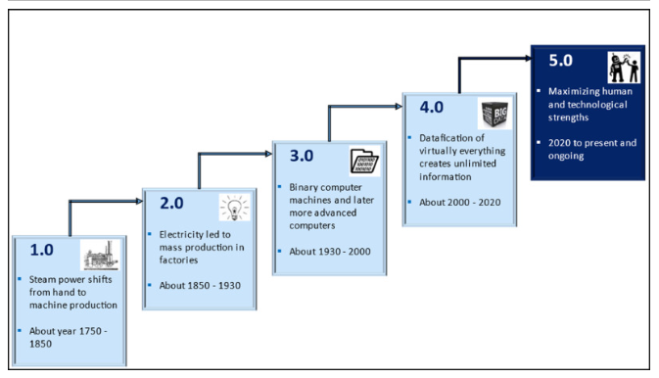
Figure 1: Industrial Revolution (Noble et, al. 2022)
Challenges faced by the manufacturing industry today, including SMEs, are not exclusive to size but are exacerbated by globalisation's demand for increased reaction to customer demands and product quality (Fatorachian and Kazemi, 2018). To remain competitive, manufacturers must reinvent their businesses by implementing digital technology (Florescu and Barabas, 2020). Intelligent manufacturing, shaped by Industry 4.0, supports innovation, competition, and adaptability to changing demands (Yildiz, Moller, and Bilberg, 2021). Despite the significant benefits of Industry 4.0 adoption, challenges such as high capital spending and uncertain return on investment persist, particularly for SMEs (Kamblea et al., 2018) and (Cotrino, Sebastián, and González-Gaya, 2020).
Research identifies obstacles to Industry 4.0 adoption in manufacturing SMEs, including a lack of practical knowledge and an untrained workforce (Cotrino, Sebastián, and González-Gaya, 2020; Surange et al. 2022; Ravinder, Rajesh, and Yogesh, 2020; Luthra and Mangla, 2018). Virtual reality technology emerges as a potential solution to accelerate the adoption of Industry 4.0 by addressing these barriers.

1.1.1 Industry 4.0 Introduction
Industry 4.0, a German initiative for advanced factories, integrates technologies like virtual reality, robotics, artificial intelligence, 3D printing, and the Internet of Things to create economically, socially, and environmentally sustainable industrial systems (Kamblea, Gunasekaranb, and Sharma, 2018). It involves the incorporation of physical and digital systems, enabling significant automation and data transmission in the manufacturing industry. This integration is characterised by the use of artificial intelligence, IoT, cloud computing, and big data analytics (Choi et al., 2022), transforming manufacturing and aiding companies in achieving new levels of profitability, efficiency, and productivity (Czvetkó et al., 2022).
The technological innovations of Industry 4.0 offer new opportunities for operational changes and business model modernisations, leading to new avenues of value (Bouchard, Abdulnour, and Gamache, 2022). While a broad domain, Industry 4.0 plays a crucial role in data management, competitiveness, and production/process efficiency in manufacturing environments (Jamwal et al., 2021). Traditional manufacturers are compelled to shift towards Industry 4.0 due to factors like mass customisation, globalisation, and competitiveness (Stock and Seliger, 2016). This revolution in manufacturing aims for optimal efficiency with minimal resource utilisation (Jamwal et al., 2021).

1.1.2 Virtual Reality Introduction
Virtual Reality, a crucial component of digital manufacturing (DM) within Industry 4.0, finds application in training, designing, and prototyping (Abidi et al., 2019). VR has been instrumental in solving real-world challenges, enhancing profitability, reducing time to market, and improving worker safety (Mujber, Szecsi, and Hashmi, 2004). It enables the identification, development, and validation of crucial manufacturing activities before their actual application, providing engineers with innovative ways to visualise and solve problems efficiently.
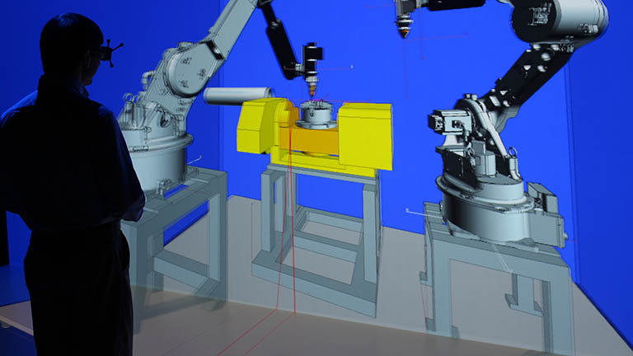
Figure 2: The immersive 3D model of a virtual factory (SME, 2019)

1.2 Research Focus
Building on the challenges of Industry 4.0 adoption in manufacturing SMEs, this research focuses on the potential use of Virtual Reality as a facilitating tool. It aims to address the barriers identified and accelerate the adoption of Industry 4.0 technologies in these manufacturing SMEs.

1.2.1 Research Question
The central question guiding this research is how Virtual Reality can impact and promote the adoption of Industry 4.0 knowledge in Manufacturing SMEs.

1.3 Overall Research Aim and Objectives
This project will demonstrate how Industry 4.0 technologies enhance production planning efficiency, contrasting technology adoption across three industry ages: Industry 3.0, Industry 3.5, and Industry 4.0. These demonstrations will be established as use cases on a virtual platform for the training and upskilling of manufacturing SMEs that are new but eager to embrace Industry 4.0. Each use case will highlight the evolution of manufacturing and business processes and their resulting benefits. The three use cases are: 1) Industry 3.0: Manual tasks, 2) Industry 3.5: Data capture with user action, and 3) Industry 4.0: Data capture with machine learning-driven automation.

1.4 Value of Research
This research posits that the vocational learning of best practice manufacturing digitalisation technologies can be accelerated through the creation of virtual training environments. By offering employees the opportunity to engage in practical digitalisation scenarios in a virtual and competitive setting, this research aims to enhance enjoyment, engagement, and learning outcomes. Leveraging web-based interactive factory simulations accessible via various devices, this approach ensures accessibility to individuals with internet access.

1.5 Scope and Limitations of Research
This research builds on existing academic work and partnerships with Fitfactory Technology Ltd and Simulanis Solutions Pvt. Ltd. Fitfactory, a UK-based manufacturing digital transformation provider, will develop contemporary business scenarios showcasing the application of Industry 4.0 technologies. Simulanis, an XR technology firm in India, will design and develop the virtual training platform. Fitfactory will lead course design, testing, and dissemination, involving its extensive customer base for testing and feedback to evaluate platform effectiveness against project objectives.
Generously supported by Fitfactory Technology Ltd and Simulanis Solutions Pvt. Ltd, this research work has minimal financial constraints, but time constraints and distance from Indian partners poses limitations.

Subject | Details
Current Industry Challenges | Digitalisation Understanding: The manufacturing workforce often lacks a clear understanding of digitalisation concepts, necessitating training in this area.  Low Retention in Remote Training: Current remote training methods, often delivered through video content, are easily consumable but suffer from low retention rates among employees.  Skilled Workforce for Technology Implementation: Small and Medium-sized Enterprises (SMEs) in manufacturing desire to implement new technologies but face a shortage of skilled workers capable of utilising these technologies effectively.  High Costs of Employee Training Programs: Employee training programs, particularly those aimed at Industry 4.0 technologies, are often expensive for manufacturing companies.  Stakeholder Buy-In Difficulty: Convincing stakeholders to invest in training programs is challenging without tangible real-world practical examples of the benefits of Industry 4.0 adoption.  Academic Perception of Industry 4.0: The concept of Industry 4.0 may appear academic and impractical to the average manufacturing SME, creating reluctance in its adoption.
Project Objective | Upskill Workforce: The overarching objective is to upskill the manufacturing workforce, facilitating a smoother transition to Industry 4.0 technologies.  Automated and Operationally Efficient Factories: Promoting a shift towards more automated and operationally efficient manufacturing processes.
Expected Outcome | Engaging and Immersive Training Platform: Developing an engaging and immersive training platform that goes beyond traditional methods, providing practical applications of Industry 4.0 concepts.  Free Introductory Courses: Offering free introductory courses accessible to all users, allowing them to explore the platform and gain insights into Industry 4.0 without financial barriers.  Progress Monitoring: Implementing a system to monitor the progress of multiple users on the platform, allowing for a comprehensive understanding of their learning journey.  Practical Application Demonstrations: Shifting the focus from academic explanations to practical demonstrations of Industry 4.0 technologies, showcasing real-world applications that resonate with manufacturing SMEs.
Table 1: Problem Statement and Proposal Summary

1.6 Structure of the Dissertation
Chapter 1: Introduction
This chapter provides background information on the adoption of Industry 4.0 in Manufacturing SMEs and the role of Virtual Reality. It discusses the focus, value, limitations, and scope of the research. The research question, overall aim, and objectives of the study are also identified.
Chapter 2: Literature Review
This chapter delves into the concept of Industry 4.0 in manufacturing SMEs and the role of Virtual Reality based on previous studies. It explores the challenges of adopting Industry 4.0 in manufacturing and establishes the application of Virtual Reality. The discussion is narrowed down to manufacturing SMEs.
Chapter 3: Research Methodology
This chapter validates the research strategy, platform development, and use case approach. It provides details on testing, dissemination, ethics, and limitations of the research.
Chapter 4: Testing, Result and Findings
This chapter presents details on the findings from the study, providing an analysis of primary data derived through research. The outcome of the research and the analysis method used are explained, followed by detailed data analysis.
Chapter 5: Discussion
This chapter explains the results and findings, linking them to the literature review. It further corroborates the findings with the research questions and identifies the practical implications and limitations of the study.
Chapter 6: Conclusion and Recommendations
This chapter revisits the overall aim and objectives of the research, drawing logical conclusions by relating the findings to these research objectives. It summarises the dissertation, highlights limitations of the study, and provides recommendations for future work.
References
This section, utilising the Harvard style, comprises a list of all secondary sources used in the research in alphabetical order.
Appendices
This section provides supporting information for this research, with references made in the main body of the work.

CHAPTER TWO:

Literature Review

CHAPTER TWO
LITERATURE REVIEW

2.1 Industry 4.0 Unveiled: A Comprehensive Overview
Industry 4.0, originating as a German initiative, has evolved into a transformative paradigm for manufacturing, integrating cutting-edge technologies like robotics, the Internet of Things, artificial intelligence, and 3D printing to create sustainable manufacturing systems (Kamblea, Gunasekaranb and Sharma, 2018). As noted by Castelo-Branco and Cruz-Jesus (2019), Industry 4.0 signifies a revolutionary shift, offering unprecedented opportunities for improvement in manufacturing practices compared to its predecessor, Industrial 3.0. Originating as an initiative focused on sustainable manufacturing systems, Industry 4.0 has become a global phenomenon influencing environmental, societal, and economic aspects of production.
The term "Industry 4.0" itself, synonymous with the Fourth Industrial Revolution (4IR), was coined by Klaus Schwab in 2016. Schwab's definition characterises 4IR as a fusion of technologies blurring the lines between the physical, digital, and biological spheres (Schwab, 2016). The first three industrial revolutions were driven by steam power, electricity, and information technology, respectively. Industry 4.0, the fourth revolution, is characterised by the confluence of emerging technologies such as AI, robotics, IoT, nanotechnology, and biotechnology (Schwab, 2016).
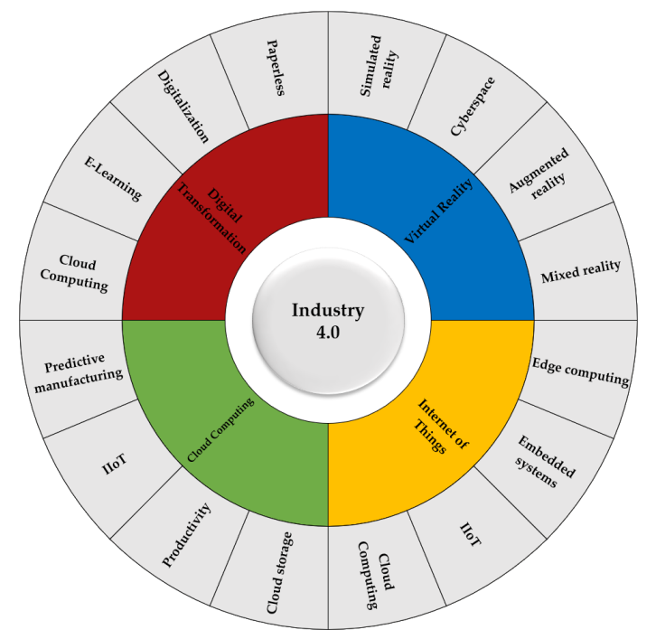
Figure 3: Elements of Industry 4.0 Technologies (Cotrino, Sebastián, and González-Gaya. 2020)
The concept of Industry 4.0 encompasses a range of enabling technologies, each playing a crucial role in the digital transformation of manufacturing. Artificial intelligence, big data analytics, IoT, robotics, 3D printing, cybersecurity, digital twin, and cloud computing are considered key instigators of digital manufacturing (Jamwal et al., 2021). These technologies collectively contribute to the achievement of digitisation, promoting process innovation, production efficiency, and sustainability (Ravinder et al., 2020).
Ricci, Battaglia, and Neirotti (2021) argue that Industry 4.0's primary aim is to encourage manufacturing automation and flexibility, facilitating process optimisation and easing interactions between machines and humans. The restructuring of manufacturing processes involves transforming analogue workflows into digital production processes, creating agile and responsive supply chains by integrating machines, data, and people (Alok et al., 2020). The imperative for Industry 4.0 adoption stems from the contemporary manufacturing landscape's demands for quicker deliveries, superior product quality, and streamlined processes (Zheng et al., 2021).
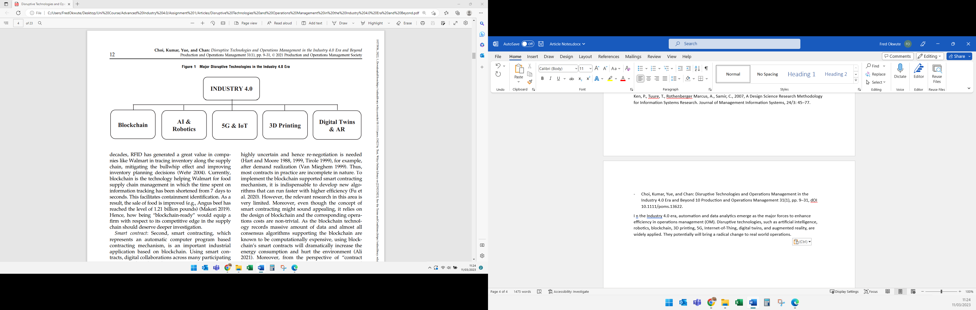
Figure 4: Industry 4.0 Business Models (Choi et al., 2022)
Traditional manufacturing processes, reliant on manual labour and siloed operations, face challenges in terms of flexibility, sustainability, and efficiency (Jimeno-Morenilla et al., 2021). Industry 4.0 addresses these challenges by optimising processes and enhancing product quality through the incorporation of emerging technologies (Čater et al., 2021). This adoption enables manufacturers to innovate, respond swiftly to customer demands, and explore new markets (Arromba et al., 2021).

2.1.1 Evolution and Key Concepts
Smart factories, empowered by Industry 4.0 technologies like AI, IoT, and Big Data, epitomise modern manufacturing, automating processes, improving efficiency, enhancing quality, and reducing costs (Morais & Monteiro, 2019). In smart manufacturing, IoT-enabled sensors and AI-driven analytics offer real-time insights and predictive capabilities, facilitating proactive decision-making (D’Almeida et al., 2022).
This concept could also be referred to as Smart Manufacturing (SM), a groundbreaking approach designed to enhance the performance of production systems across various aspects such as quality, time, cost, and flexibility. It also focuses on improving decision-making capabilities for both humans and machines. Many major enterprises have already initiated the process of incorporating Smart Manufacturing into their operations (Mittal et al. 2020).
In Abidi et al (2019), the term used for this is Digital Manufacturing, a concept that is garnering significant attention and popularity owing to its immense advantages. Positioned as one of the pillars or integral components of Industry 4.0, digital manufacturing is no longer just a theoretical concept but a tangible reality. This approach is being applied across multiple stages of the manufacturing process, including design, prototyping, and assembly training, showcasing its versatility and practicality.

2.1.1.1 Key Industry 4.0 Technologies
- Artificial Intelligence (AI): AI, simulating human intelligence, transforms manufacturing through predictive analytics, process optimisation, and automation (Ivanov et al., 2021).
- Internet of Things (IoT): Constituting interconnected devices and sensors exchanging data online, IoT optimises production and enhances operational efficiency (Alabadi et al., 2022).
- Big Data: Encompassing vast structured and unstructured data, Big Data is harnessed in manufacturing through advanced analytics, predicting maintenance needs and minimising downtime (Awan et al., 2022).
- Robotics: The development of machinery that performs tasks autonomously or with minimal human interference. In manufacturing, robots are used for activities such as packaging, material handling, and product assembly (Yin et al., 2018).
- Additive Manufacturing (AM): The use of 3D printing to build three-dimensional items by layering material on top of itself. In manufacturing, AM could be used to make prototypes, bespoke parts, and in some cases even finished goods (Marcucci et al., 2022).
- Cybersecurity: A significant concern in Industry 4.0 due to the fundamental reliance on multiple connected devices. In manufacturing, cybersecurity protects systems, networks, and devices from illegal access and similar incidents (Marcucci et al., 2022).
The synergy of AI, IoT, Big Data, robotics, additive manufacturing, and cybersecurity within Industry 4.0 heralds a new era in manufacturing, optimising processes, fostering innovation, and enabling businesses to meet evolving market demands (Serey et al., 2023). As manufacturers increasingly integrate these technologies, they propel the industry toward a future defined by efficiency, precision, and sustainable growth.
In conclusion, Industry 4.0 is not merely a technological shift but a paradigmatic evolution in manufacturing. Its impact goes beyond enhanced efficiency, touching on innovation, sustainability, and global competitiveness. The integration of AI, IoT, Big Data, robotics, additive manufacturing, and cybersecurity positions businesses at the forefront of a digital revolution. Embracing Industry 4.0 is not only a strategic necessity for staying competitive but also a symbol of hope for businesses seeking rejuvenation in the digital age.
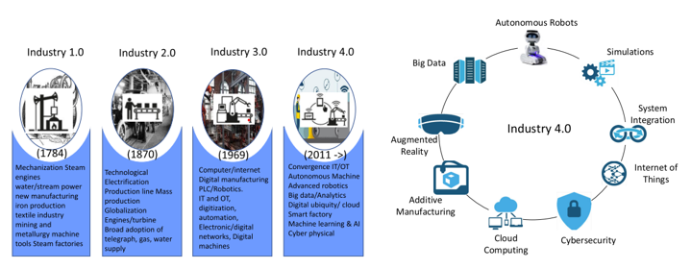
Figure 5: Industrial Revolution and Industry 4.0 Technologies (Elijah et al., 2021)

2.2 The Crucial Role of Industry 4.0 in Manufacturing SMEs
Manufacturing systems are critical in converting raw materials into finished products, with their efficacy hinging on factors such as speed, cost, quality, flexibility, and sustainability (Wang, Chen, & Zhao, 2016). Amin, Alidrisi, and Karim (2021) also argued that SMEs in manufacturing often grapple with challenges ranging from resource constraints to supply chain disruptions. Traditional manufacturing practices, while effective, are susceptible to inefficiencies, demand volatility, and environmental impacts. These challenges necessitate a paradigm shift towards more agile, automated, and technologically advanced processes.
Several authors have critically examined the potential improvements in manufacturing systems through the adoption of Industry 4.0 technologies, addressing challenges and enhancing various production aspects. It is argued that these technologies could optimise production schedules, reduce machine downtime, and enhance product quality (Čater et al., 2021). AI and Machine Learning algorithms optimise production schedules and reduce machine downtime, while IoT facilitates real-time monitoring and tracking of production equipment, leading to more efficient maintenance and repairs. Robotics automate repetitive and hazardous tasks, mitigating risks and enhancing efficiency (Serey et al., 2023).
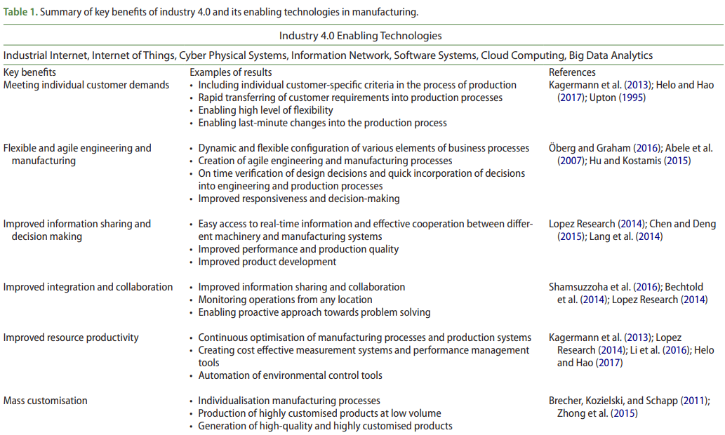
Figure 6: Summary of Key Benefits of Industry 4.0 (Fatorachian and Kazemi, 2018)

2.2.1 Benefits of Industry 4.0 in Manufacturing SMEs
Some key benefits of Industry 4.0 technologies in Manufacturing SMEs include:
- Increased Productivity and Efficiency:
Through the implementation of IoT, machines and devices communicate, allowing for real-time monitoring of production processes and encouraging predictive maintenance (Müller, Buliga and Voigt, 2018). AI optimisation processes enable SMEs to identify areas for continuous improvement, enhancing overall efficiency. Robotics automates repetitive tasks, freeing up the workforce to focus on more complex and value-added activities (Manresa, Bikfalvi and Simon, 2021).
- Enhanced Customisation and Flexibility:
Technologies such as Additive Manufacturing (AM) enable SMEs to create bespoke products and prototypes swiftly and resourcefully. Data analytics and IoT provide real-time insights into consumer preferences, allowing SMEs to adjust production processes and offerings promptly (Zheng et al., 2021).
- Improved Decision-Making and Predictive Maintenance:
Data analytics and AI empower SMEs with valuable insights for more informed decision-making. Predictive maintenance, enabled by real-time data analytics, helps prevent costly downtime and enhances overall equipment effectiveness (Felsberger and Reiner, 2020).
- Workforce Transformation and Skills Development:
The integration of Industry 4.0 necessitates a transformation in the workforce, requiring adaptation and upskilling. Training programs become crucial for employees to harness the full potential of Industry 4.0 technologies, making their jobs more rewarding and engaging (Dammacco et al., 2022). Based on the findings of Gupta et al. (2022), Industry 4.0 has been demonstrated to offer a superior and more secure working environment for employees when compared to conventional manufacturing systems.
- Strategic Considerations and Cultural Impact:
At a strategic level, the successful adoption of Industry 4.0 in SMEs requires a comprehensive evaluation of current manufacturing systems (Čater et al., 2021). Industry 4.0 technologies offer unprecedented opportunities for SMEs to optimise processes, enhance product offerings, and create new business models (Wang, Chen and Zhao, 2016). However, cultural factors and workforce dynamics must be carefully considered during implementation to ensure seamless alignment with the goals and operations of SMEs.
In conclusion, Industry 4.0 stands as a transformative force for manufacturing SMEs, offering solutions to traditional challenges, and unlocking new opportunities. The integration of advanced technologies not only enhances productivity, flexibility, and decision-making but also necessitates a workforce transformation through upskilling. Strategic considerations, combined with an awareness of cultural factors, are imperative for SMEs to successfully harness the benefits of Industry 4.0 and stay competitive in the evolving manufacturing landscape.

2.3 Navigating Challenges: Adoption Hurdles of Industry 4.0 in Manufacturing SMEs
Industry 4.0, with its promise of technological advancement, efficiency, and innovation, presents a paradigm shift in manufacturing. However, the adoption of Industry 4.0, particularly for Small and Medium-sized Enterprises, is fraught with challenges. This segment of the literature review explores the multifaceted obstacles faced by manufacturing SMEs. While the benefits of Industry 4.0 are widely acknowledged, Cotrino, Sebastián, and González-Gaya (2020) emphasise that the challenges of adoption are equally significant.
The journey to Industry 4.0 adoption is particularly arduous for SMEs, with obstacles being intensified in this context (Ravinder, Rajesh and Yogesh, 2020). Notably, existing research predominantly concentrates on large manufacturing enterprises, leaving a considerable gap in practical knowledge for SMEs (Ravinder, Rajesh and Yogesh, 2020). This knowledge gap poses a considerable hurdle for SMEs already grappling with financial and operational constraints. According to Tamvade et al (2022), Manufacturing organisations globally are enthusiastically adopting Industry 4.0 (I4.0) and the technologies linked with it. However, it's crucial to recognise that implementing these advancements presents significant challenges and risks, particularly for small and medium-sized enterprises in emerging economies.
The challenges of Industry 4.0 adoption become more acute in the context of SMEs in developing countries. Elhusseiny and Crispim (2022) highlight that developing nations face more obstacles in implementing Industry 4.0 technologies compared to their developed counterparts. Larger manufacturers in developed countries benefit from resource availability and favourable policies, making them better equipped to tackle potential risks associated with Industry 4.0 deployment (Somohano-Rodríguez and Madrid-Guijarro, 2022). On the contrary, SMEs in developing nations confront a myriad of barriers that often make transitioning to Industry 4.0 seem nearly impossible (Nwaiwu et al., 2020).
Despite the challenges, the imperative for SMEs to achieve digital transformation cannot be overstated. These SMEs serve as pillars of the economy both locally and globally, contributing significantly to economic growth (Jimeno-Morenilla et al., 2021). Therefore, addressing the challenges faced by SMEs in adopting Industry 4.0 becomes crucial for sustainable economic development.
Numerous studies have attempted to quantify the challenges faced by SMEs when adopting Industry 4.0. Luthra and Mangla (2018) identified top management support, finance, and government policies as key obstacles. Ravinder, Rajesh, and Yogesh (2020) highlighted challenges such as lack of IT infrastructure, untrained workforce, fear of failure, and absence of substitute solutions in case of breakdowns. Alok et al. (2020) emphasised technological infrastructure, lack of digital strategy, knowledge gaps, and resource scarcity as significant hindrances.
Ricci, Battaglia and Neirotti (2021) also argued that SMEs grapple with fundamental limitations such as resource and knowledge shortages, making the adoption of Industry 4.0 technologies appear complex, expensive, and yielding uncertain returns on investment. The necessary ICT infrastructure, human resources, and operational management practices for Industry 4.0 are perceived as intricate challenges for these small organisations (Cimini et al., 2019). Cimini et al. (2019) warns that SMEs should proceed with caution, emphasising the need for a clearly defined expectation and purpose behind their investment in Industry 4.0.

2.3.1 Analysis of Critical Success Factors and Limitations
Critical success factors for SMEs as identified by Nwaiwu et al. (2020), include strategy, organisational fit, operations, and human resources. However, these success factors are hindered by tangible limitations such as lack of funds, manpower, and skills. Cotrino, Sebastián, and González-Gaya (2020) categorised the main challenges as financial, technological, and staffing challenges. Surange et al. (2022), after a thorough literature review, identified insufficient revenues, lack of executive support, workforce incompetence, unfitting infrastructure, and internal resistance as prominent challenges.
A synthesis of findings from various studies reveals a convergence on certain challenges. Elhusseiny and Crispim (2022), and Surange et al. (2022) echo common obstacles such as information communication technology (ICT) infrastructure, lack of skilled employees, financial constraints, legal barriers, and the fear of unemployment. These challenges collectively contribute to a complex and multifaceted environment that hinders the seamless adoption of Industry 4.0 by SMEs.
The challenges faced by SMEs when adopting Industry 4.0 are intricate and multi-dimensional. From financial constraints to ICT infrastructure deficiencies and a lack of skilled personnel, these hurdles underscore the complexity of digital transformation for small manufacturing enterprises. Recognising the economic significance of SMEs, it becomes imperative for stakeholders, including governments, to address these challenges strategically. By mitigating these obstacles, SMEs can harness the full potential of Industry 4.0, contributing not only to their own growth but also to the broader economic development of their nations.
Upon detailed examination, the workforce's insufficient skills and knowledge constitute 11 out of the 37 identified key barriers. This represents nearly 30% of the challenges, underscoring the significance of mitigating the workforce knowledge barrier for successful adoption of Industry 4.0 technologies.
No | Adoption Barriers | Occurrence
1 | IT Infrastructure Investment | 6
2 | Lack of Finances | 5
3 | Human Resources | 4
4 | Lack of Favourable Policy | 3
5 | Lack of Business Strategy | 3
6 | Lack of Skills | 3
7 | Top Management Support | 2
8 | Lack of Knowledge | 2
9 | Resource Scarcity | 2
10 | Lack of Adequate Operational Management | 2
11 | Untrained Workforce | 1
12 | Fear of Failure | 1
13 | Lack of Manpower | 1
14 | Fear of Change | 1
15 | Fear of Unemployment | 1
Table 2: List of Industry 4.0 Adoption Barriers in a Manufacturing SME
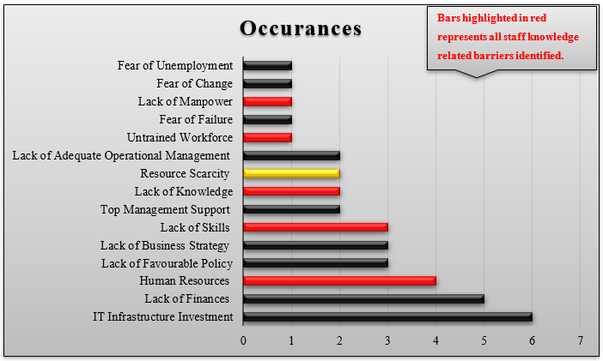
Figure 7: Recurring Barriers in the Adoption of Industry 4.0 in a Manufacturing SMEs

2.4 Unveiling Virtual Reality: A Comprehensive Overview
The infusion of Virtual Reality into manufacturing processes has undergone significant evolution and expansion. This section of the literature review aims to delve deeply into the multifaceted role of VR in Manufacturing Small and Medium Enterprises. It covers a thorough exploration of the introduction to VR technology, its historical development, and its extensive applications across various industrial sectors.
Virtual Reality, sometimes mistaken for Augmented Reality (AR), has emerged as a transformative force in manufacturing. Its applications span from training enhancements and remote collaboration facilitation to improvements in design and production processes, all achieved at a minimal cost (Abidi et al., 2019). These technologies empower users to immerse themselves in virtual environments, fostering heightened productivity, efficiency, and engagement (Yildiz, Moller and Bilberg, 2021). VR is technically defined as a computer technology generating three-dimensional models and their interrelationships, characterised by the visualisation of virtual environments, user immersion, and interaction within these environments (Aurich, Ostermayer and Wagenknecht, 2009).
Grajewski et al. (2013) scientifically defined Virtual Reality as the application of computer technology to construct an interactive three-dimensional world with spatially formed objects. This computer-generated environment, featuring stereoscopic visualisation, serves as the foundation for every VR solution. Within this virtual realm, interactive control over the displayed image is crucial, providing a sense of presence and active participation in the virtual scene, transforming the user from an observer to an engaged participant in real-time control of virtual objects and scenes.
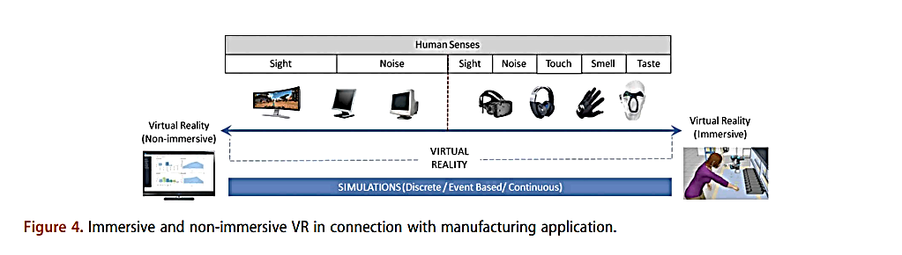
Figure 8: Virtual Reality Immersion Spectrum (Malik, Masood and Bilberg, 2020)
Mujber, Szecsi, and Hashmi (2004) contended that Virtual Reality serves as a rapidly evolving computer interface aiming to fully immerse users in experimental simulations. This immersion significantly enhances overall impact, establishing an intuitive link between the computer and human participants. In support, Tyagi and Vadrevu (2015) characterised Virtual Reality as an alternate world resembling the real world but generated through computer graphics. The simulation is created using a data suit, comprising stereophonic head-mounted video goggles, fiber-optic gloves, and proximity or occupancy sensors. This equipment collectively enables the computer to respond to the instincts of a human immersed in the virtual world, presenting outputs accordingly.
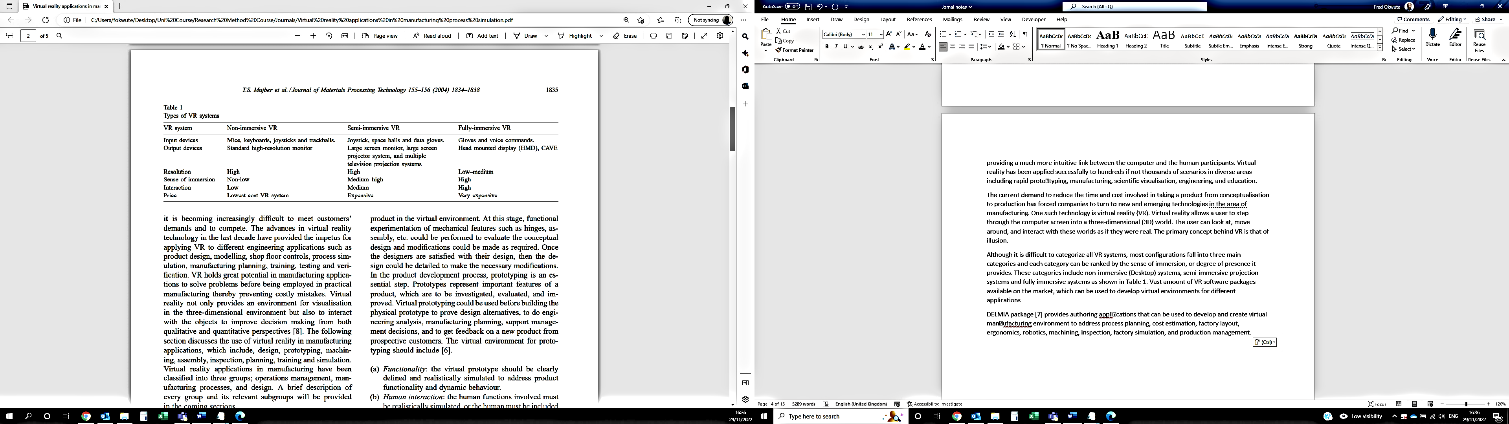
Figure 9: Types of VR System (Mujber, Szecsi and Hashmi, 2004)

The primary objective of Virtual Reality is to fully engage users in a virtual experience, simulating both physical and psychological reactions akin to real-world experiences. There are two primary types of VR systems:
(1) Desktop, where virtual environments are displayed on a screen; and
(2) Immersive system, wherein users are immersed in an environment created by projectors and screens.
Mujber, Szecsi, and Hashmi (2004) proposed key considerations for virtual environments in prototyping. Firstly, functionality is crucial, requiring a clearly defined and realistically simulated virtual prototype to address product functionality and dynamic behaviour. Secondly, human interaction must be realistically simulated, or the human element should be integrated into the simulation. Lastly, the environment aspect involves the option of conducting an offline computer simulation of functions or a combination of computer offline and real-time simulation.
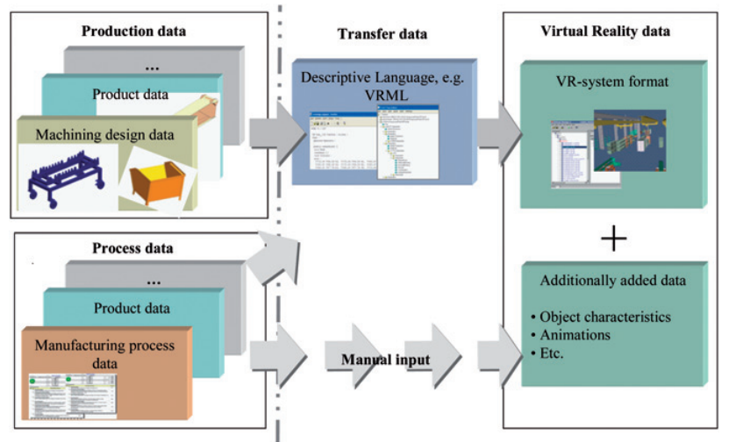
Figure 10: Manufacturing process integration with VR (Aurich, Ostermayer and Wagenknecht, 2009)

The journey of VR, originating from Ivan Sutherland's 1965 essay, "The Ultimate Display," has seen substantial advancements in both hardware and software since its inception (Berg and Vance, 2017). The visionary concept included conveying information not just to the eyes but also to the ears, nose, mouth, and hands, accompanied by technologies like 3D interaction devices, dynamic perspective rendering, haptics, and eye/gaze tracking. Over the years, industry interest in VR grew as technology performance became more practical and usable (Berg and Vance, 2017).

2.4.1 Evolution of Virtual Reality
Fred Brooks, a VR pioneer, in his 1999 paper, declared that VR had finally arrived but "barely works." Subsequent decades, however, witnessed remarkable progress, rendering VR mature, stable, and, crucially, usable across various industries (Berg and Vance, 2017). The evolution of VR technologies has given rise to both desktop and immersive systems, serving specific purposes across diverse sectors such as motion pictures, video games, construction, healthcare, and military training (Tyagi and Vadrevu, 2015). Additional researchers, as identified by Berg and Vance (2017), have recognised the diverse industries leveraging VR technology for substantial advancements in industry-level innovation. VR is instrumental in enhancing decision-making processes related to design, evaluation, and training across various disciplines.
VR's significance in manufacturing planning is pivotal. Dammacco et al. (2022) underscore that VR technologies find extensive application in manufacturing including automotive and aerospace. Notably, prevalent, and promising uses involve the simulation of real environments in the industrial context, predominantly for training, maintenance, and design purposes. VR’s widespread use in ergonomics, assembly simulation, product and production design visualisation, and employee training highlights its role in the planning stage of manufacturing systems (Aurich, Ostermayer and Wagenknecht, 2009). Virtual reality has found successful applications in numerous scenarios across diverse areas, encompassing rapid prototyping, manufacturing, scientific visualisation, engineering, and education (Mujber, Szecsi and Hashmi, 2004). Fig 9 illustrates the implementation approach for VR in manufacturing (Berg and Vance, 2017).
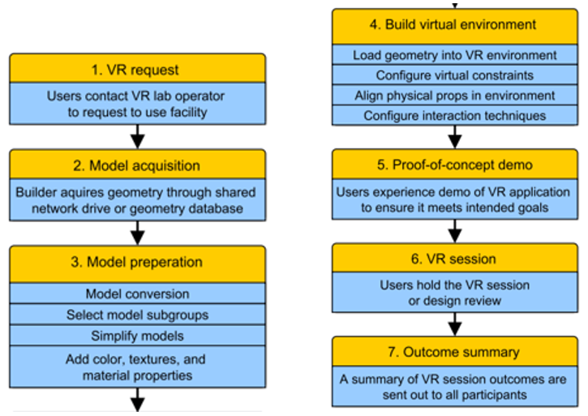
Figure 11: Implementation approach for VR (Berg and Vance, 2017)

2.5 VR's Strategic Position: Enhancing Industry 4.0 Adoption in Manufacturing SMEs
VR is a cog in the wheel of digital manufacturing, finding applications in various manufacturing phases. The planning and execution of assembly operations, a cost-intensive aspect of product development, benefit significantly from VR applications (Abidi et al., 2019). VR's ability to reduce both time and costs associated with training becomes crucial in this context. The integration of information technology with manufacturing systems, reduction in manufacturing costs, and enhanced operational planning are driving forces behind the adoption of technologies like VR in the face of unpredictable changes in the business environment (Al Jundi and Tanbour, 2023).
VR is actively supporting manufacturing industry workers by providing support, assistance, and simulation in improving manufacturing processes. Particularly, it aids semi-skilled workers in effectively completing challenging tasks (Suman et al., 2023). Fig 9 contrasts traditional manufacturing planning with virtual manufacturing planning, showcasing the transformative impact of VR on the manufacturing process (Al Jundi and Tanbour, 2023).
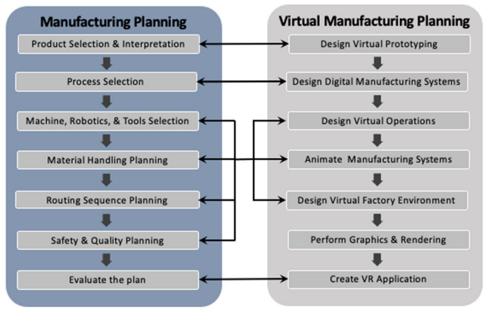
Figure 12: Contrasting Traditional to Virtual Manufacturing Planning (Al Jundi and Tanbour, 2023)

2.6 Benefits: Positive Impact of VR in Industry 4.0 Adoption for Manufacturing SMEs
The benefits of integrating VR into Industry 4.0 for manufacturing SMEs are manifold. VR training, for instance, proves more effective than conventional methods, reducing learning time, minimising errors, and improving safety for operators and equipment (Monetti et al., 2022). Abidi et al.'s (2019) study reveals that VR-trained participants commit fewer errors and demonstrate faster assembly times in actual product assembly. VR enables evaluation of assembly design, maintenance verification, human-machine interaction improvement, and layout planning (Al Jundi and Tanbour, 2023).
Research conducted by Dammacco et al. (2022) indicates that the use of VR technology enhances technical communication between experts in teamwork, particularly in identifying ergonomic flaws. The study finds VR interaction enjoyable, easy to learn, and applicable to users with varying levels of expertise. Tyagi and Vadrevu (2015) discuss a virtual manufacturing technique that seamlessly integrates cross-functional departments throughout the product lifecycle. VR facilitates the assessment of product design and manufacturing process feasibility before production. Amid rising technical complexity, VR seamlessly integrates conceptualisation, design, engineering, and manufacturing, enabling collaborative optimisation of complex assembly sequences.
According to Choi, Jung, and Noh (2015), the application of VR in product development processes within manufacturing facilitates swift consolidation of information and decision-making through visualisation and experiential engagement. In addition, Suman et al. (2023) argued that Virtual Reality has gained popularity across various application domains, encompassing industrial training, education, and gaming. This popularity is attributed to the numerous potential advantages that VR offers, including immersive experiences and intuitive interfaces.

2.7 Constraints: Limitations of VR in Industry 4.0 Adoption for Manufacturing SMEs
Despite the advantages of VR, certain limitations and challenges persist in its adoption within manufacturing SMEs. The impact of VR methods compared to traditional ones in training manufacturing operators remains unclear (Monetti et al., 2022). Designing, integrating, and evaluating VR simulation for manufacturing systems is a challenge (Al Jundi and Tanbour, 2023). Al Jundi and Tanbour (2023) argued that constructing a Virtual Reality Digital Twin of manufacturing processes is a complex task requiring integrated expertise from various fields, including VR researchers, engineers, cognitive scientists, psychologists, and expert artists and animators. Dammacco et al. (2022) note the scarcity of scientific literature on VR applications in complex manufacturing systems, often limited to small or simplified cases.
In conclusion, the role of Virtual Reality in Manufacturing SMEs is expansive and transformative. From its inception as an immersive technology to its current applications in Industry 4.0, VR stands as a valuable tool in enhancing training, design, and production processes. While the benefits are substantial, addressing the nuanced challenges and limitations is imperative for successful VR integration into the manufacturing sector.

2.8 Summary of Literature Review
This comprehensive literature review has delved into the intricate landscape of Industry 4.0 and the pivotal role it plays in the transformation of manufacturing systems. Originating as a German initiative, Industry 4.0 has evolved into a global phenomenon, incorporating cutting-edge technologies like artificial intelligence, robotics, the Internet of Things, and 3D printing. The adoption of Industry 4.0 is driven by the imperative for manufacturing automation, flexibility, and optimisation in response to contemporary demands for quicker deliveries, superior product quality, and streamlined processes.
The evolution of Industry 4.0 has given rise to key enabling technologies, including artificial intelligence, big data analytics, IoT, robotics, 3D printing, cybersecurity, digital twin, and cloud computing. These technologies collectively contribute to digitisation, promoting process innovation, production efficiency, and sustainability in manufacturing processes. The concept of smart manufacturing, encompassing AI, IoT, and big data analytics, epitomises the modern manufacturing landscape, enhancing efficiency, quality, and flexibility.
In the context of manufacturing SMEs, Industry 4.0 offers significant benefits. It optimises production schedules, reduces downtime, enhances product quality, and allows for increased customisation and flexibility. The integration of AI, IoT, and robotics in SMEs necessitates a workforce transformation, requiring adaptation and upskilling. However, the successful adoption of Industry 4.0 in SMEs is not without challenges. Financial constraints, lack of IT infrastructure, untrained workforce, and fear of failure are among the barriers that SMEs face.
Virtual Reality (VR) emerges as a transformative force in the manufacturing sector, offering applications in training, design, and production processes. The evolution of VR technologies from its conceptualisation in the 1960s to its current applications in various industries reflects its maturity and usability. VR's immersive capabilities empower users to engage in virtual environments, enhancing productivity, efficiency, and engagement.
The strategic integration of VR into Industry 4.0 adoption for manufacturing SMEs is significant. VR aids in planning and executing assembly operations, reduces training costs, and improves decision-making processes. The benefits of VR in Industry 4.0 adoption for SMEs include increased effectiveness in training, faster assembly times, improved technical communication, and enhanced collaborative optimisation of complex assembly sequences.
Despite the evident advantages, VR adoption in manufacturing SMEs is not without constraints. Challenges include uncertainties about the impact of VR methods compared to traditional ones, difficulties in designing and evaluating VR simulations for manufacturing systems, and the complexity of constructing a Virtual Reality Digital Twin for manufacturing processes.
In conclusion, this literature review provides a comprehensive exploration of Industry 4.0, its adoption in manufacturing SMEs, and the transformative role of Virtual Reality. As manufacturing SMEs navigate the digital transformation journey, understanding the nuances of Industry 4.0 and strategically integrating technologies like VR becomes essential for informed decision-making and successful integration into existing workflows. The benefits of enhanced efficiency, productivity, and workforce engagement are substantial, but addressing challenges and limitations is crucial for realising the full potential of these transformative technologies in the manufacturing sector.

CHAPTER THREE:

Research Methodology

CHAPTER THREE
RESEARCH METHODOLOGY

3.1 Introduction
This research is grounded in an examination of pertinent academic literature and collaborative endeavours with Fitfactory Technology Ltd and Simulanis Solutions Pvt. Ltd. Fitfactory, a leading digital transformation product and service provider situated in the United Kingdom, boasts a customer base exceeding 400 manufacturing SMEs. Established in 2020, Fitfactory draws upon the cumulative 25 years of manufacturing and software expertise from Tricorn. This, coupled with a versatile suite of modular solutions, empowers the company to guide manufacturers through their fourth industrial transformation, positioning them not only to endure but to flourish in the evolving market landscape. Noteworthy clients of Fitfactory include EL Aerospace, Poeton, KW Engineering, GNO Spring, and other prominent manufacturing entities in the UK and abroad.
Simulanis, an Indian XR technology enterprise founded in November 2013, has garnered multiple awards for its commitment to crafting immersive, interactive, and compelling AR-VR applications. Specialising in industrial training applications, Simulanis has been at the forefront of applying AR-VR-MR/XR technologies across diverse manufacturing sectors such as pharmaceuticals, FMCG, automotive, engineering, automation, oil and gas, paints, power, energy, and chemicals. With a portfolio encompassing collaborations with over 100 companies, Simulanis has engaged with industry leaders in various sectors, exemplifying its prowess in leveraging AR-VR-MR/XR technologies to make a meaningful societal impact. Notably, the company takes pride in contributing to the enhancement of livelihoods and workplace safety for some of the most vulnerable workers in the global workforce population.

3.2 Research Method
The proposed platform will serve as a website featuring a private user area, with virtual training environments hosted on a dedicated virtual machine (VM). This VM will establish communication channels with both the website and the Fitfactory app server. A crucial aspect of the design involves the utilisation of separate virtual machines, specifically for hosting virtual training courses. These courses will be seamlessly embedded with web links, enabling the launch of environments from the isolated VM, transparent to the user. During the execution of training courses, data generated within the virtual environment will be systematically recorded in a database residing on the Virtual Machine, facilitating subsequent queries by the website.
To ensure flexibility and rapid deployment, the virtual environments will be containerised, allowing for the swift instantiation of new environment instances. The underlying technology leverages open-source JavaScript frameworks, notably Babylon.js, to construct the virtual experiences on the web. Babylon.js, founded on open-source HTML 5 and OpenGL, enjoys widespread adoption and boasts a vibrant community. By building upon Fitfactory's extensive expertise in developing commercial cloud architecture applications, the platform is poised to offer a user-friendly, easily deployable, secure, and scalable solution. The incorporation of HTML 5 and OpenGL not only aligns with industry standards but also ensures a robust foundation for delivering an immersive and technically proficient virtual training experience.
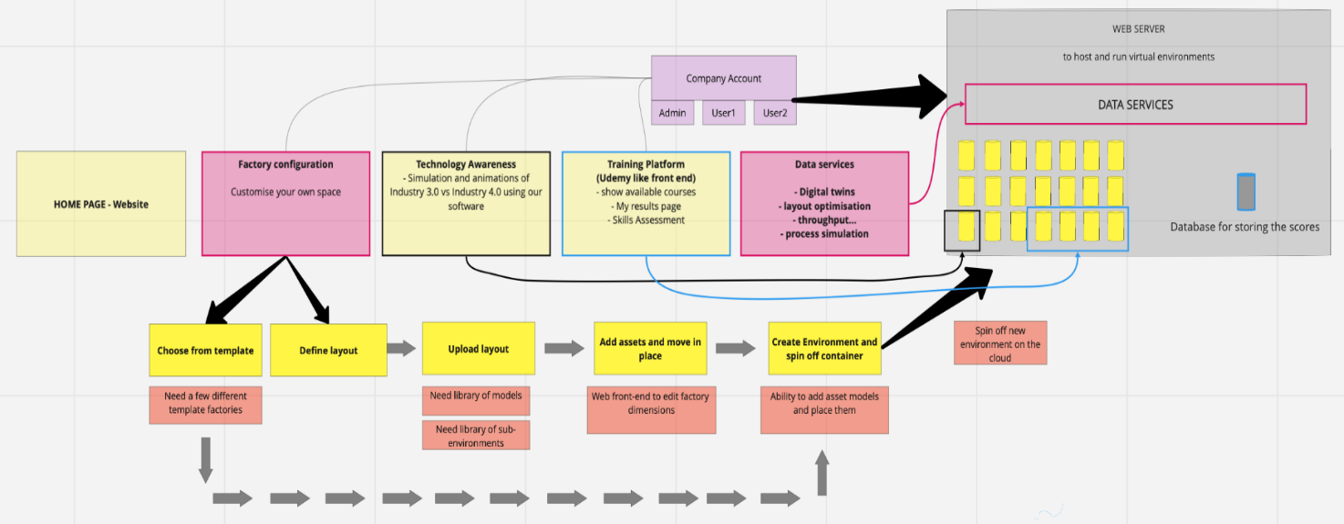
Figure 13: Virtual Platform IT Architectural Layout Design

3.3 Research Design
The instructional approach to learning design aims to systematically identify key challenges and knowledge gaps, incorporating them into intricate, multi-faceted case studies. These case studies will require learners to make informed decisions and experience the repercussions of their choices. Visualised and explained consequences will allow learners to rectify decisions, fostering an environment conducive to learning the correct course of action or response. Collaborative efforts with academia and Fitfactory manufacturing clients will contribute to the construction of learning pathways, ensuring alignment with both theoretical principles and real-world industrial challenges.
Fitfactory Technology Ltd plays a pivotal role in crafting contemporary business scenarios reflective of the challenges in operations management and logistics, particularly driven by advanced technologies such as Industry 4.0 (I4.0); Internet-of-things, and artificial intelligence. These scenarios will provide practical insights into operational challenges faced by organisations, showcasing how the application of I4.0; IoT, and AI can confer a competitive advantage in global markets. Drawing from extensive experience in consultancy projects, specialised training, and academic courses, these scenarios will remain relevant, addressing current industry standards and operating challenges, including those posed by pandemic conditions.
Learning pathways and evaluations will facilitate solution-based learning, derived from real problem scenarios, allowing users to compare and review solutions against actual implementations in real-time. Interactive features and "what-if" scenarios will empower users to test and model outcomes, evaluating and adopting optimal solutions. The user-centric design of business scenarios ensures that the learning experience is tailored to individual preferences, with advanced users accessing higher levels of functionality for continued engagement across various learning levels.
The focus of learning pathways will be on optimisation and efficiency gains, leading to the identification, creation, and enablement of sustainable competitive advantages across diverse industries. The incorporation of advanced simulations, gaming, and visualisation tools aligns with contemporary teaching and learning approaches, particularly in areas such as Industry 4.0, IoT, and AI.
The validation of business scenarios through academic study, planning, and development of training courses in alignment with academic standards, and the evaluation of learning pathways against institutional curricular requirements underscore the platform's commitment to educational rigor. Various assessment options, including weighted assessments, groupwork, peer assessment, individual assignments, and interactive quizzes, ensure a comprehensive and engaging evaluation process. The platform's design and development will be spearheaded by Simulanis Solutions Pvt. Ltd., with Fitfactory Technology leading course design, testing, and dissemination, targeting their extensive customer base for feedback on platform effectiveness vis-a-vis project objectives. These feedback from customers will also be utilised for the result and discussions of the dissertation.

3.4 Use Case Development
The project's use cases serve as practical illustrations of how production planning can be enhanced for greater efficiency, offering insights into technological advancements across three distinct industry ages: Industry 3.0, Industry 3.5, and Industry 4.0. These use cases provide learners with a tangible understanding of the evolution of manufacturing and business processes from Industry 3.0 to Industry 4.0, elucidating the associated business benefits. The project encompasses three use cases, each concentrating on a specific industry age:
- Industry 3.0: Manual task completion.
- Industry 3.5: Data is captured, requiring user intervention.
- Industry 4.0: Data is captured, machine learning occurs, and machines autonomously complete tasks on behalf of the user.
Throughout the modules, learners will engage in the task of fulfilling a customer's order while managing unscheduled interruptions typical of shop floor environments during day-to-day operations. By repeatedly executing the same task, learners discover how adopting new technologies can streamline and expedite the completion of tasks.
The course objectives are designed to train learners to:
- Understand the distinctions between Industry 3.0 and Industry 4.0.
- Comprehend the decision-making processes associated with Industry 4.0.
- Recognise how Industry 4.0 can significantly enhance productivity.
Targeted Users:
This includes experienced production managers, digital transformation leads, procurement managers, new professionals, apprentices, machine operators, and potentially students.
A key component of the use cases is the presentation of an immersive training environment, allowing users to explore various facets of a factory process, such as assembly, using Industry 4.0 technologies like VR/AR. The course guides learners through the complete assembly process of a standard product supplied from a Tier 1 Small Medium Business to an Original Equipment Manufacturer (OEM). The assembly procedure introduces production equipment and tools, accompanied by a range of Industry 4.0 technologies such as shopfloor data capture, unmanned aerial vechicles (UAVs), radio frequency identification (RFID) tagging, and AR. These technologies enable users to monitor progress, collect valuable data, and improve the process, resulting in increased ease, cost-effectiveness, and efficiency.
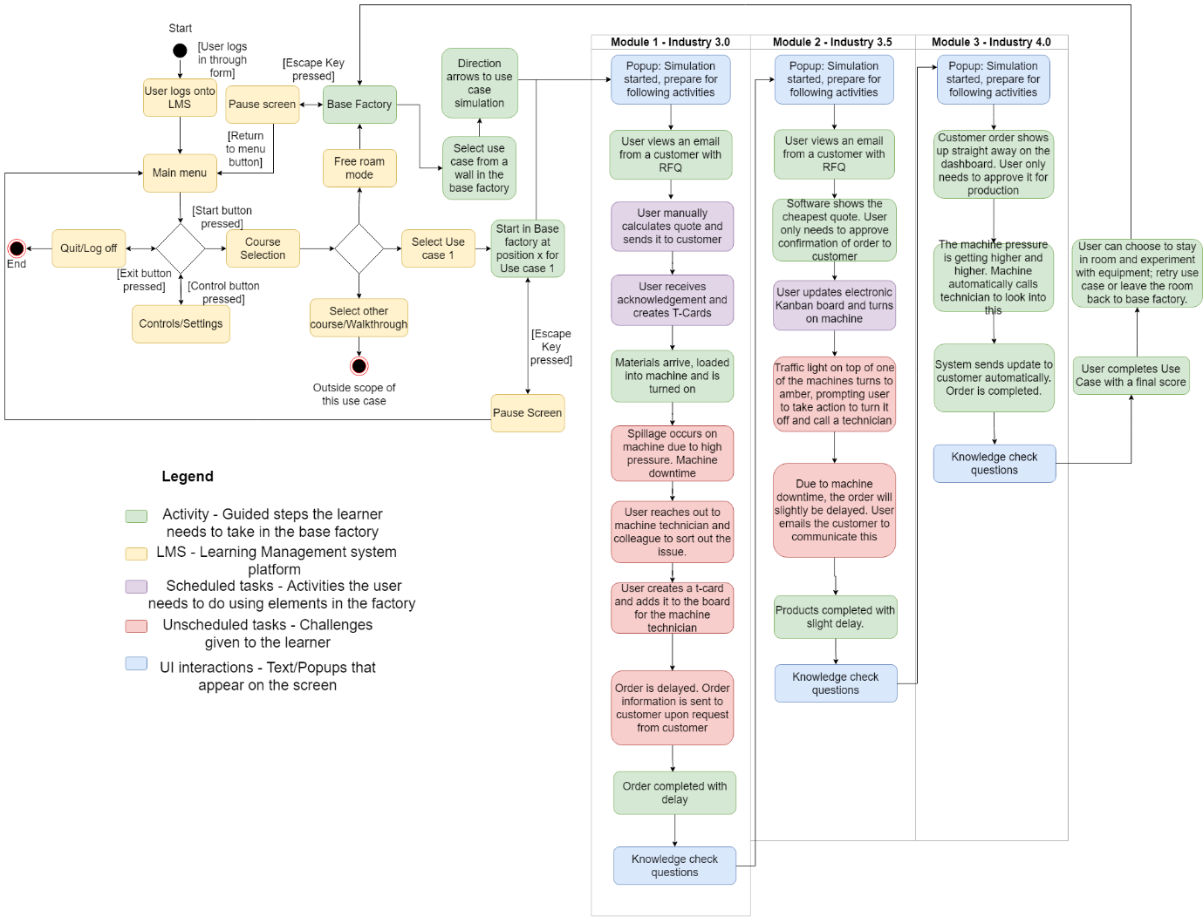
Figure 14: Use Case Overview Mapping

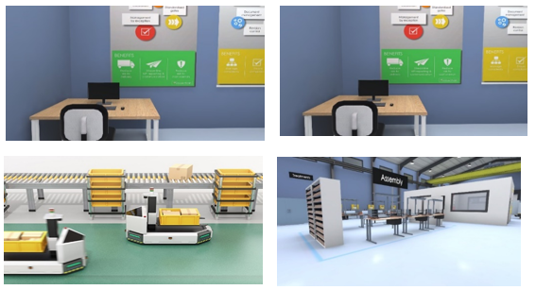
Figure 15: Virtual Environment Layout

3.4.1 Interactions and Graphics in the VR Learning Environments Design
In the context of immersive virtual learning environments, the navigation and interaction tools play a pivotal role in enhancing the user/learner experience. The following discourse delves into the intricacies of platform interactions and the graphical elements used to contribute to a dynamic and engaging learning atmosphere.
Upon initiation, users/learners are equipped with a choice of navigation tools, primarily the mouse and keyboard, to seamlessly traverse the virtual landscape. The mouse facilitates vertical movement for camera control, enabling users to effortlessly explore their surroundings by moving it up or down. Alternatively, the arrow keys on the keyboard offer an additional avenue for manipulating the camera, affording users a diverse range of options for personalised navigation.
The keyboard functionalities extend beyond camera control, with the W key propelling users forward, S directing backward movement, A facilitating leftward traversal, and D enabling rightward exploration. This intuitive control scheme not only mimics familiar gaming conventions but also ensures a smooth and accessible learning experience, aligning with the gamified nature envisioned for the platform.
In the spirit of user-friendly design, key commands for essential actions are strategically mapped on the keyboard. The P key serves a dual purpose, allowing users to pause or resume the course, ensuring flexibility in managing their learning pace. Similarly, the M key regulates audio output, providing users with the ability to toggle between muted and unmuted states.
These interaction instructions are systematically presented to users/learners at the outset of each use case, emphasising a user-centric approach and minimising any potential learning curve. This deliberate incorporation of guidance not only streamlines the onboarding process but also contributes to the overall gamified aesthetic, fostering an immersive and enjoyable learning environment.
In conclusion, the fusion of intuitive navigation tools and thoughtfully implemented keyboard controls enhances the overall user/learner engagement within the virtual learning platform. By maintaining a gamified nature through seamless interactions, the platform ensures a dynamic and interactive educational experience, catering to the diverse needs of modern learners.
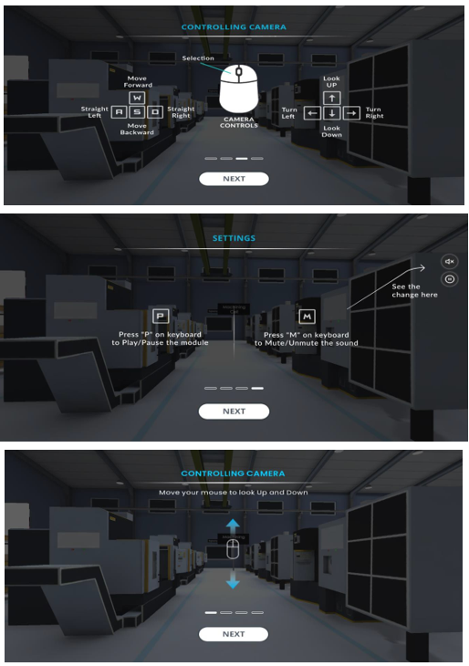
Figure 16: User/leaner control options on the Virtual Platform

Seq | Milestone | Deliverable | Deliverable Format
1 | Game Script | Step by Step flow of game design along with the storyline of the training module. | .PDF
2 | 3D Modelling | Rendered images of all environments | .JPG / .PNG
3 | User Interface Design | Instructional pop-up design | .JPG / .PNG
4 | First Draft of Module | One-third completed module for client feedback and approval | .EXE / WebGL Link
5 | Final Build | Complete module | .EXE / WebGL Link
Table 3: Key deliverables and formats for Use Cases

3.4.2 Use Case 1
This use case immerses the user in a simulated Industry 3.0 environment, highlighting the manual processes involved in a manufacturing setting. The primary objectives are to understand the distinctions between Industry 3.0 and 4.0, grasp the decision-making dynamics in Industry 4.0, and recognise how the latter contributes to enhanced productivity.
Scenario Overview:
The user embarks on a journey through a series of steps mirroring a traditional manufacturing workflow. The narrative unfolds as the user engages with the platform, making decisions and executing actions aligned with Industry 3.0 practices.
Email Check and Quotation Request:
User initiates by checking emails.
Discovers a customer's request for a quotation.
User contacts suppliers for price and delivery quotes.
Quotation Selection:
Presented with three quotes, the user manually selects the most suitable from an estimation Excel sheet.
Quote Creation and Customer Interaction:
User creates a quotation and forwards it to the customer.
Purchase Order Processing:
User receives a purchase order from the customer.
Places an order with the supplier for necessary materials.
Job Planning:
User adds jobs to the T-cardboard for workers, anticipating the arrival of raw materials.
Raw Material Handling:
Supplier delivers raw materials on the specified day.
User picks and loads raw materials onto the machine.
Spillage Management:
High-pressure spillage occurs; the user identifies and cleans the spillage.
Machine Repair Coordination:
User organises a technician to repair the machine.
Delay Communication:
Updates the T-cardboard and informs the customer about the delay.
Machine Restart:
After repairs, the user restarts the machine to resume production.
Product Retrieval and Delivery Preparation:
Manufactured parts are retrieved from the machine, prepared for delivery to the customer.
Conclusion and Questionnaire:
At the culmination of the course, the user encounters a set of reflective questions addressing various aspects:
- Reasons for Delay: Investigate the factors contributing to the delay in the order.
- Pressure Monitoring: Explore why the machine pressure increase wasn't detected sooner.
- Mitigation Strategies: Propose measures to mitigate such issues in the future.
Appendix C contains detailed list of questions provided to the user for feedback on the course, the platform, and learning outcomes. A detailed storyboard is also appended, offering a visual representation of the user's journey through the industry 3.0 simulation. This comprehensive use case aims to enhance understanding and critical thinking regarding manual processes in manufacturing, laying the groundwork for further exploration into Industry 4.0 advancements.

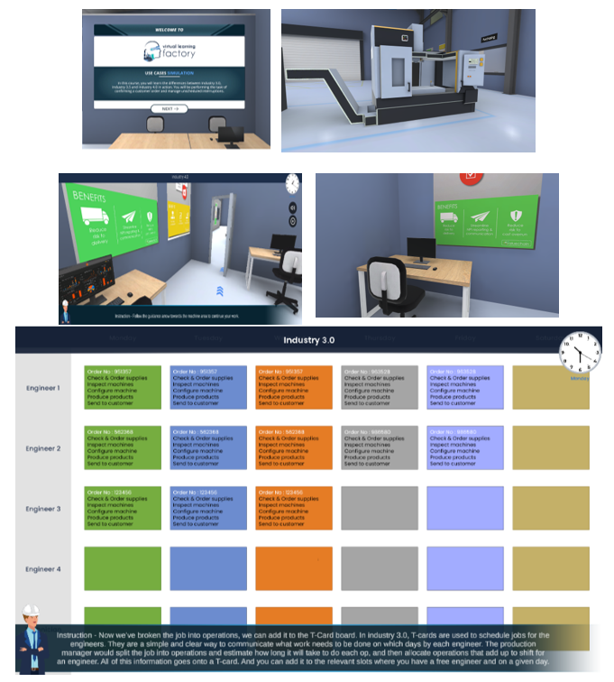
Figure 17: Images of Virtual Platform of Use Case 1

3.4.3 Use Case 2
This use case immerses the user in the intricacies of Industry 3.5, specifically focusing on the assembly of an aircraft door. The main objectives include understanding best practices in the assembly process, familiarising oneself with tools and machinery used in assembly, and exploring the application of Supply Chain 4.0 and Industry 4.0 technologies in the assembly line.
Scenario Overview:
The user steps into the world of aircraft assembly, equipped with augmented reality (AR) glasses and a smartphone to navigate the assembly process seamlessly.
Assembly Bench Introduction:
User walks to an assembly bench, setting the stage for the assembly process.
AR Glasses and Smartphone Setup:
User picks up AR glasses and puts them on for an enhanced visual experience. Grabs a smartphone from the bench to access crucial information.
Assembly Job Selection:
User selects the assembly job from the menu on the smartphone.
MBOM Versions and UAV Delivery:
Presented with three Manufacturing Bill of Materials (MBOM) versions for the structural part of the assembly. An autonomous vehicle (UAV) delivers all the required parts to the assembly benches.
UAV Interaction:
User walks to the UAV and retrieves the batch of parts, emphasising a hands-on approach.
Structural Assembly:
User picks up the Front LH Door Frame Sub-Assembly, guided by AR glasses. Attaches the part to the fixture, repeating for additional components.
Intermediate Inspection and Progress Check:
An intermediate inspection occurs to ensure quality standards. User checks progress on their phone using the E-Kanban system.
Final Inspection:
User completes a final inspection for the structural assembly, ensuring accuracy and quality.
UAV Transportation to Finished Goods Store:
UAV arrives to pick up the completed assembly and transports it to the finished goods store.
Conclusion and Questionnaire:
Upon completing the assembly process, the user is presented with reflective questions addressing critical aspects of Industry 3.5:
- Unmanned Vehicle Purpose: Explores the rationale behind using unmanned vehicles for part delivery instead of human involvement.
- Overlay Graphic Technology: Identifies the technology allowing users to see overlay graphics while working for task accuracy.
- Task Management Tools in Industry 4.0: Evaluates knowledge of task management tools utilised in Industry 4.0.
A detailed storyboard was created offering a visual representation of the user's journey through the assembly process, enhancing their understanding of Industry 3.5 principles and applications.
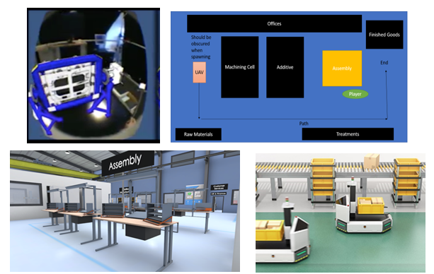
Figure 18: Images of Virtual Platform of Use Case 2

3.4.4 Use Case 3
This use case delves into the realm of Industry 4.0, focusing on problem-solving through the application of the Internet of Things in a manufacturing environment. The overarching goal is to illustrate how data-driven processes, facilitated by IoT technologies, can revolutionise industrial automation. The key objectives include learning how IoT collects data from machines, understanding data collation for process automation and efficiency improvement, and showcasing innovative problem-solving in the manufacturing industry.
Industry 4.0 Technologies Used:
Several cutting-edge technologies are employed in this use case, including Machine Monitoring Sensors, UAV Robotics, Shopfloor Data Capture (SFDC), Data Visualisation/Analysis (Insights), MRP/ERP (DNA Production), and Additive Manufacturing.
Key Interactive Elements:
The user engages with various interactive elements to simulate a manufacturing environment:
- Virtual factory layout with machines in cells and few visible operators.
- Handheld tablet with an interactive dashboard for user control.
- Glowing Up-Time sensors indicating machine functionality.
- UAVs and tracks on the shop floor receiving and executing instructions.
- Shop floor area designated for additive manufacturing machines.
Use Case 3 Summary:
The course is designed to educate users on the practical application of IoT for machine monitoring and data capturing in a manufacturing setting. It explores the utilisation of autonomous vehicles for real-time data capture, transmitting machine data to users. This data becomes instrumental in making informed decisions about future production and repair schedules. The course also provides insight into the use of 3D printing, encompassing its processes and associated technologies.
Course Progression:
Part 1: Condition Monitoring (CM) and Machine Learning (ML):
- User selects a machine monitoring dashboard widget indicating potential machine failure warning.
- Chooses an optimal schedule for maintenance intervention.
- Displays a breakdown of activities and plays a maintenance animation.
- Completion of part one in the demand driven IoT operations course.
Part 2: Demand-Driven Production and Additive Manufacturing:
- User reviews the machine monitoring dashboard.
- Deals with the unavailability of raw materials warning, witnessing an animation for delivering the part to the raw material area.
- Initiates additive manufacturing by clicking OK on screen.
- Automated display of instruction execution.
Questionnaire:
At the conclusion of the simulation, the user is presented with a set of thought-provoking questions:
- IoT Application in Manufacturing: Explores the application of IoT technology in a manufacturing environment.
- Machine Alert Response: Asks how the user would respond to an alert about a machine connected to an IoT device.
- Identification of IoT Options: Tests the user's knowledge of applicable IoT options for manufacturing.
A detailed storyboard was created, documenting the user's journey through the industry 4.0 simulation, providing a comprehensive learning experience in the realm of IoT-driven problem-solving in manufacturing.
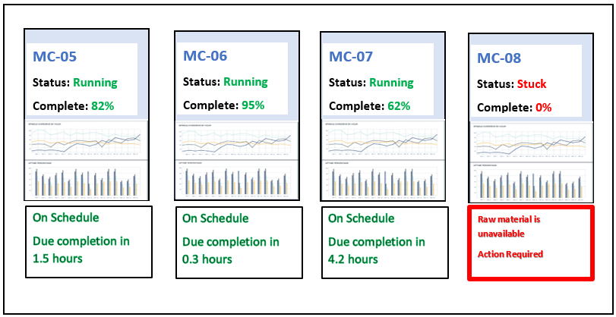
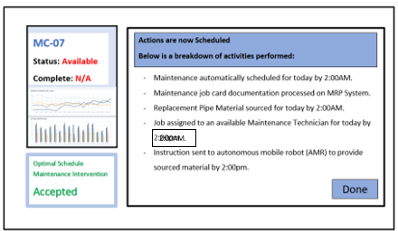
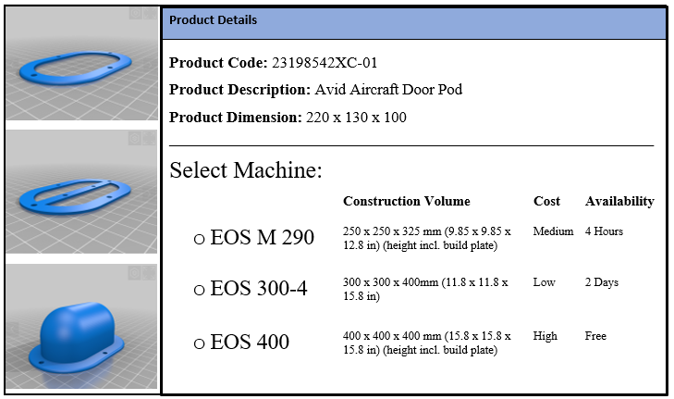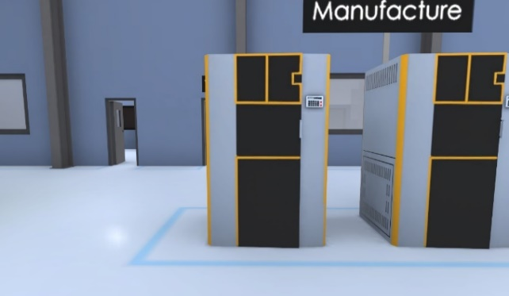
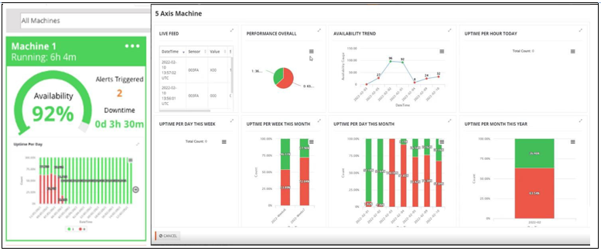
Figure 19: Images of Virtual Platform of Use Case 3

3.5 Ethics in Research Methodology
This research adheres to rigorous ethical standards, ensuring the integrity and trustworthiness of the investigation. Ethical considerations are paramount in maintaining the rights, privacy, and well-being of all involved stakeholders, including Fitfactory Technology Ltd, Simulanis Solutions Pvt. Ltd, and research participants.
- Informed Consent:
Prior to engaging with Fitfactory and Simulanis, explicit informed consent was obtained. Participants were fully informed about the research's purpose, potential risks, and their rights, ensuring voluntary and informed participation.
- Confidentiality:
All data collected, including insights from collaborative partners and participants, is treated with utmost confidentiality. Measures have been implemented to secure data storage, access, and transmission, safeguarding the privacy of individuals and organisations involved.
- Data Security:
Strict data security protocols have been established to protect sensitive information. This includes encryption, restricted access, and secure transmission channels to mitigate the risk of data breaches where and if applicable.
- Transparency:
Transparent communication is maintained throughout the research process. Collaborative partners are regularly updated on progress, ensuring clarity and mutual understanding of the study's objectives and outcomes.
- Avoidance of Bias:
Efforts have been made to minimise bias in data collection, analysis, and interpretation. Objectivity is maintained, and the perspectives of Fitfactory, Simulanis, and participants are respected, allowing for a comprehensive and unbiased exploration of the research questions.
- Voluntary Participation:
Participation in the collaborative aspects of this research with Fitfactory and Simulanis is entirely voluntary. Participants are free to withdraw at any stage without facing any adverse consequences.
- Respect for Diversity:
Cultural and organisational diversity is acknowledged and respected. Research processes are designed to accommodate and appreciate different perspectives, ensuring inclusivity and cultural sensitivity.
- Ongoing Evaluation:
Ethical considerations are not static; they are continuously reassessed throughout the research process. Any emerging ethical concerns are promptly addressed, and adjustments are made to research practices to align with ethical standards.

3.6 Limitations of Research Methodology
Despite rigorous planning and execution, this research methodology acknowledges certain limitations that may impact the study's scope, generalisability, and validity.
- Scope Constraints:
The research is constrained by the scope of collaboration with Fitfactory and Simulanis. While the insights gained are valuable, they may not fully capture the entire landscape of digital transformation in diverse industrial contexts.
- Generalisability:
The findings may not be universally applicable beyond the context of manufacturing SMEs and XR technology applications. Generalising the results to other industries or settings requires caution due to the specificity of the study's focus.
- Technological Dependencies:
The success of the proposed platform relies on technological advancements. Limitations or disruptions in technology, including but not limited to connectivity issues or software glitches, may affect the platform's effectiveness.
- Resource Constraints:
Resource limitations, such as time and budget constraints, may impact the depth and breadth of the research. Comprehensive exploration of all facets related to digital transformation may be constrained within the available resources.
- Interpretation Bias:
Despite efforts to maintain objectivity, interpretation bias may occur during the analysis of data. Different perspectives among researchers and stakeholders may influence the interpretation of findings.
- Dynamic Industry Landscape:
The industrial landscape is dynamic, with evolving technologies and practices. The research, conducted at a specific point in time, may not capture subsequent developments that could impact the relevance and applicability of the findings.
- Participant Availability:
The availability and engagement level of participants, particularly in collaborative endeavors, may vary. This could influence the richness and diversity of insights gained.
Addressing these limitations with transparency and diligence, this research methodology strives to provide valuable contributions to the understanding of digital transformation in the manufacturing sector. Recognising these constraints, efforts are made to maximise the validity and reliability of the research outcomes within the defined scope.
In conclusion, Chapter Three lays the foundation for a robust research methodology, guiding the collaborative development of a virtual training platform for Industry 4.0 experiences. The partnership between Fitfactory Technology Ltd and Simulanis Solutions Pvt. Ltd is introduced, underscoring their expertise and roles in the project. The research design focuses on creating an adaptable and secure virtual platform, featuring immersive training scenarios using open-source JavaScript frameworks and aligning with industry standards.
The instructional approach, characterised by case studies and collaboration with academia and industry, aims to bridge the gap between theoretical principles and real-world challenges. Fitfactory's role in crafting business scenarios reflects a commitment to addressing operational challenges driven by advanced technologies. Learning pathways and evaluations, featuring solution-based learning and interactive elements, are designed to cater to diverse user backgrounds and preferences.
The use case development offers practical illustrations of production planning across different industrial ages, emphasising the evolution of manufacturing processes. These scenarios, encompassing manual task completion to data-driven automation, target a wide audience, including experienced professionals and students. The immersive training environments incorporate cutting-edge technologies such as AR, VR, and UAVs, enhancing the learning experience.

The VR learning environment design prioritises user-friendly navigation, intuitive keyboard controls, and gamified elements, aligning with contemporary teaching approaches. Milestones and deliverables are outlined, emphasising transparency and providing a structured roadmap for platform development.
Ethical considerations are paramount, ensuring informed consent, confidentiality, data security, transparency, and unbiased research practices. The commitment to ethical standards reflects a dedication to maintaining the integrity and trustworthiness of the research.
While acknowledging limitations, including scope constraints and potential technological dependencies, the chapter emphasises transparency and diligence in addressing these constraints. The research methodology strives to maximise the validity and reliability of outcomes within the defined scope, contributing valuable insights to the understanding of digital transformation in the manufacturing sector.

CHAPTER FOUR:

Testing, Result and Findings

CHAPTER FOUR
TESTING, RESULT AND FINDINGS

4.1 Test Plan
The testing approach for the virtual platform in promoting Industry 4.0 knowledge adopts a methodology based on stakeholder profiles, ease of use, technology adaptation, and knowledge gap. Initially following a modified waterfall approach, it shifted to an agile paradigm due to the dynamic nature of inputs and feedback from developers and key users. This agile approach facilitates continuous changes based on iterative feedback loops.
The Test Plan aims to evaluate the usability of the Application Under Test (AUT) and confirm its readiness for a broader user launch, focusing on knowledge, application, and usability.

4.2 Test Scope
The following defines areas which are in-scope of the test plan as well as areas which are out-of-scope of the test plan.
In-Scope:
- Usability testing of the 3 virtual platform use cases.
- Usability testing of the launcher managing use cases.
- Usability testing of links to supporting applications, e.g., Fitfactory embedded Software.
Out-of-Scope:
- Full application/platform testing

4.2.1 Quality Objective
- Ensure 3 use case applications meet functional and non-functional requirements.
- Ensure the test plan aligns with project quality specifications.
- Identify and manage bugs, issues, and improvements effectively.

4.2.2 Roles and Responsibilities
- QA Analyst:
Manages AUT quality during testing and post AUT (Fitfactory/Academic Researcher).
- Test Manager:
Allocates user test team members, manages user testing activities, delivers test reports to developers (Fitfactory/Academic Researcher).
- Test Team Member:
Conducts user testing, fills test reports for each use case, retests after changes, confirms successful implementation of changes (Various: Manufacturing Stakeholders/ Fitfactory/Academic Researcher ).
- Developers:
Addresses test reports, implements recommendations, signs off completed test reports (Simulanis).
- Installation Team:
Implements AUT fully in the run environment following test report outputs (Simulanis).

4.3 User Testing Methodology (UTM)
The UTM is based on agile methodology, emphasising interactions among users, developers, and the project team. A realistic Scheduling Plan (SP) aligns with development and testing teams' timescales and project milestones.
User Test Plan includes:
- Application being tested (3 interactive use cases)
- Testing approach (logging into AUT as users and engaging with each use case)
- 3 Use cases, learning objectives, navigation, engagement, community support, etc.
Testing Timeline:
- Selecting Testers (400 Targeted)
- Briefing on the project scope
- Sending testing forms for completion over 2 hours

4.3.1 User Test approach
Usability testing: The user test approach was evaluated after the scheduling plan (SP) was completed and the UTM defined deliverables were identified. This has enabled the testing team to plan and formulate the right test approach, prepare definition documents and future developer meetings. This shall assist the team to manage the best test approach that can be used for the project.
The User Test plan will include the following:
- What application are we testing: We are presenting 3 interactive use cases; contents vary and include tests before and after each use case; this allows users and supervisors to evaluate the user journey.
- How are we testing this application; by logging-on to the AUT as users and engaging with each of the 3 use cases.
- Testing 3 Use cases: each case follows on from previous or can be run as stand-alone; specify which ones are completed if not all.
- Learning objectives: evaluate which ones are met and to what degree? How much they learned and in which areas has this contributed.
- Navigation: was navigating in the use case intuitive? Understanding the user interface and ease of use.
- Engagement: was the content engaging and at the right level? Gauge the learning levels and outcomes.
- Community support: were access to help topics and knowledge areas available; was there enough support at each stage offered if test users got stuck.
- How many users are involved in the user testing: at least 10 to 20 tester-users from manufacturing background.
- How are we capturing feedback: via user test forms, on SharePoint.
- How will the incorporation of completed user testing forms be used to drive changes and improvements? The user test forms will be analysed, and the output aggregated, to be communicated by the test manager.
- Feedback mechanism: User test forms will incorporate areas for non-research related technical feedback, which shall be captured and actioned upon in conjunction with the development teams.
- Testing Protocol: this is defined within this Test Plan document.
- Focus Group: a focus group will be convened to assess the outputs and recommendations of the Test Plan, and to suggest any further improvements to the AUT.

4.4 Test Levels
Focuses on acceptance (user) testing, involving different types such as functional testing and non-functional testing. Emphasis on Alpha and Beta testing post-acceptance testing.

4.4.1 Testing Plan
Three testing approaches: focus group, individual form completion, and MS Forms usage. The timeline spans 3 weeks, including tester selection, project briefing, and form completion.

4.5 Test Completeness
Signifies the completion of user testing objectives for the AUT, incorporating iterative feedback effectively. Criteria include 100% test coverage, execution of all manual and automated test cases, and resolution of open bugs.

4.5.1 Test Deliverables
Artifacts include use cases/launcher test reports, bug reports, test strategy, test metrics, and test team member sign-off.

4.5.2 Resource & Environment Needs
- Testing Tools, Resources, and AUT:
No specific testing tools required. Access to AUT and resources via the Internet, SharePoint, and MS Teams.
- Test Environment:
Minimum hardware requirements and necessary software versions specified for testing. Access to cloud-based user test documents and forms.

4.6 Data Collection Process
In adherence to the established test plan, a targeted email campaign was deployed to Fitfactory Technology Ltd.’s customer base. The email recipients were selected from the Fitfactory CRM database, specifically filtering on the Main Contacts category among the 400 customers. Utilising Mailchimp, the email campaign outlined a brief summary of the project and its objectives, with recipients invited to express their interest by responding to a designated email contact.
Within the initial 24 hours of launching the campaign, 7 individuals expressed interest. Subsequently, by the second day, an additional 13 respondents indicated their interest, followed by 9 more on the third day, and 2 on the fourth day. Although responses ceased after the fourth day, a total of 31 interested contacts had been identified, marking the threshold for progression to the subsequent stage.
Direct communication ensued with the 31 interested contacts, facilitated by the researcher. This involved a comprehensive set of instructions, including login details for accessing the designated virtual platform. Individual accounts were established for each contact, complete with usernames and passwords. The second email also included contact details, serving as a resource for additional support or assistance in the event of any technical hindrances preventing respondents from completing the course and survey.
Respondents were encouraged to complete both the course and survey within a 3-day timeframe, aligning with the project's time constraints. For reference, a copy of the email templates utilised can be found in Appendix B.

4.7 Result Analysis Overview
The feedback questionnaire, administered post the testing phase, is meticulously crafted to facilitate a robust quantitative analysis, ensuring precision and clarity in the interpretation of results. Participants engage with scales and Boolean-type response options, enabling a structured and numerical assessment of their experiences. The collected data is systematically organised by the researcher and subjected to a comprehensive analysis using Microsoft Excel. The questionnaire comprises eight distinct categories, housing a total of 17 questions strategically aligned with the research objectives.
Despite issuing instructions for 31 indications of interest, only 16 completed questionnaires were received after a week of the test initiation. The researcher diligently pursued other participants through two email reminders, the first sent after the 3-day lead time specified in the test instructions, and the second after an additional 2 days. At the conclusion of the 7-day period, entries were closed to proceed with result analysis.
The subsequent section delineates the specific questions presented to each participant, providing a targeted approach to gauge their insights and perceptions post the completion of the three use case courses. For each question, the average response is calculated and appended next to the questions. A more detailed and in-depth analysis of the feedback is available in the Appendix D.

 | Average Score
1. Demographic Information:
a. Are you a manufacturing SME Stakeholder? (Yes - 1/No - 0) | 1.0
b. How many years of experience do you have in the industry? | 11.5
2. Virtual Reality Experience:
a. On a scale of 1 to 5, how comfortable were you with using virtual reality technology? | 3.9
b. Did you encounter any technical difficulties while using the virtual reality platform for training? (Yes - 1/No - 0) | 0.1
3. Industry 4.0 Knowledge Perception:
a. Before the virtual reality training, rate your understanding of Industry 4.0 concepts on a scale of 1 to 5. | 1.6
b. On a scale of 1 to 5, how much did the virtual reality training enhance your understanding of Industry 4.0 technologies? | 3.9
4. Use Cases Evaluation:
a. Rate the Industry 3.0 use case (manual tasks) on a scale of 1 to 5. | 4.1
b. Rate the Industry 3.5 use case (data capture with user action) on a scale of 1 to 5. | 4.0
c. Rate the Industry 4.0 use case (data capture with machine learning-driven automation) on a scale of 1 to 5. | 4.1
5. Training Impact:
a. On a scale of 1 to 5, how confident do you feel in applying Industry 4.0 knowledge to real-world scenarios after the virtual reality training? | 4.4
b. On a scale of 1 to 5, to what extent do you believe the virtual platform positively influenced your learning outcomes? | 4.1
6. Accessibility and Engagement:
a. Rate the interactive elements and instructions of the web-based interactive factory simulations on a scale of 1 to 5. | 4.1
b. On a scale of 1 to 5, how engaged were you during the virtual training? | 3.8
7. Overall Satisfaction:
a. On a scale of 1 to 10, how satisfied are you with the virtual reality training program? | 7.5
b. On a scale of 1 to 5, were the interactive elements of the platform interesting and enjoyable? | 3.8
8. Suggestions for Improvement:
a. On a scale of 1 to 5, how much improvement do you think is needed in specific areas of the virtual reality training? | 3.5
b. Are there specific features or topics you think should be included in future virtual training sessions? (Yes - 1/No - 0) | 0.8
Table 4: Test survey result indicating average scaling.

4.7.1 Demographic Information Analysis
This segment of the survey is designed to gather essential information that validates the participants' relevance to the research. The initial inquiry aims to confirm whether the participant holds a role as a manufacturing stakeholder. It is noteworthy that a 100% response rate was achieved, indicating unanimous participation from individuals with a stake in manufacturing.
The subsequent query delves into the participants' level of manufacturing experience. The findings reveal an average of 11.5 years of experience within the manufacturing domain. A more detailed examination discloses a spectrum ranging from a minimum of 4 years to a maximum of 22 years of manufacturing expertise among the participants.
In summary, as illustrated in the chart below, these outcomes are highly beneficial for the research objectives. They successfully identify the targeted demographic—individuals with significant manufacturing stakes and an average experience level exceeding 10 years.
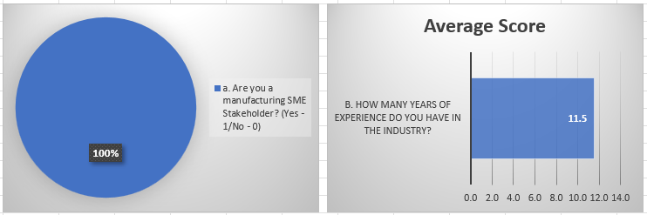
Figure 20: Demographic Information Result Analysis

4.7.2 Assessing the Impact of Virtual Reality Technology
The objective of this survey segment is to comprehend the influence of VR on the participants. The initial query required participants to rate their comfort level with VR technology on a scale from 1 to 5. The collective average score from all 16 participants was 3.9, signifying a commendable level of comfort with the utilisation of VR technology.
Subsequently, participants were asked a yes/no question aimed at determining if they encountered any technical difficulties while using the VR platform. Remarkably, only an average of 0.1 participants indicated facing technical issues, suggesting that a mere 2 out of the 16 participants experienced any form of technical challenges. This outcome underscores the overall reliability of the VR platform, as the majority of participants reported a smooth and trouble-free experience.
In summary, the responses obtained in this segment of the survey overwhelmingly align with the research objectives, affirming the positive impact of VR technology on the participants.
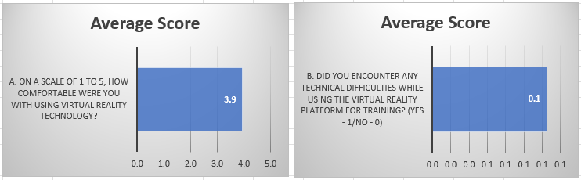
Figure 21: Virtual Reality Experience Result Analysis

4.7.3 Evaluation of Industry 4.0 Knowledge Enhancement through VR Courses
The objective of this survey category is twofold: firstly, to gauge the participants' initial proficiency in Industry 4.0, and subsequently, to measure the extent to which their knowledge improved through the implementation of VR-based courses on Industry 4.0.
The average result from all 16 participants reveals an initial knowledge level of 1.6 on Industry 4.0, assessed on a scale of 1 to 5. This outcome underscores a generally inadequate understanding of Industry 4.0 among the participants prior to engaging in the courses.
Following the completion of the VR-based courses, the results demonstrate a noteworthy enhancement, with an average score of 3.9 in the participants' understanding of Industry 4.0 technology. This significant improvement suggests a substantial impact of the courses on elevating the participants' knowledge in the field.
In summary, the findings from this survey segment strongly align with the research objectives. Participants exhibited a low level of knowledge about Industry 4.0 before undertaking the courses, with the subsequent average score of 3.9 attesting to the efficacy of the VR courses in enhancing their comprehension of Industry 4.0 technology.
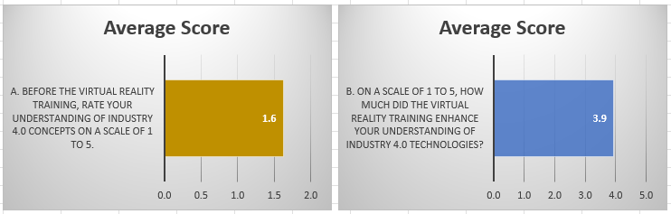
Figure 22: Industry 4.0 Knowledge Perception Result Analysis

4.7.4 Evaluation of Use Case Courses on Industry 4.0 Knowledge Enhancement
The purpose of this survey section is to aggregate feedback on the three distinct use case courses crafted to facilitate the participants' advancement in Industry 4.0 understanding. The 16 participants collectively assigned an average rating of 4.1 for use case one, 4.0 for use case two, and 4.1 for use case three.
These results are largely favourable for the research objectives. However, the marginally lower score for use case two (4.0) can be attributed to its specificity, focusing on a manual manufacturing method of assembly that may not be universally applicable to all participants. This nuance highlights the importance of tailoring course content to the diverse needs of the participants, ensuring relevance across a broader spectrum of manufacturing scenarios.
In summary, the feedback from participants affirms the effectiveness of the use case courses in enhancing Industry 4.0 knowledge, with the nuanced consideration that customisation of content can further optimise the learning experience for a diverse audience.
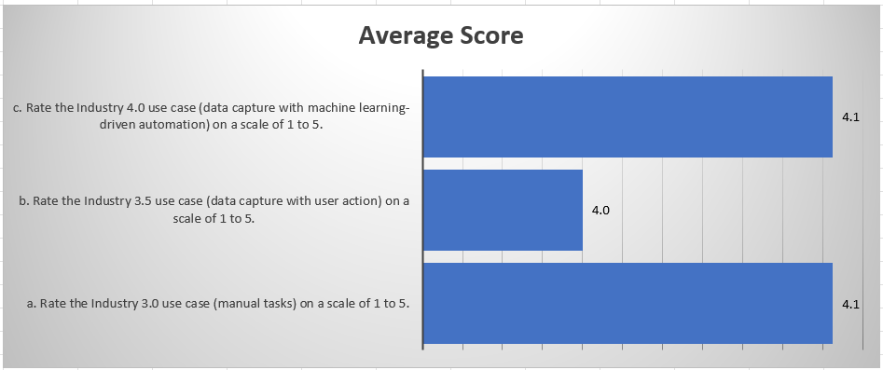
Figure 23: Use Case Evaluation Result Analysis

4.7.4 Assessment of Long-Term Impact of the Training Course in Manufacturing
This segment of the survey is designed to appraise the enduring effects of the training course within the manufacturing environment. Participants were tasked with rating, on a scale of 1 to 5, their confidence levels in applying Industry 4.0 technologies in the real-world manufacturing setting post-course completion. Additionally, they were asked to assess how the training course played a role in shaping this decision.
The analysis of results revealed an encouraging average rating of 4.4 from the 16 participants, signifying a high level of confidence in applying Industry 4.0 principles in their professional roles moving forward. Moreover, an average rating of 4.1 indicated that this decision was significantly influenced by the learning outcomes derived from the VR courses.
In summary, the findings underscore the substantial and positive impact of the training course on participants' readiness to integrate Industry 4.0 technologies into their respective roles. Furthermore, the acknowledgment of the influential role played by the VR courses in this decision affirms the effectiveness of immersive learning experiences in fostering real-world applications of acquired knowledge.
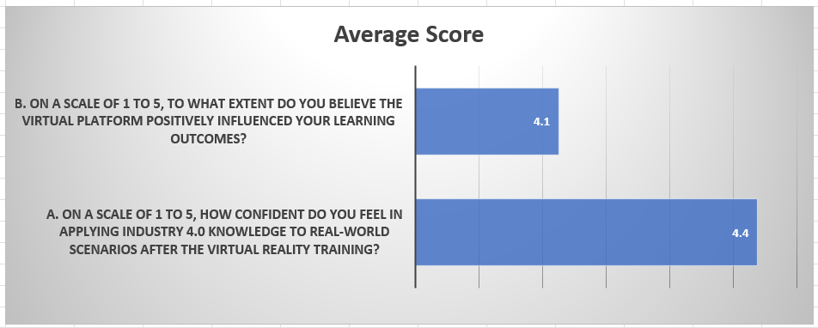
Figure 24: Training Impact Result Analysis

4.7.5 Virtual Reality Platform Interaction and Engagement Analysis
This survey segment seeks to gain insights from participants regarding their perceptions of the overall interactive elements of the VR platform, as well as the ease with which they could follow onscreen instructions and navigate the platform. Additionally, participants were requested to provide ratings, ranging from 1 to 5, reflecting their level of engagement during the course.
The results reveal an average satisfaction rating of 4.1 regarding the interactive elements, including the display of instructions on the VR platform. Furthermore, participants provided an average rating of 3.8 for their level of engagement throughout the VR course.
In summary, the findings suggest a generally positive reception of the interactive features and instructional clarity on the VR platform. While participants express a satisfactory level of engagement, the average rating of 3.8 indicates room for potential enhancements to further elevate participant engagement during the VR learning experience.
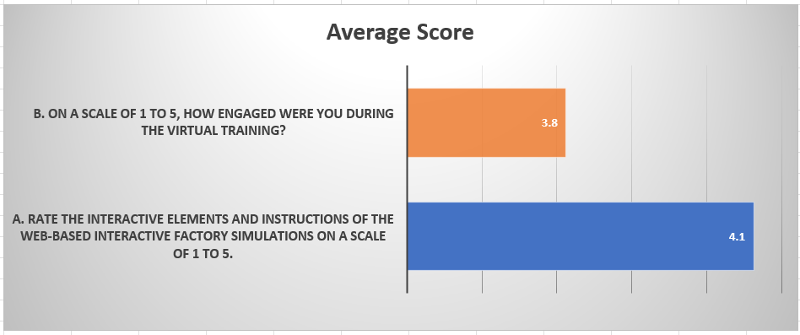
Figure 25: Accessibility and Engagement Result Analysis

4.7.6 Assessment of Participant Overall Satisfaction
In order to gauge the comprehensive satisfaction levels of the participants, they were prompted to provide ratings on a scale of 1 to 10 regarding their overall satisfaction with the VR training program. Additionally, participants were asked to rate, on a scale of 1 to 5, the extent to which they found the experience interesting and enjoyable.
The results analysis highlights an average satisfaction rating of 7.5, reflecting a generally positive reception of the overall VR training program. Furthermore, participants provided an average score of 3.8 for the perceived interest and enjoyment derived from the courses.
In summary, these findings indicate a commendable level of satisfaction with the VR training program. While participants express a positive sentiment overall, the slightly lower average score of 3.8 for interest and enjoyment suggests an avenue for potential enhancements to further enrich the participant experience.
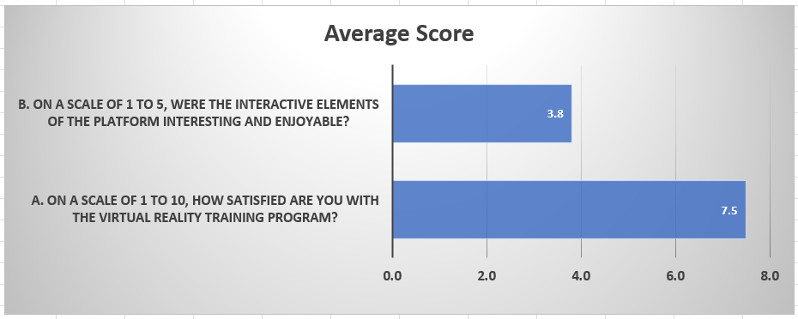
Figure 26: Overall Satisfaction Result Analysis

4.7.7 Survey Summary and Improvement Feedback
In summarising the survey, participants were asked to evaluate the extent of improvement they believe is necessary to enhance the VR training experience. Additionally, they were queried about specific features or topics they deem essential for inclusion in future virtual training courses. While both questions are quantitative in nature, participants were encouraged to provide detailed notes and comments for a more nuanced understanding of potential enhancements.
The analysis reveals an average rating of 3.5 for the perceived improvement required in the future of VR training. Moreover, a noteworthy average rating of 0.8 was obtained for the second question, indicating that 12 out of the 16 participants advocate for the inclusion of specific features or topics in future courses. Several additional comments underscore the need to expand the course library to encompass more diverse areas of manufacturing. Participants expressed a desire for insights on implementing Industry 4.0 principles to enhance efficiency and reduce administrative burdens in various manufacturing contexts.
In conclusion, the feedback signals a constructive perspective from participants, emphasising the importance of incorporating a broader range of manufacturing topics and strategies to optimise the VR training experience.
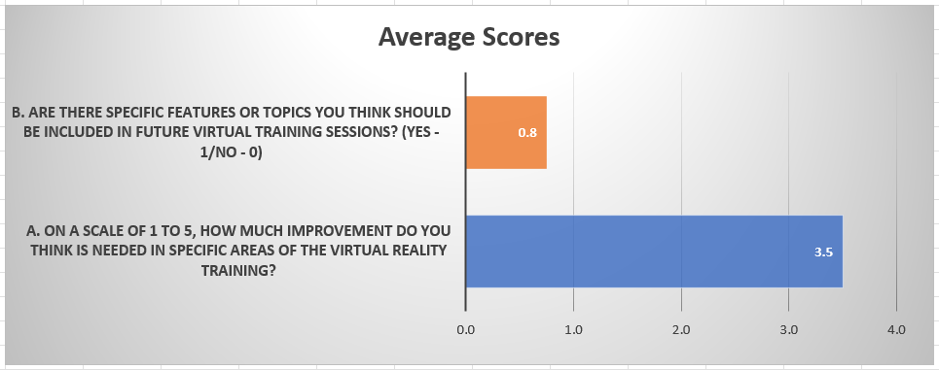
Figure 27: Suggestion for Improvement Result Analysis

A thorough examination of the survey data across diverse dimensions offers valuable insights into the efficacy and influence of the VR training program on participants' knowledge enrichment and perspectives. In summary, the survey findings underscore the success of the VR training program in augmenting knowledge, instilling confidence, and eliciting positive satisfaction among participants. The constructive feedback contributed by participants not only affirms the program's effectiveness but also establishes a foundation for ongoing enhancements, emphasising the dynamic adaptability required in virtual training initiatives within the ever-evolving context of manufacturing landscapes.

CHAPTER FIVE:

Discussion

CHAPTER FIVE
DISCUSSION

5.1 Implications for Manufacturing SMEs
This research has revolved around showcasing the transformative potential of Virtual Reality in facilitating the adoption of Industry 4.0 knowledge within Manufacturing Small and Medium-sized Enterprises. To comprehend the multifaceted landscape of Industry 4.0 technologies, a comprehensive literature review was conducted, emphasising the pivotal role of Industry 4.0. This includes Artificial Intelligence, Internet of Things, Robotics, Additive Manufacturing, and Digital Twins in enhancing the productivity, efficiency, and profitability of manufacturing businesses, particularly SMEs.
The literature, while accentuating the benefits of Industry 4.0 adoption, also shed light on the prevalent challenges and barriers hindering the seamless integration of these technologies in SMEs. A total of 37 barriers were identified and analysed, with workforce skills and knowledge gaps emerging as the predominant impediment, constituting nearly 30% of the identified barriers.
Addressing the deficiency in skills and knowledge is thus presented as a key avenue to enhance the adoption of Industry 4.0 in manufacturing SMEs. The literature introduces Virtual Reality as an emerging and effective tool for knowledge transfer within the manufacturing industry. VR, proven to be more efficacious than conventional methods, minimises training time, reduces errors, and enhances overall operational safety. Its capacity to provide enjoyable, flexible, and immersive training positions it as an ideal solution for introducing complex changes to the manufacturing environment.
Therefore, the synthesis of literature findings indicates that integrating Virtual Reality into the training paradigm can significantly contribute to mitigating the knowledge and skills gap, fostering Industry 4.0 adoption in manufacturing SMEs. In conclusion, the extensive literature analysis delineates the existing state of manufacturing SMEs, emphasising the benefits of Industry 4.0 adoption to address inherent challenges. While larger manufacturing businesses find the adoption of Industry 4.0 more accessible, SMEs encounter hurdles. Given that knowledge and skills represent approximately 30% of adoption barriers, the introduction of VR emerges as a viable solution to enhance the likelihood of manufacturing SMEs embracing Industry 4.0.
To corroborate these literature findings, a test VR platform, encompassing three industrial automation courses, was developed, and presented to manufacturing stakeholders. The feedback from 16 participants, representing diverse manufacturing SMEs in the UK, demonstrates that VR is a comfortable and effective means of learning. The participants exhibited a substantial increase in their knowledge of Industry 4.0, from an average of 32% before the courses to over 70% after completion. Additionally, participants reported an 88% increase in confidence applying Industry 4.0 knowledge to real-world scenarios after engaging with the VR courses. These findings underscore the potential of VR in addressing the knowledge and skills gap, thereby facilitating the adoption of Industry 4.0 in manufacturing SMEs.

5.2 Addressing Challenges and Limitations
The exploration of existing VR manufacturing projects in literature underscores the inherent complexities, resource demands, and challenges associated with designing and developing VR platforms. Collaborating with a diverse range of third-party partners becomes imperative, adding another layer of complexity to implementation. This research corroborates these challenges, as the creation of the VR platform necessitated collaboration with academic research, a VR development company, and a manufacturing digitalisation consultancy business. Successful collaboration, marked by clear communication and addressing stakeholder interests, was essential for overcoming these challenges.
However, the nature of this partnership, coupled with resource and time constraints, posed limitations on the breadth of courses created. Consequently, the research provides a somewhat restrained introduction to Industry 4.0 concepts for participants. Moreover, the targeted participants mainly represented the precision machining and metal assembly sector, limiting the scope to these segments and excluding other manufacturing sectors such as electronics, architectural, food, and pharmaceutical. While the insights gained from the 16 participants contribute significantly to the research objectives, a larger participant pool would have allowed for a more comprehensive evaluation of VR's impact on Industry 4.0 adoption in manufacturing SMEs.
The study acknowledges the limitations and offers insights into potential avenues for future research. First and foremost, an in-depth sector analysis is recommended to explore the nuances of VR's impact on Industry 4.0 adoption across various manufacturing domains. This diversified approach would provide a more comprehensive understanding of VR's efficacy in addressing Industry 4.0 challenges in different contexts.
Expanding the participant pool is another avenue for future research. While the 16 participants in this study provided valuable insights, a larger and more diverse sample would enhance the generalisability of the findings. A broader representation of manufacturing SMEs from various sectors and geographical locations would contribute to a richer understanding of the implications of VR on Industry 4.0 adoption.
Furthermore, a longitudinal study could be conducted to assess the long-term impact of VR training on Industry 4.0 knowledge and practices. Tracking participants over an extended period would provide insights into the sustainability of the acquired knowledge and its application in real-world scenarios.
Comparative analyses between traditional training methods and VR-based training could also be explored. This would help in benchmarking the effectiveness of VR against conventional approaches, providing a clearer perspective on the advantages and limitations of each.
Additionally, exploring advanced VR technologies such as Augmented Reality (AR) and Mixed Reality (MR) in the context of Industry 4.0 adoption could be a valuable avenue. Understanding how these immersive technologies can complement or enhance the training experience for manufacturing SMEs would contribute to the evolving landscape of digital learning in the industry.
In summary, future research endeavours could build upon the foundation laid by this study by delving deeper into specific sectors, expanding participant demographics, conducting longitudinal analyses, and exploring other immersive technologies to further enrich the understanding of VR's role in facilitating Industry 4.0 adoption for manufacturing SMEs.
The expansive exploration of literature, coupled with the empirical insights derived from the development and implementation of the VR platform, provides a robust foundation for understanding the implications, challenges, and potential of incorporating VR into the training paradigm for Industry 4.0 adoption in manufacturing SMEs. The discussion above presents a comprehensive overview of the research findings and outlines pathways for future investigations in this dynamic field.
In conclusion, the transformative potential of Virtual Reality in the context of Industry 4.0 adoption for manufacturing SMEs is evident. The integration of VR into training programs addresses crucial knowledge and skills gaps, making Industry 4.0 more accessible for small and medium-sized enterprises. While challenges and limitations exist, ongoing research and advancements in VR technology hold the promise of further enhancing its efficacy in facilitating the digital transformation of manufacturing processes. The insights gained from this study contribute to the broader conversation surrounding the intersection of immersive technologies and industrial evolution, paving the way for continued innovation and improvement in the adoption of Industry 4.0 by manufacturing SMEs.

CHAPTER SIX:

Conclusion and recommendations

CHAPTER SIX
CONCLUSION AND RECOMMENDATIONS

6.1 Summary of Key Findings
This dissertation delved into a thorough examination of how Virtual Reality can play a transformative role in facilitating the integration of Industry 4.0 knowledge within Manufacturing SMEs. The literature review emphasised the crucial impact of Industry 4.0 technologies, including AI, IoT, Robotics, Additive Manufacturing, and Digital Twins, on enhancing the efficiency, productivity, and profitability of manufacturing businesses, especially SMEs. Despite these advantages, the literature also illuminated the hurdles and obstacles impeding the seamless assimilation of Industry 4.0 in SMEs, with workforce skills and knowledge gaps representing a substantial 30% of the identified barriers.
Recognising the significance of addressing these skills and knowledge gaps, the literature introduced Virtual Reality as an emerging and potent tool for knowledge transfer in the manufacturing industry. The subsequent creation of a test VR platform, featuring three industrial automation courses, which was presented to manufacturing stakeholders, validated the efficacy of VR in alleviating the identified knowledge and skills deficiencies. The participants displayed notable enhancements in their understanding of Industry 4.0 concepts, bolstering their confidence and overall engagement. This affirms the potential of VR as a transformative instrument for SMEs seeking to navigate the challenges associated with Industry 4.0 adoption.

6.2 Contributions to the Field
This research contributes to the existing body of knowledge in several ways. Firstly, it sheds light on the unique challenges faced by manufacturing SMEs in adopting Industry 4.0, with a particular focus on the significant barrier posed by workforce skills and knowledge gaps. Secondly, the study introduces Virtual Reality as a viable solution to address these challenges, presenting empirical evidence of its effectiveness in enhancing knowledge, confidence, and engagement among manufacturing stakeholders. The creation and validation of a test VR platform serve as a practical demonstration of the potential impact of VR on Industry 4.0 adoption in SMEs.
Furthermore, this research underscores the complexities and challenges associated with the development and implementation of VR platforms in the manufacturing sector. The collaborative effort with Fitfactory Technology Ltd and Simulanis Solutions Pvt. Ltd revealed the intricate nature of partnerships and resource constraints, providing valuable insights for future endeavours in the field.

6.3 Recommendations for Future Research
Building upon the findings and contributions of this research, several avenues for future investigation are recommended:

6.3.1 In-Depth Sector Analysis
The study primarily focused on the precision machining and metal assembly sector within manufacturing SMEs. Future research should expand the scope to include other manufacturing sectors such as electronics, architectural, food, and pharmaceutical. This broader analysis would provide a more comprehensive understanding of VR's impact across diverse manufacturing domains.

6.3.2 Larger Participant Pool
While the insights gained from the 16 participants in this study contribute significantly to the research objectives, a larger participant pool would enhance the robustness and generalisability of the findings. Future research should aim for a more extensive and diverse sample size to provide a more nuanced evaluation of VR's impact on Industry 4.0 adoption.

6.3.3 Long-Term Impact Assessment
This research focused on immediate outcomes following engagement with the VR courses. Future studies could explore the long-term impact of VR training on Industry 4.0 adoption, considering factors such as sustained knowledge retention, application in real-world scenarios, and overall organisational transformation.

6.3.4 Comparative Analysis
Conducting a comparative analysis between traditional training methods and VR-based training would offer insights into the relative effectiveness and efficiency of these approaches. This could contribute to a more informed decision-making process for SMEs considering different training modalities.
In conclusion, this dissertation has provided valuable insights into the transformative potential of Virtual Reality in addressing Industry 4.0 adoption challenges in manufacturing SMEs. By summarising key findings, highlighting contributions to the field, and suggesting avenues for future research, this chapter concludes the research journey and lays the groundwork for continued exploration in this dynamic and evolving field.

REFERENCES
Abdullah, F. M., Saleh, M., Al-Ahmari A. M. and Anwar, S. (2022) ‘The Impact of Industry 4.0 Technologies on Manufacturing Strategies: Proposition of Technology-Integrated Selection’, IEEE Access, 10(2022), pp.21574-21583. doi:10.1109/ACCESS.2022.3151898.
Abidi, M. H., Al-Ahmari, A., Ahmad, A., Ameen, W. and Alkhalefah, H. (2019) ‘Assessment of virtual reality-based manufacturing assembly training system’, The International Journal of Advanced Manufacturing Technology, 105, pp. 3743–3759. doi.org/10.1007/s00170-019-03801-3.
Ada, E. M., Kumar, A. K. E. K. V., Nadeem, S. P., Kazancoglu, Y. and Kandasamy, J. (2021) “Blockchain Technology for Enhancing Traceability and Efficiency in Automobile Supply Chain—A Case Study”, Sustainability (Basel, Switzerland), 13(24), pp. 13667. doi.org/10.3390/su132413667.
Al-Jundi, H. A. and Tanbour, E.Y. (2023) ‘Design and evaluation of a high− fidelity virtual reality manufacturing planning system’, Virtual Reality 27, pp. 677–697. doi.org/10.1007/s10055-022-00683-x.
Alabadi, Habbal, A. and Wei, X. (2022) ‘Industrial Internet of Things: Requirements, Architecture, Challenges, and Future Research Directions’, IEEE Access, 10, pp. 66374–66400. oi.org/10.1109/ACCESS.2022.3185049.
Alsaadi. (2022) “Modeling and Analysis of Industry 4.0 Adoption Challenges in the Manufacturing Industry”, Processes, 10(10), pp. 2150. doi.org/10.3390/pr10102150.
Alok, R., Gourav, D., Ankit, S., Ana, B. L. J., and Sonu, R. (2020) ‘Barriers to the adoption of industry 4.0 technologies in the manufacturing sector: An inter-country comparative perspective’, International Journal of Production Economics, 224(107546), pp.1-17. doi: 10.1016/j.ijpe.2019.107546.
Amin, A. M. R., Alidrisi, H. and Karim, M. A. (2021) “A fuzzy-based leanness evaluation model for manufacturing organisations”, Production Planning & Control, 32(11), pp. 959–974. doi.org/10.1080/09537287.2020.1778113.
Amin, M.A., Alam, M.R., Alidrisi, H. and Karim, M.A., 2021. A fuzzy-based leanness evaluation model for manufacturing organisations. Production Planning & Control, 32(11), pp.959-974.
Andersen, B. T. D., Nielsen, K. and Rösiö, C. (2017) “Towards a generic design method for reconfigurable manufacturing systems: Analysis and synthesis of current design methods and evaluation of supportive tools”, Journal of Manufacturing Systems, 42(179). doi.org/10.1016/j.jmsy.2016.11.006.
Arromba, Martin, P. S., Cooper Ordoñez, R., Anholon, R., Rampasso, I. S., Santa-Eulalia, L. A., Martins, V. W. B. and Quelhas, O. L. G. (2021) “Industry 4.0 in the product development process: benefits, difficulties and its impact in marketing strategies and operations”, The Journal of Business & Industrial Marketing, 36(3), pp. 522–534. doi.org/10.1108/JBIM-01-2020-0014.
Aurich, J. C., Ostermayer, D. and Wagenknecht, C. H. (2009) ‘Improvement of manufacturing processes with virtual reality-based CIP workshops’, International Journal of Production Research, 47(19), pp. 5297-5309. doi.org/10.1080/00207540701816569.
Awan, Bhatti, S. H., Shamim, S., Khan, Z., Akhtar, P. and Balta, M. E. (2022) ‘The Role of Big Data Analytics in Manufacturing Agility and Performance: Moderation–Mediation Analysis of Organizational Creativity and of the Involvement of Customers as Data Analysts’, British Journal of Management, 33 (3), pp. 1200–1220. doi.org/10.1111/1467-8551.12549.
Babiceanu, and Seker, R. (2016) “Big Data and virtualization for manufacturing cyber-physical systems: A survey of the current status and future outlook”, Computers in Industry, 81, pp. 128–137. doi.org/10.1016/j.compind.2016.02.004.
Benzidia, M. N. and Subramanian, N. (2021) “Impact of ambidexterity of blockchain technology and social factors on new product development: A supply chain and Industry 4.0 perspective”, Technological Forecasting & Social Change, 169(120819). doi.org/10.1016/j.techfore.2021.120819.
Berg, L. P. and Vance, J. M. (2017) ‘Industry use of virtual reality in product design and manufacturing: a survey’, Virtual Reality, (21) pp. 1–17. DOI 10.1007/s10055-016-0293-9.
Bhaveshkumar, N.P., Subhash, K.M. and Santosh, B.R. (2021), ‘The current sustainability scenario of Industry 4.0 enabling technologies in Indian manufacturing industries’, International Journal of Productivity and Performance Management, 70(5), pp.1017-1048. doi.org/10.1108/IJPPM-04-2020-0196.
Bhaveshkumar, N.P., Subhash, K.M. and Santosh, B.R. (2020b), ‘Redesigning of smart manufacturing system based on IoT: perspective of disruptive innovations of industry 4.0 Paradigm’, International Journal of Mechanical and Production Engineering Research and Development (IJMPERD), 10(3), pp. 727-746.
Bokrantz, J., Skoogh, A., Berlin, C., Wuest, T. and Stahre, J. (2019) “Smart Maintenance: an empirically grounded conceptualization”, International Journal of Production Economics, 107534. doi.org/ 10.1016/j.ijpe.2019.107534.
Bouchard, S., Abdulnour, G. and Gamache, S. (2022) “Agility and Industry 4.0 Implementation Strategy in a Quebec Manufacturing SME”. Sustainability, 14(13), pp.7884. doi.org/10.3390/su14137884.
Bravi. and Murmura, F. (2021) “Industry 4.0 enabling technologies as a tool for the development of a competitive strategy in Italian manufacturing companies”, Journal of Engineering and Technology Management, 60(101629). doi.org/10.1016/j.jengtecman.2021.101629.
Brodeur J., Pellerin R. and Deschamps I. (2022) “Operationalization of Critical Success Factors to Manage the Industry 4.0 Transformation of Manufacturing SMEs”, Sustainability, 14(8954). doi.org/10.3390/su14148954.
Burinskas, A. (2021) ‘Transformation of industrial policy towards Industry 4.0 and its impact on firms’ competition’, International Journal of Economics and Management Engineering, 15 (5), pp. 579–584.
Castelo-Branco, I., Cruz-Jesus, F. and Oliveira, T. (2019) ‘Assessing Industry 4.0 readiness in manufacturing: Evidence for the European Union’, Computers In Industry, 107(May), pp.22-32. doi:10.1016/j.compind.2019.01.007.
Čater, Č. B., Černe, M., Koman, M. and Redek, T. (2021) “Industry 4.0 technologies usage: motives and enablers”, Journal of Manufacturing Technology Management, 32(9), pp. 323–345. doi.org/10.1108/JMTM-01-2021-0026.
Choi, S., Jung, K. and Noh, S. D. (2015) ‘Virtual reality applications in manufacturing industries: Past research, present findings, and future directions’, Concurrent Engineering: Research and Applications, 23(1), pp. 40–63. DOI: 10.1177/1063293X14568814.
Choi, T. M., Kumar, S., Yue, X. and Chan, H. L. (2022) “Disruptive technologies and operations management in the Industry 4.0 era and beyond”. Production and Operations Management, 53(4), pp. 681-711. doi.org/10.1111/poms.13622.
Cotrino, A., Sebastián, M. A. and González-Gaya, C. (2020) ‘Industry 4.0 Roadmap: Implementation for Small and Medium-Sized Enterprises’, Applied Science, 10(8566), pp.1-17. doi:10.3390/app10238566.
Chen, B., Wan, J., Shu, L., Li, P., Mukherjee, M. and Yin, B. (2018), ‘Smart factory of Industry 4.0: key technologies, application case, and challenges’, IEEE Access, 6(1), pp. 6505-6519.
Chen, C.L. (2020) "Cross-disciplinary innovations by Taiwanese manufacturing SMEs in the context of Industry 4.0", Journal of Manufacturing Technology Management, 31(6), pp.1145-1168.
Chen, J., Chen, Z. and Cheng, Y. (2018) “Advances in Cyber-Physical Systems for Manufacturing Applications”, IEEE Access, 6, pp. 35493-35511.
Cimini, C., Boffelli, A., Lagorio, A., Kalchschmidt, M. and Pinto, R. (2019) ‘How do industry 4.0 technologies influence organisational change? An empirical analysis of Italian SMEs’, Journal of Manufacturing Technology Management, 32(3), pp.695-721. doi:10.1108/JMTM-04-2019-0135.
Cotrino, A., Sebastián, M. A. and González-Gaya, C. (2020) ‘Industry 4.0 Roadmap: Implementation for Small and Medium-Sized Enterprises’, Applied Science, 10(8566), pp.1-17. doi:10.3390/app10238566.
Czvetkó, T., Kummer, A., Ruppert, T. and Abonyi, J. (2022) “Data-driven business process management-based development of Industry 4.0 solutions”, CIRP Journal of Manufacturing Science and Technology, 36, pp. 117-132. doi.org/10.1016/j.cirpj.2021.12.002.
Dalenogare, L. S., Benitez, G. B., Ayala, N. F. and Frank, A. G. (2018) ‘The expected contribution of Industry 4.0 technologies for industrial performance’, International Journal of Production Economics, 204(2018), pp.383-394.doi.org/10.1016/j.ijpe.2018.08.019.
Dammacco, L., Carli, R., Lazazzera, V., Fiorentino, M. and Dotoli, M. (2022) ‘Designing complex manufacturing systems by virtual reality: A novel approach and its application to the virtual commissioning of a production line’, Computers in Industry, 143 (103761). doi.org/10.1016/j.compind.2022.103761.
D’Almeida, Bergiante, N. C. R., de Souza Ferreira, G., Leta, F. R., de Campos Lima, C. B. and Lima, G. B. A. (2022) ‘Digital transformation: a review on artificial intelligence techniques in drilling and production applications’, International Journal of Advanced Manufacturing Technology, 119 (9-10), pp. 5553–5582. doi.org/10.1007/s00170-021-08631-w.
Dhamija. (2022) ‘South Africa in the era of Industry 4.0: An Insightful Investigation’, Scientometrics, 127(9), pp. 5083–5110. doi.org/10.1007/s11192-022-04461-z.
Dixit, and Gupta, M. (2013) “Current status, enablers & barriers of implementing cellular manufacturing system in Indian industries”, Advances in Manufacturing, 1(4), pp. 346–356. doi.org/10.1007/s40436-013-0048-8.
Drakaki, K. Y. L., Tziafettas, I. A., Linardos, V., and Tzionas, P. (2022) "Machine learning and deep learning-based methods toward industry 4.0 predictive maintenance in induction motors: State of the art survey", Journal of Industrial Engineering and Management, 15(1), pp. 31–57. doi.org/10.3926/jiem.3597.
Drouot, Le Bigot, N., Bolloc’h, J., Bricard, E., de Bougrenet, J.-L. and Nourrit, V. (2021) ‘The visual impact of augmented reality during an assembly task’, Displays, 66, pp. 101987–. doi.org/10.1016/j.displa.2021.101987.
Dubey, Gunasekaran, A., Childe, S. J., Blome, C. and Papadopoulos, T. (2019) ‘Big Data and Predictive Analytics and Manufacturing Performance: Integrating Institutional Theory, Resource‐Based View and Big Data Culture’, British Journal of Management, 30 (2), pp. 341–361. doi.org/10.1111/1467-8551.12355.
El Hamdi. and Abouabdellah, A. (2022) “Logistics: Impact of Industry 4.0. Applied Sciences, 12(9), pp. 4209. doi.org/10.3390/app12094209.
Elhusseiny, H. M. and Crispim, J. (2022) ‘SMEs, Barriers and Opportunities on adopting Industry 4.0: A Review’, Procedia Computer Science, 196(2022), pp.864-871. doi.org/10.1016/j.procs.2021.12.086.
Elkazini, H. M., Ali, M. B., Sahaf, K. and Rifai, S. (2021) “Impacts of adopting Industry 4.0 technologies on supply chain management: A literature review”, International Journal of Innovation and Applied Studies, 31(4), pp. 829–835.
Elijah, L. P. A., Abdul Rahim, S. K., Geok, T. K., Arsad, A., Kadir, E. A., Abdurrahman, M., Junin, R., Agi, A. and Abdulfatah, M. Y. (2021) ‘A Survey on Industry 4.0 for the Oil and Gas Industry: Upstream Sector’. IEEE Access, 9, pp. 144438 – 144468. doi.org/10.1109/ACCESS.2021.3121302.
Fatorachian, H. and Kazemi, H. (2018) ‘A critical investigation of Industry 4.0 in manufacturing: theoretical operationalisation framework’, Production Planning & Control, 29(8), pp.633-644. doi:10.1080/09537287.2018.1424960.
Felsberger A. and Reiner G. (2020) “Sustainable Industry 4.0 in Production and Operations Management: A Systematic Literature Review”, Sustainability, 12(19), 7982. doi.org/10.3390/su12197982.
Florescu, A. and Barabas, S. A. (2020) ‘Modeling and Simulation of a Flexible Manufacturing System—A Basic Component of Industry 4.0’, Applied Science, 10 (8300), pp. 1-20. doi:10.3390/app10228300.
Foster, Parkes, D. and Zheng, S. (2020) ‘The Rise of AI-Driven Simulators: Building a New Crystal Ball’. arXiv.org.
Franka, A. G., Dalenogareb, L. S. and Ayalac, N. F. (2019) ‘Industry 4.0 technologies: Implementation patterns in manufacturing companies’, International Journal of Production Economics, 210 (April 2019), pp. 15-26. doi:10.1016/j.ijpe.2019.01.004.
Gaiardelli, P. G., Rondini, A., Romero, D., Jarrahi, F., Bertoni, M., Wiesner, S., Wuest, T., Larsson, T., Zaki, M., Jussen, P., Boucher, X., Bigdeli, A. Z. & Cavalieri, S. (2021) "Product-service systems evolution in the era of Industry 4.0", Service Business, 15(1), pp. 177–207. doi.org/10.1007/s11628-021-00438-9.
Gbededo, M.A., Liyanage, K., And Garza-Reyes, J.A. (2018) ‘Towards a life cycle sustainability analysis: a systematic review of approaches to sustainable manufacturing’, Journal of Cleaner Production. 184, pp.1002-1015. doi.org/10.1016/j.jclepro.2018.02.310.
Gebhardt, K. M., Birkel, H. and Hartmann, E. (2022) “Industry 4.0 technologies as enablers of collaboration in circular supply chains: a systematic literature review”, International Journal of Production Research, 60(23), pp. 6967–6995. doi.org/10.1080/00207543.2021.1999521.
Ghadge, Er Kara, M., Moradlou, H. and Goswami, M. (2020) “The impact of Industry 4.0 implementation on supply chains”, Journal of Manufacturing Technology Management, 31(4), pp. 669–686. doi.org/10.1108/JMTM-10-2019-0368.
Ghadimi, P., Donnelly, O., Sar, K., Wang, C. and Azadnia, A. H. (2022) ‘The successful implementation of industry 4.0 in manufacturing: An analysis and prioritization of risks in Irish industry’, Technological Forecasting & Social Change, 175 (2022), pp. 121394. doi:10.1016/j.techfore.2021.121394.
Ghobakhloo, M. (2018) ‘The future of manufacturing industry: a strategic roadmap toward Industry 4.0’, Journal of Manufacturing Technology Management, 29(6), pp.910-936. doi:10.1108/JMTM-02-2018-0057.
Grajewski, D., Górski, F., Zawadzki, P. and Hamrol, A. (2013) ‘Application of Virtual Reality Techniques in Design of Ergonomic Manufacturing Workplaces’, Procedia Computer Science, 25, pp. 289-301. doi.org/10.1016/j.procs.2013.11.035.
Grieves, M. (2014) “A roadmap for US manufacturers in the age of smart machines”, Manufacturing Engineering, 152(6), pp. 77-83.
Gunasekaran, A., Papadopoulos, T., Dubey, R., Wamba, S.F., Childe, S.J., Hazen, B. and Akter, S. (2017) “Big data and predictive analytics for supply chain and organizational performance”, Journal of Business Research, 70, pp. 308-317.
Gunjan, Y., Anil, K., Sunil, L., Jose, A. G., Vikas K. and Luciano, B. (2020) ‘A framework to achieve sustainability in manufacturing organisations of developing economies using industry 4.0 technologies’ enablers’, Computers In Industry, 122(103280), pp.1-13. doi: 10.1016/j.compind.2020.103280.
Gupta, S., George, S. L. and Jain, A. (2020) "Industry 4.0: A review of potential applications in manufacturing systems", Journal of Industrial Information Integration, 18(100123). doi: 10.1016/j.jii.2020.100123.
Gupta, S., Prathipati, B., Dangayach, G. S., Rao, P. N. and Jagtap, S. (2022) ‘Development of a Structural Model for the Adoption of Industry 4.0 Enabled Sustainable Operations for Operational Excellence’, Sustainability, 14 (11103). doi.org/ 10.3390/su141711103.
Gusmão Caiado, R. G., Scavarda, L. F., Octávio Gavião, L., Ivson, P., Nascimento, D. L. and Garza-Reyes, J. A. (2021) “A fuzzy rule-based industry 4.0 maturity model for operations and supply chain management”, International Journal of Production Economics, 231 (107883). doi.org/10.1016/j.ijpe.2020.107883.
Hofmann, E. and Rüsch, M. (2017) ‘Industry 4.0 and the current status as well as future prospects on logistics’, Computers in Industry, 89(2017), pp.23-34. doi.org/10.1016/j.compind.2017.04.002.
Huang, Shen, Y., Li, J., Fey, M. and Brecher, C. (2021) ‘A Survey on AI-Driven Digital Twins in Industry 4.0: Smart Manufacturing and Advanced Robotics’, Sensors (Basel, Switzerland), 21(19), pp. 6340–. doi.org/10.3390/s21196340.
Hürkamp, A., Gellrich, S., Ossowski, T., Beuscher, J., Thiede, S., Herrmann, C. and Dröder, K. (2020) ‘Combining Simulation and Machine Learning as Digital Twin for the Manufacturing of Overmolded Thermoplastic Composites’, Journal of Manufacturing and Materials Processing, 4(92), pp. 1-20. doi:10.3390/jmmp4030092.
Ivanov, D., Tang, C. S., Dolgui, A., Battini, D. and Das, A. (2021) “Researchers' perspectives on Industry 4.0: multi-disciplinary analysis and opportunities for operations management”, International Journal of Production Research, 59(7), pp. 2055-2078, DOI:10.1080/00207543.2020.1798035.
Jagannadha, P. T., Sanjiv, N., David, A., Harish, P. and Anil, K. (2022) ‘Adopting new technology is a distant dream? The risks of implementing Industry 4.0 in emerging economy SMEs’, Technological Forecasting and Social Change, 185(122088). doi.org/10.1016/j.techfore.2022.122088.
Jamwal, A., Agrawal, R., Sharma, M. and Giallanza, A. (2021) ‘Industry 4.0 Technologies for Manufacturing Sustainability: A Systematic Review and Future Research Directions’, Applied Sciences, 11(5725). doi.org/10.3390/app11125725.
Jimeno-Morenilla, A., Azariadis, P., Molina-Carmona, R., Kyratzi, S., and Moulianitis, V. (2021) ‘Technology enablers for the implementation of Industry 4.0 to traditional manufacturing sectors: A review’, Computers in Industry, 125(103390), pp.1-13. doi.org/10.1016/j.compind.2020.103390.
Jung, W.K., Kim, D.R. and Lee, H. (2021) ‘Appropriate Smart Factory for SMEs: Concept, Application and Perspective’, International Journal of Precision Engineering and Manufacturing, 22, pp. 201–215. doi.org/10.1007/s12541-020-00445-2.
Kalsoom, T., Ahmed, S., Rafi-ul-Shan, P. M., Azmat, M., Akhtar, P., Pervez, Z., Imran, M. A. and Ur-Rehman, M. (2021) ‘Impact of IoT on Manufacturing Industry 4.0: A New Triangular Systematic Review’, Sustainability, 13(12506), pp. 1-22. Doi:10.3390/su132212506.
Kamblea, S. S., Gunasekaranb, A. and Sharma, R. (2018) ‘Analysis of the driving and dependence power of barriers to adopt industry 4.0 in Indian manufacturing industry’, Computers In Industry, 101(October 2018), pp.107-119. doi:10.1016/j.compind.2018.06.004.
Ken, P., Tuure, T., Rothenberger Marcus, A. and Samir, C. (2007) “A Design Science Research Methodology for Information Systems Research”, Journal of Management Information Systems, 24(3), pp. 45–77.
Khan, B. Y. C. and Park, N. (2020) "IoT-Blockchain Enabled Optimised Provenance System for Food Industry 4.0 Using Advanced Deep Learning", Sensors (Basel, Switzerland), 20(10), 2990. doi.org/10.3390/s20102990.
Li, X., Liang, H. and Li, J. (2019) “An intelligent manufacturing approach for productivity and efficiency improvement: A case study”, Journal of Intelligent Manufacturing, 30(3), pp. 1083-1094.
Longo, A. P., Gazzaneo, L., Frangella, J. and Diaz, R. (2021) ‘Human factors, ergonomics, and Industry 4.0 in the Oil & Gas industry: a bibliometric analysis’, Procedia Computer Science, 180, pp. 1049–1058. doi.org/10.1016/j.procs.2021.01.350.
Longo, N. L., Padovano, A., d’Atri, G. and Forte, M. (2019) "Blockchain-enabled supply chain: An experimental study", Computers & Industrial Engineering, 136, pp. 57–69. doi.org/10.1016/j.cie.2019.07.026.
Lu, Y., Xu, L. D. and Zhou, D. (2017) “The Internet of Things: A survey of enabling technologies, protocols, and applications”, IEEE Communications Surveys & Tutorials, 19(2), pp. 1142-1165.
Luo, J., Yao, X. and He, Y. (2017) "3D printing and its impact on the supply chain", International Journal of Production Research, 55(17), pp 4919-4932.
Luthra, S. and Mangla, S.K. (2018) ‘Evaluating challenges to Industry 4.0 initiatives for supply chain sustainability in emerging economies’, Process Safety and Environmental Protection, 117, pp.168-179. doi.org/10.1016/j.psep.2018.04.0.
Maganha, S. C. and Ferreira, L. M. D. F. (2020) “The impact of reconfigurability on the operational performance of manufacturing systems”, Journal of Manufacturing Technology Management, 31(1), pp. 145–168. doi.org/10.1108/JMTM-12-2018-0450.
Malik, A. A., Masood, T. and Bilberg, A. (2020) ‘Virtual reality in manufacturing: immersive and collaborative artificial-reality in design of human-robot workspace’, International Journal of Computer Integrated Manufacturing, 33(1), pp. 22–37. doi.org/10.1080/0951192X.2019.1690685.
Manresa, A., Bikfalvi, A. and Simon, A. (2021) “Investigating the impact of new technologies and organizational practices on operational performance: evidence from Spanish manufacturing companies”, Central European Journal of Operations Research, 29, pp. 1317–1327. doi.org/10.1007/s10100-020-00692-8.
Markarian, (2018) “Modernizing Pharma Manufacturing: The pharmaceutical industry is adopting Industry 4.0 and emerging technologies to improve product quality and manufacturing efficiency”, Pharmaceutical Technology (2003), 42(4), 20.
Marcucci, G., Antomarioni, S., Ciarapica, F. E. and Bevilacqua, M. (2022) “The impact of Operations and IT-related Industry 4.0 key technologies on organizational resilience”, Production Planning & Control, 33(15), pp. 1417-1431. DOI:10.1080/09537287.2021.1874702.
Matsas, E. and Vosniakos, G. (2017) ‘Design of a virtual reality training system for human–robot collaboration in manufacturing tasks’, International Journal on Interactive Design and Manufacturing (IJIDeM), 11, PP. 139–153. DOI 10.1007/s12008-015-0259-2.
Masood, and Egger, J. (2020) “Adopting augmented reality in the age of industrial digitalisation”, Computers in Industry, 115(103112). doi.org/10.1016/j.compind.2019.07.002.
Miroslav, D., Igor, S., Matija, B. and Saša, P. (2020) “The Role and Influence of Industry 4.0. in Airport Operations in the Context of COVID-19”. Sustainability, 12(10614). Doi.10.3390/su122410614.
Mittal, S., Khan, M. A., Purohit, J. K., Menon, K., Romero, D. and Wuest, T. (2020) ‘A smart manufacturing adoption framework for SMEs’, International Journal of Production Research, 58(5), pp. 1555-1573, DOI: 10.1080/00207543.2019.1661540.
Mittala, S., Khana, M. A., Romerob, D. and Wuesta, T. (2018) ‘A critical review of smart manufacturing & Industry 4.0 maturity models: Implications for small and medium-sized enterprises (SMEs)’, Journal Of Manufacturing Systems, 49(October 2018), pp.194-214. doi:10.1016/j.jmsy.2018.10.005.
Moeuf, A., Pellerin, R., Lamouri, S., Tamayo-Giraldo, S. and Barbaray, R. (2018) “The industrial management of SMEs in the era of Industry 4.0.” International Journal of Production Research, 56, pp. 1118–1136.
Monetti, F. M., de Giorgio, A., Yu, H., Maffei, A. and Romero, M. (2022) ‘An experimental study of the impact of virtual reality training on manufacturing operators on industrial robotic tasks’, Procedia CIRP, 106, pp. 33-38, doi.org/10.1016/j.procir.2022.02.151.
Morais, R. and Monteiro, R. (2019) “An Assay On The Impact of Industry 4.0 in The Operations Area”. Journal of Professional Business Review, 4(2), pp. 43-50. doi.org/10.26668/businessreview/2019.v4i2.134.
Mourtzis, F. S., Boli, N., and Pittaro, P. (2018) "Product-service system (PSS) complexity metrics within mass customization and Industry 4.0 environment", International Journal of Advanced Manufacturing Technology, 97(1-4), pp. 91–103. doi.org/10.1007/s00170-018-1903-3
Mujahid Ghouri, A. M., Mani, V., Jiao, Z., Venkatesh, V. G., Shi, Y. and Kamble, S. S. (2021) “An empirical study of real-time information-receiving using industry 4.0 technologies in downstream operations”, Technological Forecasting and Social Change, 165(120551). doi.org/10.1016/j.techfore.2020.120551.
Mujber, T. S., Szecsi, T. and Hashmi, M. S. J. (2004) ‘Virtual reality applications in manufacturing process simulation’, Journal of Materials Processing Technology, 155(156), pp. 1834–1838. doi:10.1016/j.jmatprotec.2004.04.401.
Müller, J. M., Buliga, O. and Voigt, K. (2018) “Fortune favors the prepared: How SMEs approach business model innovations in Industry 4.0”, Technological Forecasting and Social Change, 132, pp. 2-17. doi.org/10.1016/j.techfore.2017.12.019.
Nassar, M., Al-Ali, A. R. and Atiya, A. F. (2019) “Industry 4.0 technologies: A systematic review of the effects on human factors and ergonomics in manufacturing operations”, Applied Ergonomics, 78, pp. 37-56.
Nguyen, G. R. G. and Warrian, P. (2020) “A Systematic Review of Big Data Analytics for Oil and Gas Industry 4.0”, IEEE Access, 8, pp. 61183–61201. doi.org/10.1109/ACCESS.2020.2979678.
Nimawat, D. and Gidwani, B.D. (2021) ‘Identification of cause and effect relationships among barriers of Industry 4.0 using decision-making trial and evaluation laboratory method’, Benchmarking An International Journal, 10.1108/BIJ-08- 2020-0429.
Noble, S. M., Mende, M., Grewal, D. and Parasuraman, A.(2022) 'The Fifth Industrial Revolution: How Harmonious Human–Machine Collaboration is Triggering a Retail and Service [R]evolution', Journal of Retailing, 98(2), pp. 199-208. doi.org/10.1016/j.jretai.2022.04.003.
Nwaiwu, F., Duduci, M., Chromjakova, F., and Otekhile, C. F. (2020) ‘Industry 4.0 concepts within the Czech SME manufacturing sector: an empirical assessment of critical success factors’, Business: Theory and Practice, 21(1), 58-70. doi:10.3846/btp.2020.10712.
Pasi, M. S. K. and Rane, S. B. (2022) “Strategies for risk management in adopting Industry 4.0 concept in manufacturing industries”, Journal of Science and Technology Policy Management. doi.org/10.1108/JSTPM-04-2021-0057.
Pech-Rodríguez, Armendáriz-Mireles, E. N., Suárez-Velázquez, G. G., Calles-Arriaga, C. A. and Rocha-Rangel, E. (2022) “Insight into the Expected Impact of Sustainable Development in the Context of Industry 4.0: A Documentary Analysis Approach Based on Multiple Case Studies across the World”, Journal of Manufacturing and Materials Processing, 6(3), pp. 55. doi.org/10.3390/jmmp6030055.
Pons-Llinares, J. and Gisbert-Sanchis, A. (2017) "Collaborative robots in industry 4.0: A review of the literature", Journal of Industrial Integration and Management, 2(1), 1750010.
Rai, R., Tiwari, M. K., Ivanov, D. and Dolgui, A. (2021) ‘Machine learning in manufacturing and industry 4.0 applications’, International Journal of Production Research, 59(16), pp.4773-4778. doi:10.1080/00207543.2021.1956675.
Raji, S. E., Rossi, T. and Strozzi, F. (2021) “Industry 4.0 technologies as enablers of lean and agile supply chain strategies: an exploratory investigation”, The International Journal of Logistics Management, 32(4), pp. 1150–1189. doi.org/10.1108/IJLM-04-2020-0157.
Rajput, and Singh, S. P. (2021) “Industry 4.0 − challenges to implement circular economy”, Benchmarking : an International Journal, 28(5), pp. 1717–1739. doi.org/10.1108/BIJ-12-2018-0430.
Rane, and Narvel, Y. A. M. (2021) ‘Re-designing the business organization using disruptive innovations based on blockchain-IoT integrated architecture for improving agility in future Industry 4.0’, Benchmarking : an International Journal, 28(5), pp. 1883–1908. doi.org/10.1108/BIJ-12-2018-0445.
Ravinder, K., Rajesh, K. S., and Yogesh, K. D. (2020) ‘Application of industry 4.0 technologies in SMEs for ethical and sustainable operations: Analysis of challenges’, Journal of Cleaner Production, 275(124063), pp.1-13. doi:10.1016/j.jclepro.2020.124063.
Ribeiro da Silva, E., Shinohara, A. C., Nielsen, C. P., Pinheiro de Lima, E. and Angelis, J. (2020) ‘Operating Digital Manufacturing in Industry 4.0: the role of advanced manufacturing technologies’, Science Direct, 93(2020), pp.174-179. doi:10.1016/j.procir.2020.04.063.
Ricci, R., Battaglia, D. and Neirotti, P. (2021) ‘External knowledge search, opportunity recognition and industry 4.0 adoption in SMEs’, International Journal Production Economics, 240(108234), pp.1-18. doi: 10.1016/j.ijpe.2021.108234.
Rossit, D.A., Tohmé, F., and Frutos, M. (2019) ‘Industry 4.0: smart scheduling’, International Journal of Production Research, 57, pp.3802–3813. doi.org/10.1080/00207543.2018.1504248.
Schwab, K. (2016). The Fourth Industrial Revolution. Crown Business.
Segura, L. O., Ramírez-Serrano, A. and Soria, I. (2021) “Human-robot collaborative systems: Structural components for current manufacturing applications”, Advances in Industrial and Manufacturing Engineering, 3 (100060). doi.org/10.1016/j.aime.2021.100060.
Serey, J., Miguel, A., Guillermo, F., Manuel, V., Claudia, D., Rodrigo, T., Ricardo, R. and Jorge, S. (2023) “Pattern Recognition and Deep Learning Technologies, Enablers of Industry 4.0, and Their Role in Engineering Research”, Symmetry (Basel), 15(535). doi.org/10.3390/sym15020535.
Shayganmehr, K. A., Garza-Reyes, J. A. and Moktadir, M. A. (2021) “Industry 4.0 enablers for a cleaner production and circular economy within the context of business ethics: A study in a developing country”, Journal of Cleaner Production, 281(125280). doi.org/10.1016/j.jclepro.2020.125280.
Shinde, S. N. and Kasat, K. (2021) “Industry 4.0 – As A Technology Enabler For CSR”, Turkish Journal of Computer and Mathematics Education, 12(2), pp. 2634–2639. doi.org/10.17762/turcomat.v12i2.2257.
Singh, R.K. and Kumar, R. (2020) ‘Strategic issues in supply chain management of Indian SMEs due to globalization: an empirical study’, Benchmark International Journal, 27, pp.913-932. doi.org/10.1108/BIJ-09-2019-0429.
SME (2019) Virtual Reality Factory Model for Manufacturing Innovation. Available at: https://www.sme.org/technologies/articles/2019/october/virtual-reality-factory-model-for-manufacturing-innovation/ (Accessed: 18/11/2023).
Somohano-Rodríguez, F. M. and Madrid-Guijarro, A. (2022) ‘Do industry 4.0 technologies improve Cantabrian manufacturing smes performance? The role played by industry competition’, Technology in Society, 70(102019), pp.1-13. doi:10.1016/j.techsoc.2022.102019.
Stock, T. and Seliger, G. (2016) ‘Opportunities of Sustainable Manufacturing in Industry 4.0’, Procedia CIRP, 40, pp. 536–541.
Srivastava, K. V., Ekren, B. Y., Upadhyay, A., Tyagi, M. and Kumari, A. (2022) “Adopting Industry 4.0 by leveraging organisational factors”, Technological Forecasting & Social Change, 176(121439). doi.org/10.1016/j.techfore.2021.121439.
Subramanian, P. B. T., and Gardas, B. B. (2021) “Evaluation of enablers of cloud technology to boost industry 4.0 adoption in the manufacturing micro, small and medium enterprises”, Journal of Modelling in Management, 16(3), pp. 944–962. doi.org/10.1108/JM2-08-2020-0207.
Suman, K. S., Chae, H., Sol, H. Y. and Seul, C. L. (2023) ‘Ergonomic Risk Assessment of Manufacturing Works in Virtual Reality Context’, International Journal of Human–Computer Interaction, DOI: 10.1080/10447318.2023.2201558.
Surange, V. G., Bokade, S. U., Abhishek Kumar Singh, A. K. and Teli, S.N. (2022) ‘Prioritization of roadblocks to adoption of industry 4.0 technologies in manufacturing industries using VIKOR’, Materials Today: Proceedings, 50(5), pp.2194-2200. doi.org/10.1016/j.matpr.2021.09.448.
Tambare, P., Meshram, C., Lee, C. C., Ramteke, R.J. and Imoize, A.L. (2022) ‘Performance Measurement System and Quality Management in Data-Driven Industry 4.0: A Review’, Sensors, 22(224), pp.1-22. doi.org/10.3390/s22010224.
Tao, F., Cheng, Y. and Zhao, L. (2018) “Advanced manufacturing systems: Socialization, mass customization and human-machine collaboration”, Journal of Intelligent Manufacturing, 29(4), pp. 863-874.
Tortorella, G. L., Saurin, T. A., Filho, M. G., Samson, D. and Kumar, M. (2021) “Bundles of Lean Automation practices and principles and their impact on operational performance”, International Journal of Production Economics, 235(108106). doi.org/10.1016/j.ijpe.2021.108106.
Tyagi, S. and Vadrevu, S. (2015) ‘Immersive virtual reality to vindicate the application of value stream mapping in an US-based SME’, International Journal of Advanced Manufacturing Technology, 81, pp. 1259–1272. doi.org/10.1007/s00170-015-7301-1.
Wang, T. M. and Onori, M. (2015) “Current status and advancement of cyber-physical systems in manufacturing”, Journal of Manufacturing Systems, 37, pp. 517–527. doi.org/10.1016/j.jmsy.2015.04.008.
Wang, X., Chen, Y. and Zhao, X. (2016) “The development of intelligent manufacturing in China: An overview”, International Journal of Production Research, 54(23), pp. 7020-7039.
Wollschlaeger, M., Sauter, T., and Jasperneite, J. (2017) ‘The future of industrial communication: automation networks in the era of the internet of things and industry 4.0’, IEEE Industrial Electronics Magazine, 11, pp.17-27. doi.org/10.1109/ MIE.2017.2649104.
Yadav, K. A., Luthra, S., Garza-Reyes, J. A., Kumar, V. and Batista, L. (2020) “A framework to achieve sustainability in manufacturing organisations of developing economies using industry 4.0 technologies’ enablers”, Computers in Industry, 122(103280), doi.org/10.1016/j.compind.2020.103280.
Yadegaridehkordi, E., Hourmand, M., Nilashi, M., Shuib, L., Ahani, A. and Ibrahim, O. (2018) ‘Influence of big data adoption on manufacturing companies’ performance: An integrated DEMATEL-ANFIS approach’, Technological Forecasting & Social Change, 137, pp. 199–210. doi.org/10.1016/j.techfore.2018.07.043.
Yin, Y., Stecke, K. E. and Li, D. (2018) “The evolution of production systems from Industry 2.0 through Industry 4.0”, International Journal of Production Research, 56(1-2), pp. 848-861, DOI:10.1080/00207543.2017.1403664.
Yildiz, E., Møller, C. and Bilberg, A. (2021) ‘Demonstration and evaluation of a digital twin-based virtual factory’ The International Journal of Advanced Manufacturing Technology, 114, pp. 185–203. doi.org/10.1007/s00170-021-06825-w.
Yilmaz, D. M., Hezarkhani, B. and Kumar, M. (2022) “Lean and industry 4.0: Mapping determinants and barriers from a social, environmental, and operational perspective”, Technological Forecasting & Social Change, 175(121320). doi.org/10.1016/j.techfore.2021.121320.
Yunrui Wang, Y., Ren, W., Li, Y. and Zhang, C. (2021) ‘Complex product manufacturing and operation and maintenance integration based on digital twin’, The International Journal of Advanced Manufacturing Technology, 117, pp. 361–381. doi.org/10.1007/s00170-021-07350-6.
Zhang, L., Luo, J. and Wang, X. (2018) “Smart manufacturing: Characteristics, technologies and enabling factors”, China Mechanical Engineering, 29(12), pp. 1469-1483.
Zhang, Y., Luo, H. and Wang, L. (2020) “Research on the effect of intelligent manufacturing on enterprise productivity”, Journal of Intelligent Manufacturing, 31(3), pp. 791-802.
Zheng, A. M., Bacchetti, A., Perona, M. and Zanardini, M. (2020) “The impacts of Industry 4.0: a descriptive survey in the Italian manufacturing sector” Journal of Manufacturing Technology Management, 31(5), pp. 1085–1115. doi.org/10.1108/JMTM-08-2018-0269.
Zhao, P. M., Ahmed, R. R. and Sahu, A. K. (2021) ‘Research Trends and Performance of IIoT Communication Network-Architectural Layers of Petrochemical Industry 4.0 for Coping with Circular Economy’, Wireless Communications and Mobile Computing, pp 1–32. doi.org/10.1155/2021/8822786.
Zheng, T., Ardolino, M., Bacchetti, A. and Perona, M. (2021) ‘The applications of Industry 4.0 technologies in manufacturing context: a systematic literature review’, International Journal of Production Research, 59(6), pp.1922-1954, doi:10.1080/00207543.2020.1824085.
Zhu, R., Aqlan, F., Zhao, R. and Yang, H. (2022) ‘Sensor-based modeling of problem-solving in virtual reality manufacturing systems’, Expert Systems with Applications, 201(117220). doi.org/10.1016/j.eswa.2022.117220.
Zutin, G. C., Barbosa, G. F., Cabegi de Barros, P., Tiburtino, E. B., Kawano, F. L. F. and Shiki, S. B. (2022) ‘Readiness levels of Industry 4.0 technologies applied to aircraft manufacturing—a review, challenges and trends’, The International Journal of Advanced Manufacturing Technology, 120, pp.927-943. Doi: 10.1007/s00170-022-08769-1.

Appendices

Appendix A
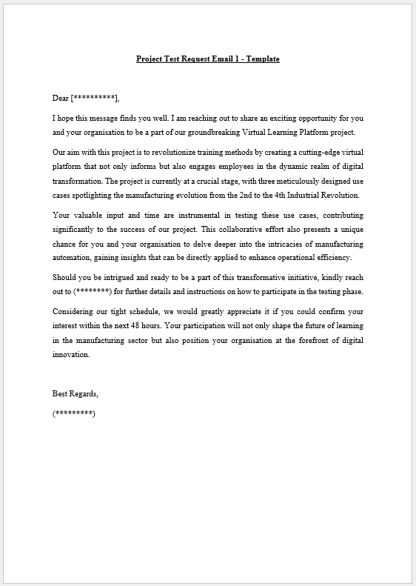

Appendix B:


Appendix C:
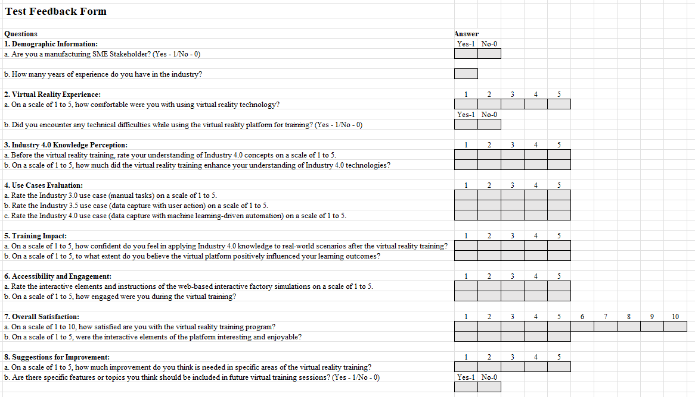

Appendix D:


