Changemakers: Creativity and Value Creation
Professions (BMHP5014)

Component 1: Online portfolio of set exercises

Student name: Ernestina Owusu Frimpong
Student number: 2330907
Lecturer’s name: G1 Laila Surani
G2 Caroline Salami (module leader)

Changemakers: Creativity and Value Creation
Healthcare innovation involves the integration of new technology, research, and changing healthcare models that can lead to dramatic improvements in healthcare outcomes (Kosiol et al., 2024). Creating value means that healthcare outcomes are enhanced with reference to resources consumed (Teisberg et al., 2020). In this portfolio, concepts of innovation, creativity, value, and change in healthcare settings are discussed with reference to health and social care. A practical application of these concepts, including analysing a problem using a mind map, group thinking, and analysing a healthcare innovation within the NHS, will also be discussed. Causes of a particular issue in healthcare settings, technology in healthcare settings, leadership, and personal learning will also be discussed.
Task 1- Defining Key Concepts in Practice
Innovation can be defined as new ideas, processes, or technology that can improve patient care and health care service delivery (Kosiol et al., 2024). Rogers' diffusion model of innovation supports that new ideas are diffused through society, with individuals being either innovators, early adopters, or laggards, accepting change once they see its advantage (Wurster et al., 2024). Innovation is essential as it results in improvements in quality, access, and efficiency. For example, telemedicine is transforming chronic care management and has shown remarkable improvements in patient engagement and outcomes (Ezeamii et al., 2024). Without innovation, health care services can deteriorate, with adverse consequences for patient care and healthcare sustainability.
Creativity means generating new and useful ideas, and in health care, it includes new ideas that can improve patient care (Thabane et al., 2025). New thinking can lead to new methods that are more useful, efficient, and safe compared to existing ones. According to Amabile’s Componential Theory of Creativity, creativity occurs when expertise, creative thinking skills, and intrinsic task motivation are present (Amabile and Mueller, 2024). Creativity is essential in health and social care, as it can lead to better solutions to problems, resulting in improvements in care. As shown by Cheraghi et al. (2021), creativity in healthcare can lead to better policies and care practices, resulting in better care quality and health technology.
Value can be defined as health outcomes obtained per unit of cost incurred (Teisberg et al., 2020). Value creation, therefore, involves improving health outcomes, like survival rates, in comparison to costs incurred. According to Porter (2010), value-based care should always prioritize outcomes over costs. Value-based care maximizes outcomes and minimizes costs, thus creating more value for patients and the healthcare system. It helps reduce waste and improve health, as all healthcare stakeholders are concerned with improving outcomes relative to costs (Teisberg et al., 2020).
Change involves a transition from the current state to a new and enhanced state (Stanz et al., 2022). Lewin’s Change Management Model is a three-stage process of change: unfreeze, change, and refreeze (Stanz et al., 2022). Change management is important in ensuring that new developments are successfully implemented. Structured change is important in the health and social care sectors as it helps in overcoming the problems of change (Harrison et al., 2021). The COVID-19 pandemic proved that failure to implement change can lead to obsolescence. Hospitals had to unfreeze their old norms and refreeze new infection control processes.

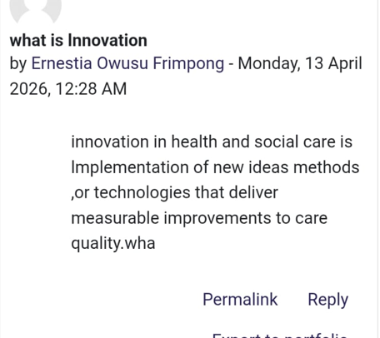
Week 1 Online activity
Task 2 - Mind Map
One of the problems in healthcare is long waiting times in hospitals, such as for appointments or emergency care. Waiting times are important as they can affect health outcomes, as long waiting times can lead to health problems, stress, and mistrust of healthcare institutions. A systems perspective of waiting times involves understanding that waiting times are a complex issue with interconnected causes (Carey and Crammond, 2015). It involves understanding that waiting times are a complex issue with interconnected causes. These causes include a lack of staff, inefficient appointment systems, and a high number of patients. Waiting times can lead to a vicious cycle of burnout, resulting in poor care, which can lead to more waiting times. Waiting times can be addressed by solving the causes, such as nurse staffing ratios.

Figure: A mind map highlighting a system of causes and impact of long wait times
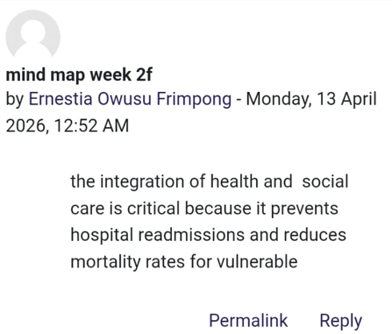
Week 2 Online activity
Task 3 - Self-Reflection of Group Activity
The Gibbs Reflective Cycle will be used for the reflective process.
Description: In the group activity, the process began with divergent thinking and ended with convergent thinking. Divergent thinking, which is the generation of ideas, came naturally to me, and I had the energy to come up with wild ideas. Convergent thinking, which is the selection and refinement of ideas, was not as natural to me, and I observed that I tended to rush to conclusions.
Feelings: During the group activity, some conflicts were observed during the convergent thinking phase, and I felt anxious as the group had difficulties reaching a consensus. To address the anxiety, the group employed the strategy of creating a list of the pros and cons of the ideas generated, which helped the group reach a consensus.
Evaluation: From the reflective practice studies, the open-mindedness that comes with such reflection is crucial for learning and developing empathy. From the experience, I realized that I could contribute to the group by providing structure to the group’s decision-making process.
Analysis: I have discovered that I enjoy divergent thinking, but still have to work on improving my convergent thinking. The activity also taught me the importance of utilizing both modes of thinking in the development of innovation. I have learned that, first, ideas have to be developed, and then the best ideas have to be refined (Wigert et al., 2024).
Conclusion and Action Plan: Next time I am given a task, I will ensure that I propose the use of both modes of thinking. I have learned the importance of utilizing both modes of thinking in the development of innovation. In future tasks, I would balance my participation by also encouraging practical analysis. Gibbs reflective practice theory suggests this kind of introspection fosters growth (Yang and Zou, 2025).
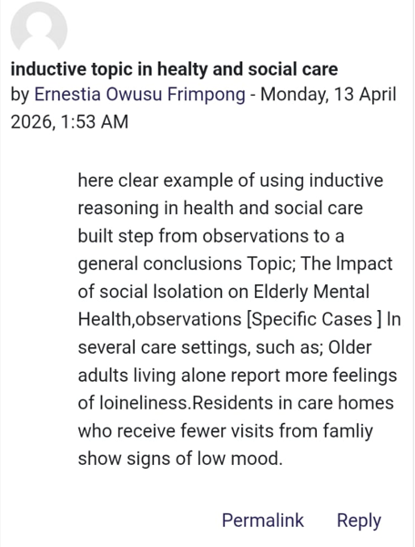
Week 3 Online activity

Task 4 – Case Study Analysis of a UK Innovation
Virtual wards are an innovation within the NHS, where patients are being treated at home instead of within the hospital. This was made necessary by the shortage of beds and the COVID-19 backlog, where there were not enough beds within the hospital for all the sick patients. According to Rogers’ Diffusion of Innovation Theory, this will spread because of the benefits seen by the clinicians (Wurster et al., 2024). It was creative because clinicians came up with innovative processes of care, using technology such as apps, wearables, and telemedicine consultations.
Virtual wards have created value for the patients, the clinicians, and the healthcare system. NHS England (2024) found that for every 4,311 patients managed through the virtual ward, there was an equivalent saving of 8,622 bed days and £3.45 million. Patients have gained by receiving care at home, where outcomes such as mortality and readmission are equivalent to, if not better than, those within the hospital. Families are more satisfied being at home with loved ones. Clinicians have gained by not having to manage all the sick patients within the hospital, where resources are scarce.
So far, the outcomes for this innovation are positive. It was found that patients within the virtual wards had lower mortality and readmission rates compared to patients within the hospital (NHS England, 2024). For the system, the NHS has scaled up virtual wards nationwide, showing that this innovation has diffused. According to Rogers Diffusion of Innovation Theory, this is because it has shown utility and ease of implementation, where digital monitoring was found to be easy for patients and clinicians to use (Wurster et al., 2024).
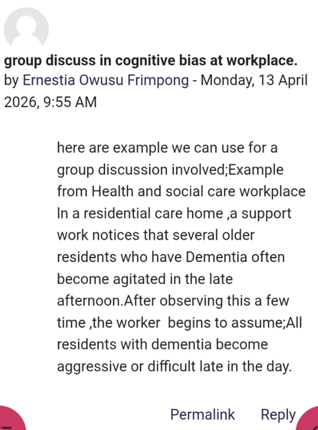
Week 4 Online activity
Task 5 - Research Task
Paling et al. (2020) analysed emergency department waiting times and discovered that when there is high inpatient bed occupancy and low patient flow, there is a sharp rise in waiting times in the emergency department. It demonstrates the issue of patient flow, or rather the lack of it, as a systems issue that contributes to the rise in waiting times in healthcare. Howlett and Wood (2022) also conducted a study on the modelling of the elective backlog in England. As demonstrated, the rise in the number of patients waiting in the hospitals is attributed to the COVID-19 pandemic. This is because the pandemic led to a rise in the number of cancelled operations and procedures, resulting in a rise in the number of elective procedures. This demonstrates the issue of capacity versus demand as the major factor in the rise in waiting times in hospitals. This is because when there is a rise in demand, there is a corresponding rise in the number of patients waiting in hospitals. This is demonstrated by the rise in the number of elective procedures as a result of the pandemic.
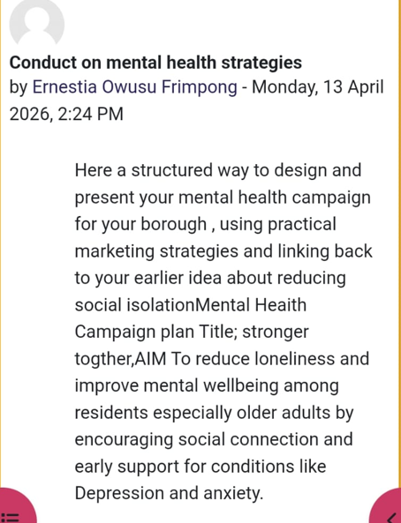
Week 5 Online activity
Task 6 - Exploring Digital Innovation in Health and Social Care
Wearable health technologies, such as smartwatches, provide constant health monitoring that can help in the improvement of chronic patient care. Schreier et al. (2026) showed that a wearable device had a specificity of 98.7% in detecting postoperative atrial fibrillation. Wearable technologies are useful in detecting problems in the patient’s condition, such as arrhythmias. This will help in the prevention of complications such as stroke, and empower patient. Diabetic patients, for example, are able to make appropriate lifestyle changes in real time by using smart glucose monitors. Wearable technologies are useful during patient self-management. This will lead to improved patient outcomes at a reasonable cost.
Electronic Health Records (EHRs) are useful in enhancing communication and teamwork because they provide instant access to patient information. This means that all the members of the patient’s team have access to the patient’s information. A doctor, a specialist, and a nurse can access the patient’s information. As Torab-Miandoab et al. (2025) showed, electronic medical records are useful during patient care because they ensure continuity of care. In addition, electronic medical records are useful in facilitating interdisciplinary communication. This means that there is no confusion in patient care.
Digital technologies promote healthy living and prevent diseases. For instance, digital technologies can be used to monitor physical activities. De Santis et al. (2023) indicate that digital technologies are very effective in improving physical activities. For instance, a digital application for a smartphone was used to monitor the physical activities of elderly people, resulting in reduced cases of diabetes (De Santis et al., 2023). Similarly, digital technologies can be used to remind people about the need for vaccinations and tests. The digital technologies are based on the Technology Acceptance Model, as the technologies are effective if the patients find them useful and convenient (De Santis et al., 2023).
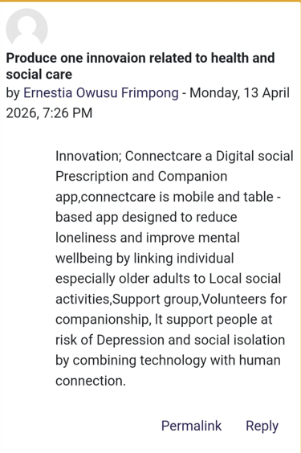
Week 6 Online activity
Task 7 - Understanding the NHS Leadership Framework
The NHS Healthcare Leadership Model highlighted nine key areas that can be considered when delivering effective healthcare leadership. They include inspiring shared purpose, leading with care, evaluating information, connecting our service, engaging the team, sharing the vision, holding to account, developing capability, and influencing for results. The framework is significant as it identifies the behaviours that NHS leaders need to demonstrate, which have the potential to create a positive culture through aligned teams and a supportive culture (Fu et al., 2022). Good leadership has been proven to have a positive impact on team morale and patient satisfaction, and the model helps leaders to navigate the complex health system.
One leadership behaviour is engaging the team. A leader who is capable of engaging his or her teams can be creative enough to deliver quality patient care. Engaging the team means valuing what other teams have contributed to the healthcare organization (NHS Leadership Academy, 2025). According to Fu et al. (2022), an effective healthcare leader who is capable of valuing what other teams have contributed can be creative enough to deliver quality healthcare services. This is because when an effective healthcare leader values what other teams have contributed, it will be easy to come up with innovative ideas that can improve patient care.
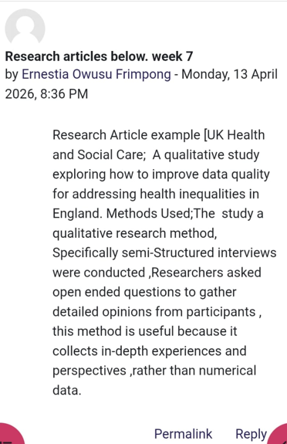
Week 7 Online activity

Task 8 – Self-Reflection Journal Entry
Looking back at this module, I recognize that my perception of innovation has changed from high-tech gadgets to more of an approach of improving the quality of care. At the beginning, I thought innovation was all about high-tech equipment, but learning about value-based care helped me understand that sometimes simple, creative, and innovative approaches, such as changing the workflow of a clinic, can create huge value, which is defined by outcomes compared to costs (Teisberg et al., 2020). I now recognize that my perception of an idea being innovative is only if it can tangibly help patients.
I was influenced by all the activities and learning materials presented throughout the module. Using Gibbs’ reflective cycle helped me realize that I was learning from all the exercises, and I noticed that I was using analytical thinking most of the time, but the exercises helped me be more open-minded, which is advocated by reflective practice and creative thinking (Yang and Zou, 2025). Looking forward, I will be able to apply all the learning from this module into my practice by always looking for value, that is, better outcomes for my patients, and by engaging the team in innovation as advocated by the NHS model, which is known to increase creativity.
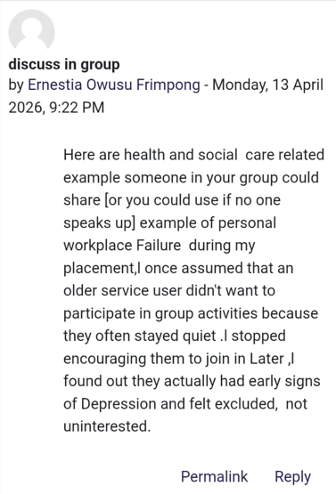
Week 8 Online activity
References
Amabile, T.M. and Mueller, J.S. (2024) ‘Studying creativity, its processes, and its antecedents: An exploration of the componential theory of creativity’, in Zhou, J., Shalley, C. E. (eds) Handbook of Organizational Creativity. Psychology Press, pp. 33-64.
Carey, G., and Crammond, B. (2015) ‘Systems change for the social determinants of health’, BMC Public Health, 15, p. 662. Available at: https://doi.org/10.1186/s12889-015-1979-8
Cheraghi, M. A., Pashaeypoor, S., Dehkordi, L. M., and Khoshkest, S. (2021) ‘Creativity in nursing care: a concept analysis’, Florence Nightingale Journal of Nursing, 29(3), pp. 389–396. Available at: https://doi.org/10.5152/FNJN.2021.21027
De Santis, K. K., Mergenthal, L., Christianson, L., Busskamp, A., Vonstein, C., and Zeeb, H. (2023) ‘Digital technologies for health promotion and disease prevention in older people: scoping review’, Journal of Medical Internet Research, 25, e43542. Available at: https://doi.org/10.2196/43542
Ezeamii, V. C., Okobi, O. E., Wambai-Sani, H., Perera, G. S., Zaynieva, S., Okonkwo, C. C., Ohaiba, M. M., William-Enemali, P. C., Obodo, O. R., and Obiefuna, N. G. (2024) ‘Revolutionizing healthcare: how telemedicine is improving patient outcomes and expanding access to care’, Cureus, 16(7), e63881. Available at: https://doi.org/10.7759/cureus.63881
Fu, Q., Cherian, J., Ahmad, N., Scholz, M., Samad, S., and Comite, U. (2022) ‘An inclusive leadership framework to foster employee creativity in the healthcare sector: the role of psychological safety and polychronicity’, International Journal of Environmental Research and Public Health, 19(8), p. 4519. Available at: https://doi.org/10.3390/ijerph19084519
Harrison, R., Fischer, S., Walpola, R. L., Chauhan, A., Babalola, T., Mears, S., and Le-Dao, H. (2021) ‘Where do models for change management, improvement and implementation meet? A systematic review of the applications of change management models in healthcare’, Journal of healthcare leadership, 13, pp. 85–108. Available at: https://doi.org/10.2147/JHL.S289176
Howlett, N. C., and Wood, R. M. (2022) ‘Modeling the recovery of elective waiting lists following COVID-19: scenario projections for England’. Value in health: the Journal of the International Society for Pharmacoeconomics and Outcomes Research, 25(11), pp. 1805–1813. Available at: https://doi.org/10.1016/j.jval.2022.06.016
Kosiol, J., Silvester, T., Cooper, H., Alford, S., and Fraser, L. (2024) ‘Revolutionising health and social care: innovative solutions for a brighter tomorrow - a systematic review of the literature’, BMC Health Services Research, 24(1), p. 809. Available at: https://doi.org/10.1186/s12913-024-11099-5
NHS England (2024) Virtual Wards Operational Framework. England.nhs.uk. Available at: https://www.england.nhs.uk/long-read/virtual-wards-operational-framework/.
NHS Leadership Academy (2025) Explore the Healthcare Leadership Model. NHS Leadership Academy. Available at: https://www.leadershipacademy.nhs.uk/healthcare-leadership-model/explore-the-healthcare-leadership-model/.
Paling, S., Lambert, J., Clouting, J., González-Esquerré, J., and Auterson, T. (2020) ‘Waiting times in emergency departments: exploring the factors associated with longer patient waits for emergency care in England using routinely collected daily data’, Emergency Medicine Journal: EMJ, 37(12), pp. 781–786. Available at: https://doi.org/10.1136/emermed-2019-208849
Porter, M. E. (2010) ‘What is value in health care?’, New England Journal of Medicine, 363(26), pp. 2477-2481. Available at: https://doi.org/10.1056/NEJMp1011024
Schreier, K., Borger, M., Sepehri Shamloo, A., Hofmann, L., Schröter, T., Eifert, S., Darma, A., Etz, C., Leontyev, S., Misfeld, M., Bollmann, A., and Arya, A. (2026) ‘Feasibility and reliability of a smartwatch to detect atrial fibrillation after cardiac surgery: a prospective study’, Frontiers in Digital Health, 7, 1718350. Available at: https://doi.org/10.3389/fdgth.2025.1718350
Stanz, L., Silverstein, S., Vo, D., and Thompson, J. (2022) ‘Leading through rapid change management’, Hospital pharmacy, 57(4), pp. 422–424. Available at: https://doi.org/10.1177/00185787211046855
Teisberg, E., Wallace, S., and O'Hara, S. (2020) ‘Defining and implementing value-based health care: a strategic framework’, Academic Medicine: Journal of the Association of American Medical Colleges, 95(5), pp. 682–685. Available at: https://doi.org/10.1097/ACM.0000000000003122
Teisberg, E., Wallace, S., and O'Hara, S. (2020) Defining and implementing value-based health care: a strategic framework, Academic Medicine: Journal of the Association of American Medical Colleges, 95(5), pp. 682–685. Available at: https://doi.org/10.1097/ACM.0000000000003122
Thabane, A., Saleh, S., Pallapothu, S., McKechnie, T., Staibano, P., Busse, J. W., Calic, G., Sonnadara, R., Parpia, S., and Bhandari, M. (2025) ‘Creativity research in medicine and nursing: A scoping review’, PloS one, 20(1), e0317209. Available at: https://doi.org/10.1371/journal.pone.0317209
Torab-Miandoab, A., Samad-Soltani, T., Jodati, A., Akbarzadeh, F., and Rezaei-Hachesu, P. (2025) ‘The impact of electronic medical records on clinical documentation: A case study’, Journal of Education and Health Promotion, 14, p. 246. Available at: https://doi.org/10.4103/jehp.jehp_320_24
Wigert, B. G., Murugavel, V. R., and Reiter-Palmon, R. (2024) ‘The utility of divergent and convergent thinking in the problem construction processes during creative problem-solving’, Psychology of Aesthetics, Creativity, and the Arts, 18(5), p. 858. Available at: https://psycnet.apa.org/doi/10.1037/aca0000513
Wurster, F., Di Gion, P., Goldberg, N., Hautsch, V., Hefter, K., Herrmann, C., Langebartels, G., Pfaff, H., and Karbach, U. (2024) ‘Roger's diffusion of innovations theory and the adoption of a patient portal's digital anamnesis collection tool: study protocol for the MAiBest project’, Implementation Science Communications, 5(1), p. 74. Available at: https://doi.org/10.1186/s43058-024-00614-8
Yang, Q., and Zou, W. (2025) ‘The impact of reflective practice on the development of nursing undergraduate students’, BMC Medical Education, 25(1), p. 880. Available at: https://doi.org/10.1186/s12909-025-07490-3

