Student Name: Svetlana Dimitrova
Student Number: 1714890
Module Number: BMSK4005
Module Title: PROFESSIONAL CAREER DEVELOPMENT
Lecturer Name: Sylvia Hoffmann

CONTENT

Introduction 3
Life line 3
Self-assessment 5
Learning stile 5
SWOT analyze 6
SMART objective 8
Johari window 9
Understanding and expectations of the world of employment 12
Personal development planning 14
Conclusion 15
References 17
Appendix 19

Introduction
I am currently developing two businesses and I am involved in an initiative to support the proper development of children in Malawi. I have enrolled in this course because I had many weaknesses and lack of information, but I wanted to improve myself. The modules covered exactly what I want to learn and in the past nine months I received an excellent teaching, have accumulated knowledge and have been successfully applying it. The lectures were invaluable to me and I see mine progression and I could say that I am confident, and it gives me a pleasure.
In this reflective Portfolio I have exposed high and low points in my life, some of my weaknesses, strengths, threats and opportunities and reflected on my self-motivation. I have declared my professional and personal goals, my understanding and expectations of the world of employment. I have described the learning stiles and what kind of learner I am, applied my knowledge about Johari window and in the end of this Portfolio, the reader will know my ambitions, aspirations, goals and my personal development plan.

Life line

Success enter life when one has attained the aim that one has set for oneself. (Yilmaz, 2018, p.1278) I had set goals in life, both personally and professionally. In my professional goals, I always wanted to find ways to establish my own business and prove to be an effective leader of the team. Upon doing lifeline exercise on the lows and highs in life and plotting on a graph (appendix 1), I was able to determine how I was able to start my own business. A lifeline exercise is shown as the lows and highs in life, whether in education, in family, in activities or in some work. (Hinds and Polinsky, 2016). It literally can be created by drawing out the line across the chart while marking up the date of occurrences. I realized that there are four major highs and lows of my life that influenced my position the way I am here now. Minor up and downs also happened in my life that made a prominent impact on my life and personality (Górnik-Durose, 2019, p. 22).
The high point occurred as my life’s low part when I was just 18 years of age, and I was not able to get admission in a university because I did not qualify for the high school requirements. Therefore, I decided to prepare my own business. I took admission in a business school. Hence, not getting admission in the university was a blessing in disguise as knowing about the basic business techniques and entrepreneurship helped me in establishing a cleaning company and in starting my online beauty business.
The third most important point of my life was when I was 23 years of age. This was the time when I exactly found out my love towards makeup, and I was discouraged by many people, of starting to sell beauty products, and then eventually I decided to drop this idea and leave it uncompleted.
Now, I am 49 years old Bulgarian, married, and I have two children. I have been living in the UK for six and a half years. I left my country because of the bad political and economic situation in the country. I had to leave my children, my husband and my parents there, while I was researching what kind of documents we needed. I started as a regular cleaner, but I always wanted to find an opportunity, which would give me a better life. At the end of 2013, I was able to have my family here. My husband and I have established a small cleaning company, and in 2017, I run my beauty online business. The past in Bulgaria was filled just with a hope to have a better life, and then I decided to change my life. When I sat down in the plane to London, I promised myself that the rest of my life would be the best of my life.

Self-assessment
Self-assessment has an important function in assessing oneself because it is the image that a person receive can be improved by themselves (Yan,2016, p.335). This evaluation helps one to take responsibility for owns self-assessment. It is known that tasks and achievement can only be unlocked when it has some kind of motivation behind it. The cleaning business was definitely an extrinsic motivation because it was not something I enjoyed, but I knew it would be rewarding my husband and me with profit to live. My online makeup business is intrinsically motivated as I do not care what the reward would be like, but since I have an interest in makeup and have studied business, it makes me happy that I am able to pursue my passion in the field of my interest.

Learning stile
According to Nisbet, and Shucksmith, (2017) the learning style term was used by the researchers when different ways were found to match the situations and methods used by the learners. A number of learning styles are present, for example, the psychological traits, and cognitive traits that are stable relatively by which these learners interact, perceive and respond to the environment present for learning (Nisbet, and Shucksmith, 2017).
Active learners are those that understand and retain the information such as applying and explaining to others; however, sometimes I also become reflective learner where I used to think about it quietly. I had a cognitive learning style, which was constructive, long-lasting and active, according to learning styles self-assessment questionnaire, which we have done in class. It helped me to engage my brain more effectively to make a connection while learning new things. I am an active learner and like to work in a group rather than alone. However, sometimes, I become reflective, as this balance is important because most of the personal experiences are done by reflective learning, which is implied on the improvement of my own personality.
Furthermore, a sequential learner is online that follows the logical step when finding the solutions and I am one of them; I remain calm, patient and follow a procedure by involving the opinion of my employees to get over the difficulties face by the business.

SWOT analyze

It is important for one to know the weaknesses and strengths of oneself, along with the threats and opportunities to be successful in this world. To have a knowledge of these conditions will help for the benefit of oneself (Phadermrod, 2019, p.194). If one can identify and understand their capabilities and advantages, the person will be able to handle the circumstances confidently. Nevertheless, if one is aware of the threats and weaknesses that have given rise to them, one may turn his attention to those areas where improvement and overcoming of obstacles arising from the threats are needed.
Strengths
Generally, my personal strengths included the power to be creative and innovative, as well as to keep an open mind. These parts have allowed me to be more efficient and effective in different ways. One of my biggest strengths is my communication, attention to details and responsibility throughout the sales process/ taking booking for a cleaning service. Furthermore, I am always open to new ideas, which helped me to stay adaptive to different changing situations. As adaptation in the world is an ability that is forming and changing constantly, hence after establishing my online beauty business of websites, I encouraged the idea to my employees to promote and start my operation on social media site as well. In addition, owning good resources is good for success and I have an important personal resource, which is my experience and education in entrepreneurship and business, that has helped me apply my knowledge.
Weaknesses
While dealing with the competitive environment, weakness is inevitable. In an organization, weakness can be known as the “the drawbacks that hinder an organization in executing strategies in pursuit of its mission” (Williams, 2016, p.877). While dealing with individuals, it stays true. Because of my ambitious nature, there were times when I pushed my team hard to perform at their best, put in extra hours, and I was very demanding.
In general, I always understand the members of my team about the challenges they are facing, but there were times for last few months when I was perceived as too uncompromising. I am open-minded, though, but when I believed I followed something to gain momentum and be best, I am not able to change the direction, and I become fixated regarding my goal. Weakness is something that we must be dealing with one way or another; if I feel I am not able to work on them to strengthen them, then I avoid them. I believe it is good to stay aware of the personal weaknesses in order to face the truth regarding what is possible and ways to avoid unrealistic thoughts.
Threats
Threats are seen as anything that can stand in the way of achieving goals that affect the ability to compete with others (Hay and Castilla, 2006, p. 4). The biggest threat for me is to see any other cleaning or beauty products company success in the same field. Furthermore, the demand in both the cleaning and beauty business is changing; the competition is strong; hence, it is a big threat to my business. I focus on developing some strategies to manage the changing environment and customer requirements I focus on developing some strategies to manage the changing environment and customer requirements.
Opportunities
One weakness is related to my leadership skills, and if I am able to eliminate it somehow, this will open up a whole new area to experience new ideas and innovations. In search of success in my career, I have many opportunities. Most of them have to be created by me Education is one prominent one, as it gives me a choice for doing well, as my education is related to my career. This could help me to improve the cleaning company and beauty products business.

SMART objective

Setting goals for yourself is the best way to follow a successful path. This is important to keep yourself on track and get to the point of fulfillment (Bjerke, 2017, p.125). For these objectives are important. It is a statement which organization, team, individual is hoping to achieve. These objectives are SMART if they are related to specific, measurable, achievable, realistic and timely.

Specific
I need to improve my leadership skills by spending one month on working on my professional and personal skills.

Measurable
This might take a month, as I have to work on my attitude as I always become too uncompromising at times. My objective will be to measure when my employees would have no complaint, and their ideas will be encouraged.

Attainable
These objectives fit the strategic priorities of both cleaning and beauty products business, as this would help in valuing employees and open for new ideas.

Johari window
The Johari window is known as a technique that will help the people to understand the relationship with others and themselves. This was created by Joseph Luft (1916–2014) and Harrington Ingham (1916–1995), and it is primarily used in the corporate settings and self-help groups (Saxena, 2015, p.134). It has quadrants related to the understanding of their lives. In order to grow and to become a real person, it is important to grow under these quadrants.
Table 1 Johari window (Saxena, 2015, p.134).

 | Known to Self | Unknown to Self
Known to Others | Adoptable  Relaxed  Good communicator  Responsive  Trustworthy  Confident  Dignified  Independent | Organized  Extroverted  Energetic
Unknown to Others | Nervous  Open-minded  Quiet  Introverted

It can be seen that others think that I am an extrovert as I have good communication skills. It is, however, not the case, I am an introvert, and it is just for business purposes. I have to work hard every day to step out of my comfort zone for socializing and interacting with the people. However, it can be seen that being among the large group for a long time can have me exhausted, and I would prefer to stay alone to regain energy. Furthermore, it is not surprising that people think that I am not a nervous person, but in reality, I am. This shows that putting my efforts in hiding the self-consciousness and to remain confident is now working. One day hopefully, I will not be associated with the word ‘Nervous’.
Although I will always doubt the accuracy of the Johari Window, this will, however, help me in understanding employees in a better way. This provides the team members for expressing their perceived thinking about me so that we as a team could better understand one another. For example, my team thinks that I sometimes do not think with an open mind which is not the case, I try to give an opportunity to my employees, but sometimes my dominating nature holds me doing this. These quadrants boosted my confidence, as it gives me more encouragement to become better. As I was unconfident about what my employees think of me, by the Johari window, I am able to discover that I am valued in my team.

Understanding and expectations of the world of employment
In order to know about their performance, employees must know what is being expected of them. Those employees that do not have any knowledge regarding what is expected by their managers cannot engage themselves in the workplace successfully. A report presented by the Gallup showed that 1000 adults employed found out that half of the employees do not have an understanding of what is being expected from them at work (Harrison et al., 2016, p.4). Personally, I have my own understanding and expectation from the employment world while doing business.

Job description
The employees must have a specific job and should know about their job description and role (Bureau, 2019). Personally, I hand them a document in which the person’s expectations are set in order to perform the role, and this also helps me in measuring their success. These documents have written clear expectations of what is important for me and in reviewing their work, this also allows to clear confusions related to assigned roles.
Performance appraisal
By the performance appraisals, the employer is able to measure the way the staff is working. This is the process to assess, summarize and develop the employee performance in line with the expectations. This is the process that has become a ritual in my company every year. By the adoption of this kind of method, result in a more relaxed conversation between me and my employer, they have an opportunity to address the issue when they arise, this results in no surprises for either party (Dipboye and Dipboye, 2018, p. 535). This will also help in assessing the issue related to the skills of employees, and their willingness to perform is the real issue. This process also helps in providing an opportunity for the improvement, better communication, reviewing and training, and it helps in the company culture development (Dipboye and Dipboye, 2018, p. 535).

Managing the poor performance
In the employment world, when an employee is not working in the discipline in response to the misconduct or misdemeanor. Then discipline is required to establish which can be both written and oral, to alert the actions of the employees, which is inappropriately deemed. We have clear standards and value in our company regarding the set expectations and standards (Leaver and Reader., 2016, p.687). As the part of the counselling, interviewing them and reading out the disciplinary process, I give the employee a chance to discover the reason behind his or her behaviour, which could also result in facilitating the improvement.

Continual Learning
Continual learning helps one to increase the contribution to the company. Both the employer and employee must keep on learning new skills and thus make themselves valuable to the company (Nguyen et al., 2017). This can be done by taking the advice from the manager and team up on things that are needed to learn in order to focus on the progress. To take the feedback from the head and from the employees are one vital skill that helps in the progress to become a better person.

Cooperation
One of the prominent assets for anyone in the employment world is to have the ability to get along. One might lack skills as compared to another, but getting along as a team and sharing knowledge and talents will help in doing work efficiently (Mead, 2018). I make this thing work in my business too, seniors are told to train the junior employees, which makes the working environment better, and this also makes me a grateful employer. By helping to get along with your team, makes the company a better place to survive- and all this can never go unrecognized. In the basic list, many other attributes can also be added, such as respect and honesty. These are important, and it has its foundation based on the attitudes. Having a positive attitude is the foundation in which one must develop its career.

Personal development planning
Personal development planning is the process that is created in a way to think and organize personal, career, and intellectual growth (Chlebikova, 2015, p.249).

Career Development
According to Piatak (2016, p.804) definition of career ambition is to have a desire to move from one position to something else, preferably on the ladder professionally. In order to succeed professionally, one must make things rather than waiting for things to happen. People wish for their own business and promotion, but those people that are ambitious enough set specific goals, research for the steps they would take to attain it (Høyland et al., 2017, p.1). Furthermore, career and its aspiration are a defined path that a career must follow.

Ambitions
One of the most important career ambitions was to obtain a specific position; for that, I learned the performance skills needed to attain the outcomes desired. My career ambitions include improving set learning and leadership skills. I am the head of my business. Still, my ambition is to increase more knowledge and skill related to teamwork and leadership skills so that I could manage my staff successfully.

Peer Recognition
Another ambition in my life is to gain positive name or recognition in my profession. This will attract more and more clients and employers to work with my company. My goal is to become one of the biggest cleaning company, along with the most reliable and recognized online business of making products. I love making sales, and also find it exciting to land new clients and also compete up with peers. My position is attractive as it provides the opportunity in making my relationships with the clients majorly while also pursue new customers. I want to remain in sales for the future too. My goal is to be one of the leading managers of my staff, to be recognized as the expert of cleaning and beauty products, having a sound record for customer satisfaction.
Aspirations
The Aspiration for my career is to become the leading general manager of a cleaning company and establish my own store of beauty products. In order to achieve this, I have to make a lot of efforts (Gregor and O’Brien, 2016, p.559). Generally, there are individual characteristics that affect the choices of people for their careers, such as self-image, personality and social backgrounds. I have chosen my career by these characteristics I believe that one day I will become the head of the biggest cleaning company of UK, this is because it matches with my ambitions and also because I have a habit of challenging myself to achieve my goals. For me, this has been aspiration from the start because I was determined from the start to work hard and to be successful. This could also have a direct impact on my personality as my personality will be changed in a standard and formal way. Further, achieving my goals will let me gain more knowledge about the beauty world and cleaning services due to the rapid growth change in the business, further gaining more profit is it turns out to be successful.
This plan (Appendix 2) for the personal development is an effective tool for the self-assessment for everyone, and it helps the people to list out the things and their weaknesses which as required to be developed and improved (Tasker, 2015). After the experiences and incidences, the skills are needed to be improved. As being the head of both my business (cleaning and online beauty products), I need improvement in each of the skill mentioned above to improve develop my personality and to let my business achieve success.

Conclusion

Certificate of higher education in a workplace is a really great program because it has helped me to deal with my weaknesses and lack of knowledge. In addition, it has allowed me to provide high quality management and feedback to my employees and colleagues, regardless of the workload involved. My ability to reflect on my own learning has improved and I have found that my work is much more adaptable to the needs of clients and employees. My assessment and understanding of a number of techniques, methods for personality development, problem solving, and decision making have evolved significantly with this program. This program has taken me along an exciting, interesting and rewarding path, to make me better. I have gained knowledge and skills and am confident in my abilities. I can greatly thank Certificate of higher education in a workplace for influencing my career and personal development. I look forward to the challenges ahead in my training and practice.

References

Bjerke, M.B. and Renger, R., 2017. Being smart about writing SMART objectives. Evaluation and program planning, 61, pp.125-127.
Bureau, H.E., 2019. Job Description. Network.
Chlebikova, D., Misankova, M. and Kramarova, K., 2015. Planning of personal development and succession. Procedia Economics and Finance, 26, pp.249-253.
Dipboye, R.L. and Dipboye, R.L., 2018. Criterion Development, Performance Appraisal, and Feedback'. In The Emerald Review of Industrial and Organizational Psychology (pp. 535-579). Emerald Publishing Limited.
Górnik-Durose, M.E., 2019. Materialism and Well-Being Revisited: The Impact of Personality. Journal of Happiness Studies, pp.1-22.
Gregor, M.A. and O’Brien, K.M., 2016. Understanding career aspirations among young women: Improving instrumentation. Journal of Career Assessment, 24(3), pp.559-572.
Harrison, I.I., Hal, H.L. and Reed, P.A., 2016. Comparing High School Students' and Adults' Perceptions of Technology. Journal of STEM Teacher Education, 51(1), p.4.
Hay, G.J. and Castilla, G., 2006, July. Object-based image analysis: strengths, weaknesses, opportunities and threats (SWOT). In Proc. 1st Int. Conf. OBIA (pp. 4-5).
Hennessey, B., Moran, S., Altringer, B. and Amabile, T.M., 2015. Extrinsic and intrinsic motivation. Wiley encyclopedia of management, pp.1-4.
Hinds, R.S. and Polinsky, G., PIVOTAL 5 LLC, 2016. Exercise device with elastic members and webbing. U.S. Patent 9,333,385.
Høyland, B., Hobolt, S.B. and Hix, S., 2017. Career ambitions and legislative participation: The moderating effect of electoral institutions. British Journal of Political Science, pp.1-22.
Leaver, M. and Reader, T.W., 2016. Non-technical skills for managing risk and performance in financial trading. Journal of Risk Research, 19(6), pp.687-721.
Mead, M., 2018. Cooperation and competition among primitive peoples. Routledge.
Nguyen, C.V., Li, Y., Bui, T.D. and Turner, R.E., 2017. Variational continual learning. arXiv preprint arXiv:1710.10628.
Nisbet, J. and Shucksmith, J., 2017. Learning strategies. Routledge.
Phadermrod, B., Crowder, R.M. and Wills, G.B., 2019. Importance-performance analysis-based SWOT analysis. International Journal of Information Management, 44, pp.194-203.
Piatak, J.S., 2016. Public service motivation, prosocial behaviors, and career ambitions. International Journal of Manpower, 37(5), pp.804-821.
Saxena, P., 2015. Johari Window: An effective model for improving interpersonal communication and managerial effectiveness. SIT Journal of Management, 5(2), pp.134-146.
Tasker, F., 2015. How to prepare a personal development plan. BMJ, 351, p.h4603.
Williams, S., Dodd, L.J., Steele, C. and Randall, R., 2016. A systematic review of current understandings of employability. Journal of education and work, 29(8), pp.877-901.
Wolff, M., Wagner, M.J., Poznanski, S., Schiller, J. and Santen, S., 2015. Not another boring lecture: engaging learners with active learning techniques. The Journal of emergency medicine, 48(1), pp.85-93.
Yan, Z. and Brown, G.T., 2017. A cyclical self-assessment process: towards a model of how students engage in self-assessment. Assessment & Evaluation in Higher Education, 42(8),
Yilmaz, H., 2018. Fear of Success and Life Satisfaction in Terms of Self-Efficacy. Universal Journal of Educational Research, 6(6), pp.1278-1285.

Appendix

Appendix 1
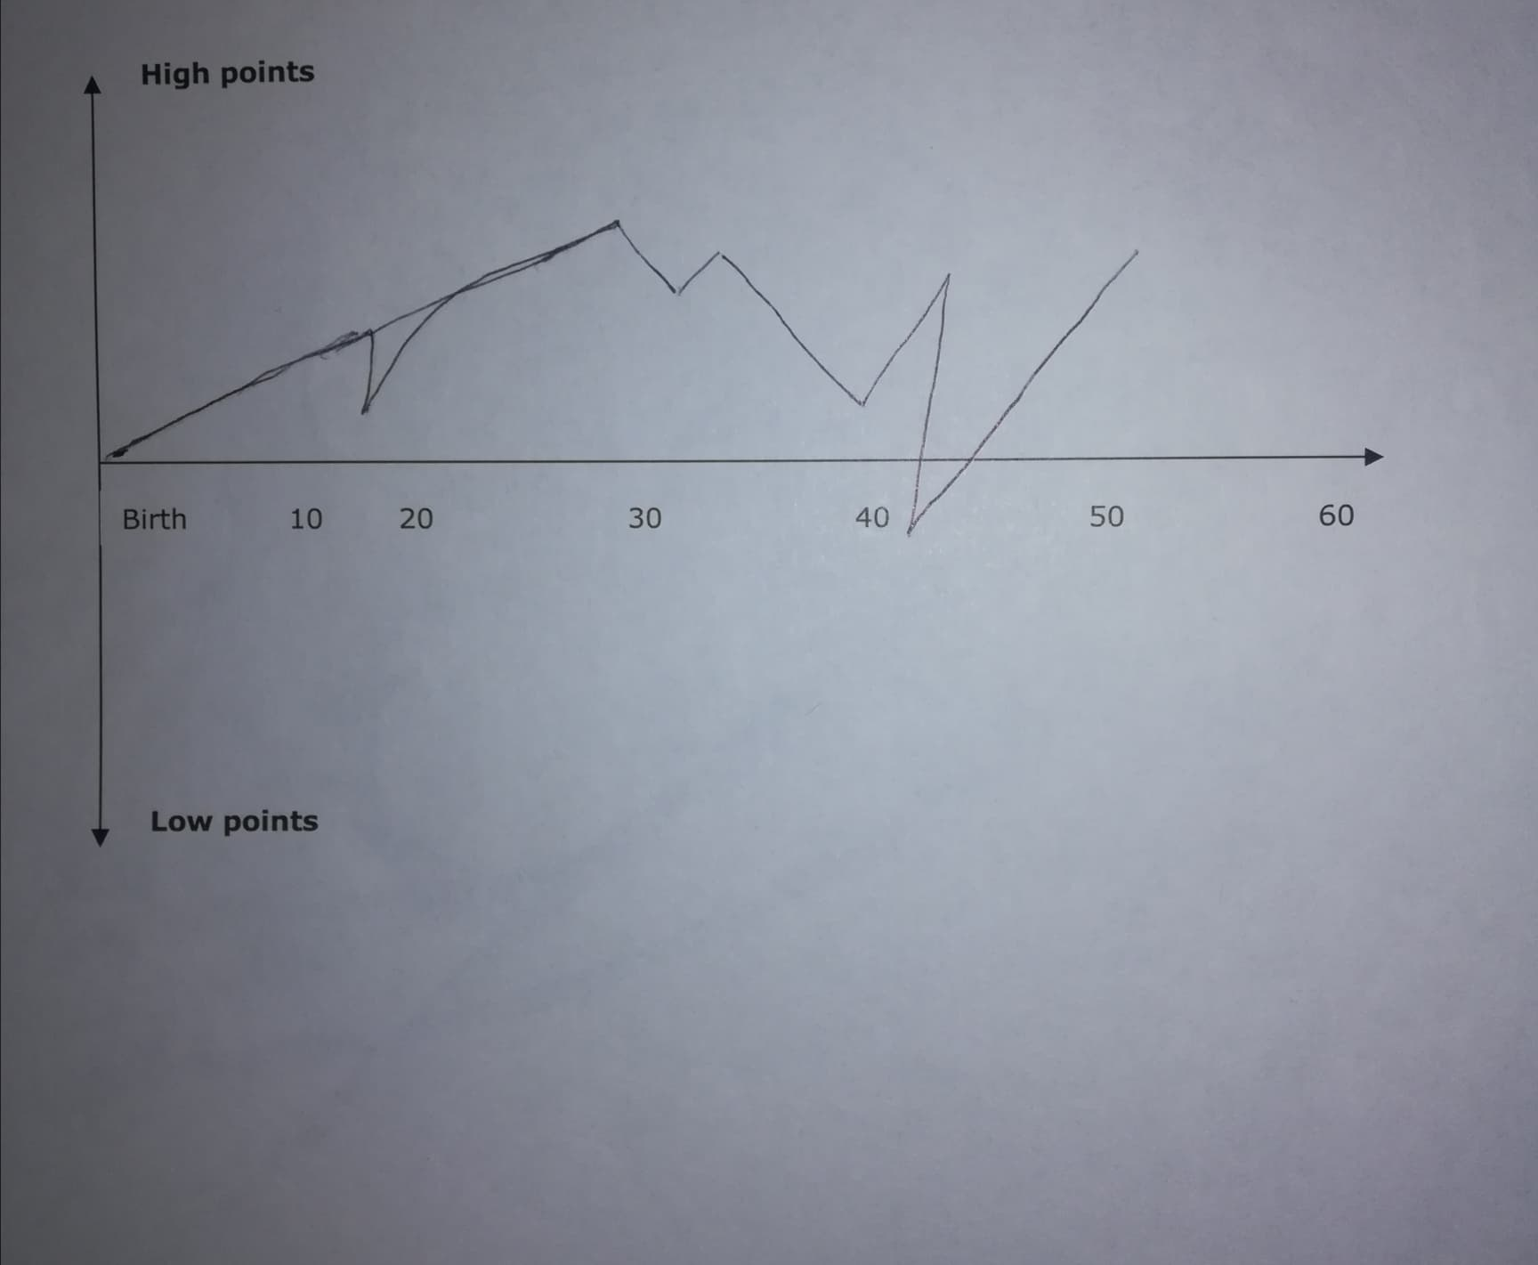

Appendix 2
 | Short-Term goals  Three -six months | Mid-Term goals  Six months – two years | Long-term goals  Two-three years
My Goals | Become a great communicator | Expand the team | Gain positive name or recognition in my profession.
Skills and knowledge to be learned | Skills of effective communication | Improve skills related to Teamwork and enhancing skills related to time management | Improve problem-solving skills and enhance skills related to future leadership
Next steps | Activities will involve team discussion, listen to the employees, getting feedback from the employees, decisions or input | Participation in the group discussion. Consider the opinions of employees present within the team. To keep up the record for time, this would be easy for me in order to manage work and time. | Taking part in the argument and debates regarding any problems. Coming to lead the team, would help in improving the skills related to leadership. Additionally, not to stop gaining knowledge or learning.
Resources | Participation in the group discussions before taking any decision ineffective communication. Additionally, presenting viewpoints or ideas in front of the audience. | Participation in group activities and class and work help in improving the skills of the team. Helping me the team to work smoothly. Jobs and task listing are needed to be done, along with the duration of time in which it is required to be completed, this would help to develop the management skills. | To use the mind maps, solving puzzles and working out is a way to improve problem-solving skills and abilities. To learn different leadership style, observing other leaders and way to these leaders utilize the skills to solve the problems.
Time Schedule | Aug’19 – Jan’20 | Sep’19-Sep’21 | Jan’20-Jan’22
When I will start | 1st August 2019 | 15th Sep’19 | 10th Jan’20
When do I expect to finish | 20th Dec 2019 | 1st Sep’21 | 20th Jan’22

