

UNIVERSITY OF WALES TRINITY SAINT DAVID

Examining customer perspective of Ethical Leadership and sustainability and its influence in customer satisfaction, trust and loyalty in Colombian Airline Industry

Module:
Quantitative Research Methods
LCDB7011

Lecturer:
Ebad Banissi

Janeth Catherine Mosquera Restrepo
Student Number:1908748
17 December 2024

Examining customer perspective of Ethical Leadership and sustainability and its influence in customer satisfaction, trust and loyalty. initiative in Colombian Airline industry

Abstract

Objectives
The research explores how customer perception of sustainability influences brand preference and how ethical leadership impact customer trust, loyalty and trust

Methods
The research used a quantitative approach, using surveys to collect data from 34 participants. The analysis of the data was done through SPSS and using statistical tests such as Anova, regressions and correlations.

Key Findings
The findings revealed that transparency has a strong positive effect on customer trust. However, ethical leadership demonstrated weak effects on trust and satisfaction, and sustainability awareness and implementation showed insignificant influence on customer perceptions and loyalty. Also, there was a negative correlation between customer satisfaction and loyalty.

Conclusions
The results show how transparency influences customer trust within the Colombian airline industry. In addition, the results found that communication is essential to improve the trust of customers and increase their awareness and perception of ethical and sustainable practices.

Keywords: Ethical Leadership, Sustainability, Airlines, Colombia, Loyalty

Table of Contents
Introduction. 3
Background 4
Problem statement 4
Research Question/Hypotheses 5
Objectives 6
Significance of the Study 6
Scope and Limitations 6
Literature Review 7
Ethical Leadership 7
Sustainability 10
Customer Satisfaction, Loyalty and Trust 12
Theoretical Framework 14
Ethical Leadership 15
Triple Bottom Line 15
Philosophy 16
Research Gap 16
Research Methodology 17
Research Design 17
Data Collection Method 17
Sampling Techniques 18
Data Analysis Methods 19
Ethical Considerations 19
Data analysis and Findings 20
Demographics 20
Descriptive Analysis 21
Discussion 33
Conclusion and Recommendations 36
References 37
Appendices 45
Appendix -I: Survey 45
Appendix - II: Supplementary material 55
A. Reliability Test- Cronbach Alpha 55
Appendix – III: Others 58
Scale tables 58
Regression of hypotheses 2. 62
Hypotheses 3 Independent Sample t-test and Anova. 64

Introduction.

Background

The airline industry is an essential way of transportation but faces various environmental challenges, such as its contribution to greenhouse gas emissions. Globally, around 2.4% of emissions are from CO2 annually, and in Colombia, it is around 4.45 million per year (Lopez Gómez et al., 2023). This shows that the sector is responsible for adopting standards that benefit customers, communities, stakeholders and the environment. Sustainability, defined by (Sahu et al.,2024) as the ability to meet current needs without harming future generations’ abilities, is one of the keys to airlines dealing with environmental and social challenges (Paşalı N. et al., 2024). Initiatives such as sustainable Aviation Fuel (SAF), carbon offset programs, and corporate social responsibility (CSR), as mentioned by Kim & Sim (2024) and Rodríguez & Mora Forero (2024), intent to reduce their impact on the environment and aligning with global sustainability standards. Leadership came to be an enabler to adopt and execute those initiatives (Karanki, F. 2024). Some studies have shown that transformational and visionary leadership styles influence organisational culture and planning to create sustainable practices (Xie, 2024; Farhan, 2024). However, these practices do not show how ethical leadership influences their implementation through behaviours such as transparency, accountability and trust. Moreover, research in emerging markets like Colombia lacks enough studies on customer awareness and perceptions of sustainability, failing to understand their impact on consumers (Farhan, 2024; Tanveer et al., 2021).

Problem statement

Consumers are becoming more interested and aware of sustainability and its environmental effects which affect their buying decisions (Korba et al., 2023; Aldahmashi et al., 2023; Utgård & Gaustad, 2024). Their expectations about airlines' responsibilities have increased, requiring them to align their goals with sustainability objectives, which airlines have integrated into their strategies (Gajić et al., 2024; Khan & Fatma, 2023; Kim & Hwang, 2023; Tanveer et al., 2021). A study by Sim and Kim (2024) and Chen et al. (2024) agree on aligning corporate strategies with customer expectations to support brand image and sustainability efforts that influence purchase intention and brand loyalty. Leadership can be seen as a tool to obtain those goals. However, ethical leadership, characterised by transparency, integrity, and accountability, influences organisational behaviour and strengthens consumer trust, loyalty and reputation (Khan & Fatma, 2023). However, how this influence occurs remains underexplored in emerging countries such as Colombia, where cultural and socioeconomic factors may be different from those in developed countries.

Some studies in emerging economies, such as Pakistan, Colombia and Peru, have studied CSR, marketing and customer experiences, highlighting the importance of sustainability and customer satisfaction (Chabán et al., 2024; Siqueira et al., 2023; Tanveer et al., 2021). These studies focus mainly on marketing strategies, ignoring the link between ethical leadership and sustainability efforts. This is critical, as ethical leadership behaviours like transparency, communication and integrity could influence customers' perceptions of sustainability initiatives and increase their trust (Kim & Sim, 2024; Rodríguez & Mora Forero, 2024). For example, Lopez-Rodriguez & Mora Forero (2024) and Shahid et al. (2024) explore brand equity, such as loyalty and awareness, and its emotional connection towards loyalty but do not address how ethical leadership and sustainable effort affect consumer trust. In addition, Customers' preferences vary according to their culture, information, and communication about their products or services, making airlines' efforts complex to align their sustainability goals with consumer expectations (Valiño et al., 2024; Chabán et al. 2024). In general, airlines face challenges in understanding customers' perceptions and their sustainability efforts, according to the International Air Transport Association (IATA, 2024), especially in Colombia, where creating trust and brand loyalty is vital for a competitive advantage. This study addresses the gaps by exploring the relationship between ethical leadership, sustainability efforts and customer perceptions in the Colombia airline industry.

Research Question/Hypotheses
This study aims to investigate the following primary research question: how do ethical leadership and sustainability practices influence customer trust, satisfaction and loyalty in the airline industry in Colombia? To answer this question, the following hypotheses will be investigated

H1: Ethical leadership has a positive effect on customer trust.
H2: Customer trust mediates the relationship between ethical leadership and customer loyalty.
H3: Customers with perceptions of sustainability prioritise one airline
over another.
H4: Ethical leadership influences customer satisfaction with sustainability in the airline industry.
H5: Awareness of sustainability programs affects customer perceptions.
H6: Customer satisfaction with sustainability initiatives impacts customer loyalty.
H7: Transparency in sustainability practices positively influences customer trust in airlines.
H8: Implementation of sustainability standards positively influences customer loyalty.
:

Objectives
1. Examine the influence of ethical leadership on customer trust and sustainability efforts.
2. Analyse how sustainability efforts or practices by the airlines and customer awareness influence perceptions, trust and loyalty.
3. Investigate the role of trust and satisfaction in the relationship between sustainability efforts, ethical leadership and customer loyalty.
4. Explore how customer perception of sustainability influences brand preference.

Significance of the Study
Building on the literature, this research intends to contribute to the theory and practice in several ways. First, this study investigates the direct influence of ethical leadership behaviours on sustainability efforts and its effect on customer trust, satisfaction and loyalty in an emerging market context. Second, this study is conducted in an emerging country, Colombia, which has unique challenges in aligning ethical leadership with sustainability. Although most statistical tests do not have significant results, these findings are valuable because they show the relationship between ethical leadership, sustainability efforts and customer perceptions.

Scope and Limitations

This research focuses on the airline industry in Colombia, examining the relationship between ethical leadership, sustainability and customer perceptions. The research was based on surveys, which increased the biases and limited the sample diversity. Also, focusing only on Colombia may decrease the generalisability. The paper includes the following sections: literature review, research methodology, analysis and results, discussion and conclusion.

Literature Review
An extensive literature review reveals that ethical leadership and sustainability practices are frequently studied in an organisational context. However, their combined impact on customer trust, satisfaction and loyalty still needs to be explored (see Table 1). While sustainability efforts like environmental, social, and governance (ESG), sustainable aviation fuel (SAF), and corporate social responsibility (CSR) are used in the airline sector, research focuses on outcomes rather than consumer perceptions. Also, the role of ethical leadership in shaping sustainable strategies has been studied, but its influences on customer-centric outcomes are less understood. The following subsections discuss the conceptual framework, the variables in this study and the hypotheses.

Ethical Leadership
Ethical leadership is key to facing the airline industry's challenges in trying to balance the environment and profits. Some researchers have studied their application in sustainability initiatives where accountability and transparency are essential to create trust, make decisions, and implement policies (Sim & Kim, 2024; IATA, 2024).
However, the industry continues to present challenges due to a lack of studies about consumers' awareness of the sustainability practices that the airlines make, and most in countries where operations are ineffective, such as Latin America (Garcia-Mendez et al. 2023). This research adds to the theory of ethical leadership, which emphasises behaviours such as transparency, fairness and integrity through personal and interpersonal relationships (Al Halbusi et al., 2021).

Ethical leadership in the airline sector can promote governance, brand loyalty and engagement, which leads to employee loyalty and a positive organisational culture that implements sustainability practices. However, some organisational and regional challenges restrain the effectiveness of leadership (Mukhezakule and Tefera, 2019). For example, Sim & Kim's (2023) study discovered that ESG enhances governance standards and increases consumer awareness. Also, it found that environmental practices have a limited impact on customer attitudes, transparency and effectiveness. Similarly, a study on customer motivation in the airline industry found that customer loyalty starts from the eco-friendly initiatives in place and how employees present them. The study also noted a lack of empirical validation in this, which limits their application (Soklaridis et al., 2024). This is worsened in regions such as Latin America, where poor infrastructure and unethical practices impede the operational flow, stakeholder trust, and ethical behaviours' efficacy (Garcia–Mez et al., 2023). Even though the government requires airlines to consider shareholders and stakeholders when making decisions about the environment and society, it is difficult to balance due to financial pressures in generating revenue and managing costs (Lee and Yoon, 2024). As can be seen, ethical leadership can improve brand perception and customer loyalty, but it depends on internal and external factors that surround it. In regions like Latin America, where unethical practices are present in the culture, it is important to adopt ethical frameworks to support leadership initiatives to lessen the factors. Additionally, the absence of communication with customers about environmental efforts highlights a gap that should be researched in addressing cultural and demographic factors that influence customer perceptions of ethical leadership (Sim & Kim, 2023; Lee & Yoon, 2024).

Ethical leadership plays a role in customer perception, ethical behaviours and sustainability initiatives, which can be represented as economic, environmental and social dimensions according to Elkington's triple bottom line theory, 1998. In the airline industry, these initiatives can be seen as reducing emissions, adopting sustainable aviation fuels (SAF) and increasing community engagement. However, these initiatives can be affected by higher costs, operational disruptions and lack of customer awareness.

Ethical leadership can be seen through triple bottom line theory principles, where sustainable practices align with organisation operations. For example, the airline "A" sustainability report demonstrated its dedication towards embracing SAF to contribute to climate protection; however, rising expenses and ambiguity in implementing strategies prevent it. (AA sustainability report, 2023). Another study by Lee et al. (2024) emphasises that strategies that include high-quality service and sustainability efforts seem to influence brand and customer satisfaction. In addition, customer satisfaction and loyalty can be enhanced by integrating sustainability and business strategies (Westin et al., 2022).

On the other hand, in a country such as Colombia, the adoption of new technologies or new strategies is challenging because of regulations, high costs, and financial constraints (Lopez et al., 2024). As observed, the studies highlight integrating business strategies with sustainable efforts to benefit the environment and society and obtain profit. Transparency and accountability, as shown in the airline report, should lead to communicating clear sustainability goals with customers about new initiatives that bring benefits in the long term. However, in the context of Colombia, most studies do not consider the customers as a part of their strategies due to financial limitations, and the integration of new sustainability practices as SAF is costly even though it can help to make a difference to the airlines and the environment. Future research should explore how ethical leadership can be integrated into business strategies to improve stakeholder engagement and how these sustainable practices influence customer perceptions of choosing one airline over another.

Stakeholders of any organisation are important to the organisation's survival and impact on performance. Customers are stakeholders who influence the organisation with their behaviour; in turn, the organisation align its practices with its expectations (Phillips et al., 2019). However, this relationship depends on behaviours such as respect and consideration for others, as ethical leadership promotes transparency, trust and loyalty to organisation values and goals, creating a culture of ethical principles (Zahari et al., 2024).

Organisational culture significantly shapes employee interactions and leadership styles. Ethical leaders prioritise fostering positive relationships between employees and customers, which affects engagement, trust and overall climate. Ethical leadership prioritises ethical practices that benefit the environment and society with sustainability practices and transparent governance, promoting trust and customer loyalty. One of these elements that impact customer trust is service quality, safety and loyalty programs (Shrestha, 2014). However, the study also noted other findings, such as attitudes varying between airlines. In addition, Thanh and Anh (2023) found that airline image strengthens loyalty through social and environmental commitments but does not influence economic factors. In Colombia, a study by Siqueira et al. (2023) supports the finding by Shrestha (2014) that brand trust and loyalty are shaped by service quality in different touchpoints such as pre-flight, in-flight and post-flight. Moreover, the relationship between servant leadership performance systems impacts employee satisfaction and retention, benefiting customer service quality (Alafeshat & Tanova, 2019). While these studies note how leadership benefits and influences employees, which in turn promotes service quality, they do not show how ethical leadership behaviours influence the trust of the customers. These observations lead to the following hypotheses for this study.

1. Ho: Ethical leadership does not influence customer trust
H1: Ethical leadership has a positive effect on customer trust
2. Ho: Customer trust does not mediate the relationship between ethical leadership and customer loyalty
H2: Customer trust mediates the relationship between ethical leadership and customer loyalty
3. Ho: Customers with perceptions of sustainability do not prioritise one airline over the other.
H3: Customers with perceptions of sustainability prioritise one airline
over another

Sustainability
Sustainability is key to address environmental challenges and promote trust and loyalty among airline customers. So, airlines have adopted sustainability practices such as SAF, carbon offset programs, and plastic that align with global sustainability goals. In the case of Colombia Airlines, Latam has committed to reducing its carbon offset by 50% in domestic flights by 2023 and becoming carbon neutral by 2050 (Latam, 2024). Avianca also committed to SAF adoption and, since 2019, has reduced its carbon emissions by 26% per passenger (Avianca, 2024). Similarly, big airlines such as American Airlines and Iberia show transparency in their sustainability report and efforts to contribute to sustainability (AA, 2024; Iberia Group, 2024). According to their efforts, these initiatives could help increase customers' loyalty and trust (Khan & Fatma, 2023). Despite airline's efforts to align with global sustainability goals, Latin America still faces challenges such as higher costs for SAF and regulatory and infrastructure issues (Lopez-Gomez, 2024). Even though the transparency of these goals could increase customer trust, not communicating them could affect the customers' perceptions and limit their engagement, increasing the barriers.

Sustainability in aviation is multifaceted because it includes environmental, social and economic dimensions. Latam's environmental goals include implementing recycling, carbon emissions reduction and zero waste to landfills by 2027 (Latam, 2024). Avianca also has waste management and carbon emission reductions (Avianca, 2024). In the social aspect, Latam, with its program' solidarity plane', supports disasters and local healthcare programs, while Avianca, with its collaborations, benefit more than 14,000 employees, promoting equity and diversity (Latam, 2024; Avianca, 2024). Economically, the airlines try to integrate their sustainability into long-term goals and profitability strategies (Latam annual report, 2023; Avianca, 2024). These airlines focus on regional impacts, trying to balance eco-friendly operations with economics to create a competitive advantage benefiting their customers and themselves, so this balance is not easy to achieve with the right strategies, innovation, policies and customer support.

Sustainability initiatives and CSR are crucial for increasing customer trust, satisfaction and loyalty. These visible efforts create customer awareness, mitigate scepticism and drive engagement. Programs such as '1+1 compensate to conserve and 'Chooose' promote customers' involvement with offset emissions (Latam annual report, 2023; Avianca, 2024). Some studies found that consumers prefer companies that care for the environment, creating brand loyalty and positive word of mouth, but their words must match their actions (Kim & Hwang, 2023; Utgård & Gaustad, 2024). Also, CSR increases customer perceptions, increasing loyalty, brand image, customer satisfaction, trust, and service quality (Thanh & Anh, 2023; Wang et al., 2023; Chung et al., 2022; Leon & Dixon, 2023). Customers' awareness of sustainability practices is more receptive to the airlines' initiatives, but communicating with them makes a significant difference in their decisions and support to the airlines. Effective communication could increase a customer's perceptions, reduce scepticism and reinforce authenticity through positive behaviours. All these lead to the following hypotheses:

4. Ho: Ethical leadership does not influence customer satisfaction with sustainability in the airline industry.
H1: Ethical leadership influences customer satisfaction with sustainability in the airline industry.
5. Ho: Awareness of sustainability programs does not affect customer perceptions
H1: Awareness of sustainability programs affects customer perceptions.
6. Ho: Customer satisfaction with sustainability initiatives does not impact customer loyalty.
H1: Customer satisfaction with sustainability initiatives impacts customer loyalty

Table Summary of the literature.
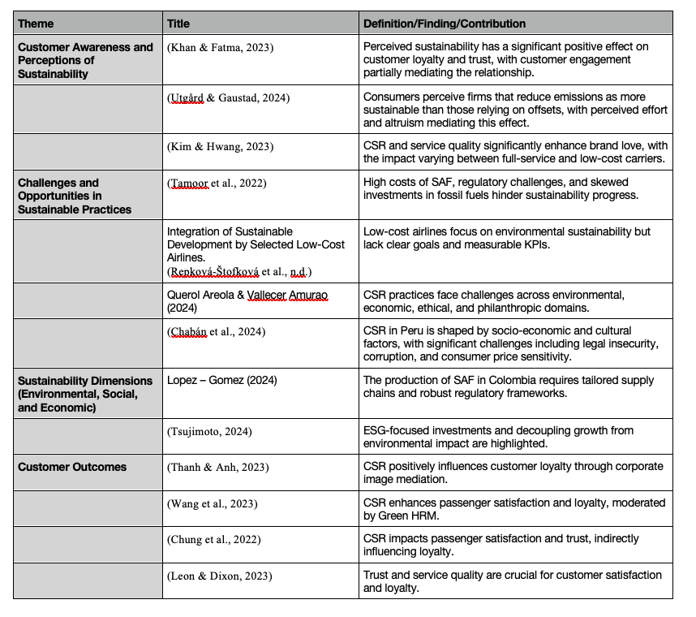

Customer Satisfaction, Loyalty and Trust
Customer satisfaction, loyalty, and trust are related and affec customer actions and enhancing brand reputation. Trust in airlines' sustainability practices leads to satisfaction and loyalty among customers. Some studies about service quality and policies on emission found that the quality of services offered to customers and the policies that support sustainability through transparency initiatives promote trust (Siqueira et al., 2023; Tamoor et al., 2022)). In addition, the use of metrics, such as ESG, helps them be transparent with their success and setbacks, building credibility and encouraging stakeholder feedback (IATA, 2024). As mentioned previously, being transparent about the actions and the results of the operations made by the airlines creates a foundation for trust, loyalty and satisfaction. Thus, airlines that align their initiatives with customers' feedback seem to create better relationships and positive vision.

The implementation of sustainability initiatives influences customer satisfaction. The impact of this satisfaction depends on the alignment between customers' expectations and airlines' sustainability practices. Integrating sustainability measures, ethics, safety, and diversity enhances customer perception and creates a positive image of the airline, increasing customer satisfaction (Lee et al., 2024; Westin et al., 2022; Lopez-Gomez, 2024). Also, customers' perception of CSR activities about the environment and community by their airlines improves their satisfaction (Wang et al., 2023). These findings show that sustainability must be achieved with stakeholders' participation in feedback and the creation of initiatives. When the expectations of these stakeholders, in this case, customers, are met, their satisfaction and positive behaviours increase.

Customers' behaviours can be positive or negative, influencing the profitability of airlines through purchase and advocacy. Satisfaction leads to positive behaviours such as being loyal and recommending the airline to others. A study by Shrestha (2014) noted that customer satisfaction influences loyalty through the repetitive use of the airline and advocacy. However, not only customer satisfaction is a trigger for their loyalty but also brand image committed to the environment and social responsibilities (Thanh & Anh, 2023; Chen et al., 2024;), ethical practices such as fair prices, communication and beneficial advertising (Tanveer et al., 2021). This evidence shows that customer satisfaction is key to enabling loyalty, but it is not enough. Airlines should build a positive brand image and follow ethical practices to continue gaining or keeping customers in the long term.

Despite the connection between satisfaction, loyalty and trust, other factors moderate this relationship. Factors such as price, demographics, economic responsibilities and service quality influence satisfaction and trust, which lead to loyalty. According to some studies, age and occupation influence loyalty towards airlines, but cost-saving measures might not impact their loyalty (Shrestha, 2014; Thanh & Anh, 2023). However, if the customers perceive a lack of authenticity and transparency in the sustainability initiative, negative behaviours could arise, such as dissatisfaction that influences their loyalty (López-Rodríguez and Mora Forero, 2024). The research highlights how loyalty is multifaceted and influenced by personal and organisational factors. Price and demographics influence satisfaction and trust but not loyalty. In addition, customers need to perceive sustainability practices as authentic and transparent to trust and prevent scepticism. Also, negative perceptions of sustainability practices can reduce customer trust and satisfaction. Thus, airlines should create sustainability strategies with integrity and accountability, which could imply that considering this, they could create a competitive advantage in a new sustainability market. So this led to the following hypotheses:

7. Ho: Transparency in sustainability practices does not influence customer trust in airlines
H1: Transparency in sustainability practices positively influences customer trust in airlines.
8. Ho: Implementation of sustainability standards does not influence customer loyalty.
H1: Implementation of sustainability standards positively influences customer loyalty.

Theoretical Framework
This research will use the ethical leadership and triple bottom line theories to provides a framework to evaluate the behaviours of leaders through customers and how economic, environmental and social dimensions affect sustainability.

Ethical Leadership
Ethical leadership emphasises the leader’s principles like transparency, fairness, accountability and integrity to explain how leaders influence employees daily. This theory was built from a study by Brown, Treviño and Harrison (2005), where they tested employees’ perceptions of their supervisors and found that ethical leadership influences trust in supervisors and job satisfaction. They also created and validated the measurement tool known as ELS. Other studies found that honesty, integrity and altruism are essential for leaders to create ethical norms and culture (Kaptein, 2019). Ethical leadership has been used in organisations to enhance employee engagement and align goals with CSR to create an environment of trust and transparency (Stavropoulou et al., 2024). In the airline industry, ethical standards are essential to address challenges such as bribery, misleading information, and poor ethics and implement sustainability initiatives (Sundresan et al., 2023; Williams, 2019). Ethical leadership shows some advantages to leaders but also pressures; some criticise this, saying that there is more emphasis on leaders’ traits that the organisation influences that could affect the organisation overall (Donaldson, 2005). Despite these limitations, ethical leadership is key to studying leaders’ behaviours in the airline industry. In this sector, ethical principles are visible and necessary to benefit the organisation and the stakeholders.

Triple Bottom Line
The triple bottom line is a framework that analyses organisations through the three dimensions: economic, social and environmental. In a review by Jeurissen (2000) of the book ‘Cannibals with Fork: the triple bottom line of 21st century business’ by Elkinton, he found that the integration of these factors in a framework is important to society and business, where the environment and society should benefit through projects such carbon emissions, community interventions. In the airline industry, programs such as sustainable aviation fuel (SAF) and CSR support communities and reduce environmental impact (Latam, 2024; Avianca, 2024; Sorsa and Bon-Sanchez, 2024). This framework gives a holistic approach to sustainability. However, according to Norman and MacDonald (2015), it lacks measures for the social and environmental outcomes, which could cause ambiguity and greenwashing, not delivering what is promising. Using this framework is adequate in the airline industry because of the balance the sector must do. Airlines should adapt the framework to their own needs, showing transparency, stakeholder engagement and metrics to ensure sustainability is adapted and aligned with global standards, especially in Latin America, where a lack of infrastructure and research could hinder their use.

Philosophy

The philosophical foundation of this research is pragmatism, emphasising the practical application of knowledge and actionable recommendations (Kelly, 2020). Epistemologically, this study adopts a pluralistic view, recognising that the interaction between leaders, sustainability programs and stakeholders' perceptions leads to knowledge (Foster, 2024). Through objectivity and subjective interpretation, this research uses surveys and customers' sustainability awareness to increase understanding of the situation. Ontologically, the research adopts a moderate realism perspective where reality is objective and subjective (Kelly, 2020) through carbon emissions and customer outcomes such as trust and satisfaction, influencing airlines. Axiologically, the research values ethics and responsibilities, prioritising sustainability through accountability, integrity and social equity (Foster, 2024; Kelly, 2020). Also, the researcher is committed to contributing to theoretical and practical knowledge and addressing challenges airlines face.

Research Gap
The previous studies demonstrate that ethical leadership and sustainability practices are essential for the airline industry; however, combining them with customer satisfaction, loyalty, and trust is underexplored (Sim & Kim, 2023; Soklaridis et al., 2024). The studies focus on these factors separately but do not consider customer-centric outcomes, such as trust, transparency and communication (Chen et al., 2024; Thanh and Anh, 2023; IATA, 2024; Kim & Hwang, 2023). These gaps are important in Latin America, where financial and regulation challenges affect the effectiveness of sustainability (Garcia-Mendez et al., 2023; Lopez-Gomez, 2024). This indicates the need to explore how ethical leadership and sustainability initiatives can improve customers’ perceptions of trust, satisfaction and loyalty.

Research Methodology

This chapter presents the methodology used in the study to investigate how the dynamics of ethical leadership behaviours and sustainability practices affect customer trust, satisfaction and loyalty within Colombia’s airline industry.

Research Design
The research adopted a qualitative research design to assess the connections among ethical leadership, sustainability effects and consumer perceptions within the airline industry. Utilising a survey-based approach to gather numerical information, the statistical techniques are analysed (Han H. et al., 2019). A pragmatic approach guides the research, aiming for practical insights and applicability to real-world contexts. (Shrestha, 2014) Data collections were organised to guarantee complete coverage of the investigated variables, including customer trust, satisfaction and loyalty.

Data Collection Method
Data was gathered through an online survey featuring Likert scale questions to gauge participants' views on ethical leadership, sustainability efforts and their effects on trust, satisfaction and loyalty. The survey link was sent through email and social media. Snowball sampling fostered broader participation as respondents were motivated to share surveys (Xie, Y.,2023). This technique increases the response rates by using social networks and encouraging participant referrals, often used when the target population is challenging to find (Saunders,2012). The study upheld strict data reliability and validity standards despite being an online survey and using Cronbach's Alpha, which assesses the internal consistency of the survey instrument.

The investigation employed adaptive and validated scales to measure essential variables (Strobi, 2023). Based on Brown et al. (2005), ethical leadership is assessed for dimensions encompassing integrity, transparency, accountability, sustainability orientation and trustworthiness. For example, statements such as "the airline's leadership shows ethical conduct through its actions" present the principles of ethical leadership. Ethical leadership reported a Cronbach's α = 0.89 in Brown et al. (2005) research.

Adapted from Alvarado-Herrera et al. (2017), customer awareness and perceptions are quantitively measured through items related to carbon reduction, ecological practices, waste recycling and community events. The original scale showed a Cronbach's α = 0.80 in Alvarado-Herrera et al. (2017).

Based on Hustvedt and Kang (2013) and Erdem and Swait (2004), statements such as "the airline fulfils its promises" are used as indicators to evaluate transparency and trustworthiness. Hustvedt and Kang (2013) reported a Cronbach's α = 0.85 for their related items on transparency.

Derived from Goldsmith et al. (2000) and Oberseder et al. (2014), customer satisfaction levels regarding sustainability are assessed, including dimensions of communication, quality and societal contributions. The original scales demonstrated a Cronbach's α value of 0.85 and higher. Using scales from Coyle and Thorson (2001) and Maxham and Netemeyer (2003), customer loyalty, purchase intentions and recommendations through word of mouth are examined. The loyalty components achieve Cronbach's α = 0.86 in Maxham and Netemeyer (2003).

Cronbach's alpha was used to evaluate the scale's reliability, ensuring internal consistency. According to Brown et al. (2005), the ethical leadership scale showed Cronbach's α = 0.89. Within the study, only specific items from the scale were utilised, and Cronbach's alpha for these items was calculated to evaluate the reliability within the sample. The results of the comprehensive reliability analysis are documented in the results section (see below). The survey underwent pre-testing to ensure clarity and contextual relevance.

Sampling Techniques
The target population encompassed individuals who either travelled within Colombia or from external countries to Colombia and who possessed a basic knowledge of sustainability practices. The sample was comprised of 34 participants, including both genders, recruited through digital platforms. A snowball sampling technique was employed where initial participants referred others who satisfied the study’s criteria (Siqueira et al.,2023). This approach facilitates the incorporation of diverse perspectives while unfolding feasibility within the parameters of the study (Xie, Y.,2023). The participants were customers who took airlines operating within Colombia.

Data Analysis Methods
Correlation analysis was used to explore associations between variables, and hypothesis testing was conducted to evaluate the study’s proposed relationships (Shi Y. et al., 2023). The results provided insights into the complex dynamics of ethical leadership and sustainability practices within the airline industry.

Data analysis was performed using IBM SPSS Statistics (Version 29). The demographic data was analysed using percentages to provide an overview of sample composition. Descriptive statistics were calculated for all variables, including mean and standard deviations. Assessments of normality tests were conducted to evaluate data distribution, revealing that certain variables adhere to normal distributions while others do not. Accordingly, the following statistical techniques were implemented. For variables to conform to the normal distribution, techniques such as regression analysis, t-test and ANOVA were conducted to investigate relationships and differences between the variables. Four variables deviate from normal distributions, and a non-parametric test was used to guarantee the analysis. Correlation analyses were used to examine associations between variables. The results showed insight into the mixed results of ethical leadership and sustainability practices within the airline industry.

Ethical Considerations
Ethical principles were meticulously served throughout the entirety of the research process. Participants were fully informed regarding the study's objectives and assured that their involvement was voluntary (Zaghmout, 2024). Informed consent was procured, and participants fully knew they could withdraw without repercussions. Confidentiality was regularly upheld on anonymised data to protect participants' privacy (Zaghmout, 2024). Ethical approval was acquired from the relevant ethical committees before the initiation of the study.

This investigation employed a quantitive research methodology to explore the relations, more difficult leadership, sustainable practices, and customer outcomes within the airline industry in Colombia. An unorganised service survey was used to connect data from 34 participants, which was analysed employing parametric and non-parametric statistical techniques. By integrating meticulous ethical standards and comprehensive and analytical techniques, this methodology provides a comprehensive framework to address the two studies' objectives and hypotheses.

Data analysis and Findings

This research examines the impact of ethical leadership and sustainability efforts on customer trust, satisfaction and loyalty in the airline industry in Colombia. Using a quantitative approach, the study analyses the demographic characteristics of 34 survey respondents, including age, gender, and education. Cronbach’s alpha was used to find the internal consistency of each section. Also, the methodology uses research design.

Demographics

The demographics of the participants were analysed based on percentages. Table 1 shows the 34 participants who filled out the questionnaires. The sample was collected using snowball sampling (non-probability sampling method). So, the participant's gender was 62.9% male and 31.4% female, and a small portion did not prefer to disclose their gender, 2.9%. This gender suggests that male participants are likelier to know more about the topics.
Regarding age, the most significant percentage was in the group 42-53 years old, with 31.1%, followed by 34.3& in the 30-41 years old. The next group was the 54+ group, with 14.3%, and a low proportion were in the age group 18-29 years, with 11.4%. The group with the most significant percentage37.1%, seems to have a medium age range where people could know or be interested in sustainability and leadership due to work or experience that enriched the study. In contrast, the lower group percentage, 11.4% for 18-29 years, might suggest that this population is not interested in the topic or is interested in other sustainability concerns.
Now, analysing the travel frequency, it showed that 48.6% of the participants travel 1 to 2 times a year, but other participants, 40% travelled 3 to 5 times a year; in contrast, only 8.6% travel less than once a year. This sample suggests that the participants are moderate to frequent travellers, relevant for the study because they have interacted more times with the airline's services. Also, due to their frequency, it could be assumed that they know a bit more about what the airlines are doing regarding sustainability and ethicality in their operations. This is confirmed with the purpose of travel, where more participants, 42.9%, travelled for business and leisure—followed by 34.3% who travelled only for leisure, 11.4% for business only and 8.6% for family reasons. This might suggest that these people are frequently flying for business and leisure and are or could be aware of the specific programs that the airlines have and have expectations regarding the delivery of such programs, such as sustainability practices and behaviours that are visible to evaluate.

Table 1: Demographic Distribution of Participants.
This table shows the frequencies and percentages for the demographic variables, which are age, gender, travel frequency, purpose of travel among participants
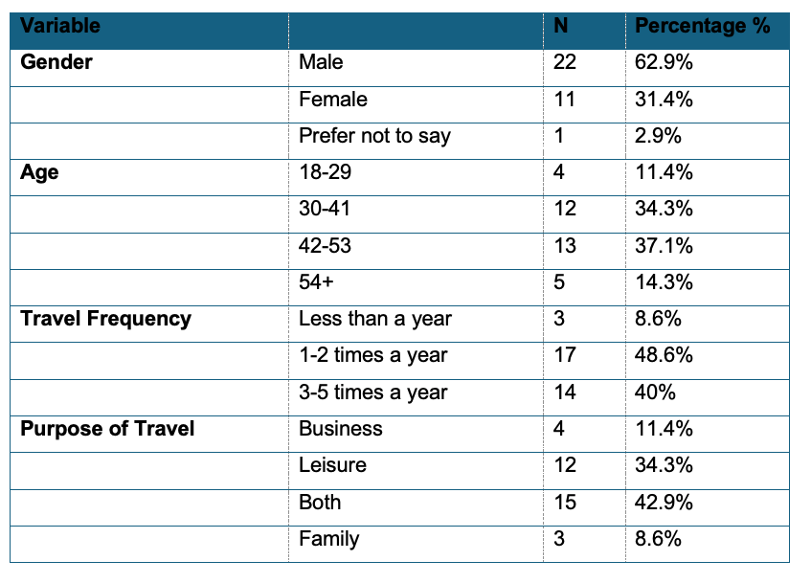

Descriptive Analysis

The study focuses on customer perceptions of ethical leadership and sustainability practices and how this influences their customer satisfaction, trust and loyalty within Colombia airlines. Perception of ethical leadership (EL) mean score was 2.75, with a standard deviation of 0.863. The skewness was 0.301 indicating slightly positive and the kurtosis was -1.090 suggesting a flatter distribution compared to a normal distribution.

The Awareness of sustainability (AS) average had a mean of 2.69, with a standard of 0.613. The skewness was 0.469 indicating a moderate positive distribution with a concentration of scores on the lower end, and the kurtosis was -2.092 suggesting a flatter distribution compared to a normal distribution.

For the perceived sustainability (PS) the mean was 3.41, with a standard deviation of 0.572. The skewness was 0.135 indicating a nearly symmetrical distribution, while, the kurtosis was -0.749 suggesting a flatter distribution compared to a normal distribution.

The trust and transparency (TT) average had a mean of 3.42 and standard deviation of 0.364. The skewness was 0.390 suggesting a slightly positive skew, while, the kurtosis was -1.253 suggesting a flatter distribution compared to a normal distribution.

Customer satisfaction with sustainability (CS) average had a mean of 4.46, and a standard deviation of 0.364. The skewness was 0.094 suggesting a nearly symmetrical distribution, while, the kurtosis was -1.439 suggesting a flatter distribution compared to a normal distribution.

Lastly, Customer Loyalty (CL) average had a mean of 3.16, and a standard deviation of 1.140. The skewness was -0.059 suggesting a nearly symmetrical distribution, while, the kurtosis was -0.768 suggesting a flatter and wider distribution compared to a normal distribution.

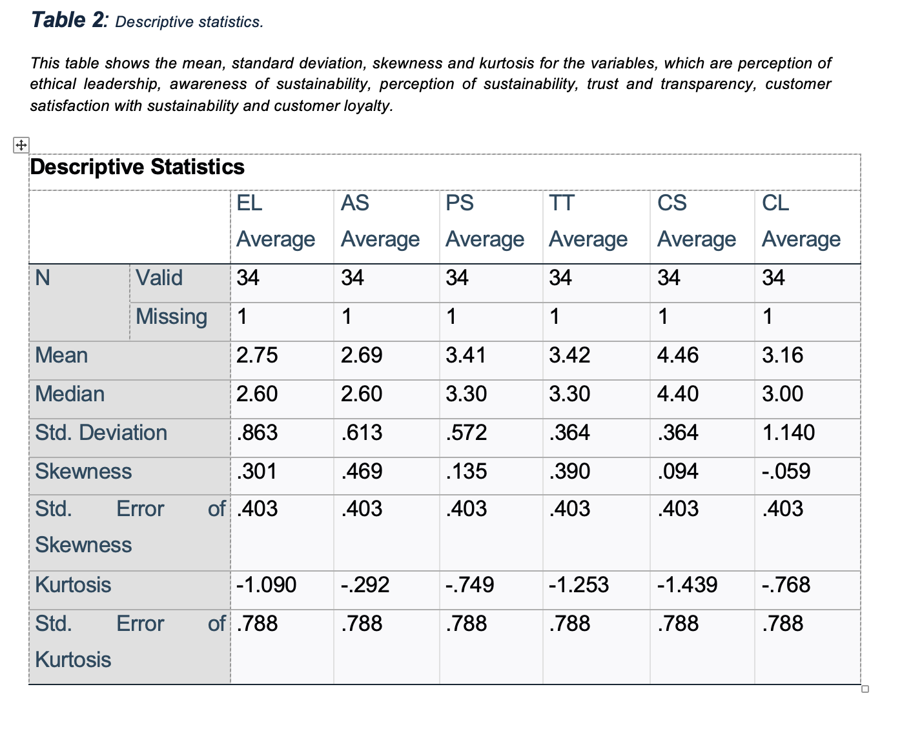

Reliability Analysis

To verify the internal consistency of the variables, Cronbach’s Alpha was done. The variables showed the following results: ethical leadership (EL) had a Cronbach’s alpha of 0.816, indicating good reliability. Awareness of sustainability (AS) was 0.839, while perception of sustainability (PS) was 0.793. For trust and transparency (TT) the value was 0.781 and customer satisfaction with sustainability (CS) was 0.771. Lastly, customer loyalty (CL) was 0.712. Most variables were measured with 5 items, except customer loyalty with 6 items, however, in t trust and transparency section, item TT1 was 0.180, was not removed because it did not affect the overall Cronbach’s alpha. Similarly, in the customer loyalty (CL) variable, items CL5 and CL6 had values of
-0.209 and -0.137, respectively. These items were retained because their answers were essential to know the perspectives of the participants. Details tables with Cronbach’s Alpha values are provide in the appendix xx

Normality Test

The Central tendency and data dispersion for the variables El, AS, PS, TT, CS and CL were assessed using the Shapiro-Wilk test because the sample of the data was small and also for all the variables the degree of freedom was 34. For ethical leadership (EL) was 0.940, a p-=value of 0.060, not significant departure from a normal distribution, see figure 1. For awareness of sustainability (AS) was 0.951 and p-value of 0.130, indicating normal distribution. Also, for perception (PS) was 0.970 and p-value of 0.467, supporting the normal distribution. In contrast the variables trust and transparency and customer satisfaction with sustainability, the values were 0.866 and a p-value of <0.001 and 0.884 and a p-value of 0.002, respectively. This indicate that they deviate from a normal distribution, see figure 2. Finally, the variable customer loyalty (CL) was 0.957 and a p-value of 0.205, supporting the normal distribution. Thus, the results of the variables were EL, AS, PS, and CL has normal distribution in comparison to TT and CS that deviate from normality.

Table 3 : Normality test result.
This table shows the normality test result of the variables in the study.
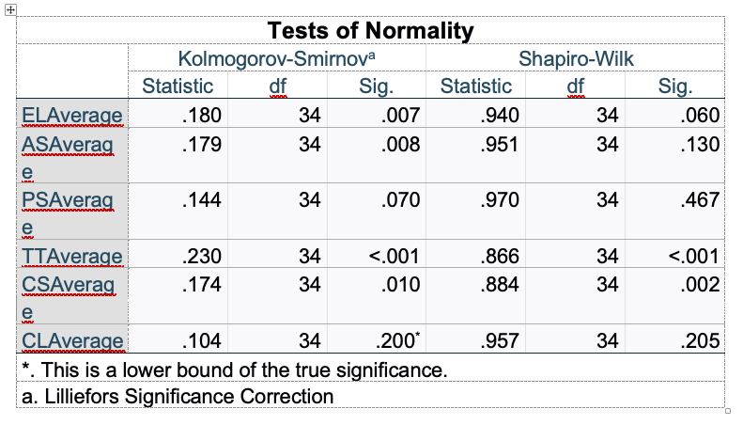

Figure 1: Normality test for perception of ethical leadership (EL).
This figure shows the Q-Q plot for perceived ethical leadership values, where the raw data (x-axis) is plotted against the expected normal scores (Y-axis). The alignment of the points along the diagonal line suggests an approximately normal distribution of the data.

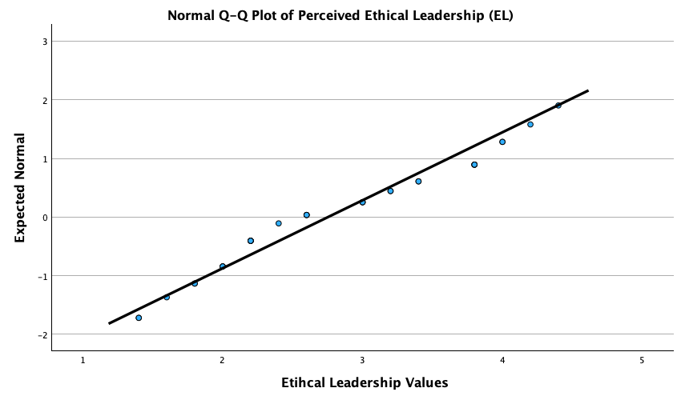

Figure 2: Boxplot for Normality test for trust and transparency (TT).
This figure shows the Q-Q plot for perceived ethical leadership values, where the raw data (x-axis) is plotted against the expected normal scores (Y-axis). The alignment of the points along the diagonal line suggests an approximately normal distribution of the data.

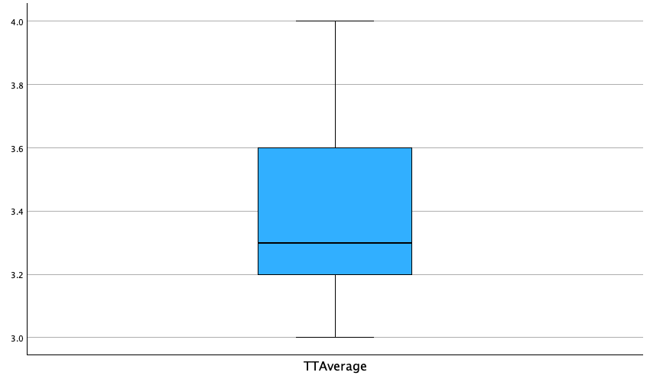

Hypothesis Testing

In this section, the results of the hypotheses will be classified into thematic categories such as ethical leadership (EL), sustainability, customer satisfaction, trust, and loyalty. It is important to note that there is an overlap between sections, so hypotheses 3 and 5 will be reported under sustainability. In contrast, hypotheses 6,7 and 8 will be under customer satisfaction, trust and loyalty because they are more related to this section. This is summarised in the following table.

Table 4: Summary of hypotheses and statistical tests.
This table shows the hypotheses tested in the study, grouped them under ethical leadership, sustainability and customer satisfaction, trust and loyalty, with the corresponding statistical test made.

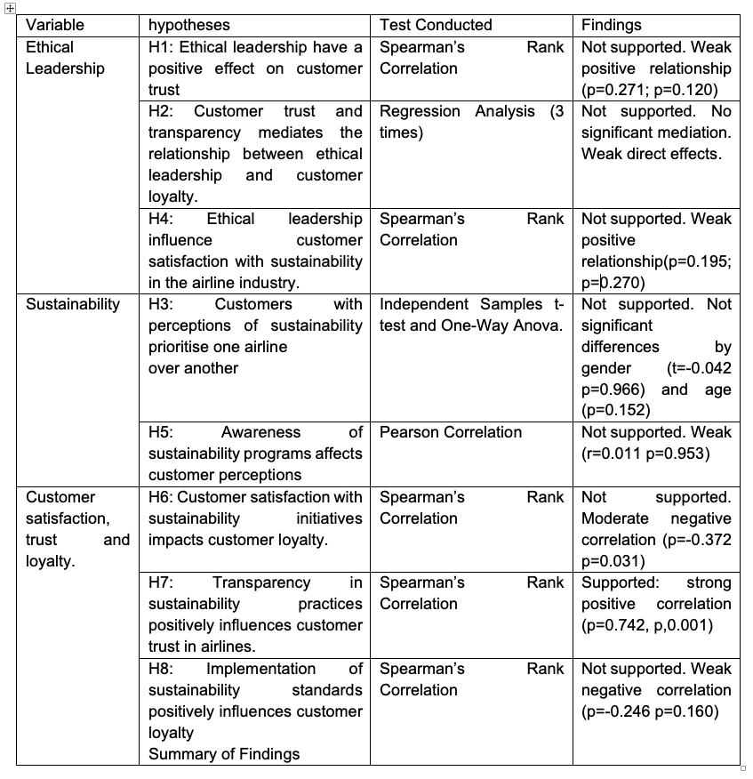

Ethical Leadership (EL) Hypotheses

This section presents the results of the hypotheses related to ethical leadership (EL) and its effects on customer trust, loyalty, and satisfaction with sustainability initiatives in the Colombian airline sector. The tested hypotheses were H1, H2 and H4, as shown in table the results of each hypothesis are discussed below.

H1: Ethical leadership have a positive effect on customer trust.
To test this hypothesis, a Spearman correlation was conducted to discover the relationship between ethical leadership (ELAverage) and Customer trust (TrustAverage).

Table 5: Spearman’s Rank Correlation for ethical leadership and customer trust
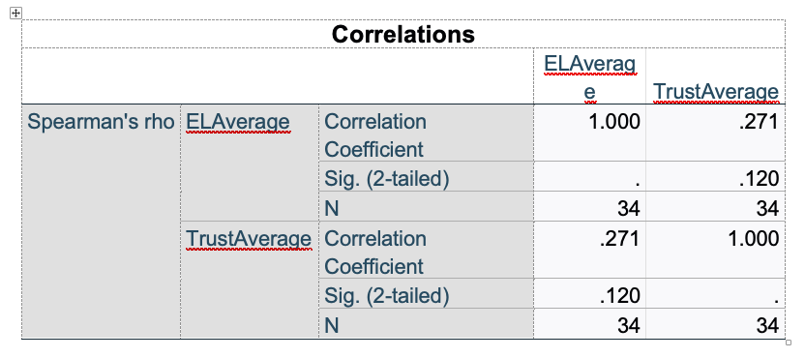

The results show a weak positive correlation between ethical leadership (ELAverage) and Customer trust (TrustAverage) with a Spearman’s rho=0.271 and a p-value of 0.120 greater than 0.05, meaning that there is no statistical significance. Thus, these findings do not give enough evidence to support H1, so ethical leadership has no relationship with customer trust in this data set.

H2: Customer trust mediates the relationship between ethical leadership and customer loyalty.
To test if customer trust mediates the relationship between ethical leadership (ELAverage) and Customer loyalty (CLAverage) various linear regression was analysed.

The first regression was testing ethical leadership and customer trust. The results show a weak relationship with R=0.298 and R²=0.089, which tell that 8.9% of the variance of customer trust is explained by ethical leadership. However, the model was not statistically significant (F=3.114, p=0.087) and the coefficient for ethical leadership was also not significant (B=0.154 and p=0.087). These results suggest that ethical leadership does not significantly predict customer trust.

The second regression tested customer trust and customer loyalty. The relationship was weak and not significant, R=0.151 and R²=0.023, which indicate that 2.3% of the variance in customer loyalty is explained by customer trust. The model’s Anova result was not significant (F=0.744 and p=0.395) and the coefficient for trust was not significant (B=0.385 and p=0.395). These results suggest that customers do not influence customer loyalty.

The last regression tested was ethical leadership and customer loyalty. It showed a weak moderate negative relationship with R=0.334 and R²=0.112, where ethical leadership explains 11.2% of the variance in customer loyalty. The model was not significant (F=4.021 and P=0.053) and the coefficient for ethical leadership was negative (B=-0.441 and p=0.053). These suggest that higher perception of ethical leadership are associated with lower customer loyalty.

Table 6: Summary of Hypotheses and regression results.
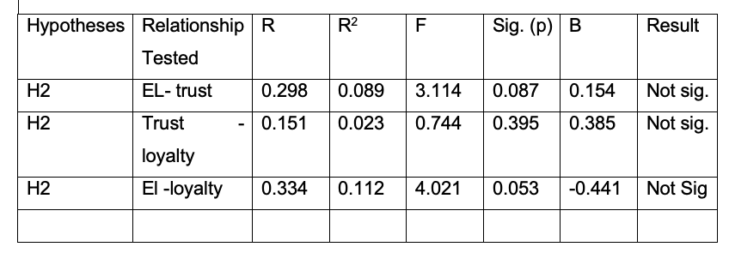

H4: Ethical leadership influence customer satisfaction with sustainability in the airline industry.
To test this, spearman’s test was made between ethical leadership (ELAverage) and customer satisfaction(CSAverage). The results showed a weak positive correlation between ethical leadership and customer satisfaction. The spearman’s test =0.195 and the p-value 0.270(sig to 2 tailed) which is not significant statically. Thus, in this dataset there is not enough evidence to say that higher perceptions of ethical leadership influence customer satisfaction with sustainability.

Table 7: Spearman’s Rank Correlation for ethical leadership and customer satisfaction.
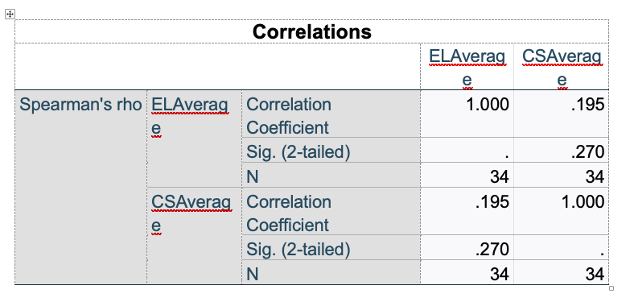
In summary, ethical leadership does not have significant over customer trust, loyalty and satisfaction with sustainability in this dataset.

Sustainability Hypotheses

This section presents the results for the hypotheses related to sustainability perception and their influence on customer behaviours. The tested hypotheses were H3 and H5 as showed in the table xxx. the results of each hypothesis are discusses below.

H3: Customers with perceptions of sustainability prioritise one airline over another.
H5: Awareness of sustainability programs affects customer perceptions.

So, the following table summarise the result for H3.
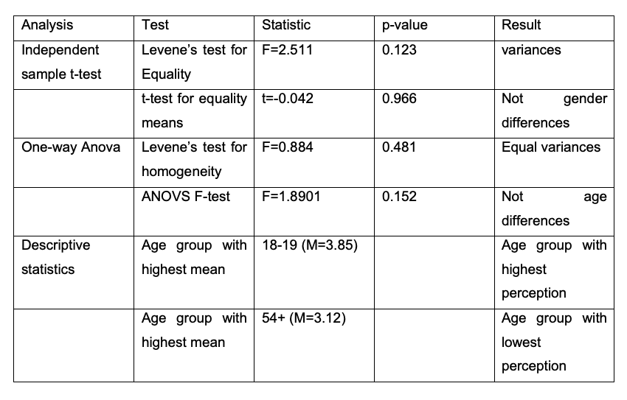
The results showed no significance differences based on gender or age groups. The test t-test (p=0.966 and one way ANOVA(p=0.152) mean not statistically significant relationship, therefore the H3 is not supported, customers do not prioritise one airline over another.

For H5 the result are as follows:
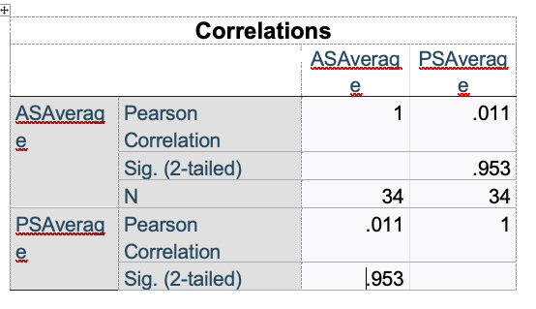
The results show a weak relationship r=0.011 between awareness of sustainability programs and customer perceptions. The relationship was not statistically significant (p=0.953) so awareness of sustainability does not affect customer perceptions.

So, in summary the sustainability hypotheses indicate not significant relationship between sustainability awareness, perceptions and customer behaviours in this dataset.

Customer Satisfaction, Trust and Loyalty Hypotheses.
This section evaluates the relationship between customer satisfaction, trust and loyalty with sustainability programs. So H6, H7 and H8 were tested to find the relationship. The following are the results for each hypothesis.

H6: Customer satisfaction with sustainability initiatives impacts customer loyalty.
H7: Transparency in sustainability practices positively influences customer trust in airlines.
H8: Implementation of sustainability standards positively influences customer loyalty.

The results for H6:

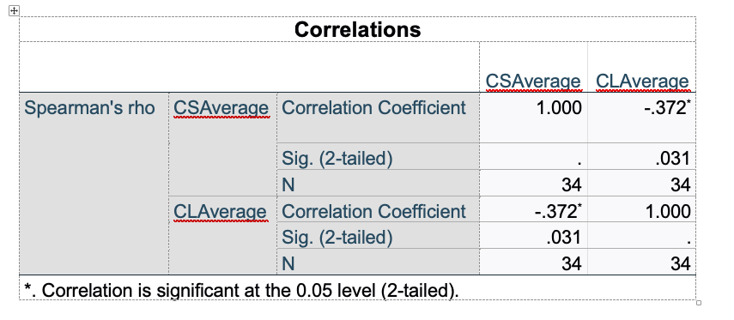
The results showed a moderate negative correlation between customer satisfaction with sustainability and customer loyalty (p=-0.372 and p=0.031). These findings suggest that as customer satisfaction decreases customer loyalty increases and vice versa. However, being negative differ from the hypotheses so it is rejected.

The results for H7:
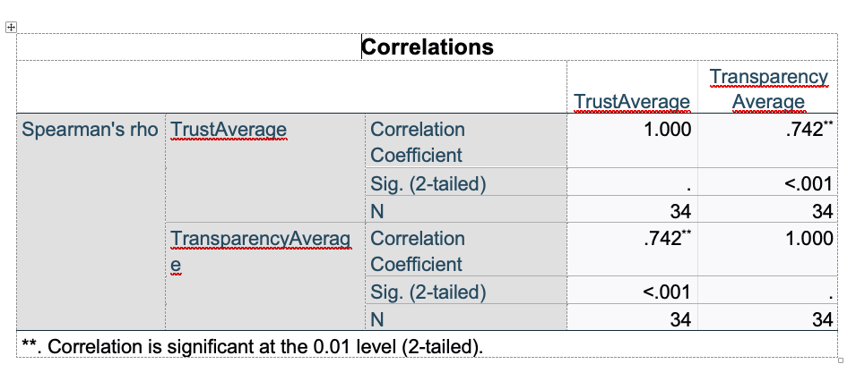

The results showed a strong positive corelation between transparency and customer trust (p=0.742 and p<0.001). This relationship is significant at the level of 0.01 meaning that transparency in airlines increase customer trust.

The results for H8
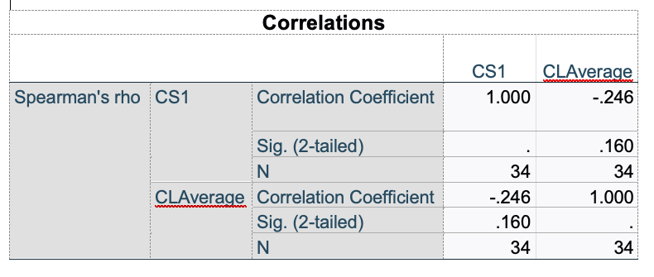

The results showed a weak negative correlation (p=-0.246) not statistically significant (p=0.0160). This means there is not significant relationship between the implementation of sustainability standard and customer loyalty in this dataset. The negative correlation could mean that there are other factor that affect this relationship.

In summary, the findings for customer satisfaction, trust and loyalty has mixed results.H6 is a negative relationship, H7 has a strong correlation and H8 do not have correlation. Thus, transparency is important for building trust, however customer loyalty is not influenced by the customer satisfaction with sustainability

Discussion

This study aimed to research the relationship between ethical leadership, sustainability initiatives, and customer satisfaction, trust, and loyalty in the Colombian airline industry. The results were a mix of positive and negative findings that gave some knowledge of these relationships in emerging countries.

The study investigates the relationship between ethical leadership and customer trust, satisfaction and loyalty. The results for H1 revealed a not significant relationship (p=0.271 and p=0.120), contrasting with Sim and Kim (2024) and Al Halbusi et al. (2021), where ethical leadership influence trust through transparency. However, Crossley et al. (2023) found that ethical leadership diminishes when there is a lack of communication and cultural distrust. These results could mean that Colombian airlines' leadership behaviours are not visible or insufficient to build customer trust.

Moreover, customer trust did not mediate the relationship between ethical leadership and customer loyalty H2; the regression analysis showed no significance. However, this differs from Than and Anh (2023), who found that sustainability efforts influence loyalty indirectly. This result suggests that trust alone is not enough to create loyal customers (Leon and Dixon, 2023). Other factors, such as service quality, price, and better customer engagement, may increase the relationship in the context of Colombia. Similarly, ethical leadership did not influence customer satisfaction with sustainability initiatives (p=0.195 and p=0.270). These results are different from the studies by Lee et al. (2024) and Westin et al. (2022), where they found that leadership with sustainability goals improves satisfaction. However, a study by Cuesta-Valiño et al. (2023) has similar results; they found that lack of visibility of CSR initiatives is perceived as inauthentic and decreases satisfaction. Thus, these results suggest that ethical leadership is a well-founded theory, and its effectiveness depends on clear communication and visible behaviours and goals.

The findings about customer perceptions of sustainability H3 do not show differences by gender or age in prioritising airlines. This is like the study of Khan and Fatma (2023), which found that perceptions of sustainability usually do not impact customers' behaviours. This should be due to the culture and the economic status, where people prioritise affordability and convenience instead of environmental considerations. Also, this contradicts the triple bottom-line environmental dimensions that support the assumption that customers will accept and choose sustainability initiatives.

Awareness about sustainability programs H5 has no significant effect (r=0.011 and p=0.953). This contrasts with Kim and Hwang's (2023) results, where CSR communications reduce distrust and improve perceptions. However, as noted previously by Khan and Fatma (2023), the lack of communication of the strategies adopted might not change customer perceptions. In the Colombia context, this could mean that lack of customer engagement affects the relationship and the awareness of the strategies adopted by airlines.

The relationship between customer satisfaction and customer loyalty H6 has a negative correlation. This differs from studies by Wang et al. (2023) and Shrestha (2014), which reported a positive relationship. However, Cuesta-Valiño et al. (2024) found that sustainability programs should be perceived as authentic to avoid adverse customer outcomes. In this study, customers seem to view sustainability as different from their expectations, leading to dissatisfaction and disloyalty. Airlines should be authentic in their strategies and communications so customers can see their behaviour as authentic.

In contrast, there is a strong correlation between transparency in sustainability practices and customer trust. This aligns with Khan and Fatma (2023) and the ethical leadership theory, which states that transparency is an essential behaviour that promotes accountability and trust. This emphasises the previous findings about communication, visibility and engagement with customers. Lastly, the implementation of sustainability did not influence customer loyalty H8; the results showed a negative correlation (p=-0.246 and p=0.160). These results are like what Lopez-Rodriguez and Mora-Forero (2024) found: distrust in sustainability efforts reduces customer loyalty. However, it contrasts with Than and Anh's (2023) results about the impact of environmental goals on customer loyalty. These results could mean that misalignment of priorities reduces loyalty.

Theoretical Implications
This study contributes to ethical leadership and triple bottom theory by adding contrasting knowledge to the usually found. This study on ethical leadership has its challenges by showing that trust and satisfaction are not generalisable and depend on the context. Also, for the triple bottom line, emerging countries such as Colombia, where cultural distrust is shared, find it challenging to balance economic, social, and environmental dimensions.

Practical Implications
These findings show airlines' importance of transparency and authenticity in their strategies, like sustainability initiatives where managers play a role and should communicate consistently and transparently with customers about sustainability goals to build trust and awareness. Also, having a good relationship could help customers understand the expectations of sustainability efforts. Lastly, airlines should combine ethical leadership and sustainability practices into the customer experience, considering engagement, service quality and affordability.

Limitations

This study has several limitations, such as the small sample size that could have influenced the results correlations and the selection of participants, which need more awareness about the sustainability made by the airlines, reducing the relationship. Also, the cross-sectional design does not promote deep analysis, and the fact that it was in only one country restricts its applicability to other regions. Future research should expand the sample size, test the scales and their items a couple of times until people understand what the variables mean, and adopt a longitudinal approach.

Conclusion and Recommendations
This study investigated the relationship between ethical leadership, sustainability initiatives and customer outcomes (trust, satisfaction and loyalty) in the Colombian airline industry. The findings revealed that transparency in sustainability practices enhances customer trust. However, ethical leadership had a minor effect on trust and satisfaction; awareness and implementation had insignificant influence on perceptions and loyalty. Furthermore, customer satisfaction showed a moderate negative impact on loyalty. Therefore, answering the research questions about how ethical leadership influence customer trust and satisfaction showed limited effects, suggesting a need for visibility and communication. As for how sustainability initiatives impact customer perceptions and loyalty, the study had a reduced effect, but transparency had a strong correlation with trust.

Recommendations for practice and future research

Airlines in Colombia should focus on transparent communications about sustainability with its customers to build trust and satisfaction and increase loyalty. If the communication improves, the customer will be aware of new strategies applied by the airline to improve the environment and the community. Future research should explore what other factors influence customer perception towards sustainability initiatives using larger sample sizes and longitudinal studies.

References

Alafeshat, R., & Tanova, C. (2019). Servant Leadership Style and High-Performance Work System Practices: Pathway to a Sustainable Jordanian Airline Industry. Sustainability, 11(22), Available at: https://doi.org/10.3390/SU11226191

Gebreslassie, D. A., Salem, A. E., & Radwan, S. H. (2023). Managing Airline Emissions, Noise, and Bird Strikes: Passengers’ Perspectives on Airlines’ Extrinsic and Intrinsic Environmental Practices, Sustainability, 15(17), Available at :https://doi.org/10.3390/su151712734

Al Halbusi, H. et al. (2021) Linking ethical leadership and ethical climate to employees’ ethical behavior: the moderating role of person–organization fit’, Personnel Review, 50, pp.159–185. Available at: https://doi.org/10.1108/PR-09-2019-0522

Alvarado-Herrera, A., et al.(2017) A Scale for Measuring Consumer Perceptions of Corporate Social Responsibility Following the Sustainable Development Paradigm, Journal of Business Ethics, 140, pp.243–262. Available at: https://doi.org/10.1007/s10551-015-2654-9

America Airlines (2024). America Airlines releases 2023 sustainability report. Available at: https://news.aa.com/news/news-details/2024/American-Airlines-releases-2023-Sustainability-Report-GEN-OTH-07/ (Accessed 20 November 2024)

Avianca, (2024). Environmental strategy. Available at: https://www.avianca.com/en/about-us/sustainability/environmental-strategy/ (Accessed 20 November 2024)

Avianca-Chooose (2024) Let’s fly together through greener skies. Available at: https://avianca.chooose.today/#scrollTo=baebf38e-9f42-4a12-bbcd-9f8f33db5f32 (Accessed 20 November 2024)

Brown, M.E., et al., (2005), Ethical leadership: a social learning perspective for construct development and testing: Organizational Behavior and Human Decision Processes, 97(2), pp.117-134. Available at : https://doi.org/10.1016/j.obhdp.2005.03.002

Coyle, J.R. and Thorson, E. (2001) The Effects of Progressive Levels of Interactivity and Vividness in Web Marketing Sites, Journal of Advertising, (30), pp.65-77. Available at :pp.https://doi.org/10.1080/00913367.2001.10673646

Chabán, O., et al., (2024). The Manager’s Vision of CSR in an Emerging Economy: From Implementation to Market Impact. Administrative Sciences. Available at: https://doi.org/10.3390/admsci14030044

Chung, S., Park, J., & Lee, S. (2022). The Influence of CSR on Airline Loyalty through the Mediations of Passenger Satisfaction, Airline Brand, and Airline Trust: Korean Market Focused. Sustainability, 14(8). Available at: https://doi.org/10.3390/su14084548

Chen, X.-R., et al., (2024) The Impact of Airline Continuity Behaviour and Corporate Image on Consumers’ Purchase Intentions: Brand Loyalty as a Moderating Variable. International Journal of Engineering, Business and Management. Available at: https://doi.org/10.22161/ijebm.8.2.4

Crossley, C. D. et al., (2023) Right From the Start: The Association Between Ethical Leadership, Trust Primacy, and Customer Loyalty, Journal of Business Ethics. Available at: https://doi.org/10.1007/s10551-023-05485-y

Donaldson, L. (2005) For Positive Management Theories while retaining Science: Reply to Ghoshal, Academy of Management Learning & Education, 4, pp. 109-113. Available at: https://research-ebsco-com.ezproxy.uwtsd.ac.uk/c/onvpsy/viewer/pdf/kkkvj7nimr (Accessed: 21 November 2024)

Erdem, T., et al., (2004). Brand Credibility, Brand Consideration, and Choice.: Journal of Consumer Research, 31(1), pp.191–198. Available at: https://doi.org/10.1086/383434
Farhan, B. Y. (2024) Visionary leadership and innovative mindset for sustainable business development: Case studies and practical applications. Research in Globalization. Available at: https://doi.org/10.1016/j.resglo.2024.100219

Foster, C. (2024) Methodological pragmatism in educational research: from qualitative-quantitative to exploratory-confirmatory distinctions, International Journal of Research & Method in Education, 47(1), pp. 4-19. Available at :DOI: 10.1080/1743727X.2023.2210063
Goldsmith, R. E., et al., (2000) The Impact of Corporate Credibility and Celebrity Credibility on Consumer Reaction to Advertisements and Brands, Journal of Advertising, 29(3), pp. 43–54. https://doi.org/10.1080/00913367.2000.10673616
Gajić, T.,et al.(2024) Tourists’ Willingness to Adopt AI in Hospitality—Assumption of Sustainability in Developing Countries. Sustainability. Available at :https://doi.org/10.3390/su16093663

Han, H., et al., (2019) 'Factors Triggering Customer Willingness to Travel on Environmentally Responsible Electric Airplanes, Sustainability, 11(7), 2035. https://doi.org/10.3390/su11072035

Iberia (2024) Sustainability. Available at: https://grupo.iberia.com/sustainability (Accessed 20 November 2024)

IATA, (2024) Begineers guide to Airlline Sustainabiliyt Report. Available at: https://www.iata.org/contentassets/77ec9a8c8a864daaa00bdb7f5de02902/beginners-guide-to-airline-sustainability-reporting-april2024.pdf (Accessed: 29 November 2024).

Jeurissen, R. (2000) Review of the book Cannibals with fork: The Triple Bottom Line of 21st Cdntury Business, by J. Elkington, Journal of Business Ethics, 23, pp. 231-234. https://doi-org.ezproxy.uwtsd.ac.uk/10.1023/A:1006129603978

Karanki, F. (2024) Redefining the skies: How sustainable aviation fuel alters airline cost structure and market dynamics; International Journal of Sustainable Transportation, 18(8),695-703. https://doi.org/10.1080/15568318.2024.2397642

Kang, J., & Hustvedt, G. (2014). Building Trust Between Consumers and Corporations: The Role of Consumer Perceptions of Transparency and Social Responsibility. Journal of Business Ethics, 125(2), pp. 253–265. http://www.jstor.org/stable/24033230. (Accessed 20 November 2024)

Kelly, L. M., & Cordeiro, M. (2020). Three principles of pragmatism for research on organizational processes. Methodological Innovations, 13(2). https://doi.org/10.1177/2059799120937242

Korba, P., Sekelová, I., Koščáková, M., & Behúnová, A. (2023). Passengers’ Knowledge and Attitudes toward Green Initiatives in Aviation. Sustainability, 15(7), 6187. Available at: https://doi.org/10.3390/su15076187

Kim, S., & Hwang, J. (2023) Airline CSR and Quality Attributes as Driving Forces of Passengers’ Brand Love: Comparing Full-Service Carriers with Low-Cost Carriers. Sustainability, 15(9). Available at: https://doi.org/10.3390/su15097293

Kaptein, M. (2019) The moral entrepreneur: A new component of Ethical Leadership, Journal Business of Ethics, 156, pp. 1135 – 1150. Available at: https://doi.org/DOI 10.1007/s10551-017-3641-0

Khan, I., & Fatma, M. (2023). Does Perceived Sustainability Affect the Customer Responses toward the Brands? Role of Customer Engagement as a Mediator. Sustainability, 15(10), Available at: https://doi.org/10.3390/su15108259

Leon, S., & Dixon, S. (2023) Airline satisfaction and loyalty: Assessing the influence of personality, trust and service quality, Journal of Air Transport Management, 113. Available at: https://doi.org/10.1016/j.jairtraman.2023.102487

López Rodríguez, C. E., & Mora Forero, J. A. (2024) Dimensions for Measuring Brand Equity in the Airlines Industry. Journal of Tourism and Services, 15(28), pp. 22–38. https://doi.org/10.29036/jots.v15i28.552

Lopez Gomez, M. (2024) Value chain for the implementation in use and production of sustainable aviation fuel(SAF) in Colombia. Available at: https://repositorio.uniandes.edu.co/entities/publication/21769278-34cc-451e-9c0a-516263cf3dd6 (Accessed: 20 November 2024)

Lee, J.W. and Yoon, S.Y. (2024) Growing stakeholderism in the airline industry after the COVID-19 pandemic, Journal of Air Transport Management [Preprint]. Available at: https://doi.org/10.1016/j.jairtraman.2024.102574.

Lopez, M et al., (2024) Analysis of the potential for sustainable aviation fuel (SAF) production from Colombian Agro-industrial residues, Chemical Engineering Transactions, 109. Available at: https://doi.org/10.3303/CET24109006

Lee, S., et al., (2024) The Effect of Service Quality and Sustainability Practices on Brand Equity: The Case of Korean Air Passengers, Sustainability, 16(11), https://doi.org/10.3390/su16114606

Leon, S., & Dixon, S. (2023) Airline satisfaction and loyalty: Assessing the influence of personality, trust and service quality, Journal of Air Transport Management, 113, 102487. https://doi.org/10.1016/j.jairtraman.2023.102487

Latam (2024) sustainability. Available at: https://www.latamairlinesgroup.net/sustainability#:~:text=With%20the%20commitment%20to%20be,the%20places%20where%20it%20operates. (Accessed 20 November 2024)

Latam (2023) Annual Report. https://www.latamairlinesgroup.net/static-files/5ca24e0f-17bf-4bcc-8611-3536b3c2a2cd (Accessed 20 November 2024)

Maxham, J. G. III, & Netemeyer, R. G. (2003). Firms reap what they sow: The effects of shared values and perceived organizational justice on customers' evaluations of complaint handling, Journal of Marketing, 67(1), pp. 46–62. Available at: https://doi.org/10.1509/jmkg.67.1.46.18591

Mukhezakule, M and Tefera, O. (2019) The relationship between corporate strategy, strategic leadership and sustainable organisational performance: proposing a conceptual framework for the south African aviation industry Journal of Hospitality, Tourism and Leisure, 8(3). Available at: https://www.ajhtl.com/

Norman, W. and McDonald, C. (2004) Getting to the bottom of “Triple Bottom Line”, Business Ethics Quarterly, 14(2), pp. 243-262. Available at :https://doi.org/ doi:10.5840/beq200414211 https://www-cambridge-org.ezproxy.uwtsd.ac.uk/core/journals/business-ethics-quarterly/article/abs/getting-to-the-bottom-of-triple-bottom-line/A7D95AB81098B4701947C999AE720697 (Accessed 20 November 2024)

Öberseder, M., et al., (2014) Perceptions of Corporate Social Responsibility: Scale Development and Validation, Journal of Business Ethics, 124, pp. 101–115 . Available at https://doi.org/10.1007/s10551-013-1787-y

Phillips, S., et al., (2019) Airline Value Chain Capabilities and CSR Performance: The Connection Between CSR Leadership and CSR Culture with CSR Performance, Customer Satisfaction and Financial Performance, The Asian Journal of Shipping and Logistics, 35(1), pp. 30–40. Available at:https://doi.org/10.1016/J.AJSL.2019.03.005

Sahu, S., et al., (2024) Navigating the transition: Embracing responsible business practices for sustainable success, Journal of Informatics Education and Research, 4(2). Available at:https://jier.org

Shi, Y., et al., (2023) Impact of sustainability on financial distress in the air transport industry: the moderating effect of Asia–Pacific, Financial Innovation 9(1), pp 97. Available at https://doi.org/10.1186/s40854-023-00506-1

Sorsa, K. and Bona-Sanchez, C. (2024) Corporate social responsibility trends in the airline industry: a bibliometric analysis, Sustainability, 16. Available at: https://doi.org/10.3390/su16072709

Sundresan, K. et al., (2023) Navigating Few Ethical challenges in the airline industry: a qualitative investigation, International Journal of Innovation and Business Strategy, 18(2), pp. 82-90. Available at: https://ijibs.utm.my/index.php/ijibs/article/view/145/117 (Accessed: 21 November 2024).

Stavropoulou, A. et al (2024) Key concepts of ethical leadership: A review of the literature, World Journal of Advanced Research and Reviews, 21 (3), pp. 2227-2232. Available at: https://doi.org/10.30574/wjarr.2024.21.3.0913

Soklaridis, S., et al., (2024) ‘A novel approach to measure perceived customer centricity in the passenger airline industry: index development and validation’, Journal of the Air Transport Research Society, p. 100044. Available at: https://doi.org/10.1016/j.jatrs.2024.100044.

Siqueira, J. R., et al., (2023). Key drivers of brand trust in a Latin American airline: the impact of Colombia’s Avianca customer experience. Journal of Marketing Analytics, 11(2), pp. 186–201. https://doi.org/10.1057/s41270-023-00208-8

Sim, M. & Kim, H. (2024) Measurement validation of a consumer-driven environmental, social, and governance (ESG) index for the airline industry, Journal of Sustainable Tourism. Available at: https://doi.org/10.1080/09669582.2024.2351179

Saunders, M., Lewis, P. and Thornhill, A. (2019), Research Methods for Business Students, 6th ed., Harlow: Pearson.

Shrestha, B.R., (2014) Airline brand loyalty: A case study involving the three airlines, SAS, Norwegian and Widerøe. Available at https://munin.uit.no/bitstream/handle/10037/6917/thesis.pdf;jsessionid=50BBB1A0445AF6F97ED8C2CD1E76E212?sequence=2

Thanh, H. P., & Anh, T. H. (2023) The mediating impact of airlines’ image in relation of corporate social responsibility and customers’ loyalty: An empirical in Vietnam. Cogent Business & Management, 10(1). Available at: https://doi.org/10.1080/23311975.2023.188641

Tamoor, M., Samak, N. A., & Xing, J. (2022). Pakistan toward Achieving Net-Zero Emissions: Policy and Roadmap, ACS Sustainable Chemistry & Engineering, 11(1), pp. 368–380. Available at: https://doi.org/10.1021/acssuschemeng.2c05839

Tanveer, M., et al., (2021) Role of Ethical Marketing in Driving Consumer Brand Relationships and Brand Loyalty: A Sustainable Marketing Approach. Sustainability, 13(12), 6839. Available at: https://doi.org/10.3390/SU13126839

Utgård, J., & Gaustad, T. (2024). Carbon Emission Reductions and Offsets: Consumer Perceptions of Firm Environmental Sustainability. Journal of Cleaner Production, 470, Available at: https://doi.org/10.1016/j.jclepro.2024.143300

Valiño, P., et al., (2024) Constraints and barriers on industrial customer performance in an omnichannel ecosystem. Review of Managerial Science. Available at: https://doi.org/10.1007/s11846-024-00780-y

Westin, L., et al., (2022). Sustainable Development as a Driver for Customer Experience, Sustainability, 14(6), Available at:. https://doi.org/10.3390/su14063505

Williams, A. S. (2019) Exploring the Ethical Leadership proficiencies organizational development change managers need to improve quality control process in the airline industry. Available at: https://www.proquest.com/docview/2433204632?fromopenview=true&parentSessionId=uwy4P8ctS2a80eLcCTFBc%2FJRBi52IuKZTwEsewawQbg%3D&pq-origsite=gscholar&accountid=130472&sourcetype=Dissertations%20&%20Theses (Accessed: 21 November 2024)

Wang, C., et al., (2023) Corporate social Responsibility’s impact on passenger loyalty and satisfaction in the Chinese airport industry: The moderating role of green HRM. Heliyon. Available at :https://doi.org/10.1016/j.heliyon.2023.e23360

Yuncong, X. (2024) Research on the role of leadership in sustainable aviation development, Bachelor of Business Administration. Available at:https://www.theseus.fi/bitstream/handle/10024/858603/Xie_Yuncong.pdf;jsessionid=86EF26C5820ED2D6279DDBAC8029D5D1?sequence=2

Zahari, A. I., et al., (2024). Ethical Culture and Leadership for Sustainability and Governance in Public Sector Organisations within the ESG Framework. Journal of Open Innovation. Available at: https://doi.org/10.1016/j.joitmc.2024.100219

Appendices

Appendix -I: Survey

Customer Perspectives of Leadership and sustainability in Airlines

This survey aims to understand consumer perspectives and awareness on leadership and sustainability practices within the airline industry. Your responses will provide valuable insights into how airlines’ ethical and environmental efforts impact customer trust, satisfaction and loyalty.

Participation is voluntary, responses are anonymous, and you may withdraw at anytime. Data will only used for academic purposes.

Section 1: Demographic Information

- Age:
18 - 29
30 - 41
42 - 53
54+

- Gender:
Male
Female
Other/Prefer not to say

- Frequency of Airline Travel:
Less than once a year.
1 – 2 times a year
3 – 5 times a year
5+ times a year
- Purpose of travel:
Business
Leisure
Both
Other (please specify)

Section 2. Perception of Ethical Leadership.
Ethical leadership in an airline refers to moral principles that are present in the organisation, including transparency, responsibility, and integrity.

Using a scale of 1(Strongly Disagree) to 5 (Strongly Agree), indicate your agreement with the following:
statements | 1(Strongly Disagree) | 2 | 3 | 4 | 5 (Strongly Agree)
Sustainability initiatives are guided by ethical principles, such as fairness and integrity.
I trust the airline’s leadership to make decisions that are ethical for the environment and society.
The airline’s leadership openly communicates its sustainability goals.
The airline’s leadership takes responsibility for its environmental and social impact.
The airline’s community projects demonstrating its ethical commitments. leadership actively support environment and

Section 3: Awareness and Perceptions of Sustainability programs.
This section covers airlines efforts to reduce environmental impact, support community initiatives and improve their efficiency.

Instructions for Awareness:
Using a scale of 1 (Not aware at all) to 5 (Very Aware), rate your awareness of
Awareness statements | 1(Not aware at All) | 2 | 3 | 4 | 5 (Very Aware)
The airline’s carbon reduction initiatives.
Eco practices, such as paperless operations and in-flight upgrades.
Development and use of sustainable aviation fuels (SAF)
Efforts to eliminate plastic use and recycle waste.
Efforts to improve the quality of life in local communities.

Instructions for Perception:
Using a scale of 1(Strongly Disagree) to 5 (Strongly Agree), indicate your agreement with the following:

Perception statements | 1(Strongly Disagree) | 2 | 3 | 4 | 5 (Strongly Agree)
The airline’s carbon reduction initiatives are impactful.
The airline’s Eco practices, such as paperless operations and in-flight upgrades are beneficial.
The airline’s development and use of sustainable aviation fuels (SAF) contribute effectively to sustainability
The airline’s efforts to eliminate plastic use and recycle waste are important.
The airline’s efforts to improve the quality of life in local communities are valuable.

Section 4: Trust and transparency

Using a scale of 1(Strongly Disagree) to 5 (Strongly Agree), indicate your agreement with the following:
Statements | 1(Strongly Disagree) | 2 | 3 | 4 | 5 (Strongly Agree)
The airline’s provide clear and accessible information about sustainability practices.
The airline communicate honestly and openly about its sustainability challenges and progress.
The airline fulfil its commitments to sustainability initiatives. | trust
The airline’s reputation reflects reliability and transparency in its sustainability practices.
The airline’s sustainability practices have earned my trust over time. | trust

Section 5: Customer satisfaction with Sustainability

Using a scale of 1 (Not satisfied at All) to 5 (Very Satisfied), rate your satisfaction with:
Statement | 1(Not satisfied at All) | 2 | 3 | 4 | 5 (Very Satisfied)
The airline effectively implements its sustainability standards |  |  | 3
The impact of the airline’s sustainability initiatives on reducing environmental harm.
The airline’s contribution to society through its sustainability efforts.
The airline’s clarity and consistency communicating its sustainability progress.
The overall alignment of the airline’s sustainability initiatives with my expectations as a customer.

Section 6 customer loyalty base on sustainability.

Using a scale of 1 (Very Unlikely) to 5(Very Likely), indicate your likelihood to :

statements | 1(Very Unlikely) | 2 | 3 | 4 | 5 (Very Likely)
Choose this airline again because of its sustainability practices.
Recommend this airline to others because of its commitment to sustainability.
Speak positively to friends, family and colleagues about the airline’s sustainability initiates.
Choose this airline over competitors because of its sustainability practices
I am likely to remain loyal to this airline if it continues to prioritise sustainability.
My trust in the airline’s sustainability practices motivates me to remain loyal.

Is there anything you would like to share about your experience regarding airline sustainability practices?
____________________

Thank You
Thank you for completing the survey! Your feedback will provide valuable insight into customer perspectives on sustainability and ethical practices within the airline industry.

Appendix - II: Supplementary material

A. Reliability Test- Cronbach Alpha

Table: Cronbach’s Alpha for perception of ethical leadership (EL).
The CA was 0.816

Ethical Leadership CA
 | Scale Mean if Item Deleted | Scale Variance if Item Deleted | Corrected Item-Total Correlation | Cronbach's Alpha if Item Deleted
EL1 | 10.94 | 9.209 | .815 | .708
EL2 | 10.91 | 14.689 | .590 | .797
EL3 | 10.97 | 11.908 | .679 | .757
EL4 | 10.91 | 13.174 | .716 | .759
EL5 | 11.32 | 13.316 | .389 | .851

Table: Cronbach’s Alpha for awareness of sustainability (AS).
The CA was 0.839

Awareness of Sustainability
 | Scale Mean if Item Deleted | Scale Variance if Item Deleted | Corrected Item-Total Correlation | Cronbach's Alpha if Item Deleted
AS1 | 10.85 | 6.614 | .591 | .820
AS2 | 10.74 | 6.685 | .556 | .829
AS3 | 10.85 | 6.675 | .624 | .812
AS4 | 11.00 | 6.061 | .615 | .816
AS5 | 10.44 | 5.284 | .842 | .743

Table: Cronbach’s Alpha for perception of sustainability (PS).
The CA was 0.793

Perception of Sustainability
 | Scale Mean if Item Deleted | Scale Variance if Item Deleted | Corrected Item-Total Correlation | Cronbach's Alpha if Item Deleted
PS1 | 13.71 | 4.578 | .793 | .672
PS2 | 13.76 | 4.791 | .689 | .713
PS3 | 13.71 | 5.305 | .691 | .717
PS4 | 13.74 | 5.837 | .701 | .730
PS5 | 13.32 | 7.013 | .129 | .884

Table: Cronbach’s Alpha for trust and transparency (TT).
The CA was 0.781

Trust and Transparency
 | Scale Mean if Item Deleted | Scale Variance if Item Deleted | Corrected Item-Total Correlation | Cronbach's Alpha if Item Deleted
TT1 | 13.76 | 2.791 | .180 | .851
TT2 | 13.71 | 2.153 | .625 | .716
TT3 | 13.71 | 2.032 | .728 | .680
TT4 | 13.62 | 2.122 | .635 | .712
TT5 | 13.68 | 2.104 | .657 | .705

Table: Cronbach’s Alpha for customer satisfaction with sustainability (CS).
The CA was 0.771

Customer Satisfaction with Sustainability
 | Scale Mean if Item Deleted | Scale Variance if Item Deleted | Corrected Item-Total Correlation | Cronbach's Alpha if Item Deleted
CS1 | 17.88 | 2.168 | .603 | .707
CS2 | 17.91 | 2.265 | .533 | .731
CS3 | 17.79 | 2.714 | .207 | .835
CS4 | 17.82 | 2.029 | .713 | .667
CS5 | 17.88 | 2.046 | .705 | .670

Table: Cronbach’s Alpha for customer loyalty (CL).
The CA was 0.712

Customer Loyalty
 | Scale Mean if Item Deleted | Scale Variance if Item Deleted | Corrected Item-Total Correlation | Cronbach's Alpha if Item Deleted
CL1 | 16.91 | 10.992 | .713 | .567
CL2 | 17.00 | 10.970 | .813 | .532
CL3 | 17.09 | 11.295 | .837 | .531
CL4 | 16.94 | 12.481 | .536 | .641
CL5 | 16.32 | 20.407 | -.209 | .810
CL6 | 16.47 | 19.893 | -.137 | .769

Appendix – III: Others

Scale tables

Table : Ethical leadership scale and Adaptation to the section 2 of the survey.
ELS | Adaptation | Dimensions
Conduct his/her personal life in an ethical manner. | The airline’s leadership demonstrates ethical behaviour through its actions. | Integrity and ethical conduct
Discusses business ethics or values with employees | The airline leadership openly communicates its sustainability goals | Transparency and communication
Sets an example of how to do things the right way in terms of ethics. | The airline’s leadership takes responsibility for its environmental impact. | Accountability and role modeling
Define success not just by results but also the way that they are obtained. | The airlines actively support environment and community projects | Sustainability foucs
Can be trusted | I trust the airline to make decisions that are ethical for the environment and society. | Trustworthiness.
Source: Ethical leadership: a social learning perspective for construct development and testing. Brown et al. 2005. available at: https://doi.org/10.1016/j.obhdp.2005.03.002

Table customer awareness and perceptions of sustainability programs. section 3

CSRConsPerScale | Awareness | Perception | Dimension
… trying to sponsor pro-environmental programmes (Env1) | (How aware are you) The airline’s carbon reduction initiatives. | The airline’s sustainability efforts have a meaningful environmental impact. | Environmental
…trying to allocate resource to offer services compatible with the environment (Env2) | Eco practices, such as paperless operations and in-flight upgrades. | The airline eco practices minimise environmental impacts. | Environmental
… trying to protect the environment (Env5) | Development and use of sustainable aviation fuels (SAF) | Sustainable aviation fuels significantly contribute to sustainability | Environmental
… trying to recycle its waste materials properly (Eng6) | Efforts to eliminate plastic use and recycle waste. | Waste reduction initiatives effectively support environmental goals. | Environmental
… trying to help to improve quality of life in the local community (Soc8) | Efforts to improve the quality of life in local communities. | Quality of life projects effectively support local communities. | Social.

SourceL A scale for measuring consumer perceptions of corporate social responsibility following the sustainable development paradigm. By Alvarado-Herrera et al. (2017). Available at: https://doi.org/10.1007/s10551-015-2654-9

Table about trust and transparency section 4

Consumer trust and transparency | Adaptation | Dimension
If I wanted to, I could easily find out about labor conditions in the factories uses to make their product. | I can find anything about airline sustainability practices. | Transparency (Hustvedt and kang, 2013)
… would be honest and sincere in addressing the issue of sweatshop labor. | The airline will be honest and sincere in addressing sustainability issues | Transparency (Hustvedt and kang, 2013)
… delivers what it promises. | The airline delivers what it promises | Trust (Erdem and Swait, 2004)
… has a name you can trust | The airline has a name you can trust | Trust (Erdem and Swait, 2004)

Source: building trust between consumers and corporations: the role of consumer perceptions of transparency and social responsibility. By Kang and Hustvedt (2013). Available at: https://doi.org/10.1007/s10551-013-1916-7

Table about customer satisfaction and sustainability section 5.

Customer satisfaction | Adaptation | dimension
Meet quality standards | The airline’s efforts to meet quality sustainability standards. | Customer domain.f6
The overall impression of the … company is favourable-unfavourable | The overall quality of the airline’s sustainability initiatives. | Overall perception (Goldsmith et al. 2000).
Contribute to solving society problems | The airline’s contribution to society through its sustainability efforts. | Societal domain f5
Communicate openly and honestly with the local community | The airline’s communicate its sustainability goals and progress. | Community domain f1
Source: Consumer’s perceptions of corporate social responsibility: scale development and validation. Available at: https://doi.org/10.1007/s10551-013-1787-y

Table about customer loyalty based on sustainability section 6

Customer loyalty | Adaptation | Dimension
It is very likely that I will buy products from (company) | Choose this airline again because of its sustainability initiatives | Purchase intention (Coyle and Thorson 2001; Putrevu and Lord 1994)
I would recommend (company) to my friends | Recommend this airline to others based on its sustainability efforts | Word of mouth> (Maxham and Netemeyer 2003)
I am likely to spread positive word of mouth about (company) | Speak positively about this airline’s sustainability initiates to others | Maxham and Netemeyer 2003
I will definitely try others products from (company) | Prioritise thi airline over others due to its sustainability practices | Purchase intention. Purchase intention (Coyle and Thorson 2001; Putrevu and Lord 1994)
Source: Consumer’s perceptions of corporate social responsibility: scale development and validation. Oberseder et al. (2014). Available at: https://doi.org/10.1007/s10551-013-1787-y

Regression of hypotheses 2.

Trust and EL

Model Summary
Model | R | R Square | Adjusted R Square | Std. Error of the Estimate
1 | .298ª | .089 | .060 | .432
a. Predictors: (Constant), ELAverage

ANOVAª
Model |  | Sum of Squares | df | Mean Square | F | Sig.
1 | Regression | .582 | 1 | .582 | 3.114 | .087^{b}
1 | Residual | 5.984 | 32 | .187
1 | Total | 6.566 | 33
a. Dependent Variable: TrustAverage
b. Predictors: (Constant), ELAverage

Coefficientsª
Model |  | Unstandardized Coefficients |  | Standardized Coefficients | t | Sig.
 |  | B | Std. Error | Beta | t | Sig.
1 | (Constant) | 3.003 | .251 |  | 11.945 | <.001
1 | ELAverage | .154 | .087 | .298 | 1.765 | .087
a. Dependent Variable: TrustAverage

Customer Loyalty and Trust

Model Summary
Model | R | R Square | Adjusted R Square | Std. Error of the Estimate
1 | .151ª | .023 | -.008 | 1.144
a. Predictors: (Constant), TrustAverage

ANOVAª
Model |  | Sum of Squares | df | Mean Square | F | Sig.
1 | Regression | .974 | 1 | .974 | .744 | .395^{b}
1 | Residual | 41.886 | 32 | 1.309
1 | Total | 42.860 | 33
a. Dependent Variable: CLAverage
b. Predictors: (Constant), TrustAverage

Coefficientsª
Model |  | Unstandardized Coefficients |  | Standardized Coefficients | t | Sig.
 |  | B | Std. Error | Beta | t | Sig.
1 | (Constant) | 1.842 | 1.542 |  | 1.194 | .241
1 | TrustAverage | .385 | .446 | .151 | .863 | .395
a. Dependent Variable: CLAverage

Customer Loyalty and Ethical Leadership
Model Summary
Model | R | R Square | Adjusted R Square | Std. Error of the Estimate
1 | .334ª | .112 | .084 | 1.091
a. Predictors: (Constant), ELAverage

ANOVAª
Model |  | Sum of Squares | df | Mean Square | F | Sig.
1 | Regression | 4.785 | 1 | 4.785 | 4.021 | .053^{b}
1 | Residual | 38.076 | 32 | 1.190
1 | Total | 42.860 | 33
a. Dependent Variable: CLAverage
b. Predictors: (Constant), ELAverage

Coefficientsª
Model |  | Unstandardized Coefficients |  | Standardized Coefficients | t | Sig.
 |  | B | Std. Error | Beta | t | Sig.
1 | (Constant) | 4.377 | .634 |  | 6.902 | <.001
1 | ELAverage | -.441 | .220 | -.334 | -2.005 | .053
a. Dependent Variable: CLAverage

Hypotheses 3 Independent Sample t-test and Anova.

Independent Samples Test
 |  | Levene's Test for Equality of Variances |  | t-test for Equality of Means
 |  | F | Sig. | t | df | Significance |  | Mean Difference | Std. Error Difference | 95% Confidence Interval of the Difference
 |  |  |  |  |  | One-Sided p | Two-Sided p | Mean Difference | Std. Error Difference | Lower | Upper
PSAverage | Equal variances assumed | 2.511 | .123 | -.042 | 31 | .483 | .966 | -.009 | .214 | -.446 | .427
PSAverage | Equal variances not assumed |  |  | -.049 | 28.589 | .481 | .961 | -.009 | .186 | -.390 | .372

Descriptives
PSAverage
 | N | Mean | Std. Deviation | Std. Error | 95% Confidence Interval for Mean |  | Minimum | Maximum
 |  |  |  |  | Lower Bound | Upper Bound | Minimum | Maximum
18-29 | 4 | 3.85 | .597 | .299 | 2.90 | 4.80 | 3 | 5
30-41 | 12 | 3.55 | .566 | .164 | 3.19 | 3.91 | 2 | 4
42-53 | 13 | 3.26 | .585 | .162 | 2.91 | 3.62 | 2 | 4
54+ | 5 | 3.12 | .303 | .136 | 2.74 | 3.50 | 3 | 4
Total | 34 | 3.41 | .572 | .098 | 3.21 | 3.61 | 2 | 5

Tests of Homogeneity of Variances
 |  | Levene Statistic | df1 | df2 | Sig.
PSAverage | Based on Mean | .844 | 3 | 30 | .481
PSAverage | Based on Median | .774 | 3 | 30 | .518
PSAverage | Based on Median and with adjusted df | .774 | 3 | 28.653 | .518
PSAverage | Based on trimmed mean | .823 | 3 | 30 | .491

ANOVA
PSAverage
 | Sum of Squares | df | Mean Square | F | Sig.
Between Groups | 1.717 | 3 | .572 | 1.891 | .152
Within Groups | 9.079 | 30 | .303
Total | 10.795 | 33

