UNIVERSITY OF WALES TRINITY SAINT DAVID
LONDON CAMPUS
Assignment 2
Learning in the Digital Era
Video Link https://uowtsd-my.sharepoint.com/:v:/r/personal/2538385_student_uwtsd_ac_uk/Documents/Assignmen%202%20LDE%20video%20presentation.mp4?d=w5346a0641a2642f8a5d93728c808a93a&csf=1&web=1&e=7pUlxW
Please be sure to give unrestricted access to your video presentation so that your work can be marked by the examiner.
Module Name: Learning in the Digital Era
Module Code: ACCA 4025

Student Name: Imran Sharif
Student ID:2538385
Group:1

Lecturer’s Name:

Table of Contents
Introduction 2
Main Body 2
Conclusion 9
References 9

Introduction

This reflection, using Gibbs’ Reflective Cycle and SMART objectives highlights the strengths that I identified myself with but, at the same time highlights the developmental areas of improvement within myself and looks at the learning theories behind the building of ‘resilience’ and the ‘learning to learn’ aspect of a students’ learning. The reflective account brings together the outcomes of the professional development which has taken place within this professional, Learning in the Digital Era, module (ACCA 4025). In this module, the assignment consisted of two parts. A self-reflection which then produced a coherent Personal Professional Development plan. The other part was a critique of the meta-competency, Learning to Learn.

Main Body
The explanation of the reasoning and reference evidence for each of the stages within my video presentation will be provided in this assignment.
VideoLink: https://uowtsd-my.sharepoint.com/:v:/r/personal/2538385_student_uwtsd_ac_uk/Documents/Assignmen%202%20LDE%20video%20presentation.mp4?d=w5346a0641a2642f8a5d93728c808a93a&csf=1&web=1&e=7pUlxW
Slide 1 COVERPAGE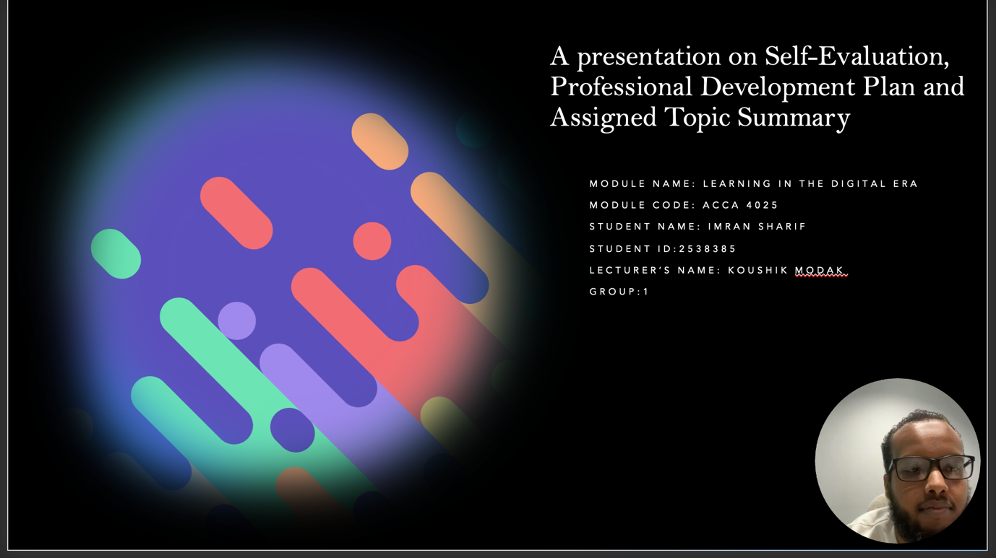

Slide 2 CONTENTS
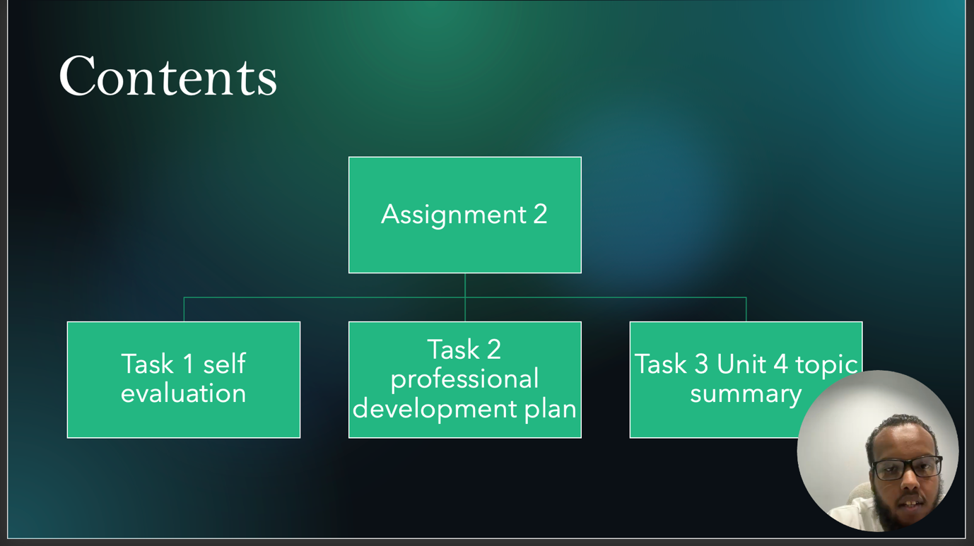

Slide 3 INTRODUCTION
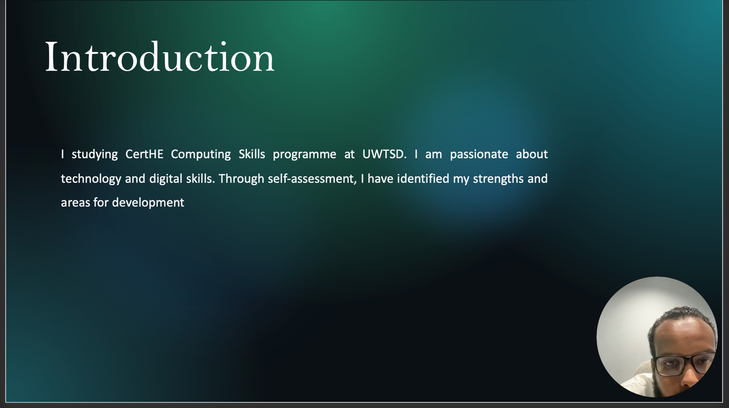

Slide 4 GIBB’s REFLECTIVE MODEL
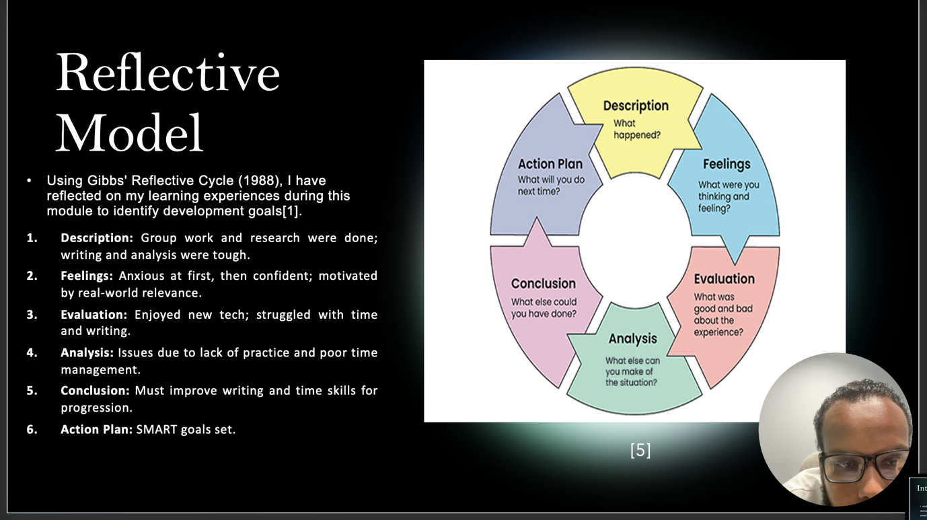
Brief explanation: Gibbs’ model of reflection can help a person think about the experience through 6 stages. The learner describes, reviews, and finishes the experience in this stage. After this, this person will put personal action plans. For my experience on the learning in digital era module, I will be using Gibbs model for reflection to reflect on my experience (Smith, 2018) [1]. This reflection has helped me appraise my learning systematically on the module. It contains my internal and external forces. One notable weakness is around time management. By reflecting on my teaching and learning, I will be able to construct a professional development plan [2].
Slide 5 TASK 1: SELF EVALUATION
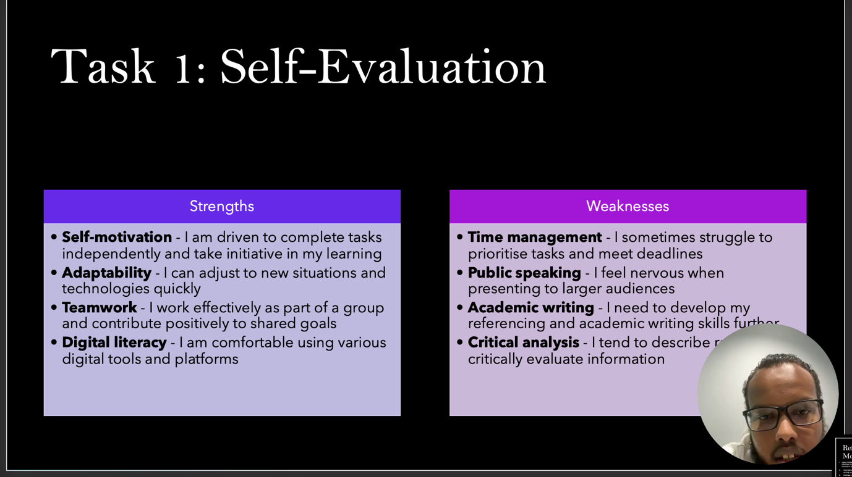
Brief explanation: After conducting a SWOT Analysis of my Strengths, Weaknesses, Opportunities and Threats I have a broad view of my own current potential. According to the prior SWOT Analysis report, my passion for all things digital and technology minded is considered my greatest strength as I am engaged in what I study and motivated by it [3] . Sadly, my greatest weakness is an academic strength of mine. I am not the best at writing essays and critiquing them. So, while writing this essay, I learnt that I am more inexperienced and out of practice than I thought. It is possible to prepare for action when one is aware of one’s weaknesses.
Slide 6. TRAITS GAINED FROM THE SELF EVALUATION
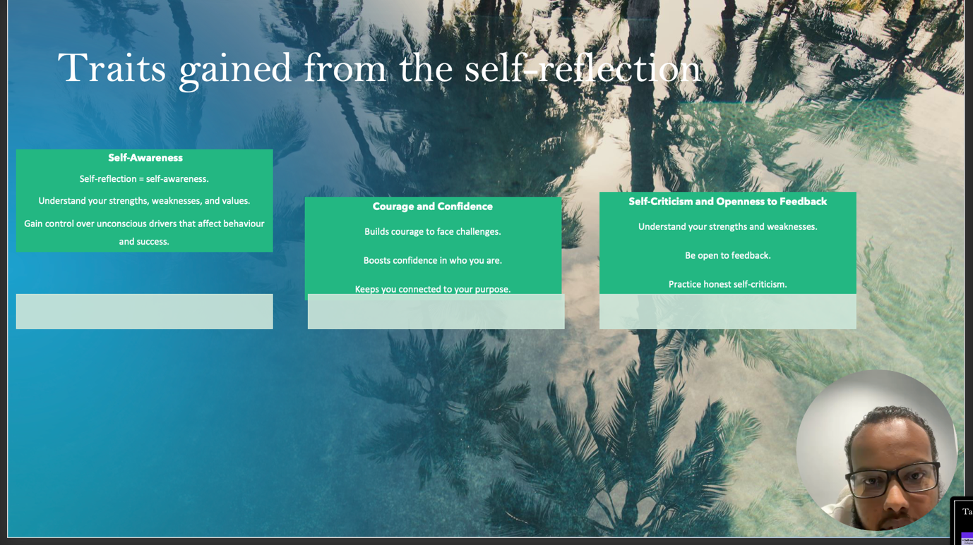

Brief explanation: My self-assessment has been helpful in pointing out a few key attributes I’ve already learned or must work on.
- Adaptability and resilience: The ability to recover from failure and adapt to a changed circumstance is resilience. When my initial studying method was ineffective, I was forced to adapt and change my plans [4].
- Self-Awareness: I am learning how to become a more effective learner by using my strengths and working on my weaknesses.
- Proactive Learning: In addition, I oversee my personal development and actively pursue other options and development opportunities outside of the course.

Slide 7 PROFESSIONAL DEVELOPMENT PLAN
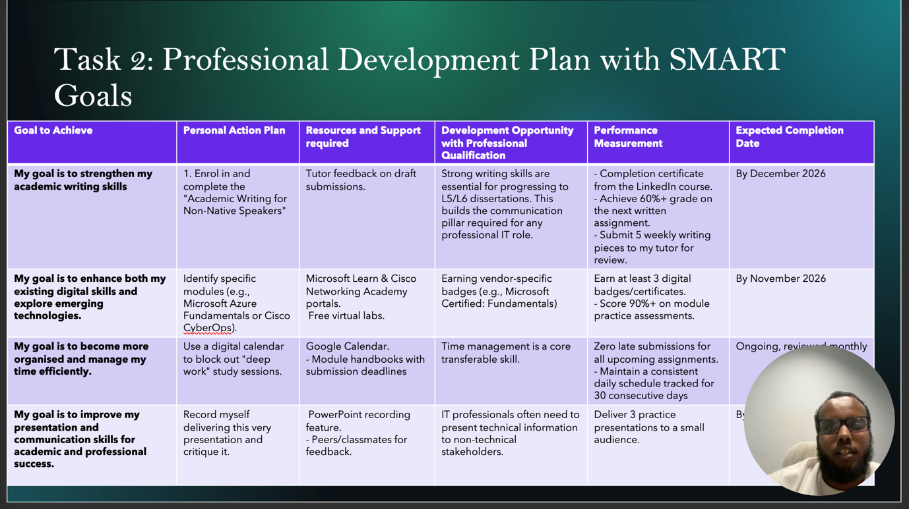
Brief explanation: Using a framework based on SMART objectives, I created a PDP that contains two objectives with clear definitions, which will be discussed shortly. The development of the PDP was due to the self-assessment that I undertook of the above-mentioned shortcomings:
- Improve Academic writing: The university provides a writing workshop and two articles from academic journals every month for next 6 months. The above will improve academic writing skills.
- Enhance Time Management: I aim to improve my time management by using a digital planner to create set study time for each module and ensure I meet all my deadlines at least a day or two before the actual date[5]. These objectives will aid in advancing my academic journey and ultimately my future career.

Slide 8 UNIT 4 TOPIC SUMMARY
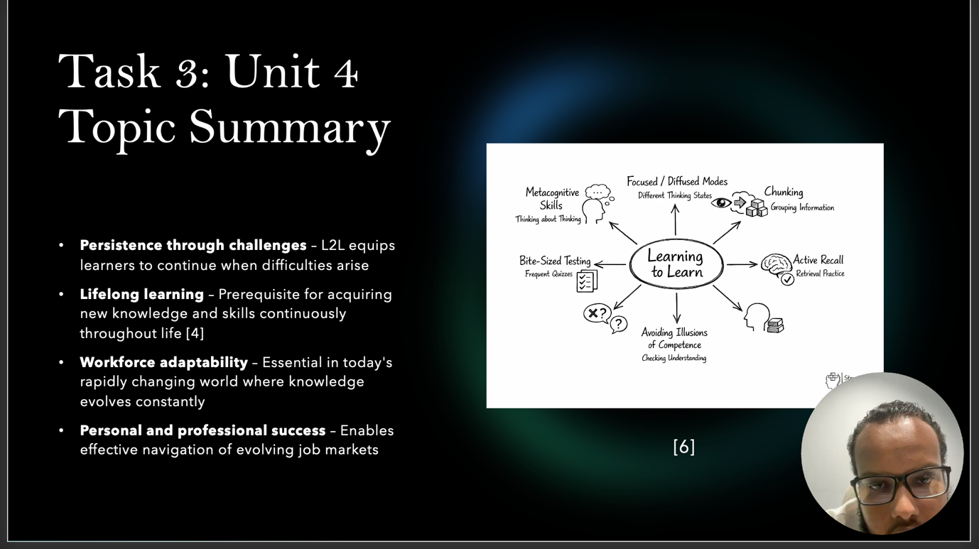
Brief explanation: However, my research summary involves Learning of Learn, is an ability or capability to arrange your own learning, to organize the available time and to continue if something gets wrong and is identified as a meta-competence [5], and as a consequence of our society has been identified to need a 21st century approach which has metacognition knowledge of self-regulatory learning growth mindset adoption to promote and instil lifelong learning [6], to prepare to be constantly learning in ever changing job market to successfully personal and professionally [7]. The ability to learn is a highly impactful competence, which means it primarily impacts other competencies. When people can control their own learning and set their own goals, manage their time, persist through difficulties, and have the willingness… Learning to learn "thinking about thinking" is known as metacognition is metacognition. Other components are self-regulated learning, reflection and emotionally resilient. Being aware of one’s learning process is what develops the skill to learn. People relate more closely with what is realistic. We push ourselves to choose and to make decisions that optimise our successes. We acknowledge and accept our responsibilities.
Slide 9 CONCLUSION

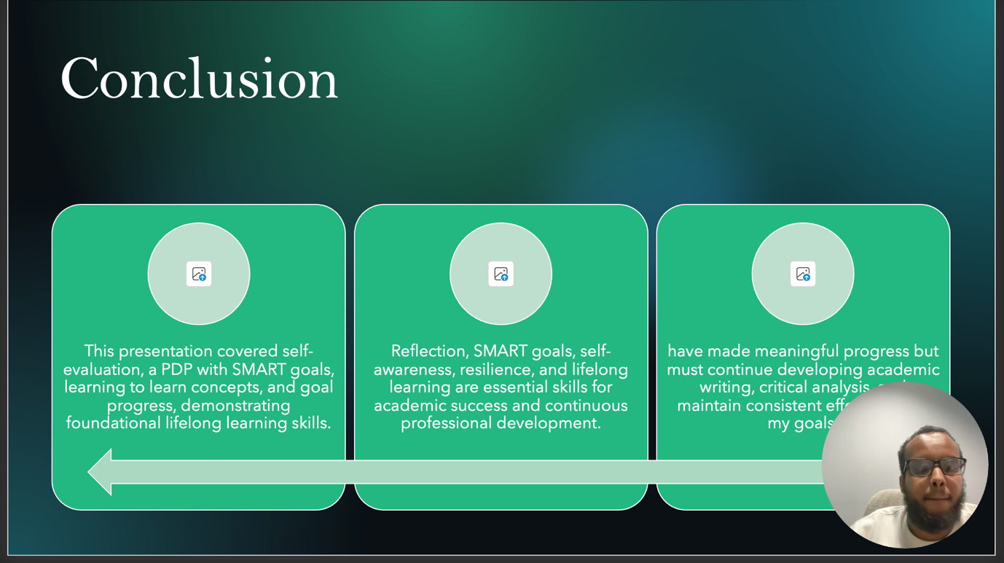

Brief explanation: In conclusion to my presentation, I was required to reflect on my learning and identify the part of my learning that could be improved which then help me to create an action plan. I fully understood how to go about this using the Gibson Reflective cycle and SMART goal setting.

Slide 10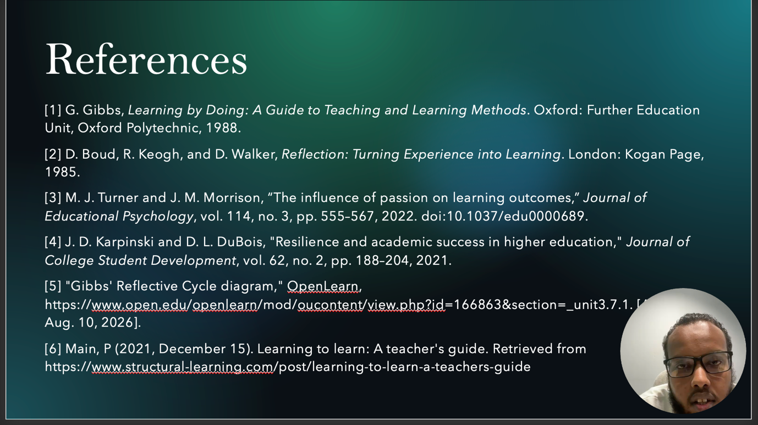

Conclusion
In summary, this document synthesizes the conclusions derived from my self-evaluation process and the specifications of my future professional learning development action plan. From the evaluation that I carried out, I identified that I always have a positive view towards any piece of technology that is offered to me, however I identified that I have a greater level of weakness academically in writing style and managing my time effectively. Based on the above factors, I created an action plan to development which in areas as identified in my self-evaluations was further added learning to learn model use where it identified now it would be useful to improve on developing my life of success in the global world of online media/technology.

References
[1] G. Gibbs, Learning by Doing: A Guide to Teaching and Learning Methods. Oxford: Further Education Unit, Oxford Polytechnic, 1988.
[2] D. Boud, R. Keogh, and D. Walker, Reflection: Turning Experience into Learning. London: Kogan Page, 1985.
[3] M. J. Turner and J. M. Morrison, “The influence of passion on learning outcomes,” Journal of Educational Psychology, vol. 114, no. 3, pp. 555–567, 2022. doi:10.1037/edu0000689.
[4] J. D. Karpinski and D. L. DuBois, "Resilience and academic success in higher education," Journal of College Student Development, vol. 62, no. 2, pp. 188–204, 2021.
[5] G. C. Latham and E. A. Locke, “New developments in goal setting and task performance,” in The Oxford Handbook of Organizational Psychology, vol. 1, S. Zedeck, Ed. New York: Oxford University Press, 2012, pp. 297–310.
[6] European Parliament and Council, "Recommendation on key competences for lifelong learning," Official Journal of the European Union, vol. 61, pp. 1–13, May 2018.
[7] J. H. Flavell, "Metacognition and cognitive monitoring: A new area of cognitive–developmental inquiry," American Psychologist, vol. 34, no. 10, pp. 906–911, 1979. doi:10.1037/0003-066X.34.10.906.
[8] S. T. A. Toom and H. J. T. H. A. van der Meij, "Learning to learn: A critical competence for the 21st-century learner," Educational Psychology Review, vol. 33, no. 4, pp. 1237–1255, 2021. doi:10.1007/s10648-021-09635-2.

