Orgo Bake Evaluation Report

Student name: Ionel Golovatii
Student ID: 2228604
Module code: LCBB5001
Module name: Entrepreneurship
Lecturer: Amer Kareem
Table of Contents
Introduction 3
Evaluation of Business Idea and Motivational Factors 3
Five entrepreneurship skills, traits, and behaviour and their importance for businesses 4
SWOT Analysis 5
PEST Analysis 5
Political Factor 6
Economic Factor 6
Social Factor 6
Technological Factor 6
Conclusion 7
Appendix 7
Reference 13

Introduction
This report evaluates the business idea of opening an organic bakery in London, driven by the rising consumer awareness of health and sustainability and factors which lead to motivation for starting a business. The report will also evaluate the entrepreneur's skills, traits, behaviours, and will explain why these are important. Further, a SWOT and PEST analysis will be conducted to understand various factors that affect the business operations.

Evaluation of Business Idea and Motivational Factors
Opening an organic bakery in London is driven by the increasing consumer awareness about health and sustainability. The demand for organic products has been strongly rising in the UK, with the market valued at approximately £2.79 billion in 2022, with London, known for its diverse and health-conscious population, representing a significant portion of this market (England, 2021). Approximately 55% of the population of the UK choose to purchase the products of a company whose business ethics is more inclined towards sustainability (Briggs, 2023). All above mentioned provide an opportunity for Orgo Bake to develop products which are exclusively organic and eco-friendly. The target audience includes health-conscious consumers, environmentally conscious individuals, and young professionals and families willing to spend more on high-quality products.
The competition includes existing organic bakeries, health food stores, and speciality coffee shops offering artisanal baked goods. Therefore, differentiation will be a determinant factor in the Orgo Bake's success. One of the main differentiation strategies of business will be a minimalistic manufacturing process which will use a minimal number of organic ingredients to produce its products. By adopting this approach the bakery will offer the best price for its organic and eco-friendly products.
A reliable supply chain focusing on local sourcing will ensure freshness, support local farmers, reduce the carbon footprint and develop a strong brand identity which will resonate with target customers.

Five entrepreneurship skills, traits, and behaviour and their importance for businesses
Creativity and innovation are essential traits, skills, and behaviours in entrepreneurship. They drive the development of new ideas that improve existing products and services. Effective innovation helps entrepreneurs think beyond traditional solutions, a process known as creativity. Entrepreneurs who think creatively generate exciting, novel ideas that captivate interest. These qualities are crucial in entrepreneurship because they enable the creation of new products and services. (Mazla et al. 2020).
Communication skills are one of the qualities of entrepreneurship which allow an entrepreneur to take a step ahead in a business context. Communication skills help an entrepreneur to create new plans and ideas to drive the success of a business. The entrepreneurs and business leaders have to collaborate thus, in this context, communication skills are very important for both business leaders and entrepreneurs. Through good communication skills they can exchange their information appropriately (Empire, 2019).
Risk-taking and resilience are among entrepreneurship behaviours, traits, and skills because organisations have to face challenges and uncertainty in their operations. Staying confident and strong in difficult situations and trying to learn from errors are crucial for entrepreneurs. This risk-taking and resilience behaviour makes entrepreneurs learn and succeed (Hayward et al.2010).
Relationship building is one of the key qualities of entrepreneurship. Entrepreneurs believe that building good relationships with stakeholders of a company such as industry peers, suppliers, investors, and customers is imperative for success. Effective relationships are beneficial to expand the connection of business (Hudson, 2024).
Self-awareness is among the key qualities of entrepreneurship which allow entrepreneurs to realistically analyse their capabilities as well as recognise their real motivations which is a useful point in starting the journey as an entrepreneur. Self-awareness or self-reflection allows entrepreneurs to assess their strengths and use them to achieve their goals or help them identify their weaknesses and improve them (Wenta, 2024).

SWOT Analysis
Strengths | Weaknesses
I possess the ability to identify market gaps and create good solutions for customers. I have previous experience in managing the purchase and store department in a bread factory based in St Albans, UK. This experience will help Orgo Bake purchase the best quality raw materials and maintain the optimal stock level ensuring that the business will always satisfy the required demand. | I do not have a wide network in the industry and this will affect the capability of the business to identify more opportunities.
Opportunities | Threats
As Orgo Bake aim to open its first bakery and selling point in London, the business has the opportunity to deal with a good customer base thus increasing the chance to succeed in the market. Also, the fast pace of city life creates the ideal conditions for bakery food consumption. The time-saving proprieties of ready-baked food combined with the organic-directed manufacturing process create further opportunities to gain loyalty among health-conscious customers. | Due to the tough competition in this specific industry, there is a big probability that as a new entry into the market, I will not succeed.

PEST Analysis
PEST stands for Political, Economical, Social and Technological. This analysis helps to understand how various factors can affect the business within a region.

Political Factor
The UK is a constitutional monarchy with a parliamentary form of government. It is a stable and suitable country for business, scoring 0.50 on the political stability index (TheGlobalEconomy, 2024). Businesses in the UK benefit from numerous opportunities and a supportive public environment. The proactive government ensures that documentation issues are resolved quickly. Power in the UK is shared between the central government and local authorities, further streamlining the process of addressing business-related documentation.

Economic Factor
This factor significantly impacts business operations. A stable economy offers businesses a prime opportunity for growth. Key economic indicators include GDP growth, unemployment rate, and inflation rate. The UK's GDP grew by 4.3%, faster than any other European country (Clark, 2024), providing businesses with a strong foundation for expanding their operations. However, fluctuating inflation poses challenges for companies in managing their pricing strategies. The unemployment rate in the UK is 4.4% (ONS, 2024), which affects consumer purchasing power.

Social Factor
Social factors heavily influence business operations, including cultural dynamics, demographics, and health and wellness trends. Understanding the cultural aspects of the UK is crucial for businesses aiming to operate successfully in the country. Additionally, the public is increasingly conscious of health and wellness, so businesses need to focus on providing services that promote people's health (Capobianco et al., 2021).

Technological Factor
Technology plays a crucial role in running a business smoothly. Recent advancements have greatly enhanced the ability of businesses to deliver satisfying services to customers. The UK is equipped with the latest technologies, including AI and robotics. For instance, AI-driven chatbots enable businesses to offer 24/7 customer service, while robotics improve service quality and reduce staff needs. These technologies help businesses lower their operational costs (Capobianco et al., 2021).

Conclusion
In conclusion, opening an organic bakery in London presents a promising opportunity due to the growing demand for organic and eco-friendly products driven by increased consumer awareness of health and sustainability. The evaluation highlights that Orgo Bake can succeed in this market by targeting health-conscious consumers, environmentally aware individuals, and young professionals willing to spend on high-quality products. Differentiation through a minimalistic manufacturing process and a reliable, locally sourced supply chain will be critical to success. Essential entrepreneurial skills such as creativity, communication, risk-taking, relationship-building, and self-awareness are imperative to succeed in the highly competitive industry. The SWOT and PEST analyses underscore the strengths, weaknesses, opportunities, threats, and external factors impacting the business, providing a comprehensive understanding of the operational environment and enhancing the likelihood of success for Orgo Bake in the dynamic London market.

Appendix

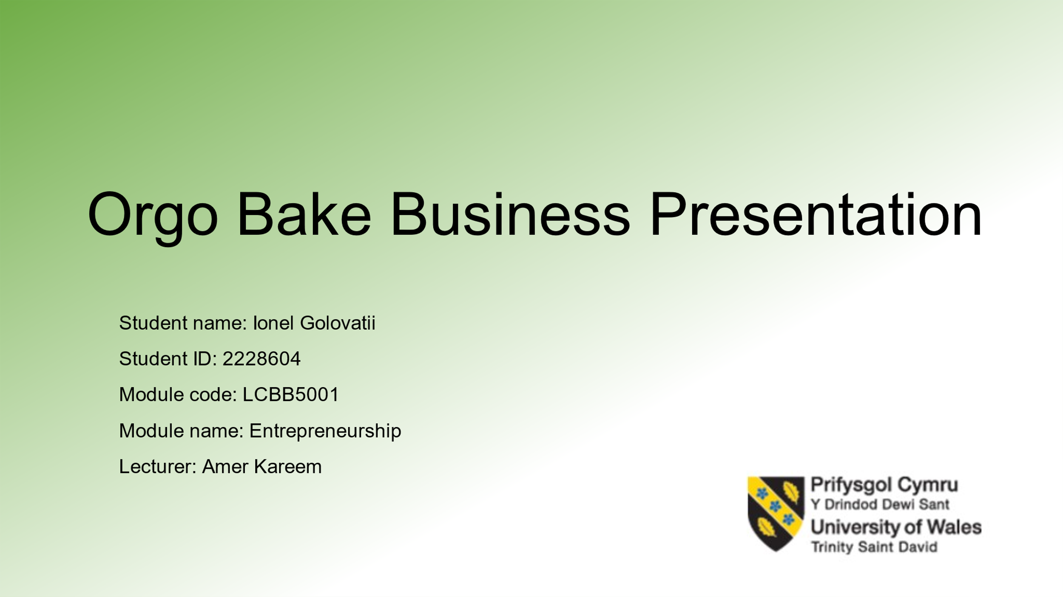
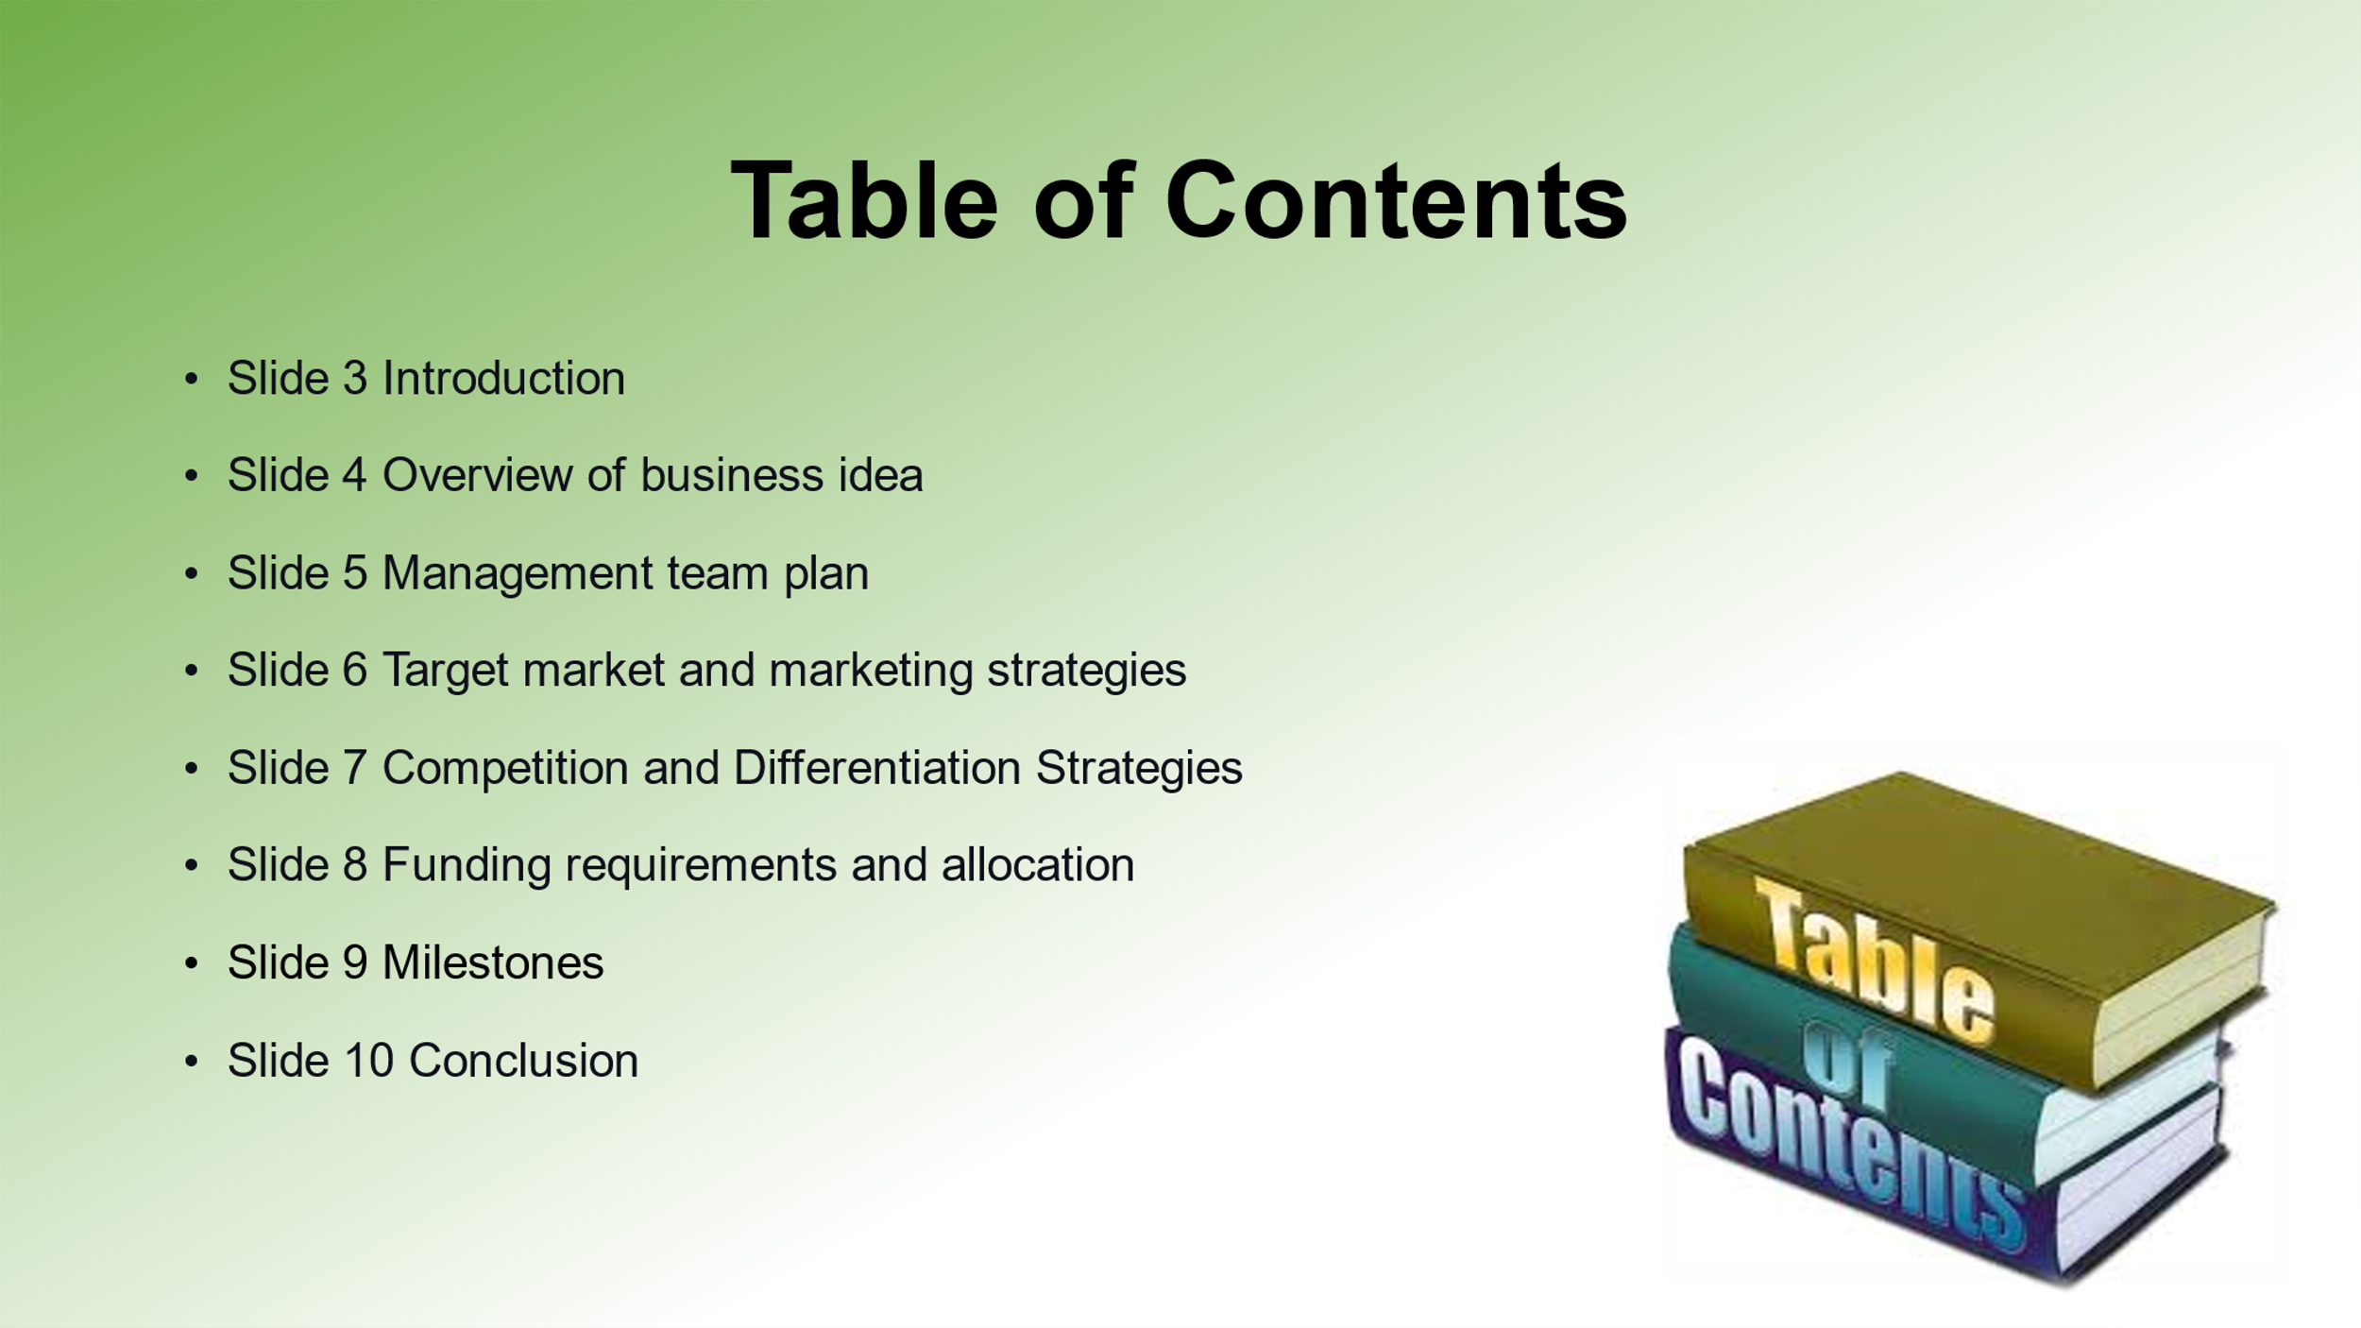
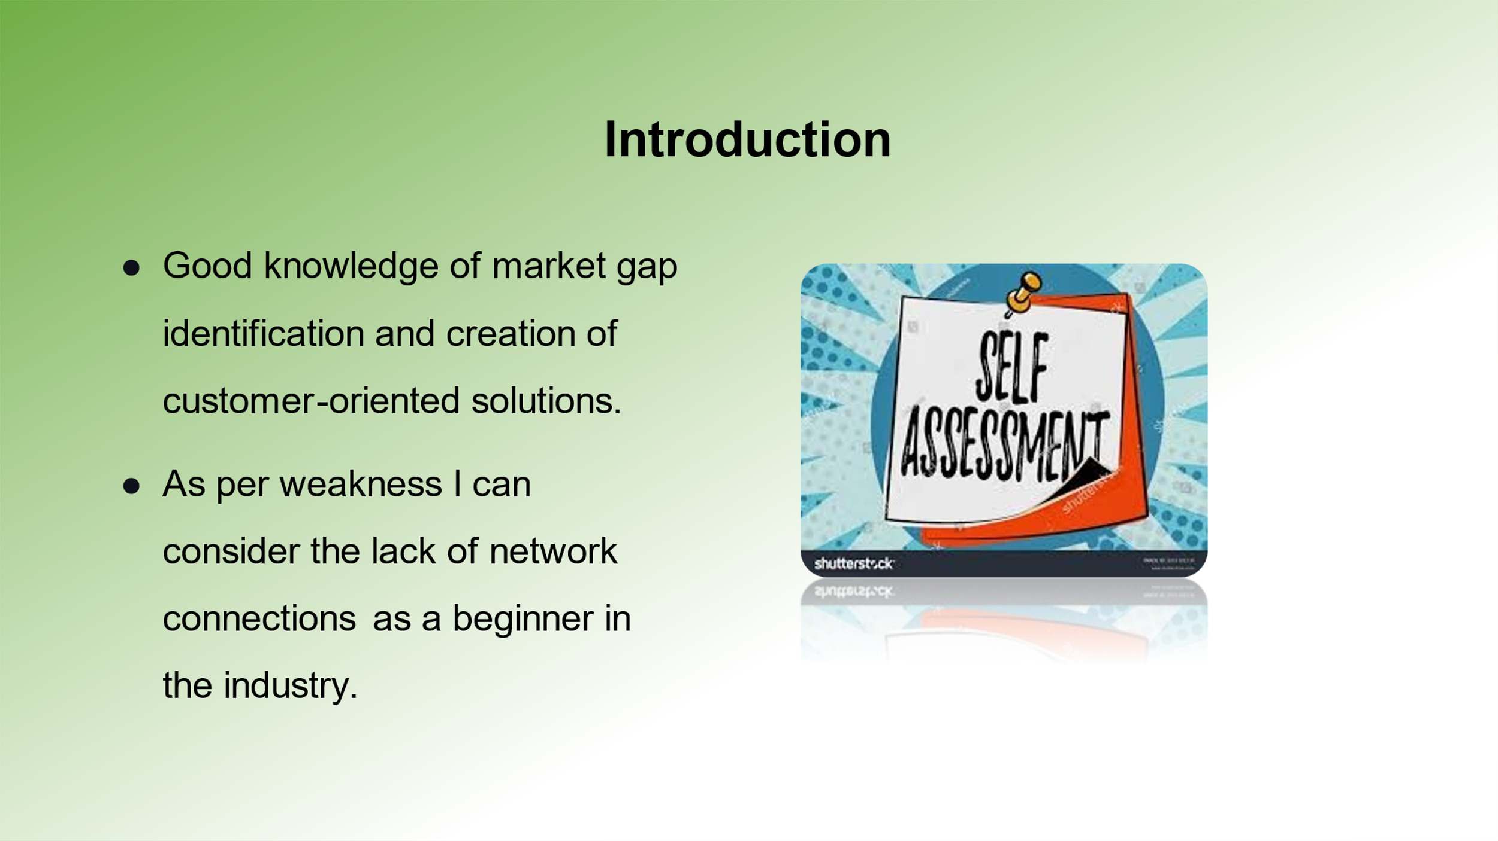
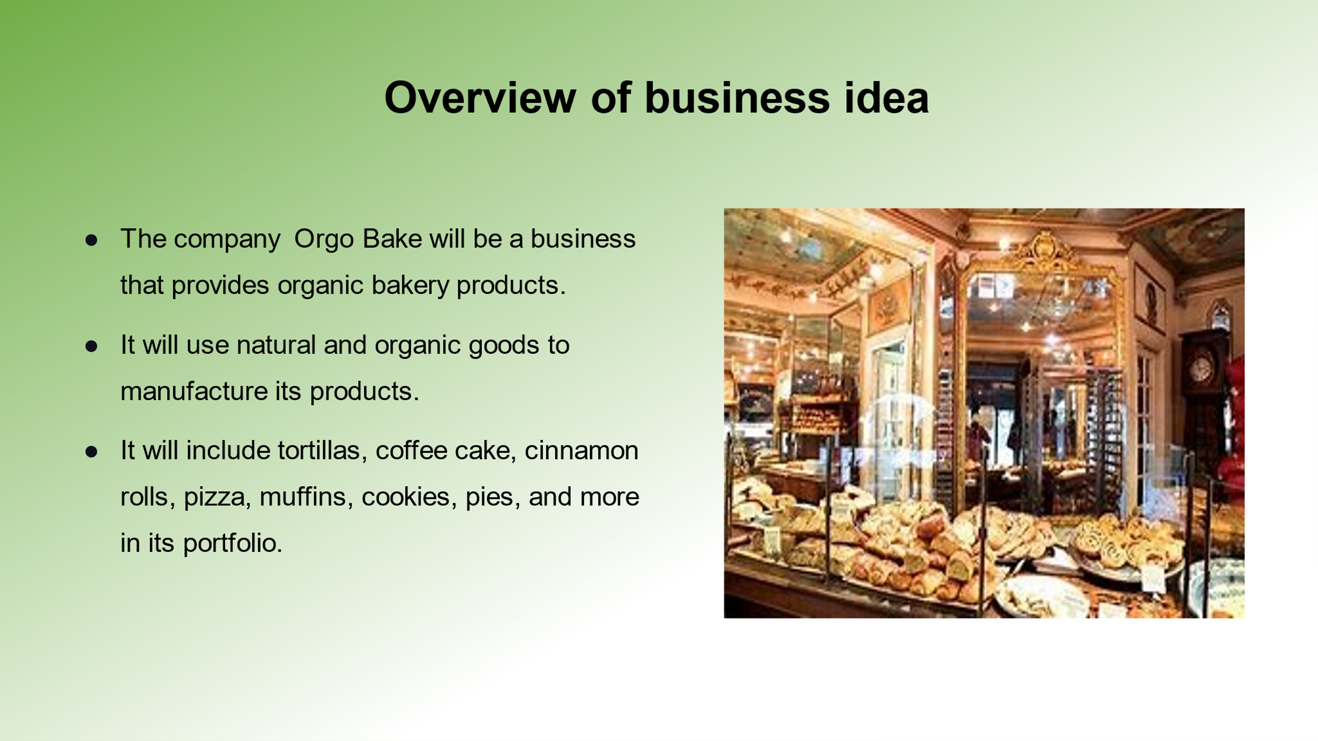
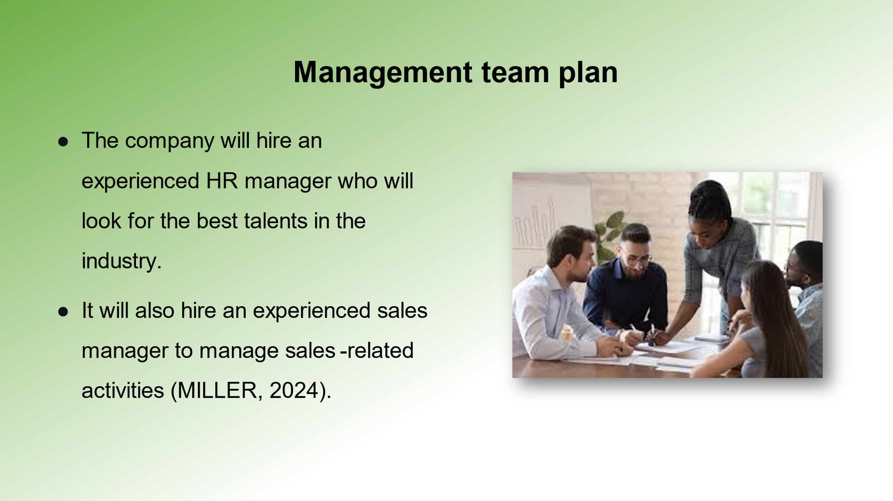
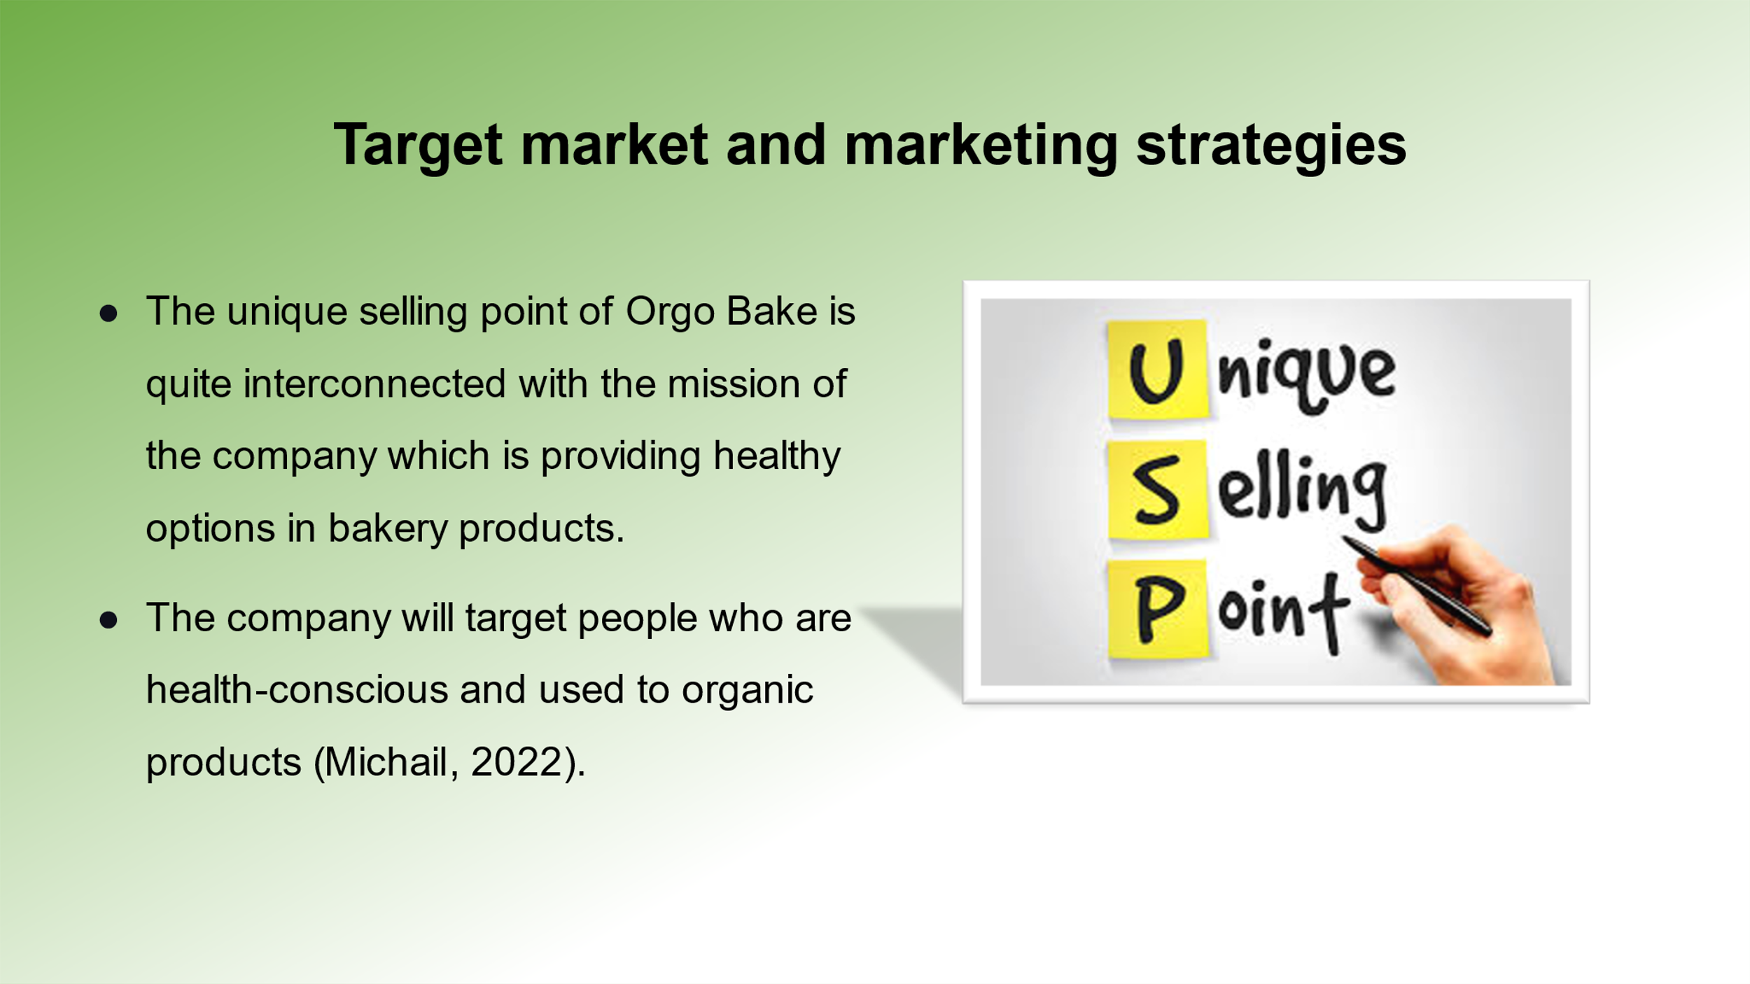
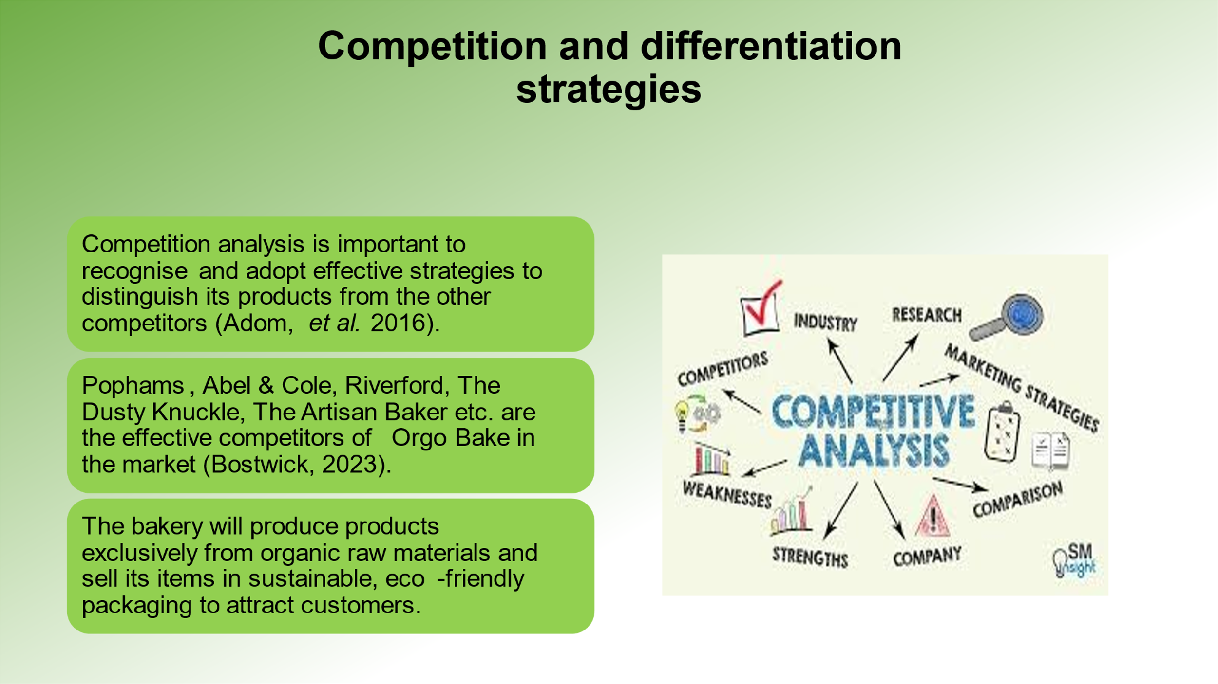
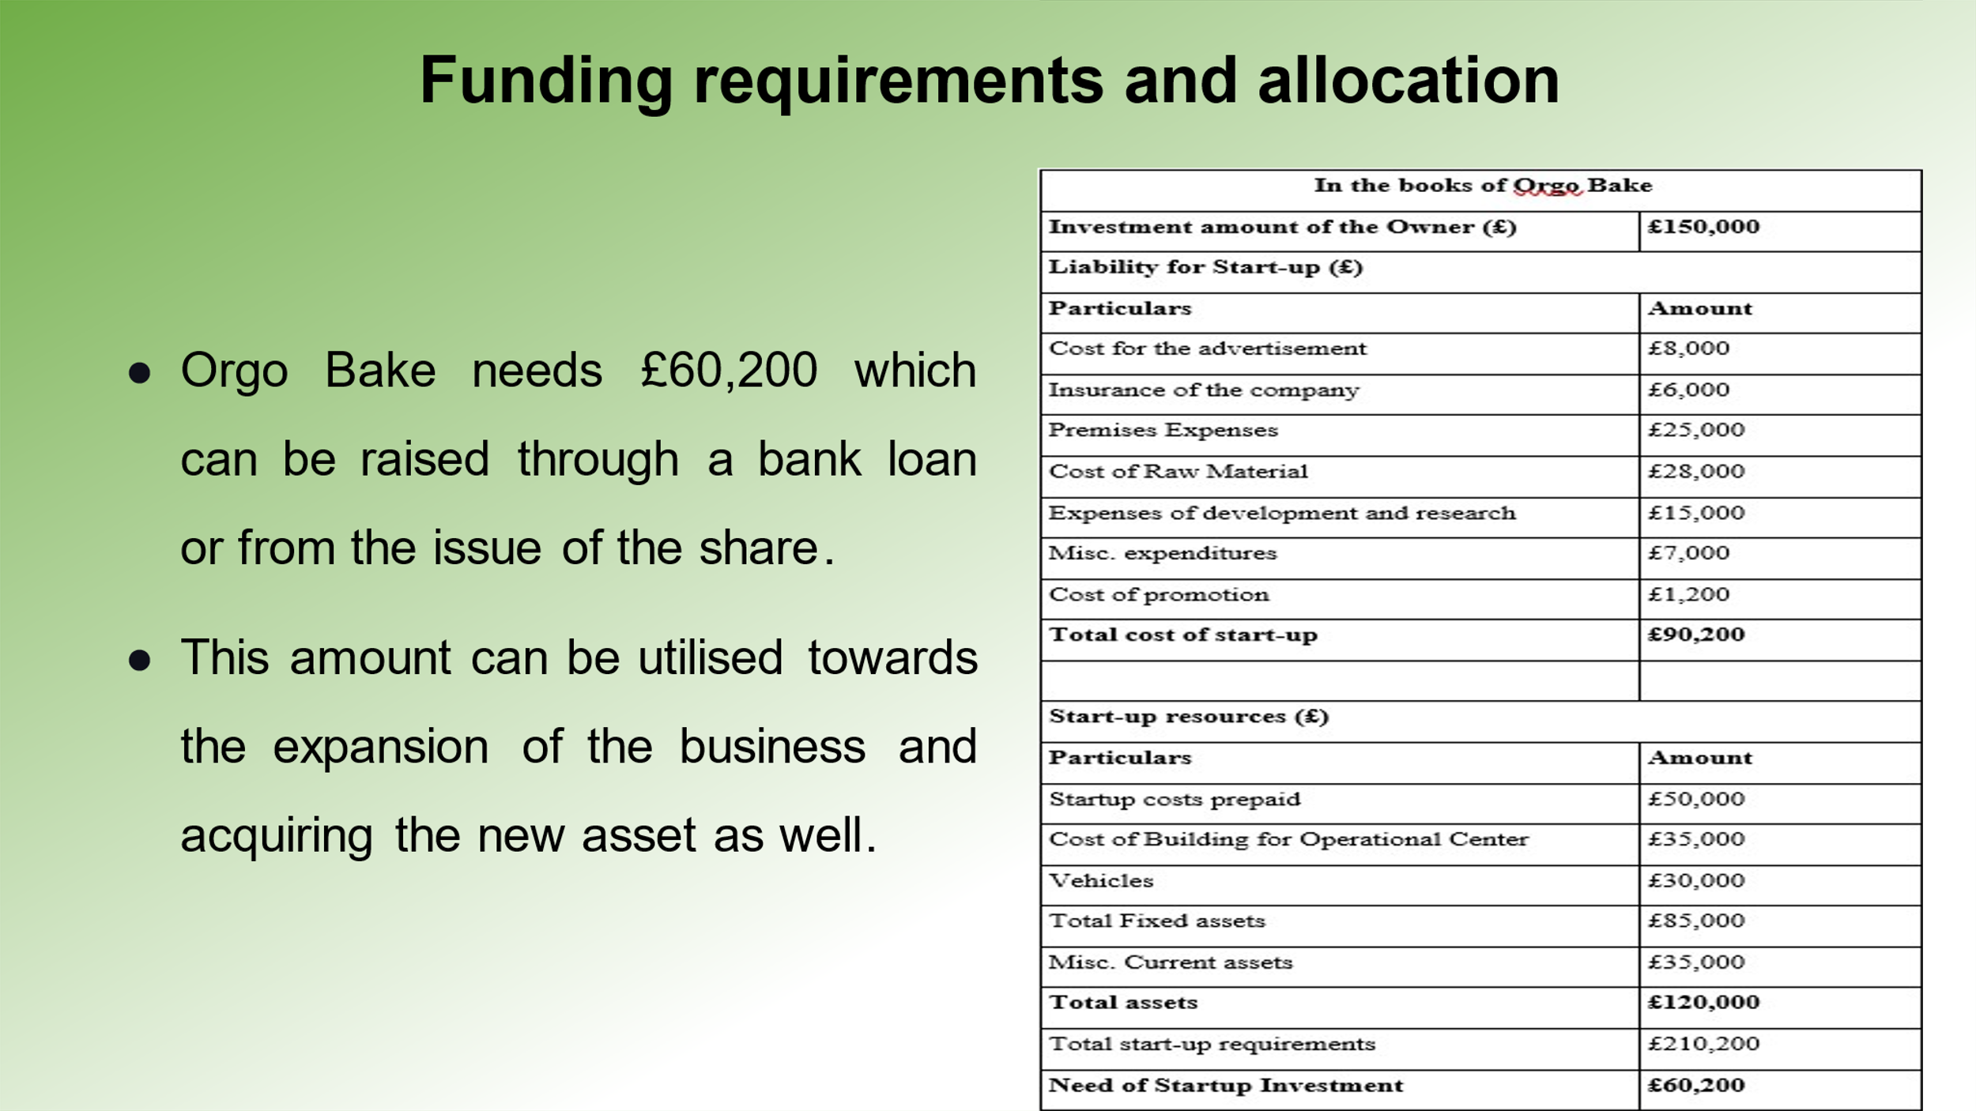
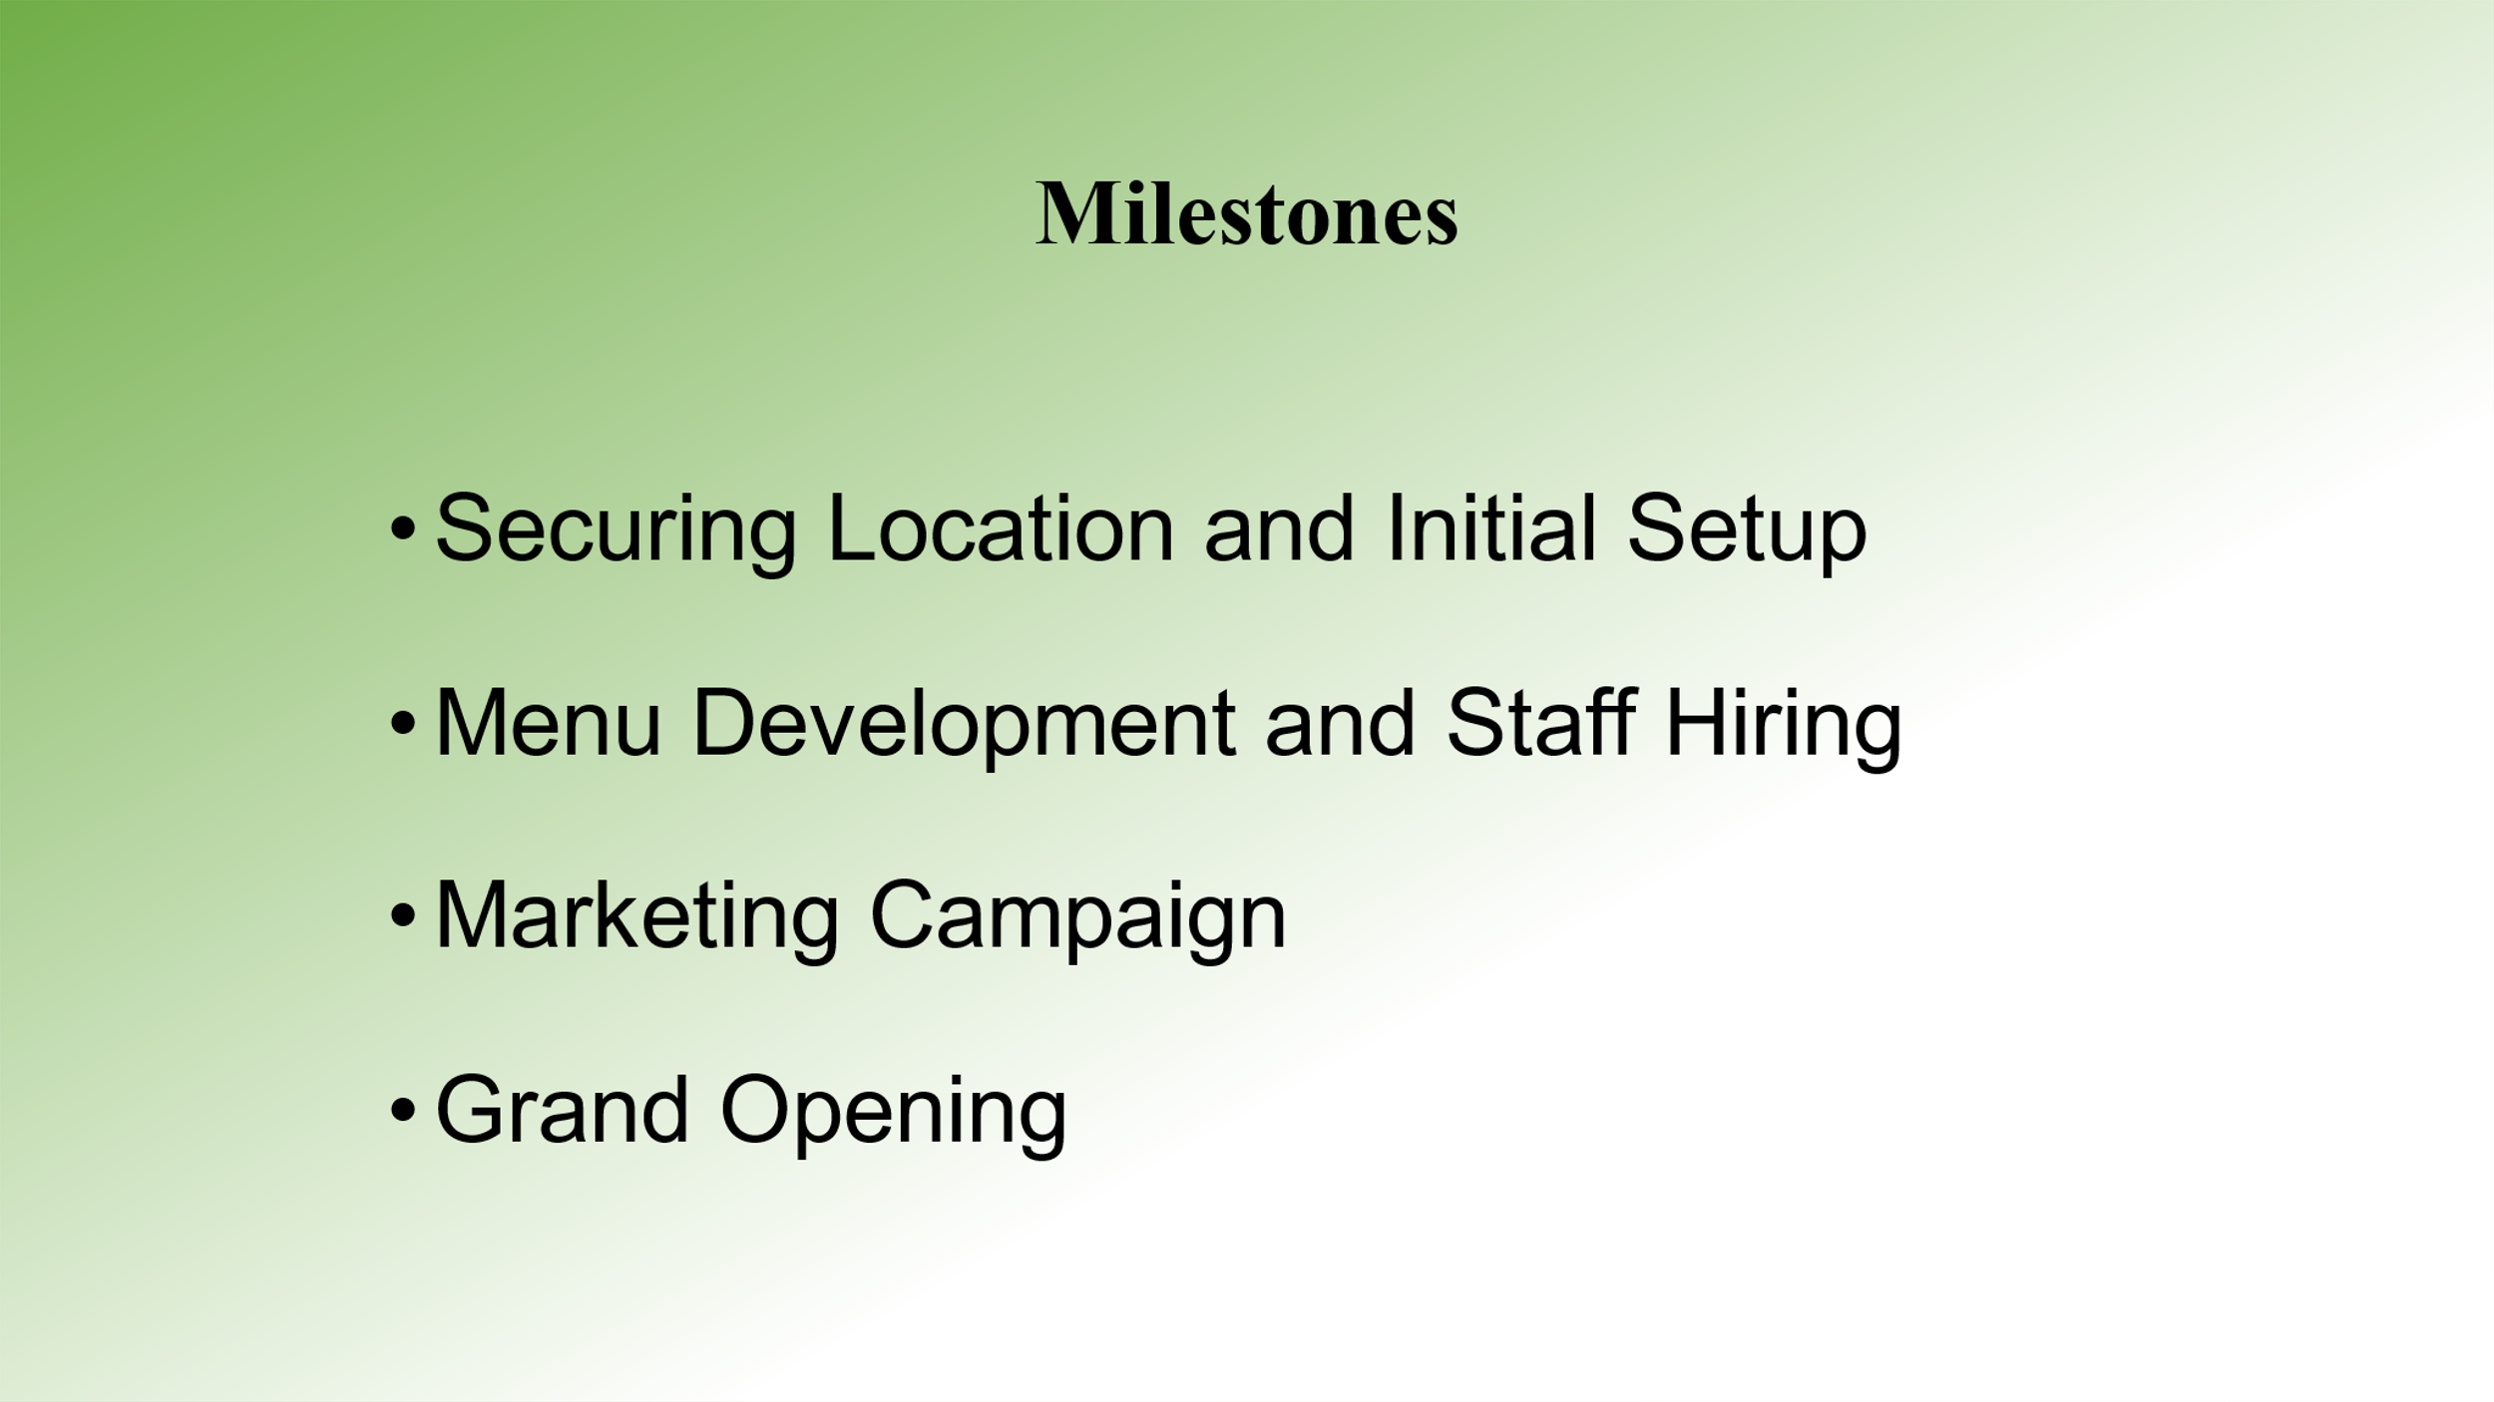
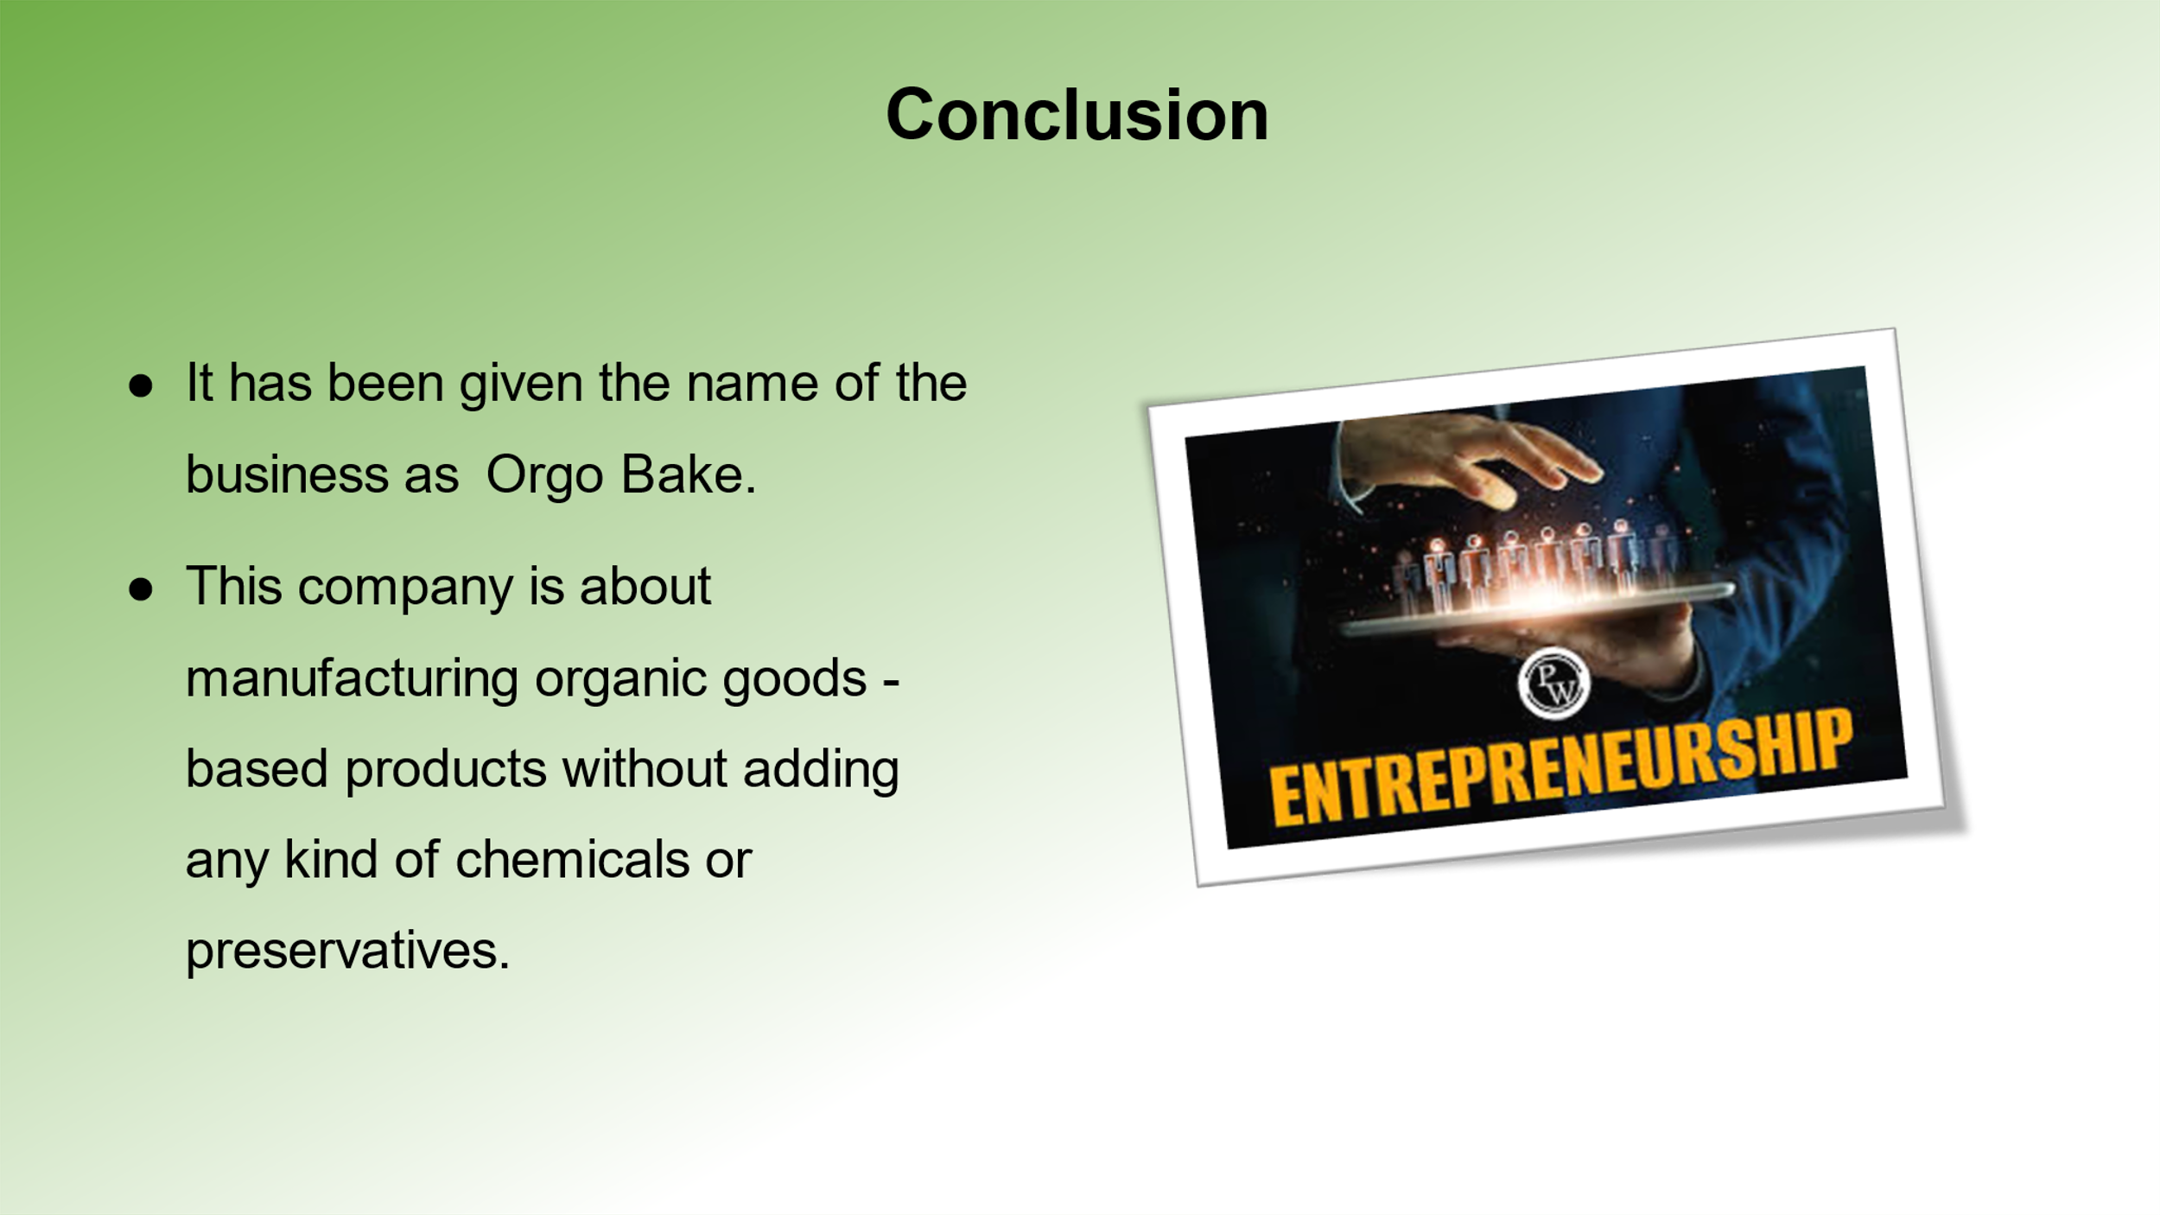
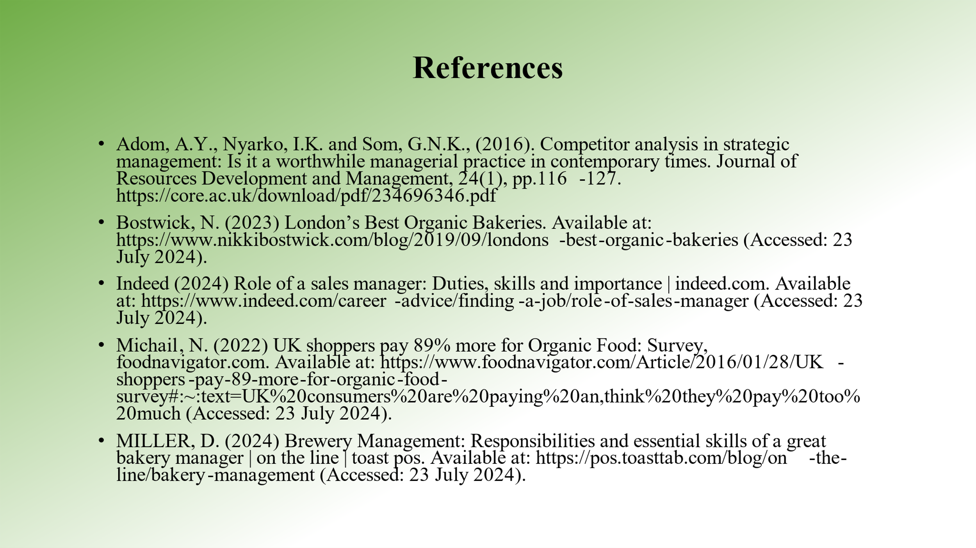

Reference
Briggs, F. (2023) Sustainability is more important to 61% of UK consumers than it was two years ago, Retail Times. Available at: https://retailtimes.co.uk/sustainability-is-more-important-to-61-of-uk-consumers-than-it-was-two-years-ago/ (Accessed: 23/07/2024).

Capobianco, N., Basile, V., Loia, F. and Vona, R., (2021). Toward a sustainable decommissioning of offshore platforms in the oil and gas industry: A PESTLE analysis. Sustainability, 13(11), p.6266.https://www.mdpi.com/2071-1050/13/11/6266

Clark, D. (2024) UK GDP growth 2023, Statista. Available at: https://www.statista.com/statistics/281734/gdp-growth-in-the-united-kingdom-uk/ (Accessed: 23/07/2024).

Empire, D. (2019) Role of communication in business, Medium. Available at: https://medium.com/@doersempire/role-of-communication-in-business-b36cef3c22ff (Accessed: 23/07/2024).

England, R. (2021) 'How is the organic food industry changing?', OneHome, 23rd of September. Available at: https://onehome.org.uk/topics/food-and-drink/sourcing/how-is-the-organic-food-industry-changing/ (Accessed: 23/07/2024).

Gelder, K. van (2024) UK online retail sales 2012-2022, Statista. Available at: https://www.statista.com/statistics/315506/online-retail-sales-in-the-united-kingdom/#:~:text=With%20the%20onset%20of%20the,to%20106%20billion%20British%20pounds. (Accessed: 23/07/2024).

Hayward, M.L., Forster, W.R., Sarasvathy, S.D. and Fredrickson, B.L., 2010. Beyond hubris: How highly confident entrepreneurs rebound to venture again. Journal of Business venturing, 25(6), pp.569-578. https://citeseerx.ist.psu.edu/document?repid=rep1&type=pdf&doi=9cc883b6538756f950397ee1cb9df9460de88022

Hudson, K. (2024) Why is building a professional network essential for entrepreneurs?, Medium. Available at: https://medium.com/@karl-hudson/why-is-building-a-professional-network-essential-for-entrepreneurs-6e54f109e7e3#:~:text=Building%20and%20maintaining%20strong%20relationships,expand%20their%20reach%20and%20visibility (Accessed: 25/07/2024).

Mazla, M.I.S.B., Jabor, M.K.B., Tufail, K., Yakim, A.F.N. and Zainal, H., 2020, September. The roles of creativity and innovation in entrepreneurship. In International Conference on Student and Disable Student Development 2019 (ICoSD 2019) (pp. 213-217). Atlantis Press. https://www.atlantis-press.com/article/125944672.pdf

ONS (2024) UK labour market statistics - house of commons library, UK Labour Market Statistics. Available at: https://commonslibrary.parliament.uk/research-briefings/cbp-9366/ (Accessed: 24/07/2024).

TheGlobalEconomy (2024) United Kingdom political stability - data, Chart, TheGlobalEconomy.com. Available at: https://www.theglobaleconomy.com/United-Kingdom/wb_political_stability/ (Accessed: 23/07/2024).

Wenta (2024) Key skills and attributes for entrepreneurs, Wenta celebrates free business support to SMEs for 40 years. Available at: https://wenta.co.uk/the-business-bookshelf/articles/key-skills-and-attributes-for-entrepreneurs (Accessed: 23/07/2024).

