Lego Spike Prime Project

L0 Integrating Project
Module Code: ACHA4008
CertHE Science Technology, Engineering
& Mathematics (Computing)

Contents
1. Introduction 1
1.1. Lego Education Spike Prime Set 1
1.2. Importance of Robotics in Education 1
1.3. Assignment Task: Solving a Course 2
1.3.1. Section 1: Following a line. 2
1.3.2. Section 2: Moving around an obstacle. 2
1.3.3. Section 3: Navigating a maze. 2
2. Literature Review 2
2.1. Hardware 2
2.2. Software and Programming Tools 3
2.2.1. Lego Icon Blocks 3
2.2.2. Lego Word Blocks 3
2.2.3. Python 5
2.3. Construction 6
3. Problem-Solving Plan 8
3.1. Vehicle Build 8
3.1.1. Vehicle modifications 9
3.2. Programming Each Course Section 12
3.2.1. Main Block 12
3.2.2. Section 1: Following the line. 12
3.2.3. Section 2: Moving around an obstacle. 13
3.2.4. Section 3: Navigating a maze. 15
4. Assessment of Success and Summary 17
4.1. Section Assessment and Reflection. 17
4.1.1. Section 1: Following the line. 17
4.1.2. Section 2: Moving around an obstacle. 17
4.1.3. Section 3: Navigating a maze. 17
References 18
Appendices 20
Appendix A: Detailed hardware review. 20
Large Hub 20
Colour Sensor 20
Distance Sensor 21
Force Sensor 21
Medium Angular Motor 22
Large Angular Motor 22
Larger Hub Rechargeable Battery 23
Appendix B: Different types of blocks. 24

Introduction

Lego Education Spike Prime Set
Lego Spike Prime is a set of building blocks, tools, and software that aims to provide secondary school students with creative learning opportunities to enhance their critical thinking skills. A combination of LEGO Technic, versatile and accurate hardware, and adapted coding languages based on Scratch and Python allows students to explore complex engineering and technological concepts hands-on [1].
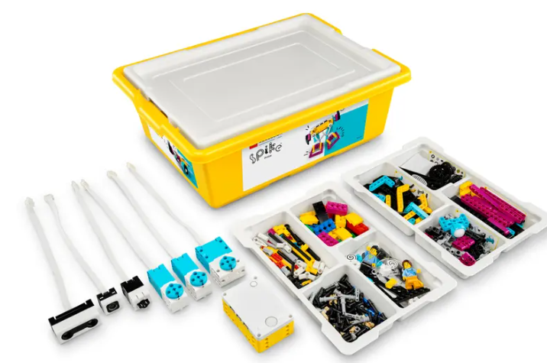
(Image: The Lego Spike Prime Set [2])

Importance of Robotics in Education
Robotics is a very visual and tactile form of learning; it can be exciting and invoke curiosity in students. Fun and enthusiasm can cultivate an interest in young students towards STEAM subjects [3]. STEAM as opposed to STEM includes design and artistic aspects which are important in engineering, this inclusion allows for teamwork and communication between students with differing interests and exposes students to new STEAM subjects [3].
Robotics involves critical and computational thinking and encourages learning by trial and error [3]. Robotics is a fantastic way to get otherwise uninterested students to actively participate in and explore STEAM subjects [3].

Assignment Task: Solving a Course
Using the Lego Spike Prime kit, teams must build a robot to navigate a course autonomously. This involves building the robot using the hardware and pieces provided and programming it to be able to successfully complete the three sections of the course.
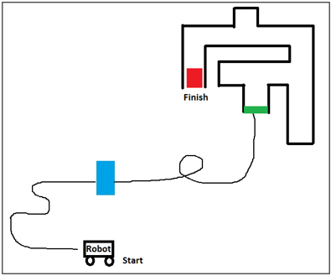
(Image: from assignment document.)

Section 1: Following a line.
In this section the robot will need to follow a line which includes curves and turns (A loop was included in the original briefing but later removed.)

Section 2: Moving around an obstacle.
This section requires for the robot to detect and then navigate around an object placed upon the line it is following. Once it has moved around the object, the robot must rediscover the line and continue to follow it.

Section 3: Navigating a maze.
The Robot concludes by entering and solving a maze, finding its way around to the finish line autonomously without a pre-programmed set of instructions giving it direction. When it reaches the finish line it must signal that it has finished the course by playing a sound.

Literature Review
A quick overview of the tools available within the Lego Spike Prime creation kit.

Hardware
Lego Spike Prime uses a variety of hardware in addition to their construction blocks. This hardware includes a variety of sensors and motors. The Large Hub is the main programmable control unit into which other pieces of hardware are connected. It features a gyro sensor built in and display screen. This piece is often at the heart of a Lego Spike Prime project [4]. Hardware sensors include the Colour Sensor, used to detect colour, reflectivity, and ambient light; the Distance Sensor using ultrasonic technology to measure distance; and the Force Sensor to detect and measure force [5] [6] [7]. There are three motors available in the kit, two Medium Angular Motors and one Large Angular Motor, each of these function as both a motor and sensor. Able to sense speed, position, and movement applied to it [8] [9]. A rechargeable lithium ion polymer battery placed inside the Large Hub supplies power to all connected hardware [10].

Software and Programming Tools
Lego Spike Prime allows for a project to be programmed using a variety of tools.

Lego Icon Blocks
The Lego Icon Blocks use icons to convey what they are and what they do. They have the advantage of being a programming tool that is very visual.
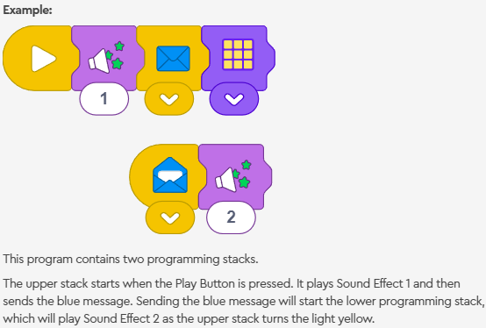
(Image from Spike Lego Education [11])
Even though the Lego Icon Blocks appear very simple, they can control all the sensors and motors.

Lego Word Blocks
The Lego Word Blocks are more complicated than the Icon blocks and include more options and functionality. They are based on the Scratch visual coding language by the Scratch Foundation non-profit organisation [12].
“Scratch promotes computational thinking and problem solving skills; creative teaching and learning; self-expression and collaboration; and equity in computing.”
(From Scratch About page [12])
Different types of blocks include the hat blocks which are so called because they can only be placed at the top of a stack of blocks. These are used to start a programme or a stack, sometimes with the use of a signal (similar to calling a function.) The stack blocks perform commands while the C blocks act as loops and conditional statements. Reporter blocks are the values and variables while the Boolean blocks evaluate expressions. Cap blocks can only be placed at the bottom of the stack, they often end the stack or programme [13].
(Full details in Appendix B)
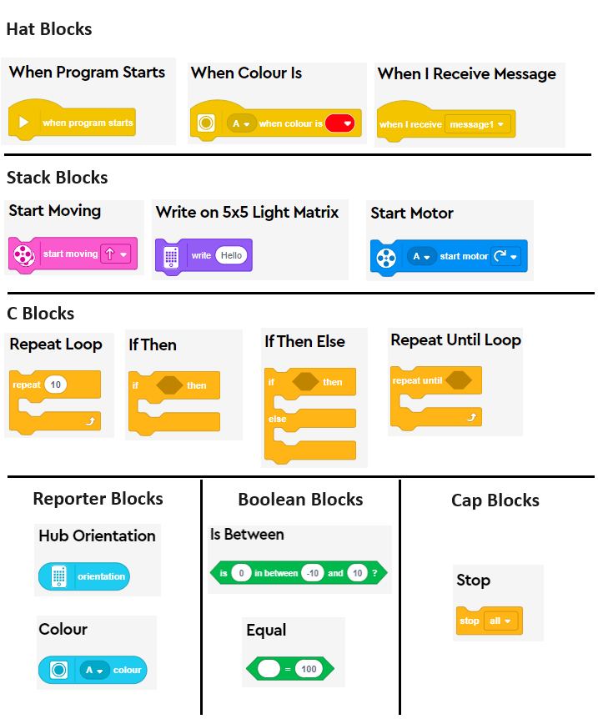
(images: Collection of images from the Lego Education Spike Prime, help word block types [13])

Python
It is also possible to programme a project using the Python programming language. Each Spike Prime component has an associated module [14]. The Hub microcontroller uses an optimised version of Python called MicroPython, an example of how this differs, is the use of milliseconds to avoid using the float variable type for fractions of a second, preferring instead integer values (.5 seconds becomes 500 milliseconds [14].)

Construction
Within the Lego Spike Prime set there are many available pieces to build a project with. These are a variety from the Lego Technic style of blocks. 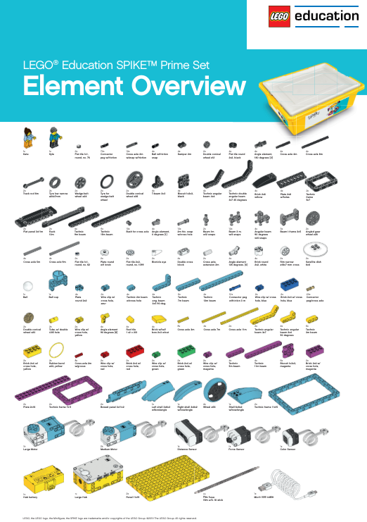
(Image: from the lego_spike_prime_element_overview.pdf supplied in assignment)
The Lego Education Spike Prime accompanying site and app provide construction instructions for a large collection of projects.
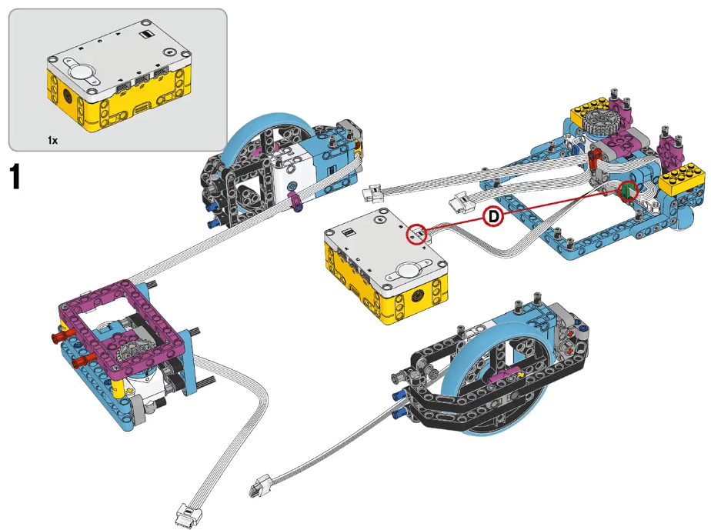
(image: Example of construction instruction found on Lego Spike Prime app/site [15].)

Problem-Solving Plan

Vehicle Build
To begin solving the problem the team had to identify a vehicular robot construction fit for the task of completing the course. As a team we decided on the Driving Base 3 complete with colour sensor. (pictured below)
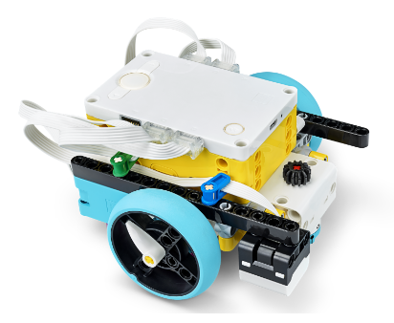
(Image: from Lego Education Spike Prime, driving base 3. [16])
The build team followed the instructions for the build.
(A sub-set of the instruction images below)
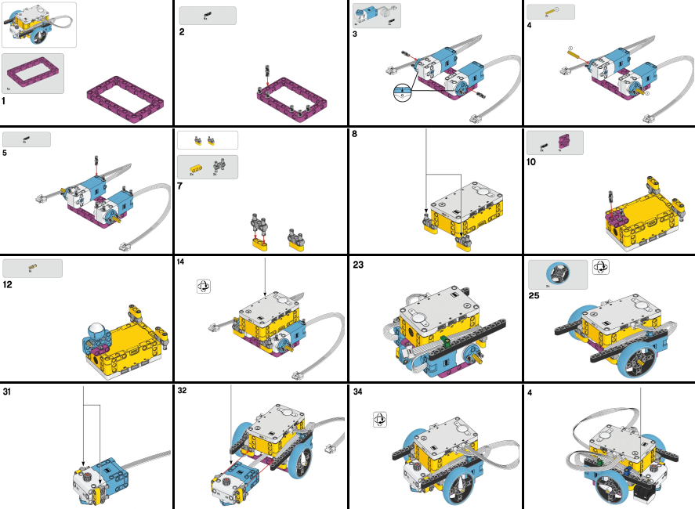
(Images: Sub-set of instruction images from Lego Education Spike Prime, Driving Base 3 [16])

Vehicle modifications
The first modification to the base build was to align the colour sensor to the front middle of the vehicle to allow for better line following.
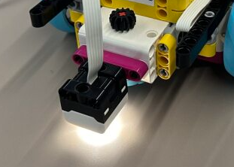
The distance sensor was later added to allow for obstacle detection.
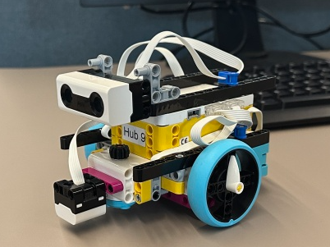
Modifications were later made, moving the distance sensor to the side of the vehicle, this was done to allow for a “hand on wall rule” maze solving method. The force sensor was placed on the front instead to allow for sensing obstacles.
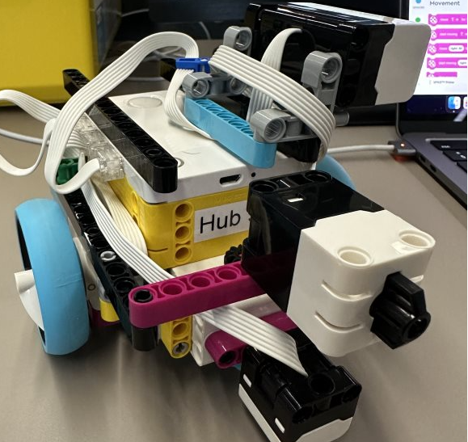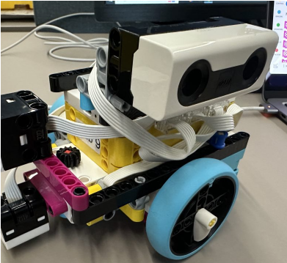

A final modification came when the vehicle was getting caught on the walls in the maze, the overhanging pieces were removed/moved to ease this problem.
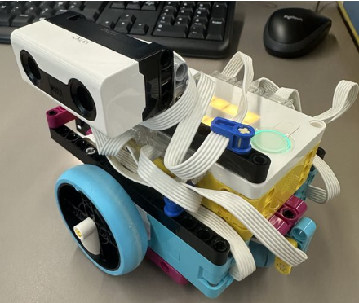

Programming Each Course Section
Programming of the vehicular robot was done in Lego Word Blocks.

Main Block
This is the main block (stack) of code in which variables are set and other blocks (stacks) are called like functions.
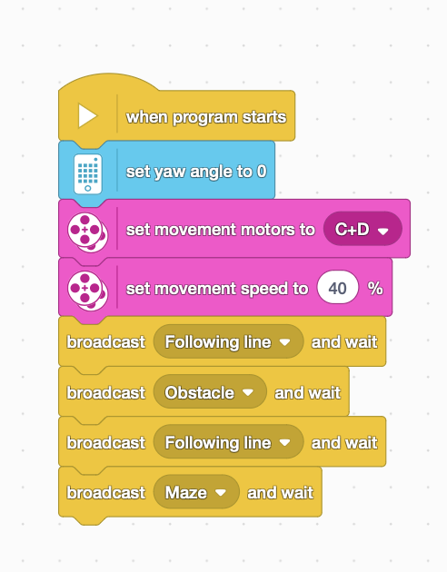

Section 1: Following the line.
The team did some research to find a solution for the line following problem. A solution was created in which the vehicle would turn right if a line was detected using the colour sensor and then turn left if the line was no longer detected. This resulted in a wiggling motion for the vehicle as it followed the line.
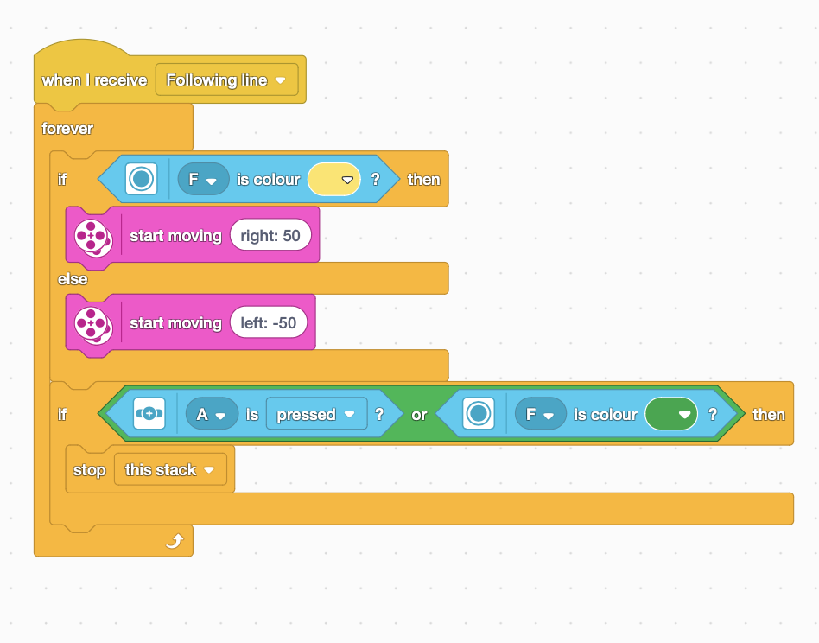

Section 2: Moving around an obstacle.
We began with a code block (stack) that had a preset size of an obstacle to move around. It activated upon detection via the force sensor and performed the preset turns and distances to move around the object. This method was not autonomous.
Having later worked on the maze solution we took inspiration from that and adjusted it to autonomously solve the obstacle problem. Upon activating the force sensor by hitting the obstacle the vehicle takes a right turn allowing the distance sensor to face the obstacle, it then follows the “hand on wall rule” and turns left into the gaps at the edges on the obstacle until it senses a line, at which point it stops, moves forwards a little, and takes a right hand turn before engaging the “following a line” function.
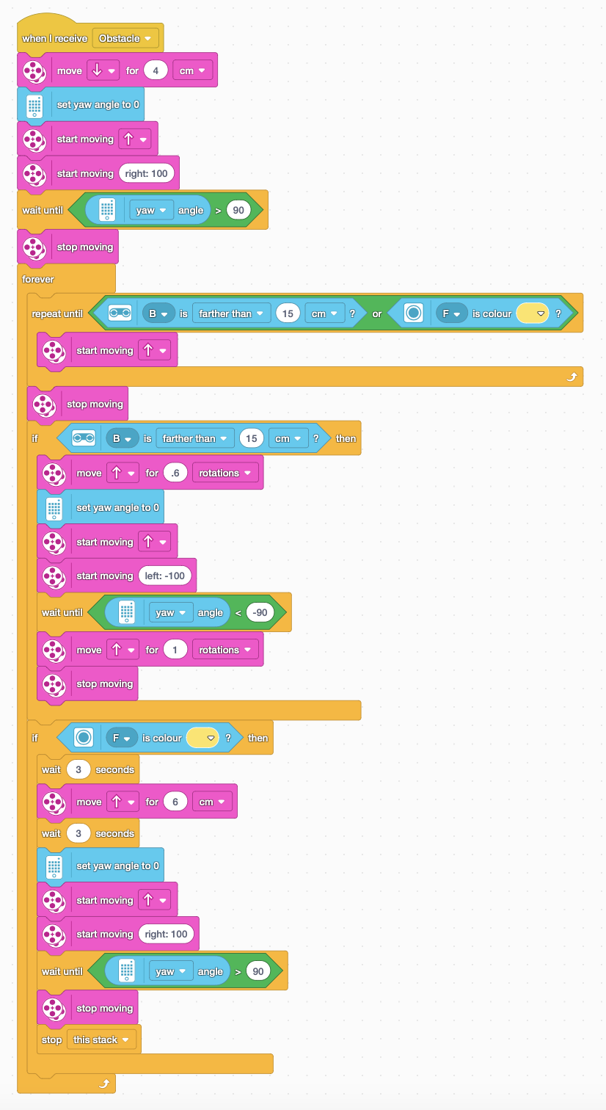

Section 3: Navigating a maze.
Following some research the best solution for the team was the “hand on wall rule” method. The concept for this method was that if a person kept their hand on the wall (choosing either side,) they would eventually find their way out of a maze [17].
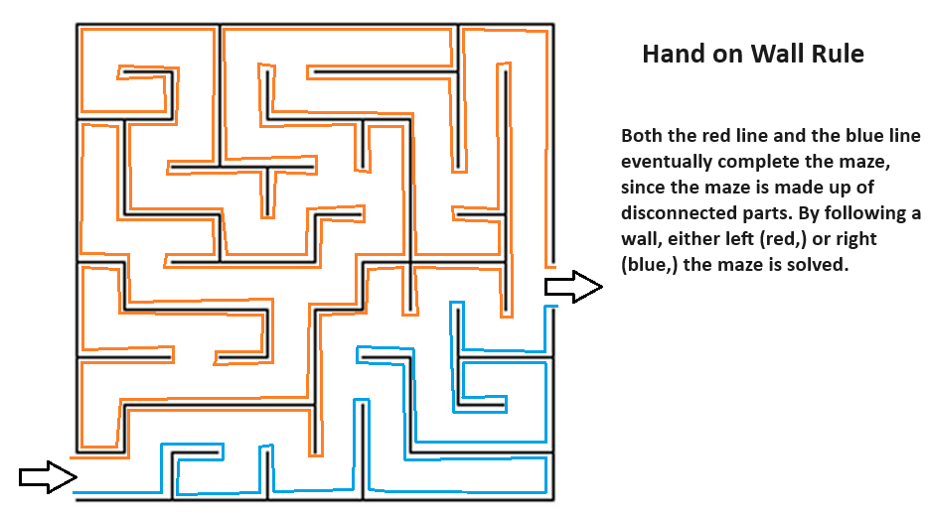
Implementing that method, the vehicle was to turn left into a gap if available, or if it came to a wall before finding a gap, it should turn right. This was achieved using the distance sensor on the side and the force sensor at the front of the vehicle.
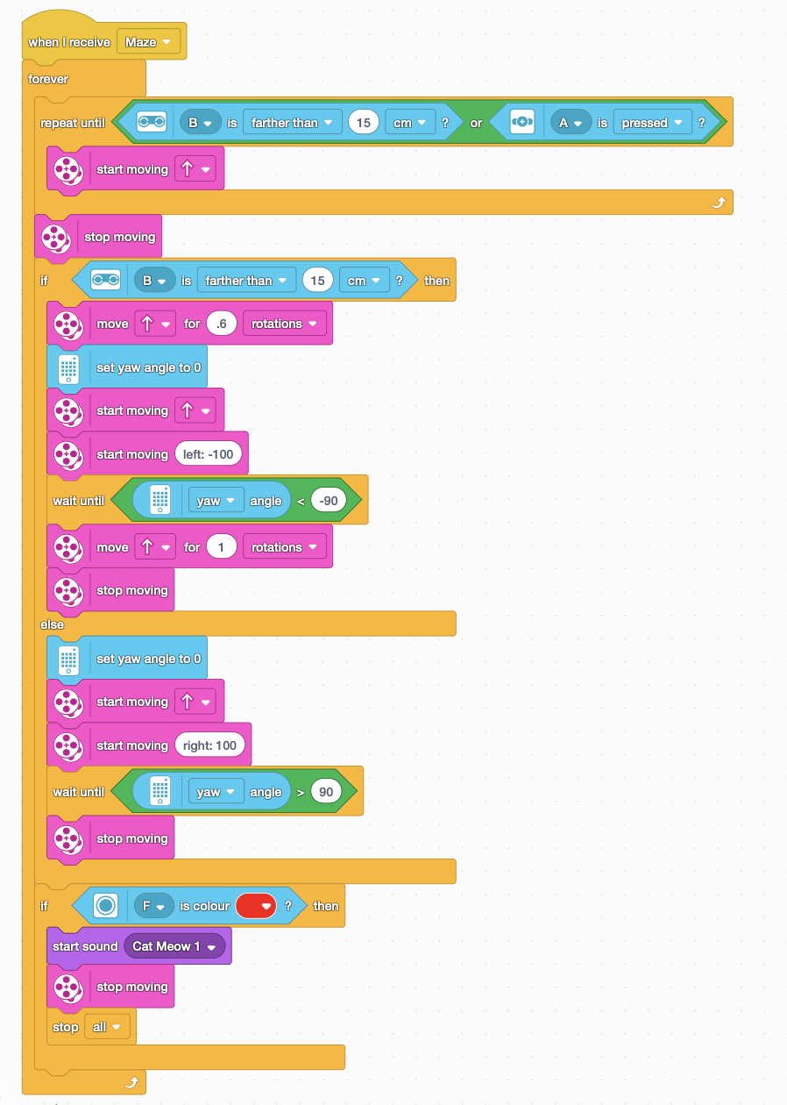
On completing the maze and moving over the red marker, a sound (meow) is played, and the programme is brought to a stop (there is an error here, discussed in ‘Stage 3: Navigate a maze’.)

Assessment of Success and Summary

Section Assessment and Reflection.
Upon reflection there is satisfaction in having managed to make all the individual sections work autonomously. Having not had the opportunity to test with the completed course, it is uncertain if the project could complete the full course including transitions between sections.

Section 1: Following the line.
For this section my main concerns are hard 90 degree turns. It is possible for the robot to lose the line and in trying to rediscover it, turn back on itself.

Section 2: Moving around an obstacle.
My concerns for this section are alignment, if the alignment of the robot is too far off that of the obstacle, it could collide and confuse the solution.

Section 3: Navigating a maze.
Here there are many concerns, the maze is tight and has fittings that protrude and force the robot out of alignment. Work was attempted on a method to fix the alignment of the robot after each turn, but none of the attempts had the desired results.
The final piece of code to play a sound upon the colour sensor discovering the red marker is bugged. It was not tested, but the error was found upon reflection on the code.
The ‘if statement’ is occurring in the wrong place, it needs to be moved into the ‘repeat until’ loop at the beginning of the maze block (stack.)

References

[1] | Lego Education, “Teacher resources. Lego education spike prime. Support technical info,” Unknown. [Online]. Available: https://education.lego.com/en-us/teacher-resources/lego-education-spike-prime/support-technical-info/lego-education-spike-prime-support-technical-info-product-info/. [Accessed 23 April 2024].
[2] | Lego, “Lego education spike prime set 45678,” Unknown. [Online]. Available: https://www.lego.com/en-gb/product/lego-education-spike-prime-set-45678. [Accessed 23 April 2024].
[3] | Space Foundation Editorial Team, “7 benefits of robotics for students,” unknown. [Online]. Available: https://cie.spacefoundation.org/7-benefits-of-robotics-for-students/. [Accessed 23 April 2024].
[4] | Lego Education Spike Prime, “techspecs techniclargehub.pdf,” 2019. [Online]. Available: https://assets.education.lego.com/v3/assets/blt293eea581807678a/bltf512a371e82f6420/5f8801baf4f4cf0fa39d2feb/techspecs_techniclargehub.pdf?locale=en-us. [Accessed 24 April 2024].
[5] | Lego Education Spike Prime, “techspecs technic color sensor.pdf,” 2019. [Online]. Available: https://assets.education.lego.com/v3/assets/blt293eea581807678a/blt62a78c227edef070/5f8801b9a302dc0d859a732b/techspecs_techniccolorsensor.pdf?locale=en-us. [Accessed 24 April 2024].
[6] | Lego Education Spike Prime, “techspecs technic distance sensor.pdf,” 2019. [Online]. Available: https://assets.education.lego.com/v3/assets/blt293eea581807678a/blt64c2b9534cf10f68/5f8801b8bc43790f5c4389ea/techspecs_technicdistancesensor.pdf?locale=en-us. [Accessed 24 April 2024].
[7] | Lego Education Spike Prime, “techspecs technic force sensor.pdf,” 2019. [Online]. Available: https://assets.education.lego.com/v3/assets/blt293eea581807678a/blt23df304b05e587b2/5f8801ba721f8178f2e5e626/techspecs_technicforcesensor.pdf?locale=en-us. [Accessed 24 April 2024].
[8] | Lego Education Spike Prime, “techspecs technic medium angular motor.pdf,” 2019. [Online]. Available: https://assets.education.lego.com/v3/assets/blt293eea581807678a/blt692436dd1e8fa71c/5f8801d5c8a27c1d9614c27e/techspecs_technicmediumangularmotor.pdf?locale=en-us. [Accessed 24 April 2024].
[9] | Lego Education Spike Prime, “spike prime tech fact sheet 45602,” 2019. [Online]. Available: https://assets.education.lego.com/v3/assets/blt293eea581807678a/bltb9abb42596a7f1b3/5f8801b5f4c5ce0e93db1587/le_spike-prime_tech-fact-sheet_45602_1hy19.pdf?locale=en-us. [Accessed 24 April 2024].
[10] | Lego Education Spike Prime, “techspecs technic large hub rechargeable battery.pdf,” 2019. [Online]. Available: https://assets.education.lego.com/v3/assets/blt293eea581807678a/bltb87f4ba8db36994a/5f8801b918967612e58a69a6/techspecs_techniclargehubrechargeablebattery.pdf?locale=en-us. [Accessed 24 April 2024].
[11] | Lego Spike Education, “help icon blocks,” unknown. [Online]. Available: https://spike.legoeducation.com/prime/help/lls-help-icon-blocks#lls-help-icon-blocks. [Accessed 24 April 2024].
[12] | Scratch Foundation, “about,” unknown. [Online]. Available: https://scratch.mit.edu/about. [Accessed 24 April 2024].
[13] | Lego Education Spike Prime, “help word block types,” unknown. [Online]. Available: https://spike.legoeducation.com/prime/help/lls-help-word-blocks#lls-help-word-block-types. [Accessed 24 April 2024].
[14] | Lego Education Spike Prime, “help python,” unknown. [Online]. Available: https://spike.legoeducation.com/essential/help/lls-help-python#lls-help-python. [Accessed 28 April 2024].
[15] | Lego Education Spike Prime, “prime models,” unknown. [Online]. Available: https://spike.legoeducation.com/prime/models/. [Accessed 28 April 2024].
[16] | Lego Education Spike Prime, “Driving Base 3,” unknown. [Online]. Available: https://spike.legoeducation.com/prime/models/blt9e7ffd6d4cc94c53. [Accessed 28 April 2024].
[17] | Wikipedia , “Maze solving algorithm,” 13 March 2024. [Online]. Available: https://en.wikipedia.org/wiki/Maze-solving_algorithm. [Accessed 28 April 2024].

Appendices

Appendix A: Detailed hardware review.

Large Hub
The large hub is the main programmable control unit into which other pieces of hardware are connected. It features a gyro sensor built in and display screen. This piece is often at the heart of a Lego Spike Prime project [4].
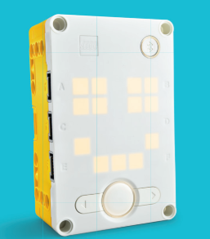
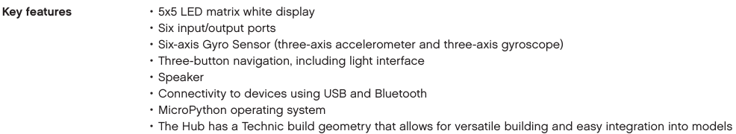
(Images form Lego Education Spike Prime Technical Specifications [4])

Colour Sensor
The Technic Colour Sensor is used to detect colour, reflectivity, and ambient light. The sensor also outputs a light therefor acting as a light source [5].
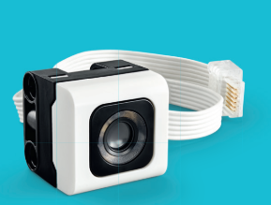

(Images from Lego Education Spike Prime Technical Specifications [5])

Distance Sensor
The Technic Distance Sensor uses ultrasonic technology to measure distance from an object or wall surface. The sensor also features a light output which is divided into four individual segments, each operable separately. The sensor can also be modified using third-party hardware [6].
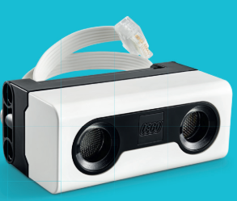
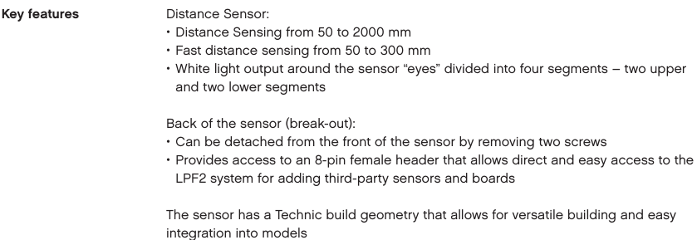
(Images from Lego Education Spike Prime Technical Specifications [6])

Force Sensor
The Technic Force Sensor is used for detecting and measuring force applied to it. This can be useful for detecting collision or even used as a button [7].
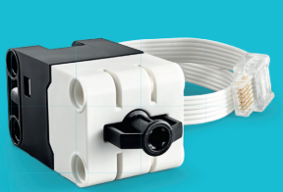

(Images from Lego Education Spike Prime Technical Specifications [7])

Medium Angular Motor
The Technic Medium Angular Motor is designed as such as to function both as a motor and as a sensor. An advanced rotation sensor is integrated into the motor so it can report speed and position. The motor can also sense direct user interactions when rotated by hand [8].
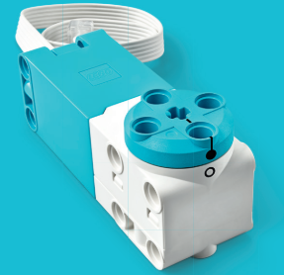
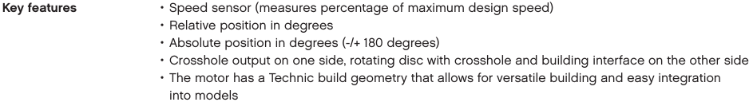
(Images from Lego Education Spike Prime Technical Specifications [8])

Large Angular Motor
The Technic Large Angular Motor is designed much like the medium one. It also functions both as a motor and sensor. It also features the integrated advanced rotation sensor to report speed and position. User input can be sensed if the motor is rotated by hand [9].
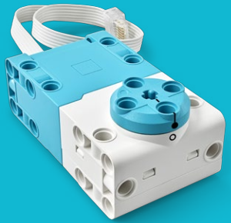

(Images from Lego Education Spike Prime Technical Specifications [9])

Larger Hub Rechargeable Battery
The Technic Large Hub Rechargeable Battery is a lithium-ion polymer battery used to power the Large Hub and devices plugged into it. It is placed withing the Large Hub and is recharged using a micro-USB. The battery is easily accessed and can be removed without the use of any tools [10].
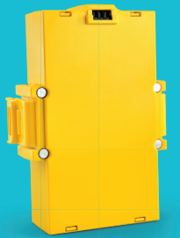
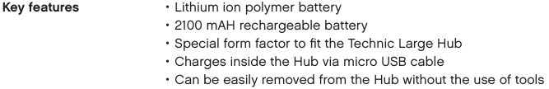
(Images from Lego Education Spike Prime Technical Specifications [10])

Appendix B: Different types of blocks.

Different types of blocks
- Hat blocks:
Hat blocks are used at the beginning of a programme, they are rounded to prevent blocks being attached to the top of them [13].
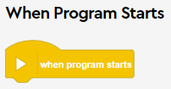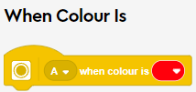
- Stack blocks:
Stack blocks perform the main commands such as moving motors and turning on lights within a project’s programme [13].
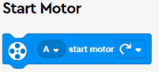 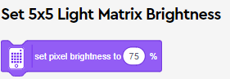
- C blocks:
C blocks are found in the control category, they are the loops and conditional branching blocks [13].
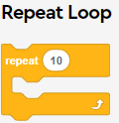 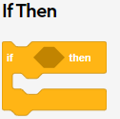
- Reporter blocks:
Reporter blocks hold values and variables such as numbers and strings. They can also hold a sensor reading [13].
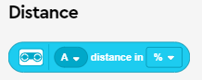 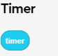
- Boolean blocks:
Boolean blocks are conditions that can be either ‘true’ or ‘false.’ When used with C blocks they form the logic of the programme [13].
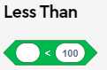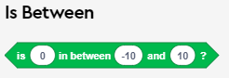
- Cap blocks:
Cap blocks are used to end a script, they are shaped with a flat edge on the bottom to prevent more blocks from being attached. Cap blocks can be found in the control category [13].


