Module Code and Title:
LCBB5013 Entrepreneurship
Portfolio
Task 1 (Week 8)
Title:
Business Plan Development for RefillRight UK: A Sustainable Mobile Refill Enterprise

Table of Contents
Introduction 2
Element 1: Business Idea, Products/Services, Objectives & USP 3
Business Idea Overview 3
Products and Services Overview 3
Business Objectives (Short-term and Long-term) 4
Unique Selling Point (USP) 4
Element 2: Business Environment & Competitor Analysis 5
PESTEL Analysis 5
SWOT Analysis 7
Porter’s Five Forces Analysis 8
Element 3: 4Ps, Market Segmentation & Marketing Strategies 10
Market Segmentation and Target Customers 10
Marketing Mix – The 4Ps 11
Online Marketing Strategies 13
Element 4: Legal, Management & Financial Planning 14
Legal Structure 14
Management and Organisational Structure 15
Financial Planning and Funding 15
Conclusion 17
References 18

Introduction
This assignment forms the basis of a complete business plan as it elaborates on the nature of business, its surroundings and how it will do business in UK market. Entrepreneurship plays an important role in the economy of UK, particularly, as the UK grows to experience more environmental and sustainability challenges. Entrepreneurs are central to coming up with solutions to problems like plastic waste and discussing them as business opportunities that would generate economic and social value. RefillRight UK is a social enterprise, mobile and sustainable, which focuses on minimising one-use plastic by providing mobile refill stations on residential and workplace personal care products and cleaners, as well as university.

Element 1: Business Idea, Products/Services, Objectives & USP

Business Idea Overview
RefillRight UK is a mobile sustainability company that pledges personal care products and cleaning services auto-refill using refill vans which travel directly to residential places, colleges, and offices in the UK. Consumers carry their own means of carrying their refillable containers rather than purchasing new bottles of plastic filler, which will reduce the volume of single-use plastic waste. It is premised on recognising a tangible social and environmental issue and transforming it into an efficient business solution, which is the main implication of entrepreneurship (Diandra and Azmy, 2020). Another way RefillRight UK reinforces the circular economy is by promoting using instead of disposing of materials, making them stay longer into use. The business is a social and sustainable enterprise as it seeks to establish environmental advantages besides being a profit-seeking business. RefillRight UK can generate value to customers and society by filling a market gap associated with sustainability, which is one of the key components of entrepreneurial value creation (Mishra and Zachary, 2015). These social enterprises are significant in raising responsible consumption and sustainable living in the UK (Dana, 2021).

Products and Services Overview
Speaking of personal care products and detergents, RefillRight UK does not emphasise a large and complicated product range and does not aim to sell refills to primary cleaning products of the household in the UK. The primary service will be the mobile refill van where it will go to designated places and enable people to refill the containers themselves. This will help minimise the use of plastic packaging and make green decisions easier to consumers. The business model is to simplify and make eco-friendly behaviour available particularly to the people who might not find their fix location close to the fixed refill stores. In this approach, it is possible to see how businesspeople use the possibility and satisfy the unmet needs at the market, like on convenience and environmental responsibility (Venkataraman, 2019). RefillRight UK can provide a powerful value-added to the customers and the environment by incorporating mobility and sustainability, which is a must to new ventures attempting to cut through the competitive markets (Blundel et al., 2017).

Business Objectives (Short-term and Long-term)
RefillRight UK will focus on launching pilot operations in large cities (London, Manchester and Birmingham) in the UK within the first one to two years. These are densely populated regions with great demand in the case of sustainable products. The other major target is to establish collaborations with universities and office spaces where masses of individuals would be able to receive refill services at a single point. There are also definite customer acquisition goals by the business to achieve constant development and economic sustainability. During the first three to five years, RefillRight UK will take the opportunity to increase its business in the UK by adding more refill vans and locations of services in the long run. The company also seeks to shift to the operation of electric cars to minimise the carbon emission even further. The other long-term goal is to ensure national ambitions e.g. net-zero emissions, reduction of plastic waste. The objectives are based on a SMART approach because they are specific, measurable, achievable, relevant, and time based. Successful entrepreneurship is an important attribute of growth, particularly when it comes to SMEs that help in the economic advancement (Davidsson et al., 2017). Creations of sustainable business opportunities such as RefillRight UK also help kick-start the UK economy in terms of job opportunities and innovation (Haltiwanger, 2022).

Unique Selling Point (USP)
The primary distinctive selling feature of the RefillRight UK is the mobile refill concept, which is more convenient than the refill stores. The business eliminates barriers to entry to the services like time used in travelling and the accessibility of refills because of direct delivery to customers. The second critical benefit is the reduction of plastic waste directly because customers do not need to purchase new containers, but to use their own. The company is also community-oriented since it makes business locally in neighbourhoods, universities, and workplaces to create trust and frequent use. RefillRight UK is more adaptive and can access a greater number of customers than the traditional refill stores.
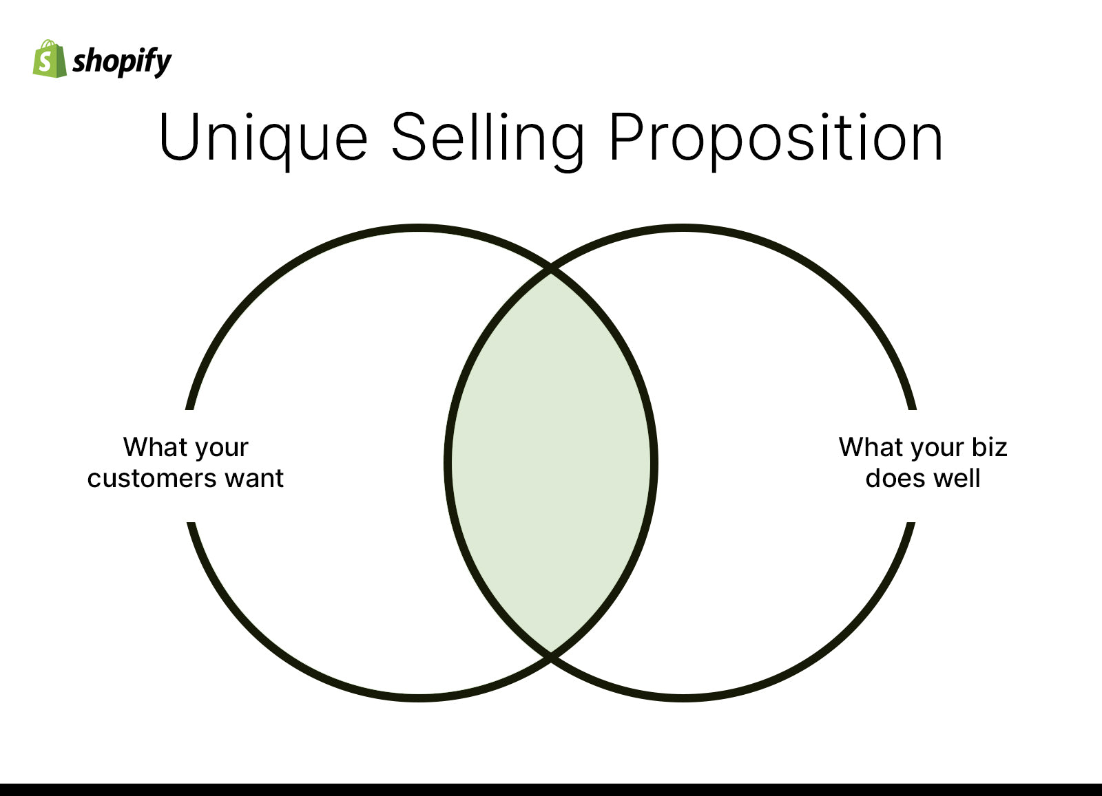
Figure 1: Unique Selling Proposition (Baker and Welter, 2020)
This brings a competitive advantage since it addresses the sustainability needs in a pragmatic manner (Kuratko and Hodgetts, 2017). The business concept is also aligned with increasing consumer demand in the UK interest towards ethical and environmental friendly products. RefillRight UK, by reacting to its particular local environment and social aspect, demonstrates the way entrepreneurship is shaped by the local, and consumer values (Baker and Welter, 2020).

Element 2: Business Environment & Competitor Analysis

PESTEL Analysis
UK political environment supports the idea of sustainable business such as RefillRight UK. The entrepreneurial activity may be immensely affected by the impact of public policy, particularly in terms of supporting the sustainability and responsible consumption (Audretsch and Moog, 2022). Nevertheless, a shift of priorities or financing in the government can influence the long-term support of the green business, which is also an outside factor that entrepreneurs should take into account (Ratten, 2023).
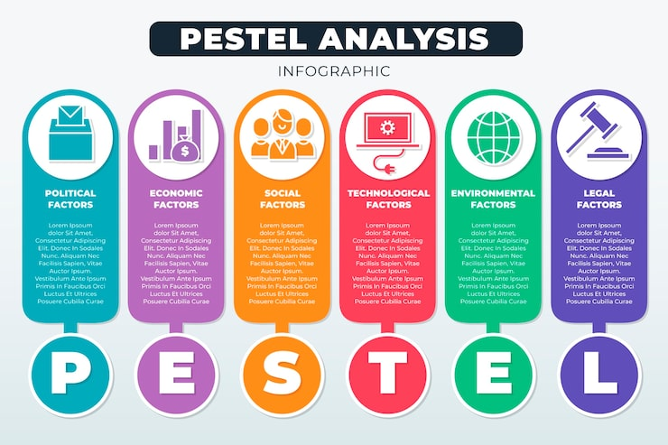
Figure 2: PESTLE Analysis (Ratten, 2023)
Economically, the UK is presently in the middle of a cost-of-living crisis that will impact the amount of money that people are ready to spend. Consumers are turning to be more knowledgeable about their finances and are seeking a bargain instead of high-quality products. Simultaneously, the cost of fuel and operation might rise leading to higher costs of a mobile business. Economic conditions are known to determine access to resources and infrastructure, which are also significant to entrepreneur growth (Audretsch et al., 2015).
The social factors are quite crucial to RefillRight UK. The trend of eco-conscious behaviour in the UK is evident with a definite increase in the behaviour among the young people and students as well. This social change reaches the demand of the refill services and sustainable products. Nevertheless, not all consumers would prioritise sustainability instead of convenience and this means that the business has to enlighten and involve its target market.
The business is also supported by technological factors. Customers are able to use refill services without any inconveniences with mobile payment systems, apps, and contactless payments. Nonetheless, operational interruptions are a threat to the small businesses, despite the fact that a failure of a system, or a cyber problem can jeopardise the work of a company (Ratten, 2023).
RefillRight UK is very favourable in the environmental factors. One key concern in the UK is climate change and waste minimisation, and the businesses are pressure-driven to minimise their environmental footprint. This provides the business with a powerful sense of providing purpose to the environment, and making it align with broader sustainability objectives.
Health and safety regulations, product labelling regulations and guidelines on the transportation and storage of cleaning and personal care products are all considered legal factors. The business should also make sure that the products are of UK safety standards and refill stations are clean and safe to be used by the population.

SWOT Analysis
The innovative mobile delivery model is among the key strengths of RefillRight UK since refill services are convenient compared to the traditional refill shops where they are located. This is a definite aim that can be used to experiment customer loyalty as well as good brand image. Strategic analysis assists entrepreneurship to know how these strengths can be utilised in the quest to compete favourably (Bygrave et al., 2024).
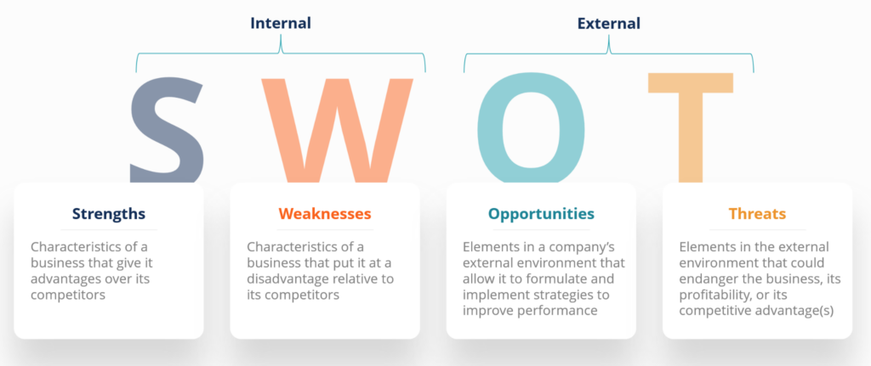
Figure 3: SWOT Analysis (Bygrave et al., 2024)
One of the flaws of RefillRight UK is the fact that the initial capital cost of buying and equipping refill vans is high. A mobile business also introduces complexity in the operations like planning routes, maintenance of the vehicle and scheduling of staff. Such difficulties may strain the cash flow particularly at start-up. Dealing with uncertainty is a typical problem to emerging ventures, especially those that vie on an inventive business model (Blundel et al., 2017).
In UK market, there are numerous opportunities of RefillRight UK. The green policies and sustainability policies supported by the government result in a healthy environment to environment-friendly businesses. Universities and workplaces can be proposed as partners; this will allow reaching a vast population of a potential customer in one place, thereby enhancing productivity and awareness.
Competition with known eco-retailers and supermarkets that are beginning to provide refill opportunities in-store are also a threat. Such businesses might be more resourced and well-known brands. The changes in regulations may also raise the cost of compliance or restrict specific products. Also, the decrease in demand may be caused by the alteration of consumer behaviour or an economic situation. These risks should be understood to make informed choices and plan towards uncertainty (Blundel et al., 2017).

Porter’s Five Forces Analysis
The intensity of the threat of new entrants is moderate in the refill market in the UK. Although the concept of refill services is not one that can be easily replicated, a mobile refill business cannot be established without capital, planning and approval by the regulatory authority. This poses certain entry barriers, which can be overcome in the long-term, yet there is increasing interests in sustainability, which could lure new entrants. There is a tendency of entrepreneurial industries to alter rapidly due to the entering new ideas (Zacharakis et al., 2025).
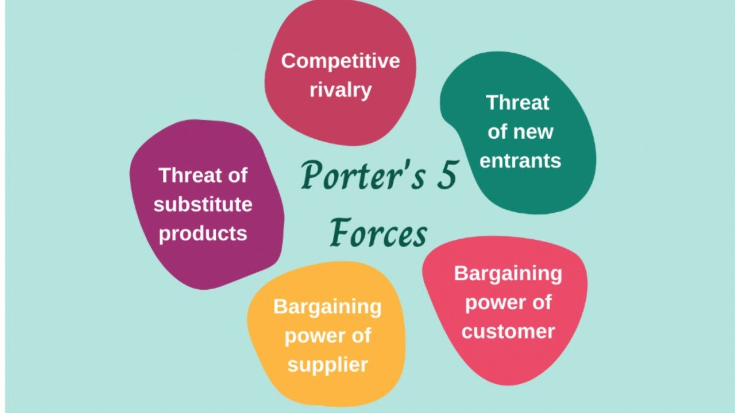
Figure 4: Porter's Five Forces (Kuratko and Hodgetts, 2017)
The supplier bargaining power is moderate to low. RefillRight UK is expected to obtain cleaning and personal care products in various suppliers and this will save the reliance on one supplier. This may, however, increase costs in case the suppliers of environmentally friendly products increase their prices. It is significant to establish positive relations with suppliers in managing this force (Kuratko and Hodgetts, 2017).
Customers bargaining power is quite low since there are high quantities of choices, such as supermarkets, online stores, and other refills. Customers will find it easy to switch when the prices are too high and the services inconveniencing. This implies that RefillRight UK has to emphasise on good value, convenience and customer experience to hold onto users.
Threat of substitutes is also high as normal packaged products are prevalent and cheap in the short run. Other customers might be attracted to accustomed brands or fast shopping. To minimise this risk, the RefillRight UK will have to specify the long-term payoff and environmental gains.
The UK refill market is facing competitive rivalry. Although the market is still new, additional businesses find their way to the sustainability arena. Competition makes businesses to be innovative and do better their services and this can be beneficial to the customers however it puts strain on small businesses. The competitive forces are to be understood to enable entrepreneurs to place their business in the market better (Kuratko and Hodgetts, 2017).

Element 3: 4Ps, Market Segmentation & Marketing Strategies

Market Segmentation and Target Customers
The market that RefillRight UK deals in is a market where needs and behaviours of the customers vary according to the location and way of life and hence market segmentation is essential. Geographically, the target market of the business mainly includes urban regions in the UK. London, Manchester, Leeds and Birmingham are densely populated cities, which implies that mobile refill services are efficient and cost effective in these cities. Cities are also more aware of the issues of sustainability and have a higher requirement of services that are environmentally friendly. Targeting these areas will enable the RefillRight UK to contact more customers within a given time and save on the travelling distance.
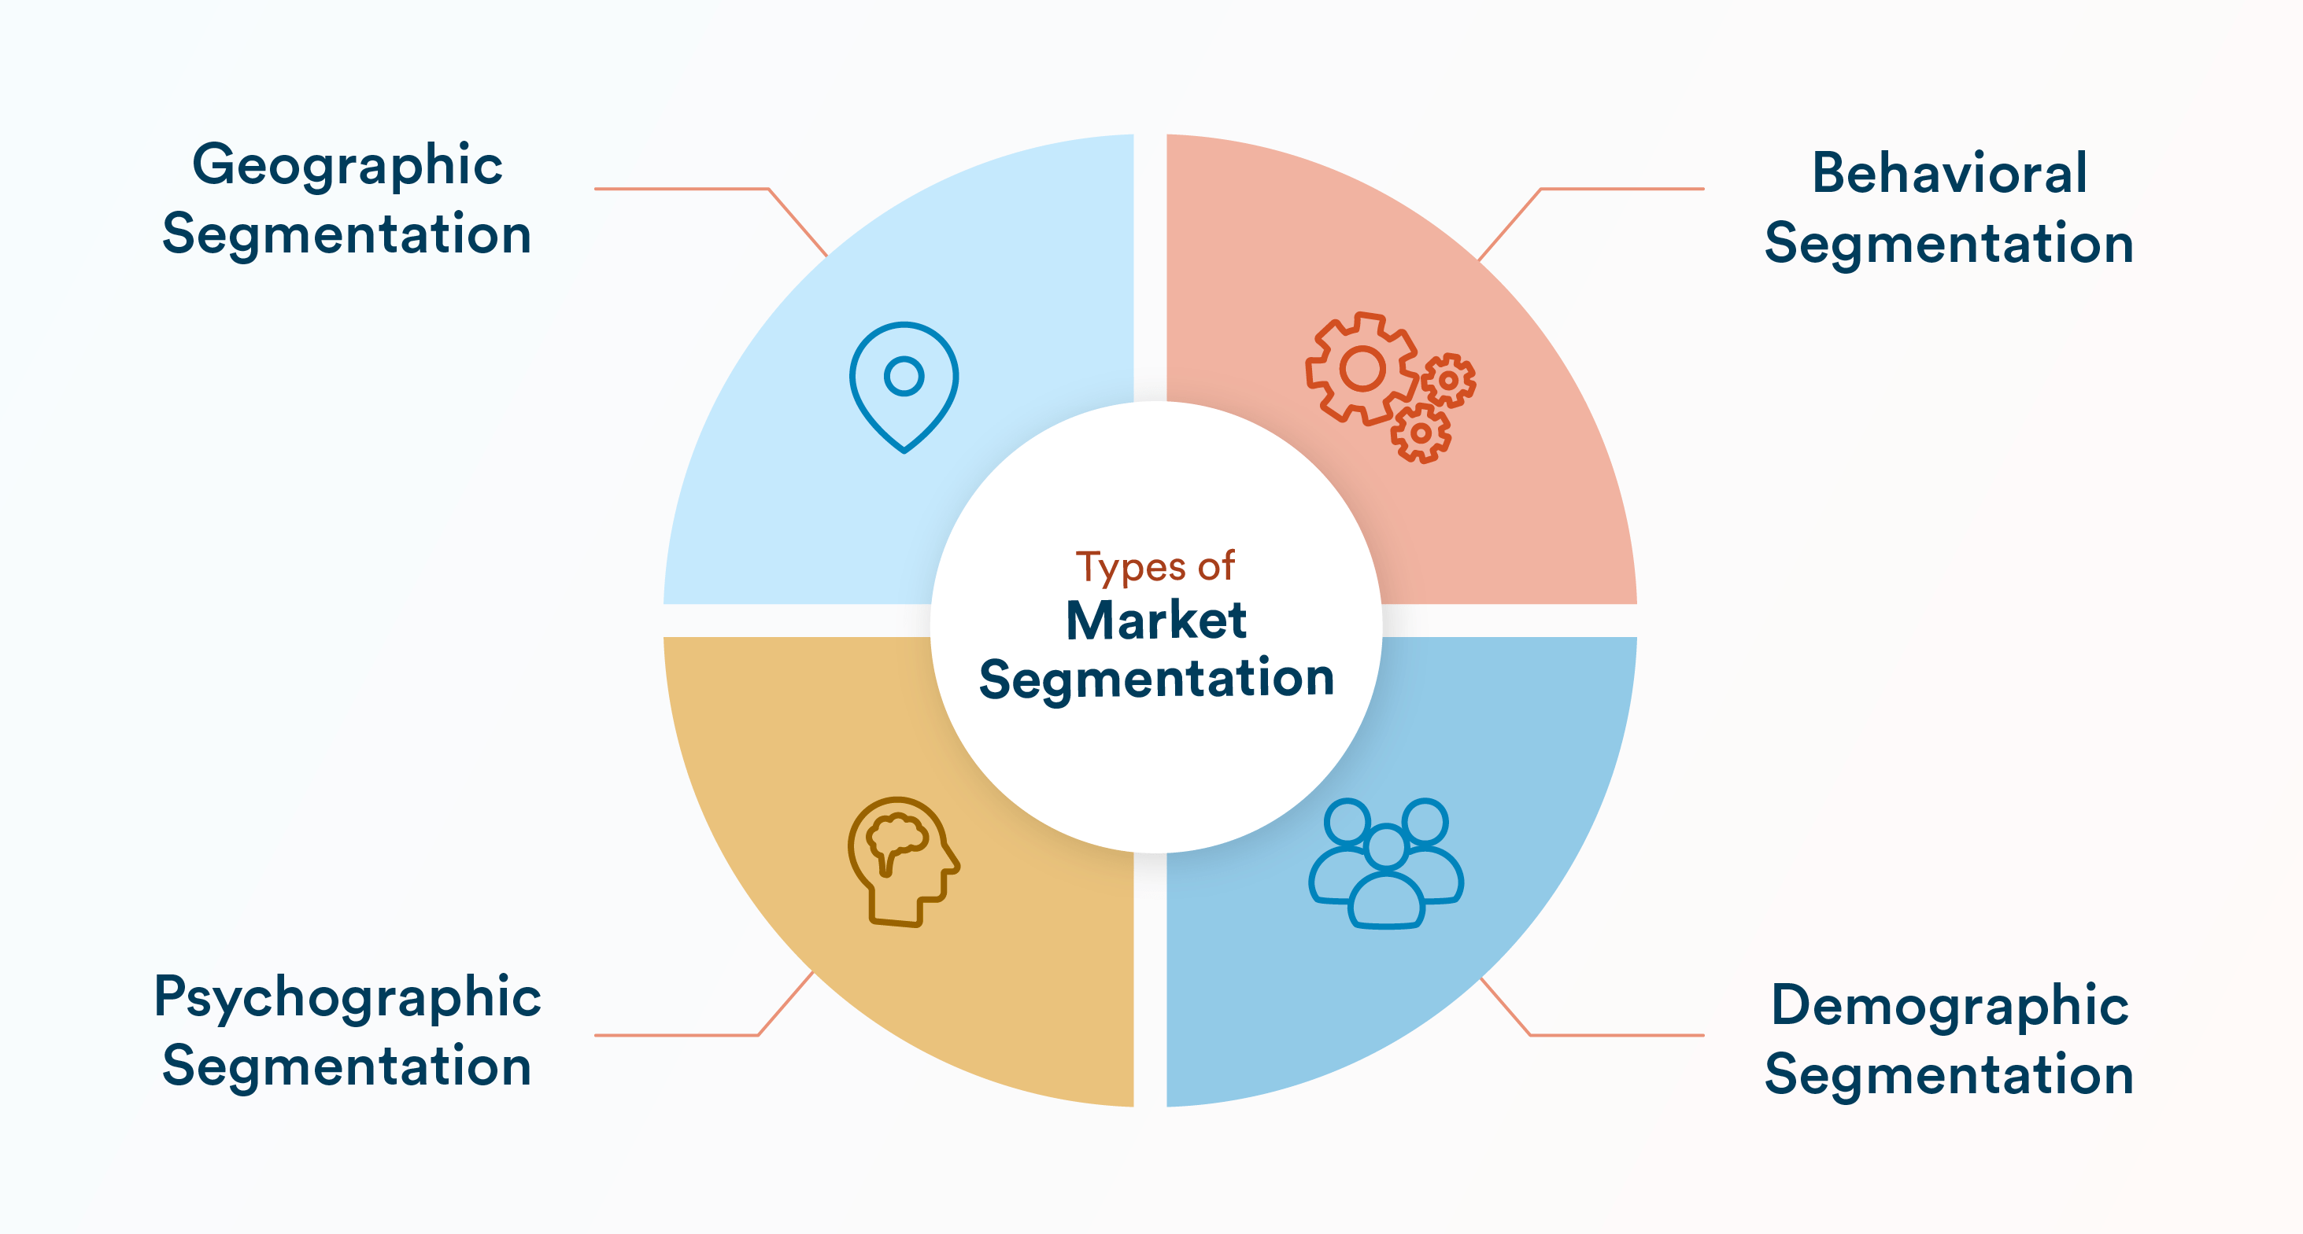
Figure 5: Market Segmentation (Zhang and Cueto, 2017)
RefillRight UK primarily focuses on students and working people with respect to demographic segmentation. The students particularly in the universities are usually more receptive to sustainable lifestyles and their thinking is also affected by the environmental campaigns. Most of the universities in the UK have been very proactive in ensuring sustainability making them a good place to have refill services. Another target group is working professionals who can be found in offices and SMEs. This group will tend to experience greater purchasing power and it can pay money to buy some convenience to them particularly when it fosters ethical values.
RefillRight UK should also use psychographic segmentation. The company aims at environmentally conscious customers who are concerned with the minimisation of plastic waste and environmental degradation. It is more likely that these customers will switch their shopping patterns to favourable business especially when it comes to sustainable ones despite the little behaviour adjustments. Nevertheless, being a perfect choice due to consumer biases and habits, not every greener consumer at the first sight will resort to refill services (Zhang and Cueto, 2017). Online platforms are significant in consumer behaviour by influencing how many find sustainable brands online and via social media networks (Olanrewaju et al., 2020).

Marketing Mix – The 4Ps
The item proposed by RefillRight UK is not the refill liquids in the first place, but the refill experience in general. The company offers mobile vans serving the purpose of filling out household cleaning and personal care products where customers can opt to utilise their premises. This will minimise plastic waste and will aid in sustainable use. The simplicity of product range makes the customers grasp the service easily, and it does not complicate it. It lays emphasis on quality, safety, and environmental impact as opposed to providing a wide variety of product choices. Such a vivid product positioning will enable the company to be unique in the sustainability market (Blundel et al., 2017).
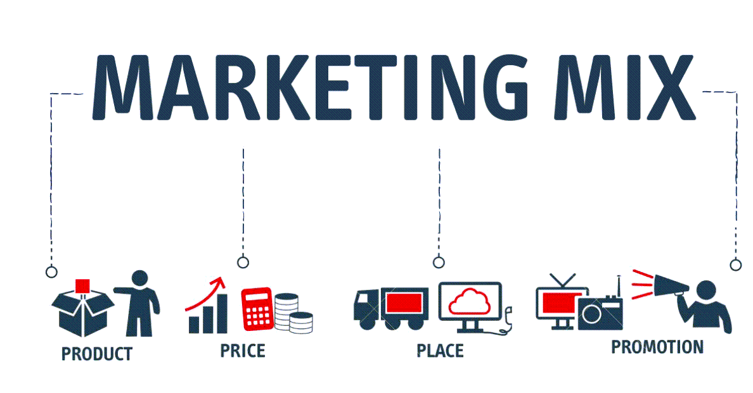
Figure 6: Marketing Mix (Baker and Welter, 2020)
The pricing is determined using a value-based approach. RefillRight UK will intend to provide fairly and competitively priced products and demonstrate to the customers how refilling is less expensive in the long run as compared to purchasing newly packaged products. The consumers are more conscious of their expenditure during the UK cost-of-living crisis and therefore price is a factor. Regular users can receive discounts with settlement and subscription to use the services regularly and become loyal. Such pricing approach succeeds in achieving the financial sustainability of a business as well as customer value which is crucial to long term success.
Place is concerning the way the service is offered to the customers. RefillRight UK operates a mobile business model, where refill vans get to universities and offices as well as homes. This will make it more convenient and eliminate the need to go to refill stores by the customers. Working in locations where one is familiar and can be used frequently assist in developing a sense of trust and a habit. The mobile model is also flexible as it means that routes and locations can be changed depending on demand and feedback. This demonstrates how marketing strategies should be in line with the local environment in which the business is doing business (Baker and Welter, 2020).
Promotion is aimed at sustainability branding and involvement. RefillRight UK does not merely advertise its products but also sells its environmental virtues like cost-cutting and reusing of plastics. The advertising messages emphasise the importance of a positive difference that could be achieved by making minor changes in our everyday practices. Straining basic and straightforward communication makes the brand to seem friendly and reliable. Promotion can also be facilitated through local relationship and events within communities to create more visibility.

Online Marketing Strategies
Marketing The marketing of RefillRight UK on the web is important in capturing and maintaining customers. Instagram and Tik Tok are particularly social media platforms that are effective in reaching younger demographics such as students and young professionals. On these platforms the business is able to post short videos, updates and educational content on plastic waste and sustainability. The visual materials that demonstrate the procedure of the refill can be used to make people less hesitant and test the service. Entrepreneurs are keen users of social media since the latter can be used to engage in low-cost marketing and directly interact with their customers (Olanrewaju et al., 2020).
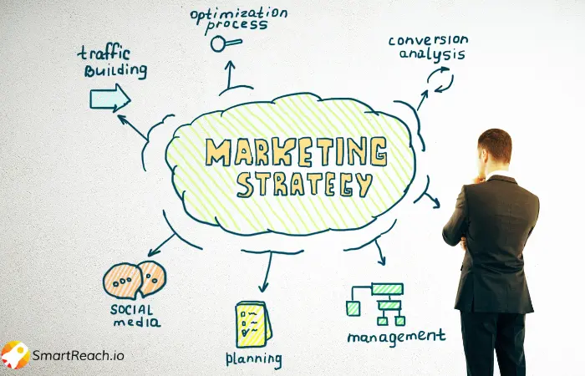
Figure 7 Marketing Strategy (Olanrewaju et al., 2020)
Brand awareness can be achieved with the help of influencer partnerships. Collaboration with the local eco-influencers or student ambassadors would allow RefillRight UK to access the new audiences in a more genuine manner. There are already existing influencers who can be used to create trust and credibility, particularly to those individuals who are not fully confident with refill services.
The other effective marketing tool that can be used to retain customers is called email marketing. Using subscriptions collected on email addresses or by the events, RefillRight UK can send notifications about the schedules of the van, new destinations, and special offers. It can be used to encourage long-term commitment and repeat usage with the use of Loyalty programmes, like discounts after a specified number of refills. It is not always economically efficient to keep seeking new customers rather than focusing on retention, which becomes particularly crucial in cases of a small business (Hisrich et al., 2017). Through the merger of online innovation and customer relationship, RefillRight UK will be able to develop a loyal customer base, as well as facilitate steady development in the UK market.

Element 4: Legal, Management & Financial Planning

Legal Structure
The structure RefillRight UK will be established is a registered limited company (Ltd), which is the usual and appropriate way of organising small businesses in the UK. Liability protection is among the primary reasons why this structure was selected. The owners do not use their personal funds to run the business since they are a small business and thus their own finances are not exposed to losses in case of financial trouble by the business. This would be crucial where the business is related to vehicles, equipment and operations with people. The other benefit of a private limited company is that it facilitates the growth in the future. Since RefillRight UK will be extending its operations to other cities, this type of structure is easier in attracting investors and seeking funds. It also makes the business look more professional which also could be used in dealing with universities, offices and suppliers. A business structure is a significant element of entrepreneurship process and influences the way business functions and develops (Kuratko and Hodgetts, 2017).

Management and Organisational Structure
Simple and lean organisational structure will be employed by RefillRight UK particularly during the initial stages. The Founder will be the Leader of the business and, at the same time, the Managing Director. This position will entail the making of significant decisions, strategy control, and supervision of the daily operations. A Operations Manager will have the role of planning the refill van routes, handling stock and meeting health and safety standards. This position is significant towards maintaining a running of the mobile service in a smooth and efficient manner. Marketing Manager will deal with branding, social media, communicating with customers, and cooperating with universities and local communities. With this structure, the team is small but focused and hence it is easy to control costs and also flexibility is in place. Other roles can be added or more personnel recruited as the business expands. Most of the business owners initially have several obligations but gradually increase the number of people joining them the larger the business grows (Burton et al., 2016).

Financial Planning and Funding
Financial planning plays a critical role in the success of RefillRight UK especially at the start-up stage. Primary start-up expenses will also be the purchase and equipping of refill vans, acquiring refill equipment, the acquisition of the original product stock and branding and marketing material development. Continued expenditures will also be on categories like fuel, maintenance, insurance and staff wages. The business will finance these costs through a combination of personal funds and external funds. Individual investment is committed and may facilitate attracting of other investors.

Figure 8: Financial Planning (Audretsch et al., 2015)
RefillRight UK can also seek UK green grants to promote the sustainable and environmental friendly businesses. Secondly, interested angel investors in social and sustainable businesses might also fund and give business guidance. A 12-month cash flow is a forecast that will be followed in terms of expected income and expenses, as well as taking care that the business will be able to cover its financial responsibilities. Financial planning allows the entrepreneur to address the risks and make decisions (Bygrave et al., 2024). Finance is central to survival and growth in the business, particularly to start up SMEs in the UK (Audretsch et al., 2015).

Conclusion
On the whole, this business plan demonstrates that RefillRight UK is a feasible and a viable business concept in the existing UK market. This analysis has demonstrated a high level of demand of sustainable solutions as a result of increasing environmental awareness and government efforts in curbing the emission of plastic waste. The mobile refill model provides an easy and convenient means by which one can transform their consumption patterns and still manage to save cash. RefillRight UK would fit the UK sustainability agenda in most aspects by contributing to waste minimisation and promoting reuse with daily products.

References
Audretsch, D.B. and Moog, P. (2022) ‘Democracy and entrepreneurship’, Entrepreneurship Theory and Practice, 46(2), pp. 368–392.
Audretsch, D.B., Heger, D. and Veith, T. (2015) ‘Infrastructure and entrepreneurship’, Small Business Economics, 44(2), pp. 219–230.
Baker, T. and Welter, F. (2020) Contextualizing entrepreneurship theory. London: Taylor & Francis.
Blundel, R., Lockett, N. and Wang, C. (2017) Exploring entrepreneurship. London: Sage.
Burton, M.D., Sørensen, J.B. and Dobrev, S.D. (2016) ‘A careers perspective on entrepreneurship’, Entrepreneurship Theory and Practice, 40(2), pp. 237–247.
Bygrave, W.D., Zacharakis, A., Wise, S. and Corbett, A.C. (2024) Entrepreneurship. Hoboken: John Wiley & Sons.
Dana, L.P. (2021) World encyclopedia of entrepreneurship. Cheltenham: Edward Elgar Publishing.
Davidsson, P., Delmar, F. and Wiklund, J. (2017) ‘Entrepreneurship as growth: Growth as entrepreneurship’, in Strategic entrepreneurship: Creating a new mindset. Oxford: Blackwell, pp. 328–342.
Diandra, D. and Azmy, A. (2020) ‘Understanding definition of entrepreneurship’, International Journal of Management, Accounting and Economics, 7(5), pp. 235–241.
Haltiwanger, J. (2022) ‘Entrepreneurship in the twenty-first century’, Small Business Economics, 58(1), pp. 27–40.
Hisrich, R.D., Peters, M.P. and Shepherd, D.A. (2017) Entrepreneurship. 10th edn. McGraw-Hill Education.
Kuratko, D.F. and Hodgetts, R.M. (2017) Entrepreneurship: Theory, process, practice. Boston: Cengage Learning.
Mishra, C.S. and Zachary, R.K. (2015) ‘The theory of entrepreneurship’, Entrepreneurship Research Journal, 5(4), pp. 251–268.
Olanrewaju, A.S.T., Hossain, M.A., Whiteside, N. and Mercieca, P. (2020) ‘Social media and entrepreneurship research: A literature review’, International Journal of Information Management, 50, pp. 90–110.
Ratten, V. (2023) ‘Entrepreneurship: Definitions, opportunities, challenges, and future directions’, Global Business and Organizational Excellence, 42(5), pp. 79–90.
Venkataraman, S. (2019) ‘The distinctive domain of entrepreneurship research’, in Seminal ideas for the next twenty-five years of advances. Bingley: Emerald Publishing Limited, pp. 5–20.
Zacharakis, A., Corbett, A.C. and Bygrave, W.D. (2025) Entrepreneurship. Hoboken: John Wiley & Sons.
Zhang, S.X. and Cueto, J. (2017) ‘The study of bias in entrepreneurship’, Entrepreneurship Theory and Practice, 41(3), pp. 419–454.

