The Global Business Environment
Assessment 2

Environmental Analysis of Ice-Cream Industry
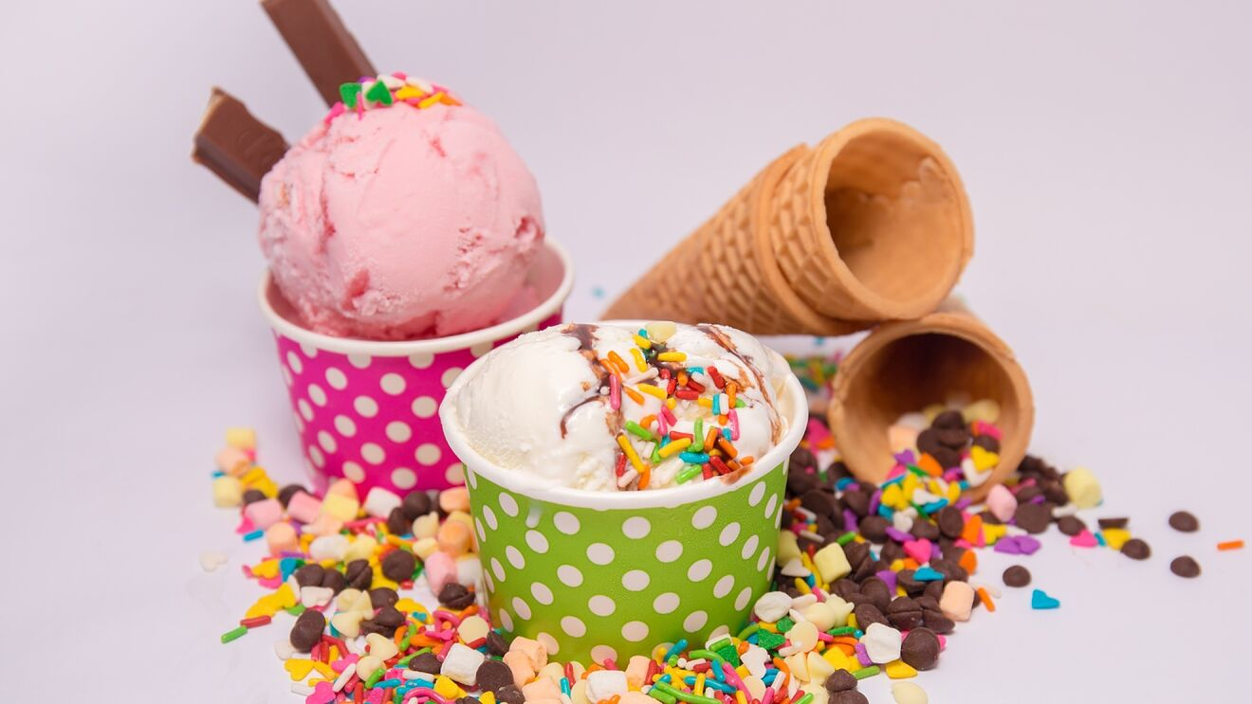

Submission date: 06-May-2022 19:58PM (UTC+0100)
Submission ID: 2121864
File name: The Global Business Environment Assessment 2_Ice-Cream Industry_Alexandru Gagos.docx (2.33 MB)
Word count: 1885

Table of Contents

- Ice-Cream Market Analysis………………………………………..3
- SWOT Analysis of Ice-Cream Industry..………………………………..5
- COVID-19 Impact ………………………………………………....6
- PESTLE Analysis ………………………………………………….8
- PORTER’S Five Forces ……….…………………………………….10
- Ice-Cream Industry Impact on Environment……………………………12
- CONCLUSION……………………………………………………..12
- References………………………………………………………13

Ice Cream Market Analysis

Ice-cream is a dessert with a sweet taste which is consumed frozen globally.
Ice cream is considered a dairy product because in most cases milk and cream are the basic ingredients. Ice cream is loved by both adults and children because it satisfies a wide range of tastes and flavors and can be composed of fruits, nuts, chocolate, syrups, essences or alcoholic beverages.
Ice cream can be enjoyed in various forms : cones, boxes or buckets, sandwiches, ice cream cakes, etc.
Ice cream is usually transported and stored in designated low temperature spaces, in refrigerators or freezers.
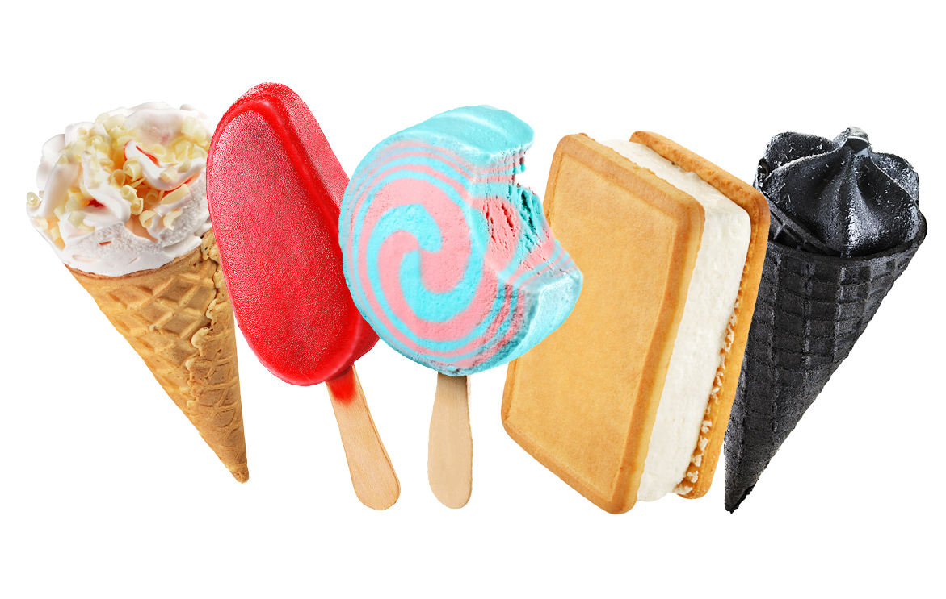

TRENDS IN THE ICE CREAM INDUSTRY
The ice cream industry is very dynamic, prosperous and is constantly looking for new tastes and experiences for its consumers. It was noticed that in countries that have a long tradition in the ice cream segment, sales are linear or have decreased. Meanwhile the sales in other markets, such as Asia, are on the rise.

Wanting to keep their loyal customers but also to reach new market segments, the producers in the ice cream industry have begun to move their attention to the niche consumers by launching new products for them :-
- Low fat or sugar free ice creams for consumers who suffer from diabetes or those who are on a diet and want to keep their weight under control
- Dairy free ice creams for consumers who suffer from lactose intolerance
- Vegan ice-cream
- Keto ice-cream
- Unique tastes and aromas : salty, spicy, smoked flavors for less conventional consumers

The global ice cream market was valued at $68,052.20 million in 2020, and is projected to reach $122,051.10 million by 2031.
The most important players in this market are : Unilever Group Nestle S.A., General Mills, Inc., Mars, Blue Bell Creameries, Lotte Confectionery, Wells Dairy Inc., Baskin-Robbins, International Dairy Queen, Inc.
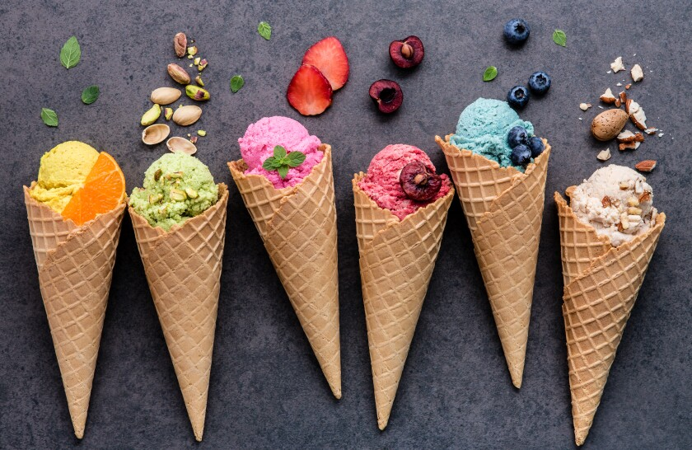

SWOT Analysis of Ice-Cream Industry

Strengths

- The industry is fully committed to protecting the environment by using only recyclable packaging and using only sustainable raw materials and ingredients
- Competitive industry which continuously invests in the development of products that differentiate market players
- The big players in the ice cream industry have built strong, famous brands with a global presence and operations
- Strong market share

Weaknesses

- Ice cream sales are seasonal
- Reaching new markets and new customer segments can be very difficult and challenging
- The ice cream market is a limited one like any other market
- False labeling to mislead consumers

Opportunities

- Rise in demand for premium ice- creams across the world
- There is great potential for growth on the niche products segment
- Increasing the exposure and the sales volume on the retail channels such as hypermarkets, supermarkets, convenience stores and discounters
- Strategic alliances

Threats

- Increased obesity and diabetes have a direct and negative impact on ice cream sales
- Fierce competition
- Economical and regulatory changes/ uncertain economic situation
- The increase in raw material prices leads to an increase in ice cream prices
- Decreasing profits

COVID-19 impact

The ice cream industry was not immune to the effects of the Covid 19 pandemic.
“Ice cream industry has suffered due to two reasons—COVID and lockdown. Supply chain disruptions impacted the ice cream sales and a lot of people are avoiding ice cream as they feel it can contract cold and get infected by the deadly Coronavirus” Dilip Rath, Chairman of the International Dairy Federation (IDF).

Consumers are increasingly concerned about health and diet askimg for ice cream products that are GMO-free, hormone-free, additive- and preservative-free, dairy-free, low in calories, organic and fat-free.
There is also a growing demand for premium ice creams, which will generate market growth. Consumers concerned about their health will look to buy premium ice creams due to the presence of high-quality ingredients and a lower amount of aeration compared to regular ice creams.
Trends
- Innovative Flavors
With an aim to gain a competitive advantage and to appeal to more consumers, ice cream manufacturers are creating products with premium and innovative ingredients. This, in turn, increases their customer base as well.
Ex : liquor ice cream is gaining popularity across developed regions such as North America and Europe.
- North America Holds the Largest Market Share
With the rising demand for frozen snacks, natural ingredients, low-calorie ice creams among population, the North American ice cream market is expected to witness significant growth. The majority of the consumers opt for frozen dessert as meal replacements.
- Competitive Landscape
The ice cream market is a competitive market and comprises regional and international competitors like Unilever, Nestle, etc. These players compete on different factors, including product offerings, quality, taste, flavor, price, functionality, size, packaging, marketing activities, introducing new products to win the interests of consumers. 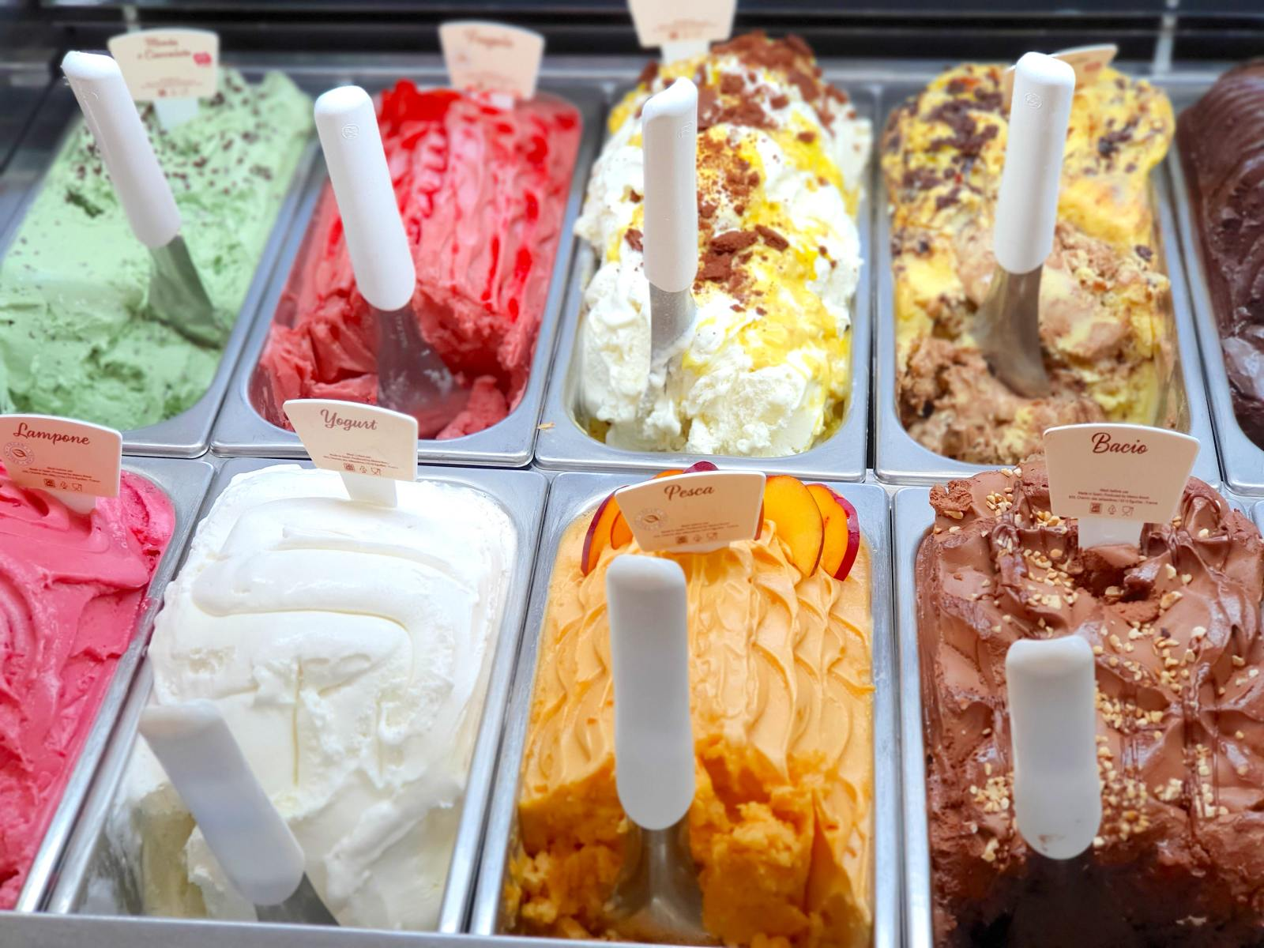

The PESTEL Analysis

Political aspects
- VAT changes: every change in VAT values affects the industries and implicitly the ice cream industry, as it leads to an increase in the price of ice cream. This generates a decrease in ice cream sales and consumer purchasing power. Ice cream is a product that is bought occasionally, it is not a basic foodstuff.
- Public programs to fight obesity : promotes healthy food and products, advising limited consumption of fats or sweet products , generating less ice cream sales.

Economic aspects
- The unemployment rate
- Increasing the inflation rate is affecting the final product prices
The purchasing power of consumers is very much impacted by the increasing unemployment rate as well as the inflation. The consumer will always choose to buy necessary products than secondary products like ice creams.

Social aspects
For most consumers,eating ice cream is a pleasant moment that must be enjoyed to the last second.
People have become lately more concerned about eating healthy, natural, low-fat products, often preferring to buy a premium product that meets these conditions. Ice cream producers need to take into account this market trend.

Technological innovations
The people now have the opportunity to prepare their own delicious ice cream in the comfort of their home with the help of specially created kitchen appliances. Ice cream industry is impacted by the innovation of powerful kitchen appliances.

Environmental
The ice cream industry is influenced by climate changes, reaching his peak sales from July to August.

Legal
There are some legal rules and hygiene standards that ice cream makers must follow. They refer mostly to the conditions of storage and transport, to the ideal storage temperatures and sanitary approvals for packaging.

Porter’s Five Forces
Porter's Five Forces model is a process of strategic analysis of a market. This model makes it possible to identify the competing forces in an industry, which determines its competitive intensity.
The analysis highlights 5 important factors that can influence a business at any time. Michael Porter tells us to take into account the 5 forces he identified, such as:

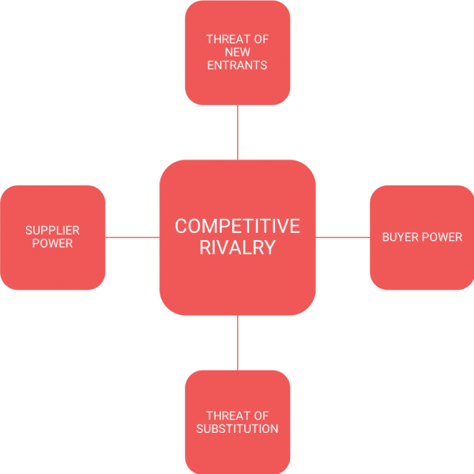

- POWER OF BUYERS (strong) : Buyers are the ones who set the trend in the market and can decide if a product or a business can have a long life. The ice cream industry is a seasonal one, whose sales are influenced by the weather, with peak sales between June and August. This shifts the balance of power towards buyers.

- POWER OF SUPPLIERS (medium) : the main suppliers in ice cream industry are suppliers of raw materials or equipment. Ice cream industry is dependent on its suppliers for raw materials such as milk, sugar, cream and eggs. This can have a negative influence on the ice cream business because when the supply costs are rising, manufacturers are forced to increase the ice cream price. There are numerous potential suppliers of ingredients and that gives to ice cream manufacturers the possibility to switch between suppliers quickly and cheaply.

- THREAT OF NEW ENTRANTS (medium) : the access of new players to the ice cream market is not difficult at all because most of the equipment can be bought or rented, and the workforce does not require much experience. However, the threat of new entrants is low because the ice cream market is dominated by global players. These players have built strong brands and are constantly investing in promoting and launching new flavors and products that meet the market trends.

- THREAT OF SUBSTITUTE (weak) : the big players in the ice cream industry have a vast and well-consolidated portfolio that covers all the requirements of the market.

- COMPETITIVE RIVALRY (strong) : competition in the ice-cream market is very strong.

How Ice Cream Affects the Environment

- Compared to other industries, ice cream has a relatively low carbon footprint. It takes around 1.82 kg CO2e to produce 1 kilogram of ice cream, a car driving equivalent of 4.5 miles.
Solutions to reduce negative impact of the ice cream industry on environment :
- growing vegan ice creams portfolio
- using solar panels
- engage with farmers to reduce the environmental impact of agriculture, investing in the welfare of both land and animals
- reforestation
- using eco friendly and reusable packaging
- support recycling or energy recovery from used packaging.

Conclusion:

Despite its challenges, period 2020-2021 created new opportunities for ice cream brands . The availability of better –for- you options continues to expand; however, indulgence and flavours remain the key ice-cream purchase attributes.
In the next years sustainability , as well as a focus on health propositions, is expected to ocuppy the centre stage of ice-cream brand strategies.
Lab-grown ingredients can make brands more appealing based on health , ethical and environmental attributes.

References :
1. CONWAY,J (2017) Size of the global ice cream market from 2013 to 2024 (in billion U.S. dollars)*[Online] STATISTA. Available from: https://www.statista.com/statistics/326315/global-ice-cream-market-size/ (Accessed 01 April 2022).
2. How green is your ice-cream ? , Financial Times - https://channels.ft.com/en/foodrevolution/green-ice-cream/ (Accessed 02 April 2022).
3. Global Ice Cream Market Report 2022, https://finance.yahoo.com/news/global-ice-cream-market-report-125300325.html, Yahoo Finance (Accesed 01 April 2022)

4. 10 Trends For The Ice Cream Industry In 2020 - https://www.tefcold.co.uk/2020-ice-cream-industry-trends . Tefcold (Accessed 01 April 2022 )

5. FANTOZZI,J (2018) Unilever Introduces A New 'Healthy' Ice Cream To Compete With Halo Top. [Online] Available from: https://www.forbes.com/sites/joannafantozzi/2018/10/18/unilever-introduces-a-new-healthy-ice-cream-to-compete-with-halo-top/ [Accessed 02 April 2022]
6. KONSTANTAS,A et al. (2019) Environmental impacts of ice cream. Journal of Cleaner Production,209, pp.259-272
7. MINTEL (2018) UK Ice Cream Market Report, November 2018. London: Mintel Group Ltd
8. ROBECO (2019) The key consumer trend of 2019: health and wellness. [Online] Available from: https://www.robeco.com/uk/insights/2019/05/the-key-consumer-trend-of-2019-health-and-wellness.html (Accesed 01 April 2022)
9. SWOT & PESTLE.COM (2022)- Ben & Jerry’s Swot & Pestle Analysis - https://www.swotandpestle.com/ben-jerrys/ (Accesed 02 April 2022)
10. How Ice-Cream Affects the Environment (2017) – Brendy’s - https://fyidelray.com/2017/11/19/ice-cream-affects-environment/ (Accesed 03 April 2022)
11. Ice-Cream Sales & Trends (2019) – IDFA.ORG - https://www.idfa.org/ice-cream-sales-trends (Accesed 02 April 2022)
12. Cooling down with sustainable ice cream (2020) – EUROPEAN UNION / European Climate Infrastructure and Environment Executive Agency - https://cinea.ec.europa.eu/news/cooling-down-sustainable-ice-cream-2020-08-17_en ( Accesed 03 April 2022)
13. The Future of Ice Cream Market Report 2021 - MINTEL (2021) - https://store.mintel.com/report/the-future-of-ice-cream-market-research-report (Accesed 03 April 2022)
14. Google – Ice-Cream images https://www.google.com/search?q=ice+cream&client=firefox-b-d&source=lnms&tbm=isch&sa=X&ved=2ahUKEwi4sMGUwen2AhU_hP0HHebGC5cQ_AUoAXoECAIQAw&biw=1366&bih=615&dpr=1#imgrc=hlwca_ycq5zMNM&imgdii=ieWw9EZpg7L9yM

