Developing Relationships and Workplace Achievement
BMSK 5002
Jomir Ullah 1708855
2019
Contents

Introduction 2
Employees Development Channels: 3
Development via Performance Management 4
Development via Training 6
Development via Motivation 10
Conclusion 15
References 16

Introduction

Since the industrial revolution there has been a lot of focus on Human Resource Management. Employees are now regarded as ‘human capital’, the most expensive labour cost for any organisation. So therefore, the need to motivate and increase performance of employee is of paramount significance. To stay ahead of competition and to utilise the skills and knowledge of the employee for the long-term success of the business.
This report aims to look at factors affecting employee behaviour and deliver an understanding of employee development in the workplace. It will also look at development methods that are available to Barclays to guide and train staff to achieve their full potential. It is stated that a motivated and well engaged employee will enhance the productivity and drive the business further(Armstrong, 2012) as the employee will show commitment to their employment.
The need to develop a variety of skills is very useful in a fast-digital society that we live. The workplace is rapidly changing. Often it is easy to be left behind due to a skills and knowledge gap, or automation of a job role. It also has a negative impact for the organisation as they can be left behind in the business market.
Many theorist have stated that organisations can use models and strategies to build and maintain their organisation. Many of these concepts that theorist analyses and the practices which they preach are still prevalent in modern day society.
This report will aim to identify these practises and examine how they influence employee behaviour and what impact it may have on motivation in the workplace. In every large organisation you will find a Human Resources Department who work with the managers and employees to identify training needs and development for the success of the business.

Employees Development Channels:

The role of the HRM within the business is responsible for taking into account the needs of the employees. Although the needs may vary (French and Emerson, 2013) they are commissioned by the organisation to develop and deliver support and training packages to individuals and managers to meet the objectives set by the company and to develop each individual with the skills they need to improve performance in the workplace.
There are two philosophies or approaches the HR department may take this is known as Hard or Soft Approach to employees. The differences are shown in the below figure.
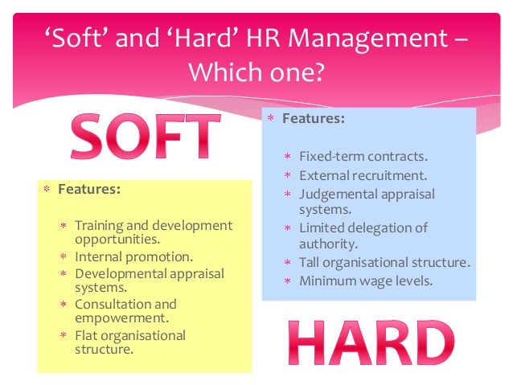
Figure 1 Differences between Hard and Soft HR approaches
The researcher realises that Barclays Bank adopt the Soft approach as it views their employee base an asset as opposed to a cost. As a result they invest heavily in new technology, new ways of working and also providing employees with the right tools and training to function to their best. They also have other methods of monitoring and developing the staff so that Barclays can retain qualified staff and gain a competitive edge over their business rivals and enter new market and find new ways of working.

Development via Performance Management

According to Tweedie et al., (2018) Businesses can develop their staff through performance management. This is where the employee is given a set of objectives to achieve and as a result they are rewarded by performance related pay and other incentives such as promotion or increased autonomy in their job role.
Mueller-Hanson and Pulakos, (2018) have stressed that performance evaluation is critical for meeting the set objectives of the business. It gives a sense of direction and purpose for the individual. Also it is a channel whereby organisation instil expected behaviour in order to meet company expectations. It also allows the company to identify low performers and give them the opportunity to improve their productivity in the workplace.
Barclays sets out its performance framework in their annual report 2017, they stress that success is achieved when the performance has a positive impact on customer and client, the individual groups and teams and the organisational as a whole.
Recently, more organisations are using Locke goal setting theory (Locke and Latham, 2019) to keep employees satisfied and productive. It is stated that when challenging tasks are set and the employees are given the right tools to perform and positive feedback is given. This process will increase job satisfaction for the employee. Therefore, it is imperative that the management setup programmes which are goal orientated and is achievable. (C. Lunenburg, 2011)
The structure of the programme should be such that any gaps in knowledge can be identified regular informal feedback is given to increase motivation and moral. The performance evaluation of the employee must have a reward attached to it to increase employee engagement. (Shoaib and Kohli, 2019)
The characteristic of PM is:
- Individual PM is concerned with gauging outcomes in the form of delivered performance linked with expectations expressed as objectives.
- It creates a favorable environment where managers and employees can have mutual dialogue and jointly review the performance set out.
- It is also linked with effort and projected work values. The inputs are the knowledge, skills required to become competent and apply these in the workplace to produce the desired results.

Gifford J. (2015) from CIPD, states that performance management has changed considerably over the years. The Management of performance needs to be done more regularly to maintain a conversation with the employee throughout the years, and give feedback on a regular basis to keep the employee motivated and to help them fulfil their desired goals. (C. Lunenburg, 2011) For the employees to develop they need to be set targets through performance management review. The process by which this can be done is shown below:

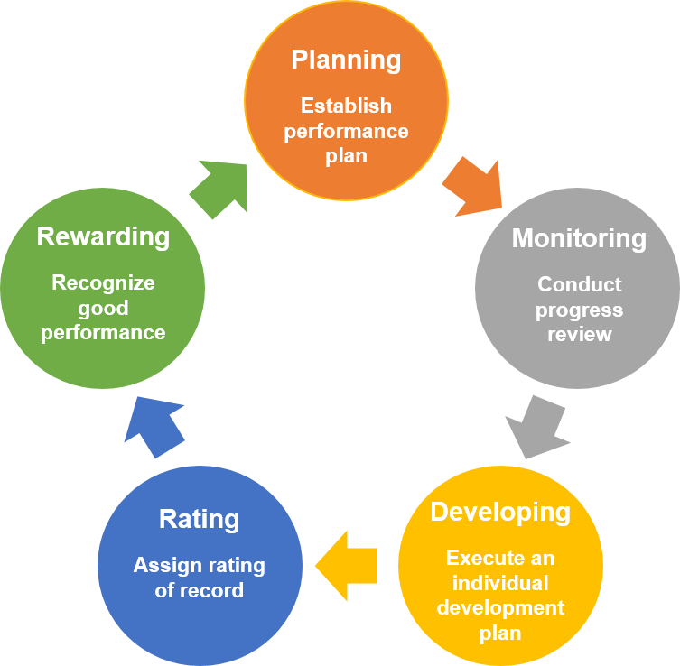
Figure 2 Process of Performance Evaluation

This diagram shows a structure which most organisation follow to monitor performance in the workplace. Barclays also has developed their performance evaluation process and reward employees whom have excelled in their roles. This is done via performance related pay or positive appraisal in the workplace. Barclays are also now changing these strategies so that if an employees underperform they are not penalised and instead their strengths are highlighted and this gives the employees more scope to develop and further challenge their own skills and abilities. This benefits both the employer and employees.
When employees realise that a reward is attached to becoming more efficient or completing their set targets. They will focus their attention on reaching their goals. This can be explained by Vroom (1964) expectancy theory. There is a saying that “there is always room for Vroom “ in almost all organisations.
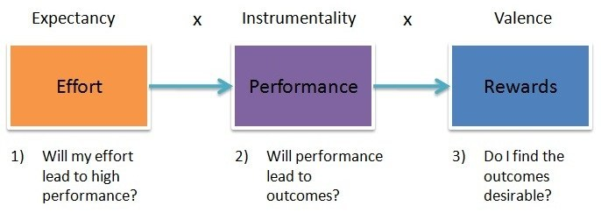
Figure 3 Vroom Expectancy Theory

However, some researchers argue that performance review is not sufficient to maintain a high-performance workforce and other factors such as job enlargement, job enrichment also play a key factor in motivating staff in the workplace. (Gruman and Saks, 2011)

Development via Training

To broadly define training, it is the process of gaining knowledge and skill which is beneficial to the employee to advance in their role.
Organisation have various methods of training that they can invest in to improve productivity in the workplace. As globalisation is affecting the world, we will look at training specific to this need.
Diversity Training. This is done to prevent civil violations and increase inclusion of many different identity groups as well as promoting effective teamwork. The aims of this type of training is to create positive inclusive work environment by helping employees recognise, appreciate and be tolerant to other co-workers. This gives employers the chance to educate employees about overcoming barriers such as ethnic, social or political diversity and its importance in the workplace. Having a diverse workforce enables greater creativity and productivity. Limitation to this type of training is that, in its totality it won’t alter the believes of the employees (Gebert, Buengeler and Heinitz, 2017) However, it will generate a greater awareness, impart knowledge and train them to accept differences of opinion in a team working environment. This reduces conflict and favours mutual understanding.
Barclays have training programmes for their employees who have joined the bank recently and for long term employees who have grown their skills and knowledge with business success.
Barclays offers this development of the individual for many reason:
- To increase productivity
- Improve quality of service
- Increase customer satisfaction
- Give employees the skills needed to use latest technology
- New ways of working
Every organisations have different reasons for training their employees. However when training is given it needs to be in a systemic approach. (Dymock and Tyler, 2018)
Businesses like Barclays have induction programmes for new recruits. They also have training for experienced existing employees. This is so that they can update their own skills, or the bank may require that they need new skills in order to adapt to how the business wishes to operate. i.e. taking the business forward in the global digital race.
The business might introduce onsite training, mechanisms might include the help of a mentor who will answer questions, and can pass on expert knowledge. According to Taylor and Curtis, (2016) This enhances the chances of development when the employee wants to progress by acquiring superior knowledge and fitting into the organisational environment they stand a better chance of promotion.
An extension to this type of training is known as ‘shadowing’. This process involves employees investing their time to work alongside another highly experienced colleague. Observing the work they do, the techniques adopted by them and learning from their working practices or experiences. This type of training is popular in most organisation as the cost level is much lower.
Training which is done off the premise is a major cost to the organisation as employees are not actually working when they are being trained away from their usual place of work. However, on occasion, off-site training needs to be done if the employee needs to attend college to get new qualifications, or attend seminars hosted by external training providers.
The benefits to the organisation are that employees will learn new skills and knowledge which they can bring back into the organisation and further improve performance at work.
Overall, the potential benefits of development of employees through training mirror the aims and objectives that the business is trying to achieve. Training provides knowledge to boost productivity. This will lead to improved quality of work and better customer relations.
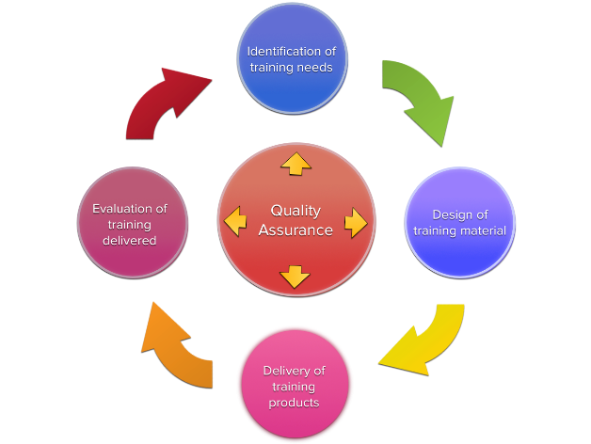
It can also be considered a motivational tool that business’s use as they look to increase the moral of the workforce (Roth, 2018) As employees might appreciate the feeling that the business is investing time and money in them and developing them by showing a caring approach.
Robertson et al., (2015) found that the general mental health of the employee and well-being can be improved by training which is robust. They emphasise that for future generations training simulation and practices need to be more varied as they found from their study that some individual gain more or less based on how the training regime was delivered.
Figure 4 Systematic Training Guideline’s
This is something that Barclays needs to adapt into their HR practises to keep hold of their human capital.
Grossman and Salas, (2011) assert that the cost of training is further amplified when the employee is unsuccessful in transferring the knowledge gained in training back into the workplace. As mentioned before, the financial cost of training can be very expensive especially for smaller businesses. Training away from workplace is more expensive as the employer has to fund the cost of training. Whilst employees are away from work, there will be a loss of productivity during their training programme. Although in the long-term, training is equipping employees with the skills and information they need. In the short term, they are not being productive by producing work yet they are paid.
We have stated that training is done to improve the employees skills. We need to consider the cost if the employee left the organisation after receiving specialist training. Now that the employees have gained further skills and knowledge or a qualification they might be in a position to bargain for higher remuneration. (Hall, 2019)
In order to keep the employees, the business might need to increase their labour cost and reward employees with higher pay for the training that they completed which was funded by the organisation. If the organisation does not reward the employees through higher remuneration after they have received training. The employee may leave the organisation to a rival business whom are willing to pay a higher salary.

Development via Motivation

Motivating the workforce is another method employers can use to develop their employees and increase their performance and overall business success.
In simple terms motivation is the reason or effort required to complete a task or to channels ones energy in a specific direction to achieve aims and goals. These can be on a personal or organisational level.
There are two types of motivation:
- Intrinsic Motivation; is internal to the employee and is driven by a personal interest in finding enjoyment in the work itself. Nazir et al., (2016) state that in this situation the person feels a sense of accomplishment. It is a natural high which reflects the person ability, competence, growth and self-control. Herzberg (1960) found that intrinsic motivators were much more powerful than financial motivators.
- Extrinsic motivation; this is more of a tangible reward system. Where the managers decide if you are worthy or a reward such as performance pay, bonus, sick-pay. Most researchers such as Gerhart and Fang, (2015) and Maslow (1943) dictate that extrinsic rewards and motivation are important but do not necessarily promote motivation to succeed in the workplace as employee’s may have several needs that are to be considered.
In the early 1900 Frederick Taylors motivation theory became known as the scientific management perspective.
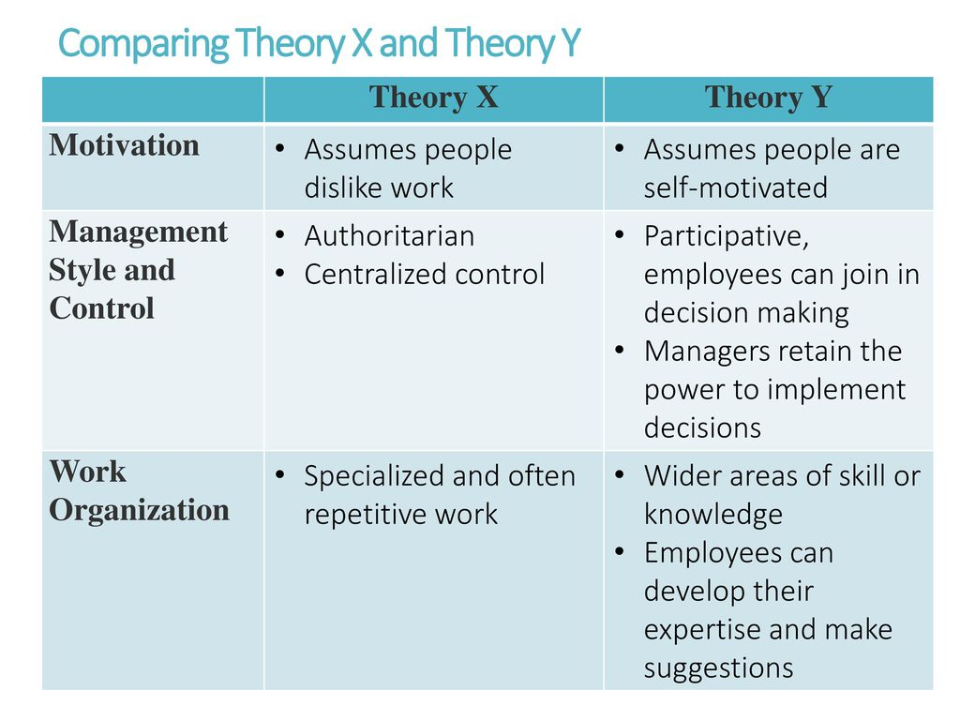
All his thought’s and philosophies are underpinned by ‘Theory X’ model/management style of Weber (1960) Taylor suggested that most employees were fundamentally lazy, that they were reluctant to be productive. They were not interested in job autonomy or any decision-making power, they felt the job of management was to provide very clear guidelines and coercion in order to get the best out of them.
Figure 5 Weber’s Management Theory
Taylor realised that in the 1900 there was no formal training and the workplace was very disorganised. He revolutionized the workplace by his Time and Motion Study and bringing in division of labour, more robust training , order and structure in relation to training. His belief was to match employees according to their skill level on specialised tasks.
As a result this caused repetition in the work pattern. He emphasised that this repetition would bring about greater productivity and employees would be rewarded according to production rate. i.e. Piece Rate Work System.
This monetary reward system provided a stimulus for workers to go above and beyond their personal targets to achieve more as it was financially more attractive to them. Organisation benefited from productivity gains and employees benefited from more monetary reward to spend on their families.
Furthermore, as employees were becoming motivated by financial rewards and produced more work the organisation realised that they could reduce their labour cost as some employees were putting in double the effort for personal gains.
Taylors theory partly ran into some difficulties and became the victim of it own success, as the organisation were reducing production and labour cost, they needed a smaller workforce. This created fear and a demotivating factor as employees friends and colleagues were no longer employed. Also the productivity targets were constantly being increased leading to more challenging work environment. This created a negativity in the work place and caused industrial unrest. This further lead to a rise in the creation of unions membership and industrial action where Taylorism was being adopted.
Although his research does not have empirical data and is outdated, his underlying principles are still being used in modern day workforce. (Barley, S., Bechky, B. and Milliken, F. 2017). It is the opinion of the researcher that Barclays use Taylors theory in the Mortgage Claims section where employees are rewarded by financial commission/ performance related pay as a tool to become more motivated and productive. Other examples in different industries include:
e.g. Large manufacturing business, where there is a division of labour, production equals more pay as a booster for motivation.
e.g. sports industry, in football players who scores more goals will be rewarded accordingly and receive recognition for their skill
e.g. service and sales sector work.

Workforce management is much different today due to the introduction of Human Relations Theory by Elton Mayo. Taylorism and Elton mayo work are in tandem as they both advocate similar approaches to motivating employees. Mayo study provided other physical factors to motivate employees. Mayo study proclaimed that part of his control group (Hawthorne, 1984) individuals were beginning to create bonds and communicating as a team. People began to get on with the researchers and contributed to the study. Employees just being asked their opinion was an exciting moral boosting occasion.
This further gave them the motivation to co-operation better and productivity amongst the group was increased.
In essence, Mayo prophesised that there were more human and social factors at play when determining people motivation and productivity. Although his study started off on physical factors at work controlling behaviour and productivity. He later realised that social factors and to some extent emotional factors were equally significant in stimulating and motivating the workforce.
These social factors made employees feel special, single out and valued in the organisation and provided a platform for workers to communicate better and work as a team.
These social factors have been engrained into the core values of Barclays bank. The need to feel part of a team and belonging, working collaboratively, having a common ethos, having a common motivational strand all help develop organisational behaviour and allow the individual to be motivated and provides meaning to work itself. (Barley, Bechky and Milliken, 2017)
Current day business hierarchy are actually devoted to thinking about the personnel needs of their labour force. Organisation now have Human resources department to carry out this function to regulate organisational behaviour by having core values, motivating and stimulating employees to do their best work, also developing and training to hold on to this human capital for long term business success. (Roos and Van Eeden, 2008).
Herzberg (1960) was another neo human relations theorist, his research was most distinct as it introduced:
Hygiene factors:
- Pay
- Working environment
- Relationship with colleagues
According to Herzberg these were aspect of the job that did not motivate, in the absence of these features it would demotivate you but not increase job satisfaction.
Motivators:
- Opportunities for promotion and self-improvement which lead to
- Job enlargement
- Job enrichment
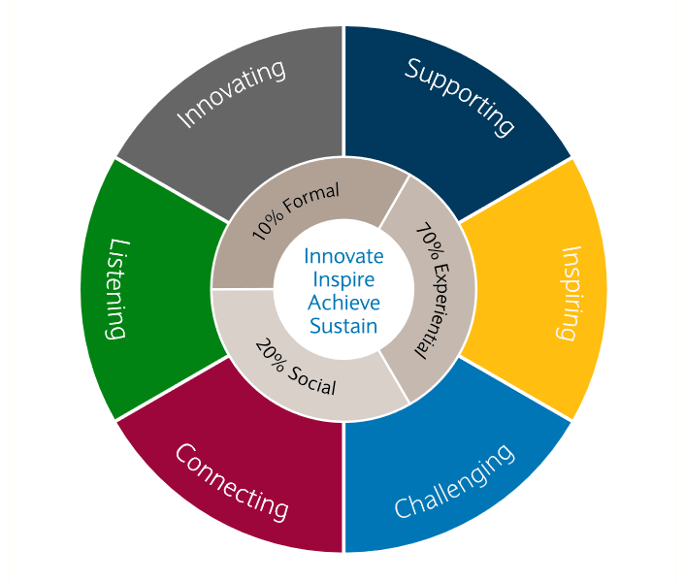
- Empowerment.
His research was against Eton mayo as he stated hygiene factors such as pay will not increase motivation in the workplace. Barclays already allows job autonomy to their staff as they are allowed to work from home. However, Barclays needs to learn from these theories to ensure that they have adequate resources available to continue to develop individual to make Barclays market leader and get the support and loyalty from their customers. When the employees are happy in their workplace only then will they put in maximum effort to meet the objectives of the business.
Figure 6 Factors needed to promote motivation in the workplace

Professional Development Plan:
A development plan will enable business and the individual to set out the agenda for development in the workplace. By using a development plan the employee is able to reflect on their knowledge and skills and this will enhance their learning. It also enables the employee to acknowledge and rejoice their achievements by following through on the plan. The plan needs to have SMART objectives so that one remains within the timeframe to complete their personal or organisational objectives.
Having completed the development programme one can then think about career progression and look at new channels that they can take to further make them more employable and also learn new skills to enter emerging markets around the world.
Below is a table which details current training needs for the individual working at Barclays:

PDP

Conclusion

Having looked at this report it can be said that learning and development in the workplace or in ones lifetime is a never-ending process. Our intention at work is to perform to our best ability and also learn new skills to stay ahead of the ever-changing digital world which is impacting on how services are delivered to the public.
By using these methods the organisation is able to build principles of effective communication and the skills required to build trust, manage relationships, resolve conflict and secure workplace achievement
The report further suggests the digitalisation and the force in which it has impacted on society will play a major role in HRM, as employers are concerned about how employees are feeling in the workplace and what their needs are. This is costing them a lot in labour cost. To reduce this cost, they may indeed not need to hire humans in the future and rely on automated machinery to do the task required. This will no doubt makes the company more profitable, however society will not have a good image of the organisation.

References

Vincent, M., Herzberg, F., Mausner, B. and Snyderman, B. (1960). The Motivation to Work. American Sociological Review, 25(2), p.288.
Armstrong, M. (2012). Armstrong's handbook of human resource management practice, 12th edition. 12th ed. London, U.K.: Kogan Page.
Dymock, D. and Tyler, M. (2018). Towards a more systematic approach to continuing professional development in vocational education and training. Studies in Continuing Education, 40(2), pp.198-211.
Roth, A. (2018). Leadership Strategies for Retaining Mariners Aboard State Maritime Academy Training Ships. Doctor of Business Administration (D.B.A.). Walden University.
Hall, M. (2019). Relationship between Employee Development, Employee Burnout, and Employee Turnover Intentions. Doctor of Business Administration (D.B.A.). Walden University.
Taylor, E. and Curtis, M. (2016). Mentoring: A Path to Prosocial Behavior. Journal of Business Ethics, 152(4), pp.1133-1148.
Grossman, R. and Salas, E. (2011). The transfer of training: what really matters. International Journal of Training and Development, 15(2), pp.103-120.
Gebert, D., Buengeler, C. and Heinitz, K. (2017). Tolerance: A Neglected Dimension in Diversity Training?. Academy of Management Learning & Education, 16(3), pp.415-438.
Mueller-Hanson, R. and Pulakos, E. (2018). Transforming performance management to drive performance. New York: Routledge,.
Tweedie, D., Wild, D., Rhodes, C. and Martinov‐Bennie, N. (2018). How Does Performance Management Affect Workers? Beyond Human Resource Management and Its Critique. International Journal of Management Reviews, 21(1), pp.76-96.

Gerhart, B. and Fang, M. (2015). Pay, Intrinsic Motivation, Extrinsic Motivation, Performance, and Creativity in the Workplace: Revisiting Long-Held Beliefs. Annual Review of Organizational Psychology and Organizational Behavior, 2(1), pp.489-521.
Shoaib, F. and Kohli, N. (2019). Employee engagement and goal setting theory. Indian Journal of Health & Wellbeing, 8(8), pp.877-880.
Barley, S., Bechky, B. and Milliken, F. (2017). The Changing Nature of Work: Careers, Identities, and Work Lives in the 21st Century. Academy of Management Discoveries, 3(2), pp.111-115.
Bode, C., Singh, J. and Rogan, M. (2015). Corporate Social Initiatives and Employee Retention. Organization Science, 26(6), pp.1702-1720.
C. Lunenburg, F. (2011). Goal-Setting Theory of Motivation. International Journal of Management. Business and Administration, [online] 15(1), pp.1-6. Available at: https://static1.squarespace.com/static/5b0b8f55365f02045e1ecaa5/t/5b14d215758d46f9851858d1/1528091160453/Lunenburg%2C+Fred+C.+Goal-Setting+Theoryof+Motivation+IJMBA+V15+N1+2011.pdf [Accessed 1 Aug. 2019].
(French and Emerson, 2013)
French, P. and Emerson, M. (2013). One Size Does Not Fit All. Review of Public Personnel Administration, 35(1), pp.82-94.
Maslow, A. (1943). A theory of human motivation. Psychological Review, [online] 50(4), pp.370-396. Available at: https://psycnet.apa.org/record/1943-03751-001
Vroom, V. (1964). Work and motivation. San Francisco (California): Jossey-Bass Publishing.
Nazir, S., Shafi, A., Qun, W., Nazir, N. and Tran, Q. (2016). Influence of organizational rewards on organizational commitment and turnover intentions. Employee Relations, 38(4), pp.596-619.
(Ramlall, 2004)
Ramlall, S. (2004). A review of employee motivation theories and their implications for employee retention within organizations. Journal of American Academy of Business, 5(1), pp.52-63.
Roos, W. and Van Eeden, R. (2008). The relationship between employee motivation, job satisfaction and corporate culture. SA Journal of Industrial Psychology, 34(1).
(Shelton, 2001), Waqas and Munir, 2016)
Khan, N., Waqas, H. and Munir, R. (2016). Impact of Rewards (Intrinsic and extrinsic) on Employee Performance With Special Reference to Courier Companies of City Faisalabad, Pakistan. International Journal of Management Excellence, [online] 8(2), p.937. Available at: https://iiste.org/Journals/index.php/EJBM/article/viewFile/32894/33789

Gruman, J. and Saks, A. (2011). Performance management and employee engagement. Human Resource Management Review, 21(2), pp.123-136.
Robertson, I., Cooper, C., Sarkar, M. and Curran, T. (2015). Resilience training in the workplace from 2003 to 2014: A systematic review. Journal of Occupational and Organizational Psychology, 88(3), pp.533-562.

