Contents
1. Proposed Dissertation Title 1
2. Dissertation Brief 1
3. My Aims and Objectives 1
4. What is a Senior Civil Engineering Surveyor 1
4.1 What is Civil Engineering Surveying 1
5. What is the Importance of this Position 2
6. How do you achieve this Position 2
6.1 What Qualifications can get you here 2
6.2 What Experience and Skills do you have to have 2
7. Chartership 3
8. Timetable 3
9. References 3
10. Appendix 4
Chapter 2 5
Chapter 3 6

Proposed Dissertation Title

How to Become a Senior Civil Engineering Surveyor

Dissertation Brief
The purpose of this paper is to highlight the need for Senior Civil Engineering Surveyors and the need for people to gain Chartership to improve the expertise and experience in the Industry.

My Aims and Objectives
My aims are to explain what is a Senior Civil Engineering Surveyor, its importance ,explaining how you reach this position and importance and how you reach chartership. My objectives are to identify the qualifications, experience, competencies and roles of the position. Also, to demonstrate how you can reach Chartership.

What is a Senior Civil Engineering Surveyor

What is Civil Engineering Surveying
Civil Engineering is “Civil engineering is everything you see that’s been built around us.” (ICE, n.d.)
A Surveyor is “Surveyors shape the way we live. From our towns and cities to our streets and homes, they help create safer, better, happier communities.” (RICS, n.d.)
A Civil Engineering Surveyor is the both combined and more as they done setting out, surveying, record keeping, design, planning, management and various other tasks. The roles differ depending on project and tasks.
The position of Senior/Chief is used for one who’s reached this position not due to age but Skill, Experience, Competence and Recognition. The purpose of the role is to teach the next generation of engineers and to improve and develop the industry.

What is the Importance of this Position
The position holds lots of importance to the industry as they’re looked up at as Mentors to younger engineers due to their expertise, experience and skill. They teach and guide next generations into the future pushing for newer and better ways of doing things in the industry making it better for the new generation. From 50 years ago setting out with Inverse Levels and Theodlites to now 3D Machine control, Drones and GPS. They are the ones who have authority and power to change the industry as to get this position requires recognition from the industry, Institutions and respect from others.

How do you achieve this Position

What Qualifications can get you here
The qualifications for this position depend on the route you taken from when you first leave school. Either through 6th form or Apprenticeship or Vocational course routes are the first step into this position.

The 6th From route is the longer route of the 2 as you have 2yrs in school, then the next step after that is degree, masters and PhD if you want to go that far.

Figures 1 and 2 are showing the qualifications route to get into the industry.
As you need these qualifications as these are fundamental skills you need.
As next step after these is Experience and variety of work.
(ICE, How can I become a Civil Engineer, n.d.)

Figures 3 and 4 show the route through Apprenticeships as vocational route is similar to this as one is full-time and the other part-time.
Apprenticeships are the best way as you learn on the job and in the class room gaining knowledge and experience at the same time. Bettering yourself. (ICE, How can I become a Civil Engineer, n.d.)

What Experience and Skills do you have to have
In engineering and surveying you are always looked at for your thinking, planning and management skills and more.
You need to be able to do maths and problem solving as to be able to think on your feet and make decisions there and then. As in the industry nothing always goes to plan so being able to show creative thinking, quick judgement and taking action shows your confident and competent.
As a surveyor you need to be able to use technology as when surveying, design work and managing data. Same goes for engineers as they aren’t Peg Bashers like they were their Data managers now.

Chartership
The best way for becoming a Senior Civil Engineering Surveyor is through Chartership.
Chartership is gaining Recognition from the industry and peers of your skill and expertise. This title is recognized worldwide as it “is one of the most recognisable international engineering qualifications” (ICE, How to become a professionally qualified civil engineer, n.d.).
Getting this title is a huge and life changing achievement to people. As this grants worldwide opportunities and benefits to them.
To get this title you have to go through the ranks and constantly better yourself with CPD. As you can start as a Student Member as its free to join, next step is EngTech which is having “”approved level 3 diploma or an HND or foundation degree or above” as achieving this title shows your competence and commitment to professional standards. (ICE, How to become a professionally qualified civil engineer, n.d.).
After EngTech its IEng which requires an accredited bachelors degrees or having HNC/HND and working towards it in the industry due to experience. This is seen by others in the industry that you’re a competent engineer and committed to the profession.
Chartership is the final title and to get here you have to go through all of these and proving your constantly improving yourself and competence. All the titles from IEng to Charted are protected by law.

Timetable
The research will start in the new year and spread across 3 months to gain and ask others of their and mine own experiences.

References
ICE. (n.d.). How can I become a Civil Engineer. Retrieved from ICE: https://www.ice.org.uk/what-is-civil-engineering/how-can-i-become-a-civil-engineer
ICE. (n.d.). How to become a professionally qualified civil engineer. Retrieved from ICE: https://www.ice.org.uk/careers-and-training/graduate-civil-engineers/how-to-become-professionally-qualified
ICE. (n.d.). What is civil engineering. Retrieved from ICE: https://www.ice.org.uk/what-is-civil-engineering
RICS. (n.d.). What surveyors do. Retrieved from RICS: https://www.rics.org/uk/surveying-profession/what-is-surveying/what-surveyors-do/

Appendix

Figure 1- A Level and Highers 2
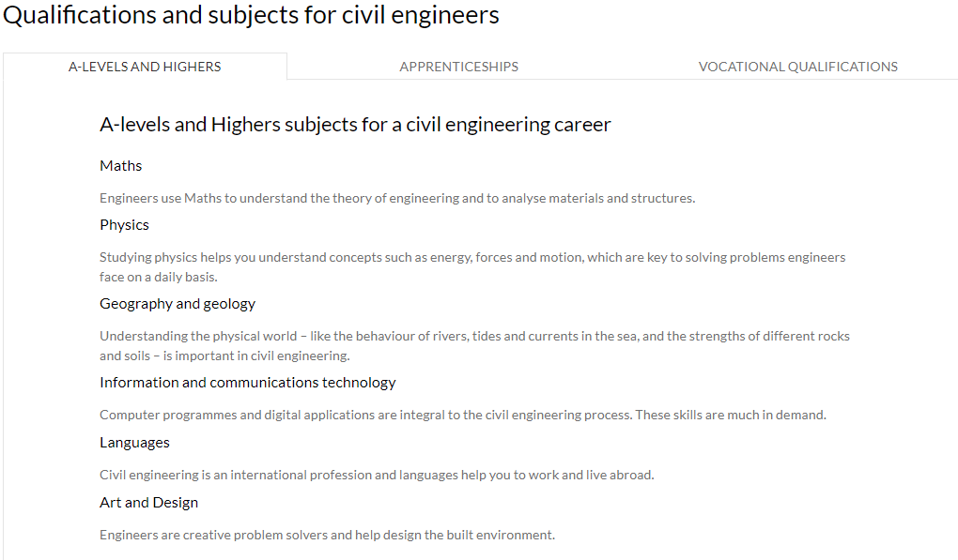
Figure 2- University 3
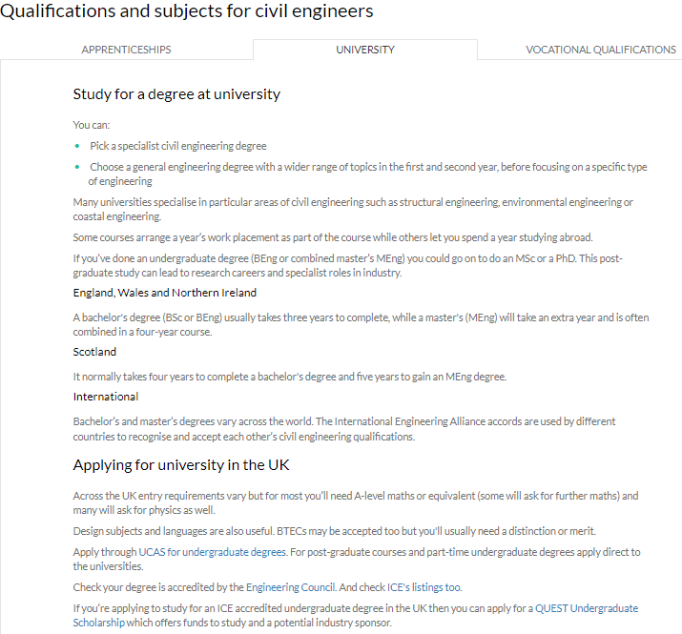
Figure 3- Apprenticeship Route 3
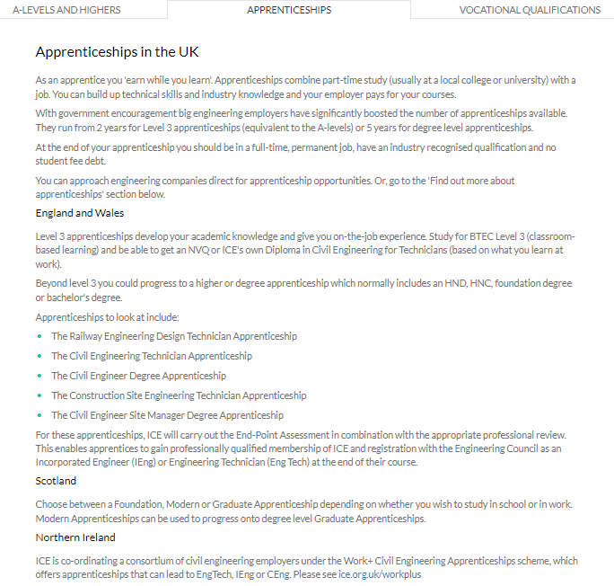
Figure 4- Vocational Route 4
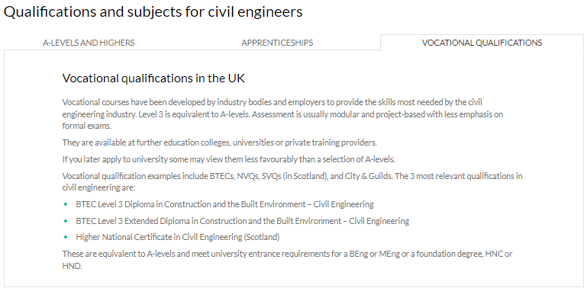

Chapter 2

Over the last few months I’ve been working to my goal of becoming a Senior Engineering surveyor. Since working for Griffiths, its helping me achieve my goal and gain the experience, training and knowledge to become a Senior Engineering Surveyor. As being on the A40 Bypass Project in Llanddewi Velfrey I’ve learnt many and done lots of new things. My role on site is as a Section Engineer, this means I’m in charge of a portion of the scheme. With this role I’m doing all forms of work from management, supervision, surveying, setting out and record keeping. I’ve been helping with doing RAMS, Permits to Dig and supervising workforce as well as a Graduate engineer as he’s green to the industry. These are helping me gain confidence and more responsibility as I’m becoming more able to confidence in speaking to Agents telling them information I’ve gotten from site and the workforce giving them orders and telling them what they need to do and how to do it safely. One of the other roles I carry out is taking records such as photographs of the work being carried out, pre-conditional photos and just general records and storing them on the site SharePoint and managing the photos everyone puts on there as organizing them into year, month and weekending .
Furthermore, on the project I’ve been using and gaining more experience on the engineering equipment we have and drawing up surveys and sending them off to the Senior Engineering Surveyor on site or Design Manager. Also, asking the right questions and working with Topcon and Sealand Survey who supply us with our equipment and software. As been having one to one training with them on the software and then having time to play with it and trying out the different functions on it. I’ve also been making my own Code Library on the software to suit the coding we use when we are surveying rather than Topcons as its general. The purpose of this is to make uniformity with all the engineers and graduates on site so that we are all using the same codes and can read any survey or drawings the other has produced.
On the project, we hired 2 graduates to be Chainpersons for the engineers. As I’ve been teaching them about the equipment how to use them, the functions and modes on them which we can use. Then showing them what to survey and pick up and that as a surveyor your drawing a map for someone else to look at and read as that’s the many role of a surveyor creating a map of what you see for someone else. I’ve also, talked to them about what there goals are and about going into ICE either going up the ranks or going straight to chartership. As for myself I’ve started my application for the Engineering Technician aka EngTech so then can start my journey to Chartership.
Outside of Griffiths, I’m on the Graduate and Student Committee of South West Wales ICE. So I’ve taken part in meetings and carried out talks with a few of the members and now organizing an event in University of Wales Trinity St David for my fellow peers. I’ve also now taken the role of Sponsorship Lead for the Engineering Team Challenge which is an event that ICE’s Graduate and Student Committees carry out for schools and colleges to take part in and compete for a prize. My role is to get in touch with companies to sponsor the event and help us run it and make it successful as covid has stop it from happening the last 2 years. This is helping me get better understanding of budgeting, expenses and overheads. Being part of the committee now has taught me new skills and improved my current ones as how to take lead of my own talks/events, managing cost and organisation skills.

Chapter 3

Since the start of 2022 I’ve been getting closer to my goal. I’ve been starting to produce my own drawings of my surveys I’ve caried out for the Public Liasian Officers. As before I would send the data off to the Senior Engineer to draw it up and say what points and lines are what. However, I’ve taken it upon myself to start drawing my surveys as created my own title sheet, adding photos and key maps to them and then submitting them off to the Agents, Design Manger and the Client.
I’ve also taken more responsibility as applying to become a STEM Ambassador to better myself and to work around all different types of people. As completed the Induction waiting on the DBS check. I’ve started on my Application for the Engineering Technician with ICE as my first step into getting Chartership. As going on an ICE Workshop for the EngTech with ICE to help me through the application process. I took part in a workshop with the Committee having University students come in and ask us questions and give our advice.
I’ve had training on Sitelink3d V2 which is a management software to help manage the machinery on site and to remotely access and download or import data for the Machine Control Software. This helps me getting closer to my goal as learning and seeing the technology that’s out there to import the quality of works and manage the cost.
In February, I went up to Sheffield to see an old friend of my fathers who he worked with on the Pipeline 10 plus years ago. As to see his company and set up. I learned and saw mean new and interesting things up there on how BIM, Drones, Laser Scanning and Virtual Reality are becoming some of the biggest parts of the industry. As I tried the VR headset they had up there and walked through a few of their projects and seen the detail and accuracy of the data. This is how they can be incorporated into our works as this showed me the different avenues I could go into with Engineering and Surveying and gain the experience and variety of work to help process and development myself to become a Senior Civil Engineering Surveyor.
I’ve entered 2 events with the Institute of Civil Engineers. First, being the Apprentice of the Year award which is an award that all Civil Engineering Apprentices can enter. This has helped me with my goal as there are different questions which ask about your experience and how to you solve a certain problem, how was your role important in it, leadership and Teamwork related questions. As this help me think and highlight areas for me to improve and start take more responsibility and charge of my work and voicing my opinion and contributing to the team. The other award is the Emerging Engineers award as this is to write about a certain topic of interest to you and have to do a paper on it and submit it to ICE as this is helpful for me as I’m researching and looking at different areas I could write about and exploring the many different aspects of the industry and learning more and bettering myself.
So far I’ve gained quite a bit of experience and knowledge to help me achieve my goal. As seen and experienced so far the different ways engineering can go and how much work and variety is out there. At the moment it’s a long way away but I am getting closer to the goal.

Chapter 4

Since my last submission, I’ve made quite substantial steps to achieving the aim of my paper. On the site I’m currently working on, one of the engineers has left the project for a higher paying job in Sierra Leone. So my work load has charged and have to step up to the role and take more responsibility. As at first it was a nervous and uneasy feeling as it’s my first project being in charge of the engineering in a whole section. However, I’ve taken to the position and able to manage and organise my work well and able to not put myself under stress or panic. As it’s the calm before the storm on site as the major works are starting shortly and requires me to take charge and being able to manage and work with the Foreman and Agents. As this is helping me gain the experience of working with others and taking the responsibility on as an Civil Engineering Surveyor.
As I’m attending a workshop to help with my EngTech Application with ICE up in the Clayton Hotel, Cardiff. This will help me see how to improve it and make my application more professional and picked for the interview. This will helps as it puts me a step closer to getting Chartership and professionally qualified as these are key points in becoming a Senior Civil Engineering Surveyor.
Part of the way of becoming a Senior Civil Engineering Surveyor is having a variety of work to gain experience and being able to apply different methods and using different ways to solve problems. As well as keeping up to date with new technology and changing with the times. As I’ve done drone training on how to fly/pilot, the benefits, the cost, outputs and various other things related to drones done by Ben Evan from the Drone Academy. As drones are becoming more popular in the world of construction and being able to experience and work with them helps me to keep in the loop of the future of the industry. Furthermore, learning how to use 3D Machine Control and create the mesh for the model. This is showing me the design but also technical side of engineering. Where looking at the model making sure all the correct layers are on, that there’s no abnormal levels like 0’s. As well as making sure it’s the up to date design we are importing because once the job starts there will be 40 to 60 ton machines ripping out the bulk of the site and the model has to be right as we wont be allowed to enter the area when they are working.

Reflection

Over the last few months my research into how to become a Senior Civil Engineering Surveyor has been insightful but also opened my eyes up to lots of different avenues and choices.
During it I’ve learned a lot about myself as a person and about my career. Its shown me, my good and bad qualities which I need to improve on. The good qualities I’ve seen is my drive and passion for the career and my work as I love my work and how its evolving daily. As everyday is a new day to learn and understand something new. Also, seen that I’m head of many people my age and older because I’m pushing myself to accomplish tasks, achievement and skills ahead of others. As learning this has given me more confidence in myself to be better than my Father and proving to others that I didn’t get here through my Fathers Reputation and his Skills but through my own merits and drive to be better and the best. However, I’ve uncovered my weaknesses which have held me back. Firstly, been my laziness and relying on my father. Secondly, arrogances thinking I can be the best and that I’m better than others. Lastly, allowing the comments and opinions of others get to me and affecting my mental health as during the lockdown I did have a moment where I believed I didn’t deserve my apprenticeship and that they were right. This is my biggest fault as I fell for the trap and lost belief in myself.
Theses months if research have taught me how green and young I am. As now I’ll work on myself making myself stronger. As my weaknesses showed me where I can be better on and never have any doubt in myself as a person. I’ll become more efficient and rely on myself, be confident in my ability but not arrogant and become cocky. Finally to only care about the opinions of those that respect me and I respect cause they are the ones who support me in my path.
In my journey to my goals I did achieve them but they did open up more questions that I want answered. I learned how it’s the experience you gain helps you to achieve the position of a senior engineering surveyor. Although it does ponder me what checks and how do you assess the skill of a person to class them as a Senior. The importance of the role was successful as learning how the knowledge and experience they have can help a project run smoothly and help in situations where you have problems and need someone to make that call. However, why is there a lack of people in this position if it’s so important and why aren’t people addressing it or sorting it out.
If given the chance I would do this project again and a different way and method than I have for this one. I’ve logged and tracked my experiences and thoughts. However, it isn’t enough information as I wanted. Next time I would approach the Institution of Civil Engineers and the Chartered Institute of Civil Engineering Surveyors. Asking them their opinions, standards and requirements for the role. As they as essentially the governing bodies that dictate the standards and requirements for Chartership and Fellows, so the information they would proved will be of great quality. Furthermore, I would’ve carried out questionnaires and posted it on LinkedIN as using it as the platform to help gain data as my contacts on it would answer it but it would be seen by others and shared about so the sphere of influence would be massive allowing me to collect data not from the UK but possible around the world as the industry around the world has so many different standards and methods.
Doing this research has changed my ambition while strengthening it. As I carried out this research to learn and understand the role and importance of become a Senor Civil Engineering Surveyor. As well as learning how to better myself. The part that’s changed is which part of the industry do I want to go into whether its surveying doing plans, maps and surveys, structures or going as a Civil engineer and working to be a Project Manager. My ambition of being the role but bettering myself and becoming someone I’m confident in and who I respect as I want to be able to be confident in giving out answers, data, solving problems and talking to clients and the team. As I want to strengthen my ability in myself to be the person I want to be. As I mentioned about my strengths and weaknesses they are what I want to I prove and strengthen. The future I want is to be someone people respected and admire my merit of work and skill not looking at me through my fathers shadow.
Lastly, I’ve gained a new ambition while learning and discovering new things in my research. That ambition is to make the industry a better place for Engineers as at the moment they are treated at the bottom and only treated as equals when something goes wring and needs to be solved. This ambition is one I want to achieve and help those who are similar position as me, graduates or those who don’t know what they want to do as the reason for lack in the positions for Seniors, Engineers and Surveyors is because of money, value and lack of opportunities for people to get into the industry. As I know it’s a large ambition but it’s one which I deem personal as one that will help the industry and prove to myself that I’ve achieved the peak of my career.

