Mike Oldham
2235684@student.uwtsd.ac.uk
Computer architecture & Operating systems
Operating Systems

Contents
Introduction 2
Task 1: Key functions of general Operating Instructions 3
Task 2: Windows OS CLI Commands – (10 PowerShell Commands) 5
Task 3: Linux OS CLI Commands (10 Bash Commands) 12
Task 4: Windows OS Scripts (PowerShell) 15
Task 5: Linux OS Scripts 18
Conclusion 19
References 20
Appendices 21
Tutorial 1 Activity: Types of Operating Systems. 21
Linux Unhatched: (Online Course) 22

Introduction

This assignment explores the fundamental concepts of operating systems. Looking into the key features I will be researching them to better understand an OS. Additionally, I will be looking into different Command Line Interfaces and the use of PowerShell, Batch and Bash scripting and commands used within Windows and Linux. I will explore these by testing different commands and further creating scripts in both Batch and Bash to cover the different functions that can be achieved within these environments.

Task 1: Key functions of general Operating Instructions


An operating system can be categorised as System Software which manages all the different resources of the computer. It helps with the communication between the software and hardware of a computer. The design of an operating system enables it to manage the overall resources and operations of a computer.
[1]

The Operating System is the most important type of system software used in a computer system. It is a set of specialised programs that handle all the operations of a computer. [2]

Part of the Operating System is Memory Management. This comprises of two main components which are the processor and the memory unit. The efficiency of this depends on how well these two components interact with each other. This can be split into Memory unit organisation and Memory access. The Memory unit is made up of many different types which are organised into a hierarchy. The way in which these are organised affect the data access speeds and storage sizes. Faster caches are closer to the CPU whilst other larger and slower memory sit further away. [3]
With memory access, primary memory is faster but does not allow for permanent storage; however, secondary memory allows for permanent storage with slower speeds.

File Management is also a key feature of the Operating System which is used to manage individual as well as groups of files in the computer system. This also gives certain details about the files including the location, owners, creation time, type etc. File management is one of the more basic features however it is an important one. [4]

Another key feature of the operating system is the Device Management. This refers to the controlling of the Input/Output devices like a keyboard, printer, scanner, microphone, and USB ports to ensure seamless communication between the hardware components and the operating system, facilitating user interaction and data transfer. Additionally, device management involves setting up and maintaining how devices communicate with the computer. This includes making sure each device has the right settings and software to work properly. It helps users use their devices smoothly and keeps the computer running well. [5]

The User Interface of an operating system acts as the main component for users to interact with the computer. Through displaying visual icons and windows, it enables users to navigate, launch applications, and carry out tasks using input devices. Furthermore, the Operating System interface supports multitasking by allowing users to switch between applications and manage multiple tasks efficiently. Accessibility features ensure that individuals with disabilities can also use the system. Additionally, the interface notifies users of system messages and errors, assisting in troubleshooting and problem resolution. In summary, the OS interface is crucial for improving the user experience and ensuring seamless interaction with the system. [6]

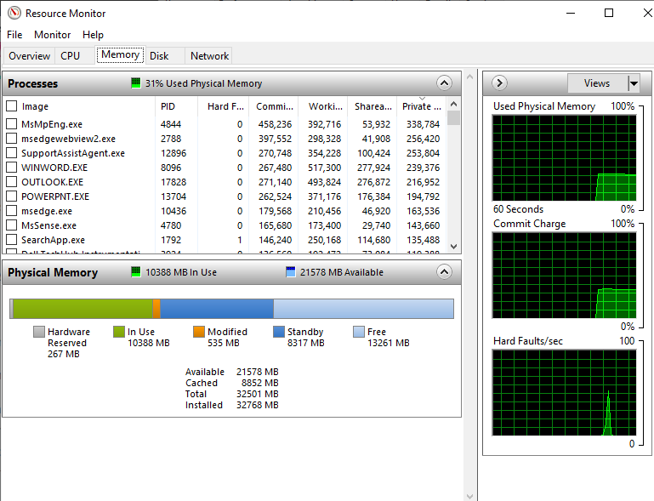
Screenshot of Resource Monitor showing different Memory Stats:

Screenshot of Task Manager showing the different processes running along with statistics on the CPU/Memory/Disk usage for different programs running in the background:
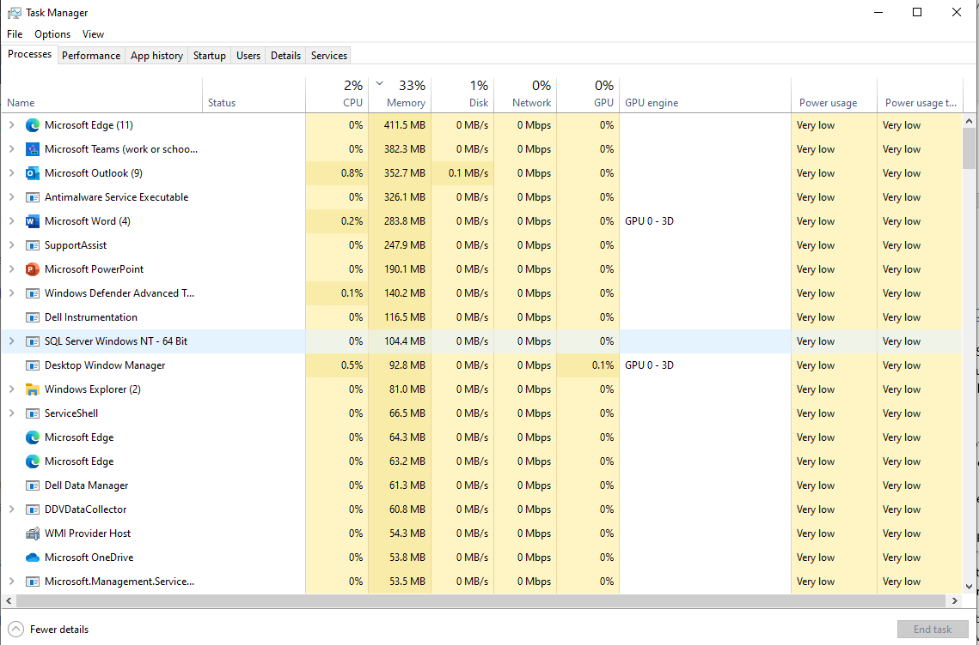

Task 2: Windows OS CLI Commands – (10 PowerShell Commands)

- ‘Get-Help’ command
- One of the first commands that should be learnt for PowerShell is the get help command. This command is self-explanatory as it provides help with other commands. Here is an example of me using this command in PowerShell:
- 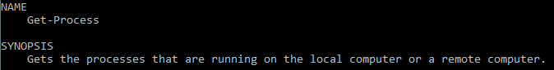

- ‘Start’ command
- This command is used to start one or more processes, such as launching applications or executing commands. It allows you to specify the name of the executable file to run and provides various options to control how the process is started. Some of the common parameters of the Start-Process cmdlet include -FilePath to specify the path to the executable file.
- Here is an example of the start process command to launch the Chrome browser:

After running this command, the following Chrome browser window pops up:

- ‘Exit’ command
- The exit command in PowerShell is used to terminate the current PowerShell session or script execution. When you execute the exit command, PowerShell will close the current session or script, and you will return to the previous environment, such as the command prompt or the desktop.
- Here is an example of this being used:
- 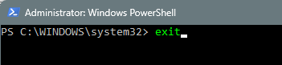
- After this runs, the PowerShell window is closed down and my other open programs remain running.

- ‘CLS’ Command
- This command clears the contents of the current PowerShell window and removes any of the information from the previous commands used:
- 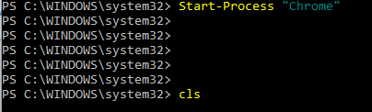
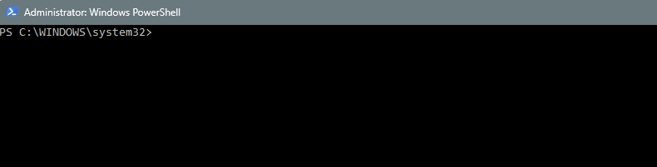
- ‘Ipconfig’ Command
- The ipconfig command in Windows is a command-line utility that provides information about the network configuration of the computer. It displays details such as the IP address, subnet mask, default gateway, and DNS servers for all network adapters installed on the system.
- Here is an example of this:
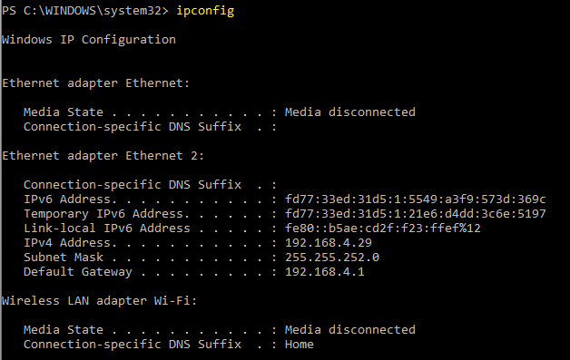

Further to this, you can use parameters on the command for additional information:
Here is me using the /all parameter to show more detailed information about all network adapters including the configuration settings:

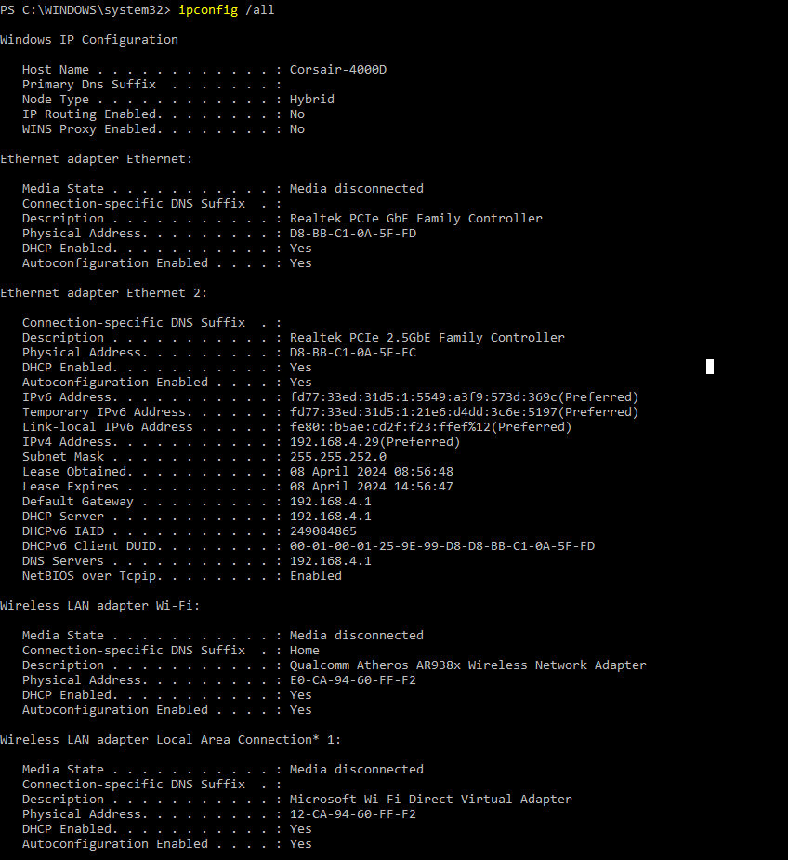

- ‘Tasklist /?’ Command
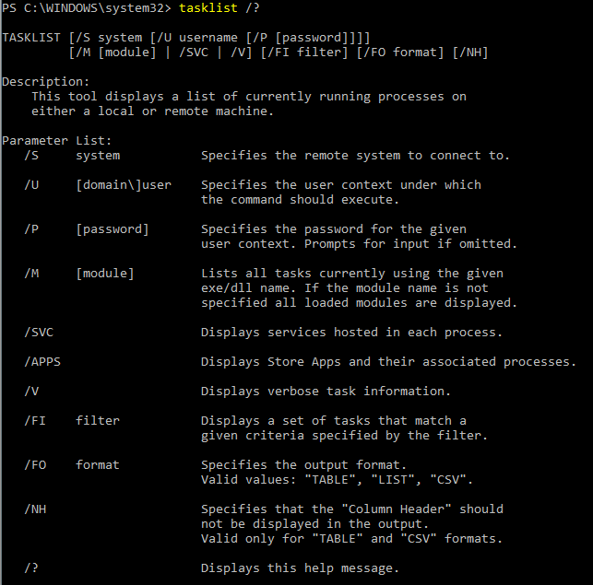
- This command is used to display information about all running processes and their associated process IDs (PIDs). When executed in the command prompt or PowerShell, it shows a brief help message that explains how to use the tasklist command and its various options:

- ‘Taskmgr’ Command
- This command is used to open the Task Manager tool:
- 
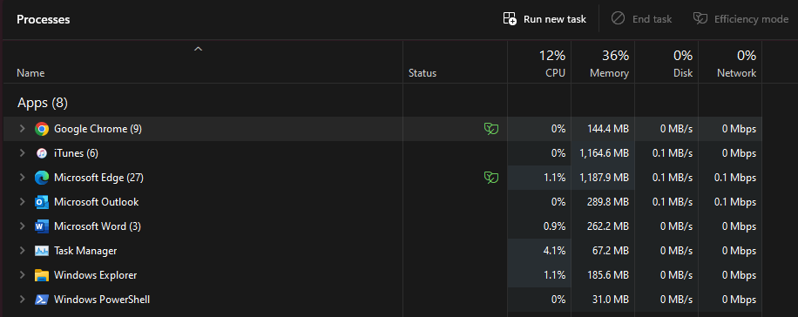
- Here is the tool once opened which shows a list of processes, the performance stats of the computer and much more:

You can see here a list of the programs I currently have open along with the different CPU and Memory usage stats each program is using.
Here is a screenshot of the performance tab:
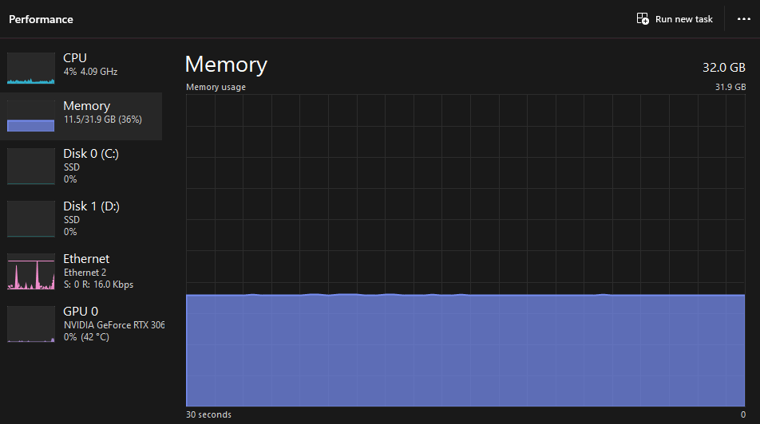
This shows my CPU / RAM / GPU (Graphics Card) that I have within my pc along with the current stats on how they are performing.

- ‘Systeminfo’ Command
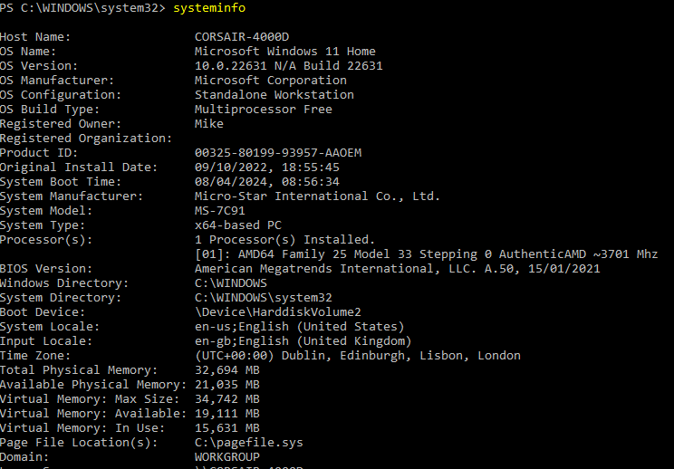
- The systeminfo command in Windows is used to display detailed information about the computer's hardware configuration, operating system, and system components. When executed in the command prompt or PowerShell, it generates a comprehensive report containing various system details:

- ‘Shutdown’ Command
- This command again is self-explanatory in that it will shut down the computer. Additional parameters that can be added include: ‘-s’ which shuts down the computer, ‘-r’ which restarts it and ‘-l’ which logs off the current user. A further switch/parameter can be added which is ‘-t’ and this allows the user to set a time (in seconds) which can be used to delay the command from running.
- An example of the shutdown command could be:
- This will shutdown the pc immediately using the ‘-f’ switch to force close any applications that are running without any warning. If you wanted to restart the pc in 5 minutes, you could use this:
- ‘Net use’ Command
- The net use command in Windows is used to connect, disconnect, and manage network shares, network resources, and mapped network drives. It allows users to map network drives to local drive letters, connect to shared folders on remote computers, and view information about existing connections. Additional parameters can be used such as ‘/user:<username>’ which would specify the username to use when connecting to the shared network. If this is not specified, it would automatically use the current credentials. This is the same as the ‘/password:<password>’ switch.

Task 3: Linux OS CLI Commands (10 Bash Commands)

Examples of BASH Commands

1. ‘ls -l’ Command
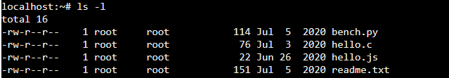
The ls -l command is used in the Linux shell to list detailed information about files and directories in a specific directory. When running this command, the output usually includes several columns of information for each file and directory including: File Permissions, Number of Links, Owner, Group, File Size and File/Directory Name.

Additional parameters can be added to the ls command such as ‘-a’ to list all content including any hidden files or ‘-R’ to list the subdirectories recursively.

2. ‘mkdir’ Command

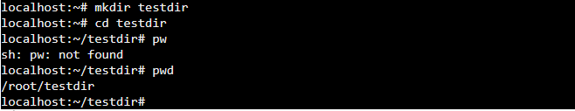
The mkdir command in Unix/Linux is used to create directories (folders) within the file system. It stands for "make directory". An example of this can be seen here where I have created a directory called testdir and used the ‘pwd’ command to print the current working directory:

3. ‘clear’ Command
This is another simple command which can be used in the Linux CLI to clear the current and any previous commands run. Example:
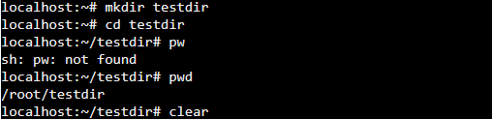

Output:


4. ‘echo’ Command
The echo command in Unix/Linux is used to display a line of text or a string on the terminal. It's a simple and commonly used command for printing messages, variables, or any other text content:

5. ‘cd’ Command
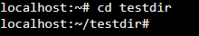
This command stands for ‘Change Directory’. When you execute the ‘cd’ command followed by a directory name, it changes the current working directory to that directory.
Further to this, if you just use the ‘cd’ command on its own without specifying a directory, it will take you to your home directory.

6. ‘pwd’ Command
This stands for ‘Print Working Directory’. This simply tells you the full pathname of the current working directory. Here is an example where I have created a further directory within the original test one I made and then used the ‘pwd’ command to show these directories.
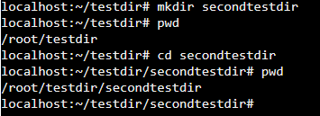

7. ‘rm’ Command
This command stands for Remove and can be used to either remove specific files within the current directory. You can do this to remove singular or multiple files. Or by adding the -r parameter to rm (rm -r) you can then specify a directory to remove, which will also remove all its contents.

8. ‘touch’ Command
This creates a new empty file or updates the timestamp of existing files. To create an empty text file, the command can be used as such:

9. Additional to the standard echo command, this can be used to insert the statement into a file. Here is an example of this:
- ‘cat’ Command
This command can be used in multiple ways. It stands for Concatenate and can display the contents of files but it can also concatenate files and their contents in the order you specify.
Here is an example of it printing out the details within a file from the original echo statement I used above:

Task 4: Windows OS Scripts (PowerShell)
@echo off

:input_name
:: This function asks the user to enter their name which is done using the /p User Input switch
set /p name="Please enter your name: "

:: If the name is empty, jump to the "name_error" label
if "%name%"=="" goto name_error

:input_age
:: Once the user has entered their name, they are asked for their age
set /p age="Please enter your age: "

:: If the age is empty, jump to the "age_error" label
if "%age%"=="" goto age_error

:: A statement is then printed using the variables set from the user input above
echo Hello, %name%! You are %age% years old.

pause
goto end

:name_error
echo Error: You didn't enter a name!
pause
goto input_name

:age_error
echo Error: You didn't enter an age!
pause
goto input_age

:end

pause

Above is my batch script which makes use of the User Input /p switch, Goto, if statement and Variables.
The /p switch allows the user to enter their name and age whilst the set function stores this input as the corresponding variables (objects), An If statement is then used if the name or age is equal to blank (not entered) this then uses the Goto function to display the relative error and then put the user back to the input question until correctly entered.
@echo off
set /p start=Enter starting number:
set /p end=Enter ending number:

echo Looping through numbers %start% to %end%:
for /l %%i in (%start%, 1, %end%) do (
echo %%i
)
pause

The script above is a simple way of demonstrating a for loop while using user input:

@echo off: This command turns off the command echoing in the console, so only the output of the commands will be displayed, not the commands themselves.

set /p start. This line prompts the user to input a starting number. The input is stored in the variable %start%.

set /p end . This line prompts the user to input an ending number. The input is stored in the variable %end%.

echo Looping through numbers %start% to %end%. This line simply displays a message indicating the range of numbers that will be looped through, using the values provided by the user.

In summary, this script prompts the user to input a starting and ending number, then it loops through all the numbers from the starting number to the ending number and displays each number in the window.

I have also used the ‘pause’ function in the script as I found without this, the CLI would open and closed quickly once the script had run, not allowing the user to see the outputs or enter any information required.

@echo off

echo Let's make a shopping list!

:: Prompt the user to enter three items
set /p "shoppinglist[0]=Enter the first item: "
set /p "shoppinglist[1]=Enter the second item: "
set /p "shoppinglist[2]=Enter the third item: "

:: Call a function passing the array
call :printArray shoppinglist
pause
exit /b

:: Define a function to print the elements of an array
:printArray
echo Here is your shopping list:
for /l %%i in (0, 1, 2) do (
call echo %%shoppinglist[%%i]%%
)
exit /b
pause

Here is my batch script which incorporates the use of an array and the call function.

I have asked the user to create a shopping list (using 3 items in an array). The user is prompted 1 by 1 to enter an item. Once 3 items have been entered, I call on the printArray which uses a for loop to echo out each item in the shopping list array created.

Task 5: Linux OS Scripts
echo "Tell me your name?"
read name

echo "Tell me your age?"
read age

echo "Tell me where you live?"
read home

echo "Hello, $name! I see that you are $age years old and you live in $home."

Above is my Bash code that I have produced in order to show the variables and user input.
The system asks for the users name, age and where they live. The read function is then used to store the users input into the corresponding variables.
echo "Enter a number:"
read number

if [ $number -gt 0 ]; then
echo "The number you have entered is more than zero."
elif [ $number -lt 0 ]; then
echo "The number you have entered is below zero and is a minus number."
else
echo "You have entered the number zero."
fi

echo "Printing numbers from 1 to $number:"
counter=1
while [ $counter -le $number ]; do
echo $counter
((counter++))
done

Above is my second example of showing Bash Scripting. This asks the user to enter a number which is then stored in the variable ‘number’ when the user enters it. It then uses an if/elif/else function to check if the number is greater than 0, less than 0 or equal to 0. Based on this, the system will tell the user if the number is a positive number or negative number. After this, a while loop is used to simply print the list of numbers from 1 to whatever number the user has entered. The while loop checks whether the counter is less than or equal to the number entered and cycles through until it reaches that number.

Conclusion

In comparing Batch and Bash commands and scripts, along with Windows and Linux operating systems, I’ve found many similarities and differences.

Both Batch and Bash offer ways to interact directly with the different operating system, performing tasks like managing files and controlling processes. Whilst their abilities vary, they are also very similar.

In scripting, PowerShell in Windows and Bash in Linux provide powerful tools for automation. PowerShell integrates well with Windows, accessing system functions. Meanwhile, Bash scripts in Linux benefit from a wide range of command-line tools and community-contributed packages.

For users, familiarity plays a big role. Those comfortable with Windows might find Batch scripting easier to grasp, while Linux users may prefer the simplicity and flexibility of Bash; however, as mentioned, they are very similar to each other.

Learning Batch or Bash scripting can greatly enhance productivity and efficiency in system administration tasks, regardless of the chosen operating system. The choice between them depends on factors like platform preference and task requirements.

In conclusion, operating systems are the backbone of computing, enabling essential functions such as process management and file system organisation. They provide a platform for software applications to run efficiently and enable users to interact with hardware resources seamlessly.

Additionally, operating systems ensure system security, facilitate communication between software and hardware components, and offer a user-friendly interface for managing tasks and accessing resources. Overall, the key features of an operating system are essential in helping the smooth operation and usability of computer systems.

References

[1]
“The Operating System.” https://itech.erickuha.com/book/ch1-computer-basics/4_operating_system.html (accessed Feb. 05, 2024).
[2]
“Device Management.” https://www.techopedia.com/definition/30187/device-management (accessed Apr. 08, 2024).
[3]
“What is an Operating System?,” 2021. https://www.geeksforgeeks.org/what-is-an-operating-system/ (accessed Jan. 29, 2024).
[4]
S. Gaurav, “File Management in Operating System,” 2022. https://www.scaler.com/topics/file-management-in-operating-system/ (accessed Feb. 05, 2024).
[5]
“What is the user interface and operating system interface?” https://www.tutorialspoint.com/what-is-the-user-interface-and-operating-system-interface (accessed Apr. 08, 2024).
[6]
M. Dancuk, “Memory Management in Operating Systems Explained,” 2023. https://phoenixnap.com/kb/memory-management (accessed Feb. 05, 2024).

Appendices

Tutorial 1 Activity: Types of Operating Systems.

Windows OS was created by Microsoft and is a popular and widely used operating systems. It offers a user-friendly interface, supports many different software and hardware, and is widely compatible. [1]

macOS is developed by Apple and is the operating system used on Mac computers (MacBook, iMac, Mac Pro). It is known for its sleek design, integration with other Apple devices, and a robust set of built-in applications like Safari, Mail, and iTunes. [2]

Linux OS is an open-source operating system based on the Unix kernel. It is highly customisable and used largely in servers, personal computers as well as supercomputers. There are different distributions of Linux, such as Ubuntu, Debian, and Linux Mint. [3]

iOS, by Apple, is the operating system used on iPhones and the iPad. It is known for its security features, integration with other Apple devices, and a selection of apps through the App Store. [4]

Tutorial References

[1] Wikipedia Contributors, “Microsoft Windows,” Wikipedia, Sep. 06, 2019. https://en.wikipedia.org/wiki/Microsoft_Windows

[2] A. Gillis, “What is macOS? - Definition from WhatIs.com,” WhatIs.com, Jan. 2022. https://www.techtarget.com/whatis/definition/Mac-OS

[3] Linux, “What is Linux? - Linux.com,” Linux.com, 2018. https://www.linux.com/what-is-linux/

‌[4] Wikipedia Contributors, “iOS,” Wikipedia, Jun. 06, 2019. https://en.wikipedia.org/wiki/IOS

‌

Linux Unhatched: (Online Course)





