Exercises for lists in Python (2) (SOLUTIONS)

2a. Using float

Create an empty list to hold some temperatures.

temps = []

2b. Allow the user to enter 6 temperature readings into your list. Use .append() and preferably a for loop!

Sample output:

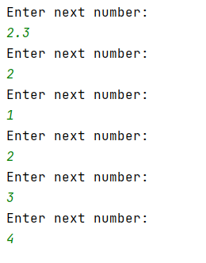

Solution:

temps = []
for counter in range(0,6):
print("Enter next number: ")
temps.append(float(input()))

2c. Print out the numbers entered by the user.

Sample output:

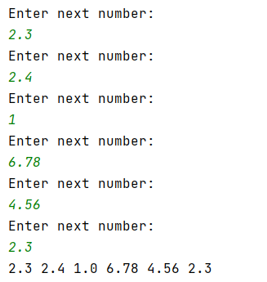

Solution:

temps = []
for counter in range(0,6):
print("Enter next number: ")
temps.append(float(input()))
for counter in range(0,6):
print(temps[counter], end=" ")

2d. Allow the user to select which element they would like to see.

Sample output:

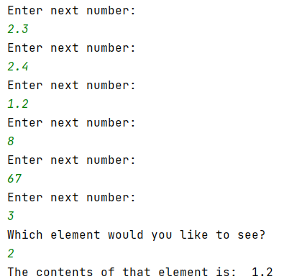

Solution:

temps = []
for counter in range(0,6):
print("Enter next number: ")
temps.append(float(input()))
print("Which element would you like to see? ")
choice = int(input())
print("The contents of that element is: ", temps[choice])

3a Create a program with the following list:

theNumbers = [2, 4, 3, 7, 3, 1, 3, 8, 9]

3b Multiply every list item by 2 and print the result on the screen:

Sample output:

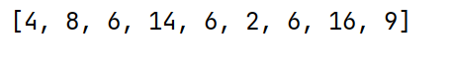

Solution

theNumbers = [2, 4, 3, 7, 3, 1, 3, 8, 9]
for counter in range(0, 8):
theNumbers[counter] = theNumbers[counter] * 2
print(theNumbers)

3c (Harder) – Find the average of the following list (ie add the contents of the list – preferably using a loop – and then divide by the number of entries in the list)

theNumbers = [2, 4, 3, 7, 3, 1, 3, 8, 9]

Sample output:

Solution:

theNumbers = [2, 4, 3, 7, 3, 1, 3, 8, 9]
total = 0;
for counter in range(0,9):
total = total + theNumbers[counter]
average = total / len(theNumbers)
print("The average is: ", average)

OR
(with for…each loop)

theNumbers = [2, 4, 3, 7, 3, 1, 3, 8, 9]
total = 0;
for nextno in theNumbers:
total = total + nextno
average = total / len(temps)
print("The average is: ", average)

4a. Create 2 lists, one of strings and one of integers with 8 entries. The string list will hold names, the integer list will hold telephone extension numbers eg. 4234, 6545

Solution:

theNames = ["Gaynor", "Bob", "James", "Nik", "Mike", "Tim", "Frank", "Callum"]
theTel = [4356, 6757, 4325, 1232, 4314, 4353, 1235, 2543]

4b. Print the lists on the screen as shown in the sample output below, using a for loop.

Sample output:

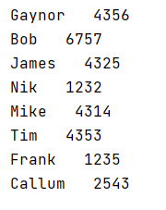

Solution:

theNames = ["Gaynor", "Bob", "James", "Nik", "Mike", "Tim", "Frank", "Callum"]
theTel = [4356, 6757, 4325, 1232, 4314, 4353, 1235, 2543]
for counter in range(0, 8):
print(theNames[counter], " ", theTel[counter])

4c (Harder) Allow the user to enter a name. Look through the list and find the name. When you find it, print out the number associated with that name.

Sample output:

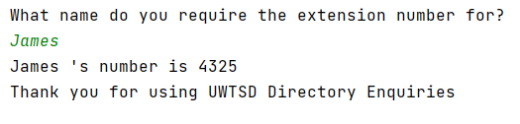

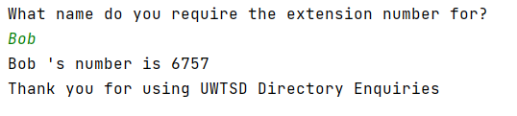

Solution:

theNames = ["Gaynor", "Bob", "James", "Nik", "Mike", "Tim", "Frank", "Callum"]
theTel = [4356, 6757, 4325, 1232, 4314, 4353, 1235, 2543]
print("What name do you require the extension number for? ")
choice = input()
for counter in range(0, 8):
if theNames[counter] == choice:
print(choice, "'s number is", theTel[counter])
print("Thank you for using UWTSD Directory Enquiries")

