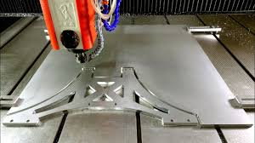

Alternatives to Traditional Machining equipment
  - Advanced PROCESSES & MATERIALS
Andrew Sims | P147955 | 19/11/19

Table of Contents
- Introduction
- Abrasive water jet cutting
- Direct metal laser sintering
- Evaluation
- References

Introduction

CNC (computer numerical control) is a traditional reductive manufacturing process that was developed in the 1940’s to cope with the massive demand for the manufacture of aircraft parts which had complex geometries. Before the use of computers these machines were controlled by punch cards which gave the machine its instructions of where to position its cutting tool on the workpiece.

Today, the programming codes have stayed, but as the power of computers has evolved and replaced the punch cards, the programming language allows the machine to carry out its task with great ease and accuracy albeit under the correct operation of its skilled machinist.

For this assignment, we have been asked to provide 2 suitable alternatives to CNC milling in the production of a helicopter cockpit floor whilst still maintaining a tolerance of +/- 0.0127 cm whilst also hopefully improving the surface quality of the finished product.
The dimensions for this cockpit floor are 50cms x 33cms x 2.5cms which must be taken into consideration when suggesting a feasible alternative.

Abrasive Waterjet cutting

Water jet cutting has gone from a concept first thought of in the 50’s as a solution for logging and deforestation to one of the most widely used manufacturing techniques we use today.
Initially using just water through a high-pressure nozzle, engineers were able to cut through soft materials to a relative degree of accuracy.
It wasn’t until abrasive particles were added to the water in the late 1980’s, the brainchild of Dr M. Hashish, that its true potential to cut through harder materials such as steel

An electro-servo pump will pressurize the water to the high levels required to cut through the material. It is then focused through a small precious stone orifice to generate the cutting stream, (techniwaterjet.com, 2018) often 3 times greater than the speed of sound.
As the water leaves the high-pressure nozzle it has abrasive parts added to it and its accelerated towards the work piece at extremely high pressures. Typical waterjet machine pumps operate at pressures of around 55,000-60,000 PSI ( 4136 BAR) (Smith, 2001) which allows for the removal of material with great ease and most modern machine operate on a 5 axes which allows for greater complexity and intricacy of the finished product.

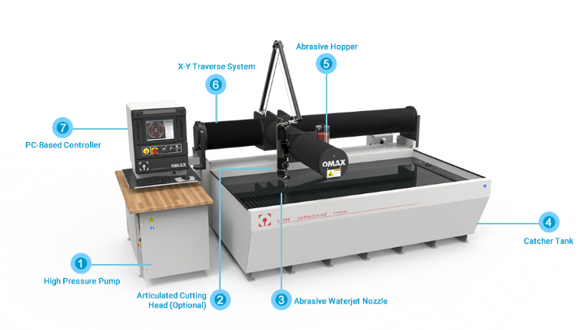
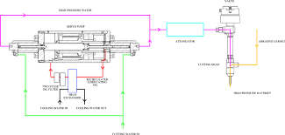

Figure 1. Diagram of components Figure 2. Abrasive water jet
Cutting machine

Traditional CNC milling and water jet cutting are both subtractive or reductive manufacturing methods in that they remove material form the work piece in order to produce the required dimensions. This makes the most sense when trying to manufacture large volume of product with very basic design. However, there are many differences in these methods.

As CNC machines use a very hard cutting tool to remove material which are constantly in need of replacing due to the high stresses and levels of friction they endure. The most common types of wear to a cutting tool are “crater wear” and “flank wear” (Groover, 2011) which although slightly different, both occur as a result of rubbing between the tool and the workpiece . As well as needing to be replaced, these cutting tools can be dangerous both to the user, and the integrity of the finished product if the drill for example becomes jarred or caught in the material. The tooling is expensive to replace and more importantly requires a 100% accurate programme not to damage the piece. The main advantage when it comes to tooling with the AWJ, is that it doesn’t need to change its tooling at all as its all done with the jet. This can again significantly cut down on tooling costs. However, as we stated previously the water jet uses small precious stones to increase the pressure to such high levels and inevitably, these wear down and are not cheap. This means it can often be cheaper to mass produce with traditional CNC instead. Also, if we are cutting steel or harder materials it can have a detrimental affect on the accuracy of the cut. “Waterjet lag” occurs when the exit point of the jet lags the entry point which will affect the accuracy and more importantly in this case, the surface quality. As the jet doesn’t generate heat when it cuts the material, it also protects the strength of the metal and ensured a smoother finish.
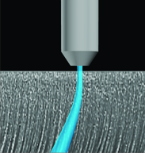
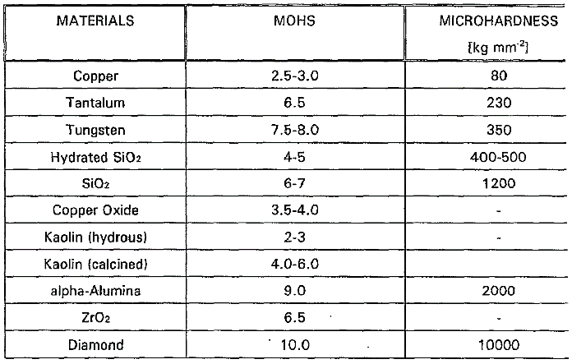

Figure 3.” water-jet lag” Figure 4. Hardness table

This however only occurs when cutting thicker pieces of material or harder materials and as our desired workpiece in this case is only 25mm thick and is made of Aluminum, which is a relatively soft metal, we shouldn’t have a problem with lag or a badly cut surface. This also means that jet would not need to run at such high pressures and would increase the working life of the precious stone orifice inside the attenuator which would also save costs.

This method has similar levels of repeatability to CNC ( roughly 0.0254mm) so there would be no loss there if this method was chosen and also typically has the tolerances we desire of +/- 0.127mm so we know that we can obtain accurate, high repeatable products and ensure the quality of surface due to the lower required pressures to cut through aluminium sheet.

Direct metal laser sintering

Powder metallurgy dates back to the ancient Egyptians for jewelry and other things. Sintering is the third stage after the powder has been blended and mixed and involves heating the powder to a temperature just below melting point to form solid-state bonding of the particles and strengthening of the part (Groover, 2011).
It is a costly but highly efficient additive manufacturing process where the machine takes 3D CAD data and breaks it into 2D layers. A laser is then used to sinter the metal powder to form that layer. The base plate is then lowered, and another layer of powder is spread across on top ready for sintering and the process repeats itself until a final 3D piece is finished. This method is an additive manufacturing process, so it operates without the need for different tooling, any sacrificial material (swarf/excess) and can be produced directly from CAD without the need for a mould or template. As the un-sintered powder acts as support layers which makes it perfect for fit-to-form assemblies.

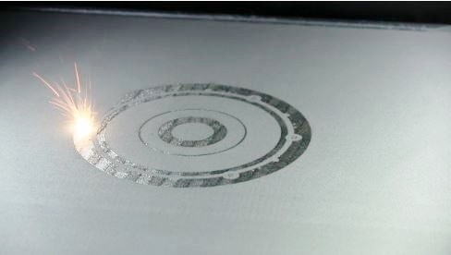
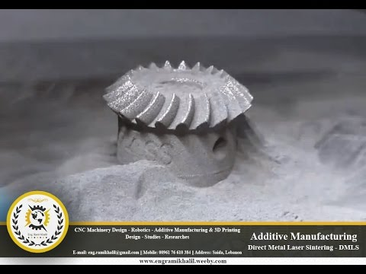

Figure 4. a 2D layer being sintered Figure 5. A completed 3D piece

It has very low tolerances as well as excellent surface roughness which makes it well used in the aerospace industry, for tools, manufacturing aids and small structures. Completed pieces of sintered metal then require additional heat treatment for improved strength.

Evaluation

From looking at both these manufacturing alternatives we can see the qualities which make them possible alternatives to CNC milling. The most obvious contrast is that one is an additive process and the other reductive and although it could be argued that the additive has no waste at all, in this case it’s aluminium, which is cheaper and easier to recycle and reshape than buy new due to its lower melting point (zmescience.com, 2018) The sintering process will achieve great accuracy, repeatability and surface quality but is largely expensive and needlessly complex for this basic helicopter floor part.

It is also time consuming as each layer can be 0.075–0.15 mm depending on material and we need 2.5cm of material in this case so would take longer. The components for both the proposed alternatives are more expensive and harder to come by so would lead to longer lead times and therefore not be too feasible in the long run.

This said however it is still more practical to employ the use of an abrasive water cutter for many reasons. As we are producing a high-quality part that should never need to be replaced, it is better to do it once but to a higher degree of quality which the AWJ would give.The largest consumable cost of running an abrasive water jet cutter is the abrasive itself and the ruby orifice usually lasts up to 40 hours (wardjet.com, 2018).

With this in mind, it would have to be established how long it takes for one floor to be cut this way before it can be compared to the current method of CNC. Even though direct metal laser sintering gives a better completed product it is unnecessary to use such a long and costly process to cut down aluminium to these dimensions (25mm) and the expense of time and money is not justified in this case as the machines themselves go upwards of hundreds of thousands of pounds i.e. the “EOS P 500” model ($250,000) (3dnatives.com, 2018).

References
3dnatives.com, 2018. [Online]
Available at: https://www.3dnatives.com/en/different-sls-3d-printers-220320184/
Groover, M. P., 2011. Principles of Modern Manufacturing. In: s.l.:Hoboken.
Smith, 2001. Waterjet goes mainstream. American Machinist, p. 78.
techniwaterjet.com, 2018. www.techniwaterjet.com. [Online]
Available at: www.techniwaterjet.com/how-it-works
wardjet.com, 2018. www.wardjet.com. [Online]
Available at: https://wardjet.com/waterjet/cost-to-run-a-waterjet
[Accessed 2018].
zmescience.com, 2018. https://www.zmescience.com. [Online]
Available at: https://www.zmescience.com/ecology/environmental-issues/recycled-metal-aluminium-882342/

