2019
Ceri Puddle p150771
UWTSD
5/3/2019
Reseach proposal
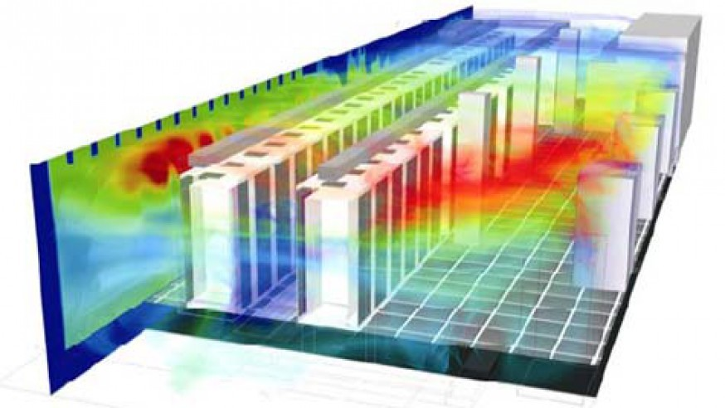
Figure 1
Table of Contents
1.0 Introduction / Background to the proposed research 2
1.1 Title for the project 2
1.2 Why the author chooses to research this topic 2
1.3 Literature review 3
1.4 Datacentre industry 4
1.5 Field of study 5
1.6 The Aim of this Research 5
1.7 Objectives 5
1.7.1 Research 5
1.7.2 Design 5
1.7.3 Build 6
1.7.4 Test 6
1.8 Expected outcome of the research 6
2.0 Research & development methods 7
2.1 Types of test that are going to be carried out 7
2.2 Development methods 8
2.3 Identify risks/limitations 8
2.4 How is the data going to evaluated? 9
3.0 Resources and planning 10
4.0 Gantt chart 11
Bibliography 12

1.0 Introduction / Background to the proposed research

This project proposal will be based on the third-year project that a student of UWTSD will be carrying out. Throughout the proposal, you will find the type of project that is going to be undertaken and what the different task that are going to be undertaken and how the research is going to be carried out. Along with some background information on the subject, the industry of study and literature review on the subject. The ethical and legal issues are also going to be stated in the bottom of the research proposal.
The area of this research is related to computer networks, Data centres, and IOT devices. The paper will be a explaining the problems related to cooling a data centre and how IOT can reduce premature failure of devices. The Idea is to create a device that uses wireless sensors to monitor and warn the data centre staff of a potential problem which might relate in device failure. This will be accomplished by monitoring the temperature of any given device to judge the health and efficiency.

1.1 Title for the project

Is it possible to predict the failure of data centre by monitoring the devices by using wireless sensors?

1.2 Why the author chooses to research this topic

Recently the author got contacted by a friend who works in desktop support saying that the business that they worked for had a site wide failure due to a switch dying. The cause turned out to be that It had clogged up with dust and caused it to overheat, resulting in a premature death of the switch.
After receiving the news, the author was speculated whether this could have possibly been avoided by having a monitoring system to predict if a device is about to fail.

1.3 Literature review

The first source that was studied was called “Economic analysis of data centre cooling strategies”. The article explains the importance of managing data centre’s cooling capability’s through many different medians, such as looking into water-cooling components to help reduce the temperate and increase the lifespan of the devices. Also, in the study the researchers were looking to find the differences between different cooling strategies relating to the efficiency and the complexity of the install, judging whether it was economic or not.
In the study, they stated by reducing the temperature of the devices inside the data centre they could receive improved energy efficient and improve the life cycle of the devices.
Looking more into how heat effects a computer I came across this article that states the following [1]
“Computers have to be kept in a specific environment to function efficiently. Conditions such as heat, cold, dust, and excessive humidity all can damage and lessen the performance of a computer. External and internal temperature especially cause fluctuations of performance, although a computer is more vulnerable to heat than to cold.”
After analysing the article, it was apparent the overheating and humidity have a big role to play when it comes to the life span of the computer components. Further reading discovered that before the system comes to a stop it would try and slow itself down to try and reduce heat that it’s producing causing less than optimal performance for devices such as Hard drives and processors.
“The Effect of Humidity on Static Electricity Induced Reliability Issues of ICT Equipment in Data Centres-Motivation and Setup of the Study” was the next piece of literature to be reviewed, the first part of the paper explains the what ESD (Electrostatic Discharge) is. [2]
“in the normal state of matter, atoms are electrically neutral or balanced as they have an equal number of positively charged protons and negatively charged electrons. Whenever two items, surfaces or materials contact and subsequently separate, one of the involved materials will take electrons from the other.”
ESD is also relative to the local temperature of the datacentre, The higher the temperature the lower the humidity in specific environments
In the conclusion of the paper, they state that a low humidity supports and increase in ESD severity, therefor increasing the risk of damage due to interaction between a human and an electronic device. It appears that Increasing the humidity of a room will help greatly in reducing the amount of ESD and protect components

1.4 Datacentre industry

As technology grows our appetite grows with it. Services like google, Facebook, YouTube, Online forums, ISP’s (internet service providers), Data mining farms and so much more use their own data centres which comprises of a huge area dedicated to processing data for the end user such as people who are searching google or browsing social media.
Since it become more easier to be able to access these sites and our reliance on the internet for everyday tasks, this trend is only set to grow bigger and bigger. This only means one thing, more data centres more users and more powerful devices within the data centre to keep everything running the way it should.
All of this doesn’t come without a cost though. Analysing this news article, it states the following:[3]
“U.S. data centers use more than 90 billion kilowatt-hours of electricity a year, requiring roughly 34 giant (500-megawatt) coal-powered plants. Global data centers used roughly 416 terawatts (4.16 x 10¹⁴ watts) (or about 3% of the total electricity) last year, nearly 40% more than the entire United Kingdom. And this consumption will double every four years.”
What does this mean? Data centres are consuming more and more power based on the figures and this is because as stated in the previous paragraph our use of these data centres has had the industry expand at an exponential rate resulting in a billion-dollar industry struggling to keep up. As devices get faster and the more load placed on the datacentre it is producing more heat. Removing the heat from the data centres is no easy task and is costing the industry a lot of money just to keep the components cool.

1.5 Field of study

The field of study is based around wireless networking and smart devices to allow the devices to be monitored.
The study for this research is going to be based around the monitoring of data centre and IOT deceives. Data centres have a multitude of different devices such as but not limited to: Servers, Routers, Switches, UPS’s, Monitors, NAS’s, Tape Backup, Firewalls, and Modems.
There is a large span of devices inside a data centre each with its own OS’s and software installed on each one. So, there isn’t many software solutions to monitor all the different devices. There is a current solution released by a company called “PAESSLER” which provides a broad monitoring system that along with other features, allows the monitoring of the temperature of the components. The only issue being that they only support devices that run on certain windows operating systems.
After reading the literature it is apparent that heat relates to the sudden death of devices, By understanding that it would be interesting to see if temperature and humidity could be monitored to predict if a device is about to fail. Meaning that it could prove useful and insightful to create a hardware solution to fix the issue using wireless sensors. The idea of the device is to allow a user to be able to prevent a system failure before it results in disruption.
It is an interesting study that would provide a better look on how a device is performing based on the temperature and provide instant feedback to the user if a device needs to be inspected.

1.6 The Aim of this Research

The aim of the research is to create a hardware solution to monitor and report the temperature, humidity, and performance of a device based in a data centre using wireless sensors. Using this an individual should be able to judge whether the device requires maintenance and inspection.

1.7 Objectives

1.7.1 Research
- Reseach Temperature and Humidity, i.e. What are the causes? How the physics works?
- Reseach more into the industry and learn the best ways of measuring temperature and humidity
- Reseach the best hardware to create the system on. I.E Raspberry pie, Arduino, NodeMCU
- Find the best sensor for the system

1.7.2 Design
- Design the device
- Design the flow chart for the code
- Design a storyboard for the website interface
- Produce a network simulation for the wireless sensors
- Design a MySQL database to store the sensor values
- Design a test environment to test the finished system

1.7.3 Build
- Develop the code for the device using C
- Produce a database
- Create and build the temperature and humidity monitoring device
- Create a UI to show the temperatures in a graphical way (html/php)

1.7.4 Test
- Gather results from the test to put into the final report
- Evaluate the results to judge the accuracy of the device.

1.8 Expected outcome of the research

The expected outcome of the research it to be able to predict whether a device is about to fail and reduce the downtime for the device. At the end of the study, a complete system will be created using wireless sensors along with results from the tests using the device. The results should show that with the constant monitoring of the temperature and humidity. Based on the research its recommended to measure the ambient temperature compared to the exhaust temperatures of the devices, this is because any changes in the ambient temperatures will directly affect the output data and skew the results.

Research & development methods

To gather the results from the tests the author is going to be setting up a test environment either in a house or university, This will be created using devices commonly found inside a found inside a data centre such as a routers, Switches, Servers, monitors and such.
The research proposal with be carried out on a positivist method since the data that is going to be derived from the rests is going to be mathematical and can be observed. The types of data to be measured will be temperature numbers and humidity percentages.
The approach that will be taken is a deductive approach, by creating a hypothesis the author will be able to prove or disprove the hypotheses by the results from the test. Example hypothesis:
Is it possible to predict the failure of data centre by monitoring the devices by using wireless sensors?
The strategy that is going to be undertaken is an experimental one since the tests are going to be carried out on physical devices in a simulated environment. The use of software development is also going to be used to create a piece of software to collect the data from multiple different sensors
The test environment must have a constant which would be the ambient temperature and humidity, this will ensure that the output data prove, there will be multiple tests carried out. This is the following list of the types of test that are going to be carried out. The data is all going to be observant using numbers and graphs to display the results. This will provide accurate and clear data that can then be used to prove or disprove the hypothesis.

2.1 Types of test that are going to be carried out

- Simulating different severity levels of dust contamination

This will be achieved by restricting the airflow to the devices, by doing this we can see if the device slows down in efficiency, consumes more power, and if the temperature can be accurately measured.

- Installing the sensor in different locations

Bu installing the sensor in different locations we can judge which sensor placement performs the best. We will also be testing different mounting methods of the sensors such is using a thermal pad, thermal paste for example.

- Testing safe levels of humidity in the test environment
This test will provide a base line for the device to accurately inform if the environment is suited for the devices and if action is needed to ensure the safety of the device.

2.2 Development methods

For the project, there is going to be some software development. This will either be done on a raspberry pie or Arduino system since they both provide a wide range of addons and uses. These devices run on their own languages based upon the C language that is commonly know and is very widespread.
For the development of the device, there is going to be a design flow chart created to show the way the device is going to work. This gives the creator a clear representation of the way the device is going to create and process data throughout the program.
The device is also going to have a MySQL server with an PHP/HTML front end to display the data recived from the server. This is going to be planned using storyboards along with flowcharts. The idea of the storyboards is to show what functions will be displayed on the website and to show what the layout is going to be like.
Development of the sensors is going to be done in NETSIM to decide the best modulation techniques for the wireless communications. Buy running multiple test in net sim, this will show what the best modulation technique is by judging the reliability of the connection measuring the packet loss. To test the best modulation technique e.g (QUAM, BPSK, QPSK ect) a piece of software called MATLAB is going to be used to provide a greater insight to the capabilities of each modulation technique and decide which is most suited to the job.

2.3 Identify risks/limitations

As the project goes, it is based upon creating a device to predict failure of a component. Ideally, this would be best to test this theory on a working datacentre. But there are quite a few problems that are going to have to be addressed if that was the route that is going to be taken.
For example, the risk of loss of data within the data centre would be high because the developer would be in contact with live machines meaning that there is the potential to cause a problem such as knocking out a cable and causing the system to crash. Along with that, there is a lot of personal data that might be present on the working systems that might present some legal issues by allowing the developer into the data centre. Although the device is not going to be direct interacting with their devices in the data centre there are still big hurdles that must be completed in order just to get access to the racks.
To work around this an emulated area with be set up to simulate a data centre avoiding the need to get approval and most probably cause chaos. The Author is going to gather equipment like that of a data centre and create an area either in a house or the university to run the equipment.
Because the device is going to be set up in a contained environment there is little to no legal or ethical concerns that must be worried about. The research will not involve any persons, no personal data and nothing illegal.

2.4 How is the data going to evaluated?

Throughout the document, there was references to the way the data is going to be used. There is going be a lot of analysis and comparisons of base line number that have been provided buy the setup. This will give the results something to compare too. For example, to generate a baseline number for the temperature, the system is firstly going to sit and idle for 30mins to get up to temperature. By doing this the temperature will be able to hit equilibrium and flatline. This figure with then bet the number that the results are going to be compared too.

3.0 Resources and planning

There are going to be some resources that are going to be used to write up the project such as the Microsoft office package for MSword and
There are going to be a lot of resources that are going to be needed to both construct the device and build the simulated data centre. Here is a list of items that are going to be needed to make and develop the device:
- A raspberry pie or Arduino equivalent is going to be needed to create the system that measures the data.
- Multiple sensors that can accurately measure heat and humidity
- Thermal pads/ thermal paste for the mounting method
- A Computer to create and upload the code to the raspberry pie or Arduino (This could either be a personal pc or a university supplied pc)
- MATLAB software is needed to decide upon the best modulation technique
- Netsim is going to be needed to simulate the placement of the sensors and finding the best ways to arrange the nodes.
- Arduino IDE using C is going to be used to code the Arduino/raspberry pie
- Microsoft office package to document the process of creating the device
- A server with mySQL built in, to store the data from the sensors
- Microsoft office code to create a webserver with PHP front end to create a UI for the data
Here is the different resources that are needed to make and create a emulated datacentre:
- Network devices such as routers and switches un a rack configuration
- A server rack to hold the components
- A test area that can be closed off to create its own environment
- Fans to intake and exhaust air
- An infrared heat gun to compare the temperature compared to the sensors to ensure they are accurate
- A temperature reader for ambient temperature readings
- Humidity measuring device
- Some sacrificial devices to test the longevity of them (such as hard disks) when subjected to lack of airflow

4.0 Gantt chart
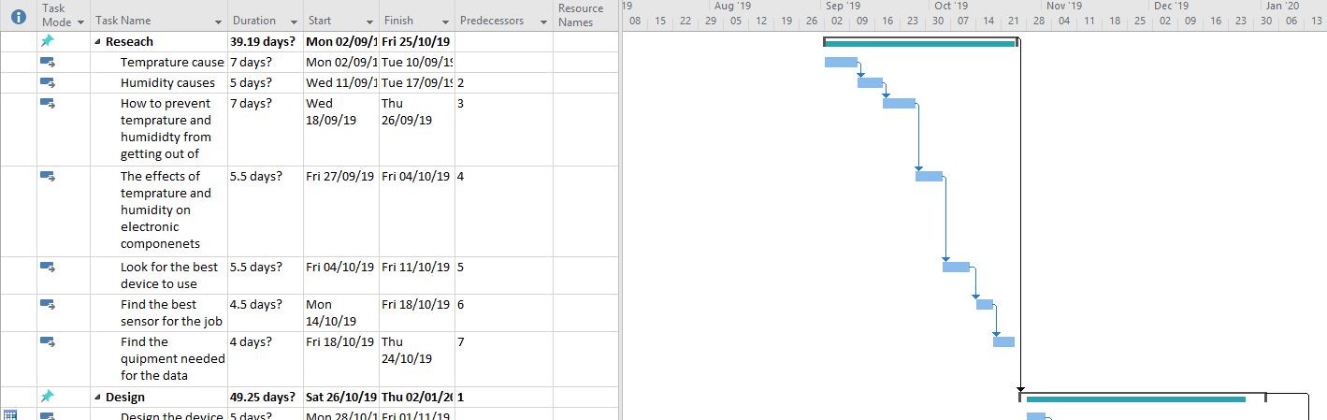
This is the draft version of the Gantt chart that is going to be used for the project in the next academic year. As of right now, there is no confirmation for the official deadlines for term times so this is based off rough dates.
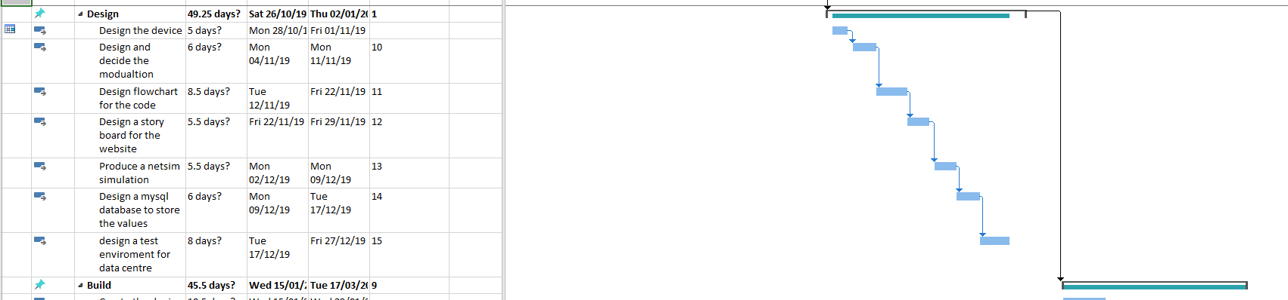
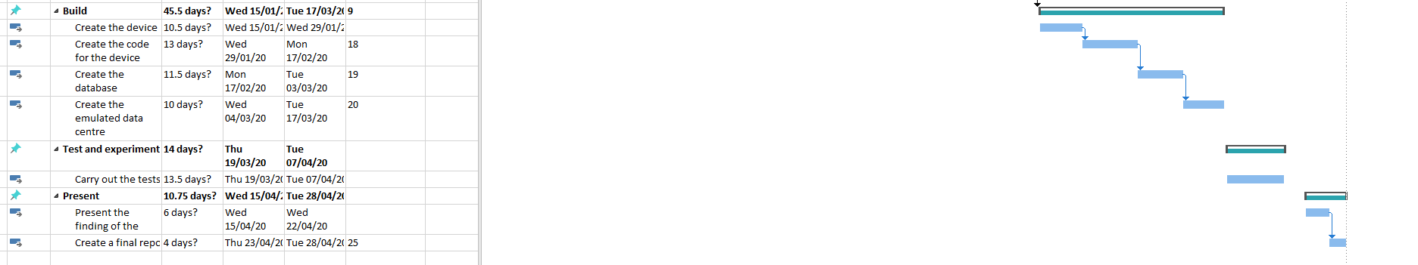

Bibliography

[1]K. Cho, H. Chang, Y. Jung and Y. Yoon, "Economic analysis of data center cooling strategies", Sustainable Cities and Society, vol. 31, pp. 234-243, 2017. Available: 10.1016/j.scs.2017.03.008.
[2]F. Wan, M. Hillstorm, C. Stayer, D. Swenson and D. Pommerenke, "The Effect of Humidity on Static Electricity Induced Reliability Issues of ICT Equipment in Data Centers-Motivation and Setup of the Study", TRANSACTIONS- AMERICAN SOCIETY OF HEATING REFRIGERATING AND AIR CONDITIONING ENGINEERS, pp. 341-357, 2013. [Accessed 3 May 2019].
[3]"Council Post: Why Energy Is A Big And Rapidly Growing Problem For Data Centers", Forbes.com, 2019. [Online]. Available: https://www.forbes.com/sites/forbestechcouncil/2017/12/15/why-energy-is-a-big-and-rapidly-growing-problem-for-data-centers/#708cbcaa5a30. [Accessed: 03- May- 2019].

Figure 1 0
[1]"CFD: An Intuitive Tool for Efficient Thermal Management of Data Centers", Engineeringexchange.com, 2019. [Online]. Available: https://www.engineeringexchange.com/profiles/blogs/cfd-an-intuitive-tool-for-efficient-thermal-management-of-data. [Accessed: 03- May- 2019]

