

NAME: ARUN TEJA GOUD RANGA
STUDENT NUMBER: 22125752

MODULE: LCBM7001

TITLE: MARKETING MANAGEMENT ASSESSMENT 2

LECTURER: TUSHARA BALENDRAN

WORD COUNT: 2000 WORDS OR EQUIVALENT

SUBMISSION DATE: 12/01/2023

Company: Sainsbury’s

Table of Contents
Question A 3
Introduction 3
Conduct an environmental marketing analysis 3
PESTLE analysis 3
Porter’s five forces 5
SWOT analysis 7
Segmentation, targeting and positioning of the company 8
Marketing mix strategies of the company 9
Conclusion 10
Question B 11
Include recommendations for the future 11
References 12

Question A

Introduction
This study aims to explore the environmental marketing analysis and internal environment of Sainsbury’s. Sainsbury’s is the second-highest supermarket chain in the UK, operating over 1400 locations globally and holding sixteen per cent of the entire supermarket sector (ContactPigeon, 2022).
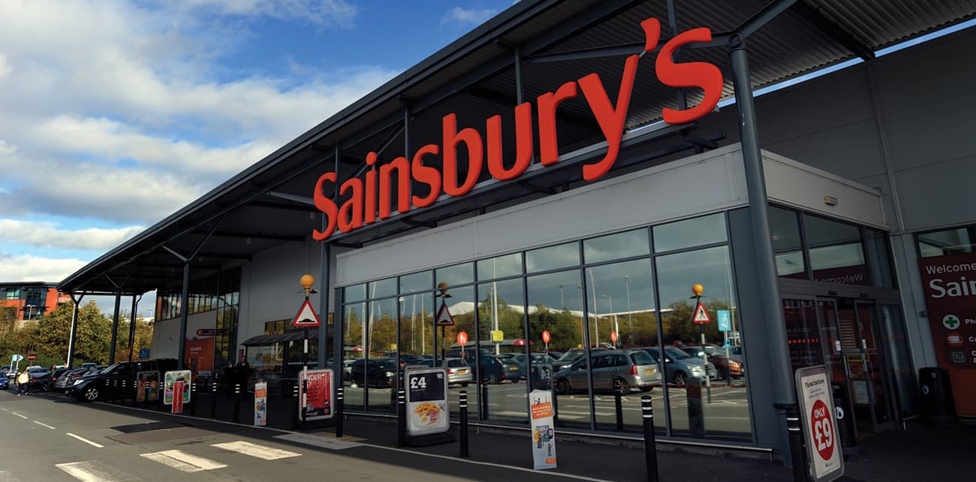
Figure 1: Sainsbury’s
Source: (ContactPigeon, 2022)
In this case, this study elaborates on PESTLE analysis of the UK retail sector for analysing the macro environment. Porter's five forces model of Sainsbury's is also given for exploring the power of the forces. Also, SWOT analysis for showing the capability of Sainsbury's and STP analysis for presenting this company's segmentation, targeting and positioning approach is stated. This section also demonstrates the marketing mix to know its marketing strategies. Lastly, a recommendation section is attached to determine its future marketing strategies.

Conduct an environmental marketing analysis

PESTLE analysis
The PESTEL framework is used to identify and evaluate the external macro-environmental factors of Sainsbury’s. The PESTLE analysis of Sainsbury’s is described below.
Political
1. Brexit is one of the significant political scenarios impacting every business in the UK (Rothwell and Bennett, 2020). As the UK leaves the European Union, the retailers must pay an extra tariff for importing and exporting to other European countries. For this reason, the products' cost is increased, which negatively impacts Sainsbury's as its profit margin becomes less.
2. The stable government of the UK provides an advantage to Sainsbury’s as they do not need to change their business policies frequently.
Economic
1. The UK's gasoline and diesel price is rising gradually (Sonnichsen, 2022). Therefore, Sainsbury's supply chain and transportation costs are highly increased. It results in a threat to Sainsbury's.
2. The GDP of the UK may increase to US$4551.55 in 2027 from US$3376 in 2022. It implies a steady growth in the GDP rate (O'Neill, 2022). Therefore, it will increase the customers' purchasing power, which is an opportunity for Sainsbury’s.
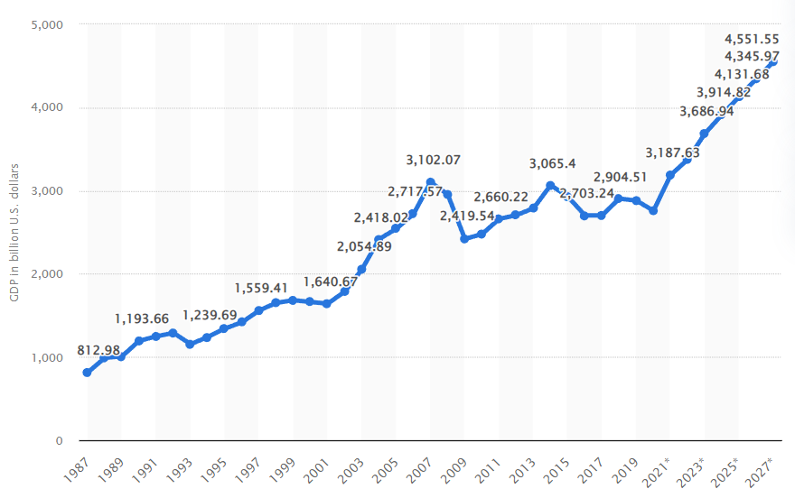
Figure 2: GDP of the UK
Source: (O'Neill, 2022)
Social
1. Customers prefer to buy items from big markets like Sainsbury's these days rather than from neighbourhood retail businesses, as the customers can get a vast range of products from the supermarkets (Davey, 2021). Therefore, it is a positive impact on Sainsbury's.
2. The customers of the UK have become more health-conscious. Therefore, Sainsbury's needs to include healthy products in its product line to gain opportunity.
Technological
1. Research and development sector of the UK is modernised. The company must utilise the advanced technology to benefit from R&D. As a result, Sainsbury's can easily access and implement new technologies in its services to gain a competitive advantage. Therefore, it is an opportunity for Sainsbury’s.
2. Due to technological advancement, the demand for the e-commerce sector is rising. Additionally, Sainsbury’s now provides online buying possibilities (Sainsbury's, 2022). Therefore, it is an opportunity to Sainsbury’s to extend their business online.
Environmental
1. UK Government will implement strict environmental laws to achieve the UN SDGs by 2030 (Lee, 2021). Being a large and responsible company in the UK, Sainsbury’s has to adopt sustainable practices to reduce the harmful effects on the environment.
Legal
1. UK Government has implemented Sugar Tax for every company to fight against obesity and other health diseases. Thus, Sainsbury's has to change its product lines and advertisements to avoid paying these taxes and gain opportunities.

Porter’s five forces
The framework of Porter’s Five Forces helps to explore the external micro-factors and competitive markets for Sainsbury’s (Bruijl and Gerard, 2018). Porter's Five Forces of Sainsbury’s are analysed below.
The threat of New Entrants [Moderate] - New players in the retail industry bring innovation and new methods of operation and exert pressure on Sainsbury's (J) Plc. These new companies provide the same quality products at a lower price, making the situation for Sainsbury's tougher. However, these new entrants require a high infrastructure and financial structure to reach the level of Sainsbury’s. So, the threats of a new entrant can influence the market value moderately.
The threat of Substitutes [Moderate] – As Sainsbury's is a grocery retailer, there is a huge range of alternative products available to other rival supermarkets (Global Data, 2022). Sainsbury's is tackling this by emphasising customer service above product focus, and they also try to comprehend the client's basic needs rather than just what they are purchasing. Based on the customer needs, they make product innovation and make this threat level moderate.
Bargaining Power of Buyers [High] – As per the consumption expenditure ratio of the UK, while considering the grocery industry, consumers have significant negotiating leverage (Sabanoglu, 2022). Price is the driving factor for UK consumers in this sector, and recent occurrences, such as the influx of customers at Lidl and Aldi, have reinforced this claim. As the customers' switching cost is low, buyers' bargaining power can highly impact business growth.
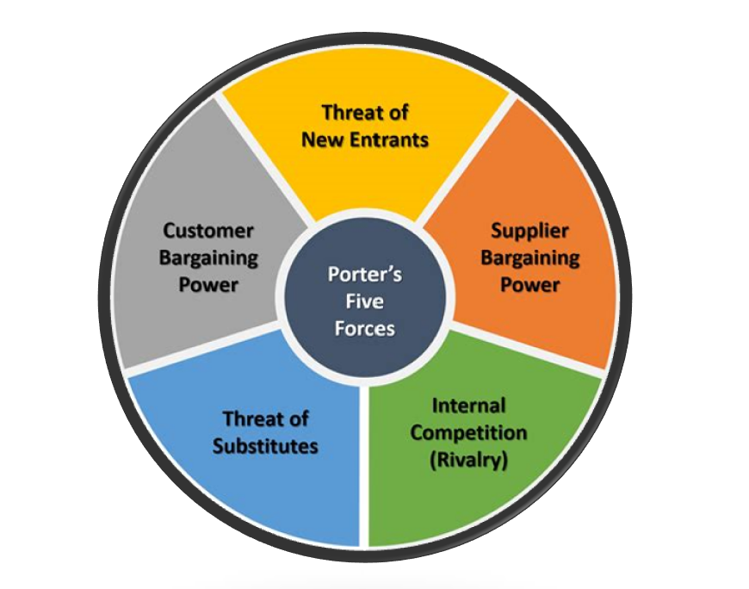
Figure 3: Porter’s Five Forces
Source: (Bruijl and Gerard, 2018)
Bargaining Power of Suppliers [Low]- Several suppliers in the UK market provide retail products. As Sainsbury’s brand image is high, the suppliers want to make a good relationship with this company. As a result, the negotiation power of the suppliers is reduced, which makes this threat low.
Competitive Rivalry [High] – Due to the intense rivalry among Tesco, Morrisons, Asda, Aldi, Lidl, Amazon and more, Sainsbury’s get a huge competitive threat (Jones and Comfort, 2020). These large sectors make continuous innovations and cut prices to gain a competitive advantage. Therefore, Sainsbury’s has to face a high threat of competitive rivalry.

SWOT analysis
SWOT analysis is the most effective framework to analyse Sainsbury's internal strengths and weaknesses and external opportunities and threats.
Strengths | Weaknesses
a) Collaboration with celebrities - One of the major sponsors of the Paralympics is Sainsbury's. Ellie Simmonds, David Beckham, and Jamie Oliver are just a few celebrities and influencers brought on as Sainsbury's ambassadors.  b) Widespread operations - More than 600 supermarkets and 800 convenience outlets have been opened by Sainsbury’s. Customers find this accessibility appealing, which expands the number of people who use the brand (Walker et al., 2022).  c) Listed on the stock exchange – Sainsbury's could expand and resolve its cash flow issues because of the enormous sums of money it made from selling its shares in the process (Xiao et al., 2021). | a) Weakness in marketing: Sainsbury's marketing seems to be forgetful for the people. Moreover, the profit margin has shrunk because of operational expenses (Kuijpers et al., 2018).  b. High Price: Sainsbury's products are higher than discounted stores like Aldi and Lidl. Therefore, many price-sensitive customers prefer something other than Sainsbury’s.
Opportunities | Threats
1. Economic shift: For the customer prevalence and economic uplift of the people, most customers have shifted towards Sainsbury’s services. In this case, Sainsbury’s has already converted 5-6 focus DIY stores into supermarkets (Xiao et al., 2021).  2. Growth in villages: People from rural areas have recently utilised branded products. Therefore, it provides an opportunity for the supermarkets like Sainsbury’s for further expansion. | 1. Covid-19 pandemic: The worst pandemic to have occurred recently was COVID-19. Sainsbury’s reported a $304.4 million loss as a result (Jones and Comfort, 2020). Now that the lockdowns have been removed, things appear to be returning to normal. For Sainsbury’s, the pandemic threat yet remains.  2. Intense competition: There are several large retail sectors like ASDA, Tesco, Lidl, Aldi, Morrison's, Amazon etc., which makes a substantial competitive threat to Sainsbury’s (Jones and Comfort, 2020).

Segmentation, targeting and positioning of the company
STP analysis is a practical framework for determining the company's segmentation, targeting and positioning approach (Camilleri, 2018). Here, it is applied to Sainsbury's.
Segmentation: Sainsbury’s follows demographic and psychographic segmentation to segment the specific market. Demographic segmentation is based on consumers’ age, gender, generation, and income, whereas psychographic segmentation depends on consumers' wants, interests, and lifestyles.
Targeting: As per demographic segmentation. Sainsbury’s targets people aged between 15 to 80 as all people of this age go to their supermarket store for comfort (Shastri, 2022). They also target middle-class families as their product pricing is reasonable. Based on psychographic segmentation, the targeted consumer of Sainsbury's is those who want all things to purchase from one place and want the best quality as they are the largest supermarket chain in the UK. However, they mainly target the family unit, especially Mother.
Positioning: The positioning approach of Sainsbury’s is shifted as per the changing preferences of its targeted consumer base. They provide the best quality products with affordable pricing, which also meet the targeted audience's needs (Xiao et al., 2021). This strategy helps them position themselves in the market and create positive consumer value. The perceptual map is drawn here to determine positioning in the competitive marketplace, which allows them to develop competitive benefits.

Sainsbury’s

High-quality Product

Low price
High price

(Figure: Positioning of Sainsbury’s)
Low-quality
(Source: Created by the author)
Figure 4: Position Mapping
Source: (Self-created)

Marketing mix strategies of the company
The 4Ps of the marketing mix can be implemented to determine the marketing strategies of Sainsbury's (Mahmoud, 2019).
Product
Sainsbury's has a vast range of services and products from several brands. It has approximately 15,000 own branded products (Jones, 2022). Sainsbury's products include grocery, frozen foods, drinks, meat, bakery, cleaning products, electronics, health and beauty products, clothing, and entertainment. This company invests a vast amount of product for product development, and many customers prefer this company for its high product quality.
Price: Sainsbury's sets its products' prices aligning with its positioning strategies. This company has positioned in the medium to high-end market (Kim et al., 2021). For this reason, it maintains a premium pricing strategy for many products. On the other hand, many primary products come at a lower price than other competitors. It also supports a penetration pricing strategy for several products to get a competitive advantage over the price wars. For example, in 2020, it cut off its 300-branded products' price by 30% to gain a competitive advantage (Kim et al., 2021).
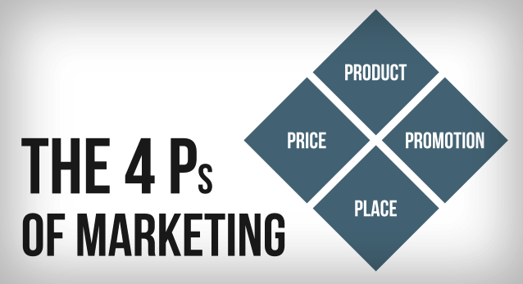
Figure 5: 4Ps of the marketing mix
Source: (Mahmoud, 2019)
Place: Customers can avail of Sainsbury's products from supermarkets, offline stores and online. This company consists of 800 convenience stores and 600 supermarkets (Walker et al., 2022). It has an online application from which customers can order their products. In 2021, Sainsbury's received more than 250,000 online orders weekly. Therefore, Sainsbury's utilises all the available channels to increase customer satisfaction.
Promotion: Sainsbury's utilise radio, TV, newspapers and social media to promote its products. Sainsbury's indulges in celebrity endorsements like Jamie Oliver, Daniel Sturridge, David Beckham etc., to promote its products. This company was the only sponsor of the London 2012 Paralympics (Hassan, 2018). Additionally, in recent days, it has focused more on social media promotion to get competitive advantages in this digital era. It also provides discounts and loyalty schemes like the "Nectar reward card' to increase customer loyalty.

Conclusion
After analysing the whole study, it can be concluded that Brexit, increasing the price of gasoline, sugar tax, strict environmental regulations, and intense competition are some threats to Sainsbury's. Contrarily, GDP growth, customers' preference for supermarkets, and rural market expansion are some of Sainsbury's opportunities. However, the financial structure and collaboration with celebrities are some of the strengths, but they have a weakness in marketing. Sainsbury’s targets people aged between 15 to 80 years from a middle-class family and position the products with medium price and high quality. It has more than 15000 own branded products. It maintains both premium and penetration pricing strategies for its products. It uses all types of channels to avail its products to the customers.

Question B

Include recommendations for the future
Some recommendations should be followed by Sainsbury’s for developing future marketing strategies.
1. Sainsbury’s needs to focus on new product development per the consumers' demand and preferences, as the needs of consumers have been changing daily after the pandemic (Morgan and Liker, 2020). Therefore, to keep consumers engaged, this company should make new things. As UK citizens become health-conscious, they should bring healthy food options. It can help Sainsbury's generate a considerable profit and eliminate the pandemic threat.
2. To resolve competitive threats and develop a competitive advantage, Sainsbury's is recommended to sell online as people prefer online shopping to stores. Therefore, they can promote social media at a higher rate by investing more in this aspect (Dannenberg et al., 2020). It will help to get new consumers and retain the existing consumers so that they can keep competitive in the market.

References
Bruijl, D. and Gerard, H.T. (2018) The relevance of Porter's five forces in today's innovative and changing business environment. Available at SSRN 3192207.
Camilleri, M.A. (2018) Market segmentation, targeting and positioning. In Travel marketing, tourism economics and the airline product (pp. 69-83). Springer, Cham.
ContactPigeon (2022) Sainsbury's marketing strategy: Becoming the second-largest supermarket chain in the UK - contactpigeon: Blog, ContactPigeon. Available at: https://blog.contactpigeon.com/sainsburys-marketing-strategy/ (Accessed: December 16, 2022).
Dannenberg, P., Fuchs, M., Riedler, T. and Wiedemann, C. (2020) Digital transition by COVID‐19 pandemic? The German food online retail. Tijdschrift voor economische en sociale geografie, 111(3), pp.543-560.
Davey, J. (2021) Britain's Sainsbury's makes it personal in price battle with rivals. Accessed on: 14 December 2022. Available at: https://www.reuters.com/business/retail-consumer/britains-sainsburys-makes-it-personal-price-battle-with-rivals-2021-09-15/
Global Data (2022) J Sainsbury Plc: Competitors. Accessed on: 14 December 2022. Available at: https://www.globaldata.com/company-profile/j-sainsbury-plc/competitors/
Hassan, M.R. (2018) Theses Report On Identification Of The Role of Buying Office in Developing Garment Product Quality and Promotional Strategy (Doctoral dissertation, Jahangirnagar University).
Jones, P. (2022) UK Retailers and Plant-Based Alternatives to Meat and Dairy Products. Athens Journal of Business and Economics, 8, pp.1-13.
Jones, P. and Comfort, D. (2020) A commentary on the United Kingdom's leading food retailers' resilience plans in the face of climate change. Journal of Public Affairs, 20(2), p.e2047.
Kim, S.H., Lan, H. and Dobson, P.W. (2021) Identifying price-leadership structures in oligopoly. Oxford Economic Papers, 73(1), pp.350-370.
Kuijpers, D., Simmons, V. and Van Wamelen, J. (2018) Reviving grocery retail: Six imperatives. McKinsey & Company.
Lee, J. (2021) COP26: Supermarkets promise to halve environmental impact by 2030. Accessed on: 14 December 2022. Available at: https://www.bbc.com/news/uk-59184278
Mahmoud, T.O. (2019) Green marketing: A marketing mix concept. International Journal of Electrical, Electronics and Computers, 4(1), pp.20-26.
Morgan, J.M. and Liker, JK (2020) The Toyota product development system: integrating people, process, and technology. Productivity press.
O'Neill, A. (2022) United Kingdom - gross domestic product (GDP) 2027. Available at: https://www.statista.com/statistics/263590/gross-domestic-product-gdp-of-the-united-kingdom/ (Accessed: December 17, 2022).
Rothwell, J. and Bennett, A. (2020) Brexit explained: All your questions answered about the UK leaving the EU. Accessed on: 14 December 2022. Available at: https://www.telegraph.co.uk/politics/0/brexit-explained-questions-answered-consequences-why-uk-leaving-eu/?WT.mc_id=tmgoff_psc_ppc_dsa_politics&gclid=CjwKCAiAheacBhB8EiwAItVO20n-CE05ZgiNMuzdiVB_5LkwdHAtAm6A1v9aWLNYWZff82yP5kte5xoC708QAvD_BwE
Sabanoglu, T. (2022) Household consumption expenditure in the United Kingdom (UK) from 2005 to 2021(in million GBP). Accessed on: 14 December 2022. Available at: https://www.statista.com/statistics/368665/consumer-expenditure-united-kingdom-uk/
Sainsbury's (2022) Delivery, Your Way. Accessed on: 14 December 2022. Available at: https://www.sainsburys.co.uk/webapp/wcs/stores/servlet/gb/groceries/discoverhome/shopping-online/delivery?storeId=10151&langId=44&krypto=Y%2BHp25RYUXBOyiX4ZBBOykRRqK5m0DdwxRRCckJgSj8qs%2FaosNiLfKYjfs9bJw%2B8r%2Bb0FEOFTsxRj45%2Fe4WsEoZpwUVa3eYdgJiEjV%2FPIfLGQ7wjtjttecTONzGBCmjp1MLjCwfeld0hWITP3Ba%2BYnqjiTkv%2F9R%2BYQ0l9HULnGQ%3D&ddkey=https%3Agb%2Fgroceries%2Fdiscoverhome%2Fshopping-online%2Fdelivery
Shastri, A. (2022) Extensive marketing strategy of Sainsbury's - 2022, IIDE. Available at: https://iide.co/case-studies/marketing-strategy-of-sainsburys/#:~:text=Segmentation%2C%20Targeting%2C%20and%20Positioning%20Sainsbury%E2%80%99s%20pricing%20strategy%20is,only%20delivers%20a%20short-term%20gain%20in%20market%20share. (Accessed: December 16, 2022).
Sonnichsen, N. (2022) Average price of diesel fuel in the United Kingdom (UK) from September 2017 to September 2022. Accessed on: 14 December 2022. Available at: https://www.statista.com/statistics/299552/average-price-of-diesel-in-the-united-kingdom/
Walker, S., Stratton, C. and McVinnie, S. (2022) Is Sainsbury's open today? queen funeral bank holiday opening, The Sun. The Sun. Available at: https://www.thesun.co.uk/money/18693221/sainsburys-bank-holiday-opening-times/ (Accessed: December 17, 2022).
Xiao, B., Chen, Q. and Yu, Z. (2021, April) Research on the Investment Value of Sainsbury’s. In 2021 6th International Conference on Social Sciences and Economic Development (ICSSED 2021) (pp. 108-115). Atlantis Press.
Xiao, B., Chen, Q. and Yu, Z. (2021, April) Research on the Investment Value of Sainsbury’s. In 2021 6th International Conference on Social Sciences and Economic Development (ICSSED 2021) (pp. 108-115). Atlantis Press.

