Name: favour obi
Student id: 2502853
Assignment title: Aims and objectives of the event, and the short-term and long-term impacts (economic, social, cultural, environmental, and political) of the chosen industry
Lecturer name: Debbie Jenkins
Submission date: 27th of November
Word count: 1,900
Module code: BMTP4018

Module name; tourism, events, and leisure industry

Introduction
This report talks about Glastonbury, a small town in Somerset in the UK. The town is known because of the Glastonbury Festival. This festival is one of the biggest music and arts events in the world. It happens every year. More than 200,000 people come to the event. Many visitors travel by train, bus, coach, or car. They often arrive from big cities like London, Bristol, and Bath. The aim of this report is to explain the festival in very simple words and show how it affects the town. The report also explains how people travel, how visitors behave, what they want, and what type of tourists they are. At the end, the report gives ideas to help keep the festival and town safe and sustainable in the future.

Event Overview and Importance

The Glastonbury Festival started in 1970 on a farm. At first it was small. Now it is one of the biggest festivals in the world. The festival has music, art, food, culture, camping, and many fun activities. People from all around the world come to enjoy it. Because the festival happens every year, it has a big effect on Glastonbury. It changes how people see the town, how much money comes in, and how people in the area live during the event.

Industry Trend: Overtourism

Overtourism means too many people visit the same place at the same time. This causes problems like crowding, noise, traffic, long lines, lack of space, and stress for local people. Glastonbury has overtourism during the festival because the town becomes extremely full. The roads get blocked, buses become packed, and shops get very busy. This makes things hard for both residents and the festival team.

Aims and Objectives of the Event

The main aim of the Glastonbury Festival is to celebrate music, art, and culture. Another aim is to bring people together and create a joyful and peaceful atmosphere. The festival also wants to support charities and help the area earn money. It aims to create a safe and enjoyable space for all visitors and to stay strong for many years.

The festival also has clear objectives. One important objective is to keep visitors safe by having security teams, medical staff, and good rules. Another objective is to help local businesses by working with them and creating jobs. The festival also wants to protect the environment by recycling more, using green energy, and reducing waste. It also wants to stay popular in the future.

Short-Term Impacts

The festival has many short-term effects. One big effect is economic. During festival week, local shops, food stalls, hotels, farms, and taxis make a lot of money. Many temporary jobs appear, which helps local workers.

There are social effects too. The festival brings people together and creates a strong feeling of community and happiness. But many local people feel stressed because of loud noise, traffic, and large crowds.

Cultural impacts also happen. The festival celebrates art, music, and creative activities. People from different backgrounds come together and share ideas.

The environment is affected as well. There is a lot of waste on the ground. The land can get damaged because so many people walk on it. Cars and buses create pollution.

The festival also creates political impacts. Local leaders need to make rules about safety, cleaning, and crowd control.

Long-Term Impacts

The festival also has long-term effects. Economically, Glastonbury becomes more famous and attracts visitors all year round. This helps businesses grow. But it can also make house prices go up, which makes it harder for some people to afford living there.

Socially, the town becomes well known, which can make people proud. But too many visitors over time can make life harder for some residents.

Culturally, the festival keeps creativity alive. It helps protect music and art traditions. It also brings new ideas to the area.

There are long-term environmental effects too. Land that is used each year can become weak. But the festival now uses more green energy, better recycling, and new systems to reduce waste.

Politically, the festival affects planning in the area. Local leaders must always plan transport, safety, and community support because of the event.

Transport Accessibility and Travel Management

Glastonbury does not have its own train station. The closest train stations are Castle Cary and Bristol Temple Meads. Visitors travel to these stations and then take shuttle buses to the festival. Many people come by coach because it is cheaper and better for the environment. Good travel planning is important. It helps reduce traffic, keeps people safe, and makes travel less stressful.

Target Markets and Visitor Profile

The festival attracts many kinds of visitors. Young adults come for music and camping. Families come for art, food, and activities. Older adults come for comfort and certain performances. Many international visitors come because the festival is famous worldwide.

Visitor Behaviour and Typologies
Cohen’s model looks at how familiar or new a tourist wants their trip to be. It explains four types of tourists. The first type is the Organised Mass Tourist. This person wants a trip that is already planned for them. They like package holidays where someone else decides where they stay, what they eat, and what they do. They travel in groups and do not want any surprises. They want comfort, safety, and things that feel familiar, like normal hotels and food they already know.
The second type is the Individual Mass Tourist. This person is still part of mass tourism, but they have a bit more choice. They may book their own flights and hotel, but still use common tourist services. They may join tours but also choose some activities themselves. They still like comfort and safety, but they enjoy having small amounts of freedom. They use normal tourism places like big hotels and busy attractions.
The third type is the Explorer. This person travels on their own and likes to see new things, but they still stay safe. They do not want crowded tourist places, but they also do not want to be completely alone without help. They may book a hotel early but spend most of their time exploring local places. They like culture and meeting local people, but they still keep a “safety net” so they never feel unsafe.
The fourth type is the Drifter. This person wants full freedom. They do not want tourist areas at all. They avoid big hotels, busy attractions, or guided tours. They do not plan every detail. They want to live like the local people and see the real culture. They often stay for a long time and move from place to place with no fixed plan.
These four tourist types show that some tourists want familiarity and comfort, while others want new and different experiences. Organised and Individual Mass Tourists enjoy familiar places, while Explorers and Drifters want new and exciting experiences.
Plog’s model explains tourist behaviour using personality traits. It says that different people choose different places based on their personality. Plog’s model has tourists on a line from “psychocentric” to “allocentric.” Psychocentric tourists prefer safe, familiar places and planned trips. Allocentric tourists prefer adventure and new places. Most tourists fall in the middle, which is the “mid-centric” group.
Psychocentric tourists like simple, predictable holidays. They like things that feel safe and easy. They often take package holidays or travel close to home. They do not want surprises or challenges. They like places with strong tourism services, such as resorts and guided tours.
Allocentric tourists are the opposite. They want adventure, new places, and exciting experiences. They enjoy going somewhere different that most people do not visit. They like flexible plans and often travel alone. They enjoy hiking, backpacking, cultural exploring, or trying things they have never seen before.
The largest group is the Mid-centric tourist. This person likes some comfort but also likes some new experiences. They may go to new countries but still want good hotels and safe transport. They like a balance between adventure and relaxation. They may plan some parts of the trip but also leave time for exploring.
Plog’s model helps tourism businesses because it shows what different tourists want. It helps places understand what type of visitor they should attract. It helps travel companies design the right products, such as adventure trips for allocentric tourists or safe package holidays for psychocentric tourists. It also helps destinations create better marketing because they can show the right message to the right type of visitor.
Both Cohen’s and Plog’s models are important because they help us understand how different people travel. Some visitors want comfort. Some want adventure. Some want a mix of both. These models help tourism workers plan trips, build better services, and make sure visitors enjoy their travel. They also help destinations think about how to grow and attract the right type of tourists.

Maslow’s theory explains visitor needs. The festival gives food, water, and shelter. It provides safety through security and medical teams. People feel social connection because they meet others. They feel esteem when they enjoy music and express themselves. They feel self-growth when they feel inspired and creative.

Current Trends in Event Tourism

There are new trends in event tourism. One trend is sustainability. Glastonbury tries to reduce waste, stop single-use plastic, and use green energy. Another trend is hybrid and virtual events. Since COVID-19, many people watch festivals online. Glastonbury streams performances for people who cannot attend.

Another trend is destination development. Big events help improve roads, buses, and services. Glastonbury builds new temporary structures each year to support visitors.

The festival matches many event tourism features. It has high demand. It makes the area busy during festival season. It makes Glastonbury famous. It brings a lot of money to the area.

Conclusion

Glastonbury is a very important tourism place because of the festival. The festival brings economic, social, cultural, environmental, and political impacts. Overtourism is one of the biggest issues because the event brings many people at once. But with good travel planning and sustainability work, problems can be controlled. Visitors come for different reasons, and their behaviour matches known theories. With good planning, the festival can stay strong and sustainable for many more years.

Recommendations

government should improve bus routes, add more recycling areas, and protect residents during festival week. Event organisers should use more green energy, improve safety plans, and reduce waste. Businesses should offer eco-friendly products and fair prices. Community members should join meetings and talk about their concerns. Visitors should use public transport and follow recycling rules. Policy-makers should support sustainable tourism rules. Tourism boards should promote visits outside the festival season and help train workers.

References (Harvard Style)
VisitBritain (2024) Glastonbury Festival Tourism Impact Report.
Somerset Council (2023) Transport Planning for Major Events.
Smith, J. (2022) Event Tourism and Destination Management.
Brown, L. (2023) Overtourism in Rural UK Destinations.
Glastonbury Festival (2024) Sustainability Policy.
Plog, S. (2020) Tourist Behaviour Models.
Cohen, E. (2019) Tourist Typologies and Motivation.
Maslow, A. (2018) Hierarchy of Needs in Tourism.
UNWTO (2024) Trends in Global Event Tourism.
Green Events Report (2023) Eco Practices in UK Festivals.
BBC News (2024) Travel Updates During Glastonbury.
UK Tourism Board (2023) Visitor Profiles and Motivations.
Hall, C. (2022) Event Impacts on Local Communities.
EventPro (2024) Hybrid Event Trends.
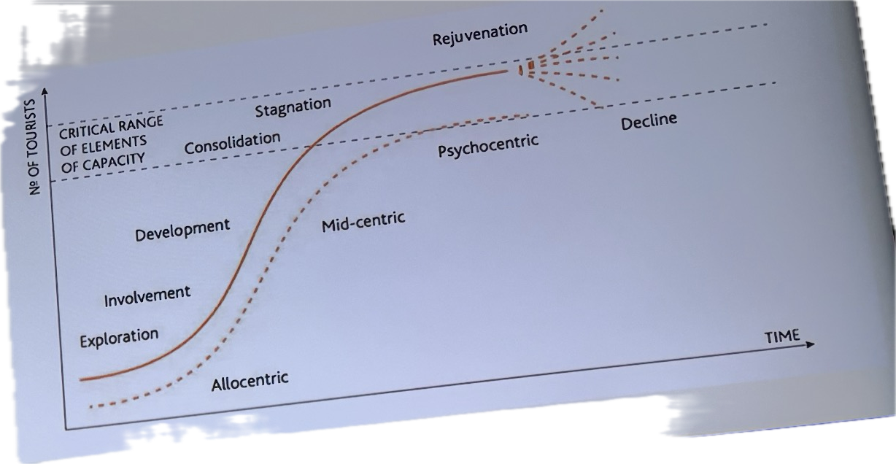
Travel Weekly (2023) Destination Development and Tourism Growth.

