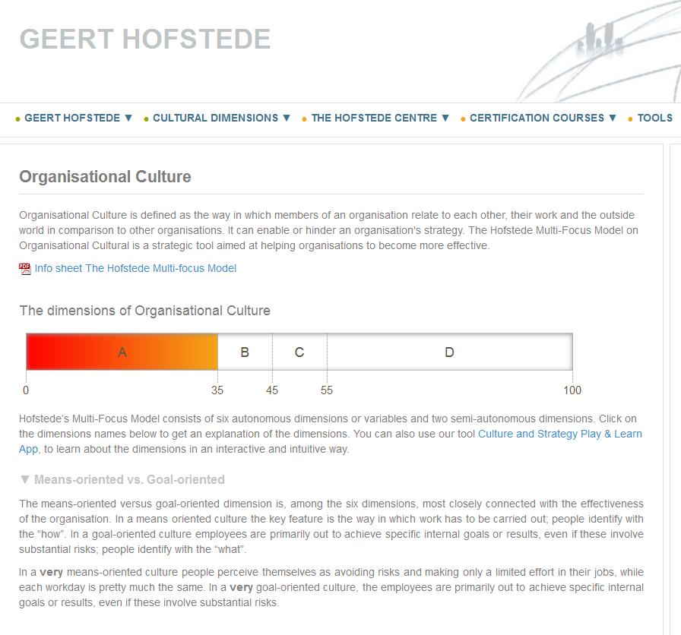

Internally driven vs. Externally driven
In a very internally driven culture employees perceive their task towards the outside world as totally given, based on the idea that business ethics and honesty matters most and that they know best what is good for the customer and the world at large. In a very externally driven culture the only emphasis is on meeting the customer’s requirements; results are most important and a pragmatic rather than an ethical attitude prevails.
This dimension is distinguishable from means- versus goal-orientation because, in this case, it is not impersonal results that are at stake, but the satisfaction of the customer, client or commissioning party.

Easygoing work discipline vs. Strict work discipline

This dimension refers to the amount of internal structuring, control and discipline. A very easygoing culture reveals loose internal structure, a lack of predictability, and little control and discipline; there is a lot of improvisation and surprises. A very strict work discipline reveals the reverse. People are very cost-conscious, punctual and serious.
Local vs. Professional
In a local company, employees identify with the boss and/or the unit in which one works. In a professional organisation the identity of an employee is determined by his profession and/or the content of the job. In a very local culture, employees are very short-term directed, they are internally focused and there is strong social control to be like everybody else. In a very professional culture it is the reverse.
Open system vs. Closed system
This dimension relates to the accessibility of an organisation. In a very open culture newcomers are made immediately welcome, one is open both to insiders and outsiders, and it is believed that almost anyone would fit in the organisation. In a very closed organisation it is the reverse.
Employee-oriented vs. Work-oriented
This aspect of the culture is most related to the management philosophy per se. In very employee-oriented organisations, members of staff feel that personal problems are taken into account and that the organisation takes responsibility for the welfare of its employees, even if this is at the expense of the work. In very work-oriented organisations, there is heavy pressure to perform the task even if this is at the expense of employees.
Degree of acceptance of leadership style
This dimension tells us to which degree the leadership style of respondents’ direct boss is being in line with respondents’ preferences. The fact that people, depending on the project they are working for, may have different bosses doesn’t play a role at the level of culture. Culture measures central tendencies.
Degree of identification with your organization
This dimension shows to which degree respondents identify with the organisation in its totality. People are able to simultaneously identify with different aspects of a company. Thus, it is possible that employees identify at the same time strongly with the internal goals of the company, with the client, with one’s own group and/or with one’s direct boss and with the whole organisation. It is also possible that employees don’t feel strongly connected with any of these aspects.

The only model based on solid research
The model is the results of a study on organisational cultures in twenty units from ten different organisations
in Denmark and the Netherlands, done by Geert Hofstede and his research team. The research showed that a large part of the differences among the twenty units, included in the research, could be explained by six factors, related to concepts within the field of organisational sociology and the six dimensions were developed based on the litterature.
Data was collected through:.
- In-depth interviews of 2-3 hours with industry and academic leaders: total 180 interviews
- Defining meaningful questions to identify as many differences among work practices as possible
- Testing around 200 questions to assess whether they are well understood and whether the answers differentiate
- Paper-pencil survey using around 100 questions administered among a total of around 1.500 respondents (25 managers, 25 professionals and 25 non managers per unit ad-randomly chosen)

Read more about the model from the research perspective in the following article:
Geert Hofstede, Bram Neuijen, Denise Daval Ohayv and Geert Sanders: Measuring Organizational Cultures: A Qualitative and Quantitative Study Across Twenty Cases
Administrative Science Quarterly Vol. 35, No. 2 (Jun., 1990), pp. 286-316 Published by: Sage Publications, Inc. Article Stable URL: http://www.jstor.org/stable/2393392
Accessed from:
https://geert-hofstede.com/organisational-culture.html
(08.02.17)

