Evaluating a GIS as an Alternative EUD

By
Paige Harris
P145700

With
Beverly Holland

Contents
Introduction 3
Map of Neath Port Talbot 3
What is GIS? 4
Map Info 4
Data 4
Middle Super Output Area 6
Lower Super Output Areas 7
Map of Neath Port Talbot Showing Population 8
Map Info Showing the type of person living in the area 9
Map showing the Population by colour 10
Conclusion 11
Bibliography 12

Figure 1 Map of Neath Port Talbot 3
Figure 2 Boundary Data Selector 5
Figure 3 Excel Data in Map Info 5
Figure 4 Middle Super Output Area 6
Figure 5 Lower Super Output Area 7
Figure 6 Map showing Population using Icons 8
Figure 7 Map of Type of person Living in an Area 9
Figure 8 Map Showing Population by Area 10

Introduction
This assignment will use Geographical Information Systems (GIS) to analyse statistical data. The UK Data Service will be used to obtain data related to the Neath Port Talbot Area. MapInfo will be used to show a visual representation of the data collected from the UK Data Service and aid in recognising patterns within the data.

Map of Neath Port Talbot
The map below shows the different areas within Neath Port Talbot to be able to understand what the map info maps are relating to.
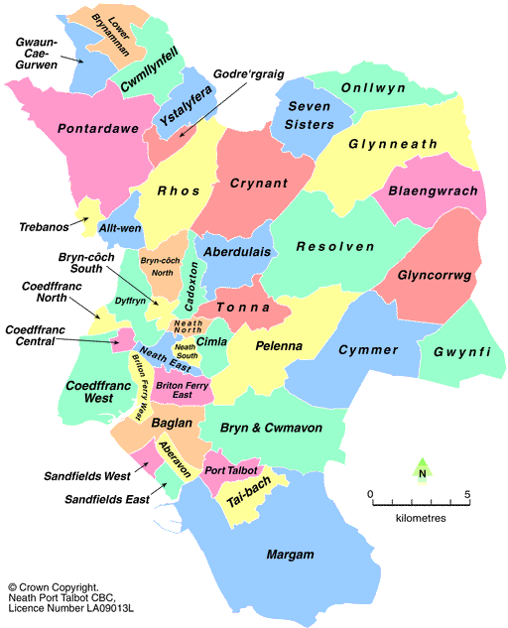
Figure 1 Map of Neath Port Talbot

What is GIS?
GIS stands for Geographic information system and is used to capture, manage and present data in a geographical form. “Geographic information (GI) is data about something's location and includes features such as buildings, roads, railways, population density, height and flooding data. GI can also be used to tell you about the people in a particular location, for example their age profiles, crime levels or movement patterns.” [1] There are many different forms of software which can be used to present geographic data such as Map info, Bing maps and PowerMap which is an add on Microsoft excel. For the first assignment PowerMap was used to show data which was taken from the UK Data Service and Health Maps Wales. The first data set retrieved was Deprivation data on the Neath Port Talbot area. “The Welsh Index of Multiple Deprivation (WIMD) is designed to identify the small areas of Wales that are the most deprived. The most recent WIMD was published in 2014. However a selection of indicators used within WIMD are updated annually.” [2]. The second data set used was from Health Maps Wales and was titled “Hospital Admissions due to Alcohol-specific and Attributable Conditions” the number of admissions from alcohol related.

Map Info
Map info has been used to show the data in a Graphical form, making it easier for people to visually understand the data. “MapInfo Professional is a desktop geographic information system software product produced by Pitney Bowes Software and used for mapping and location analysis” [3]

Data
The data that has been added to Map info includes;
- Boundary Data
  - Middle super outputs
  - Lower super output
  - Wards
- 2011 census data
  - Geo Code/ Label/ Type
  - Employment Data
    - Part Time
    - Full Time
    - Unemployed
    - Full time Student
    - Self Employed
  - Occupancy
    - Total Occupancy
    - Occupancy -1
  - Households
    - Total Households
    - Total Owned Outright
  - Car or Van
    - Total Cars or Vans
    - No Cars or Vans

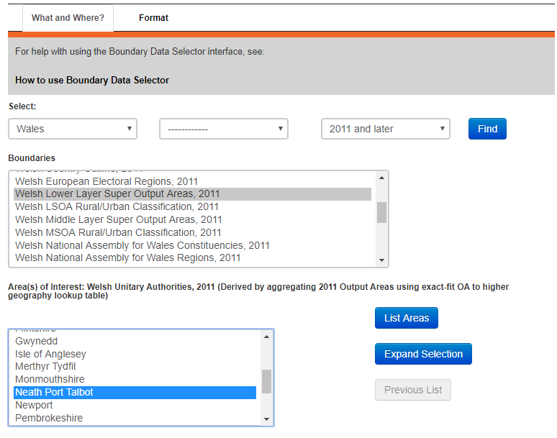
Figure 2 Boundary Data Selector
Map Info is used to show a map of a specific area once data from excel has been transferred into the software. The image below is the data that has been transferred into Map Info.
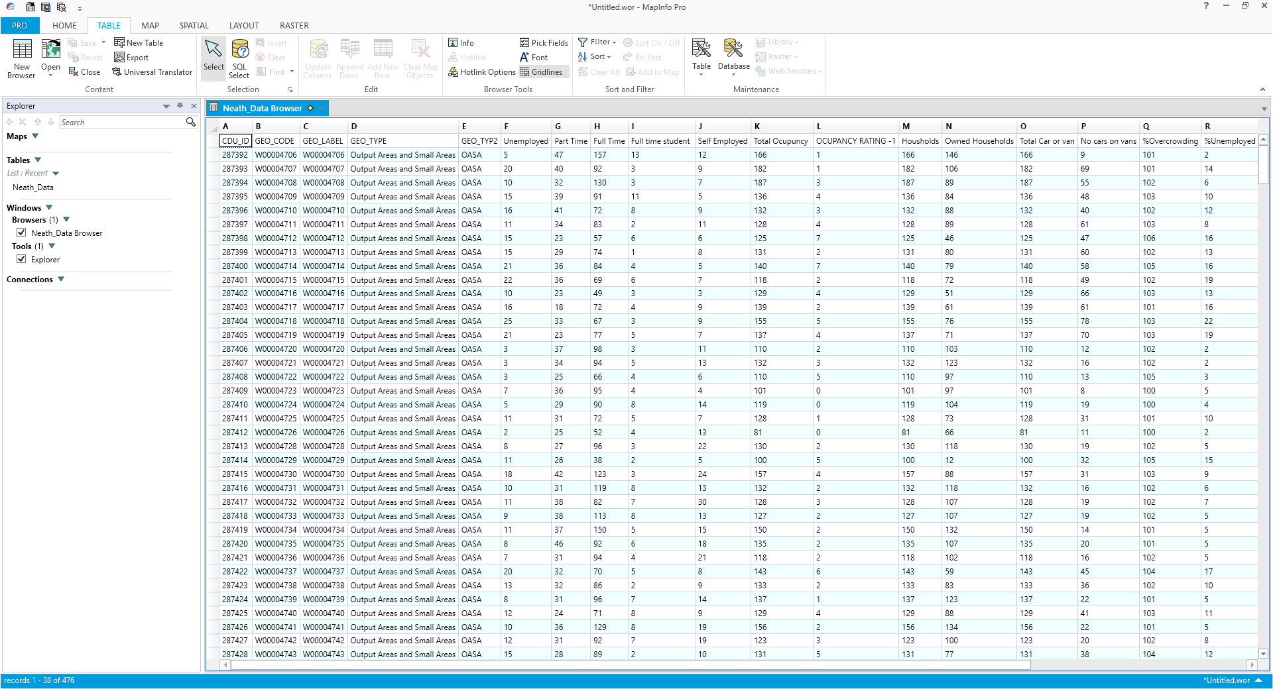
Figure 3 Excel Data in Map Info

Middle Super Output Area
Middle Super output area is “A Middle Layer Super Output Area (MSOA) is a GEOGRAPHIC AREA. Middle Layer Super Output Areas are a geographic hierarchy designed to improve the reporting of small area statistics in England and Wales. Middle Layer Super Output Areas are built from groups of contiguous Lower Layer Super Output Areas.” [4] The minimum population is 5000 and the mean is 7200.”The mid super output using Map Info is shown below.
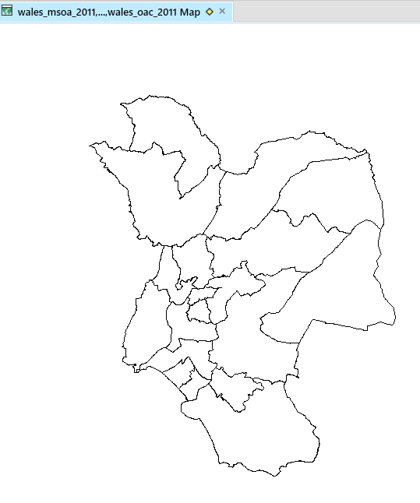
Figure 4 Middle Super Output Area

Lower Super Output Areas
“A Lower Layer Super Output Area (LSOA) is a GEOGRAPHIC AREA. Lower Layer Super Output Areas are a geographic hierarchy designed to improve the reporting of small area statistics in England and Wales. Lower Layer Super Output Areas are built from groups of contiguous Output Areas and have been automatically generated to be as consistent in population size as possible, and typically contain from four to six Output Areas. The Minimum population is 1000 and the mean is 1500.” [5] The Lower Super output areas are shown in the map below.
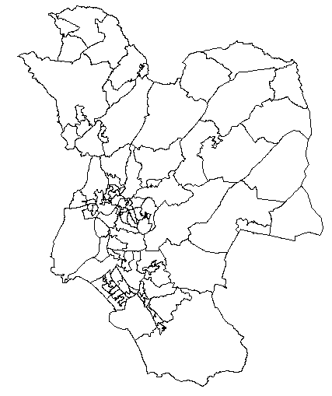
Figure 5 Lower Super Output Area

Map of Neath Port Talbot Showing Population
The map below is of Neath Port Talbot and shows the area’s population by the number of stickmen and the size of them. It’s clear that the Sandfields west and east has a high population along with Neath central. 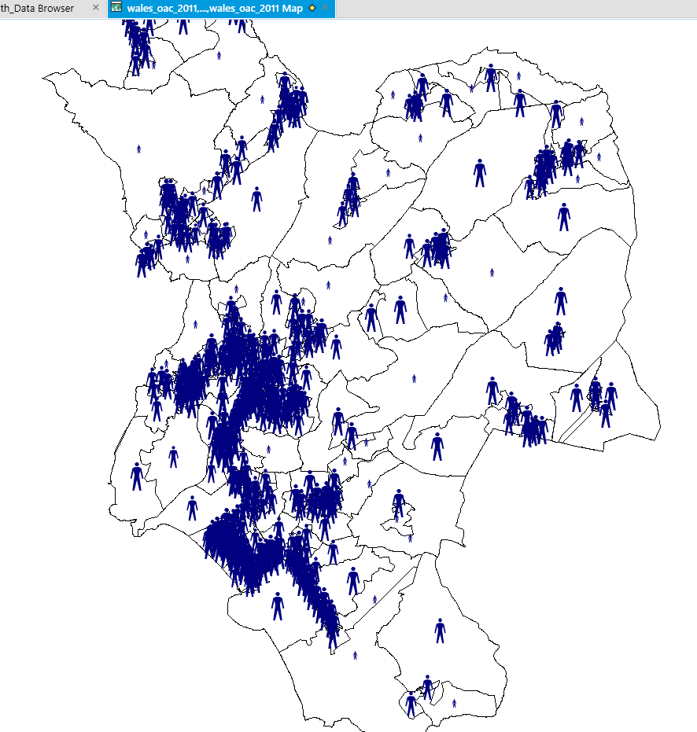
Figure 6 Map showing Population using Icons

Map Info Showing the type of person living in the area
The map below shows a small area of Neath Port Talbot and labels showing the type of person living in that particular area. For example, they are claiming that a person who lives in Sandfields West is classed as Industrious Hardship, whereas people living in Sandfields East are Aging Industrious Workers.
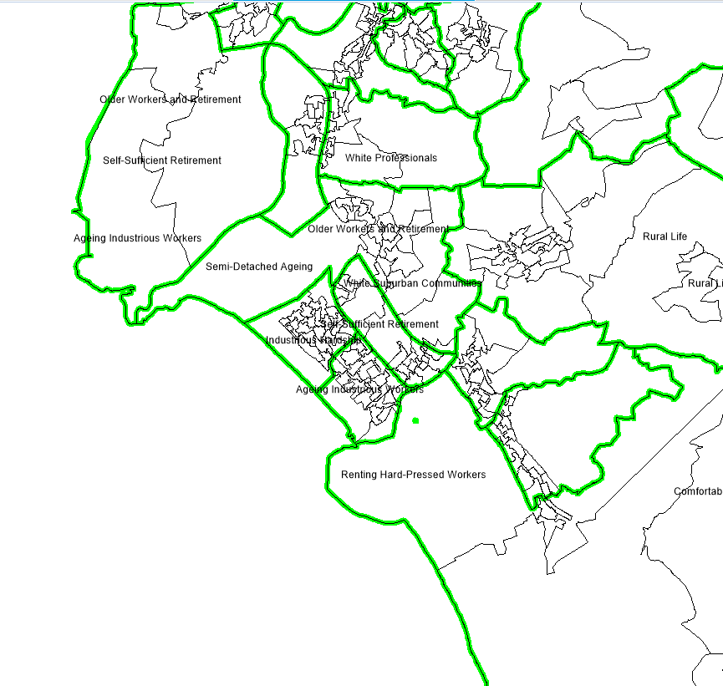
Figure 7 Map of Type of person living in an Area

Map showing the Population by colour
The map below shows the population within the Neath Port Talbot area using colour. Blue being the highest percentage population and yellow decreasing.
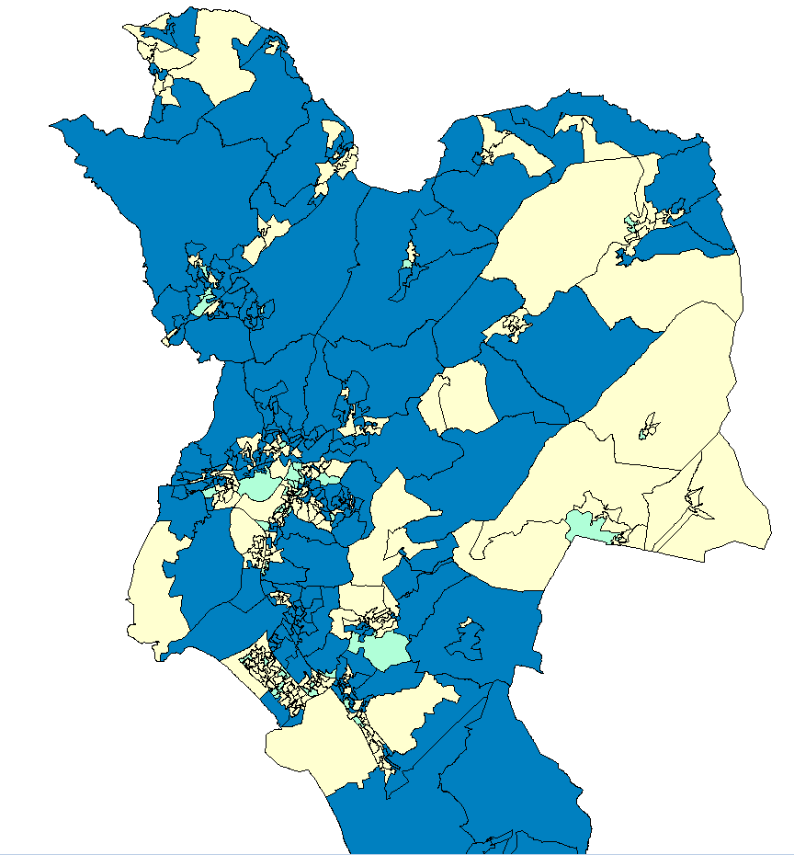
Figure 8 Map Showing Population by Area

Conclusion
In conclusion, after using Map Info to show a geographical representation of the data which has been collect from the UK Data Service, its shown that Map Info is a good way to show information using maps when colours and icons are used to aid in showing the data. The maps generated for the Neath Port Talbot area, should have included area names on them to make understanding the data easier for those who might not be completely familiar with the area or even those who are from the area could have trouble understanding the data as the lower super output areas are small and not easy to determine.

Bibliography

[1] | “Understanding GIS,” ordnancesurvey, [Online]. Available: https://www.ordnancesurvey.co.uk/support/understanding-gis/. [Accessed 04 04 2018].
[2] | “welsh-index-multiple-deprivation,” [Online]. Available: http://gov.wales/statistics-and-research/welsh-index-multiple-deprivation/?lang=en. [Accessed 01 02 2018].
[3] | “Map Info Professional,” Wikipedria, [Online]. Available: https://en.wikipedia.org/wiki/MapInfo_Professional. [Accessed 04 05 2018].
[4] | “middle_layer_super_output_area,” Data Dictionary, [Online]. Available: https://www.datadictionary.nhs.uk/data_dictionary/nhs_business_definitions/m/middle_layer_super_output_area_de.asp?shownav=1. [Accessed 04 05 2018].
[5] | “ower_layer_super_output_area,” Data Dictionary NHS, [Online]. Available: https://www.datadictionary.nhs.uk/data_dictionary/nhs_business_definitions/l/lower_layer_super_output_area_de.asp?shownav=1. [Accessed 04 05 2018].

