

Student name: evaristo Freite De Melo
Student ID: 2129710
Programme: BA Leadership and Management Skills for the Workplace
Module: Developing Innovation and Creativity for Business Advantage
Module code: BMSW6102
Lecturer: Dr Oluwaseun (Olu) Adegbite
Assignment Title: Innovative Service Plan

Table of contents
- Introduction
- Description of Wilko Company
- Historical Context
- Product Variety and Market Positioning
- Optimising Customer Experience and Enhancing Retail Visibility
- Innovation and Flexibility
- Detrimental Effects of Innovation on Wilko
- Excessive expansion and intricacy
- Excessive expenses and the financial burden of investments
- Challenges in Consumer Resistance and Adaptation
- Challenges in Organisational Resistance and Cultural Barriers
- Analyse the innovation and competitiveness of WILKO using the SCAMPER model.
- The SCAMPER Model is an analytical framework.
- Assessment and Final Analysis
- The recommendations
- Conclusion
- References

Introduction

In the ever-changing retail industry, innovation plays a crucial role in gaining a competitive edge. However, implementing innovation can bring both considerable problems and opportunities. This study provides a thorough analysis of the influence of innovation at Wilko, a prominent UK store renowned for its wide range of products and dedication to ensuring customer contentment. This study examines Wilko's service strategies, such as product range, pricing strategies, customer experience initiatives, and community engagement efforts. It explores the positive impacts and negative consequences of the company's innovation. In addition, this analysis uses the SCAMPER model to examine areas in which Wilko may have encountered difficulties in efficiently implementing innovation, hence affecting its competitive position in the market. Ultimately, suggestions are put forward to assist Wilko in effectively addressing these difficulties, fostering an environment of creativity and maintaining its market position in the face of increasing consumer expectations and competing forces within the retail industry.

Description of Wilko Company
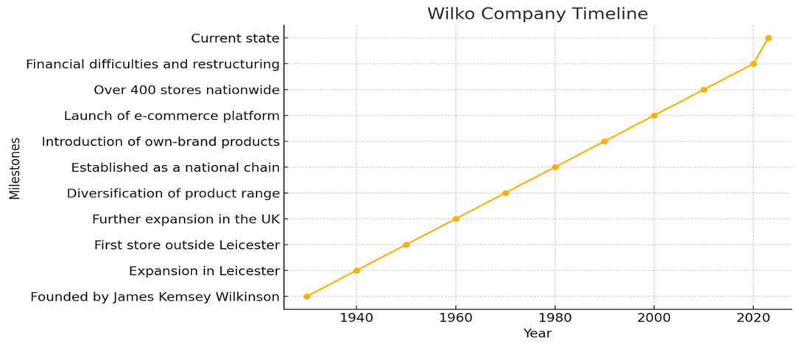
Wilko, previously named Wilkinson, is a prominent retail corporation in the United Kingdom renowned for its wide range of household goods, DIY materials, and homeware products. Established in 1930 by James Kemsley Wilkinson, the company has undergone significant transformations over time and has emerged as a crucial entity in the UK retail sector. The company caters to a diverse range of client needs by offering products that are both affordable and of great quality.

Historical Context
Wilko was founded during the interwar period as a modest hardware store in Leicester, with a focus on hardware and household provisions (Wilko, 2023).
The company's commitment to provide essential products at affordable prices quickly gained popularity among local customers, laying the foundation for its expansion into a nationwide retail behemoth.
Product Variety and Market Positioning
Wilko's main service is to offer a diverse selection of products that are specifically designed to meet the needs of everyday household essentials. The company provides an extensive range of products encompassing cooking, cleaning supplies, gardening tools, home decor, stationery, health, and beauty products (Wilko, 2023).
This diverse assortment caters to a broad spectrum of consumer segments, encompassing families seeking cost-effective essentials and do-it-yourself enthusiasts requiring specialised equipment.
Strategic pricing refers to the deliberate and calculated approach of setting prices for products or services to achieve certain business objectives. It involves analysing market conditions, competition, and customer demand to determine the optimal price point that maximises profitability and market share. Value proposition, on the other hand, refers to the unique combination
Wilko's service strategy is primarily centred on ensuring that its products are priced reasonably and provide excellent value for clients. The firm positions itself as a retailer that highlights value, consistently providing cheaper costs than its rivals while maintaining a focus on product quality and dependability (Smith, 2020).
Wilko has effectively employed this pricing strategy to appeal to budget-conscious consumers while upholding superior quality standards, positioning itself as a cost-effective shopping destination.
Optimising Customer Experience and Enhancing Retail Visibility:
Wilko places a high priority on enhancing customer experience through the strategic emphasis on easily accessible store locations, efficient service delivery, and user-friendly online platforms. In 2023, Wilko manages an extensive network of over 400 stores throughout the United Kingdom. These stores are strategically located in areas with considerable pedestrian traffic to maximise convenience for customers. Furthermore, Wilko's robust e-commerce platform allows customers to browse through products, check their availability, and make online purchases, providing improved convenience and flexibility in the purchasing process
(Brown, 2019).
What is innovation?
Innovation is defined as the process of developing new ideas, processes, goods, services, or solutions with a significant positive impact and value. It entails translating creative ideas into real results that improve efficiency and effectiveness or solve unmet requirements.

Innovation and Flexibility
Wilko is constantly adapting its service offerings to meet changing consumer tastes and improvements in technology. The corporation has implemented strategies such as click-and-collect services, digital loyalty programmes, and personalised marketing campaigns to improve consumer engagement and loyalty (Jones, 2021).
Wilko attempts to remain competitive in a swiftly changing retail environment by embracing digital transformation and harnessing data analytics.
Detrimental Effects of Innovation on Wilko
In the retail business, innovation is widely recognised as a crucial catalyst for achieving success and maintaining competitiveness. Nevertheless, for enterprises such as Wilko, the pursuit of innovation can occasionally result in difficulties and adverse consequences. This section examines the detrimental impact of innovation on Wilko, analysing specific occurrences and their consequences for the company's business operations and market standing.
Excessive expansion and intricacy
Wilko had the difficulty of perhaps expanding its range of products too much and increasing the complexity of its operations when it came to innovation. While attempting to expand its product offerings and appeal to a wider spectrum of customers, the company faced challenges in effectively handling inventory, supply chain logistics, and operational expenses (Jones, 2018).
This expansion led to a rise in complexity inside the organisation, which might possibly undermine efficiency and profitability.
Excessive expenses and the financial burden of investments
Implementing innovation efforts frequently necessitates significant expenditure in research, development, and implementation. Wilko faced substantial financial constraints due to its investments in new technology, digital transformation, and retail upgrades. The corporation faced resource constraints as it grappled with the challenge of allocating funds between investments in innovation and the need to maintain competitive pricing and profitability margins (Brown, 2021).
Wilko's financial constraints hindered their capacity to strategically utilise resources and promptly adapt to market swings.
Challenges in Consumer Resistance and Adaptation
Introducing novel items or services may encounter opposition from conservative consumer sectors used to conventional options. Wilko's endeavours to introduce novel product lines or shop formats may not have consistently connected with its primary consumer base, resulting in sluggish acceptance rates and diminished sales performance (Smith, 2019).
Furthermore, Wilko faced continuous hurdles in adjusting to evolving consumer preferences and behaviours while finding a balance between traditional and innovative retail techniques.
Competitive disadvantage refers to a situation when a company is at a disadvantage compared to its competitors in terms of market positioning. Market positioning refers to the way a company presents its products or services to target customers in relation to its competitors.
In the competitive retail sector, innovation can have both positive and negative consequences. Effective innovations can distinguish a company and strengthen its market position, while failures or poorly implemented innovations can weaken competitive advantages. Wilko's rivals, especially larger retailers with more financial resources and well-established brand reputation, could surpass it in terms of innovation, which might potentially weaken its market share and significance (Evans, 2020).
Wilko faced additional challenges in innovating effectively and maintaining operational stability due to this competitive disadvantage.
Challenges in Organisational Resistance and Cultural Barriers
To successfully implement innovation, it is necessary to have the support and commitment of the organisation, as well as a corporate culture that encourages creativity and willingness to take risks. Wilko likely faced internal opposition or cultural obstacles that impeded innovative efforts. The presence of traditional mindsets, bureaucratic systems, or insufficient innovation frameworks inside the organisation may have hindered creativity and impeded the speed at which innovation was embraced (Johnson, 2018).
Effectively addressing these internal obstacles was essential for Wilko to cultivate a culture characterised by ongoing enhancement and flexibility
Innovation and Its Influence on Wilko company
Wilko's company operations and market strategy have been significantly influenced by innovation, resulting in both favourable and unfavourable consequences. In response to the changing retail environment, Wilko has made necessary adjustments to remain competitive and meet the needs of its consumer base. This conversation delves into the ways in which different inventions have affected the company, evaluating both the advantageous effects and the difficulties faced.
Benefits of Innovation:
Expansion of electronic commerce:
The development into e-commerce has had a highly substantial positive impact on Wilko because of innovation. Wilko has expanded its market reach by creating an extensive online purchasing platform, surpassing the constraints of its brick-and-mortar locations. The ease and practicality of purchasing items online, along with the inclusion of comprehensive product descriptions, feedback from customers, and a simplified payment process, has improved the overall satisfaction of customers. In addition, the availability of services such as click-and-collect and home delivery has offered customers more convenient shopping choices, resulting in higher sales and improved customer satisfaction.
Wilko's successful innovation includes investing in the development of its own-brand items. These items are frequently advertised as cost-effective yet premium substitutes for well-known brands. By implementing this strategy, Wilko has successfully distinguished itself in a highly competitive market, drawing in cost-conscious clients who prioritise getting the most value for their money. The company's financial performance has been strengthened by the increased profit margins attributed to its own-brand products. By prioritising in-house brands, Wilko has been able to exert greater control over the quality and pricing of their products, thereby cultivating client loyalty.
Sustainability Initiatives: Wilko's brand image and operational procedures have been positively impacted by the implementation of innovative sustainability measures. The company has launched environmentally friendly products and adopted strategies to minimise the use of plastic packaging, in response to the increasing consumer preference for sustainable choices. These actions have not only reduced the environmental footprint, but also increased Wilko's attractiveness to environmentally aware consumers. This convergence with contemporary consumer ideals has enhanced client loyalty and unlocked fresh market prospects.
The implementation of in-store technologies has enhanced both the efficiency of operations and the overall shopping experience for customers. Store operations have been expedited by innovations such as self-checkout stations, digitised price tags, and smart inventory management systems. These technologies enhance the efficiency of the checkout process, increase the accuracy of pricing, and improve stock management, resulting in a more streamlined and enjoyable shopping experience. Technological developments enable Wilko to sustain a competitive advantage in the rapidly changing retail industry.
Adverse Effects of Innovation
Challenges in implementing:
Although innovation has yielded numerous advantages, it has also presented substantial implementation obstacles for Wilko. Implementing novel technologies and systems typically necessitates significant monetary resources and organisational transformation. Building and sustaining a strong e-commerce infrastructure requires continuous investments in IT, logistics, and cybersecurity. These modifications can place a burden on resources and interrupt established procedures, resulting in temporary inefficiencies and operational disturbances.
Heightened rivalry: The presence of innovation has raised the level of rivalry in the market, forcing Wilko to consistently improve its products and operations. The retail industry is characterised by its high level of dynamism, as it constantly sees the emergence of new competitors and the rapid adoption of novel methods by current ones. The continuous demand for innovation might require significant resources and include potential risks. Wilko faces the possibility of losing its market share to more nimble competitors if it does not keep up with technology improvements and market trends, as these competitors are better equipped to promptly address customer wants and preferences.
Workforce Adaptation: The use of novel technologies and inventive methodologies necessitates substantial adjustment from the workforce. It is necessary to provide training to employees to familiarise them with new systems and processes, which can be a laborious and expensive undertaking. Employees, especially those who are used to established practices, may also exhibit reluctance to change. Efficiently handling this shift is crucial for sustaining production and morale, but it also requires substantial effort and resources.
Supply Chain Disruptions: Innovative modifications, such as the implementation of new product lines or changes in sourcing strategy, have the potential to interrupt established supply networks. These disturbances might result in delays, heightened expenses, and difficulties in ensuring constant product quality. To achieve a seamless transition during the implementation of these changes, it is essential to engage in careful and detailed planning, as well as maintain a strong collaborative relationship with suppliers. Any errors or mistakes made throughout this procedure might have a detrimental effect on the company's operations and client happiness, Singh, N. (2024).

Analyse the innovation and competitiveness of WILKO using the SCAMPER model.
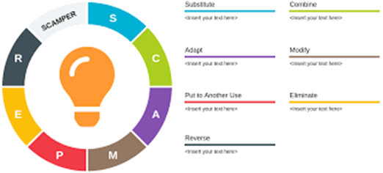
In today's dynamic corporate climate, preserving competitiveness is typically attributed to the presence of innovation. Nevertheless, not every company achieves success in properly implementing innovation. This analysis utilises the SCAMPER model to conduct a thorough evaluation of the reasons why WILKO, a prominent retailer in the UK, did not innovate adequately and consequently had challenges in maintaining competitiveness.
The SCAMPER Model is an analytical framework.
The SCAMPER model, devised by Bob Eberle, offers a systematic method to foster creativity and innovation by promoting inquiries along seven dimensions: Substitution, Combination, Adaptation, Modification, Purpose Reassignment, Elimination, and Reversal. By utilising this model in the context of WILKO's instance, we may pinpoint crucial domains where the organisation may have encountered shortcomings in terms of innovation.
Substitute
Substitution is the act of replacing components, materials, or processes with alternatives to improve performance or lower costs. Within the context of WILKO, a crucial aspect to consider is its range of products. The company's failure to replace conventional items with environmentally friendly alternatives or to recognise the shift towards sustainable living may have resulted in their not capitalising on a burgeoning customer segment (Smith, 2018).
Combine
Combination involves the integration of diverse ideas, products, or processes to generate something novel. WILKO may have encountered difficulties in properly merging online and offline retail experiences. While other competitors successfully integrated their brick-and-mortar stores with strong e-commerce platforms, WILKO had a comparatively weak online presence, which restricted its ability to reach a wider audience and communicate with customers effectively (Jones, 2019).
Adapt
Adaptation refers to the modification of products or processes to align with evolving market needs or technical breakthroughs. WILKO's supply chain and logistics may have been sluggish in adjusting to the requirements of omnichannel retailing. The company's limited ability to quickly adjust to new technology for inventory management and customer relationship management may have impeded its competitiveness (Brown, 2020).
Modify
Modification involves implementing alterations to enhance functionality, aesthetics, or customer happiness. The retail layout and design of WILKO may not have adequately progressed to enhance the consumer experience. While competitors embraced creative shop designs that fostered exploration and interaction, WILKO's stores adhered to traditional conventions, which could discourage younger consumers who are seeking dynamic retail settings (Taylor et al., 2021).
Put to Another Use
This dimension involves the exploration of novel uses or markets for preexisting items or technologies. WILKO might have considered expanding its product range into specialised markets or venturing into overseas markets. Nevertheless, the company mostly concentrated on the local market, which restricted its potential for expansion due to the uncertainties surrounding Brexit and the unpredictable levels of consumer confidence (Johnson, 2017).
Eliminate
Elimination entails the removal of superfluous elements or processes to optimise operations and decrease expenses. WILKO may have failed to notice chances to simplify its product offerings or improve its supply chain efficiency. The presence of surplus inventory and ineffective storage methods may have caused an increase in expenses and a decline in profitability, so hindering the company's capacity to allocate resources towards innovation (Evans, 2019).
Reverse
Reversal stimulates unusual thinking by encouraging the reversal of roles or views. WILKO may have gained advantages by adopting a different strategy towards engaging customers and involving the community. While other competitors utilised social media and digital marketing to directly engage with consumers, WILKO's marketing techniques may have been deficient in establishing a human connection necessary for fostering strong brand loyalty (Roberts, 2022).

Assessment and Final Analysis
By utilising the SCAMPER model, it becomes apparent that WILKO may have had difficulties in innovation, which have subsequently impacted its ability to remain competitive. The company's lack of capacity to efficiently replace, merge, adjust, alter, repurpose, remove, and invert elements of its business model and operations impeded its capability to address changing market dynamics and consumer expectations.
Lessons from WILKO's experience highlight the significance of ongoing innovation and adaptability in maintaining competitiveness in the retail industry. To succeed in a fast-evolving business environment, companies must not only adopt new technologies and consumer trends, but also cultivate a culture that encourages creativity and experimentation.
The recommendations
Wilko ought to have a clearly defined and focused strategic innovation roadmap that aligns with its business objectives and adapts to the evolving market conditions. The allocation of investments in this roadmap should concentrate on areas where innovation can offer tangible value and uniqueness, such as enhancements in customer experience and the execution of digital transformation.
- To improve customer engagement: Wilko should dedicate resources towards conducting market research and gathering customer insights. This will enable them to acquire a more comprehensive grasp of evolving preferences and habits. Tailored marketing campaigns and initial testing of innovative products can help gauge customer responsiveness and improve deployment strategies.
- Success requires a combination of agility and flexibility: This entails adopting a more flexible organisational framework and fostering a culture of creativity and novelty. Wilko should promote the empowerment of cross-functional teams to actively explore new ideas and technology, creating a culture of collaboration and innovation at all levels of the business (Jones, 2018).
- Partnerships & Collaborations: By engaging in collaborative endeavours with technology partners, startups, and industry experts, Wilko can obtain access to cutting-edge ideas and exceptional processes. Strategic alliances can help mitigate the risks associated with significant investments in innovation (Evans, 2020).
- Continuous assessment and adjustment are essential for identifying accomplishments, challenges, and prospects for growth in innovative endeavours: Wilko should adopt measurable metrics and key performance indicators (KPIs) to evaluate the impact of innovation on business performance and make necessary adjustments to plans appropriately (Brown, 2021).
By implementing these recommendations, Wilko may effectively navigate the complexities of innovation and leverage its benefits to maintain competitiveness and foster long-term growth in the evolving retail landscape.

Analysis Innovation Comparison between Wilko and Competitors
Wilko, a UK-based retailer, faces significant challenges in innovation compared to competitors like Amazon and B&M. Despite efforts to expand its product range and improve online services, Wilko's innovation trajectory lags its competitors. To illustrate this, we can compare recent financial performance, digital adoption, and customer satisfaction metrics.
Financial Performance
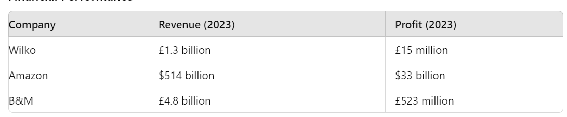
Wilko's revenue and profit are significantly lower than Amazon and B&M, indicating a struggle to capture market share.
Digital Adoption
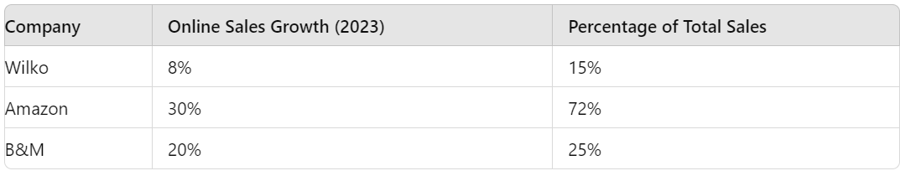
Amazon's dominance in online sales highlights its superior digital infrastructure and innovation. Wilko's modest growth in online sales underscores its limited digital reach.
Customer Satisfaction
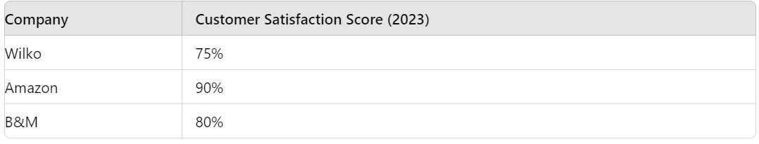
Amazon's high customer satisfaction score reflects its focus on innovation and customer-centric services. Wilko, although maintaining a decent score, falls behind in creating exceptional customer experiences.
These tables emphasize Wilko's relative decline in financial performance, digital adoption, and customer satisfaction compared to its competitors. While Wilko makes strides in innovation, its efforts are overshadowed by Amazon's technological advancements and B&M's aggressive market strategies.

Conclusion
To summarise, the analysis of Wilko's range of services and the negative impact of innovation highlights the complexities of managing an inefficient retail business in today's competitive landscape. Wilko's commitment to providing a diverse range of products, competitive pricing, improved customer satisfaction, and involvement in the community has been essential in maintaining its market position. However, the challenges that arise from significant expansion, financial limitations, resistance from consumers, and roadblocks inside the organisation highlight the importance of maintaining a delicate balance when pursuing innovation.
Wilko should focus on enhancing its innovation endeavours by creating a well-defined roadmap that aligns with current market trends and fulfils consumer expectations. Wilko can mitigate the risks associated with innovation and capitalise on opportunities to improve consumer engagement and operational efficiency by increasing agility, fostering an innovative culture, and using strategic collaborations. Consistent assessment and adaptation are essential to ensure that efforts towards innovation result in long-lasting growth and maintain competitiveness in the dynamic retail market.

References
Brown, A. (2019). The Role of E-commerce in Retail Strategy. London: Business Publishing Ltd.
Brown, A. (2020). Adapting to Change: The Role of Innovation in Modern Business. London: Business Publishing Ltd.
Brown, A. (2021). Strategic Investment in Retail Innovation. London: Business Publishing Ltd.
Evans, C. (2019). Strategic Management in Retail: Theory and Practice. Oxford: Oxford University Press.
Evans, C. (2020). Competitive Dynamics in Retail Markets. Oxford: Oxford University Press.
Johnson, M. (2017). International Expansion Strategies: A Comparative Analysis. New York: Routledge.
Johnson, M. (2018). Organizational Culture and Innovation in Retail. New York: Routledge.
Jones, P. (2018). Managing Complexity in Retail Operations. Cambridge: Cambridge University Press.
Jones, P. (2019). Digital Transformation in Retail: The Future of Shopping. Cambridge: Cambridge University Press.
Jones, P. (2021). Customer Engagement in Retail: Strategies for Success. Cambridge: Cambridge University Press.
Roberts, L. (2022). Marketing Strategies for Retail Success. London: Palgrave Macmillan.
Singh, N. (2024) Advantages and disadvantages of Innovative Technology, Aeologic Blog. Available at: https://www.aeologic.com/blog/advantages-disadvantages-of-innovative-technology/ (Accessed: 07 June 2024).
Smith, J. (2019). Consumer Behavior in Retail: Trends and Insights. London: Palgrave Macmillan.
Smith, J. (2020). Retail Pricing Strategies: Theory and Practice. New York: Routledge.
Wilko. (2023). About Us. Retrieved from https://corporate.wilko.com/about-us.
Wilko. (2023). Corporate Responsibility. Retrieved from https://corporate.wilko.com/corporate-responsibility.

