
innovation and customer journey for roll-royce


Name: Cristina Budureanu
Student ID: 2314760
Module: Design Thinking and Innovation
Module Code: LCLM60002_LON
Lecturer: Rexon Nting

Contents
Introduction to the chosen organisation 2
Key consumer and industry and data that affect the organisation. 3
Part 1. An analysis of the organisation’s approach to innovation including application of the Innovation Ambition Matrix and the current customer journey (including the visualised customer journey map) 5
Application of Innovation Ambition Matrix 5
Application of current customer journey 10
Part 2: Proposed new digital transformation initiative and how it will add value to the organisation (including the new and enhanced customer journey map) 14
A new digital transformation initiative for the organisation 14
Updated and enhanced customer journey map 15
How the proposed initiative will positively impact on the organisation 17
How you will measure the impact and the success of the proposed initiative 18
Conclusion 19
Reference 20

Introduction to the chosen organisation
Rolls-Royce Holdings plc is the world leader in the power and propulsion technologies and is in business in Civil Aerospace, Defence, Power Systems, and New Markets. The company is still undertaking an effort to change its operations to emerge as a high-performing competitive and resilient business (Rolls-Royce, 2025). In 2024, Rolls-Royce recorded its best financial performance in a long time, underlying revenue of the company was £17.85 billion and statutory revenue of the company was £18.91 billion, which indicated a big growth in all divisions (Rolls-Royce, 2025). The company has also realised record underlying operating profit of £2.46 billion, which was catalysed by the increased levels of efficiency, enhanced commercial performance, and an augmented aftermarket activity (Rolls-Royce, 2025).
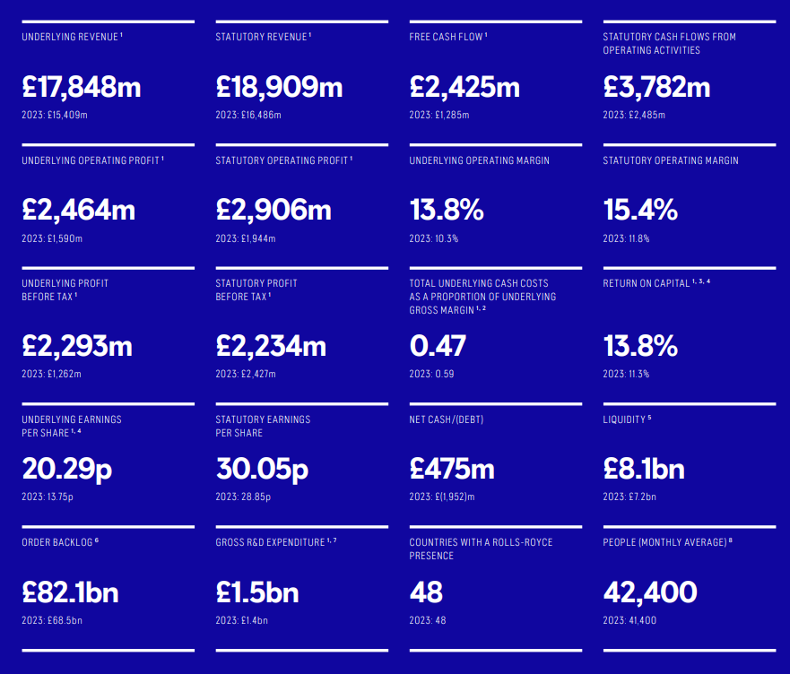Figure 1: Rolls-Royce Holdings at a glance (Source: Rolls-Royce, 2025)
As of 2024, Rolls-Royce was an average international employer of 42,400 employees, witch also proves its status as a major international employer and engineering, manufacturing, and services provider (Rolls-Royce, 2025). Its strategy continues to be rather innovative with gross R&D spending of high value of 1.5 billion. These investments are aimed at the development of the next generation aero engines, sustainable power source, and the small modular reactors (SMRs) (Rolls-Royce, 2025). It has several highlights in its technology such as the development of the Ultra Fan aero engine, creation of hydrogen-ready engines, and creation of small modular nuclear reactor design. By investing in further R&D and radical innovation, Rolls-Royce will be on the cutting-edge of net-zero aviation, defence technologies and green energy system.

Key consumer and industry and data that affect the organisation.
The automotive industry in UK is experiencing massive structural, economic and technological changes that are very strong determinants of organisational strategy and performance. Once of the key trends that have influencing the industry is the reduction in the domestic car manufacturing which will take place long term (Cole and Yakushiji, 2020). The industry that was once the second-largest in the globe regarding production in the middle of 20th century has shrunk dramatically because of global financial crises, the uncertainty posed by the Brexit and the Mother of All Evils, the Diesel gate scandal, among other factors that have disrupted production caused by the COVID-19 pandemic (EY, 2025). In 2020, production dropped to its lowest post-1984 in terms of volume and produced some 900,000 passenger cars and about 10,000 people were jobless (Statista, 2025). Further constriction of production through until 2021 was seen through continued supply chain fragility-notably semiconductor shortages and labour shortages.
The high dependence on the export markets is another trend that defines the UK. In 2021, approximately 706,000 passenger cars and 38,000 commercial vehicles were manufactured, and a majority of the trade was with the European Union (Maran et al., 2021). International demand, trade deals, and stability of the border, therefore, are very important in ensuring the organisational competitiveness.
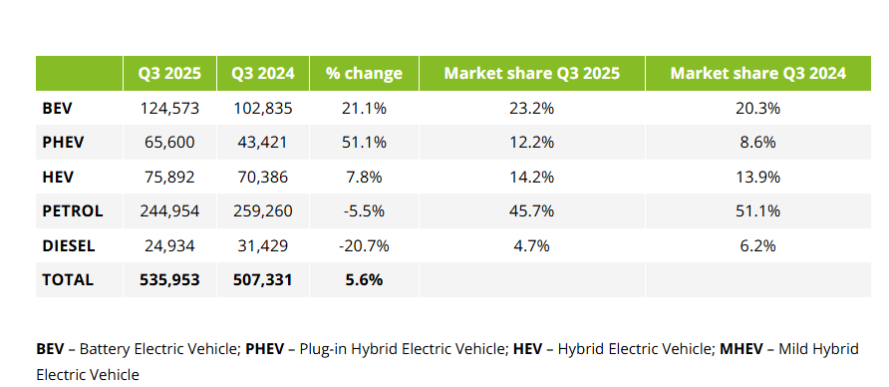
Figure 2: UK car registrations Q3 2025 (Source: Deloitte, 2025)
The UK market sees a significant recovery on the demand from a consumer side. The quarter three sales saw a growth of 5.6 percent due to the introduction of the new plate 75 and attractive incentives alongside manufactures (Deloitte, 2025). Positively, the level of private sales in September 2025 increased by 8.9 % despite the uncertainty in the economy, which is positive that shows a slight determination in consumer confidence (Deloitte, 2025). Nevertheless, the annualized performance is unpredictable since it depends on the changes in the business environment and governmental regulations.
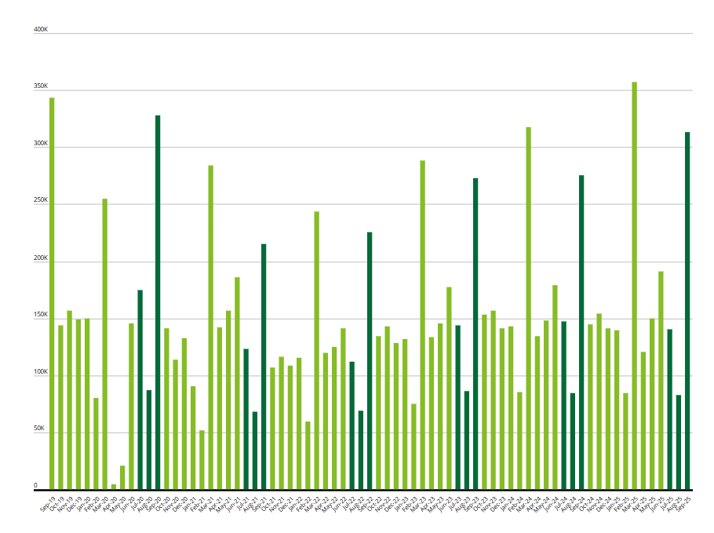
Figure 3: “UK car registrations monthly (volume)” (Source: Deloitte, 2025)
The increased rate of electrification is one of the most radical trends. A 46% market petrol vehicles at the first nine months of 2025 is still considered as the lead but a 6-percentage-point drop compared to 2024 (Deloitte, 2025). The market of electric and hybrid vehicles is growing at a very high rate as it is governed by government policies, environmental aspects, and economic motives (Stolfa et al., 2020). Over 50 percent of all vehicles are registered in September 2025, the battery electric vehicles (BEV) have an all-time high market share at 23.3 percent (Deloitte, 2025). There were 72,779 new BEV’s registered in September 2025 alone, the largest number of BEV’s registered in a month (Deloitte, 2025). To cope with this transition, organisations will need to match the product portfolio, engage in charging infrastructure alliances and address the Zero Emission Vehicle (ZEV) Mandate (Deloitte, 2025).
It is also increasing market fragmentation. The market share in 10 leading brands has dropped to percent versus 60 percent, which means more competitors are entering the market especially Chinese OEMs with favourable prices, high technological products, and attractive in-car software (EY, 2025). Customers experiences, after sales service and excellent finance provision have to be used as differentiators by traditional manufactures to maintain market share (EY, 2025).
Collectively, these trends build a challenging and yet opportunity rich environment in such that organisations must be flexible, innovative, and consumer oriented.

Part 1. An analysis of the organisation’s approach to innovation including application of the Innovation Ambition Matrix and the current customer journey (including the visualised customer journey map)

Application of Innovation Ambition Matrix
Innovation Category | Description of Innovation Focus | Key Activities and Examples | Strategic Impact on the Organisation
Core Innovations (70%) | Enhancing existing products, services, and processes to meet current market needs – particulary for petrol, hybrid, and entry-level EV models. | - Incremental  improvements of existing petrol and hybrid vehicles.  - Enhancing  battery efficiency, range, and in-car software features for current EV models.  - Strengthening  aftersales services and fleet management solutions.  - Optimising  manufacturing processes to address to labour shortages and supply chain constraints. | Core innovation helps the organisation maintain competitiveness in the existing market. It supports short-term revenue stability, improves product reliability, and ensures compliance with immediate regulatory standards. In a market where petrol vehicles still holds 46% share, incremental enhancements protect current customer segments and brand loyalty.
Adjacent Innovations (20%) | Expanding into related markets or customer segments, particularly in electrified mobility, charging infrastructure partnerships, and software-driven services. | - Development of affordable EV models to compete with rising Chinese OEMs.  - Collaboration with charging point operators to increase infrastructure access.  - New subscription or leasing models targeting private consumers and fleets.  - Expiation into digital ecosystems-connected car services, apps, and data-driven maintenance. | Adjacent innovation enables organisations to capture emerging consumer demand for electrified, connected, and flexible mobility. It supports growth in new revenue streams such as software services and strengthens competitiveness in a fragmented EV market. It also helps attract new segments, including budget-conscious EV buyers and urban consumers reliant on public charging.
Transformational Innovations (10%) | High-risk, high-reward innovations aimed at reshaping the future of mobility and positioning the organisation for long-term leadership toward full electrification and zero emissions. | - Development of next-generation BEVs with solid -state batteries.  - Autonomous driving technologies and AI-driven mobility solutions.  - Circular-economy vehicle production (recycling, reuse, remanufacturing).  - Exploration of hydrogen-powered vehicles or alternative green propulsion. | Transformational innovation prepares the organisation for major industry shifts, including the 2030 ICE phase-out and rising ZEV mandate targets. These innovations create long-term differentiation, support environmental commitments, and open new markets. Although costly, they future proof the organisation against competition from technologically advanced new entrants.

Table 1: Innovation ambition matrix (Source: Self-created)
Analysis
The context of innovation in the organisation is conditioned by the necessity to combine both short-term delivery and long-term change in the context of a very dynamic UK automotive environment (Kattel et al.,2023). The organisation has a multi-layered and systematic strategy to innovation that cuts across core, adjacent, and transformational activities guided by the Innovation Ambition Matrix. This strategy will allow the company to leverage on the current markets and at the same time venture in disruptive technology and new mobility solutions.
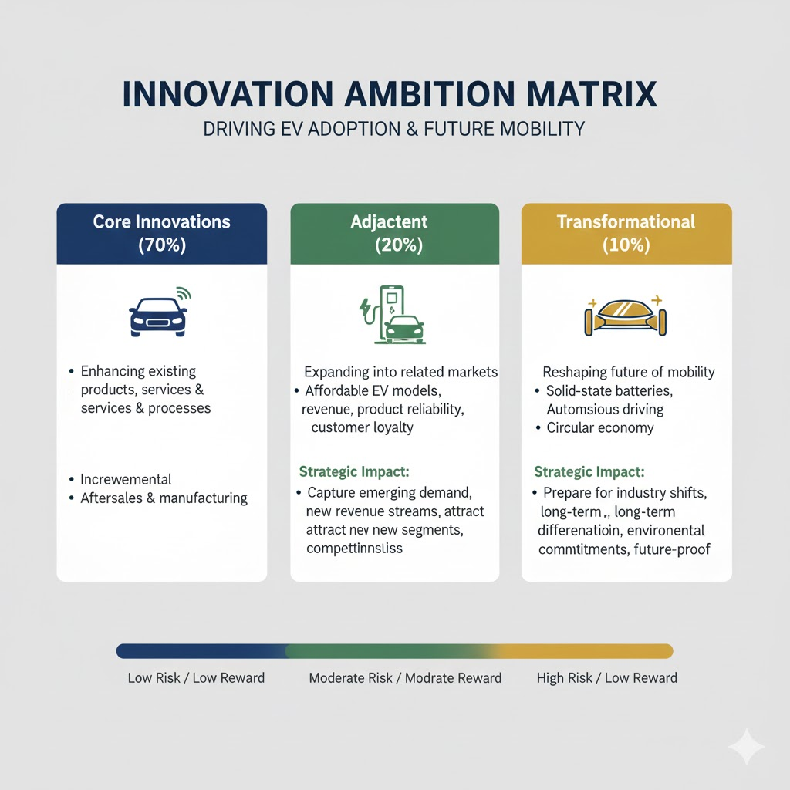
Figure 4: Innovation Ambition Index (Source: Self-created)
At the core innovation level, the focus of the organisation is to enhance its existing product line and make operations more efficient. This includes the progressive development of internal combustion engine (ICE) technologies, improved hybrid powertrains and the addition of digital interface to the existing vehicles (Kattel et al., 2024). Illustratively, numerous manufactures have been spending on the improvement of driver-assistance systems and incorporation of over-the-air (OTA) software updates and customer are enjoying real-time enhancements without having to undergo physical servicing. The organisation is also aiming to maximize the production by automation, robotics, and anticipated maintenance system to mitigate against supply chain failures (Fang et al., 2024). These fundamental innovations are not only facets of stability, but also cost reduction in production, and additional protection in customer loyalty in a market where cheapness and consistency still determine buying conduct.
The organisation is also seeking to venture into the closely related markets, which are in the neighbouring innovation space, but complement its current capabilities. Partnerships with energy providers, technology companies, and charging infrastructure companies are one of the consequent shifts (Hall et al., 2020). As the number of organisations seeking to offer electrified mobility increases, the number of organisations that gathers to come up with interoperable Energy-efficient battery management networks and charging system is rising. Certain automotive companies, e.g., have introduced subscriptions to accommodate vehicle ownership and digital services with personalised maintenance schedule, routes planning and real-time energy consumption monitoring (Costigan and Wilsdon, 2021). These adjacencies complement the customer experience and increase the presence of the organisation in other mobility ecosystem than vehicles manufacturing.
The increment of software-defined vehicles is another factor that compels the organisation to invest in related services such as telematics, vehicle-to-grid (V2G) services, and in-car e-commerce (Mojumder et al.,2022). The innovations are indicative of the product-centric to the service centric business design, which allows them to provide a recurrent revenue stream as well as have closer customer relationship.
Although a minor part of total activity, transformational innovation is the cornerstone of long-term strategy of the organisation. These encompass investments in all-electric breakthrough technologies like solid-state batteries, hydrogen-powered fuel cells, and self-driving systems. A number of auto companies have started to test the prototypes of autonomous cars in controlled conditions and to seek the possibilities of artificial intelligence (AI) implementation to make decision and diagnose the car in real-time (Sovacool et al., 2020). Transformational innovation also includes the process of implementing a second step towards circular manufacturing, such as designing pieces that are 100 percent recyclable materials (such as vehicle), finding a second life (different uses of used batteries) and creating vehicle take-back programmes.
Furthermore, organisations are investing in sophisticated research centres, innovation centres as well as partnerships with universities as a way of enhancing scientific breakthroughs. Internal incubators which resemble venture capital assist in the identification of high-potential technologies, that the company does not lose its competitive edge over new entrants, especially those that are digital-first and electric-only manufactures (Yang et al., 2024).

Application of current customer journey
Stages | Customer Action | Customer needs and Expectation | Pain Points | Opportunities for the Organisation
1. Awareness | 1. Browses online for vehicle options.  2. Social media ads, influencer content, and EV incentives.  3. Learns about new models through online reviews and comparison website. | 1. Easy access to trustworthy information  2. Transparent details on pricing, EV grants, running costs, and features. | 1. Overwhelming choices due to market fragmentation.  2. Confusion about charging infrastructure and EV range. | 1. Strengthen digital marketing and targeted campaigns.  2. Provide simple EV education tools and comparison guides.
2. Considerations | 1. Shortlists petrol, hybrid, or EV models.  2. Uses configurators to explore customisation.  3. Reads user reviews and watches test-drive videos. | 1. Clear comparisons of models, features, and total cost of ownership.  2. Accurate delivery timelines. | 1. Lack of clarity on charging access for those without off-street parking.  2. Difficulty comparing traditional and EV models. | 1. Offer interactive tools and range estimators.  2. Provide transparent cost-of-ownership calculators.
3. Evaluation/ Test Drive | 1. Visits dealership or books online test drives.  2. Engages with sales advisors for product demonstrations.  3. Check financing options. | 1. Hands-on experience.  2. Knowledgeable staff explaining EV benefits and charging options.  3. Flexible appointments. | 1. Limited test-drive availability for high-demand EV models.  2. Mismatched information between online and in-store staff. | 1. Train staff to specialise in EV advising.  2. Offer virtual test drives or home-test options.
4. Purchase | 1. Selects models and finalises financing/leasing.  2. Applies for EV grants or discounts.  3. Completes paperwork digitally or in-store. | 1. Quick transparent, and paper-light process.  2. Clear delivery expectations. | 1. Long wait times due to supply shortages.  2. Complicated EV grant processes. | 1. Streamline digital onboarding and reduce administrative steps.  2. Provide real-time tracking for vehicle delivery.
5. Ownership | 1. Charges vehicle at home or public stations.  2. Uses connected apps for diagnostics.  3. Visits service centres for maintenance. | 1. Reliable charging options.  2. Quick servicing and predictable costs.  3. Helpful mobile apps. | 1. Charge-point access issues.  2. Software glitches or app inconsistencies. | 1. Improve app experience.  2. Expand charging partners hips and mobile servicing options.
6. Loyalty/ Advocacy | 1. Shares experience online.  2. Recommends brands to peers.  3. Considers trade-ins or upgrades. | 1. Rewards for loyalty and referrals.  2. Up-to date communication. | 1. Limited trade-in value due to rapid EV depreciation. | 1. Offer loyalty programmes, flexible financing, and guaranteed buy-back options.

Table 2: Customer Journey Map (Source: Self- created).
Analysis
The changing customer experience that is increasingly digitally discovered, evaluated in a personalised way, purchased seamlessly and owned through technology has a strong influence on how the organisation approaches innovation (Tueanrat et al., 2021). The study of every step of this journey enables the separation of innovation aimed at the organisation in specific directions to minimise the friction, improve the experience and create a long-term loyalty in a competitive and quickly electrifying environment.
At the Awareness level, customers are strongly dependent on online platforms, user-created review, and the third-party comparison site. In a bit to be competitive in this setting, organisations invest into high level digital marketing analytics and AI-based targeting systems (Rana et al., 2022). A number of automotive firms currently employ predictive models to comprehend Internet behaviour and provide personalised advertisement which leads to an increased rate of engagement. According to industry statistics more than 70 percent of automobile purchasers in the UK initiate their purchases digitally and this has prompted manufactures to invest in online showrooms, car 360 images, and adjustable product movies to enhance customer connection in the initial phase of the purchasing cycle (Deloitte,2025).
As the stage of innovation, Consideration is concerned with complicated decision-making where simplifying these processes is essential to improve it. The increased interest in the electrified cars implies that the customers would desire to know more information about their costs of charging, the ability of the battery, and the long-term benefits (Ngarmwongnoi et al., 2020). Some of the ways organisations are innovating include coming up with interactive instruments, like real-time cost-charging calculator, battery-health forecasting, individualised total cost of ownership dashboard (Hoyer et al., 2020). The displaying of local charging availability on the website or apps of organisations through new data partnership with charging providers also allows organisations to showcase data on local charging options. This level of transparency does not only lower the level of purchase hesitation but also informs the customers that might be not accustomed to EV technology.
Technological innovation carries out to increase trust and accessibility when in the Evaluation and Test-Drive stage. Since attempts to access test-drive, vehicles physically may be reduced or diminished by supply chain variability, organisations are launching virtual test drives, augmented reality test-drives, and mobile test-drives services that come to consumer at home (Kaufmann, 2025). According to some manufactures, test-drive sessions through the virtual environment have also conversions by up to 25 percent, which proves that digital-first innovation can be beneficial (Huang et al., 2021). Also, dealerships are embracing customer-relationship management (CRM) platforms that integrate the on-line and offline moments of touch making sure that the customer gets uniform information no matter the channel.
During the Purchase stage, innovation is focused on the organisation of the administrative process and the minimization of friction. As a large number of customers have moved to digital transactions, businesses are spending money on e-signature solutions, digital authorization of finance, and real-time inventory monitoring. Based on the retail analysis of the automotive industry, fully digital car purchases increased over 30% in the UK up to 2022-2024, and organisations are redesigned to buy new faster and more transparent ways (Terho et al.,2022). The process of purchases is made more efficient and well-received by such innovations as the real-time delivery tracking, digitalized documentation consolidation, and automated grand-eligibility checks.
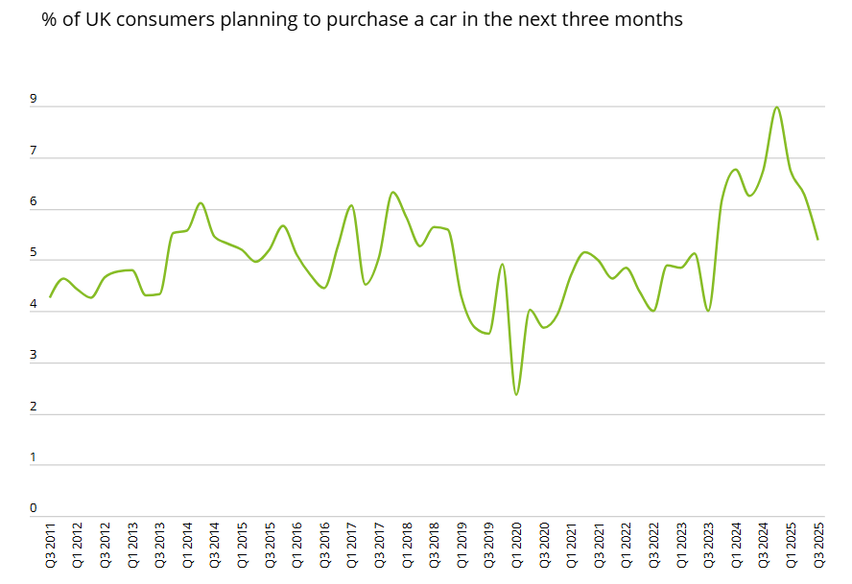
Figure 5: Planned car purchases (% of UK consumer planning to purchase a car in the next three months)
(Source: Deloite,2025)
Lastly, long-term engagement in digital engagements is the target of the organisation in the Ownership and Loyalty phases. Ecosystems of connected cars are taking centre stage in ownership innovation where mobile applications provide remote diagnostics, smart charges schedules, route planners, and predictive maintenance warnings. Telematics-based service centres are forming faster and longer-lasting business strategies which help to predict customer requirements and minimise time of service and intervene less often unforeseen service failures. Some of the examples of loyalty innovations are offers of personalised upgrades, a trade-in guarantees on EVs and piece of software available as a subscription, which will improve performance or comfort.

Part 2: Proposed new digital transformation initiative and how it will add value to the organisation (including the new and enhanced customer journey map)

A new digital transformation initiative for the organisation
The organisation may introduce Unified Intelligence Mobility Ecosystem (UIME), entirely integrated digital environment that would respond to the main challenges they found through the customer experience, such as information complexity, services fragmentation, EV infrastructure issue, and discrepancy between online in-store experiences (Zhao et al., 2024).
The UIME platform would integrate AI-based personalization, real time data integration as well as connected car technologies into a single customer and dealer facing ecosystem. By doing this, customers would be given a flawlessly oriented service since first research to long-term ownership. And the level of friction against awareness, consideration and purchase would be considerably minimized in the first stages of the process.
During the awareness phase, the platform would examine the behaviour of browsing and produce recommendations of specific vehicles in relation to driving pattern, cost-effectiveness, environment affection, and access to charging facilities locally using AI (Goncalves, 2023). This would only speak to a market on the growing side of confusion and decision fatigue.
In the consideration and purchase phase, all these would be incorporated into the platform with real-time dealership inventory, open delivery schedule, and immediate finance approvals (Alam et al., 2024). An in-house EV-readiness test-based on the local infrastructure and the average commuting range would provide potential EV purchasers with advice, specific to them, reducing range and charging-related concern.
The ownership phase would integrate the ecosystem with the telematics of the vehicle to provide predictive maintenance alerts, automated service appointments and optimal schedule adjustments of charging power stations according to utility charges and grid loads (Butler et al., 2020). This contributes towards reliability and satisfaction of customers in the long run.

Updated and enhanced customer journey map

Stage | Enhanced Customer Actions | Enhanced experience And New Feature (UIME) | Outcome
1. Awareness | 1. Browses online using search engines and social media.  2. Interacts with AI-driven ads tailored to driving habits and location. | 1. UIME personalises recommendations using behavioural analytics.  2. Provides instant comparisons and EV-readiness insights. | 1. Faster understanding of suitable models.  2. Reduced confusion and information overload.
2. Consideration | 1. Use UIME platform to shortlist vehicles.  2. Engages with interactive tools and personalised total-cost-of-ownership dashboards. | 1. Real-time charging availability mapped to the customers area.  2. Automated EV suitability report based on commute data. | 1. More confident decision-making and clearer evaluation of EV options.
3. Evaluation/Test Drive | 1. Books virtual or physical test drives through the platform.  2. Consults remote advisors. | 1. Unified data ensures consistent online-offline information.  2. AR/VR test-drive simulations enhance product understanding. | 1. Higher trust and better-informed product evaluation.
4. Purchase | 1. Completes financing and documentation digitally.  2. Tracks order status through the app. | 1. Instant finance approvals through integrated systems.  2. Transparent delivery timelines synced across dealerships. | 1. Faster, smoother purchase journey with reduced administrative burden.
5. Ownership | 1. Uses app for smart charging, diagnostics, and booking service appointments. | 1. predictive maintenance alerts and optimal charging schedules using telematics.  2. Integrated loyalty rewards. | 1. Improved vehicle performance and proactive service experience.
6. Loyalty/ Advocacy | 1. Shares experiences and receives tailored upgrade offers. | 1. Trade-in valuations updated automatically using real-time data.  2. personalised retention programmes. | 1. Stronger loyalty, repeat purchases, and positive advocacy.

Table 3: Updated and enhanced customer journey map
(Source: Self-Created)
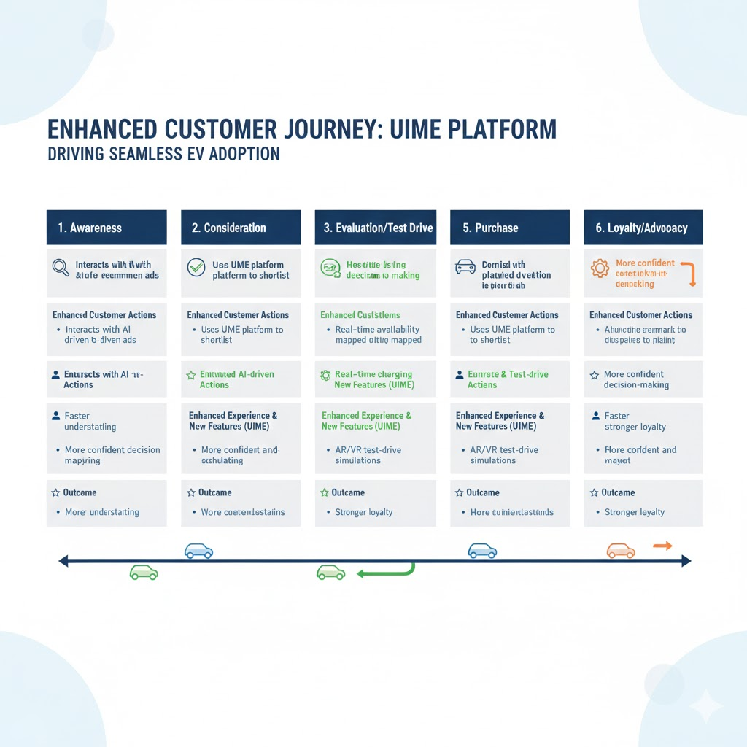
Figure 6: Updated and enhances customer journey map
(Source: Self-created)

How the proposed initiative will positively impact on the organisation
The proposed Unified Intelligent Mobility Ecosystem (UIME) would bring a lot of strategic, operation, and financial value to the organisation as a way of modernising its model of engaging these customers., creating a stronger competitiveness, and increasing long-term resilience. Incorporating AI-based personalisation, real-time vehicles, and connected mobility services, the organisation would be in a better place to keep abreast of the evolving consumer demands in a market where digital interaction makes more than 85 percent of the purchase decisions in the automotive market.
Commercially, UIME would assist in the boost of the conversion rates through customized advice and open vehicle comparison. Studies conducted in the industry have shown that individualised online experiences have the capacity of increasing lead-to-sale conversion by up to 20 percent, implying that companies can potentially boost their revenues significantly. This project would also decrease customer walk-out due to poor congruency of information between online research and dealership transactions, which in one of the problems leading to lost sales in traditional car deal settings.
The ecosystem would operate by bringing dealerships to the centre on inventory, delivery schedules and customer information. This would lower management obligations and enhance correct allocation of vehicles. With synchronised systems shown to deliver significant value, organisations that have integrated digital retailing have claimed up to 30% reduction in delays in the processing.
The predictive maintenance features would enhance retention of services in the aftermarket stage. In the worldwide automotive industry, customer return rates of connected-car programmes improved by showing a 25-40 percent of improvement in the cases where servicing is undertaken through telematics. This generates sustained source of revenue and stabilises the use of workshops.
The UIME platform would enhance brand differentiation in a highly fragment market, which is a strategic move. New digital-cantered entrants, especially within the EV market, are quite aggressive, hence the competitive advantage would be provided by the organisation through a lack of friction in the mobility ecosystem with enormous amounts of data, promoting customer trust and loyalty.

How you will measure the impact and the success of the proposed initiative
In order to achieve value that is meaningful in Unified Intelligent Mobility Ecosystem (UIME), the organisation should have a fully developed measurement framework that addresses performance in terms of commercial, operational, customer experience and innovation. The effectiveness of the initiative may be evaluated based on the quantitative KPIs, qualitative information combined with the longitudinal performance monitoring.
1. Commercial Performance Matrix
Increased lead conversion rates will become the first sign of success. Comparing the data using the pre- and post-implementation sales funnel the organisation is able to gauge how personalised recommendations, transparent financing option, and real-time inventory visibility all translate into an increase in sales. Commercial impact will be depicted by metrics like test-drive-to-purchase ratio, digital lead-to-purchase conversion, and average revenue per user (ARPU) (Zang et al., 2021). Also, observing the alterations in the ratio of digital sales and especially in the case of electric vehicles, will assist in establishing the fact that the platform assists in strategic priorities.
2. Customer Experience Metrics
Another significant success measure will be customer satisfaction. Such tools as Net Promoter Score (NPS), Customer Satisfaction (CSAT), survey, as well as heatmaps of digital journeys can be used to monitor the process of customer perception of the increase in the ease of use, transparency, and service responsiveness (Wagh and Shahare, 2024). When the number of complaints with regard to EV uncertainly, delivery delays, or service scheduling decrease among customers, it will be an additional confirmation of the product of the platform. The app engagement and active user retention rates should also be tracked in the organisation, as it shows the relevant nature of the platforms.
3. Operational Efficiency Metrics
Various ways in which operational efficiency can be measured include shortening of administrative processing time, a higher level od accuracy in delivery prediction and an increment in the use of various service centres which are more driven by predictive maintenance (Schouten et al., 2023). The speed of dealership coordination, lead response time, and fewer manual paperwork measurements will be insightful in the area of the internal performance gains.
4. After-Sales and Loyalty Metrics
Service retention rates, frequency of repeat purchase and trade in volumes can be used to measure the effect on the long-term customer value (Abdullah, 2023). These metrics should improve in a measurable manner in 12-24 months, in case predictive maintenance features and loyalty programmes will succeed.

Conclusion
Conclusively, the Unified Intelligent Mobility Ecosystem (UIME) proposed provides the organisation with a revolutionary avenue through which it can circumvent the challenges that arise and become more competitive in the fast-charging scene of the automotive industry. The initiative also brings together personalised digital interactions, real-time data intelligence, and connected car services by boosting each customer-facing phase, including awareness, through to long-term relationship with customers. By focusing on open performance measures and the process of continuous review, the organisation will be able to build long term value. Finally, UIME will put the organisation in a more innovative, customer-focused, and resilient future in the mobility market.

Reference
Abdullah, M., 2023. Effect of After-Sale Services on Customer Satisfaction and Loyalty in Automation Company Case Cimcorp.
Alam, T., Gupta, R., Nasurudeen Ahamed, N., Ullah, A. and Almaghthwi, A., 2024. Smart mobility adoption in sustainable smart cities to establish a growing ecosystem: Challenges and opportunities. MRS Energy & Sustainability, 11(2), pp.304-316.
Butler, L., Yigitcanlar, T. and Paz, A., 2020. Smart urban mobility innovations: A comprehensive review and evaluation. Ieee Access, 8, pp.196034-196049.
Cole, R.E. and Yakushiji, T., 2020. The American and Japanese auto industries in transition: report of the joint US–Japan automotive study (p. 251). University of Michigan Press.
Costigan, G. and Wilsdon, J., 2021. UK science, technology & innovation policy after Brexit: priorities, ambitions & uncertainties.
Deloitte, (2025), Automotive sector quarterly update, Available at: https://www.deloitte.com/uk/en/Industries/consumer/research/consumer-tracker/automotive-sector.html [Accessed on 25th November 2025]
EY, (2025), Opportunities and challenges ahead for UK auto industry in 2025 – EY comments, Available at: https://www.ey.com/en_uk/newsroom/2025/01/opportunities-and-challenges-for-uk-automotive-in-2025 [Accessed on 25th November 2025]
Fang, T., von Jouanne, A., Agamloh, E. and Yokochi, A., 2024. Opportunities and Challenges of Fuel Cell Electric Vehicle-to-Grid (V2G) Integration. Energies, 17(22), p.5646.
Gonçalves, M.S.C., 2023. A safety perspective for soft mobility in the ITS ecosystem.
Hall, S., Mazur, C., Hardy, J., Workman, M. and Powell, M., 2020. Prioritising business model innovation: What needs to change in the United Kingdom energy system to grow low carbon entrepreneurship?. Energy Research & Social Science, 60, p.101317.
Hoyer, W.D., Kroschke, M., Schmitt, B., Kraume, K. and Shankar, V., 2020. Transforming the customer experience through new technologies. Journal of interactive marketing, 51(1), pp.57-71.
Huang, D., Chen, Q., Huang, J., Kong, S. and Li, Z., 2021. Customer-robot interactions: Understanding customer experience with service robots. International Journal of Hospitality Management, 99, p.103078.
Kattel, R., McLaren, J., Sari, V. and Manaldo, M., 2024. Towards inclusive innovation systems: developing a mission-oriented framework for No Limits: Unlocking untapped innovation potential in the UK.
Kattel, R., McLaren, J., Sari, V.A. and Maldonado, M., 2023. An equitable, inclusive and diverse innovation system in the UK Towards a mission-oriented framework for No Limits.
Kaufmann, T., 2025. Customer Journey Analyse. In Strategiewerkzeuge aus der Praxis: Band 1: Analyse und Beurteilung der strategischen Ausgangslage (pp. 125-135). Berlin, Heidelberg: Springer Berlin Heidelberg.
Khan, I., Hollebeek, L.D., Fatma, M., Islam, J.U. and Riivits-Arkonsuo, I., 2020. Customer experience and commitment in retailing: does customer age matter?. Journal of Retailing and Consumer Services, 57, p.102219.
Maran, K., Rekha, L., Babu, M.A.R. and Salehi, M., 2021. A study on factors influencing employee job satisfaction in automobile industries in Kanchipuram district. Ilkogretim Online, 20(1), pp.5024-5031.
Mojumder, M.R.H., Ahmed Antara, F., Hasanuzzaman, M., Alamri, B. and Alsharef, M., 2022. Electric vehicle-to-grid (V2G) technologies: Impact on the power grid and battery. Sustainability, 14(21), p.13856.
Ngarmwongnoi, C., Oliveira, J.S., AbedRabbo, M. and Mousavi, S., 2020. The implications of eWOM adoption on the customer journey. Journal of Consumer Marketing, 37(7), pp.749-759.
Rana, J., Gaur, L., Singh, G., Awan, U. and Rasheed, M.I., 2022. Reinforcing customer journey through artificial intelligence: a review and research agenda. International Journal of Emerging Markets, 17(7), pp.1738-1758.
Rolls-Royce, (2025), ANNUAL REPORT 2024, Available at: https://www.rolls-royce.com/~/media/Files/R/Rolls-Royce/documents/annual-report/2025/2024-annual-report.pdf [Accessed on 25th November 2025]
Schouten, A.M., Flipse, S.M., Van Nieuwenhuizen, K.E., Jansen, F.W., Van Der Eijk, A.C. and Van Den Dobbelsteen, J.J., 2023. Operating room performance optimization metrics: a systematic review. Journal of Medical Systems, 47(1), p.19.
Sovacool, B.K., Kester, J., Noel, L. and de Rubens, G.Z., 2020. Actors, business models, and innovation activity systems for vehicle-to-grid (V2G) technology: A comprehensive review. Renewable and Sustainable Energy Reviews, 131, p.109963.
Statista, (2025), Automotive manufacturing industry in the UK - statistics & facts, Available at: https://www.statista.com/topics/5457/automotive-manufacturing-industry-in-the-uk/?srsltid=AfmBOorkjVjWCM90ac81bH8N8OTIACkbDtg9egU5FjpI6WKe7sKyr-YA#topicOverview [Accessed on 25th November 2025]
Stolfa, J., Stolfa, S., Baio, C., Madaleno, U., Dolejsi, P., Brugnoli, F. and Messnarz, R., 2020. DRIVES—EU blueprint project for the automotive sector—a literature review of drivers of change in automotive industry. Journal of Software: Evolution and Process, 32(3), p.e2222.
Terho, H., Mero, J., Siutla, L. and Jaakkola, E., 2022. Digital content marketing in business markets: Activities, consequences, and contingencies along the customer journey. Industrial Marketing Management, 105, pp.294-310.
Tueanrat, Y., Papagiannidis, S. and Alamanos, E., 2021. Going on a journey: A review of the customer journey literature. Journal of business research, 125, pp.336-353.
Wagh, P.D. and Shahare, P., 2024. Customer Experience Measurement: a Critical Review of Literature. Revista de Gestão Social e Ambiental, 18(8), pp.1-13.
Yang, Y., Wang, W., Qin, J., Wang, M., Ma, Q. and Zhong, Y., 2024. Review of vehicle to grid integration to support power grid security. Energy Reports, 12, pp.2786-2800.
Zhang, Z., Liu, X., Zheng, Z., Zhang, C., Xu, M., Pan, J., Yu, C., Wu, F., Xu, J. and Gai, K., 2021, March. Optimizing multiple performance metrics with deep GSP auctions for e-commerce advertising. In Proceedings of the 14th ACM International Conference on Web Search and Data Mining (pp. 993-1001).
Zhao, R., Leong, C. and Ge, C., 2024. On the Road to Sustainability: The Emergence of a Smart Mobility Ecosystem.

