Dean’a Comrie 1906643
BSc Health and Social Care
BMHP5014_(BIRM)
Changemakers: Creativity and Value Creation
Dr Azora Hurd

E-Portfolio Evidence of Learning

TASK1
Create a mind map that demonstrates how the ideas and concepts covered in Unit One of the modules are interconnected and how they contributed to the development of your project idea. Your mind map should be no more than 300 words, with supporting imagery, and can be hand drawn or produced using MS Word, PowerPoint using Office 365 or an appropriate technology such as Mind Meister available at: www.mindmeister.com/. The mind map should be referenced appropriately. The resources covered in Unit One of the module material’s which will help you to complete this task. Ensure that you the University’s Office 365 PowerPoint. The project idea can be anything of your choice which you are passionate about. Ensure it is a topic area which you can create links with supporting imagery.
(18 marks)

TASK 2
Using a medium of your choice, create a summary that outlines how you came up with your idea and how it adds value, based on the concepts introduced in Unit Two of the module. You should use a medium appropriate to your subject discipline, this can be a written document, a blog, or a visualisation and should be equivalent to 500 words. A list of sources used to inform your summary should be included in a reference list, using the appropriate referencing standard. The resources covered in Unit Two of this module will help you to complete this task.
(18 marks)

Task1 - Mind Map
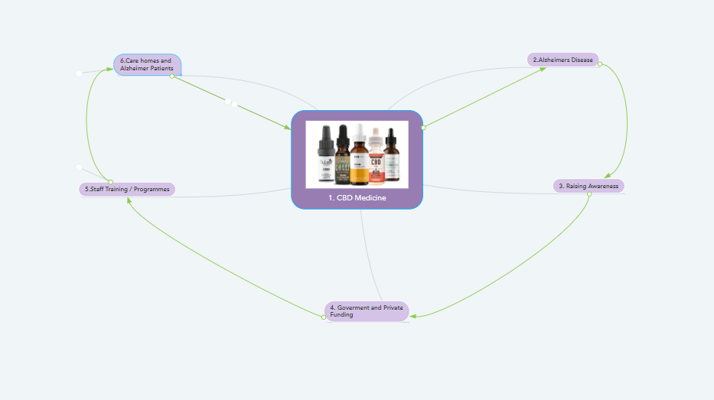
https://www.mindmeister.com/1786293749
I opened an account on Mindmeister.com which was where i was able to design this from the contents which the weblink offers. My idea in the illustrated mind-map in this example relates to how CBD oil can be beneficial and to be provided and how it can be beneficial to those who suffer from Alzheimer’s Disease. CBD oil has many positive effects when used positively With new CBD and Alzheimer's studies, the subject of CBD health benefits continues to develop. CBD has been shown to minimize or eliminate the effect of inflammation, oxygen accumulation and decrease in brain cells in recent studies CITE(https://medium.com/@josh_37797/cbd-for-alzheimers-784ea72ebf31). CBD oil is giving hope and another chance to those that have been suffering with the disease.
- CBD oil
- Alzheimer’s Disease
- Raising Awareness
- Government and private funding
- Staff training and programmes.
- Care home / Alzheimer’s patients

1.CBD Oil
CBD Oil is an abbreviation for the meaning Cannabidiol. Cannabidiol is a compound (= a chemical that combines two or more elements) that is present in cannabis (= a drug, illegal in many countries, that is made from the dried leaves and flowers of the hemp plant) and that may have a use in medical treatment (Cambridge University Press,2021m). CBD oil can be used for many health benefits, such as soothing effects, sleep can alleviate pain, anxiety and depression can be minimized. Can ease symptoms related to cancer. May decrease acne, may have neuroprotective properties, may improve heart health and many other possible benefits (Kubala 2018).

2.Alzheimiers Disease
Alzheimers Disease is a physical disease that affects the brain. The brain is made up of billions of interconnecting nerve cells. Connections between these cells are lost in Alzheimer's disease. This is because proteins create irregular structures called 'plaques' and 'tangles' and shape them. Nerve cells gradually die and brain tissue is lost ,It is named after Alois Alzheimer, the doctor who first described it (Alzheimer's Society 2021.). This disease doesn’t just affect the person with he disease just doesn’t effect the person with the disease but the people who care for them nurses,family and friends etc (Eubanks, L.M.,2006.. Molecular pharmaceutics, 3(6), pp.773-777.) THC is a considerably superior inhibitor of aggregation relative to currently approved medications used for the treatment of Alzheimer's disease, and this research offers a previously unrecognized molecular mechanism by which cannabinoid molecules may have a direct effect on the development of this terrible illness.

3.Raising Awareness
There are many advantages of using CBD oil in heath, but not many people are educated on this or are very cautious as there are many different opinions out there, but there are many different ways to teach and educate people. To learn the valuable benefits of what it can do in the health aspect, being able to raise awareness in various ways such as flyer classes presentations, Volunteering and offering to particaiptate in this events will get other interested and involved allowing donations for research. Raising Funds can be done in many innovate ways like starting a social medis campaign like gofundme.com. these

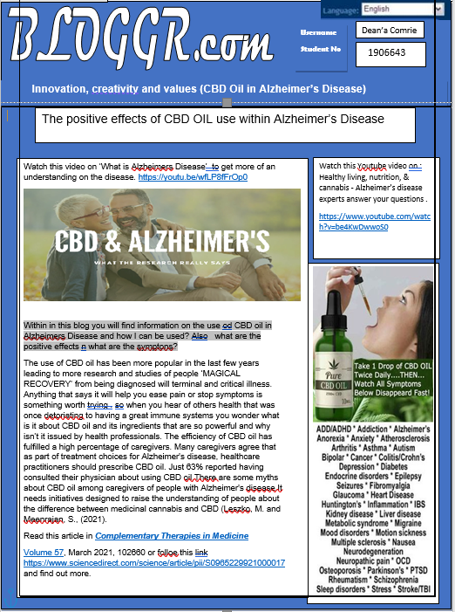
Task 2 – Blog

References
https://www.mindmeister.com/1786293749.
Cambridge Dictionary (2021) Definition of cannabidiol from the Cambridge Advanced Learner's Dictionary & Thesaurus © Cambridge University Press,2021 Available at: https://dictionary.cambridge.org/dictionary/english/cannabidiol Accessed: (10/02/2021).
Jillian Kubala, MS, RD (2018) ‘7 Benefits and Uses of CBD Oil (Plus Side Effects)’, 2005-2021 Healthline Media A Red Ventures Company 2018 Available at : https://www.healthline.com/nutrition/cbd-oil-benefits#TOC_TITLE_HDR_7 (Accessed09/02/2021).
CBD oil blog image https://www.google.com/search?q=cbd+oil+in+alzheimer%27s&tbm=isch&hl=en&sa=X&ved=2ahUKEwjx0PTh4fPuAhUV1IUKHZImAb4QBXoECAEQKw&biw=1579&bih=763#imgrc=la-bC_ycUhGhKM Accessed:(17/02/2021).
https://www.alzheimers.org.uk/about-dementia/types-dementia/alzheimers-disease?-- Accessed: (10/02/2021)
A Molecular Link between the Active Component of Marijuana and Alzheimer's Disease Pathology Lisa M. Eubanks,Claude J. Rogers, Beuscher, George F. Koob Arthur J. Olson, Tobin J. Dickerson,Kim D. Janda https://pubs.acs.org/doi/abs/10.1021/mp060066m 2006 American Chemical Society,Accessed:(09/02/2021)
https://www.youtube.com/watch?v=be4KwDwwoS0 Accessed:(08/02/2021)
Leszko, M. and Meenrajan, S., (2021). Attitudes, beliefs, and changing trends of cannabidiol (CBD) oil use among caregivers of individuals with Alzheimer’s disease. Complementary Therapies in Medicine, 57, p.102660
Blog image https://www.nzhempress.co.nz/blogs/news/can-hemp-oil-help-with-alzheimers Accessed : (09/02/2021)

