Table of Contents
Executive Summary 3
AI and HR Practices Overview 4
Systems Theory and AI 4
Analysis (AI) 8
PEST 8
Political Challenges 8
Economic Challenges 8
Social Challenges 9
Technological Challenges 9
SWOT 10
Strengths 10
Weakness 10
Opportunities 10
Threats 11
AI Automation and Job Losses 12
Impact of Automation (Three waves) 12
Algorithm Wave 12
Augmentation Wave 13
Autonomy Wave 13
Automation Risk On Workers 13
Gender 13
Education 14
Socio-Technical Theory 16
Human Adaptability 16
Human-Centred Approach 18
Conclusion 19
References 21

Artificial Intelligence (AI) in Human Resource Management (HRM): Aspect of Job Losses and Human Adaptability

M I C E
Dr Amare Desta

1 8 1 6 9 1 1
Hassam Aziz Khawaja

Executive Summary

Smart automation tools such as robotics, machine learning, deep learning, Artificial intelligence are predicted to penetrate the world of management on a much bigger scale in the near future. A view exist in which smart automation can be a medium for obtaining great benefits in an organisation and on an economy level by enhancing productivity through new and better products and services. In a study carried by Pwc estimated that technologies of these kind can contribute up to 14% in global GDP by 2030 (PwC, 2018).

Todays advances in digital technology dictate the trend of remaking in all the sectors of economy. Many alarms have sounded on the potential of the AI to affect the workforce. While chasing the growth and productivity aspects to the economy, employing digital automation tools have a tendency to affect the human aspects through disruptions specially in the job market. Global survey from PwC (2018) concluded 37% of the workers showed concern regarding potentially losing their job due to recent revolution in automation.

In this report we aim to expand on the concept of Artificial Intelligence (AI) on what it actually is. We support our expansion with the help of system’s theory. Furthermore, we converge our point of view through a SWOT analysis on the phenomenon of Artificial Intelligence which helps to understand the actual strengths and weaknesses of the smart automation tool of artificial intelligence and its capitalisation on potential opportunities and challenges in the contemporary organisational environment and furthermore PEST analysis for macro aspects.

We analyse the main people management issue of job losses as an affect of employing artificial intelligence in an economy on a global level with the help of case study done by Price Waterhouse and Coopers (PwC). Pwc studied 200,000 workers from 29 countries. Workers of different age, gender and education level were the target and we also unfold the process of automation in three levels

- Algorithm
- Augmentation
- Autonomy

A theory is just a theory until it gets tested in the real world situations and actually produce results. A theory itself is just not enough to demonstrate the automation, practicality of the automation in the real world is a big challenge in hand. We introduce Socio-technical theory as a basis of arguments regarding the adaptability of humans with technology aspect and suggest a framework that promotes human intelligence and participation of humans in general along with AI and so called Human Artificial Intelligence and then we conclude our report with our analysis.

AI and HR Practices Overview

Automation and AI as revolutionary technology has led reforms in HR practices. AI as a system umbrellas various set of technology tools such as expert systems, deep learning, robotics, block chain. Decentralised nature of the technologies with block chain helps automate the process of information and document verification which tend to be more accurate and time efficient. Moreover, trends such as automated CV validation, contractual records, smart contracts in education and employment qualifications, party validation and crypto currency as an emerging phenomenon in relation with national and international payrolls have transformed the HR era of doing things with disruptive technology (Michailidis, 2018). Advances in technology employment on a big scale in organisations have affecting the employment patterns in terms of job retention and job losses. Forrester being one of the most prominent research and advisory firms in the world estimated that to substitute humans over 40% of companies will employ robots and machines (Michailidis, 2018).

Therefore, impact of AI engagement in HR practices will be widespread. Applications, software, computer systems, virtual applications powered by AI look to takeover HR sector with its automated capability providing its benefits to the organisation, However, it can have its implications and consequences at the same time. As understood by its nature, automation technology appears to be very expensive and require huge capital for its instalments (Michailidis, 2018). Consequently, it would demand high skilled and high educated individuals to operate the AI tools. It would be hard to find the right fit for the job with the current nature of workforce as it takes time for human adaptation as oppose to technology instalment. This scenario soon to creates a global crisis of job losses. Our report focuses on that particular aspect and argue the scenario with theory and case study.

Systems Theory and AI

We believe theoretical basis of systems thinking will provide foundations for addressing AI as a contemporary issue and at the same time it is appropriate to develop understanding of phenomena of system. Systems concept was introduced by Peter Senge in 90s. According to Senge (1990) systems thinking referred as the fifth discipline as it umbrella the proposed five disciplines namely 1) System thinking, 2) Mental Models, 3) Personal Mastery, 4) Shared Vision and 5) Team Learning. The nature of system thinking to integrate all the disciplines together, Therefore, these five disciplines conclusively referred as the systems thinking. The notion behind developing this framework was to guide the organisations to develop, excel and manage their potential of success after reaching their initial goals and sustain in the change environment.

We believe that in order to address the complex nature of technology challenge within management sectors in the form of AI, we need a comprehensive and more unifying definition of systems theory. Klir (1972) state regarding systems theory as

“a new way of looking at the world in which individual phenomena are viewed as interrelated rather than isolated, and complexity has become the subject of interest”

Systems thinking in simple words can be identified as “a system, made up of systems, developing and thinking about systems”. Since we have witnessed not one specific way of addressing this phenomenon hence it challenges the scholars to look into this from a more holistic way. System thinking proposed definition by Arnold and Wade (2015)

“Systems thinking is a set of synergistic analytic skills used to improve the capability of identifying and understanding systems, predicting their behaviours, and devising modifications to them in order to produce desired effects. These skills work together as a system”

Gaining knowledge of organisational system regarding their operations and connectivity holds immense importance in order to identify the challenges and issues rending the organisation as a system (Scholtes, 1998, p. 9-10). The author highlights the approach of strengthening of a system where relying on ordinary people result in outstanding performance rather the other way around. Fast-paced advances in 21st century in the field of technology and futuristic automation dictates the arising concerns regarding the foundation principles on which the systems are functioning around humans. The apprehension has been witnessed among the general public related to uncapped hegemony of artificial intelligence and the concerns of the AI nature being destructive towards humans. The idea of integration of AI automation in organisations questions the compatibility with regards to human jobs and humans’ adaptability towards this futuristic complexity.

Considering the world as a system, we face enormous political, social and physical challenges. Mingers (2014) highlight the global issues such as climate change, financial crisis, fast-paced technological development and a lag in human adaptation, unethical corporate behaviour so on
And so forth. The system of the world implicitly faces these challenges due to its characteristics of interdependency, interconnectedness of the complex, nonlinear, multidisciplinary environment (Rhydderch et al., 2004; Mingers, J., 2014; Broks, A., 2016; Jokonya, O., 2016).

In already well established systematic way, the biggest trial to face tend to be the transition towards a change. We stand on the brink of new industrial revolution where managers and organisations along with its employees face inevitable change in the ubiquitous ways of operations already exist. Changing organisational behaviour and the means of their foundations best tackled through employed theories. However, unique and novel technologies drive the requirement of paradigm shift in those foundations and demand a change in the organisational behaviour such as the employed theories (Adams et al., 2014).

Novelty such as Artificial Intelligence and the ways humans can make use of it in the near future is unimaginable and beyond comprehension. We exercise the application of early stages of somewhat matured AI in our daily lives around us. AI being part of every household slowly becoming a necessity since the trend of dependency on technology is booming among humans. The domination of AI in our daily operations is unavoidable and unprecedented such as mobile phones, powerful computers, expert systems, Electric cars, driverless cars, robots in logistics with home delivery, online shopping and access to information to name a few. AI as an effective science has tremendous affects can be referred as innovative disruption on businesses and organisation and sectors especially healthcare. AI encompasses multiple technologies such as machine learning, computer vision, expert systems, deep learning and gears like algorithms, robotics, image recognitions.

The phenomenon of Artificial Intelligence (AI) requires the understanding of what it actually is. Literature has offered various AI definitions, each of these definitions encompass around concepts of intelligent human like machines programmed to perform tasks similar to human execution. Kaplan and Haenlein (2019) define AI as “a system’s ability to interpret external data correctly, to learn from such data, and to use those learnings to achieve specific goals and tasks through flexible adaptation”

AI should be considered different than big data, internet of things while looking at the definition above, it reflects the idea of interpretation from the inputs of combined external data through different means. Inputs such as big data also a concept of gathered large data from different means such as applications and mobile phones essentially involving people (Kaplan and Haenlein, 2019). The intelligence of humans classified as homo sapiens to learn new knowledge, understand and further apply it in order to gain new skills have played its role in establishing the human evolution (Thomas, 2017).

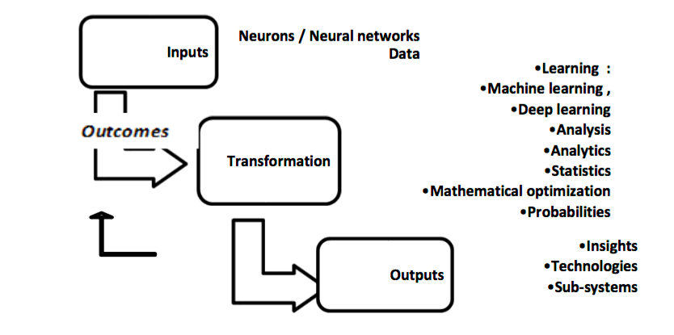
AI System Construct (El Namaki, 2019)

According to El Namaki (2019) Artificial intelligence system (AIS) is a combination of two components namely Data and Artificial neurons. The system dimension of artificial intelligence illustrated in the figure above shows AI fragments becoming a coherent whole when put into system framework. System framework for AI suggest input, transformational process, output and also loop for feedbacks. Inputs comprises of data and artificial neurons, transformational process is conducted through analytics, analysis and learning, Output is poised of insights and subsystems and feedback from the output completes the definition of a system.

The technology advancement in 21st century have triggered an avalanche of transformation in the systems of business environment and specifically in people management with-in organisations. Research study Salomon et al (1991), provide insights arguing the support of intelligent machines to human minds to enhance the intellectual performance. Intelligent machines nowadays support humans with artificial memory where people can store their data (Witten et al., 2017). Artificial intelligence in work places is increasing dramatically and anticipation of how it will affect our jobs is at a slow pace (Hogg, 2019).

AI embodies heterogeneous set of tools, techniques and algorithms; Moreover, emerging AI systems tend to possess incomparable abilities to undertake knowledge-based tasks that previously seen as under the human domain (Jarrahi, 2018). Digital transformation has been an important change at the same time a challenge faced by the businesses. Bader (2019) state a demand has been marked for and use of AI based technologies for HR functions in general. AI soon to be a powerful asset for the organisations to plan the future. Artificial intelligence can potentially assist the business leaders with identifying trends and opportunities arising for the businesses (Jones, 2019). The understanding is that the intelligence of non-human which consider to be as intelligent as humans, can perform the tasks as executed by the humans (Thomas, 2017).

Understanding the need of AI parallel to transformation of late millennials and the gap between millennials and Gen Z with regards to inclination towards the use of technology is paramount. Tushar and Bhatia (2018) have seen 22% of younger workforce expecting a response in less than 10 minutes from the brands. Integration of artificial intelligence in the human resource (HR) has grown exponentially in 2017 (Tushar and Bhatia, 2018). According to Bader (2019) artificial intelligence could be an encouraging anecdote for the HR to catch up in areas of business where needed. However, recent hyperbole from sceptics around AI and similar cognitive technologies have made the world question the possibility of machines taking over the humans and the principal of displacement in terms of the jobs (Jarrahi, 2018).

Kolbjornsrud et al (2015) give insights regarding the acceptance of AI in emerging economies and also state that the acceptance of AI varies in different geographies. The authors also differentiate how the managers in emerging economies appear more (46%) inclined towards adapting AI than the managers from the developed economies (18%). Managers from the emerging economies more likely to embrace the high-tech tools such as AI to keep the competitive edge and be present in the global market.

Analysis (AI)

Our report provides insights regarding the significance of Artificial Intelligence and requirement of a shift in management paradigm, not just in HR in fact in every sector of the management. However, we focus on people management issue in our next section. In the current abnormalities of the world, AI as a tool can present unprecedented opportunities for value creation and at the same time daunting challenges for the management. AI can potentially dictate the managers to rethink and redefine the roles they already operate. We undertake a PEST analysis for wider macro aspects and SWOT analysis in order to extract information on AI’s micro aspects. Essentially we aim to express that the capitalization on strengths turn around and become future opportunities. Similarly, organisations unable to compress the weaknesses eventually turn around and become a potential threat.

PEST

Political Challenges

There can be enormous political challenges for implementing AI comprehensively in organisations due to its uncapped intangible power. AI with-in governments needs a more holistic approach towards the understanding of its role. Wirtz et al (2018) claims that implementation of AI in the public sector arises many challenges. AI can lead a disconnection among humans regarding beliefs, preferences and policies in a public sphere. Political potential requires more of a human conscious to organise, evaluate and regulate political community by thinking of its own, where as AI cannot think of its on (Gregg, 2018, p.170). AI cannot implement political orientation such as empathy as it is non-existent. Empathy derived by the feelings which exist in humans. According to Cath (2018) a very recent political challenge faced by the US when AI regulations were questioned related to Cambridge analytica and Facebook coordination over breach of information for political gains. Hence, another political danger would be digitisation of the political community undermining political goals and behaviours (Gregg, 2018, p.171). The misuse of AI ranging from military, social media, justice system and political. Political misuse of AI for individual gains can have economic and social consequences beyond boarders and international relations. As Feijoo et al (2020) claims that sovereign states are continuously working towards defying malicious and unfair practices of AI in order to protect their citizens and their interests and even their own political stability.

Economic Challenges

AI comes with huge economic challenges and it can potentially become a differentiating point between developed and underdeveloped economies around the world. Since productivity and growth with efficiency tend to be the focal points of the organisations, employing AI and other Tech artefacts requires huge amount of capital and a total shift in working norms. Dviwedi et al (2019) discusses the inevitability of substantial financial investment and changes in the working environment. Moreover, AI likely to bring changes in every sector of the organisation. AI hold the potential to increase the gap of wealth between rich and poor countries. The healthcare related economic challenges can not be ignored. Since we established that AI demands huge capital investment ultimately would result in high treatment costs for the patients and imbalance in hospitals profits (Dwivedi et al., 2019). The same blueprint would work in other departments and that trend would affect the workforce as the requirement would be a high skilled and educated workforce means high cost of hiring.

Social Challenges

Increase employment of AI would certainly bring barriers among sectors of population and challenge cultural norms. Holzinger et al (2018) highlights the core problem of trust across people demographics. People may find it extremely difficult to adapt to algorithmic wave with their personal and sensitive information as unexplainable nature of algorithms. Author further states that it can be a major issue for hospital patients and in general safety decision makings. Xu et al (2019) focuses on AI challenges in the healthcare and patient privacy related to sensitive information and stresses on the educating healthcare professionals in delivery quality healthcare and patients to overcome the fear.

Various studies have been undertaken on social issue of job losses due to automation and employment of AI equipped machines and a lot of attention has been received by this issue due to attached severe consequences. Risse (2019) highlights the human rights challenges that generates due to AI. The author further stresses that the employment of AI also dictates the change of trend in the nature of work and that questions the human participation in the society.

Technological Challenges

Increase adoption of automation and AI technologies within organisation systems generates equally complex challenges. AI based system tend to operate like a black box which becomes a barrier between a machine and a human on the basis of trust and transparency. Specially in the medical and healthcare sectors adopting the contemporary technology require the operators’ confidence such as nurses and clinicians as well as the patients. Algorithmic nature of the technology and its decision making cannot be mirrored like humans. Machines cannot experience the element of feel, empathy and emotions as a whole hence cannot understand the aspects of human intelligence in particular situations. Since, machines cannot understand the right meaning from a particular situation that can hinder the right decision. Therefore, AI becomes hugely invaluable.

SWOT

Strengths

AI can be a massive help in various business and non-business activities if its algorithm is coded correctly. High tech AI have unbelievable accuracy, speed and precision leading to growth, productivity and efficiency for organisations. It can overtake the repetitive tasks and human workforce can divert their attention to other important tasks such as meetings, consultation, presentations with stakeholders. It minimizes the possibility of errors as oppose to humans tend to make repetitive errors.

AI offers advantages such as hardware, superior processing power, superior serial power (time), increased parallel power, algorithmic improvement, self-improvement and superior communication (Sotala, 2012)

Weakness

Automation through AI still have its weak links. Limitations in AI are partly technical and partly practical. Primarily, explaining and justifying decisions taken by the AI equipped machines at certain times and in certain situations may be difficult for the humans. Since AI understandably a mean of interpretation of input data through algorithmic motion, generalizing and learning the algorithms tend to be challenging. It can further raise the issues such as biasness, malicious use and security of its use as it holds enormous uncapped power. Recent issue with Gcses and Alevels student with their grading through algorithmic process turned out to be unfair due to pre-installed programming.

Adaptability of AI presents a different type of challenge to business organisations where aspects of readiness in the workforce, process readiness, data availability, integration process and challenge of displacement of technology makes it problematic.

Opportunities

Displacement of rapid technological progress from traditional industrial robots and automation to contemporary and more capable autonomous systems such as autonomous cars and automated checkouts in grocery stores is imminent. Improvement in systems and components such as software, sensors and mechanics have made the biggest progress. AI specifically has made leaping developments in more sophisticated algorithms which has given an opportunity for exponential growth in readily available data with computing power (Mckinsey and Company, 2018).

AI has enormous potential to transform businesses with productivity and contribute towards the growth of the economy. Big data and AI integration have attracted significant interest (Dwivedi et al, 2019). The contemporary generation of AI advances the analytics to a higher level including the techniques addressing clustering problems, estimation, classification guaranteeing value. Artificial neural networks could add up $3.5-$5.8 trillion in annual value, equivalent to 40% just by the analytics techniques (Mckinsey and Company, 2018). AI holds the hegemony to solve societal challenges especially related to healthcare, climate science and cybersecurity. According to Dwivedi et al (2019) AI has a potential for improved healthcare operations with in different domains of the hospital. AI can help in providing improved diagnostic system, patient care and image interpretation in radiology. AI screening for cancers and detection potentially reduce false flags and human errors.

Threats

The authors (Mark, 1993; Goralski and Tan, 2020) discuss that some people view employment and utilisation of AI as a positive for economy, performance, efficiency and some people refer to it as possible crisis for humanity in the form of exacerbate global economy. Having so many opportunities in the following decade in the spectrum of employing AI, However, also bring a lot of disruptions and threats to human workforce in different capacities. Around estimated half of the activities in the coming decade will be automated.

In highly predictable and structured environments, physical activities such as collecting and processing of the data as oppose to providing expertise and engaging and interacting with stakeholders. It can be stated that soon many CEO’s and seniors who require data handling and processing in organisations may be working alongside automated machines rather with humans. Automation through AI will displace workers. Some fields of occupations will see huge decline by the end of next 10 years. (Mckinsey and Company, 2018).

Winn et al (2005) claims that AI expert systems will be wrong at times even if there is no programming error. In the case of autonomous weapon system, they select and engage with the target with the help of expert systems without human intervention (Garner, 2015). Garner also states that AI communities occupied with a challenge of making an ethical decision regarding (LAWS) lethal autonomous weapon system development. Any systematic error or failure within the system can cause massive destruction and possible human casualties.

AI Automation and Job Losses

Indications and warnings have been there in the past century regarding automation, computers and technology were going to take over many lower and middleclass jobs (Autor, 2015). 21st century technological advancement has affected the organisations on every level. Industry 4.0 is a contemporary buzzword and it denotes for forth industrial revolution in the pipeline. In this section we aim to form socio-technical theory as the basis of our analysis while using the selected case study “Will robots really steal our jobs?” for illustration purposes on the challenge of job losses due to the automation, artificial intelligence, and a worldwide digital network that serve as an empowering platform for unprecedented innovation.

Impact of Automation (Three waves)

Resurgence of AI in our contemporary business organizational environment pose a threat to the workforce already working in their roles. We can witness the trend of automation already evolving with-in the organisations structure. PwC case study stated that covering 200,000 workers across 29 different countries, 3% potential jobs estimated to be at high risk by early 2020, 20% by late 2020’s and it rises up to 30% by mid 2030’s (PwC, 2018, p. 14). The automation process as mentioned earlier in the summary has three overlapping stages of implementation namely Algorithm wave, Augmentation wave and Autonomy wave.

(PwC, 2018)

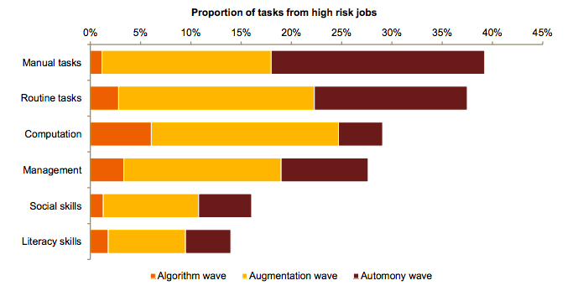

Algorithm Wave

Algorithm wave is the first stage of potential automation with-in organisations. It primarily encompasses around simple computational tasks and the structured data. The above figure shows the manual tasks at a very starting phase such as mathematical calculations, using search engines, basic software packages including simple ad-hoc management duties such as compilation of files, signing the documents. Moreover, big data processing applications, machine learning algorithms and more sophisticated applications are available in the market. Therefore, it can be stated that intern level jobs that carry out such computational, manual, ad-hoc tasks would be at high risk (PwC, 2018, p. 14).

Augmentation Wave

The second stage of automation involves the way how the tasks and the jobs are conducted with a more dynamic change. The second wave of automation aims to displace routine tasks such as filing and exchanging information papers, physical transfer of the information with the help of technology. One of the main augmentation would be the replacing the tasks which are repeated. Moreover, decreasing the need of programming language for repeated programmed tasks. Machine algorithm has an important role to play in augmentation process. As machines can learn and redesign algorithms internally. Evolving the algorithmic sense in machines will continue the advances in robotics. However, in this decade until late 2020s humans will be working alongside machines as an assistance and its impacts will be experienced until late 2020’s (PwC, 2018).

Autonomy Wave

The third stage of automation is with fully autonomous AI technology and robotics which will further takeover the physical labour and manual dexterity to a much larger scale. Problem solving and analytics aspects will require much immediate responsiveness and that can be satisfied through employing autonomous systems such as expert systems involving artificial intelligence and algorithms. For example, currently we have partial autonomous vehicles that can accelerate, brake, avoid accidents and steer to some extent. Even this partial autonomous vehicle are the luxury cars. It is expected in next 10 to 15 years where full automation will exist without human intervention whatsoever and with fully AI assisted systems (Beede et al., 2017). Full autonomy of the intelligent systems is expected to penetrate with-in organisational systems around mid 2030’s (PwC, 2018).

Automation Risk On Workers

Gender

Gender partiality exist deeply in the contemporary social order. The consequent realm of technology-driven work tends to intensify gender fairness gaps, if the gender partiality is not addressed. The automation of work-operations in organisational environment through different tools such as Artificial Intelligence, digitisation, robots and expert systems may influence the necessity of female workers dissimilarly as compare to the men workers (Kral et al., 2019). However, scholars’ views disagree with the notion that the automation is going to take over the jobs, with estimated job losses in billions around the world (Waldman-Brown, 2019). Our selected case-study PwC (2018) analysis state that the existing jobs open to high risk of automation tend to be more for male workers with a median estimation rate of 34% as compare to woman workers 26%. One of the main reasons for that consider to be the higher representation of male workers’ in automatable sectors such as transportation, construction, manufacturing as compare to the woman’s participation in health, social work and education. When it comes to the young males and young females, the difference appears in the type of jobs they do in industries. In retail as an example, young male workers are tending to be more participatory towards crafts and trade workers where as young female workers tend to be inclined towards customer service and sales workers. The automation rate for the young male workers tend to be higher at 46% as compare to the young females at 20% (PwC, 2018).

Education

According to Hessel et al (2018) computers and machines have already replaced jobs in large numbers and an unprecedented advancement in technology dictate significant shift in job opportunities in the favour of individuals who have acquired higher qualifications and higher skills as compare to the lower level workers. Possible loss of jobs in significant numbers particularly lies with lower educated doing so-called routine jobs.

When it comes to aiming for the productivity and growth, automation, machines, robots and AI equipped means of algorithm having the attributes of accuracy, precision, efficient would be the preference of organisations in the age of 21st century. However, employing these high-tech human-like machines require a huge capital. Since we have already established in our previous section regarding the type of tasks to get automated initially tend to be simple computational, manual and routine task therefore, these tasks would not require a highly educated individual and it would require an entry level educated individual to carry out those activities. Employing automation require intense capital, which reduces the output gains hence that can be accumulated by employing high-skilled and high educated labour and replacing low skilled and educated (Kral et al., 2019).

(PwC, 2018, p. 30)

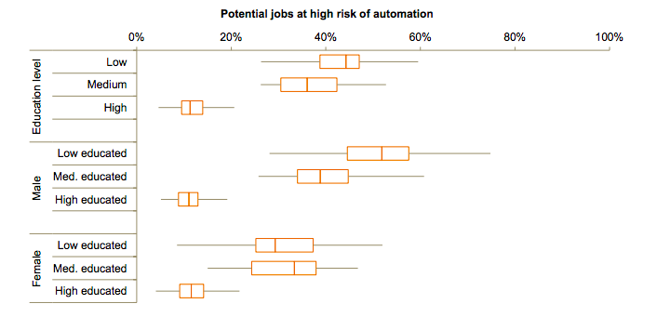

According to PwC (2018, p.30) greatest imbalance in the share of jobs at risk relate to the education level of the workers. A we can see in the above figure, the median risk of automation for low and medium education level is higher 44% and 36% respectively where as when it comes to high education level such as graduates from university maintain a lower level of potential risk of job automation at around 11%. Individual workers with a university degree tend to be involve in more professional, consultancy, decision making on policies, research, education and technical roles which are less likely to get automated in the near future.
When it comes to the specification of gender, males and females with high education level stand similar on estimated automation grounds with 11% and 12% respectively. However, with low level of education significant difference has been seen with regards to estimated job automation between males and females. According to the figure above low and medium educated males tend to face higher risk of potential job automation 52% as compare to the females at 29%. This significant difference has to do with the nature of jobs these genders do. As we discussed earlier in the gender section, the types of job males and females tend to do have a huge part to play in terms of risks involve in estimated job automation.

Automation through AI, robotics and other automation tools bring challenges within people management such as job losses. Organisations in 21st centaury strategizing to tackle competition through productivity, growth and efficiency in the operation while reducing costs specially in a longer term perspective. Having recent technological revolution, it can be assumed with the insights of above case study that human-jobs are at greater risks. In order to minimise the negative affects of automation and AI technology, we further discuss human capability of adaptability in situations like these with the basis of theory and what should be the approach for organisations in the future.

Socio-Technical Theory

Socio-Technical Theory is the study of people, technology and task aspects. Socio-Technical Theory (STT) hypothesises the existence of two systems; technical and social, in every organisation (Cartelli, 2007). More than just technology, equipment, resources, technical sub-system can be recognised as conversion system from input to an output. However, the conversion system requires constant control in order to ensure the achievement of organisation goals. On the other hand, in social sub-system of STT, people perform the technical control tasks where tasks are assigned to individuals to be performed as a group responsibility. The cornerstone of STT is to achieve a design process to mutually optimise the subsystems. The organisational performance can only be achieved when the interdependency of subsystems is recognised. Davis et al (2014) asserts that interrelatedness of the elements demand joint consideration. Design process of the subsystems must take in to account the impact they may have on each other, therefore, planning and coordination must be in place for pursuing superior results from each subsystem in order to conduct operations of subsystems in harmony (Cartelli, 2007).

Sony and Naik (2020) have studied industry 4.0 in relation with the socio-technical theory. The authors have described industry 4.0 as the new industry revolution having a focal point of technology such as cyber physical systems, artificial intelligence, Internet of things, advanced digitisation and cloud computing. With industry 4.0, traditional mind-set claims that more automation result in less human involvement. However, the researchers have denied that trend and argued that industry 4.0 may require the workforce to acquire advanced skillset. The skills may have to be more specialised hence, industry 4.0 will be a system of social and technical aspects. The ontology of socio-technical theory is focused on the abstract interaction between people, process, technology producing product and services (Sony and Naik, 2020). The authors state that employing new machinery without human behaviour issues consideration may result in workplace complications. Sony and Naik (2020) describe the socio-technical thinking as:

“The thinking that design is systemic and it calls for consideration of both the social and technical factors while implementing new technology or business change within the organization”

Human Adaptability

Human-Robot interaction (HRI) research in the past held more interest from the scholars in order to investigate robot to human adaptation using techniques such as machine learning. However, in recent times due to technological revolution and existence of AI equipped machines in almost every household and organisations, possibility of utilising the human ability of adaptation towards human to robot phenomena is becoming a global talk (Mohammad and Noshida, 2008). Socio-technical theory lay down the principals of abstract interaction between people, process and technology through its social and technical subsystems (Sony and Naik, 2020).

According to HolmesNoble (2019) humans sit at the brink of industrial revolution 4.0. The early stages of another technological revolution where humans and machines coexist and people are in the process of learning to work alongside machines. As predicted in our case study above (PwC, 2018) 30% of the UK jobs face the risk of automation by mid 2030, it is only wise to start equating machines, AI, robotics with humans and their collaboration rather insisting on the fear of job losses and only machines taking over the human jobs. In many cases, it can be stated that the nature of the jobs will change rather jobs disappearing. AI and machine learning have already been utilised in manufacturing, logistics and supply chain industries for example amazon (Holmesnoble, 2019). Bushel and Floreano (2018) claim that drive of automation in organisations have neglected the importance of human intelligence related to adaptability. In a recent effort towards full automation from Tesla in 2018 where they targeted production of 5000 cars in a week and they failed. Hence, the CEO Elon Musk stated that the excessive automation towards the production was a failure and the intelligence of humans was undermined. Possibility of the collaboration of human-machine aspect can give organisations the following (Holmesnoble, 2019) :

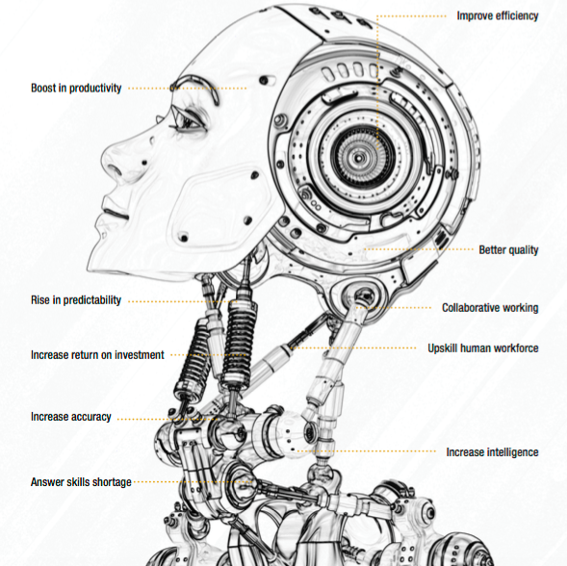

Human-Centred Approach

Figure: (Xu, W. 2019)
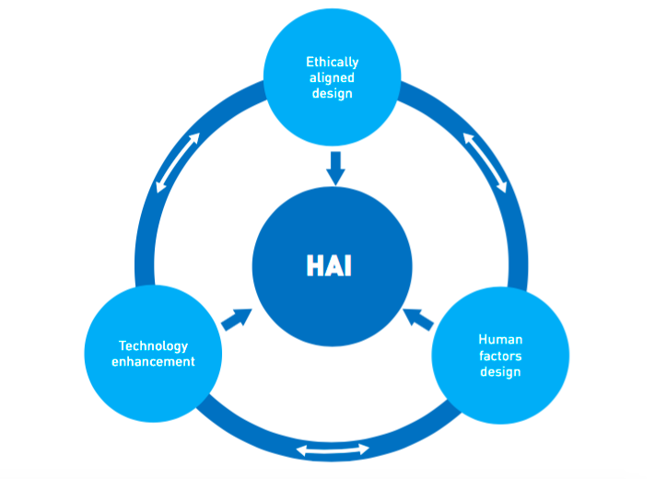

Human Artificial Intelligence (HAI) framework comprise of three aspects as shown in the above figure. 1) Ethically aligned design. 2) Technology enhancement. 3) Human factor design. The agenda of this framework is to comprehensively address the challenges between humans and Artificial intelligence technology. This framework anecdote the synergy between these three interdependent components. Ethically aligned design addresses the challenging aspects of biasness, unfairness, discrimination and most importantly negates the replacement of humans. Technology enhancement addresses the integration of human intelligence with the technology to further enhance AI. Human factor design ensure the most important barrier of AI adaptability that AI solutions are explainable and useful.

AI have advanced in stages in the last decade. In the initial stages (1950-70) of AI, major advances were related to connectivity, identifying the reality, production systems, early expert systems and knowledge inferences. The middle stage (1980-1990) of AI became slightly more advanced with expert systems, speech recognition, Artificial neural network, algorithm patterns. However, the similarity between these two stages were that these advances were unable to satisfy human needs, focus of these advances was only technology related and lacked overall maturity. The third stage (2006 onwards) of AI made all the necessary advances such as deep learning, robotics, algorithms, block chain, big data and high performance computers. These advances have started to satisfy human needs such as problem solving and focus not just on technological aspect but also on ethical, economical, societal solutions (Xu, W. 2019).

Conclusion

In this report, we make AI and related automation and the aspects of job losses and human adaptability our focal point of discussion. We initiate with the overview of AI impact on HR practices and then we build upon relevant selected theory of systems for AI and then highlight the crisis in jobs due to AI, automation and other tools with the help of case study. We propose the aspect of human adaptability in the era of revolutionary tech advancement with the likes of AI, robotics, expert systems and smart systems. We use socio-technical theory which typically addresses people, task and technology as the foundation of human adaptability behaviour. We highlight the importance of human intelligence and humans as natural adaptors. We provide insights on potential jobs at risk due to automation with the help of case study.

At a time of contemporary challenges national and international policy and regulations need to be in place more than ever. AI holds the power of more fundamental affects to the human lives than any other technology. Policy coordination remains paramount in tackling ethical, social, political and economical challenges arises by AI employment. Technology diplomacy should be taken under consideration in order to devise policy and governance structures. Technology and automation should be seen as a complementary element to human lives rather than a substitute. In fact, workforce of current generation and millenials should be motivated towards learning and evolving with the potential industrial revolution 4.0. Human intelligence should be given importance rather than ignoring and undermining the human ability.

Businesses and nations seem confident having the reality of technological world of automation that it can create more jobs than losing more jobs (Marria, 2019). However, in order to achieve and embrace the full flow of the tech-revolution, government should take responsibility to devise human friendly policies and structures of operation to avoid any societal inequality such as gap between rich and poor. Businesses and individuals need to overcome the fear of AI and develop trust and at the same time organisations and employers should introduce seminars and study packages for the employees to upskill them and develop their sustainability towards the jobs.

It can be argued that the education system within schools and universities need a proper revamp. Addressing the adaptation issue from a very early stage seek attention from the relevant authorities. Education systems need to introduce differentiated modules where students get involve with AI. On one hand where AI technology can perform repetitive tasks more efficiently and give productive results and on the other hand humans and human intelligence will perform better on creativeness, imagination, consultation, relationship building and involving with different stakeholders. The HAI framework suggests to make human centric policy when implementing AI technology. More importantly, ensuring humans coexistence with the technology would boost the output in many ways as human intelligence still is unmatchable.

References

Arnold, R and Wade, J., (2015), A Definition of Systems Thinking: A Systems Approach, Conference on Systems Engineering Research, 44, pp 669-678

Bader, B. (2019). How do HR professionals feel about artificial intelligence?, People Management(Online), Available at: https://www.peoplemanagement.co.uk/voices/comment/how-does-hr-feel-about-artificial-intelligence Accessed on 06-08-2020

Cath, C. (2018). Governing artificial intelligence: ethical, legal and technical opportunities and challenges, pdf online, available at: https://royalsocietypublishing.org/doi/full/10.1098/rsta.2018.0080 , Accessed on 7-08-2020
Garner, T., (2015). Ethics of Artificial Intelligence, Nature; London, 521(7553), pp 415-418.

Dviwedi, Y et al. (2019). Artificial Intelligence (AI): Multidisciplinary perspectives on emerging challenges, opportunities, and agenda for research, practice and policy, International Journal of Information Management, https://doi.org/10.1016/j.ijinfomgt.2019.08.002

El Namaki, MS. (2019). A Systems Approach to the Artificial Intelligence Concept, International Journal of Knowledge Management Application and Practise, 1 (2), pp 33-39

HolmesNoble. (2019). Automation – the collaboration between human and machine, pdf online, Available at: https://www.holmesnoble.com/wp-content/uploads/2019/01/Holmes-Noble-Discussion-Paper-Automation-the-collaboration-between-human-machine.pdf , Accessed on 18-08-20

Jarrahi, M. (2018). Artificial intelligence and the future of work: Human-AI symbiosis in organizational decision making, Business Horizon, https://doi.org/10.1016/j.bushor.2018.03.007 0007-6813/

Jokonya, O., (2016), Towards a Critical Systems Thinking Approach during IT Adoption in Organisations, Procedia Computer Science, 856 – 864

Kaplan, A and Haenlein, M. (2019). Siri, Siri, in my hand: Who’s the fairest in the land? On the interpretations, illustrations, and implications of artificial intelligence, Business Horizons, 62, pp 15-25

Khalil, O., (1996). Artificial decision-making and artificial ethics: A management concern, Journal of Business Ethics, 12(4), pp 313-321

Mskinsey&Company. (2018). AI, AUTOMATION, AND THE FUTURE OF WORK: TEN THINGS TO SOLVE FOR, pdf online, available at: http://dln.jaipuria.ac.in:8080/jspui/bitstream/123456789/1335/1/MGI-Briefing-Note-AI-automation-and-the-future-of-work_June2018.pdf , Accessed on 10-08-2020

Mingers, J., (2014). Helping Business Schools Engage with Real Problems: The Contribution of Critical Realism and Systems Thinking, European Journal of Operational Research, 242 (1), pp 316-331

Michailidis, M.P. (2018). The Challenges of AI and Blockchain on HR Recruiting Practices, The Cyprus Review, 30 (2), pp 169-180

Mohammad, Y and Nishida, T. (2008). Human Adaptation to a Miniature Robot: Precursors of Mutual Adaptation, pdf online, Available at: https://d1wqtxts1xzle7.cloudfront.net/30601816/yasser_roman08.pdf?1361178427=&response-content-disposition=inline%3B+filename%3DHuman_adaptation_to_a_miniature_robot_Pr.pdf&Expires=1597867708&Signature=M0Q-Ixe5p5ABhT9wrifusDxSkCgesWIYmALGhtINp1APLcKVF0-jjg8jAdzgBuls1iXbYCvZLTiVqECBnItC6i8jFtOw3y0-Q-OrHxHiWqt9VEYxoae-9jxofU~cEOra3IrH557NzthMqBYjjSGdmG4SFWIjKGEtWKGp6I98SPo2zeo1pC7jpDsmaekLpAT67ZrAhoLQ-mTvexLO~lahl5-4wThQtnOLJpMXSazAIHZ4pDVInIt~5M1koe29qrgBV0BquaScSTcBNtsJ2g8BHetsLwUZ4cQEJVbckzDqBKRus7EvtV6lWki1jwDAKZN2ow~WPUBaSO8AunEsY5Hh4g__&Key-Pair-Id=APKAJLOHF5GGSLRBV4ZA , Accessed on 18-08-2020

PWC. (2018). Will Robots Really Steal Our Jobs? An international analysis of the potential long term impact of automation, Pdf Online, available at: https://www.pwc.com/hu/hu/kiadvanyok/assets/pdf/impact_of_automation_on_jobs.pdf
, Accessed on 15-08-20

Risse, M. (2019). Human rights and artificial intelligence: An urgently needed agenda, Human Rights Quarterly, 40 (1), pp 1-16

Rhydderch, M., Elwyn, G., Marshall, M and Grol, R., (2004), Organisational change theory and the use of indicators in general practice, Quality and Safety in Healthcare, 13(3), pp 213

Scholtes, R., (1998). The Leaders Handbook: A guide to Inspiring your People and Managing the Daily Workflow, Newyork

Senge, P., (1990). The Fifth Discipline, the Art and Practice of the Learning Organization. New York

Sotala, K. (2012). Advantages of Artificial Intelligences, Uploads, and Digital Minds, International Journal of Machine Consciousness, 4 (1), pp 275–291. doi:10.1142/S1793843012400161

Thomas, A. C. (2017). An introduction to Artificial Intelligence. Hackernoon [Online], Aug 20. Available via: https://hackernoon.com/understanding-understanding-an-introto-artificial-intelligence-be76c5ec4d2e [Retrieved 02-08-2020]

Winn, G., Gopalakrishnan, B., Akladios, M and Premkumar, R., (2005), Expert Systems, Professional Safety, 50(8), pp 45

Witten, I. H., Frank, E., Hall, M. A., & Pal, C. J. (2017). Data Mining: Practical machine learning tools and techniques. Morgan Kaufmann.

Xu et al. (2019). Translating cancer genomics into precision medicine with artificial intelligence: applications, challenges and future perspectives, Human Genetics Review, 138, pp 109- 124

Xu, W. (2019). Towards Human Centered AI: A Perspective of Human-Computer Interaction, pdf online, available at: https://www.researchgate.net/profile/Wei_Xu214/publication/335383054_User-centered_design_IV_Human-centered_artificial_intelligence/links/5e8635e24585150839b94685/User-centered-design-IV-Human-centered-artificial-intelligence.pdf , Accessed on 19-08-2020

