An individual reflective response to the Professional Teaching Experience

Throughout the course of my first Professional Teaching Practice (PTE1) I was required to reflect on an important event for each day. Throughout the 3 weeks I spent in Year 6 I believe I have made good progress as a trainee teacher. The first week was to be spent observing the class, but I made sure to also be actively involved in a support role within the class and also had opportunity to work with some groups. The second and third week were spent teaching either groups or whole class lessons. Reflection is a crucial part of learning to become a teacher, it gives opportunity to look back at the lesson/event as a whole to see which aspects went well and should be used again, which parts of the lesson/event did not work as well as I would have liked, and give opportunity to put in place fixes and better ways of handling situations to make the whole experience better and more beneficial to those involved. This is best viewed as a cyclical process. Once I have reflected, I will implement the changes needed before once again reflecting on the effectiveness these changes have had to the experience and implementing more changes to further improve it. John Dewey (1993) said that as teachers we have a responsibility to reflect on our actions and bring about improvements.
My first target in relation to the QTS standards I must meet as a trainee teacher was to “demonstrate the professionalism to ensure that relationships with learners are built on mutual trust and respect and to recognise that this will help maximise their learning potential.” (Education Wales, 2009, p.5). These positive relationships can be formed very quickly with children simply by being kind. Asking how they are feeling, greeting them every morning and listening to things they have to say. If a child tells you about something that they are doing that night or weekend, and you remember to ask them about it the day after they will appreciate that you have listened, remembered and care enough to ask about it again. Learning the names of each child in the class is also a vital step in creating positive relationships as it shows you care. I spent time in my first few days making sure I knew the names of every child in my class, being sure to ask them to remind me if I was unsure. Getting to know the children in my class also helped me get to know how their social relationships with other children worked, which in turn gave me the ability to group pupils with others with whom they would work well. This links to Vygotsky’s theory of Social Constructivism and his belief that children can learn from a more knowledgeable other, even if that more knowledgeable other is a child. (Vygotsky, L. 1978). Placing children within groups or pairs that work well together helps to encourage them to discuss things they are stuck on and support each other. As can be seen in the arc reflection form in the arc review reflection in Appendix 1, the fact I had gotten to know the children in the class meant that when a supply teacher came in and, through not knowing the needs of a child, made a judgement that caused a bad situation, I was able to talk to the child in question and make sure he was comfortable, happy and back on task. If I hadn’t created a positive relationship with him personally, I would not have understood his needs as he was unable to express while upset to calm him down and steer him back on task.
Another target I set myself in relation to the QTS was standard S2.7 which says I am to “know a range of strategies to promote good behaviour and establish a purposeful learning environment” (Education Wales, 2009. P.8). I chose this particular target as I believe that as a teacher if I cannot promote good behaviour from your pupils, then I will struggle to keep the class on task. “Children do not automatically know how to behave. They have to be taught what is right and wrong. Inevitably all children will at some point lapse in their behaviour and may act out of character in the classroom” (Griggs, 2010, p.338). I think it is very important that pupils know exactly what kind of behaviour I expect from my pupils both within the classroom and around the school in general and learn this as early as possible. Operant conditioning is a method of learning that occurs through rewards and punishments for behaviour. Through operant conditioning, an individual makes an association between a particular behaviour and a consequence (Skinner, 1938). My placement school uses house points as a means of rewarding pupils for good behaviour. Each week these house points are counted and added to a year-long total to see which colour house has earned the most rewards for good work and good behaviour. I was hoping when going in to placement that the school would use a digital form of reward system such as Class Dojo which I could then use throughout my time there, but unfortunately the school don’t use it. The flip-side of this rewards system is the punishment for bad behaviour. Minor levels of bad behaviour would result in the loss of house points (this negatively affects both the pupil at fault along with their peers), while worse behaviour could result in detention or even suspension from attending school. During my placement I tried to avoid giving out any detentions, as the simple warning that if they did not complete their work for example then they would have to stay in to finish it during play was usually enough for even the most disruptive children. This target was quite a good choice, as my mentor and teacher is the member of staff other teachers would bring children to if they were misbehaving, so I had the opportunity to see, experience and be involved in quite a lot of strategies used in promoting and maintaining good behaviour towards pupils throughout the school. This is a target I will continue to work to improve on throughout the rest of my placements and future career as a teacher. Behavioural procedures are forever evolving. If as a teacher I cannot move forward and take on board new behaviour management techniques, then my techniques will become outdated and as a result, ineffective.
A third target in relation to QTS I selected was standard S3.2.5. “With the help of an experienced teacher, they can identify the levels of attainment of those learning English or Welsh where this is the language in which they are being taught and is different from the language or form of language of their home. They begin to analyse the language demands and learning activities in order to provide cognitive challenge as well as language support.” (Education Wales, 2009. P.9). To help me work towards this target, I took control of a week long Welsh guided reading project, working with children split into groups based on their Welsh ability to read a story in Welsh using the interactive board and answer questions based on the book. I worked with one group per day to monitor how well they read, understood, responded and spoke in Welsh. Using marking criteria given to me by the Welsh language lead teacher I then had to make notes for each individual pupil and relate them to the standardised levels of attainment before identifying the level at which each child, and each group were working at. This was a fantastic opportunity to not only work with pupils in Welsh, but also to try my hand at identifying levels of ability for a subject. My placement school was inspected in July 2018 and it was reported that “Most pupils across the school are developing purposeful writing skills in Welsh. The Year 2 pupils write simple dialogues between doctor and patient successfully and Year 6 confidently write television reviews well. However, progress in pupils’ Welsh oracy and reading skills is less well developed.” (Estyn Report, 2018 p.5). As a result of this, the school is working hard on improving Welsh oracy for its pupils while also making sure to use more incidental Welsh throughout the school day. The ability to identify these levels will help with future targets such as identifying levels in other subjects, and showing I can use Welsh language as part of my teaching in other subjects and parts of the school day (QTS S3.3.2 b). As part of this future target, each day I took the register and dinner register, pupils would respond in Welsh whether they were having “Brechdanau” or “Cinio”. Pupils are greeted in Welsh and must ask simple questions through the day in Welsh.
In conclusion, I believe that reflection is one of the most powerful tools we have in our arsenal as teachers. Without the ability to effectively reflect on our experiences, we would never be able to improve upon our work and the things we do. Reflection allows us to move forward positively and successfully, and look at all experiences, especially those that did not go well and see how to improve them for ourselves and our learners. Reflection is seen as the corner stone of emotional resilience in many careers where an event can have an effect on your emotional well-being, and this goes to show just how important it is to reflect on things that happen. Whether that be through reflecting on action, or reflecting in action (Schon, D. 1978), by using the reflective cycle (Gibbs, G) or the Experiential learning model (Kolb, D) as can be seen in Appendix 2.

Appendix 1
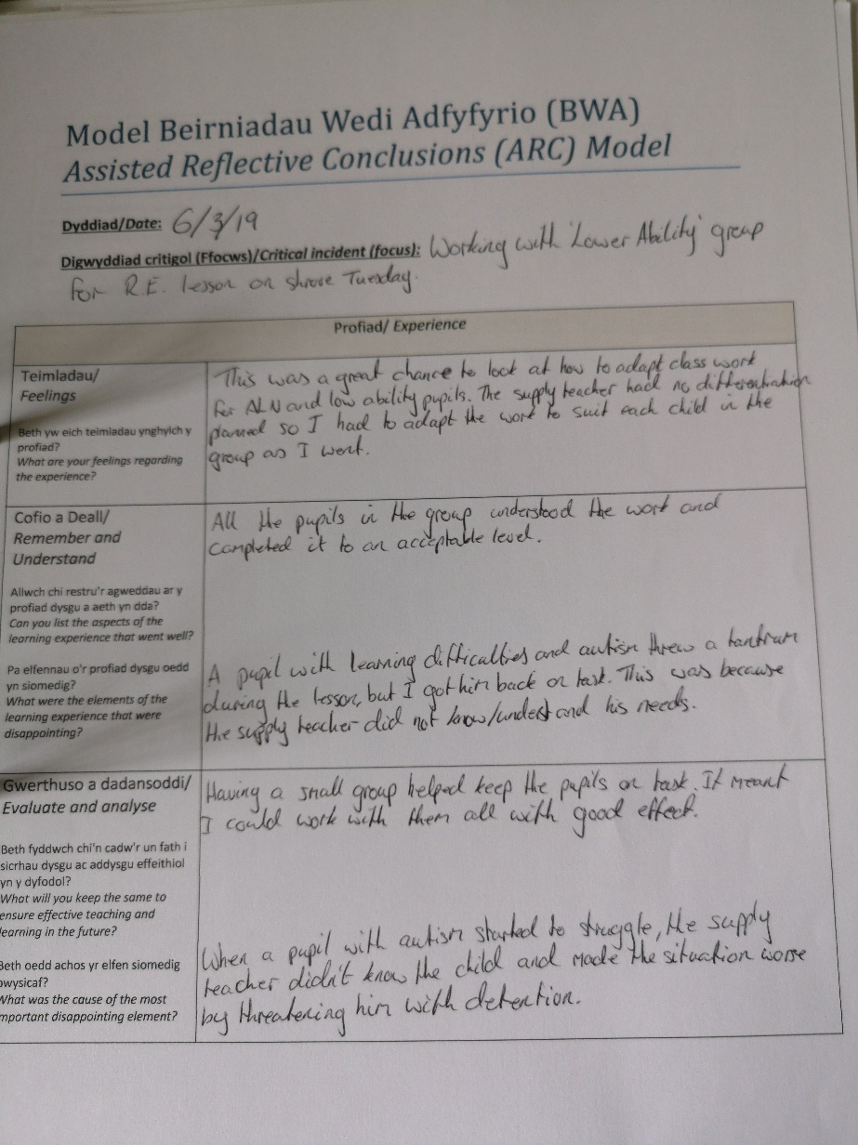
Arc Review


Appendix 2
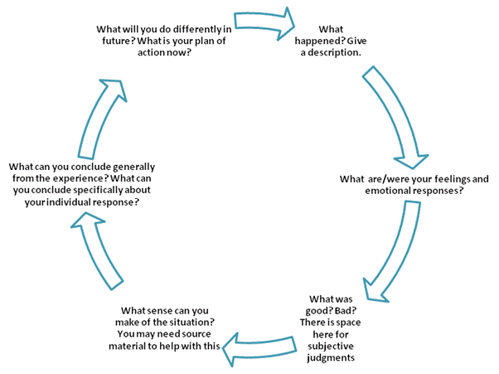
Gibbs Model

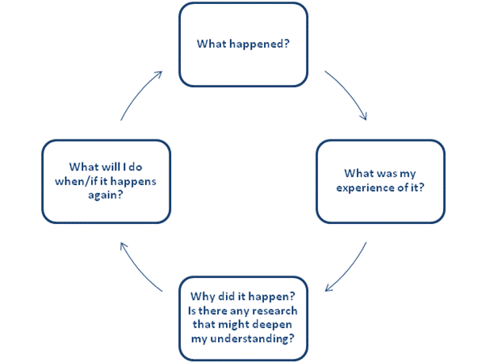
Kolb Model

Schon Model
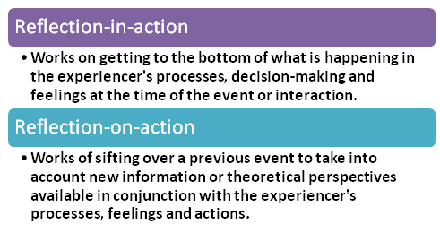

Reference List
Dewey, J. (1993) – How we think. New York: Health & Co.
Education Wales (2009) - Qualified Teacher Standards Wales.
ESTYN (2018) – A report on Bryncethin Primary School
Griggs, R. (2010) – Behaviour Management
Schon, D (1978) – The Reflective Practitioner
Skinner, F. (1938) - The Behaviour of Organisms: An Experimental Analysis
Vygotsky, L. (1978) – Interaction between learning and development.

