Psychology for Health and Social Care

Task 1

Student Name: HUMINATU HELEN DEEN

Module code: BMHP4003

Student ID: 1905866

Lecturers name: DIYA GANGULY
Contents
Introduction 3
Discussion 4
Conclusion 10
References 11

Introduction

In this essay, I am going to explore the significance of psychology in health and social care. For this purpose, I am going to use at least twolifespan theories of developmental psychology and three or more recent studies related to the developmental psychology in health and social care and will connect them with my preferred age group ‘infant’. After connecting the theories of developmental psychology I will use the recent research results and outcomes to conclude the significance of thedevelopmental psychology in health and social care for the defined age group.

Discussion
Before exploring the selected theories of developmental psychology the definition of the developmental psychology needs to be defined as this definition will ease the common readers to get the insight of developmental psychology. In a general sense,developmental psychology means the study of the brain and behaviour with the development of their whole physique. However, some psychologists focus on the study of brain development in relation to psychological development. According to McLeod(2017), developmental psychology is, ‘Developmental psychology is a scientific approach which aims to explain growth, change and consistency though the lifespan. Developmental psychology looks at how thinking, feeling, and behaviour change throughout a person’s life.’ In other words, we can say that developmental psychology means the development of the brain and the action of the people in accordance with brain development with the age. The main purpose of developmental psychology is to explore the factors of development and to explain the outcomes of the development psychology (Baltes, Reese, &Lipsitt, 1980). The main focal point of the development psychology is to explore how human’s behaviour changes over time.However, the development of psychology was pre-dominated by the development period of the infancy as well as pre-adolescent and adolescent period. But later the focus point expanded from infancy to cover all the lifespan including – adult development and ageing. The study of the development psychology covers cognitive development, physical development as well as the relation between the two in relation to the behavioural change over the period of time. The transition of the human from the infancy level to pre-adolescent period and adolescent period had always been a matter of experiment in the field of psychology as well as in health and social care as the scientific exploration will broaden the horizon of the mental ill-health as well as other mental health issues.Many influential psychologists have been the supporters of developmental psychology and their works have made developmental psychology as a dominant field of psychology. Many human traits can be explained with the help of different developmental theories. However, more and more psychologists are strengthening the base of developmental psychology with their knowledge and insight about developmental psychology. Important and dominant research,theories and their results might become obsolete at some point. One group might believe and support any particular theory. Another group of psychologists might oppose the idea of that theory. These different supporter groups are known as the school of the thought of that particular theory. Sometimes one theory contradicts with another theory; sometimes one theory strengthens other theory.

Jean Piaget is one of the most dominant theorists in the field of psychology as well as developmental psychology. Jean Piaget’s theory of development rejects the idea of fixed intelligence trait. Piaget (1936) argued that intelligence is not a fixed trait, rather intelligence flourished with cognitive development. That means the intelligence in an infant is not a constant matter. It changes over time with the interaction with the environment or because of biological reason.That behavioural change, as well as intelligence trait, are interrelated and they are both the sign of good or bad mental health and socially expected behaviour.This developmental theory of Piaget was focused on the biological aspect of the development. McLeod (2017) argued that Piaget theory of development fails to address the key feature of development like – social setting, social environment etc. Piaget had only given importance to the biological aspect of development. Vygotsky had stressed the idea of social interaction in the process of cognitive development.

The importance of biological factors for the development of the infant is significant. There are four stages of development which was identified by Piaget himself(Baltes, Reese andNesselroade, 2014).They are – sensorimotor stage (0-2years), Pre-operational stage(2-7years), concrete operational stage(7-11years) and the last stage is formal operational stage(11years+). As I have chosen the infant period my focus will be on the sensorimotor stage it represents infancy stage.
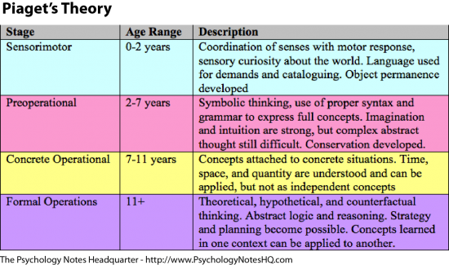
In the sensorimotor stage, children of 0 to 2years try to make sense of the existence. They try to touch and feel things around them. The main achievement of this period is object permanence. Piaget argued that a child can only search for a hidden toy or object if the child has a mental representation of that toy. So this is the stage when the children get the opportunity to use his/her sensorimotor skills to develop a schema of mental representation of an object or a set of objects.Piaget’s method of observation was criticised by different scholars. However,Duveen(2000) backed up Piaget’s method opining that study of the infancy was truly complicated as the infants can notinteract verbally, as a result, the use of language as a toolcan not be used to measure children’s inner brain development. To address this problem, Piaget used his 3 children and observe them with a firm belief of universal cognitive development (Keller,2008). Piaget’s first stage emphasizes the idea of reflective actions. For example – sucking objects, holding objects with force in the palm etc. In fact, all the basic skills of human brain intend to develop in this stage.Knickmeyer et al.(2008) argued that 0 to 2years of the age is the most important and dynamic period of the human.At birth, the total weight of the brain is only 25% of adult brain ; however, in 3years the weight of the brain reach to the 90% of the adult brain which is an interesting phenomenon(DiPietro, 2000). This matter of weight gaining of the brain surely denotes the idea of slowly cognitive development. McLeod(2017) also pointed out that Piaget was very much interested in this stage of life and it is certainly interesting for health and social care. However, the importance of developmental psychology in the infant was not given much importance (Lefmann and Combs-Orme, 2013).The idea of existence is sensed by the children through their senses. On the other hand,children try to suck things,hold things and try to keep things in the palm that give us the notion of motor capability. Both the sensor and motor cortex try to develop themselves in the first stage of life (Terumitsu et al., 2009) which is responsible for ‘trial and error’ behaviour of the children.
In health care, the importance of the sensorimotor stage could be proven useful. Especially in mental health issues. Health care, as well as social care professional, can use the case studies of different mental health patients by studying their 0-2years of the period. Much important informationabout this particular sensorimotor stage can be linked to the creation of mental health issues in the first place. Though there are many criticisms of Piaget’s theory this theory is widely accepted by many scholars and psychologists. I think the case study of the sensorimotor stage of different mental health patient will bear fruit to link the unusual behaviour of the patients. This stage of life buildsa solid base for the other stages to develop.
Piaget’s theory was phenomenal but was only focused on biological development (McLeod,2018). He had completely bypassed different social factors which can be played an important role in the development of a human brain. But I think the theory of Vygotsky completes the theory of Piaget. Vygotsky’s theory is known as socio-cultural theory. Unlike Piaget’s theory, this theory focuses on the socio-cultural aspect of development(Mooney,2013). Piaget gave more focus on the biological maturation; on the contrary, Vygotsky stressed more on the socio-cultural aspect. Vygotsky believed that socio-cultural factors are important in cognitive development. He believed the social interaction of the children make the children learn. However,he did not reject the idea of Piaget’s independent learning. He just added one area which is also important for learning.

Vygotsky’s work is mainly focused on the children or infant(Mooney,2013). He coined two new terms to strengthen his works. One concept is the Zone of proximal development (ZPD) and more knowledge of others (MKO)(Vygotsky,2012). Zone of proximal development means the difference between what a child can do without any outside help and what that child can do with help from outside.Vygotsky believed that children can do many things which they have already faced; however, they might face problems while encountering the new scenario. For example, a student might fail to solve a math problem on his/her own. But with the help of the teacher, he/she managed to solve the problem.
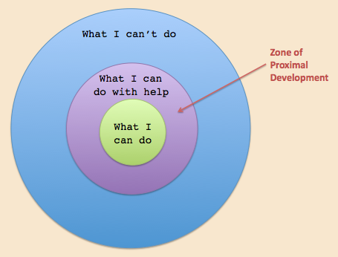
ZPD: Image source:google image
The difference between not being able to solve the math problem is known as the Zone of proximal development (ZPD). And here the teacher is the more knowledgeable others (MKO). However, it is not necessary that all the time the MKO would be a person. MKO could be a tool too. For example –if the student in this scenario had solved the problem with the help of the internet, then the MKO would be the internet.

Smagorinsky(2012) argued that in Vygotsky’s Volume 2 of collective works Vygotsky had argued that people or individuals who depart from the normal norm should be treated with a more inclusive way. In his works, Vygotsky argued that mental and cognitive differences do not comprise mental defect or deficiencies rather it portrays how one is developed psychologically.

Vygotsky(1993) had argued that ‘defect’ or mental illness is negative in common sense. However, Vygotsky believed that defect may be minus in some aspects, but could be plus in some aspects(Smagorinsky,2012).So, in a nutshell, it can be said that Vygotsky(1993) had not seen mental illness as a total defect. He stressed that it is the cognitive environment which is more or less responsible for the mental ill-health and other mental health issues like – stress, anxiety, depression etc(Smagorinsky,2012). He argued that mental ill health and all other mental issues are like other physical diseases which should be treated(Daniels,2016).

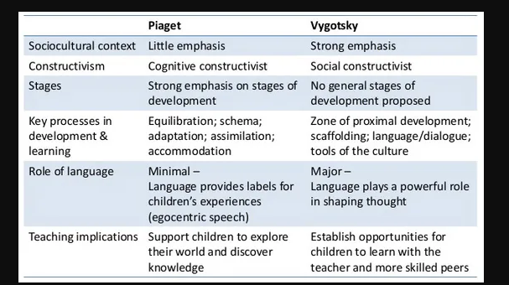
Difference between Vygotsky and Piaget’s theories: Image source: Simplypsychology.org
The health and social care should also focus on the mental health issues as well as socio-cultural factorswhich can bethe root cause of the mental health issues which can be proved deadly afterwards.

The health and social care workers should focus on the past medical records as well as the socio-cultural background of the mental health patients which will give the more outstanding insight to treat a mental health patients suffering from depression, mental stressetc.

Conclusion
Both the Vygotsky and the Piagethave done an extraordinary job to give fuel to developmental psychology. However, they both have covered brain development issues from a very different perspective. Vygotsky focused on the socio-cultural aspects to explore and explain the brain and psychological development. On the other hand, Piaget focused on the maturation of the human body to explore and explain different traits. Both theories focus on the infancy or childhood period of life. In health care and social care services, both the Vygotsky and Piaget’s theory can play a vital role. But it would be better to adopt a mixed approach of these two theories to treat mental ill-health as well as other health and social care problems. Because a single aspect can not cover the whole aspects of mental health issues as well as other problems,we should look forward to taking help from both the biological as well as socio-cultural aspects.

References
Baltes, P. B., Reese, H., & Lipsett, L. 1980. Lifespan developmental psychology, Annual Review of Pyschology 31: 65 – 110.
Baltes, P.B., Reese, H.W. and Nesselroade, J.R., 2014. Life-span developmental psychology: Introduction to research methods. Psychology Press.
Daniels, H., 2016. Vygotsky and pedagogy. Routledge.
DiPietro, J. A. 2000. Baby and the brain: Advances in child development. Annual Review of Public Health, 21, 455–471.
Duveen, G. 2000. Piaget ethnographer. Social Science Information, 39(1), 79–97
Keller, H. 2008. Culture and biology. Social and Personality Psychology Compass, 2, 668–681.
Knickmeyer, R. C., Gouttard, S., Kang, C., Evans, D., Wilber, K., Smith, J. K., : : : Gilmore, J. H. 2008. A structuralMRI study of human brain development from birth to 2 years. The Journal of Neuroscience, 28(47), 12176–12182.

Lefmann, T. and Combs-Orme, T., 2013. Early brain development for social work practice: Integrating neuroscience with Piaget's Theory of Cognitive Development. Journal of Human Behavior in the Social Environment, 23(5), pp.640-647.
McLeod, S. A., 2017. Developmental psychology. Simply Psychology. https://www.simplypsychology.org/developmental-psychology.html
McLeod, S. A. 2018 . Lev Vygotsky. Simply Psychology. https://www.simplypsychology.org/vygotsky.html
McLeod, S. A.,2018. Jean piaget's theory of cognitive development. Simply Psychology. https://www.simplypsychology.org/piaget.html
Mooney, C.G., 2013. Theories of Childhood: An Introduction to Dewey, Montessori, Erikson, Piaget & Vygotsky. Redleaf Press.
Piaget, J. 1950. The psychology of intelligence. London, UK: Routledge and Kegan Paul
Piaget, J. 1963. The origins of intelligence in children. New York, NY: W.W. Norton & Company, Inc.
Smagorinsky, P., 2012. “Every individual has his own insanity”: Applying Vygotsky's work on defectology to the question of mental health as an issue of inclusion. Learning, Culture and Social Interaction, 1(2), pp.67-77.
Smagorinsky, P., 2012. Vygotsky. Journal of Language and Literacy Education, 8(1), pp.1-25.
Terumitsu, M., Ikeda, K., Kwee, I. L., &Nakada, T. (2009). Participation of primary motor cortex area 4a in complexsensory processing: 3.0-T fMRI study. Neuroreport, 20(7), 679–683.
Vygotsky, L. S. 1993. The collected works of L. S. Vygotsky. Volume 2: The fundamentals of defectology (abnormal psychology and learning disabilities) (R. W. Rieber&A. S. Carton, Eds.; J. E. Knox & C. B. Stevens, Trans.). New York: Plenum.
Vygotsky, L.S., 2012. The collected works of LS Vygotsky: Scientific legacy. Springer Science & Business Media.

