BA Leadership and Management
- Assignment Title: Innovation & Customer Journey
- Student Name: Samyan Amin
- Student ID:2308928
- Module: LCLM 6002- Design Thinking and Innovation
- Module Leaders: Rexon Nting and Doreen Nyaa Amundam

- Internal Verifier: Md Kalam and Samuel Ofori

- Submission Date:

Contents
Analysis and Evaluation of Toyota Motors 2
Introduction of Toyota 2
Trends in automotive Industry 3
(Part 1) 5
Digital Innovation: Current Position, Future Prospects and Solutions for Toyota 5
Innovation Ambition Matrix – Innovations at Toyota 6
Core Innovation (Product, Safety, Connectivity) 6
Adjacent Innovation (Mobility Services, Data, Platforms) 7
Transformational Innovation (Future Energy, Smart City, Autonomy) 7
Present consumer situational analysis across UK 8
Customer Journey Map – Transition to Toyota Electric Vehicles (UK) 9
Touchpoints 9
Pain Points 10
Service (Customer Gains) 10
Solutions / Opportunities 10
Part 2 11
Proposed Digital Solution: Toyota Virtual Experience Ecosystem (TVEE) – In App 11
1. Immersive VR/AR Vehicle Interaction – Virtual showroom 11
2. Personalized Vehicle Recommendation System 11
3. Interactive Feature Tutorials and Real-Scenario Demos 12
4. Enhanced Toyota Smart Path for EVs 12
Relevance of the Proposed Digital Solution to Toyota’s Business Model 13
Updated Customer Journey Map 15
Key Improvements After TVEE Integration 15
Success measuring criteria of the Solution 16
Gantt Chart 17
Budget Allocation – TVEE Pilot Program (10 Dealerships) 18
Role of Leadership 18
Conclusion 19
References 21

Analysis and Evaluation of Toyota Motors

Introduction of Toyota
Toyota Motor Corporation is a leading multinational automotive company headquartered in Toyota City, Aichi, Japan. As one of the world’s largest car manufacturers, Toyota designs, manufactures, and sells a wide range of passenger and commercial vehicles, including cars, trucks, minivans, and specialty vehicles. Toyota’s main goal is to lead the future of mobility by providing safe, innovative, and sustainable transportation solutions that create happiness for all, exceeding customer expectations through continuous improvement and quality, while upholding its core pillars of Kaizen (Continuous Improvement) and Respect for People (Liker, 2004) to foster an inclusive society where everyone is free to move.
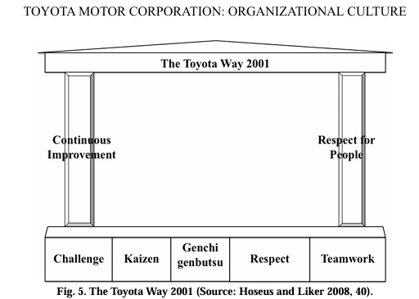
Figure 1 Toyota Corporate Culture (Sosnovskikh, 2016).
As of June 2024, Toyota was the second most valuable automotive brand worldwide, surpassing Mercedes-Benz, BMW, and Porsche, and standing as the closest rival to Germany’s Volkswagen Group. The company employed approximately 383,900 people at the end of its 2025 fiscal year, a 0.8% increase from the previous year. Toyota’s net revenue grew by 6.5% to 48.04 trillion JPY, with total assets of 93.6 trillion JPY (Statista, 2025), reflecting strong financial performance and stability.
Toyota continues to expand its global presence through innovation and a strong focus on sustainability. In the first half of 2025, Toyota Motor Europe (TME) achieved record sales of 635,328 vehicles, a 1% year-on-year increase, securing a 7.3% market share, with 77% of total sales coming from electrified vehicles (Toyota Europe, 2025).
However, in the UK market, Toyota faces challenges as its market share fell to 5.4% (March 2025) amid the country’s rapid transition toward fully electric vehicles (EVs). The company’s sales remain dominated by hybrids like the Yaris Hybrid and Corolla Hybrid, reflecting its multi-pathway strategy that combines hybrid and battery-electric options. Nonetheless, Toyota’s all-electric vehicle performance in the UK continues to lag behind competitors such as Ford and BYD.

Trends in automotive Industry
1. Shift to Electrified Vehicles
Consumers are increasingly transitioning toward electrified powertrains such as hybrid, plug-in hybrid, and fully battery-electric vehicles. This shift is driven by growing environmental awareness, rising fuel prices, government incentives, and rapid improvements in EV technology and infrastructure (Bryła, Chatterjee and Ciabiada-Bryła, 2022). Studies indicate that environmental concern, perceived technological maturity, and the availability of charging facilities are among the most influential factors in consumers’ decision to adopt electric vehicles. As electric mobility becomes more common across developed and emerging markets, EVs are moving from being niche products to mainstream consumer choices.
2. Original Equipment Manufacturer Roadmaps to Full Electric
Automotive manufacturers have announced ambitious goals to transition to fully electric lineups, signalling to consumers that the industry’s long-term direction is electric. Brands such as Volvo, Mercedes-Benz, and Ford (Europe) have pledged to sell only electric vehicles by the early 2030s. This commitment creates a sense of inevitability among consumers, positioning EVs as the “default next car.” Research across G20 markets indicates that clear manufacturer and government policies reduce perceived risk and improve consumer trust in adopting electric vehicles.
3. Connected and Software-Defined Cars
Modern consumers now expect cars to remain digitally updatable throughout their lifecycle. This includes connectivity features, over-the-air updates, and integrated infotainment and safety systems. Software-defined vehicles (SDVs), a modern car whose key functions and performance are primarily governed and updated through software instead of relying solely on hardware components (Arjunan and Murugan, 2025), are rapidly moving from premium segments into the mass market as automakers aim to enhance user experience and generate continuous digital revenue. The rise of SDVs reflects consumers’ growing desire for convenience, personalization, and technological integration in daily mobility.
4. Sustainability and Green Image
Sustainability has become a key factor influencing purchasing decisions, particularly among younger and urban consumers. Rise of green mobility shows that environmental identity and social value strongly predict the preference for low-emission vehicles. Many consumers now view car ownership through the lens of ecological responsibility but still a large portion of consumers still prefer petrol or diesel engines (Alkan and Şimşek, 2024). In addition, environmental, social, and governance (ESG) reporting by manufacturers and local clean-air initiatives reinforce consumers’ preference for sustainable automotive options.
5. Affordability and Flexible Access
Economic pressures have reshaped consumer expectations of car ownership, as high vehicle prices and rising interest rates encourage buyers to consider flexible options such as vehicle subscriptions, short-term leases, and used electric vehicles. While many are open to innovative ownership models, affordability and cost transparency continue to be the key factors influencing purchasing decisions.
6. Safety and ADAS as Core Features
Safety has emerged as one of the strongest determinants of purchase intent in the automotive market. Consumers increasingly prioritize advanced driver-assistance systems (ADAS) such as automatic emergency braking, lane-keeping assist, and blind-spot detection. However, majority of the consumers and users have very low understanding and pre-knowledge of the features (Kaye et al., 2022). Automakers are therefore making these safety features standard, reflecting a broader shift toward safety-first consumer behaviour.
7. Personalization and Digital Customer Experience
Consumers are increasingly seeking personalized automotive experiences, from customizable in-car settings to tailored post-purchase services. The integration of artificial intelligence, big data, and cloud platforms allows automakers to offer predictive maintenance, adaptive infotainment. Smith and Kelleher (2020) highlight that personalization can increase engagement of customers by 30% and enhances customer satisfaction, brand loyalty, and perceived value. Automakers are thus shifting toward data-driven engagement strategies that make each customer interaction unique and consistent across digital and physical touchpoints (Bagul, 2024).

(Part 1)

Digital Innovation: Current Position, Future Prospects and Solutions for Toyota
The UK’s electric vehicle (EV) market is expected to generate about US $40.9 billion in 2025 and grow at a 7.27 % CAGR, reaching nearly US $58 billion by 2030. Unit sales are forecasted at around 913,000 vehicles, reflecting the country’s steady transition toward sustainable mobility. Growth is supported by government incentives, expanded model options, and better charging infrastructure, positioning the UK as one of Europe’s leading markets for electric mobility. Toyota, in response, is accelerating its move from traditional hybrids toward fully electric and plug-in vehicles, underscoring its strategic shift toward zero-emission transport.

Innovation Ambition Matrix – Innovations at Toyota
Innovation Ambition Matrix encourages firms to distribute their innovation initiatives across core, adjacent, and transformational areas to achieve a balance between immediate performance and long-term growth (Nagji and Tuff, 2012).
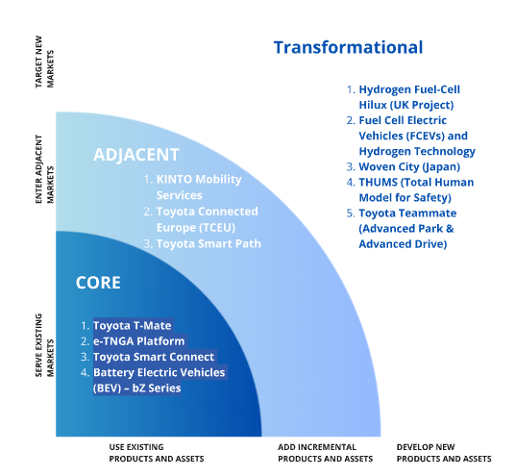

Core Innovation (Product, Safety, Connectivity)
Toyota has been continuously enhancing its vehicle range through product improvements, digital integration, and advanced safety features.
- Toyota T-Mate (including Toyota Safety Sense): Toyota has developed an advanced driver-assistance suite that integrates adaptive cruise control, lane-keeping assist, and pre-collision systems. T-Mate is being introduced across most new Toyota models to ensure safer and more convenient driving experiences.
- e-TNGA Platform (Beyond Zero – bZ Series): Toyota has developed its dedicated battery-electric vehicle (BEV) platform, known as e-TNGA, which underpins the bZ4X and will support future zero-emission models. This flexible architecture is designed to integrate connected systems and enable over-the-air (OTA) updates.
- Toyota Smart Connect / Multimedia System and MyT App: The company has launched Smart Connect, its latest infotainment platform, offering cloud-based navigation, live updates, and seamless smartphone connectivity to enhance customer convenience. It makes the buying process more transparent and convenient, appealing to tech-savvy and younger buyers.
- Battery Electric Vehicles (BEV) – bZ Series: Toyota is expanding its “Beyond Zero” range of BEVs, led by the bZ4X, and plans to introduce additional electric models in Europe over the coming years as part of its carbon-neutrality roadmap.

Adjacent Innovation (Mobility Services, Data, Platforms)
Toyota is extending its business model beyond traditional vehicle manufacturing to create integrated mobility and digital service ecosystems.
- KINTO Mobility Services: Toyota has established KINTO, its mobility brand operating across Europe and the UK, which offers subscription-based vehicle access, car-sharing, and fleet solutions. It allows customers to experience flexible, app-based mobility tailored to their lifestyle.
- Toyota Connected Europe (TCEU): Headquartered in London, Toyota has developed this digital hub to harness vehicle data and analytics. TCEU is responsible for creating connected-car technologies, predictive maintenance systems, and customer-centric digital mobility products.
- Toyota Smart Path: Toyota Smart Path is the company’s digital retail solution that enhances the customer purchasing journey by integrating online and in-dealership experiences. It enables customers to configure, finance, and finalize vehicle purchases digitally (Toyota, 2025), reflecting Toyota’s shift toward seamless digital engagement and personalization in the automotive retail landscape.

Transformational Innovation (Future Energy, Smart City, Autonomy)
Toyota is actively pioneering next-generation technologies that aim to transform transportation and energy systems globally.
- Hydrogen Fuel-Cell Hilux (UK Project): Toyota Manufacturing UK has developed ten hydrogen fuel-cell Hilux prototypes in Derbyshire, now undergoing testing to evaluate their commercial potential as zero-emission work vehicles.
- Fuel Cell Electric Vehicles (FCEVs) and Hydrogen Technology: Toyota has already commercialized the Mirai, its hydrogen-powered passenger vehicle, and continues to refine modular fuel-cell systems for use in cars, trucks, and industrial applications. A Fuel-Cell Electric Vehicle (FCEV) uses hydrogen stored in onboard tanks to generate electricity through a chemical reaction with oxygen, powering an electric motor with only water vapour as the by-product.
- Woven City (Japan): Toyota is building Woven City, a real-world experimental “smart city” at the base of Mount Fuji. It serves as a living laboratory for testing AI, robotics, autonomous mobility, and sustainable infrastructure, insights from which are applied to Toyota’s UK and European innovation programs.
- THUMS (Total Human Model for Safety): Toyota has developed this advanced virtual human-body simulation model to enhance crash safety design. The technology is shared freely with global research institutions to promote vehicle safety innovation across the industry.
- Toyota Teammate (Advanced Park & Advanced Drive): Toyota has introduced its semi-autonomous driving systems. Advanced Park automates parking manoeuvres by controlling acceleration, braking, and steering, while Advanced Drive assists drivers on highways under specific conditions, reflecting Toyota’s commitment to autonomous mobility.

Present consumer situational analysis across UK
The UK automotive market is undergoing a decisive shift toward electric mobility, with growing consumer awareness around sustainability and government initiatives accelerating the phase-out of petrol and diesel cars. Strong competitors such as Tesla, Hyundai, Kia, BMW, and Nissan currently dominate the UK’s EV landscape, offering well-established electric lineups and extensive charging partnerships. Toyota, long recognized for reliability and hybrid leadership, now faces the challenge of repositioning itself as a key player in the fully electric segment. Many potential customers are curious but cautious that are often families, professionals, or long-time Toyota owners who value dependability but remain uncertain about range, charging access, and long-term costs of EV ownership. They want assurance that transitioning to an electric vehicle will be seamless, affordable, and practical for their lifestyle. To meet this expectation, Toyota seeks to create an engaging and informative experience by using digital storytelling, immersive test drives, dealership education, and trade-in incentives to demonstrate how its new bZ (Beyond Zero) electric lineup delivers the same trust and quality Toyota is known for, now powered by clean energy. The goal is to not just sell EVs, but to build confidence, loyalty, and excitement for Toyota’s electric future among a new generation of UK drivers.

Customer Journey Map – Transition to Toyota Electric Vehicles (UK)
According to Kantola, Nazir, and Salminen (2020), the customer journey ultimately shapes the customer experience, which reflects the overall perception a customer forms about a brand based on their interactions and touchpoints across different stages of the journey.
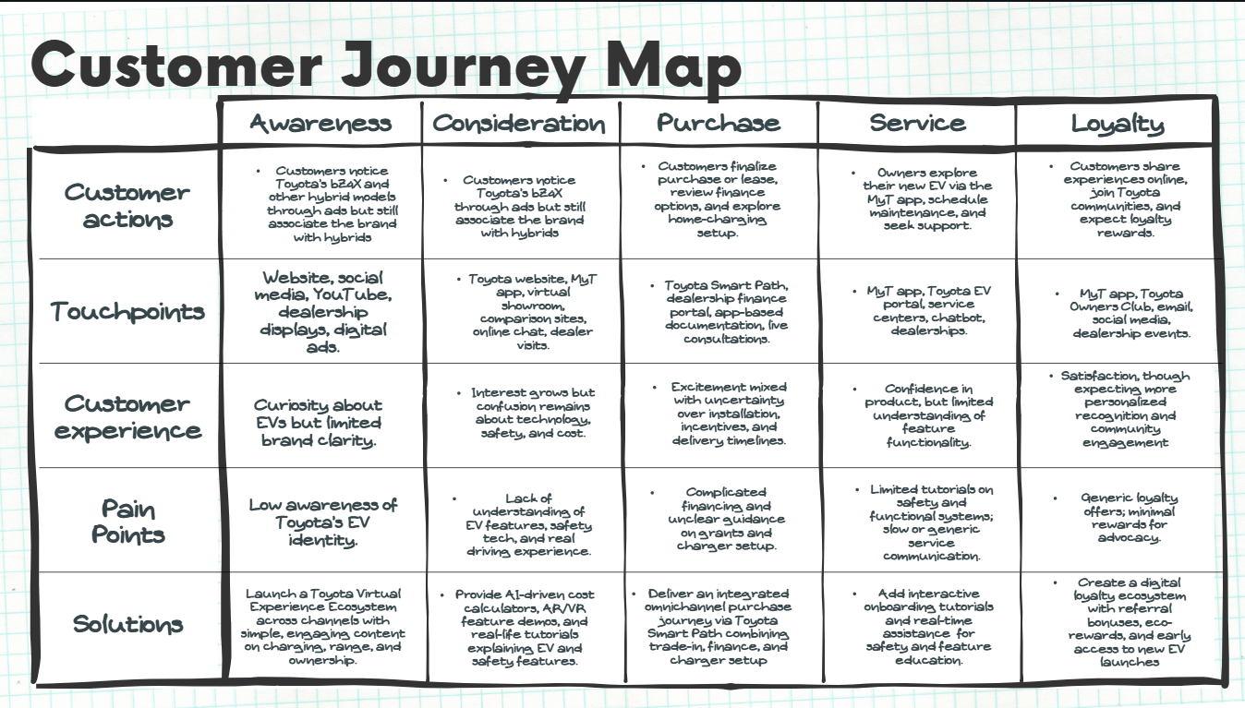

Touchpoints
According to Lemon and Verhoef (2016), enhancing customer experience across multiple touchpoints drives satisfaction and loyalty — directly achieved through Toyota’s omnichannel ecosystem that integrates online and offline interactions to ensure a seamless experience. In the awareness and consideration stages, customers engage with Toyota through digital touchpoints such as social media ads, the Toyota UK website, YouTube, and online configurators. During the purchase stage, the journey extends to Toyota Smart Path, where customers can compare models, customize financing, and schedule appointments both online and at dealerships. Post-purchase engagement continues through the MyT app, customer support chat, and in-person service centers. This multi-platform presence allows customers to begin their journey digitally and continue it in-store without losing context and ensuring convenience, transparency, and continuity across every stage.

Pain Points
Despite increasing EV interest, customers face several challenges throughout the journey. At the awareness stage, many consumers have limited understanding of Toyota’s fully electric identity, still associating the brand primarily with hybrids. As they move toward consideration, customers often struggle with technical complexity, including EV jargon, unclear cost-of-ownership comparisons, and little knowledge of safety and functional features like regenerative braking or driver-assistance systems.
In the purchase and service stages, the process becomes fragmented—buyers face complicated financing language, uncertainty over charger installation, and a lack of real-time, hands-on experience with the EV they intend to buy. At the post-purchase level, many owners report minimal onboarding support and delayed service communication, making it harder to fully utilize the advanced features of their vehicles.

Service (Customer Gains)
Customers seek a reliable, transparent, and confidence-building experience when transitioning to electric mobility. They want ease of navigation through digital and physical channels, clear explanations of EV features, and ongoing support after purchase. Access to integrated financing, home-charger installation, and government incentive information through one platform adds significant value. Post-purchase, customers appreciate the ability to track vehicle performance, schedule maintenance, and receive eco-driving feedback through the MyT app. By enhancing education, accessibility, and personalization, Toyota can deliver customer gains in the form of reduced uncertainty, higher engagement, and greater trust in its EV technology.

Solutions / Opportunities
Toyota’s opportunities lie in leveraging digital innovation and experiential learning to bridge knowledge and confidence gaps among EV buyers. The company can strengthen brand perception by developing an interactive Toyota EV Experience Hub that offers simplified explanations, short educational videos, and real-world EV ownership stories. Introducing AI-driven tools such as cost-of-ownership calculators and charging simulators can clarify long-term value and affordability.
To address the lack of real-life exposure, Toyota should implement AR/VR-based tutorials and in-store demo zones that allow customers to experience EV safety, connectivity, and performance features firsthand. Enhancing the MyT app with personalized onboarding tutorials, predictive maintenance alerts, and a chat-based assistant will improve engagement and retention. Finally, a digital loyalty ecosystem—featuring referral bonuses, eco-rewards, and community events—can transform satisfied customers into long-term brand advocates.

(Part 2)

Proposed Digital Solution: Toyota Virtual Experience Ecosystem (TVEE) – In App
In order to address customer pain points identified across the Toyota EV customer journey particularly low awareness, limited EV knowledge, and lack of real-world experience with vehicle features, this proposal introduces the Toyota Virtual Experience Ecosystem (TVEE).
This digital platform leverages Virtual Reality (VR), Augmented Reality (AR), and AI-driven personalization to create a seamless omnichannel experience for users exploring Toyota’s electric lineup. It also integrates MyT App features and enhances Toyota Smart Path, offering customers an end-to-end digital buying journey that educates, engages, and builds confidence in EV ownership.

1. Immersive VR/AR Vehicle Interaction – Virtual showroom
Objective: Give users a virtual, real-life experience of Toyota EVs to reduce hesitation and increase purchase confidence.
Customers can virtually explore the interior and exterior of Toyota’s bZ (Beyond Zero) series using VR/AR technology, either through their smartphones via TVEE, VR headsets, or in dealership kiosks.
- AR-based exploration: Allows users to project the vehicle into their real-world environment through 3D interactive displays to view its size, colour options, and features (Gao, Wang and Zhang, 2024).
- VR driving simulation: Offers an interactive experience to “test drive” the bZ4X or other EVs, experiencing acceleration, handling, and digital dashboard interfaces.
- Feature hotspots: Clicking on different components (battery pack, infotainment system, safety sensors, etc.) reveals tooltips, videos, and performance explanations.
- Dealership integration: In-store AR screens and VR booths mirror the online experience, ensuring omnichannel continuity.
This feature addresses the lack of hands-on interaction and limited understanding of functionality, allowing users to experience the car before setting foot in a dealership.

2. Personalized Vehicle Recommendation System
Objective: Help users make informed, data-driven choices suited to their lifestyle, budget, and sustainability preferences.
When users log in to the platform, they enter their driving habits, daily mileage, family size, preferred features, and budget. The system then uses AI algorithms to recommend the most suitable Toyota EV model (e.g., bZ4X, bZ3X) along with cost comparisons and alternative suggestions based on:
- Price and financing options (lease vs. purchase)
- Battery capacity and range optimization
- Charging compatibility (home vs. public)
- Maintenance and running cost forecasts
- Performance and technology match
This guided process eliminates guesswork, helping customers understand why a specific EV fits their needs while introducing them to potentially better or more cost-effective alternatives.

3. Interactive Feature Tutorials and Real-Scenario Demos
Objective: Educate customers on Toyota’s advanced safety and driving features through engaging, real-life tutorials.
Many EV buyers lack knowledge of safety systems (e.g., Toyota T-Mate, Lane Trace Assist, Adaptive Cruise Control) and driver-assist technologies.
The solution provides:
- 3D interactive tutorials demonstrating when and how each feature activates (e.g., emergency braking in city traffic, lane assist on highways).
- Scenario-based demos (e.g., night driving, wet road conditions) showing how technology ensures driver safety.
- Personalized progress tracking in the TVEE, rewarding users for completing tutorials with badges or loyalty points.
This not only builds confidence and trust but also reinforces Toyota’s core principle of safety through innovation.

4. Enhanced Toyota Smart Path for EVs
Objective: Transform Toyota Smart Path into a comprehensive omnichannel EV retail platform in collaboration with TVEE with integrated education, financing, and service.
The enhanced Smart Path EV Suite will act as the backbone of the digital ecosystem, linking customer exploration, configuration, purchase, and post-purchase experiences.
Enhanced Features:
- Interactive EV Configurator: Customize colour, battery size, interior design, and accessories in real time with visual updates in VR/AR.
- Smart Trade-In Estimator: Calculate trade-in value instantly using AI-based market data and customer-provided details.
- Integrated Finance & Incentive Portal: Display EV grants, government subsidies, and Toyota finance plans in clear, simplified language.
- Home-Charger Integration: Partner with installation services to book and track home charger setup directly within the platform.
- Delivery & Ownership Tracker: Provide real-time order updates, delivery scheduling, and onboarding support integrated through the MyT app.
- After-Sales Connectivity: Link directly to MyT for maintenance reminders, eco-driving insights, and predictive diagnostics.
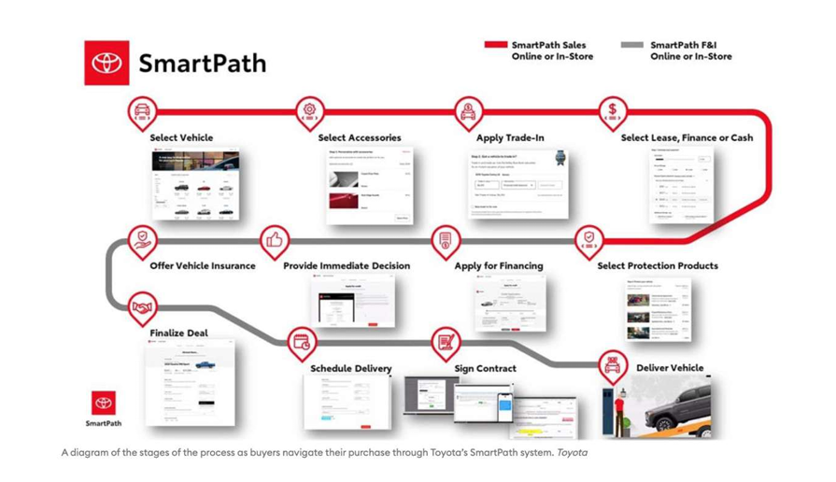
(Schumacher, Andrea and Ochoa, 2012)

Relevance of the Proposed Digital Solution to Toyota’s Business Model
1. Reinforces Toyota’s Customer-Centric Philosophy
- TVEE aligns with Toyota’s long-standing “Customer First” principle by improving transparency, accessibility, and understanding at every stage of the EV journey.
- Through AR/VR experiences, Toyota addresses the modern customer’s demand for interactive, informative, and trust-building experiences, enhancing brand reliability and satisfaction.
2. Supports the Transition to Sustainable Mobility
- The platform complements Toyota’s Beyond Zero (bZ) vision by promoting EV adoption through education and awareness rather than aggressive sales.
- By helping customers understand EV performance, cost efficiency, and charging practicality, TVEE removes adoption barriers — accelerating Toyota’s shift toward carbon-neutral mobility.
3. Expands the Omnichannel Retail Model
- The integration of Toyota Smart Path and MyT app strengthens Toyota’s omnichannel ecosystem, allowing customers to move smoothly between digital and physical touchpoints.
- It reflects the business model’s evolution from traditional dealership-based sales to a hybrid digital-retail experience, improving operational efficiency and data-driven marketing.
4. Enhances the Value Proposition Through Personalization
- The AI-based vehicle recommendation system personalizes offerings according to lifestyle, budget, and driving patterns — creating tailored solutions that increase conversion rates.
- This data-driven personalization enables Toyota to refine its customer relationship management (CRM) strategy and forecast demand more accurately.
5. Strengthens Brand Differentiation and Market Competitiveness
- Competitors like Tesla and Hyundai already leverage immersive experiences; TVEE positions Toyota as an innovation leader in digital engagement within the UK EV market.
- By blending immersive learning with Toyota’s reputation for reliability, the solution enhances brand equity and appeal to younger, tech-savvy consumers.
6. Improves Post-Purchase Engagement and Loyalty
- Integration with MyT app adds continuous value through tutorials, maintenance alerts, and loyalty rewards — extending the relationship beyond the point of sale.
- This sustained engagement supports Toyota’s business model of lifetime customer value, encouraging repeat purchases, referrals, and advocacy.
7. Optimizes Dealership and After-Sales Operations
- Virtual showrooms and digital configurators reduce dealership congestion and physical display costs.
- Predictive analytics from Smart Path and MyT integration enable Toyota to optimize inventory management, service planning, and resource allocation.
8. Creates Data-Driven Business Insights
- User interactions within TVEE generate valuable behavioral data — preferences, dwell times, and purchase patterns — supporting strategic decisions in product design, pricing, and marketing.
- This analytical feedback loop strengthens Toyota’s data-driven business model, improving efficiency and responsiveness across markets.

Updated Customer Journey Map

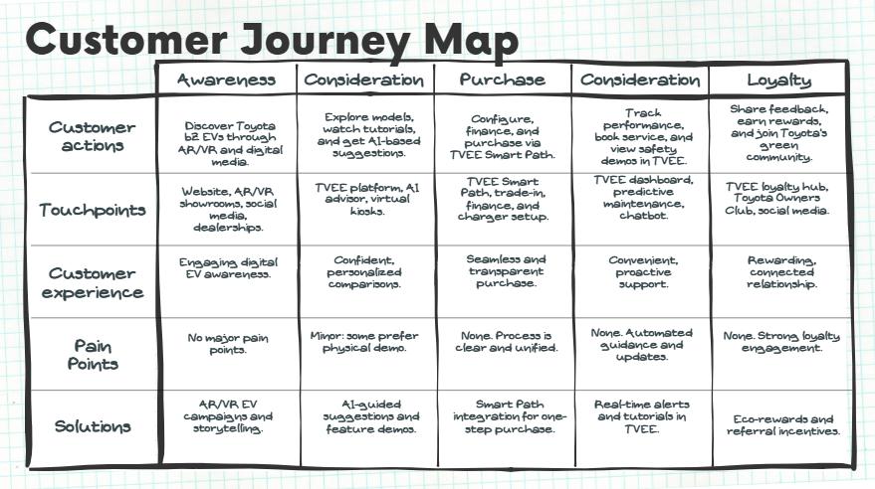

Key Improvements After TVEE Integration
- Unified Ecosystem: TVEE combines Smart Path and MyT features into one seamless digital platform.
- Immersive Awareness: AR/VR showrooms let users explore Toyota EVs virtually, improving understanding and engagement.
- AI Personalization: Smart recommendations match EV models to users’ needs, lifestyle, and budget.
- Simplified Purchase: One-step digital process for trade-in, financing, and charger setup via Smart Path.
- Predictive Service: Real-time alerts, tutorials, and maintenance tracking directly through TVEE.
- Enhanced Loyalty: Eco-rewards, referral bonuses, and digital community programs strengthen retention.
- Pain Points Removed: Clear EV awareness, transparent financing, and easy feature education and guidance.
- Omnichannel Consistency: Smooth transition between online, in-store, and post-purchase experiences.

Success measuring criteria of the Solution
Perspective | Objective | Key KPI | Target / Metric | Measurement Focus / Rationale
Customer | Strengthen EV awareness, satisfaction & loyalty | EV Awareness Rate | +25% within 12 months | Measures visibility and campaign effectiveness.
 |  | Customer Satisfaction (CSAT) | ≥ 85% (benchmark 80%) | Indicates customer happiness and experience quality.
 |  | Net Promoter Score (NPS) | ≥ 70 | Reflects loyalty and advocacy.
Financial | Drive EV sales & digital ROI | Lead-to-Sale Conversion Rate | +15% in 1 year | Evaluates impact of Smart Path and AI tools on sales.
 |  | Digital Sales Contribution | ≥ 30% of total EV sales | Tracks success of hybrid digital-retail model.
Internal Process | Improve efficiency & dealer performance | Dealer Response Efficiency | 20% less inquiry-to-purchase time | Measures improved digital coordination and response.
 |  | Platform Uptime | ≥ 99.5% | Ensures reliability and accessibility.
Learning & Innovation | Enhance customer knowledge & innovation | EV Feature Knowledge Index | ≥ 80% users score >70% | Assesses learning from feature tutorials.

Gantt Chart
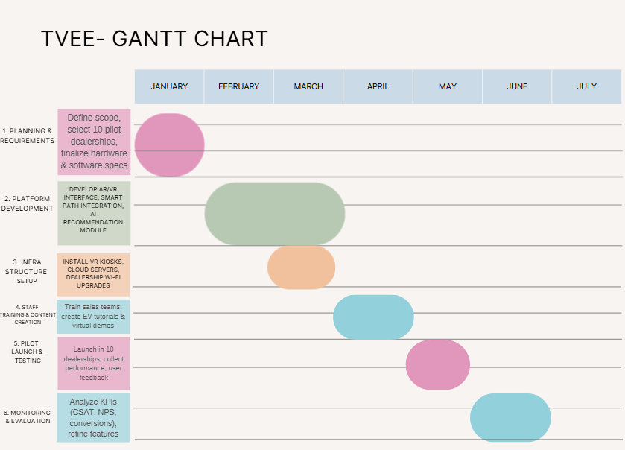

Budget Allocation – TVEE Pilot Program (10 Dealerships)
Category | Details | Estimated Cost (GBP) | % of Total
Hardware & Installation | 10 × AR/VR Driving Kiosks (£15,000 each: VR setup, 3D cameras, displays) | £150,000 | 37.5 %
Software Development | AR/VR platform design, Smart Path & MyT integration, AI configuration engine | £90,000 | 22.5 %
Content Production | 3D vehicle models, tutorials, voiceover demos, safety simulations | £45,000 | 11.3 %
Training & Staff Enablement | On-site dealership workshops, training modules, support materials | £30,000 | 7.5 %
Marketing & Awareness | Local digital ads, launch events, social media promotion | £25,000 | 6.3 %
Monitoring & Evaluation | KPI tracking dashboard, data analytics, feedback surveys | £20,000 | 5.0 %
Maintenance & Contingency | System support, updates, and 10 % risk buffer | £40,000 | 10.0 %
Total Estimated Budget | — | £400,000 | 100 %

Role of Leadership
Effective leadership is pivotal to the successful implementation of Toyota’s Virtual Experience Ecosystem (TVEE). Leaders act not only as strategic enablers but also as cultural stewards, ensuring that innovation remains consistent with Toyota’s enduring principles of Customer First, Kaizen (Continuous Improvement), Respect for People, and Challenge.
Leadership’s role extends beyond operational oversight it involves articulating a clear digital vision that connects the TVEE initiative to Toyota’s broader Beyond Zero (bZ) sustainability goals. Leaders must ensure that every level of the organization understands how the project contributes to enhancing customer trust, digital accessibility, and environmental responsibility.
Strong leadership further drives cross-functional collaboration by integrating IT specialists, marketing teams, engineers, and dealership staff to deliver a cohesive, omnichannel experience. Through empowerment and training, leaders foster a culture where employees are confident to innovate, test, and adapt to new digital systems.
Continuous performance monitoring and KPI-based accountability also fall under leadership’s remit. By tracking measurable outcomes such as EV awareness, customer satisfaction, and operational efficiency, leaders can refine processes and sustain the momentum of transformation.

Conclusion
The implementation of the Toyota Virtual Experience Ecosystem (TVEE) marks a transformative step in Toyota’s digital and sustainable mobility strategy. By integrating Virtual and Augmented Reality (VR/AR) with AI-driven personalization and an enhanced Smart Path platform, the initiative directly addresses major customer challenges such as limited EV awareness, lack of experiential interaction, and uncertainty about advanced safety features.
This digital solution empowers customers to virtually explore Toyota’s electric lineup, receive tailored recommendations, and gain real-time understanding of performance and safety technologies. The approach aligns with Toyota’s core principles of Customer First and Kaizen, reinforcing its dedication to continuous improvement and customer satisfaction.
Strong, transformational leadership ensures that the initiative remains people-centered while advancing Toyota’s Beyond Zero (bZ) vision for carbon-neutral mobility. Clear Key Performance Indicators (KPIs) including customer satisfaction (CSAT ≥85%), conversion growth, and user engagement and lead to sale conversion rate will guide performance evaluation.
Ultimately, the TVEE pilot program positions Toyota as a frontrunner in digital innovation, sustainability, and user engagement, bridging technology with trust. It lays the groundwork for a scalable, omnichannel retail model that enhances customer confidence, strengthens brand equity, and supports Toyota’s long-term vision for the future of electric mobility.

References
- Alkan, N. and Şimşek, M. (2024) ‘Identifying consumer preferences for new-generation green vehicles’, Management & Marketing, 19(3), pp. 57–73. Available at: https://essuir.sumdu.edu.ua/server/api/core/bitstreams/0b947875-056e-41cd-9ce1-dbca810c5061/content
- Arjunan, R. and Murugan, G. (2025) ‘Software Defined Vehicles: Transforming the Automotive Industry’, International Journal of Science and Research (IJSR), 14(1), pp.1165–1167. doi:https://doi.org/10.21275/sr25125001736.
- Bagul, J. (2024) Personalization in Digital Marketing: Enhancing Customer Experience Through AI. International Journal of Scientific Research in Engineering and Management. Available at: https://www.researchgate.net/publication/393186010_Personalization_in_Digital_Marketing_Enhancing_Customer_Experience_Through_AI.
- Bryła, P., Chatterjee, S. and Ciabiada-Bryła, B. (2022) ‘Consumer Adoption of Electric Vehicles: A Systematic Literature Review’, Energies, 16(1), p.205. doi:https://doi.org/10.3390/en16010205.
- Gao, C., Wang, F. and Zhang, M. (2024) ‘How Automotive 3D Interactive Display Marketing Affects Consumers’ Intention to Buy Cars’, SAGE Open, 14(2). doi:https://doi.org/10.1177/21582440241246429.
- Kantola, J.I., Nazir, S. and Salminen, V. (eds.) (2020) Advances in Human Factors, Business Management and Leadership: Proceedings of the AHFE 2020 Virtual Conferences on Human Factors, Business Management and Society, and Human Factors in Management and Leadership, July 16–20, 2020, USA (Vol. 1209). Cham: Springer Nature, p.200. Available at: https://books.google.com/books?hl=en&lr=&id=DpvuDwAAQBAJ [Accessed 8 Nov. 2025].
- Kaye, S.-A., Nandavar, S., Yasmin, S., Lewis, I. and Oviedo-Trespalacios, O. (2022) ‘Consumer knowledge and acceptance of advanced driver assistance systems’, Transportation Research Part F: Traffic Psychology and Behaviour, 90, pp.300–311. doi:https://doi.org/10.1016/j.trf.2022.09.004.
- Lemon, K.N. and Verhoef, P.C. (2016) ‘Understanding Customer Experience Throughout the Customer Journey’, Journal of Marketing, 80(6), pp.69–96. doi:https://doi.org/10.1509/jm.15.0420.
- Liker, J.K. (2004) The Toyota Way: 14 Management Principles from the World's Greatest Manufacturer. McGraw-Hill. Available at: https://books.google.co.uk/books/about/The_Toyota_Way_14_Management_Principles.html?id=9v_sxqERqvMC. [Accessed 8 Nov. 2025].
- Nagji, B. and Tuff, G. (2012) ‘Managing Your Innovation Portfolio’, Harvard Business Review. Available at: https://www.lifelongfaith.com/uploads/5/1/6/4/5164069/managing_your_innovation_portfolio.pdf.
- Schumacher, A., Andrea, K. and Ochoa, T. (2012) MBA Automotive Industry: An Explorative Impact Analysis of Digitalization in Automotive Customer Journey and Retail Experience. Available at: https://repositum.tuwien.at/bitstream/20.500.12708/187641/1/Tena%20Ochoa%20Karla%20Andrea%20-%202023%20-%20An%20explorative%20Impact%20Analysis%20of...pdf.
- Smith, A. and Kelleher, B. (2020) ‘AI-driven personalization and customer engagement’, Marketing Review, 11(2), pp.215–232.
- Sosnovskikh, S. (2016) ‘Toyota Motor Corporation: Organizational Culture’, Philosophy Study, 6(7). doi:https://doi.org/10.17265/2159-5313/2016.07.005.
- Statista (2025) Topic: Toyota Motor Corporation. Available at: https://www.statista.com/topics/1893/toyota/?srsltid=AfmBOooYeehj8J3j8umm9plh96MpLRt_9VMEwKJzYbyansjXGEALH5tE#topicOverview.
- Toyota (2025) SmartPath - How it Works | Toyota. Available at: https://www.toyota.com/smartpath/how-it-works/ [Accessed 9 Nov. 2025].
- Toyota Europe (2025) Toyota Motor Europe outperforms the market, posting record first half year sales of 635,328 vehicles. Available at: https://newsroom.toyota.eu/toyota-motor-europe-outperforms-the-market-posting-record-first-half-year-sales-of-635328-vehicles/ [Accessed 6 Nov. 2025].

‌

