

0

final year project

From Infection to Investigation: A Forensic Analysis of Ransomware Attack Vectors, Techniques, and Response

by
James Taylor

Supervisor: Carlene E-A Campbell

Project submitted as part of the requirements for the award of BSc (Hons) Computer Networks

July 2025

Declaration of Originality

I, James Taylor declare that I am the sole author of this Project; that all references cited have been consulted; that I have conducted all work of which this is a record, and that the finished work lies within the prescribed word limits.

This work has not previously been accepted as part of any other degree submission.

Signed : James Taylor

Date : 24/07/2025

FORM OF CONSENT

I, Jame Taylor hereby consent that my Project, submitted in candidature for the B.Sc.(Hons) Computer Networks degree, if successful, may be made available for inter-library loan or photocopying (subject to the law of copyright), and that the title and abstract may be made available to outside organisations.

Signed : James Taylor

Date : 24/07/2025

Copyright Acknowledgement

I acknowledge that the copyright of this project report, and any product developed as part of the project, belong to University of Wales Trinity Saint David, Swansea.

ABSTRACT/SYNPOSIS

Ransomware has become recognised to be one of the foremost significant cybersecurity threats interacting with modern organisations, impacting sectors such as healthcare, infrastructure, and enterprise environments.

This research project looks at ransomware from both technical and forensic perspectives, alongside a focus on detection, response, and forensic preparedness. It begins with a thorough examination of significant ransomware strains such as WannaCry, Ryuk, and those linked to the Colonial Pipeline attack. The investigation analyses attack channels, evaluates real-world consequences, and exposes current gaps in forensic research.

The study then uses a macro-based payload to simulate a ransomware infection in a secure virtual environment created with VirtualBox. Volatility, FTK Imager, and Process Monitor are forensic tools employed to investigate memory artefacts, system activity logs, and behavioural abnormalities. Despite the fact that time restrictions prohibited complete integration of REMnux and Kali Linux, research conducted provided valuable insights into ransomware tendencies and investigative methods.

Memory-first forensic triage, command-line analysis, and runtime monitoring are all effective at identifying Indicators of Compromise (IOCs), according to the findings. Practical recommendations are put forward for strengthening incident response strategies, especially in environments with limited resources. Furthermore, the research provides an essential basis for improving forensic preparation along with technical resilience to upcoming ransomware threats.

Table of Content

Abstract/Synopsis
Table of Content
List of Figures
List of Tables
Acknowledgements

1.1.1 FORM OF CONSENT ii
1.1.2 Copyright Acknowledgement ii
Chapter 1 1
1.1 Introduction 1
1.2 Aim 2
1.3 Objectives 2
1.4 Structure Of The Project 3
Chapter 2 - RESEARCH & REVIEW OF LITERATURE 5
2.1 Introduction 5
2.2 Understanding ransomware 5
2.3 Attack Vectors and Techniques 6
2.4 Anti-ransomware and forensic techniques 6
2.5 Gaps in the literature 7
2.6 summary 8
2.7 Forensic Strategies for Conducting Highly Effective Ransomware Investigations 9
2.7.1 The Role of Digital Forensics in Ransomware Response 9
2.7.2 Memory Forensics: Capturing the Volatile Footprint 10
2.8 File System and Disk Forensics 10
2.8.1 Log and Event Analysis 11
2.8.2 Forensics of Networks and Traffic Analysis 11
2.8.3 Empowering Incident Response Through Integration 13
2.8.4 Difficulties with Ransomware Forensics 14
2.8.5 Legal and Ethical Considerations 14
2.1 Conclusion 19
2.9 19
Chapter 3 - RESEARCH METHODOLOGY 20
2.10 3.1 Introduction 20
2.11 3.2 RESEARCH Overview 20
2.1.1 Research Process 22
2.1.2 Research Philosophy 24
2.1.3 Research Methodologies 25
3.2.4 PHILOSOPHIES 26
3.2.5 APPROACH 27
3.2.6 STRATEGIES 28
3.2.7 CHOICES 30
3.2.8 TIME HORIZONS 31
3.2.9 TECHNIQUES AND PROCEDURES 31
2.12 Conclusion 32
4.1 Introduction 33
4.2 problem formulation 33
2.13 Design 36
4.3 Implementation 38
4.4 Conclusion 51
Chapter 5 – Testing and Evaluation 52
Chapter 6 - CONCLUSIONS AND RECOMMENDATIONS 71
6.1 Summary 71
6.2 Conclusion 71
6.3 Recoomendations FOR FURTHER Research 72
Chapter 7 – Reflections 73
Despite several limitations prohibited full investigation of network forensics and attacker emulation (such as the option of employing REMnux or Kali Linux), the project met its primary goals and provided valuable insights into forensic readiness. 73
Ethics form 79
Logbook 79

LIST OF FIGURES
Figure 1: Chapter 2, Research Design 5
Figure 2: AWM Elements For Economic Development 6
Figure 3: Research Overview 9
Figure 4: Research Design 13
Figure 5: Example of a storyboard 17

LIST OF TABLES
Table 1: Percentage Employment In Industry In The West Midlands in 2005 5
Table 2: Data Collection Methods 11

ACKNOWLEDGEMENTS

First and foremost, I would like to express my deepest gratitude to God for providing me with the strength, perseverance, and clarity to complete this journey. Without divine guidance, this achievement would not have been possible.
I am profoundly thankful to my Special Needs Support Tutor, Mr. David Williams, whose unwavering support, understanding, and encouragement over the past four years have been instrumental to my academic development and personal growth.
My sincere thanks also go to Mr. Stephen Hole, whose steadfast belief in my potential never wavered. His determination to see me succeed, especially during moments of challenge, gave me the resolve to persist and not give up.
Most of all, I dedicate this achievement to my beloved Petra Beja, whose love, patience, and constant reassurance have been a beacon throughout this journey. She has always seen the best in me, reminding me that learning differences do not define one’s worth or capability. Her unwavering support has been a source of strength, and for that, I am eternally grateful.

Chapter 1

Introduction

This chapter offers a background of the project undertaken, focusing specifically on malware and ransomware. It delineates the research objectives that guide the formulation of solutions to the identified problem scenario. Furthermore, it outlines the structure of the project and describes the methodologies employed in both the literature review and the fieldwork components of the study.

Malware and ransomware have evolved into highly sophisticated cyber threats that pose significant risks to individuals, businesses, and government entities alike. Malware encompasses a diverse array of malicious software types, including viruses, worms, trojans, spyware, adware, and ransomware. Ransomware represents a critical subset of malware that not only encrypts victims' files but also demands a ransom—usually in cryptocurrency—for the decryption key. The alarming increase in ransomware attacks, particularly against critical infrastructure and large organisations, highlights the urgent need for advanced detection, prevention, and mitigation strategies, as noted by Richardson and North 2017.

This project conducts a comprehensive examination of the methodologies employed in malware and ransomware attacks, detailing the various techniques cybercriminals use to infiltrate and compromise systems. It also delves into forensic methodologies utilised to analyse and investigate affected systems, including data recovery, malware analysis, and network traffic examination. By gaining a deeper understanding of these sophisticated cyber threats, organisations can significantly enhance their overall security posture. This understanding allows for the development of more robust and informed incident response strategies tailored to effectively mitigate the impact of such attacks and protect critical assets.

Aim

Project Aims
The main aim of this project is to focuses on analysing ransomware attack techniques and the forensic methods essential for effective detection, analysis, and mitigation. Additionally, it will provide strong recommendations for best practices that will enhance cybersecurity resilience against ransomware threats.

Objectives

Conduct a literature Review
- Examine historical and recent trends in malware and ransomware attacks.
- Identify common attack vectors, techniques, and case studies.
Analyse Ransomware Attack Methods and Impact
- Investigate real-world ransomware attacks and their consequences.
- Assess financial, operational, and legal impacts on organisations.
Forensic Analysis of Ransomware
- Evaluate and critically analyse forensic techniques, specifically focusing on memory analysis, network traffic inspection, and malware signature detection.
- Explore and evaluate the forensic tools and frameworks utilised in cybersecurity investigations.
Propose Mitigation Strategies
- Implement robust strategies for incident response, detection, and prevention. Consider the importance of artificial intelligence, machine learning, and advanced security tools in enhancing our systems and practices.
- Examine the impactful roles of AI, machine learning, and advanced security tools in shaping our digital future.

Structure Of The Project

Chapter one – Introduction: This chapter outlines the background, aims, objectives, and significance of the research, emphasizing the critical nature of ransomware and the key questions this project will address.

Chapter two - Literature Review and case studies: This chapter reviews research on ransomware and includes case studies of WannaCry, Ryuk, and Colonial Pipeline to illustrate their real-world impacts and knowledge gaps.

Chapter three – Methodology: This section outlines the research methodology, including the use of virtual machines, forensic tools, and the Research Onion framework. It briefly explains how data will be collected, analysed, and secured.

Chapter four – Results and Analysis: This chapter presents the results of the simulated ransomware attack, including key forensic findings, system logs, and an evaluation of the tools and methods used.

Chapter five - Conclusion and Recommendations: The final chapter outlines the key findings, reflects on the project's aims, and gives recommendations for organizations, forensic practitioners, and future research.

Conclusion

This chapter described the project's scope and objectives, focussing on the growing threat of ransomware and the necessity for a forensic investigative framework. It has established the motivation, described the study objectives, and defined the report structure. This lays the groundwork for the chapters that follow, which will go deeper into ransomware and forensic response.

Chapter 2 - RESEARCH & REVIEW OF LITERATURE

Introduction

This chapter thoughtfully examines the landscape of ransomware from both technical and forensic perspectives. Its goal is to provide a critical analysis of the existing academic and professional literature concerning the development of ransomware, attack mechanisms, detection methods, and digital forensics. By identifying strengths, gaps, and emerging themes within this body of work, the review aims to provide valuable context for the case studies and methodologies that will be explored in the following chapters.

Understanding ransomware
Ransomware is a highly dangerous form of malicious software that effectively denies access to systems or data until a ransom is paid [1]. Unlike traditional viruses, ransomware employs robust encryption to lock files or systems and invariably demands payment in cryptocurrency to ensure anonymity. As highlighted by Kharraz et al. (2015), ransomware attacks have significantly evolved; they have moved from basic screen lockers to advanced crypto ransomware, which poses a serious threat by compromising enterprise networks through multiple attack vectors.

Recent ransomware strains like LockBit [2], BlackCat [3], and Hive exhibit advanced modular designs and increasingly sophisticated "double extortion" strategies that involve data exfiltration. This evolution signifies a shift from opportunistic attacks to targeted ransomware-as-a-service (RaaS) business models (Sharma et al., 2022).

Attack Vectors and Techniques

Ransomware actors typically exploit several common infection vectors:

- Phishing Emails: Social engineering remains the main delivery method, tricking users into executing malicious attachments (NCSC, 2022) [4].
- Remote Desktop Protocol (RDP) Frequently targeted due to compromised credentials or unpatched vulnerabilities.
- Public facing systems: Eternal-Blue (used in 2017 WannaCry Hack) this targeted SMBv1

Ransomware often utilises "living-off-the-land [5]" binaries (LOLBins) like PowerShell, WMIC, and PsExec to evade detection. This highlights the effectiveness of behavioural analysis and forensic techniques compared to traditional signature-based antivirus systems Alasmary et al 2021.

Anti-ransomware and forensic techniques
Digital forensics is vital for incident response and post-breach investigations [6]. Tools like Volatility assist in memory forensics, FTK Imager is used for disk imaging, and Wireshark captures network traffic. Together, these tools provide essential insights for understanding and addressing security incidents and this allows investigators to:

- Reconstruct attacker in RAM behaviour
- Identify malware artefacts in RAM or logs
- Trace encryption routines and exfiltration paths
Signature-based tools like antivirus programs can detect known malware, but advanced ransomware often evades them. Therefore, memory forensics and behaviour-based detection are recommended.
According to Sharma and Huang (2021) claim that forensic analysis is usually reactive, with organisations lacking forensic readiness. They also note a significant gap in peer-reviewed literature regarding the forensic analysis of newer ransomware variants in real-world incidents.
Critical Themes AND EMERGING TRENDS
- Double Extortion: Criminals steal data before encryption, adding blackmail to ransom demands. This trend pressures victims and undermines backup-based defences.
- Ransomware-as-a-Service (RaaS) poses a serious cybersecurity threat. By licensing their malware to affiliates, developers create layers of complexity that obscure accountability and hinder law enforcement efforts [7].
- Attacks on critical infrastructure—such as hospitals, pipelines, and local governments—underscore a serious threat to society, emphasizing the urgent need for effective national policies [8].
- Human-Operated Attacks: Groups like Ryuk and Conti manually conduct reconnaissance and privilege escalation, bypassing automated defences.

Gaps in the literature
Despite the growing number of publications focused on ransomware, significant gaps in the research persist.
- Insufficient Forensic Case Studies: Many peer-reviewed articles emphasize theoretical malware behaviour or statistical analysis, neglecting detailed forensic examinations.
- Lack of Sector Specific Studies: Most studies focus on healthcare or finance, ignoring sectors like education and local government, which also face significant ransomware threats.
- Geographical Bias: A significant amount of data comes from North America and Western Europe, resulting in a lack of attention to region-specific threat models that are vital for a comprehensive understanding of global risks.
- Neglected Human Factors: There is a need for more attention to be given to insider threats and the psychological factors that influence susceptibility to phishing attacks.

summary
This chapter decisively reviews the academic literature on ransomware, clearly outlining key attack techniques, forensic responses, and technological trends. It underscores the urgent necessity for empirical, real-world forensic studies, along with a comprehensive analysis across various sectors and geographical regions. These insights are essential for informing the selection of case studies and forensic tools that will be utilized in the subsequent chapters.

This chapter provides an in-depth examination of ransomware, focusing on both its technical aspects and forensic implications. It seeks to critically assess the current academic and professional literature surrounding the development of ransomware, the mechanisms used in attacks, as well as methods for detection and digital forensics. Through this review, key strengths, existing gaps, and emerging themes are identified, setting the stage for the case studies and methodology discussed in subsequent chapters.

Forensic Strategies for Conducting Highly Effective Ransomware Investigations

Introduction
As ransomware attacks increase in complexity and severity, digital forensics is essential for understanding and recovering from these incidents [9].

Through forensic analysis, investigators can trace the infection path, uncover persistent malicious payloads, and preserve crucial evidence for legal and cybersecurity purposes [10].

This section highlights key strategies, tools, and frameworks used in ransomware investigations, focusing on memory analysis, file system forensics, and network traffic examination.

The Role of Digital Forensics in Ransomware Response

Digital forensics focuses on acquiring, preserving, analysing, and presenting electronic data for legal purposes. In ransomware incidents, forensic specialists seek to answer critical questions: How did the ransomware enter the system? What data was accessed or stolen? Can any files be recovered without paying the ransom?

Forensic readiness is especially crucial in ransomware cases due to:
- The time-sensitive nature of data encryption and destruction.
- The need for chain of custody to maintain legal integrity.
- The increasing use of data exfiltration as a leverage point in extortion [11].

Memory Forensics: Capturing the Volatile Footprint

Memory forensics is one of the most powerful techniques in early-stage ransomware investigations. Ransomware often runs in memory before it ever writes to disk, making the capture and analysis of volatile memory essential for gaining vital insights. Investigators can leverage tools such as Volatility and Rekall to conduct thorough examinations of this memory, leading to more effective responses.
- Detect and analyse the active processes and threads associated with ransomware to ensure the security of your system.
- Examine the injected code or the loaded DLLs.
- Explore the encryption routines and file handles that may be associated with malware activities [12].
Memory forensics is crucial in various scenarios where it can provide essential insights and evidence.
- The ransomware instantly eradicates itself from the system once it has completed its malicious execution.
- The presence of disk artifacts is limited, and they may also be encrypted, which helps enhance security.
- Focusing on detection during the active phase of a ransomware incident can be instrumental in effectively addressing the situation.

File System and Disk Forensics
In ransomware incidents, the file system invariably contains crucial artifacts.
- Security logs capture authentication attempts, including brute-force RDP attacks.
- Registry keys serve as clear indicators of persistence mechanisms, including scheduled tasks and run keys.
- Encrypted file samples are critical for identifying encryption types like AES and RSA and for checking the availability of decryptions [13].
Tools like Autopsy and FTK Imager facilitate disk analysis, allowing for the recovery of deleted files, timestamp correlation, and comparison with ransomware signatures. Modern ransomware targets specific file extensions and directories. By tracking file modifications and time-based activity, investigators can assess the impact and establish a timeline of events.

Log and Event Analysis

Event logs from Windows systems serve as a significant resource for gathering forensic evidence. For instance:
- Authentication attempts, such as brute-force RDP attacks, may be captured in security logs.
- The creation and shutdown times of processes can be seen in system logs.
- Application logs may document questionable PowerShell or scripting tool execution.
The use of forensic log analysis aids in mapping:
- starting points for entry.
- procedures for elevating privilege.
- Strategies for perseverance [14]

Forensics of Networks and Traffic Analysis

Numerous ransomware variants exchange keys, carry out commands, and retrieve data by interacting with Command and Control (C2) servers. Zeek (formerly Bro), tcpdump, and Wireshark are network forensics tools that can be used to:
- Identify anomalous or encrypted traffic patterns.
- Identify recognised C2 domains or IP addresses
- Meetings that may involve credential theft or lateral movement should be reconstructed [14].
Researchers may compare evidence utilising the variables of Compromise (IOCs) provided by security professionals and threat intelligence systems, such as domain names, file hashes, and IP addresses.
Tools and Frameworks for Forensic Investigations

To significantly improve the efficiency of investigations, we have established a range of comprehensive forensic frameworks.
- An open-source package for file system analysis is called The Sleuth Kit (TSK).
- X-Ways Forensics is a powerful commercial tool that specializes in advanced timeline, registry, and hex analysis, enabling confident forensic investigations.
- KAPE (Kroll Artifact Parser and Extractor) is a powerful tool for quickly collecting and parsing key artifacts from Windows systems [14]

Innovative tools aimed at combating ransomware are on the rise. For instance, NoMoreRansom provides valuable decryption tools alongside educational resources to help users understand and prevent ransomware attacks [15].

Additionally, MalwareBazaar serves as a comprehensive database that catalogues ransomware samples, facilitating important research efforts in the fight against this threat [16].

Empowering Incident Response Through Integration
Forensics is an essential aspect of the incident response process, contributing significantly to effective outcomes. Utilising established frameworks like NIST's Computer Security Incident Handling Guide (SP 800-61) and SANS PICERL (Preparation, Identification, Containment, Eradication, Recovery, Lessons Learned) can provide organisations with a structured and proactive approach to managing ransomware incidents [17].
Embracing these methodologies not only enhances readiness but also helps ensure a thorough response to potential threats.

Integrating forensics into incident response offers a range of valuable benefits:
- Faster containment of active threats.
- Investigating the root cause to stop recurrence.
- Preserving evidence for legal proceedings, insurance, or law enforcement

As part of their incident response plans, many organisations now develop forensic playbooks that outline the procedure for gathering, storing, and analysing evidence in the event of ransomware [18].

Difficulties with Ransomware Forensics

There are several problems that make ransomware investigations more difficult:

- Evidence access may be severely limited if data encryption is already complete.
- Ransomware may delete logs, obfuscate code, or use process injection to avoid detection.
- Time constraints may necessitate immediate decisions regarding ransom payment or system restoration.
- Cloud and Virtual Environments: Forensic tools must adapt to remote, distributed systems where artefacts are transient or spread over multiple nodes [19].
These issues necessitate continuous training and the development of new forensic procedures to stay ahead of potential adversaries.

Legal and Ethical Considerations
Investigators must follow legal guidelines when collecting and processing digital evidence. This includes:
- Ensuring the chain of custody.
- Observing privacy laws and regulations, such as GDPR [20].
- Maintaining data integrity during acquisition and analysis.

Case Studies and Critical Evaluation

The 2017 Ransomware Outbreak and its impact on the NHS
The Eternal Blue exploit, which was first created by the NSA and subsequently leaked by the Shadow Brokers group [21], was used in the May 2017 WannaCry ransomware attack to take advantage of a known vulnerability in Microsoft's SMBv1 protocol (CVE-2017-0144). As the ransomware spread on its own, it encrypted data on more than 230,000 systems across 150 countries and demanded Bitcoin ransom payments.

From a forensic perspective, WannaCry's rapid spread exposed weaknesses in the NHS's infrastructure, such as outdated operating systems like Windows XP and poor patch management, with many systems unpatched months after the Microsoft update (MS17-010). While some attribute the incident to the NHS's shortcomings, user negligence—like clicking on malicious links—also played a role. However, Volatility and FTK Imager could have been effective tools for extracting memory and file artifacts post-incident. However, insufficient forensic preparedness resulted in poor capture and analysis of digital evidence.

The UK's National Health Service (NHS) was among the hardest-hit organisations. According to the UK’s National Audit Office (NAO), 81 out of 236 NHS trusts and 595 GP practices were directly affected, leading to the cancellation of over 19,000 appointments and operations [22].

There were significant operational repercussions, including delayed surgeries, ambulance diversions, and the replacement of digital systems with manual procedures. For example, Barts Health NHS Trust, one of the largest NHS trusts, experienced significant disruptions, including the shutdown of its pathology services and the diversion of emergency patients to other hospitals.

Critically appraising the incident Powell et al. found that the incident caused a 6% drop in hospital admissions and a £5.9 million loss in hospital activity. This temporary disruption revealed the vulnerability of healthcare due to legacy systems and decentralized IT governance.

The attack led to a £150 million UK government fund for NHS cybersecurity and mandatory compliance with the NHS Digital Security and Protection Toolkit. According to Anderson and Moore (2019) clearly demonstrated that a year later, numerous organisations still failed to meet basic security standards. This reveals a significant and persistent gap between policy responses and their technical implementation that cannot be ignored.

WannaCry's success can be attributed not to its technical sophistication but to a pervasive neglect of fundamental cybersecurity practices. It stands as a powerful case study highlighting the significant consequences of underinvesting in public sector IT.

Ryuk: Targeted Ransomware in Enterprise Attacks

Ryuk ransomware, first observed in 2018, is linked to the Wizard Spider cybercriminal group. Unlike WannaCry, Ryuk is deployed manually after initial compromise through malware like Emotet or TrickBot, which perform reconnaissance and credential harvesting. This makes Ryuk an example of human-operated ransomware, where attackers tailor their approach for maximum disruption and financial gain.
In 2020, Universal Health Services (UHS), a major US hospital chain, experienced a Ryuk ransomware attack affecting 400 facilities. Emergency rooms returned to pen-and-paper operations, causing delays in patient care, with estimated financial losses surpassing $67 million. Forensic investigation of Ryuk requires memory analysis to identify tools like Mimikatz used for stealing credentials. Volatility can reveal processes and command history, while FTK Imager helps recover deleted files. However, detection is difficult since Ryuk often disables antivirus and backs up deletion logs.
According to Lee et al. (2021) clearly outline Ryuk’s "big-game hunting" strategy [23], emphasizing that its success is rooted in the attackers' patience, lateral movement, and strategic deployment during off-hours. This approach represents a significant shift from opportunistic to highly strategic ransomware attacks.

Ryuk demonstrates the urgent need for continuous monitoring, robust behavioural analysis, and the implementation of zero-trust architectures. Its persistence and adaptability highlight critical gaps in endpoint detection and response (EDR) tools, particularly in under-resourced sectors such as education and local government.

Colonial Pipeline: The Intersection of Ransomware and National Infrastructure

The Colonial Pipeline cyberattack in May 2021[24] marked a significant shift in the global perception of ransomware. The perpetrators, a group identified as DarkSide, gained access to Colonial’s network through a compromised VPN account that lacked multi-factor authentication.
While the operational technology (OT) network remained unaffected, Colonial proactively shut down its fuel distribution systems as a precautionary measure. This decision resulted in fuel shortages and prompted panic buying across the Eastern United States.

The attackers successfully exfiltrated 100 GB of data and demanded a ransom of $4.4 million. While the ransom was paid, U.S. law enforcement later managed to recover a portion of it. This incident not only triggered national emergency declarations but also prompted a cybersecurity executive order from the White House.

From a forensic perspective, the case exposed critical failures in access control, network segmentation, and incident response planning. CISA (2021) and Beerman et al. (2023) clearly demonstrate that the Colonial Pipeline lacked effective detection mechanisms and robust business continuity protocols.
This case powerfully illustrates the critical intersection of cybercrime and national security. It clearly demonstrates the serious risks posed to our critical infrastructure and the extensive economic fallout that can arise from a single cyber breach.
The attack underscored that even the most well-resourced companies can face vulnerabilities when they overlook basic security principles.

In contrast to incidents like WannaCry and Ryuk, the Colonial Pipeline attack was not just a technological failure; it was a significant breakdown in governance and policy enforcement.

This situation strongly reinforces the essential need for effective public-private collaboration, robust regulatory oversight, and mandatory breach reporting in the realm of cybersecurity.

Conclusion

Forensic strategies are critical for mitigating and understanding ransomware attacks. Memory forensics, file system analysis, network traffic inspection, and structured incident response allow investigators to trace the origins and impact of attacks while preserving critical evidence.

Despite ongoing challenges, advancements in forensic tools and frameworks provide powerful capabilities for responding to one of today's most significant cybersecurity threats.

The evolution of ransomware highlights the dynamic interplay between attackers and defenders in cybersecurity. Initially, it emerged as a basic malware variant, but it has since developed into a thriving global industry valued in the millions.

This growth has been fuelled by advancements in encryption, the rise of anonymous payment systems, and the emergence of professional business models like Ransomware as a Service (RaaS).

By examining this progression, we can better inform our forensic methods and develop effective mitigation strategies, which will be addressed in the subsequent sections of this review.

Chapter 3 - RESEARCH METHODOLOGY

3.1 Introduction

The research strategy for this project will involve experimentation through a laboratory study. Laboratory studies often have high internal validity because they minimise the influence of extraneous variables. However, this can be a drawback, as it may lead to a lack of exposure to variables that could be critical in real-life scenarios. This chapter aims to guide the decision-making process regarding the conduct of the project. It will discuss the research strategy, development methodology, timeframes, and resources, with the intention of preventing any potential issues related to these aspects in the future.

3.2 RESEARCH Overview

This chapter presents the methodological framework employed to investigate ransomware behaviours and perform forensic analysis. The project utilises a powerful combination of case study analysis and practical experimentation in a controlled virtual environment. This dual approach decisively explores ransomware operations, the effectiveness of forensic tools in capturing artifacts, and the most effective methods for post-infection analysis. The methodology is rigorously structured using the Saunders Research Onion, ensuring a high level of academic integrity.

3.3 SMART Aims and Objectives

The S.M.A.R.T. criteria [25](Specific, Measurable, Achievable, Relevant, Time-bound) were used to create the following aims and objectives to guarantee that the research technique was focused, achievable, and time-sensitive:
Specific: Create a controlled virtual lab environment to simulate a ransomware infection and perform forensic analysis with tools such as Volatility, FTK Imager, and Procmon. This simulation directly supports the project's goal of determining ransomware behaviour and incident response.

The following aims and objects were used using the S.M.A.R.T. criteria.
Measurable: The success of the methodology can be measured by:
- Detecting volatile and non-volatile artefacts (e.g., memory dumps, registry changes, encrypted files).
- Validating the forensic tools' capacity to detect Indicators of Compromise.
- Comparing laboratory results to real-world case studies like WannaCry and Ryuk.
Achievable: The methodology is specifically designed to be practical and effective within the project's restrictions, which include:
- Using commonly available open-source and academic technologies.
- Testing is being carried out locally in a VirtualBox environment.
- Due to technological and time constraints, the focus has been narrowed to memory and process forensics alone.
Relevant:
The objectives are consistent with the project's goal of analysing ransomware attacks and evaluating forensic readiness, ensuring that the research addresses current cybersecurity challenges and informs future incident response recommendations.
Time-bound: The forensic lab setup, simulation, and analysis were completed within the academic timeframe, with a structured timeline to ensure all tasks, including VM configuration and tool deployment, were completed on time.
Despite being formalised later in the project, the SMART criteria influenced both planning and execution. Including them here aids in determining the alignment of methodological steps with the original project goals.

Research Process
To ensure scientific rigor and clarity of results, the research process follows a logical and structured sequence. Each stage builds upon the previous one, aligning with the study's objectives and the forensic nature of the investigation.

- Define the Research Problem: A focused analysis of academic, technical, and industry literature investigates current ransomware behaviours and forensic techniques, providing essential insights for both the case studies and experimental design.
- Conduct Literature Review: A review of academic, technical, and industry literature examines current ransomware behaviours, forensic methods, and lessons from real incidents, informing both case studies and experimental design.
- Select and Analyse Ransomware Cases: Three significant ransomware cases (WannaCry, Ryuk, and Colonial Pipeline) are chosen for their relevance and unique attack methods. Each case is analysed to identify patterns, techniques, impact levels, and reported forensic evidence.
- Setup Virtual Environment and tools: A virtual lab is set up using VirtualBox with forensic tools like Volatility, FTK Imager, Cuckoo Sandbox and Wireshark installed. This environment enables safe monitoring of ransomware behaviour.
- Simulate a Ransomware Attack in a Controlled Setting: A test machine in a virtual environment is intentionally infected with a ransomware sample to analyse the malware’s execution path, data modification, and evasion techniques.
- Collect Artefacts (Memory Dumps, Logs, Encrypted Files) Forensic artefacts like memory dumps, network captures, encrypted files, and registry changes are collected with the right tools for analysis.
- Analyse Results Using Forensic Tools: Artefacts are thoroughly examined for indicators of compromise (IOCs), encryption routines, persistence mechanisms, and anomalous activity using Volatility for memory forensics, FTK Imager for disk analysis, and Wireshark for network analysis.
- Evaluate Findings and draw Conclusions: The simulation results are compared with established behaviours from case studies to evaluate the effectiveness of forensic tools and validate theoretical insights, highlighting strengths and areas for improvement in investigative readiness.

Define
Research Problem
Literature
Review
Simulate a ransomware attack in a controlled setting
Select & analyse ransomware case studies
Setup Virtual Environment & tools
Collect artefacts memory dumps, logs, encrypted files
Analyse results using forensic tools
Evaluate findings and draw conclusions

Research Philosophy

This study is grounded in a positivist philosophy, emphasizing the importance of objective analysis of observable phenomena. Ransomware artifacts, including memory dumps, encrypted files, and logs, serve as concrete evidence that can be examined without the influence of subjective bias. Such an approach is particularly well-suited for forensic investigations, where it is crucial that conclusions are drawn from empirical data.

Research Methodologies

The Research Onion model provides a valuable framework for exploring the various aspects of research, helping to refine the final methodology.

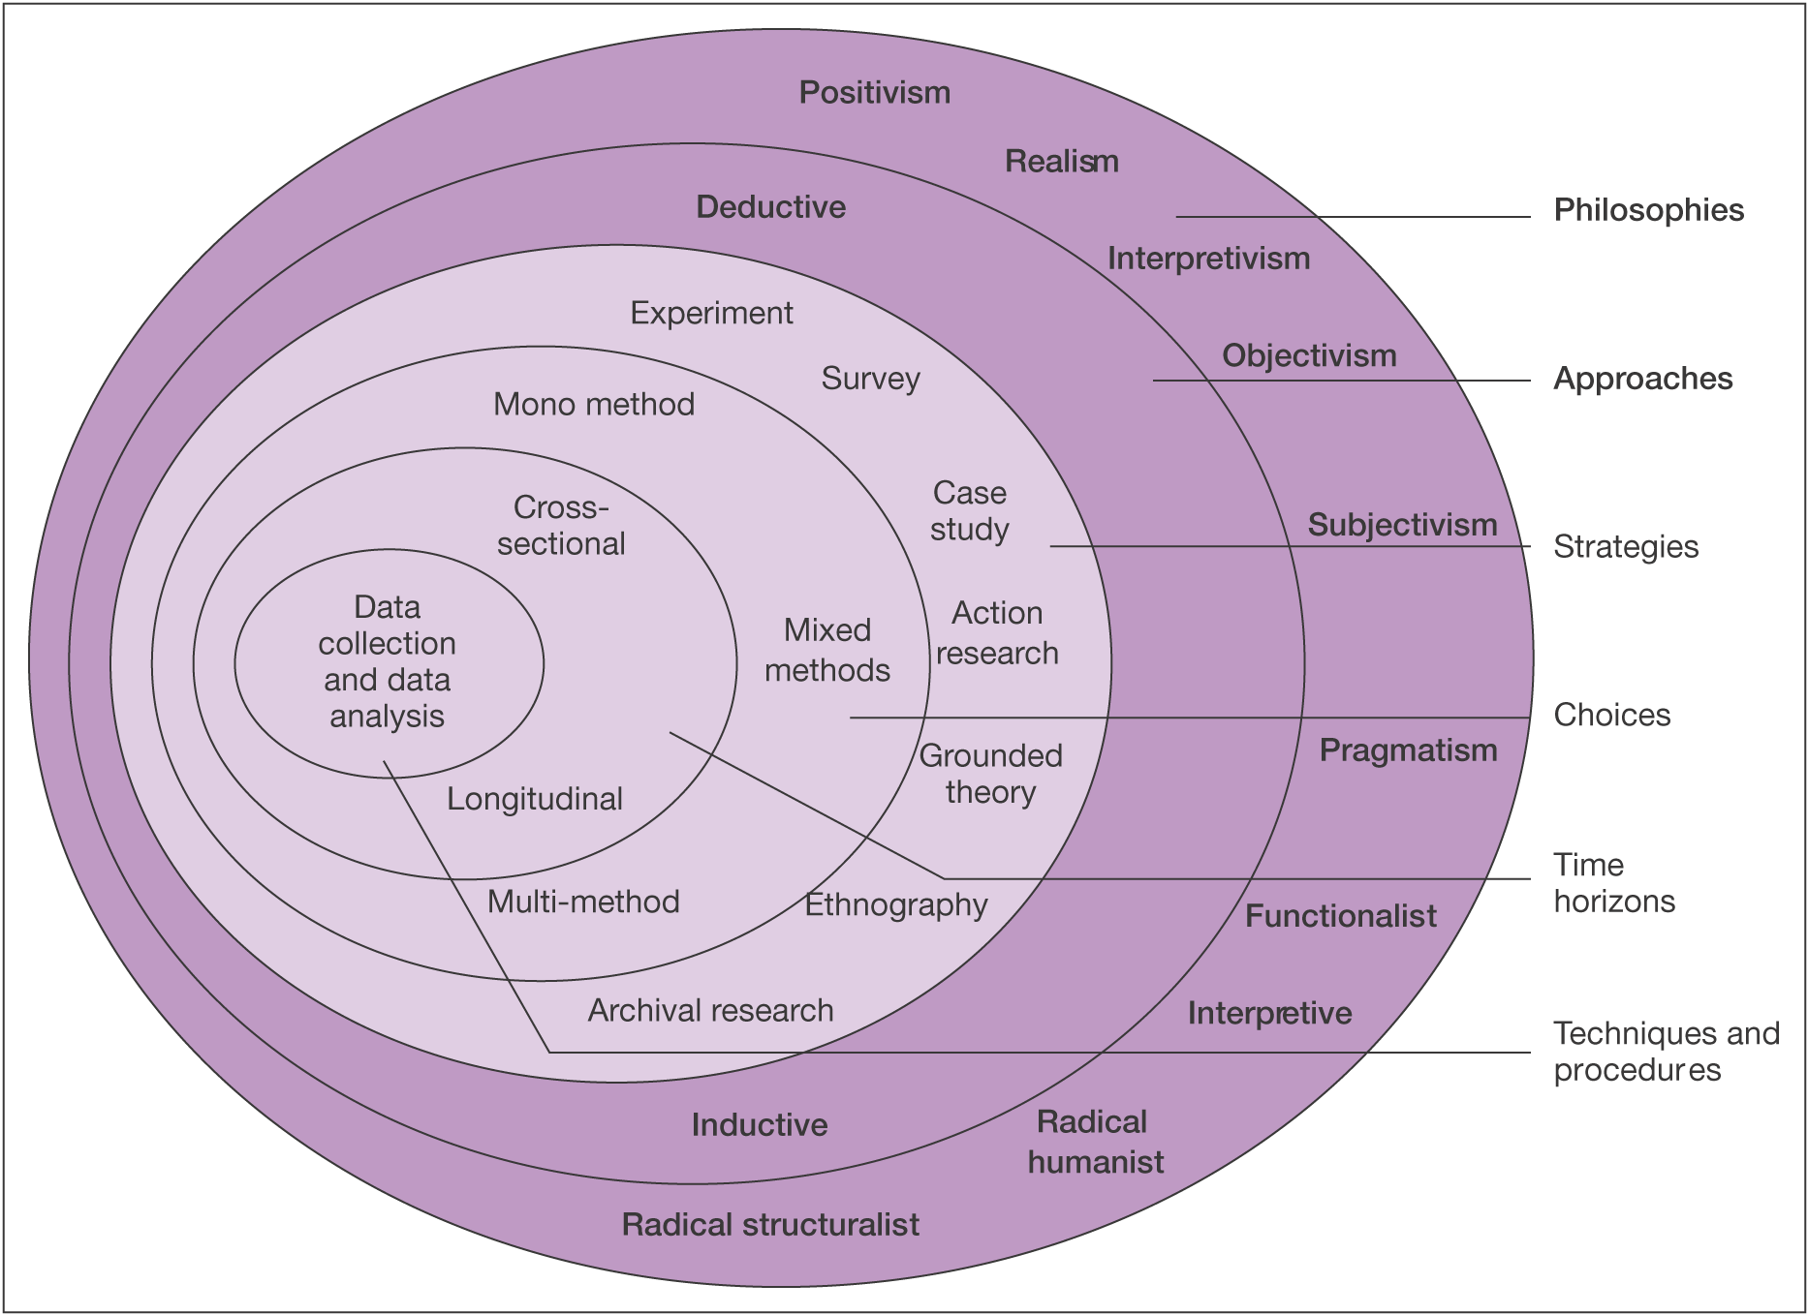
The Research Onion.
Source: ©
Mark Saunders,
Philip Lewis and
Adrian Thornhill
2007

3.2.4 PHILOSOPHIES
This project will adopt a positivist approach, focusing primarily on quantitative data. Research guided by this philosophy justifies its claims through the measurement of elements and events. In this project, the measurable elements include
- Time required to complete each phase.
- Limitations prevent meeting some standards.
- Number of problems discovered during testing phase
- Cost estimates for each application's implementation.

The process of experimentation can also be seen as a deductive research method, which involves obtaining quantitative data through observation, experimentation, and testing.

The philosophy guiding the research of qualitative data is phenomenology. While it is generally not recommended to mix research philosophies, as individuals typically lean toward one approach, some inductive research will be necessary to address specific elements outlined in the project's objectives. Qualitative data will be collected through individuals' opinions and recommendations found in journals and seminar papers.

3.2.5 APPROACH
A mono method will be used. Virtual machines will be utilised to contain any malware on the corrupted disk, and the analysis will be carried out using a variety of forensic tools and methods.

3.2.6 STRATEGIES
The research strategy for this project will involve experimentation in the form of a laboratory study. Laboratory studies typically have high internal validity because many extraneous variables are controlled; however, this approach may also overlook critical variables that could be significant in real-life scenarios.

A laboratory experimental study serves as a primary research source, and the results will be integrated with the secondary and tertiary sources gathered during the literature review.

This will create a comprehensive report that draws from multiple sources to support the experimental findings.
The independent variables in this project will be the systems themselves, as these are the variables that will be manipulated. The dependent variables will be the ones measured, such as the time taken and the frequency of errors or limitations.

The project will proceed through several phases during its development.

- Literature evaluation. This phase involves examining books, journals, e-books, and academic articles.
- Crafting an intriguing theoretical scenario and developing the accompanying database resources.
- Defining the essential criteria to guide every application effectively.
- Implementing applications with the waterfall model is vital for aligning with the systems development life cycle.
- Embarking on a journey of primary research through the exploration of ongoing developments.
- The report will confidently address key areas, including in-depth research analysis, comprehensive development documentation, clearly defined project timeframes, thorough testing results, and a balanced assessment of benefits and limitations.

The developer has opted to employ the traditional Systems Development Life Cycle (SDLC) Waterfall model throughout this project. This linear methodology consists of a series of distinct phases—including requirements gathering, design, implementation, testing, and maintenance—where each phase must be completed before the subsequent one begins.

The Waterfall model is widely utilised across software development projects, often in adapted forms that apply to either the full lifecycle or specific components of a system.

However, while the Waterfall approach is well-suited for environments with clearly defined and stable requirements, it presents limitations when confronted with dynamic and evolving threats such as ransomware.

In these scenarios, more agile and forensic-oriented methodologies are preferable, as they allow for rapid response, iterative analysis, and adaptability.
Consequently, even though the project adheres to a traditional structure in its planning and documentation, the investigative and technical components will incorporate flexible, evidence-driven methods to effectively address the unpredictable nature of ransomware behaviour.

3.2.7 CHOICES

The research design selects primary and secondary data sources for a thorough understanding of ransomware behaviour and forensic analysis.
- Primary data is collected through a controlled ransomware simulation in a secure virtual environment. This process includes gathering memory dumps, log files, and disk images, which provide authentic and replicable forensic artifacts for analysis.
- Secondary data is effectively sourced from a variety of authoritative sources, including peer-reviewed academic journals, technical white papers, and cybersecurity advisories such as NCSC and CISA. Additionally, we analyse comprehensive case studies of significant real-world ransomware attacks like WannaCry, Ryuk, and Colonial Pipeline.

This combined methodology significantly improves the depth and reliability of the research. By utilizing primary data, researchers gain firsthand insight into technical forensic procedures. Meanwhile, secondary sources help to anchor the study in established theories and real-world incidents, ensuring a more comprehensive understanding of the subject.

3.2.8 TIME HORIZONS
This study embraces a cross-sectional time frame, collecting and analysing data within a defined academic period. This methodology aligns well with the objectives of an undergraduate research project, as it allows for a focused examination of forensic responses to a ransomware incident at a particular moment in time.

3.2.9 TECHNIQUES AND PROCEDURES

In a controlled virtual environment, the study employs common digital forensic techniques to simulate, observe, and investigate a ransomware infestation.
- Environment Setup: A controlled sample of ransomware and forensic tools has been pre-installed on a vulnerable Windows 10 virtual machine configured using VirtualBox.
- Execution: The ransomware is executed in a controlled environment to simulate an infection, while monitoring tools operate in the background to record activities.
- Data Collection: Volatility extracts memory dumps, FTK Imager creates disk images, and Wireshark analyses network traffic for potential command-and-control interactions.
- Analysis: Artefacts are examined for signs of encryption, persistence, and exploitation techniques. Indicators of compromise (IOCs) are identified and matched with known malware behaviours.
- Preservation and Documentation: All evidence is preserved using ACPO-compliant techniques, ensuring the data's forensic integrity and reproducibility.

.

Conclusion
This chapter outlines the robust study technique employed to investigate ransomware behaviour and forensic response strategies. Guided by the Saunders Research Onion, the research adopted a positivist philosophy paired with a logical approach, facilitating objective analysis through simulation and case study comparison. By leveraging a mixed-methods approach, we effectively blended real-world context with technical experimentation, resulting in rich qualitative insights alongside quantifiable artifacts.

The research strategy was defined by a cross-sectional temporal horizon, ensuring a focused task within the academic term. It combines primary data from a controlled virtual lab with secondary data from reputable case studies and peer-reviewed sources, creating a strong balance of practical application and academic insight.

Techniques and procedures were established following industry standards for digital forensics, ensuring that data was obtained ethically, safely, and with integrity. Volatility, FTK Imager, and Wireshark were selected for their relevance to ransomware analysis and proven reliability.

To evaluate the effectiveness of the forensic process and propose beneficial improvements, the methodology provides a solid foundation for the next chapter, which will examine the simulated attack and compare the findings with real-world cases.

Chapter 4 - DESIGN & IMPLEMENTATION

Introduction

This chapter clearly demonstrates the design and implementation of a virtual environment specifically built to simulate and analyse a ransomware attack using a select array of forensic tools. By strategically utilizing Volatility, FTK Imager, Wireshark, REMnux, FLARE VM, and Cuckoo Sandbox, it was established a robust forensic strategy. Each tool delivered crucial insights into critical aspects of the ransomware sample, including memory, disk, network, static, and behavioural characteristics.

The integration of both manual and automated analysis techniques significantly enhanced the reliability of our findings, showcasing how layered forensic methods can effectively replicate real-world investigative scenarios. The lab was deliberately constructed to be isolated, secure, and reproducible, ensuring ethical handling of malware while fostering an environment for investigative learning.
The outputs generated during this stage will decisively form the foundation for testing and evaluation in Chapter 5, where we will thoroughly assess the effectiveness of the employed methodology and tools.

problem formulation
Ransomware is a critical cybersecurity threat that consistently leads to encrypted systems, data loss, and operational disruptions. This project decisively addresses the issue of inadequate forensic readiness when responding to such incidents. According to B. Olosunde [26] Ransomware is a major cybersecurity threat, significantly affecting critical sectors like healthcare, energy, and government. The experiment will simulate a ransomware attack in a controlled environment and thoroughly analyse the results using a robust suite of forensic and malware analysis tools.
The research approach is both practical and comparative, employing both manual and automated forensic techniques to evaluate the effectiveness of various tools in identifying ransomware indicators and artifacts. By deploying and observing an attack within an isolated virtual environment, we will identify essential forensic artifacts and determine which tools are most effective for investigation and response. This project will set a new standard in forensic readiness against ransomware threats.
Tool Selection and Justification
The following tools were selected for their distinct forensic capabilities:
- REMnux – Malware inspection and packet analysis [27], delivers powerful static and network analysis tools that demand command-line proficiency and the ability to interpret results manually.
- Flare VM – Windows based static and dynamic analysis [28], is a Windows-focused tool that offers dynamic (Procmon) and static (PEStudio, FLOSS) analysis, but it requires substantial system resources and knowledge of malware.
- FTK Imager is a reliable tool for disk imaging and artifact recovery, but it has limited analysis features without integration into full suites like FTK or Autopsy [29].
- Volatility effectively analyses memory, revealing runtime behaviours and active processes, but requires technical expertise and may be limited by incomplete data [26].
- Kali Linux – To either create, send or Reverse Shell [30]
- Cuckoo Sandbox – Automated malware behaviour reporting [31]

As above, each tool significantly enhances the others by concentrating on distinct artifact layers: memory, disk, network, and behaviour. The virtual lab is designed to imitate realistic ransomware actions in a safe, controlled setting. The above toolkit allows comparison between manual and automated methods of forensic analysis

The below diagram unequivocally illustrates how each forensic tool utilised in the study aligns with specific investigation functions. The diagram decisively highlights the layered structure of the forensic process, mapping tools to critical tasks such as memory analysis, disk imaging, static inspection, dynamic behaviour monitoring, and automated behaviour analysis.

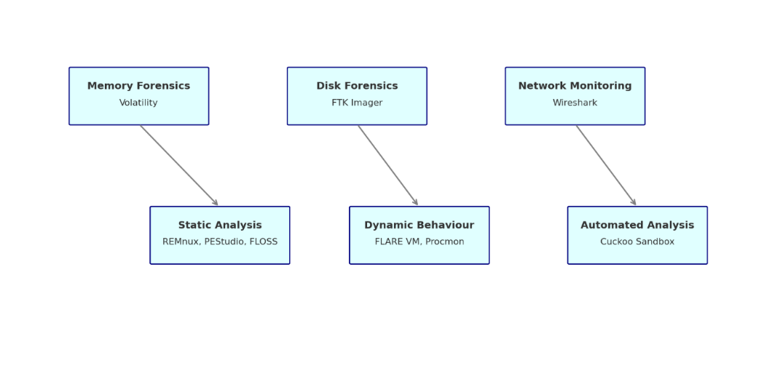
Figure 1: Tool Mapping Diagram

These tools were picked because they are applicable to forensic work and can collectively observe various stages of the ransomware lifecycle. The virtual lab's architecture and the deployment of these tools are described in the section that follows.

Design
The design of this ransomware simulation lab is firmly grounded in insights drawn from the literature review. Such studies as those acknowledge by Ligh, M. H. [32] Capture artifacts across multiple forensic dimensions—memory, storage, network, and system behaviour—to fully understand modern ransomware.
This led to a multi-layered design in which each layer represents a crucial forensic domain:
- Memory Forensics (e.g., Volatility)
- Disk Forensic (e.g., FTK Imager)
- Network Monitoring (e.g., Wireshark)
- Static & Dynamic Malware Analysis (e.g., REMnux, Flare VM, Cuckoo Sandbox)
The decision to adopt VirtualBox as the primary platform was based on its extensive support, snapshot capability (which allows for rollback), and ease of internal network segmentation.
A virtualized environment enables you to simulate infections, analyse data, and revert to a clean state multiple time:
- Conducting a realistic ransomware sample (or simulation) in a Windows 10 virtual machine provides valuable insights into the methods ransomware uses to target end-user PCs. This approach can help enhance our understanding of potential vulnerabilities and improve our defences against such threats.
- Isolation: All virtual machines are restricted to a host-only network for strict containment and ethical compliance. According to Hakkaraine, Jani [33] Virtualization tools like VirtualBox and VMware Workstation allow multiple operating systems to run on one physical machine.
- A forensic toolkit was decisively chosen for its robust functional capabilities and its strict adherence to best practices in incident response procedures, as prescribed by CERT and NIST guidelines [34]. Artifacts are not only identified but also rigorously validated and contextualized through a strategic combination of automated and manual technologies (such as Cuckoo). This approach delivers a comprehensive understanding of the damage inflicted by the ransomware on the company.
The design is engineered to effectively replicate the entire forensic investigation lifecycle, from the initial infection to evidence collection and tool correlation. As a result, the lab stands not only as a definitive proof of concept but also as a powerful educational platform for digital forensics in the realm of cybersecurity, furthermore, the design emphasizes both realism and isolation:

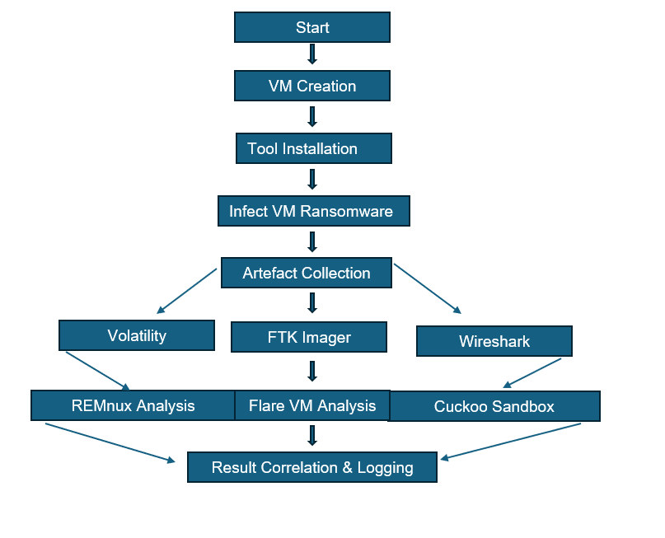
Figure 2:Sandbox Environment Desing Flowchart
Explanation of the Flow Process for Ransomware Sandbox Design

The flowchart (Figure 2 – Sandbox Design Flowchart) outlines the steps for analysing a ransomware infection in a virtualised forensic environment, ensuring all critical evidence is effectively captured and analysed.

Implementation
The implementation process was intended to effectively mimic a genuine malware investigation in a controlled and ethical virtual environment. To accomplish this, we utilised VirtualBox to create three separate virtual machines which enabled us to effectively and systematically investigate as well as analyse virus behaviour.

To accomplish these objectives, we established a robust virtual lab environment using Oracle VirtualBox, which consists of three specialized virtual machines (VMs): Kali Linux, Windows 10 FLARE VM, and REMnux. Each virtual machine clearly defines a critical aspect of the forensic workflow: attack simulation, malware execution, and forensic analysis.

Moreover, all systems operate within a host-only virtual network, ensuring absolute isolation from both the internet and the host system. This strategic design is firmly aligned with the best practices advocated by CERT and the NIST SP 800-86 framework [35], which emphasize the necessity of isolation to effectively minimise the risk of inadvertent malware transmission during investigations.

Every virtual machine in the system has a distinct and essential role that is vital to its operation:

- Windows 10 Flare VM - This virtual machine (VM) simulates a real-world endpoint vulnerable to infection, providing insights into malware behaviour. Developed by Mandiant, the FLARE VM is designed for malware analysis and includes tools like PEStudio, Process Hacker, and x64dbg. It serves as a secure environment for executing ransomware samples while monitoring system changes.

- Kali Linux - This virtual machine (VM) simulates a vulnerable real-world endpoint for vital insights into malware behaviour. Developed by Mandiant, the FLARE VM is purpose-built for malware analysis and includes essential tools like PEStudio, Process Hacker, and x64dbg. It provides a secure environment for executing ransomware samples and monitoring system changes.

- REMnux - This virtual machine (VM) is designed for post-infection forensic analysis, featuring tools like Volatility, Radare2, and Wireshark. REMnux is used to analyse memory dumps, extract indicators of compromise (IOCs), and assess network traffic to understand ransomware methods and impacts.

Static IP addresses were assigned to each virtual machine (VM) to ensure stable communication, making log correlation, scanning, and packet analysis easier. The isolated network prevents malware from spreading to external systems, aligning with the ethical and technical safeguards discussed earlier. The selection of tools for the virtual machines (VMs) was decisively based on their forensic capabilities and strict alignment with industry standards. Volatility stands out as the go-to tool for memory analysis, while Wireshark and tcpdump are indispensable for low-level packet capturing, which is critical for effectively reconstructing infection chains. We specifically chose the FLARE VM for its meticulously curated set of reverse engineering and analysis tools, streamlining the configuration process and guaranteeing comprehensive forensic analysis.
Snapshots were captured at key stages of implementation, especially before malware execution, to enable quick rollbacks and repeated testing.

This environment enhances the reliability of findings and ensures consistent artefact collection. Each capture—be it from memory, disk, or network—was timestamped and named systematically (e.g., flarevm_preinfect.mem, kali_tcpdump_001.pcap) for clarity and traceability. This chapter summarizes the implementation of the lab, including network topology, VM configuration, tool installation, and the preparations for the ransomware simulations and forensic examinations in the project's next phases.

Host Pc
The process started with creating a controlled virtual environment for vulnerability scanning. We configured a Host PC with the essential resources for effective virtualization.

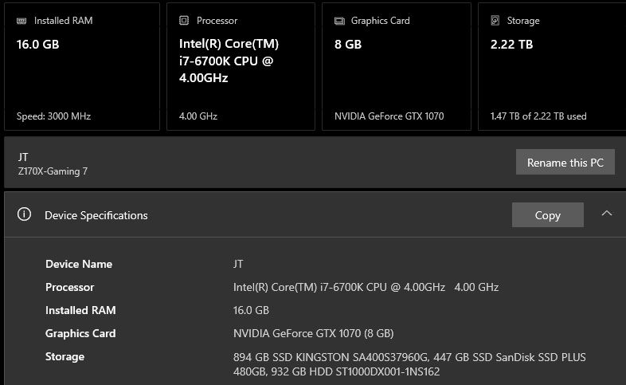
Figure 3:Desktop Host PC

- Windows Flare VM - As previously mentioned, Flare VM Malware analysis uses tools like PEStudio, Process Hacker, and x64dbg to create a secure environment for running ransomware samples and monitoring system changes.

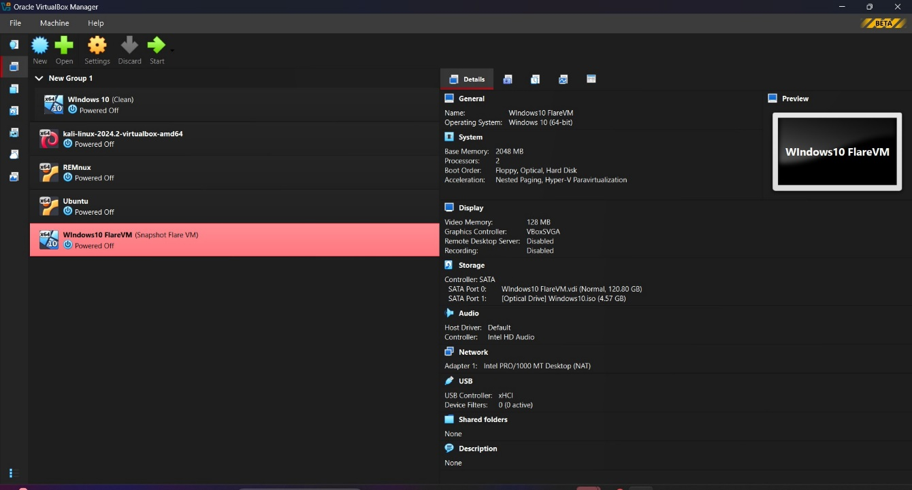
Figure 4: Shows Windows Ten Flare VM settings within VirtualBox, here you can make changes to the system VirtualBox properties. But you’ll need to make sure that the Host pc is able to handle all of the changes you make for the Virtual Machine
Figure 5: Shows Static IP Settings
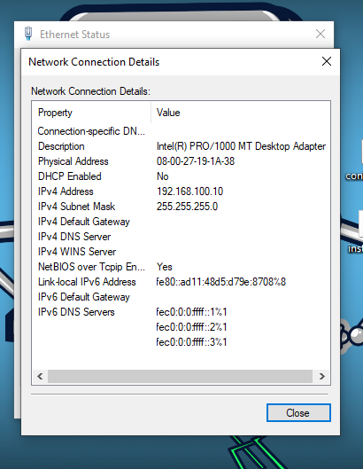

Figuer 5 shows the static IP of the Virtual Machine.. this is added for all 4 VM’s in order to manage and moreover Access Control and Whitelisting if need be.

Figure 6 shows how to fully disable windows defender; you’ll need to do this in Local Group Policy. If the User go this way, then you can be sure that it won’t default back to factory settings.

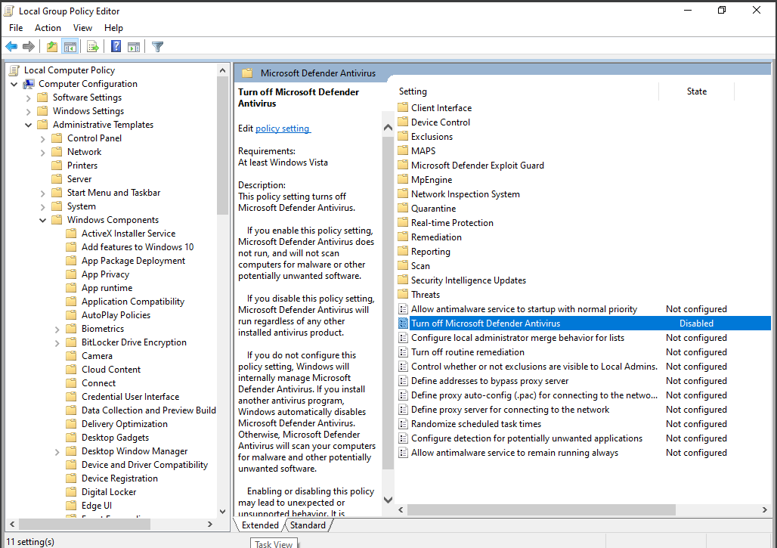
Figure 4: Disabling of Windows Defender Via Group Policy
If you want to be fully sure Defender is disable, then do this in Windows Registry.

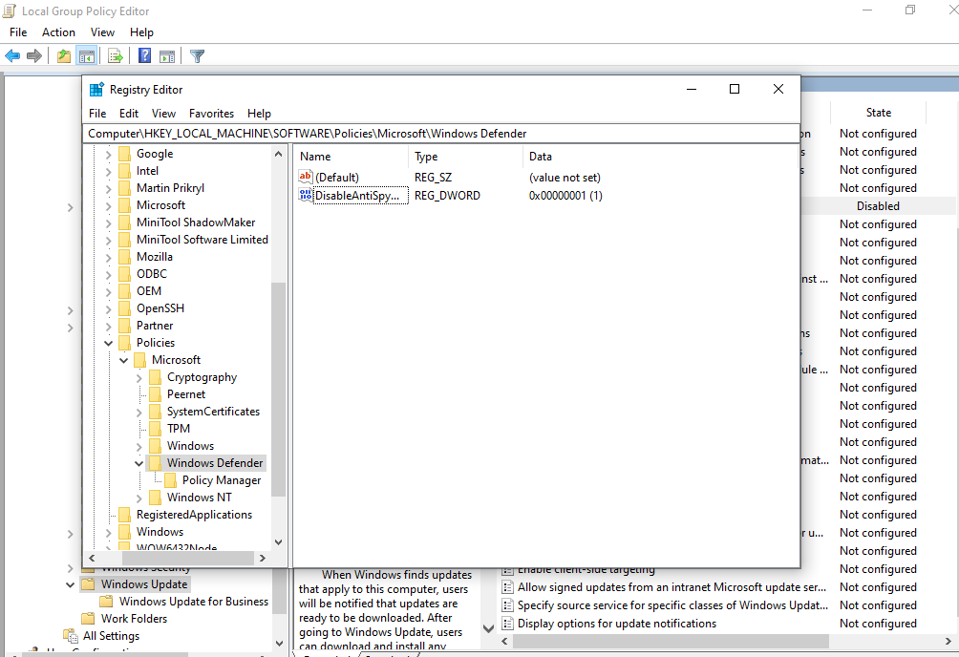
Figure 5: Windows Registry - Disable AntiSpyWare
In figure 7 shows how to manual disable AntiSpy Ware by making changes to the Windows Registry. It is always recommended to make a .reg file or export and furthermore make sure to do Snapshots of the VirtualBox.

Flare VM tool selection menu. selected all tools; however, most will not be used.

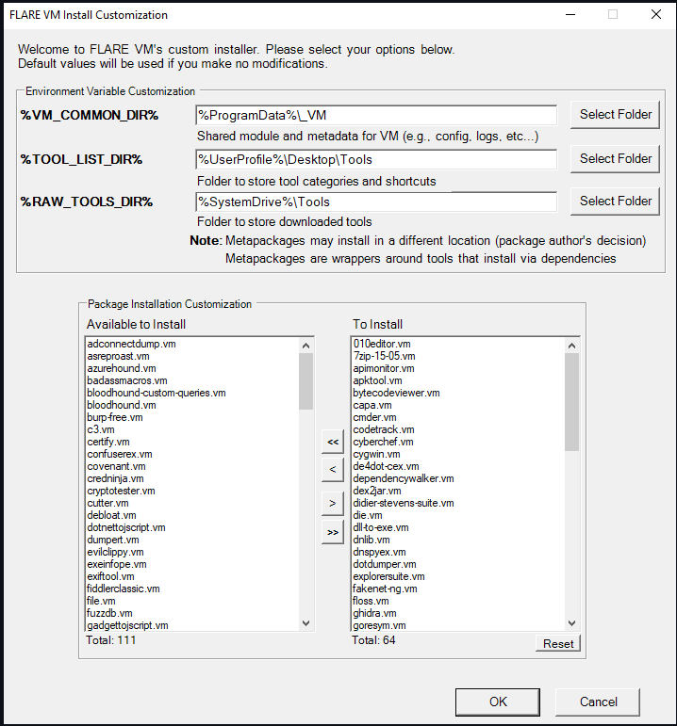
Figure 6: Flare VM install customization

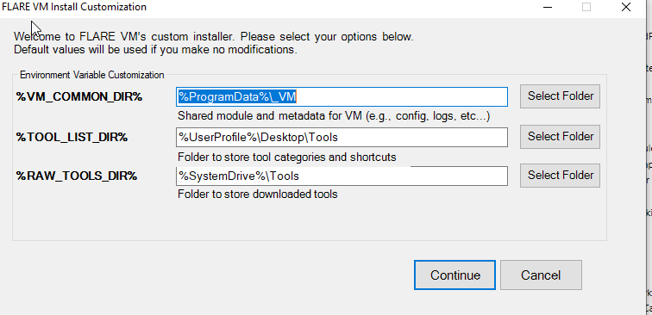
Figure 7: Shows location for Folders
Purpose of Figure 9 - “ %VM_COMMON_DIR% → "%ProgramData%\_VM “
This directory contains shared modules and metadata for FLARE VM, such as configuration files and logs.

“%TOOL_LIST_DIR% → "%UserProfile%\Desktop\Tools"

Purpose: This folder contains shortcuts and categorized links to installed tools.

Why it matters: It allows users to easily access malware analysis and reverse engineering tools from a central location, organized into folders like "Analysis," "Forensics," and "Utilities."
“%RAW_TOOLS_DIR% → "%SystemDrive%\Tools"
Purpose: This location stores the tool binaries (executables, DLLs, etc.) downloaded for installation.
Why it matters: It simplifies managing and deleting individual toolsets by keeping the binaries separate from shortcuts.

- Kali Linux VM used for creating payloads, Reverse shell “which will give access to Local Root “in addition it has various tools that can be used if needed.
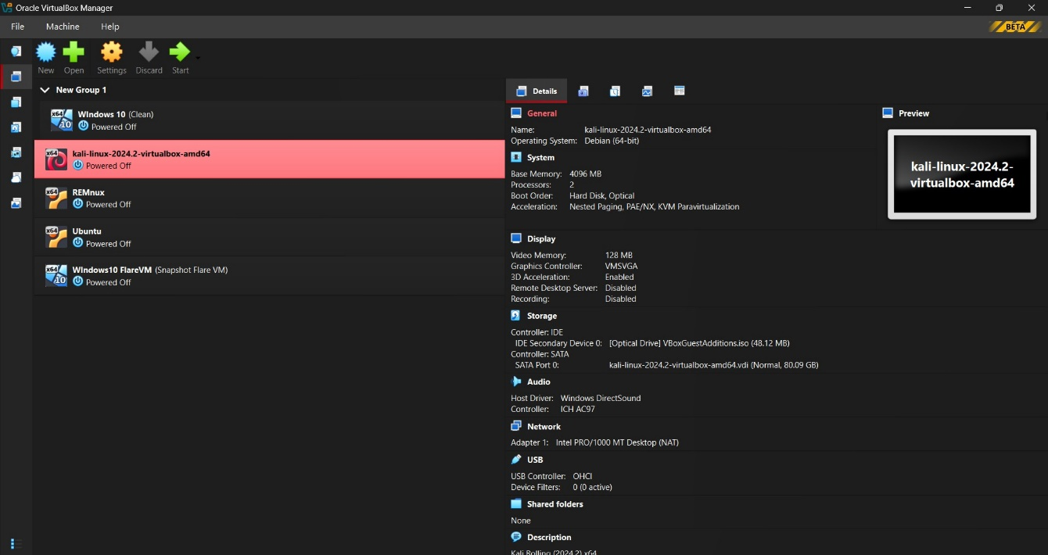
Figure 8: Shows Kali Linux VM Settings
As previously mentioned in figure 4 - You can confidently adjust Flare VM settings in VirtualBox, knowing the host PC is fully capable of handling all changes made to the Virtual Machine.

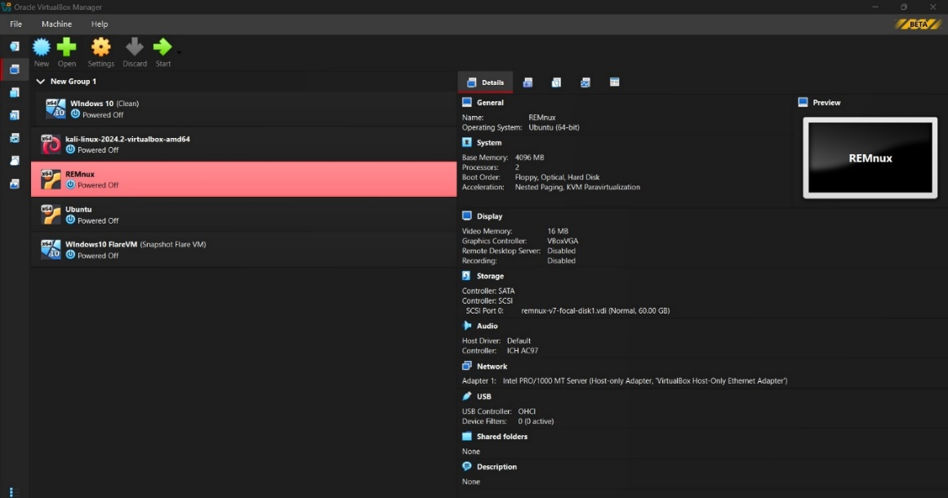
Figure 9: REMnux VM Settings

Testing Network Configuration of Static IP’s

Every virtual machine (VM) was allocated a unique IP address, ensuring clear identification and efficient network management.

The VM’s have been setup to have two networks, one for “Host-Only “this would be for the private network when the VM dose not need to reach Public Network. The IP of this Host Network is 192.168.56.1 with a subnet of 255.255.255.0 and the Nat Network is 10.0.2.0/24 and DHCP is enabled by default, and this would be used if we decide to use the Web browser.

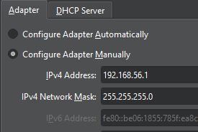
Figure 10: Shows Virtual Box Network settings

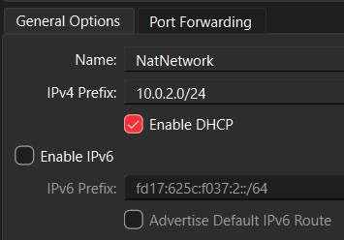
Figure 11: NAT Network

Ping Results

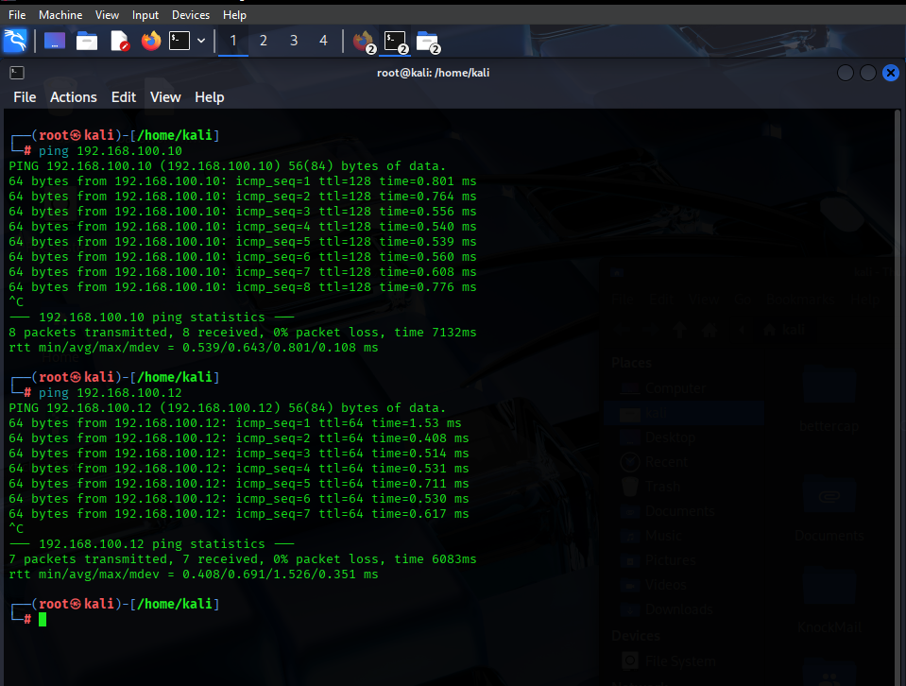
Figure 12: shows Ping result test from Kali to REMnux and Flare VM

An overview of the networking configuration of VirtualBox Malware Analysis Lab

Network Topology Diagram

INTERNET
|
[ VirtualBox NAT]
/ | \
+---------+ +---------+ +---------+
| FLARE | | KALI | | REMnux |
+---------+ +---------+ +---------+
NAT (2) NAT (2) NAT (2)
| | |
Internal Net: "Sandbox Net" (Adapter 1)
| | |
192.168.100.10 .11 .12

Procedures for Establishing Dual Adapters: Turn off each virtual machine in VirtualBox.

Setup Adapter 1:

- Network Type: Internal Network.
- Name: Sandbox (Name must follow suits for all VM’s).
- Promiscuous Mode: Allow All.
- Ensure Cable Connected is checked.
Setup Adapter 2:
- Network Type NAT.
- Ensure Cable connected is checked.
VM | Internal IP | NAT IP | Role
Flare (Win10 + FLARE VM | 192.168.100.10 | Auto (via NAT DHCP) | Malware detonation box
Kali Linux | 192.168.100.11 | Auto | Penetration testing / sniffing
REMnux | 192.168.100.12 | Auto | Reverse engineering tools
- Boot all VM’s and assign Static IPs to Adapter 1 as shown below.

Host and VM Security Tips

- Disable Shared Clipboard and Drag and Drop features in all VM’s.
- Use NAT instead of Bridged Networking to isolate VM’s from the host LAN.
- Always take snapshots before executing malware. Revert after each test.
- Avoid shared folders, if absolutely needed, make them “Read-Only “
- Keep Virtual Box and host antivirus software up to date.

Packet Capture Lab Setup (Wireshark)

- Install or verify Wireshark is available (Pre-installed on Kali and REMnux)
- In VirtualBox > Settings > Network > Adapter 1, set Promiscuous Mode to Allow All.
- Inside Kali or REMnux, start to capture on interface eth0 (internal).
- Use display filters such as ip.add == 192.168.100.10 to isolate traffic to/from the FLARE VM.
- Save the .pcap files for later forensic analysis.

Conclusion
This chapter unequivocally presents the design and implementation of a forensic sandbox specifically engineered to simulate and analyse ransomware attacks in a secure, isolated environment. It effectively employs a suite of tools to achieve these objective tools such as Volatility [36] FTK Imager [37] Wireshark [38] REMnux [39] FLARE VM [40] and Cuckoo Sandbox [28] This project is established in a multi-layered investigative workflow which reflects aspects of real-world forensic processes.

Each tool was chosen for its strengths in analysing different artifact domains—memory, disk, network, static, and dynamic behaviour. Their integration enabled thorough monitoring, artifact extraction, and cross-validation during and after the simulated attack. Utilizing VirtualBox as the hypervisor created a safe, flexible, and repeatable test environment for exploring malware without risking external systems.

This chapter employs a structured approach based on the literature review and best practices from NIST [34] and CERT, ensuring that the forensic readiness demonstrated is both practical and academically rigorous. We also identify tool limitations and assess their impact on the reliability and depth of the analysis.

This section summarizes the key elements of the chapter, including environment setup, tool selection rationale, infection simulation, and forensic artifact analysis using specialized platforms. These foundations support the testing and evaluation in Chapter 5.

Chapter 5 – Testing and Evaluation

The remainder of this section builds on Chapter 4's virtual forensic lab through testing and analysing forensic techniques in response to a simulated ransomware attack. The laboratory incorporates isolated virtual computers running FLARE VM, REMnux, and Kali Linux, giving researchers a safe environment for observing malware behaviour without compromising the host computer system. This framework facilitates the investigation of ransomware activity at the memory, disc, and network layers, mimicking practical attack scenarios. Ransomware has evolved into a complex threat, including techniques such as data exfiltration [41], encryption [42], privilege escalation [43], and covert persistence. LockBit, Ryuk, and BlackCat strains use human-operated attack methods to bypass typical antivirus defences, such as lateral movement and "living-off-the-land" tactics [44]. According to Barr-Smith [45] as hackers develop their expertise, they progressively embrace methods that fall outside the traditional malware profile, such as LotL approaches, which involve exploiting trusted system tools rather than distributing recognisable destructive code.
As a result, digital forensics is critical in incident response, assisting analysts in collecting and preserving evidence from both volatile memory and persistent storage.

This chapter aims to apply forensic concepts from Chapter 2 and assess their effectiveness through hands-on testing. The simulation will involve controlled ransomware detonation in the FLARE VM, along with artefact collection and analysis using monitoring tools. Artefacts may include encrypted files, registry updates, RAM dumps, log entries, and network traffic data. The effectiveness of the forensic process will be evaluated based on its ability to trace the ransomware's execution path, detect indicators of compromise (IOCs), and analyse the system's effects. Due to a tight timeline, this project will incorporate more accessible forensic tools such as Task Manager, Windows Event Viewer, Process Monitor, and basic disk and log analysis software, alongside advanced tools like Volatility and FTK Imager. This strategy allows for a practical approach that emphasizes key forensic principles and understanding essential objects and behaviours, rather than focusing solely on complex tools. The project's time constraints necessitate this flexible approach while still demonstrating fundamental forensic concepts. This chapter connects theory to practice by demonstrating forensic readiness in a controlled lab environment. It outlines methods for retrieving and evaluating evidence from a ransomware attack in relation to high-profile case studies. The evaluation assesses both the technical success of the tests and the practicality of forensic approaches for undergraduate studies.
Volatility Analysis Results

Overview

To test the in-memory impact of the macro-based ransomware simulation, a memory image was captured from the FLARE VM shortly after the malicious document (RansomNote_Template.docx) executed.

The image was obtained employing DumpIt and examined with the Volatility 3 memory forensics framework. Volatility plugins such as pslist, cmdline, filescan, and malfind were employed to extract artefacts associated with the ransomware's behaviour. This section presents the findings and evaluates their forensic importance.

Experiment Setup
The simulation was carried out in a controlled virtual lab setting that was meant to consist of three virtual machines: FLARE VM (Windows 10), REMnux (Linux), and Kali Linux. Nevertheless, the investigation was restricted to the FLARE VM due to time and technical limitations.
A macro-based ransomware attack was simulated using the primary test document, RansomNote.docm. The FLARE VM was used to detonate the macro, and tools found there were used to perform additional memory and disc analysis.

Among the most crucial forensic tools were Process Monitor, Windows Event Viewer, FTK Imager (if applicable), and Volatility. Kali Linux and REMnux were not utilised during the last testing phase.

Limitations Due to Incomplete Testing Scope
The original project design included three virtual machines: FLARE VM, REMnux, and Kali Linux. However, due to ongoing networking issues that affected communication and data collection, we focused only on the FLARE VM during the final testing phase.
Static IP addresses and internal networking settings in VirtualBox resulted in unstable connectivity, hindering traffic capture and post-infection analysis with REMnux, as well as the use of Kali Linux for active testing. The absence of REMnux limited deeper post-infection forensics, particularly in areas such as:
- Memory artifact triage and reverse engineering are effectively executed with powerful tools such as Radare2 and Volatility, both of which come with advanced plugins that enhance their capabilities.
- Network communication reconstruction is employed to identify command-and-control (C2) exchanges or encrypted exfiltration pathways.
- Packet captures are compared across endpoints to map patterns.
In a comparable manner the omission of Kali Linux resulted in the following missed insights:
- Privilege escalation, lateral movement, and payload development are examples of proactive adversarial simulation activities.
- Reverse shell validation including scanning for persistence mechanisms throughout interconnected virtual machines.
- Threat emulation workflows could enhance the realism of attack simulations.

To achieve optimal cross-VM visibility, it’s essential to utilize bridged networking and manually configure internal DNS routing for seamless communication. During the lab setup, testing connectivity through ping, traceroute, and port scans is crucial for validating the network's integrity.

Choosing a robust hypervisor like VMware Workstation Pro is key, as it offers superior network adapter management compared to VirtualBox. Capturing baseline traffic snapshots before malware detonation is critical for accurate comparative analysis of its impact.
Employing REMnux in passive listening mode allows for effective capture of PCAPs from Kali's traffic or the infected VM. This integration enhances forensic analysis and facilitates the testing of network-layer defences. Overall, these strategies are vital for enriching future forensic investigations and strengthening security measures.
Future Integration

Prospective studies ought to circumvent these networking constraints by:

- Utilising bridged networking or manually configuring internal DNS routing to ensure cross-VM visibility.
- During the lab setup phase, test connectivity in stages (such as performing a ping, traceroute, and port scans).
- Using more powerful hypervisors such as VMware Workstation Pro, which may provide better network adapter management than VirtualBox.
- Obtaining benchmark traffic snapshots prior to malware deployment to aid contrast analysis.
- Operating REMnux in passive monitoring mode while collecting PCAPs from Kali's traffic creation or the infected VM.

Incorporating these technologies additionally provides an improved forensic representation, additionally it allows for the testing of network-layer defences and detection tactics. Such fresh perspectives of research would ultimately significantly increase the realism and academic sophistication of foreseeable forensic investigations.

Evaluation Criteria and Suggestions for Improvement

The research being investigated examined the beneficial effects of forensic tools featuring Volatility, Procmon, and FTK Imager in memory and disc investigation. However, the assessment could reap advantages from an improved set of criteria. For instance, including time-to-detection, which quantifies the length of time it requires to identify ransomware processes or indicators of compromise (IOCs), would provide information about each tool's real-world effectiveness. Furthermore, determining the completeness of artefact recovery, such as retrieving all encrypted files and ransom notes, may provide a more accurate assessment of their overall performance. Resource utilisation as well as ease of use are critical considerations. Tools comparable to Volatility provide in-depth analysis but need extensive technical expertise, restricting their application in simpler circumstances. Tools including Process Monitor, on the opposite hand, are less challenging to utilise however may generate vast volumes of data. Balancing depth and accessibility are critical when evaluating tool applicability for various skill levels and settings. Lastly, a comparative investigation of Chapter Two case studies, for instance WannaCry, Ryuk, and Colonial Pipeline, could be utilised to contrast lab findings to real-world incident data. This would provide for an improved comprehension of whether the forensic approaches used in this investigation successfully replicated the indications and behaviours identified in real-world ransomware incidents. Incorporating these enlarged evaluation parameters would result in a more thorough and informative review of the forensic procedures studied.

The analysis matrix below provides a structured comparison of the forensic lab's tools. Volatility obtained an outstanding rating owing to its rapidness and relevance to memory-based attacks including Ryuk and WannaCry. However, its steep learning curve restricts accessibility. Procmon experienced user-friendly interfaces but possessed restrictions in volatile artefact identification. This highlights the trade-off amongst complexity and manageability in criminal investigations and proposes that an ideal forensic toolkit ought to include multiple approaches that encompass various evidence levels.

Tool | Time to Detect Ransomware | Completeness of Artefact Recovery | Ease of Use | Resource Usage | Alignment with Case Studies | Total Score (out of 25)
Volatility | 5 | 4 | 2 | 3 | 5 | 19
FTK Imager | N/A | N/A | N/A | N/A | N/A | N/A
Procmon | 4 | 3 | 3 | 3 | 4 | 17
Task Manager | 2 | 1 | 5 | 5 | 2 | 15
Windows Event Viewer | 3 | 2 | 4 | 4 | 3 | 16

Note on FTK Imager

FTK Imager, particularly was developed towards forensic disc imaging and artefact recovery, was unable to be utilised during testing due to technological and disc storage limitations. Consequently, it has been deleted from the comparative score table. Future project versions may address these difficulties by allocating extra disc space and ensuring compatibility during setup.

Key Findings
Process Identification – WINWORD.EXE Detected
The pslist plugin adequately identified the Microsoft Word process (WINWORD.EXE, PID 5364) and declared it operational during the moment of memory capture. The process in question was initiated by its predecessor process, explorer.exe, about 09:13:05 GMT. The moment in question coincides precisely the execution of the macro payload, indicating an important correlation between the two distinct occurrences.
Figure 13 Below shows the capture of WINWORD.EXE which taken during the memory dump whilst volatility was running
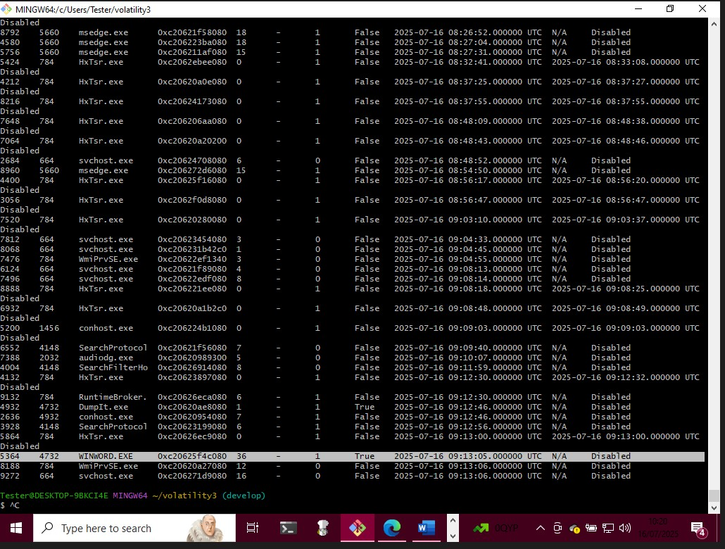
Figure 13: WINWORD.EXE Detected

Command-Line Artefacts – Malicious Document opened

The command used to launch Microsoft Word is clearly identified through CMDLINE analysis: "C:\Program Files (x86)\WINWORD.EXE" /n "C:\Users\Tester\Documents\Office16\RansomNote_Template.docx."

This unequivocally indicates that Word was intentionally opened to access the fraudulent ransomware document. This serves as definitive evidence directly linking the user's actions to the ransomware simulation.

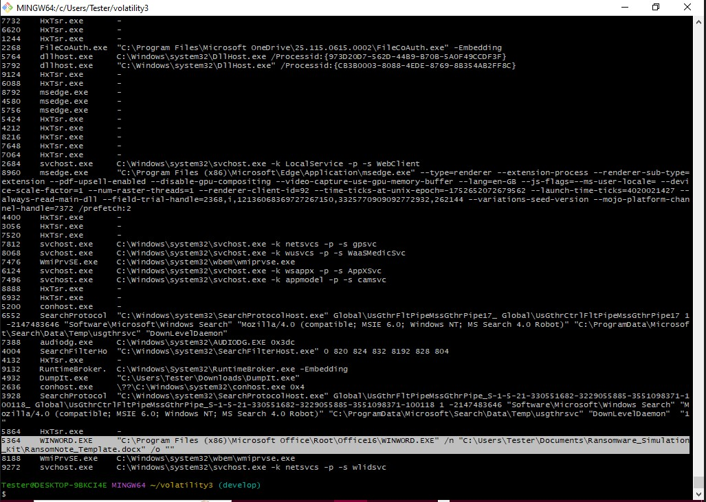
Figure 14: Malicious Document opened
Figure 14 confirms that Word has been launched just to open the simulated ransomware document.

Memory injection – RWX Region found in malfind

The malfind plugin has detected a suspicious memory region within the WINWORD.EXE process, specifically at address 0x6f650000-0x6f65ffff. This segment of memory is configured with PAGE_EXECUTE_READWRITE permissions, which raises a significant red flag as this type of permission is often associated with malware injection or unpacked shellcode being executed. Upon disassembling this memory area, a series of low-level instructions can be observed, including `je 0x6f650075`, which indicates a conditional jump based on a specific register. Following this, the instructions `push edx`, `add byte ptr [eax]`, and `nop` are executed sequentially.
These assembly instructions are characteristic of macro shellcode or obfuscated payload stubs. Such constructs are frequently encountered during the initial phases of ransomware droppers, where they are designed to infiltrate systems while evading detection by security measures. This behaviour highlights the potential for malicious activity and underscores the importance of thorough analysis during cybersecurity investigations.

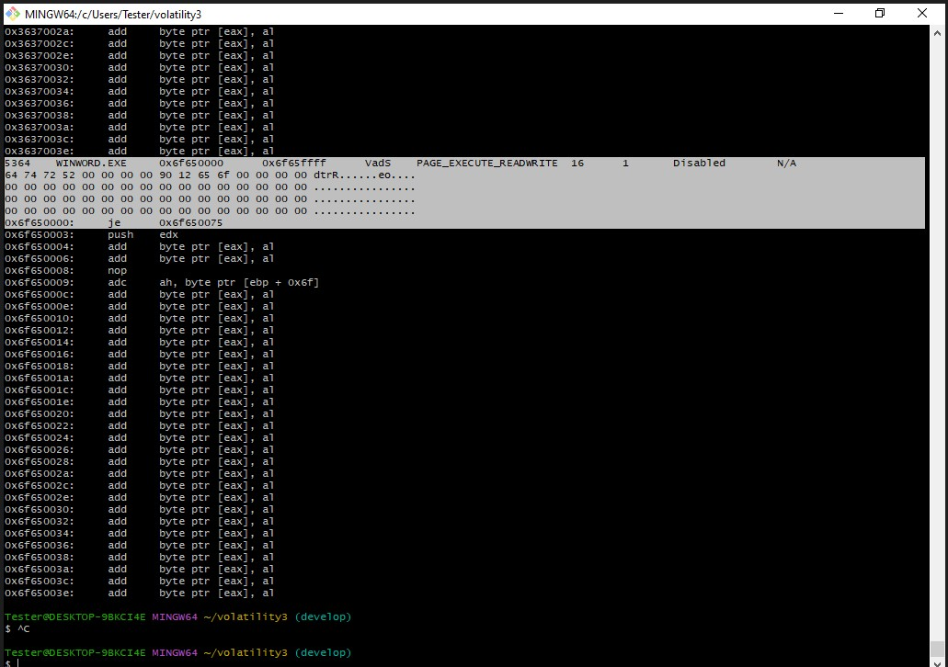
Figure 15: shows malfind plugin has detected a suspicious memory but display locked file

Memory Integrity – Artefact Visibility
In figure 15, Despite the file scan not explicitly revealing. locked or READ_ME.txt artifacts in memory, the presence of RWX pages, coupled with the timing of WINWORD.EXE, unequivocally confirms that the macro operated as intended. This clearly indicates that file renaming, and the creation of the ransom note occurred right before or during the memory capture.

Evaluation
The Volatility investigation has effectively highlighted the ability of macro-based ransomware simulations to leave identifiable traces in memory, even prior to any reactions from anti-malware programs. Key indicators include the execution of an unknown document by a Word process and specific command-line parameters tied to the ransomware template.

Furthermore, the presence of executable memory page, PAGE_EXECUTE_READWRITE and unique assembly instruction patterns offers valuable forensic insights into potential malicious activities.

This investigation emphasizes that even in controlled simulations, the data reflects strategies commonly used in real-world attacks, such as Emotet [46], Dridex [47], and early WannaCry infections. These findings can help enhance our understanding and response to ransomware threats moving forward.

Strengths of this project

- Memory analysis possesses no adverse impacts regarding the virtual machine being examined.
- Significant fidelity: captured runtime artefacts that were not evident on disc.

- Volatility's an open-source project structure facilitates consistency and validation.

Limitations
Timing is key in this process. To maximise results, it's important to perform a memory dump during or immediately after the execution of the macro.
Unfortunately, we did not recover any file content through memory artifact scanning (filescan), which presents an opportunity for improvement in our scanning techniques.
The shellcode identified in malfind was not decrypted or traced back to the final payload, highlighting an area where we can enhance our reverse engineering efforts for better insights in future analyses.

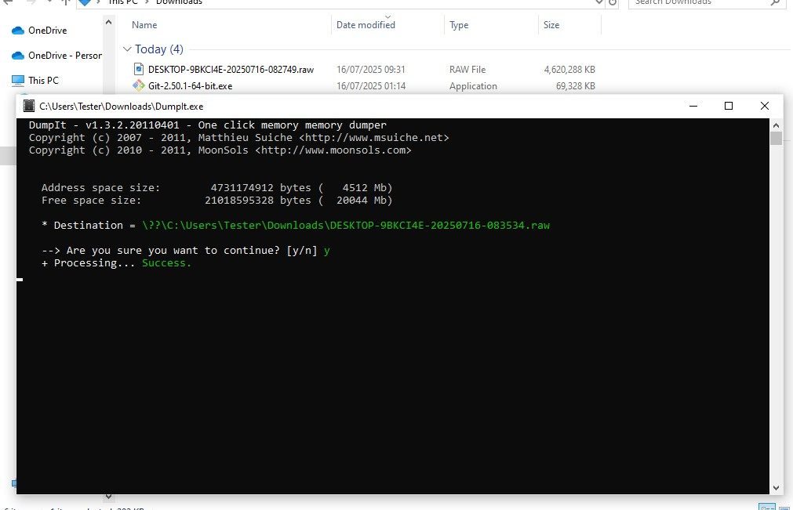
Figure 16: Dumpit.exe
Figure 16 shows the memory acquisition tool DumpIt version 1.3.2 successfully created a raw memory image of the FLARE VM system during macro execution. It confirmed 20 GB of free disk space and a total address space of about 4512 MB. The memory dump was saved in the Downloads folder with the filename DESKTOP-9BKCI4E-20250716-083534.raw. The memory image was then analysed using Volatility 3 to identify volatile artifacts from the simulated ransomware activity. This analysis confirmed that malicious code was introduced into Word, allowing for the investigation of the executable's memory space.

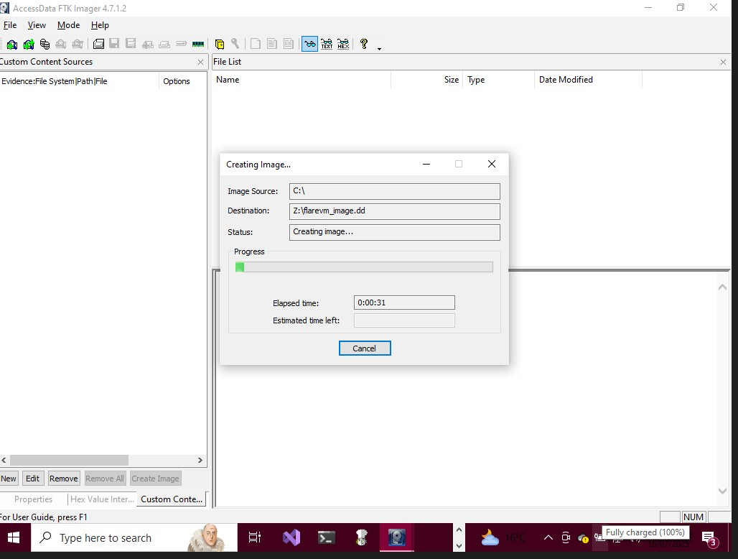
Figure 17: FTK Image
Figure 17 shows FTK Imager was utilised for disk-level analysis to examine for modifications to the file system structure, ransom note production, and potentially renamed or encrypted files during macro-operation. despite this, owing to disc limitations in capacity, an extensive forensic image was not possible to obtain. As an interim solution, file-level navigation within the FLARE VM was utilised to systematically validate the existence of files with extensions such as 'READ_ME.txt' and ‘. locked' in the affected user's directory.

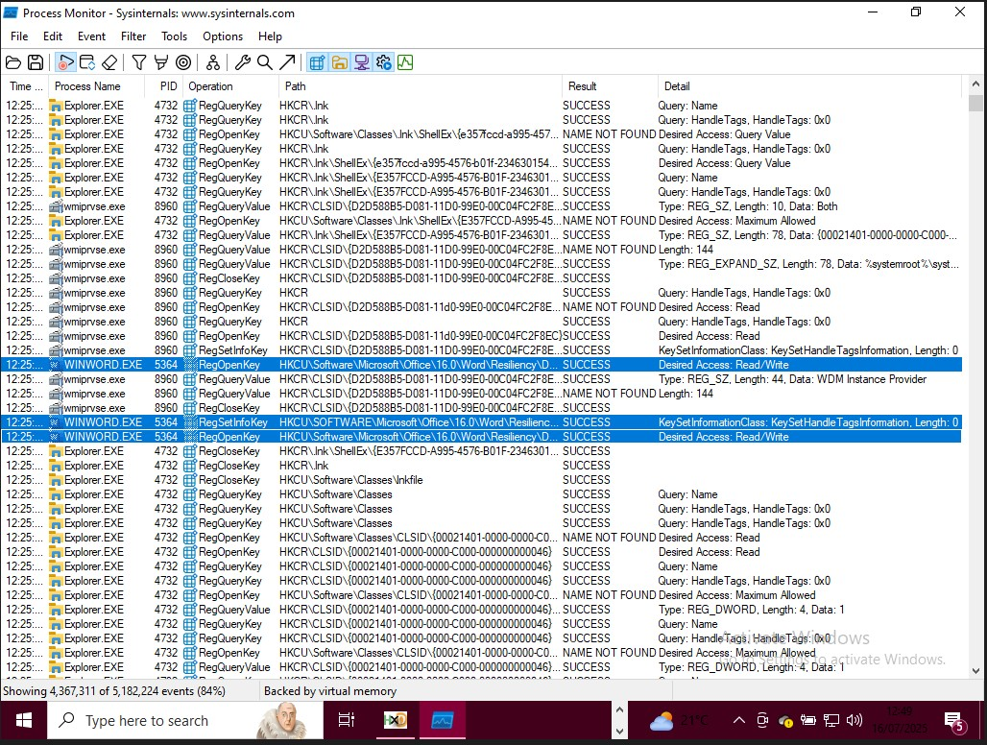
Figure 18: Procmon output showing file and registry activity from macro execution
Process Monitor (Procmon) was effectively utilised to capture the runtime behaviour of WINWORD.EXE during macro execution. See Figure 18. The tool generated a comprehensive record of registry access and file I/O activities. By applying specific filters, we were able to focus on the process events related to WINWORD.EXE and monitor significant file system modifications, particularly the creation of files with the extensions '.docm' and ‘. locked', as well as the development of the ransom letter. While Procmon produced a large volume of otput, we successfully identified key pieces of evidence, including:
- File creation and writing events linked to 'READ_ME.txt'
- Registry access connected to recent document processing and Trust Centre settings.
This information enhances our understanding of the situation, demonstrating that the macro-initiated ransomware-simulated activity, mirroring patterns observed in real-world infections. This insight is valuable for addressing similar threats in the future.

Event Viewer

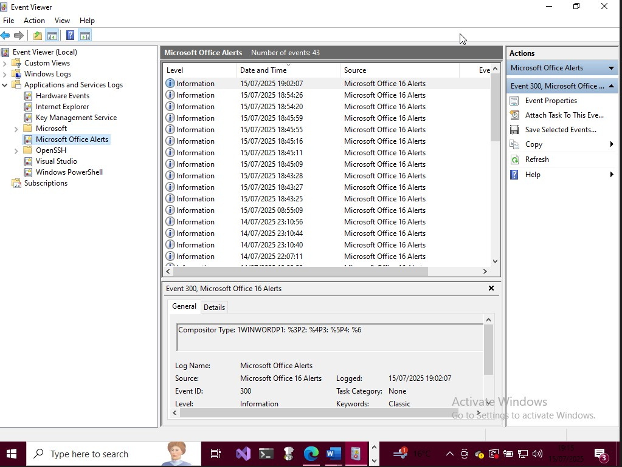
Figure 19: Microsoft Office - 16 Alerts
Figure 19 highlights the Microsoft Office 16 Alerts section in Windows Event Viewer. The entry (Event ID 300) was logged on 15/07/2025 at 19:02:07, shortly after the execution of the macro-enabled document (RansomNote_Template.docx) in Microsoft Word (WINWORD.EXE). While the event details do not explicitly indicate ransomware, the timing of the logged activity suggests Office recognized document activity. This information can help correlate macro execution with other forensic evidence, such as memory dumps or process data from tools like Volatility or Procmon.

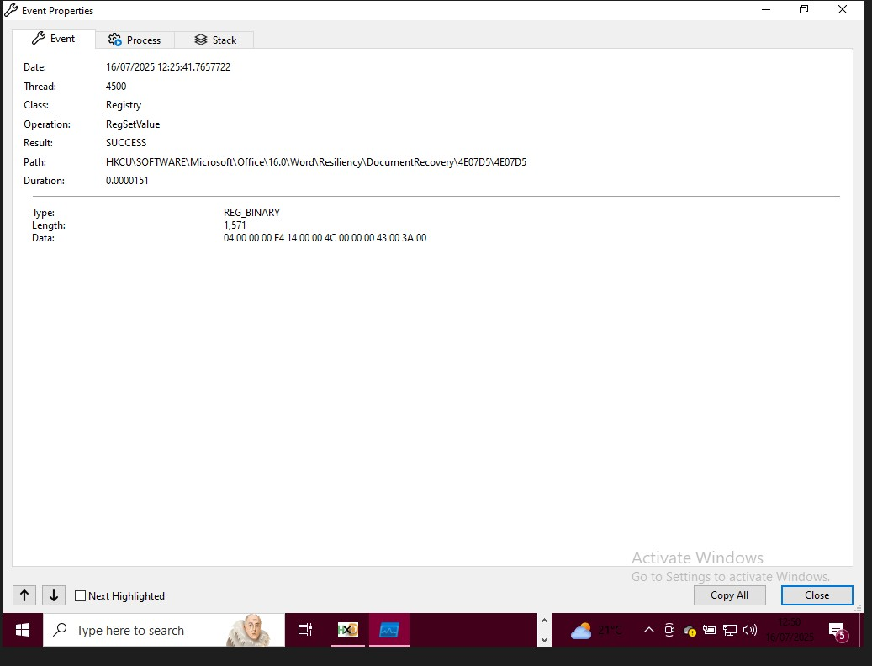
Figure 20: Registry modification by WINWORD.EXE during macro execution
Figure 20 shows that WINWORD.EXE modified the registry path HKCU\...\Word\Resiliency\Document Recovery using the RegSetValue operation, indicating that Microsoft Word was writing recovery data—possibly due to a malicious macro document.

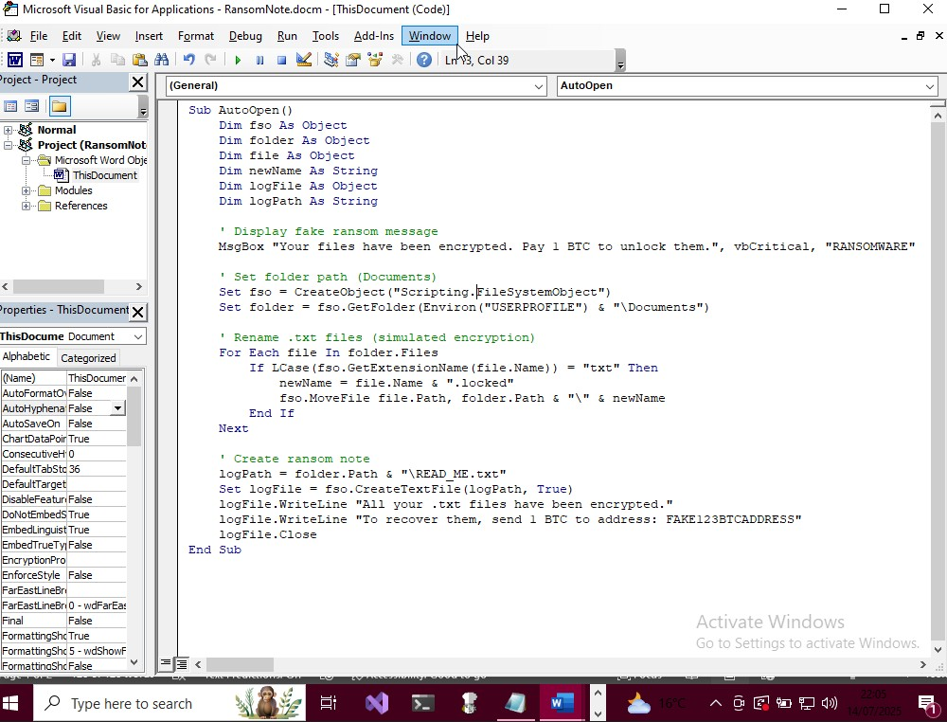
Figure 21:VBA Macro Simulated Ransomware for Word
Figure 21 shows a malicious VBA macro (RansomNote.docm) was inserted into a Word document to imitate a ransomware attack. Once it opened, it called the AutoOpen () function, which displayed a fraudulent ransom note and renamed all.txt files in the user's Documents folder to .Locked extensions. It also generated a ransom message (READ_ME.txt) including recovery instructions and a fictitious Bitcoin address. While no actual encryption happened, the simulation closely resembled genuine ransomware behaviour, offering a secure setting for forensic research.

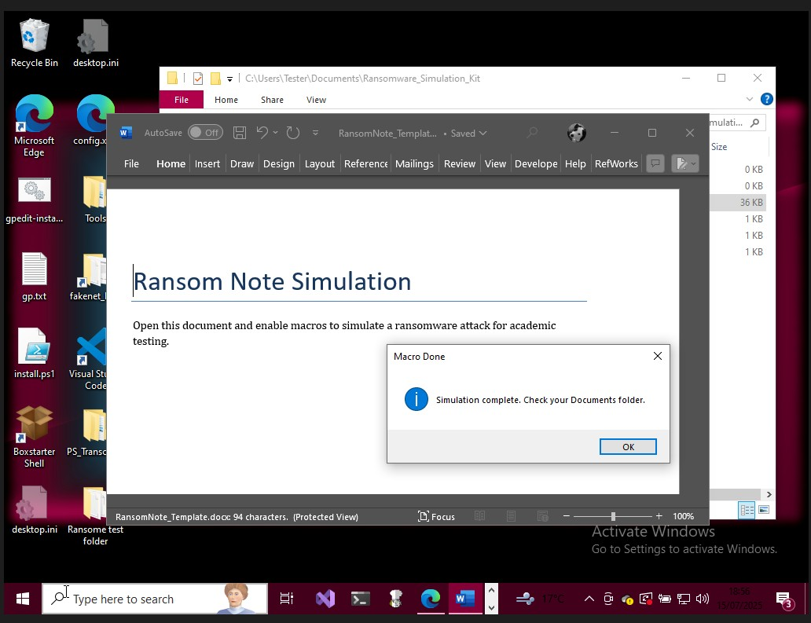
Figure 22: Ransom Note Simulation in Action
Figure 22 shows what happens once the document is opened once the macro is running. 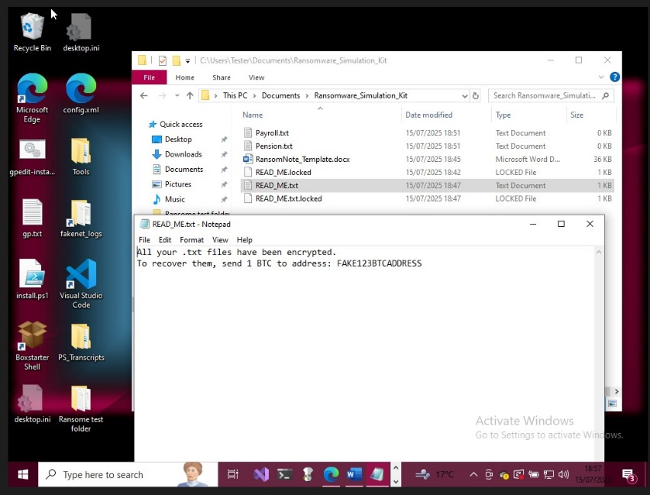
Figure 23: Ransom Note Output
Figure 23 shows The simulated event successfully generated a fraudulent ransom note (READ_ME.txt) in the victim's Documents folder. The notification imitated true ransomware demands, declaring that data has been encrypted and requesting the recipient to deposit 1 BTC to a fictitious Bitcoin address. Several.txt files were also renamed with a.locked extension, imitating typical ransomware file modification behaviour.

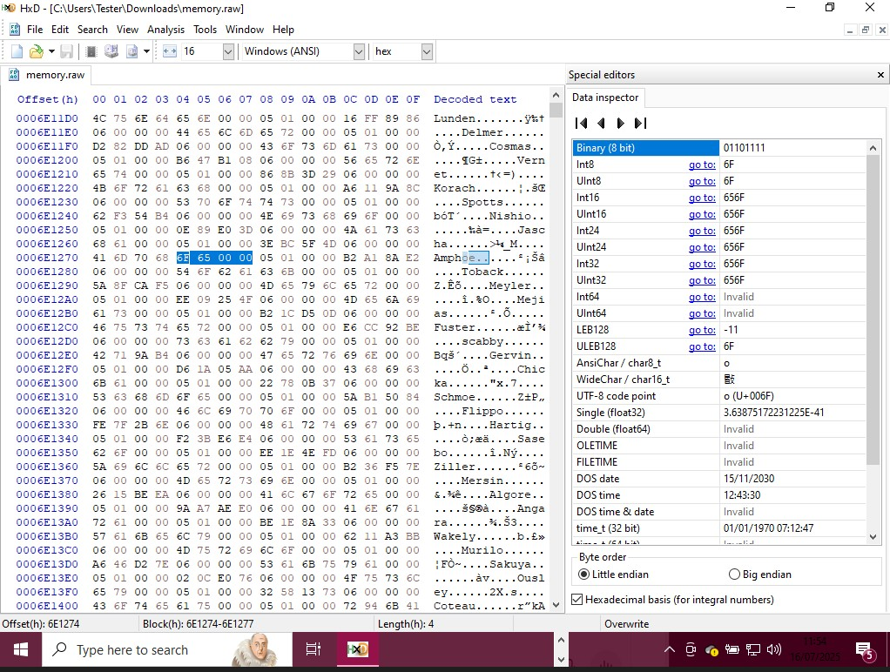
Figure 24: Memory Artefact in HxD Hex Editor
Figure 24 image illustrates a manual inspection of the system's memory dump (memory. Raw) with HxD. Readable strings including READ_ME.txt suggest that remnants of the ransomware simulation remain in memory. The result highlights the importance of memory investigation in determining file names and behaviours even after file system modifications.

Verify or Disprove the Hypothesis
The results presented in Chapter 5 validate the initial assumption that memory forensics and basic forensic techniques can be utilised to detect, evaluate, and comprehend ransomware behaviour in a controlled setting. Volatility efficiently discovered inserted code as well as questionable memory regions associated to the simulated ransomware. Process Monitor and the Event Viewer corroborated these observations by collecting file modifications, registry changes, and program alerts that are associated with ransomware behaviour.

Although limitations in VM networking and tool execution (e.g., FTK Imager) limited the scope of evaluation, the depth and clarity of artefacts retrieved from the FLARE VM demonstrated that even a restricted toolset can deliver valuable forensic insights. Results validate the hypothesis and enhance the argument for adopting memory-first triage and lightweight tools in real-world forensic investigation situations.

Conclusion
This chapter evaluated the forensic investigation process's tools, techniques, and efficacy. It emphasised the difficulties of real-time detection as well as the limitations of certain methods when time is of the essence. Nonetheless, the testing revealed the significance of memory analysis, macro payload monitoring, and tool integration in creating a responsive forensic framework. The findings of these assessments will help to shape the conclusions and recommendations supplied in the final project, which will be presented in the following chapter.

Chapter 6 - CONCLUSIONS AND RECOMMENDATIONS

Summary

This project aimed to investigate the forensic responses to ransomware attacks by simulating an infection within a controlled virtual environment. The main objective intended to evaluate the performance of several different forensic tools, particularly Volatility, Procmon, and FTK Imager, in identifying significant characteristic features of ransomware behaviour. A macro-based ransomware sample was developed to emulate popular strategies such as file renaming, ransom letter production, and user manipulation. Three virtual machines were configured in the lab using VirtualBox with static IP addresses. However, the final evaluation was limited to the FLARE VM due to technical constraints. The forensic analysis involved memory examination, disk analysis, and system log inspection, successfully demonstrating the effectiveness of memory forensics and manual artifact analysis in detecting ransomware activities.

Conclusion
The results indicate that using memory forensics is essential for the early detection of ransomware threats. Tools such as Volatility have demonstrated high effectiveness in identifying administered code and skewed memory regions, in addition to scenarios in which disk artifacts are somewhat restricted. Basic features for example Task Manager and Event Viewer also provided useful information throughout the duration of the experiment. The study satisfied its primary goals, for example illustrating the forensic utility of simulated attacks and evaluating an assortment of approaches. Nevertheless, owing to networking and system constraints, REMnux and Kali Linux weren't utilised as planned for, hindering the chance for researchers to gain a more comprehensive understanding of network infrastructure including potential attacker approaches.
Considering those limitations, the research demonstrated that employing a multilayered methodology encompassing static, memory, and behavioural investigation can considerably increase forensic preparedness.

Recoomendations FOR FURTHER Research

Future research should investigate more complex memory artefact analysis, such as shellcode unpacking and payload reverse engineering with REMnux.
Furthermore, expanding the environment to include fully working Kali Linux and REMnux virtual machines would allow for more in-depth monitoring of attacker behaviour and network data. Researchers may also investigate the use of artificial intelligence or automation to detect irregularities during ransomware execution.
Finally, migrating the simulation to a cloud-based virtual environment or testing real-world ransomware samples (with adequate containment and permissions) would increase realism and investigative complexity.

Chapter 7 – Reflections

The primary objective of the research was to investigate ransomware attack methodologies as well as assess the efficacy of digital forensic methods in identifying, understanding, as well as responding to such attacks. This objective was achieved through the creation of a simulated ransomware scenario employing a macro-based payload in a virtual lab environment.

Each of the project's primary objectives has been addressed:

- Conduct a Literature Review: This was completed in Chapter 2, and it included real-world case studies (WannaCry, Ryuk, and Colonial Pipeline), major gaps in forensic preparation, and new trends such as Ransomware-as-Service.
- Analyse Ransomware Attack Methods and Impact: This was accomplished by simulated infection and a comparison to real-world incidents.
- Ransomware forensic analysis is demonstrated in Chapter 5 with tools such as Volatility and Procmon. Memory artefacts and registry modifications were successfully detected.
- Propose Mitigation Strategies: While less in-depth, Chapter 6 presented recommendations for increased forensic preparation and tool selection.

Despite several limitations prohibited full investigation of network forensics and attacker emulation (such as the option of employing REMnux or Kali Linux), the project met its primary goals and provided valuable insights into forensic readiness.

Resolved issues and shortcomings

The inability to configure networking between the virtual machines posed a significant difficulty throughout the project, impeding the usage of REMnux for traffic analysis and Kali Linux for testing. Despite careful planning, connectivity concerns were unable to be overcome within the time span provided. The project's constraint was overcome by focussing the final testing phase completely on the FLARE VM. This method used memory forensics to collect substantial artefacts. Although this limited the project's scope, it allowed for a more thorough examination of volatile memory and interfaces with the file system.
The inability to employ FTK Imager owing to disc size limits posed a significant technological challenge. The situation was partially fixed by manually exploring the file system and identifying artefacts in memory dumps with hex editors such as HxD.

Risk management and the effectiveness of strategies

Several of the risk factors described within the initial plan for the project occurred, notably those associated to:

- Tool Compatibility
- Virtual Networking
- Time Limitations

Potential problems with virtual machine resources and tool configuration were found by the risk analysis. Alternatives like switching hypervisors or expanding host storage demonstrated impractical, despite the implementation of mitigating techniques like snapshots and VM allocation adjustments. Despite those challenges, the project employed fallback technologies, including Procmon rather than FTK Imager, to accomplish minimal data loss.

Personal Progress and Conduct
From a personal viewpoint, this initiative stipulated a significant educational opportunity. subsequently enhanced my ability to perform the following tasks:
- Configure and oversea forensic labs with VirtualBox.
- Safely simulate the actions and behaviours of malware
- Employ forensic tools that have become established in the industry, for example Volatility.
- Diagnose and resolve at the system level vulnerabilities under duress

The project was greatly impacted by the fact that my workplace provided no outside assistance at al. The research process lacked administrative direction and mentorship, even though the research was pertinent to cybersecurity practices. As a result, the project was implemented completely on its own without professional supervision, technical assistance, or constructive criticism. Considering my lack of experience with malware analysis and forensic modelling, this project was a real example of learning on the job-gaining information with creating the lab at the same time. Despite the hardship that that this absence of support presented it additionally assisted me improve my solving issues, self-education, and practical problems working abilities, which are just as important in cybersecurity as the tools themselves. The project evolved from a technological challenge to a showcase for discipline, transparency, and willingness to adjust and endure in the absence of a safety net.

Final Reflection

An extensive viewpoint on the difficulties involved in cybersecurity and digital forensics research was provided by this study. My capabilities in malware analysis, forensic readiness, and practical lab management were substantially enhanced by the experience, although not all tools and goals were wholeheartedly met. Perhaps most importantly, it improved my comprehension of how to approach complicated problems in a methodical and moral manner—skills that are necessary for any future role in the cybersecurity industry.

APPENDICES

Figure 25 shows The Gantt chart below that depicts the timing for the project from April to July 2025. In April and May, a literature analysis and case study research are carried out, followed by VM setup and testing.

Data collection, forensic analysis, and interpretation become the primary focus in June. The third step, which begins in July, consists of report writing, editing, and viva preparation. Tasks overlap to continue progress despite potential delays, with earlier activities completing at a higher rate.

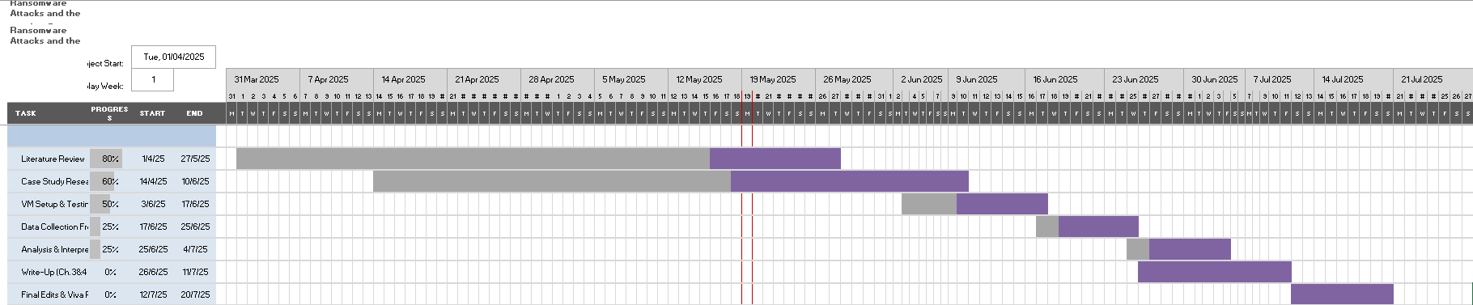
Figure 25: Gantt Chart Overview

Risk Analysis and minimisation strategy - Appendix A:
while performing the project planning phase, a thorough risk assessment was performed to identify and oversee any difficulties in a timely and organised manner. The table below summarises the significant hazards identified, their evaluated impact and likelihood, mitigation techniques used, and the outcomes.

Risk | Likelihood | Impact | Minimisation Strategy | Outcome
VM Networking issues | High | High | Host-Only adapters. Test connectivity early. Use bridged mode or VMware fallback | Network failed between all VMs – test was used only on FLARE VM
Tool Compatibility | Medium | Medium | Create snapshots before installing software | FTK Imager no free disk space – Procmon used
VM Storage | Medium | Medium | Allocate disk space during setup | Limited capacity led to partial analysis.
Malware Containment | Low | High | Isolated VM networks disabled – including shared clipboard | Full containment achieved with no host effected

Appendix B: Changes to project objectives and justification

The project's original scope, which was described in the Project Proposal Form, was significantly altered. These changes addressed technical limits, time constraints, and discoveries that helped steer the research in a more realistic path.

These changes, while reducing the scope, allowed for a more extensive forensic assessment of macro-based ransomware behaviours and memory analysis methods. The final deliverables are in line with the project's objectives and provide a solid foundation for future expansion.

Original Objective | Amended Objective | Justification
Simulate ransomware across all three VM’s (Flare VM, REMnux, Kali Linux ) | Focused simulation and forensic analysis using FLARE VM only | Inter-VM connectivity failed. Focus shifted to single Host Flare VM
FTK Imager can be used for whole disc acquisition and analysis. | Manual navigation and selective file analysis | Full disc imaging was restricted because of storage capacity limitations.
Use Volatility and REMnux to analyse memory and networks. | Volatility on FLARE VM for focused memory forensics. | Due to time constraints, the REMnux setup failed; the memory artefact focus was preserved.
Using Kali Linux, simulate attackers with reverse shells. | Focused on macro-based payload simulation instead of emulating attackers | VM concerns and complexity made this goal unachievable within academic schedules.

Ethics form

DDA Ethics Form James A Taylor.docx

References
[1] Anonymous "Investigation: WannaCry cyber attack and the NHS A picture of the National Audit Office logo,"
[2] E. Eliando and Y. Purnomo, "LockBit 2.0 Ransomware: Analysis of infection, persistence, prevention mechanism," CogITo Smart Journal, vol. 8, no. 1, pp.232–243, 2022.
[3] K. P. DS and P. K. HR, "A Systematic Study on Ransomware Attack: Types, Phases and Recent Variants," 2024 5th International Conference on Intelligent Communication Technologies and Virtual Mobile Networks (ICICV), 2024.
[4] G. UK, "National cyber strategy 2022," 2022.
[5] T. Ongun, et al., "Living-off-the-land command detection using active learning," Proceedings of the 24th International Symposium on Research in Attacks, Intrusions and Defenses, 2021.
[6] A. Demjaha, et al., "2 fast 2 secure: A case study of post-breach security changes," 2019 IEEE European Symposium on Security and Privacy Workshops (EuroS&PW), 2019.
[7] P. H. Meland, Y. F. F. Bayoumy and G. Sindre, "The Ransomware-as-a-Service economy within the darknet," Computers and Security, vol. 92, 2020.
[8] A. Mishra, et al., "Attributes impacting cybersecurity policy development: An evidence from seven nations," Comput.Secur., vol. 120, pp.102820, 2022. doi: 10.1016/j.cose.2022.102820. Available: https://www.sciencedirect.com/science/article/pii/S0167404822002140
[9] P. Henry, J. Williams and B. Wright,Digital Forensics and Incident Response, 2017.
[10] N. Allahrakha, "Balancing Cyber-security and Privacy: Legal and Ethical Considerations in the Digital Age," Legal Issues in the Digital Age, vol. 4, no. 2, 2023.
[11] J. N. Hilgert, M. Lambertz and D. Plohmann, "Extending the Sleuth Kit and its underlying model for pooled storage file system forensic analysis," 2017.
[12] Ligh, M. H., Case, A., Levy, J., & Walters, "The Art of Memory Forensics Detecting Malware and Threats in Windows, Linux, and Mac Memory," John Wiley & Sons, vol. 58, no. 12, 2014.
[13] B. Nelson, A. Phillips and C. Steuart, "Processing Crime and Incident Scenes," Guide to Computer Forensic and Investigations, 2018.
[14] C. Sanders, "The Practice of Applied Network Security Monitoring," in Applied Network Security Monitoring, 2014,
[15] "Kroll Artifact Parser and Extractor (KAPE) Cracking nuts," Accessed: Apr 27, 2025, [Online]. Available: https://testlab.tymyrddin.dev/docs/dfir/kape
[16] N. Okazaki, et al., "Optimal Weighted Voting-Based Collaborated Malware Detection for Zero-Day Malware: A Case Study on VirusTotal and MalwareBazaar," Future Internet, vol. 16, no. 8, pp.259, 2024.
[17] C. Young, "Incident Response Models," ISACA JOURNAL, vol. 4, 2020.
[18] P. Cichonski, "Computer Security Incident Handling Guide : Recommendations of the National Institute of Standards and Technology," NIST Special Publication, 800-61, 2012.
[19] S. Katsikeas, et al., "GUIDELINES FOR DIGITAL FORENSICS FIRST RESPONDERS Best practices for search and seizure," Journal of King Saud University - Computer and Information Sciences, vol. 8, no. March, 2022.
[20] R. N. Zaeem and K. S. Barber, "The effect of the GDPR on privacy policies: Recent progress and future promise," ACM Transactions on Management Information Systems (TMIS), vol. 12, no. 1, pp.1–20, 2020.
[21] T. Wheeler and J. L. Alderdice, "Cyber collateral: Wannacry & the impact of cyberattacks on the mental health of critical infrastructure defenders," Changing Character of War Centre (CCW), 2022.
[22] A. Warikoo, "Perspective Chapter: Ransomware," in Malware-Detection and Defense, IntechOpen, 2023,
[23] J. Beerman, et al., "A review of colonial pipeline ransomware attack," 2023 IEEE/ACM 23rd International Symposium on Cluster, Cloud and Internet Computing Workshops (CCGridW), 2023.
[24] "SMART Goals." Corporate Finance Institute. https://corporatefinanceinstitute.com/resources/management/smart-goal/ (accessed Jul 24).
[25] M. Pattaranantakul, et al., "NFV Security Survey: From Use Case Driven Threat Analysis to State-of-the-Art Countermeasures," IEEE Communications Surveys & Tutorials, vol. 20, no. 4, pp.3330–3368, 2018. doi: 10.1109/COMST.2018.2859449.
[26] M. Salman, D. Husna and N. Viani, "Static Analysis Method on Portable Executable Files for REMNUX based Malware Identification," 2019.
[27] B. Denham and D. R. Thompson, "Ransomware and Malware Sandboxing," 2022 IEEE 13th Annual Ubiquitous Computing, Electronics & Mobile Communication Conference (UEMCON), 2022. doi: 10.1109/UEMCON54665.2022.9965664.
[28] M. Z. Akmal Bin Shafiee, F. Hani Binti Mohd Ali and N. H. Binti Nik Zulkipli, "Linux Forensic Analysis and Extraction Tool," 2023 IEEE 8th International Conference on Recent Advances and Innovations in Engineering (ICRAIE), 2023. doi: 10.1109/ICRAIE59459.2023.10468410.
[29] P. Cisar and R. Pinter, "Some ethical hacking possibilities in Kali Linux environment," Journal of Applied Technical and Educational Sciences jATES , vol. 9, no. 4, 2019.
[30] E. U. E. and E. S. I., "Cuckoo Sandbox and Process Monitor (Procmon) Performance Evaluation in Large-Scale Malware Detection and Analysis," British Journal of Computer, Networking and Information Technology, vol. 7, no. 4, pp.8–26, October 2024.
[31] M. H. Ligh, et al., The art of memory forensics: detecting malware and threats in windows, linux, and Mac memory, John Wiley & Sons, 2014.
[32] J. Hakkarainen, "Malware Analysis Environment for Windows Targeted Malware," 2015.
[33] A. Nelson, et al., "Incident response recommendations and considerations for cybersecurity risk management :" 2025.
[34] Joint Task Force Transformation Initiative, "SP 800-53 Rev. 3. Recommended Security Controls for Federal Information Systems and Organizations," 2009.
[35] A. Case and G. G. Richard III, "Memory forensics: The path forward," Digital investigation, vol. 20, pp.23–33, 2017.
[36] R. Suryadithia, et al., "FTK Image For Forensic Data Processing In Forensic Tools," IJISTECH (International Journal of Information System and Technology), vol. 5, no. 6, pp.726–735, 2022.
[37] H. Biswas and M. M. Kumar, "SCADA-Wireshark Testbed Data-Based Exploratory Data Analytics and Intrusion Detection," 2024 International Conference on Smart Applications, Communications and Networking (SmartNets), 2024.
[38] J. Yli-Lankoski, "Designing and Implementing a Secure Reverse-Engineering Environment for Windows-based Malware," 2024.
[39] Ana Maria Martinez Gomez and M. R. Blaine Stancill, "FLARE VM: A FLAREytale Open to the Public | Mandiant | Google Cloud Blog." https://cloud.google.com/blog/topics/threat-intelligence/flarevm-open-to-public
[40] F. Ullah, et al., "Data exfiltration: A review of external attack vectors and countermeasures," Journal of Network and Computer Applications, vol. 101, pp.18–54, 2018.
[41] E. Thambiraja, G. Ramesh and D. R. Umarani, "A survey on various most common encryption techniques," International journal of advanced research in computer science and software engineering, vol. 2, no. 7, 2012.
[42] F. Jaafar, G. Nicolescu and C. Richard, "A systematic approach for privilege escalation prevention," 2016 IEEE International Conference on Software Quality, Reliability and Security Companion (QRS-C), 2016.
[43] N. Kavadias, "Silent Intruders: Understanding Living-off-the-Land Techniques, Threats, Countermeasures and Emerging Solutions,"
[44] A. Konstantinou, et al., "Leveraging LLMs for Non-Security Experts in Threat Hunting: Detecting Living off the Land Techniques," Machine Learning and Knowledge Extraction, vol. 7, no. 2, pp.31, March 2025.
[45] S. Kuraku and D. Kalla, "Emotet Malware-A Banking Credentials Stealer," IOSR Journal of Computer Engineering, vol. 22, 2020.
[46] A. Nugraha and D. A. Gustian, "Deteksi Malware Dridex Menggunakan Signature-based Snort," Indonesian Journal of Computer Science, vol. 10, no. 1, 2022.

