

Master of Business Administration
LCMB7024 Marketing Management
Brand development strategy for Oracle Corporation: Launching an AI-powered small business cloud platform as a strategic brand extension
Reference Style: Harvard
Student Name: Ravikumar Mukeshbhai Bhadiyadra
Lecturer's Name: Laila Maazouz
Student ID: 2531864
Word Count: 2397

Table of Contents
Element 1: Brand Extension Poster content 3
Element 2: Segmentation, Targeting, Differentiation and Positioning 3
Element 3: Marketing Mix (7Ps) 7
Element 4: Reflection 10
References 13

Element 1: Brand Extension Poster content
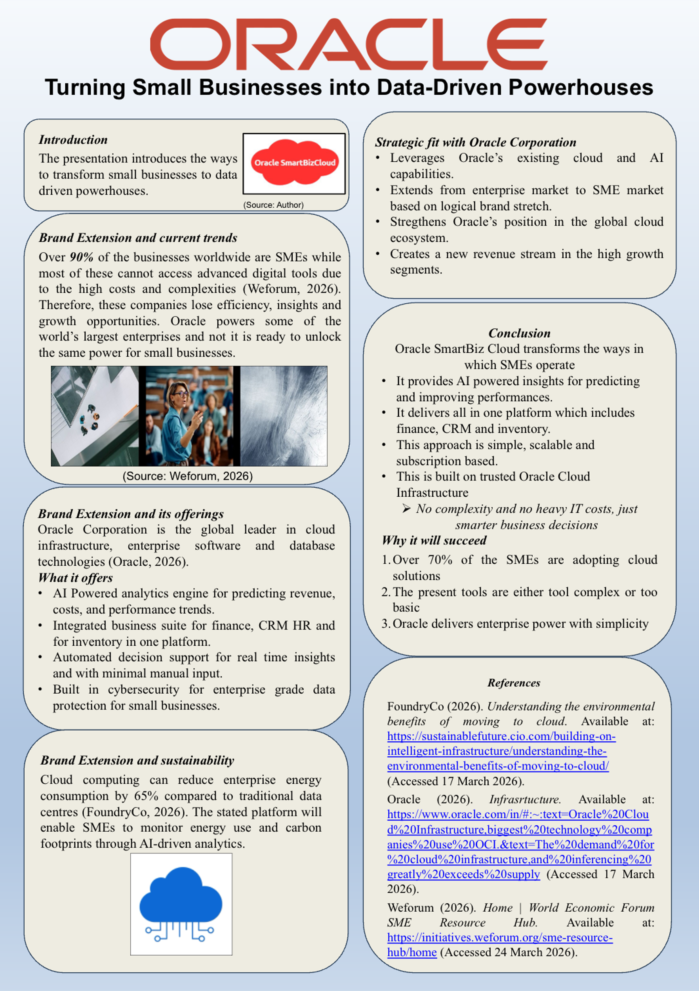
(Source: Author)

Element 2: Segmentation, Targeting, Differentiation and Positioning
Segmentation
Market segment for the product is essential for identifying the distinct customer groups and for tailoring marketing strategies accordingly. With respect to Oracle SmartBiz Cloud’s segmentation, it is based on the geographic, demographic, psychographic and behavioural variables.
Considering geographic segmentation, primarily the focus of the innovation includes technologically advanced and rapidly digitising markets like North America, Europe, India, Australia and Southeast Asia. The stated regions have a high concentration of SMEs, and they seek strong digital transformation initiatives (Rampaul, 2025). For instance, India alone hosts over 63 million SMEs, among which many are increasingly adapting cloud-based technologies for improving efficiency (Rai, 2025).
Demographic Segmentation
This segment will include business owners and entrepreneurs, followed by the operational managers within SMEs that employ nearly 10 to 250 employees. The stated firms will be selected, which typically generate annual revenues between $1 million and $50 million and also require scalable digital solutions to manage business operations efficiently.
Psychographic Segmentation
This segmentation focuses on the businesses that prioritise innovation, operational efficiency and data-driven decision making. The stated organisations tend to adopt emerging technologies to gain competitive advantages and value solutions that will reduce operational complexities.
Behavioural Segmentation
The behavioural segmentation recognises the benefits sought by SMEs that adopt cloud platforms. The stated implication includes improved operational efficiency with the reduction of IT costs, enhanced cybersecurity protection, and real-time business insights. Additionally, many SMEs prefer subscription-based SaaS platforms because they eliminate large upfront technology investments.
Targeting Strategy
Oracle will adopt a differentiated targeting strategy which focuses on digitally transforming SMEs. This will enable the company to design customised solutions for specific industry sectors such as retail, logistics, e-commerce and professional services (Agustian et al., 2024). According to research, 70% of the SMEs are increasing their investment in cloud technology for improving operational efficiency (MacRae, 2022). Contrarily, many small firms lack the expertise required for implementing enterprise-level systems. This gap can be resolved by Oracle SmarBix Cloud by offering simplified enterprise capabilities. The stated target customer, therefore, includes SME decision makers, who are seeking affordable cloud infrastructure, AI-driven analytics and integrated business tools within a single platform.
Differentiation strategy
Differentiation is received through the three major factors, which are technological capability, integration efficiency and enterprise credibility. At first, Oracle SmartBiz Cloud will leverage Oracle’s existing enterprise technologies, which enable SMEs to access the same AI-driven analytics used by large corporations. The implication will provide a significant technological advantage over many SME focused platforms. Secondly, the platform will integrate multiple functions, which include CRM, financial management and inventory control into the unified system. Most of the existing SME tools require multiple software subscriptions, which increases operational complexities (Telukdarie et al., 2023). Lastly, Oracle’s established reputation in enterprise data management provides strong brand credibility.
Positioning strategy
The strategy for positioning emphasises accessibility, intelligence and enterprise-level reliability. The positioning statement will be for the small and medium-sized businesses seeking advanced digital transformation. “Oracle SmartBiz Cloud is the AI-powered business management platform that delivers enterprise-level cloud technology in a simplified and affordable ecosystem”. The stated positioning highlights Oracle’s core strengths in data analytics, cloud computing and enterprise technology while addressing the usability needs and affordability of SMEs.
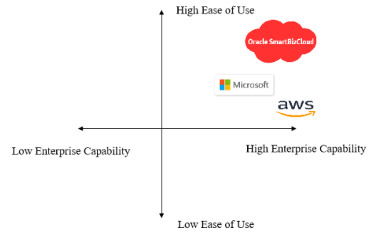
Figure 1: Positioning Map
(Source: Author)
The positioning map demonstrated the ways in which Oracle SmartBiz Cloud aims to occupy the unique market position by the combination of enterprise-level technological capability with high usability for SMEs. Many existing cloud providers are present, like Amazon Web Services and Microsoft, which offer powerful cloud infrastructure but are often complex for smaller organisations with limited IT expertise (Van Der Vlist, 2024). In contrast, many SME focused platforms provide simple interfaces but lack advanced analytics and enterprise-grade capabilities. This gap will be bridged by Oracle SmartBiz Cloud through the AI-powered enterprise tools in the simplified and user-friendly ecosystem, which are tailored mainly for SMEs. The stated positioning supports Oracle’s strategic objective of expanding into the SME market while maintaining its reputation for high-performance cloud infrastructure and advanced data management solutions.

Element 3: Marketing Mix (7Ps)
A strategic framework is provided by the marketing mix for the implementation of marketing strategies by aligning the product offerings with the customer needs and organisational objectives. According to Jain et al. (2022), the traditional model of the marketing mix was originally developed as the 4Ps but later expanded to 7Ps to better address the service-based offerings. As Oracle SmartBiz Cloud is a cloud-based digital platform, the extended 7Ps framework will be delivered to the SME market. The following section critically examines the ways in which each element of the marketing mix supports the brand extension strategy of Oracle Corporation by positioning the Oracle SmartBiz Cloud as an accessible yet technologically advanced cloud platform for small and medium-sized enterprises.
Product
The element product refers to the core value proposition, which is delivered to the customers. As per Rauschnabel et al. (2022), the product should be viewed across three layers, which are the core product, the actual product and the augmented product. With respect to Oracle SmartBiz Cloud, the core product is the ability to simplify business operations through the integrated cloud-based management tools. According to Hendayani et al. (2022), SMEs often struggle to manage multiple operational processes like the financial reporting, customer relationship management and the inventory tracking. With the integration of these functions within a single AI-powered platform, Oracle addresses a critical operational challenge faced by small businesses.
The actual product consists of the technical features which are offered by the platform, and these include the AI-powered business analytics, followed by the automated accounting and reporting tools. These also include the inventory and supply chain management systems with the integrated customer relationship management functionality. The stated system will operate through Oracle’s existing cloud infrastructure, mainly Oracle Cloud infrastructure, which ensures scalability, security, and reliability.
Moreover, the augmented product explicitly strengthens the offerings through customer support services with regular software updates and cybersecurity protections, followed by data analytics insights. The stated additional services enhance customer value and encourage long-term subscription retention. Following strategic perspectives, the product supports Oracle’s brand extension strategy by leveraging the company’s existing technological capabilities while adapting them to meet the specific needs of SMEs.
Price
In market adaptation, the pricing plays a critical role, mainly for technology solutions targeting smaller organisations with limited financial resources. According to Solakis et al. (2022), pricing must reflect both perceived value and competitive positioning. Based on this, Oracle SmartBiz will adopt the subscription-based pricing model, which is widely used in Software as a Service or SaaS markets. As per Idemudia et al. (2023) the subscription based pricing allows SMEs to avoid large upfront investments in IT infrastructure. This provides predictable recurring revenue for Oracle. The tiered pricing structure is proposed as the basic plan will be comprised of $29 per user per month, the professional plan will be for $79 per user per month, and the advanced SME plan will be $149 per user per month. The stated pricing structure follows the value-based pricing strategy, where the customers will pay according to the level of functionality required. The smaller businesses can initially adopt the basic plan, while the larger SMEs require advanced analytics and automation tools, which can be upgraded to the premium packages. Moreover, a freemium trial period of 30 days will be offered to encourage adaptation, and this will reduce the perceived risks. According to Li (2022), trial-based pricing strategies can significantly increase SaaS conversion rates. In summary, the pricing strategy supports the brand extension by making enterprise-level cloud technology financially accessible to SMEs.
Place
The element place refers to the distribution channels through which the product reaches customers. Considering digital services, the distribution is mainly conducted through online platforms. Oracle SmartBiz Cloud will be distributed globally through Oracle’s digital infrastructure. The customers will be able to subscribe directly through the official websites of Oracle Corporation, where the platform will be integrated with the existing Oracle Cloud services. Oracle will establish strategic partnerships with IT consulting firms, followed by the digital transformation agencies and managed service providers. The stated partners will assist SMEs with the implementation, onboarding and system integrations. Many strategic advantages will be distributed by the cloud-based distribution, and at first, this will allow Oracle to scale the platform globally without significant physical infrastructure investments. Secondly, this enables continuous software updates and improvements through the centralised cloud management. Thirdly, the digital distribution ensures rapid deployment and accessibility for the SMEs located in the different geographic regions. The distribution strategy aligns with the brand extension objective of delivering enterprise technology through a simple and scalable platform.
Promotion
As Oracle SmartBiz Cloud targets SMEs, the promotional strategy will focus on digital B2B marketing channels. LinkedIn advertising will play a significant role in targeting business owners, managers, and decision makers within SMEs. LinkedIn is recognised as an effective platform for B2B marketing due to the professional user base (Dasanayake et al., 2022). Moreover, the company will organise webinars and technology workshops followed by virtual conferences to demonstrate the platform’s capabilities. The events allow potential customers to interact with the product experts and help to gain a deeper understanding of the platform.
People
People highlight the importance of human interaction in the service delivery. Even though the cloud platforms are largely automated, customer support and technical expertise remain essential. The company will establish specialised customer support teams dedicated to the SME clients. The stated teams will provide onboarding assistance, followed by technical guidance and troubleshooting services (Gregory et al., 2022). Moreover, the certified consultants of Oracle and the partner organisations will assist customers during the initial implementation stage. They provide high-quality customer support with the enhancement of user satisfaction and will strengthen brand loyalty.
Processes
It refers to the systems and procedures which will be used for delivering services efficiently. In case of the cloud-based platform, the streamlined service process is essential for ensuring the positive customer experiences (Abiagom and Ijomah, 2024). Moreover, the onboarding process will begin with the simple online registration system and once registered, users will receive guided instructions for setting up business modules like finance management, CRM and inventory tracking. Artificial intelligence will also assist users by recommending the system configuration based on the business type and operational needs. The implication of the automated updates will ensure that customers always have access to the latest software features without manual installation. With the minimisation of complexity and by simplifying the implementation, the service process supports the brand extension’s objective of making enterprise technology accessible to the SMEs.
Physical Evidence
Physical evidence refers to the tangible elements that reinforce customer confidence in an otherwise intangible service. In the case of Oracle SmartBiz Cloud, physical evidence will include the platform’s digital interface, followed by the dashboard design and professional website presentation. According to Li et al. (2022), a well-designed user interface enhances usability and reinforces perceptions of quality and reliability. The additional evidence of credibility will include customer testimonials, followed by the case studies and compliance documentation. The stated elements are mainly important in cloud computing markets where data security and reliability are the critical decision factors. Moreover, the company’s global reputation and established brand presence serve as powerful forms of physical evidence that strengthen trust in the new platform.

Element 4: Reflection
Considering the development of the brand extension, Oracle SmartBiz Cloud for the Oracle Corporation has been a valuable learning experience that enhanced both of my theoretical understanding and practical application of the marketing strategy. The present project required me to integrate key marketing concepts like brand development, segmentation and the marketing mix into a coherent and realistic business strategy. With the help of this process, I developed a deeper appreciation of how marketing decisions contribute to organisational growth, mainly in the context of technology-driven markets. The most significant insights gained were the importance of aligning a brand extension with the core competencies of the parent company. Moreover, Oracle is traditionally associated with enterprise-level solutions and extending into the SME market requires the careful evaluation of the ways in which the existing technological strengths could be adopted (Rîndaşu et al., 2024). It highlights the risks associated with the brand extension, mainly the potential for brand dilution if the new offering does not align with the parent brand’s identity. Therefore, I learned the ways to maintain strategic consistency while exploring new market opportunities. The present understanding improved my abilities to apply segmentation frameworks more critically, rather than treating them as purely theoretical models. This has reinforced the importance of selecting a clearly defined target market to ensure effective positioning and resource allocation.
Furthermore, the development of the 7Ps marketing mix strengthened my strategic thinking skills, and from this, I realised that each element of the marketing mix must be interconnected and aligned with the overall positioning strategy. For instance, the subscription-based pricing model supports affordability, while digital distribution ensures accessibility (Ahlawat et al., 2025). The stated experience demonstrated the ways in which marketing decisions must be integrated rather than developed in isolation. The stated project has improved my analytical and problem-solving skills. I gained experience in evaluating market trends like the digital transformation and cloud adoption, which are highly relevant in today’s business environment. Moreover, I developed a stronger ability to apply academic theories to real-world scenarios, which is essential for a career in marketing management. Contrarily, I also identified areas where I could improve in future projects. For instance, the incorporation of more quantitative data and financial analysis would strengthen the strategic justification of brand extension. Furthermore, the conducting of primary research, such as surveys or interviews with SME owners, could provide deeper insights into customer needs, and this improves the accuracy of the targeting strategy.
The presentation of the poster further enhanced my communication and presentation skills. The condensing of complex marketing strategy into the concise and visually engaging format was challenging and this required me to prioritise key information. Delivering the presentation also improved my confidence in explaining strategic concepts and responding to the potential questions from an audience.
In summary, this assignment significantly contributed to my personal and professional development by enhancing my understanding of strategic marketing and its practical application. The skills and knowledge gained from this project will be highly valuable in my future career, mainly in the roles involving business strategy and digital innovation.

References
Abiagom, C. N., and Ijomah, T. I. (2024). Enhancing customer experience through AI-driven language processing in service interactions. Open access research journal of engineering and technology, 7(1), 014-021. https://doi.org/10.53022/oarjet.2024.7.1.0027
Agustian, K., Rosadi, H. Y., and Zen, A. (2024). An integrative analysis of product differentiation strategies and customer experience in enhancing loyalty in the e-commerce industry. Journal of Contemporary Administration and Management (ADMAN), 2(2), 561-568. https://doi.org/10.61100/adman.v2i2.206
Ahlawat, C., Prajapati, A., Tufchi, S., and Gupta, S. (2025, November). Sab-Share: Enhancing Digital Affordability Through Collaborative Subscription Sharing. In International Conference on Computer Science and Communication Engineering (ICCSCE 2025) (pp. 3412-3424). Atlantis Press. https://doi.org/10.2991/978-94-6463-858-5_286
Dasanayake, D. W. M. N. C. (2022). Exploring the effectiveness of LinkedIn as a tool for B2B customer acquisition in the Asia Pacific region. Journal of International Business and Management, 5(6), 01-19. https://doi.org/10.37227/JIBM-2022-04-5391
FoundryCo (2026). Understanding the environmental benefits of moving to cloud. Available at: https://sustainablefuture.cio.com/building-on-intelligent-infrastructure/understanding-the-environmental-benefits-of-moving-to-cloud/ (Accessed 17 April 2026).
Rai A. (2025). Case Study: Indian SME Growth with Cloud Hosting. Available at: https://community.nasscom.in/communities/digital-transformation/case-study-indian-sme-growth-cloud-hosting (Accessed 19 April 2026).
Gregory, P., Strode, D. E., Sharp, H., and Barroca, L. (2022). An onboarding model for integrating newcomers into agile project teams. Information and Software Technology, 143, 106792. https://doi.org/10.1016/j.infsof.2021.106792
Hendayani, N., Muzakir, M., Yuliana, Y., Asir, M., and Wahab, A. (2022). Best Practice of Financial Management in SMEs Operation in Digital times. Budapest International Research and Critics Institute-Journal (BIRCI-Journal), 5(1), 3350-3361. https://doi.org/10.33258/birci.v5i1.4002
Idemudia, S. O., Chima, O. K., Ezeilo, O. J., Ojonugwa, B. M., and Adesuyi, A. O. M. O. (2023). Digital infrastructure barriers faced by SMEs in transitioning to smart business models. International Journal of Scientific Research in Science, Engineering and Technology, 10(4), 353-370. https://doi.org/10.32628/IJSRSET
Jain, R., Jain, S., and Jain, S. (2022). Analyzing and exploring the effectiveness of each element of 7Ps of marketing mix. International Journal of All Research Education and Scientific Methods (IJARESM), 10(1), 2455-6211. https://www.researchgate.net/profile/Riddhisha-Jain/publication/357657009_Analyzing_and_Exploring_the_Effectiveness_of_Each_Element_of_7Ps_of_Marketing_Mix/links/61d84cdfb6b5667157d148c7/Analyzing-and-Exploring-the-Effectiveness-of-Each-Element-of-7Ps-of-Marketing-Mix.pdf
Li, H. (2022). Converting free users to paid subscribers in the SaaS context: The impact of marketing touchpoints, message content, and usage. Production and Operations Management, 31(5), 2185-2203. https://doi.org/10.1111/poms.13672
Li, W., Zhou, Y., Luo, S., and Dong, Y. (2022). Design factors to improve the consistency and sustainable user experience of responsive interface design. Sustainability, 14(15), 9131. https://doi.org/10.3390/su14159131
MacRae D. (2022). 70% of tech infrastructure will be cloud-based within three years. Available at: https://www.cloudcomputing-news.net/news/70-of-tech-infrastructure-will-be-cloud-based-within-three-years/ (Accessed 19 April 2026).
Oracle (2026). Infrasrtucture. Available at: https://www.oracle.com/in/#:~:text=Oracle%20Cloud%20Infrastructure,biggest%20technology%20companies%20use%20OCI.&text=The%20demand%20for%20cloud%20infrastructure,and%20inferencing%20greatly%20exceeds%20supply (Accessed 20 April 2026).
Oracle (2026). Oracle Products, Solutions, and Services. Available at: https://www.oracle.com/in/products/ (Accessed 22 April 2026).
Rampaul, K. (2025). Digital transformation and sme growth in emerging markets. Journal of Emerging Markets and Management, 1(1), 15-25. https://doi.org/10.63385/jemm.v1i1.35
Rauschnabel, P. A., Babin, B. J., Tom Dieck, M. C., Krey, N., and Jung, T. (2022). What is augmented reality marketing? Its definition, complexity, and future. Journal of business research, 142, 1140-1150. https://doi.org/10.1016/j.jbusres.2021.12.084
Rîndaşu, S. M., Ionescu-Feleagă, L., Ionescu, B. Ș., and Barbu, A. M. (2024). Unveiling challenges and insights in cloud Enterprise Resource Planning systems adoption: A case study of the Oracle Fusion Cloud ERP. Management & Marketing, 19(4). https://doi.org/10.2478/mmcks-2024-0029.
Solakis, K., Pena-Vinces, J., and Lopez-Bonilla, J. M. (2022). Value co-creation and perceived value: A customer perspective in the hospitality context. European research on management and business economics, 28(1), 100175. https://doi.org/10.1016/j.iedeen.2021.100175
Telukdarie, A., Dube, T., Matjuta, P., and Philbin, S. (2023). The opportunities and challenges of digitalization for SME's. Procedia Computer Science, 217, 689-698. https://doi.org/10.1016/j.procs.2022.12.265
Van Der Vlist, F., Helmond, A., and Ferrari, F. (2024). Big AI: Cloud infrastructure dependence and the industrialisation of artificial intelligence. Big Data & Society, 11(1), 20539517241232630. https://doi.org/10.1177/20539517241232630
Weforum (2026). Home | World Economic Forum SME Resource Hub. Available at: https://initiatives.weforum.org/sme-resource-hub/home (Accessed 28 April 2026).

