International Marketing

Student’s Name:
Student’s ID:
Course Name:

Table of Contents
1. Introduction 4
2. Company Overview 5
3. Comparison and Contrast of the Marketing Strategies Used the Management of the brand 7
3.1 STP Similarities in USA and India 7
3.2 STP Differences in India and USA 10
3.3 7P Marketing Mix Similarities in USA and India 13
3.4 7P Marketing Mix Differences in India and USA 16
3.5 Similarities in Directional Development 21
3.6 Differences in Directional Development 24
4. Justification behind the Approach used in both Countries 26
5. Conclusion 27
References 28

1. Introduction
Marketing strategy is essential for any business. It provides a plan for how the business will reach its objectives and how it will differentiate itself from its competitors. It also helps the business determine which marketing tactics it should use to reach its goals. Marketing strategy helps a business to identify its target market and develop effective campaigns to reach them (Baker and Hart, 2008). It helps to define the brand and create a message that resonates with customers. It also helps to develop a unique selling proposition that makes the business stand out from its competitors.
The importance of a brand to make different marketing strategies in different countries is essential for businesses. It helps to ensure that their products and services are recognised and appreciated in different countries. For example, a business may need to create a marketing strategy tailored to the culture of a particular country, as well as its language and customs. This will help the business to reach out to customers in that country and create a positive image of the brand (Kim and Chao, 2019). A brand can also be used to create a sense of familiarity in different countries. It can be used to create a strong presence in new markets and to establish a reputation for quality and reliability.
Additionally, a brand can be used to create a sense of loyalty among customers in different countries, allowing them to feel as though they are part of the company’s family. This can lead to increased sales and customer retention. By creating different marketing strategies in different countries, a brand can also reach out to customers in different countries with different offers and promotions. This particular report will emphasise analysing different marketing strategies used by Apple in the USA and India. Alongside this, the report will also find out the similarities in the marketing approaches of Apple in both countries.

Fig. 1: Official Logo of Apple
(Source: Apple, 2019)

2. Company Overview
Apple Inc. is a multinational technology corporation headquartered in Cupertino, California (Addison and Adelaide, 2022). It was established in 1976 by Steve Jobs, Steve Wozniak, and Ronald Wayne. Apple Inc. designs, manufactures and markets consumer electronics, computer software, online services, and personal computers. As of 2019, Apple Inc. reported revenues of $260.17 billion and employed approximately 137,000 people worldwide (Laricchia, 2022). Apple is one of the world’s largest and most valuable companies, with a market capitalisation of $1.37 trillion as of October 2020. Apple’s products and services include the iPhone, iPad, Mac, Apple Watch, AirPods, Apple TV, Apple Music, Apple Arcade, iCloud, and Apple Pay.
Apple’s success is based on its strategy of creating high-quality products, creating strong relationships with its customers, and creating an ecosystem of products and services that work together seamlessly. The company has consistently been at the forefront of innovation, and its products have transformed the tech industry.
Apple is the world’s largest technology company by revenue and one of the world’s most valuable brands. The company has operations and retail stores in more than 25 countries, including the United States, the United Kingdom, India, Australia, China, Japan, Canada, and Mexico. Apple has a market share of over 50% in the tablet and smartphone markets and is the world’s top seller of smartwatches (Amin and Munsi, 2020). Apple was the first company to hit a trillion-dollar market capitalisation and remains one of the world’s most valuable and influential companies. Its products and services have redefined the way people interact with technology, and the company continues to push the boundaries of innovation and creativity.
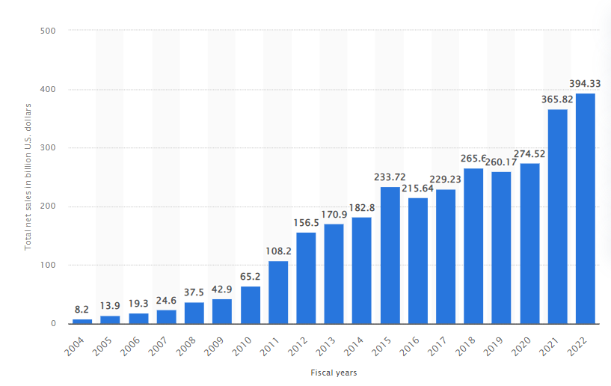
Fig. 2: Revenue of Apple from 2004-2022
(Source: Laricchia, 2022)

3. Comparison and Contrast of the Marketing Strategies Used the Management of the brand

3.1 STP Similarities in USA and India
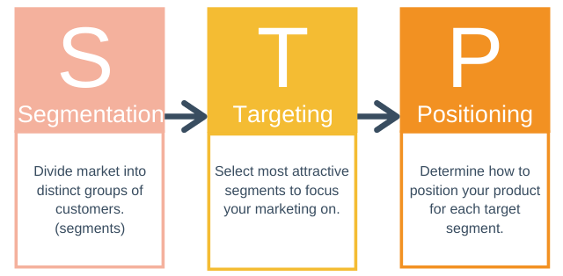
Fig. 3: Fundamentals of the STP Model
(Source: Liu et al., 2019)
Segmentation Strategy
Segmentation strategy is an important tool used by companies to identify and target specific customer groups. It helps companies to identify and serve the needs of their target market, thus increasing their profitability and market share. Apple Inc. is one of the highest-valued companies in the world, and its segmentation strategy has been a key factor in its success (Tien, 2019).
In both countries, Apple Inc. has adopted a two-pronged approach to segmentation. First, it has segmented the market based on the type of customer. It has identified two main customer segments: the “Professional” segment, which includes those who use Apple products for their professional work, and the “Consumer” segment, which includes those who use Apple products for entertainment (Zhang et al., 2020). Apple has also segmented its customers based on their level of engagement with the company. Those who are highly engaged are called “Power Users”, while those who are less engaged are called “Casual Users”.
Second, Apple has also segmented its products based on the needs of its customers. For example, the Professional segment is served by the MacBook Pro, iMac, and other professional-grade products, while the Consumer segment is served by the iPhone, iPad, and other consumer-grade products (Kabeyi, 2018). This segmentation helps Apple to target its products to specific customer segments, thereby increasing its market share and profitability.
In India, Apple has taken a more traditional approach to market segmentation, using socioeconomic and demographic data to identify and target its customer segments. For example, Apple has identified a high-end segment among the wealthy and educated segment of the population and a mid-range segment among the middle class. Apple has also identified a lower-end segment among the rural population.
In the USA, Apple has adopted a more innovative approach to market segmentation. It has used psychographic data to identify and target its customer segments. This approach involves understanding customers’ needs, lifestyle preferences, and emotional triggers that influence their buying behaviour (Zhang et al., 2020). For example, Apple has identified a “creative” segment among creative professionals, a “tech-savvy” segment among tech-savvy people, and a “casual” segment among casual users.
The similarities between Apple’s segmentation strategy in India and the USA are clear. In both countries, Apple has adopted a two-pronged approach to segmentation, using socioeconomic and demographic data to identify and target its customer segments in India, and using psychographic data to identify and target its customer segments in the USA (Tien, 2019). In both countries, Apple has also segmented its products based on the needs of its customers. By adopting this segmentation strategy, Apple has been able to increase its market share and profitability in both India and the USA.
Targeting
In terms of targeting India and the USA have several similarities that have been crucial for the success of Apple in both countries.
The first similarity between the target groups of Apple in India and the USA is that they both have a large, affluent middle class. This is an important factor in the success of Apple in both countries as it creates a large base of potential customers. Apple products are generally expensive and require a certain level of disposable income in order to be purchased, so having a large middle class that is able to afford them is essential.
The second similarity between the target groups is that they both have a large number of tech-savvy individuals. Apple products are known for their sophisticated technology, and this requires users to be familiar with the latest technology (Tien, 2019). This is an important factor for Apple’s success in both countries as it ensures that their products are being used by those who understand and appreciate the technology behind them.
The third similarity is that both target groups are well-educated. Apple products are usually associated with a certain level of sophistication, and this requires their users to be well-educated so that they can use and understand the technology behind the products (Pooja, 2020). This is an important factor for Apple’s success in both countries as it ensures that their products are being used by informed individuals who can appreciate the technology and features of their products.
The fourth similarity is that both target groups have access to the internet. This is an important factor for Apple’s success in both countries as it allows them to reach a wider audience through online marketing campaigns (Kabeyi, 2018). These campaigns can be tailored to the target groups in both countries, allowing Apple to reach the right customers more easily.
Positioning Strategy
The positioning strategy of Apple in India and the USA have many similarities. A positioning strategy is essential for any brand to create a unique identity in the minds of its customers (MISHRA, 2022). Apple, one of the most successful technology companies in the world, has implemented a well-defined positioning strategy in India and the USA that has helped it become an iconic brand.
The first similarity between Apple’s positioning strategy in India and the USA is the focus on creating a unique and differentiated brand image. Apple has established itself as a brand that stands for innovation, creativity, and quality (Kabeyi, 2018). Apple’s products are known for their sleek design and cutting-edge technology, and the company has positioned itself as a trendsetter in the technology industry. This focus on creating a unique and differentiated brand image is common to both countries.
The second similarity between Apple’s positioning strategy in India and the USA is the emphasis on targeting a specific demographic. Apple has positioned itself as a premium brand that appeals to affluent and stylish customers (MISHRA, 2022). In India, Apple has focused its marketing efforts on the affluent middle class, while in the USA, the company has adopted a more upscale approach.
The third similarity between Apple’s positioning strategy in India and the USA is the emphasis on providing superior customer service. Apple has established a reputation for providing excellent customer service, and this is a key part of the company’s positioning strategy in both countries (Baber et al., 2020). Apple has established service centres across India and the USA, and customers can easily access assistance when they have an issue with their Apple product.
The fourth similarity between Apple’s positioning strategy in India and the USA is the focus on creating an emotional connection with customers. Apple has successfully created an emotional connection with its customers by emphasising its commitment to innovation and quality (Deng, 2021). The company has also created loyalty programs in both countries to reward loyal customers.
The fifth similarity between Apple’s positioning strategy in India and the USA is the focus on creating a unique and aspirational brand identity. Apple has positioned itself as a luxury brand, and this is reflected in its pricing strategy (Baber et al., 2020). The company has adopted a premium pricing strategy in both countries, and this has helped to create an aspirational brand identity.

3.2 STP Differences in India and USA
Segmentation Strategy Differences
- Segmentation Criteria: The first difference in Apple’s STP strategy between India and the United States lies in the segmentation criteria. In India, Apple has segmented the market based on the consumer’s income level and lifestyle (Kabeyi, 2018). This segmentation strategy has allowed Apple to target both the affluent class as well as the growing middle class in India. The company has also used consumer lifestyle, such as the type of activities they engage in, to identify its target market (Baber et al., 2020). On the other hand, in the United States, Apple has used a more traditional segmentation strategy based on factors such as age, gender, and demographic characteristics.
- Segmentation Strategy: Apple has used demographic segmentation to differentiate its product offerings in India and USA. In India, Apple has focused on offering its products to the urban, middle-class population. The products have been designed to cater to the needs of the urban middle class and have been priced accordingly. This segmentation strategy has enabled Apple to capture a large market share in India. In the USA, Apple has focused on offering its products to a more affluent segment of the population (Romppanen, 2021). Apple has also targeted the youth segment in the USA and has launched products that are tailored to their needs. Apple has also focused on selling products that are more expensive and are geared towards the affluent segment of the population.
Target Market Differences
Firstly, the target market of Apple in India is significantly different from that of the United States. In the United States, Apple’s target market is largely the affluent, tech-savvy demographic that is drawn to its premium products. In India, however, Apple’s target market is composed of a wide range of socioeconomic groups, from those with high disposable incomes to those with limited incomes who are looking for a budget-friendly option. This difference in target markets is due to the fact that the Indian market is much more price-sensitive than the US market, and Apple has had to cater to this by offering products that are more affordable.
Secondly, the target market of Apple in India is much more focused on the younger demographic than in the United States (Majumdar, 2007). In the US, Apple’s target market spans all age groups, from teenagers and young adults to older consumers. In India, however, Apple’s target market is overwhelmingly composed of the younger demographic, with the majority of its customer base being composed of students and young professionals. This is large because Apple’s products have become increasingly popular among the younger generation in India, and the company has responded to this by marketing its products to this demographic.
Finally, the target market of Apple in India is much more focused on the rural populations than in the United States. In the United States, Apple’s target market is largely urban, with its products being marketed to those living in the cities (Cohen and Muñoz, 2016). In India, however, Apple has made a concerted effort to reach out to the rural population, with its products being marketed to those living in the countryside. This difference is largely due to the fact that Apple has recognised that the rural population in India is a large potential market for its products and, as such, has invested in marketing campaigns that target this demographic.
Positioning Strategy Differences
- Different Target Markets: Apple has adopted different target markets for India and the USA. In the USA, Apple has targeted the high-end market, with its products and services aimed at affluent consumers. In India, however, Apple has targeted a wider audience, with its products and services aimed at both affluent and mid-market consumers (GUANGHUI, 2019). This difference in target markets has resulted in different strategies for positioning Apple products in each market.
- Different Pricing Strategies: Apple has adopted different pricing strategies in India and the USA. In the USA, Apple has adopted a premium pricing strategy, with its products and services priced at a premium (Akareem, 2018). However, in India, Apple has adopted a more affordable pricing strategy, with its products and services priced to appeal to a wider range of consumers. This difference in pricing strategies has resulted in different positioning strategies for Apple products in each market.
- Different Advertising Strategies: Apple has adopted different advertising strategies in India and the USA. In the USA, Apple has adopted a high-end advertising strategy, with its ads aimed at affluent consumers. In India, however, Apple has adopted a more mass-market advertising strategy, with its ads aimed at a wider range of consumers (Baber et al., 2020). This difference in advertising strategies has also resulted in different positioning strategies for Apple products in each market.
Overall, Apple has adopted different positioning strategies for India and the USA. These strategies are based on the different target markets, pricing strategies, and advertising strategies in each market. By adopting different positioning strategies for each market, Apple is able to better appeal to customers in each market and maximise its success.

3.3 7P Marketing Mix Similarities in USA and India
Product
Apple Inc. sells the same products in both the US and India, although the product line and availability may vary between the two countries. The most popular product sold in both countries is the iPhone (Bahador, 2019). The iPhone is available in both countries with similar features and specifications. However, the product line may differ depending on the market. For example, in India, Apple offers the iPhone SE and iPhone 7 models, while in the US, there are more models available such as the iPhone 8, X and 11.
Price
The pricing of Apple Inc. products varies between the US and India. In India, Apple Inc. products are typically more expensive than in the US due to the higher taxes and import duties (Jain et al., 2019). Additionally, the prices in the US are more competitive due to the higher number of retailers selling Apple products.
Placement
Apple Inc. products are available in both countries through their official retail stores, as well as various other retailers such as Best Buy, Target, and Walmart (Rego et al., 2022). Apple Inc. also has its own online stores in both countries, allowing customers to purchase products directly from the company. Additionally, Apple Inc. products are available through various mobile carriers in both countries.
Promotion
Apple Inc. utilises a variety of promotional strategies in both the US and India. In the US, Apple Inc. utilises traditional advertising such as television, radio and print media (Bahador, 2019). Additionally, Apple Inc. promotes its products through social media and its official website. In India, Apple Inc. utilises a combination of traditional and digital advertising, as well as promotional events such as “Apple Days”, where customers can receive discounts on Apple products.
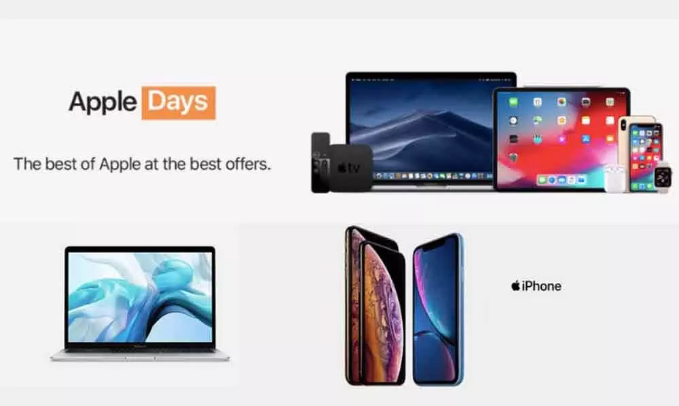
Fig. 4: “Apple Days” Promotional Banner
(Source: Apple, 2019)
People
Apple Inc. employs similar personnel in both countries. In both countries, Apple Inc. employs a team of engineers and designers to create their products. Additionally, Apple Inc. employs a team of customer service representatives and sales personnel to assist customers in both countries.
Process
Apple Inc. utilises a similar process for selling its products in both countries. Customers can purchase Apple products through their retail stores, online stores and various other retailers (Lan, 2021). Additionally, both countries utilise Apple’s customer service for support and repairs.
Physical Evidence
Apple Inc. stores in both countries utilise similar physical evidence to promote their products. In both countries, Apple Inc. stores utilise product displays and customer service desks to assist customers (Lan, 2021). Additionally, Apple Inc. stores in both countries utilise interactive displays and product demonstrations to showcase their products.
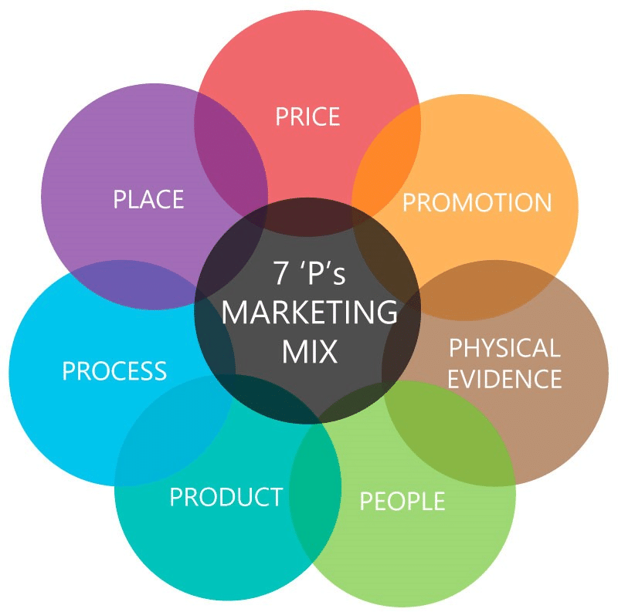
Fig. 5: 7P Marketing Model
(Source: Ryńca and Ziaeian, 2021)
In summary, Apple Inc. utilises a similar 7P marketing mix in both the US and India. The products, prices, placement, promotion, people, process and physical evidence, are all similar between the two countries. However, there are some differences in the product line and pricing between the two countries. Additionally, Apple Inc. utilises different promotional strategies in the two countries.

3.4 7P Marketing Mix Differences in India and USA
Product
The main product Apple offers in both the United States and India is its range of electronic devices and services. These include the iPhone, iPad, Mac computers, Apple Watch, Apple TV, iTunes, iCloud, and other software and services. However, there are some differences in the products available in the two countries. In the United States, Apple offers an extensive range of products, including the latest models of iPhones, iPads, and Macs (Smizer, 2021). In India, Apple’s product lineup is more limited, with older models of iPhones and iPads, as well as some Macs, being the only products available.
Price
The price of Apple products differs between the two countries due to a variety of factors, such as taxes, currency exchange rates, and local competition. In the United States, Apple products are generally more expensive than in India due to higher taxes and the strength of the US dollar. For example, the latest iPhone 12 Pro Max retails for $1,099 in the US, while it retails for ₹1,29,900 in India (Farraro, 2021).
Place
The availability of Apple products and services also differs between the two countries. In the United States, Apple products can be purchased from Apple retail stores, authorised Apple resellers, and online stores such as Amazon. In India, Apple products are available from Apple stores, authorised Apple resellers, and online stores such as Flipkart (Smizer, 2021). Apple products can also be purchased from third-party retailers in both countries, but the selection is more limited in India.
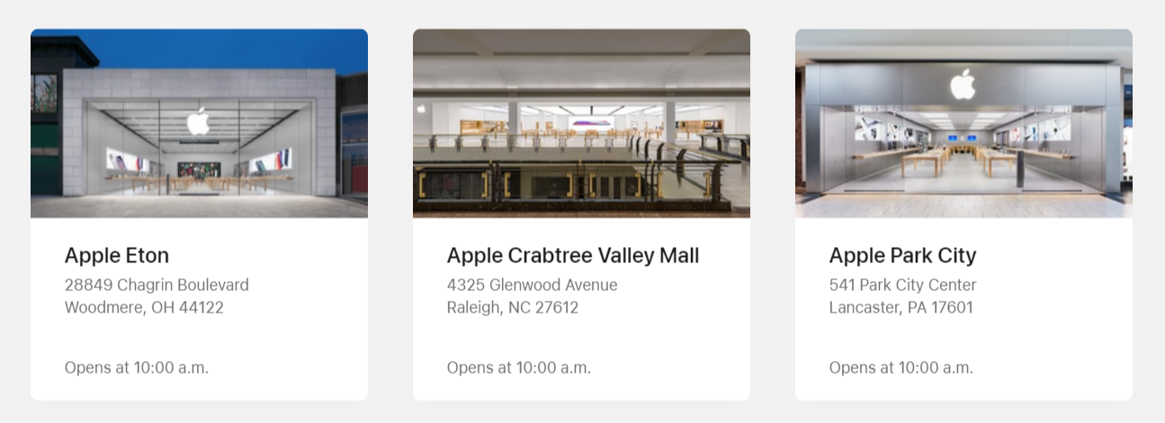
Fig. 6: Physical Stores of Apple
(Source: Apple, 2019)
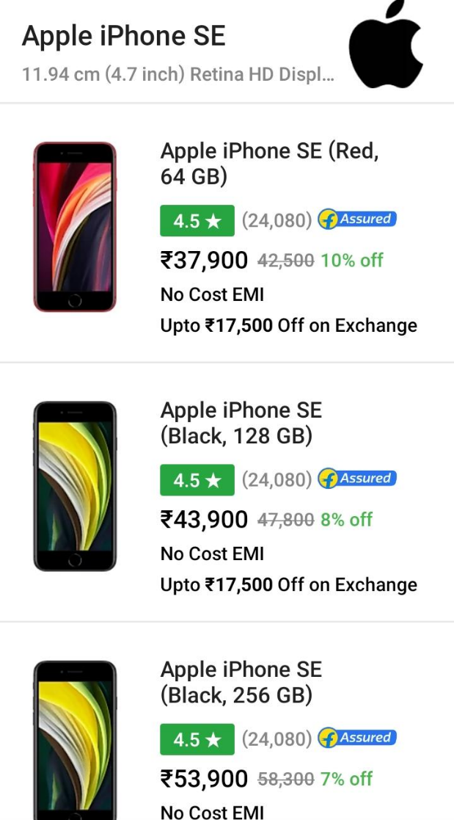
Fig. 7: Apple Phones available on Flipkart
(Source: Smizer, 2021)
Promotion
Apple’s promotional strategies in the United States are focused on creating a strong brand presence and building customer loyalty. Apple’s approach to marketing is to create an emotional connection with its customers. To do this, Apple has created a strong brand identity with its iconic logo, glossy product designs, and engaging advertising campaigns (Benbunan, Schreier and Knapp, 2019). The company also uses experiential marketing tactics, such as Apple Stores, to create an immersive experience for customers.
In the United States, Apple Inc. uses traditional media channels to promote its products and services. The company runs television commercials, radio ads, print advertisements, and billboards to reach a wide audience. Apple also relies heavily on digital marketing channels, such as social media and search engine optimisation, to reach its target customers. Additionally, Apple Inc. uses influencer marketing to reach its core audience by partnering with influencers who have large followings and can promote the brand’s products and services.

Fig. 8: Glimpse of TV Ad in the USA
(Source: Benbunan, Schreier and Knapp, 2019)
In India, Apple Inc.’s promotional strategies are focused on creating a local presence and building customer trust. Apple Inc. has developed localised marketing campaigns that are tailored to the needs of Indian customers (Singh and Misra, 2021). The company has launched campaigns with local celebrities to increase brand awareness and create a personal connection with its customers. Apple Inc. has also invested heavily in creating an online presence in India, with a localised website and social media channels.
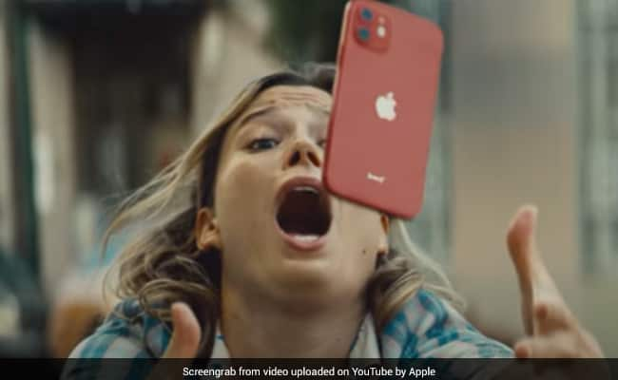
Fig. 9: Glimpse of Apple’s TV Ad in India, which has used Indian Beats
(Source: Shukla, 2021)
Apple Inc. uses a mix of traditional and digital marketing channels to promote its products and services in India (Shukla, 2021). The company runs television commercials, radio ads, and print advertisements to reach a wide audience. Apple also relies heavily on digital marketing channels, such as social media and search engine optimisation, to reach its target customers. Additionally, Apple Inc. uses influencer marketing to reach its core audience by partnering with influencers who have large followings and can promote the brand’s products and services. In this regard, Apple has partnered with a number of celebrities and influencers in India to promote their products and services, including Bollywood actors Aamir Khan and Sonam Kapoor.
People
Apple has a strong presence in both the United States and India, with a large team of employees in each country. In the US, Apple has a large team of sales and marketing employees, as well as customer support staff (Grosse, 2019). In India, Apple has a smaller team of sales and marketing staff, as well as customer support staff. Apple also has a strong network of authorised resellers in both countries.
Process
The process of buying Apple products differs between the two countries. In the United States, customers can purchase Apple products from retail stores, authorised Apple resellers, and online stores (Lan, 2021). In India, customers can purchase Apple products from Apple stores, authorised Apple resellers, and online stores. Apple also has an online store in both countries, offering customers the same range of products and services.
Physical Evidence
The physical evidence of Apple’s presence in the two countries also differs. In the US, Apple has a large number of retail stores and authorised resellers. In India, Apple has a smaller number of retail stores and authorised resellers. Apple also has a strong online presence in both countries, with an extensive range of products and services available on its website (Lan, 2021).
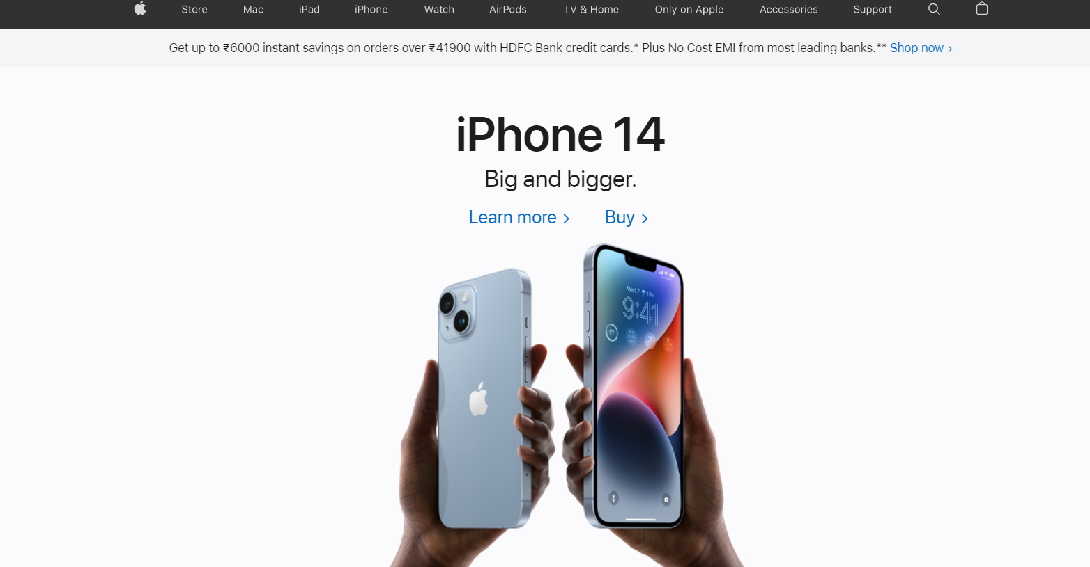
Fig. 10: Apple’s Website in the USA
(Source: Shukla, 2021)
To sum up, Apple’s 7P Marketing Mix is different in the United States and India due to factors such as taxes, currency exchange rates, and local competition. Apple offers a more extensive range of products in the US, while prices are generally higher than in India. Apple also uses different promotional strategies in the two countries and has different teams of employees and resellers. Apple also has a different process of buying products in the two countries and different physical evidence of its presence.

3.5 Similarities in Directional Development
The SOSTAC model is a powerful tool for planning and managing any marketing campaign. It stands for Situation, Objectives, Strategy, Tactics, Action and Control and is widely used by marketers and organisations to ensure their marketing plans are effective and successful. The model was developed by PR Smith and is a popular choice for developing a marketing plan and is widely used by organisations.
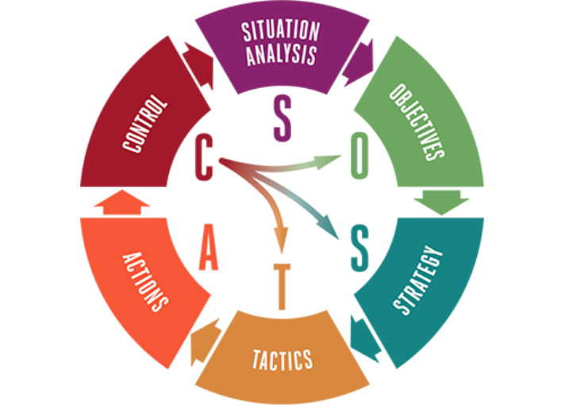
Fig. 11: Fundamentals of the SOSTAC Model
(Source: Pranata and Amaranti, 2021)
Situation:
Apple Inc. is a technology giant that is well known for its products, services and marketing strategies. The company has a presence in many countries around the world and is one of the most successful and recognisable brands in the world (Westervelt, 2021). Apple Inc. is a multinational technology company based in the United States and is one of the world’s largest technology companies by revenue.
Objectives:
Apple Inc. has two primary objectives for its marketing operations in India and America. The first is to increase its market share in India and America by offering innovative products and services that meet the needs of consumers in these two countries. The second objective is to increase brand recognition and loyalty in both countries.
Strategy:
Apple Inc. has adopted an aggressive marketing strategy in India and America (Dash, 2020). It has invested heavily in research and development to create innovative products and services that are tailored to the needs of consumers in these two countries. The company also works closely with local partners to ensure that its products and services are tailored to the local market needs. Apple Inc. also invests heavily in advertising and promotion in India and America to increase its brand recognition.
Tactics:
In order to achieve its objectives, Apple Inc. has adopted a number of tactics in India and America. These include using a mix of online and offline marketing strategies, such as television commercials, radio spots, print ads, and digital campaigns (Grabara, 2021). The company also uses promotional activities such as product launches and discounts. Apple Inc. also works closely with local partners and influencers to ensure that its products and services are well-known and accepted in the local markets.
Action:
Once the strategies and tactics have been developed, Apple Inc. implements the marketing plan in India and America. The company works closely with its partners and influencers to ensure that its products and services are well-known and accepted in the local markets (Esber and Wong, 2020). The company also works with local media outlets to ensure that its marketing campaigns are effective and well-received.
Control:
Apple Inc. monitors the effectiveness of its marketing campaigns in India and America to ensure that they are achieving the desired results. The company also monitors the feedback from consumers in these two countries to ensure that its products and services meet their needs (Gerke et al., 2020). In addition, Apple Inc. regularly evaluates its marketing strategies and tactics to ensure that they are effective and relevant.
The marketing operations of Apple Inc. in India and America are similar in many ways. The company has adopted an aggressive marketing strategy in both countries and has invested heavily in research and development to create innovative products and services (Lan, 2021). It works closely with its local partners and influencers to ensure that its products and services are well-known and accepted in the local markets. Additionally, Apple Inc. invests heavily in advertising and promotion to increase its brand recognition in both countries.
The marketing operations of Apple Inc. in India and America are also evolving. The company is continuously investing in research and development to create innovative products and services that meet the needs of consumers in these two countries. Additionally, Apple Inc. is also investing in emerging technologies such as artificial intelligence and machine learning to create even more innovative products and services (Aldhyani and Alzahrani, 2022). This will help the company stay ahead of its competitors and ensure that its products and services remain relevant in the market.
In conclusion, the SOSTAC model is an effective tool for planning and managing any marketing campaign. Apple Inc. has used this model to successfully conduct its marketing operations in India and America. The company has adopted a similar strategy in both countries and is continuously investing and innovating to ensure that its products and services remain relevant in the market.

3.6 Differences in Directional Development
Situation Analysis:
India and the United States are two of Apple’s biggest markets. The Indian market is characterised by a large population, with a growing middle class and a young demographic profile (Faske, 2018). It is a highly competitive market with many players, including Samsung and Xiaomi. The US market is also competitive, but Apple has a strong presence in the market and is considered a leader in the smartphone industry.
Objectives:
Apple’s primary goal in both markets is to increase market share and sales. In India, Apple is focused on capturing a larger share of the market by introducing new products and increasing its presence in its retail outlets (Flaig, Kindström and Ottosson, 2021). In the US, Apple is focused on maintaining its market share and expanding its customer base.
Strategy:
Apple’s strategy for both markets is to focus on product innovation and marketing. In India, Apple has invested heavily in advertising, including television and digital campaigns. It has also opened up retail outlets in major cities and has partnered with retail stores to increase its presence (Dash, 2020). In the US, Apple has focused on product innovation, launching new products such as the iPhone, iPad, and Apple Watch. It has also invested heavily in digital marketing, using platforms such as Instagram and Twitter to reach customers.
Tactics:
In India, Apple has used a variety of tactics to reach customers, including offering discounts and promotions, advertising on television and digital platforms, and partnering with retailers. In the US, Apple has used a combination of tactics, including product launches, digital marketing, and in-store events (Berg, 2021).
Actions:
Apple has taken a number of actions to implement its marketing strategy in both markets. In India, it has launched new products, opened retail outlets, and partnered with retailers. In the US, it has launched new products, invested in digital marketing, and hosted in-store events (Budiono et al., 2021).
Control:
Apple has implemented a number of measures to monitor and control its marketing operations in both markets (Zhao and Zhang, 2022). It uses analytics to monitor customer engagement and sales, as well as to measure the effectiveness of its marketing campaigns. It also uses feedback from customers to evaluate its performance and make adjustments to its strategies as needed.
Directional Development:
Apple’s marketing operations have continued to evolve and expand in both markets over the years. In India, Apple has invested heavily in advertising and retail expansion, while in the US, it has focused on product innovation and digital marketing (Yie, Zhi and Ping, 2021). Going forward, Apple is likely to continue to invest in both markets, as well as explore new markets and opportunities.
In summary, the SOSTAC model is a comprehensive and systematic approach to analysing and making decisions about a company’s marketing strategy. The SOSTAC model has been used to analyse how Apple conducts its marketing operations in India and America, identify the differences between the two markets, and discuss the directional development of Apple Inc. Apple has invested heavily in both markets and is continuing to evolve and expand its operations. Going forward, Apple is likely to continue to invest in both markets, as well as explore new markets and opportunities.

4. Justification behind the Approach used in both Countries
Apple has an impressive marketing strategy that has been successful in both the United States and India. Here is a breakdown of some of the key performance indicators (KPIs) used to measure its effectiveness.
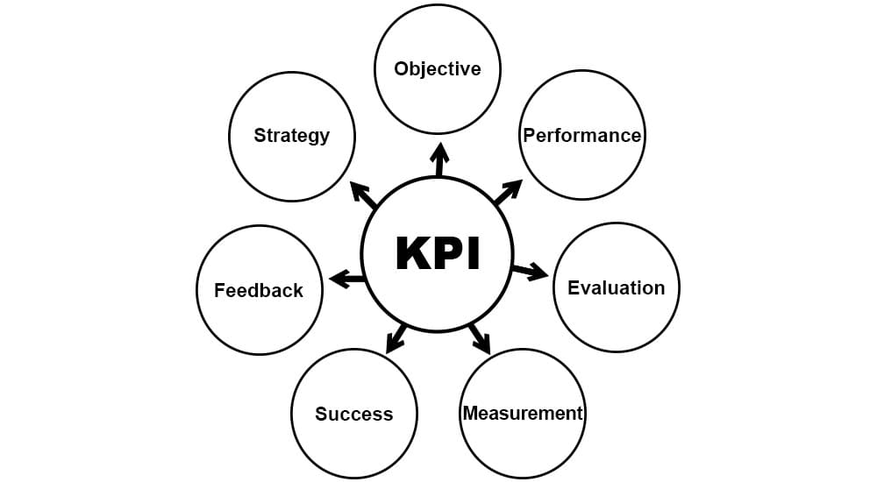
Fig. 12: Key Performance Indicator
(Source: Hinderks et al., 2019)
In the United States, Apple’s brand recognition and loyalty are evident in its high consumer preference score. According to a 2020 survey, Apple had a consumer preference score of 86%, compared to the industry average of 63% (Hsu et al., 2021). This indicates that Apple’s marketing strategy is successful in capturing consumer attention and loyalty in the US market.
Apple’s share of the US market also reveals the success of its marketing strategy. According to the latest available figures, Apple had a market share of over 44% in the US smartphone market in 2020. This indicates that Apple’s marketing strategy is successful in capturing and sustaining a large market share.
In India, Apple’s marketing strategy has also been successful in driving market share. According to the latest available figures, Apple had a market share of 10.6% in the Indian smartphone market in 2020 (Alam, 2021). This is a significant increase from its market share of 1.2% in 2016, indicating that Apple’s marketing strategy has been successful in driving market share in India.
Apple’s marketing strategy has also been successful in driving online sales in India. According to a recent report, Apple’s online sales in India grew by 71% in 2020 compared to the previous year (Luke and Emmett, 2021). This indicates that Apple’s marketing strategy has been effective in leveraging the digital space to reach and engage consumers in India.
Overall, Apple’s marketing strategy has been successful in both the US and Indian markets. Its high consumer preference score and large market share in both markets indicate that its strategies are effective in capturing consumer attention and loyalty. Additionally, its significant growth in online sales in India shows that its strategy is effective in leveraging the digital space to reach and engage with consumers in India.

5. Conclusion
In conclusion, this report has highlighted the different marketing approaches used by Apple in the USA and India. Despite their different approaches, the fundamental goal remains the same; to increase their brand visibility and market share. In the USA, Apple has invested heavily in traditional marketing techniques such as TV, print, and radio advertisements, as well as outdoor billboards and promotional events. In India, on the other hand, Apple has chiefly employed digital marketing techniques such as online advertising, search engine optimisation and social media. It is clear that Apple has adopted a tailored approach to marketing in both countries.
This is indicative of Apple’s commitment to understanding the needs of its target markets and responding to them accordingly. While this report has only scratched the surface of Apple’s marketing strategies, it has presented useful insight into the different approaches they have employed. Ultimately, it is this successful implementation of tailored marketing strategies that has allowed Apple to become the global powerhouse it is today.

References
Addison, M. and Adelaide, V., 2022. Brand Development and Marketing Strategies in the USA: A Case of Apple Inc. Journal of Marketing and Communication, 5(1).
Akareem, H.S., 2018. Report on Apple (iMac).
Alam, S., 2021. Reviewing the Global Smartphone Industry Strategic Implication in Response to COVID-19 Situation. International Journal of Interactive Mobile Technologies (iJIM).
Aldhyani, T.H. and Alzahrani, A., 2022. Framework for predicting and modeling stock market prices based on deep learning algorithms. Electronics, 11(19), p.3149.
Amin, M.R. and Munsi, M., 2020. Motivational Techniques for Business Organization–A Case Study of Apple Inc.
Apple, 2019. Apple Store - Find a Store - Apple. [online] Available at: https://www.apple.com/retail/. [Accessed on 5th December, 2022]
Baber, R., Upadhyay, Y., Kaurav, R.P.S. and Baber, P., 2020. Application of’masstige’theory and approaches for the marketing of smartphone brands in India. International Journal of Business and Emerging Markets, 12(3), pp.296-312.
Bahador, M.H.H., 2019. The effect of marketing mix on organisations performance. In 1st Strategic Management Conference 2019.
Baker, M. and Hart, S., 2008. The marketing book. Routledge.
Benbunan, J., Schreier, G. and Knapp, B., 2019. Disruptive Branding: How to Win in Times of Change. Kogan Page Publishers.
Berg, F.S.A., 2021. Independent podcasts on the Apple Podcast platform in the streaming era. MedieKultur: Journal of media and communication research, 37(70), pp.110-130.
Budiono, S., Purba, J.T., Adirinekso, G.P. and Rajagukguk, W., 2021. Market Growth Strategy through Consumers’ Satisfaction, Product Quality and Brand Image: Evidence from Jakarta Indonesia.
Cohen, B. and Muñoz, P., 2016. The emergence of the urban entrepreneur: How the growth of cities and the sharing economy are driving a new breed of innovators. ABC-CLIO.
Dash, S.P., 2020. The impact of IoT in healthcare: global technological change & the roadmap to a networked architecture in India. Journal of the Indian Institute of Science, 100(4), pp.773-785.
Deng, Z., 2021. Analysis on One Plus’ International Strategy. International Journal of Frontiers in Sociology, 3(20).
Esber, D. and Wong, J., 2020. Discussions in digital: Influencer marketing is ready for its close-up. McKinsey & Company, 15.
Farraro, J.T., 2021. A Legacy of Excellence: Remembering Diana Natalicio.
Faske, B., 2018. Turning billions into (green) trillions: Tracking the growth and development of the green bond market in China, France, India, and the United States. Tulane Environmental Law Journal, 31(2), pp.293-325.
Flaig, A., Kindström, D. and Ottosson, M., 2021. Market-shaping strategies: A conceptual framework for generating market outcomes. Industrial Marketing Management, 96, pp.254-266.
Gerke, S., Shachar, C., Chai, P.R. and Cohen, I.G., 2020. Regulatory, safety, and privacy concerns of home monitoring technologies during COVID-19. Nature medicine, 26(8), pp.1176-1182.
Grabara, D., 2021. iPhone 11 premium mobile device offers on e-commerce auction platform in the context of Marketing Mix framework and COVID-19 pandemic. Procedia Computer Science, 192, pp.1720-1729.
Grosse, R., 2019. Innovation by MNEs in emerging markets. Transnational Corporations, 26(3), p.1.
GUANGHUI, G., 2019. RESEARCH ON MARKETING STRATEGY OF HUAWEI’S HIGH-END SMARTPHONES (Doctoral dissertation, SIAM UNIVERSITY).
Hinderks, A., Schrepp, M., Mayo, F.J.D., Escalona, M.J. and Thomaschewski, J., 2019. Developing a UX KPI based on the user experience questionnaire. Computer Standards & Interfaces, 65, pp.38-44.
Hsu, T.H., Her, S.T., Chang, Y.H. and Hou, J.J., 2021. The Application of an Innovative Marketing Strategy MADM Model—SIVA-Need: A Case Study of Apple Company. International Journal of Electronic Commerce Studies, 13(1), pp.33-68.
Jain, V., Chawla, C., Arya, S., Agarwal, R. and Agarwal, M., 2019. An Empirical Study of Product Design for New Product Development with Special Reference to Indian Mobile Industry. Research Gate Publication, 81, pp.1241-1254.
Kabeyi, M.J.B., 2018. Michael porter’s five competitive forces and generetic strategies, market segmentation strategy and case study of competition in global smartphone manufacturing industry. IJAR, 4(10), pp.39-45.
Kim, R.B. and Chao, Y., 2019. Effects of brand experience, brand image and brand trust on brand building process: The case of Chinese millennial generation consumers. Journal of International Studies, 12(3).
Lan, B., 2021, April. Analysis of Apple’s Marketing Strategy. In 2021 6th International Conference on Social Sciences and Economic Development (ICSSED 2021) (pp. 128-132). Atlantis Press.
Lan, B., 2021, April. Analysis of Apple’s Marketing Strategy. In 2021 6th International Conference on Social Sciences and Economic Development (ICSSED 2021) (pp. 128-132). Atlantis Press.
Laricchia, F., 2022. Apple: annual revenue 2018 | Statista. [online] Statista. Available at: https://www.statista.com/statistics/265125/total-net-sales-of-apple-since-2004/. [Accessed on 5th December 2022]
Liu, Y., Liang, H., Li, M., Huang, L., Hu, K., Yang, C. and Wang, M., 2019. STP models of optimal differential and linear trail for s-box based ciphers. Cryptology ePrint Archive.
Luke, T. and Emmett, B., 2021. Critical Review of Apple’s Advertising Strategies in North America. Journal of Marketing and Communication, 4(1).
Majumdar, R., 2007. Product management in India. PHI Learning Pvt. Ltd..
MISHRA, D.L., 2022. Marketing Strategy of Smartphone Companies.
Pooja, B.C., 2020. An Organization Study Report Of Apple Inc (Doctoral dissertation, CMR Institute of Technology. Bangalore).
Pranata, Y.A. and Amaranti, R., 2021. Rancangan Strategi Pemasaran Media Sosial Menggunakan Model SOSTAC. Jurnal Riset Teknik Industri, 1(2), pp.110-120.
Rego, L., Brady, M., Leone, R., Roberts, J., Srivastava, C. and Srivastava, R., 2022. Brand response to environmental turbulence: A framework and propositions for resistance, recovery and reinvention. International Journal of Research in Marketing, 39(2), pp.583-602.
Romppanen, J.M., 2021. Segmentation, Targeting & Positioning (STP).
Ryńca, R. and Ziaeian, Y., 2021. Applying the goal programming in the management of the 7P marketing mix model at universities-case study. PloS one, 16(11), p.e0260067.
Shukla, R., 2021. Watch: Apple Uses Indian Beats To Promote iPhone12. [online] Available at: https://www.ndtv.com/offbeat/watch-apple-uses-indian-beats-to-promote-iphone12-2399177 [Accessed 5 Dec. 2022].
Singh, K. and Misra, M., 2021. The evolving path of CSR: toward business and society relationship. Journal of Economic and Administrative Sciences.
Smizer, E.C., 2021. Epic Games v. Apple: Tech-Tying and the Future of Antitrust. Loy. LA Ent. L. Rev., 41, p.215.
Tien, N.H., 2019. International distribution policy comparative analysis between samsung and apple. International journal of research in marketing management and sales, 2020(1), p.2.
Westervelt, B., 2021. How Brand Identity and Consumer Perception Influences the Marketing Strategies of the Apple Company.
Yie, C.E., Zhi, C.E. and Ping, N.T.S., 2021. A Critical Analysis of Internal and External Environment: Case Study of Apple Inc. Journal of International Business and Management, 4(10), pp.01-14.
Zhang, W., Hu, J., Zhou, G. and He, M., 2020. Detection of apple defects based on the FCM-NPGA and multivariate image analysis. IEEE Access, 8, pp.38833-38845.
Zhao, Y. and Zhang, Z., 2022, April. Strategy Analysis of the COVID-19’s Influence on Apple. In 2022 7th International Conference on Social Sciences and Economic Development (ICSSED 2022) (pp. 9-13). Atlantis Press.

