Astable 555 Timer Circuit
Laboratory Notebook
Name: Thomas Caswell
Student ID Number: 2109158
Module: ACDA4018 Fundamentals of Electrical and Electronic Systems
Course: Ordnance, Munitions & Explosives Level 4 HNC

Contents
1. Assignment Objective 2
2. Circuit Description & Operation 2
3. Simulation in Proteus: 4
4. Design Calculations 4
4.1 Calculating the resistance of R3 and R4. 4
4.2 Calculating the On and Off Times. 5
4.3 Calculating the Period 5
4.4 Calculating the Frequency 5
5. Timing Measurements from Proteus 6
6. Simulated Graph of C1 Voltage and Output Voltage vs. Time 6
7. Building the Circuit 7
8. Measurements from the Circuit 8
References 9

Assignment Objective
This assignment aim is to build and test the following design of an astable 555-timer circuit:
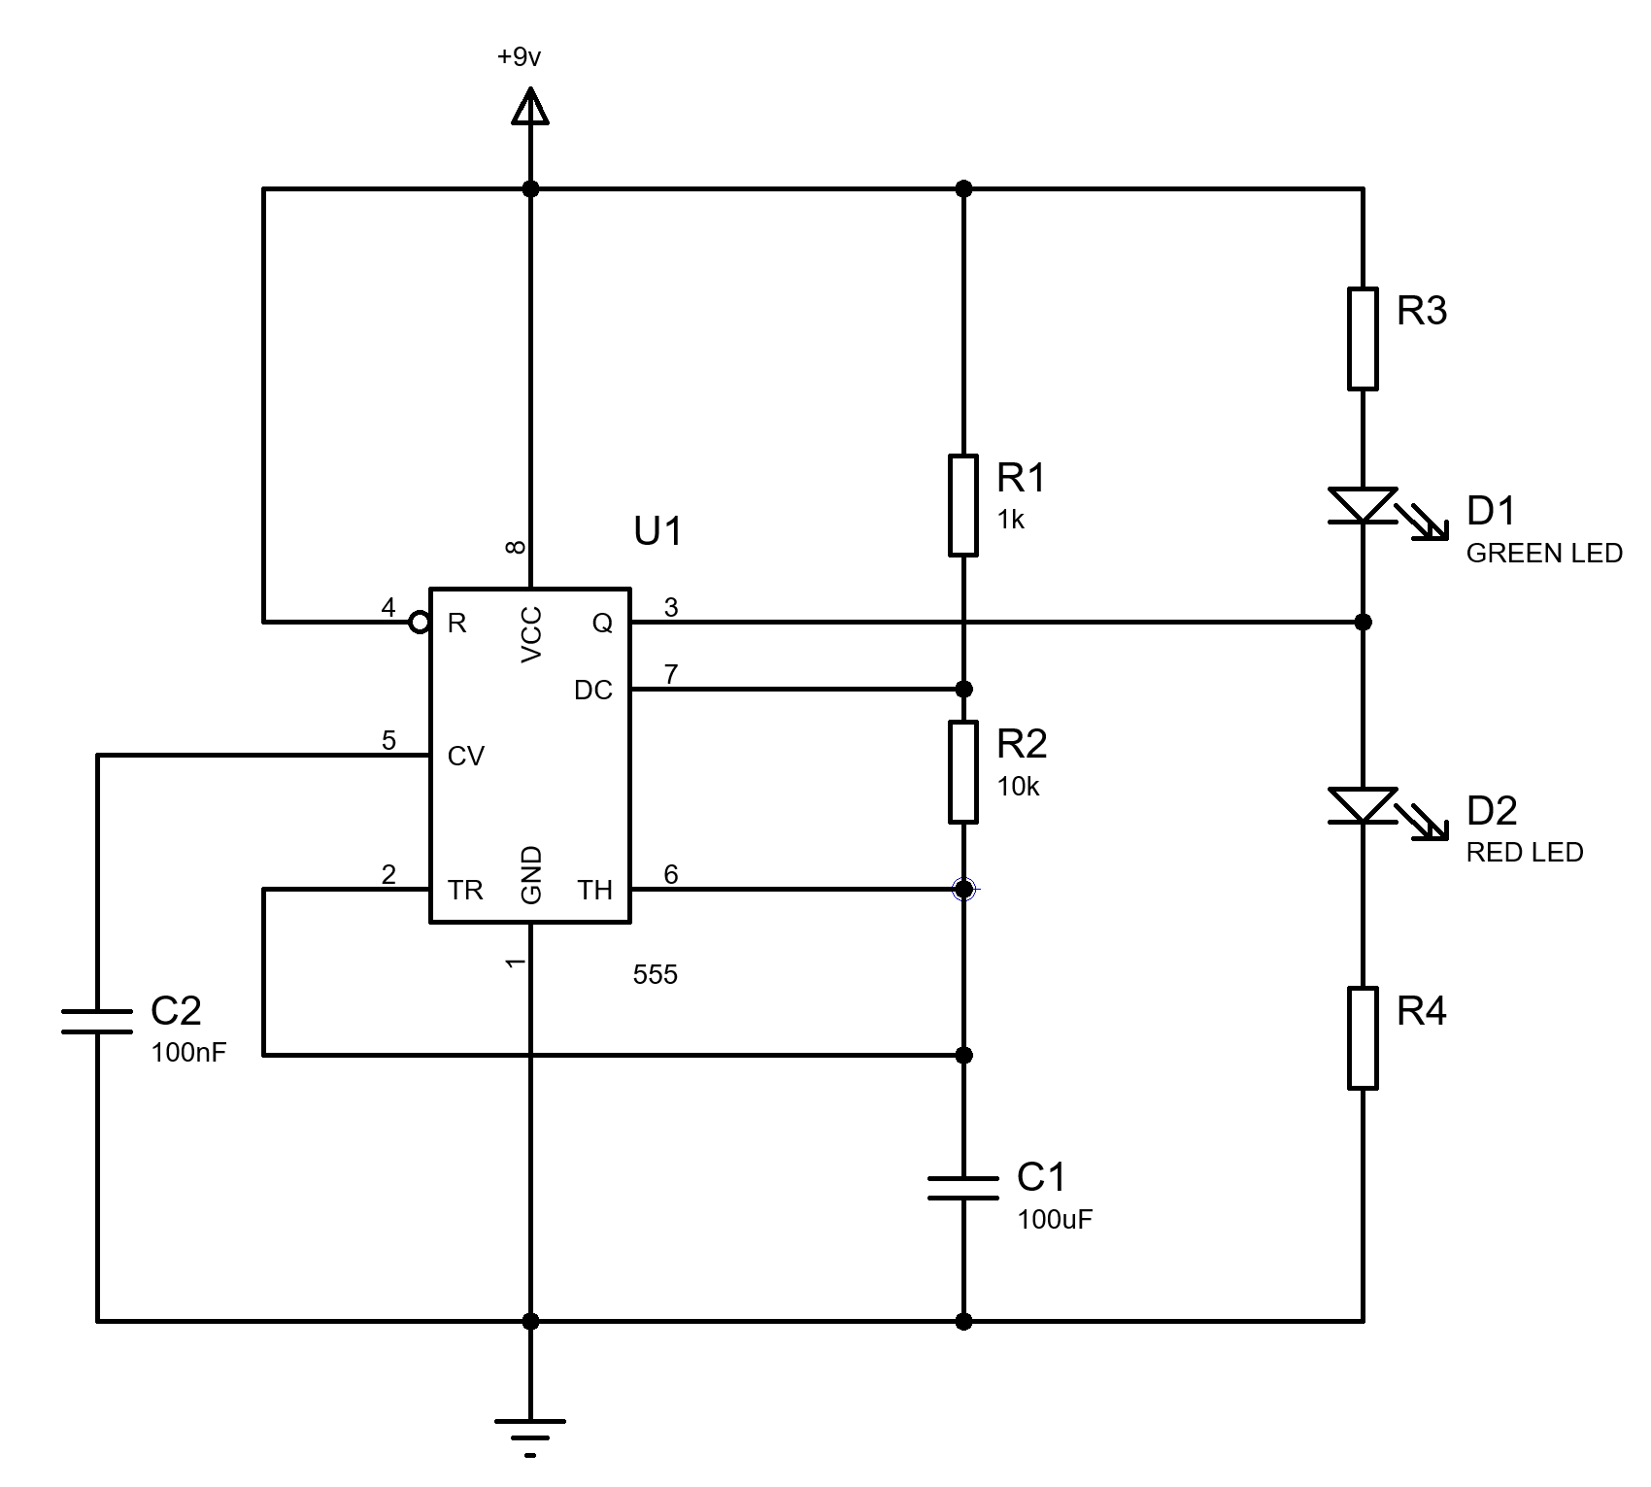
Figure 1: Assignment astable 555 timer circuit design.

Circuit Description & Operation
The definition of "astable” relating to a system or electronic circuit is that it oscillates spontaneously between unstable states [1].
Within the timer circuit is a 555 timer Integrated Circuit (IC). The reason for this being called “555” is that between pins 1 and 8 in the IC component are wired three 5kΩ resistors in series. These three resistors act as a three-step voltage divider between the supply voltage (V_{cc}) and ground (GND) [2].
A proteus construction of this circuit (Figure 2) we can see that the voltage probes between R1 and R2 is 6V and the voltage probe between R2 and R3 is 3V. This is 2/3 and 1/3 of the V_{cc} (9V) respectively.
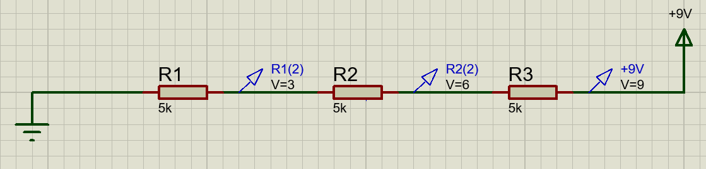
Figure 2: Proteus circuit of three 5kΩ resistors in series.
This is important as this voltage divide of 1/3 V_{cc} and 2/3 V_{cc} is used to control the operation of two comparators in the rest of the IC.
A block diagram of a 555 timer IC is shown in Figure 3. In this diagram it is possible to see the voltage divider running from pins 1 to 8 (GND to V_{cc}).
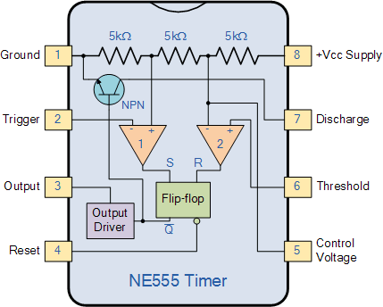
Figure 3: 555 Timer Block Diagram [3].
Connected to the voltage divider are two comparators (triangles 1 and 2). These comparator function with the following logic:
$$If {V_{IN}}^{+}>{V_{IN}}^{-} then:V_{OUT}=V_{cc }(high)$$
$$If {V_{IN}}^{+}<{V_{IN}}^{-} then:V_{OUT}=0V (low)$$
Equation 1: Comparator Logic in the 555 Timer IC.
The flip-flop component operates when the Setup (S) receives V_{cc} an inverted output is sent out (Q). When Reset (R) receives V_{cc} the inverted output is reset to its original state and V_{cc} is sent out via pin 4.
The output driver here is an inverter and will invert the high or low signal received from the flip flop to pin 3.
The KPN transistor at the top of Figure 3 will connect or disconnect the V_{cc} of the chip (pin 8) to GND (pin 1) based on the signal it receives from the flip flop Q output.
With this information it is possible to deduce the operation of the astable 555 timer circuit design in Figure 1.
- At the start the capacitor is fully discharged and there is 0V potential across pins 6 and 7.
- On connecting to V_{cc} (+9V) C1 will charge via R1 and R2.
- Whilst C2 is less than 2/3 V_{cc}:
  - Comparator 1: V_{IN}⁺=1/3V and V_{IN}⁻<1/3V, therefore V_{OUT} = High or V_{cc}.
  - Therefore, the flip flop will output low to the bipolar transistor.
  - The bipolar transistor is disconnected from V_{cc} enabling C2 to continue charging.
  - The flip flop outputs low to pin 4 (Reset) and the green LED is not lit.
  - The output drive sends high to pin 3 and the red LED is lit.
- Once C2 is greater than 2/3 V_{cc:}
  - Comparator 2: V_{IN}⁺<2/3V and V_{IN}⁻=2/3V, therefore V_{OUT} = High or V_{cc}.
  - The high out put resets the flip flop.
  - The flip flop then resets and outputs high to the bipolar transistor and the output drive, and high to pin 4 (Reset) and the green LED is lit.
  - The output drive outputs low, and the red LED turns off.
  - The bipolar transistor then connects the pin 7 (discharge) to GND.
  - C2 then begins to discharge R2 and pin 7 to ground and pin1.
- When C2 is less than 2/3 V_{cc}:
  - Go back to step 3 and repeat.

Simulation in Proteus:
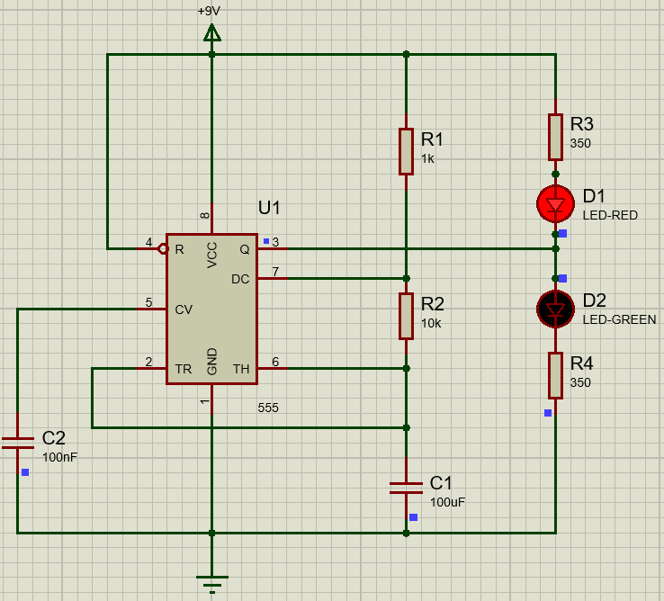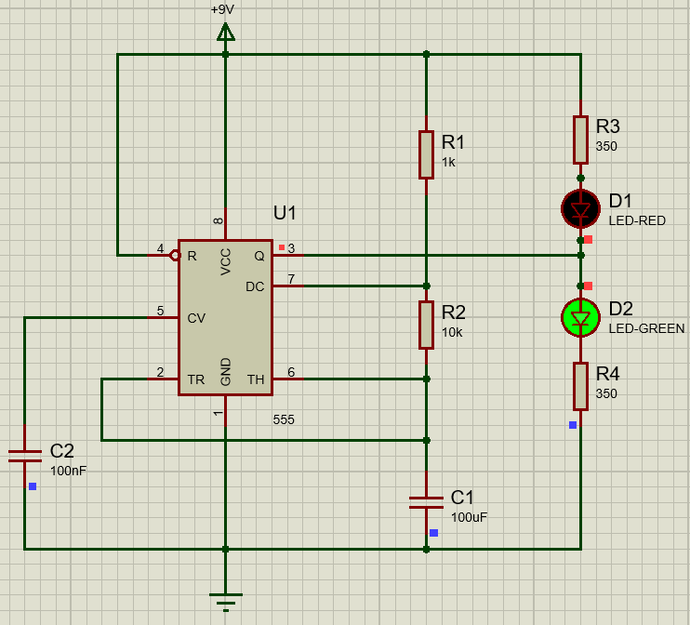
Figure 4: C2 charging and red LED lit (left), C2 discharging and green LED lit (right).

Design Calculations

Calculating the resistance of R3 and R4.
Ohm’s law is required to calculate the resistance of the resistors that protect the Light Emitting Diodes (LED) from too high a current from the circuit [4].
$$Resistance \left(Ω\right)=\frac{Voltage (V)}{Current, I (A)}$$
Equation 2: Ohm's Law.
The properties of the LEDs used in the proteus schematic are:
Full drive current | 20 mA
Forward voltage (@20mA) | 2 V
Table 1: LED properties.
The supply voltage for the circuit is given as +9V Direct Current (DC).
Therefore, the required resistance for R3 and R4 is:
$${(9V-2V)}/{0.02A}=350Ω$$
Equation 3: Calculation of the resistance of R3 and R4

4.2 Calculating the On and Off Times.
Time on (t_{on}) corresponds to the time the capacitor is charging and when the output is high. This can be calculated from:
$$t_{on}= \ln{2(}R1+R2) ×C$$
$$t_{on}= \ln{2}\left(1000Ω+10000Ω\right)×0.0001F=0.7625 secs=763 ms$$
Equation 4: Calculation for t_{on}.
This is because the capacitor charges through both R1 and R2 in series. Therefore, the total resistance is the sum of both resistors.
Time off (t_{off}) corresponds to the time the capacitor is discharging and when the output is low. This can be calculated from:
$$t_{off}= \ln{2(}R2) ×C$$
$$t_{off}= \ln{2}\left(10000Ω\right)×0.0001F=0.6931 secs=693 ms$$
Equation 5: Calculation for t_{off}.

4.3 Calculating the Period
The period of the waveform in the oscilloscope can be calculated from:
$$t_{period}=t_{on}+t_{off}$$
$$t_{period}=763 ms+693 ms=1456 ms=1.456 s$$
Equation 6: Calculation for t_{period}.

4.4 Calculating the Frequency
The frequency of the astable timer can be calculated from:
$$f=\frac{1}{t_{period}}$$
$$f=\frac{1}{1.456 s}=0.687 s^{-1}$$
Equation 7: Calculation for frequency of the astable 555 timer.

In summary, the following values are expected in the proteus simulation:
Feature | Value
C2 1/3 V_{cc} | +3 V
C2 2/3 V_{cc} | +6 V
Output high | +9 V
Output low | 0 V
t_{on} | 0.763 s
t_{off} | 0.693 s
t_{period} | 1.456 s
Table 2: Calculated voltages and timings for the circuit.

Timing Measurements from Proteus
Table 3 contains timing measurements that were taken from the Proteus simulation.
- Feature | Value
C2 1/3 V_{cc} | +3.01 V
C2 2/3 V_{cc} | +5.99 V
Output high | +8.86 V
Output low | +0.00141 V
t_{on} | 1.86 s - 1.11 s = 0.75 s
t_{off} | 2.56 s - 1.86 s = 0.70 s
t_{period} | 2.56 s - 1.11 s = 1.45 s
Table 3: Voltages and timings from proteus simulation.

6. Simulated Graph of C1 Voltage and Output Voltage vs. Time
Figure 5 contains two traces from the simulated voltage output from C2 (green waveform) and the output voltage from pin 3 (red square waveform). From this we can determine the following voltages and timings:
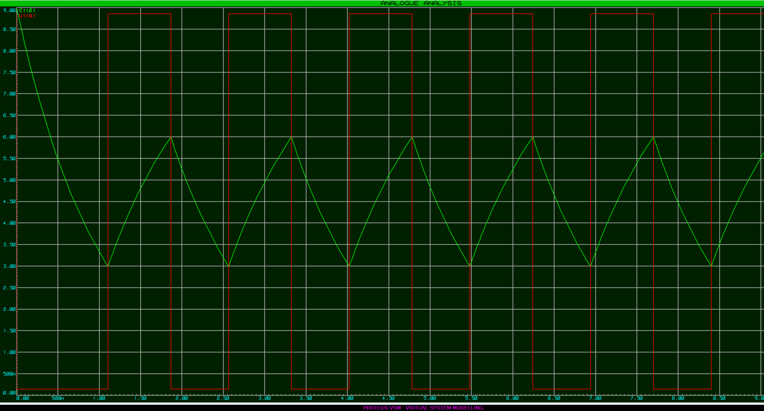
Figure 5: Capacitor voltage (green trace) & Output voltage (red trace) against time.
The differences between the values may be attributed to:
- Errors in reading the traces from the computer.
- The sampling rate on Proteus being too low.
- The simulation may be considering factors such as internal resistance, wire impedance of the circuit for which the calculations will not be able to.

Building the Circuit
To build the circuit on a bread board a paper plan was first mapped out with each to the components and the wires that would be required. The circuit was then constructed in the bread board and connected to a power supply as can be seen in Figure 6. Once turned on the circuit drew 6 mA, and the LEDs began flashing alternately.
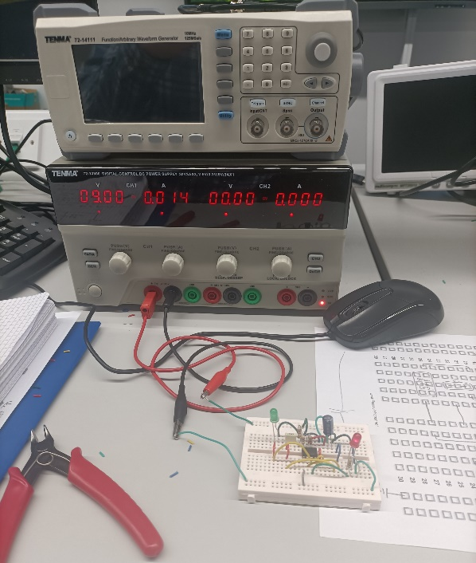
Figure 6: Constructed Astable 555 Timer Bread Board Circuit.

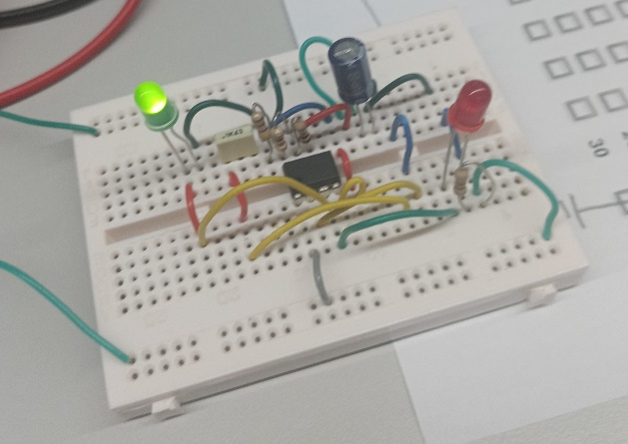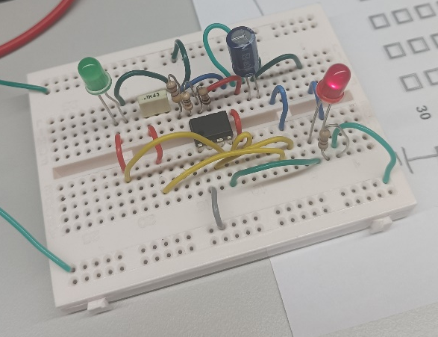
Figure 7: Astable 555 Timer circuit Flashing (left image green LED, right image red LED)

8. Measurements from the Circuit
To take measurements from the bread board circuit as was done for the proteus simulation an oscilloscope and probe cables would be required.
To record the C1 capacitor voltage, channel one on the oscilloscope should be connected via a probe lead to the leg of the capacitor that connects towards pin 2 and six on the 555-timer chip.
To record the pin 8 output, channel two on the oscilloscope should be connected via a probe lead to the wire that connects the pin 3 out put to the bread board track with the LEDs.
It would have then been possible to obtain another graph of C1 voltage and output voltage from the oscilloscope. From this graph the same timing measurements as in Table 3 could be calculated and then compared against the simulation.
Measurements with the oscilloscope and the constructed bread board circuit was not possible during the laboratory session in Swansea.

References

[1] | O. U. Press, Oxford English Dictionary.
[2] | P. Scherz, Practical Electronics for Inventors, 2nd ed., New York: McGraw Hill, 2007.
[3] | “Electronics Tutorials,” Aspencore, 2022. [Online]. Available: https://www.electronics-tutorials.ws/waveforms/555_timer.html. [Accessed 02 12 2022].
[4] | R. Dickson, Elecrtonics for Dummies, Chichester: Wiley, 2010.

