

Applied Leadership and Management in the Workplace
Module Assignment Submission
Student Name: | Nicola Powell
Student Number: | 2433701
Module No: | BMSK5014
Module Title: | Project Management

Statement of Confirmation of Authenticity
By the act of making this submission, the student declares that this is the work of the student named above. The work has not, in whole or in part, been knowingly presented elsewhere for assessment, or where assessment has been built on a previous assessment, this has been identified. Where materials have been used from other sources it has been properly acknowledged. If this statement is untrue, the student acknowledges that an assessment offence has been committed.
Attention is drawn to the plagiarism and unfair practice policies of both the University and of ILM.

Contents
Executive Summary 3
1. Introduction 3
2. Defining the Project Idea: What and Why 5
2.1 Organisational Context and Project Concept 5
2.2 Project Objectives, Scope and Success Criteria 5
3. Application of Project Management Philosophies and Processes 7
3.1 Project Management Methodologies 7
3.2 Project Initiation 7
3.3 Environmental Analysis 8
3.4 Work Breakdown Structure 8
3.5 Project Management Tools and Communication Plan 9
3.6 Risk Identification and Management 10
3.7 Monitoring, Control and Project Close-down 11
4. Project Manager Attributes, Self-Audit and PDP 13
4.1 Key Attributes of an Effective Project Manager 13
4.2 Self-Audit 13
4.3 Personal Development Plan 15
5. Conclusion 17
6. References 18

Executive Summary
This report develops a complete project plan for a Scheduling and SLA Visibility Improvement Project within Rock Compliance, a specialist air and water hygiene organisation. The project concept responds to a practical operational challenge experienced in my current scheduling role, maintaining reliable customer appointments and statutory service frequencies while balancing engineer availability, geographical routing, reactive work, sickness, and changing customer priorities. The proposed project introduces a standardised scheduling dashboard, clearer exception-management rules and a structured communication process between Scheduling, Engineering and Account Management. Its principal objective is to reduce overdue scheduling tasks by 20% while improving visibility of SLA risk and supporting more consistent customer communication.
The report follows the project management process from concept to completion and critically evaluates methodologies, initiation, environmental analysis, work breakdown structures, scheduling tools, stakeholder communication, risk management, monitoring and close-down. A hybrid delivery philosophy is recommended, traditional stage-gates provide governance and control in a compliance environment, while short iterative pilot cycles enable users to test the dashboard and refine working practices before wider deployment. The report argues that project tools are valuable when they improve decision quality and shared understanding but can become bureaucratic if applied mechanically or at a level disproportionate to project complexity.
The final section evaluates the attributes required of a project manager and compares these against my current capabilities. Strengths are identified in operational planning, communication, stakeholder coordination, prioritisation, and KPI awareness. Development priorities include formal risk quantification, change management and greater proficiency with dedicated project management tools. A focused personal development plan is proposed to convert existing operational management experience into stronger end-to-end project leadership capability.

1. Introduction
Project management provides organisations with a structured approach to implementing change, improving performance, and achieving defined objectives within agreed time, cost, quality, and resource constraints. The Association for Project Management (APM, 2019) describes project management as the application of processes, methods, knowledge, skills, and experience to achieve specific objectives, while the Project Management Institute (PMI, 2021) emphasises adapting project approaches to organisational circumstances and desired outcomes.
Rock Compliance operates within the water and air hygiene sector, where effective operational scheduling is essential to maintaining regulatory compliance and meeting customer Service Level Agreements (SLAs). Within my current role in Operations Scheduling, engineer workloads must be coordinated according to competence, geographical location, customer requirements, and contractual deadlines. However, engineer sickness, reactive work and changing customer priorities can disrupt planned schedules and increase the risk of missed deadlines.
This report proposes a Scheduling and SLA Visibility Improvement Project designed to improve scheduling visibility, resource allocation, and the early identification of potential SLA risks. Improved visibility could also strengthen communication between Operations Scheduling, Engineering and Account Management, enabling operational issues to be addressed more proactively.
The report critically applies project management methodologies, processes, and tools to the project from initial concept through planning, implementation, monitoring, and closure. Recognising that no single methodology is appropriate for every project, different approaches are evaluated according to organisational context and project requirements (Kerzner, 2022). Environmental analysis, work breakdown structures, communication planning, risk management, and project monitoring are also critically assessed.
Finally, the key attributes required of an effective project manager are examined and compared against a personal self-audit. The findings inform a Personal Development Plan (PDP) identifying actions to strengthen areas for development. Overall, the report combines academic theory with practical workplace experience to demonstrate how effective project management can support operational improvement at Rock Compliance.

2. Defining the Project Idea: What and Why

2.1 Organisational Context and Project Concept
The WHAT of the proposed project is the design and implementation of a standardised operational scheduling and SLA visibility approach. The core deliverables are, a dashboard that highlights upcoming and overdue work by priority; agreed exception categories for reactive work, sickness, access issues, and customer-driven changes; a common escalation process; and a communication rhythm linking Scheduling, Engineering and Account Management. The project is not intended to replace Rock Compliance's existing operational systems. Instead, it is a process-improvement layer that uses available data more consistently and creates clearer ownership of work at risk.
The WHY is grounded in both customer and operational value. Scheduling decisions are currently made under competing constraints. A scheduler may have to choose between protecting an existing planned route, inserting a high-priority reactive task, moving an engineer across a large geographical area, or reallocating work following sickness. These decisions can be made effectively through experience, but when information is fragmented the organisation becomes more dependent on individual knowledge. A shared visibility process reduces this dependency and makes emerging SLA risk easier to identify before work becomes overdue. It also supports my existing performance objective of reducing overdue scheduling tasks by 20% and consistently meeting SLAs.
From a strategic perspective, the project supports service reliability, customer retention, and more efficient use of engineering capacity. The benefits are therefore both tangible and intangible: fewer overdue tasks, improved engineer utilisation, reduced last-minute rescheduling, better customer communication, and stronger cross-functional accountability. However, benefits should not be overstated. A dashboard cannot remove unpredictable demand or create additional engineering capacity. Its value lies in improving the timeliness and quality of decisions, which means success depends on user behaviour and management follow-through as much as the technical output.

2.2 Project Objectives, Scope, and Success Criteria
The primary SMART objective is to reduce overdue scheduling tasks by 20% within three months of full implementation, measured against a four-week pre-project baseline. Supporting objectives are to improve the proportion of at-risk work identified at least five working days before its due date; establish a single agreed escalation route for priority conflicts; achieve at least 90% completion of user training; and improve internal stakeholder satisfaction with scheduling visibility. These measures combine outcome, process, and adoption indicators, avoiding the weakness of judging the project solely by whether the dashboard was delivered.
In scope are scheduling workflows, SLA-risk categorisation, dashboard design, stakeholder reporting, pilot testing, training, and benefits review. Out of scope are changes to contractual SLA definitions, recruitment of additional engineers, replacement of enterprise systems and redesign of technical compliance procedures. Explicit boundaries are important because scope creep can gradually convert a focused improvement project into a wider transformation programme, increasing cost, complexity, and delivery risk (Larson & Gray, 2021).
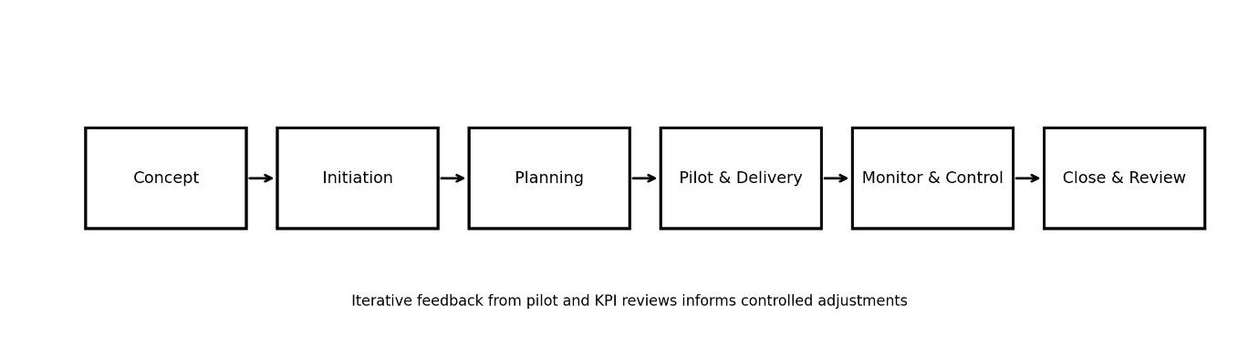
Diagram - Proposed project life cycle.
Source: Author, adapted from APM (2019) and PMI (2021).

3. Application of Project Management Philosophies and Processes

3.1 Project Management Methodologies
A methodology provides a structured approach for organising project work, but methodology selection should be contingent on project uncertainty, organisational culture, and governance needs. Traditional predictive or waterfall approaches define requirements early and progress through sequential phases. Their strengths include clarity of scope, documentation, accountability, and stage control, making them appropriate where outputs are stable and regulatory assurance is important (APM, 2019; Kerzner, 2022). For Rock Compliance, these features are valuable because changes to scheduling processes affect live customer commitments and require clear approval. The weakness is that a fully predictive approach can lock in assumptions before schedulers and account managers have tested whether the proposed dashboard actually supports day-to-day decisions.
Agile approaches emphasise collaboration, iterative delivery, feedback, and responsiveness to change. The Agile Manifesto prioritises individuals and interactions, working solutions, customer collaboration and responding to change (Beck et al., 2001). APM (2022) similarly identifies benefits including improved visibility, prioritisation, and adaptability, although agile maturity and cultural readiness can limit effectiveness. Applied to this project, an agile approach would enable the scheduling team to test an early dashboard, identify unnecessary fields, and refine escalation rules quickly. However, pure agile delivery could create ambiguity around governance, documentation, and final acceptance in a compliance-focused organisation. Iteration is useful, but not every element should remain fluid.
PRINCE2 offers stronger governance through defined roles, continued business justification, management by stages and focus on products (PeopleCert, 2023). Its discipline is attractive for ensuring sponsor accountability and formal closure, but full PRINCE2 documentation would be disproportionate for a relatively small internal improvement project. Scrum is similarly useful for short cycles and team ownership, yet formal roles such as Product Owner and Scrum Master may add complexity where a small cross-functional project team can work through existing management structures (Schwaber & Sutherland, 2020).
A hybrid methodology is therefore most appropriate. The project will use predictive controls for the business case, scope, risk, milestones, approval, and benefits measures, while using iterative two-week design and pilot cycles to refine the dashboard and process. This reflects the argument that agile and waterfall exist on a continuum and that techniques should be selected according to context rather than ideology (APM, n.d.). The hybrid model also mirrors operational reality at Rock Compliance: statutory deadlines and customer commitments require control, while scheduling practice requires rapid adaptation when circumstances change.

3.2 Project Initiation
Project initiation converts an improvement idea into an authorised piece of work. The first tool would be a concise project charter or project initiation document containing the problem statement, objectives, scope, sponsor, project manager, assumptions, constraints, high-level risks, milestones, and success measures. This is useful because it creates a common reference point and prevents different stakeholders interpreting the project differently. Nevertheless, a charter has limited value if it becomes a static approval document. It should be revisited when significant assumptions change.
The business case would compare the expected benefits with the resources required. Direct financial benefits may be difficult to isolate because the project primarily improves productivity and service reliability rather than generating a discrete revenue stream.
Consequently, the case should combine quantitative indicators, such as reduction in overdue work and avoidable rescheduling, with qualitative benefits including customer confidence and reduced operational firefighting. This is consistent with benefits-management thinking, which distinguishes project outputs from the organisational outcomes they enable (Ward & Daniel, 2012).
Stakeholder identification is equally important. Key stakeholders include the Operations Manager/project sponsor, schedulers as primary users, engineers whose workloads are affected, Account Managers who communicate with customers, compliance/administration teams, IT or system support, and senior management receiving KPI information. Freeman's (1984) stakeholder theory demonstrates that organisational decisions create value through relationships with multiple affected groups. A power-interest matrix would classify the sponsor and Operations leadership as high-power/high-interest stakeholders requiring close management, schedulers as high-interest users requiring active involvement, engineers as high-interest operational stakeholders requiring consultation, and senior leaders as high-power stakeholders requiring concise performance reporting. The limitation of the matrix is that stakeholder influence can change during the project, so it must be reviewed rather than treated as fixed (Mendelow, 1991; Turkulainen et al., 2015).

3.3 Environmental Analysis
A PESTLE analysis provides a structured view of the external environment. Politically and legally, compliance services operate within health and safety expectations and customer-specific governance, meaning scheduling improvements must preserve auditability and service frequencies. Economically, travel cost, engineer utilisation and productivity create pressure to design efficient routes. Socially, customers expect reliable appointments and prompt communication when changes occur. Technologically, digital scheduling and dashboard tools create opportunities for real-time visibility but also introduce data-quality and adoption risks. Environmentally, improved route planning may reduce unnecessary mileage. These factors show that the project has wider operational consequences than a simple reporting change.
Internally, a SWOT analysis identifies strengths such as experienced schedulers, established SLA knowledge and existing performance data; weaknesses such as reliance on individual judgement, fragmented exception information and reactive communication; opportunities including predictive alerts, standardisation and cross-functional visibility; and threats such as resistance to change, poor data quality, competing operational priorities and insufficient time for training. SWOT is useful for generating discussion but is subjective and can produce generic lists. Its value increases when findings are translated into actions, risks, or requirements rather than remaining descriptive (Helms & Nixon, 2010).

3.4 Work Breakdown Structure
A Work Breakdown Structure (WBS) decomposes the total project scope into manageable deliverables and work packages. For this project, level-one packages are initiation, design, pilot, roll-out and close. These are further divided into tasks such as baseline measurement, stakeholder requirements, dashboard configuration, process mapping, training materials, pilot review, and benefits evaluation. The WBS is valuable because it clarifies what work is included, supports estimation and creates the basis for responsibility assignment and scheduling (PMI, 2021).
Its limitation is that decomposition can encourage a false sense of certainty. In an iterative pilot, some work cannot be fully specified until users test the solution. Over-detailed WBS structures can also become administratively expensive to maintain. The appropriate level is therefore one that supports ownership and control without attempting to predict every minor activity.
In my scheduling role, this is comparable to route planning: excessive detail can become obsolete when reactive work changes the day, whereas too little detail prevents effective coordination.
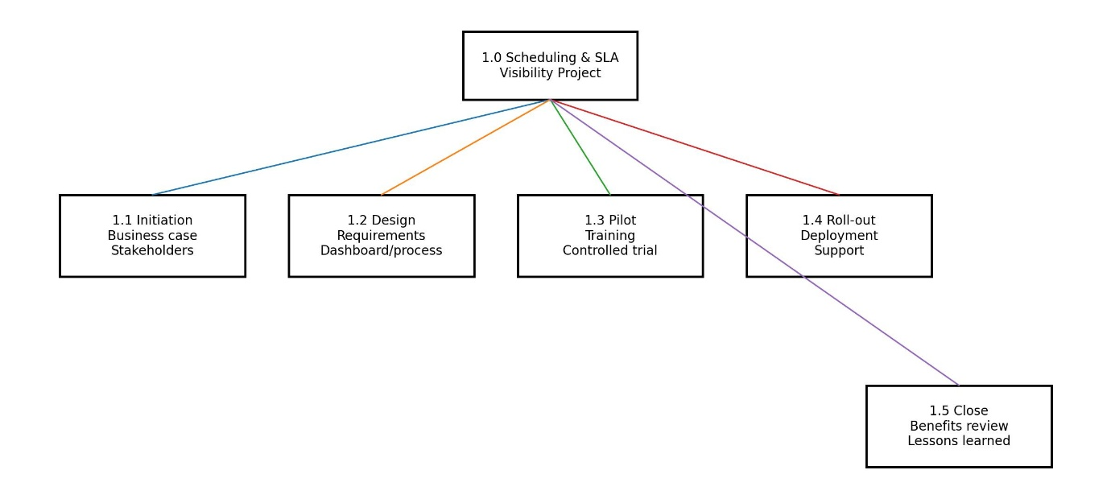
Diagram - High-level work breakdown structure.
Source: Author, informed by PMI (2021) and Larson and Gray (2021).

3.5 Project Management Tools and Communication Plan
A Gantt chart will provide the time baseline, sequencing major activities across a 13-week implementation. It is particularly useful for communicating dependencies and milestone dates to stakeholders who do not need task-level detail. For example, dashboard build cannot be finalised before requirements are agreed, and roll-out should not begin before pilot findings are reviewed. The Gantt chart is less effective at representing uncertainty or the intensity of iterative work. If treated as a fixed prediction rather than a control baseline, it can encourage teams to defend outdated dates rather than respond intelligently to new information (Maylor, 2010).
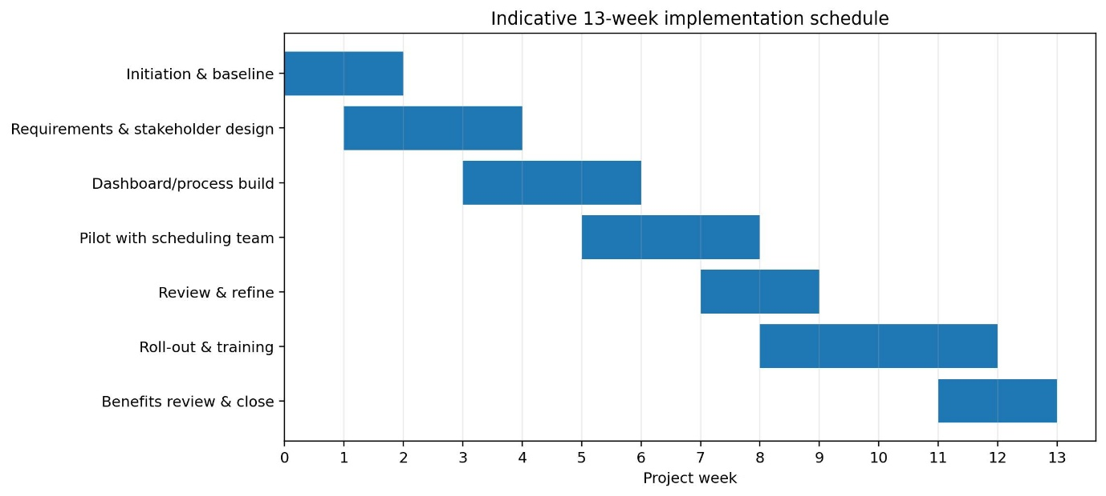
Diagram - Indicative project Gantt chart.
Source: Nicola Powell
A RACI matrix will define who is Responsible, Accountable, Consulted and Informed for each major deliverable. For example, the project manager may be responsible for the pilot, the sponsor accountable, schedulers and Account Managers consulted, and wider Engineering informed. RACI is useful where cross-functional responsibilities are easily blurred. However, it can oversimplify collaboration and may create unhelpful boundary behaviour if individuals interpret 'not responsible' as 'not involved'. It should therefore support conversation rather than replace it.
The communication plan should specify stakeholder, information need, channel, owner, and frequency. The sponsor should receive a weekly one-page status report covering milestones, risks, decisions, and KPI trends. The project team should hold a short weekly working meeting, with more frequent communication during the pilot. Schedulers should participate in fortnightly feedback sessions, while engineers and Account Managers should receive targeted process updates and clear escalation guidance. Senior management should receive milestone and benefits summaries rather than operational detail. Research indicates that communication needs change across the project life cycle and should reflect stakeholder salience rather than using one uniform method (Turkulainen et al., 2015).
A shared action log, decision log and issue log will strengthen traceability. These simple tools are often more useful than sophisticated software because they create visible ownership. Dedicated project platforms can improve collaboration, but tool complexity can become a barrier when users already work across operational systems. The principle should therefore be minimum effective governance: use enough structure to make work and decisions visible but avoid duplicating data solely to demonstrate that project management tools are being used.

3.6 Risk Identification and Management
Risk management is a continuous process of identifying uncertainty, assessing probability and impact, planning responses and monitoring exposure throughout the project (Chapman & Ward, 2003; Hillson, 2009). A facilitated risk workshop at initiation would draw on schedulers, Engineering, Account Management, and system support because different functions perceive different threats. The resulting risk register would record cause, event, consequence, likelihood, impact, owner, response, and review date.
The principal risks are: R1, inaccurate or incomplete source data reduces trust in the dashboard; R2, operational workload prevents users participating in design or training; R3, resistance to standardised escalation leads to inconsistent adoption; R4, technical limitations delay dashboard configuration; and R5, the pilot temporarily disrupts live scheduling. Probability-impact scoring helps prioritise management attention, but numerical scores are not objective facts. Two risks with the same score may require different responses because of timing, detectability, or stakeholder sensitivity. Risk scoring should therefore inform judgement rather than replace it.
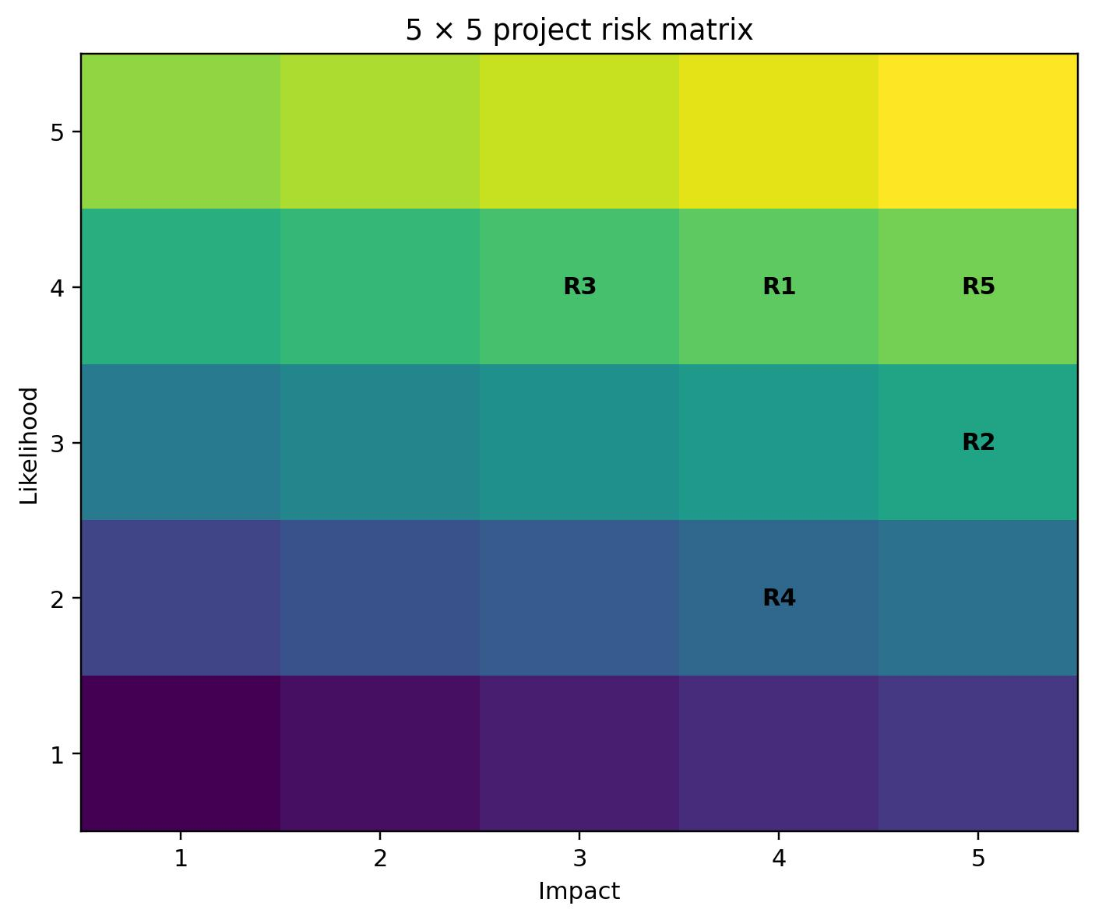
Diagram - Project risk probability-impact matrix.
Source: Author, adapted from Hillson (2009) and PMI (2021).
Mitigation would include validating baseline data before dashboard development; protecting training time; involving schedulers in design to increase ownership; maintaining a manual fallback process during the pilot; and using a small pilot group before wider deployment. Kotter (1996) argues that change is more sustainable when urgency, coalition, communication, and short-term wins are deliberately managed. This is relevant because the greatest project risk may not be technical failure but behavioural non-adoption. Risk communication must also be proportionate and regular; PMI literature emphasises that stakeholders require clear information about probability, impact, and response rather than an unfiltered list of every possible risk (Alderton, 2014).

3.7 Monitoring, Control and Project Close-down
Monitoring compares actual performance against agreed baselines and determines whether corrective action is required. The project dashboard should therefore monitor both delivery and benefits. Delivery measures include milestone status, open risks, issues, training completion, and pilot actions. Benefits measures include overdue scheduling tasks, percentage of at-risk work identified five days in advance, rescheduling frequency, SLA compliance, and stakeholder satisfaction. A simple red-amber-green status can support executive visibility, although thresholds must be defined to avoid subjective reporting.
The project manager should hold weekly reviews and use exception-based escalation where tolerances are exceeded. A change log will assess requests against scope, benefit, effort, and risk before approval. This is important because users may identify valuable enhancements during the pilot; rejecting all change would undermine learning, while accepting every request would create scope creep. The hybrid methodology allows controlled iteration inside agreed boundaries.
Project closure should confirm acceptance of deliverables, transition ownership to Operations, close outstanding actions, archive decisions, and capture lessons learned.
A formal benefits review should occur approximately three months after roll-out because operational benefits may not be visible at the point of technical completion. The project should only be considered successful if the new process is being used and performance has improved, not simply because the dashboard exists. A lessons-learned session should examine what worked, what created delay and what should be repeated in future improvement projects. Schön's (1983) reflective-practice perspective is relevant because learning from action strengthens professional judgement rather than treating project closure as an administrative endpoint.

4. Project Manager Attributes, Self-Audit and PDP

4.1 Key Attributes of an Effective Project Manager
Project managers require a combination of technical, interpersonal, and contextual capability. Technical competence includes planning, scope control, risk management, scheduling, governance, and performance measurement. Interpersonal competence includes communication, negotiation, leadership, conflict management, emotional intelligence, and the ability to build commitment across people who may not report directly to the project manager (APM, 2019; PMI, 2021). Contextual competence requires understanding organisational strategy, culture, regulation, and operational constraints.
Communication is particularly important because project managers integrate information across functions and convert uncertainty into decisions. Goleman (1998) links effective leadership with emotional intelligence, including self-awareness, self-regulation, motivation, empathy, and social skill. In a scheduling project, this means recognising that engineers, schedulers, Account Managers, and senior leaders may view the same change differently. A technically sound solution can fail if the project manager cannot explain why the change matters or manage resistance constructively.
Leadership also requires adaptability. Belbin (2010) demonstrates that effective teams benefit from complementary roles rather than one dominant capability. My natural strengths in coordination and resource investigation support stakeholder engagement, information gathering and connecting people, but project leadership also requires disciplined completion, risk challenge, and formal governance. The effective project manager therefore balances relationship-building with accountability.

4.2 Self-Audit
My current Operations Scheduler role provides a strong foundation for project management. I routinely plan complex workloads, prioritise competing demands, coordinate remote engineers, communicate with customers and internal stakeholders, respond to unexpected changes, and use SLA/KPI information to guide decisions. These experiences translate directly into project planning, stakeholder management, communication, and problem-solving. I am comfortable making time-sensitive decisions and maintaining service continuity when circumstances change.
My strongest areas are planning, communication, stakeholder coordination, leadership, and data/KPI awareness, each assessed at four out of five. I also have practical experience of risk-based thinking because scheduling requires continuous assessment of what may cause work to become overdue. However, this is often intuitive rather than documented through formal project techniques. I therefore assess formal risk management, change management and technical project tools at three out of five. I can identify operational risks and coordinate responses, but I need greater experience in structured probability-impact analysis, benefits tracking, formal change control, and software-based project planning.
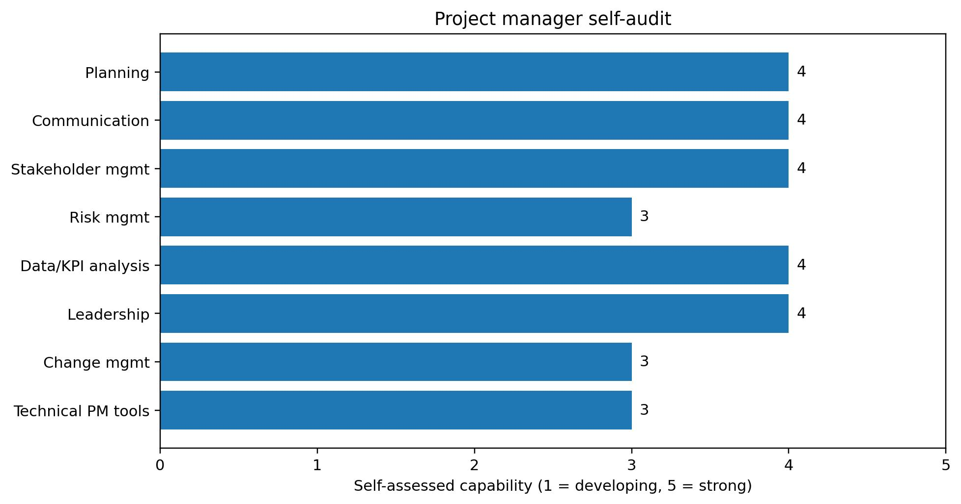
Diagram - Self-audit against key project manager capabilities.
Source: Author self-assessment, informed by APM (2019) and PMI (2021).
A further development area is moving from operational urgency to project-level strategic perspective. Scheduling rewards immediate problem resolution: project management also requires protecting time for analysis, stakeholder engagement, documentation, and future risk. My tendency to resolve issues quickly is valuable, but there is a risk of moving to action before fully testing assumptions. Kolb's (1984) experiential learning cycle suggests development occurs through experience, reflection, conceptualisation, and experimentation. Applying this deliberately would help convert operational experience into more systematic project judgement.

4.3 Personal Development Plan
Development need | Action | Timescale | Measure of success | Application
Formal risk management | Complete a recognised project risk module; use a live risk register and probability-impact matrix on an improvement project. | 0-3 months | Can facilitate a risk workshop and maintain quantified risks independently. | Apply to scheduling/SLA improvement project.
Project planning tools | Develop practical competence in Gantt, dependency and milestone planning using an approved project tool. | 0-3 months | Produce and maintain a baseline plan with dependencies and change history. | Use for pilot and roll-out planning.
Change management | Study Kotter and ADKAR principles; shadow/lead stakeholder adoption activities. | 3-6 months | Improved adoption measures and documented stakeholder feedback. | Build training and communication into process changes.
Benefits realisation | Define baselines, leading/lagging KPIs and post-project review measures. | 3-6 months | Benefits report links outputs to operational outcomes. | Track overdue tasks, SLA risk, and rescheduling.
Project leadership | Seek ownership of a cross-functional improvement project and request structured sponsor feedback. | 6-12 months | Successful delivery plus evidence of stakeholder and sponsor feedback. | Progress from operational coordination to end-to-end project leadership.
The PDP is intentionally practical. Development should not be limited to academic knowledge because project competence is demonstrated through application. Each activity therefore includes a workplace measure. Progress should be reviewed quarterly with my manager, and evidence retained through project plans, risk registers, feedback, and benefits reports. This creates a cycle of planned development, workplace application, and reflection consistent with continuing professional development principles.

5. Conclusion
This report has developed a project concept and complete management plan for improving scheduling and SLA visibility at Rock Compliance. The project addresses a genuine operational challenge: delivering reliable, compliant customer service while coordinating engineer capacity, geography, reactive work, and changing priorities. The proposed solution combines a shared visibility dashboard with standardised exception management, escalation, and communication. Its central success measure is a 20% reduction in overdue scheduling tasks, supported by earlier identification of SLA risk, user adoption, and improved stakeholder visibility.
Critical evaluation of project methodologies indicates that no single philosophy is sufficient. Predictive approaches provide the governance, scope discipline and accountability needed in a compliance environment, while agile techniques provide feedback and adaptability during design and pilot activity. A hybrid approach therefore offers the strongest fit. Similarly, tools such as the WBS, Gantt chart, RACI, stakeholder matrix, and risk register are useful because they make complexity visible and support shared decisions; however, each becomes less effective when used mechanically, maintained at excessive detail or treated as a substitute for judgement and communication.
The report also demonstrates that project success extends beyond delivery of outputs. Monitoring must include operational benefits, and closure must transfer ownership, review lessons, and confirm whether the change has improved performance. Finally, the self-audit shows that my existing experience in scheduling provides transferable strengths in planning, coordination, communication, prioritisation, and KPI awareness. Development in formal risk management, change management, benefits realisation and project tools would strengthen my ability to lead projects from concept to completion. The proposed PDP provides a structured route for converting these development needs into practical project-management capability.

6. References
Alderton, M. (2014). Explaining risk: It’s not enough to understand risk; project practitioners also must communicate it to stakeholders. PM Network, 28(1), 52–58.
Association for Project Management. (2019). APM body of knowledge (7th ed.). Association for Project Management.
Association for Project Management. (2022). Understanding agile in project management. Association for Project Management.
Association for Project Management. (n.d.). Difference between agile and waterfall approaches to project management. Association for Project Management.
Beck, K., Beedle, M., van Bennekum, A., Cockburn, A., Cunningham, W., Fowler, M., Grenning, J., Highsmith, J., Hunt, A., Jeffries, R., Kern, J., Marick, B., Martin, R. C., Mellor, S., Schwaber, K., Sutherland, J., & Thomas, D. (2001). Manifesto for agile software development. Agile Alliance.
Belbin, R. M. (2010). Team roles at work (2nd ed.). Butterworth-Heinemann.
Chapman, C., & Ward, S. (2003). Project risk management: Processes, techniques, and insights (2nd ed.). Wiley.
Deming, W. E. (1986). Out of the crisis. MIT Press.
Freeman, R. E. (1984). Strategic management: A stakeholder approach. Pitman.
Goleman, D. (1998). Working with emotional intelligence. Bantam Books.
Helms, M. M., & Nixon, J. (2010). Exploring SWOT analysis – where are we now? Journal of Strategy and Management, 3(3), 215–251.
Hillson, D. (2009). Managing risk in projects. Gower.
International Organization for Standardization. (2020). ISO 21502:2020 project, programme, and portfolio management—Guidance on project management. ISO.
Kerzner, H. (2022). Project management: A systems approach to planning, scheduling, and controlling (13th ed.). Wiley.
Kolb, D. A. (1984). Experiential learning: Experience as the source of learning and development. Prentice Hall.
Kotter, J. P. (1996). Leading change. Harvard Business School Press.
Larson, E. W., & Gray, C. F. (2021). Project management: The managerial process (8th ed.). McGraw Hill.
Maylor, H. (2010). Project management (4th ed.). Pearson Education.
Mendelow, A. L. (1991). Environmental scanning: The impact of the stakeholder concept. Proceedings of the Second International Conference on Information Systems, 407–418.
PeopleCert. (2023). Managing successful projects with PRINCE2 (7th ed.). TSO.
Project Management Institute. (2021). A guide to the project management body of knowledge (PMBOK guide) and the standard for project management (7th ed.). Project Management Institute.
Schön, D. A. (1983). The reflective practitioner: How professionals think in action. Basic Books.
Schwaber, K., & Sutherland, J. (2020). The Scrum guide: The definitive guide to Scrum: The rules of the game. Scrum.org.
Turkulainen, V., Aaltonen, K., & Lohikoski, P. (2015). Managing project stakeholder communication: The Qstock Festival case. Project Management Journal, 46(6), 74–91.
Ward, J., & Daniel, E. (2012). Benefits management: How to increase the business value of your IT projects (2nd ed.). Wiley.

