Name: Mayuri Prajapati
Student ID : 2542276
Programme: Master of Business Administration
Module: Financial Management
Lecturer: Dr Shengfeng Mei
Module code: LCMB7002
Assignment Title: Financial performance and management
STRATEGIC CFO CHALLENGE: FINANCIAL ANALYSIS AND STRATEGIC PLAN OF HILTON WORLDWIDE HOLDINGS INC.

Table of Contents
1. Financial Health Check 4
1.1 Overview of Financial Performance 4
1.2 Ratio Analysis 5
1.3 Trend Analysis 11
1.4 Strengths and Weaknesses 12
1.5 Evaluating Hilton's Performance with industry benchmark 12
2. Working Capital Management Analysis 13
2.1 Cash Operating Cycle Analysis 13
2.2 Evaluation of Current Working Capital Position 14
2.3 Working Capital Improvement Strategies 14
2.4 Financing Working Capital 15
2.5 Evaluation of Financing Choice 16
3. Strategic Financial Restructuring Plan 17
3.1 Need for Financial Restructuring 17
3.2 Proposed Restructuring Strategies 17
3.3 Impact Assessment 19
3.4 International Considerations 19
3.5 Ethical and CSR Considerations 19
4. Investment Appraisal and Capital Budgeting 21
4.1 Overview of Investment Projects 21
4.2 Assumptions 21
4.3 Investment Appraisal Techniques 22
4.4 Results and Comparative Analysis 24
4.5 Project Selection Decision 24
4.6 Capital Rationing Decision (£100 Million Budget) 25
4.7 Consideration of Non-Financial Factors 25
5. Conclusion 27
5.1 Tool Disclosure 27
5.2 Critical Evaluation of AI Output 27
5.3 Contribution Analysis 27
5.4 Ethical and Professional Reflection 28
Reference List 29
Appendices 35
Appendix A: Financial Ratio Tables 35
Appendix B: Financial Statements (2021–2025) 38
Appendix C: Working Capital Calculations 51
Appendix D: Investment Appraisal Calculations 51

1. Financial Health Check

1.1 Overview of Financial Performance
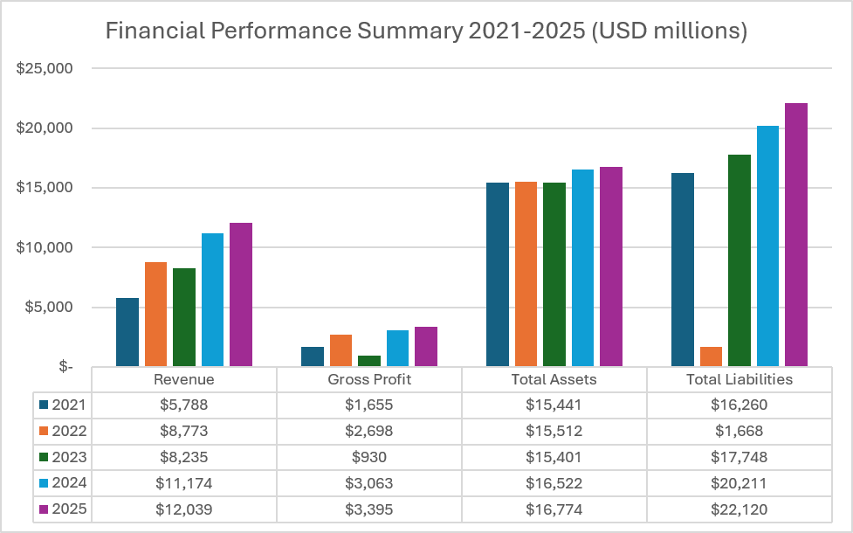
Figure 1: Overview of Financial Performance
Hilton Worldwide holdings, Inc. enjoyed robust financial growth in 2021-2025 following a recovery in global tourism and business travel. Revenue rose to $12.04 billion in 2025, up 108 per cent on $5.79 billion in 2021. Gross profit increased to $3.40 billion as compared to $1.66 billion and the EBIT increased to $2.69 billion as compared to $1.01 billion. The net income grew way upwards to $1.46 billion as compared to $407 million, which indicates better operation in spite of increased financing costs. There was also an increment in total assets to $16.77 billion (as compared to $15.44 billion), which shows the further investment and expansion of businesses (Hilton, 2022; Hilton Worldwide Holdings Inc., 2023; Hilton Worldwide Holdings Inc, 2025).

1.2 Ratio Analysis

1.2.1 Profitability Ratios
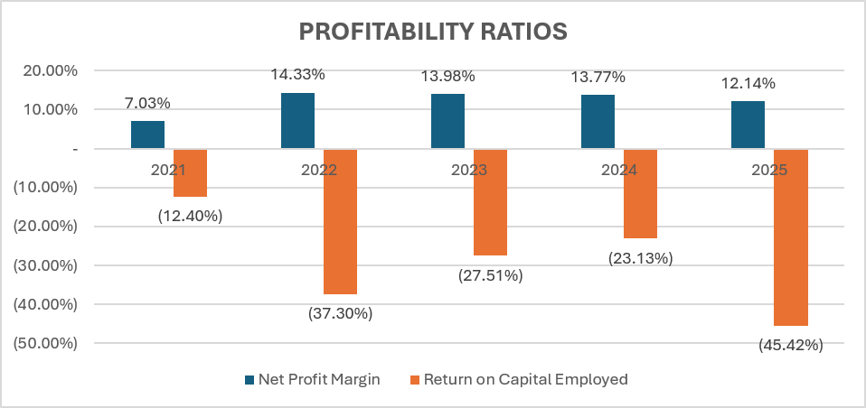
Figure 2: Profitability Ratios
The profitability of Hilton had been on an upward trend. Gross profit margin increased from 28.6% in 2021 to 30.8% in 2022 before easing to 28.2% in 2025. EBIT margin was improved by 17.4 percent to 22.4 percent and net profit margin was improved by 7.0 percent to 12.1 percent which shows positive earnings. Return on Assets (ROA) was increased by a margin of 2.6% to 8.7, indicating better usage of the assets. Though the Return on equity (ROE) had been negative due to the presence of negative shareholders in terms of shareholders equity, Return on Capital Employed (ROCE) rose by 8.1 percent to 22.0 percent which implied that the long-term capital was used more optimally. The EBITDA margin also improved and rose to 23.8 as opposed to 20.7 and this is an indication of better operating efficiency (Hilton, 2022; Hilton Worldwide Holdings Inc., 2023; Hilton Worldwide Holdings Inc, 2025).

1.2.2 Liquidity Ratios
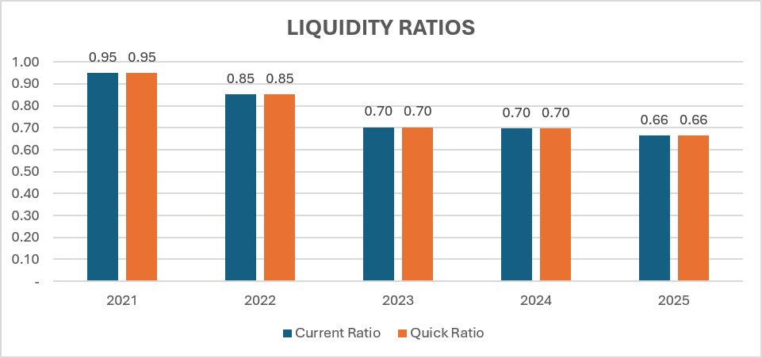
Figure 3: Liquidity Ratios
The liquidity ratios were lower and below the conventional levels in Hilton. The current ratio of 0.95 in 2021 decreased to 0.66 in 2025 with the quick ratio similarly decreasing because there were low levels of inventories. The cash ratio went down to 0.20, 0.47 to indicate less in terms of cash in comparison with current liabilities. The net working capital also worsened to negative $148 million and negative $1.51 billion (Hilton, 2022; Hilton Worldwide Holdings Inc., 2023; Hilton Worldwide Holdings Inc, 2025). These weak liquidity measures are however minimized by the asset light business model and the stable operating cash flows of Hilton (Simply Wall St, 2026).

1.2.3 Efficiency Ratios
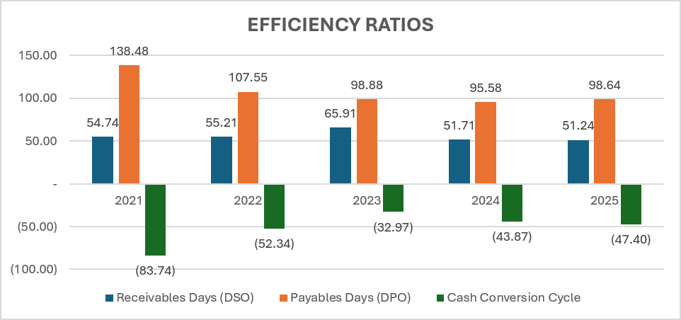
Figure 4: Efficiency Ratios
The efficiency of operations increased over the period of five years. Asset turnover rose by 0.37 to 0.72, which is a sign of a better utilisation of the company assets. The turnover of receivables increased by 5.42 to 7.12 and Days Sales Outstanding reduced by 67.3 days to 51.2 days which is a faster collection. Payables Days. Payables Days also decreased by 138.5 days to 98.6 days (Hilton, 2022; Hilton Worldwide Holdings Inc., 2023; Hilton Worldwide Holdings Inc, 2025). Hilton also had a negative Cash Conversion Cycle which showed that customer receipts were still funding day-to-day operations as well as supporting healthy operating cash flows (Alameri et al., 2021).

1.2.4 Gearing (Leverage) Ratios
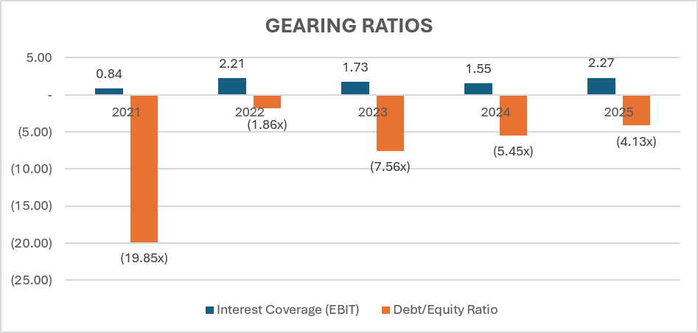
Figure 5: Gearing (Leverage) Ratios
Hilton remained and was relatively geared. In the future the long-term debt rose to $12.34 billion in 2025 compared to $8.71 billion in 2021. The negative shareholder equity also minimized the utility of debt-to-equity ratio due to repeated buying of shares. However, interest coverage rose as 2.54 times to 4.34 times, which demonstrates increased debt-servicing power due to an improved operating profits (Hilton, 2022; Hilton Worldwide Holdings Inc., 2023; Hilton Worldwide Holdings Inc, 2025). All in all, Hilton has been able to have a manageable leverage position as it has had a steady increase in earnings and a strong cash flow (Hilton, 2026).

1.2.5 Investment or Market Ratios
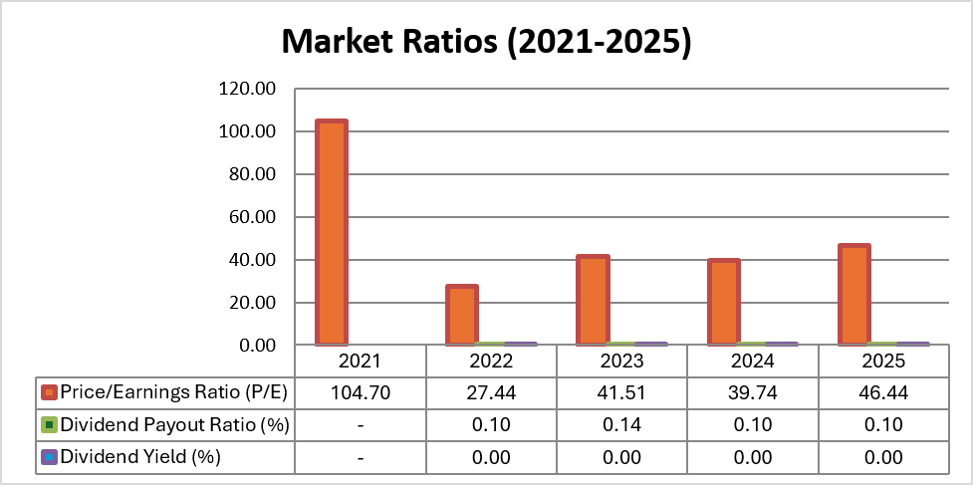
Figure 6: Investment or Market Ratios
The investment and market ratios of Hilton indicate that its shareholders have value growth between 2021 and 2025. Earnings per Share (EPS) was raised to $1.14 to $6.17, as the net income rose, and share shares remained being bought off that decreased the number of outstanding shares. The dividends per Share (DPS) went up as well to $0.80 as against $0.60 as the management was confident in the ability to generate sustainable cash. The dividend payout ratio was moderate so that Hilton could be able to compensate shareholders but still had enough earnings to spend on strategic expansion and debt repayment (Hilton, 2022; Hilton Worldwide Holdings Inc., 2023; Hilton Worldwide Holdings Inc, 2025). The P/E does not show substantial fluctuations in the market, indicating the confidence of the investors.

1.2.6 Cash Flow Analysis
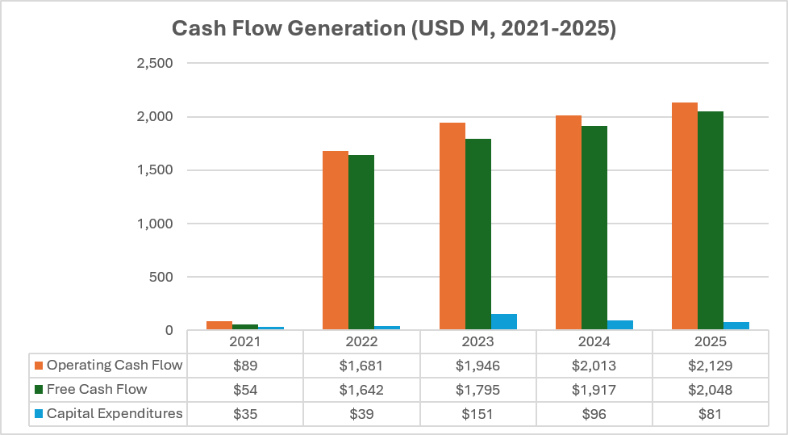
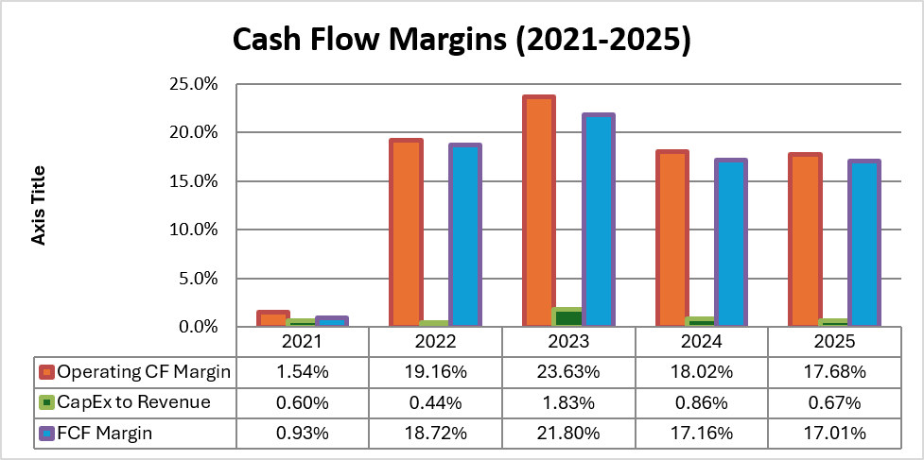
Figure 7: Cash Flow Analysis
Hilton generated high operating cash flows over the period of five years which funded the investment and financing activities. Profitability improved, resulting in net cash in operating activities rising by about $1.19 billion in 2021 to $2.69 billion in 2025. Cash flow investment was still taken as negative due to capital expenditure, technological investments, and in support of hotel development, and due to the asset-light business model, capital requirements are low as compared to traditional hotel owners (Hilton, 2022; Hilton Worldwide Holdings Inc., 2023; Hilton Worldwide Holdings Inc, 2025). Financing cash flows were mostly negative as Hilton kept on paying dividends, repurchasing shares, and paying debt (Yahoo Finance, 2025).

1.3 Trend Analysis
Figure 8: Trend Analysis
The financial performance of Hilton shows three definite stages. The first period was 2021-2022, which was a period of recovering after the pandemic, with international travel being back, which brought a higher revenue at a rate of over three-thirds and increased operating rates. In the second phase, 2023-2024, increased growth was seen due to the rising leisure demand, recuperation of business travel, increasing average daily room rates, and further expansion of franchises (Müller, 2026). The net income amounted to more than $1.5 billion during this period, and operating cash flow has increased significantly. The last stage, 2025 shows business stabilisation as revenue is $12.04 billion and profitability is still strong, even with the pressures of inflation, high labour costs and increasing costs of borrowing. In spite of weakened liquidity ratios and negative shareholder equity, Hilton was still getting its operations more efficient and profitable and to use its assets better, which meant that the company was successfully transferring to recovery to sustainable long-term development (Hilton, 2026b).

1.4 Strengths and Weaknesses
Strengths: Hilton Worldwide Holdings, Inc. has a number of financial strengths that help it to be competitive within the long term. The raising of the revenue to $12.04 billion in 2025 compared to $5.79 billion in 2021 and the rise of the net profit margin to 12.1% against 7.0% indicate the improved efficiency of the operations. ROCE increased by 22.0% to 8.1, and asset turnover nearly doubled by 0.37 almost 0.72 showing that it utilised the long-term capital from a better standpoint. Good operating cash flows also facilitate growth, debt repairs and dividends to shareholders (Olaoluwa Fowosere and Mohammed, 2024). Hilton also has an asset-light business model that limits its capital investment and produces consistent income in the form of franchise and management fees (Umbrex, 2026).
Weaknesses: But there are also various weaknesses of the company. The current ratio has gone down to 0.66 and is thus relatively low in the sense of short term liquidity but the shareholder equity is negative so the short term leverage ratios are not useful as such. Throughout the period, long-term debt was growing, which exposes Hilton to a cost of increased financing operation, especially when the interest rate is high. In addition, the decreasing amount of cash can lead to a decrease in financial flexibility in the case of negative market conditions (Santos et al., 2024).

1.5 Evaluating Hilton's Performance with industry benchmark
Hilton's liquidity ratios are below conventional hospitality industry standards. Current ratio of the company was 0.66 with quick ratio being 0.66 in 2025 which is lower than the industry standard of about 1.0-1.2 times. These ratios show relatively lower liquidity in the short term as the current liabilities are higher than the current assets. Nevertheless, the performance of Hilton needs to be viewed in the framework of its asset-lite business model that yields consistent franchise fee and management fee revenues with minimal inventory needs (Hilton Worldwide Holdings Inc, 2025). Stable operating cash flows and cash conversion cycle having consistently negative values, Hilton can run smoothly with significant liquidity ratios below industry norms and thus the risk of short term financial stress decreasing.

2. Working Capital Management Analysis

2.1 Cash Operating Cycle Analysis
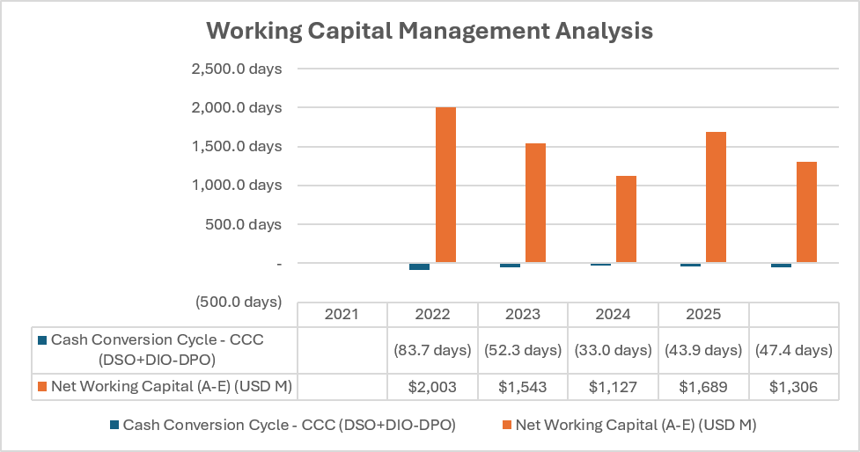
Figure 9: Working Capital Management Analysis
The Hilton cash operating cycle shows the effective management of working capital over the year 2021-2025. As the firm uses asset light hotel franchise and management system, it does not have inventories hence Days Inventory Outstanding (DIO) does not apply. As a result, Days Sales Outstanding (DSO)- Days Payables Outstanding (DPO) are used to determine Cash Conversion Cycle (CCC). DSO dropped to 51.2 days in 2025 compared to 67.3 days in 2021 as the company collects the receivables of the hotel owners and franchisees quicker. Despite a decline of DPO that was 138.5 days to 98.6 days, Hilton had a negative CCC all over the review period, with a range of -71.1 days to -47.4 days. The achieved negative trend in the cash conversion cycle implies that the company accommodates cash flow prior to paying them off to suppliers and, thus, minimizes financial needs and enhances the liquidity of operations (Ghosh, 2022; Ali, 2024).

2.2 Evaluation of Current Working Capital Position
Table 1: WORKING CAPITAL MANAGEMENT ANALYSIS
The working capital position of Hilton was negative in all the five years. Compared to the increase in current assets by $2,871 million to $2,996 million between 2021 and 2025, current liabilities grew significantly by $3,019 million to $4,508 million between 2021 and 2025. As a result net working capital dropped to negative $1,512 million as compared to negative $148 million. On the same note, the current ratio and the quick ratio also dropped by 0.95 times to 0.66 times which means that short-term liabilities surpassed current liabilities. Although all these ratios would present an opinion of liquidity problem, Hilton is not a typical hotel ownership company (Austin and Phalippou, 2022). The company is able to perform operations albeit having negative working capital due to constant management fee, franchise revenue and consistent operating cash flows.

2.3 Working Capital Improvement Strategies

2.3.1 Cash Management
Hilton must ensure that it is well liquidated by enhancing cash forecasting as well as treasury management. Any excess cash ought to be invested in the interest-bearing short-term instruments and have enough cash reserves to cater to seasonal changes, debt payment and the long run growth. Better predicting also maximises sitting cash and boosts returns on liquid assets (Barnabas and Oloyede, 2025).

2.3.2 Receivables Management
The reduction in DSO is an indication of an increase in collection efficiency. Hilton should proceed with automated invoicing and digital payment systems and increasing credit coverage to reduce even further the time to collect (Nuno, 2026). The routine check of the franchisees pay performance would reduce the outstanding balances and enhance operating cash inflows.

2.3.3 Payables Management
Despite the drop in DPO during the period of review, Hilton must negotiate favourable terms of payment with suppliers and still ensure good commercial relations. Prolonging payment to where warranted without compromising the trust of the supplier would maintain the liquidity and the negative cash conversion cycle would be further entrenched in the company (Krieger, 2025).

2.4 Financing Working Capital

2.4.1 Short-Term Financing Options
Option | Cost | Flexibility | Risk | Best Use
Trade Credit | No direct financing cost | High | Low | Managing routine operating expenses and supplier payments (Vora, 2026)
Bank Overdraft | Variable interest rate | Very High | Medium | Covering temporary cash shortages and seasonal fluctuations
Revolving Credit Facility | SOFR + lending margin | High | Low | Maintaining liquidity and emergency funding requirements (BBVA, 2025)
Commercial Paper | Lower than bank borrowing | Medium | Medium | Short-term corporate funding for working capital needs
Table 2: Short-Term Financing Options

2.4.2 Long-Term Financing Options
Option | Cost | Maturity | Risk | Best Use
Corporate Bonds | Fixed interest rate | 5–10 years | Low | Long-term expansion and refinancing existing debt
Sustainability-Linked Loans | Floating rate | 3–7 years | Medium | ESG initiatives and technology investments (Chura, 2026)
Equity Financing | No repayment obligation | Permanent | Low | Strategic acquisitions and major expansion projects
Term Loans | Fixed or variable interest | 5–8 years | Medium | Capital investment and refinancing (SoFi, 2020)
Table 3: Long-Term Financing Options

2.5 Evaluation of Financing Choice
A balanced financing structure is the most appropriate financing structure to embrace by Hilton. The main source of working capital funding needs to be strong operating cash flows obtained as a result of its franchise and management business. Short term financing instruments will be provided and revolving credit facilities and trade credit in particular released to satisfy the short term liquidity requirement but not financial commitments of the long term (Hilton Worldwide Holdings Inc, 2025). The Hilton needs to be reliant on corporate bonds and sustainability-linked loans to continue growing strategically, refinancing and investing in technology as long as the firm is able to access relatively cheap financing and achieve the objectives of funding environmental activities (Osman Ahmed El-Said et al., 2024).

3. Strategic Financial Restructuring Plan

3.1 Need for Financial Restructuring
Hilton Worldwide Holdings Inc. is operationally sound, but it needs to undergo specific financial restructuring that would enable it to attain sustainable long-term growth and increase its flexibility on the balance sheet. Between 2021 and 2025, the long-term debt increased by $3.63 billion to $12.34 billion, and the current ratio has decreased to 0.66, although it was 0.95 in 2021, which means that the company is more dependent on debt and suffers poor short-term liquidity.

3.2 Proposed Restructuring Strategies

3.2.1 Capital Structure Optimisation
Hilton need not be in a hurry to deleverage itself but allocate a higher proportion of operating cash flow to cut on high cost debt. The company ought to convert short term maturities into long run low coupon instruments wherever the market allows to reduce interest charge and to smooth out the maturity structure. The disciplined range of target leverage, based on EBITDA and cash production, will assist in regaining investor confidence and enhance credit ratings without limiting growth (Velickovic, Stanojevic and Veselinovic, 2023).

3.2.2 Asset-Light Expansion Strategy
The asset-light model where the franchise and management and not essence ownership are used to multiply should be at the center. This will reduce the amount of capital outlay, save cash and raise recurring fees. Hilton has the opportunity to expand internationally and reduce the risks of being exposed to the balance sheet since it has more than 527,000 rooms in the global development pipeline in 2026 (Business Wire, 2026). Disposition of non-core owned assets can also be selected to further increase liquidity and redeploy capital to more lucrative and fee-based programs.

3.2.3 Strategic Partnerships, Acquisitions and Joint Ventures
The joint venture and strategic partnership with developers and institutional investors will shorten the process of entering new markets in high-growth markets like Asia-Pacific, Middle East, and Africa and share the risk of investments (Janberg, 2024). The mix of cash, debt and selective equity or hybrid instrumentation should be used to fund targeted acquisitions that improve distribution, loyalty, or digital capabilities to prevent over leverage.

3.2.4 Equity or Capital Raising Strategy
Although the cash flow of Hilton is high, the selective issuance of equity or hybrid funds is perhaps suitable towards transformational investments- digital platforms, loyalty upgrades, or big strategic acquisitions. The equity or any hybrid issuance must be tuned to the lowest possible shareholder dilution and maintain the flexibility such that proceeds are used to finance growth that can clearly raise the long-term free cash flow (Research and Markets, 2024).

3.3 Impact Assessment

3.3.1 Shareholder Value
A better way to remodel is to focus on a system that lowers financing expenses and moves towards a greater focus on fee-driven growth; this should increase profitability and free cash flow to support dividends and disciplined share buybacks over time. The projections of net income of $1.911.94 billion over 2026 and the ongoing recovery of the RevPAR also offer a basis on which Hilton can create the value in the future (Tulum and Maya, 2023). The increased predictability through franchise revenues will diminish the changeability in earnings and underpin a more tenable valuation multiple.

3.3.2 Debt Structure
Refinancing risk and interest expense will be reduced through improvement of the debt profile through extension of maturities and substitution of high-cost borrowings. The net debt of approximately $11.8 billion and a net leverage of approximately 3.1X EBITDA (per 2026 projection) give it the opportunity to deleverage materially and control maturities, which will mean better credit ratios and get access to capital markets at favourable rates.

3.3.3 Operational Flexibility
The resilient balance sheet is contributing to the ability of investing in technology, sustainability and overseas growth. The asset-light model would reduce capital intensity, enabling Hilton to enhance the brand, customer experience and digital innovation and keep the cash liquid to make opportunistic investments (BCG Global, 2023).

3.4 International Considerations
This system is exposed to currency risk in the international presence of Hilton, changes in the taxation system including the minimum tax in the OECD, long term inflationary pressures of labour and input prices. Downside risks to demand are geopolitical tensions and disruptions to travel. The appropriate application of currency hedging, tax planning and local costs will be required in order to cushion margins and translated earnings (Jelski, 2026).

3.5 Ethical and CSR Considerations
Restructuring should be based on the ESG commitments of Hilton. Further investments in energy efficiency, responsible sourcing, employee welfare, diversity and community programmes will ward off reputation and regulatory position. Reporting sustainability in capital allocation will increase long run resilience, attract responsible investors and ultimately enhance the competitiveness of Hilton in the global hospitality sector (Conrad and Arzana, 2024).

4. Investment Appraisal and Capital Budgeting

4.1 Overview of Investment Projects
Table 4: Project Cash Flow Schedules (£ Millions)
There are three mutually exclusive investment projects that have been suggested to be allocated in the capital of Hilton. They need the same initial investment of 50 million pounds, but the projects are themselves materially different in terms of their cash inflow velocity shapes in the five year horizon. Project A is rising followed by a fall that adds up to £54m, Project B is a flat-rate annuity of £11m per year which adds up to £55m, and Project C is heavily-back-loaded with the highest inflow in Year 4 of cumulative inflows totalling £65m. This section will be aimed at an evaluation of every option based on conventional capital budgeting methodologies, and propose a course of action that is also aligned with Hilton financial profile.

4.2 Assumptions
Table 5: Discount Factors
The appraisal uses a discount rate of 8 percent, which is the weighted cost of capital that has been adjusted to the hotel-sector risk of Hilton. The straight-line depreciation is applied over the five-year life of each project and the investment of £50m is written down to zero salvage value producing a depreciation charge of 10m/year. The approaches to cash flows include treating cash flows as accruing at the end of every period, assuming an identical taxation impact on the project, and assuming a constant inflation (Hilton, 2025). Figures are all in pounds sterling. To maintain comparability, the 8% hurdle rate is consistently used in NPV, PI and IRR calculations.

4.3 Investment Appraisal Techniques

4.3.1 Payback Period (PBP)
Table 6: Payback Period (PBP)
PBP quantifies the rate of breaking even of every project. Project A will recover its money of £50m in about 4 years and 6 months, Project B in 4 years and 7 months and Project C in 3 years and 7 months. Project C is quickest nearly one-year ahead of the other due to its solid Year 3 and Year 4 inflows. PBP will approach scenarios that favour liquidity and reducing risk, but neglects cash flows after the recovery point and not discounting time (Oyetola Oyelakun et al., 2025). Project C being the least exposed to long-horizon uncertainty is identified as such by the screening tool.

4.3.2 Accounting Rate of Return (ARR)
Table 7: Accounting Rate of Return (ARR)
ARR is a statement of the average annual accounting profit as a percentage of the average investment (£25m under straight-line depreciation). Project A yields an ARR of 3.2%, Project B 4.0%, and Project C 12%. The ARR of project C is greater than its competitors since the cumulative inflows make a cumulative accounting profit of this project as £13m in the five years thus this can be converted into the average annual profit as £2.6m. ARR is consistent with reported earnings but does not consider timing of cash flows, cost of capital thus needs to be used in conjunction with discounted indicators and not independently (Fisher, 2024).

4.3.3 Net Present Value (NPV)
Table 8: Net Present Value (NPV)
The main decision criterion in capital budgeting is NPV as it quantifies the absolute worth which is added to shareholders at the required rate of return. When discounted at 8 percent, the cash flows of the projects will result as depicted below. Project A has the negative NPV of -£6.54m and would be value destroying. Project B generates a negative of -£6.08m. Project C generates the highest, comfortably, of the three funds 0.26m. The back-loaded profile of the project C has the advantage of the compounding effect of the high inflows in Years 3 and 4 after discounting. On a naked NPV basis, Project C is the unquestionably strongest.

4.3.4 Profitability Index (PI)
Table 9: Profitability Index (PI)
PI puts forward the value of inflows/pounds invested, this is mainly valuable where the restricted capital budget applies. Project A has a PI of 0.8691x, suggesting value destruction and Project B is just below unity of 0.8784x. Project C is the top in 1.0172x as it brings forth a present value of 1.17 on each pound invested. In the current situation, PI prioritizes projects sequentially as NPV, but its per pound framing becomes the determinant in a subsequent capital rationing exercise that ensues in section 5.6 below (CFI Team, 2023).

4.3.5 Internal Rate of Return (IRR)
Table 10: Internal Rate of Return (IRR)
IRR determines the discount rate at which the net present value of each project is zero. The IRR of Project A is about 2.72%, Project B is 3.26% and Project C is 8.59%. In pure terms of IRR, Project C will again lead out by a wide margin as compared to the two projects. The IRR is also intuitive in the sense that it is written in the form of percentage of returns but it is deceptive where the profiles of cash flows vary markedly, such as is the case here (Wilson, 2025). Since the three projects are equally big in nature, NPV must be adopted as the winning tool.

4.4 Results and Comparative Analysis
Bringing together the five techniques, Project C tops all the single measures; fastest PBP 3 years 7 months, highest ARR 12%, largest NPV of 0.86m, highest PI 1.0172x, and highest IRR of 8.59%. Project B comes way behind, generating a mere positive NPV, and PI slightly greater than 1.00x. Project A is prevailing in all parameters and would diminish shareholder value. The difference between the ranking of the two discounted measures and non-discounted measures gives a lot of confidence to the conclusion and removes the uncertainty that is sometimes presented by non-agreement between NPV and IRR measures (Imarticus, 2024).

4.5 Project Selection Decision
It can be recommended that Project C standalone be selected. Hilton is currently financially sound which makes this recommendation stronger. The Hilton operations margin of 22.4% and EBITDA margin of 23.8% and free cash flow of UK2,028 million give Hilton the sufficient room to finance a 50m project internally. The interest coverage ratio of 4.34 times indicates that the debt servicing is comfortable and the current ratio of 0.66 times, as is usual with operators of hotel high deferred revenue balances, does not actually constitute a liquidity constraint. The smaller payback and bigger NPV of project C also fits into a company that would take back the capital aggressively to the share holders as with shorter payback flexibility remains as they can give back with further buybacks and dividends (Syaiful, 2025).

4.6 Capital Rationing Decision (£100 Million Budget)
Table 11: Capital Rationing
Only two of the three close to half of the projects amounting to 50 m can be pursued under a ceiling of less than 100 million. The A+C combination would give a smaller cumulative NPV of or less 0.86, since Project A will create negative value to C, a-bit, and therefore, this should be discarded straight away. A+B will have a cumulative NPV of negative 12.62m and this should be jettisoned. B+C thus will maximise value creation within the constraint to meet the NPV rule, and the per-pound efficiency of PI-based rationing.

4.7 Consideration of Non-Financial Factors
There are non-financial risks that make the recommendation strong in addition to the quantitative case. The future cash flows of project C rely on the maintenance of travel demand which leaves it vulnerable to political and macro economic risks like changes in regulations, restrictions on travel and geopolitical conflicts in major markets. This is partly offset by the global brand recognition that Hilton has, the number of its Hilton Honors loyalty members (over 220 million) and the diverse geographic presence which diversifies country-specific risk. The reputational and ESG and customer loyalty factors combined with the resilience shown in the recent industry cycles also justify the effort of pursuing a growth orientated, back loaded project like Project C in addition to the more stable annuity character of Project B in capital rationing scenario (Ahmed and Khalaf, 2025).

5. Conclusion

5.1 Tool Disclosure
In the creation of this report, Artificial Intelligence (AI) was only utilized to take care of the proofreading. Namely, AI was used to test grammar, spelling, sentence organization, punctuation, and overall clarity of the language to enhance the clarity and presentability of the report. None of the AI generated financial and computation, interpretation, recommendations and strategic analysis were directly included in the final submission. This modest use has been reported by filling in the AI Use Acknowledgement to acknowledge the academic integrity requirements (Auro del Giglio and Mateus, 2023). All the financial computations, ratio analysis, investment assessment/assessment and strategic inference were done on their own through the published financial statements of the company on their own and with the assistance of the academic reference material.

5.2 Critical Evaluation of AI Output
Regardless of the fact that AI was involved only in the process of proofreading, any proposed grammatical and stylistic changes were thoroughly checked before rest. All the recommendations were cross-verified so that the original meaning of the analysis was not distorted and that the financial terms and technical interpretation was not changed falsely. Given that no AI was employed in the creation of financial analysis, the chances of factual errors or even hallucinated finances were low (Belanche, Casaló and Flavián, 2026). However, all numerical values, ratios, calculations, and interpretation included in this report underwent independent verification with annual reports of Hilton Worldwide Holdings Inc., and calculated financial ratios, and the supporting academic literature (Alameri et al., 2021). Any suggestion in proofreading that modified the desired meaning, or which modified technical terminology, or which lowered the level of analytical precision, was discarded to ensure the report was accurate and consistent.

5.3 Contribution Analysis
The author is the original author of the report. The entire calculations and analysis of the financial ratios, working capital, investment appraisals, strategic financial restructuring plans, critical analysis, and recommendations were all made by the author without any author contribution and without the input of referring to the working capital, annual report of Hilton Worldwide Holdings Inc. or any other academic sources (Martinho, 2021). Financial arguments were not developed using artificial intelligence, nor were the results of the study or conclusions formulated through artificial intelligence. It only proofread, which entailed tracking down of grammar flaws, bettering the writing process, increasing our readability, and making the report overall more presentable. Consequently, all the analytical material, critical analysis, strategic syntheses, interpretations, conclusions and final statements are solely of intellectual input of the author and reflect a responsible approach to research and adherence to institutional academic integrity policies (AllahRakha, 2026). It has been done through clear disclosure of AI use in accordance with university guidelines during the evaluation process and submission policies.

5.4 Ethical and Professional Reflection
In both academic and professional financial practice, responsibility as of AI use is necessary. AI as a tool only to aid in proofreading does not affect academic integrity or independent critical thinking. It is essential to be transparent in terms of the use of AI to be honest and preserve trust in the originality of the work provided (Deep and Chen, 2025). Moreover, sensitive financial data must never be disregarded in order to ensure organisational data privacy as well as adhere to professional practice. When making executive-level decisions, financial professionals must not over-use AI because strategic financial planning involves professional judgement, ethical decision-making, and situational analysis that cannot be automated by automated systems (Diro et al., 2025). Thus, AI needs to be considered as a complementary tool to enhance written communication, but it is not a replacement of independent financial analytical research.

Reference List
Ahmed, O. and Khalaf, B.A. (2025) “The Impact of ESG on Firm Value: The Moderating Role of Cash Holdings,” Heliyon, 11(2), p. e41868. Available at: https://doi.org/10.1016/j.heliyon.2025.e41868.
Alameri, M., Alshamsi, F., Alsaedi, S., Alkaabi, A., Alamri, R., Alshamsi, M. and Nobanee, H. (2021) “Financial Analysis of Hilton Holdings,” SSRN Electronic Journal [Preprint]. Available at: https://doi.org/10.2139/ssrn.3930493.
Ali, R. (2024) Hospitality Financial Management: A Complete Guide, Oracle NetSuite. Available at: https://www.netsuite.com/portal/resource/articles/financial-management/hospitality-financial-management.shtml
AllahRakha, N. (2026) “Accuracy, reliability, and regulatory concerns in the use of AI tools in education and research,” Social Sciences & Humanities Open, 14, p. 103102. Available at: https://doi.org/10.1016/j.ssaho.2026.103102.
Auro del Giglio and Mateus (2023) “The use of artificial intelligence to improve the scientific writing of non-native english speakers,” Revista Da Associacao Medica Brasileira, 69(9). Available at: https://doi.org/10.1590/1806-9282.20230560.
Austin, N. and Phalippou, L. (2022) “Decomposing value gains – The case of the best leveraged buy-out ever,” Journal of Corporate Finance, 81, p. 102317. Available at: https://doi.org/10.1016/j.jcorpfin.2022.102317.
Barnabas, B. and Oloyede, J. (2025) “Cash Flow Optimization: Strategies for Enhancing Short-Term Liquidity,” Cash Flow Optimization: Strategies for Enhancing Short-Term Liquidity [Preprint]. Available at: https://doi.org/10.2139/ssrn.5004465.
BBVA (2025) What is a RCF or Revolving Credit Facility?, NEWS BBVA. BBVA. Available at: https://www.bbva.com/en/economy-and-finance/what-is-a-rcf-or-revolving-credit-facility/
BCG Global (2023) A Resilient Balance Sheet Pays Off in Uncertain Times, BCG Global. Available at: https://www.bcg.com/publications/2023/why-a-resilient-balance-sheet-is-critical-to-creating-value
Belanche, D., Casaló, L.V. and Flavián, C. (2026) “When AI Fails: The Impacts of Hallucinations and Service Errors on Customer Loyalty and Word of Mouth,” Journal of Travel Research [Preprint]. Available at: https://doi.org/10.1177/00472875261456334.
Business Wire (2026) Hilton Reports First Quarter Results; Raises Full Year Outlook. Available at: https://www.businesswire.com/news/home/20260428679863/en/Hilton-Reports-First-Quarter-Results-Raises-Full-Year-Outlook.
CFI Team (2023) Net Present Value Rule, Corporate Finance Institute. Available at: https://corporatefinanceinstitute.com/resources/valuation/net-present-value-rule/
Chura, S. (2026) Overview of sustainability-linked loans – Vinod Kothari Consultants. Available at: https://vinodkothari.com/2024/03/overview-of-sustainability-linked-loans/
Conrad, R. and Arzana (2024) Travel with Purpose 2024 Report. Available at: https://travelwithpurpose.hilton.com/wp-content/uploads/sites/4/2025/06/2024Report.pdf
Deep, P. Das and Chen, Y. (2025) “The Role of AI in Academic Writing: Impacts on Writing Skills, Critical Thinking, and Integrity in Higher Education,” Societies, 15(9), pp. 247–247. Available at: https://doi.org/10.3390/soc15090247.
Diro, A., Kaisar, S., Saini, A., Fatima, S., Hiep, P.C. and Erba, F. (2025) “Workplace security and privacy implications in the GenAI age: A survey,” Journal of Information Security and Applications, 89, pp. 103960–103960. Available at: https://doi.org/10.1016/j.jisa.2024.103960.
Fisher, R. (2024) What Is Accounting Rate of Return (ARR): Formula and Examples, Www.highradius.com. Available at: https://www.highradius.com/resources/Blog/accounting-rate-of-return-arr/
Ghosh, N. (2022) What is Cash Conversion Cycle (CCC)? – Formula & Calculation. Available at: https://www.highradius.com/resources/Blog/what-is-cash-conversion-cycle/
Hilton (2022) Hilton 2022 year in review, Stories from Hilton. Available at: https://stories.hilton.com/2022-annual-report
Hilton (2025) Responsible Business. Available at: https://travelwithpurpose.hilton.com/wp-content/uploads/sites/4/2025/06/Risk-Management.pdf
Hilton (2026a) Hilton Reports First Quarter Results; Raises Full Year Outlook. Available at: https://ir.hilton.com/~/media/Files/H/Hilton-Worldwide-IR-V3/quarterly-results/2026/q1-2026-earnings-release.pdf
Hilton (2026b) Investor Presentation. Available at: https://ir.hilton.com/~/media/Files/H/Hilton-Worldwide-IR-V3/presentations/hlt-investor-presentation-february-2026.
Hilton Worldwide Holdings Inc. (2023) Hilton Worldwide Holdings Inc. 2023. Available at: https://stories-editor.hilton.com/wp-content/uploads/2024/04/2023-Annual-Report-10-K.pdf
Hilton Worldwide Holdings Inc (2025) Hilton Worldwide Holdings Inc. 2025. Available at: https://stories-editor.hilton.com/wp-content/uploads/2026/03/Hilton-2025-Annual-Report-SEC-Form-10-K.pdf
Imarticus (2024) Discounting vs. Non-Discounting Methods: Which is Better for Capital Budgeting?, Finance, Tech & Analytics Career Resources | Imarticus Blog. Imarticus Learning. Available at: https://imarticus.org/blog/capital-budgeting-methods/
Janberg, W. (2024) Hilton’s Strategic Expansion in Asia Pacific: A Vision for Growth, ReportLinker. Available at: https://www.reportlinker.com/article/8138
Jelski, C. (2026) Hilton braces for ripple effects from Iran war, Travelweekly.com. Travel Weekly. Available at: https://www.travelweekly.com/travel-news/hotel-news/hilton-braces-for-ripple-effects-from-iran-war
Krieger, A. (2025) A Strategic Audit of Hilton Hotels A Strategic Audit of Hilton Hotels. Available at: https://digitalcommons.unl.edu/cgi/viewcontent.cgi?article=1849&context=honorstheses
Martinho, V.J.P.D. (2021) “Bibliometric Analysis for Working Capital: Identifying Gaps, Co-Authorships and Insights from a Literature Survey,” International Journal of Financial Studies, 9(4), p. 72. Available at: https://doi.org/10.3390/ijfs9040072.
Müller, R. (2026) Hilton Worldwide stock reflects global hotel recovery amid steady US travel demand, Hilton Worldwide stock reflects global hotel recovery amid steady US travel demand. ad-hoc-news.de. Available at: https://www.ad-hoc-news.de/boerse/news/ueberblick/hilton-worldwide-stock-reflects-global-hotel-recovery-amid-steady-us/69737600
Newsdesk (2026) Hilton (HLT) Has a Fee-and-Loyalty Engine Bigger Than a Hotel-Cycle Trade, Alphastreet - Earnings Decoded. Market Intelligence Delivered. Available at: https://news.alphastreet.com/hilton-hlt-has-a-fee-and-loyalty-engine-bigger-than-a-hotel-cycle-trade/
Nuno (2026) Understanding days sales outstanding (DSO) in accounts receivable: Why it matters, Serrala. Available at: https://www.serrala.com/blog/understanding-days-sales-outstanding-in-accounts-receivable-and-why-it-matters
Olaoluwa Fowosere and Mohammed, S.A. (2024) Comparative Financial Performance and Social Impact in the Global Hospitality Industry: Evidence from Marriott International and Hilton Worldwide. Available at: https://www.researchgate.net/publication/399899124_Comparative_Financial_Performance_and_Social_Impact_in_the_Global_Hospitality_Industry_Evidence_from_Marriott_International_and_Hilton_Worldwide
Osman Ahmed El-Said, Sayed Elhoushy, Smith, M. and Marwa Youssif (2024) “Crisis-driven innovation in hospitality: How do international hotel chains innovate to recover from a global crisis?,” International journal of hospitality management, 120, pp. 103758–103758. Available at: https://doi.org/10.1016/j.ijhm.2024.103758.
Oyetola Oyelakun, Adetunji Aderemi, Oluseyanu Olamide Abdul-Azeez and Ibrahim, A.-L. (2025) “THE PAYBACK PERIOD (PBP) UNIFIED FORMULA: A SIMPLIFIED PROPOSED METHOD FOR CALCULATING PBP IN CAPITAL...,” ResearchGate, 10(2), pp. 31–42. Available at: https://www.researchgate.net/publication/389436092_THE_PAYBACK_PERIOD_PBP_UNIFIED_FORMULA_A_SIMPLIFIED_PROPOSED_METHOD_FOR_CALCULATING_PBP_IN_CAPITAL_BUDGETING_DECISION
Research and Markets (2024) Hilton Worldwide Holdings Digital Transformation Strategy Analysis 2024: Innovation Programs, Technology Initiatives, Estimated ICT Budget, and Major ICT Contracts, Yahoo Finance. Available at: https://finance.yahoo.com/news/hilton-worldwide-holdings-digital-transformation-095700618.html
Santos, L.L., Gomes, C., Malheiros, C., Crespo, C. and Bento, C. (2024) “Factors Influencing Hotel Revenue Management in Times of Crisis: Towards Financial Sustainability,” International Journal of Financial Studies, 12(4), pp. 112–112. Available at: https://doi.org/10.3390/ijfs12040112.
Simply Wall St (2026) A Look At Hilton Worldwide Holdings (HLT) Valuation After Recent Share Price Strength, Yahoo Finance. Yahoo! Finance. Available at: https://finance.yahoo.com/news/look-hilton-worldwide-holdings-hlt-041502027.html
SoFi (2020) Fixed vs Variable Rates Explained, SoFi. Available at: https://www.sofi.com/fixed-vs-variable-rate-loans/
Syaiful, S. (2025) “Decision Analysis of Dividend Distribution versus Share Buyback in Shareholder Value Strategy,” Advances in Management & Financial Reporting, 3(1), pp. 43–56. Available at: https://doi.org/10.60079/amfr.v3i1.433.
Tulum, C. and Maya, R. (2023) Investor Presentation. Available at: https://ir.hilton.com/~/media/Files/H/Hilton-Worldwide-IR-V3/presentations/hlt-investor-presentation-august-2023.pdf
Umbrex (2026) Hilton Strategy and Business Model, Independent Management Consultants. Available at: https://umbrex.com/resources/company-profiles/hilton/
Velickovic, G., Stanojevic, J. and Veselinovic, M. (2023) “Managing Financial Performance toward Achievements in Sustainability Prospects: Comparative Analysis of the e-Commerce and Hospitality Industries,” Journal of Risk and Financial Management, 16(9), p. 395. Available at: https://doi.org/10.3390/jrfm16090395.
Vora, R. (2026) Vendor Financing vs Trade Credit | Which Suits Your Business?, Dripcapital.com. Available at: https://www.dripcapital.com/resources/blog/vendor-financing-vs-trade-credit
Wilson, E. (2025) IRR Exposed: How the Internal Rate of Return Can Mislead Investors, Freedomventure.com. Available at: https://www.freedomventure.com/blogs/irr-exposed-how-the-internal-rate-of-return-can-mislead-investors
Yahoo Finance (2025) Hilton Worldwide Holdings Inc. (HLT) Cash Flow - Yahoo Finance - Yahoo Finance, Finance.yahoo.com. Available at: https://finance.yahoo.com/quote/HLT/cash-flow/

Appendices

Appendix A: Financial Ratio Tables
1. PROFITABILITY RATIOS
Particulars | Details | 2021 | 2022 | 2023 | 2024 | 2025
Revenue (USD M) | A | $ 5,788 | $ 8,773 | $ 8,235 | $ 11,174 | $ 12,039
Gross Profit (USD M) | B | $ 1,655 | $ 2,698 | $ 930 | $ 3,063 | $ 3,395
EBIT / Operating Profit (USD M) | C | $ 333 | $ 916 | $ 803 | $ 883 | $ 1,408
Net Income / Net Profit (USD M) | D | $ 407 | $ 1,257 | $ 1,151 | $ 1,539 | $ 1,461
Total Assets (USD M) | E | $ 15,441 | $ 15,512 | $ 15,401 | $ 16,522 | $ 16,774
Shareholders' Equity (USD M) | F | $ (821) | $ (182) | $ (2,360) | $ (3,727) | $ (5,388)
Current Liabilities (USD M) | G | $ 3,019 | $ 3,372 | $ 3,722 | $ 4,700 | $ 4,508
EBITDA (USD M) | H | $ 188 | $ 162 | $ 147 | $ 146 | $ 177
Net Profit Margin (D/A) |  | 7.03% | 14.33% | 13.98% | 13.77% | 12.14%
Return on Capital Employed (ROCE) (C/(E-G)) |  | (12.40%) | (37.30%) | (27.51%) | (23.13%) | (45.42%)
2. LIQUIDITY RATIOS
Particulars | Details | 2021 | 2022 | 2023 | 2024 | 2025
Current Assets (USD M) | A | $ 2,871 | $ 2,870 | $ 2,614 | $ 3,272 | $ 2,996
Inventories (USD M) | B | $ - | $ - | $ - | $ - | $ -
Cash & Equivalents (USD M) | C | $ 1,427 | $ 1,209 | $ 800 | $ 1,301 | $ 918
Current Liabilities (USD M) | D | $ 3,019 | $ 3,372 | $ 3,722 | $ 4,700 | $ 4,508
Current Ratio (A/D) |  | 0.95x | 0.85x | 0.70x | 0.70x | 0.66x
Quick Ratio - Acid Test ((A-B)/D) |  | 0.95x | 0.85x | 0.70x | 0.70x | 0.66x
3. GEARING (LEVERAGE) RATIOS
Particulars | Details | 2021 | 2022 | 2023 | 2024 | 2025
Total Liabilities (USD M) | A | $ 16,260 | $ 1,668 | $ 17,748 | $ 20,211 | $ 22,120
Total Equity (USD M) | B | $ (819) | $ (898) | $ (2,347) | $ (3,706) | $ (5,359)
EBIT / Operating Profit (USD M) | C | $ 333 | $ 916 | $ 803 | $ 883 | $ 1,408
Interest Expense (USD M) | D | $ 397 | $ 415 | $ 464 | $ 569 | $ 620
Long-term Debt (USD M) | E | $ 8,712 | $ 8,708 | $ 9,157 | $ 8,616 | $ 12,338
Short-term Debt (USD M) | F | $ 54 | $ 39 | $ 39 | $ 535 | $ 25
Debt/Equity Ratio (A/B) [N/M: neg. equity] |  | (19.85x) | (1.86x) | (7.56x) | (5.45x) | (4.13x)
Interest Coverage Ratio (EBIT) (C/D) |  | 0.84x | 2.21x | 1.73x | 1.55x | 2.27x
4. EFFICIENCY (ACTIVITY) RATIOS
Particulars | Details | 2021 | 2022 | 2023 | 2024 | 2025
Revenue (USD M) | A | $ 5,788 | $ 8,773 | $ 8,235 | $ 11,174 | $ 12,039
Cost of Revenue (USD M) | B | $ 4,133 | $ 6,075 | $ 7,305 | $ 8,111 | $ 8,644
Inventories (USD M) | C | $ - | $ - | $ - | $ - | $ -
Accounts Receivable (USD M) | D | $ 868 | $ 1,327 | $ 1,487 | $ 1,583 | $ 1,690
Accounts Payable (USD M) | E | $ 1,568 | $ 1,790 | $ 1,979 | $ 2,124 | $ 2,336
Total Assets (USD M) | F | $ 15,441 | $ 15,512 | $ 15,401 | $ 16,522 | $ 16,774
Asset Turnover (A/F) |  | 0.37x | 0.57x | 0.53x | 0.68x | 0.72x
Receivables Turnover (A/D) |  | 6.67x | 6.61x | 5.54x | 7.06x | 7.12x
Receivables Days - DSO (365/(A/D)) |  | 54.7 days | 55.2 days | 65.9 days | 51.7 days | 51.2 days
Payables Turnover (B/E) |  | 2.64x | 3.39x | 3.69x | 3.82x | 3.70x
Payables Days - DPO (365/(B/E)) |  | 138.5 days | 107.5 days | 98.9 days | 95.6 days | 98.6 days
Cash Conversion Cycle - CCC (DSO+DIO-DPO) |  | (83.7 days) | (52.3 days) | (33.0 days) | (43.9 days) | (47.4 days)
5. MARKET (INVESTOR) RATIOS
Particulars | Details | 2021 | 2022 | 2023 | 2024 | 2025
EPS - Basic (USD per share) | A | $1.47 | $4.56 | $4.36 | $6.20 | $6.18
Shares Outstanding (Millions) | B | 279.09 | 267.86 | 253.49 | 241.81 | 230.43
Dividends Paid (USD M) | C | $ - | $ 123 | $ 158 | $ 150 | $ 143
Market Price per Share (USD, year-end) | D | $153.91 | $125.11 | $181.00 | $246.37 | $286.98
Shareholders' Equity (USD M) | E | $ (821) | $ (182) | $ (2,360) | $ (3,727) | $ (5,388)
DPS - Dividend per Share (C/B) (USD) |  | - | $0.46 | $0.62 | $0.62 | $0.62
Dividend Payout Ratio ((C/B)/A) |  | - | 10.07% | 14.30% | 10.01% | 10.04%
Dividend Yield (DPS/Price) |  | - | 0.37% | 0.34% | 0.25% | 0.22%
Price/Earnings Ratio - P/E (D/A) |  | 104.70x | 27.44x | 41.51x | 39.74x | 46.44x
Book Value per Share (E/B) [neg. for Hilton] |  | ($2.94) | ($0.68) | ($9.31) | ($15.41) | ($23.38)
Market Cap (USD M) (B*D) |  | $ 42,955 | $ 33,512 | $ 45,881 | $ 59,574 | $ 66,130
6. CASH FLOW RATIOS
Particulars | Details | 2021 | 2022 | 2023 | 2024 | 2025
Operating Cash Flow (USD M) | A | $ 89 | $ 1,681 | $ 1,946 | $ 2,013 | $ 2,129
Revenue (USD M) | B | $ 5,788 | $ 8,773 | $ 8,235 | $ 11,174 | $ 12,039
Net Income (USD M) | C | $ 407 | $ 1,257 | $ 1,151 | $ 1,539 | $ 1,461
Capital Expenditures (USD M) | D | $ 35 | $ 39 | $ 151 | $ 96 | $ 81
Current Liabilities (USD M) | E | $ 3,019 | $ 3,372 | $ 3,722 | $ 4,700 | $ 4,508
Operating CF Margin (A/B) |  | 1.54% | 19.16% | 23.63% | 18.02% | 17.68%
Operating CF / Net Income (A/C) |  | 0.22x | 1.34x | 1.69x | 1.31x | 1.46x
Operating CF Ratio - vs Current Liabilities (A/E) |  | 0.03x | 0.50x | 0.52x | 0.43x | 0.47x
CapEx to Revenue (D/B) |  | 0.60% | 0.44% | 1.83% | 0.86% | 0.67%
Free Cash Flow (A-D) (USD M) |  | $ 54 | $ 1,642 | $ 1,795 | $ 1,917 | $ 2,048
FCF Margin ((A-D)/B) |  | 0.93% | 18.72% | 21.80% | 17.16% | 17.01%

Appendix B: Financial Statements (2021–2025)
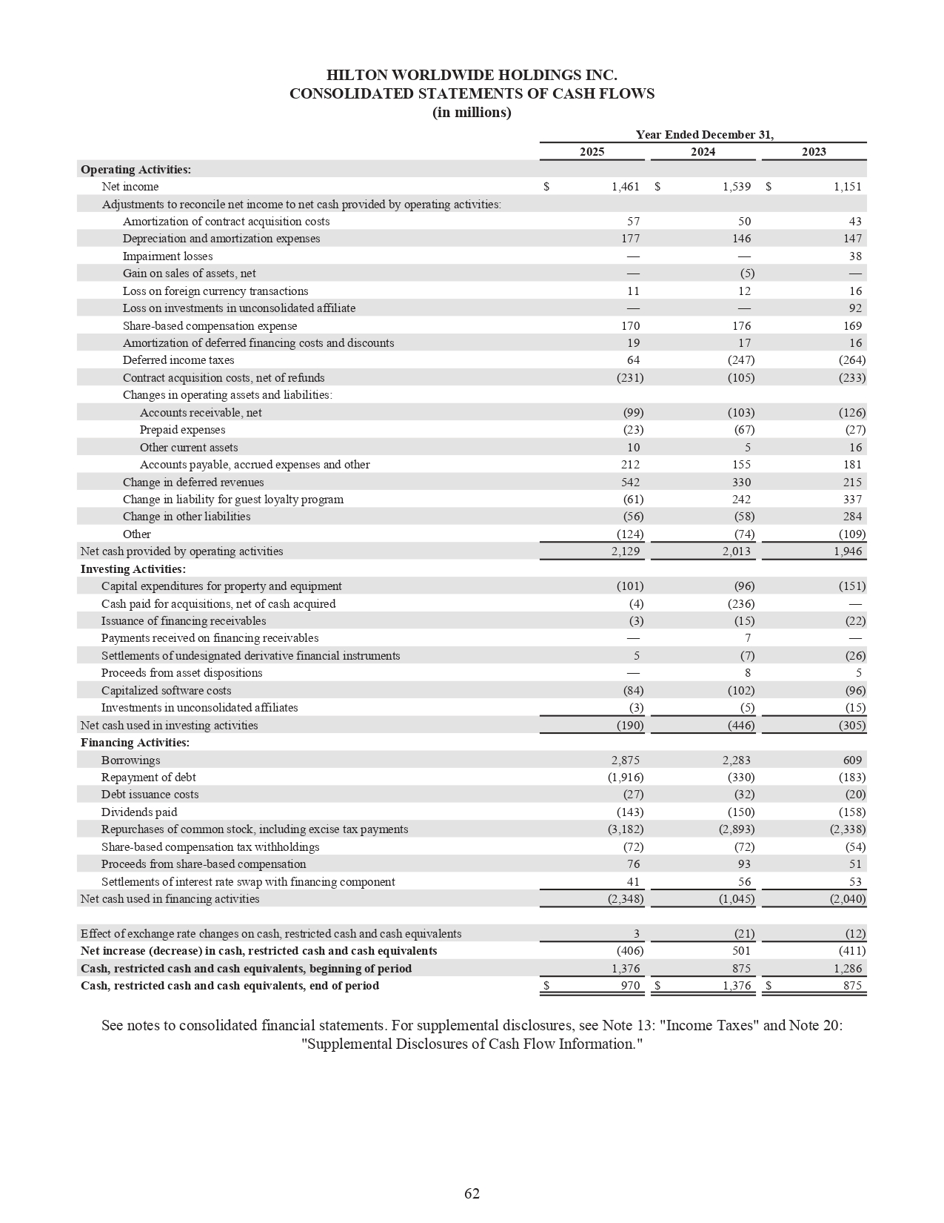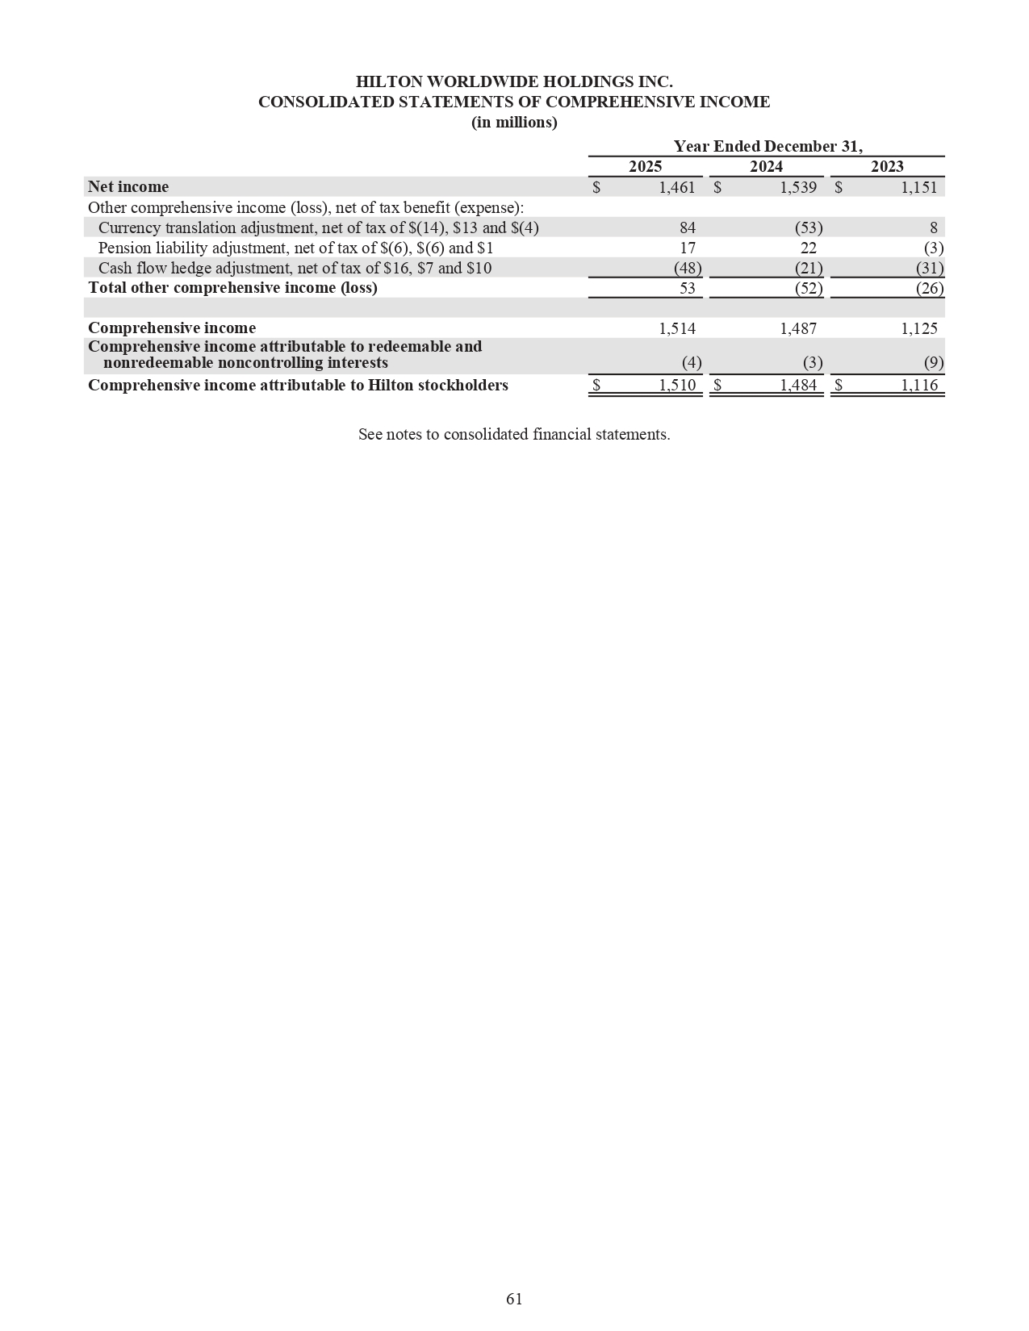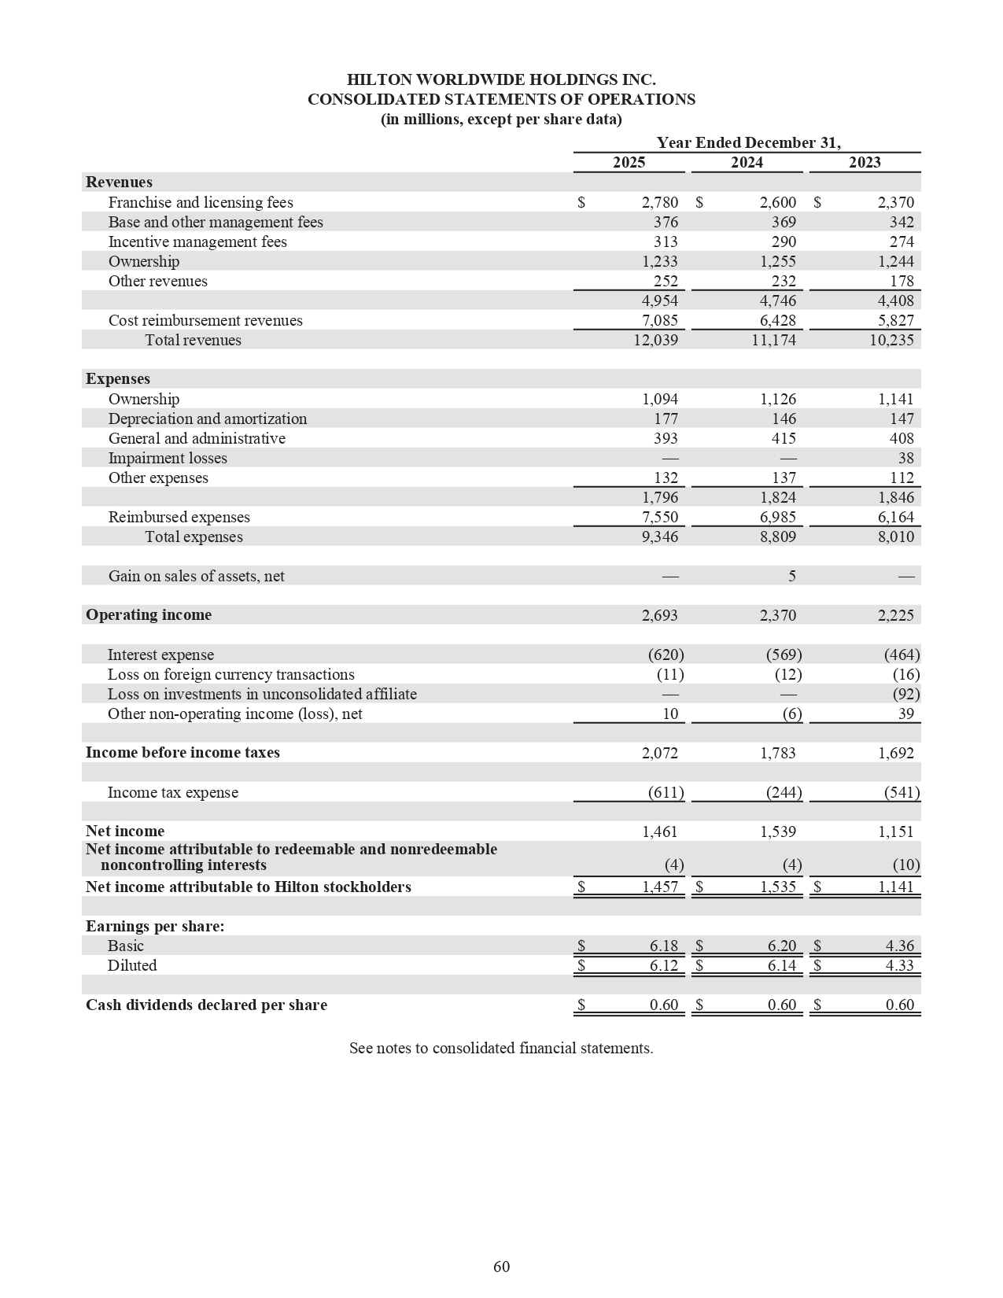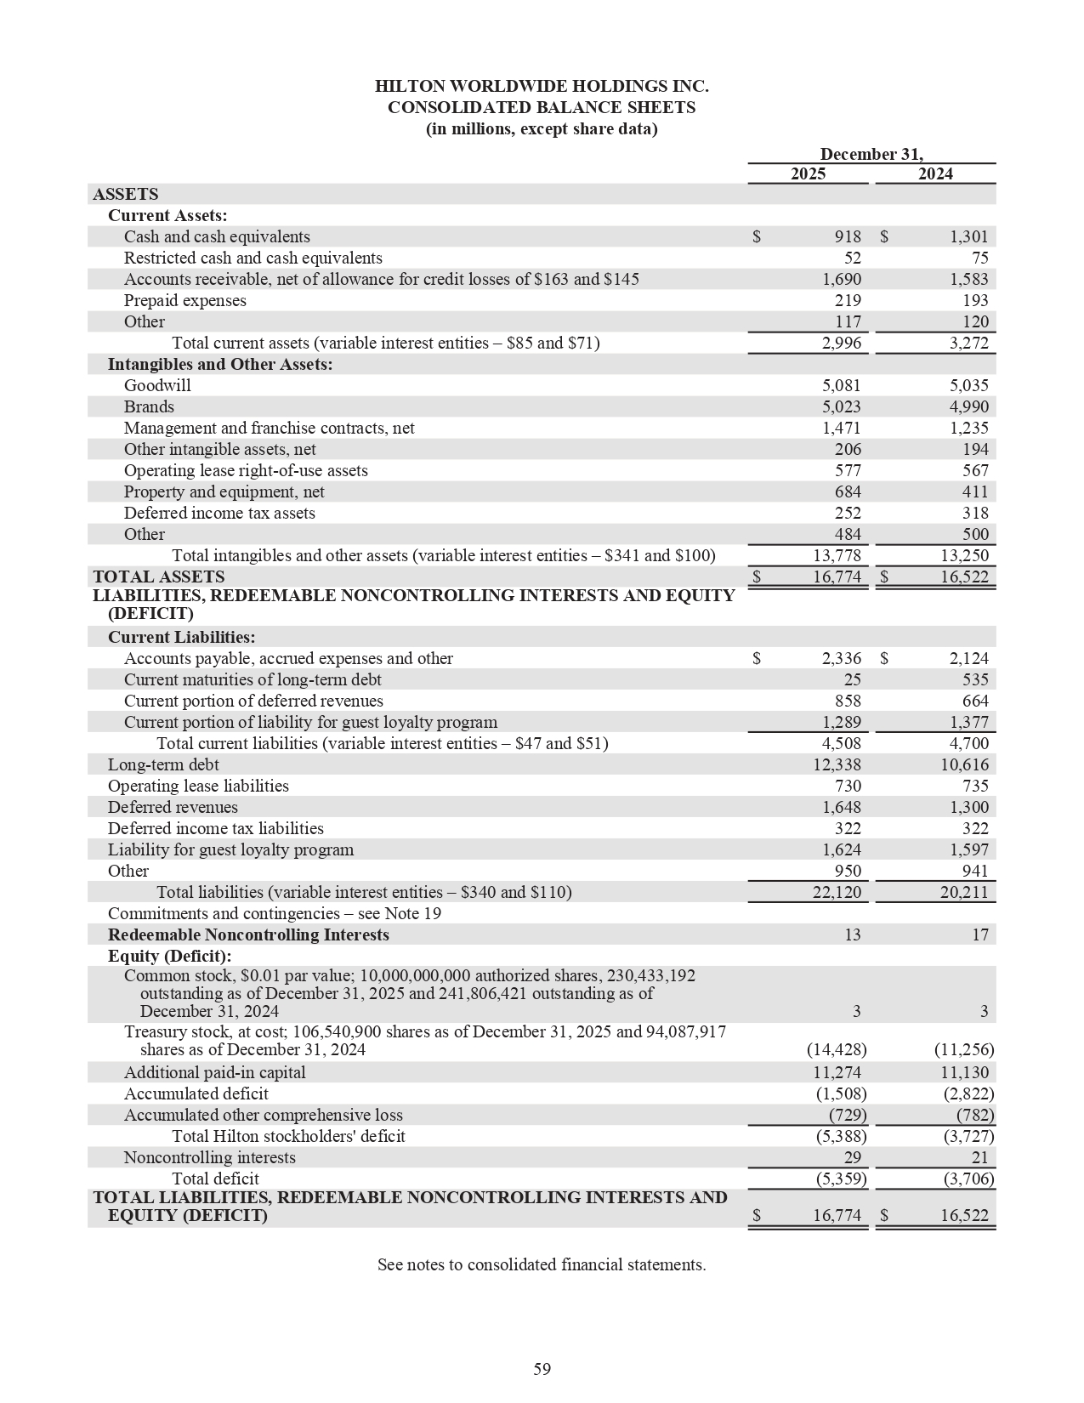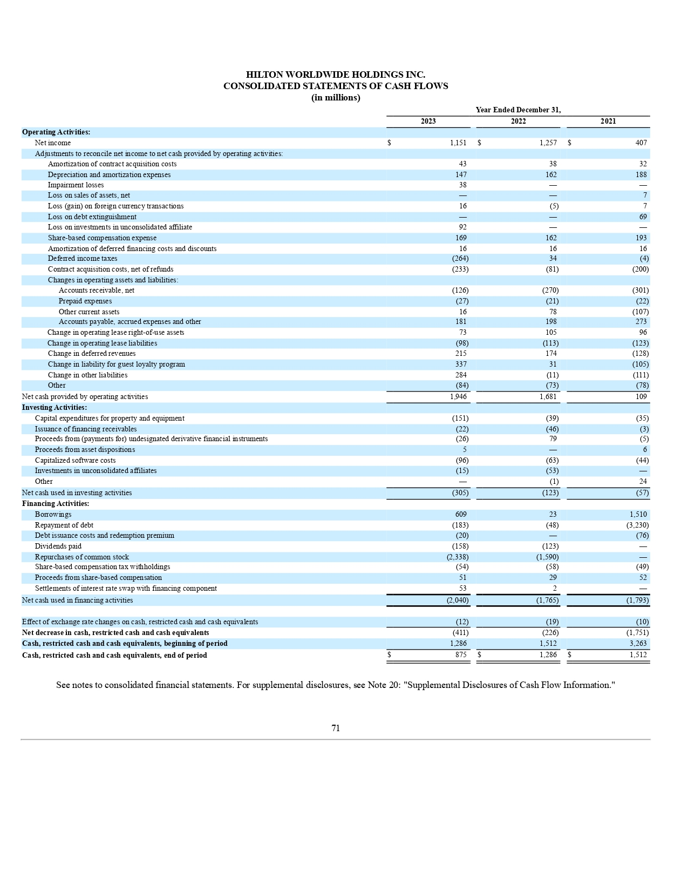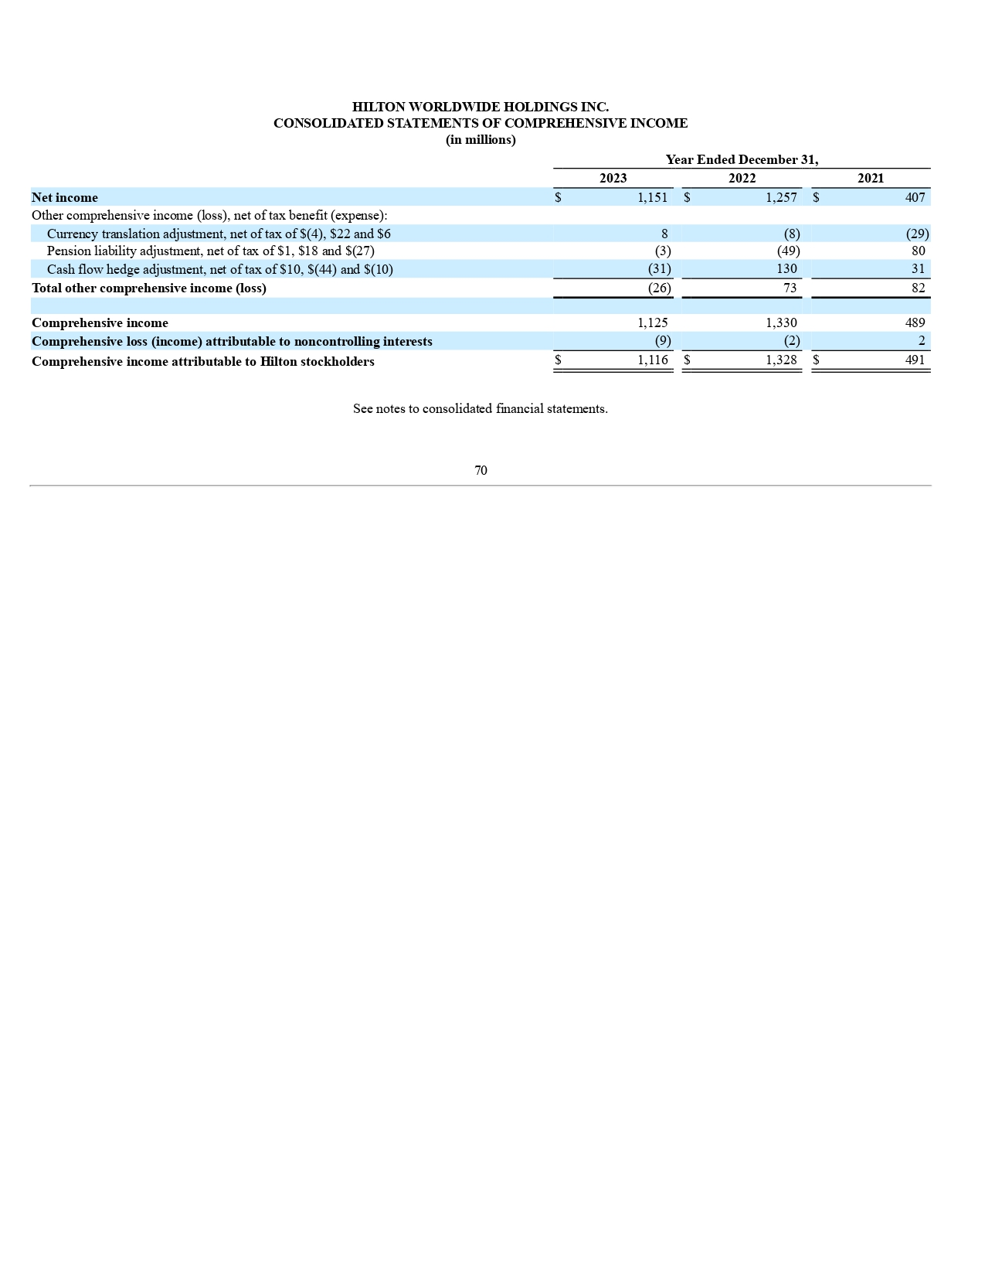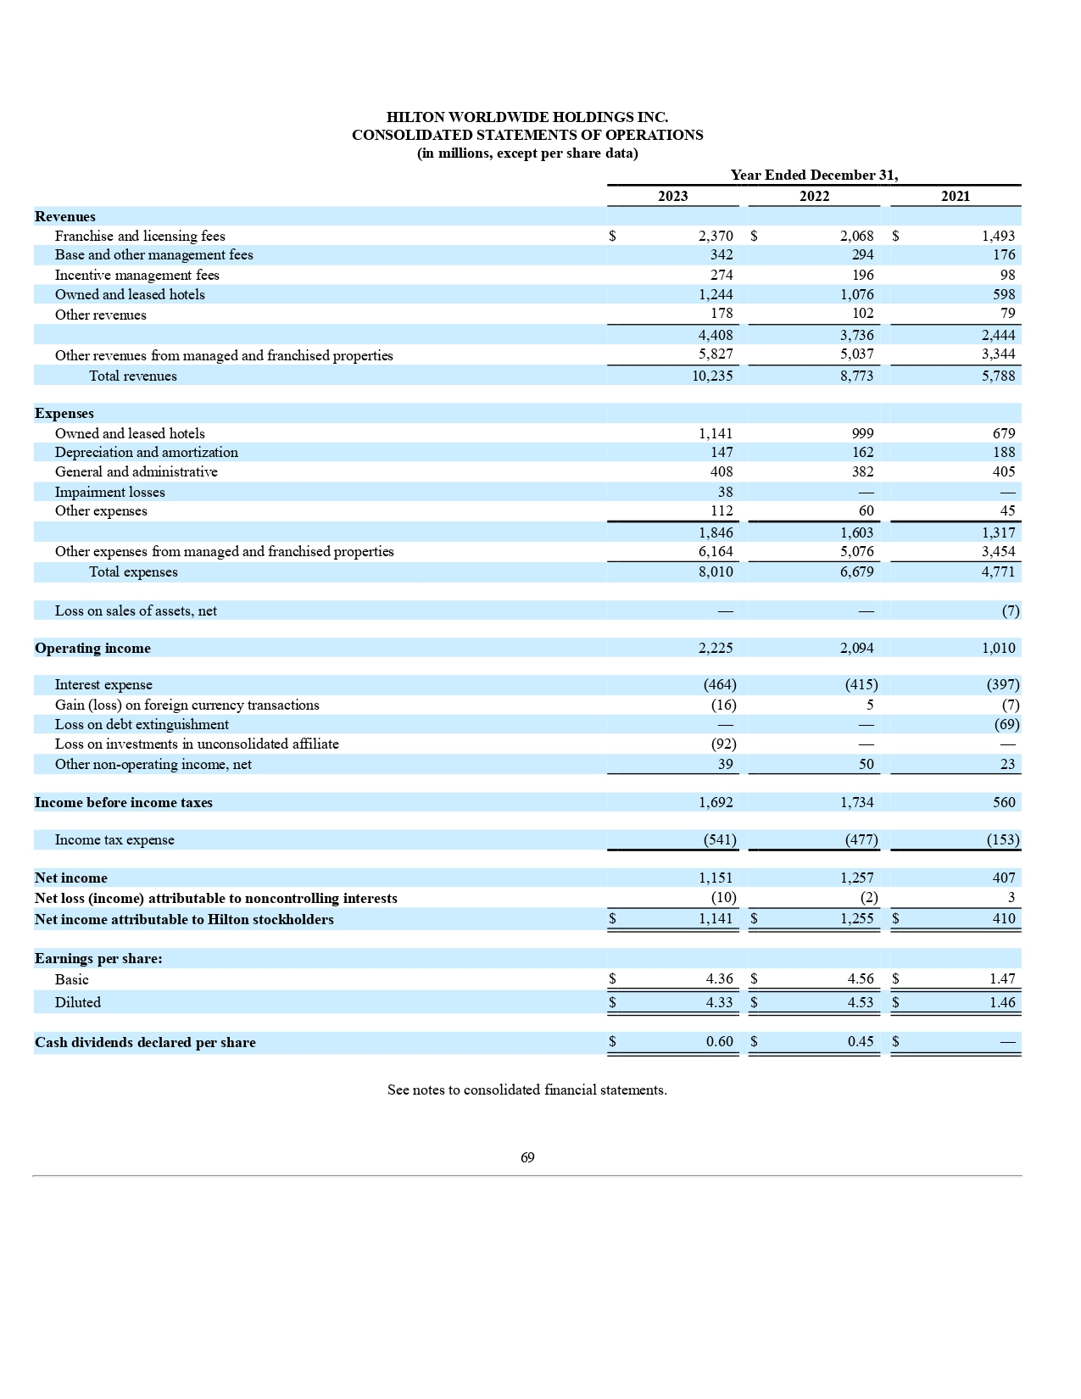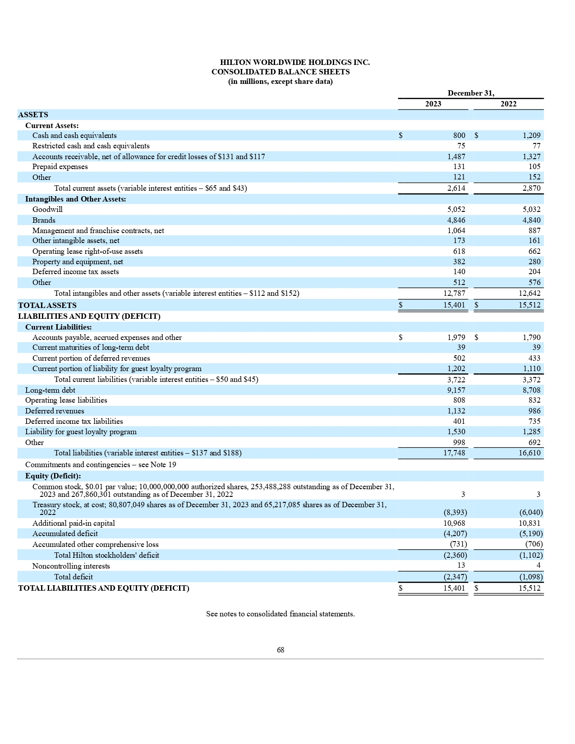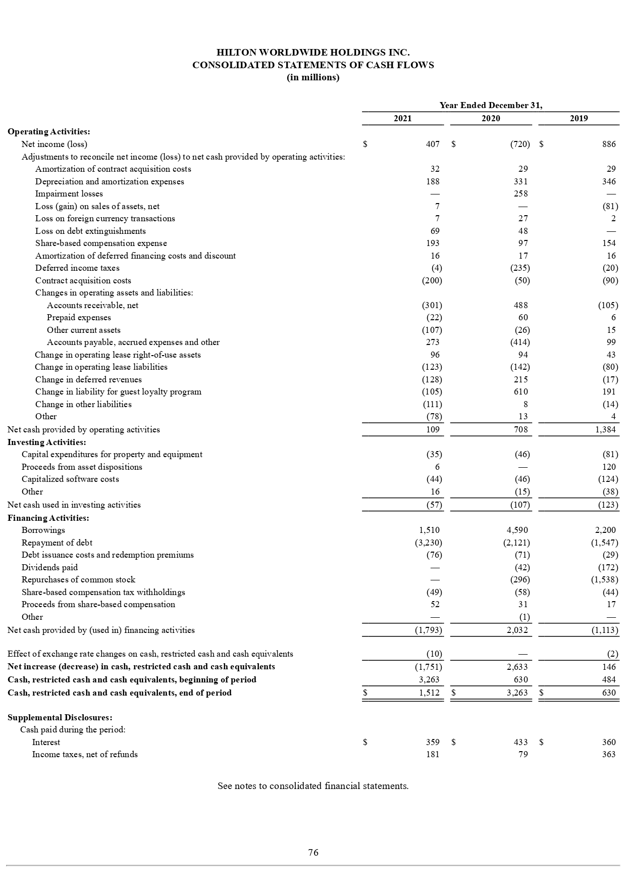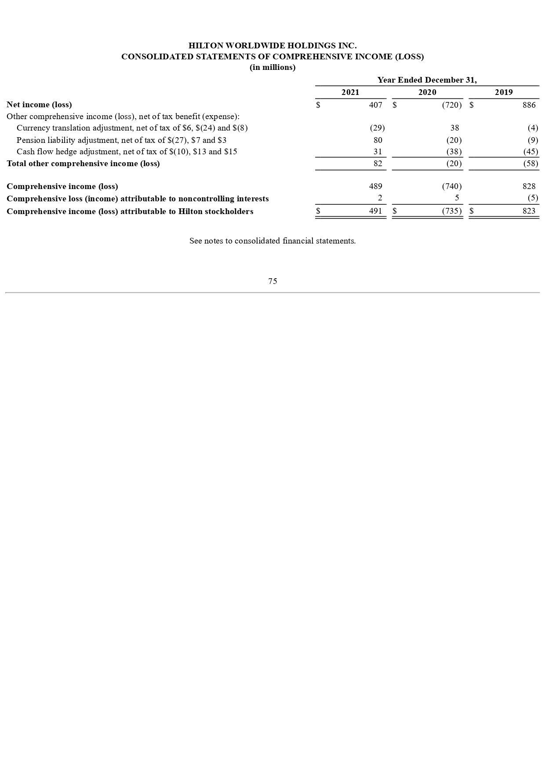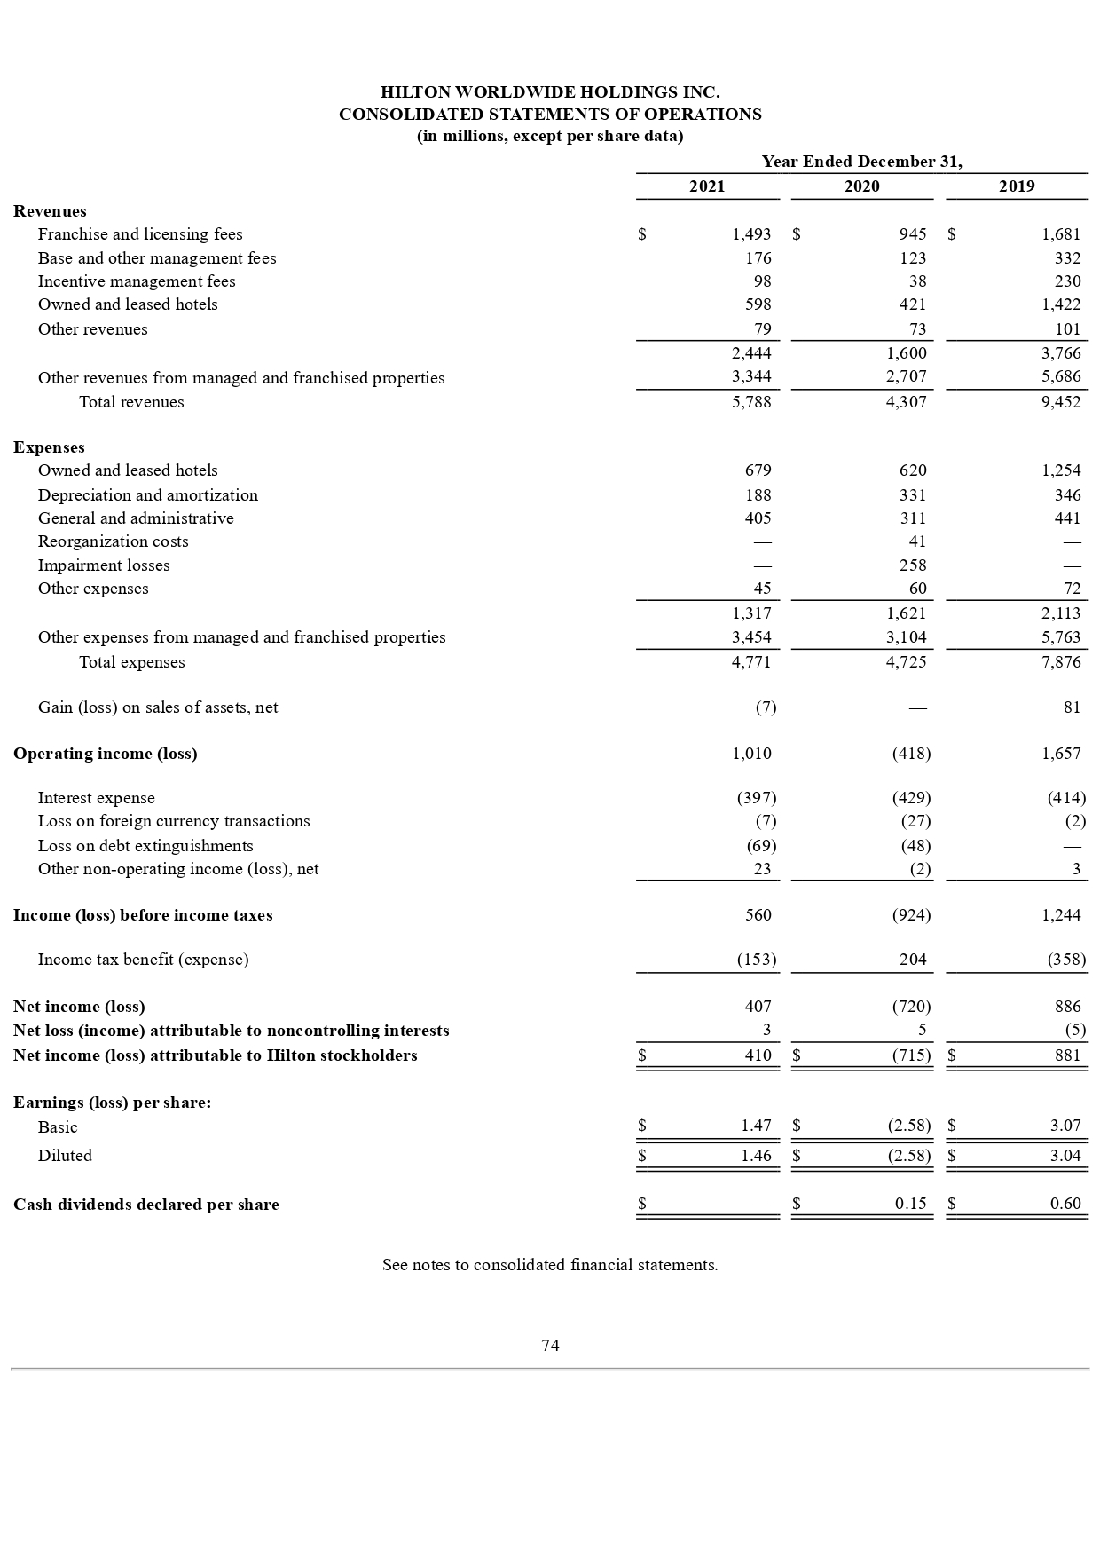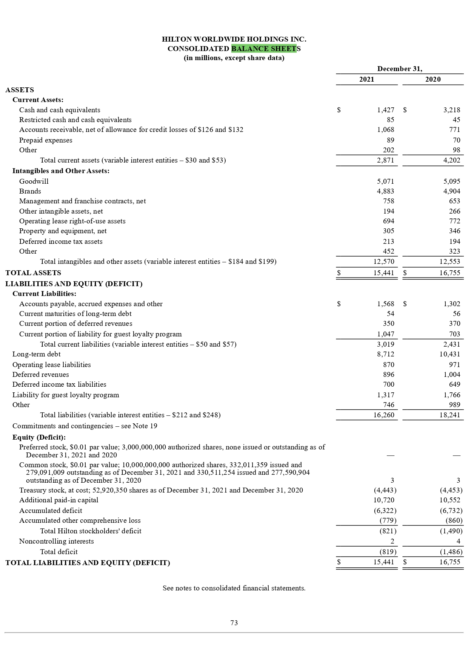

Appendix C: Working Capital Calculations
HILTON WORLDWIDE HOLDINGS INC.
Working Capital Management Analysis 2021-2025 (USD millions)
WORKING CAPITAL MANAGEMENT ANALYSIS
Particulars | Details | 2021 | 2022 | 2023 | 2024 | 2025
Current Assets (USD M) | A | $ 2,871 | $ 2,870 | $ 2,614 | $ 3,272 | $ 2,996
Inventories (USD M) | B | $ - | $ - | $ - | $ - | $ -
Accounts Receivable (USD M) | C | $ 868 | $ 1,327 | $ 1,487 | $ 1,583 | $ 1,690
Accounts Payable (USD M) | D | $ 1,568 | $ 1,790 | $ 1,979 | $ 2,124 | $ 2,336
Current Liabilities (USD M) | E | $ 3,019 | $ 3,372 | $ 3,722 | $ 4,700 | $ 4,508
Revenue (USD M) | F | $ 5,788 | $ 8,773 | $ 8,235 | $ 11,174 | $ 12,039
Cost of Revenue (USD M) | G | $ 4,133 | $ 6,075 | $ 7,305 | $ 8,111 | $ 8,644
Operating Cash Flow (USD M) | H | $ 89 | $ 1,681 | $ 1,946 | $ 2,013 | $ 2,129
Days Sales Outstanding - DSO (365/(F/C)) |  | 54.7 days | 55.2 days | 65.9 days | 51.7 days | 51.2 days
Days Inventory Outstanding - DIO (365/(G/B)) [N/A] |  | N/A | N/A | N/A | N/A | N/A
Days Payable Outstanding - DPO (365/(G/D)) |  | 138.5 days | 107.5 days | 98.9 days | 95.6 days | 98.6 days
Cash Conversion Cycle - CCC (DSO+DIO-DPO) |  | (83.7 days) | (52.3 days) | (33.0 days) | (43.9 days) | (47.4 days)
Net Working Capital (A-E) (USD M) |  | $ 2,003 | $ 1,543 | $ 1,127 | $ 1,689 | $ 1,306
Current Ratio (A/E) |  | 3.31x | 2.16x | 1.76x | 2.07x | 1.77x
Quick Ratio ((A-B)/E) |  | 3.31x | 2.16x | 1.76x | 2.07x | 1.77x

Appendix D: Investment Appraisal Calculations
Investment Appraisal & Capital Budgeting (£ Millions | Discount Rate: 8%)
Project Cash Flow Schedules (£ Millions)
Project | Year 0 | Year 1 | Year 2 | Year 3 | Year 4 | Year 5 | Total Inflows
Project A | (£50.0) | £8.0 | £12.0 | £14.0 | £8.0 | £8.0 | £54.0
Project B | (£50.0) | £11.0 | £11.0 | £11.0 | £11.0 | £11.0 | £55.0
Project C | (£50.0) | £5.0 | £8.0 | £20.0 | £25.0 | £5.0 | £65.0
Discount Factors at 8%
 | Formula | 1 | 2 | 3 | 4 | 5
Discount Factor (18%) | 1/(1.08)^n | 0.9259 | 0.8573 | 0.7938 | 0.7350 | 0.6806
1. Payback Period (PBP)
Project | Year 0 | Cum CF Yr1 | Cum CF Yr2 | Cum CF Yr3 | Cum CF Yr4 | Cum CF Yr5 | PBP (years)
Project A | -£50m | (£42.00) | (£30.00) | (£16.00) | (£8.00) | £4.00 | 4yr 6m
Project B | -£50m | (£39.00) | (£28.00) | (£17.00) | (£6.00) | £10.00 | 4yr 7m
Project C | -£50m | (£45.00) | (£37.00) | (£17.00) | £8.00 | £28.00 | 3yr 7m
Best: Project C (fastest payback)
2. Accounting Rate of Return (ARR) – Straight-Line Depreciation to Zero
Project | Initial Inv. | Annual Dep. | Total CF | Total Profit | Avg Annual Profit | Avg Investment | ARR (%)
Project A | £50.0 | £10.0 | £50.0 | £0.0 | £0.0 | £25.0 | 3.20%
Project B | £50.0 | £10.0 | £55.0 | £5.0 | £1.0 | £25.0 | 4.00%
Project C | £50.0 | £10.0 | £63.0 | £13.0 | £2.6 | £25.0 | 10.40%
Best: Project C (highest accounting return)
3. Net Present Value (NPV) – Discount Rate: 8%
Project | Year 0 | PV Year 1 | PV Year 2 | PV Year 3 | PV Year 4 | PV Year 5 | NPV (£m)
Project A | -£50m | £7.41 | £11.11 | £12.96 | £7.41 | £7.41 | (£3.70)
Project B | -£50m | £10.19 | £10.19 | £10.19 | £10.19 | £10.19 | £0.93
Project C | -£50m | £4.63 | £7.41 | £18.52 | £23.15 | £4.63 | £8.33
Best: Project C (highest value creation – primary decision criterion)
4. Profitability Index (PI) = Total PV of Inflows ÷ Initial Investment
Project | Initial Inv. | Total PV of Inflows | PI | NPV (£m) | PI ≥ 1.0?
Project A | £50.0 | £46.30 | 0.9259x | -£3.70 | ✗ Reject
Project B | £50.0 | £50.93 | 1.0185x | £0.93 | ✗ Reject
Project C | £50.0 | £58.33 | 1.1667x | £8.33 | ✗ Reject
Best: Project C (highest value per £ invested – key for capital rationing)
5. Internal Rate of Return (IRR) – Hurdle Rate: 8%
Project | Year 0 | Year 1 | Year 2 | Year 3 | Year 4 | Year 5 | IRR (%)
Project A | -£ 50.00 | £7.41 | £11.11 | £12.96 | £7.41 | £7.41 | -2.58%
Project B | -£ 50.00 | £10.19 | £10.19 | £10.19 | £10.19 | £10.19 | 0.61%
Project C | -£ 50.00 | £4.63 | £7.41 | £18.52 | £23.15 | £4.63 | 4.87%
Best: Project C (all three exceed 8% hurdle)

