What is the Problem?
what is the solution
Hannah’s home help

Selling a house is rated as one of the most stressful life events and having been through it myself a few times I wanted to see if there was an easier way.
In a survey by Onepoll 41% loathed having to clean and 35% hated even the idea of having to pack up their home.
Many homebuyers find the whole process to be overwhelming. I believe the source of this stress and anxiety is lack of information and assistance.
Many of those I have interviewed and liaised with, have resided themselves to this has always been the way property sales have been. I Believe moving home should be full of excitement, joy and hope for the future.
“1 in 5 people surveyed said they considered pulling out because it was too stressful.”

Research
There have been many studies and endless statistics on the property market. However, I do not believe these statistics show the mental strain the process can have on an individual or family. A Study of 2000 homebuyers conducted by Onepoll truly investigated the customer experience of selling and moving home. Its findings showed how the process from beginning to end was distressing for many homebuyers. My own independent survey showed that 50% found dealing with paperwork, packing and moving day to be the most stressful about moving.
All Clients would be supplied with a detailed homebuyer's guide which will provide all the information required for selling, buying, conveyancing and the logistics of moving

There are 6 Main Stages Buying and Selling a property STRESS FREE
- Preparing – This would be before the property is valued or photographed. Either, renovating to improve the value or repairs to increase saleability.

- Viewings – Ensuring the property is clean, well maintained and presented well. With personalised cleaning plans for each property and a full staging service. Also within the guide are helpful hints and tips to maximise your homes potential.
- Once an offer has been accepted – Organising a solicitor/conveyancer, protecting yourself with homebuyer’s insurance, ensuring you have all the documentation and explaining the conveyancing process.
This is a good place to briefly, but effectively, describe your product or services.
Title Text
- Packing – When to start, what to pack and when and packing hints and tips.
- To do list before the move – Change of address lists, hiring help for the move and forwarding mail.
References
Anon., 2021. Help and Advice. [Online]
Available at: https://helpandadvice.co.uk/how-long-does-conveyancing-take/
[Accessed July 2021].
Home Staging Association UK & Ireland, 2019. Home Staging Report 2019, London: HSA.
Image - Nick White, G. I., 2019. House With Sold Sign. s.l.:s.n.
MacFarlane, I., 2020. Show House. [Online]
Available at: https://www.showhouse.co.uk/news/10-statistics-that-tell-the-story-of-home-movers-in-2020/
[Accessed 24 June 2021].
Representative, C. H. L., 2021. Conveyancing Process [Interview] (24 June 2021).
RightMove, 2021. House Price Index Report, London: s.n.

- First few days in your new home – Essential supplies, an overnight bag and last bits checklist.

What Service Will I Offer?

Repairs and Decorating
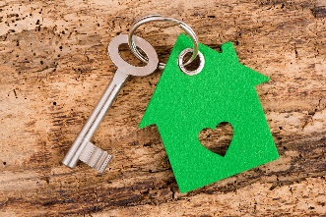
Deep Cleaning
Staging
Maintenance
Document management
Chasing Solicitors and Estate
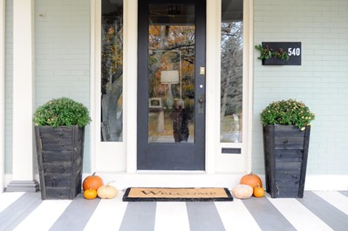
94% of Estate Agents
Stated staging increases the number of viewings

Staging

50% of Buyer and Sellers
Believe the whole process is overly complicated

