PREDICTIVE MAINTENANCE IN TEXTILE INDUSTRIAL EQUIPMENT USING ML

Word Count: 4062
Table of Contents
1. Introduction 3
1.1. Context and Background 3
1.2. Research Problem 4
1.3. Research Aim and Objectives 5
1.4. Significance of the Research 5
2. Literature Review 6
2.1 Introduction 6
2.2 Evolution of Predictive Maintenance Strategies 7
2.3 Application of Machine Learning Algorithms 7
2.4 Sensor Integration and Data Acquisition 8
2.5 Industry 4.0 and Smart Manufacturing Context 8
2.6 Adoption of Predictive Maintenance in the Textile Industry 9
2.7 Key Contributions and Gaps in the Literature 9
2.8 Theoretical and Technical Frameworks 10
2.9 Relation to the Current Study 10
2.10 Summary 11
3. Research Design and Methodology 11
3.1. Research Design 11
3.2. Research Methods and Materials 12
4. Expected Outcome 13
5. Timeline 14
References 15

1. Introduction

1.1. Context and Background
The field of predictive maintenance is an intersection of Artificial Intelligence (AI), data mining, and industrial engineering. It is part of the wider Industry 4.0 concept, which involves incorporating smart technologies into production facilities to increase productivity, minimise disruption, and maximise resource usage [1]. Using historical and real-time data, ML is a core subfield of AI that enhances conventional maintenance approaches by assisting systems in identifying trends and future equipment failures with minimal errors. In mechanical engineering, especially in textile Industries, the mechanised knitting, weaving, and dyeing equipment are subjected to significant working conditions. This equipment is required to run day and night with minimal downtime that can be attributed to a mechanical failure. Textile manufacturing companies have mainly relied on reactive maintenance, which is based on time or occurrence-based preventive approaches [2]. Even though these methods provide a certain level of confidence, they do not prevent failure, and most often, production ceases unexpectedly, and organisational costs rise.
The advancement in recent years in data-driven technologies has made way for predictive maintenance, where the equipment and devices are monitored using sensors such as temperature, vibration, and pressure to predict a potential failure of equipment. This has received a boost due to the integration of IoT devices that capture real-time data from equipment and new-age ML algorithms that analyse large data sets to identify warning signs of failure. Cloud computing and edge computing also enhance the scalability and flexibility of such systems.
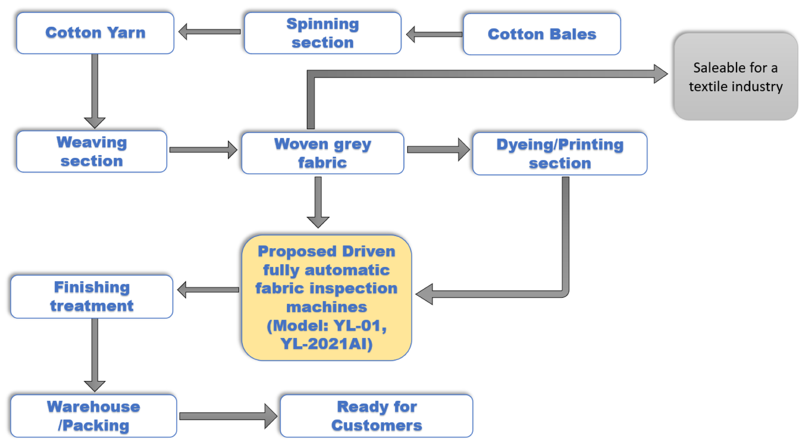
Figure 1: Smart Manufacturing in the Textile Industry
(Source: Kaur et al. 2024)
Although predictive maintenance has been implemented in many industries like automotive, aerospace, and the oil and gas industries, it has only recently been adopted in the textile industry. Recent studies show how such highly non-linear processes in textiles manufacturing can be addressed by using different, more flexible ML models [3]. Time series sensor data is being analysed and patterns of equipment degradation are investigated using Random Forest, Support Vector Machine, and LSTM networks.
As the need to maintain product quality and cut costs increases, the implementation of intelligent maintenance systems becomes imperative. This research stands in this growing literature stream, which aims to use ML for enhancing maintenance activities in textile equipment and contributing to the digitalisation of the industrial context.

1.2. Research Problem :
This research focuses on the issue in the textile manufacturing industry, in which there is a low utilisation of machine learning for predictive maintenance frameworks [4]. The process demands the use of cutting-edge and high-speed equipment with frequent contact with severe conditions. These kinds of equipment can break down frequently, and the failures are usually unforeseen, which consequently lead to downtimes, loss-making, and poor-quality output. Nevertheless, conventional preventive maintenance is still common because, despite its schedule-based approach, it may contain unnecessary servicing or fail to predict an upcoming issue.
Although many industries have demonstrated the effectiveness of machine learning (ML) in prediction concerning maintenance, this function is not adequately implemented in the textile industry [5]. The implementation of ML models within textile manufacturing processes is challenging because the production conditions are constantly changing, the equipment differs, and the quality of the collected sensor data may vary. Current predictive maintenance methodologies for especially small and medium-sized textile companies are either reactive or based upon threshold-based systems, which result in substantial false positives. These inaccuracies not only lead to increased operating costs due to unscheduled system intrusions but also make the system less credible in the broader industry.
The most significant issue is that most existing ML models do not allow for real-time adaptation. Some of these models are learned from datasets that can hardly capture the dynamic environment that surrounds manufacturing facilities these days. Additionally, it is difficult to have access to well-defined labelled datasets, and there can be variations in the calibration process. There is also a technical challenge in the implementation of the ML algorithms into the current industrial setting since many industries do not have the hardware and processing systems for real-time fault analysis and prediction.
One potential problem is the reluctance of organisations to embrace the new shifts in technology in industries that have already been set up such as the textile industry [6]. Other challenges include internal technical limitations, concerns over cost, and difficulties in proving the value of maintenance of intelligent maintenance systems. In order to address these challenges, the current study seeks to design a predictive maintenance model based on machine learning applied to textile manufacturing. It also discusses that the solution strategy prohibits accepting a large number of false alarms, enhancing real-time expectancy precision, and applying the same predictive model to other textile equipment.

1.3. Research Aim and Objectives :
Aim
The study aims to identify the most effective machine learning techniques for predicting maintenance to minimise equipment failure in the textile industry.
Objectives
- To gather and preprocess real-time sensor data from textile equipment to detect initial signs of equipment failure
- To implement and assess Random Forest, SVM and LSTM classifiers to predict the probability of equipment faults in the textile industry
- To check the accuracy of the model in the prediction of equipment failure, using metrics such as accuracy, precision, recall, and F1-score
- To identify the best model and develop a predictive maintenance solution applicable to real-time industrial contexts

1.4. Significance of the Research :
The importance of this research is based on the ability of machine learning (ML) technologies to improve the maintenance practices within the textile manufacturing industry [7]. ML for predictive maintenance is a move away from the conventional break-fix or time-based maintenance strategies that are unproductive and costly. Actual time capturing, especially through sensors, helps in the early detection of signs of possible equipment breakdowns, hence reducing the effects of potentially disruptive downtimes. This has implications for the research community in the textile industry, where equipment reliability and efficiency play a significant role.
From an academic viewpoint, the research will make a contribution to the growing literature on the application of artificial intelligence in industrial automation. It will fill a significant research gap that examines the limited application of ML in real-time predictive maintenance in the textile industry, focusing on light steel framing and fabric manufacturing industries [8]. Predictive models of current solutions remain rigid and imprecise in dynamic work environments. Hence, the purpose of this research is to develop improved ML algorithms both in terms of accuracy and false positives that are more efficient and practical for use in real-world scenarios.
In terms of research methodology, the research will use ML techniques like LSTM networks, SVM and Random Forest classifiers for dense time-series data originating from the industrial IoT sensors. This will improve the theoretical analysis of the performance of machine learning models under conditions of variability and noise characteristic of manufacturing contexts. The establishment of such models also satisfies Industry 4.0 principles of automation, data sharing, and intelligent manufacturing platforms.
The significance of this research will be seen in the practical applications of the research findings. Advanced maintenance frameworks are expected to help in increasing the lifespan of the textile equipment, cut costs of operation and also enhance the quality of products by reducing disruptions [9]. Also, the use of remote data analytics and real-time fault detection of faults will enable efficient monitoring and promote the development of efficient maintenance methodologies. Applying ML to maintenance systems will also help manufacturing processes become more sustainable by pursuing energy efficiency and low material and time waste within the supply chain. This study will not only address an industry demand but also provide the foundation for advanced technology for preventing equipment failures by providing intelligent, extensible, and cost-effective solutions for asset management in textile industries.

2. Literature Review :

2.1 Introduction :
This literature review synthesises research from academic and industry solutions focusing on predicting maintenance using ML techniques, especially in textile plants. Its primary goal is to outline trends, arguments and research gaps associated with the development of predictive maintenance systems, with a focus on Industry 4.0 technologies. The key research topics are related to real-time monitoring, time-series data analysis, as well as the application of ML approaches in the context of maintenance planning. It is organised thematically to discuss the development of the predictive maintenance process, the incorporation of sensing systems, and issues with the current paradigm of predictive maintenance. Special emphasis is placed on the textile industry, in which issues of intelligent, data-driven maintenance have received relatively little attention despite its central role in modern manufacturing. This review situates the study in that background, emphasising the implications of the study for increasing equipment reliability and production efficiency in textiles.
2.2 Evolution of Predictive Maintenance Strategies :
Predictive maintenance was developed due to the drawbacks of reactive and preventive maintenance models [10]. Conventional maintenance methods involve inspecting the assets for faults or waiting for equipment to fail before attending to the problem. Such approaches are expensive and time-consuming, and lead to increased costs and longer project times. In modern forms of predictive maintenance adopted with the aid of digital technologies, condition monitoring refers to the use of data collected from the operational environment to predict future failures. In the textile industry, starting with predictive maintenance, it was initially applied using statistical models or alarm signals from vibration or temperature [11]. These systems proved to be rigid and imprecise in dynamic operating environments. New developments, such as the integration of machine learning, have enabled the use of adaptive models, which can use past and real-time data to enhance fault detection and failure prediction.
2.3 Application of Machine Learning Algorithms :
Machine learning solutions are a critical component of contemporary approaches to predictive maintenance. Different techniques like Support Vector Machines (SVM), Random Forest, Decision Trees, and Deep Learning methods, named Long Short-Term Memory (LSTM). They are trained on time-series data collected by several sensors installed in industrial facilities. The main idea of the field is to prevent failures and look for signs of them before they occur [12]. Random Forest is preferred because it offers higher accuracy and is less sensitive to noisy data. LSTM networks, for their part, are ideal for modelling sequential data and have better performance when applied to the temporal data and long-term dependencies in the sensor data. These models can also work with multiple inputs and outputs to identify intricate interactions between them, like temperature, pressure, load, and vibration.
Several studies suggest the issues of overfitting, high computational costs, and large labelled data sets required for its implementation [13]. However, the performance of these models depends greatly on data quality and the use of appropriate features as input.
2.4 Sensor Integration and Data Acquisition :
Sensors and data acquisition systems are integral to the overall concept of predictive maintenance. Contemporary industrial processes are connected with IoT devices that constantly capture relevant performance characteristics. Sensors are used to capture the parameters such as speed, vibration, temperature and tension of the motors, shafts and fabrics respectively in textile equipment [14]. Real-time monitoring with cloud-based platforms has also been made possible through the advanced sensors and their data transmission. However, some gaps, such as prolonged latency, data privacy concerns, and variations in sensor calibration, present new challenges in the implementation of real-time predictive maintenance models. Moreover, it is challenging to acquire data from textile equipment as they work under fluctuating loads and different environmental circumstances.
2.5 Industry 4.0 and Smart Manufacturing Context :
Predictive maintenance techniques are particularly relevant to the technical evolution that has become famous as Industry 4.0 [15]. This concept focuses on the combination of cyber-physical systems, big data analytics, cloud computing, and artificial intelligence in manufacturing. In this regard, predictive maintenance has emerged as a key enabler of disruptive manufacturing practices given its ability to automate maintenance decisions, minimise time losses, and enhance production processes. In this realm, literature refers to the use of sensors on various equipment and interconnectivity that allows for the monitoring of equipment condition to inform timely intervention.
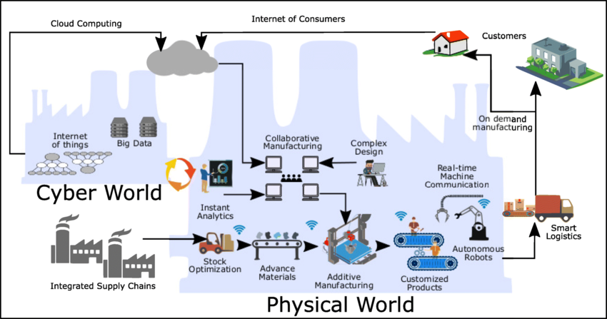
Figure 2: Industry 4.0 and Smart Manufacturing
(Source: Balderas et al. 2021)
Another use of digital twins as virtual replicas of physical systems is to simulate maintenance conditions and outcomes [16]. However, the literature suggests that there is still a call for end-to-end solutions that can embrace domain-specific concerns like data heterogeneity, varying environments, and the interpretation of ML results. These factors are especially relevant in a diverse production environment where existing solutions do not always meet industrial requirements. Therefore, in the environment where the level of automation is relatively low, there is a growing concern for the design of academically and industry-fostering frameworks for efficient, reliable predictive maintenance systems.
2.6 Adoption of Predictive Maintenance in the Textile Industry :
The textile industry is one of the most challenging industries to address the stakes of implementing predictive maintenance systems because of the equipment type, processes, and environment. It differs from such industries as electronics and high-tech manufacturing, where equipment tends to be relatively new and of similar design and functionality, thus making it difficult to apply a strategic approach to maintenance. Current literature on predictive maintenance specific to textile industries has limited reports, with the majority of predictive maintenance studies done on general industrial equipment or otherwise on highly automated industries such as automotive and aerospace [17]. However, the literature reveals that textile manufacturing is severely negatively impacted by unpredictable equipment breakdowns, resulting in production downtime, product quality deterioration, and increased costs.
Machine learning is valuable in this segment based on use cases like loom vibration, temperature monitoring, and spindle monitoring. However, most of these works are proof of concept or simulation studies with little or no implementation in real textile industries [18]. However, the absence of consensus in terms of datasets and the access to new equipment with sensors still represent significant challenges in the utilisation of such an approach. As such, there is an increasing awareness of the need for studies that develop predictive maintenance models relevant to textiles, using real-time data and horizontally scalable machine learning.
2.7 Key Contributions and Gaps in the Literature :
The existing literature has contributed immensely by providing more insights and research on various implementations of predictive maintenance. Research has demonstrated that by applying ML-based models, maintenance costs can be cut, unexpected outages can be reduced, and equipment availability increased [19]. One of the areas that has benefited most from the change from schedule-based to condition-based maintenance is resources and operations. Nonetheless, notable gaps persist. Most prior studies are concentrated in large industries like automotive, aerospace, and energy industries, while less attention has been paid to the textile industry. The patterns discovered in most approaches to predictive maintenance are created under highly controlled conditions or on artificial data generated from real textile production lines. Moreover, few studies focus on the interpretability of the ML models, which is vital for maintenance engineers and decision-makers.
2.8 Theoretical and Technical Frameworks :
Some theoretical frameworks associated with predictive maintenance planning are reliability-centred maintenance (RCM) and prognostics and health management (PHM). These frameworks underscore failure modes, features of remaining useful life (RUL), and subsequent maintenance preferences [20]. In the context of machine learning, these theories are implemented by supervised learning algorithms, anomaly detection algorithms, and integrative systems that meld physics-based and data-driven methodologies. Technically, the evaluation of the predictive maintenance system requires data preprocessing, including normalisation, feature selection, and dimension reduction. Signal processing techniques such as the Fast Fourier Transform and Wavelet Transforms are employed on raw signal data to obtain features. Well-used software frameworks comprise Python-based libraries like Scikit-learn, TensorFlow, and PyTorch, which provide reliable environments for modelling, training, and assessing.
2.9 Relation to the Current Study :
This research contributes to the existing literature by exploring the application of real-time sensor data and machine learning for effective implementation of predictive maintenance in the textile industry. While many previous studies rely on static or simulated datasets, this study utilizes publicly available sensor data that reflect realistic industrial conditions. This enhances the relevance of the findings and supports their application in real-world scenarios.
The research will compare machine learning models including Random Forest, Support Vector Machine (SVM), and Long Short-Term Memory (LSTM) networks under controlled conditions to identify the most suitable algorithm for textile-related fault prediction. The results will provide valuable insight into the performance, adaptability, and practicality of machine learning techniques in an industry-specific maintenance context.
Additionally, the study will incorporate explainable artificial intelligence (XAI) to improve the interpretability of model outputs, aiding adoption by field engineers and decision-makers. By linking model performance with system-level integration considerations, this research adds both theoretical and practical value to the field of industrial AI applications.
2.10 Summary :
The literature also posits that the use of machine learning in predictive maintenance adds significant operational value across multiple industries. Their features are based on high-performance ML algorithms, the Incorporation of the real-time sensor network, and the implementation of smart maintenance systems based on Industry 4.0 systems. Nevertheless, the existing body of literature remains largely dominated by well-funded industrial industries, excluding textile manufacturing. This indicates that there is a need to develop models that will fit the context of textile production equipment. Further, issues such as the limited use of real-time data in applications, understanding the model, or implementing the model into practice also pose potential questions. In order to meet these challenges, this study will advance the current state of knowledge by designing, testing and enhancing ML-based predictive maintenance systems for textile applications.

3. Research Design and Methodology :
3.1. Research Design :
This study utilises the Design Science Research (DSR) methodology since it can be applied in building and testing novel technologies, such as machine learning models in textile manufacturing for predictive maintenance [21]. DSR is useful in constructing and evaluating artefacts that address existing organisational issues, which suits this study, as the study aims to develop machine learning frameworks that increase equipment reliability and reduce failure occurrences.
Design Science Research is a cyclical method that involves identifying a problem, designing an artefact, testing, and revising the artefact. The study establishes the general research problem, which highlights the challenges that textile manufacturing industries face in their maintenance practices. Random Forest, LSTM network, and Support Vector Machines will be developed as machine learning models in response to this problem. The models will be trained and tested using real-world industrial datasets, which will make the offered solutions realistic and applicable.
DSR is particularly suitable for this study because of the principles of relevance and rigour that saturate the approach. This is achieved by focusing on solving actual industrial problems, and the latter through a strict experimental approach and benchmarking with quantitative measures such as accuracy, precision, recall, and F1-score [22]. The iterative DSR process implies that predictive maintenance models are adjusted and improved according to the evaluation results, resulting in better and more effective frameworks.
Besides the Design Science framework, aspects of experimentation are also included to compare the performance of models developed under various operating conditions. This ensures that the final artefacts are not only theory-relevant but also real-world feasible for industrial deployment. Hence, the adopted research design is suitable for fulfilling the study goal and contributing valuable insights to the academic literature and the practical application of predictive maintenance in industries.

3.2. Research Methods and Materials :
Methods :
The current study uses both qualitative and quantitative research methodologies. It is quantitative in determining the effectiveness of the machine learning models through statistical evaluation and qualitative in analyzing any practical considerations encountered during the implementation process. A mixed approach is considered appropriate because it captures both the technical validity and the practical relevance of the implemented techniques in predictive maintenance.
The research strategy is based on a combination of experimental design and a simulated case study. Activities include training and testing machine learning models such as Random Forest, Long Short-Term Memory (LSTM), and Support Vector Machine (SVM) using structured sensor data related to equipment behavior. This strategy supports evaluation in a controlled and replicable environment, while still maintaining relevance to industrial applications.
The system architecture includes data preprocessing, feature engineering, model training, and evaluation phases. A machine learning pipeline will be implemented to automate the handling of raw sensor inputs, facilitate model training, and measure predictive performance.
For data analysis, standard performance metrics will be used, including confusion matrices, ROC curves, accuracy, precision, recall, and F1-score. These indicators will assess the model's ability to detect early faults and minimize false alarms.
The sensor data used for training the models will include variables such as vibration, temperature, and pressure—commonly associated with predictive maintenance scenarios. The dataset is anonymized and publicly available, and it reflects realistic operating conditions, supporting generalizability of the findings. Ethical considerations are fully observed by using only data that is non-identifiable and freely accessible for academic use.
Python will be used as the programming language due to its versatility and extensive support for machine learning development. Libraries including TensorFlow, Scikit-learn, Keras, and Matplotlib will be utilized for model construction, testing, and visualization. For hardware, access to GPU-enabled cloud platforms such as Google Colab will be employed to support model training and performance evaluation.
Materials :
The study will employ secondary data collected from publicly accessible datasets that contain sensor readings relevant to predictive maintenance applications. These include variables such as vibration, temperature, and pressure from industrial equipment typically used in manufacturing settings. Data preprocessing will involve cleaning, transformation, and normalization to extract the most informative features for model development. Python’s Pandas and NumPy libraries will be used during this stage to manage and structure the data effectively.
The selected data is representative of real-world operational scenarios, supporting the study’s aim of implementing condition monitoring strategies for early detection of faults in rotating equipment. These datasets are anonymized, publicly available, and ethically suitable for academic research purposes.
Python will serve as the primary programming language due to its extensive support for machine learning tasks. Core libraries to be used include TensorFlow, Scikit-learn, Keras, and Matplotlib, all of which support efficient development, training, and visualization of models. Google Colab will be used as the integrated development environment, offering cloud-based access to GPU resources needed for training complex models such as LSTM networks.
Given the computational demands of deep learning, cloud-based high-performance computing resources will be utilized for rapid iteration and efficient handling of large data volumes. Additional storage and compute resources may be deployed if needed during the modeling and evaluation phases.

4. Expected Outcome :
The conclusion of this research work is expected to lead to the generation of intelligent models that can aid in predicting equipment failure rates in the textile sector [27]. It is anticipated that the models—Random Forest, SVM, and LSTM—will outperform traditional maintenance strategies in terms of accuracy, precision, and early fault detection. The application of these models could help reduce operational downtime, lower maintenance costs, and improve the reliability and efficiency of textile machinery.
The research is also expected to contribute theoretical insights into the use of machine learning for predictive maintenance, particularly in environments characterized by high variability and limited automation. Furthermore, the project will provide comparative performance metrics to help select the most suitable model for further real-time integration with industrial systems.
Limitations of the Proposed Study :
This proposed study presents several limitations that may affect its scope, implementation, and generalisability:
- Use of Secondary Data:
The research relies on a publicly available dataset from Kaggle rather than real-time data collected from operational textile manufacturing systems. While useful for model training and testing, secondary data may not fully reflect the specific operating conditions, failure modes, and sensor variability encountered in live production environments.
- Lack of Real-Time Testing:
Due to the project's current proposal stage and pending ethical approvals, the machine learning models will not be tested in a real-time production setting. As a result, factors like real-time response, system latency, and integration with factory hardware cannot yet be evaluated.
- Computational Constraints:
Deep learning models such as LSTM require significant processing power. This study is limited to cloud-based environments like Google Colab, which may restrict the scale, speed, and complexity of model training due to timeouts, memory limits, and shared hardware.
- Model Generalisation Issues:
The dataset used represents a generalised view of textile equipment. The models trained on this data may not generalise well across different machines, factory conditions, or production scales. Without domain-specific calibration, model accuracy and reliability may vary in real-world applications.
- Limited Scope for Deployment:
While Web API integration is identified as a future enhancement, it is not implemented at this stage. Consequently, the project does not currently address challenges associated with live deployment, such as real-time alert delivery, API performance, user interface design, or operational feedback loops.

5. Timeline :
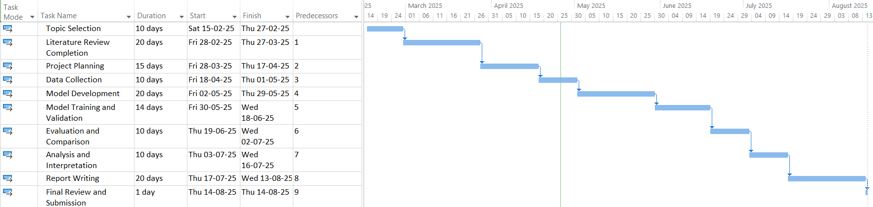
Figure 3: Project Milestone and Gantt Chart
(Source: Created Using MS Project)

References
[1] Kaur, G., Dey, B.K., Pandey, P., Majumder, A. and Gupta, S., 2024. A smart manufacturing process for textile industry automation under uncertainties. Processes, 12(4), p.778. Access Link: https://www.mdpi.com/2227-9717/12/4/778
[2] Nicoletti, B., 2023. Supply Network 5.0 Human Automation Machine Collaboration. In Supply Network 5.0: How to Improve Human Automation in the Supply Chain (pp. 103-137). Cham: Springer International Publishing. Access Link: https://link.springer.com/chapter/10.1007/978-3-031-22032-6_4
[3] Fri, M., 2024. LEAD TIME PREDICTION USING ADVANCED DEEP LEARNING APPROACHES: A CASE STUDY IN THE TEXTILE INDUSTRY. LogForum, 20(2). Access Link: https://www.researchgate.net/profile/Mouhsene-Fri-2/publication/381845149_Lead_Time_Prediction_Using_Advanced_Deep_Learning_Approaches_A_Case_Study_in_the_Textile_Industry/links/6712d35824a01038d0f20426/Lead-Time-Prediction-Using-Advanced-Deep-Learning-Approaches-A-Case-Study-in-the-Textile-Industry.pdf
[4] Chang, R.I., Lee, C.Y. and Hung, Y.H., 2021. Cloud-based analytics module for predictive maintenance of the textile manufacturing process. Applied Sciences, 11(21), p.9945. Access Link: https://www.mdpi.com/2076-3417/11/21/9945
[5] Abidi, M.H., Mohammed, M.K. and Alkhalefah, H., 2022. Predictive maintenance planning for industry 4.0 using machine learning for sustainable manufacturing. Sustainability, 14(6), p.3387. Access Link: https://www.mdpi.com/2071-1050/14/6/3387
[6] Majumdar, A., Garg, H. and Jain, R., 2021. Managing the barriers of Industry 4.0 adoption and implementation in textile and clothing industry: Interpretive structural model and triple helix framework. Computers in Industry, 125, p.103372. Access Link: https://www.sciencedirect.com/science/article/pii/S0166361520306060
[7] Jamwal, A., Agrawal, R. and Sharma, M., 2022. Deep learning for manufacturing sustainability: Models, applications in Industry 4.0 and implications. International Journal of Information Management Data Insights, 2(2), p.100107. Access Link: https://www.sciencedirect.com/science/article/pii/S2667096822000507
[8] Obioha Val, Onyinye, Oluwaseun Oladeji Olaniyi, Oluwatosin Selesi-Aina, Michael Olayinka Gbadebo, and Titilayo Modupe Kolade. "Machine Learning-enabled Smart Sensors for Real-time Industrial Monitoring: Revolutionizing Predictive Analytics and Decision-making in Diverse Sector." Machine Learning-enabled Smart Sensors for Real-time Industrial Monitoring: Revolutionizing Predictive Analytics and Decision-making in Diverse Sector (November 22, 2024). Asian Journal of Research in Computer Science 17, no. 11 (2024): 10-9734. Access Link: https://papers.ssrn.com/sol3/papers.cfm?abstract_id=5030556
[9] Kose, Y., Muftuoglu, S., Cevikcan, E. and Durmusoglu, M.B., 2022. Axiomatic design for lean autonomous maintenance system: an application from textile industry. International Journal of Lean Six Sigma, 14(3), pp.555-587. Access Link: https://www.emerald.com/insight/content/doi/10.1108/IJLSS-01-2022-0020
[10] Achouch, M., Dimitrova, M., Ziane, K., Sattarpanah Karganroudi, S., Dhouib, R., Ibrahim, H. and Adda, M., 2022. On predictive maintenance in industry 4.0: Overview, models, and challenges. Applied Sciences, 12(16), p.8081. Access Link: https://www.mdpi.com/2076-3417/12/16/8081
[11] Pech, M., Vrchota, J. and Bednář, J., 2021. Predictive maintenance and intelligent sensors in smart factory. Sensors, 21(4), p.1470. Access Link: https://www.mdpi.com/1424-8220/21/4/1470
[12] Kipchumba, B.B., Chemweno, P., Ochola, J. and Nganyi, E.O., 2024. Statistical mapping and data collection of critical equipment failures in the weaving section of textile manufacturing. Engineering Reports, 6(3), p.e12743. Access Link: https://onlinelibrary.wiley.com/doi/abs/10.1002/eng2.12743
[13] Santos, C.F.G.D. and Papa, J.P., 2022. Avoiding overfitting: A survey on regularization methods for convolutional neural networks. ACM Computing Surveys (Csur), 54(10s), pp.1-25. Access Link: https://dl.acm.org/doi/abs/10.1145/3510413
[14] Zhou, Z., Chen, N., Zhong, H., Zhang, W., Zhang, Y., Yin, X. and He, B., 2021. Textile-based mechanical sensors: A review. Materials, 14(20), p.6073. Access Link: https://www.mdpi.com/1996-1944/14/20/6073
[15] Achouch, M., Dimitrova, M., Ziane, K., Sattarpanah Karganroudi, S., Dhouib, R., Ibrahim, H. and Adda, M., 2022. On predictive maintenance in industry 4.0: Overview, models, and challenges. Applied Sciences, 12(16), p.8081. Access Link: https://www.mdpi.com/2076-3417/12/16/8081
[16] Balderas, D., Ortiz, A., Méndez, E., Ponce, P. and Molina, A., 2021. Empowering Digital Twin for Industry 4.0 using metaheuristic optimization algorithms: case study PCB drilling optimization. The International Journal of Advanced Manufacturing Technology, 113, pp.1295-1306. Access Link: https://link.springer.com/article/10.1007/s00170-021-06649-8
[17] Arena, F., Collotta, M., Luca, L., Ruggieri, M. and Termine, F.G., 2021. Predictive maintenance in the automotive sector: A literature review. Mathematical and Computational Applications, 27(1), p.2. Access Link: https://www.mdpi.com/2297-8747/27/1/2
[18] Silva, V., Ferreira, L.P., Silva, F.J., Tjahjono, B. and Ávila, P., 2021. Simulation-based decision support system to improve material flow of a textile company. Sustainability, 13(5), p.2947. Access Link: https://www.mdpi.com/2071-1050/13/5/2947
[19] Akyaz, T. and Engin, D., 2024. Machine Learning based Predictive Maintenance System for Artificial Yarn Machines. IEEE Access. Access Link: https://ieeexplore.ieee.org/abstract/document/10664535/
[20] Kumar, A., Parkash, C., Tang, H. and Xiang, J., 2023. Intelligent framework for degradation monitoring, defect identification and estimation of remaining useful life (RUL) of bearing. Advanced Engineering Informatics, 58, p.102206. Access Link: https://www.sciencedirect.com/science/article/pii/S1474034623003348
[21] Kins, R., Möbitz, C. and Gries, T., 2024. Towards autonomous learning and optimisation in textile production: data-driven simulation approach for optimiser validation. Journal of Intelligent Manufacturing, pp.1-26. Access Link: https://link.springer.com/article/10.1007/s10845-024-02405-3
[22] Podder, I. and Bub, U., 2023, September. A Design Science Research Approach Towards Knowledge Discovery and Predictive Maintenance of MEMS Inertial Sensors Using Machine Learning. In International Conference on Computational Collective Intelligence (pp. 313-325). Cham: Springer Nature Switzerland. Access Link: https://link.springer.com/chapter/10.1007/978-3-031-41774-0_25
[23] Khanam, R., Hussain, M., Hill, R. and Allen, P., 2024. A comprehensive review of convolutional neural networks for defect detection in industrial applications. IEEE Access. Access Link: https://ieeexplore.ieee.org/abstract/document/10589380/
[24] Xu, J. and Zhang, Y., 2024. Device Fault Prediction Model based on LSTM and Random Forest. arXiv preprint arXiv:2403.05179. Access Link: https://arxiv.org/abs/2403.05179
[25] Islam, M.M., Mintoo, A.A. and Saimon, A.S.M., 2024. Enhancing textile quality control with iot sensors: A case study of automated defect detection. Int. J. Manag. Inf. Syst. Data Sci, 1, pp.19-30. Access Link: https://www.researchgate.net/profile/Abu-Saleh-Muhammad-Saimon/publication/390244530_ENHANCING_TEXTILE_QUALITY_CONTROL_WITH_IOT_SENSORS_A_CASE_STUDY_OF_AUTOMATED_DEFECT_DETECTION/links/67e5c2bb8a5ab03f9715aa3f/ENHANCING-TEXTILE-QUALITY-CONTROL-WITH-IOT-SENSORS-A-CASE-STUDY-OF-AUTOMATED-DEFECT-DETECTION.pdf
[26] Patel, S. and Tere, D.G., 2024. Analyzing Programming Language Trends Across Industries: Adoption Patterns and Future Directions. Access Link: https://papers.ssrn.com/sol3/papers.cfm?abstract_id=5100547
[27] Sikka, M.P., Sarkar, A. and Garg, S., 2024. Artificial intelligence (AI) in textile industry operational modernization. Research Journal of Textile and Apparel, 28(1), pp.67-83. Access Link: https://www.emerald.com/insight/content/doi/10.1108/rjta-04-2021-0046/full/html

