Electronics 1 Exam Answers/screenshots

Question 1
A)
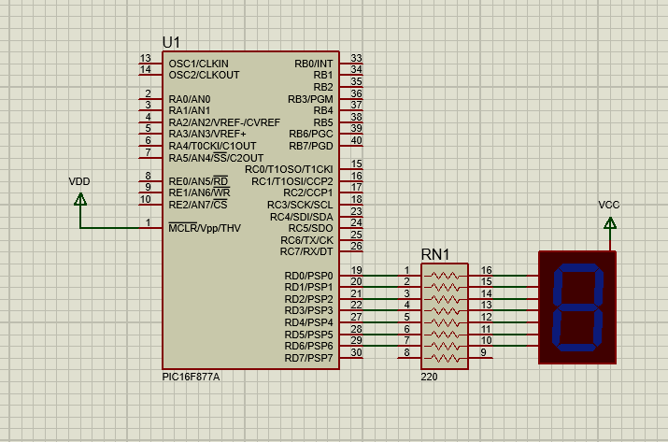
B)
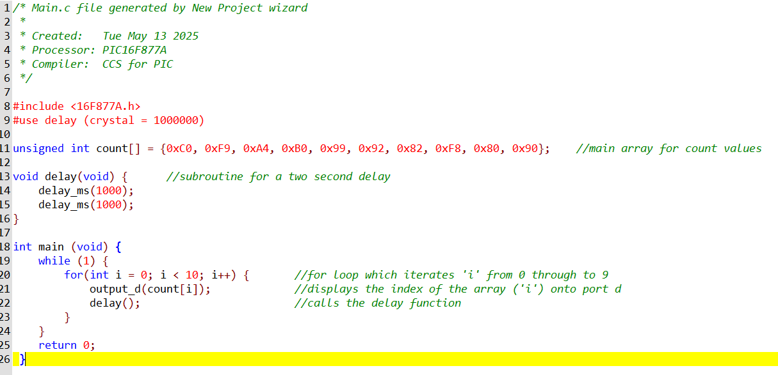

C)
@ 0 seconds
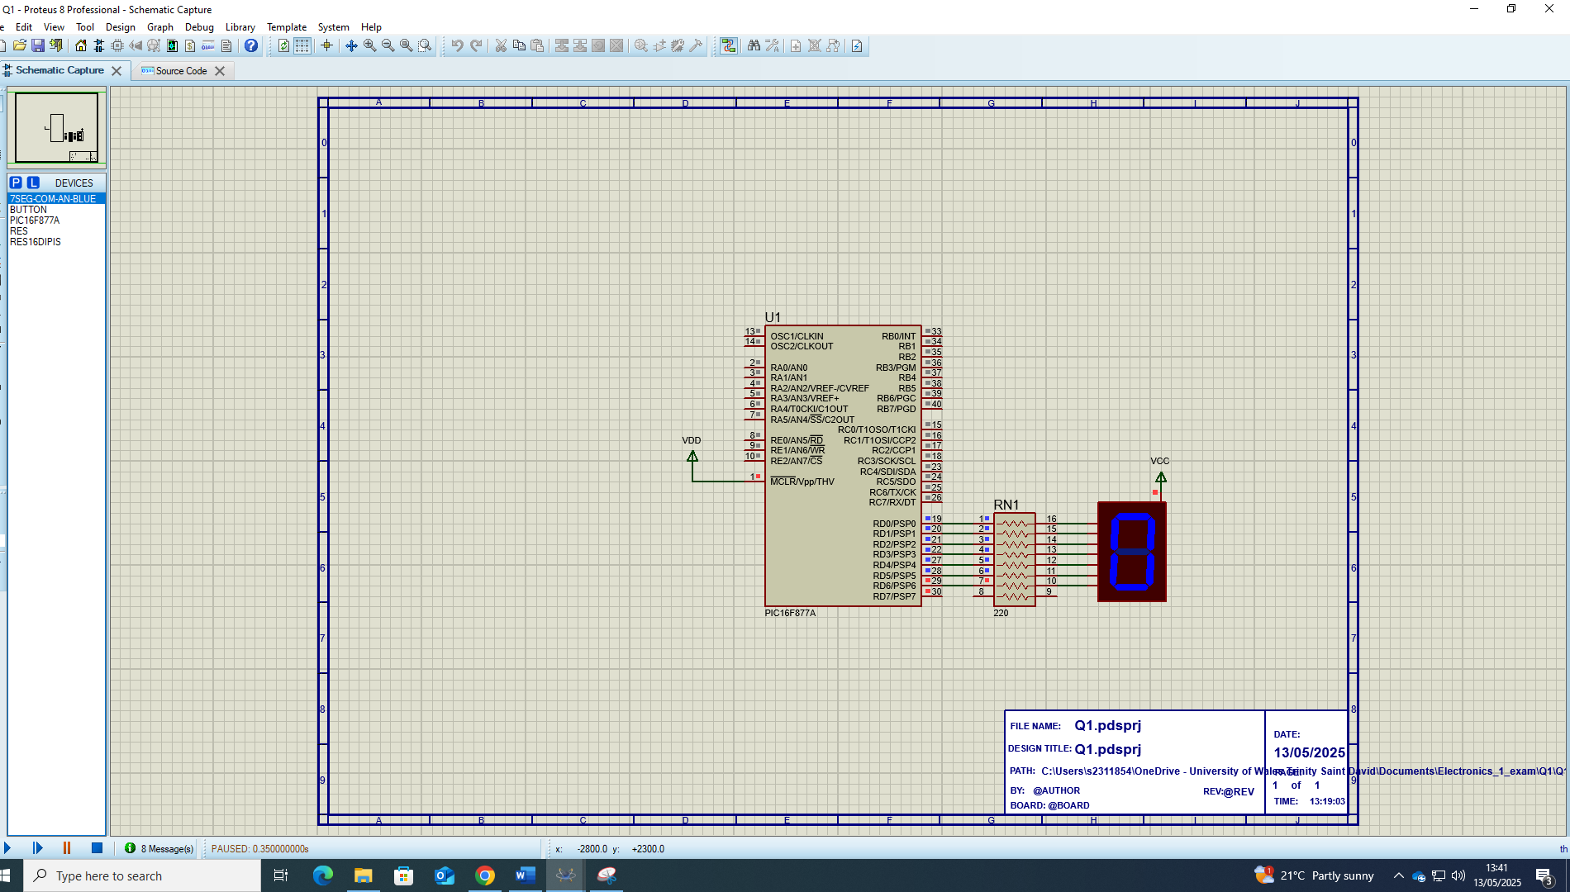
@ 2 seconds
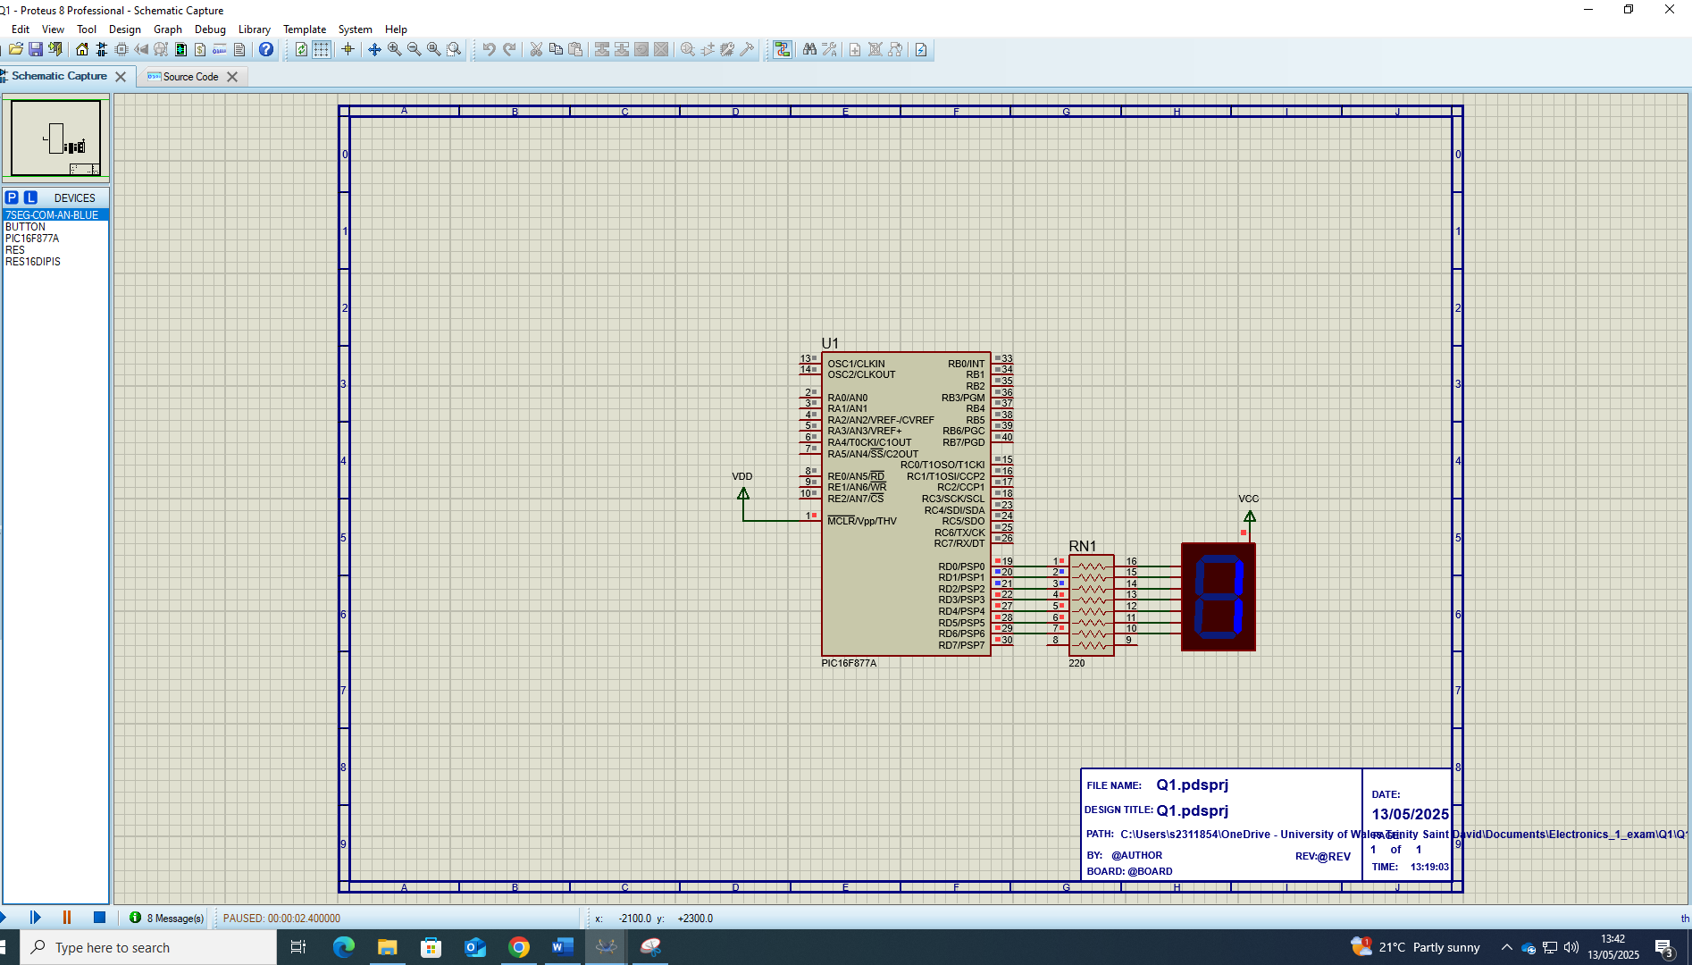
@ 4 seconds
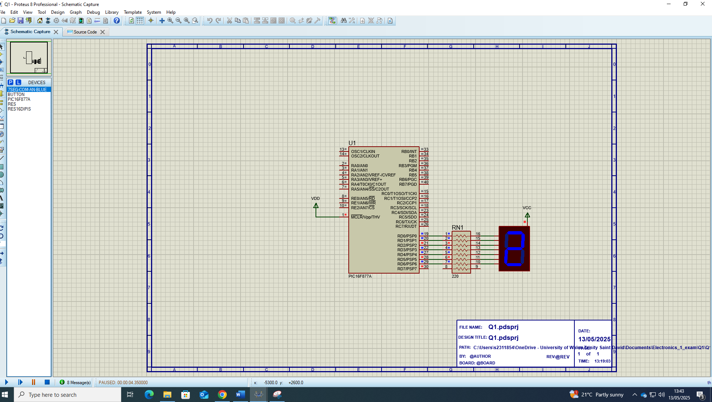

@ 6 seconds
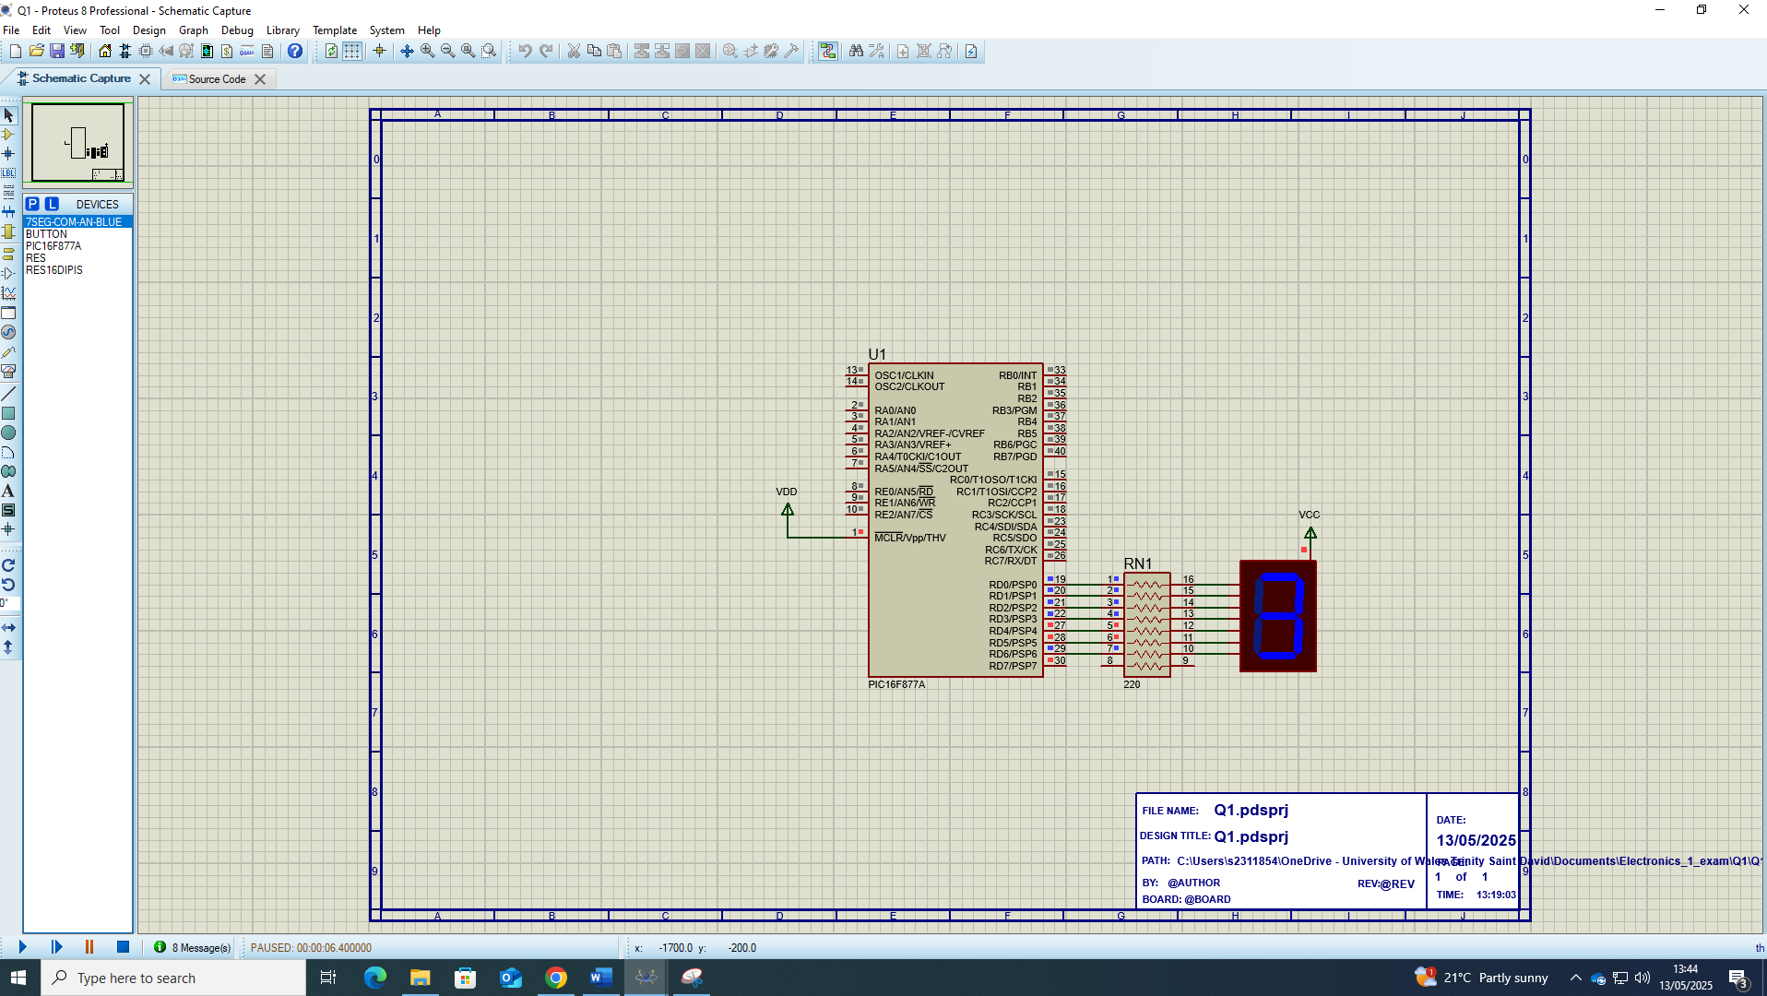
@ 8 seconds
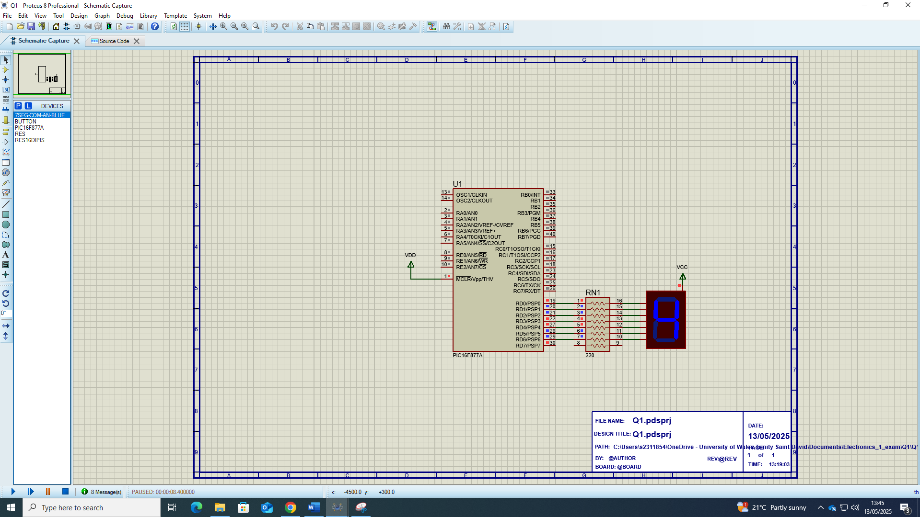
@ 10 seconds
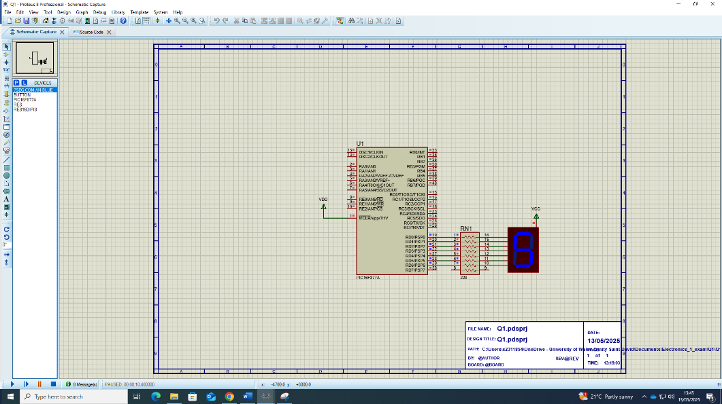

@ 12 seconds
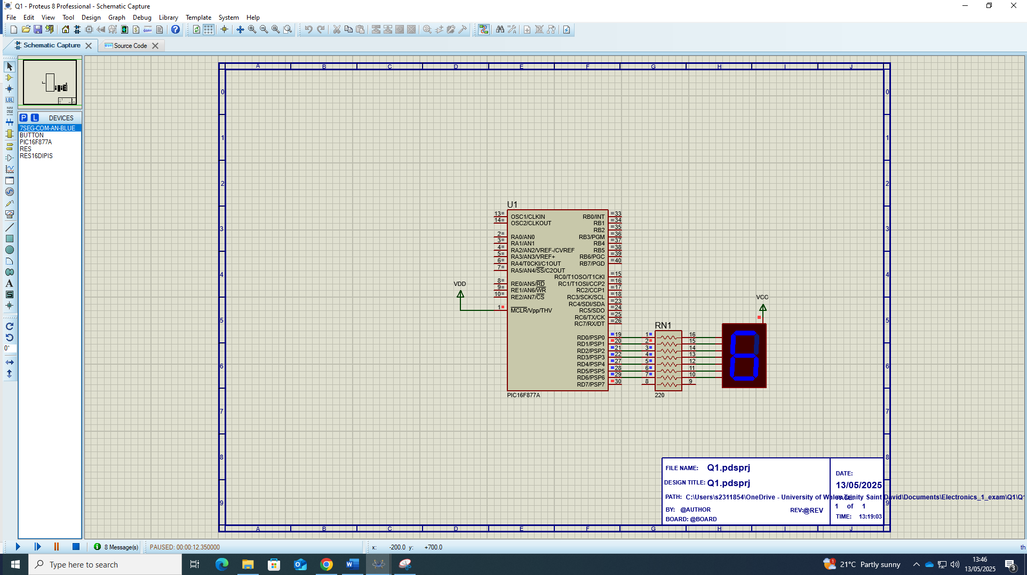
@14 seconds
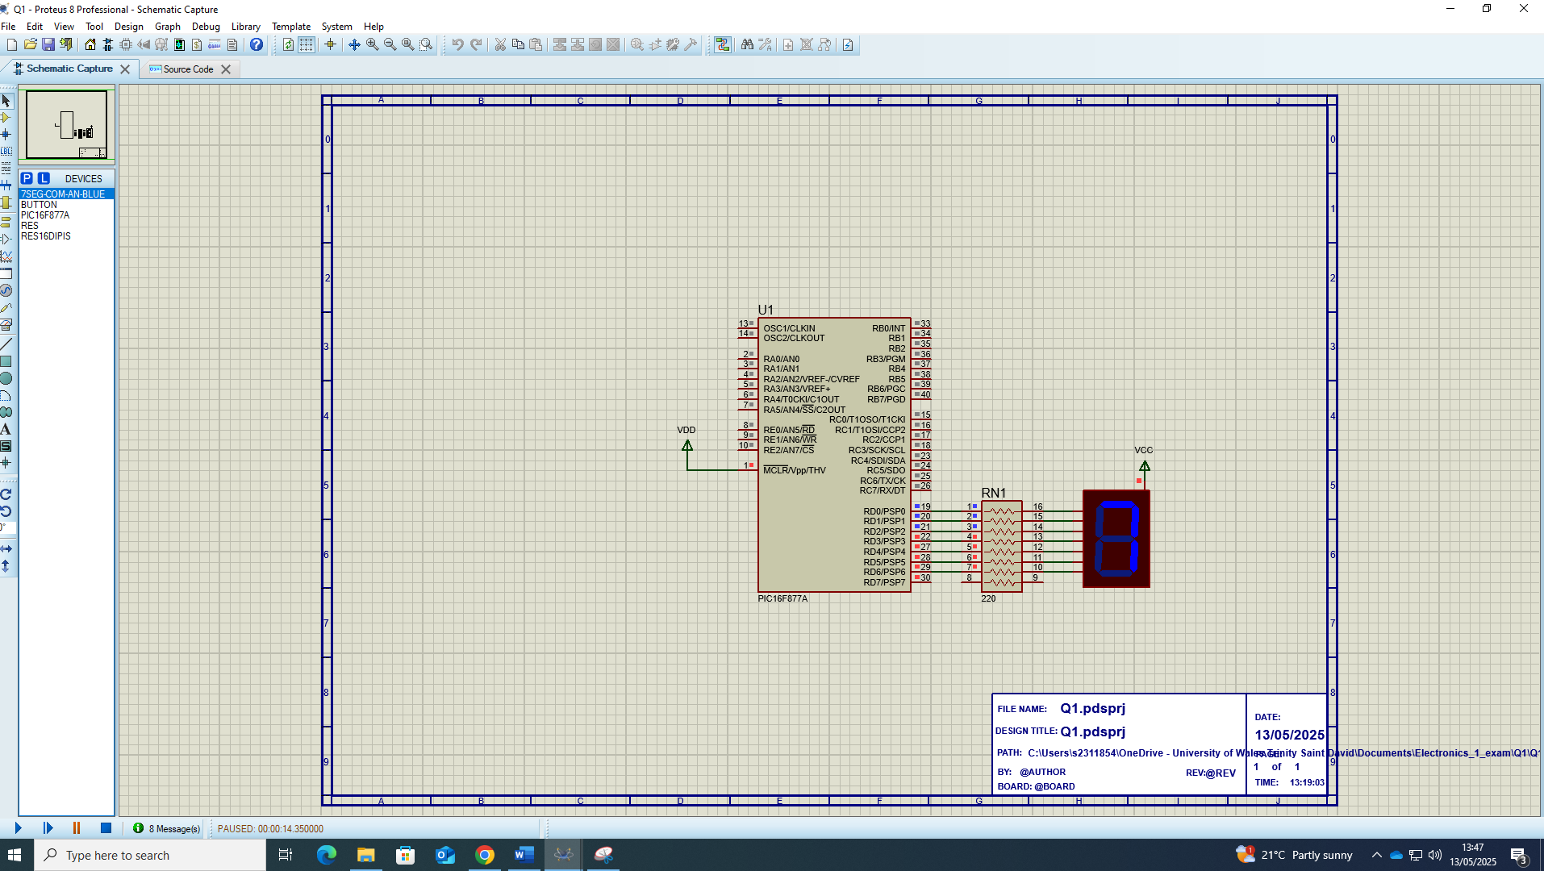
@ 16 seconds
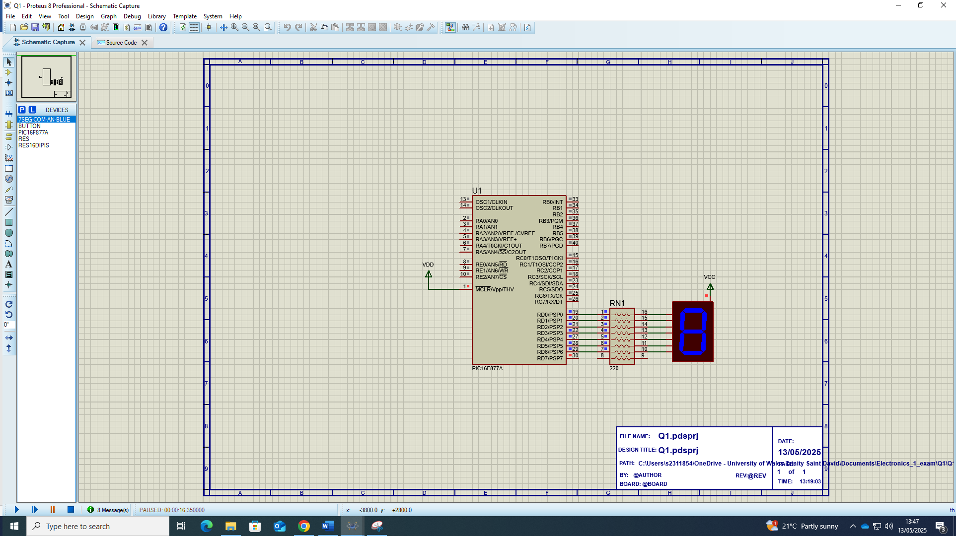

@ 18 seconds
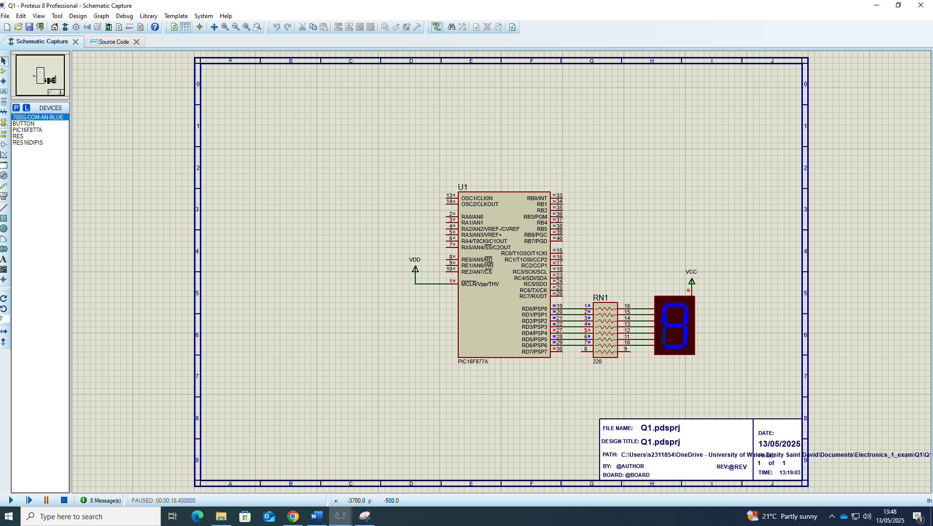

Question 2

A)
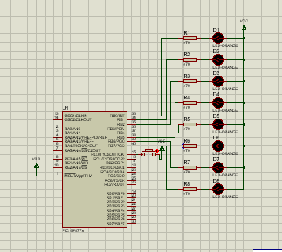
B)


C)
Button not pressed
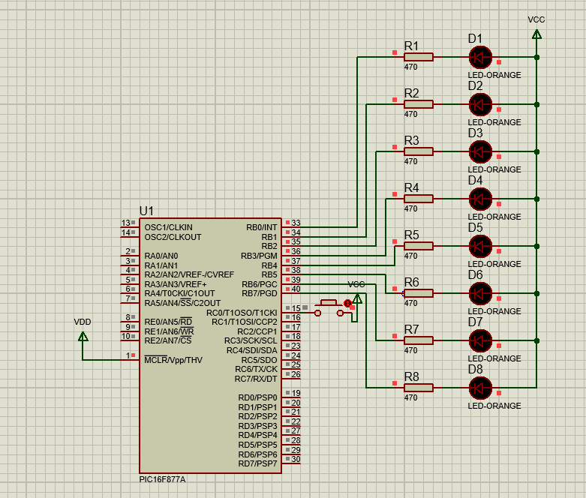

Button pressed
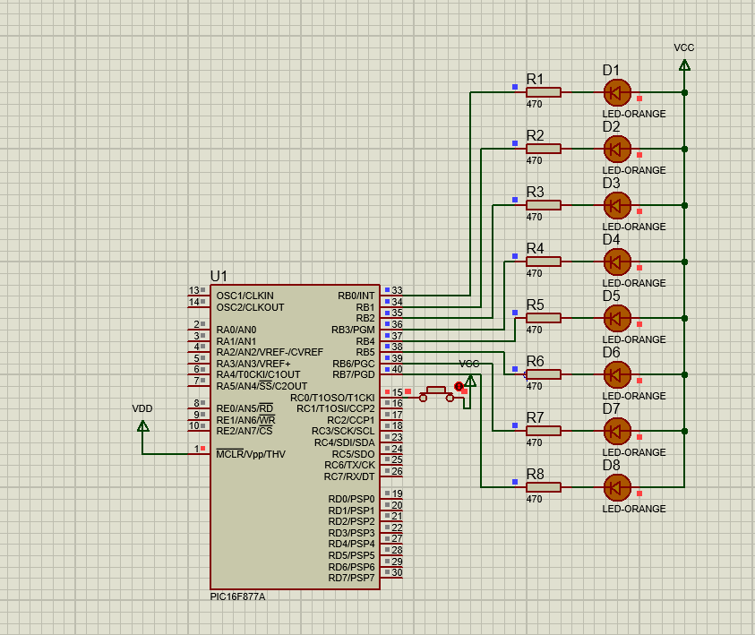

Question 3
A)
The circuit shown in the image is a LM393 comparator circuit. It compares the voltage outputs of the two potential dividers which is input into pins 2 and 3 of the op-amp.

B)
The Vin is being sent through two potential dividers (R5/RV1 and RV2/R4). The Vout(U1:A) of the second potential divider is being provided as a voltage reference (Vref) for the comparison. The other Vout(RV1) is being compared to this Vref. If Vout(RV1) is greater than Vref then the LM393 will produce an output current so there will be no potential difference across the LED so it will not turn on.
If Vout(RV1) is less than Vref then the LM393 will not produce a current so it will be sinking current from the supply rail and then the LED will light.
C}
As mentioned above, when Vout(RV1) is greater than the Vout(U2:A) the LED(D1 will not light:
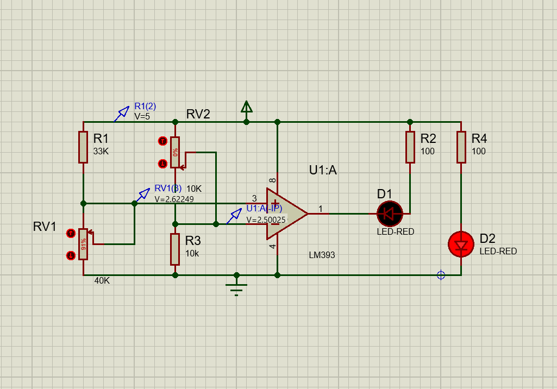

Also mentioned above; the led(D1) will light when the Vout(RV1) is less than the Vout(U2:A):
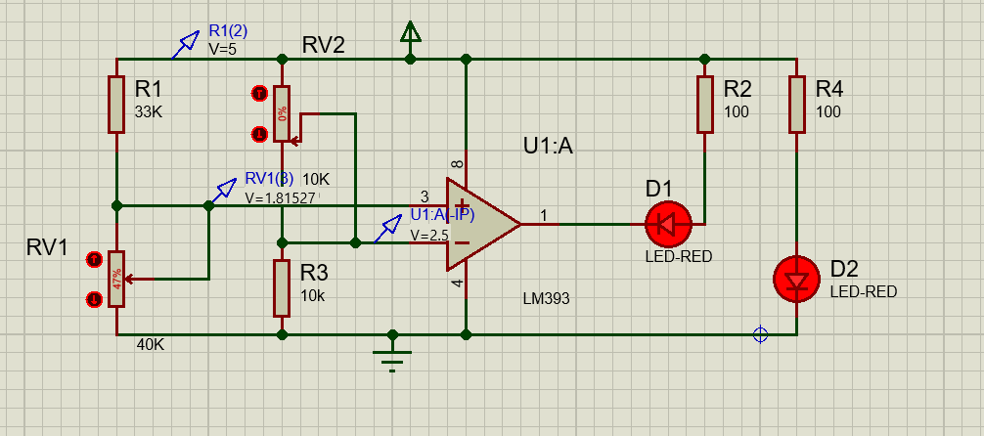

Question 4
A)
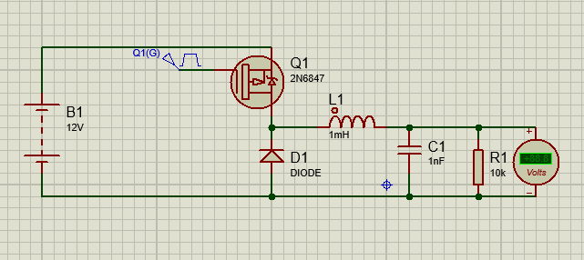
B)
When the oscillator is at logic high (1), the mosfet switched into the on position allowing current to flow through the inductor. This current flow builds the magnetic field around the inductor and charges the capacitor.
When the oscillator produces logic 0 then the mosfet turns off stopping the flow of current though the inductor. This causes the steady collapse of the magnetic field. The movement of the magnetic field induces a current. The mosfet closing causes a lack of voltage in the load side of the system. This means that the inductor must cause a voltage to be induced to to Ohm’s law. V=IR. There is a current from the inductor and a resistance in the load.
This voltage will be lower than the voltage from the battery.
C)
Shown below is the buck converter circuit acting as the intended down converter. Converting 20V into 0.03V.


