
Skills for the Workplace
Module Assignment Submission

Table of Contents
Introduction 3
Identify and evaluate appropriate sources of information and gathering data on how modern technology has affected the world of business. 3
Demonstrate the effective use of various IT approaches 5
Explore the social media in the workplace as a tool for marketing, customer service, information gathering and communication 6
Conclusion 9
References 10
Appendix 1 11
Appendix 2 12

Introduction

In this assignment I will demonstrate the ability to evaluate the appropriate use of digital skills to improve workplace and the world of business. To do this I will be researching devices, modem day technology and emails which all have the best use in a workplace. I will also create my own professional accounts on three different social networking accounts which are Facebook, twitter and Linkdin. I will evaluate the possibility for communication and collaboration in the workplace that use these social networks. Finally, I will look at how the social media is used in the workplace as a tool for: marketing, customer service, information gathering and disseminating and communication.

Identify and evaluate appropriate sources of information and gathering data on how modern technology has affected the world of business.

Technology in the workplace is the most important part, without technology we can’t even imagine any office. Cloud storage, virtual office, social networking, emails have made the workplace so easy that people can connect from anywhere in the matter of minutes or seconds without even leaving the office.
From my findings there are many different sources of information on how modern technology has affected the world of business, so to make it easier I have decided to talk about 3 different types of smart technology which have turned out to be the most popular smart technology out there at this day of age and they are email provers, devices and web conferencing. Personally, I use these on a day to day basis and it would be interesting to expand my knowledge on them. Which smart technology increasing business are being more efficient. I have gathered data on would modern day technology is used for and how this help would a business run more successful.
Email providers- emails are messages distributed by electronics which means from one device to one or more recipients via a network. Email providers provide the public email services where they can send, receive, accept and store emails for other organisation or end users, on them behave. There are many email providers out there such as; outlook, g-mail, yahoo and AOL. (fisher, n.d.). Despite the host of benefits, there are certain weaknesses of email that you should be aware of, such as:
- spam - unsolicited email can overwhelm your email system unless you install a firewall and anti-spam software - see internet and email security issues
- viruses - easily spread through email attachments
- sending emails by mistake - at a click of a button, an email can go to the wrong person accidentally, potentially leaking confidential data and sensitive business information
- data storage - electronic storing space can become a problem, particularly where emails with large attachments are widely distributed
Less formal nature of email can lead to careless or even libellous remarks being made which can damage your business.

Devices – these are adapted for a purpose, especially a piece of mechanical or electronic equipment. Devices are used to perform one or more relatively simple tasks. Many devices can connect to the internet where individuals can use these devices for work commitments. iPad, tablets, mobile phones, computers, and laptops are all known as devices. (university , 2012). As much as there are advantages there are downsides to digital technology too. Digital technology means that vast amounts of data can be collected and stored. This can be private information concerning individuals or organizations. It can be very difficult to keep this data safe. Just a single breach can mean vast amounts of private information going into the hands of criminals, terrorists, foreign enemies, or other malign entities. There is an increasing tendency for people to socialize and communicate via digital devices rather than through real life contact. This can easily lead to a sense of disconnect and isolation. Human beings have evolved over thousands of years to have real contact, taking that away is a bad idea. Studies have suggested that the lack of real life contact is causing depression and other forms of mental illness in many people.
Web conferencing- this is an online service by which you can hold live meetings, conferencing, presentation and trainings via the internet. You can connect to the conference either by telephone or using your computer/laptop speakers and microphone. (rouse, n.d.) The following are some of the disadvantages of web conferencing. Hacking is a real threat in our society right now. Even with the tightest of securities, there is bound to be a few loopholes here and there which if explored can and will open the door to breach of security. Hackers can get access to private conferences and leak information that may be paramount to a company. Due to the shareability factor, it is very possible to get information which want designed for the public reaching the public. Slight openings may bring with them massive loses in trust. Information which should otherwise be obtained through a fee may become accessible to individuals who hadn’t paid for it. To protect the integrity of their meetings and information, some companies are choosing to invest in their own servers. This is a move geared towards eliminating the risk of hacking and unintended sharing.

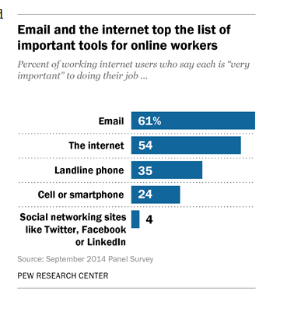
It seems that currently the modern-day technology has come a long way, the process in the way things used to work has changed quite a lot, nowadays Secretaries now use word processors and not typewriters. Travel agents book holidays by computer, not by phone or letter. Telephone banking has meant that many bank staff now work by phone in front of a computer, instead of being in a branch, behind a counter. De-skilling has taken place. Some jobs which needed a high level of skill in the past can now be done more easily. For example, print workers today can use DTP software to lay out their work. Designers now use CAD software rather than pencil and paper on a drawing board.

Demonstrate the effective use of various IT approaches

The approaches I will be demonstrating are devices known to be used in a business environment. I have researched effective uses of IT in a workplace and the outcome was many devices were used to run a successful business and the most popular device was a laptop. In my further research it shown the best make and model that were highly recommended for business use, I have gathered data to show which device is more suitable for me when running my business. The make and model I have chosen to compare are dell and apple. These devices are designed by different companies which means they run off different software, for example the apple laptop runs off IOS whereas Dell runs off Quest software. I think when running my business, a laptop would be more practical as it is an up and go device which will benefit my employees as they would be able to complete work tasks at home.
Many laptops in this generation have been developed meaning there are no longer a heavy weight and are easy to carry around for business purposes. Laptops have also been developed with new types of software which have been purposely made to make the life of business person much easier and they can complete tasks with the correct equipment. For my business its only the matter of figuring out what my teams priorities are and what they need out of a laptop, this is where I’m going to be looking at my two chosen models and finding out which is the most beneficial.
 | Apple (Mac book Pro) | Dell (XPS 15)
Cost | £1,249 | £1,296
Weight | 1.37KG | 1.2KG
Battery | 7 hours | 11 hours
Screen size | 13 inches | 15.6 inches
Colours | Sliver & space grey | Multi range
Software | MacOS | Microsoft

With these two devices there are many pros and cons to the public buy or skip. With the Macbook Pro they say it’s a beautiful laptop with a great screen and a touch bar and touch ID. It has a massive trackpad, thin and relatively light, it has a USB-C and the battery life is ok. The cons to the Macbook pro is that it has no USB-A, no ethernet, no native display ports, no upgrading after purchase and they are very expensive. There are many pros and cons on the XPS are infinity display, key bored and touchpad, battery life and then the bad qualities are palm rest, ergonomics.
To conclude both the apple and dell they have their own pros and cons, both are equally strong contenders and are bound to rule the app market place with their own strength and positives there is very little between the two, although the open source nature of MacOS offers the opportunity for a diverse apps, if not more in number with dell you are restricted to apps and other software.

Explore the social media in the workplace as a tool for marketing, customer service, information gathering and communication

Online social networks facilitate connections between individuals based on shared interest, values, membership groups. They make it easier for individuals to find and communicate with individuals who are in their networks using the web as the interface.

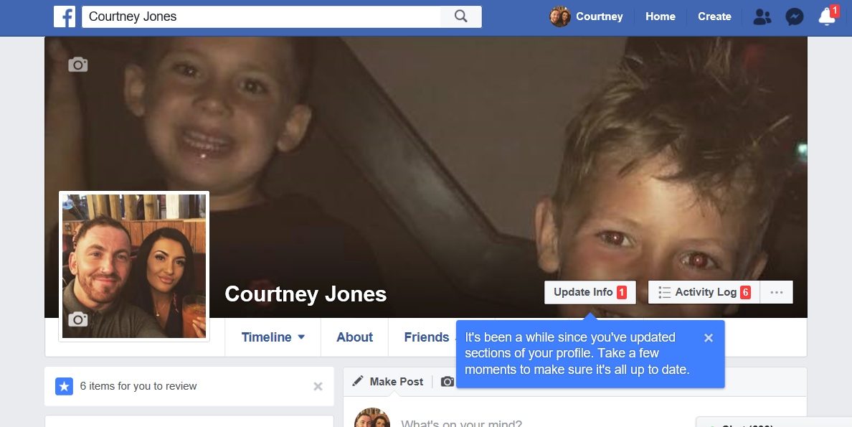

Facebook was originally developed for individuals to connect, so it has more informal, social air than you will find on LinkedIn. It is open to anyone, you will still find that Facebook is the preferred network for all youngsters. Facebook combines the personal and the professional. Members can play games, join groups, share photos and send each other virtual gifts. This is the network where you are most likely to see both pictures of someone’s weekend activities, a well as a link to their online portfolio or professional website. Many companies are using Facebook as a recruitment tool.

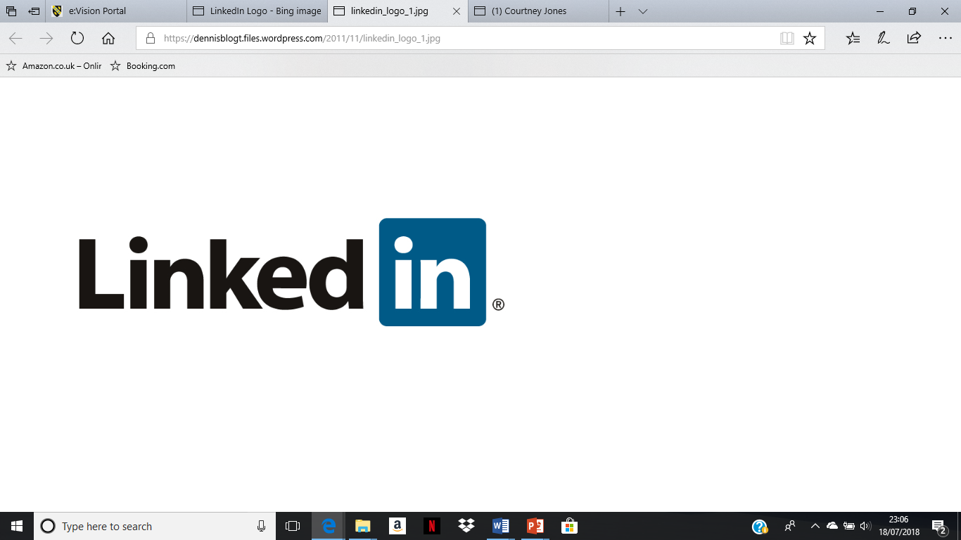

LinkedIn is primarily a professional network, designed to facilitate linkages between individuals who are wanting to connect for work-related purpose. It is more buttoned down than Facebook with more formal culture of relationships and connections. It is also the network of choice for most professional networking, there’s a greater emphasis on building a reputation and connecting to employment and business opportunities. LinkedIn questions and answer are a way for individuals to ask questions and receive expert advice. Answers can be rated and individuals who do this can improve their LinkedIn reputation. There are also employment listings and an ability to receive recommendations from your connections that then become part of your profile.

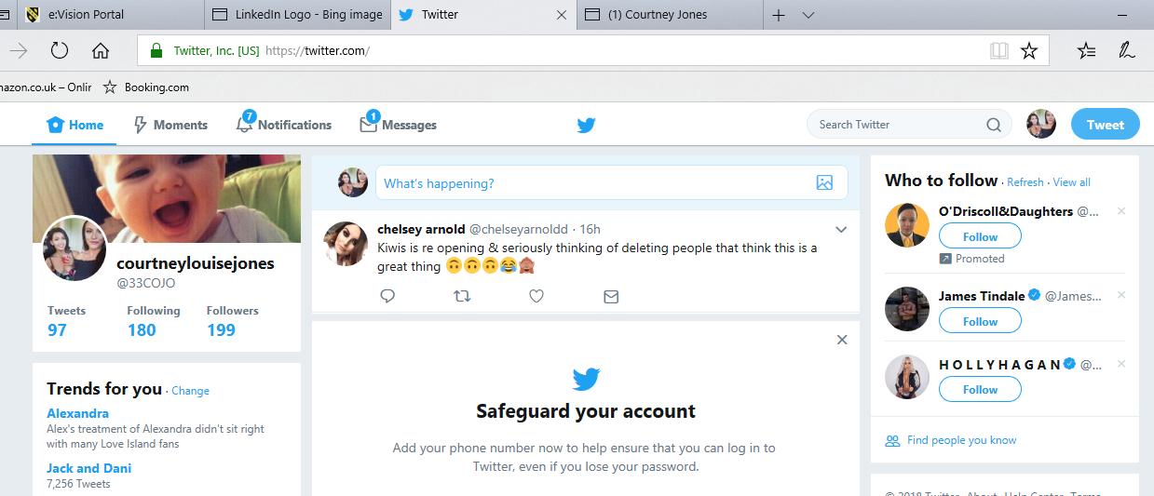

I would have never thought this, but twitter is more than just a way to publicise a new product or service. It’s a way for businesses to quickly connect and engage with customers, partners and employees and build a loyal following. Twitter can be used to prospect customers, just being searching for intent based tweets. You can also monitor twitter to find happy customers of your competitors. Businesses are now recruiting, scanning for qualified in individual’s fields, it can be a great channel to recruit your most active fans to join your company as employees.
In our days social networking can help businesses expand dramatically as a business that is started in America for instance can be easily viewed from all over the world.
Marketing- From my research I gathered that Social media marketing increases your brand’s awareness. 78 % of small businesses use social media to attract new customers. Furthermore 33% of customers have identified social media as how they identify new brands products and services. Social media marketing helps to validate your brand. A company’s social media presence, when done correctly.

Costumer Service- by having social media enables you to engage your customers directly. If you have concerns about something, you can ask questions and receive responses quickly. If customers have questions or complaints, they can interact directly with a member of your team who should respond sympathetically to their concerns and try to resolve the issue

Communication- although I believe social media can be very beneficial in the world of business as it is quick, and you can do it from the comfort of your desk, we must be careful things aren’t taking the wrong with or miscommunicated.

Conclusion

To conclude smart technology is having a huge impact on business connectivity and the rise of wearables now meaning employees need wider access to company data through mobile devices and remote locations. User experience is a priority for businesses, and many vendors are taking this into consideration, ensuring everything from laptops to tablets have built in 4G, wireless and Bluetooth. Companies are also responding to the increasingly mobile workforce by creating apps for basic business functions such as printing on the go and accessing sensitive company data. However, with additional connectivity comes the need for additional security. Smart devices are increasingly exposed to potential threats and having an open connection can pave the way for hackers to enter systems and cause harm. Within an office, everything from a smartphone to a printer needs to have a security control in place.

References

(fisher, n.d.)
(rouse, n.d.)
(university , 2012)

Appendix 1

Appendix 2

