
people management


November 11, 2022
University of Wales Trinity Saint David

Corina-Elena Cernat 2019920

Executive Summary
The scope of this report is to establish the skills required by managers to ensure effective people management and to analyse the importance of performance management and how this can be done effectively to achieve the organisational goals.
In a business environment managers should adopt a leadership style that allows employees to perform and increase their productivity. One style does not suit everyone, and while a transformational style positively impacts employee’s motivation, managers should focus on adapting to different leadership styles while constantly training to gain and improve their soft skills essential for their team’s success.
As the employees are a company’s most important asset, keeping them motivated and engaged should be a priority for every manager and the role of some of the motivational theories has been established, as well as the benefits provided by treating them equally and providing flexible working arrangements.
One of the most important aspects of performance management is the investment in training and development plans, both for employees and their managers. Some examples have been provided of how the development plans help companies to make more profit, have a better retention, better working culture, motivated employees, improved customer service and overall increased productivity.

Table of Contents
Executive Summary 1
Introduction 3
Findings 3
Management skills 3
Effective teamwork 4
Employee motivation 4
Flexible working 5
Equality 6
Performance management 6
Conclusion 8
Bibliography 9

Introduction
People Management is an important concept that every leader should take into consideration, as this can have a direct impact on the overall productivity and motivation of the employees (Dutta, Chaudhry, 2021).
To determine how a leader can successfully support people management, the report will critically evaluate theories about effective leadership and effective teamwork, as they are important to highlight the skills and approaches that a leader should use. At the same time, the subject of employee motivation will be also touched to determine its importance and ways in which a leader can increase the motivation at the workplace, such as ensuring that equality procedures and practices are implemented and respected or providing flexible working structures. Finally, the last area of interest on the report is performance management, where the skills that a leader must have during appraisal will be determined and the organisation implication and support will be critically evaluated.

Findings

Management skills
Managers are focused on controlling and problem solving and achievement of goals while leader’s role is to motivate and inspire people to a common direction. The two concepts are often used with the same meaning, but there are clear differences between them and while not all leaders are managers, it is recommended that all managers should also be leaders (Rees & Porter, 2015).
When studying leadership models, the foundation has ben set by Kurt Lewin in 1930 who identified three leadership styles described in the figure below.
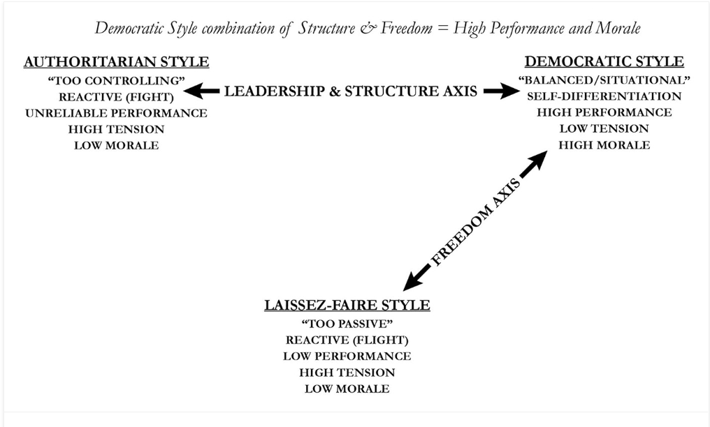
Figure 1. Lewin leadership styles (Crosby, 2021)
In a business environment the transformational leadership style has proven to be the most effective (Mindtools, 2022). These types of leaders are inspirational, have high emotional intelligence, are humble, empathetic, aware of their employees’ strengths and weaknesses and offer them support for development. The main components of this leadership style are charisma, motivation, intellectual stimulation, and individual consideration. Recent studies have demonstrated there is a positive relationship between work motivation and high levels of employee’s perception of transformational leadership behaviours (Chua & Ayoko, 2021). While this is perceived as a higher form of leadership, it does have limitations and can not be applied in all organisations because it excludes the idea of conflict between employees and managers (Rees & Porter, 2015).
Another popular leadership style is the transactional one and it focuses on clarifying the objectives and responsibilities of each employee. It is beneficial for those individuals who are motivated by external rewards and are ambitious. It can be limited though in creativity and knowledge-based work.
As there is no perfect leadership style that can be applied in every business, it is important to consider different approaches to become an effective leader. In terms of essential skills for people management, every manager should demonstrate abilities like active listening, trust, effective communication, accountability, and conflict management.

Effective teamwork
Teamwork can be defined as a process of people working together towards a common goal. It is an essential part of every business because of the implications it has on the organisation’s performance.
The leadership style plays an important role in determining the efficiency of a team (Mullins & McLean, 2019). Team members are more likely to stay united and work better if they are listened to, given support, offered encouragement, guidance, and are provided with a balance in the workplace.
When analysing what makes a successful team, in 1981 Meredith Belbin (Bednar & Ljudvigová, 2020) identified nine roles divided in three categories:
- Action oriented
- Thinking roles
- People roles
The theory has been validated and is universally applied not only because team members identify their natural role and their strengths, but also because they can learn to manage their weaknesses (Belbin, 2010 ).
Ureba, et al. ( 2022) have concluded that the presence of a larger number of these roles in the team guarantees a better performance thanks to the skills and knowledge needed to perform a task.
In terms of what role is most suitable for a successful leader, the Co-ordinator has come first, followed by the Shaper, who is more driven. In the research, Belbin concluded that even the managers who do not belong to one of these two roles, can prove to be successful leaders through motivation and self-awareness (Belbin, 2010).

Employee motivation
Employee motivation is one of the most important aspects in the success of every organisation and a challenging job for every leader (Khan & Wajidi, 2019). There are two types of motivation (Armstrong & Stephen, 2020).
Intrinsic motivation is provided by the actual job and occurs when employees feel their work is challenging and important, offers them chances to progress and a scope to develop their skills. This motivation tends to last longer because is not bound to external factors.
Extrinsic motivation is given by external motivating factors, like incentives, praise, higher pay, promotion, but also disciplinaries, criticism or pay cuts. It is more powerful than the intrinsic one, but it does not last long.
Therefore, work management theories have become more important and are present in many leadership, management, and organizational courses. These help to explain why people behave in a certain way, what drives them towards achieving a goal and how satisfied they are in the workplace (Benson & Dresdow, 2019).
Two of the most common work theories that allow leaders to learn and understand motivation are Vroom’s Expectancy Theory and Adam’s Equity Theory (Swain, et al., 2020). According to Vroom’s Theory, individuals are motivated by three things: valence, expectancy, and instrumentality.
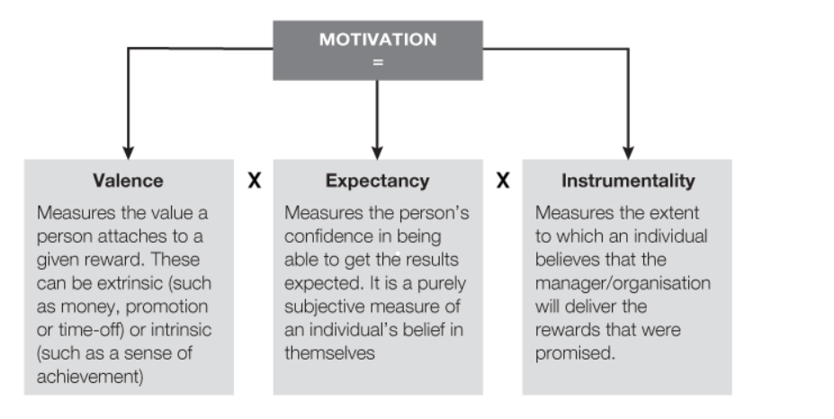 Figure 2. Vroom’s Expectancy Theory
The second theory revolves around people’s perception of equality and fairness. Individuals are more likely to remain motivated if they feel the remuneration received for their inputs is fair. In an organization, the inputs are all the things the employees are contributing with, like time, experience, resilience, education, trust, commitment, loyalty, enthusiasm. Among the outputs, the most important are the financial benefits, but also recognition, development, benefits, growth opportunities, and purpose.
When analysing the relationship between leadership competencies and employee motivation, studies by Diskiene, et al., (2019) have shown that the leader’s cognitive competencies are most important in keeping them motivated, followed by the emotional and social intelligence. The employees admire the leader who allows them to grow, is fair, trusts them, is positive and committed to their work.

Flexible working
Flexible working has become more popular over the years, especially in the context on the most recent pandemic, because of the benefits it brings to both the employer and the employees. It is predicted this will be become the normal way of working as opposed to just a less frequent one.
The main aspect of flexible working is providing the employee the control over where and when they choose to work (Chung & Van der Lippe, 2018). Flexible working jobs are considered more relaxed and allow people to create a healthier balance between work and their personal life. Some of most common flexible working arrangements are (CIPD, 2022):
Part time jobs are very popular working arrangements, with more people choosing this type of work, especially in the service sector, representing 23% of the working age people in 2021, with three times more women than men (ONS, 2021). From the employer’s perspective, part time workers are more hardworking than those in full time positions and better at retaining skills (Marchington, et al., 2020)
Flexitime allows the employee to change the working hours to meet their objectives while considering other obligations outside the office. Over the last ten years, the number of flexitime workers has increased in UK by 13%, with more than 4.3 million people being on a flexitime employment contract (Statista, 2022).
Remote working refers to working from home or any other location outside an office with the help of technology that allows employees to communicate with their colleagues and supports these working practices (Wang, et al., 2021). It is no surprise the number of people working from home has increased following the pandemic and is still a very popular way of working, but the ease of restrictions has led to a rise in a new way of flexible working arrangement- hybrid working, a mix between working from office and from home. In UK 24% of people are working both at home and in an office, as opposed to just 14% who solely work from home (The Home Office Life, 2022).
A study from 2019 (CIPD) has concluded that in UK women are more likely to have a flexible working arrangement, together with those who have dependable children and those who belong in very young or oldest age group.
Some of the benefits for the companies are increased employee engagement, productivity and wellbeing, higher retention, better diversity, lower absence (CIPD & Simply Health, 2022). There can also be some disadvantages for employees when choosing a type of flexible working, the main one being a reduced pay. Some individuals can also have less motivation or feel lonely, especially in a remote working job (Indeed, 2022)

Equality
Every individual in an organisation should be given equal and fair opportunities for learning, working, and growing and the employer has the obligation to ensure the working environment is safe and promotes diversity and inclusion (HR Dept, 2022).
In UK the Equality Act introduced in 2010 (GOV, 2015) replaced the previous anti-discrimination regulations and protects against nine types of discriminations: disability, age, gender, pregnancy and maternity, marriage, sexual orientation, sex, religion, and gender reassignment.

Performance management
An effective performance management is one of the main objectives of every organisation as this leads to higher employee motivation, engagement, and achievement of the strategic goals (Stephen, 2022).
Performance appraisals are often met in larger organisations and are all about motivating the employees to improve their performance by setting them individual objectives (Hutchinson, 2013).
For an appraisal to be delivered effectively it is critical that the manager takes time to be fully prepared and be clear about their expectations from the interviews (Rees, 2015). They need to be aware of previous appraisals, propose objectives, create learning and development plans, and identify what support is required.
One of the theories that analysis what makes an effective performance management is AMO (Van Waeyenberg & Decramer, 2018), a model formed of three components: ability, motivation, and opportunity. It is because people perform better when they have the knowledge and skills required for their job (ability), are motivated and are offered opportunities to progress.
Research conducted by Delloite (2018) has shown that the organisations where effective performance management is conducted are more likely to deal with change, achieve their financial targets by 30% more and innovate.
To ensure effective performance management is achieved, every organisation needs to invest its resources in several areas. Firstly, it needs to create a high performing work culture that can be achieved by offering learning and development opportunities, setting clear goals for the team, providing employees with regular feedback and coaching, offering performance evaluation, and creating a rewards and recognition tool (Delloite, 2022).
Secondly, the companies need to invest in their leaders and line-managers who are critical in improving employee performance. They need to be offered training and ongoing support and created a plan for them to prove their new skills.
Training and development are important in every company for the numerous benefits they provide (Herrity, 2022). Although it is costly, is always more expensive to hire new people than to retain existing ones. The productivity increases, there is less need for supervision, employees have a higher morale, and the organizational culture is improved. Companies that constantly invest in learning and development also have a higher profit. A comprehensive training programme delivered through online platforms that focusses on the individual is what allowed Tesco to become more competitive recently compared to other supermarkets (Tesco PLC, 2022). Asda is another big supermarket that understands the importance of development and last year introduced its Academy Centres that focused on delivering leadership courses and helped 20% of its participants to obtain a senior position (ASDA, 2022).
Furthermore, companies should always embrace technology and search for tools that are meant to make their work easier, reduce their costs and allows them to grow. The employees need to be upskilled consistently to keep up with the latest technology that helps them increase their efficiency (Simplilearn, 2022)

Conclusion
Effective people management comprises training, motivation, teamworking, problem-solving and is important for every leader as it leads to increased productivity and professional development.
One of the most important aspects of performance management is the appraisal process that is used to evaluate how well the employees are performing and to create development plans meant to grow their efficiency.
Training and development plans are essential in every organisation for the numerous benefits they provide for both the company and the individuals. They increase profit, employee retention, customer satisfaction while allowing the employees to maximise their skills and knowledge. This also has a positive effect on keeping the employee’s motivation who will then be more engaged and focused on achieving the organisation’s objectives.
While it is difficult to find a general leadership style that can be effective for every manager, it is important that these spend the time to acquire and improve the necessary skills to lead their teams to success.

Bibliography
Armstrong, M. & Stephen, T., (2020) Armstrong's Handbook of Human Resource Management Practice. London: Kogan Page, Limited.
ASDA, (2022). Learning and Development. [Online]
Available at: https://www.asda.com/creating-change-for-better/better-lives/great-place-to-work/learning-and-development
[Accessed 09 11 2022].
Bednar, R. & Ljudvigová, I., (2020). Belbin team roles in a start-up team. [Online]
Available at: https://www.proquest.com/docview/2456247351?accountid=130472&parentSessionId=BdTnJQjxs6yNIOgyHpQDm3P%2BwWgbbMpewTzeWeYNBv0%3D&pq-origsite=primo
[Accessed 23 10 2022].
Belbin, M. R., (2010) . The art of building a team. In: Team roles at work. Oxford: Routledge
Belbin, M. R., (2010) Team leadership. In: Management teams : why they succeed or fail. Oxford: Butterworth-Heinemann.
Benson, J. & Dresdow, S., (2019). Delight and Frustration: Using Personal Messages to Understand Motivation. Management Teaching Review, 6(2), pp. 112-122.
Chua, J. & Ayoko, O., (2021). Employees’ delf-determined motivation, transformational leadership and work engagement. Journal of management & organization, 27(3), pp. 523-543.
Chung, H. & Van der Lippe, T., (2018). Flexible Working, Work–Life Balance, and Gender Equality: Introduction. Social Indicators Research volume, Volume 151, pp. 365-381.
CIPD & Simply Health, (2022). Health and Wellbeing at work 2022. [Online]
Available at: https://www.cipd.co.uk/knowledge/culture/well-being/health-well-being-work
[Accessed 01 11 2022].
CIPD, (2019). UK Working Lives. [Online]
Available at: https://www.cipd.co.uk/Images/uk-working-lives-summary-2019-v1_tcm18-58584.pdf
[Accessed 07 11 2022].
CIPD, (2022). Flexible working practices. [Online]
Available at: https://www.cipd.co.uk/knowledge/fundamentals/relations/flexible-working/factsheet
[Accessed 01 11 2022].
Crosby, G., (2021). Lewin’s Democratic Style of Situational Leadership: A Fresh Look at a Powerful OD Model. The Journal of applied behavioral science, 57(3), pp. 398-401.
Delloite, (2018). Seven Top Findings from High Impact Performance Management Research. [Online]
Available at: https://www2.deloitte.com/content/dam/Deloitte/us/Documents/human-capital/us-human-capital-high-impact-performance-management.pdf
[Accessed 26 10 2022].
Delloite, (2022). Better Support Your Teams Through Better Performance Management Practices. [Online]
Available at: https://action.deloitte.com/insight/1147/better-support-your-teams-through-better-performance-management-practices
[Accessed 26 10 2022].
Diskiene, D., Pauliene, R. & Ramanauskaite, D., (2019). Relationships between Leadership Competencies and Employees' Motivation, Initiative and Interest to Work. Montenegrin Journal of Economics, 15(1), pp. 113-129.
Dutta, A., Chaudhry, S. R., (2021). Managing people more effectively: Challenges and best practices. Journal of Management Research and Analysis, 8(1), 10-14.
GOV, (2015). Equality Act 2010: guidance. [Online]
Available at: https://www.gov.uk/guidance/equality-act-2010-guidance#:~:text=The%20Equality%20Act%202010%20legally,strengthening%20protection%20in%20some%20situations.
[Accessed 09 11 2022].
Herrity, J., (2022). The Importance of Training Employees: 11 Benefits. [Online]
Available at: https://www.indeed.com/career-advice/career-development/importance-of-training
[Accessed 08 11 2022].
HR Dept, (2022). Diversity, inclusion and equality. [Online]
Available at: https://www.hrdept.co.uk/services/diversity-inclusion-equality-workplace/
[Accessed 09 11 2022].
Hutchinson, S., (2013). Performance management. London: Chartered Institute of Personnel and Development.
Indeed, (2022). Examples of flexible working (Including their benefits). [Online]
Available at: https://uk.indeed.com/career-advice/career-development/examples-of-flexible-working
[Accessed 07 11 2022].
Khan, M. R. & Wajidi, A., (2019). Role of Leadership and Team Building in Employee Motivation at Workplace. Global Management Journal for Academic & Corporate Studies, 9(1), pp. 39-49.
Marchington, M., Wilkinson, A., Donnelly, R. & Kynighou, A., (2020). Human Resource Management at Work: The Definitive Guide. London: Kogan Page Limited.
Mindtools, (2022). Types of Leadership Styles. [Online]
Available at: https://www.mindtools.com/pages/article/newLDR_84.htm
[Accessed 09 11 2022].
Mullins, L. J. & McLean, J. E., (2019). Organisational behaviour in the workplace. [Online]
Available at: https://ebookcentral.proquest.com/lib/trinity/reader.action?docID=5830196#
[Accessed 23 10 2022].
ONS, (2021). Annual population survey (APS) QMI. [Online]
Available at: https://www.ons.gov.uk/employmentandlabourmarket/peopleinwork/employmentandemployeetypes/methodologies/annualpopulationsurveyapsqmi
[Accessed 07 11 2022].
Rees, D. & Porter, C., (2015). Skills of Management and Leadership : Managing People in Organisations. London: Bloomsbury Publishing Plc.
Rees, W. D., (2015). Appraisal and performance management. In: Skills of management and leadership : managing people in organisations. London: Macmillan Education ; Palgrave.
Simplilearn, (2022). Top 8 Benefits of Employee Training and Development in 2023. [Online]
Available at: https://www.simplilearn.com/benefits-of-employee-training-and-development-article
[Accessed 08 11 2022].
Statista, (2022). Number of employees working flexi-time in the UK 2013-2022. [Online]
Available at: https://www.statista.com/statistics/415887/number-of-employees-flextime-uk/
[Accessed 07 11 2022].
Stephen, T., (2022). Improving organisational performance. In: Human Resource Management: People and Organisations. s.l.:Kogan Page, pp. 134-155.
Swain, J., Kumlien, K. & Bond, A., (2020). An experiential exercise for teaching theories of work motivation: using a game to teach equity and expectancy theories. Organization Management Journal, 17(3), pp. 119-132.
Tesco PLC, (2022). Jobs & Skills. [Online]
Available at: https://www.tescoplc.com/sustainability/colleagues/jobs-skills/
[Accessed 09 11 2022].
The Home Office Life, (2022). Working from home UK statistics 2022. [Online]
Available at: https://thehomeofficelife.com/blog/work-from-home-statistics
[Accessed 07 11 2022].
Ureba, S. A., Simon de Blas, C., Borras-Gene, O. & Macias-Guillen, A., (2022). Analyzing the Influence of Belbin’s Roles on the Quality of Collaborative Learning for the Study of Business Fundamentals. Education Sciences, 12(9), p. 594.
Van Waeyenberg, T. & Decramer, A., (2018). Line managers’ AMO to manage employees’ performance: the route to effective and satisfying performance management’. International journal of human resource management, 29(22), pp. 3093-3114.
Wang, B., Liu, Y., Qian, J. & Parker, S., (2021). Achieving Effective Remote Working During the COVID-19 Pandemic: A Work Design Perspective. Applied Psychology, Volume 70, pp. 16-59.

