QR code solutions and seamless guest experience in well-being industry using SWOT analysis
PRESENTER: JUDIT ANIKO LENGYEL, ID: 2025465
DATE: 27.02.24.
Module: Contemporary Themes
Module code: BMIH6001
Lecturer: Giulia Chifari


Content
Introduction
Main body
Conclusion
Recommendations
Reference list


Introduction
- The purpose of this study has been to explain how hotel businesses are digitalizing their work processes as the availability of new technological solutions in the health and wellness services using QR code strategies.
- The current QR code implementations are enabling flexibility and being beneficial in the hospitality sector.
- Online booking platforms, contactless check-ins and mobile apps contribute to efficiency, convenience and improved overall service.


Contemporary technologies positive impacts
- So many touch- free options now than ever before fulfilling their experience.
- Eliminating the old system to fill out a form and wait the queue, supportive for patients who cannot come in person and available for a virtual consultation reducing the risk of contagion after pandemic.
- Create an individual gust experience along every step of their journey. The specific method will allow resort to set up a detailed traveler history and activate these consumer preferences, help to personalize in advance any future guest experience.
- Seamlessly connect with a robust booking system, so visitors are easily able to add variety of wellness activities, spa amenities and restaurant options in advance when making a reservation.
- Empowerments for taking part in health and wellness workshops, seminars and events.

Using SWOT analysis will describe how the contemporary ‘Technology’ theme impacts in the hospitality industry using various QR code examples.

STRENGHT
Online presence: a strong online presence including social media and review platforms is crucial for marketing and reputation management in the digital age.
QR codes can be easily shared in several social media with product pictures that influence the purchase intention.
Upgrading mobile apps and online booking system with personalized services will support a seamless positive guest experience, growing customer loyalty and satisfaction also.

SWOT ANALYSIS

Technology integration
FOCUSING ON
- Improving overall efficiency
- Depending hotel size, type of guests, customer needs and expectations
- 71% travellers are willing to spend more money just to enjoy a customized service (Kelleher, 2022)
- Integration helps to reduce operational costs, automating traditional labour tasks, flexible working practices, saving time
- QR code welcome packs, promotional strategies

QR CODE EMPOWERMENTS

- Enhance wellness programs ( massage, physiotherapy, swimming, sauna)
- Focusing on the health and well being importance
- Staying more active as gym and spa facility demonstrations
- Healthy meal ideas
- Special fitness and nutrition programs are available, discounts, special offers, packages
- QR codes can be linked to Instagram, Facebook-making connections, feedback

RECOMMENDATIONS
BOOST CUSTOMER ENGAGEMENT AND FEEDBACK
- Remarkable results
- Impeccable reputation
- Feedback collection process
- Easier to address customer needs
EASY ACCESS
- Building trusts
- Elevates the employee professionalism
- Digitalized prices and timetables
CHOOSING THE RIGHT TYPE OF QR CODES AND THEIR CREATION
- Providing seamless guest experience
- URL QR code (website)
- TEXT QR code (simple text message)
- CARD QR code (share contacts)
- EMAIL QR code (swift email)

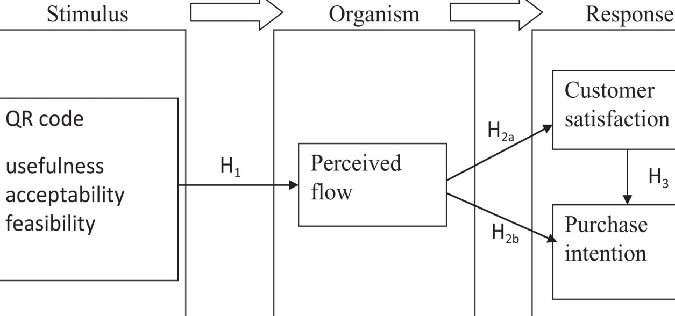

CONCLUSION
- Unnecessary touch points and stress free vacation
- Leading for a relaxing vacation experience what hotel guest deserve
- No hassle as using a smart phone, customer can head to their room without key collection
- Post pandemic era, safety concerns, keyless entry
- Ultimately increase guest satisfaction and loyalty

REFERENCE LIST

- Bustos, C. (2023, May 9). 13 Smart uses of QR codes for gyms in your wellness business. QR.io Blog. Available at: https://qr.io/blog/13-smart-uses-of-qr-codes-for-gyms-in-your-wellness-business/ (Accessed 01 February 2024)
- Clark, J., Mauck, N., & Pruitt, S. W. (2021). The financial impact of COVID-19: Evidence from an event study of global hospitality firms. Research in International Business and Finance, 58, 101452. https://doi.org/10.1016/j.ribaf.2021.101452
- Contributor, G. (2023b, January 17). 2023 trends: Top 5 future innovations in hotels and hospitality. eXceed Global Learning Pty Limited. Available at: https://insights.ehotelier.com/insights/2023/01/19/2023-trends-top-5-future-innovations-in-hotels-and-hospitality/ (Accessed 27 January 2024)
- Day, J., Dudley, N., Hockings, M., Holmes, G., Laffoley, D. D. A., Stolton, S., & Wells, S. M. (2012). Guidelines for applying the IUCN protected area management categories to marine protected areas. IUCN.
- Debata, B., Patnaik, P., & Mishra, A. (2020). COVID-19 pandemic! It's impact on people, economy, and environment. Journal of Public Affairs, 20(4), e2372.
- Elkhwesky, Z., El Manzani, Y., & Elbayoumi Salem, I. (2022). Driving hospitality and tourism to foster sustainable innovation: A systematic review of COVID-19-related studies and practical implications in the digital era. Tourism and Hospitality Research, 146735842211267. In press.
- Elliott, C. (2023, November 20). Why hotels are happy to accommodate guest requests — up to a point. Elliott Report. Available at: https://www.elliott.org/the-navigator/hotels-happy-accommodate-guest-requests-point/ (Accessed 27 January 2024)
- Executive, S. (2023, November 29). 2024 Spa & Wellness Trend: wellness travel & innovative approaches. Spa Executive. Available at: https://spaexecutive.com/2023/11/08/2024-spa-wellness-trend-wellness-travel-innovative-approaches/ (Accessed 30 January 2024)
- How innovative technology can help your resort capitalize on 6 emerging wellness trends in 2023. (2023b, August 3). hotel.report - Журнал Современный Отель. Available at: https://en.hotel.report/management/how-innovative-technology-can-help-your-resort-capitalize-on-6-emerging-wellness-trends-in-2023 (Accessed 01 February 2024)
- High-tech mine planning. (n.d.). Sandvik Group. Available at: https://www.home.sandvik/en/stories/articles/2023/09/digital-mining/ (Accessed 04 February 2024)
- Hunter, T. (2021, October 7). QR codes are a privacy problem — but not for the reasons you’ve heard. Washington Post. Available at: https://www.washingtonpost.com/technology/2021/10/07/are-qr-codes-safe/ (Accessed 0 February 2024)
- Kelleher, S. R. (2022, March 21). Travelers want to spend big, go far in 2022, Amex survey finds. Forbes. Available at: https://www.forbes.com/sites/suzannerowankelleher/2022/03/21/travelers-want-to-spend-big-go-far-in-2022-amex-survey-finds/ (Accessed 02 February 2024)
- Marques, I. A., Borges, I., Pereira, A. M., & Magalhães, J. (2022). Hotel technology innovations as drivers of safety and hygiene in hotel customers. In Smart innovation, systems and technologies (pp. 571–583). https://doi.org/10.1007/978-981-16-9701-2_47
- Murphy, J. (2023b, December 20). The biggest wellness travel trends for 2024. Condé Nast Traveler. Available at: https://www.cntraveler.com/story/wellness-travel-trends-2024 (Accessed 02 February, 2024)
- Stamps, M. (n.d.). Four risks and solutions when using QR codes. Available at: https://blog.techguard.com/four-risks-and-solutions-when-using-qr-codes (Accessed 02 February 2024)

