Programme: MSc Public Health and Social Care in Practice
Module: Population Health and Digital Health Promotion
Module code: LCHS7007
Student Name: Vatsal Khandelwal
Student ID: 2331781

Table of Contents
BLOG 1: Revolutionizing Mental Health: The Role of Digital Apps in Well-being 2
Blog 2 Introducing Programme: MSc Public Health and Social Care in Practice
Task 2 : Poster 8
References 9

Task 1: Blogs

BLOG 1: Revolutionizing Mental Health: The Role of Digital Apps in Well-being

Mental Health Apps: Transforming Wellness
Mental health has become an emerging issue across the world as anxiety, depression and stress are seen to occur in one in eight people. These together inflict over $1 trillion in productivity loss every year (WHO, 2022). With healthcare systems stretched, mental health apps Calm, BetterHelp, and Sanvello are proposing solutions in terms of access and creativity.
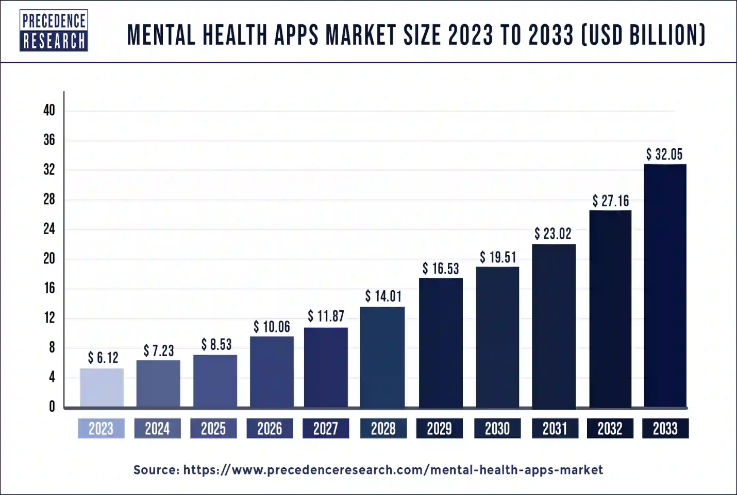
Source: (Precedence Research, 2024)

The Benefits
- Convenience: Currently, applications such as Sanvello offers self-help procedures and ways of tracking feelings round the clock, so help is always accessible. This is particularly suitable for those with so many activities to attend to.
- Affordability: Some of the apps, such as BetterHelp which match the users with graduate-students trained counselors, cost less than most similar therapy services.
- Personalization: Calm is deigned for relaxing with tools such as breathing exercises and sleeping stories of which can be of benefit to insomniacs and stressed.
- Free Options: Mental health apps such as Woebot, which is an artificial intelligent chatbot designed to offer mental health support, costs nothing and therefore can targets clients who cannot afford to pay for a therapist.
The market is growing fast—valued at $6.1 billion in 2023, it’s projected to hit $26.5 billion by 2032 (Straits, 2024).

The Challenges
- Privacy Concerns: Apps like Talkspace often require sensitive data but lack robust security, leaving users vulnerable (Schroeder et al., 2021).
- Generic Solutions: While apps like Happify offer general well-being exercises, their one-size-fits-all approach can limit their effectiveness for complex mental health needs (Alqahtani & Orji, 2020).
- Access Issues: Low-income families or rural communities often lack internet access or devices, making apps like BetterHelp, which relies on video sessions, inaccessible.
- Online Dependency: Apps such as Calm depend on internet connections for streaming resources, limiting their usefulness in areas with poor connectivity (Iwaya et al., 2022).

Moving Forward: What’s Next for Mental Health Apps?
To maximize their impact, mental health apps need to address these issues:
- Stronger Privacy Measures: Developers must ensure apps like Talkspace implement secure encryption and transparent data-sharing policies (Miranda, 2022).
- Personalized Solutions: AI-driven apps like Wysa are a step in the right direction. Wysa uses AI to offer tailored conversations based on individual user needs, making mental health support more personal and relevant (Aquino, 2024).
- Offline Access: Incorporating offline features would make apps like Sanvello more inclusive for rural or low-income users (Bautista et al., 2024).
- Wider Device Compatibility: Simplifying apps to run smoothly on older devices or with limited connectivity could open access to underserved populations.

Conclusion
Mental health apps are already breaking down barriers like stigma, cost, and accessibility. With the right innovations, they could revolutionize mental health care, making help available to anyone, anywhere.

Blog 2 Introducing SafeMind: A Revolutionary Voice-Activated Mental Health App
Depression and other mental health challenges are everywhere. The WHO tells us that 1 in 4 people globally experience mental health disorders, costing the world over $1 trillion annually. Yet, despite the staggering numbers, so many people remain unheard—held back by stigma, structural barriers, or simply not knowing where to begin (Radez et al., 2020). That’s where SafeMind comes in. It’s not just an app; it’s a game-changer that listens when no one else does.
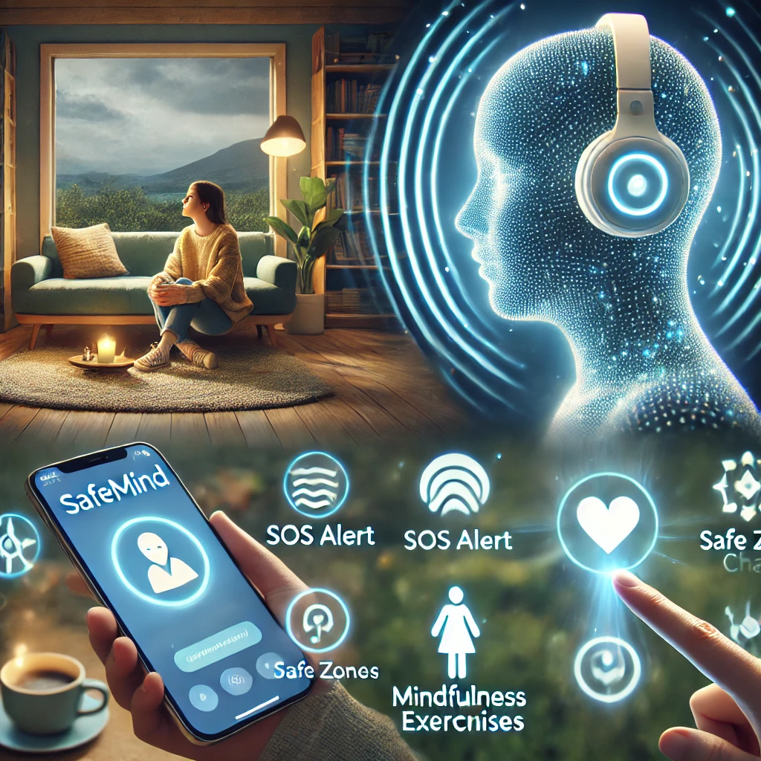
SafeMind uses voice analysis to recognize emotional cues like changes in pitch, tempo, and tone during conversations. Think about it—your voice might reveal anxiety, stress, or depression before you even realize something’s wrong. Studies show vocal biomarkers are surprisingly reliable at spotting emotional distress, and SafeMind’s AI steps in at just the right moment. But it doesn’t stop at detection. SafeMind can notify up to three trusted contacts during severe distress, sending an SOS message along with your location. Imagine the peace of mind this could bring when everything feels like it’s falling apart. It even offers guided breathing exercises, mindfulness routines, and access to therapists or mental health helplines, bridging the gap between feeling overwhelmed and finding help (Varun, 2024).
Here’s where we’ve added something unique: SafeMind now includes an "Encourage Me" feature. Picture this—you’re having a bad day, maybe stuck in a funk that no breathing exercise can fix. You tap "Encourage Me," and suddenly, you get a motivational boost. It might be an inspiring quote, a quick joke, or even a calming audio clip reminding you to take it one step at a time. It’s like having a personal cheerleader, available whenever you need it. This small, thoughtful addition transforms SafeMind into more than just a tool—it becomes a source of comfort, ready to lift your spirits.
Of course, SafeMind isn’t perfect. End-to-end encryption protects your data, but the idea of 24/7 voice monitoring can feel intrusive. And yes, sometimes the app might overreact, sending out a false alarm that has your friends unnecessarily worried. But these issues aren’t deal-breakers; they’re opportunities. As the AI grows smarter and offline features improve, SafeMind will continue to evolve, reaching more people in areas with limited internet access (Internet Society, 2024).
SafeMind isn’t just another mental health app. It’s a lifeline for those who need it most, offering early intervention, emotional support, and now a little extra encouragement when life feels heavy. It’s not here to replace therapy—it’s here to make help accessible when you need it most. Because sometimes, all you need is someone—or something—that really listens (Colizzi, Lasalvia, and Ruggeri, 2020).

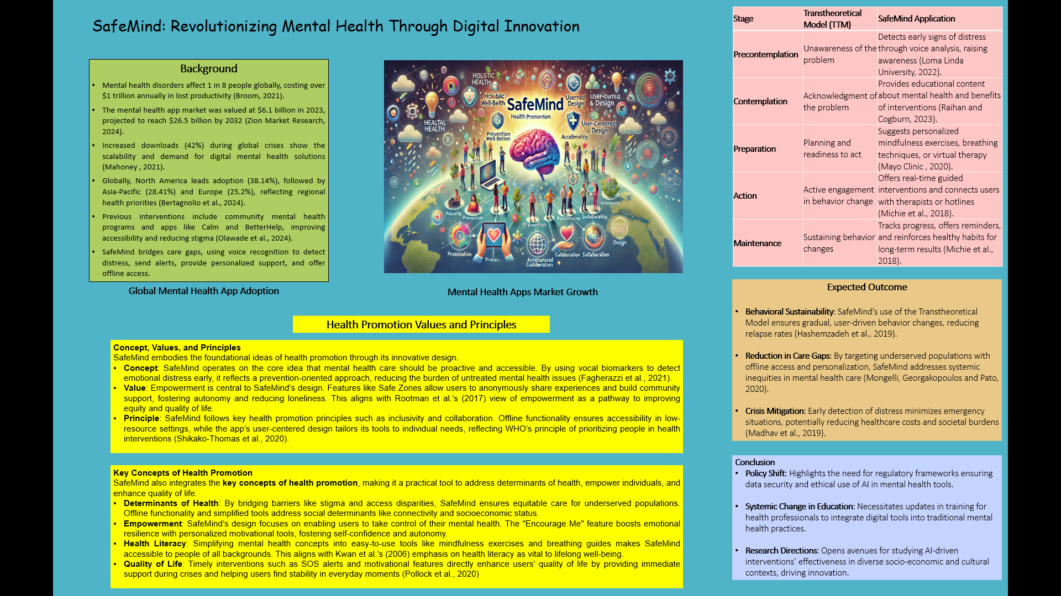
Task 2: Poster

References
Alqahtani, F. and Orji, R. (2020). Insights from user reviews to improve mental health apps. Health Informatics Journal, [online] 26(3), pp.2042–2066. https://doi.org/10.1177/1460458219896492.
Aquino, S. (2024, November 4). How Wysa Is Using AI To Make Mental Health Services More Accessible To Everyone. Forbes. https://www.forbes.com/sites/stevenaquino/2024/11/04/how-wysa-is-using-ai-to-make-mental-health-services-more-accessible-to-everyone/
Bautista, J., Liu, M., Alvarez, M., & Schueller, S. M. (2024). Multi-Media Field Test: Cognitive-Behavioral Therapy at Our Fingertips: Sanvello Provides On-Demand Support for Mental Health. Cognitive and Behavioral Practice. https://doi.org/10.1016/j.cbpra.2023.12.008
Bertagnolio, S., Zlatina Dobreva, Centner, C.M., Ioana Diana Olaru, Donà, D., Burzo, S., Huttner, B.D., Chaillon, A., Gebreselassie, N., Wi, T., Mateusz Hasso-Agopsowicz, Benedetta Allegranzi, Hatim Sati, Verica Ivanovska, Kothari, K.U., Balkhy, H.H., Cassini, A., Hamers, R.L. and Kitty Van Weezenbeek (2024). WHO global research priorities for antimicrobial resistance in human health. The Lancet Microbe, pp.100902–100902. https://doi.org/10.1016/s2666-5247(24)00134-4.
Broom, D. (2021). 5 things to know about mental health across the world. [online] World Economic Forum. Available at: https://www.weforum.org/stories/2020/10/mental-health-day-covid19-coronavirus-global/.
Chodavadia, P., Teo, I., Poremski, D., Fung, D.S.S. and Finkelstein, E.A. (2023). Prevalence and economic burden of depression and anxiety symptoms among Singaporean adults: results from a 2022 web panel. BMC Psychiatry, [online] 23(1). https://doi.org/10.1186/s12888-023-04581-7.
Colizzi, M., Lasalvia, A. and Ruggeri, M. (2020). Prevention and early intervention in youth mental health: Is it time for a multidisciplinary and trans-diagnostic model for care? International Journal of Mental Health Systems, [online] 14(1), pp.1–14. https://doi.org/10.1186/s13033-020-00356-9.
Gross, N. and Mothersill, D. (2023). Surveillance Capitalism in Mental Health: When Good Apps Go Rogue (and What Can Be Done about It). Social Sciences, [online] 12(12), p.679. https://doi.org/10.3390/socsci12120679.
Hashemzadeh, M., Rahimi, A., Zare-Farashbandi, F., Alavi-Naeini, A. and Daei, A. (2019). Transtheoretical model of health behavioral change: A systematic review. Iranian Journal of Nursing and Midwifery Research, 24(2), pp.83–90. https://doi.org/10.4103/ijnmr.IJNMR_94_17.
Internet Society (2024). Preemptive Monitoring in End-to-end Encrypted Services - Internet Society. [online] Internet Society. Available at: https://www.internetsociety.org/resources/doc/2024/preemptive-monitoring-e2ee-services/ [Accessed 16 Nov. 2024].
Iwaya, L.H., Babar, M.A., Rashid, A. and Wijayarathna, C. (2022). On the privacy of mental health apps. Empirical Software Engineering, 28(1). https://doi.org/10.1007/s10664-022-10236-0.
Kasparek, M. (2023). The Importance of Mental Health: A Holistic Approach to Well-being. [online] Catholic Charities. Available at: https://www.ccfairfield.org/2023/04/19/the-importance-of-mental-health-a-holistic-approach-to-well-being/.
Knapp, A.A., Cohen, K., Nicholas, J., Mohr, D.C., Carlo, A.D., Skerl, J.J. and Lattie, E.G. (2021). Integration of Digital Tools into Community Mental Health Care Settings that Serve Young People: Considerations from Clinicians (Preprint). JMIR Mental Health, 8(8). https://doi.org/10.2196/27379.
Loma Linda University (2022). Stages of Change Model | School of Medicine. [online] medicine.llu.edu. Available at: https://medicine.llu.edu/academics/resources/stages-change-model.
Madhav, N., Oppenheim, B., Gallivan, M., Prime Mulembakani, Rubin, E. and Wolfe, N. (2019). Pandemics: Risks, Impacts, and Mitigation. Nih.gov, [online] 17(3). Available at: https://www.ncbi.nlm.nih.gov/books/NBK525302/.
Mahoney (2021). A tale of two countries: Increased uptake of digital mental health services during the COVID-19 pandemic in Australia and New Zealand. Internet Interventions, [online] 25, p.100439. https://doi.org/10.1016/j.invent.2021.100439.
Mayo Clinic (2020). Mindfulness exercises. [online] Mayo Clinic. Available at: https://www.mayoclinic.org/healthy-lifestyle/consumer-health/in-depth/mindfulness-exercises/art-20046356.
Michie, S., West, R., Sheals, K. and Godinho, C.A. (2018). Evaluating the effectiveness of behavior change techniques in health-related behavior: a scoping review of methods used. Translational Behavioral Medicine, [online] 8(2), pp.212–224. https://doi.org/10.1093/tbm/ibx019.
Miranda, S. (2022, July 18). How to protect your privacy when using mental health care apps. NPR. https://www.npr.org/2022/07/18/1110699297/betterhelp-talkspace-privacy-data-tips-online-therapy
Mongelli, F., Georgakopoulos, P. and Pato, M.T. (2020). Challenges and opportunities to meet the mental health needs of underserved and disenfranchised populations in the united states. Focus, 18(1), pp.16–24. https://doi.org/10.1176/appi.focus.20190028.
Olawade, D.B., Wada, O.Z., Aderonke Odetayo, Aanuoluwapo Clement David-Olawade, Fiyinfoluwa Asaolu and Eberhardt, J. (2024). Enhancing Mental Health with Artificial Intelligence: Current Trends and Future Prospects. Journal of medicine, surgery, and public health, [online] 3(3), pp.100099–100099. https://doi.org/10.1016/j.glmedi.2024.100099.
Parliament of Australia (2019). Chapter 7 - promotion, prevention and early intervention. [online] aph.gov.au. Available at: https://www.aph.gov.au/Parliamentary_Business/Committees/Senate/Former_Committees/mentalhealth/report/c07.
Precedence Research (2024). Mental Health Apps Market Size, Trends, Growth, Report 2030. [online] www.precedenceresearch.com. Available at: https://www.precedenceresearch.com/mental-health-apps-market.
Radez, J., Reardon, T., Creswell, C., Lawrence, P.J., Evdoka-Burton, G. and Waite, P. (2020). Why Do Children and Adolescents (not) Seek and Access Professional Help for Their Mental Health problems? a Systematic Review of Quantitative and Qualitative Studies. European Child & Adolescent Psychiatry, [online] 30(2), pp.183–211. https://doi.org/10.1007/s00787-019-01469-4.
Raihan, N. and Cogburn, M. (2023). Stages of change theory. [online] PubMed. Available at: https://www.ncbi.nlm.nih.gov/books/NBK556005/.
Samba, D. (2024). Mental Health App Development: Ultimate Guide for 2024. [online] Digitalsamba.com. Available at: https://www.digitalsamba.com/blog/mental-health-app-development.
Schroeder, T., Haug, M. and Gewald, H. (2021). Where Does All the Data Go? The Data Privacy Concerns of Mature Adults Using mHealth Apps and Smart Speakers. (Preprint). JMIR Formative Research, 6(6). https://doi.org/10.2196/28025.
Straits (2024). Mental Health Apps Market Size to Surpass USD 9.96 billion by 2032 | Straits Research. [online] GlobeNewswire News Room. Available at: https://www.globenewswire.com/news-release/2024/11/07/2976885/0/en/Mental-Health-Apps-Market-Size-to-Surpass-USD-9-96-billion-by-2032-Straits-Research.html [Accessed 11 Nov. 2024].
Varun (2024). Introduction An SOS application is a vital mobile tool designed to enhance personal safety by providing a quick and efficient way to alert emergency contacts or authorities in times of danger. It is especially useful in emergencies where immediate help is crucial. [online] Linkedin.com. Available at: https://www.linkedin.com/pulse/importance-development-sos-applications-lifesaving-n-s-%E3%82%B9%E3%83%AA%E3%83%B4%E3%82%A1%E3%83%AB%E3%83%B3--3br0c.
Wainberg, M.L., Scorza, P., Shultz, J.M., Helpman, L., Mootz, J.J., Johnson, K.A., Neria, Y., Bradford, J.-M.E., Oquendo, M.A. and Arbuckle, M.R. (2019). Challenges and Opportunities in Global Mental Health: a Research-to-Practice Perspective. Current Psychiatry Reports, [online] 19(5). https://doi.org/10.1007/s11920-017-0780-z.
World Health Organization (2022). Mental Disorders. [online] World Health Organization. Available at: https://www.who.int/news-room/fact-sheets/detail/mental-disorders.
Zion Market Research (2024). Mental Health Apps Market Size, Share, Growth and Forecast 2032. [online] Zion Market Research. Available at: https://www.zionmarketresearch.com/report/mental-health-apps-market.

