Student name: Sofia Sacalus
Student number: 1907696

Module Name: Introduction to Psychology
Module Code: BMHP5003_BIRM

Programme name: BSc Health and Social Care

Assignment title: Individual Academic Poster
Lecturer Name:

Respiratory System
The respiratory system is the set of organs that is responsible for breathing: the movement of air in and out of the lungs. We breathe to get oxygen into our bodies and carbon dioxide out.
Parts of respiratory system
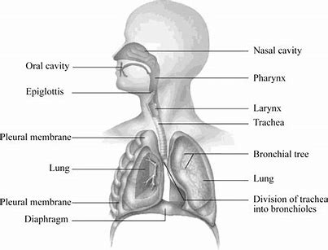
Total lung capacity
The volume of air contained in the lungs at the end of a maximal inspiration
Tidal volume
The amount of air normally inhaled and exhaled per breath.
Vital capacity
The maximum volume of air exhaled after the lungs have been filled.

Figure 1. Parts of respiratory system
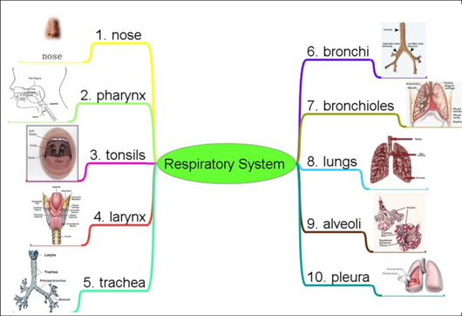
What are the parts of the respiratory system?
The respiratory system has many different parts that work together to help you breathe. Each group of parts has many separate components.
Your airways deliver air to your lungs. Your airways are a complicated system that includes your:
Mouth and nose: Openings that pull air from outside your body into your respiratory system.
Sinuses: Hollow areas between the bones in your head that help regulate the temperature and humidity of the air you inhale.
Pharynx (throat): Tube that delivers air from your mouth and nose to the trachea (windpipe).
Trachea: Passage connecting your throat and lungs.
Bronchial tubes: Tubes at the bottom of your windpipe that connect into each lung.
Lungs: Two organs that remove oxygen from the air and pass it into your blood. (Cleveland Clinic, 2020

What does the respiratory system do?
The respiratory system has many functions. Besides helping you inhale (breathe in) and exhale (breathe out), it:
Allows you to talk and to smell.
Warms air to match your body temperature and moisturizes it to the humidity level your body needs.
Delivers oxygen to the cells in your body.
Removes waste gases, including carbon dioxide, from the body when you exhale.
Protects your airways from harmful substances and irritants. (Cleveland Clinic, 2020)

During inspiration, the rib cage moves outwards and upwards and the diaphragm lowers increasing the volume of the thoracic cavity. This causes the internal pressure in the lungs to be lower than the atmospheric pressure. The difference in pressure forces air (introducing oxygen to the alveoli) into the lungs.

Respiratory system structure and function

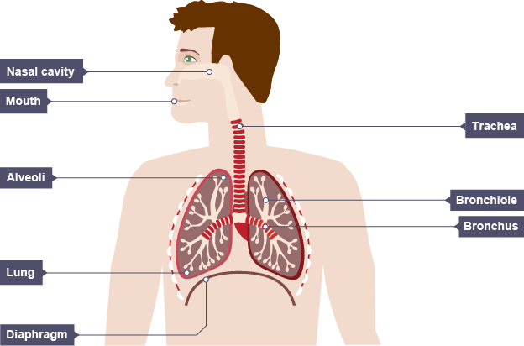
Breathing is carried out through the two structures known as the intercostal muscles and the diaphragm. These muscles control the movement of air and are separated from the rest of the body by the chest cavity.
The intercostal muscle contracts and moves the ribs upwards. This increases the size of both the chest and the air pressure inside it.
The diaphragm widens and stays in its domed shape. The rib cage elevates the air pressure in the chest and pushes the lungs out. (BBC Bitesize, 2019)
Exchange of Gasses between Lungs and Blood − Interior the lungs, oxygen is exchanged for carbon dioxide through the strategy called outside breathing. This respiratory strategy happens through incalculable minute sacs called alveoli. Oxygen from admissions
Figure 2. Respiratory system structure
discuss diffuses from the alveoli into aspiratory vessels enveloping them.
It bonds with the haemoglobin within the RBC's and is pumped through the circulatory framework. The carbon dioxide from deoxygenated blood diffuses from the vessels into the alveoli and is expelled through exhalation. (Pasumarthy, 2019)
Homeostasis

- Homeostasis
- Keeping the internal environment of the body balanced
- Need to balance O2 in and CO2 out
- Need to balance energy production
- Exercise
    - Breathe faster
      - Need more energy
      - Bring in more O2 and remove more CO2
- Disease
    - Poor lung or heart function =breathe faster
      - Need to work harder to bring in O2 and remove CO2. (West, 2013)

The respiratory system participates in a variety of homeostatic processes, and the two most important of these are maintaining pH and regulating gas exchange. Both homeostatic functions are related to the biochemical roles played by the two primary respiratory gases, carbon dioxide and oxygen.
Blood Pressure Homeostatic components within the lower districts of the brain stabilize blood weight through positive and negative feedback. Pressure receptors all through the complete body send input to the brain. When the weight is as well tall, weight receptors send negative criticism, which causes the heart rate to drop. When blood weight is as well moo, the weight receptors send positive criticism, which causes the heart rate to extend. This entire handle guarantees that the weight at which blood is being pumped is steady and meets the body demands. (Pierce, 2017)

Disorders of respiratory system

Factors Affecting Respiratory System Disorders
There are several factors associated with respiratory system disorders. Few of these factors include:
- Genetics
- Allergies
- Smoking
- Air Pollution
- Bacterial and viral infections.
Respiratory Diseases
Following are the major respiratory disorders or diseases:
Asthma
Asthma is a chronic disease which affects the bronchi and bronchioles of the lungs. It causes difficulty in breathing and followed by severe cough, restlessness, cough and a wheezing sound while breathing.
Asthma might cause due to the following factors:
- Cold air
- Airborne allergens
- Respiratory infections
- Physical activity
- Air pollutants (Admin, 2017)

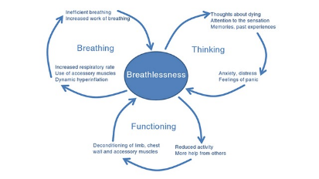
Interventions

Figure 3. Perpetuation of breathlessness by vicious cycles

Description of the intervention
Appropriate administration to calm breathlessness in progressed illnesses requires both pharmacological and non‐pharmacological mediations. Distinctive efficient surveys and meta‐analyses were distributed in later a long time and dissected the impacts of pharmacological mediations such as opioids, benzodiazepines, and oxygen for breathlessness in grown-up patients. However, the utilize of drugs to treat breathlessness is in some cases constrained as they involve antagonistic impacts and measurements must be titrated carefully. Subsequently, non‐pharmacological intercessions are a vital portion of the treatment of breathlessness. As specified over, numerous precise surveys dissected the impacts of pharmacological medications, which is why we are centring exclusively on non‐pharmacological mediations in this audit. (Bolzani et al., 2017)

References

Admin (2017). Respiratory System Disorders. [online] BYJUS. Available at: https://byjus.com/biology/respiratory-system-disorders/.
BBC Bitesize (2019). Respiratory system - Edexcel - Revision 1 - GCSE Physical Education - BBC Bitesize. [online] BBC Bitesize. Available at: https://www.bbc.co.uk/bitesize/guides/ztkr82p/revision/1.
Bolzani, A., Rolser, S.M., Kalies, H., Maddocks, M., Rehfuess, E., Swan, F., Gysels, M., Higginson, I.J., Booth, S. and Bausewein, C. (2017). Respiratory interventions for breathlessness in adults with advanced diseases. Cochrane Database of Systematic Reviews.
BYJUS. (n.d.). Respiratory System Disorders - Types and Causes of Respiratory Diseases. [online] Available at: https://byjus.com/biology/respiratory-system-disorders/#:~:text=Respiratory%20System%20Disorders%201%20Asthma.%20
Asthma%20is%20a [Accessed 18 Oct. 2021].
Custers, E. (n.d.). What is the Respiratory System: Diagram and Function. [online] HubPages. Available at: https://discover.hubpages.com/education/What-is-the-Respiratory-System.
Cleveland Clinic (2020). Respiratory System: Functions, Facts, Organs & Anatomy. [online] Cleveland Clinic. Available at: https://my.clevelandclinic.org/health/articles/21205-respiratory-system.
https://images.saymedia-content.com/.image/c_limit%2Ccs_srgb%2Cq_auto:eco%2Cw_1240/MTc2MjQzNzQ3MDM2ODAwNDI1/what-is-the-respiratory-system.webp
https://cdn1.byjus.com/wp-content/uploads/2019/04/Respiratory-System-Disorders.png
Pasumarthy, S. (2019). What is the function of respiratory system? Tutorials point. Available at: https://www.tutorialspoint.com/what-is-the-function-of-respiratory-system [Accessed 18 Oct. 2021].
Pierce, R. (2017). What is goal of Homeostasis. Sciencing. Available at: https://sciencing.com/what-is-the-respiratory-systems-role-in-homeostasis-12730698.html [Accessed 18 Oct. 2021].
West, J. (2013). What Is the Respiratory System’s Role in Homeostasis? [online] Sciencing. Available at: https://sciencing.com/what-is-the-respiratory-systems-role-in-homeostasis-12730698.html.

