

Student Name: Meetkumar Sureshbhai Vaghasiya
Student ID: 2432237
Module Name: Strategic Management
Module Code: LCMB7003
Lecturer’s Name: Balendran Kandasamy
Title : Spotify
Course: MBA
Submission Deadline : 29th April 2026

Table of Contents
1. Introduction 3
2. Selection of Organisation and Target Market 4
2.1 Justification of choosing Spotify 4
2.2 Global Operations 6
2.2.1 Research & Development (R&D) 6
2.2.2 Sourcing & Content Acquisition 6
2.2.3 Global Marketing & Sales 7
2.3 Chosen International Market and Entry Modes 8
2.3.1 Dominant Entry Mode 10
2.4 Benefits from International Operations 11
2.4.1 Revenue Diversification 11
2.4.2 Access to Global Talent Pools 11
2.4.3 Economies of Scale 11
2.4.4 Network Effects 11
2.4.5 Content Localisation 11
3. Comprehensive Strategic Analysis 12
3.1. Macro-Environmental Analysis of Brazil through: PESTLE 12
3.2. Competitive Analysis: Porter's Five Forces 13
3.3. Critical Evaluation 14
4. Strategic Development and Formulation 14
4.1. Market Entry Mode Choice 14
4.2. OLI framework for understanding company’s competative advantage 15
4.4 Impact on Entry Strategy 19
4.4 Impact on Business 20
5. Performance Evaluation Framework for Spotify's Expansion in Brazil 22
5.1. Balanced Scorecard (BSC) 22
5.2. Triple Bottom Line 24
References 28

1. Introduction
This report examines Spotify's business expansion in Brazil, a rapidly expanding emerging market, and fiercely competitive digital economy. As the top audio streaming service in the world, Spotify routinely outperforms rivals like Apple Music, Amazon Music, and Tencent, holding about 32% of the global subscriber market share in 2023 (Statista, 2025). Despite a stabilising premium ARPU of four to five euros per person, the platform had more than 670 million monthly active users by late 2024, including more than 260 million paying customers who generate the majority of its revenue.
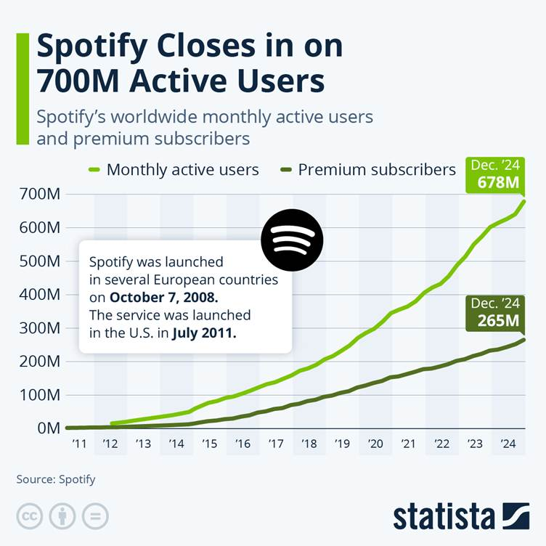
Figure 1: Active Users
(Source: Statista, 2025)
Strong subscriber growth and growing global audio consumption habits drove Spotify's 2024 revenue of over 15 billion euros and net profit of over one billion euros. As it battles YouTube for supremacy in the spoken-audio market, the corporation keeps making significant R&D investments, especially in podcasting and video-podcast features (Statista, 2025). In the meantime, Spotify's growing international user base is reflected in the global diversity of music consumption, which ranges from English-language pop to Spanish, Korean, and other international genres. This report assesses Spotify's global operations and offers tactical suggestions to improve its performance in Brazil.

2. Selection of Organisation and Target Market

2.1 Justification of choosing Spotify
Spotify has been selected because it holds a strong global presence with advanced recommendation algorithms and scalable digital platforms, thereby making it a highly suitable choice for international expansion (Spotify, 2025). The size of Spotify and integration of its international operations, Spotify is unquestionably a Multinational Corporation (MNC) and a Transnational Corporation (TNC). As of December 2024, the company's network of fully owned subsidiaries, which includes Spotify USA Inc., Spotify Japan K.K., Spotify India LLP, and several European and Asia-Pacific organisations, supported its operations in 184 countries and territories (Spotify, 2025a). This wide-ranging presence shows not only geographical dispersion but also an organisational strategy designed to handle financing, content distribution, global value creation, and regulatory compliance across several jurisdictions.
Although Spotify's platform is centrally built in Sweden and the US, its content licensing, marketing, pricing, and monetisation strategies need to be deeply localised to align with local legislative, cultural, and commercial circumstances. This makes Spotify's business model intrinsically international. In 2024, the company employs 7,691 full-time workers in North America, Europe, Latin America, and Asia, with a sizable workforce in the United States (3,690), Sweden (1,397), the United Kingdom (874), and notable clusters in India, Germany, and Mexico (Spotify, 2025a). This illustrates the intricacy of its dispersion of human resources and its dependence on foreign expertise.
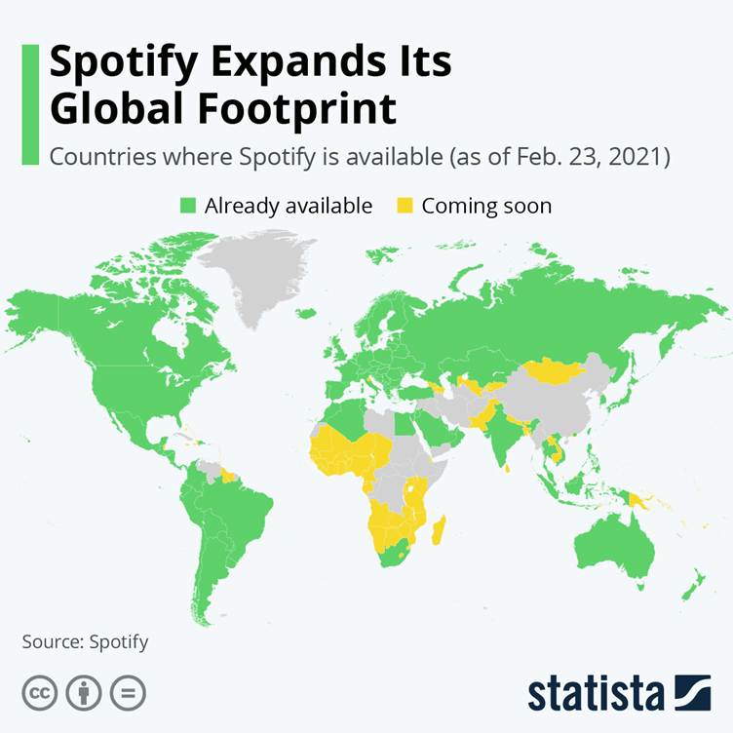
Figure 2: Global Footprint
(Source: Statista, 2021)
Additionally, Spotify's operations involve significant cross-border flows of intellectual property, payments for content licensing, multicurrency subscription fees, and advertising income from both domestic and international partnerships (Nordea, 2025). Its exposure to international payment networks, regulatory differences, and foreign exchange risks further solidifies its status as a multinational company involved in intricately linked transnational operations. Because of this, Spotify satisfies every conventional requirement for being classified as an MNC or TNC, including global market participation, multinational presence, cross-border revenue dependency, and internationally integrated operations.

2.2 Global Operations

2.2.1 Research & Development (R&D)
The core of Spotify's worldwide value offering is its R&D skills. In addition to maintaining significant product and engineering centres in Stockholm and New York, the firm employs close to 4,000 people in research and development (3,944 in 2024). Spotify Ltd. in the United Kingdom provides further R&D support through contract research and technology development (Spotify, 2025a). Algorithmic search, recommendation systems, AI-powered discovery tools, advertising technologies, infrastructure for audio ingestion and encoding, podcast hosting tools, and audiobook streaming features are the main areas of R&D spending.
Spotify is still making significant investments in new areas of engagement and content discovery. New analytics tools and features for creators, including dynamic ad insertion, growth analytics, and streaming optimisation technologies, had to be developed to expand into podcasts and audiobooks (Spotify Advertising, 2023).

2.2.2 Sourcing & Content Acquisition
Another essential component of Spotify's value chain is content acquisition. The business negotiates licensing deals with large international record companies, independent labels, music publishers, publishers of audiobooks, and producers of podcasts. The majority of Spotify's revenue comes from royalties paid to rights holders. Depending on the type of subscription, music royalties are structured around revenue shares or per-user rates, while ad-supported streams adhere to CPM-based revenue-sharing agreements (Wondrasek, 2025).
Additionally, thanks to its purchases of platforms like Megaphone and unique podcast hosting technology, Spotify maintains exclusive content agreements with podcast producers and creators. Additionally, the Spotify Audience Network (SPAN) improves its worldwide inventory and reach by integrating podcast creators and publishers into a single advertising marketplace (Spotify, 2025a).

2.2.3 Global Marketing & Sales
Through its subsidiaries in the United States, Japan, India, Mexico, and Europe, Spotify employs locally specific marketing techniques (Spotify, 2025a). Local customer acquisition, pricing strategies, partnerships, promotional activities, and cultural marketing collaborations are all managed by these subsidiaries.
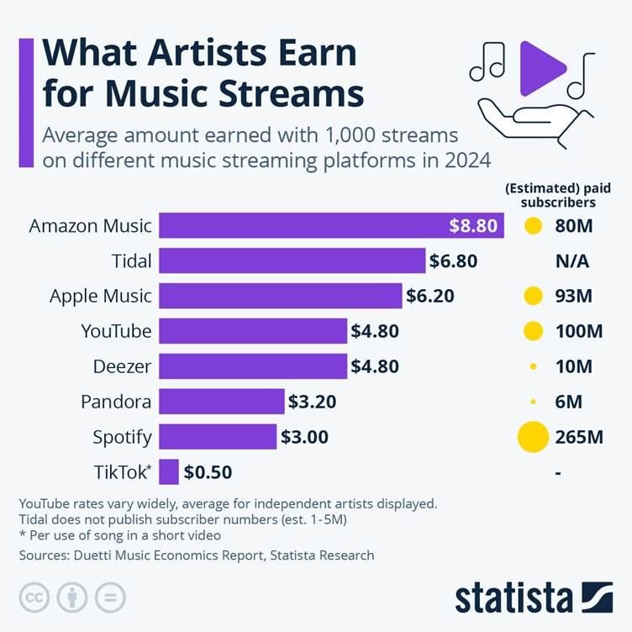
Figure 3: Earn from Music Stream
Source: Statista, 2025
In the Brazilian market Spotify faces competitors like Apple Music, YouTube, Amazon Music, and regional streaming providers, marketing is essential to preserving leadership (Gandra, 2024). By utilizing data-driven advertising and social media interaction worldwide, Spotify's branding strengthens its cultural positioning.

2.3 Chosen International Market and Entry Modes
Brazil is one of the world's biggest music markets, with a population of more than 200 million people and a large young population that engages with digital media. Brazil boasts a rich and varied music scene (from samba to funk to sertanejo) that complements Spotify's user-driven music discovery and content localization strategies (de Melo et al., 2020). Brazil is an ideal target market because it has one of the fastest-growing music streaming industries, along with a high smartphone penetration and a young audience who are a digitally engaged population. The country's rich music culture and the rising internet usage have sufficiently created a strong demand for streaming services over time (Spotify, 2025). Strategically, Brazil offers growth opportunities through their localization telecom partnership and advertisement-supported models. All these facilities or opportunities allow Spotify to expand its user base successfully while building up its competitive position in imaging markets.
Moreover, Brazil has seen significant increases in internet and mobile phone adoption, which facilitates streaming. This facilitates Spotify's business strategies (subscriptions and ads) in the country's cities. Economic challenges notwithstanding, the growing middle class and greater uptake of low-cost mobile data plans offer potential for growth (de Melo et al., 2020).
In addition to licensing deals, local content partnerships, and telecom bundling alliances in particular markets, Spotify's international expansion is distinguished by its predominant dependence on wholly owned subsidiaries as its principal market entry mechanism (Spotify, 2025a).
Spotify's reliance on content licensing, which serves as an extra entrance route, is a fundamental component of its worldwide entry strategy. Spotify must negotiate complicated licensing deals with international rights holders like Universal, Sony, Warner, and Merlin in order to operate in 184 countries (Spotify, 2025a). Together, these companies accounted for over 71% of all music streams supplied on the site in 2024. Spotify frequently has to bargain directly with local labels and publishers to obtain libraries like Brazilian funk, sertanejo, MPB, or pagode in markets like Brazil, where local material is crucial.
Spotify uses distribution and bundling relationships as a hybrid entry strategy to supplement FDI and licensing in emerging areas. Telecommunications partners frequently sell the Premium Service by bundling Spotify into mobile data plans, collecting payments, and negotiating per-subscriber fees under partner agreements (Lau, 2025). In areas with less developed recurring subscription services, this strategy is particularly crucial.
One obvious example of Spotify's multi-mode entry strategy is Brazil. Spotify has complete control over marketing, pricing, and distribution operations thanks to its completely owned subsidiary, Spotify Brasil Servição de Música LTDA. Local presence is essential for rights management and artist engagement due to Brazil's market dynamics, which include 22.5 million streaming subscribers (Music Ally, 2024).
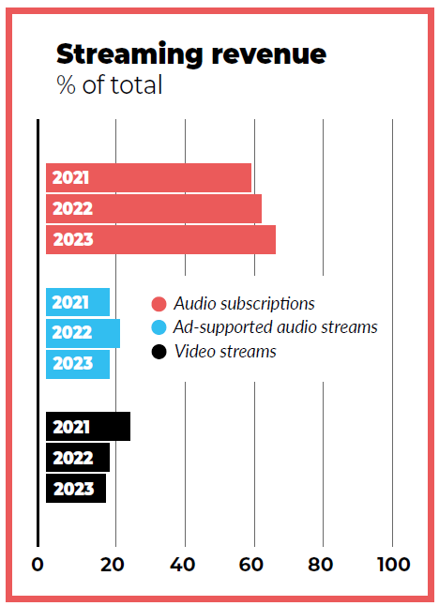
Figure 4: Streaming Revenue
Source: Music Ally (2024)
Over 50 million total streamers, and streaming accounting for 99.2% of all recorded music revenue in the first half of 2024 (Music Ally, 2024). In early 2024, subscription sales increased by 28.4% to R$995 million, while ad-supported revenues increased by 6.6% to R$436 million (Spotify, 2025a). This highlights the importance of localised pricing, partnerships, and ad-selling activities.

2.3.1 Dominant Entry Mode
Wholly owned subsidiaries are the most common entrance strategy in all areas, with telecom bundling alliances in some developing economies and licensing agreements as a universal prerequisite (Spotify, 2025a). This combination enables Spotify to adjust pricing and content to local market conditions while maintaining global strategic coherence.
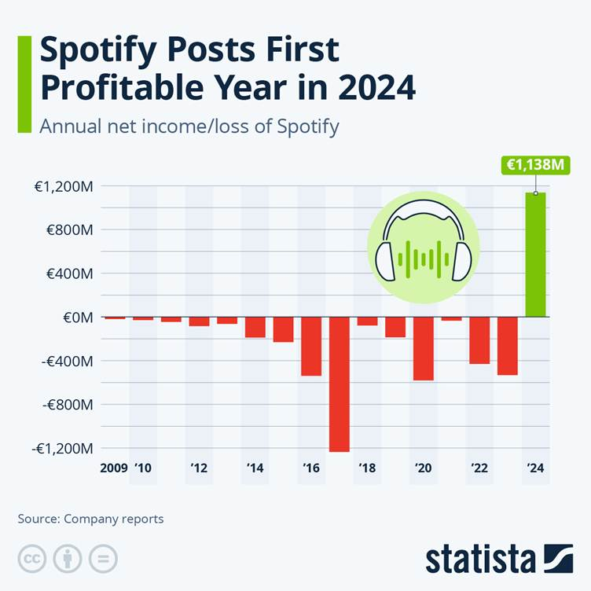
Figure 5: Spotify's Profitable Year
Source: Statista, 2025

2.4 Benefits from International Operations

2.4.1 Revenue Diversification
Spotify's global presence enables a variety of revenue sources in various geographical areas. With 27% of MAUs, Europe continues to be its largest region, followed by North America (17%), Latin America (including Brazil) (22%), and its fastest-growing region (14% annual MAU growth in 2024) (Spotify, 2025a). This geographical dispersion lessens reliance on any one market.

2.4.2 Access to Global Talent Pools
Spotify's dispersed workforce fosters innovation by providing access to commercial, engineering, and creative talent throughout the globe. Its staff is spread across numerous nations, with a focus on R&D and high-value engineering roles in Sweden, the United States, and the United Kingdom, as well as support and sales roles in Latin America and Asia (Spotify, 2025a).

2.4.3 Economies of Scale
Shared R&D expenses, reduced marginal costs per user, and economies in cloud infrastructure and content licensing are all made possible by a global platform. Spotify uses data to improve recommendations, lower attrition, and boost upsell opportunities as more users interact with the service, resulting in scale-driven increases in revenue (Spotify, 2025a).

2.4.4 Network Effects
Strong network effects are produced by Spotify's enormous user base. The platform's ability to draw in additional artists, marketers, and exclusive content partners, thanks to its 675 million MAUs and 263 million Premium users, strengthens its competitive position (Spotify, 2025a). Because diversified content consumption affects recommendations and discovery worldwide, these network effects are reinforced internationally.

2.4.5 Content Localisation
Spotify must localise its content, price, and marketing tactics in order to operate in developing areas like Brazil. Brazilian funk, sertanejo, and regional pop are examples of local music genres that encourage high engagement and assist greater user retention and cultural relevance (Spotify, 2025b). Spotify can more successfully negotiate with local rights holders and customize products thanks to local subsidiaries.

3. Comprehensive Strategic Analysis

3.1. Macro-Environmental Analysis of Brazil through: PESTLE
Factor | Analysis (Brazil Market)
Political | If reports are to be believed, then Brazil has a relatively stable government. Experience to recover in 2021 with 4.6% GDP growth (US Department of State, 2025). But due to some complex regulations, digital taxes, its operational costs of Spotify have gradually increased.
Economic | Brazil has a growing economy that defines income inequality and currency fluctuations as key factors. Due to its persistent challenges with key factors like inequality. Its economic performance is referred to as steady but low, with recent growth in 2022 and 2023 at 2.9% (US Department of State, 2025). This will affect their subscription affordability.  Brazil has a lower Average Rate Per User (ARPU) compared to developed markets, which sometimes fall below €10-15 per month, compared to North America or parts of Europe (Fitch Rating, 2025)
Social | Brazil holds a strong musical culture, such as funk, samba, and sertanejo (Dantas et al., 2024). Spotify should focus on a young population so that it can drive high streaming demand and engagement.
Technological | High smartphone engagement and internet usage can provide support to Spotify's digital streaming growth, especially mobile-first consumption (Lee, 2018).
Legal | Data protection laws (LGPD) (law number 13, 709/2018) is similar to the GDPR. It also has licensing rules that require strong compliance, thereby increasing its operational complexity over time (General Data Protection Regulation, 2019).
Environmental | Digital firms are presently facing intense pressure to minimise their carbon footprint generated from their data centres and streaming infrastructure. So Spotify should become more cautious in reducing its carbon footprint (Climate Change Performance Index, 2025).

3.2. Competitive Analysis: Porter's Five Forces
Force | Analysis (Brazil Market)
Competitive Rivalry | Very high as in this market already have several strong competitors like Apple Music, YouTube Music, and Amazon Music.
Threat of New Entrants | It is Low due to high licensing costs and strong brand dominance create entry barriers (De Marchi, 2023).
Bargaining Power of Suppliers | High power of suppliers as record labels and artists control music rights, increasing costs.
Bargaining Power of Buyers | High power of users, which can easily switch platforms due to low switching costs.
Threat of Substitutes | High threat as there are option of free platforms (e.g., YouTube) and piracy offer alternatives (De Marchi, 2023).

3.3. Critical Evaluation
The use of PESTLE and Porter's 5 forces have seamlessly provided a structured understanding of Brazil's market environment and competitive landscape (Jaakkola, 2019). PESTLE is an effective framework for identifying the external macro factors. This includes the economic conditions, cultural preferences and regulatory challenges that have created a direct influence on Spotify's expansion strategy. It has also highlighted the key opportunities that lie in growing digital adoption and risks such as currency stability (Jaakkola, 2019). However, its limitation is that it remains descriptive and it does not prioritise the factors that are more critical for carrying out the decision-making process.
On the other hand, Porter 5 forces have proved to be useful for analysing the industry competition and profitability (Spotify, 2025a). It has clearly shown that Spotify operates in a highly competitive and price-sensitive market, along with strong supplier power. This has further helped to justify the need for differentiation and localisation strategies (De Marchi, 2023). However, the model strongly assumes relatively stable market conditions, and it does not fully capture the fast-changing nature of the digital platforms' network effects and innovation-driven competition.

4. Strategic Development and Formulation

4.1. Market Entry Mode Choice
Spotify's entry into Brazil through a fully owned local subsidiary is completely consistent with the OLI framework, given the strong ownership advantages, obvious geographical advantages in Brazil, and major internalisation imperatives (Spotify, 2025a). With a high-control market entrance approach backed by the company's organisational and technology strengths, Spotify Brasil Servição de Música LTDA gives the company complete control over marketing, compliance, talent acquisition, rights negotiations, and local alliances (Spotify, 2025a).
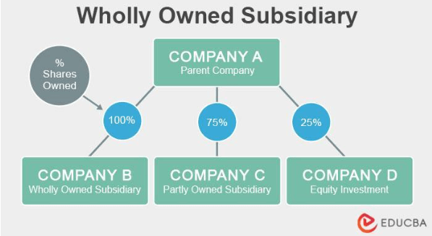
Figure 6: Wholly Owned Subsidiary
Source: EDUCBA, 2026
Because it allows Spotify to preserve product integrity, protect intellectual property, and carry out quick iterative innovation, all necessary for competing with regional platforms, YouTube Music, and Apple Music, this entrance strategy is beneficial (Spotify, 2025a). Spotify's capacity to adjust pricing to local conditions, such as student pricing, discounted prepaid plans, and mobile carrier bundles catered to Brazilian consumer behaviour, is further strengthened by internalising operations.
But there are drawbacks to this entrance method as well. Brazil's high digital service taxation, inflation risk, and unstable economy raise operating expenses and limit price options. The administrative load is further increased by the need to adhere to Brazil's complicated labour laws and data privacy legislation (LGPD) (DLA Piper, 2023). Despite these difficulties, the fully owned subsidiary strategy is still the best option because other strategies, including joint ventures or licensing, would reduce Spotify's control over infrastructure, data, and service quality and compromise its worldwide value proposition.

4.2. OLI framework for understanding company’s competative advantage
Ownership Advantages (O)
Spotify's technological superiority, global reach, proprietary data assets, advanced recommendation algorithms, and well-known brand are the main sources of its ownership advantages. With 675 million monthly active users and 263 million Premium subscribers in 2024, Spotify, the largest music streaming platform in the world, offers a structural advantage in content acquisition, data-driven personalisation, and advertising monetisation (Spotify, 2025a).
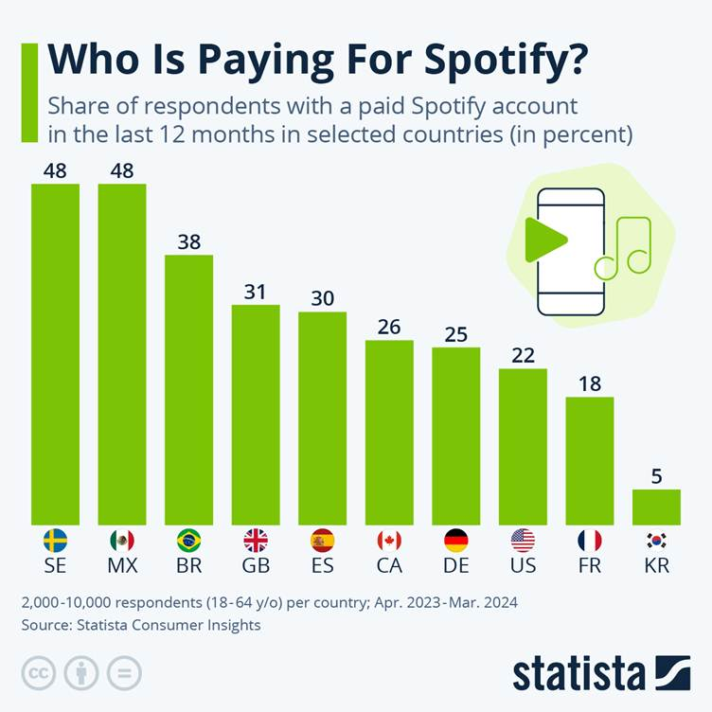
Figure 7: Paying for Spotify
Source: Statista, 2025
Its possession of cutting-edge machine-learning systems, which maximise user interaction and recommendations, gives it a significant competitive edge. In order to support its growth into podcasts, audiobooks, and sophisticated ad-delivery systems, Spotify made significant investments in algorithmic innovation, according to the Annual Report. The company used roughly 4,000 R&D workers spread throughout Sweden, the United States, and the United Kingdom (Spotify, 2025a).
Spotify's competitive advantage is further reinforced by its possession of exclusive and semi-exclusive arrangements with significant podcast creators. The platform is in charge of the Spotify Audience Network (SPAN), an advertising marketplace that unifies inventory from publishers and creators and allows for dynamic ad insertion and targeted advertising at scale (Spotify, 2025a). This is an advantage that rival platforms in emerging regions cannot replicate.
Additionally, the company possesses advanced worldwide infrastructure for content distribution, rights management, analytics, and multi-device integration, including linked TVs, smart speakers, desktop computers, mobile devices, and cars (Spotify, 2025a). Because of these ownership benefits, Spotify is able to expand its service into new markets at a low marginal cost while keeping a constant level of quality throughout the world.
Moreover, the company's solid financial base, which is based on €15.1 billion in revenue and more than €1 billion in net profit in 2024, permits continued investment in localised market strategies and long-term commitments to artists and rights holders (Spotify, 2025a). Together, these characteristics give Spotify the internal resources and competencies needed to enter Brazil with a high-control entry mode, which is supported by the company's capacity to effectively transfer IP-intensive assets, managerial know-how, and proprietary technology across borders.
Location Advantages (L)
Brazil provides significant geographic benefits for Spotify's global expansion. Brazil has access to a rapidly expanding, young, mobile-first population that is heavily involved with streaming media, making it one of the biggest music marketplaces in the world and the dominating digital entertainment economy in Latin America.
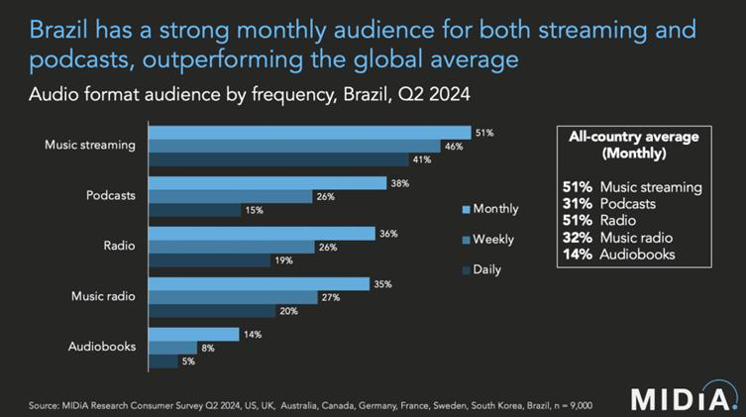
Figure 8: Monthly Audience
Source: Hype, 2024
Latin America is the fastest-growing region in the world for recorded music, with 19.4% year-over-year increase, primarily due to Brazil and Mexico (IFPI, 2025). It also highlights a significant shift in consumer preferences toward streaming platforms. Local music genres, including sertanejo, Brazilian funk, pagode, and MPB, influence Brazil's music streaming market. These genres have a high level of domestic consumption and are ideal for Spotify's localisation plans.
High smartphone adoption, extensive usage of prepaid mobile plans, and integration with large telecom companies that facilitate bundled streaming services are other advantages for Brazil. Local billing, Brazilian real currency pricing, and collaborations with operators like Vivo, Claro, and TIM are all made possible by Spotify's subsidiary structure, which enhances customer acquisition and retention. The region's significance within the company's regional portfolio shows that Latin America accounts for 22% of Spotify's entire user base and has had 14% year-over-year MAU growth (Spotify, 2025a).
Furthermore, in comparison to other emerging economies, Brazil has a comparatively favourable regulatory framework for digital services. Brazil's openness to international IT companies and stable intellectual property enforcement lowers barriers to entry, despite obstacles like high taxes on digital services and complicated compliance procedures (ITA, 2025). Spotify's choice to create a fully owned subsidiary rather than depend on indirect entry methods is further supported by Brazil's long-standing strong music culture and its close proximity to international rights holders.
Internalisation Advantages (I)
The necessity to keep control over proprietary technologies, user data, algorithms, and rights-management procedures is what motivates Spotify's internationalisation strategy. By reducing the risks associated with local middlemen, such as intellectual property leakage or deterioration of product quality, internalisation guarantees that the company maintains control over its fundamental competitive assets (Yan, Li and Zhang, 2021; Mets, Kaarna and Kelli, 2010).
Additionally, a high level of internal control makes it possible to harmonise platform features across regions and maintain consistent global product quality (Aksoy and Aksoy, 2020). To preserve economies of scale in platform engineering and cloud infrastructure, Spotify's digital offering needs to operate consistently across markets. There would be too much danger and variability if these crucial procedures were outsourced or given to regional partners.
Moreover, Spotify's widespread usage of consolidated global subsidiaries contributes to its internalisation advantages by enabling the company to manage financial flows, hedge foreign exchange exposures, and adhere to intricate royalty commitments from a centralised structure (Spotify, 2025a). This is especially crucial in Brazil, where varying taxes and exchange rates could otherwise impede operational effectiveness.
Also, Spotify needs complete internal control to manage country-specific licensing arrangements and negotiate successfully with global rights holders. The company lowers transaction costs, increases negotiating power, and keeps direct connections with publishers, artists, and business partners by internalising these services through its Brazilian subsidiary (Spotify, 2025a). Because of these internalisation benefits, Spotify prefers wholly owned subsidiaries over joint ventures or franchise arrangements in Brazil.

4.4 Impact on Entry Strategy
Spotify decided to develop a real organisational presence in Brazil instead of managing operations remotely due to cultural differences. Spotify can embed local management, work closely with local artists, and negotiate directly with regional rights holders thanks to a wholly owned subsidiary, activities that greatly benefit from cultural proximity. Building local trust is crucial to the company's global artist and creative activities, and in a relationship-oriented culture like Brazil, this is best accomplished through on-the-ground presence (TCFG, 2025).
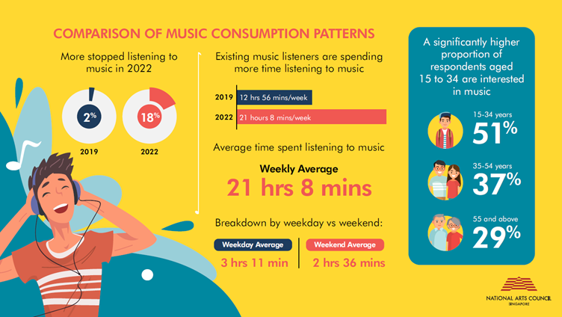
Figure 9: Comparison of Music Comparison Patterns
Source: National Arts Council, 2026
Spotify's localisation strategy was also influenced by cultural studies. In order to increase cultural relevance, Spotify made investments in country-specific editorial teams, curated playlists like "Top Brasil," and partnerships with local artists after realising that Brazilians preferred authenticity, emotive storytelling, and social connection (Spotify, 2025a).
Given that the average ARPU in Latin America is substantially lower than in Europe or North America, its pricing strategy demonstrates sensitivity to local expectations for affordability, transparency, and value. Despite lower monetisation levels, Latin America is experiencing strong user growth, indicating the need for offers that are both culturally and economically acceptable (Spotify, 2025a).

4.4 Impact on Business
Brazilian users' interactions with Spotify are significantly influenced by cultural differences. Spotify's emphasis on collaborative playlists, social discovery tools, and interaction with social platforms is influenced by Brazil's collectivist mindset, which means that music consumption frequently takes place in shared social situations (TCFG, 2025). Spotify must consistently invest in region-specific curation teams who are aware of local trends and audience feelings due to the popularity of regional genres and the sentimental character of Brazilian music culture.
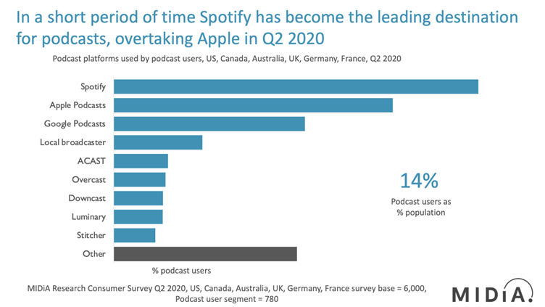
Figure 10: Leading Destination of Spotify
Source: Midia, 2020
In contrast to Sweden's more subdued marketing standards, Brazil's expressive and socially active culture enables Spotify to leverage influencer relationships, live events, and culturally embedded advertising (TCFG, 2025). Operationally, customer service and onboarding must be more transparent and encouraging than in the United States due to Brazil's propensity for structured direction. Additionally, users are more sensitive to platform stability, predictable pricing, and service reliability when uncertainty avoidance is high, which puts pressure on Spotify to maintain consistent performance in spite of regional infrastructure variations.
Partnerships with marketers are also impacted by cultural variations. Compared to clients in the United States, Spotify's advertising clients in Brazil anticipate more consultative engagements and local insights due to the country's high-context communication culture (TCFG, 2025). The local expansion of the Spotify Audience Network necessitates relationship management that is in line with Brazilian expectations for long-term, trust-based engagement as opposed to strictly transactional engagements.

5. Performance Evaluation Framework for Spotify's Expansion in Brazil
To effectively and seamlessly evaluate Spotify's expansion into Brazil, a balanced scorecard combined with the triple bottom line has been successfully implemented. While these frameworks provide a structured way to measure the performance, they also critically assess their usefulness, limitations and the real-world applicability in a fast-changing digital market.

5.1. Balanced Scorecard (BSC)
Perspective | Objective | Key Performance Indicators (KPIs) | Success Metrics
Financial | To achieve sustainable revenue growth | Revenue growth rate, ARPU, ad revenue, cost per acquisition | 15–20% revenue growth will gradually increase ARPU (average rate per user), along with controlled costs.
Customers | To improve engagement and loyalty | MAUs, premium conversion rate, retention rate, listening time | High user growth will automatically increase engagement while reducing the competitive pressure
Internal Processes | To ensure efficient platform operations | Platform uptime, local content %, streaming speed, ad efficiency | 99% uptime, with strong localisation, will lead to smooth performance
Learning and Growth | To support innovation and capability building | R&D investment, feature adoption, employee productivity, and local hiring | Continuous innovation through a skilled workforce will develop a strong local presence.

The balanced scorecard is quite useful because it moves beyond the financial Matrix and captures multiple dimensions of performance (Mamabolo and Myers, 2020). For Spotify, this becomes very important because success in Brazil mainly depends on user engagement, culture fit and technology performance and not just profit margin.
Brazil's economic stability and fluctuations in the currency, as identified in PESTLE analysis, mean that the growth of revenue alone is not a reliable measure of success (Arbache and Sarquis, 2018). Spotify must track its real profitability by adjusting for the exchange rate risk. Porter's 5 Forces analysis, on the other hand, has shown that a high level of competition is prevailing in the streaming market, so aggressive pricing may reduce the profit margin. Therefore, success should be measured through balanced growth and not just focus on expansion (Heikkinen, 2024).
Previously, it was highlighted that Brazil have a strong music cultural hold and they also have high buyer power, that is, users can easily switch to another streaming platform. This means that Spotify cannot totally rely on user growth, so it must measure the engagement and retention of its customers very closely (Heikkinen, 2024). High usage of Brazilian content like funk and sertanejo becomes a critical indicator of strategic success and not just a supporting metric.
Spotify also depends heavily on record levels, showing high supplier power. Therefore, the KPI like content availability and licensing efficiency directly reflect their strategic control (Lee, 2018). Also, the technological factors play a very important role as it requires high platform reliability. If streaming quality drops, then the users will automatically switch to another streaming platform due to the loss of switching and subscription costs (Lee, 2018).
However, the framework has some key limitations.
First, it estimates that all points of view are equally true and important. This may not be true in reality. For Spotify, the customer and their perspective are far more critical than financial outcomes. This can happen in the early stages of expansion. Focusing too much on financial key performance indicators like ARPU too early may limit the growth (Arbache and Sarquis, 2018). It can also become a price-sensitive market like Brazil.
Second, the BSC is relatively small and internally focused. It does not entirely cover the external factors like competition from YouTube Music. Along with the changing consumer behaviour (Arbache and Sarquis, 2018). In the digital market, conditions change rapidly, and static keeps performance indicators quickly become outdated.
Third, there is a measurement challenge. Some KPIs, such as "user satisfaction" or "engagement quality", are very difficult to measure accurately (Mamabolo and Myres, 2020). High listening time does not always mean high satisfaction. It may also simply mean passive usage. While the balanced scorecard is helpful, Spotify should also try to utilise it flexibly and combine it with real-time data (Mamabolo and Myres, 2020). This can also be done with Data analytics and market feedback.

5.2. Triple Bottom Line
The triple bottom line adds a sustainability dimension by strongly focusing on economic, social and environmental performance (Loviscek, 2021).
Economic (profit):
KPI
- Revenue growth,
- Premium subscriber growth,
- Advertising revenue,
- Market share.
The economic dimension plays a very important role, but it becomes complex in the context of Brazil (Teixeira et al., 2022). Spotify's strategy is mainly based on its higher user growth percentage with low ARPU, which creates a trade-off between scale and profitability. However, the limitation with respect to TBL is that it does not clearly show how to balance this trade-off of relation. For example, focusing on growth may reduce short-term profit, while focusing on profitability may limit user expansion (Teixeira et al., 2022). Therefore, Spotify must take into account its long-term value over short-term financial gains.
Social (People)
KPIs:
- Number of local artists supported
- Local content
- Consumption Customer Satisfaction
- Workforce diversity.
This is a major strength for Spotify in Brazil. Supporting the local artist and their culture can create a strong emotional connection and bond while building up brand loyalty (Dantas et al., 2024). However, measuring the social impact is highly subjective. For example, promoting the local artist does not automatically guarantee the success of the fairness of any streaming platform. There is also a concern that the global algorithm, which favours international content, limits true localisation (Dantas et al., 2024). Furthermore, focusing excessively on social goals may also increase the cost without immediate financial returns, which can prove to be pressurising for companies like Spotify.
Environmental (Planet)
KPIs:
- Energy consumption of data centres,
- carbon emission,
- Use of renewable energy
While the environmental performance pleasure important role, its direct impact on Spotify's comparative advantage is limited in Brazil (De Marchi, 2023). Most of the consumers in the emerging market mainly take into account the price and usability over sustainability. This further highlights the limitation of TBL. It assumes that all three dimensions, that is, profit, people, and planet, are equally important, which is not always realistic (De Marchi, 2023). For Spotify, environmental goals are more relevant for long-term global reputation rather than short-term success in Brazil.
For Spotify's expansion in Brazil, the most critical success factor that has been identified is not their short-term financial performance, but it is their ability to build a strong and sustainable user ecosystem (De Marchi, 2023). In a digital platform business, long-term value is achieved by attracting and retaining a large number of users rather than focusing only on immediate profit margin. This also highlights the fact that Spotify should prioritize their user growth by offering affordable and accessible services, particularly in a price-sensitive market like Brazil (Dallos and Konieczka, 2025). As more users are joining the platform, network effects also become stronger, where increased users attract more local artists and local content, thereby creating a higher value for all participants. At the same time, Spotify should also continuously adapt to Brazil's cultural preferences and make itself available to the rapidly changing technology trends so that it can remain relevant and competitive. Therefore, a performance framework like the balanced scorecard should not be used rigidly, but rather it should be looked at as a flexible tool (Dallos and Konieczka, 2025). Spotify should combine them with real-time data analytics to understand their consumer behaviour and their liking, and follow up with continuous monitoring of the competitors to make informed and adaptive strategic decisions.
6. Conclusion
This study has shown that Spotify's success as a multinational corporation stems from its ownership advantages, wide international reach, and capacity to modify its business practices in response to various cultural and economic contexts. According to the OLI research, Spotify's use of a fully owned subsidiary in Brazil is justified by its technological advantages, strong brand, and centralised platform innovation, allowing the firm to maintain control over intellectual property, data, and service quality. Significant distinctions between Sweden, the United States, and Brazil were also shown by the cultural research, underscoring the necessity of more thorough localisation in organisational communication, pricing strategies, and content strategy. To ensure Spotify's long-term competitiveness in Brazil, the suggested balanced scorecard and triple bottom line provided a well-structured and comprehensive approach to strongly evaluate Spotify's expansion into Brazil. That effectiveness is limited by the static nature and measurement challenges. For a dynamic digital platform like Spotify, success mainly depends on flexible strategy execution, continuous innovation and deep market understanding. Spotify can take full advantage of one of the most dynamic developing music markets in the world by institutionalising these modifications.

References
Aksoy, T. and Aksoy, L. (2020) 'Increasing importance of internal control in the light of global developments, national and international standards and regulations,' Sayıştay Dergisi, (118), pp. 9–40
Arbache, J. and Sarquis, S.J., 2018. Growth volatility and economic growth in Brazil. In The Oxford Handbook of the Brazilian Economy (pp. 147-174). New York: Oxford University Press.
Blodgett, J.G., Bakir, A. and Rose, G.M. (2008) 'A test of the validity of Hofstede’s cultural framework,' Journal of Consumer Marketing, 25(6), pp. 339–349.
CCPI (2025). NDC and climate finance mechanisms show ambition, but enforcement is called into question. Available at: https://ccpi.org/country/bra/#:~:text=Brazil%20ranks%2027th%20in%20the,the%20Amazon%20is%20a%20negative. (Accessed: 27th April, 2026)
Dallos, C. and Konieczka, G., 2025. Data, Privacy, and Personalisation: How Spotify Maintains a Competitive Advantage under the GDPR.
Dantas, D.C., Carvalho, A., Correia Dubeux, V.J. and Mansur, B., 2024. Partnerships between Artists and Brands: A Case Study in the Brazilian Music Market. International Journal of Arts Management, 26(3).
De Marchi, L., 2023. The digitalisation of the music industry in Brazil: A new productive structure, the legal framework and challenges for peripheral music in the digital age. Journal of Legal Anthropology, 7(2), pp.87-103.
De Marchi, L., 2023. The digitalisation of the music industry in Brazil: A new productive structure, the legal framework and challenges for peripheral music in the digital age. Journal of Legal Anthropology, 7(2), pp.87-103.
de Melo, G.B.V., Machado, A.F. and de Carvalho, L.R., 2020. Music consumption in Brazil: an analysis of streaming reproductions.
DLA Piper (2023). Data protection laws in Brazil - Data Protection Laws of the World. Available at:https://www.dlapiperdataprotection.com/index.html?t=law&c=BR (Accessed: December 11, 2025)
EDUCBA, 2026. Wholly Owned Subsidiary Definition. Available at: https://www.educba.com/wholly-owned-subsidiary/ [Accessed on: 11.12.2025]
Fitch Rating (2025). Brazil’s Telecom Sector Continues to Benefit from Strong Fundamentals. Available at: https://www.fitchratings.com/research/corporate-finance/brazils-telecom-sector-continues-to-benefit-from-strong-fundamentals-06-06-2025#:~:text=The%20increase%20in%20average%20revenue,companies%20push%20for%20plan%20upgrades. (Accessed: 27th April, 2026)
Gandra, A. (2024). Streaming makes Brazil the world’s 9th biggest market for music. Available at:https://agenciabrasil.ebc.com.br/en/geral/noticia/2024-03/streaming-makes-brazil-worlds-9th-biggest-market-music (Accessed: December 11, 2025).
GDPR (2019). What is the LGPD? Brazil’s version of the GDPR. Available at: https://gdpr.eu/gdpr-vs-lgpd/#:~:text=Brazil%20passed%20the%20General%20Data%20Protection%20Law,govern%20personal%20data%2C%20both%20online%20and%20offline. (Accessed: 27th April, 2026)
Heikkinen, S., 2024. Optimising Spotify’s business through big data analytics.
Hype, 2024. Brazil Climbs the Global Top 10: A New Era For The Music Market. https://www.hypebot.com/hypebot/2024/10/brazil-climbs-the-global-top-10-a-new-era-for-the-music-market-midias-tatiana-cirisano.html [Accessed on: 11.12.2025]
IFPI (2025) Global Music Report, IFPI. Available at: https://gmr.ifpi.org/. (Accessed: December 11, 2025)
ITA (2025) Brazil - market challenges. Available at:https://www.trade.gov/country-commercial-guides/brazil-market-challenges (Accessed: December 11, 2025).
Jaakkola, H., 2019. The Possibilities of Finnish EdTech Start-Ups in the Brazilian Market.
Lau, S. (2025) 'Spotify pricing Strategy explained: The role of bundling and tiered plans - NewswireJet,' NewswireJet, 3 July. https://newswirejet.com/spotify-pricing-strategy/ (Accessed: December 11, 2025)
Lee, C.C., Nagpal, P., Ruane, S.G. and Lim, H.S., 2018. Factors affecting online streaming subscriptions. Communications of the IIMA, 16(1), p.2.
Lin, M., Ke, X. and Whinston, A.B. (2012) 'Vertical differentiation and a comparison of online advertising models,' Journal of Management Information Systems, 29(1), pp. 195–236.
Loviscek, V., 2021. Triple bottom line toward a holistic framework for sustainability: A systematic review. Revista de Administração Contemporânea, 25, p.e200017.
Mamabolo, A. and Myres, K., 2020. Performance measurement in emerging market social enterprises using a balanced scorecard. Journal of Social Entrepreneurship, 11(1), pp.65-87.
Mets, T., Kaarna, K. and Kelli, A. (2010) 'Intellectual property – lever or barrier to the globalization of knowledge-intensive SMEs of small country origin,' Engineering Economics, 21(4).
Midia, 2020. Podcasts Q2 2020: Spotify takes an early lead. Available at: https://www.midiaresearch.com/blog/podcasts-q2-2020-spotify-takes-an-early-lead [Accessed on: 11.12.2025]
Music Ally (2024) Brazil: Country profiles, Music Ally.
National Arts Council, 2026. National Music Consumption Survey (2017, 2019, 2022). Available at: https://www.nac.gov.sg/resources/research/artform-specific/national-music-consumption-survey [Accessed on: 11.12.2025]
Nordea (2025) Streaming across borders: How Spotify overcomes global currency hurdles. Available at:https://www.nordea.com/en/news/streaming-across-borders-how-spotify-overcomes-global-currency-hurdles. (Accessed: December 11, 2025).
Spotify (2025) Annual Report 2024. Available at:https://investors.spotify.com/financials/default.aspx. (Accessed: December 11, 2025).
Spotify (2025b). How Spotify continues to supercharge Brazil’s music industry. Available at:https://newsroom.spotify.com/2025-05-28/how-spotify-continues-to-supercharge-brazils-music-industry/. (Accessed: December 11, 2025).
Spotify Advertising (2023) Introducing Spotify Ad Analytics. Available at:https://ads.spotify.com/en-US/news-and-insights/introducing-spotify-ad-analytics/. (Accessed: December 11, 2025).
Statista, 2025. How Profitable Is Spotify?. Available at: https://www.statista.com/chart/26773/profitability-development-of-spotify/?srsltid=AfmBOoqS1quVsOyQxf2-qSYU0q4oPHi6_IFcVnnE5VIkNhqHeBFCIRP_ (Accessed: December 11, 2025)
Statista, 2024. How Important Are Ad-Supported Subscriptions for Spotify? Available at: https://www.statista.com/chart/31696/annual-revenue-of-spotify-by-subscription-type/?srsltid=AfmBOorEEt2Lt2JLBTr4oUt6E0uiZxSsihuP8SsgLqOwckieCu2FjLe1 (Accessed: December 11, 2025)
Statista, 2025. What Artists Earn For Music Streams. Available at: https://www.statista.com/chart/26100/average-amount-of-streams-needed-to-reach-payout-of-dollar1/?srsltid=AfmBOortmKBNWBqYLFnp5PXyl98tKRGBVKUPP_03KnPkpt0naVhj2QCv [Accessed on: 11.12.2025]
Statista, 2022. Spotify Succeeds on Its Home Turf. Available at: https://www.statista.com/chart/27062/share-of-respondents-in-selected-countries-with-a-paid-spotify-subscription-in-the-last-12-months/?srsltid=AfmBOoobW0sYoYANhHz-N5YOx8M-_AUqrq0kwxawQTwtwgl3w4yezvXh [Accessed on: 11.12.2025]
Statista, 2021. Spotify Expands Its Global Footprint. Available at: https://www.statista.com/chart/24253/global-availability-of-spotify/?srsltid=AfmBOorm0vemutmAermg1Muc0O-19nOUKktPetQky6YEi_qETbQ8ebRZ [Accessed on: 11.12.2025]
Statista, 2025. Spotify Closes in on 700M Active Users. Available at: https://www.statista.com/chart/15697/spotify-user-growth/?srsltid=AfmBOooUxp8WS1QIEIMw75lQOG3gZ7cLFVXB8kt7aL9xbA81Y_IzBipS [Accessed on: 11.12.2025]
Statista, 2025. Who Is Paying For Spotify?. Available at: https://www.statista.com/chart/31115/respondents-with-a-paid-spotify-account/?srsltid=AfmBOoqiyht_kjOdSQUClTltCy41bEnjZYpjTuJQS1Ynnlr_Zdq43Eoq [Accessed on: 11.12.2025]
Statista (2025) Spotify. Available at:https://www.statista.com/topics/2075/spotify/?srsltid=AfmBOoqTmrTs3uD2xtP09I3c7_jfc40E28hXgAQ61G7J4slHNfRMjJry#topicOverview. (Accessed: December 11, 2025).
TCFG, 2025. Country Comparison Tool. Available at: https://www.theculturefactor.com/country-comparison-tool?countries=brazil%2Cunited+states [Accessed on: 11.12.2025]
TCFG (2025) Country comparison tool. Available at:https://www.theculturefactor.com/country-comparison-tool?countries=brazil%2Cunited+states. (Accessed: December 11, 2025).
Teixeira, F.O., Missio, F.J. and Dathein, R., 2022. Economic complexity, structural transformation and economic growth in a regional context: Evidence for Brazil. PSL Quarterly Review, 75(300), pp.47-79.
U.S. Department of State (2025). 2024 Investment Climate Statements: Brazil. Available at: https://2021-2025.state.gov/reports/2024-investment-climate-statements/brazil/#:~:text=Brazil%20is%20the%20second%20largest,labor%20force%20unemployed%20or%20underutilized. (Accessed: 27th April, 2026).
Wondrasek, J.A. (2025). How Spotify loses money on every stream but grows shareholder value. Available at:https://www.softwareseni.com/how-spotify-loses-money-on-every-stream-but-grows-shareholder-value/. (Accessed: December 11, 2025).
Yan, Y., Li, J. and Zhang, J. (2021) 'Protecting intellectual property in foreign subsidiaries: An internal network defence perspective,' Journal of International Business Studies, 53(9), pp. 1924–1944.

