

Coaching and Mentoring
within an organisational context

Student Name: Ciprian Grosu
Student Number: 2209375
Degree: BA Developing Leadership and Management
Module Name: Coaching and Mentoring
Module Code: BMSW6007
Module Leader: Rhiannon Akers

Table of Contents
Table of Contents 1
1. Introduction 2
2. Understanding Coaching and Mentoring 2
2.1 Instant Pay-Off Coaching Model 3
2.2 OSCAR Coaching Model 3
3. Personal Analysis 4
3.1 Personal Development Plan 6
4. Conclusion 7
5. Reference List 7

1. Introduction

Coaching has become a vital element in modern workplaces, especially in the post-COVID era, where employee development, resilience and well-being have gained significant attention. In this reflective analysis assignment, we will explore a recent peer-coaching exercise and evaluate personal performance through the application of studied reflective cycles. The discussion will consider the value of coaching in comparison with other learning and development interventions, while critically identifying the core skills required to be an effective coach. Additionally, insights from the current business will be integrated to help examine how coaching is utilised and how it could be further leveraged to support personal and workforce development.

2. Understanding Coaching and Mentoring

Palmucci and Santoro (2024) assert that in the post-COVID-19 context, characterised by a heightened focus on employee development and well-being policies, coaching and mentoring have emerged as essential tools in modern organisations. Martens and Vealey (2023) say that a coach is someone who helps people or groups reach their personal or professional goals by giving them advice, support, and motivation. Ives (2008) refines this definition by describing a coach as a person who works with a coachee, either alone or with a group, to help them reach their full potential, improve their skills, and do better by looking into all the resources they have, both inside and outside of themselves. In other words, coaching is a relationship between a coach and a coachee that helps both of them become more aware and grow so they can reach their full potential (Sabock, 1985). Coaching makes you think about the future, while therapy makes you think about the past. This is because coaching helps people figure out what they want to do, what their problems are, and how to fix them (Latham, 2023; Boyatzis, 2022).
Ivey and Dupre (2022) define a mentor as an individual who has experienced significant challenges and assists a mentee in their professional and personal development through guidance and advice. Rowley (1999) defined a mentor as someone who helps, guides, and advises someone who is less experienced, which is the same thing that Ivey and Dupre (2022) said. Rowley (1999) and Ivey and Dupre (2022) assert that mentoring relationships are often informal, focussing on long-term professional development, personal growth, and leadership skills. Viera (2021) says that mentoring helps mentees figure things out, feel better about themselves, and make good choices at work and in their personal lives.
Two important ways to help people grow are coaching and mentoring. They look a lot alike, so it might be hard to tell them apart. A coachee or mentee's progress hinges on their capacity to cultivate a robust relationship (Toni et al., 2025). Carl Rogers (2004) says that trust grows when you respect someone and always think well of them. Triantari (2024) says that a coach or mentor needs to be able to take care of themselves and know what they are doing. Also, asking open-ended questions and really listening is important because it makes the person you're coaching or mentoring want to fix their problems (Knowles, 2022). Coaches also need to be able to change how they work with each coachee based on what they need and what's going on (Devereaux, 2025). You also need to be able to give people constructive criticism, get them to think about themselves, and help them grow as people in both jobs (Brockbank, 2006). Mentors give you more advice than coaches do. Mentors use their own experiences in a more direct way. But how well they do at work depends a lot on how well they can talk to and get along with other people (Garvey and Stokes, 2021).
Sometimes, coaches have trouble with their feelings, like when people say bad things about them or when they have to meet too high of expectations. To help people with these issues, a good coach should be kind, caring, and not judgemental (Knowles, 2022). A coach or mentor can make the relationship unhealthy if they put their own needs ahead of the person they are coaching or mentoring. This is another important part of having a good relationship with your coach or mentor (Viera, 2021). It also helps the other person grow and makes the relationship stronger if you are consistent, emotionally mature, and really care about them (Rachmand, 2025). In conclusion, coaches and mentors need to stop being bad people if they want to find good and moral ways to coach or mentor that will help people grow over time.

As we can already argue, if applied correctly, coaching and mentoring can offer numerous benefits. Within a business context, particularly in the post-COVID era, where many organisations have faced rapid change, and employees have increased pressure and stress, these two tools and practices provide individualised support which helps employees feel valued, emotionally supported, and better prepared to manage workplace changes (Kaushuk, 2020; Wright, 2007; Erdogan et. al, 2025) . Coaching and mentoring are also cost-effective interventions, which is especially important when organisational budgets are restricted, and organisations need practical ways to enhance employees' skills without investing too much in external training (Malik, 2023). Within an individual context, we can argue that coaching and mentoring can strengthen confidence, which then encourages personal growth, leading to improved performance. We can also argue that from an organisational perspective, both tools can contribute to higher engagement among employees, improved retention, and the development of internal talent. Furthermore, the promotion of a coaching culture since the pandemic has helped organisations cultivate a readiness for change by encouraging open communication, continuous learning, and resilience (Jarosz, 2021). Therefore, in a climate of constant change, coaching and mentoring enable both people and organisations to adapt more effectively. To better understand this in practice, two coaching models, the Instant Pay-Off Coaching Model and the OSCAR Coaching Model, will be explained below.

2.1 Instant Pay-Off Coaching Model

The Instant Pay-Off Coaching Model, created by Landsberg (2015), is a framework designed to produce tangible and immediate developmental outcomes for a coachee. This means that the model is a results-oriented framework because it puts an accent on clear goals, identifying barriers quickly, and formulating short and actionable steps that can be implemented without delay. Moreover, this framework does not adapt the path of long-term development, but rather focuses on achieving progress within a single session, making the model suitable for professionals with limited time. In other words, this model encourages a structured conversation between a coach and coachee, where the coachee articulates their desired outcomes, and the coach supports the coachee by exploring the existing challenges, leading to the creation of a practical and actionable strategy.

2.2 OSCAR Coaching Model

The OSCAR Coaching Model, shown in Image 1.0, is a structured and flexible framework used in professional coaching to guide conversations and support goal achievement. The acronym OSCAR stands for Outcome, Situation, Choices, Actions, and Review, providing a step-by-step approach to facilitate clarity and progress for both the coach and coachee (Gilbert and Whittleworth, 2009). The OSCAR Coaching Models begins with the Outcome because this ensures that the coachees has a clear vision of what they want to achieve. Next, the coachee’s Situation is explored to assess and identify any challenges or obstacles. At the choices stage, the coachee is encouraged by the coach to consider alternative strategies and solutions, leading to the promotion of autonomy and creative problem-solving (Gilbert and Whittleworth, 2009). The coach and coachee then define specific actions to take towards the goal. Finally, at the review phase, progress is evaluated and adjustments are identified for future action. In conclusion, the OSCAR Coaching Model is a model that, if applied correctly, can foster accountability for the coachee and can help drive behavioural change.

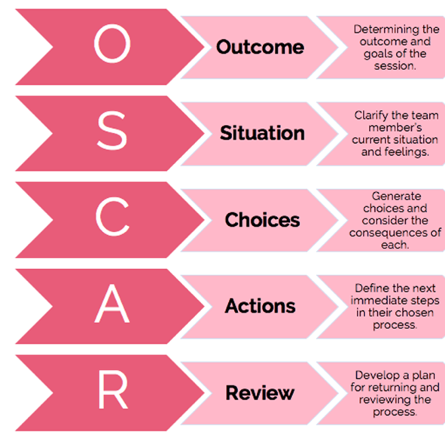
Image 1.0 - OSCAR Coaching Model

3. Personal Analysis

I used the "Instant Payoff" coaching paradigm (Landsberg, 2015) in a peer coaching experiment to assess my own coaching technique. I spent fifteen minutes as a coach, fifteen minutes as a coachee, and fifteen minutes as an observer. The Instant Payoff Coaching Model is a results-driven coaching technique that aims to provide the coachee with immediate feedback and rewards following each session, as explained in Section 2 of the assignment (Landberg, 2015). In light of this, I set out to study and implement the concept with Jaroslav, my coachee. Following the coaching session, the observer provided comments, which is displayed in Images 2.0–6.0 (see below).

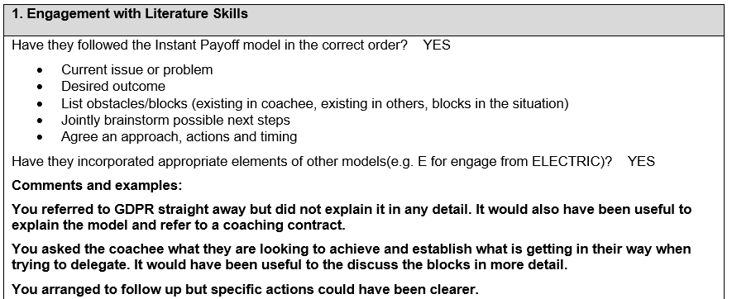
Image 1.0 - Feedback 1
Image 1.0 feedback shows that I followed the Instant Payoff model correctly and incorporated elements from other models. However, as the observer states, I could have explained GDPR and the coaching contract in more detail and explored the blocks more thoroughly. Moreover, during the follow-up, I could have been clearer and set specific actions to strengthen session outcomes.

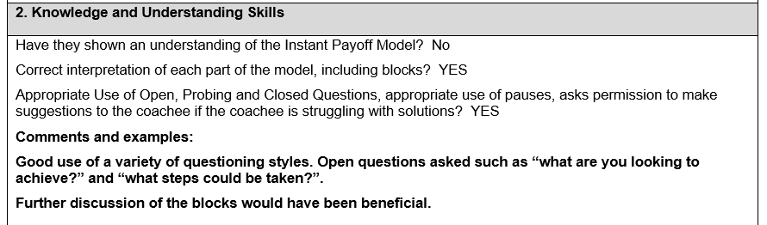
Image 2.0 - Feedback 2
The feedback presented in Image 2.0 shows that despite demonstrating correct use of questioning techniques through open questions and understanding of each model step, I didn’t apply the Instant Payoff model fully because I needed to have deeper conversations to support the coachee in identifying his barriers.

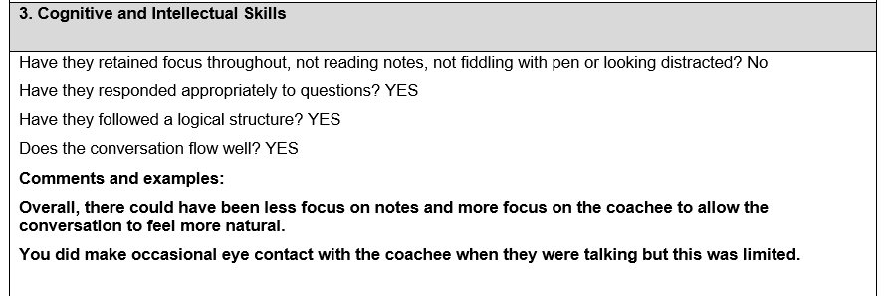
Image 3.0 - Feedback 3
Image 3.0 highlights that I maintained a logical structure. However, due to relying on notes and limiting eye contact with my coachee, I reduced the natural flow of our conversation. This means that I should have focused on the coachee more to ensure I am fully engaged and make the session feel conversational.
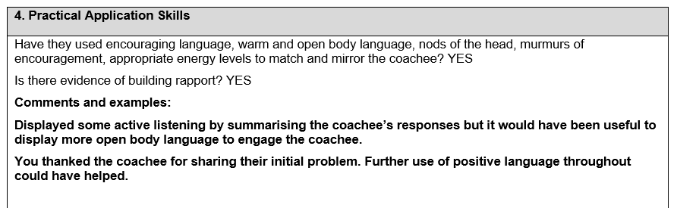
Image 4.0 - Feedback 4
Image 4.0 shows that I displayed active listening, built rapport, and summarised the coachee’s responses. However, as the observer stated, a more open body language and positive reinforcement would have improved engagement and a more supportive coaching environment.
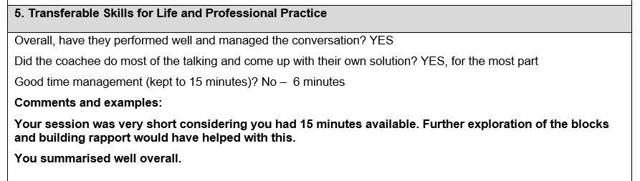
Image 5.0 - Feedback 5
Image 5.0 shows the last feedback, which highlights that my session was well-managed, and that the coachee generated their own solutions for most time. However, time management was the only issue, with the session lasting only six minutes, limiting the rapport I built with the coachee and exploring his obstacles in more detail. Therefore, to improve in future, I will be allocating more time with the coachee.
Based on the feedback received, I have identified areas that require improvement, as well as my strengths. In terms of strengths, I demonstrated the use of summarising techniques and active listening, which helped me build rapport with Jaroslav during the session. Additionally, I followed the Instant Payoff model correctly and incorporated elements from other coaching approaches, which shows my ability to transfer theory into practice. Another strength was that I acknowledged Jaroslav’s concerns and encouraged him to generate his own solutions.
However, there were also a couple of personal weaknesses highlighted by the observer. One weakness was my reliance on notes and limited eye contact, which reduced the natural flow of our conversation and affected my presence as a coach. Furthermore, I did not fully explore Jaroslav’s blocks, which prevented deeper reflection. Finally, my poor time management restricted my ability to apply the model fully and limited the opportunity to build rapport with Jaroslav and examine his obstacles in detail.

3.1 Personal Development Plan
Following the interpretation of the feedback received from the peer coaching exercise and as a result of identifying my strengths and weaknesses, I developed the following Personal Development Plan to improve my coaching skills.

Personal Development Plan
Action | Method | Requirements | Success Indicator | Review Date
Improve my engagement and presence during the coaching session. | To action this, I will dedicate more time to building rapport at the start of the coaching session. | To implement this action and develop my skills, I am required to learn and use mental checklists during my coaching sessions. On top of this, based on the individual I am coaching, I need to ask more open-ended questions and use mirroring techniques. | A success indicator would be improved rapport and engagement levels based on the coachee's feedback. | I will review this after each coaching session.
Reduce my reliance on written notes | To action this, I will practice summarising key points verbally during the session instead of writing everything down or reading from a piece of paper. | To implement this successfully, I am required to develop my confidence in active listening skills and memory recall. | A success indicator would be improved eye contact and conversational flow, reflected in coachee feedback. | I will review this after each coaching session.
Improve my time management to ensure the full model is delivered within the allocated session time. | To action this, I will plan the session using a loose time breakdown for each stage of the model and monitor progress throughout. I will also set a brief agenda at the start of the session and communicate time expectations with the coachee. | To implement this action and develop my skills, I am required to develop clearer opening and closing techniques to keep the conversation focused. | A success indicator would be to complete all stages of the coaching model within the agreed time frame. | I will review this after each coaching session.
I believe the Personal Development Plan developed above will help me to improve my coaching skills by targeting personal areas of improvement and preparing me with the necessary tools to better engage with my future coaches in order to guide them in identifying their obstacles and achieving higher performance levels.

4. Conclusion

In conclusion, this reflective assignment provides a valuable understanding of the significance of coaching as a professional development tool, particularly in the post-COVID-19 era. By understanding coaching and mentoring and examining two recognised coaching models, I was able to evaluate my coaching performance and identify both my strengths and areas of improvement. The feedback received as part of my practical application of the Instant Payoff Coaching Model reinforced the importance of active listening, presence, and structured questioning, while also highlighting the need to manage my time more effectively and engage deeper with my coachee’s barriers. Through the development of the Personal Development Plan, I have outlined clear actions to improve my capabilities and apply coaching more effectively in a professional context, specifically as a business owner. Overall, this experience has strengthened my understanding of coaching as a developmental intervention.

5. Reference List
Brockbank, A., & McGill, I. (2006). Facilitating reflective learning through mentoring & coaching. Kogan Page Publishers.
Boyatzis, R. E., Hullinger, A., Ehasz, S. F., Harvey, J., Tassarotti, S., Gallotti, A., & Penafort, F. (2022). The grand challenge for research on the future of coaching. The Journal of Applied Behavioral Science, 58(2), 202-222.
Devereaux, T. (2025) Exploring rapport-building in coaching relationships: coach's perspective.
Erdogan, B., Kudret, S., Campion, E. D., Bauer, T. N., McCarthy, J., & Cheng, B. H. (2025). Under pressure: Employee work stress, supervisory mentoring support, and employee career success. Personnel psychology, 78(1), 123-144.
Gilbert, A. and Whittleworth, K. (2009) The OSCAR coaching model.
Garvey, R., & Stokes, P. (2021). Coaching and mentoring: Theory and practice.
Ives, Y. (2008) ‘What is coaching? An exploration of conflicting paradigms’, International Journal of Evidence Based Coaching & Mentoring, 6(2).
Ivey, G.W. and Dupré, K.E. (2022) ‘Workplace mentorship: A critical review’, Journal of Career Development, 49(3), pp. 714–729.
Jarosz, J. (2021) ‘The impact of coaching on well-being and performance of managers and their teams during pandemic’, International Journal of Evidence Based Coaching & Mentoring, 19(1).
Knowles, S. (2022) ‘Coaching skills’, in Positive Psychology Coaching, pp. 79–90. Cham: Springer International Publishing.
Kaushik, M. (2020). Post COVID-19 World-A paradigm shift at workplace. Test Eng. Manag, 83.
Landsberg, M. (2015) The Tao of Coaching.
Malik, W.H. (2023) The impact of coaching and mentoring on employee performance in a selected hotel group. University of Johannesburg (South Africa).
Martens, R. and Vealey, R.S. (2023) Successful coaching. Human Kinetics.
Palmucci, D.N. and Santoro, G. (2024) ‘Managing employees’ needs and well-being in the post-COVID-19 era’, Management Decision, 62(12), pp. 4138–4147.
Rachmad, Y.E. (2025) Reinforcement theory. United Nations Economic and Social Council.
Rogers, J. (2004) Coaching skills: A handbook. Available at: https://www.wiley.com/ (Accessed:08/12/2025).
Sabock, R.J. (1985) The coach. Human Kinetics Publishers.
Toni, M., Mehta, A. K., Chandel, P. S., MK, K., & Selvakumar, P. (2025). Mentoring and Coaching in Staff Development. In Innovative Approaches to Staff Development in Transnational Higher Education (pp. 1-26). IGI Global Scientific Publishing.
Triantari, S. (2024). From coaching to Mentor Leader:: Profile and skills of the mentor leader in human resources management. dianoesis, 15, 103-122.
Viera, C.A. (2021) ‘A comparison of mentoring and coaching: what’s the difference?’, Performance Improvement, 60(7), pp. 13–20.
Wright, J. (2007). Stress in the workplace: A coaching approach. Work, 28(3), 279-284.

Appendices



