CRITICAL REFLECTION

In order to reflect I will use the Gibbs reflective model (Gibbs, 1988) which considers six different stages: Description, Feelings, Evaluation, Analysis, Conclusion and Action plan (Paterson & Chapman, 2013).

Figure 1. Gibbs Model of Reflection

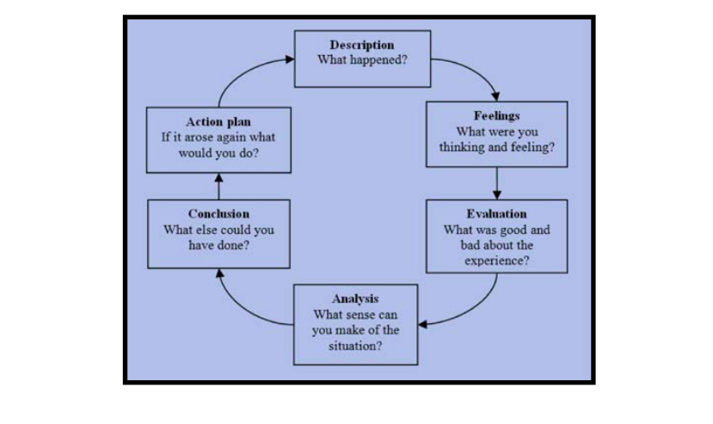
(Paterson & Chapman, 2013)

For this assignment I created a poster and then answered defence questions on my work. I then continued with a report on CSR and a critical reflection.

I believe the assignment went well. However, there were initial difficulties due to an inability to use copyright images. This limited the amount available for the poster.

I found this assignment beneficial as it allowed me to explore an ethical issue of great interest. It was enlightening to consider the different responsibilities that businesses should strive to achieve. One difficulty I encountered with the assignment was trying to create a poster that effectively expressed my viewpoint.

From the research undertaken I found that, although Purdue appear to make the right movements in CSR theory, they have not complied with their own internal governance code. Purdue’s product was falsely marketed, and a correlation of drug related addiction was found resulting from the use of their prescription painkillers (Jayawant & Balkrishnan, 2005).

I could have analysed all Purdue products to evaluate whether there were other ethical shortcomings within the company.

If I was to complete the assignment again, I would hope to achieve a more professional poster image. This would be with a view to better conveying the underlying message that companies, responsible for the health of patients, had actually become the source of death and addiction.

References:

Gibbs, G., 1988. Learning by doing: A guide to learning and teaching methods. Birmingham: Sced.

Paterson, C. and Chapman, J., 2013. Enhancing skills of critical reflection to evidence learning in professional practice. Physical Therapy in Sport, 14(3), pp.133-138.

Jayawant, S.S. and Balkrishnan, R., 2005. The controversy surrounding OxyContin abuse: issues and solutions. Therapeutics and clinical risk management, 1(2), p.77

