Enhancing Guest Dining Experience: An Analysis of Service Quality and Customer Satisfaction in the Restaurant at Novotel Birmingham Airport

Student Name: Florin Dragomir
Student ID: 2227451
Module Number: BMIH 5004
Module Name: Hotel Placement Research Project
Lecturer:Ben Ka PO Chong

Acknowledgement of use of AI tools
I confirm that I have not used any AI tools in the research and creation of this assignment. I confirm that i have not presented any AI generated materials as my own work. I confirm I have copies of my drafts, notes and other resources I used, which I may be asked to provide in evidence

Abstract
A particular case study-based focus has been made on the Novotel Birmingham Airport’s restaurant. The restaurant is part of a mid-range international hotel and has a diverse range of visitors, including travellers, tourists, and airline passengers. In this study, an aim has been taken to evaluate the impact of the current service quality of the restaurant on guest satisfaction rates. In Chapter 1, the background of the restaurant has been evaluated while also highlighting the operational challenges faced by the services in terms of creating a high-quality dining experience for guests. Thus, the analysis has been made on five dimensions of service quality, including responsiveness, reliability, empathy, assurance and tangibles.
In Chapter 2, a highly comprehensive literature review has been conducted. In this review, the most recent and relevant studies have been critically analysed while generalising the topic of service quality and customer satisfaction in the hospitality industry. The literature identifies staff behaviour, food quality, ambience, and hygiene as key factors in proper guest satisfaction creation. The SERVQUAL Model has been used as a theoretical framework to align the service context with the satisfaction evaluation process. The review also highlights gaps in the existing literature regarding the need for a context-specific analysis and a wider research base.
Chapter 3 outlines the overall methodological direction of this research. A secondary qualitative thematic analysis has been selected for the methodological data collection and analysis process. A factual analysis process has been prioritised due to the nature of the study is an analysis of customer experience. Thus, a pragmatist paradigm, deductive approach and descriptive design have been considered for creating a focused methodological direction.
In Chapter 4, detailed findings and discussion of information have been considered through factual evaluation. A total of three themes has been developed that include evaluation of key factors of customer satisfaction, alignment of UK regulations and solutions for further improvement. These themes are developed in alignment with the research objectives and questions so that they can be answered in this section. Customer comments and third-party ratings of the restaurant have been analysed critically to ensure a detailed and context-specific analysis of the case. The discussion section is utilised to critically compare the data in the findings section with the literature review findings. Thus, a detailed valuation of the direction of the research has also been made, followed by an analysis of study implications and limitations.
This research discusses the relationship between service quality and customer satisfaction in the restaurant of Novotel Birmingham Airport. It analyses five dimensions, namely, tangibility, reliability, responsiveness, assurance, and empathy, with the help of the SERVQUAL framework in order to define the gaps in the services and areas to improve them. The results indicate that the influence of responsiveness, empathy and personalised service on guest satisfaction is very high. Some of the recommendations made are staff training, technology integration, menu improvement, and improvement of ambience. As a measure to improve the total guest dining experience and maintain brand loyalty, the research points out that maintaining excellent service delivery and innovativeness are crucial.

Declaration
I confirm that I have not presented any AI generated text as my own work. I confirm I have copies of my drafts, notes, and other resources I used before, and after the use of AI tools which I may be asked to provide in evidence.

Signed: Florin Dragomir

Table of Contents
Chapter 1: Introduction 8
1.1 Research and Organisational Background 8
1.2 Research Purpose 8
1.3 Problem Statement 8
1.4 Research Aim 9
1.5 Research Objectives 9
1.6 Research Questions 10
1.7 Research Rationale 10
1.8 Research Significance 11
Chapter 2: Literature Review 12
2.1 Introduction 12
2.2 Comprehensive Evaluation of Service Quality Standards in the Restaurant 12
2.3 Identification and Analysis of Key Factors Influencing Customer Satisfaction 12
2.4 Strategic Recommendations to Enhance Guest Dining Experience 13
2.5 Theoretical Analysis: SERVQUAL Model 14
2.6 Conceptual Framework 15
2.7 Literature Gaps 16
2.8 Chapter Summary 16
Chapter 3: Methodology 17
3.1 Chapter introduction 17
3.2 Project paradigm 17
3.3 Project approach 18
3.4 Project design 18
3.5 Data collection process 18
3.6 Data analysis process 18
3.7 Ethical consideration 19
3.8 Chapter conclusion 19
Chapter 4: Findings and Discussion 20
4.1 Chapter introduction 20
4.2 Secondary qualitative findings 20
4.2.1 Key factors influencing customer satisfaction in the Novotel Birmingham Airport’s restaurant 20
4.2.2 Alignment of the services at the Novotel Birmingham Airport’s restaurant with local service quality standards 22
4.2.3 Strategies for further improvement of the services at the Novotel Birmingham Airport 24
4.3 Discussion 24
4.4 Implications and limitations 28
4.5 Chapter summary 28
Chapter 5: Conclusion 30
5.1 Conclusion of Key Findings 30
5.2 Research Limitations 31
5.3 Future Scope 31
Chapter 6: Recommendations 33
Reference List 36

Acknowledgement
I would like to express my special thanks to my teacher Ben Ka Po Chon as well as our principal, who gave me the golden opportunity to do this wonderful project on the topic, which also helped me in doing a lot of research, and I came to know about so many new things. I am thankful to them. Secondly, I would also like to thank my parents and friends, who helped me a lot in finalising this project within the limited time frame.

Chapter 1: Introduction

1.1 Research and Organisational Background
Novotel Birmingham Airport is a part of the Accor Hotels Group. It is a middle scale international hotel that thoroughly serves business travellers, airline passengers, and tourists at a time (Accor, 2025). Its onsite restaurant is very popular for its high-end guest experience, breakfast, lunch, and dinner facilities with various choice of cuisines. The restaurant plays a vital role in shaping customer perceptions, satisfaction, and loyalty. As it is an airport-based restaurant, it faces issues of a cultural gaps, services in limited time, and diverse customer expectations.

1.2 Research Purpose
This research focuses on exploring the relationship between service quality and customer satisfaction in the restaurant at Novotel Birmingham Airport. The goal of this study is to find out the particular parts of the dine in and out experience. It helps to determine the customer's understanding, including the staff's behaviour, the quality of the food, the atmosphere, and the service quality (Adriatico et al., 2022). The research also will provide practical solutions by which the customer experience can be improved.

1.3 Problem Statement
Even though Novotel Birmingham Airport tries to uphold a high level of service, the restaurant struggles to provide a satisfying dining experience regularly. Likewise, the responses from the guests sometimes reveal that the performance of the restaurant is average at best, mentioning that the service is delayed, food quality varies, and there is a lack of staff engagement. Hence, these reasons may cause a reduction in customer satisfaction, negative comments, and a possible decrease in the hotel's loyal customers (Abdullah, Sufi and Kumar, 2022). Due to the increasing competition among the hotels around the airport and food outlets, it has become a necessity to assess the quality of service in a professional manner.

1.4 Research Aim
The aim is to critically evaluate how service quality in the restaurant at Novotel Birmingham Airport influences customer satisfaction.

1.5 Research Objectives
SMART | Objective 1: Evaluate service quality standards | Objective 2: Identify key factors influencing customer satisfaction | Objective 3: Recommend strategies for improvement
Specific | Observe and measure restaurant service delivery against set standards. | Determine elements (speed, menu, staff behaviour, ambience) shaping guest satisfaction. | Suggest targeted solutions to enhance the guest dining experience.
Measurable | Use guest surveys, comment cards, and observation checklists. | Collect at least 30 guest responses during placement. | Provide 3–5 practical recommendations supported by findings.
Achievable | Can be done within the restaurant placement using existing tools. | Data collection is possible through short surveys and daily observation. | Recommendations based on real evidence from collected data.
Realistic | Aligns with the hotel's operational priorities and resources. | Guests are accessible daily, making feedback realistic to obtain. | Proposals will be feasible with current staffing and budget.
Time-bound | Complete evaluation by the midpoint of placement. | Analyse factors by the third month of placement. | Submit recommendations by the end of the placement project deadline.
Table 1: Research Objectives

1.6 Research Questions
- What benchmarks are used to measure service quality within the organisation?
- Which major elements contribute to shaping customer satisfaction levels?
- What strategic actions can be implemented to enhance overall service performance?

1.7 Research Rationale
The rationale for this study is based on the recognition of the pivotal role that the dining experience has in the general evaluation of a hotel and the creation of customer loyalty. Dining facilities in airport hotels have to deal with a different set of challenges in their operations, which include a rapid change of guests, a lack of time, and different cultural expectations (Talukder and Kumar, 2025). Therefore, an investigation of the quality of services in such a situation would enable one to understand those factors that lead to positive guest experiences. As a matter of fact, studying the restaurant at Novotel Birmingham Airport provides a convenient place where one can put into practice the theories of hospitality management.

1.8 Research Significance
The study is essential in both academic and practical terms. In the same way, it contributes knowledge about service quality and customer satisfaction in the hospitality and airport hotel sector (Bichler, Pikkemaat and Peters, 2021). In reality, the results could help the managers and the employees of the restaurant at Novotel Birmingham Airport to upgrade their performance, the quality of their services, and the satisfaction of their customers.

Chapter 2: Literature Review

2.1 Introduction
This research is carried out to improve the guest dining experience at the airport. It is a study of the service quality and customer satisfaction. The paper dives deep into the main factors influencing the perceptions, assesses the existing service levels, and uses the SERVQUAL model to locate the holes. The results are targeted to deliver the practical suggestions that will upgrade the total dining experiences and the return of the customers.

2.2 Comprehensive Evaluation of Service Quality Standards in the Restaurant
Reliability is a feature of service quality, which the restaurant has through the capability to deliver meals on time and also maintain the quality of the food. However, it is mentioned that there are some delays during the rush hours of the restaurant (Abdullah, Sufi and Kumar, 2023). Responsiveness refers to the gesture of staff members to the needs of guests, including giving dietary advice, but it is a fact that the high turnover rate and time pressure are the reasons for the low efficiency. Assurance is extremely important since the staff's skills, their polite conduct, and the way they make the customer feel safe are among the factors that help to build the total hotel guest perception. Empathy is about personalised communication and the understanding of guests' needs, which can be varied because of the fast turnover of guests at an airport hotel. Tangibles, restaurant cleanliness, décor, comfortable seating, and the presentation of the meals are some factors that influence people’s first impressions and overall satisfaction (Ali et al., 2021). When they evaluate these factors, they see that the hotel has a lot of well-trained staff and a modern dining environment, but at the same time, it suffers from a lack of speed during peak periods and communication gaps.

2.3 Identification and Analysis of Key Factors Influencing Customer Satisfaction
Satisfaction of customers at the restaurant in airports depends on a mix of both tangible and intangible elements that, together, define the customer dining experience. Quality of food, which is generally the most important factor and includes taste, freshness, and presentation besides the variety of the menu, is the main reason for the satisfaction of guests in an airport hotel, as they expect standards to be at least the same as in other international restaurants (Anu and Manorselvi, 2021). Customer service also greatly influences the level of satisfaction with the service delivery, which includes staff responsiveness, attentiveness, and the ability to handle special requests efficiently. In addition to the factors mentioned above, the ambience, which can be described by the lighting, seating arrangement, noise levels, and also the overall restaurant aesthetics, is what the customer perceives as the comfort and enjoyment of the meal. On the other hand, time management, especially the speed of service during a breakfast rush or an evening check-in, significantly influences the customers' satisfaction as airport guests are usually in a hurry and have a tight schedule (Talukder et al., 2023). The prices and the perceived value for money are the factors influencing customer satisfaction in a further stage, while customers decide whether they get the quality of food and service at a reasonable price. Moreover, hygiene and safety standards, which are very important, especially after the pandemic, are the main factors that help to improve the guest's trust in the restaurant.

2.4 Strategic Recommendations to Enhance Guest Dining Experience
Elevating the dining experience of guests at airport restaurants is possible through the implementation of a blend of operational, staff-related and technology-driven strategies which, together, address the gaps in service quality and customer satisfaction that have been identified. Firstly, the introduction of well-planned staff training programs that focus on customer service, responsiveness, and cultural awareness will not only enhance the level of staff-customer interactions but also ensure that the same standards of service are maintained throughout different shifts (Wong et al., 2022). Improving the service through changes in the workflow, for example, during the busiest hours and pre-preparing the parts of the menu that are most requested, can not only shorten the waiting times for the guests but also increase the productivity of the staff to a greater degree. The use of technology can bring about efficient and easy restaurant operations. This is because digital ordering systems, table management apps, and customer feedback platforms give the management real-time access to service quality and thus, any deviations from the required standards can be corrected immediately. Menu innovation to the rescue of the hotel restaurant is a sure way to stay ahead of the competition, and this can be done by catering to customer preferences and dietary trends that inform the choice of new and relevant menus that ensure variety (Candra et al., 2023). A quality control system can be maintained to ensure that the food going to the guests is always of the same standard and the presentation is up to the mark. Small restaurant improvements like lighting, seating comfort, and updated decorations can go on a long which can help to get more valuable consumer satisfaction.

2.5 Theoretical Analysis: SERVQUAL Model
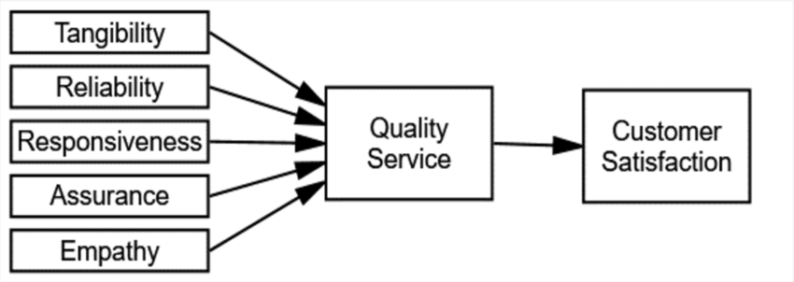
Figure 1: SERVQUAL Model
Source: (Nautwima and Asa, 2022)
Parasuraman, Zeithaml, and Berry's SERVQUAL model is an elaborate system for measuring service quality through five dimensions, including reliability, responsiveness, assurance, empathy, and tangibles. The model is extremely helpful in the case of the Novotel Birmingham Airport restaurant to understand and elevate guest dining experiences. Reliability looks at the restaurant’s ability to provide a service that is not only fast but also accurate and of good quality, thereby, for example, ensuring both the prompt serving of the meal and the freshness of the food (Ismail et al., 2022). Responsiveness evaluates staff willingness and promptness in dealing with guest requests, offering dietary help or solving complaints in the shortest time possible. Assurance is about the staff's skills and the professional behaviour, thus trust and confidence in the diners are the results. Empathy is about personalising and giving the right attention to each customer, and this is very important in the airport environment, where guests may have certain expectations or be in a hurry. Finally, tangibles refer to the physical side of things, such as restaurant cleanliness, décor, comfortable seating, and food presentation, which are all factors that determine the quality of first impressions.

2.6 Conceptual Framework
Enhancing Guest Dining Experience

An Analysis of Service Quality and Customer Satisfaction in the Restaurant
SERVQUAL Model
Identification and Analysis of Key Factors Influencing Customer Satisfaction
Comprehensive Evaluation of Service Quality Standards in the Restaurant
Strategic Recommendations to Enhance Guest Dining Experience

Figure 2: Conceptual Framework
Source: Self-Developed

2.7 Literature Gaps
Although a lot of research has been done on service quality and customer satisfaction in the hospitality sector, there is very little attention paid to the restaurants in airport hotels, which have different kinds of time-sensitive and high-turnover situations. Most of the studies have been done on hotel dining in general or on standalone restaurants, and thus, the effect of transient guests, cultural diversity, and operational pressures specific to airport settings is usually left out. Besides that, linking the SERVQUAL dimensions directly to guest loyalty and repeat visits in a measurable way in this context is something that has not been studied much either.

2.8 Chapter Summary
The chapter described the research background, purpose, problem statement, rationale, and significance. It analysed the service quality, as well as the factors influencing customer satisfaction and suggested the customer-related strategic changes. Besides, the theoretical investigation by means of the SERVQUAL model illuminated the practical side, whereas the uncovered themes in the literature pinpointed the necessity for specifically directed research in the airport hotel restaurants to enhance customer experiences.

Chapter 3: Methodology

3.1 Chapter introduction
Methodological evaluation helps in creating a structure and direction for the following data collection and evaluation process. In this case, a case-based evaluation of Novotel Birmingham Airport’s restaurant services has been analysed. Thus, a real-case-based findings management methodology has been used to align the process with the outcomes, using steps identified in Saunders’ research onion (Saunders, 2019).
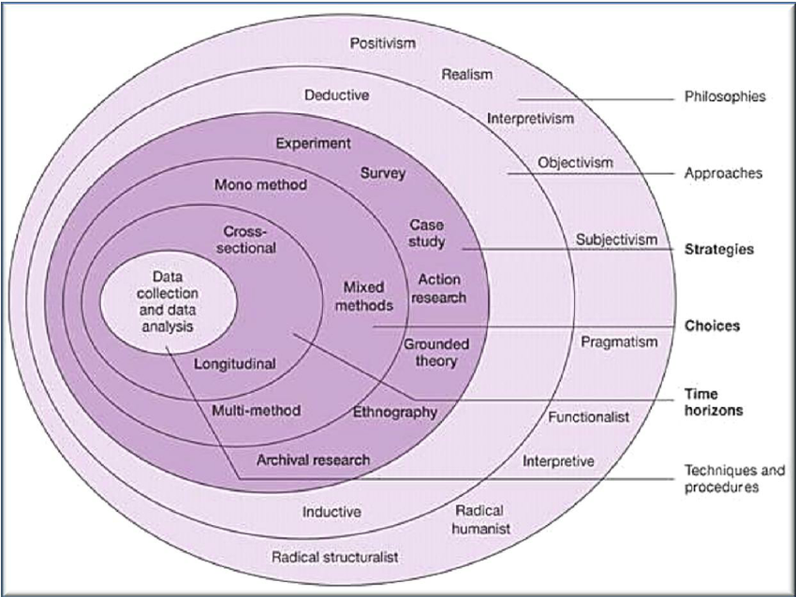
Figure 3: Saunders’ research onion
(Source: Saunders, 2019).

3.2 Project paradigm
Methodological paradigm is used to create a specific direction of the research based on the data analysis needs. In this research, a pragmatist paradigm is used to emphasise the practical consequences in the cause-and-effect relationship between the mentioned restaurant’s services and customer satisfaction. Thus, the pragmatism paradigm has been used as a problem-solving tool for the project.

3.3 Project approach
Methodological approach accounts for the identification of specific tools and processes used in research to ensure obtaining the desired outcome (Reed et al., 2021). In this research, a deductive approach has been used to identify specific variables from a wide range of discussions and create concise and specific findings. Other approaches, like abductive and inductive approaches, are avoided to avoid the creation of any other argument not directly related to the research outcome.

3.4 Project design
Methodological project design evaluation is the consideration of managing the process of arranging the data analysis process, to get the most relevant and valuable findings (Cheong et al. 2023). In this project, a descriptive project design has been used to identify the best aligned variables in the research and critically evaluate them to get the most appropriate findings. Other designs, such as co-relational, experimental or quasi-experimental designs, have not been used to avoid deviation from the discussion of the main topic.

3.5 Data collection process
A secondary qualitative data collection consideration and related process have been implemented in this research. Thus, mainly most recent and relevant sources from Google Scholar and the University library will be used in this research, along with third-party and company websites for obtaining and analysing customer reviews. The Reviews will be critically evaluated, comparing with the findings from other scholarly secondary sources. An inclusion and exclusion criterion-based sampling will be used to collect the necessary data for further analysis.

3.6 Data analysis process
A secondary qualitative data analysis process is implemented in this research to align with the broader methodological needs and the aim, objectives and questions developed for the research. A secondary qualitative analysis can be either case-study-based or thematic analysis-based (Sandhiya and Bhuvaneswari, 2024). In this case, a thematic analysis process is used to answer the research objectives and questions through the themes. Furthermore, a critical discussion of the findings is also considered, comparing them with the previous findings of the literature review. Actuarial customer comments and rating data will be used to critically discuss claims and practices of the company with the service standards.

3.7 Ethical consideration
Due to the implementation of a secondary qualitative discussion, a secondary research ethics will also be followed in the evaluation of the research. The Data Protection Act 2018 principles and the University's ethical research guidelines will be maintained while collecting, analysing and storing the data. No manipulation of the data will be considered, despite the desired outcome. Furthermore, the sources and the gathered data will be safely stored in the University cloud for further usability and relevance.

3.8 Chapter conclusion
In conclusion, it can be said that a secondary qualitative data analysis is best suited for this research due to time restrictions and financial constraints. Thus, aligning with the data collection and analysis requires a pragmatist paradigm, a deductive approach and a descriptive design has been chosen to answer the research objectives and questions. A detailed secondary research ethical consideration will also be followed to develop proper ethical outcomes.

Chapter 4: Findings and Discussion

4.1 Chapter introduction
In this chapter, the methods identified in the previous chapter have been thoroughly utilised to analyse data for identifying service quality and customer satisfaction at the Novotel Birmingham Airport restaurant. In this case, a secondary qualitative thematic analysis has been adopted as the main source of comparative evaluation and to analyse diverse guest perspectives through their own words. Thus, the main focus has been on considering a factual analysis of the found data and arriving at a specific conclusion regarding the matter. The themes used in the following are derived from the objectives and questions of the study to ensure higher quality management and a focused conclusion.

4.2 Secondary qualitative findings

4.2.1 Key factors influencing customer satisfaction in the Novotel Birmingham Airport’s restaurant
Customer satisfaction in hotel-based restaurants is shaped by both tangible and intangible elements and through both product and service accountabilities. The third-party guest reviews of Novotel Birmingham Airport’s restaurant identify those factors like staff responsiveness, food quality, and ambience are central to creating a positive dining experience for the customers. The reviews are mostly positive, indicating that the hotel has good restaurant service, while the staff interactions are friendly. Furthermore, the restaurant has a clean environment, and the meals are also well-presented (Tripadvisor, 2024a; Tripadvisor, 2024b). In this context, the findings of Singgalen (2024) also indicate that the professionalism of the staff, cleanliness and the value of money obtained by the customers are the main determinants of their satisfaction in a hotel dining setting. The Novotel Birmingham Airport’s restaurant can provide these tangible and intangible satisfaction aspects to the customers and thus create a good customer satisfaction rating.
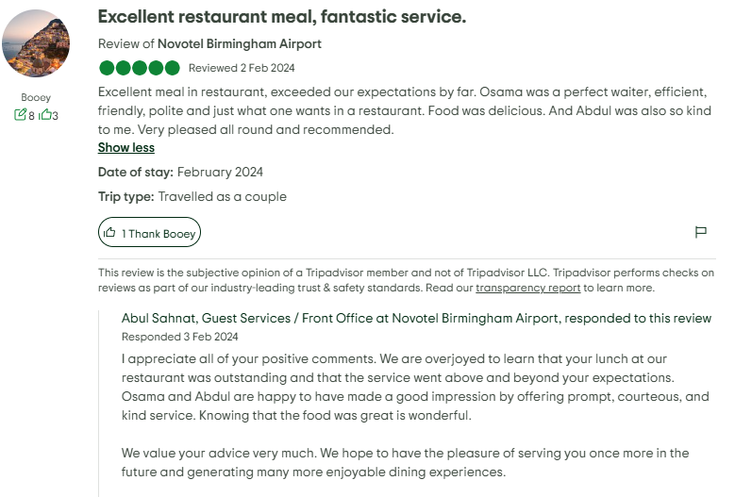
Figure 4: Positive Customer review 1
(Source: Tripadvisor, 2024a)
Other than the positive reviews, a negative review has also been spotted in the third-party review disclosure. This review exposes critical gaps in the services regarding assurance and empathy. Furthermore, gaps have also been exposed regarding allergy awareness and food safety protocols, which are essential factors in delivering a good service (Tripadvisor, 2024b). Hygiene management is one of the most important aspects of a restaurant service, and failing to properly manage hygiene can lead to significant customer dissatisfaction. The research identifies that customer trust in the restaurants is significantly dependent on a consistent and hygienic service quality. A good and consistent service quality, high maintenance and staff commitment regarding these practices can significantly improve customer satisfaction and loyalty to the services (Kumolu-Johnson, 2025). Thus, the Novotel Birmingham Airport’s restaurant must also improve its services in some areas to ensure better customer satisfaction and loyalty generation.
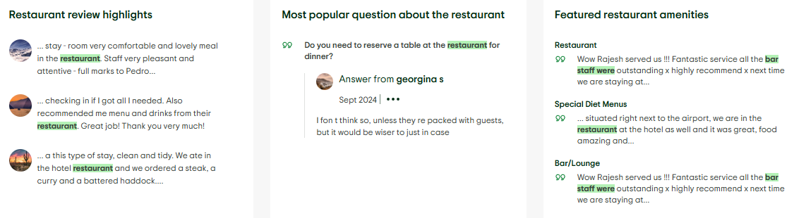
Figure 5: Positive Customer review 2
(Tripadvisor, 2025)
The service quality of a restaurant is generally determined by the SERVQUAL dimensions, which include responsiveness, reliability, assurance, tangibility and empathy (Arli, Esch and Weaven, 2024). Inclusion of all these aspects in a restaurant service makes it compliant, effective and effective for managing customer satisfaction. For example, the reliability of a restaurant service is determined when the meals are delivered promptly and consistently. In this context indicates that in modern environments, personalised guest services significantly help build customer trust and loyalty in the service operations (Ali et al., 2021). The personalised services must reflect the SERVQUAL dimensions in the operations, to ensure high accountability and credibility of service. Based on the reviews, it can be said that Novotel’s restaurant can meet these expectations during off-peak hours. However, the same company struggles to provide the same services during peak operational periods. Thus, an immediate operational adjustment is needed in the company to help it become more relevant in all seasonal services.
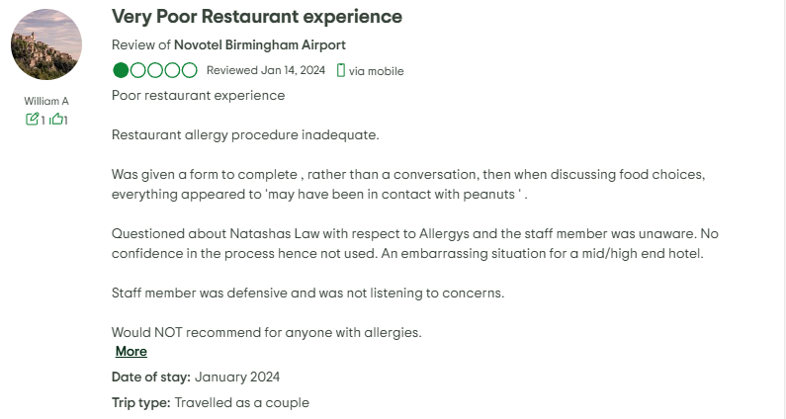
Figure 6: Negative Customer review 1
(Tripadvisor, 2024b)

4.2.2 Alignment of the services at the Novotel Birmingham Airport’s restaurant with local service quality standards
For understanding the impact of the restaurant services of the Novotel Birmingham Airport on the customer satisfaction rates, it is also essential to understand whether the services align with local and international standards or not. Restaurant service quality in the UK service sector is compared against frameworks like ISO 9001 (Rusavska et al., 2025). Alternatively, food quality transparency management in the sector is evaluated with Natasha’s Law. Other than that, the industry itself sets out several expectations for hygiene, staff competence, and customer engagement practices (NQA, 2025). In this case, Novotel Birmingham Airport’s restaurant has strengths in managing tangible assets like cleanliness, décor, and food presentation. Thus, these practices can be consistent with the British Hospitality Association (Tripadvisor, 2024a). The guests love the ambience and visual appeal of the services and their plosive reviews supports this discussion.
On a different note, the identified negative review suggests that the services currently have inconsistencies in terms of assurance and responsiveness accountabilities, which are two of the main dimensions of the SERVQUAL model (NQA, 2025). The negative review indicated that the restaurant staff has a lack of knowledge regarding allergy handling procedures. The staff is also unfamiliar with Natasha’s Law and related hygiene guidelines. As a result, an inconsistency was seen in the restaurant services regarding allergen labelling and staff awareness. These incidents are not aligned with UK hotel and hospitality regulations and also creates legal complications. Extensive and regular staff training is required to help the staff become aware of the legal boundaries and restrictions to ensure further compliance. As per Bulochova et al. (2024), both staff training and regulatory compliance management are essential practices in maintaining service quality in the restaurants. Thus, the Novote must consider implementing an immediate staff training procedure to ensure future compliance and effective staff management.
As per the reviews, the restaurant staff has also been highly responsive during the off-peak hours. While some of the guests report efficient service management, other reviews indicate delays in responsiveness. This indicates an operational inefficiency in the overall services. According to the 2025 complex guide of Sovereign Water, the UK restaurants must ensure workforce efficiency and safety standards, especially in terms of time-sensitive operations (Dwight, 2025). In this context, Novotel’s restaurant-related performance during the off-peak hours aligns well with the expectations. However, there is also a presence of peak-time inconsistencies, which require attention and further regulatory alignment.

4.2.3 Strategies for further improvement of the services at the Novotel Birmingham Airport
To manage the exciting drawbacks in the restaurant service operations, the Novotel Birmingham Airport must first identify the specific aspects of the drawbacks related to operational efficiency, staff competence, and guest-centric innovation. Then, addressing the aspects through proper theoretical understanding and practical application can help the company account for better service delivery. In a more specific context, Novotel can consider better staff development accountability by analysing the reviews and coming up with suitable solutions. One of the reviews indicates that there are gaps in responsiveness and allergy awareness among the staff (Tripadvisor, 2024b). As per the findings of Mehner, Rothenbusch and Kauffeld (2024), the implementation of structured training programs can help a company manage relevant skill gaps and ensure the creation of better services through the staff. Furthermore, Shiri et al. (2023) also highlight that the utilisation of a continuous training practice can help enhance staff confidence, even in high-pressure environments. Thus, staff training can improve the staff turnover rate of the Novotel Birmingham Airport restaurant.
The issues with order delays in the restaurant can be solved by proper utilisation of hospitality technology in the restaurant’s order processing system. In this case, the utilisation of streamlined order processing systems can help automate some parts of the order management process and thus improve guest experience. Digital ordering systems, real-time feedback platforms and table management apps can reduce the overall wait time of the customers and improve the service accuracy (Shorbaji, Alalwan and Algharabat, 2025). Furthermore, the findings of Talukder et al. (2023) also suggest that the dining systems in the restaurants, which are enhanced by technological support, help boost customer satisfaction and revisit intentions. Novotel can use such tools in their restaurant operations to significantly boost productivity and customer service concerns even during the peak hours and thus, reduce the existing service gaps.

4.3 Discussion
The secondary qualitative findings of the study reveal that a good understanding of service quality and customer satisfaction concerns is essential for a restaurant to maintain relevance in the market while accounting for better customer satisfaction. Thus, the Novotel Birmingham Airport also require similar aspects of understanding to evaluate the root causes of the problems associated with customer dissatisfaction and ensure further quality management in the operations. In the discussion of the findings, the key aspects emerging from the detailed analysis of the case are as follows:
4.3.1 The Novotel Birmingham Airport restaurant showcases a mixed performance.
One of the most prominent discussions arising from the findings and previous studies is the need for staff responsiveness and assurance in the restaurant business. Consideration of better responsiveness and awareness creation can help the Novotel Birmingham Airport restaurant create better customer satisfaction. Some positive third-party reviews indicate that the services generally meet customer expectations and also showcase staff friendliness and attentiveness. However, it has also been found that these qualities are only seen in off-peak hours (Tripadvisor, 2024a; Tripadvisor, 2025). On the other hand, the previous discussion of Singgalen (2024) highlighted that staff professionalism and responsiveness are key drivers in terms of satisfying the hotel dining customers. Thus, Novotel have to further improve on these aspects to make sure that the customers also get better services during the peak hours.
The findings also identify a negative review, indicating a serious gap in assurance. Issues related to the lack of allergy awareness among the staff were prominent as per the findings (Tripadvisor, 2024b). On a contradictory note, the literature-related discussion of Abdullah, Sufi, and Kumar (2022) indicated that reliability and empathy are essentially important in fostering guest loyalty and thus managing customer satisfaction. An inconsistency in staff knowledge and responsiveness can lead to customer dissatisfaction and reduced retention. Thus, the Novotel Birmingham Airport restaurant has to consider improving customer engagement by the staff during the peak hours through the implementation of related training practices.
4.2.2 The Novotel Birmingham Airport restaurant has good ambience and tangible services.
The findings also indicate that tangible aspects like cleanliness, décor, and food presentation are essential in satisfying restaurant guests. These aspects positively contribute to first impressions and overall satisfaction of the customers. For the Novotel Birmingham Airport restaurant, the food presentation and decor have also satisfied the guests (Tripadvisor, 2024a; Tripadvisor, 2025). Critically analysing this aspect with the previously analysed literature of Ali et al. (2021) and Bichler, Pikkemaat, and Peters (2021), it can be said that ambience and visual appeal in restaurants play a good part in enhancing revisit intentions of the customers. Furthermore, Novotel’s restaurant service also succeeds in performing well in most of the tangible areas of quality associated with the SERVQUAL model (Arli, Esch, and Weaven, 2024). The modern design and clean environment of the restaurant meet the customer expectations as well as the UK hospitality standards. The alignment of the operations with the ISO 9001 benchmarks proves this aspect (Rusavska et al., 2025). Therefore, it can be said that the Novotel Birmingham Airport restaurant is already competent in some of the service quality management areas.
Alternatively, the previous literature discussion also indicates that tangible aspects of quality alone cannot compensate for deficiencies in managing interpersonal services. In this context, Prabhakar and Gunasekeran (2025) have argued that tangible aspects of service must also be complemented by personalised services for providing a holistic customer experience. The findings section supports this view by indicating that while Novotel has a good internal ambience, gaps still exist in the positivity aspects, resulting in negative reviews.
4.2.3 The Novotel Birmingham Airport restaurant also faces reliability and operational efficiency issues as challenges
In terms of reliability of the services, the findings from the guest posts and comments indicate that the restaurant has not been competent enough to deliver consistent and timely service. The guests had reported satisfactory service during quieter periods, but also reported delays and inefficiencies in the services during peak hours (Tripadvisor, 2024b). These incidents indicates that such issues are more common in airport restaurants. The restaurants constantly face time pressure due to busy schedule of the passengers and occasional increase in travel frequency. The previous literature also supports such arguments. For example, Talukder and Kumar (2025) identified that time-constrained service delivery is crucial in airport settings, as the customers often have tight schedules and do not have time to wait in the restaurant for a long time. Thus, the airport restaurants must manage their time more effectively to deliver a proper customer service can maintain satisfaction.
Furthermore, the findings of Wong et al. (2022) and Shorbaji, Alalwan, and Algharabat (2025) also support the integration of smart technologies to enhance the reliability of the operations. In the recommendation part of the findings, it is also indicated that the inclusion of digital ordering systems and table management apps can reduce customer wait time and thus further strengthen customer trust in the operations. Furthermore, the inclusion of technology can reduce the gap between lean and peak-time operational efficiency, reducing the overall efficiency challenges faced by the restaurant in the market.
4.2.4 The Novotel Birmingham Airport restaurant is in partial compliance with UK hotel and restaurant service standards
The findings also reveal that Novotel Birmingham Airport’s restaurant has partial alignment with the UK service quality standards. In terms of hygiene and ambience, the services are largely aligned to cater for a good customer satisfaction rate. The observational data utilised in the findings, along with the positive reviews found, indicate that the operations of the restaurant are aligned with ISO 9001 and British Hospitality Association benchmarks (Tripadvisor, 2024a; Tripadvisor, 2025). However, negative reviews regarding the services have also been found, indicating non-compliance with Natasha’s Law. Thus, there is a gap in regulation alignment and related management in the restaurant, which can be improved in the future.
However, the continuation of such inconsistencies can impact the restaurant negatively in the long term. The findings of Olawuyi and Kleynhans (2025) from the previous literature indicated that regulatory compliance is non-negotiable in the hospitality sector, especially in high-risk environments like airport hotels. Thus, having gaps in regulatory compliance fulfilment can be proven significantly harmful for the future operations of the restaurant. Apart from this aspect, the Sovereign Water compliance guide (Dwight, 2025) also suggested the importance of workforce efficiency in time-sensitive operations like airport restaurants. Thus, Novotel also have to create a balance between their off-peak and peak time services to ensure managing a constant service and generate better customer experience. Thus, the company might have to include better scheduling and staff allocation to enhance its compliance management practices and customer satisfaction.
4.2.5 Staff training, technological innovation and personalisation can be presented as solutions.
In the findings section, several possible solutions have also been proposed as strategies for improvement for the Novotel Birmingham Airport restaurant and its existing operations. Both the literature review and the findings indicate staff training as a solution for managing existing gaps in the restaurant services. Both Mehner, Rothenbusch, and Kauffeld (2024) and Shiri et al. (2023) indicate that considering continuous development can help with building competence and confidence among the staff. As a result, the overall performance of the services will also improve. Thus, both the guest feedback-based findings and the academic insights can be aligned in this context that improve staff through training and reduce the existing gaps in the restaurant.
Furthermore, relevant technological integration can also be considered as a key strategy for managing the exigent issues. In this case, the findings suggest the adoption of digital tools like digital booking systems to streamline service delivery. This argument can also be supported by the previous findings of Talukder et al. (2023) and Wong et al. (2022), where it is said that, seasonal changes in menus and decor can enhance both tangible assets and improve emotional engagement in the customers. Using tangible assets like restaurant management technologies, peak time issues in the restaurant can be solved easily, while improving customer satisfaction.

4.4 Implications and limitations
The study creates a specific context-based decision using the Novotel Birmingham Airport’s restaurant as a case study. The findings highlight the importance of hygiene compliance, staff training and technological integration in enhancing guest experiences in the restaurant. Thus, this study is particularly useful for the future management of the restaurant and can provide insights regarding how operations in airport restaurants can be better managed.
Despite all the critical evolution and specific contexts subjected, the research is still limited in terms of data quality usage. Only secondary qualitative data has been used in analysing the research findings, which limits the use of primary viewpoints. The performance of the restaurants is best evaluated from the experience of the customers. However, customer experience as primary data has not been used in this research as a support for the secondary data. Additionally, the findings of the study are highly context-specific and cannot easily be generalised for usage in other relevant research practices.

4.5 Chapter summary
Summarising the findings and discussion section, it can be ensured that in a restaurant service, customer satisfaction and service quality are directly related to one another. For the Novotel Birmingham Airport’s restaurant, it is evident that they need to further improve their service quality and consistency to ensure a better customer satisfaction rate. The restaurant is currently competent in terms of creating an ambience and food presentation. However, there are still gaps regarding staff responsiveness, assurance, and allergy awareness issues in the operations. These issues can be mitigated by technological adaptation and staff training practices in the future.

Chapter 5: Conclusion

5.1 Conclusion of Key Findings
This study determines that service quality has a final influence on the entire dining experience of the customers, which then impacts future satisfaction, loyalty and formation of brand value. The results highlight that providing consistent service, staff behaviour, food quality, and ambient comfort are critical towards the rate of customer satisfaction in the hospitality industry, particularly in an airport hotel atmosphere where convenience, efficiency and high-quality customer experience influence customer expectations. The evaluation of secondary information revealed the fact that the guests of Novotel Birmingham Airport appreciate such dimensions of quality as timely service, professional staff and personal attention as essential and critical to them. The SERVQUAL model offered a practical theoretical framework that allowed for evaluating service gaps in five dimensions that took centre stage in the framework, such as tangibility, reliability, responsiveness, assurance, and empathy. The findings showed that the Novotel restaurant is doing well in terms of tangibles and reliability, although such dimensions as responsiveness and empathy continue to be improved. Tourists are getting used to faster service on special requests, authentic contact, and personalisation beyond what is offered by normal hospitality.
Another crucial satisfaction determinant became food quality. Visitors enjoyed the reliability of the quality of the served menu, and the range of it, but the feedback indicated that freshness, food presentation, and dietary inclusivity (such as vegan or gluten-free food) could be improved to enhance the food experience. The emotional satisfaction and memory are greatly affected by the sensory aspect of food, which is taste, smell, and visual appeal, which supports the conclusion that culinary excellence should be complemented with service excellence to create an experience for the guest in its entirety. Furthermore, it was determined that the dining environment (ambience, cleanliness, lighting, and level of noise) has a direct relationship with the perception of comfort and satisfaction. The physical atmosphere can significantly influence the mood and contentment in an airport hotel setting, where the traveller tends to feel fatigued or time-starved. Hence,​‍​‌‍​‍‌ it becomes an essential subject to keep the establishment in a peaceful, hospitable, and clean setting.
Therefore, these technological interventions are useful in operational innovation in the service sector. However, it can also be stressed that technological improvements do not take the place of the human touch that makes up authentic hospitality but are its complements. As a manager, it is essential to engage in constant training of the staff in terms of communication, emotional intelligence, and problem-solving. Empowered and valued employees are more likely to provide guests with excellent service, thus having a direct impact on guest satisfaction. The presence of a service excellence culture, which is supported by effective leadership and well-developed performance standards, will make the quality of the services consistent regardless of the shifts and circumstances. The restaurant of Novotel Birmingham Airport is in a good position to reinforce its competitive advantage by means of strategic improvement of its service quality dimensions. The restaurant can establish personalised experiences that become memorable and, therefore, result in loyalty, positive word of mouth, and repeat visits by streamlining operations in line with the expectations of guests, investing in staff development, enhancing responsiveness, and using technology to create the most memorable experiences. A constant focus on customer response, active service development, and focus on hospitality quality will eventually guarantee that the meal experience at Novotel Birmingham Airport remains beyond the expectations of guests and reveals itself as a part of the global brand image of quality and comfort.

5.2 Research Limitations
The study was also bound by the fact that it was only conducted in one restaurant within the Novotel Birmingham Airport, and this does not aid in generalising the results to other hotels or restaurant environments. The number of guests sampled to give feedback and the number of staff sampled to be interviewed were relatively low, thus restricting the reliability of the statistics. Also, a time period was taken, and data were recorded in a specific time period. Thus, seasonal variations or changes in management practices were not measured. The research also counted on self-reported customer perceptions, which can be subject to bias as a result of individual preferences or expectations. Finally, extraneous factors like the reason for travelling or the time of flights may have impacted the dining satisfaction response of the guests.

5.3 Future Scope
Future studies may broaden the study to various branches of Novotel or other hotels in airport locations to enable a comparative analysis and more generalisation. Quantitative approaches like regression analysis may be used in identifying stronger relationships between the dimensions of service quality and customer satisfaction. The effects of overtime service improvement on repeat visits and brand loyalty could also be investigated using longitudinal studies. Furthermore, the role of emergent technologies like AI-powered personalisation or self-service kiosks in improving the dining experiences may be involved in future studies. Last, the analysis of the cultural and demographic diversities of international travellers might have added more insights into the varied expectations of different guests and ways of satisfaction.

Chapter 6: Recommendations
As per the result of this research, various suggestions are made to improve the guest dining experience and increase the satisfaction of customers in the restaurant overall at Novotel Birmingham Airport.
Enhancing Service Responsiveness and Efficiency: The speed and the responsiveness of service are also the key aspects that require enhancement. Since a good percentage of customers in a hotel in an airport are business travellers or passengers with limited time, prompt service delivery is of utmost importance. The restaurant ought to use a table-management system with a digital order platform whereby the staff can access the waiting time to make the maximum use of the tables (Marković et al., 2021). The use of tablets or QR-code menus can help expedite the placement of orders and reduce the workload of the staff. In addition, the employees can be cross-trained to take up more than one position during peak seasons, as this will guarantee that the guests are attended to promptly. Perceived responsiveness and reliability can be further increased with a formal escalation procedure for special requests or complaints.
Improving Personalisation and Empathy: Customers are becoming more demanding regarding personalised services and emotional connection with the service staff. In order to create empathy, staff-training programmes must focus on emotional intelligence, cultural competence, and proactive communication. Employees can be advised to study and adopt the use of the name of the guest, remember the preferences of regular customers, and give them polite gestures like free drinks or desserts during special occasions (Bucic, 2021). Guest Experience Log may be kept in order to capture preferences and feedback, and then staff will be able to adjust interactions in accordance. The management must also foster a culture where the employees feel free to make impulsive, on-the-spot decisions that will lead to improved guest satisfaction, like making meal substitutions or giving them priority service.
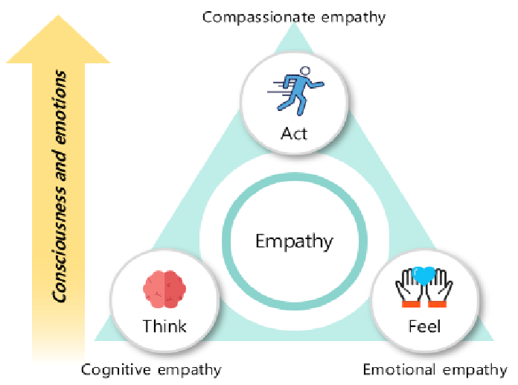
Figure: Empathy
Source: (Paudel et al., 2024)
Enhancing Food Quality and Diversity of Menus: Despite the fact that the restaurant of Novotel currently offers an acceptable level of food quality, competitive viability implies consistent improvement. Taste and authenticity may be enhanced by teaming up with local suppliers to obtain fresh and local products. The innovation of the menu ought to take into consideration various preferences on diets such as vegan, vegetarian, gluten-free, and low-calorie diets. Consistency and innovation can be ensured through a regular menu audit and a tasting session with the chefs and the guests (Ma et al., 2023). Moreover, presentation of foods is a critical factor in the perception of their customers. Therefore, chefs need to be trained in modern presentation methods that will enhance their visual appearance. A feedback loop that is specific to food items will help to identify the areas of improvement more precisely.
Improving the Golden Age of Sensations and Materials: The physical milieu of the restaurant has a great impact on the experience of the guest. Low-key lighting, modern decor, ergonomic seating, and soothing background music are but a few of the improvements that can be made in a restaurant to make it more inviting and relaxing to eat at. Sound insulation and scent branding will alleviate stress and increase comfort in the context of an airport location (Youssef and Spence, 2023). Audit of maintenance and cleanliness should be done on a periodic basis to maintain hygiene and visual appeal. Furthermore, the possibility of a seasonal thematic area decoration or live-cooking stand may help to enhance the interest and make the restaurant stand out among others.
The use of Technology in Service Innovation: Technology in the dining process can be integrated to increase convenience and efficiency of operations. Customer interactions can be made simpler by the deployment of a mobile application or other digital platform to facilitate reservations, pre-ordering and feedback. Artificially intelligent tools can use the information about guests to suggest a menu based on their previous preferences, thus providing a personal experience (Ismail et al., 2022). The immediate feedback can be collected and the service recovered through real-time satisfaction surveys that are administered by digital kiosks or mobile prompts. However, the management has to be careful that technology supplements do not replace human service, so the hospitality will not be as cold and artificial.
Ongoing Employee Training and Inspirations: Workers are the key to the service quality. Training and motivational programmes should also be introduced in order to develop communication, teamwork and problem-solving skills. Morale and retention can be improved by recognition programmes for employees, the employee of the month, feedback-based awards, career development programmes, and many more (Liu et al., 2022). Regular customer care and product knowledge refresher workshops can be used to ensure that the employees maintain a high performance standard. Promoting the culture of appreciation and service pride encourages employees to give guest success stories at every meeting.
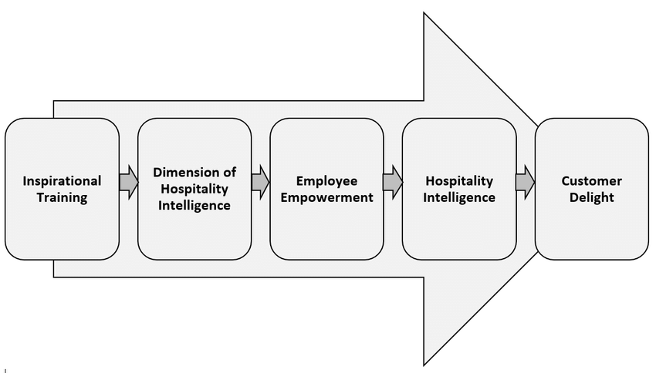
Figure: Employee Training and Inspiration Process
Source: (Ogbeide, 2021)

Reference List
Abdullah, O., Sufi, T. and Kumar, S., 2022. Service quality and its influence on customer satisfaction and customer loyalty in the restaurants of five-star hotels. African Journal of Hospitality, Tourism and Leisure, 11(6), pp.2173-2189. https://doi.org/10.46222/ajhtl.19770720.349
Abdullah, O., Sufi, T. and Kumar, S., 2023. Impact of food and beverage quality and service quality towards customer satisfaction and customer retention, A study of five-star hotels. International Journal of Professional Business Review: Int. J. Prof. Bus. Rev., 8(5), p.98. https://doi.org/10.26668/businessreview/2023.v8i5.1994
Accor, 2025. Novotel Birmingham Airport | 4 Star Hotel - ALL. [online] Available at: https://all.accor.com/hotel/1158/index.en.shtml [Accessed 16 Oct. 2025].
Adriatico, R.L., Razalan, A.M.A., Pagbilao, C.M.V., Afalla, B.T. and Dela Cruz, L.M., 2022. Service Quality and Customer Satisfaction in Dining Restaurants: Inputs for Tourism and Hospitality Curriculum Enhancement. Academic Journal of Interdisciplinary Studies, 11(3), pp.30-37. https://doi.org/10.36941/ajis-2022-0065
Ali, B.J., Gardi, B., Othman, B.J., Ahmed, S.A., Ismael, N.B., Hamza, P.A., Aziz, H.M., Sabir, B.Y., Sorguli, S. and Anwar, G., 2021. Hotel service quality: The impact of service quality on customer satisfaction in hospitality. International Journal of Engineering, Business and Management, 5(3), pp.14-28. https://dx.doi.org/10.22161/ijebm.5.3.2
Anu, B. and Manorselvi, A., 2021. Influence of service quality in restaurant and its impact on customer satisfaction. International Journal of Management (IJM), 12(3), pp.1112-1117. https://doi.org/10.34218/IJM.12.3.2021.104
Arli, D., Esch, P. van and Weaven, S. 2024. The Impact of SERVQUAL on Consumers’ Satisfaction, Loyalty, and Intention to Use Online Food Delivery Services. Journal of Promotion Management, 30(7), pp.1–30. doi:https://doi.org/10.1080/10496491.2024.2372858.
Bichler, B.F., Pikkemaat, B. and Peters, M., 2021. Exploring the role of service quality, atmosphere and food for revisits in restaurants by using a e-mystery guest approach. Journal of Hospitality and Tourism Insights, 4(3), pp.351-369. https://doi.org/10.1108/JHTI-04-2020-0048
Bucic, B., 2021, January. Aesthetic Guest Experience in Restaurant: A State-Of-The-Art Review. In International Scientific Conference EMAN–Economics and Management: How to Cope with Disrupted Times. https://doi.org/10.31410/EMAN.S.P.2021.135
Bulochova, V., Evans, E.W., Haven-Tang, C. and Redmond, E.C. 2024. Methods and measures in food service food safety research: A review of the published literature. Heliyon, 10(4), pp.e25798–e25798. doi:https://doi.org/10.1016/j.heliyon.2024.e25798.
Candra, P., Mahaputra, M.R. and Mahaputra, M.R., 2023. Service quality and customer satisfaction have an impact on increasing hotel room occupancy ratio: Literature review study. Greenation International Journal of Tourism and Management, 1(4), pp.400-412. https://doi.org/10.38035/gijtm.v1i3
Cheong, H., Lyons, A., Houghton, R. and Majumdar, A. 2023. Secondary Qualitative Research Methodology Using Online Data within the Context of Social Sciences. International Journal of Qualitative Methods, 22(1), pp.1–19. doi:https://doi.org/10.1177/16094069231180160.
Dwight, J. 2025. Restaurant Water Filtration Compliance 2025: A Comprehensive Guide for the Hospitality Industry. [online] Available at: https://sovereignwater.co.uk/restaurant-water-filtration-compliance-2025-a-comprehensive-guide-for-the-hospitality-industry/ [Accessed 27 Oct. 2025].
Ismail, T.A.T., Zahari, M.S.M., Hanafiah, M.H. and Balasubramanian, K., 2022. Customer brand personality, dining experience, and satisfaction at luxury hotel restaurants. Journal of Tourism and Services, 13(24), pp.26-42. https://doi.org/10.29036/jots.v13i24.278
Ismail, T.A.T., Zahari, M.S.M., Hanafiah, M.H. and Balasubramanian, K., 2022. Customer brand personality, dining experience, and satisfaction at luxury hotel restaurants. Journal of Tourism and Services, 13(24), pp.26-42. https://doi.org/10.29036/jots.v13i24.278
Kumolu-Johnson, B. 2025. Improving Service Quality in the Fast-Food Service Industry. Journal of Service Science and Management, 17(1). doi:https://doi.org/10.4236/jssm.2024.171002.
Liu, C.R., Wang, Y.C., Kuo, T.M., Chen, H. and Tsui, C.H., 2022. Memorable dining experiences with five senses: Conceptualization and scale development. Journal of Hospitality and Tourism Management, 53, pp.198-207. https://doi.org/10.1016/j.jhtm.2022.11.001
Ma, F., DiPietro, R.B., Li, J. and Harris, K.J., 2023. Memorable dining experiences amidst the COVID-19 pandemic. International Journal of Contemporary Hospitality Management, 35(3), pp.871-892. https://doi.org/10.1108/IJCHM-01-2022-0117
Marković, S., Dorčić, J., Rašan, D., Bucić, B. and Blažić, M., 2021, March. Aesthetic guest experience in restaurant: a state-of-the-art review. In Economics & Management: How to Cope with Disrupted Times-Selected Papers. Paper presented at 5th International Scientific Conference EMAN (pp. 135-148). https://doi.org/10.31410/EMAN.S.P.2021
Mehner, L., Rothenbusch, S. and Kauffeld, S. 2024. How to Maximize the Impact of Workplace Training: a Mixed-method Analysis of Social Support, Training Transfer and Knowledge Sharing. European Journal of Work and Organizational Psychology, 34(2), pp.1–17. doi:https://doi.org/10.1080/1359432X.2024.2319082.
Nautwima, J.P. and Asa, A.R., 2022. The impact of quality service on customer satisfaction in the banking sector amidst Covid-19 pandemic: A literature review for the state of current knowledge. International Journal of Management Science and Business Administration, 8(3), pp.31-38. https://doi.org/10.18775/ijmsba.1849-5664-5419.2014.83.1004
NQA 2025. What Standards Apply to the Hospitality Industry? | NQA. [online] www.nqa.com. Available at: https://www.nqa.com/en-gb/certification/sectors/hospitality [Accessed 27 Oct. 2025].
Ogbeide, G.C., 2021. Hospitality Intelligence: Evolution, Definition and Dimensions. Events and Tourism Review, 2(1), pp.1-20. https://doi.org/10.18060/23228
Paudel, P., Yang, H.J., Divakaran, A., Kim, S.W., Shin, J.E. and Kim, S.H., 2024. A Survey on Identifying Empathic Expression in Remote Collaboration From Empathic Computing. IEEE Access. https://ieeexplore.ieee.org/stamp/stamp.jsp?arnumber=10604808
Reed, M.S., Ferré, M., Martin-Ortega, J., Blanche, R., Lawford-Rolfe, R., Dallimer, M. and Holden, J. 2021. Evaluating Impact from research: a Methodological Framework. Research Policy, [online] 50(4). Available at: https://www.sciencedirect.com/science/article/pii/S0048733320302225 [Accessed 27 Oct. 2025].
Rusavska, V., Zavadynska, O., Honchar, L. and Holubets, I. 2025. Quality Management in Restaurant Businesses: Theoretical Bases and Modern Methodological Approaches. Socio-Cultural Management Journal, 8(1), pp.23–45. doi:https://doi.org/10.31866/2709-846x.1.2025.336355.
Sandhiya, V. and Bhuvaneswari, M. 2024. Qualitative Research Analysis. Advances in library and information science (ALIS) book series, [online] pp.295–316. doi:https://doi.org/10.4018/979-8-3693-1135-6.ch014.
Saunders, M.N.K. 2019. Research Methods for Business Students. 8th Edition, Pearson, New York. - References - Scientific Research Publishing. www.scirp.org. [online] Available at: https://www.scirp.org/reference/referencespapers?referenceid=2907709 [Accessed 27 Oct. 2025].
Shiri, R., El-Metwally, A., Sallinen, M., Pöyry, M., Härmä, M. and Toppinen-Tanner, S. 2023. The role of continuing professional training or development in maintaining current employment: A systematic review. Healthcare, 11(21), pp.1–17. doi:https://doi.org/10.3390/healthcare11212900.
Shorbaji, M.F., Alalwan, A.A. and Algharabat, R. 2025. AI-Enabled Mobile Food-Ordering Apps and Customer Experience: A Systematic Review and Future Research Agenda. Journal of Theoretical and Applied Electronic Commerce Research, 20(3), p.156. doi:https://doi.org/10.3390/jtaer20030156.
Singgalen, Y.A. 2024. Hotel Customer Satisfaction: A Comprehensive Analysis of Perceived Cleanliness, Location, Service, and Value. Journal of Business and Economics Research (JBE), 5(3). doi:https://doi.org/10.47065/jbe.v5i3.6016.
Talukder, M.B. and Kumar, S., 2025. Impact of Food Service Quality on Guest Satisfaction in Five-Star Hotels: an Exploratory Study. Sport and Tourism Central European Journal, 8(2), pp.137-161. http://dx.doi.org/10.16926/sit.2025.02.08
Talukder, M.B., Kumar, S., Sood, K. and Grima, S. 2023. Information Technology, Food Service Quality and Restaurant Revisit Intention. International Journal of Sustainable Development and Planning, 18(1), pp.295–303. doi:https://doi.org/10.18280/ijsdp.180131.
Talukder, M.B., Kumar, S., Sood, K. and Grima, S., 2023. Information technology, food service quality and restaurant revisit intention. https://doi.org/10.18280/ijsdp.180131
Tripadvisor 2024a. Excellent restaurant meal, fantastic service. [online] Available at: [online] Available at: https://www.tripadvisor.co.uk/ShowUserReviews-g186402-d191977-r936636019-Novotel_Birmingham_Airport-Birmingham_West_Midlands_England.html. [Accessed 27 Oct. 2025].
Tripadvisor 2024b. Very Poor Restaurant experience. [online] Available at: https://www.tripadvisor.ca/ShowUserReviews-g186402-d191977-r933984051-Novotel_Birmingham_Airport-Birmingham_West_Midlands_England.html [Accessed 27 Oct. 2025].
Tripadvisor 2025. All You Need to Know About the Restaurant. [online] Available at: https://www.tripadvisor.com.my/Hotel_Feature-g186402-d191977-zft9165-Novotel_Birmingham_Airport.html. [Accessed 27 Oct. 2025].
Wong, I.A., Huang, J., Lin, Z. and Jiao, H., 2022. Smart dining, smart restaurant, and smart service quality (SSQ). International Journal of Contemporary Hospitality Management, 34(6), pp.2272-2297. https://doi.org/10.1108/IJCHM-10-2021-1207
Youssef, J. and Spence, C., 2023. Gastromotive dining: Using experiential multisensory dining to engage customers. International Journal of Gastronomy and Food Science, 31, p.100686. https://doi.org/10.1016/j.ijgfs.2023.100686

