SPSS Tutorial

Part I

- Setting up the data file -

You are going to create a simple data file in SPSS and learn to manipulate the data. This procedure is step-by-step to make the process as easy as possible.
Let's assume we've completed a survey of twelve people who have completed a weight reduction program. Each person is sequentially assigned an ID number. We've asked them their height, original weight, sex, political party, weight after the weight reduction program, and eight questions from an extroversion questionnaire. First, you'll need to open SPSS from the desktop. It should look something like Figure 1 below. You've got a blank slate. It's always best to plan your data set before you just randomly plug in variables. We're going to enter the data for each person as follows:

Table 1
- ID number (id)
- sex (sex)
- height, inches (height)
- weight before the program (before)
- weight after the program (after)
- political party affiliation (party)
- eight questions about extroversion (e1 through e8)

Since SPSS is rather specific about what you name your variables (variables are limited to certain alphanumeric characters and a length of eight characters), we're going to use the names in parenthesis as our variable names.
Figure 1: 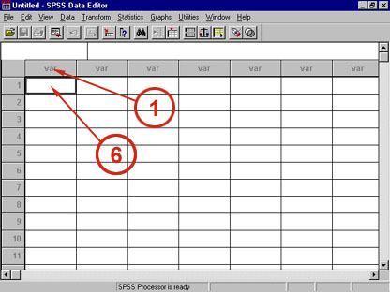

(Note: The numbers are going to coincide with the numbers in the figures so you'll know exactly where you should be as you follow this guide.)
1) Double-click on the "var" at the top of the column. A dialog box will appear like in Figure 2.
2) Change the default text in the field that the arrow is pointing to ("VAR00001") to "id", the first of our variable names.
Figure 2: 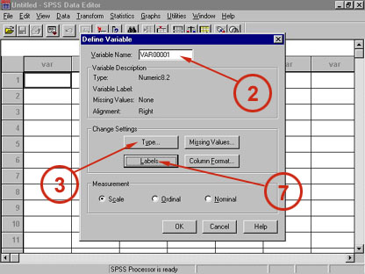
3) Click on the "Type" button. This brings up the box in Figure 3.
4) Notice that the type is "Numeric."
5) Change the "Width" to 3 and the "Decimal Places" to 0. Click on Continue for this box. Then click on the OK for the first box. You've now defined the first variable.
Figure 3: 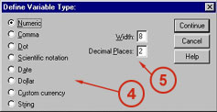
6) (See Figure 1) Click into the first white box under the "id" column. Type "1." This is the ID number of the first subject. Proceed down the column entering ID numbers from "1" to "12."
7) Double click on the top of the next column to the right of id to name it "sex." Under "Type" set the width to 1 and "Decimal Places" to 0. After you're done with that, click on the "Labels" button (see Figure 2); this will bring up a dialog box like the one in Figure 4.
8) Set the "Variable Label" to "Sex."
Figure 4: 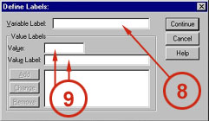
9) Under "Value" type a 1, and under "Value Label" type "Male." Click the "Add" button. Now make "Value" 2 and "Value Label" "Female." Click the "Add" button again. Click Continue. Click OK. What we just did here is use numbers to represent the values for sex.
You'll need to put in twelve values under the sex column. Use the following data: 1, 2, 1, 2, 2, 1, 2, 1, 1, 1, 2, 2.

Now, using what you've learned so far, create the remaining variables with the data given below:
- Variable Name: height
  - Type: Numeric, Width = 2, Decimal Places = 0
  - Enter these data: 76, 59, 67, 65, 63, 72, 70, 68, 69, 74, 68, 63.
- Variable Name: before
  - Type: Numeric, Width = 3, Decimal Places = 0
  - Labels: Variable Label = "Weight before"
  - Enter these data: 185, 113, 145, 156, 106, 191, 155, 165, 175, 180, 135, 118.
- Variable Name: after
  - Type: Numeric, Width = 3, Decimal Places = 0
  - Labels: Variable Label = "Weight after"
  - Enter these data: 176, 90, 140, 135, 100, 184, 130, 158, 165, 172, 120, 102.
- Variable Name: party
  - Type: Numeric, Width = 1, Decimal Places = 0
  - Labels: Variable Label = "Political party"
  - Labels: Value Labels: "1" = "Democrat", "2" = "Republican", "3" = "Other"
  - Enter these data: 2, 1, 1, 1, 1, 2, 2, 2, 1, 1, 2, 2.
- Variable Name: e1
  - Type: Numeric, Width = 2, Decimal Places = 0
  - Enter these data: 5, 6, 5, 5, 5, 5, 3, 4, 6, 5, 7, 5.
- Variable Name: e2
  - Type: Numeric, Width = 2, Decimal Places = 0
  - Enter these data: 3, 7, 5, 6, 4, 4, 6, 4, 4, 2, 5, 3.
- Variable Name: e3
  - Type: Numeric, Width = 2, Decimal Places = 0
  - Enter these data: 5, 5, 6, 4, 5, 4, 7, 6, 3, 3, 6, 5.
- Variable Name: e4
  - Type: Numeric, Width = 2, Decimal Places = 0
  - Enter these data: 4, 6, 7, 7, 6, 5, 5, 6, 5, 5, 4, 7.
- Variable Name: e5
  - Type: Numeric, Width = 2, Decimal Places = 0
  - Enter these data: 6, 5, 6, 7, 6, 3, 6, 5, 6, 7, 6, 4.
- Variable Name: e6
  - Type: Numeric, Width = 2, Decimal Places = 0
  - Enter these data: 4, 6, 4, 6, 5, 2, 4, 5, 5, 7, 5, 6.
- Variable Name: e7
  - Type: Numeric, Width = 2, Decimal Places = 0
  - Enter these data: 3, 7, 3, 5, 4, 6, 3, 2, 3, 4, 3, 3.
- Variable Name: e8
  - Type: Numeric, Width = 2, Decimal Places = 0
  - Enter these data: 3, 6, 3, 5, 5, 1, 3, 3, 2, 3, 5, 2.
Your file should look like Figure 5. You can save your file under the pulldown menu File: Save.
Figure 5: 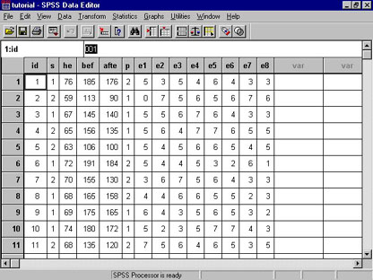

SPSS Tutorial

Part II

- Performing a statistical analysis -

This part of the beginner's guide to SPSS will walk you through performing a simple correlational test on the data file created in the first part.
“Correlation is a statistical measurement of the relationship between two variables. Possible correlations range from +1 to –1. A zero correlation indicates that there is no relationship between the variables. A correlation of –1 indicates a perfect negative correlation, meaning that as one variable goes up, the other goes down. A correlation of +1 indicates a perfect positive correlation, meaning that both variables move in the same direction together [1].”
Pearson’s Correlation Coefficient [2]

Definition: Measures the strength of the linear relationship between two variables.
Assumptions: Both variables (often called X and Y) are interval/ratio and approximately normally distributed, and their joint distribution is bivariate normal.
Characteristics: Pearson's Correlation Coefficient is usually signified by r (rho), and can take on the values from -1.0 to 1.0. Where -1.0 is a perfect negative (inverse) correlation, 0.0 is no correlation, and 1.0 is a perfect positive correlation.
Related statistics: R² (called the coefficient of determination or r squared) can be interpreted as the proportion of variance in Y that is contained in X.
Tests: The statistical significance of r is tested using a t-test. The hypotheses for this test are:
H₀: rho = 0
H_{a}: rho <> 0
The Pearson's Product Moment Correlation Coefficient tells us how well two sets of continuous data correlate to each other. The value can fall between 0.00 (no correlation) and 1.00 (perfect correlation). A p value tells us if the Pearson's is significant or not. Generally p values under 0.05 are considered significant.
Have open the data file you created in Part I.
Figure 1: 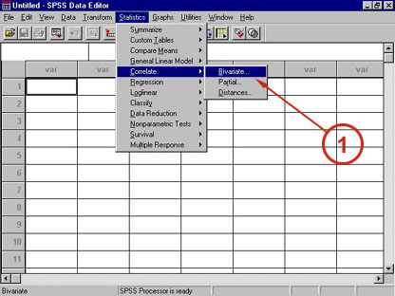
1) Select the option under Statistics: Correlate: Bivariate. This will bring up a menu like the one in Figure 2.
Figure 2: 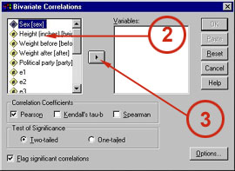
2) Highlight "Weight before" by clicking on it once.
3) Transfer the variable to the box on the right by clicking once on the arrow button. Repeat this procedure for the "Height (inches)" variable. Now click on OK.
SPSS is going to generate some correlational data now. It should appear as in Figure 3.
Figure 3: 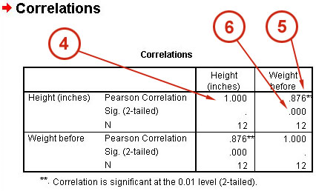
Now let's interpret these dreams, Daniel . . . .
4) In general you'll notice that both height and weight are set up in a matrix so that their columns intersect. Where height and height intersect obviously there is going to be a perfect correlation (1.00). Of course this is unimportant (as well as painfully obvious), so there is no p value given.
5) Now for the data that actually makes sense, note the values that occur in the intersections of the height and weight columns/rows. The Pearson's value is the .876, and the significance is the .000 (which doesn't mean that it is zero, only that it is lower than .001). The asterisks (**) indicate significant values.
From this we can say that there is a significant correlation between height and weight. Makes sense, right?

From following this walk-though guide you hopefully have a feel for SPSS and will be able to use it for some of the more difficult analyses.

References
[1] K. Cherry. (2011, 29th April 2011). Definition of Correlation. Available: <http://psychology.about.com/od/cindex/g/def_correlation.htm>

[2] Winkpear. (2011, April 29th 2011). Definition of Pearson's Correlation Coefficient. Available: <http://www.texasoft.com/winkpear.html>

