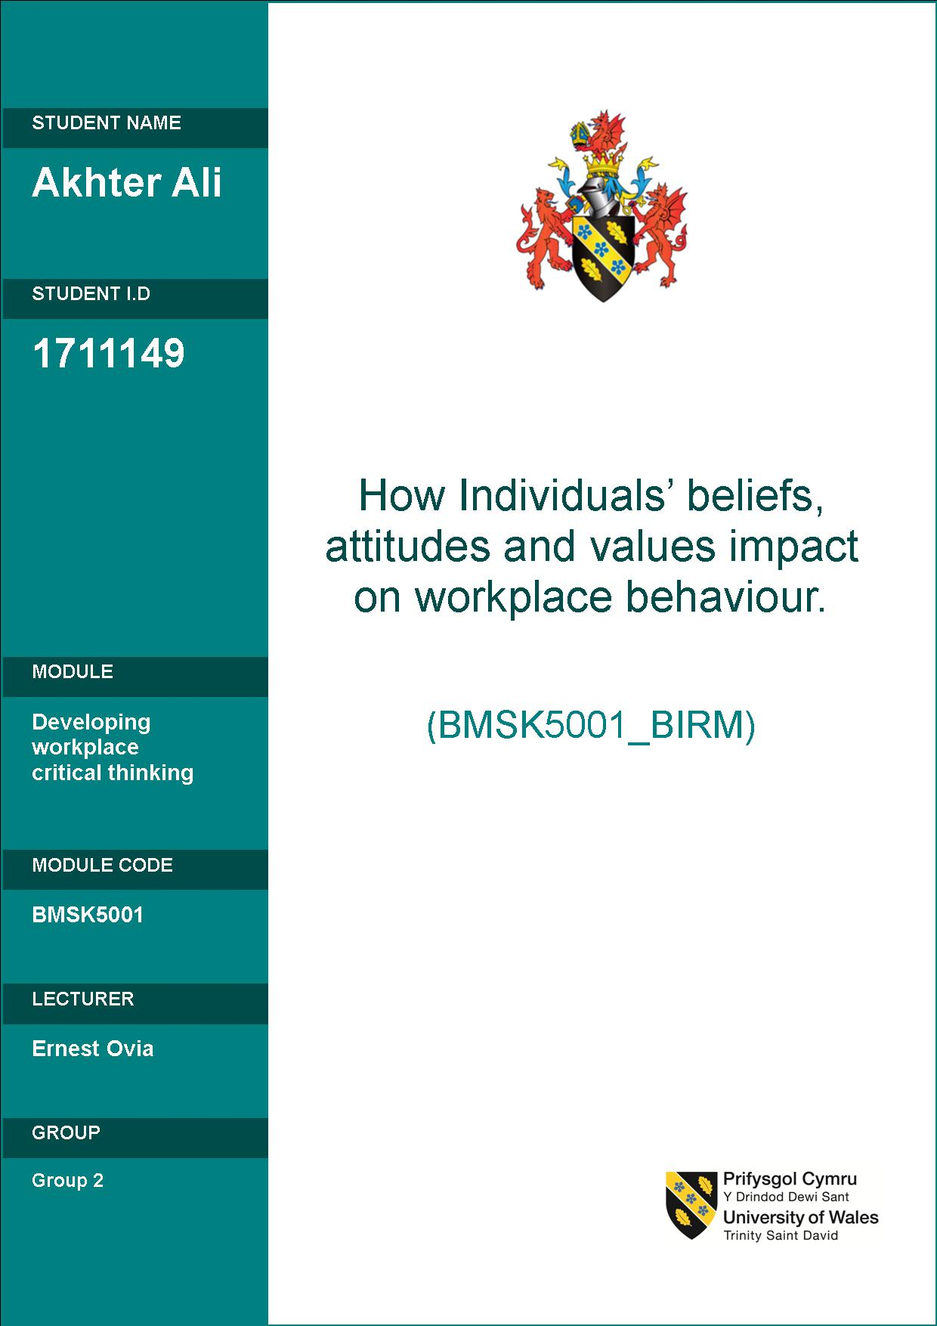

Table of Contents

Abstract 3
What is Critical Thinking? 3
What are Beliefs, Values, and Attitudes? 5
Importance of ‘Employee Values’ in the workplace 7
Acting: 8
Thinking: 9
Feelings: 9
Importance of ‘Organisational Values’ in the workplace 10
The community 11
The organization 11
The business unit 11
The individual/employee 12
Management Theories 12
Principles of Frederick. W. Taylor’s Scientific Management Theory 12
Principles of Max Webbers Bureaucratic Management Approach 14
Principles of Henri Fayol – administrative theory 14
Impact of personal values in the work environment 16

Abstract
This formal report will be conducted in two parts to explore and critically analyze the impact of beliefs, attitudes, and values on workplace behaviour.
Part one will look at the basic definitions of these subjects and explore their uses and benefits, as well as the explore the evolution process connecting them together. Impacts of these resulting attitudes on the workplace will then be critically analyzed using information from reliable sources to support the premises. The report will focus on both, the employee's beliefs, attitudes, and values as well as the Values championed by the Employer.
Part two of the report will focus on an identified Management Theory and its relationship to a modern workplace. This part of the report will explore the theory in more detail, evaluate its relevance and critically asses its impact on the employee’s beliefs, values, and resulting attitudes.

What is Critical Thinking?
Critical thinking has been defined by many prominent academics in different ways.
According to McPeck it is “the propensity and skill to engage in an activity with reflective skepticism” (McPeck, 1981, p. 8); in the view of Ennis it is “ reflective and reasonable thinking that is focused on deciding what to believe or do” (Ennis, 1985, p. 45);
Lipman describes Critical thinking as “Skillful, responsible thinking that facilitates good judgment because it (1) relies upon criteria, (2) is self-correcting, and (3) is sensitive to context” (Lipman, 1988, p. 39), and Bailin et al, defines it as a goal-directed and purposive “thinking aimed at forming a judgment,” where the thinking itself meets standards of adequacy and accuracy (Bailin et al., 1999b, p. 287);
According to Lewis & Smith (1993), the roots of critical thinking stem from two primary academic principles: philosophy and psychology. The philosophical approach focuses on the actual thinking process enumerating the qualities of ‘good thoughts’ and characteristics of individuals rather than the behavioural or action-orientated aspect. This type of thinking focuses on the capabilities of people under certain circumstances.
The Psychological aspect of critical thinking is concerned with the cognitive elements of thinking and are focussed on how people actually think versus how they could or should think under ideal conditions (Sternberg, 1986). Cognitive psychological thinking tends to define critical thinking by the types of actions or behaviours critical thinkers can do. This often includes a list of skills or procedures performed by critical thinkers.
One of the key contributors to theory related to critical thinking is from the educational practitioner Benjamin Bloom (Bloom, 1956). In the field of teaching and assessing higher-order thinking skills, Blooms Taxonomy for information processing is one of the most widely used sources.

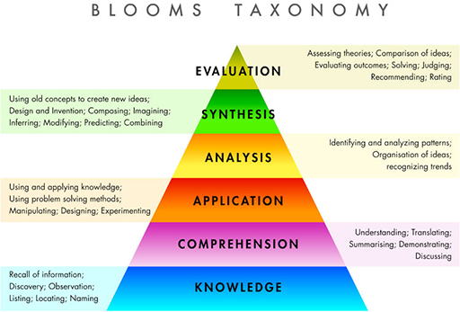

According to Kenedy et al (1991) the three highest levels represent critical thinking. The original Taxonomy devised by bloom (illustrated in figure 2) was revised in 2001 by Lorin Anderson and David Krathwohl. The revised version replaced ‘Synthesis’ and added ‘Creation’ and implied that it was the most demanding and complex cognitive skill and a pinnacle of the thinking process (KRATHWOHL and ANDERSON, 2010)

What are Beliefs, Values, and Attitudes?
Values and beliefs are hard to define. Moore (1922) admits to the difficulties of defining values and compares it to describing the color ‘green’, Frondizi (1971) agrees with Moore and states the reason for the ‘indefinability’ is due to the complexities of varying values.
Hence values and beliefs have been defined by different researchers/authors and practitioners from a different perspective such as Psychology, Theology, and Management (Mashlah 2015).
According to Meglino and Ravlin (1998), Values occupy a prominent position in scientific and public discourse on quite a few different levels.
The Cambridge Dictionary (Woodford & Jackson, 2003) defines values as: “The beliefs people have about what is right and wrong and what is most important in life, which control their behavior”. According to this definition peoples thoughts, ideology, morality, and perspective is linked to their values and directly impacts/influences their behavior.
According to Anderson & De Silva (2009) ‘belief’ is an internal feeling that something is true, even though that belief may be unproven or irrational. e.g. I believe that walking on cracked pavement stones brings bad luck, or I believe that there is life after death. Although these things might not seem logical to some people to others they might seem very true and important.
A value is defined by Anderson & De Silva (2009) is a measure of the worth or importance a person attaches to something; our values are often reflected in the way we live our lives e.g. I value freedom of speech, or I value my family, morals (Anderson & De Silva, 2009).
Values can consist of a person’s past experience, beliefs, ethics, morals and virtues and anything he or she considers important. It can be the foundation block for their overall attitudes. Values play a very important role in people’s perceptions, preferences, decision making and overall behavior in both personal and workplace environments (Mashlah 2015).

In order to understand peoples values, one has to understand peoples beliefs, how they perceive their personal values and why they hold those values dear. Only then can you understand how their personal values might influence the way they think to feel and act (Meglino and Ravlin 1998).
Understanding individual personal values can increase a person’s self-awareness and help them to develop their overall attitude to ‘learn’ and ‘know’, which can be applied to the workplace.
Shared values can form the basis of strong friendships and relationships in personal life and good working camaraderie, it can motivate us in the sense that we will actively pursue something that we believe in. knowing
- Shared Values are the basis of relationship
- Values can motivate us –if we value something we will go after it.
- Knowing our own values makes us more tolerant of others
- They help to give lives meaningful significance

Importance of ‘Employee Values’ in the workplace
Peoples personal beliefs and values are an essential part of their thinking and acting process, hence the way they behave or the way their attitudes are displayed is a direct result of their overall beliefs and values (Schwartz, 1992; Bourne & Jenkins, 2013). Schwartz states that the first thing that drew him to the study of values was the question “Do values make a difference? Do values affect what people do, what they believe, what and whom they like? “(Schwartz, 2011, p.309).
There have been many social scientists who have conducted research and experiments into the relationship between Beliefs, values and attitudes and their effect on the workplace such as Kluckhohn (1951), Meglino & Ravlin, (1998). Some of these experiments and research have shed some light on attitudes, behaviors, emotions, policies, and experiences in the workplace. Kluckhohn (1951) states that activities in the workplace which are not aligned to an individual's beliefs and values will be mostly avoided by the individual and should they still somehow engage in that activity they may feel shame, guilt or self-depreciation. They certainly would not be motivated to do something that was against their beliefs and values.

People’s perception of things is what dictates the importance and value they attach to it, and their social standards and feelings are also an extension of their value and belief system. y Hemingway (2005, p.13) highlights value and belief as an “ integral facet of human decision-making”.

Taking into consideration Hemingway’s view it would seem that every decision made at the workplace would in some way be influenced by the decision-makers personal beliefs and values and not just on the basis of the problems/decisions own merit. In organizations where there is an assortment of people from all walks of life with different beliefs and values, it is important to take into consideration the individual attitudes that can result from every individual. Baker (1999. P.11) argues that personal beliefs and values people hold direct their intrinsic behavior and can alter their feelings, behavior, and actions.
Amongst beliefs and values, there are some that are more dominant than others and they are different for different people. One person may values ‘integrity above duty’ whilst another may value ‘duty above integrity’ and later on these same people could re-evaluate the importance of the two values and re-prioritize them. It would be difficult for a person who has strong morals, integrity and believes in telling the truth to work in an advertising career or marketing organization where twisting the truth to get a sale or contract is quite common; on the other hand, such an individual would be ideal as a teacher or journalist. A person who values loyalty, determination and financial security above honesty and integrity may have less compulsion against lying or misinforming to get a job done. These types of people would be ideally suited in careers such as politics or marketing.
Specific values and beliefs tend to build specific attitudes, and general values and beliefs can result in general behaviors, for example, if an employee was asked about their job satisfaction and they honestly responded with a positive reply, this could indicate the person's motivation and contribution to the organization.
Attitudes in the workplace are an important consideration since they affect the job. If for example, an employee believed their superiors were conspiring to increase their workload, or that fellow employees/colleagues were trying to undermine their efforts; it is very likely that this person would become de-motivated, anxious and start feeling negative about the whole work environment. These feelings would manifest in their negative attitude and the employees overall production would be negatively affected.
Sameer Mashla (Mashla, 2015) published a paper called ‘THE ROLE OF PEOPLE’S PERSONAL VALUES IN THE WORKPLACE’ based on a study conducted at the Anglia Ruskin University. The study was a qualitative exploratory research attempt to understand the role of individuals values in the workplace.
A number of test participants were asked to explain where their personal core values were derived from, define those values and explain how those values influenced or affected the way they did their work. The study was undertaken to explore three phases of personal values- Acting, Feeling and Thinking.

Acting:
The study discovered that there was a direct link between personal values and attitudes. The data revealed that behavior and other characteristics were a result of practicing personal beliefs and values: for example, a person won’t be considered honest unless he practices honesty as a value, and a person will not be considered moral unless he practices and holds to high moral standards. In either case, the person's beliefs and values will be reflected in their attitudes and actions.

Thinking:
When asked, the participants agreed that their thinking process was partly influenced by their beliefs and personal values and their everyday preferences, choices, decisions, judgment, relationships and even their perception, outlook and direction to life was influenced by their beliefs and values. Participants used clear words and phrases to express their thoughts, which was a reflection of how they conceptualize their own personal value

Feelings:
Participants were asked about their past experiences in their personal life as well as their workplace and if those experiences affect their work at present. Based on their answers it was established that that personal values played a major role in their work environment and that these values were considered by most participants as the source of their spirituality, energy and the driving factor that satisfied their spiritual needs.
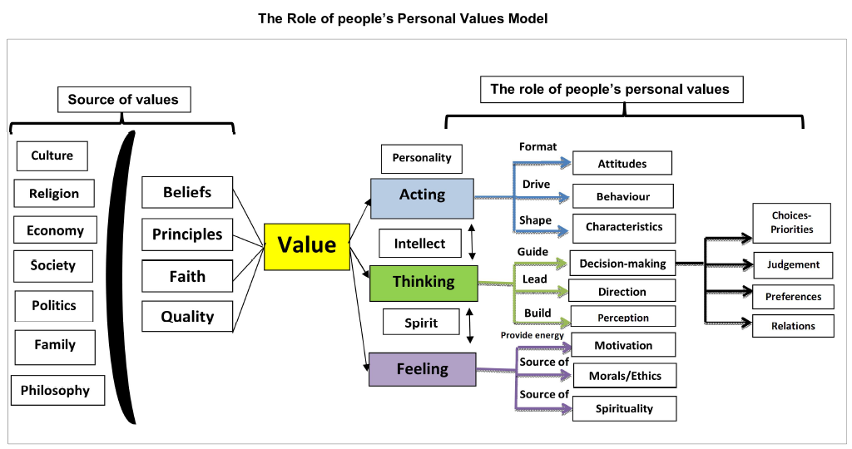

The findings of the report revealed peoples personal values and their implication in the workplace but also highlighted some discrepancies between what they perceived as their personal values and their actual roles. Most participants described their aspirations and values as idealistic, ethical, virtuous and moralistic yet it was not clear as to whether the participants themselves become more ethical, virtuous and moral as a result of holding to those views.
Participants of the study also stated that their values and beliefs were most influencing when they were in the presence of people who were either most aligned to those values or held to values very different from their own. The experiment clearly showed that people would often get deterred from doing something that was against their values and beliefs and were more motivated to do things if those tasks were aligned to their own beliefs and values.

Importance of ‘Organisational Values’ in the workplace
The collective approach of an organizations beliefs, values, mission, vision, and direction are known as ‘Organisational Culture’ or just ‘Culture’
Organizations today are constantly evolving to address the needs of their changing environment and no longer work on anyone philosophy; They have become almost living entities which tap into different networks of knowledge and focus on various sectors. Today’s Organisations are quick to adapt to social and political changes and invest more in their Human resource departments than the organizations of past generations. Employees are considered a major asset and vital component to the growth and development of an organization. Gone are the days of Taylorism (1911) when employees were considered a tool in the mechanics of an organization. Organizations now realize that by employing the right people in their organization and by providing for their needs, their chance of long term success is much greater.
Organizations now spend a considerable amount of finance and resources on finding the most suitable candidates for particular jobs and spend a reasonable amount of training and so that the employee will be able to carry out their job satisfactorily. Once the organization has attracted and employed the candidate it is also necessary to provide for the employees' needs in order to get the best results from them. and this is where a companies culture comes into play. When looking at the organizational culture it is important to take into consideration how the values are spread across all levels of the organization. Organizational culture sets the framework of how everyone in the organization should act and behave. Organizations try to create an environment where people of different backgrounds, beliefs, values, and personalities can work together to achieve the goals of the organization.
If the company has a culture with values and beliefs aligned to the employees' values and beliefs then the employee can be counted on to give full effort on
In order for organizations to understand the employee and utilize the employees full potential the following four aspects should be looked at:
- The community
- The organization
- The business unit
- The individual/employee

The community
Values which work in one business environment might not work in another: for instance, people in the USA may have different values to people in China due to the difference in cultural beliefs and values of the geographical locations.
The leadership in organizations need to take into account local community beliefs and values when formulating their organizational culture.

The organization
Organizations have to create cultures that suit their needs and end goals and entails their principles, beliefs, and values. Some companies are very service orientated such as Apple PLC, where apple employees have been known to replace or repair products for their customers even after the service warranty has expired (Gallo, 2012c), other companies are more innovation orientated such as Google LLC, which allows their employees 20% free time from their total working hours to work on anything they fancy using company resources. Google state that the majority of their innovations are made within this 20% time framework and is the strategy that created AdSense, Gmail, Google Maps, Google News, Google Talk, etc (Inc.com, 2019). Every organization should tailor their culture to their needs.

The business unit
Most big organizations have smaller departments that deal with specific areas of the business: for Google LLC it could be any of the projects such as Gmail, Google maps, Product development, etc, for Apple PLC it could be software development or new technology; the point is each such business unit will eventually develop its own brand of company culture often referred to as ‘subculture’. These subcultures consist of systems and beliefs which are suited to that department or business unit and may not be suitable for other business units within the same organizations. Having an understanding of these subcultures are also important considerations for organizational leadership.

The individual/employee
The leadership of each business unit is partly responsible for nurturing guiding and shaping the attitude of employees within the workplace. Employees come to the organization from all walks of life with different attitudes that have been built on varying beliefs and values. Good leadership can find common grounds on every employee's beliefs and values and help to align them with the culture of the organization. This task can be hugely simplified at the recruitment level where the organization should seek to employ people who fit the profile of their organizational needs, and further developed with training as needed.

Management Theories
Management theories are structured formula’s and applications that can be used as a reference manual for leadership motivation and change. They can be applied to real-life situations and can help in the identification, evaluation and solving of problems.
There are quite a few Major Schools of Management Thoughts that are studied by academics and business leaders alike. Amongst the most prominent are the Classical management theories which consist of:
- Frederick. W. Taylor’s Scientific management school (1911)
- Max Weber’s Bureaucratic Theory (1947)
- Henri Fayol’s Administrative Theory (Fayol, 1949)

Principles of Frederick. W. Taylor’s Scientific Management Theory
In its most simplistic terms, Taylor’s theory advocated systematic training of workers in “the one best practice” and advocated against allowing them to use their own discretion.
He believed that Workload should be shared evenly between management and the workforce with each performing specif tasks that were suited to them. The important tasks such as the instructing and decision making would be undertaken by the management whilst the repetitive labor work would be done by the workforce. The key components of Taylor’s theory were to:
- Develop a ‘system to replace old guesswork methods: and a pay system that would reflect the amount of work done by an employee.
- Workers to be ‘scientifically’ selected on the ability to carry out jobs faster and more effectively. Moreso to be trained to be proficient at a specific task.
- The ‘science of work’ to be brought together with scientifically selected and trained people to achieve the best results.
- Responsibility and jobs to be equally divided between management and workforce who would be interdependent on each other.
Whilst this theory found a lot of popularity due to the booming manufacturing industry at the time, it almost dehumanized the workers. Taylor went as far as introducing a system of stop-watch time trials which measured the employees' speed of work in order to increase productivity. Application of the Scientific Method to work would include the following process:
- Train the workers
- Selection of the most capable workers
- Provide resources to workers
- Provide fair pay incentives to workers (share productivity gains)
Taylor believed that the job of a manager was to plan and control work and that there was a single most efficient way to do any job.
He used time and motion techniques to break down work processes and eliminate unnecessary actions and laid the foundation for division of labor and mass production – later applied by Henry Ford
Taylor Argued for carefully selecting and training staff and to provide additional opportunities for those that showed potential; outstanding workers had a chalk mark put on their bench which later became the origins of benchmarking?
Taylors theory has often been criticized for its mechanical approach to employees (Rose, 1975) and attacked for its failure to take into consideration the employees perspective or social and psychological factors.

Principles of Max Webbers Bureaucratic Management Approach
- Chain of command: in order for decisions and information to flow effectively from top to bottom, Organizational hierarchy should be constructed with a clear chain of command.
- Division of labor: There should be a balance between responsibilities and power and Division of labor specialization should be fixed.
- Selection and Promotion Based on Qualifications: The workers should be selected and promotion should be given based on criteria such as experience, age, etc and not because of personal relationships or other benefits.
- Formalized rules: The organization should run on a set of rules that are clear and followed by everyone.
- Separation of personal and official property: Owners and organization’s assets are separate and can to be treated as same by the owner or the organization.
Webbers Bureaucratic Management model has seen opposition from several sides. Many have pointed out that the formal organizational structure Webber emphasizes is far different from the real-life informal characteristics of organizations and that this kind of formalized rule-bound behavior can have negative impacts such as goal displacements. It has been pointed out by Parson (1960) that conflict can also arise between a technicals expertise and bureaucrat's authority derived from position in the hierarchy. Gouldner (1959) argues that the values that individuals bring with them would eventually impinge upon the bureaucracy.

Principles of Henri Fayol – administrative theory
Fayol believed that management had five principle roles:
- To forecast and plan - anticipating the future
- To organize - the development of the institution’s resources,
- To command - keeping the institution’s actions and processes running
- To co-ordinate - the alignment and harmonization of the group’s efforts
- To control - activities performed in accordance with appropriate rules and procedures
Fayol’s administration theory has also had its own share of criticism. According to Herbert Simon (1946), the principles of Foyols theory are ambiguous and unclear and contain terms which are poorly defined. Simon even argues that the theory isn’t even scientific since it was not the result of empirical research.
The extended form of classical theories of management is known as the Neo-classical approach and expand and broaden the original classical theories by adding a human factor to the science of management in organizations management (Sarker et al. 2013). The Neo-classical approach is an evolution which is not limited by the boundaries of the classical theories, and advocates relationships between operators, researchers, and supervisors (Hersey and Blanchard 1997).
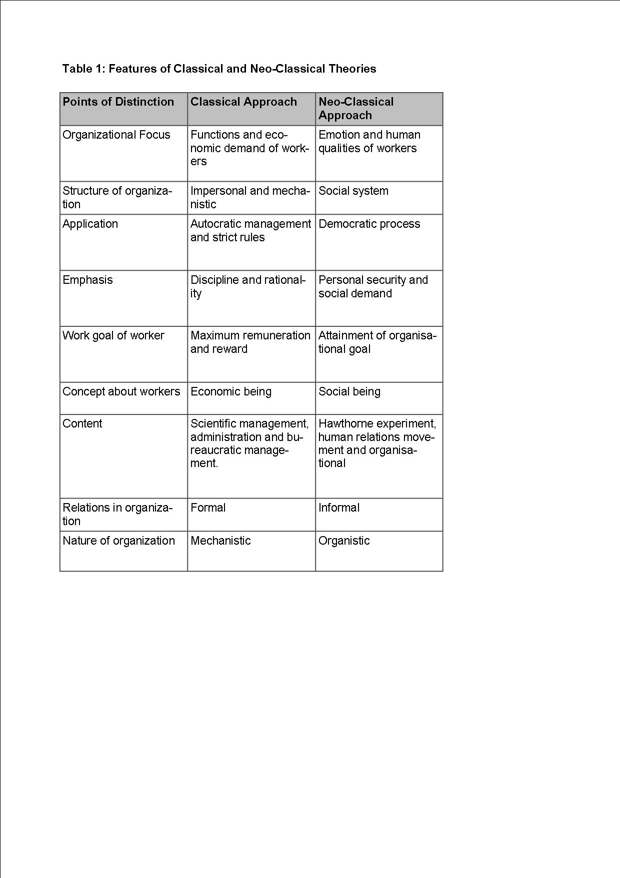

Impact of personal values in the work environment
Having looked at the definition and uses of Beliefs, Values, and Attitude, it becomes necessary to examine their impact on the workplace. Our beliefs and values have developed through a myriad of experiences ranging from family experiences, relationship with friends and community, things we've read and heard about and hundreds of other influencing factors. All have contributed to our outlook on life and the world.
As individuals, we should examine our own values and consider their application or impact in the workplace. How dominant our own values compared to the values of people and the society around us? Often what is considered a dominant value amongst one group of people may not be considered the same in another.

To understand our own values we should explore our views on as many areas of belief and values as possible and be willing to explore and reflect upon our own values. This kind of self-reflection can provide an insight into our attitudes and its impact in the workplace.

We should reflect on our actions in the workplace because reflections can help us understand the values of people around us and better prepare us for the work environment. It is important to understand that everyone has a right to fair treatment and equal opportunity and professional and courteous service, regardless of their personal beliefs and values.

Often there exists amongst groups, societies or individuals pre-existing beliefs related to stereotypes that have developed around a number of issues like sexuality, alcohol and drugs and many others. These stereotypes could affect the way people interact and work with their peers and clients. We should be aware of the existence of such pre-existing beliefs and ensure that they do not interfere in our ability to carry out our duties.
Sometimes our pre-existing beliefs and values can make us blind to the values and opinions of others. we should understand that because we have all had different sets of beliefs and values we will not think about the same issues in the same way.
In order to remain professional in the workplace, we should make allowances for others to express their views and opinions and make decisions based on their own values and beliefs as long as those decisions further the objective of the organization.
One of the major problems people experience with attitude is that we often ignore information which is not aligned with our values and beliefs-we become selective when in perceiving or responding to issues and events and lose sight of the primary objective. By reflecting on these matters and developing an understanding of our own attitude, we can minimize the risk of making work-related decisions based on our unconscious pre-existing perceptions; thus allowing us to perform our work more professionally.

Reference List

Baker, M., 1999. Work, work values, and religious values: How Christian clinical psychologists experience the connections. Ph.D. Yorkshire: University of Hull.

Bloom, B. S. (1956). "Taxonomy of Educational Objectives, Handbook I: The Cognitive Domain." New York: David McKay Co Inc.

Ennis, R. H. (1985). Critical Thinking and the Curriculum. National Forum: Phi Kappa Phi Journal, 65(1), 28-31

Fayol, Henri.1949. General and Industrial Management. (Translated by C. Storrs),

Gallo, C. (2012b, August 30). Apple’s Secret Employee Training Manual Reinvents Customer Service in Seven Ways. Forbes.com. Retrieved from http://www.forbes.com/sites/carminegallo/2012/08/30/apples-secret-employee-training-manual-reinvents-customer-service-in-seven-ways/

Gouldner, A. W. (1959). "Organizational Analysis." in Sociology Today. edited by R. K. Merton, L. Broom, and L. S. J. Cottrell. New York: Basic Books, 400-428.

Hemingway, C.A., 2005. The role of personal values incorporate social entrepreneurship. Research Paper Series: No. 31–2005. International Centre for Corporate Social Responsibility. Nottingham. 2005. Nottingham University Business School: University of Nottingham.

Inc.com. (2019). How Google's 20 Percent Rule Can Make You More Productive and Energetic. [online] Available at: https://www.inc.com/bryan-adams/12-ways-to-encourage-more-free-thinking-and-innovation-into-any-business.html [Accessed 1 Aug. 2019].

Kennedy, M., Fisher, M. B., & Ennis, R. H. (1991). Critical thinking: Literature review and needed research. In L. Idol & B.F. Jones (Eds.), Educational values and cognitive instruction: Implications for reform. Hillsdale, New Jersey: Lawrence Erlbaum & Associates.

Kluckhohn, C., 1951. Values and Value-Orientations in theTheory of Action. In T. Parsons and E. Shils .eds. Toward a General Theory of Action. Cambridge: Harvard UniversityPress.

Lewis, A., & Smith, D. (1993). Defining Higher Order Thinking. Theory into Practice, 32, 131-137.

Lipman, M. (1988). Critical thinking - what can it be? Educational Leadership, 46(1), 38-43.

Lorin W Anderson; David R Krathwohl, (2010). Merlin C. Wittrock and the Revision of Bloom's Taxonomy. Educational Psychologist, 45(1), pp.64-65.

Mashlah, Samer. (2015). THE ROLE OF PEOPLE’S PERSONAL VALUES IN THE WORKPLACE. International Journal of Management and Applied Science. 1. 158-164.

McPeck, J. E. (1981). Critical thinking and education. New York: St. Martin’s.

Meglino, B.M., and Ravlin, E.C. 1998. Individual Values in Organizations: Concepts, Controversies, and Research.Journal of Management.

Parsons, T. 1960. Structure and Process in Modern Societies. Illinois: Free Press.

Schwartz, S. H. 1992. Universals in the content and structure of values: Theoretical advances and empirical tests in 20 countries. In M. P. Zanna (Ed.), Advances in experimental social psychology. Vol. 25 (pp. 1–65).London: Academic Press.
Schwartz, S. H., and Bilsky, W., 1987. Toward a universal psychological structure of human values. Journal of Personality and Social Psychology, (53), pp.550-562.[40].

Sharon Bailin, Roland Case, Jerrold R. Coombs & Leroi B. Daniels, Volume 31, 1999 - Issue 3

Simon, Herbert. A. 1946. The Proverbs of administration. Public Administration Review, 6 (1), 53-67.

Sternberg, Robert J. Critical Thinking: It’s Mature, Measurement, and Improvement. National Inst. of Education (ED), Washington, DC. [1986]

Taylor, Frederick W. 1911. The Principles of Scientific Management. New York: Harper Bros., 5-29

Weber, M. 1947. The Theory of Social and Economic Organisation. London: Oxford University Press.

