University of Wales Trinity Saint David


Title: Assessment component - Individual report
Assignment Title: Report
Student Name: Zahraa Araf
Student ID: 2211190
Module: Strategic Management
Module Code: LCMB7003
Name of Lecturer: Amare Desta
Zulf Khan
Internal verifier: Vasilios Tavlaridis
Hoang Nguyen
Date: 26 March 2026
Word count: 5053
Contents
Section-1 1
1. Organizational Context and Overview 1
1.1 Organizational perspectives 1
1.2 Industry and Competitive perspectives 1
2. External and Internal Environment Analysis 2
2.1 External Environment Analysis (PESTEL) of Tesco PLC External Environment 2
2.2 Critical Success Factors and Strategic Challenges 3
2.3 Strategic Challenges 4
2.4 Analysis of Tesco PLC Internal Environment 4
Key Resources 4
Capabilities 5
Core Competencies 5
2.5 VRIO Framework Analysis 6
2.6 Contribution of Internal Strengths to Competitive Advantage 6
3. CSR and Sustainability Objectives 7
4. Comprehensive and Holistic View of the Organization: The Balanced Scorecard 7
5. Strategic Choices and Implementation 9
5.1 Evaluation and Recommendation of Strategic Choices 9
5.2 Critical Assessment of Change Management and Strategic Implementation 10
6. Strategic Evaluation and Recommendations 12
6.1 Critical Evaluation of Current Strategy 12
6.2 Recommendations to sustain competitive advantage 12
Section-2 13
7. Reflective Account: Researching and Analyzing Tesco PLC Strategic Environment 13
References 16
Appendixes 19
Appendix-I 19
Appendix-II 19
Appendix-III 20


Strategic Management Practices

BP PLC



Section-1

1. Organizational Context and Overview

1.1 Organizational perspectives
BP PLC (BP) is an energy company operating at the international level, the history of which can be traced back to the Anglo-Persian Oil Company in 1909, the legacy of which the company scores in its historical record-refer to Appendix-I our History (BP Plc, 2026). Through its history, BP has become one of the most successful integrated oil and gas majors world-over, through the various number of geopolitics and industry changes. In current times, it is stated as providing the world with energy, today and tomorrow and it is a strategic balancing measure between its conventional hydrocarbon business and its energy transition ambitions (BP Plc, Our purpose). The vision of the company is reflected implicitly in the company strategy to become an International Oil Company (IOC) to an Integrated Energy Company-refer to Appendix-II- Our strategy at work (BP Plc, 2026). Its business model is aligned to three primary business groups, which are Gas & Low Carbon Energy, Production and operations and Customers and Products that are built on this strategy to achieve long term shareholder value-Refer to Appendix-III our organization (BP Plc, 2026).

1.2 Industry and Competitive perspectives
BP is in a highly competitive and unstable oil and gas industry in the world. Although the company has developed a strong position in the market, it indicates the internal forces that dominate the industry at the moment. BP had a market capitalisation of 91.0 billion as of September 2025, which makes it the 8th largest in the world of the largest integrated oil and gas companies, ranking behind other competitors, including Exxon Mobil (480.7bn), Shell (209.0bn), and TotalEnergies (131.7bn) refer to Appendix-IV Oil and Gas Report (BDO, 2026, p. 6). This ranking is an indication of a stiff contest over investor trust and capital. The other global majors, especially Shell and TotalEnergies, and major national oil companies in the world such as Saudi Aramco are the major competitors of BP. BP also plays an important role in the UK North Sea, although there is a threat of competition with a generation of consolidating independent producers. New joint ventures such as Adura (Shell/Equinor) and Neo Next + (TotalEnergies/NEO/Repsol) are transforming the competition into bigger, more flexible operators, which are cost efficient and can maximise the value of the mature assets- refer Appendix-IV Oil and Gas Report (BDO, 2026, p. 10; Mordor Intelligence, 2026). The market dynamics of 2025 are also difficult to the position of BP. The company registered a revenue of 144.8 billion Q1-Q3 2025, which is down by 1.2 percent relative to the period in 2024, a situation evident in most European majors since average prices of oil, natural gas and refined products are lower-refer to Appendix-IV Oil and Gas Report (BDO, 2026, p. 6-7). It is a pressure on the budget that is compelling BP and its competitors to impose strict cost discipline, with BP intending to keep capital spending between 14.5 and 13-15 billion, respectively in 2025 and 2026-2027-refer to Appendix-IV Oil and Gas Report (BDO, 2026, p. 11). This is a conservative CapEx policy that is a reaction to the unstable world environment and emphasises shareholder returns.
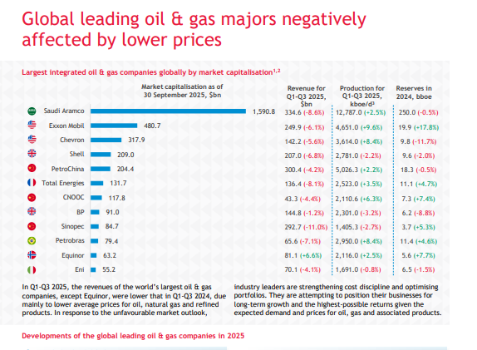
Figure 1 Global Leading Oil and Gas firms-Industry analysis

2. External and Internal Environment Analysis

2.1 External Environment Analysis (PESTEL) of Tesco PLC External Environment
Political Factors: Geopolitical instability has been the political factor that has most affected BP. The invasion of Ukraine by Russia has continued to transform the global energy flows with Russian crude exports dropping to 4.3 mb/d in 2025 as flows shifted to Asia-refer to Appendix-IV Oil and Gas Report (BDO, 2026, p. 15). This diversion has resulted in operational risks; in June 2025, the situation around Israel and Iran worsened causing oil prices to increase, which raised the share price of BP temporarily and created shipping risks in the Strait of Hormuz- Appendix-IV Oil and Gas Report (BDO, 2026, p. 16; BP Plc, Annual Report 2025, p. 62). Political instability as a deterrent to investment was highlighted by the US arrest of the President of Venezuela in January 2026 (BDO, 2026, p. 4) and now the greatest instability resulted due to the US-Israil war on Iran. Fiscal policy is essential in the UK. Inafter windfall taxes, the government unveiled a permanent Oil and Gas Price Mechanism starting in 2030, which will levy a 35% surcharge only under the condition of higher prices that exceed 90/tbbl, but the headline rate goes back to 40% - Appendix-IV Oil and Gas Report (BDO, 2026, p. 13; NSTA, 2025, p. 15).
Economic Factors: The global oil demand is expected to decline to only 0.7mb/d in 2026 as compared to the 1.6mb/d in 2024 because of slower GDP growth and trade tensions (BDO, 2026, p. 12; IEA, 2025). In 2025, the average prices of the Brent crude hit a mark of 69 per barrel, which was a fall of 11.7 compared to 2024, as expected the prices will fall to 60 per barrel in 2026- Appendix-IV Oil and Gas Report (BDO, 2026, p. 5). This low ending environment is compromising revenues; the revenue of BP in the first three quarters of 2025 was 144.8 billion, a 1.2 year-on-year decline (BDO, 2026, p. 7). To counter this, BP has increased capital discipline, with the company intending to invest fully in 2025 of up to $14.5bn and in 2026-2027 of up to 13-15bn-Refer to Appendix-V (BP Plc, Annual Report 2025, p. 388; BDO, 2026, p. 11). This shift of efficiency can be attributed to low-growth economic situation (BP Plc, Strategic Report 2025, p. 8).
Social Factors: he industry is being redefined through the pressure of decarbonisation that is being exerted by society. The UK's new Scope 3 emissions guidance, issued following the Finch ruling, requires developers to assess downstream emissions as part of Environmental Impact Assessments- Appendix-IV Oil and Gas Report (BDO, 2026, p. 14; UK Government, 2025). It compels BP to juggle its oil and gas production with its vision of being an integrated energy company-Refer to Appendix-II Our strategy at work (BP Plc, 2026). Nonetheless, the 2025 Strategic Report of BP shows that it has reduced its 2030 emissions reduction goal of 15-20 to 8-10, which is a strategic retreat in the face of competition (BP Plc, Strategic Report 2025, p. 12; BDO, 2026, p. 18). According to the ESG Datasheet 2025 by the company, the Scope 1&2 emissions have grown 4.67% in 2024, which highlights the problem of fulfilling the conflicting social requirements of energy security and climate action (BP Plc, ESG Datasheet 2025, p. 4).
Technological Factors: The main opportunities include digital tools and AI; BDO (2026, p. 20) refers to estimates of World Economic Forums that the required portion of emissions reduction may be made possible through the use of digital technologies up to 20% of the necessary range by 2050. BP is capitalising on such technologies, and in its October 2025 start-up of the Murlach field, a tie-back venture of existing infrastructure, it shows how high-technology execution can reduce costs and emissions- Refer to Appendix-VI Press releases (BP Plc, 2026). According to Mordor Intelligence (2026), one of the plans used in extending the life cycle of mature hubs is subsea tie-backs. On the other hand, a major threat is the growing adoption of the use of electric vehicles (EVs). The IEA forecasts oil demand will rise by approximately 690 kb/d in 2026, which is partly related to EV growth- Appendix-IV Oil and Gas Report (BDO, 2026, p. 12; IEA, 2025), which directly affects BP downstream business (BP Plc, bp at a glance).
Environmental Factors: There is a high level of environmental controls that are completely changing the BP operating environment. The intention of the UK to cut GHG emissions by 68 percent by 2030 is one of the major drivers- Appendix-IV Oil and Gas Report (BDO, 2026, p. 13; UK Government, 2025). As stated in the ESG Datasheet 2025 by BP, the company stated that its Scope 1&2 emissions have grown by 4.67% in 2024, and now, the company has to decrease these emissions. A study of the Institute of Environmental Science and Technology (ICTA-UAB) shows that 250 largest oil and gas firms in the world only contribute 1.37% of the global operating renewable capacity- Appendix-IV Oil and Gas Report (BDO, 2026, p. 19). In the case of BP which obtains less than half a percent of its total energy in renewables, this is a serious strategic challenge (BP Plc, ESG Datasheet 2025, p. 12).
Legal Factors: The legal environment in the UK is creating significant uncertainty for BP. The "Finch ruling" has led to new guidance on Scope 3 emissions assessments, increasing the cost and legal risk of the EIA process- Appendix-IV Oil and Gas Report (BDO, 2026, p. 14; UK Supreme Court, 2024). According to the report by the North Sea Transition Authority, the balance between climate objectives and energy security needs the consistency of the legal framework (NSTA, 2025, p. 8).
2.2 Critical Success Factors and Strategic Challenges
BP has the following critical success factors (CSFs): operational efficiency and cost discipline, portfolio flexibility, and effective capital allocation. Primacy belongs to the capability to cut structural costs, whereby BP is aimed at a cumulative cut since 2023, and 2 billion is to be cut by 2025- Refer to Appendix-V (BP Plc, Annual Report 2025, p. 388). It is essential to have portfolio flexibility as indicated by the capability of BP to switch between oil and gas investments and the investment in low-carbon. The final success factor that results in maximum shareholder returns is the successful allocation of capital between its three business groups- Refer to Appendix-V (BP Plc, Annual Report 2025, p. 386).
The interdependence of the strategic challenges is linked. The main issue is the balancing the energy transition with financial returns. BP has been under pressure in the market to reduce plans of transition in favour of the more profitable oil and gas and in doing so jeopardise the loss of environmental conscious stakeholders- Appendix-IV Oil and Gas Report (BDO, 2026, p. 18). The second risk is managing geopolitical and regulatory risk. The new UK fiscal regime and legal environment of environmental permitting present a high-risk operating environment (BDO, 2026, p. 13-14). The third issue is maintaining competitive positioning. As its market capitalisation is lower than that of its competitors such as Shell and Exxon, BP needs to show a plausible plan to win the belief of its investors back (BDO, 2026, p. 6).
2.3 Internal Environment Analysis (VRIO Framework)
Resource/Capability 1: Global Portfolio of Tier 1 Upstream Assets (Valuable, Not Rare, Costly to Imitate, Organised)
BP owns massive and cheap oil and gas resources in the world market. The value of these assets is enormous, and they bring in a lot of cash flow-BP produced 2,301 kboe/d on Q1-Q3 2025- Appendix-IV Oil and Gas Report (BDO, 2026, p.7). Although they are not unique in the majors, they are expensive to replicate. It is the structure of BP to take advantage of these under its business division of Production and Operations-Refer to Appendix-III Our organisation (BP Plc, 2026), which gives it a Sustained Competitive Advantage.
Resource/Capability 2: Advanced Project Execution Capability (Valuable, Rare, Costly to Imitate, Organized)
One of the core competencies of BP is their ability to complete complicated projects on schedule and within the budget. This is the case with the successful start-up of the Murlach field in October 2025, its sixth major project start-up of the year-refer to Appendix-VI Press releases (BP Plc, 2026). The tacit knowledge and proprietary engineering practises are rare and hard to duplicate, which makes this a Sustained Competitive Advantage (Mordor Intelligence, 2026).
Resource/Capability 3: Strong Brand and Established Customer Network (Valuable, Not Rare, Imitable, Organised)
The brand of BP and the huge retail chain enjoyed worldwide recognition provides consistent downstream revenues. The strength of a brand is not exceptional, though, Shell and TotalEnergies have equally strong brands. This is a Temporary Competitive Advantage, which is at stake of being overwhelmed by the long-term transition to EVs (BP Plc, bp at a glance).
Resource/Capability 4: Energy Transition & Low-Carbon Capabilities (Valuable, Rare, Imitable, Not Organised)
BP has low-carbon investment (4.0 GW operational, 8.2 GW construction, 60.6 GW pipeline) which is useful in future-proofing (BP Plc, ESG Datasheet 2025; BDO, 2026, p. 19). Although such capabilities remain comparatively uncommon, they can be copied, with other rivals, such as TotalEnergies, also launching massive investments- Appendix-IV Oil and Gas Report (BDO, 2026, p. 19). Of great importance is that BP has not completely structured itself to take advantage of this as witnessed in the move to drop its 2030 emissions target and grow upstream investment to 75% of the total expenditure (BDO, 2026, p. 18). This now provides Competitive Parity.
2.4 Contribution of Internal Strengths to Competitive Advantage
The current competitive advantage of BP is based on its internal strengths, namely, the tier-one asset portfolio and the execution of projects world-class. These enable the firm to endure economic crises and geopolitical shocks more than smaller firms. Although the revenue of BP dropped in 2025, the company had a robust balance sheet and it continued to pay dividends -Refer to Appendix-V (BP Plc, Annual Report 2025). These strengths however are mainly in oil and gas. The future of competitive advantage will probably be characterised by success in the energy transition. Here, the BP internal strengths are young and organisational alignment is not clear. By returning its focus to the fossil fuels to respond to the short-term needs of shareholders, BP is likely to lose its competitiveness in the long-term. The key issue is whether BP can capitalise on its project implementation and capital discipline capabilities to develop equally strong competencies in the low-carbon industry before its core capabilities start to decline.

3. CSR and Sustainability Objectives
The CSR and sustainability strategy of BP is expressed in the purpose statement of the company which is to provide energy to the world, today, and tomorrow, in order to strike a balance between the short-term energy security objectives and the long-term transition goals (BP Plc, Our purpose). Nevertheless, a sharp examination shows that its sustainability rhetoric and the strategic choices made recently do not correspond closely. The Strategic Report 2025 of the company shows a physical shift towards fossil fuels, as it has reduced its 2030 fossil fuel reduction target of 15-20 percent to only 8-10 per cent now because of the pressures of the market forces on higher returns of oil and gas (BP Plc, Strategic Report 2025, p. 12; BDO, 2026, p. 18). Plans to make upstream oil and gas investment 75 percent of total capital expenditure- Appendix-IV Oil and Gas Report (BDO, 2026, p. 18) also indicate this strategic retreat, since it is a move that puts immediate profitability over its low-carbon vision statement. Although BP has low-carbon investments, 4.0 GW of renewable power is already in operation, another 8.2 GW is under construction, and the last 60.6 GW is in its pipeline (BP Plc, ESG Datasheet 2025), it has a very little contribution to the energy transition. The company uses less than half a percent of its total energy with renewables (BDO, 2026, p. 19), and the 250 biggest oil and gas businesses in the world of the world only 1.37 percent of its operating renewable capacity (BDO, 2026, p. 19). Moreover, the Scope 1 and 2 emissions of BP grew by 4.67 in 2024 (BP Plc, ESG Datasheet 2025, p. 4) refuting its sustainability arguments. This conflict between the CSR goals and business strategy poses a threat of losing the support of environmentally conscious stakeholders since the company activities imply focusing the attention on the short-term shareholder returns rather than the long-term sustainability undertakings (BP Plc, Annual Report 2025).

4. Comprehensive and Holistic View of the Organization: The Balanced Scorecard
The Balanced Scorecard (Kaplan & Norton, 1992) provides a framework to evaluate BP’s performance across four interconnected perspectives, revealing how its mission and strategy translate into measurable objectives.
Financial Perspective: BP has financial targets that are aimed at shareholder value and disciplined capital deployment. By end-2027, the company aims to reduce its cumulative structural costs by 4-5 billion having done so by 2025- Refer to Appendix-V (BP Plc, Annual Report 2025, p. 388). Adjusted free cash flow (24.5 billion in 2025)- Refer to Appendix-V (BP Plc, Annual Report 2025, p. 388) and return on average capital employed (ROACE) (0.1 per cent in 2025) on a reported basis (but price-adjusted basis on 70/bbl basis) are the key performance indicators (KPIs). The decision to sell 65 percent of Castrol activities is an indication of simplifying the portfolio in an effort to maximise returns- Refer to Appendix-V (BP Plc, Annual Report 2025, p. 387). Nevertheless, the market capitalisation of BP of $91.0billion is lower than Shell (209.0billion) and TotalEnergies (131.7billion) meaning that the company is not able to meet market expectations (BDO, 2026, p. 6).
Customer Perspective: The goal of BP is to provide high-quality energy as it shifts to the low-carbon energy. The business group of Customers and Products deals with a large global retail network of which the KPIs comprise the customer satisfaction and market share in major areas (BP Plc, bp at a glance). One of the major strategic actions is the transition to subsea tie-backs, including the start of the Murlach field in October in 2025, which will reduce expenses and emissions, satisfying the customers with affordable and sustainable energy-Refer to Appendix-VI Press releases (BP Plc, 2026). However, the increasing use of electric vehicles (EVs) is a threat; IEA estimates that oil demand will decrease to 690 kb/d in 2026 partially because of EV adoption and this will undermine the downstream clientele of BP (BDO, 2026, p. 12; IEA, 2025).
Internal Business Processes Perspective: BP has an operational excellence which forms part of its strategy. Among KPIs, there are volume of production 2,301 kboe/d, Q1-Q3, 2025, and capital expenditure efficiency (BDO, 2026, p. 7). The firm has high level of project execution capacity seen by initiating six major projects in 2025 using subsea tie-backs to lengthen the life of mature hubs- Refer to Appendix-VI Press releases (BP Plc, 2026; Mordor Intelligence, 2026). The improvement of operational efficiency as one of the initiatives can be accomplished by embracing digital tools and AI BDO (2026, p. According to 20), the utilisation of digital technologies may facilitate up to 20 percent of the needed reduction in emissions by 2050. Nevertheless, Scope 1&2 emissions of the BP grew by 4.67% in 2024, which signifies the strong necessity to improve the process further (BP Plc, ESG Datasheet 2025, p. 4).
Learning and Growth Perspective: In the long term, the sustainability of BP will be in terms of its capacity to build low-carbon facilities and create a skilled workforce. The KPIs comprise investment in renewals and employee participation in the energy transition. BP owns 4.0 GW of operating renewable power, 8.2 GW of under construction power and 60.6 GW along its pipeline as well as has active carbon capture, utilisation, and storage (CCUS) projects- Appendix-IV Oil and Gas Report (BP Plc, ESG Datasheet 2025; BDO, 2026, p. 19). Nonetheless, the Institute of Environmental Science and Technology (ICTA-UAB) discovered that the percentage of renewable capacity provided by oil & gas firms is low (1.37), and BP produces less than half a percent of total energy with the help of renewable sources (BDO, 2026, p. 19). Moreover, the fact that BP recently reduced its target relating to the reduction of the emission of greenhouse gases to 8-10 percent in 2030 compared to 15-20 percent (BP Plc, Strategic Report 2025, p. 12; BDO, 2026, p. 18) indicates a strategic de-prioritisation of low-carbon learning and development and long-term gains in oil and gas.

5. Strategic Choices and Implementation

5.1 Evaluation and Recommendation of Strategic Choices
Business-Level Strategy Evaluation: The present approach of BP is a hybrid strategy that involves cost leadership and differentiation. It is clear that its cost leadership initiatives have seen it attain a cost reduction of 2 billion structures in 2025 and a cumulative target of 4-5 billion by end-2027- Refer to Appendix-V (BP Plc, Annual Report 2025, p. 388). Intended investments of $14.5bn in 2025 and 13-15bn between 2026 and 2027 strengthen capital discipline (BDO, 2026, p. 11). The differentiation is sought through advanced project implementation such as in the Murlach field subsea tie-back start-up in October 2025 that will reduce the expense and the emissions- Refer to Appendix-VI Press releases (BP Plc, 2026). However, a completely differentiation approach, grounded in the leadership of low-carbon, is undercut by the fact that BP reduced a 15-20% target on its carbon emissions cuts to 8-10% and raised its upstream oil and gas investments to three-quarters of all its expenditures- Appendix-IV Oil and Gas Report (BDO, 2026, p. 18). The targeted approach of focusing on niche markets of renewable energy theoretically can be discussed as not well-resourced in comparison with competitors; TotalEnergies has 26.0 GW of renewable in operation, and BP has 4.0 GW (BDO, 2026, p. 19).
Corporate-Level Strategy Evaluation: everal years ago, the corporate strategy of BP focused on vertical integration in the exploration, production, refining, and retail sectors. Later on, they have diversified into low-carbon power, where 4.0 GW of power is active, 8.2 GW is under construction, and 60.6 GW in its pipeline (BP Plc, ESG Datasheet 2025). International growth is essential, where BP is able to explore the Gulf of Mexico, North Sea and other world basins, and production in 2025/Q1-Q3 is 2,301kboe/d (BDO, 2026, p. 7). Nevertheless, the new fiscal regime of the UK, which is a permanent Oil and Gas Price Mechanism that applies a 35% surcharge in cases where the price goes above 90/tbbl, poses a problematic home market- Appendix-IV Oil and Gas Report (BDO, 2026, p. 13; NSTA, 2025, p. 15). Another corporate strategy that BP could contemplate as a means of risk management and capital-intensive investments sharing is consolidation through joint venture, like the partnership between Adura and Neo Next+ that is redefining the North Sea (BDO, 2026, p. 10).
Recommended Strategic Choices: BP is advised to use the focused differentiation strategy on the business level, focus on the exploitation of its high level of project execution to be the leader in the industry in terms of the low-carbon integrated energy solutions. This would demand a turnaround on the recent scaled down ambitions of transition- Appendix-IV Oil and Gas Report (BDO, 2026, p.). 18) and shifting capital towards its 60.6 GW renewable pipeline. At the corporate level, BP ought to seek strategies of strategic alliances and joint ventures in order to de-risk capital-intensive projects that minimise carbon, similar to consolidation modals used in the North Sea (BDO, 2026, p. 10). Also, it should expand internationally to other incentive-driven frontier markets, including Indonesia, Nigeria, and Angola, that are providing fiscal reforms to encourage investment to diversify geopolitical risk off the UK fiscal environment, which is becoming increasingly challenging (BDO, 2026, p. 17).
Change Management and Implementation Assessment: The current situation with strategic change management in BP creates major tensions. According to the 2025 Strategic Report of the company, the desire to transition towards lowering the emissions objectives and focusing back on upstream oil and gas is a reversion of the previous ambitions of transition (BP Plc, Strategic Report 2025, p. 12; BDO, 2026, p. 18). This inversion implies reactive change management induced by short term market pressures as opposed to strategy alignment. This has hindered the implementation process due to differences in stakeholder expectations as BP continued paying dividends despite declining revenues- Refer to Appendix-V (BP Plc, Annual Report 2025); investors are not convinced as its market capitalisation of 91.0 billion is behind Shell (209.0bn) and TotalEnergies (131.7bn) positions- Appendix-IV Oil and Gas Report (BDO, 2026, p. 6).

6. Strategic Evaluation and Recommendations

6.1 Critical Evaluation of Current Strategy
Strategic Evaluation using Ansoff’s Matrix: he strategy that BP is currently employed can be viewed as mainly associated with market penetration, i.e. extracting the greatest amount of value of the current oil and gas reserves. It is supported by the fact that the company has opted to make upstream oil and gas investment up to 75 percent of the total capital expenditure, and reduce its 2030 emissions reduction goal to 8-10 percent (BDO, 2026, p. 18). The fact that BP was producing 2,301 kboe/d in Q1-Q3 2025 shows that it is devoted to its main business, which is hydrocarbon- Appendix-IV Oil and Gas Report (BDO, 2026, p. 7). The product development is reflected in the low-carbon investments, 4.0 GW of the renewable power are already operating, 8.2 GW are being built, and 60.6 GW are planned, and the active CCUS works are being conducted-Refer to Appendix-VII (BP Plc, ESG Datasheet 2025; BDO, 2026, p. 19). However, the UK has a poor fiscal environment limiting the market development due to the new Oil and Gas Price Mechanism that charges 35 percent premium on surpassing the prices of $90/tbbl discouraging growth in the domestic market (BDO, 2026, p. 13; NSTA, 2025, p. 15). Renewable diversification is only beginning to take shape, and BP currently produces less than half a percent of all its energy as renewable power, far behind the 26.0 GW of renewable power that TotalEnergies currently operates- Appendix-IV Oil and Gas Report (BDO, 2026, p. 19).
SWOT Analysis Integration: The strengths of BP are its tier-one asset base and developed ability to execute its projects, which are exhibited by the successful start-up of Murlach field in October 2025- Refer to Appendix-VI Press releases (BP Plc, 2026). The weaknesses are increasing the Scope 1 and 2 emissions (4.67% in the year 2024) and the market capitalisation of 91.0 billion that is lower compared to Shell (209.0bn) and TotalEnergies (131.7bn)- Refer to Appendix-VII (BDO, 2026, p. 6; BP Plc, ESG Datasheet 2025, p. 4). There are also prospects in the frontier markets like Indonesia, Nigeria, and Angola, which are running fiscal reforms and investment incentives in order to attract upstream capital (BDO, 2026, p. 17). The threat here is the increasing use of electric vehicles (EVs), where the IEA estimated oil demand OG growth to decelerate to 690 kb/d in 2026 partly because of EV expansion, and it is under regulatory uncertainty, since the UK passed the Finch judgement on Scope 3 emissions assessment- Appendix-IV Oil and Gas Report (BDO, 2026, p. 12; BDO, 2026, p. 14).

Recommendations:
First, BP needs to redistribute its portfolio towards product development and diversification, as put across by Ansoff. The company ought to roll back its strategic retreat in transition ambitions in the recent past (BDO, 2026, p). 18) and redistribute capital in accordance with the competition such as TotalEnergies which has a significantly more significant renewable capacity. This is consistent with the differentiation strategy brought forward by Porter, which allows the development of a unique low-carbon competence at BP prior to the demise of traditional oil and gas advantages.
Second, BP needs to expand geographically to frontier markets with fiscal incentives. As BDO (2026, p. According to 17) notes, Indonesia, Nigeria and Angola are in the process of instituting reforms that will draw investments. This will help avert the danger of excessive concentration in the UK where the fiscal policy has turned more disciplinary. This suggestion will support Ansoff in its market development strategy and minimise the risk of being subjected to one regulatory system.
Third, to increase the effectiveness of change management, BP needs to increase capital allocation with the declared sustainability aims. The existing disengagement, which includes keeping a vision of an integrated energy company and consolidating more up-stream investment and lowering emissions targets, is deteriorating the confidence of stakeholders Refer to Appendix-II Our strategy at work (BP Plc, 2026; BDO, 2026, p. 18). Application of the eight-step change model proposed by Kotter would assist in creating strategic clarity, presenting the vision of the transition on a regular basis, and getting the required resources to support the low-carbon efforts.

Section-2

7. Reflective Account: Researching and Analyzing Tesco PLC Strategic Environment
I will critically examine the process of researching, analysing and preparing the strategic evaluation and recommendations of BP plc using Gibbs Reflective Cycle (1988).
Description: I was assigned to critically analyse the current strategy of BP and give recommendations on how to retain the competitive advantage. It was done by examining several sources, such as the BDO Oil & Gas Report 2026, the Annual Report and Form 20-F 2025 of BP, the ESG Datasheet 2025 of BP, the North Sea Transition Authority report, and industry analysis on Mordor Intelligence and the International Energy Agency. The use of the Ansoff framework of the Matrix and SWOT analysis helped me to organise my assessment using the concepts of the competitive strategy created by Porter and the change management model developed by Kotter to support my recommendations. The result was a 5000-word strategic analysis which synthesised quantitative data which includes BP market capitalisation of 91.0 billion and 4.67% increase on emissions and qualitative strategic analysis (Eccles and Klimenko, 2019).
Feelings: Initially, My confidence in the beginning was high as there was plenty of sources. As the process went on, I began to gain a deeper understanding of why strategic management in the energy industry is so complex, especially the challenge of meeting the demands of short-term shareholder returns and the long-term need to be sustainable (Bocken et al., 2014).
Evaluation: The strengths of my approach were the presence of systematic integration of various sources so that each of the claims was backed up by credible pieces of evidence. For instance, I used BDO's (2026, p. 18)- Appendix-IV Oil and Gas Report statistics of BP lower emission goals and even the Strategic Report of BP 2025 so as to show strategic inconsistency. I also successfully utilised theoretical frameworks, with the use of Ansoff Matrix to classify the market penetration and nascent product development strategies of BP (Johnson, Scholes and Whittington, 2020). However, one of the weaknesses was the excessive use of secondary industry reports instead of the primary data through more detailed operational disclosures of BP (Saunders, Lewis and Thornhill, 2019).
Analysis: Reflecting critically, I realise that I could have approached the analysis by better understanding the governance structures at BP (Tricker, 2019). The BP Governance Report 2025 that is listed in the given links in the references list was not widely used. This omission implied that I did not exhaustively research on the role of board-level decisions in strategic direction. Moreover, during my critique of the effectiveness of change management in BP, I did not directly mention the eight-step model developed by Kotter (1996) in the section of the evaluation, but only in the suggestions. This is an indication that there is a propensity to ensure that theoretical application and critical evaluation are avoided instead of being integrated to result in seamless and smooth integration. I also observe that I analysed the opportunities of frontier markets- Appendix-IV Oil and Gas Report (BDO, 2026, p. 17) would have been enhanced by a comparison of the international presence of BP with that of competitors such as TotalEnergies that has a more global presence.
This process brought out the significance of triangulation of sources. The achievements of cost reduction given by BP by itself in its Annual Report (2025, p. 388) and its independent analysis given by BDO (2026, p.) were positive. I gave vital background information concerning the strategic withdrawal of transition ambitions. This comparison was necessary in order to come up with a balanced assessment. I also got to understand that quantitative data, like the 1.37% share of oil majors to the global renewable capacity provided by ICTA-UAB- Appendix-IV Oil and Gas Report (as cited in BDO, 2026, p. 19), is rather persuasive when it comes to strategic analysis and introducing abstract ideas to measurable reality (McAfee and Brynjolfsson, 2012).
Conclusion: I can have done better by making time to go through the inaccessible S&P Global link by conducting other searches or asking to have this explained. I would have taken the governance perspectives more literally and made theoretical frameworks more embedded in the analysis and not sections attached to the analysis. However, I was able to synthesise a variety of sources to generate a critical assessment based on evidence and backed by the existing strategic management theory.
Action Plan: To become more effective in terms of the strategic analysis in the future, I will: (1) ensure that all the sources are available in the very first step, not to have gaps at the very end; (2) make it a habit of including corporate governance reports into the process to know how decisions are made; (3) practice blending theoretical frameworks into the process of critical analysis, not as separate blocks; and (4) train myself more on how to compare the approaches of competitors using more than two data points. My focus will also be to balance secondary reports in the industry with more analysis of primary sources in order to get a deeper analytic depth.

References
- Arthur D. Little (2026) Oil & Gas and Natural Resources. Available at: https://www.adlittle.com/en/industries/oil-gas-other-natural-resources
- BDO (2026) Oil & Gas Report 2026. Available at: https://www.bdo.co.uk/getmedia/e473c24c-f8ab-439e-852b-27dc52336333/NR-Report-BDO-Oil-and-Gas-Report-2026.pdf
- BDO (2026) Oil and Gas Market Overview. Available at: https://www.bdo.co.uk/en-gb/insights/industries/natural-resources-and-energy/oil-and-gas-market-overview
- Barney, J.B. and Hesterly, W.S. (2021) Strategic Management and Competitive Advantage. 6th edn. Online available at https://api.pageplace.de/preview/DT0400.9781292266961_A37749477/preview-9781292266961_A37749477.pdf
- Bocken, N.M.P. et al. (2014) ‘A literature and practice review to develop sustainable business model archetypes’, Journal of Cleaner Production, 65, pp. 42–56. Available at: https://doi.org/10.1016/j.jclepro.2013.11.039
- BP (2026) BP AGM Notice of Meeting 2026. Available at: https://www.bp.com/content/dam/bp/business-sites/en/global/corporate/pdfs/investors/bp-agm-notice-of-meeting-2026.pdf
- BP (2026) BP Annual Report 2025. Available at: https://www.bp.com/content/dam/bp/business-sites/en/global/corporate/pdfs/investors/bp-annual-report-and-form-20f-2025.pdf
- BP (2026) BP ESG Datasheet 2025. Available at: https://www.bp.com/content/dam/bp/business-sites/en/global/corporate/pdfs/sustainability/group-reports/bp-esg-datasheet-2025.pdf
- BP (2026) BP at a glance. Available at: https://www.bp.com/en/global/corporate/what-we-do/bp-at-a-glance.html
- BP (2026) Governance Report 2025. Available at: https://www.bp.com/content/dam/bp/business-sites/en/global/corporate/pdfs/investors/bp-governance-report-2025.pdf
- BP (2026) Investors. Available at: https://www.bp.com/en/global/corporate/investors.html
- BP (2026) Our history. Available at: https://www.bp.com/en/global/corporate/who-we-are/our-history.html
- BP (2026) Our strategy at work. Available at: https://www.bp.com/en/global/corporate/what-we-do/our-strategy-at-work.html
- BP (2026) Strategic Report 2025. Available at: https://www.bp.com/content/dam/bp/business-sites/en/global/corporate/pdfs/investors/bp-ar2025-strategic-report.pdf
- BP (2026) Sustainability reporting centre and archive. Available at: https://www.bp.com/en/global/corporate/sustainability/reporting-centre-and-archive.html
- Eccles, R.G. and Klimenko, S. (2019) ‘The investor revolution’, Harvard Business Review, 97(3), pp. 106–116.
- Flick, U. (2018) An Introduction to Qualitative Research. 6th edn.
- Grant, R.M. (2021) Contemporary Strategy Analysis. 11th edn.
- Gibbs, G. (1988) Learning by Doing: A Guide to Teaching and Learning Methods. Oxford: Further Education Unit.
- International Energy Agency (2025) Oil Market Report: United Kingdom. Available at: https://www.iea.org/countries/united-kingdom/oil
- International Energy Agency (2025) United Kingdom Oil Market Report. Available at: https://www.iea.org/countries/united-kingdom/oil
- Johnson, G., Scholes, K. and Whittington, R. (2020) Exploring Strategy. 12th edn.
- Kaplan, R.S. and Norton, D.P. (1992) ‘The Balanced Scorecard: Measures That Drive Performance’, Harvard Business Review, 70(1), pp. 71–79.
- Kotter, J.P. (1996) Leading Change. Boston: Harvard Business School Press.
- Mordor Intelligence (2026) Top United Kingdom Oil and Gas Companies. Available at: https://www.mordorintelligence.com/industry-reports/united-kingdom-oil-and-gas-market/companies
- Mintzberg, H., Ahlstrand, B. and Lampel, J. (2009) Strategy Safari. 2nd edn.
- North Sea Transition Authority (2025) Reserves and Resources as at end 2024. Available at: https://assets.publishing.service.gov.uk/media/6878a1fe0263c35f52e4dcd4/SIGNED_ACCOUNT_FOR_CERTIFICATION_-_OGA_ARA_2024-25_-_certified.pdf
- Porter, M.E. (1980) Competitive Strategy: Techniques for Analyzing Industries and Competitors. New York: Free Press.
- S&P Global (2026) Energy. Available at: https://www.spglobal.com/energy/en
- Saunders, M., Lewis, P. and Thornhill, A. (2019) Research Methods for Business Students. 8th edn.
- The Data City (2026) Open Sourcing the Industrial Strategy. Available at: https://thedatacity.com/reports/open-sourcing-the-industrial-strategy/
- Tricker, B. (2019) Corporate Governance: Principles, Policies, and Practices. 4th edn.
- UK Government (2025) Scope 3 Emissions Guidance for Offshore Oil and Gas.
- UK Supreme Court (2024) Finch v Surrey County Council [2024] UKSC 24.

Appendixes

Appendix-I-Our History
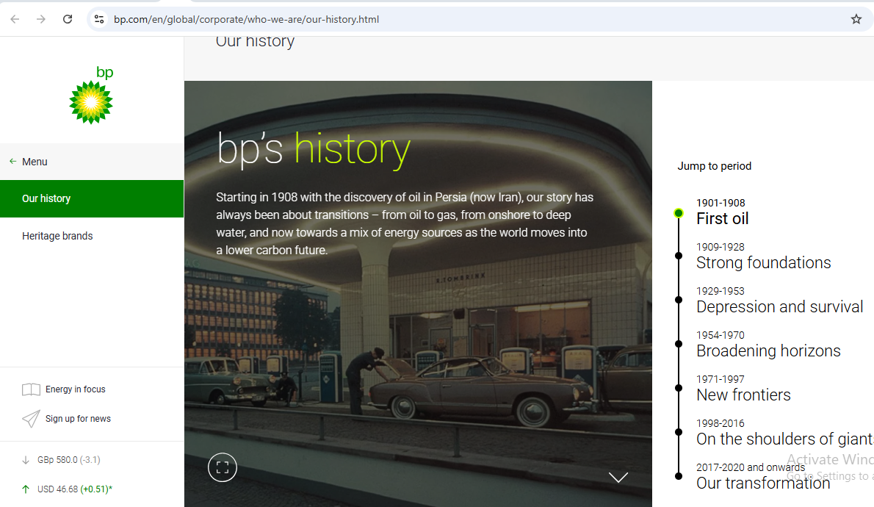
Source: https://www.bp.com/en/global/corporate/who-we-are/our-history.html
Figure 2 BP History details

Appendix-II-Our work strategy
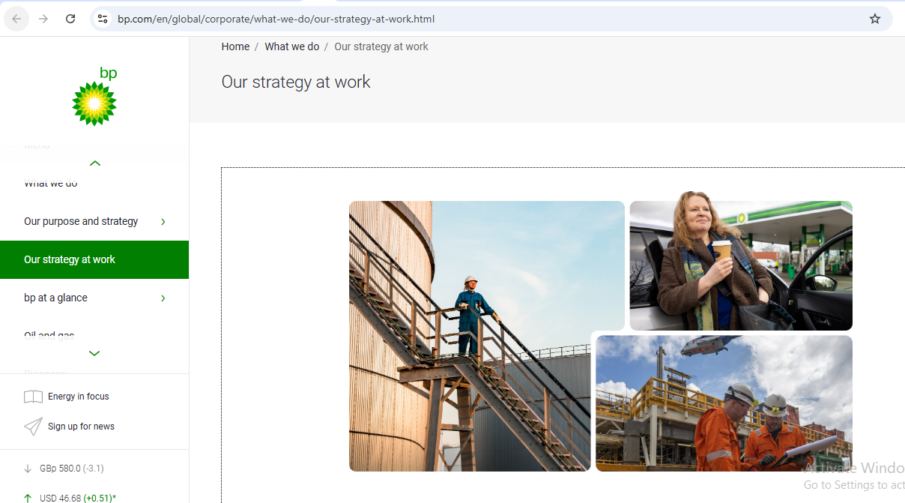
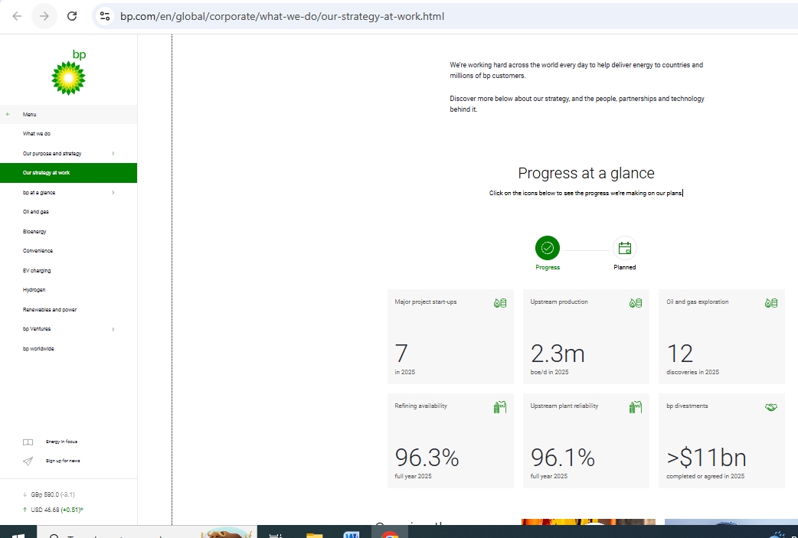
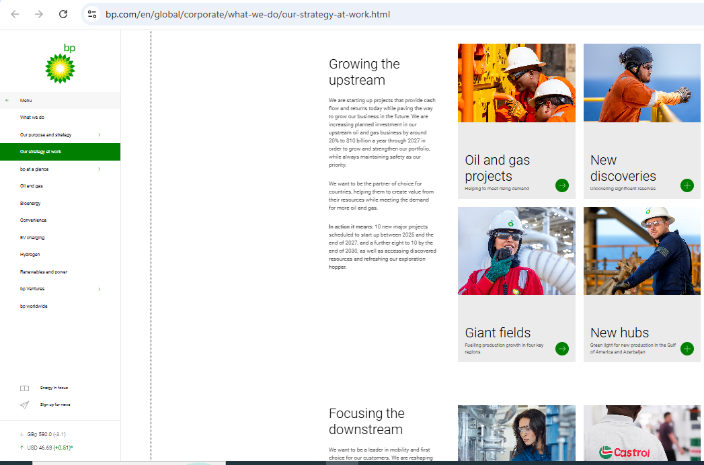
Source: https://www.bp.com/en/global/corporate/what-we-do/our-strategy-at-work.html
Figure 3 Our-strategy-at-work

Appendix-III our organization

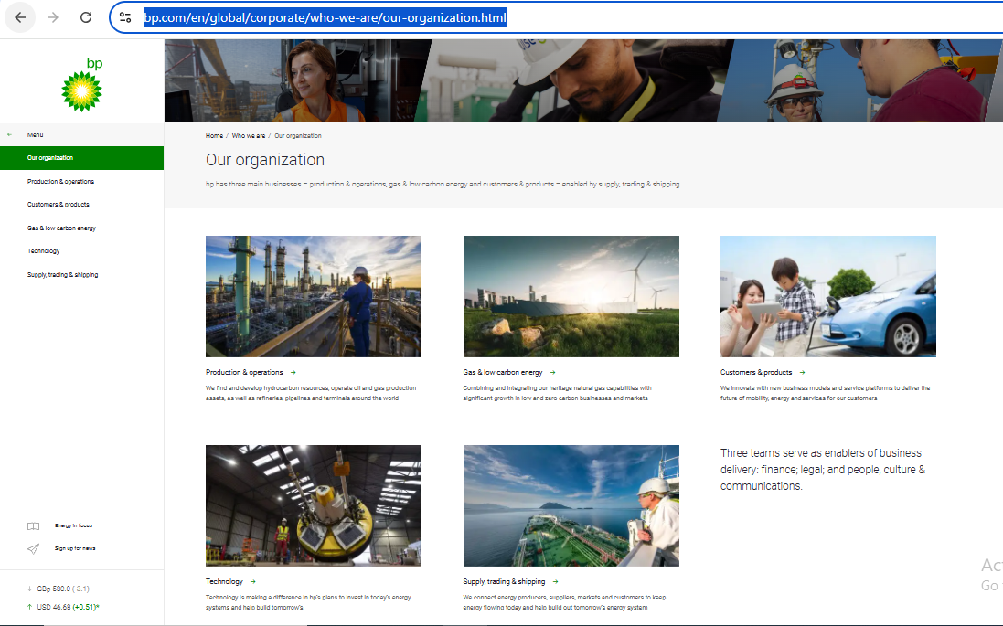
Source: https://www.bp.com/en/global/corporate/who-we-are/our-organization.html
Figure 4 our organization

Appendix-IV-Oil and Gas Report
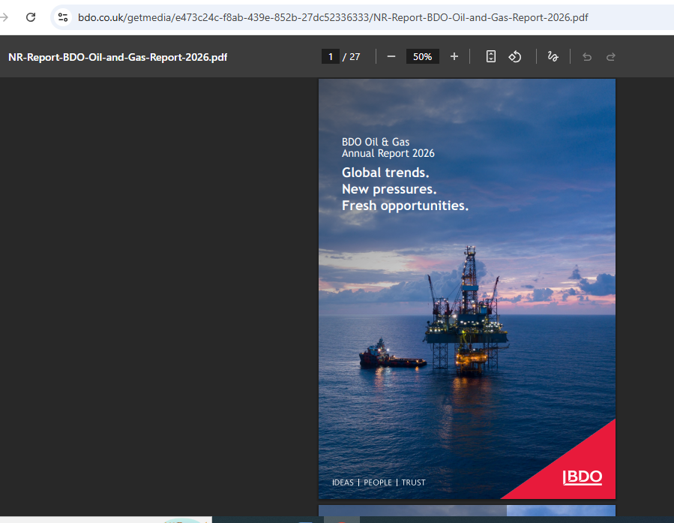
Source: https://www.bdo.co.uk/getmedia/e473c24c-f8ab-439e-852b-27dc52336333/NR-Report-BDO-Oil-and-Gas-Report-2026.pdf

Figure 5 BDO-Oil and Gas Report

Appendix-V-PB PLC Annual Report 2025
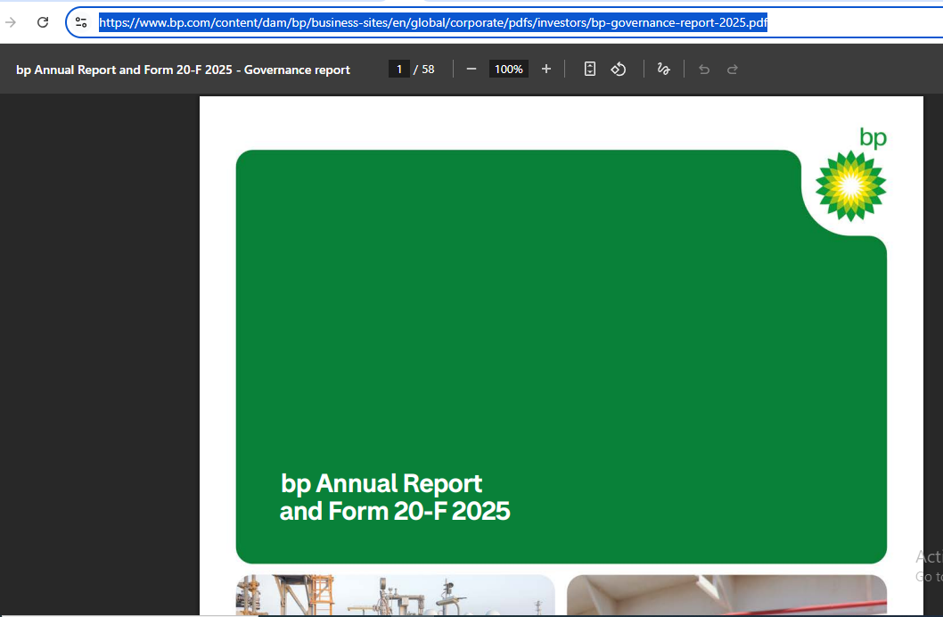
Source: https://www.bp.com/content/dam/bp/business-sites/en/global/corporate/pdfs/investors/bp-governance-report-2025.pdf
Figure 6 PB PLC Annual Report 2025

Appendix-VI-Press Release
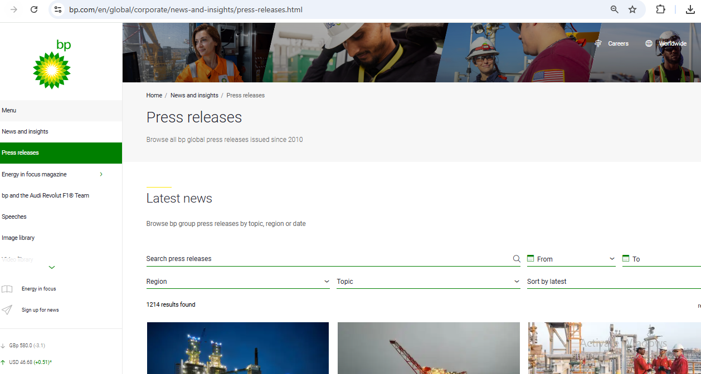
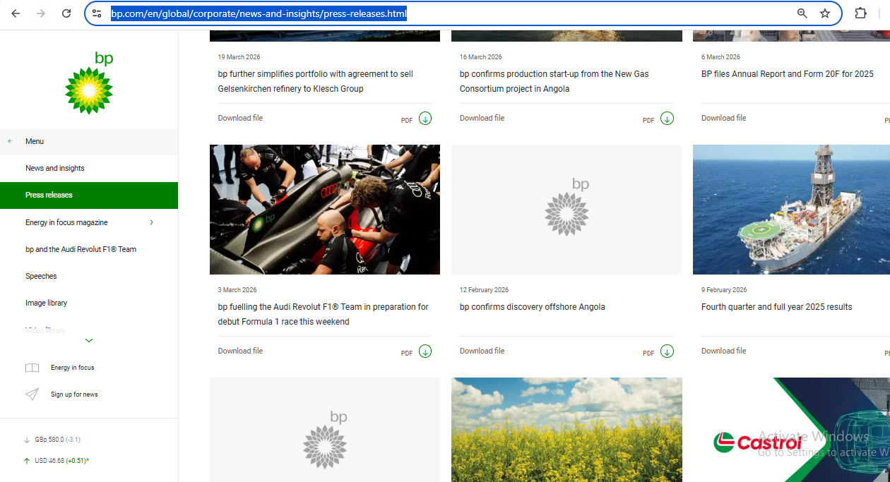
Source: https://www.bp.com/en/global/corporate/news-and-insights/press-releases.html
Figure 7 Press Release

Appendix-VII-ESG Datasheet of BP PLC 2025
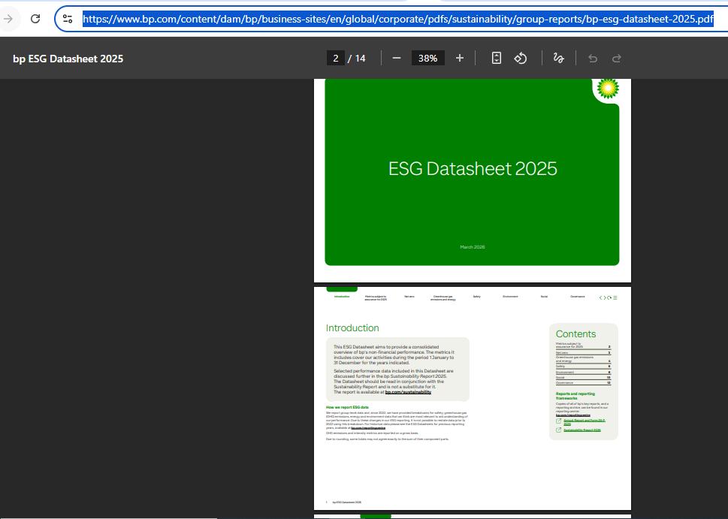
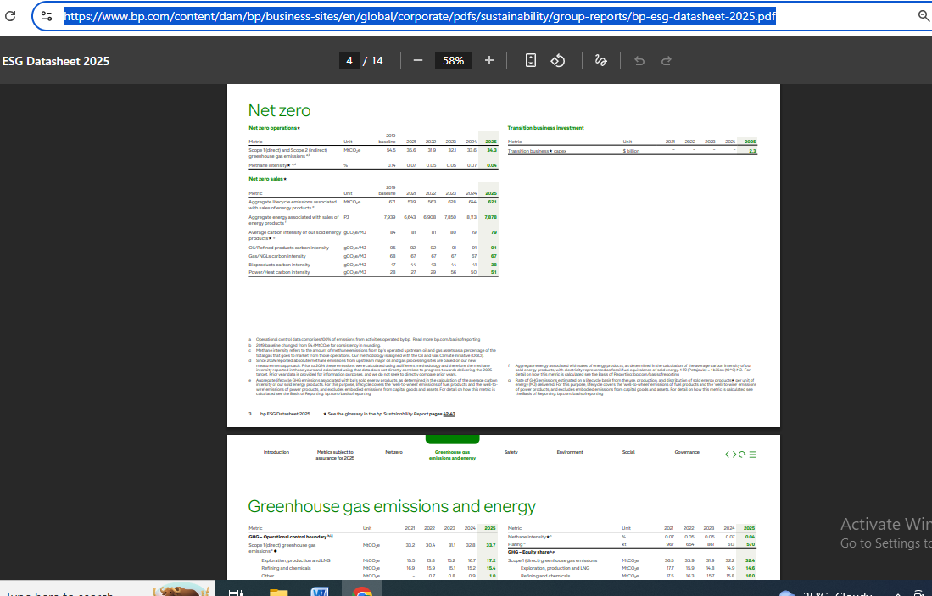
https://www.bp.com/content/dam/bp/business-sites/en/global/corporate/pdfs/sustainability/group-reports/bp-esg-datasheet-2025.pdf
Figure 8ESG Datasheet of BP PLC 2025

Appendix-VIII Gibbs reflective cycle

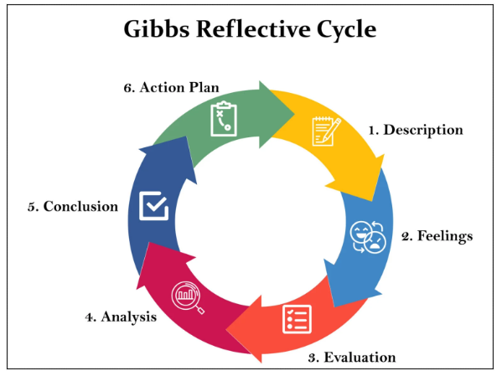
Figure 9 Gibbs reflective cycle

